HISO 10008.3:2019
Notifiable Disease Messaging Implementation Guide

March 2019

Document information
HISO 10008.3:2019 Notifiable Disease Messaging Implementation Guide is a standard approved for the New Zealand health and disability sector
First published in March 2017 and updated in March 2019 by the Ministry of Health
ISBN 978-1-98-856869-0 (online)
HP 7060
Health Information Standards Organisation (HISO) standards are published by the Ministry of Health for use by the health and disability sector
HISO standards are posted on the Ministry website: http://www.health.govt.nz/our-work/health-information-standards/approved-standards
Contributors
The Institute of Environmental Science and Research (ESR)
Copyright
Crown copyright (c) – This copyright work is licensed under the Creative Commons Attribution-No Derivative Works 4.0 licence http://creativecommons.org/licenses/by-nd/4.0/. You may copy and distribute this work provided you attribute it to the Ministry of Health, you do not adapt it and you abide by the other licence terms.
Keeping standards up-to-date
HISO standards are regularly updated to reflect advances in health information science and technology. Always be sure to use the latest edition of these living documents.
We welcome your ideas for improving this standard and will correct any errors you report. Contact us at standards@health.govt.nz or write to Health Information Standards, Ministry of Health, PO Box 5013, Wellington 6145.
Version control
Reason for Change | Version | Date
Original published document | 2017 | March 2017
Updated to reflect changes made to the list of notifiable diseases in Schedule 1 of the Health Act 1956 and also incorporate the future use of APIs and SNOMED CT. | 2019 | March 2019

Contents
1 Introduction 1
1.1 Overview 1
1.2 Background 1
1.3 Notifiable disease surveillance systems 1
1.4 Scope of this implementation guide 2
1.5 New Zealand legislation and regulations 3
1.6 Related standards 3
2 Business processes 4
2.1 Notification processes 4
2.2 Interim notification data flow 5
2.3 Notification data flow 7
2.4 End-to-end laboratory notification process map 8
2.5 Urgency and acknowledgement 10
3 Information requirements 11
4 Privacy and security 12
4.1 Privacy requirements 12
4.2 Security requirements 12
5 Transactions and message types 13
5.1 Exchanging information with the ENDMS 13
5.2 Flat file not supported 16
5.3 ORU laboratory results message 16
5.4 ACK– response message 17
5.5 General considerations 17
5.6 Diagnosis 18
5.7 Traceability 18
5.8 Data types 18
5.9 HL7 composite data types 19
5.10 MSH − message header segment 25
5.11 ERR − error segment 30
5.12 PID patient identification 31
5.13 Notification identification 33
5.14 Observation request 34
5.15 Observation result 40
5.16 NTE − note segment 44
5.17 Examples 46
Appendix A – Code tables 47
Disease codes 47

Introduction
This implementation guide provides assistance in the development of applications using messaging to report notifications into the Electronic Notifiable Disease Messaging System (ENDMS). Also included in this guide is the structure of electronic messages using HL7® version 2.4.

Overview
Notification is a key part of monitoring and managing communicable disease (and some non-communicable issues) under the current Health Act 1956. Under Schedules 1 and 2 of the Health Act 1956 there are a number of diseases and conditions that are required to be notified (including on suspicion) to a Medical Officer of Health.
Section 74AA of the Health Act 1956 requires laboratories to directly notify a Medical Officer of Health, based at one of 20 local public health units, on confirmation or suspicion that a patient has a notifiable disease. It is anticipated that the requirement to report on suspicion will no longer be necessary once a review of procedures has been completed.
The primary purpose of notification is to trigger an appropriate public health response so that further illness can be prevented. The secondary purpose is for surveillance; that is, is to predict, observe and minimise the harm caused by outbreak, epidemic and pandemic situations. Accurate and timely data is essential if we are to promptly identify and respond to important public health events such as pandemic influenza, or a similar emergent infectious agent with epidemic or pandemic potential.

Background
In 2003 the Ministry of Health initiated a review of the current system of notifiable diseases and conditions. The review identified a need to improve the effectiveness of the current system, especially in relation to data accuracy and timeliness. A major recommendation was to create the legal framework that would allow direct laboratory notification of notifiable diseases.
The Health Amendment Act 2006 was passed in December 2006. As well as improving the government’s ability to respond to an outbreak of pandemic flu or a similar highly infectious disease, this new legislation provided for direct laboratory notification (of notifiable diseases). Along with the aim of improving the New Zealand disease surveillance system in terms of its timeliness, quality and accessibility, the problematic nature of relying on the voluntary participation of laboratories to supply data was strong justification for introducing a legal requirement for laboratories to report cases of notifiable diseases.
In July 2016, Schedule 1 of the Health Act 1956 was updated as a result of the passing of the Health (Protection) Amendment Act 2016. This new legislation increased the range of infectious diseases to be notified. This will provide the ability to improve the management of individuals with infectious diseases that may put others at risk and strengthen the provision of contact tracing of people that may have been exposed to an infectious disease.

Notifiable disease surveillance systems
The method of notification approved by the Direct Laboratory Notification Advisory Group is through a national electronic system that builds on existing systems, including EpiSurv, the national notifiable diseases database maintained by Environmental Science and Research (ESR).
EpiSurv7, a web-based real-time version of the national notifiable disease surveillance system, was deployed in April 2007. EpiSurv7 is an extensible and scalable system and is currently used by public health services throughout New Zealand.
The national electronic system provides a base set of functionality and tools, including:
- electronic and manual data capture
- recording of cases of notifiable diseases and subsequent investigation details
- recording of contact tracing information and linking of cases
- data analysis and reporting.
The system is intended to work alongside local public health unit systems, which are used to support more advanced requirements for notifiable disease case management, contact tracing and management, and outbreak and emergency responses. Basically, it provides interfaces through which data can be exchanged electronically.
ESR has developed an enhanced, robust and secure information management platform known as SurvINZ. In this platform, ESR has integrated (and continues to integrate) its surveillance systems and activities to achieve greater efficiency and deliver more integrated and timely information to its stakeholders and end-users for the benefit of public health.

Scope of this implementation guide
This document presents guidelines for sending HL7 messages to the Electronic Notifiable Disease Messaging System (ENDMS).
This implementation guide uses definitions from HISO 10008.2:2015 Pathology and Radiology Messaging Standard.
The messages covered are test results provided by laboratories and the response from ESR. Notifications from other practitioners are not covered here, but over time it is envisaged that additional information will be managed by providing a copy of an electronic laboratory order to ESR, or sending additional information using a referral message (REF) using current RSD version 2.4 HL7 standard.
This guide covers the following topics:
- specific use of message segments where there are alternative uses, and the enforcement of optional fields that are required for the ENDMS
- provision of all the technical information required for a health provider (or their system vendor) to make all the necessary system changes to support the ENDMS.

New Zealand legislation and regulations
The following Acts of Parliament and Regulations have specific relevance to this standard. Readers should be aware of the need to consider other Acts and Regulations as may be appropriate to their own implementation or use of this standard.
- Health Act 1956
- Health and Disability Commissioner (Code of Health and Disability Services Consumers’ Rights) Regulations 1996
- Health Information Privacy Code 2020
- Privacy Act 2020

Related standards
- HISO 10004 New Zealand Pathology Observation Code Set (NZPOCS)
- HISO 10008.2:2015 Pathology and Radiology Messaging Standard
- HISO 10008.1:2015 Pathology and Radiology Implementation Guide
- HISO 10029:2015 Health Information Security Framework
- HISO: 10005 Health Practitioner Index Data Set
- HISO: 10006 Health Practitioner Index Code Set
- HL7 Standard version 2.4 − An Application Protocol for Electronic Data Exchange in Healthcare Environments. Ann Arbor: Health Level Seven Inc.
- ISO 3166: ISO 3166-1:1997, Codes for the Representation of Names of Countries and Their Subdivisions: Part 1: Country codes

Business processes

Notification processes
To meet legal requirements, the person in charge of a medical laboratory has several options to report, depending on their laboratory’s capacity. The following methods may be used to notify Medical Officers of Health:
- manual notification, including phone or fax
- electronic copying of test results from a DHB laboratory to a DHB public health unit (for DHB patients only)
- sending a modified HL7 message electronically to the Medical Officer of Health
- electronic notification via the national EpiSurv system.
Laboratories may decide to continue to use a manual system, and in some smaller districts this will not cause any problems due to their small volumes of notifiable disease results. Those public health units that receive an HL7 message directly from laboratories should consider using an HL7 viewer (a basic software package) to enable the receipt and display of electronic information from laboratories and comply with the Privacy Act.
DHB hospital laboratories will need to approach their corporate services to determine what information can be transferred from the hospital laboratories to the local public health unit. Organisation structures, governance and contractual arrangements will differ from DHB to DHB. It may be permissible to send test results unconnected to the notification to another medical practitioner (eg, a Medical Officer of Health within the same DHB). Because the restrictions will differ for each DHB, the Ministry advises DHBs to seek their own legal advice on this issue.
For private laboratories, all patient-identifiable information not required by a Medical Officer of Health for public health action must be removed from the test result before it can be transferred to the Medical Officer of Health.

Interim notification data flow
The diagram below provides a simplified view of the interim flow of information for direct notification of notifiable diseases.
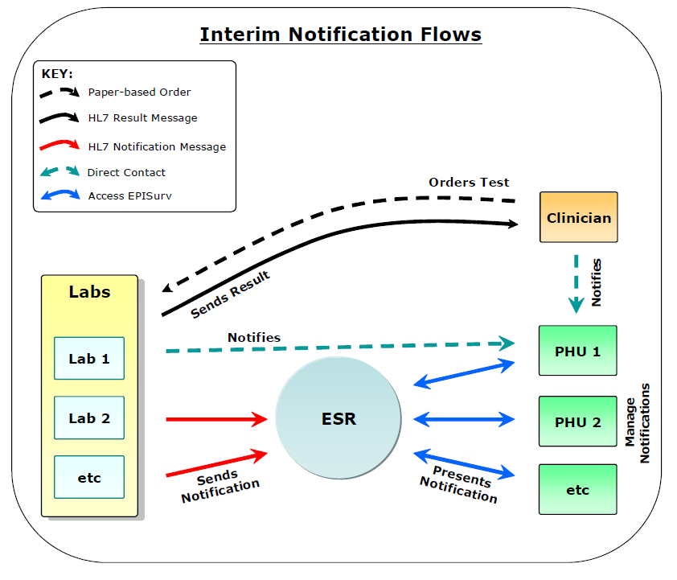
Figure 1: Interim flow for direct notification
The notification messages comply with HISO 10008.2:2015 Pathology and Radiology Messaging Standard and HL7 version 2.4.
Direct contact between a laboratory and a public health unit may be via phone, fax or email, or possibly an electronic message. Typically this would be because a laboratory is unable to send a notification message that meets the required specification. Where an electronic message is sent directly to a Medical Officer of Health, the public health unit requires the capability to receive such information and need to manually create a case in EpiSurv.

The participants are described in the following table.
  - Table 1: The participants in the notification processes
Participant | Role
Clinician | Requests laboratory tests and sends a notification message to a public health unit (via EpiSurv) on suspicion of a notifiable disease.
Laboratory | Undertakes the tests requested, sends the results to the requesting clinician and sends a notification message (via EpiSurv) to a public health unit on confirmation of a notifiable disease.
ESR | Receives a notification message from a laboratory and a health care practitioner, stores the notification information in EpiSurv, and alerts the appropriate public health unit.  ESR operates EpiSurv, a national notifiable diseases reporting and basic case management system.
Medical Officer of Health | Accesses a ‘notifications module’ on EpiSurv via a web browser on a computer at the public health unit (PHU). Case report forms are created where necessary (an automated process). The Medical Officer of Health may contact the attending clinician, testing laboratory and/or patient for information, follow-up or public health action purposes.
Message broker | While not shown in the diagram, the broker’s role is to manage laboratory order and results messages and notification messages to ensure they are securely passed between the appropriate parties: in this case, a clinician and a laboratory, a laboratory and ESR, and a clinician and ESR.
Communication network | While not shown in the diagram, this is the underlying telecommunications-related infrastructure over which messages are securely passed between the parties; for example, the Connected Health Network or RESTful APIs.
Laboratory test orders, results and notification messages ensure information is provided in a structured and consistent way and can be easily stored and processed by ESR’s EpiSurv system. A public health unit does not need to manually create a case in EpiSurv. These messages comply with the HL7 version 2.4.
Direct contact between a clinician and a public health unit may be via phone, fax or email. Typically this would be because a clinician wants to provide early warning to a public health unit regarding a suspected patient with a notifiable disease. In the future, it is likely that clinicians will also be able to send electronic notifications to a public health unit via EpiSurv using, for example, their practice management system.

Notification data flow
The diagram below provides a simplified view of the flow of information for direct notification of notifiable diseases.
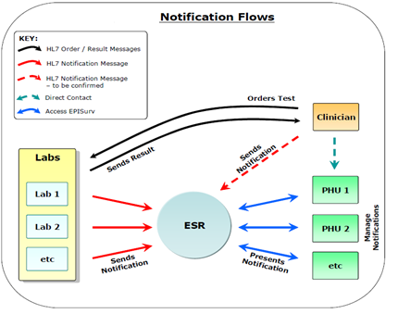
Figure 2: Flow of information for direct notification
The participants are the same as in the interim diagram (Figure 1).

End-to-end laboratory notification process map
The map below (Table 2) sets out the main notification routes required for different circumstances, depending on whether a manual or an electronic notification system is used and whether more than one laboratory is involved in testing the sample. Simplified diagrams showing only the electronic messaging are provided in section 5.1.
  - Table 2: Main notification routes
Clinician | Laboratory 1 | Laboratory 2 | Overseas laboratory | ESR | Medical Officer of Health receives notification
Sends notification to relevant MO of H on suspicion of communicable disease (phone, fax, email, HL7)
Requests laboratory test | Scenario 1  Performs test. Uses laboratory notification flowcharts to assess if and when to send a notification to MO of H.
 | If notifiable, the laboratory must immediately send notification to MO of H.
 | If using a manual system of notification, laboratory 1 faxes, phones or emails relevant MO of H.
 | If using the national electronic system, Laboratory 1 sends an HL7 version 2.1 of version 2.4 message to relevant MO of H via EpiSurv. |  |  | ESR processes the message in real time and sends to the relevant MO of H.
Receives test results | Sends test results back to the clinician.
Scenario 2
If Laboratory 1 generates either a partial or first result and then sends a sample to another laboratory for testing, then it sends notifiable cases to MOH (manual or electronic).
 | Sends sample  to second laboratory. | Tests sample. If notifiable result, notifies MO of H.
 |  | Sends test results to clinician and/or Laboratory 1
 |  | Where possible lest Laboratory 1 know Laboratory 2 has notified when sending back the test results.
 | Scenario 3  Laboratory 1 receives a sample that it cannot test and must forward to another laboratory. | Tests sample.  If results are notifiable, send notification to MOH of H.  Sends test results back to practitioner and/or Laboratory 1.
Scenario 4
Laboratory receives sample that requires testing overseas. Any notifiable results from initial testing must be notified to MO of H.
 | Sends test to overseas laboratory.  All notifiable test results received from overseas laboratory must be notified to MO of H. |  | Laboratory performs tests and sends results back to New Zealand laboratory.

Urgency and acknowledgement
Existing manual systems, such as fax (auto-receipt) and telephone, mean that the person notifying is aware that a notification has been received at a public health unit. In moving to electronic notification, acknowledgement that a notification has been received (or rejected) will be required. This function may be discharged either by the receiving application itself or an intermediary message broker.
For some conditions, it is particularly important that a notification is received and actioned as soon as possible. For laboratories reporting electronically, professional judgement should be exercised in relation to the reporting of results that are likely to require urgent action by the public health unit. In such circumstances, phoning through the results as well as sending the results electronically is recommended.

Information requirements
Laboratories are required by law to provide the Medical Officer of Health with a subset of the ideal data set. The absolute minimum information required by the Medical Officer of Health to ensure public health action can be initiated following notification (by contacting the clinician) is given in the following list:
- patient name
- date of birth
- name of referring practitioner
- disease (code)
- laboratory name
- public health unit (code)
- sample reference number (filler order number).
Based on existing processes and technology, laboratories should be able to provide the mandatory six items of above information. It is important that the appropriate public health unit code (PHU code) be assigned to each notification to ensure necessary action can be taken.
Due to privacy requirements, laboratories must send only the test results relating to the notifiable disease in question. Public health units will require only some negative results to enable de-notification of a previous clinician notification (e.g. invasive meningococcal disease).
Ideally, additional information will be available to a public health unit upon notification (see the list below). Initially, if not provided by a laboratory, this information will need to be collected from secondary sources (the clinician, or from other hospital or other systems):
- NHI (National Health Index) number
- gender
- ethnicity
- occupation
- address details (house number, street name, suburb, town/city, postcode)
- patient’s and clinician’s contact details
- phone numbers (home, business, mobile)
- diagnosis/clinical information
- unique reference number
- symptoms
- date of onset.
It is envisaged that a rich data set sent directly from laboratories to public health units, including all or most of the information outlined above, has become a reality with the developments such as electronic ordering of laboratory investigations.

Privacy and security

Privacy requirements
Although notification under the Health Act 1956 allows for named patient information to be shared for the purpose of protecting the public health, all health-related information relating to individuals must be adequately protected.
Additional security provided for through an electronic system, such as role-based security (ie, blocking certain information from general view) will be used to ensure individual privacy. Access to patient-level data for all other diseases and conditions will be restricted to the staff at the responsible (local) public health unit. All identifiable information will be blocked from the view of ‘national users’.
Note: Although AIDS and HIV infection notifications are compiled by the AIDS Epidemiology Group (AEG) at the University of Otago, Dunedin, positive laboratory results that meet the DLN criteria should be notified using the ESR e-notification system. A process is in place to automatically remove identifiable data and replace it with a case code before the notification is transferred to the responsible Public Health Unit. Creation of the case in EpiSurv automatically triggers creation of a case questionnaire in the AEG surveillance database.
Creutzfeldt–Jakob disease (CJD) notifications should not be entered into or sent to EpiSurv. CJD notifications are to be sent to the CJD register at the University of Otago by the responsible public health unit.

Security requirements
It is expected that both laboratories and public health unit users will connect and/or send messages via the Connected Health Network or RESTful APIs. Public health unit users will require a log-in name and password to access the system. Security will allow public health units to view and report on their local data in detail, and view and report on national data at a summary level.
Laboratories, public health units and ESR must use the Connected Health Network to exchange data through the ENDMS and comply with the information security requirements of the HISO 10029:2015 Health Information Security Framework.

Transactions and message types

Exchanging information with the ENDMS
HL7 version 2 is an international standard that is used globally and within New Zealand to manage the workflow and content involved with the exchange of clinical information about patients between providers. The ENDMS has adopted the HL7 version 2.4. Message specifications have been developed based on information requirements for disease notification. This information includes:
- demographic information
- relevant clinical information
- test results
This document provides a guide to adopting the required messaging standards for the ENDMS. Phase 1, which covers the transmission of messages from laboratories, should use a store and forward messaging service to transport messages to the ENDMS using HL7 version 2.4. Alternative mechanisms for message transportation will be developed in the future.
The following diagrams show the electronic messages involved in each scenario, followed by a description of the steps involved. Each message has a corresponding acknowledgement message, but these have been omitted from the diagrams in the interests of simplicity.

Transaction 1 – standard notification

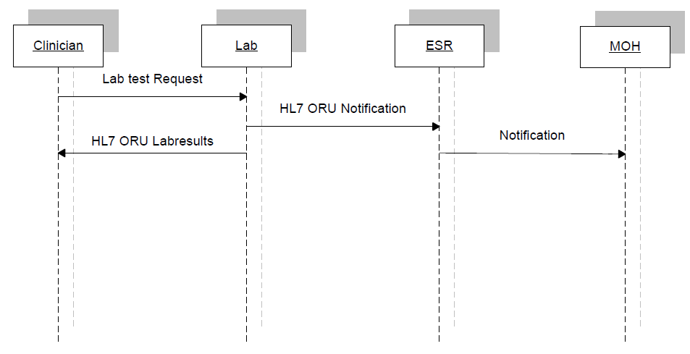
Figure 3: Flow for standard notification

Step 1. The clinician examines the patient, obtains a sample and requests a laboratory test.
Step 2. The laboratory performs tests, and uses laboratory notification flowcharts to assess if and when to send a notification to the Medical Officer of Health. If notifiable, the laboratory must immediately send an HL7 version 2.4 message to the relevant Medical Officer of Health, via EpiSurv.
Step 3. ESR processes the message in real time. Notifications become available, on EpiSurv, to the relevant Medical Officer of Health.
Step 4. The laboratory sends the test results back to the clinician.

Transaction 2 – Partial send-away testing and notification
Figure 4: Flow for partial send-away testing and notification
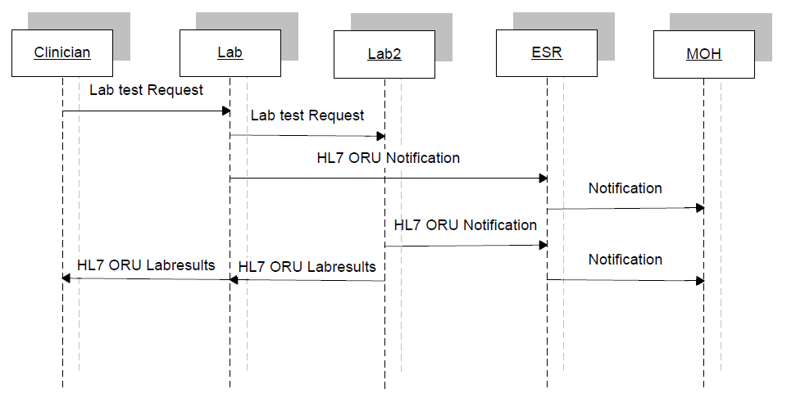
Step 1. The clinician examines the patient, obtains a sample and requests a laboratory test.
Step 2. The laboratory performs the tests, generates either a partial or first result, and then sends a sample to another laboratory for testing.
Step 3. The first laboratory uses laboratory notification flowcharts to assess if and when to send a notification to the Medical Officer of Health. If notifiable, the laboratory must immediately send an HL7 version 2.4 message to the relevant Medical Officer of Health via EpiSurv.
Step 4. The second laboratory performs tests. If a notifiable result is found, it notifies the Medical Officer of Health.
Step 5. ESR processes the messages in real time. Notifications become available, on EpiSurv, to the relevant Medical Officer of Health.
Step 6. Where possible, the second laboratory advises the original laboratory that it has notified the Medical Officer of Health when sending back the test results.
Step 7. Both laboratories send their test results back to the clinician

Transaction 3 – Full send-away testing and notification
Figure 5: Flow for full send-away testing and notification
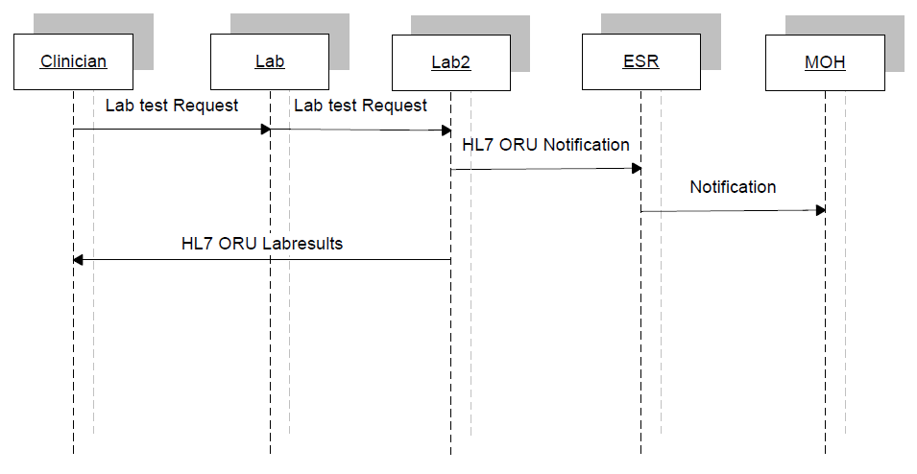
Step 1. The clinician examines the patient, obtains a sample and requests a laboratory test.
Step 2. The laboratory cannot perform the requested tests and sends a sample to another laboratory for testing.
Step 3. The second laboratory performs the tests. The laboratory uses laboratory notification flowcharts to assess if and when to send a notification to the Medical Officer of Health. If notifiable, the laboratory must immediately send an HL7 version 2.4 message to the relevant Medical Officer of Health via EpiSurv.
Step 4. ESR processes the message in real time. Notifications become available, on EpiSurv, to the relevant Medical Officer of Health.
Step 5. Where possible, the second laboratory advises the original laboratory that it has notified the Medical Officer of Health when sending back the test results.
Step 6. The second laboratory sends the test results back to the clinician.

Transaction 4 – Overseas send-away testing and notification
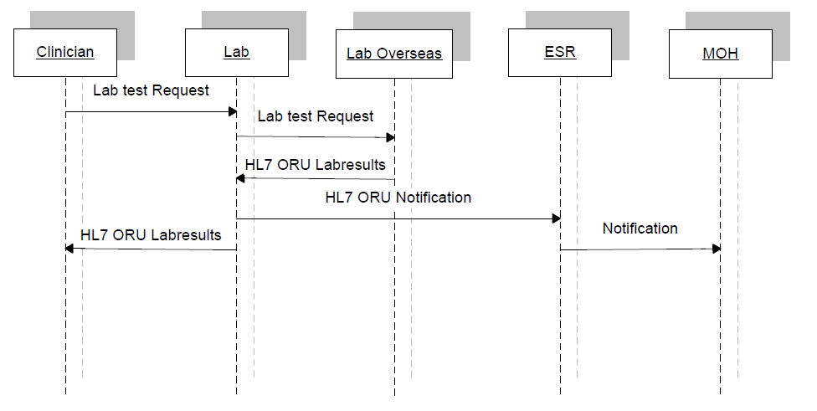
Step 1. The clinician examines the patient, obtains a sample and requests a laboratory test.
Figure 6: Flow for overseas send-away testing and notification
Step 2. The laboratory cannot perform the tests and sends a sample to an overseas laboratory for testing.
Step 3. The overseas laboratory performs tests and sends the test results back to the original laboratory.
Step 4. The original laboratory uses laboratory notification flowcharts to assess if and when to send a notification to the Medical Officer of Health. If notifiable, the laboratory must immediately send an HL7 version 2.4 message to the relevant Medical Officer of Health via EpiSurv.
Step 5. ESR processes the messages in real time. Notifications become available, on EpiSurv, to the relevant Medical Officer of Health.
Step 6. The laboratory sends the test results back to the clinician.

Flat file not supported
It is important to note that current laboratory messages are usually converted to a flat file format from the HL7 message before being sent to a GP system. This process places a number of restrictions on the generated message. Any message constructed using this guide may not be able to be sent to any recipient using a flat file format.

ORU laboratory results message
The tables below show the segments that are used, and the responses. Items enclosed within square brackets ([ ]) are optional, and those within braces ({ }) may be repeated multiple times. The tables are followed by some general considerations and a detailed description of the segments.
It must be stressed that these should be read in conjunction with the appropriate standard. While some items may be optional in HL7, they may be mandatory in this implementation and further restrictions may be applied that are not in the reference standard.
  - Table 3: ORU laboratory results segment
Segment name | Description
MSH | Message header
PID | Patient identification
[PV1] | Patient visit (used to convey notification number)
OBR | Order detail – observation request
OBX | Observation/result (optional in HL7 version 2.4 but required for this implementation)
[{NTE}] | Notes and comments on result information

Note: Although the PV1 segment is officially optional, in practice it is almost always sent because many practice management systems require this message to be sent. Please see the specific notes on PV1 for more information on the usage of this segment.
The OBX segment is mandatory.

ACK– response message
  - Table 4: ACK response message
Segment name | Description
MSH | Message header
MSA | Message acknowledgement
[ERR] | Error

General considerations
The sending and receiving HPI facility IDs or ‘EDI’ addresses are used by the messaging gateway to direct the message to the correct destination, and the destination swaps the sender and receiver HPI facility IDs so the gateway can return the ACK messages to the originator of the results. These fields must contain the correct HPI facility ID or EDI values.
The ENDMS accepts data as standard unsolicited results (ORU) but restricts some fields to specific ranges of values. Some optional fields are mandatory when sending data to the ENDMS.
The ENDMS does not support delimiters other than the default ones specified in the standard. It is essential that messages be constructed in segmented form, where possible, rather than using large blocks of formatted text.
Only segments MSH, PID, PV1, OBR, OBX and NTE will be processed; any others will be discarded.
It is implied in general by the HL7 standards that non-repeating fields can be repeated by local agreement. The ENDMS will ignore additional repeats.
Where multiple OBX occur with the same code in OBX-3, then sub-IDs will need to be used in OBX-4, starting at 1 and incrementing by 1 for each subsequent OBX in a set.
As most messages to the ESR are copies of messages, the original recipient is lost from the message header. Furthermore, the message header does not use HPI codes. For this reason, all messages must have values for the HPI facility IDs in OBR-46 (placer HPI facility ID) and OBR-47 (filler HPI facility ID) where the name of the coding system is HF for HPI identifiers.
The ENDMS supports ASCII and UNICODE, and any value in MSH-18 will be ignored.
Note: Within Section 5, only segments and fields that are used in the ENDMS message have been documented (unless otherwise stated with a ‘not used’ in the notes column).

Diagnosis
When reporting the results, a diagnosis is required as well. There is no provision for a DG1 segment in an ORU message, so the diagnosis will be reported in an OBX segment associated with the requested test. If there are two diagnoses, then two OBX will be supplied and distinguished using sub-IDs in OBX-4. These OBX will be before any result containing OBX.
OBX-3 will contain the LOINC code 29308-4. OBX-5 must contain a value from the Disease Code table (Table 41) in Appendix A. It is anticipated that the SNOMED CT Notifiable Disease Reference Set will be incorporated in the future.

Traceability
All processes must be linked together. Laboratories may issue a new placer order number when they send a specimen to another laboratory rather than using their original filler order number. If this occurs the link is potentially lost. To address this, a number will be generated as early in the process as possible and maintained within all message transactions. The patient visit segment (PV1-5) will be used to convey this number. This number could be the case number issued by the ESR on initial notification, a concatenation of the GP HPI facility ID and the GP order number or the GP order number itself.

Data types
The following data types are used in the definition of segments. All of these are standard HL7 types. Consult HL7 Chapter two for further information.
  - Table 5: HL7 data types
Data type | Meaning | Comment
CM | Composite data type | This field is a combination of other data items. Where it occurs, the structure of the composite will be defined in field notes.
DT | Date | Always formatted as YYYYMMDD.
FT | Formatted text | Same as ST but allows embedded HL7 formatting characters.
HD | Hierarchic identifier | Treated the same as ST in this implementation as there is no name space specified.
ID | Coded value | The value in this field must be drawn from a table of HL7 defined values. The table of acceptable values will be found in the field notes.
IS | Coded value | The value in this field must be drawn from a table of user-defined values. The table of acceptable values will be found in the field notes. If the table occurs more than once it will be repeated in an appendix.
NM | Numeric data | A number value.
ST | String data | A string of alphanumeric characters.
SI | Sequence ID | A non-negative integer.
TS | Time stamp | Always formatted as YYYYMMDD[HHMM[SS]]. HL7 allows 4 additional fields of milliseconds. These are not used in this implementation.
TX | Text data | ST that allows some additional special characters.

HL7 composite data types
These composites are used in the definitions of the segments. Where additional clarification is required, these tables may be repeated in the segment notes. The composites are only those that are used in this document.

AD – address
This composite allows the transmission of address. Other designation (sub-component 2) is used exclusively as suburb. The country code is entered into the state and province code and not in HL7 defined country code field.
  - Table 6: AD address composite
Sub-component | Type | Notes
<Street address>^ | ST | Limited to 35 characters
<Suburb>^ | ST | Limited to 30 characters
<City>^ | ST | Limited to 30 characters
<Country code>^ | ST | Limited to 7 characters
<Zip or postal code>^ | ST | Not used
<Country> | ST | Not used

Note: The field length limits are to comply with the HISO 10008.2:2015 Pathology and Radiology Messaging Standard.

CE – coded element
This allows transmission of codes and the associated text.
  - Table 7: CE coded element composite
Sub-component | Type | Notes
<Identifier>^ | ST
<Text>^ | ST
<Name of coding system>^ | ST
<alternate identifier>^ |  | Not used
<alternate text>^ |  | Not used
<name of alternate coding system> |  | Not used

CK – composite ID with check digit
This specifies an ID value and associated check digit. For the purposes of this implementation the check digit components will not be used.
  - Table 8: CK check digit composite
Sub-component | Type | Notes
<ID Number>^ | NM
<Check Digit>^ |  | Not used
<check digit scheme>^ |  | Not used
<assigning authority> |  | Not used

CN – composite ID number and name
This composite is usually used for identifying medical practitioners throughout the message, be they laboratory or other medical personnel.
  - Table 9: CN number and name composite
Sub-component | Type | Notes
<ID number>^ | ST | Wherever possible this field will contain the HPI CPN number  (or NZMC number) of the provider.  Limited to eight characters.
<Family name>^ | ST | Limited to 25 characters.
<Given name>^ | ST | Limited to 20 characters.
<Middle initial or name>^ | ST | Always the middle initial. If the person’s name has two  middle names then the first middle initial should be  used.
<Suffix>^ | ST | Not used
<Prefix>^ | ST | Not used
<Degree> | ST | Not used

Note: The field length limits are to comply with the HISO 10008.2:2015 Pathology and Radiology Messaging Standard.

CQ − composite quantity
  - Table 10: CQ quantity composite
Sub-component | Type | Notes
<Quantity>^ | NM
<Units> | CE

CX – composite ID with check digit
This specifies an ID value and associated check digit. For the purposes of this implementation the check digit components will not be used.
The CX data type is used for specifying an identifier with its associated administrative detail. The maximum length of this field is 250. The table below shows the CX data type components.
  - Table 11: CX composite ID with check digit
Sub-component | Type | Notes
<ID> | ST | The value of the identifier itself.
<Check digit> | ST | Not used.
<Code identifying the check digit  scheme employed> | ID | Not used.
<Assigning authority> | HD | Refer to HISO 10008.2:2015 Pathology and Radiology Messaging Standard for values.
<Identifier type code> |  | A code corresponding to the type of identifier. In some cases this code may be used as a qualifier to the <assigning authority> component. Not likely to be used.
<Assigning facility> | HD | The place or location identifier where the identifier was first assigned to the patient.
<Effective date> | DT | The first date, if known, on which the identifier is valid and active.
<Expiration date> | DT | The last date, if known, on which the identifier is valid and active.

EI – entity identifier
The entity identifier defines a given entity within a specified series of identifiers. Typical use is for placer and filler order numbers. The table below shows the EI components.
  - Table 12: EI entity identifier composite
Sub-component | Type | Notes
<Entity identifier>^ | ST | This is usually defined to be unique within the series of identifiers created by the <assigning authority>, defined by a hierarchic designator.
<Namespace ID>^ | IS | Used as the HL7 identifier for the user-defined table of values for this component.
<Universal ID>^ | ST | A string formatted according to the scheme defined by the <universal ID type>.
<Universal ID type> | ID | Refer to the 10008 HISO Pathology and Radiology Messaging Standard for valid values.

In the case of order numbers, the following usage is recommended.
  - Table 13: Order number identifier
Sub-component | Type | Notes
<Entity identifier>^ | ST | Actual order number (mandatory).
<Namespace ID>^ | IS | Name of the organisation issuing the number (optional).
<Universal ID>^ | ST | Code of the organisation issuing the number. This should be the HPI facility ID where possible (mandatory if not the normal issuer; e.g., if placer order number is generated by the laboratory).
<Universal ID type> | ID | Refer to the 10008.2:2015 HISO Pathology and Radiology Messaging Standard for valid values.

PN – patient name
This composite is used for the name of any patients identified in the message.
  - Table 14: PN patient name composite
Sub-component | Type | Notes
<Family name>^ | ST | Limited to 25 characters.
<Given name>^ | ST | Limited to 20 characters.
<Middle initial or name>^ | ST | Always the middle initial. If the person’s name has two middle names, then the first middle initial should be used.
<Suffix>^ | ST | Not used
<Prefix>^ | ST | Not used
<Degree> | ST | Not used

Note: The field length limits for the previous table are to comply with the HISO 10008.2:2015 Pathology and Radiology Messaging Standard.

XAD – extended address
This composite differs from the standard HL7 version 2.4 composite in a number of ways. The other designation (sub-component 2) is used exclusively as suburb.
  - Table 15: Extended address composite
Sub-component | Type | Notes
<Street address>^ | ST | Limited to 35 characters
<Suburb>^ | ST | Limited to 30 characters
<City>^ | ST | Limited to 30 characters
<Province>^ | ST | Limited to 7 characters
<Zip or postal code>^ | ST
<Country> | ST | Limited to 7 characters ISO3166 codes
<Type>^ | ID | C, P, M, B
<GeoCode>^ | ST | Both separated by colon
<County code>^ | IS | Not used
<Domicile code>^ | IS
<Address code>^ | ID | Not used
<Address validity range> | DR

Note: The field length limits are to comply with the HISO 10008.2:2015 Pathology and Radiology Messaging Standard.

XCN extended composite ID number and name for persons
This field is usually reserved for the identification of health care providers. The maximum length of this field is 250. The table below shows the XCN components.
  - Table 16: Extended number and name for persons
Sub-component | Type | Notes
<ID number>^ | ST | CPN, NZMC, NZNC or APC number
<Family name>^ | FN | See note below
<Given name>^ | ST
<Middle initial or name>^ | ST
<Suffix>^ | ST
<Prefix>^ | ST
<Degree>^ | IS
<Source table>^ |  | Not used
<Assigning authority>^ | HD | A code corresponding to the type of identifier (eg, HI for HPI organisation code)
Sub-components of family name are given in Table 17.
  - Table 17: Sub-components of family name
Sub-component of family name | Type | Notes
<Surname> | ST
<Own surname prefix> | ST
<Own surname> | ST
<Surname prefix from partner/spouse> | ST
<Surname from partner/spouse> | ST

XPN – extended person name
This composite is used for the name of any patients identified in the message.
  - Table 18: Extended person name
Sub-component | Type | Notes
<Family name>^ | ST | Limited to 25 characters.
<Given name>^ | ST | Limited to 20 characters.
<Middle initial or name>^ | ST | Always the middle initial. If the person’s name has two middle names then the first middle initial should be used.
<Suffix>^ | ST | Not used
<Prefix>^ | ST | Not used
<Degree>^ | ST | Not used
<Name type code> | ST | A, B, C, D, I, L, M, N, P, R, S, T, U

Note: The field length limits are to comply with the HISO 10008.2:2015 Pathology and Radiology Messaging Standard.

XTN – extended telecommunications number
  - Table 19: Extended telecommunications number
Sub-component | Type | Notes
<Phone number string>^ |  | Not used
<Telecommunication use code>^ | ID | Indicates if it is home, work, etc
<Telecommunication equipment type>^ | ID | Indicates if it is a phone or fax etc
<Email address>^ | ST
<Country code>^ | NM
<Area code>^ | NM
<Number>^ | NM
<Extension>^ | NM
<Any text> | ST
For tables included in 4.11 onwards, the column headings identified below are to be interpreted as follows:
Len (Length) | Defines the total length of the field.
Opt (Optionality) | R (Required) | This field must always contain data.
 | O (Optional) | This field does not have to have data
 | C (Conditional) | This field must contain data in certain situations that will be described in the field notes.
Required for: | BusProc (Business Process) | Necessary to ensure an essential business process is able to be fulfilled;
 | PHAction (Public Health Action) | To enable public health unit staff to assess the need for, and perform the appropriate, public health action(s)
 | Legislation | Required under legislation

MSH − message header segment
  - Table 20: MSH message header segment
Data element | Field | Len | Type | Opt | Required for: | Comments
Field separator | MSH-1 | 1 |  | R | BusProc | The field separator character will be ‘|’
Encoding | MSH-2 | 4 |  | R | BusProc | To ensure messaging consistency, the following encoding characters must be used:  ^ − component separator  ~ − repetition separator  \ − escape character  & − sub-component separator
Sending application | MSH-3 | 180 | HD | O | BusProc | If the sending application which generated the message is not named, this field should contain the text ‘LABRESULT’ for version 2.1.
Sending facility | MSH-4 | 180 | HD | R | BusProc and PHAction | The EDI account name of the sending facility. This must be filled in correctly so that message acknowledgements can be correctly processed and delivered to the appropriate system.
Receiving application | MSH-5 | 180 | HD | O | BusProc | The default value is LABRESULT
Receiving facility | MSH-6 | 180 | HD | R | BusProc | The EDI account name of the intended recipient of this message, as nominated by the MO of H.
Date/time of message | MSH-7 | 26 |  | R | BusProc | Format:  YYYY[MM[DD[HHMM[SS[.S[S[S[  S]]]]]]]][+/-ZZZZ]
Message type | MSH-9 | 13 |  | R | BusProc | Minimum requirement is the text ‘ORU’ or ‘ACK’. The field can optionally extend to the trigger event and message structure components in the following format:  ORU^R01^ORU_R01  ACK^R01^ACK_R01
Message control ID | MSH-10 | 20 |  | R | BusProc | Number or other identifier generated by the sending application that uniquely identifies a message.
Processing | MSH-11 | 3 |  | R | BusProc | The following values must be used:  P – normal processing  D – debugging  T – training  P is the default
Version ID | MSH-12 | 60 |  | R | BusProc | Format: ‘2.4’ HL7 version 2.4 format can optionally extend to the ‘Internationalisation Code’ and ‘International Version ID’ components allowed by HL7.

MSH-1 – field separator
The field separator character will be ‘|’.
Example:
MSH|^~\&|DELPHIC...

MSH-2 – encoding characters
This field contains the separator characters for component, repeat and the escape character and sub-components, respectively. We strongly recommend that this field contain ‘^~\&’. Please see the section above on separators.
Example:
MSH|^~\&|DELPHIC|MEDLAB|LABRESULT|...

MSH-3 – sending application
This field should be filled in with the name of the sending application. Since this message is usually sent from a laboratory, this normally contains the name of the laboratory application. If the laboratory application is not named, this field should contain the text ‘LABRESULT’; most messages use this value.
Example: In this case the sending laboratory uses the Delphic Laboratory Results module:
MSH|^~\&|DELPHIC|ediaccnt|LABRESULT|...

MSH-4 – sending facility
This field should be filled in with the EDI account name of the sending facility. This must be filled in correctly so that message acknowledgements can be correctly processed. This field should not be more than eight characters in length and should always be in lower case.
Example:
MSH|^~\&|DELPHIC|ediaccnt|EPISURV|...
Variance to HL7: eight-character limit on the mailbox name. The use of this field could be extended when alternative communication methods are introduced.

MSH-5 – receiving application
This field identifies the receiving application. Since the receiving application is presently the laboratory result message processor, this field should always contain the text ‘LABRESULT’. This should contain EpiSurv.
Example:
...|^~\&|DELPHIC|ediaccnt|EpiSurv|esrendms|...

MSH-6 – receiving facility
This field should be filled in with the EDI account name of the intended recipient of this message. This must be filled in correctly so that the message can be delivered to the correct destination. EDI accounts are always eight or fewer characters and are always lower case. The use of this field could be extended when alternative communication methods are introduced.
The address for notifications is esrendms.
Example:
...|DELPHIC|ediaccnt|EPISURV|esrendms|20000120092032|...

MSH-7 – date/time of message
This is the date/time that the sending system created the message.
It is strongly recommended that it be filled at all times to maximum precision.
Example: This message was generated on 20 January 2000 at 9:20:32am:
...| EpiSurv | esrendms |20000120092032|PKI|ORU|...

MSH-8 – security
This field is used to implement security features. A public key infrastructure will be used, and this field will have its contents replaced by PKI.
Example: A PKI security scheme was employed when sending this message:
...|20000120092032|PKI|ORU|0155002273|P|2.4

MSH-9 – message type
This field identifies the message type. It should always contain ‘ORU’ for laboratory result messages and ‘ACK’ for acknowledgement messages.
Example: This message is an ORU message:
...|20000120092032|PKI|ORU|0155002273|P|2.4

MSH-10 – message control ID
This field is a number or other identifier that uniquely identifies a message from a particular sender. Each sender is responsible for ensuring that the message control IDs from their facility are unique.
Example:
...|20000120092032|PKI|ORU|0155002273|P|2.4

MSH-11 – processing ID
This field tells how a receiving system should process this message.
Table 21: MSH-11 processing ID
Value | Meaning
P | Process this message as normal.
D | This message is being used for debugging purposes. It should be properly acknowledged, but the data should be ignored.
T | Training.
Example: This message should be processed as normal:
...|20000120092032|SECURITY|ORU|0155002273|P|2.4

MSH-12 – Version ID
This field contains the HL7 version number of this message with further optional clarification components.
Example: This message subscribes to HL7 version 2.4.
...|20000120092032|SECURITY|ORU|0155002273|P|2.4

MSA − message acknowledgement segment
The MSA segment contains information to be sent when replying to or acknowledging another message. The data in this segment can be safely ignored by new implementations, but older systems still require this segment.
  - Table 22: MSA message acknowledgement segment
Data element | Field | Len | Opt | Required for: | Comments
Acknowledgement code | MSA-1 | 2 | R | BusProc | Values are AA, AE, AR
Message control ID | MSA-2 | 20 | R | BusProc | To ensure matching of response to original message.
Text message | MSA-3 | 80 | O | BusProc | Error message text.
Error condition | MSA-6 | 250 | O | BusProc | Information may be in an ERR segment.

MSA-1 – acknowledgement code
This field provides information about the processing of the message to which this message is a response. This field will always be present, and must contain one of the following values. In an unsolicited ORU message this field should contain ‘AA’.
  - Table 23: MSA-1 acknowledgement code
Value | Meaning | Comment
AA | Application accept | The message was processed successfully. In an ORU message this field will always have this value.
AE | Application error | The message had semantic difficulties.
AR | Application reject | The message contained errors such as required fields missing or fields too long. This may also be generated if a serious error has been caused by processing the original message.
Example: The message that this message is replying to was processed correctly:
MSA|AA|0155002273|This is a text message

MSA-2 – message control ID
This field contains the message control ID of the message sent by the sending system to which this message is a response. Thus the systems can keep a record of those messages that have been responded to and those that have not. In an unsolicited ORU message, the value in this field is the same as that in MSH-9 message control ID.
Example: The message, to which this message is a reply, was processed correctly:
MSA|AA|0155002273|This is a text message

MSA-3 – text message
This field can contain any text relating to the processing of the message to which this is a reply. In an unsolicited ORU message this field does not normally contain any data. In an ACK message, however, this field is important, especially if the acknowledgement code is not AA. This field is used in conjunction with the ERR segment to report errors.
Example:
MSA|AA|0155002273|This is a text message

ERR − error segment
The ERR segment is used to add error comments to acknowledgement messages.
  - Table 24: ERR error segment
Data element | Field | Len | Opt | Required for: | Comments
Error code | ERR-1 | 80 | R | BusProc

ERR-1 – error code and location
This field identifies an erroneous segment in another message. This field should be filled in as completely as possible. It is composed of the following components.
  - Table 25: Error code and location
Sub-component | Len | Type | Notes
<Segment ID>^ | 3 | ST | Name of segment (eg, OBR)
<Set ID> | 4 | NM | The set ID of the offending segment.
<Field position>^ | 4 | NM | Not used.
<Text> | 51 | ST | Text describing the error.
Example: This shows that required field OBR-2 in the first occurrence of the OBR segment in the message was missing:
ERR|OBR^1^2^^Required field missing

PID patient identification
  - Table 26: PID patient Identification
Data element | Field | Len | Type | Opt | Required for: | Comments | Future requirements
Patient identifier list | PID-3 | 250 | CX | R | BusProc | The identifier (the patient’s NHI is recommended to be used as the identifier).  ESR will also check PID-2 if this is blank
Patient name | PID-5 | 250 | XPN | R | PHAction,  Legislation and BusProc | At least LastName^Givenname  Repeats are ignored. This also includes a component for name type.
Date time of birth | PID-7 | 26 |  | R | BusProc | Date of birth only required.
Sex | PID-8 | 1 |  | R | BusProc | M, F, U, I
Ethnicity | PID-10 | 250 |  | R | PHAction | Three repeats only  Will accept ‘99’ (not stated).
Patient address | PID-11 | 250 | XAD | O | PHAction | One repeat allowed if actual address is different from mailing address. | Mandatory
Home phone | PID-13 | 250 | XTN | O | PHAction | Repeats allowed.  This allows the addition of email addresses, etc. | Mandatory
Business phone | PID-14 | 250 | XTN | O | PHAction | Repeats are ignored.

PID-1 – set ID
This field uniquely identifies each repeat of the PID segment. The value is 1 for the first PID segment in the message and is incremented for each subsequent PID segment.
Example: This is the first PID segment in this message:
PID|1||CBC2654^^^NZLMOH||DWARF^SLEEPY^E||19811019|F|||...

PID-3 patient identifier list
This field should contain the patient NHI number. Normally only in exceptional circumstances (such as reporting sexual health cases) should any other identifier be used. If the NHI number is not supplied then a local number can be used. The assigning authority in this example is NZLMOH.
Example:
PID|1||XXX9999^^^NZLMOH||DWARF^SLEEPY^E||19811019|F|||...

PID-5 – patient name
This field contains the patient’s name. This is also provides a component to distinguish legal names from aliases etc. In the case of sexual health reporting, the name will be ‘Confidential’ to satisfy the required entry conditions.
Example:
PID|1||XXX9999^^^NZLMOH||DWARF^SLEEPY^E||19811019|F|||...

PID-7 – date of birth
This field contains the patient’s date of birth and (optionally) the time of birth.
Example:
...||DWARF^SLEEPY^E||19811019|F|||215 GRANGE RD^OTUMOETAI^TAURANGA

PID-8 – sex
This field contains the patient’s sex. The following values may be used. We strongly recommend that one of the first two values be employed as far as possible.
  - Table 27: PID-8 sex
Value | Meaning
M | Male
F | Female
U | The patient’s sex is not known
I | Indeterminate. This should almost never be used unless it is a case of the patient’s sex being impossible to determine. In all other cases use U for unknown.
Example:
...||DWARF^SLEEPY^E||19811019|M|||215 GRANGE RD^OTUMOETAI^TAURANGA

PID-10 – patient ethnicity
This field contains the ethnicity of the patient.
Example:
... ||19811019|M||11000|215 GRANGE RD^OTUMOETAI^TAURANGA

PID-11 – patient address
This field contains the mailing address of the patient. This is an extended to XAD for version 2.4, which provides for multiple address types. The mailing address is always first, so the physical address should be second.
Example:
... ||19811019|M||11000|215 GRANGE RD^OTUMOETAI^TAURANGA

PID-13– home phone number
This field contains home contact details of the patient.
Example:
…|||215 GRANGE RD^OTUMOETAI^TAURANGA||09 123 4567

PID-14 business phone number
This field contains the business contact details of the patient.
Example: This is the format for the phone and email address:
…||09 123 4567|^WPN^PH^^64^9^3456123^afternoons only~^NET^Internet^fred@hisisp.co.nz

Notification identification
This segment (PV1) is not required until further notice. This is anticipated to be after laboratory information systems have been adapted to cater for this requirement.
  - Table 28: Notification identification
Data | Field | Len | Opt | Required for: | Comments
Patient class | PV1-2 | 1 | R | BusProc | Use ‘N’ not applicable
Pre-admit number | PV1-5 | 250 | R | PHAction, and BusProc

PV1-2 – patient class
This field is used by some laboratory systems to classify patients. In the case of a notification this is not applicable so the code ‘N’ is used.
Example:
PV1|N|||esr number

PV1-5– pre-admit number
See section 4.8 for more detail on the use of this field. The future requirement will be the notification number issued by the ESR or the GP-linked tracing number.
Example:
PV1|N|||GP order number

Observation request
  - Table 29: OBR observation request message
Data element | Field | Len | Type | Opt | Required for: | Comments
Placer order number | OBR-2 | 50 | EI | R | BusProc,  PHAction | Specimen/sample number from a practitioner. Created by laboratory when none supplied.
Filler order number | OBR-3 | 50 | EI | R | BusProc,  PHAction | Specimen/sample number preferably from the laboratory doing the test.  Order numbers should be kept below 50 in length to ensure forward compatibility.
Universal service ID | OBR-4 | 250 |  | R | PHAction, Legislation
Observation date | OBR-7 | 26 |  | R | Legislation, BusProc and PHAction | Collection date for sample (used for onset date)
Relevant clinical information | OBR-13 | 300 |  | O | PHAction | Clinical info on patient or specimen
Specimen received date | OBR-14 | 26 |  | R | BusProc, PHAction | Date specimen received at laboratory
Specimen source | OBR-15 | 300 |  | C | PHAction | The source and site from where the specimen was obtained. Required where clinically relevant.
Ordering provider | OBR-16 | 250 | XCN | R | BusProc, PHAction | Ordering practitioner. If this is not available because it has been referred by another laboratory, then the referring individual or laboratory should be used.
Results report/status change date time | OBR-22 | 26 |  | R | BusProc and PHAction | Required for result corrections
Diagnostic service Selector ID | OBR-24 | 10 |  | R | BusProc
Result status | OBR-25 | 1 |  | R | BusProc and PHAction | F C and X only
Results copy to | OBR-28 | 250 |  | R | BusProc and PHAction | Used to record public health unit case assigned to as well as the normal ‘copies to’
Placer supplement al service information | OBR-46 | 250 |  | R | PHAction | Placer facility ID
Filler supplement al service information | OBR-47 | 250 |  | R | PHAction | Filler facility ID

OBR-2 – placer order number
This is the unique identifier given to this test by the placer of the order. In this case, this would be the identifier the practice management system of the GP assigned to this test.
Example:
OBR|1|1322.4^^F2J088^HF|00/147871401000|4010^HAEMATOLOGY.....^L|
This field contains an order number and a name space. The name space contains the code in this example for DML but no description (to save space). HF is the code for the HPI that issued the code. The name space has been added because in this example the code has been issued by the laboratory rather than the GP (filler). The fact that it has been issued by the laboratory can be confirmed by comparing the code with the ordering facility code in OBR-46. The uniqueness of the number is assured by combining it with the facility code in OBR-46 if issued by the placer, or with OBR-47 if issued by the filler.

OBR-3 – filler order number
This is the unique identifier given to this test by the filler of the order. The filler of the order is always responsible for generating the message in this implementation. Consequently, the filler order number should always be known and used in the message.
  - Table 30: OBR-3 filler order number
Sub-component | Len | Type | Opt | Notes
<Lab order number>^ | 20 | ST | R
<Lab ID> | 20 | ST | O
This field contains an order number and an optional name space. The uniqueness of the number is assured by combining it with the facility code in OBR-47.

OBR-4 – universal service ID
This field contains the code for the requested observation or test. This can be either a local or a universal code. Where possible a universal procedure identifier should be used. This standard recommends the use of New Zealand Pathology Observation Code Sets (NZPOCS) or LOINC. Local codes should only be used where no NZPOCS or LOINC code is available.
  - Table 31: OBR-4 universal service ID
Sub-component | Len | Type | Opt | Notes
<Code>^ | 10 | ST | R | This field is not required but should always be filled. If the coding system is NZPOCS, use ‘NZ”, if LOINC, use ‘LN’, if local, use ‘L’ in this field; otherwise use the full name of the coding system.
<Description >^ | 30 | ST | R
<Coding system> | 10 | ST | O
Example: This test was a complete haematology scan, code 4010 of a local coding system:
...|00/147871401000|4010^HAEMATOLOGY^L|R||2000011917...

OBR-7 – observation date/time
This field contains the clinically relevant date and time of the observation. This is the date and time the samples or specimens were collected, or the time the observation was made if the observation did not involve specimen collection.
Example: The specimen was collected on 19 January 2000 at 5:52pm:
...|4010^HAEMATOLOGY^L|R||200001191752||...

OBR-13 – relevant clinical info
This field contains additional clinical information about the patient or specimen. It can be used to report clinical findings on requests for interpreted diagnostic studies. If a more structured form of information is required, a series of OBX segments should be used instead. Many messages do not use this field.
Example:
...|R||200001191752||||||Clinical Info|200001191752|EYE|...

OBR-14 – specimen received date/time
This is the time the specimen was received (or taken) by the laboratory to perform the test. In many cases this is the same as the observation date/time. HL7 requires the use of this field.
Example:
...|”“|”“||||Clinical Info|200001191752|EYE|2107^BARRETT^F|||...

OBR-15 – specimen source
This is the site from and method by which the specimen was obtained. Both the source and body site are recorded here. Refer to the body site table documented in the HISO 10008.2:2015 Pathology and Radiology Messaging Standard. It is anticipated that the SNOMED CT Notifiable Disease Reference Set will be added to the standard in the future which will better reflect New Zealand requirements.
Example:
...|”“|”“||||Clinical Info|200001191752|EYE|2107^BARRETT^F|||...

OBR-16 – ordering provider
This contains the details of the GP or practitioner who ordered the test. Version 2.4 uses the XCN. Use the HPI number where this is available, otherwise the NZMC number.
Example:
...|200001181424|EYE|2107^BARRETT^F||F2J088 |7200^FORD^SAM|...

OBR-18 – placer facility code
This is the HPI facility ID of the GP or laboratory placing the order.
Example:
...|200001181424|EYE|2107^BARRETT^F||F2J088 |7200^FORD^SAM|...

OBR-21 – filler facility code
This is the HPI facility ID of the laboratory processing the order.
Example:
...| 2107^BARRETT^F||F2J088|7200^FORD^SAM||F5A123 |200001200920|…

OBR-22 – results report status change
This field holds the date the result status changed. For this implementation this will be the time the results were loaded into the laboratory system. Many systems have this field, which is the same as MSH-7 date/time of message.
Example:
...| 2107^BARRETT^F||F2J088 |7200^FORD^SAM||F5A123 |200001200920|…

OBR-24 – diagnostic service section ID
This field identifies which section of the laboratory was responsible for conducting the test
Example:
...| 2107^BARRETT^F||F2J088|7200^FORD^SAM|| F5A123 |200001200920||MCB|…

OBR-25 – observation result status
This field provides information about the status of the result. In almost all messages in this implementation the results are final and verified; therefore ‘F’ should be used. Other acceptable values are ‘C’ for a corrected result, or ‘X’ for deleting a result sent in error.
Example:
...| |F2J088|7200^FORD^SAM||F2J088 |200001200920||MCB||F|…

OBR-28 – results copy to
This field identifies which public health unit this case has been allocated to in addition to the normal “copies to”. There is no implied order to the entries as the PHU entry can easily be identified by the fact that it is a facility rather than a person.
The field is an XCN. In New Zealand, the implementation of extra fields in the XCN data type are not used, so they can be treated as being identical. This field is intended to identify a person, but in this application it has been adapted to identify the public health unit associated with the case. The first component will hold the facility ID. This will eventually be the HPI facility ID, but in the interim will be a code from below. The second component will hold the public health unit facility name, and the ninth component will contain the value ‘HF’.
  - Table 32: OBR-28 results copy to code
Public health unit office | OBR-28 public health unit office copy
Whangarei | episurvWH
Auckland | episurvAK
Hamilton | episurvHN
Whakatane | episurvWT
Rotorua | episurvRO
Tauranga | episurvTG
Gisborne | episurvGS
Napier | episurvNA
New Plymouth | episurvNP
Palmerston North | episurvPN
Wanganui | episurvWG
Wellington | episurvWN
Nelson | episurvNN
Blenheim | episurvBM
Christchurch | episurvCH
Timaru | episurvTI
Greymouth | episurvGM
Dunedin | episurvDN
Invercargill | episurvIN
Example:
...|F2J088 |200001200920||MCB||F|||episurvAK^Auckland^^^^^^^HF|…

OBR-46 – placer facility code
This is the HPI facility ID of the GP or laboratory placing the order. It is mandatory for version 2.4.
Example:
…||MCB||F||| episurvAK^Auckland^^^^^^^HF ||||||||||||||||||F2J088^^HF|F5A123^^HF

OBR-47 – filler facility code
This is the HPI facility ID of the laboratory processing the order. It is mandatory for version 2.4.
Example:
…||MCB||F||| episurvAK^Auckland^^^^^^^HF ||||||||||||||||||F2J088^^HF|F5A123^^HF

Observation result
Results will be in the form of a block of text with only additional OBX to carry the disease code.
  - Table 33: OBX− observation result message segment
Data element | Field | Len | Opt | Required for: | Comments
Set ID | OBX-1 | 4 | C | BusProc | Identifier for repeats
Value type | OBX-2 | 2 | R | BusProc
Observation identifier | OBX-3 | 250 | R | PHAction | LOINC or NZPOCS codes to be used where available. Local codes to be used when LOINC and NZPOCS are not available.
Observation Sub-ID | OBX-4 | 20 | R* | BusProc | Required if more than one result per test
Units | OBX-6 | 250 | O | PHAction
Reference ranges | OBX-7 | 60 | O | PHAction
Observation result status | OBX-11 | 1 | R | PHAction and BusProc | F, C and D values only
Date/time of observation | OBX-14 | 26 | O | PHAction and BusProc | If OBR-7 is empty
Producer’s ID | OBX-15 | 250 | C | Legislation and PHAction | Required if results reported back from another laboratory that carried out the work.
Responsible observer | OBX-16 | 250 | O | PHAction

OBX-1 – set ID
This field is used to identify repeats of this segment against each OBR segment. After every OBR the first OBX will have a set ID of ‘1’, which will increment for each subsequent OBX segment. If OBX is more than the 6144 characters allowed, then the result can be split across two OBX segments with the same set IDs.
Example 1: Standard set IDs:
OBR|...
OBX|1|ST|4120^HAEMOGLOBIN^L||134|g/L|115-165||||F
OBX|2|ST|4030^DIFFERENTIAL^L|NEUS^Neut Seg|12.35|b/L|2.0-7.5|H|||F OBR|...
OBX|1|ST|4120^HAEMOGLOBIN^L||134|g/L|115-165||||F
Example 2: Same result split across two OBX segments:
OBX|1|ST|4030^DIFFERENTIAL^L|1|NEUS^Neut Seg <and more text to 6144>...
OBX|1|ST|4030^DIFFERENTIAL^L|2|this completes the result above.

OBX-2 – value type
This field contains the format of the observation value in the OBX (field 5) and should always be filled. It can contain any value supported by the standard.
  - Table 34: OBX-2 value type
Value | Meaning
ST | OBX-5 contains an HL7 string. This is the default.
TX | OBX-5 contains HL7 text, which is a string intended for user display.
FT | OBX-5 contains HL7 text, including formatting characters. Please see HL7 version 2.4,
 | section 2.4.6, for information on the use of escape sequences and formatting characters.
CE | See detail in OBX-3 below

Variance to HL7:
- In HL7, this field is conditionally required.
- This field will contain ST even if the result is numeric (as in the example).

Example:
OBX|1|ST|4120^HAEMOGLOBIN^L||134|g/L|115-165||||F

OBX-3 – observation identifier
This field contains a unique identifier for the specific observation this result reports.
This may be the same as OBR-4 universal ID if there is only one result to report for that test. This may be either a local code or a universal identifier. LOINC or NZPOCS codes are to be used in this field wherever possible. For future requirements, a repeat of this field will be used for the disease name.
  - Table 35: OBX-3 observation identifiers
Sub-component | Len | Type | Opt | Notes
<Code>^ | 10 | ST | R | This field is not required but should always be filled. In some cases the value is obvious and can be omitted; for example, when the source is one HL7 table specified in the standard. If the coding system is local, use ‘L’ in this field; otherwise use the name of the coding system (ie, ‘LN’ for LOINC, ‘SNM-ccyy’ for SNOMED CT).
<Description >^ | 30 | ST | O
<Coding system> | 10 | ST | O
Example: This is a local code for the haemoglobin count:
OBX|1|ST|4120^HAEMOGLOBIN^L||134|g/L|115-165||||F

OBX-4 – observation sub-ID
This field is used to distinguish between multiple OBX segments with the same observation ID organised under one OBR.

OBX-5 – observation value
This field contains the value observed – the result of the test. This may be as simple as a numerical value, or it may contain detailed text describing the outcome. Information in this field should relate directly to the result. Notes on the result should be sent in separate notes and comments segments.
Variance to HL7: HL7 allows 64k to be sent in this field.
Example 1: Simple observation value:
OBX|1|ST|4120^HAEMOGLOBIN^L||134|g/L|115-165||||F
Example 2: Text observation value; note the value in OBX 2:
OBX|1|FT|…|THROAT SWAB^ ^CULTURE:Normal flora|...
Example 3: Diagnosis; note the value in OBX 2:
OBX|1|CE|…|ANTH^Anthrax^99NZESRDC|...

OBX-6 – units
This field specifies the measurement units of the fields in this segment, including results and reference ranges and any other additional data. See Pathology standards for the regulations for legal units and prefixes.
Example: The units for the haemoglobin test result given last field is grams per litre:
OBX|1|ST|4120^HAEMOGLOBIN^L||134|g/L|115-165||||F

OBX-7 – reference ranges
This is the reference range of the test conducted. The reference range is the range that a normal test will fall into. This should be in one of the following formats.
  - Table 36: OBX-7 reference ranges
Format | Notes
Lower limit–upper limit | This is the most common format.
>Lower limit | Use this only if there is no upper limit.
<Upper limit | Use this only if there is no lower limit.
Example: Normal results for the haemoglobin are from 115 to 165 g/L:
OBX|1|ST|4120^HAEMOGLOBIN^L||134|g/L|115-165||||F

OBX-8 – abnormal flags
If the result of the test is abnormal, the abnormality should be communicated in this field. The most common values for non-microbiology tests are as follows. Please consult HISO 10008.2:2015 Pathology and Radiology Messaging Standard for a comprehensive list of acceptable values for all tests.
  - Table 37: OBX-8 abnormal flags
Value | Meaning
L | Low
H | High
LL | Below lower panic limit
HH | Above upper panic limit
N | Normal; applies only to non-numeric values
Example 1: Because this result is in the normal reference range and the result is numeric, no value is sent:
OBX|1|ST|4120^HAEMOGLOBIN^L||134|g/L|115-165||||F
Example 2: Value for the test is abnormally high:
OBX|1|ST|0060^Glucose^L||9.0|mmol/L|3.0-6.1|H|||F

OBX-11 – observation result status
This field provides information about the status of the result for the test described in OBX-3. In almost all messages in this implementation the results are final and verified; therefore F should be used. Other acceptable values are as follows.
  - Table 38: OBX-11 observation result status
Value | Meaning
C | Correction, replaces final result.
D | Delete, currently held result with same ID. (Note: the complete OBR should be deleted with an X and the remaining correct results resent.)
P | Provisional Result
F | Final result.
Many practice management systems will not support the functionality of some of these values. The sender and recipient will need to agree on the finer points of the functionality of these results. For example, is a D always going to be followed up with another F (final result)? Will unverified results be accessible, etc.?
Example: This result is final:
OBX|1|ST|4120^HAEMOGLOBIN^L||134|g/L|115-165||||F

NTE − note segment
The NTE segment is used for sending notes and comments. Typically in this implementation it will be used to supply additional information about a result.
  - Table 39: NTE note segment
Data element | Field | Len | Opt | Required for: | Comments
Set ID | NTE-1 | 4 | R | BusProc
Source of comment | NTE-2 | 8 | O | BusProc
Comment | NTE-3 | 64k | R | BusProc | May repeat.
Comment type | NTE-4 | 250 | O | BusProc | Will be disregarded in this implementation

NTE-1 – set ID
This field is used where there is more than one NTE segment in a message. The number system used is as follows.
If the comment is greater than 120 characters in length, it should be split across multiple NTE segments and the same set ID should be used for all of them. After each OBX segment the first NTE segment will have a set ID of 1. If more comments are required, the subsequent set IDs will increment the set ID by one (1) for each unrelated NTE segment.
Although officially this field is optional, it should always be filled in so that accurate debugging information can be returned and processed.
Example 1: The following example shows the set IDs from two unrelated comments for a single OBX segment:
OBX|…
NTE|1|L|Moderate neutrophilic leucocytosis.
NTE|2|L|Mild thrombocytopenia.
Example 2: The following example shows the set IDs from two unrelated NTE segments for two different OBX segments:
OBX|…
NTE|1|L|Moderate neutrophilic leucocytosis.
OBX|…
NTE|1|L|Poliomyelitis antibodies not detected
Example 3: The following example shows the set IDs from the same comment split across two NTE segments:
OBX|…
NTE|1|L|Laboratory test performed as requested… <to 120 characters> NTE|1|L|and completed but no antibodies detected.

NTE-2 – source of comment
This identifies the source of the comment. In this implementation the laboratory is almost always the source of the comment, and the field usually contains L.
  - Table 40: NTE-2 source of comment
Value | Meaning
L | The filler was the source of the comment. This corresponds to the laboratory.
P | The placer system was the source of the comment. This corresponds to the GP in most cases
O | Other system.
Example: The laboratory entered the comment:
NTE|1|L|Moderate neutrophilic leucocytosis.

NTE-3 – comment
This contains the text of the comment.
Example:
NTE|1|L|Moderate neutrophilic leucocytosis.

Examples
All data in these messages is completely fictitious.

Version 2.4 message
The following message example for an amended result where the diagnosis has not changed but the result report has been amended. The diagnosis has been reported as a structured segment and the remainder as formatted text. Refer to the messaging standard for an explanation of the formatting characters.
MSH|^~\&|DIAGNOSTIC|DMLTESTS|EPISURV|endmsesr|200712121359||ORU|00963
425|P|2.4
PID|1||LLX0159^^^NZLMOH ||TESTING^Rosemary^||19551225|F||11|215 GRANGE RD^OTUMOETAI^TAURANGA||||^PRN^PH^^64^9^3454567||^WPN^PH^^64^9^345612
3^afternoons only~^NET^Internet^fred@hisisp.co.nz PV1||N|||esr123456 OBR|1|1322.4^^F2J088^HF|0714380051433200^|3930^Cerebrospinal Fluid^L^RNZ7101^Culture (Microbiology)^NZ|R||200711261256||||||Headache and fever|200711261256|CSF^^Lumbar puncture^|07315^TESTDR^JOCK||||13005^H^Medical|F2A099^Hospital Lab^HF|200711281256||MCB|C|||episurvAK^Auckland^^^^^^^HF
||||||||||||||||||F2J088^^HF|F5A123^^HF
OBX|1|CE|29308-4^Disease^LN||MEND^Neisseria meningitidis invasive disease^99NZESRDC||||||F
OBX|2|CE|3930^CSF^L^31208-2^Specimen Source^LN||Cerebrospinal fluid||||||F
OBX|3|CE|^^^XNZ7301^Gross Observation^NZ||Clear straw-coloured.||||||F
OBX|4|CE|^^^664-3^Microscopic Observation^LN|1|Small numbers of white cells seen.||||||F
OBX|5|CE|^^^664-3^Microscopic Observation^LN|2|No organisms seen.||||||F
OBX|6|CE|^^^6463-4^Bacteria Identified^LN||Growth of Neisseria meningitidis.||||||F
OBX|7|CE|^^^18964-7^Penicillin^LN||S||||||F
OBX|8|CE|^^^18895-3^Ceftriaxone^LN||S||||||F
NTE|1|L|Neisseria meningitidis is an uncommon cause of acute bacterial meningitis in adults.<cr>
NTE|1|L|Systemic antibiotic therapy is recommended.<cr>
NTE|1|L|Meningococcal meningitis must be reported to the Medical Officer of Health.

Two diseases reported on the same test
In this case, two OBX segments are sent before the test result. Note the numbering in OBX-1.
OBR|…
OBX|1|CE|29308-4^disease^LN|1|CRYP^ Cryptosporidiosis ^99NZESRDC||||||F OBX|2|CE|29308-4^disease^LN|2|GIAR^ Giardiasis^99NZESRDC||||||F
OBX||FT|…

Appendix A – Code tables
This appendix enumerates ENDMS disease codes. The table below will eventually be retired in favour of SNOMED CT. The SNOMED CT Notifiable Disease Reference Set is available to download from https://mlds.ihtsdotools.org/#/landing.

Disease codes
  - Table 41: 99NZESRDC disease codes
Disease | Code
Acute gastroenteritis
- Adenovirus | ADEN
- Astrovirus | ASTR
- Bacterial – Other | BOTH
- Escherichia coli (excludes VTEC/STEC) | ECOL
- Parasite – Other | POTH
- Rotavirus | ROTA
- Staphylococcus aureus | STAP
- Viral – Other | VOTH
Anthrax | ANTH
Arboviral infection
- Barmah Forest virus infection | BARM
- Chikungunya fever | CHIK
- Dengue fever | DENG
- Eastern and Western Equine encephalitis | EWEQ
- Japanese encephalitis | JAPA
- La Crosse encephalitis | LACR
- Murray Valley encephalitis | MURR
- Powassan Viral encephalitis | POWA
- Reticuloendotheliosis virus | RETI
- Rift Valley fever | RIFT
- Ross river virus infection | ROSS
- Sindbis virus | SIND
- St. Louis encephalitis | STLO
- Venezuelan equine encephalitis | VENE
- West Nile virus | WEST
- Arborviral – not elsewhere specified | AOTH
Botulism | BOTU
Brucellosis | BRUC
Campylobacteriosis | CAMP
Chlamydia | CHLA
Cholera | CHOL
COVID-19 | NCOV
Creutzfeldt-Jakob Disease and other spongiform encephalopathies | CREU
Cryptosporidiosis | CRYP
Cysticercosis | CYST
Diphtheria | DIPH
Cronobacter Species invasive disease | ESAK
Giardiasis | GIAR
Gonorrhoeal infection | GONO
Haemophilus influenzae type b invasive disease | HIBD
Hepatitis A | HEPA
Hepatitis B
- Acute Hepatitis B | HPBA
- Chronic Hepatitis B | HPBC
- Unspecified Hepatitis B | HPBU
Hepatitis C | HEPC
Hepatitis D | HEPD
Hepatitis E | HEPE
Hepatitis G | HEPG
Highly pathogenic avian influenza (including HPAI subtype H5N1) | HPAI
Human Immunodeficiency Virus (HIV) infection | HIVP
Hydatid disease | HYDD
Invasive pneumococcal disease | IPND
Blood lead level ≥ 0.48 µmol/L (10 µg/dl) | LEAD
Legionellosis | LEGI
Leprosy | LEPR
Leptospirosis | LEPT
Listeriosis | LIST
Malaria | MALA
Measles | MEAS
Middle East Respiratory Syndrome (MERS) | MERS
Monkeypox | MPOX
Mumps | MUMP
Neisseria meningitidis invasive disease | MEND
Non seasonal influenza (capable of being transmitted between human beings) | NSIF
Norovirus | NORO
Paratyphoid fever | PARA
Pertussis | PERT
Plague | PLAG
Poliomyelitis | POLI
Primary amoebic meningoencephalitis | PAME
Q fever | QFVR
Rabies or other lyssaviruses | RABI
Rheumatic fever | RHEU
Rickettsial diseases | RICK
Rubella | RUBE
Salmonellosis | SALM
Severe Acute Respiratory Syndrome (SARS) | SARS
Shigellosis | SHIG
Syphilis | SYPH
Taeniasis | TAEN
Tetanus | TETA
Toxic shellfish poisoning | TXSP
Trichinosis = trichiniasis = trichinellosis | TRIC
Tuberculosis (new case, reactivation) | TUBD
Tuberculosis, latent (LTBI) | LBTI
Tularemia | TULA
Typhoid | TYPH
Verotoxin-producing or Shiga toxin-producing Escherichia coli | VTEC
Viral haemorrhagic fevers
- Crimean-Congo haemorrhagic fever | CRIM
- Ebola haemorrhagic fever | EBOL
- Hanta virus | HANT
- Kyasanur forest disease | KYAS
- Lassa fever | LASS
- Marburg haemorrhagic fever | MARB
- Omsk Hemorrhagic Fever | OMSK
- Viral hemorrhagic fevers – not elsewhere specified | VHFO
Yellow fever | YELF
Yersiniosis | YERS
Zika virus | ZIKV

Note: Items in italics are not currently required to be reported but are included for historic purposes or it is anticipated that they will be added to the reporting requirements in the future.

HL7® is the trademark of Health Level Seven and is referred to as HL7 within this document.
This option may not be available to all DHB laboratories due to organisation structures and contractual arrangements.
A copy of the test results modified to exclude all patient identifiable information not required by the Medical Officer of Health.
If not available use the date: 1/1/1900
Public health unit in the health district where the case was staying at the time of illness; if this is not known, refer the notification to your local public health unit.
CJD notifications should not be entered into or sent to EpiSurv. CJD notifications are to be send to the CJD register at the University of Otago by the responsible public health unit.

