COVID-19 TRENDS AND INSIGHTS REPORT
23 December 2022

Released 2022 health.govt.nz

Citation: Public Health Agency. 2022. COVID-19 Trends and Insights Report.
Wellington: Ministry of Health
Published in December 2022 by Ministry of Health PO Box 5013, Wellington 6140, New Zealand
HP 8608

This document is available at health.govt.nz

This work is licensed under the Creative Commons Attribution 4.0 International licence. In essence, you are free to: share i.e., copy and redistribute the material in any medium
or format; adapt i.e., remix, transform and build upon the material. You must give appropriate credit, provide a link to the licence and indicate if changes were made.

Contents
Executive summary 2
Key insights 3
National Trends 3
Māori 3
Pacific peoples 4
International Insights 4
National summary of epidemic trends 5
Hospitalisation and mortality trends 8
Whole Genomic Sequencing 11
Reinfection 13
Comparison of epidemic trends by ethnicity 16
Comparison of epidemic trends by deprivation 19
Global pandemic summary 22
Appendix: Table of summary statistics 24

COVID-19 TRENDS AND INSIGHTS REPORT iii

List of Figures

Figure 1: National wastewater trends (SARS-CoV-2 genome copies) and reported cases to 18 December 2022 6

Figure 2: COVID-19 Modelling Aotearoa scenarios compared with national reported case numbers 6

Figure 3: Regional reported case rates from 01 January to 18 December 2022 7

Figure 4: National reported case rates by age from 01 January to 18 December 2022 7

Figure 5: National hospital admissions rate for COVID-19, 01 January to 11 December 2022 8

Figure 6: COVID-19 Modelling Aotearoa hospital admissions for COVID-19 scenario compared with national admissions 9

Figure 7: National weekly death counts by cause of death, 01 January to 18 December 2022 10

Figure 8: COVID-19 Modelling Aotearoa death count compared with national observed deaths attributed to COVID-19 10

Figure 9: Proportion of Variants of Concern in community cases 11

Figure 10: Reinfections 7 day rolling average from 01 January to 18 December
2022 14

Figure 11: Reinfections cumulatively from 01 January to 18 December 2022 14

Figure 12: Reinfections by age group 01 January to 11 December 2022 15

Figure 13: National age-standardised reported case rates by ethnicity from 01 January to 18 December 2022 17

Figure 14: National age-standardised hospitalisation rates by ethnicity from 01 January to 11 December 2022 17

Figure 15: Age-standardised cumulative incidence (and 95% confidence intervals) of hospitalisation for COVID-19 by ethnicity, 01 January 2022 to 18 December 2022 18

Figure 16: Age-standardised cumulative incidence (and 95% confidence intervals) of mortality attributed to COVID-19 by ethnicity, 01 January 2022 to 18 December 2022 18

Figure 17: National age-standardised reported case rates by deprivation status for weeks 01 January to 18 December 2022 20

Figure 18: Age-standardised hospital admission rates for COVID-19 by deprivation from 01 January to 11 November 2022 20

Figure 19: Age-standardised cumulative incidence (and 95% confidence intervals) of hospitalisation for COVID-19 by deprivation, 01 January 2022 to 18 December 2022 21

Figure 20: Age-standardised cumulative incidence (and 95% confidence intervals) of mortality attributed to COVID-19 by deprivation, 01 January 2022 to 18 December 2022 21

Purpose of report
This report comments on trends in the New Zealand COVID-19 outbreak, including cases, hospitalisations and mortality. It also comments on international COVID-19 trends and the latest scientific insights related to outbreak management. The report relies on data that may be subject to change or are incomplete. An unknown proportion of infections are not reported as cases. This proportion may differ by characteristics such as ethnicity or deprivation group. Therefore, any differences in reported case rates must be interpreted with caution.

Executive summary
Overall, the key measures of infection used to monitor the COVID-19 epidemic showed an increase in the past week. Case rates, wastewater quantification of viral genomes and hospital admission have increased; mortality has been relatively stable.

The proportion of BA.2.75 variant was an estimated 39% of cases which surpassed BA.5 variant (33% of cases). Detections of BQ.1.1 and BA.2.75 are trending upward; XBC and XBB were steady both in whole genomic sequencing (WGS) and wastewater.

It is likely that cases, hospitalisations, and mortality will continue to increase over the next few weeks. However, the size, timing, and duration of the peak, as well as new baseline trends of cases, hospitalisations, and mortality are uncertain.

Key insights

National Trends

Cases | The 7-day rolling average of reported case rates was 116.5 per 100,000 population for the week ending 18 December. This was a 6.6% increase from the previous week, which was 109.3 per 100,000. This week rates were highest in the 65+ age group, followed by 25-44 (135.6 and 132.7 per 100,000, respectively). The proportion of cases that were reinfections increased this week, making up 29.7% of cases.
Wastewater | Wastewater quantification of viral RNA has indicated a substantial increase in infections for the second consecutive week.
Hospitalisations | In the week ending 11 December, the 7-day rolling average of hospital admissions was 2.1 per 100,000 population, an increase compared with the previous week (1.8 per 100,000). The rate was highest in the 65+ age group (7.5 per 100,000).
Mortality | As of 18 December, there were 2,237 deaths attributed to COVID-19 in 2022. Deaths peaked in the last week of July, and in the past month the trend has been relatively stable.
Variants of Concern | Prevalence of non-BA.5 variants continues to increase. BA.5 accounted for 33% of sequenced cases seen in the week ending 09 December, BA.2.75 was the largest group (39%), BQ.1.1 (14%), and XBC (5%).  Wastewater variant analysis for the fortnight ending 11 December reported the following proportions: BA.2.751 58%, BA.4/5 19%, BQ.1.1 18%, XBC 3% and XBB 2%.

Māori

Cases | The 7-day rolling average of age-standardised reported case rates has been increasing for the past four weeks to 106.9 per 100,000 population on 18 December, lower than for European or Other, however there may be case ascertainment biases. The highest age-specific rate was in those aged 25-44 (139.3 per 100,000).
Hospitalisations | The 7-day rolling average on 11 December was 2.2 per 100,000 population and was highest for those aged 80+ (12.1 per 100,000). The age- standardised cumulative hospital admission risk for 2022 was 1.8 times higher in Māori than European or Other.
Mortality | The age-standardised cumulative mortality rate for Māori was 1.7 times higher than European or Other in 2022.

1 Here BA.2.75 refers to BA.2.75/CH.1.1/BR.2 constellation of subvariants

Pacific peoples

Cases | The 7-day rolling average of age-standardised reported case rates remained stable at 115.5 per 100,000 population as of 18 December. The highest age-specific rate was in those aged 25-44 (154.6 per 100,000).
Hospitalisations | The 7-day rolling average to 11 December was 2.6 per 100,000 and was highest in those aged 80+ (23.4 per 100,000). Pacific peoples have the highest age-standardised cumulative risk of hospital admission in 2022, 2.3 times higher than European or Other
Mortality | Pacific peoples have the highest age-standardised cumulative mortality risk of any ethnicity in 2022, 2.2 times that of European or Other.

International Insights

Globally, in the week ending 18 December, the number of new weekly cases was similar (+3%) to the previous week, with over 3.7 million new cases reported. The number of new weekly deaths increased by 6% compared with the previous week, with over 10,400 new fatalities reported.
BA.5 and its descendent lineages continued to be dominant globally, accounting for 68% of sequences submitted to GISAID in the week ending 04 December 2022; however, prevalence has been decreasing. Prevalence of BA.2 and its descendent lineages is rising, mainly due to BA.2.75; together BA.2 and BA.2.75 account for 12.6% of sequences submitted. BA.4 and its descendent
lineages are declining with a prevalence of 1.2% during the same reporting period.
At the country level, the highest numbers of new weekly cases were reported from Japan (1,046,650 new cases; +23%), the Republic of Korea (459,811 new cases; +9%), the United States of America
(445,424 new cases; -3%), France (341,136 new cases; -20%), and Brazil (337,810 new cases; +74%).
In Australia, in the 14 days to 16 December 2022, there were 795 new cases per 100,000 population. This is similar (+4%) to the week prior (14 days to 09 December 2022) where there were 764 per 100,000 population.
In China, there were 5 confirmed deaths reported in the week to 19 December 2022; in the previous week there were no deaths. Multiple regions (Zhejiang province, Chongqing and Wuhu City) have allowed employees testing positive for COVID-19 to be at workplaces.

National summary of epidemic trends

Case trends
Evidence suggests the incidence in the community has increased in the past week. Both reported2 case rates and levels of viral ribonucleic acid (RNA) in wastewater have increased in the week to 18 December (see Figure 1).
Based on combining wastewater data and reported cases, a preliminary estimate of case ascertainment rate (the proportion of infections reported as cases) is 51% (90% Uncertainty Interval: 0.36 to 0.53) for the fortnight to 11 December3.
Modelling has been updated to better fit recent data and capture the impact of changes to public health measures on 12 September 2022 and the impact of new variants, indicating cases are expected to increase (see Figure 2)4. Reported cases have been tracking around the modelled best fit since early September. However, in the week ending 18 December, cases tracked below the modelled best fit.
The reported case rate for the week ending 18 December was 116.5 per 100,000, a 6.6% increase compared to the previous week (109.3 per 100,000). Case rates increased in all regions except in Te Waipounamu where case rate remained stable; the rate was highest in Central region (129.0 per 100,000) and lowest in Te Manawa Taki (103.0 per 100,000) (See Figure 3).
Case rates increased for those aged under 5, 15–24, 45–64 and 65+, whilst remained stable for 5–14 and 25–44 age groups compared to the week prior. The highest rates across all age groups were in those aged 65+, 25–44 and 45-64 (135.6, 132.7, and 131.0 per 100,000, respectively). The lowest rates were among under 5 years and 5–14- year-olds (48.9 and 55.0 per 100,000, respectively) (see Figure 4).
Table 1 of the appendix provides information on specific rates.

2 Since 24 February 2022, most testing has been through self-administered rapid antigen tests (RATs) which require self-reporting of results. Therefore, it is likely that many infections are not detected or reported, and the proportion of infections reported (‘reported cases’) may differ by age, ethnicity, and deprivation.
3 Case ascertainment has declined from peak ascertainment in March. Work is underway to provide estimates of the peak ascertainment and current ascertainment levels. The wastewater data has not yet been seasonal adjusted and therefore may be subject to change depending on rainfall patterns across the motu.

Figure 1: National wastewater trends (SARS-CoV-2 genome copies)4 and reported cases to 18 December 2022
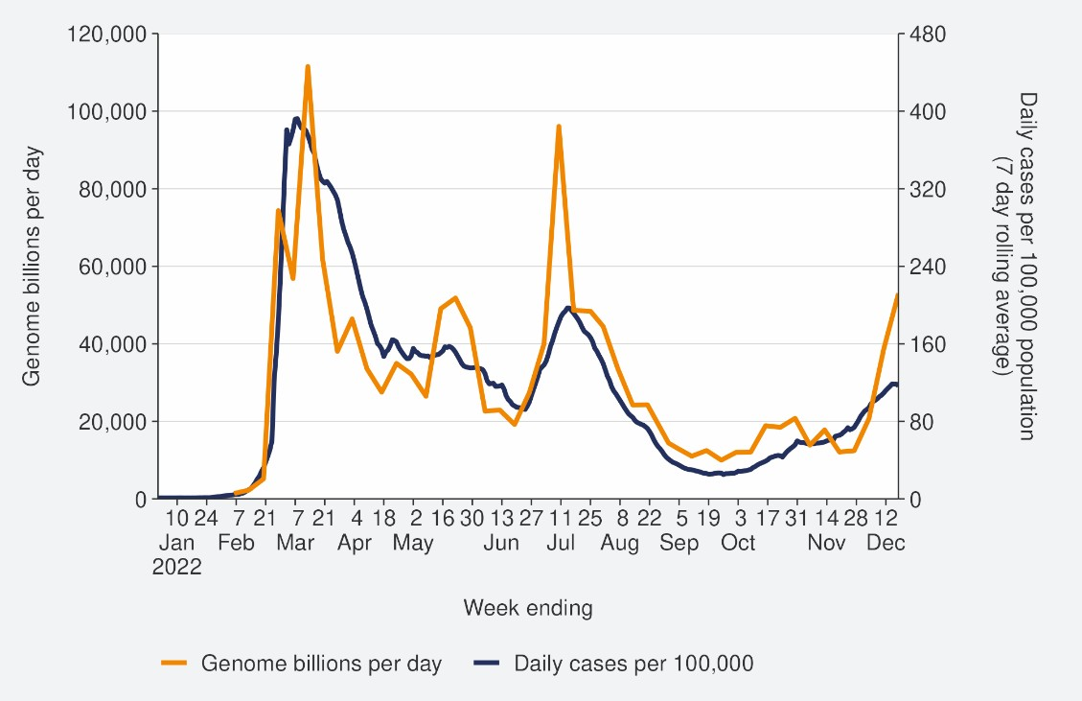
Sources: ESR SARS-CoV-2 in wastewater update for week ending 11 December 2022 and NCTS/EpiSurv as at 2359hrs 18 December 2022

Figure 2: COVID-19 Modelling Aotearoa scenarios5 compared with national reported case numbers
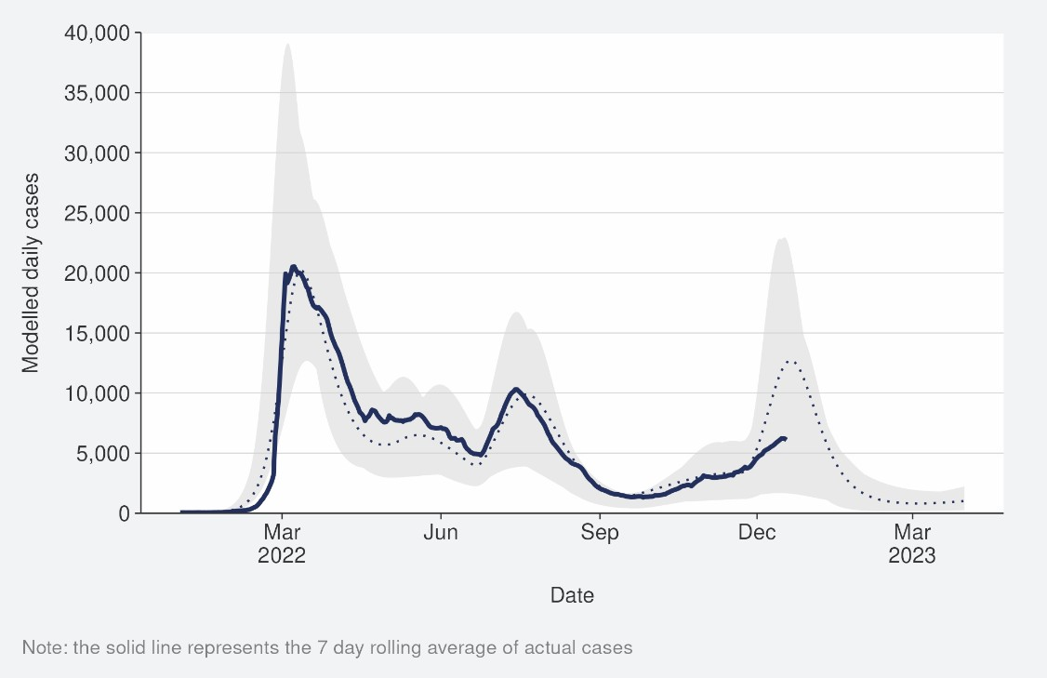
Sources: COVID-19 Modelling Aotearoa, ordinary differential equation model, October 2022, and NCTS/EpiSurv as at 2359hrs 18 December 2022

4 Wastewater levels cannot be used to predict numbers of cases but do indicate trends in the infection rates.
5 The ‘July’ BA.5 scenario assumes that previous infection provides greater protection against reinfection and severe disease, this is consistent with emerging international evidence. It also incorporates updated data and future projections of uptake of second boosters, and an earlier transition to BA.5, consistent with the timing of cases and hospitalisations in New Zealand.

Figure 3: Regional reported case rates from 01 January to 18 December 2022
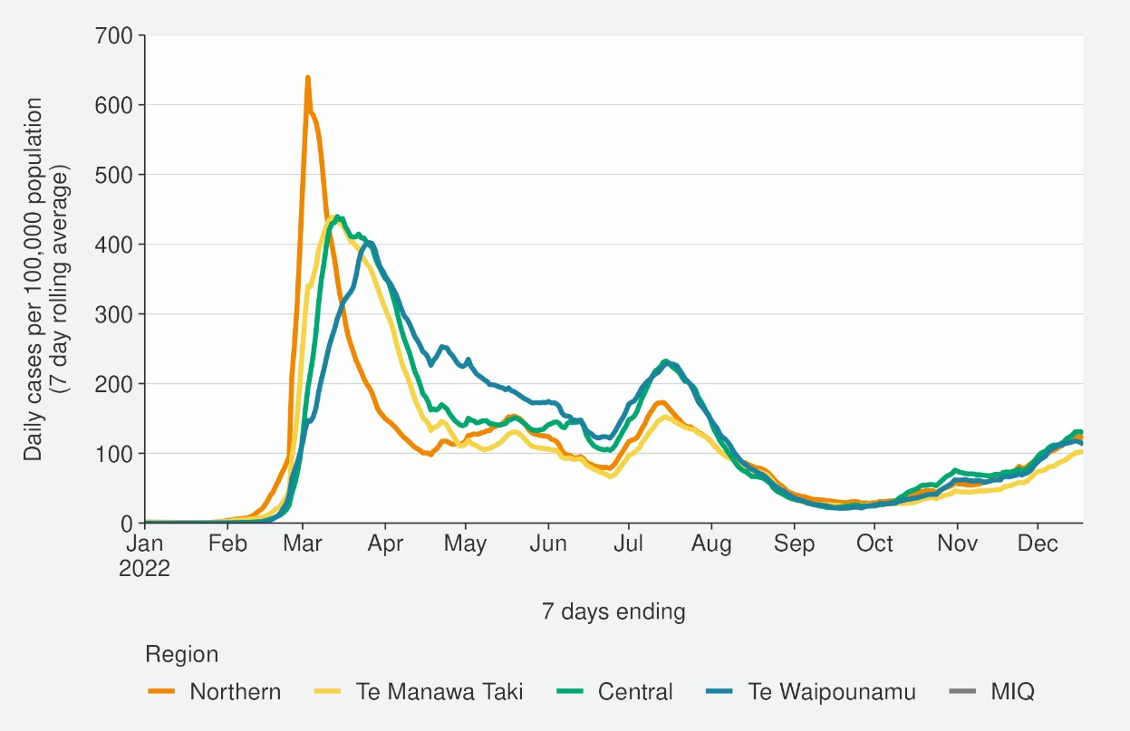
Source: NCTS/EpiSurv as at 2359hrs 18 December 2022

Figure 4: National reported case rates by age from 01 January to 18 December 2022
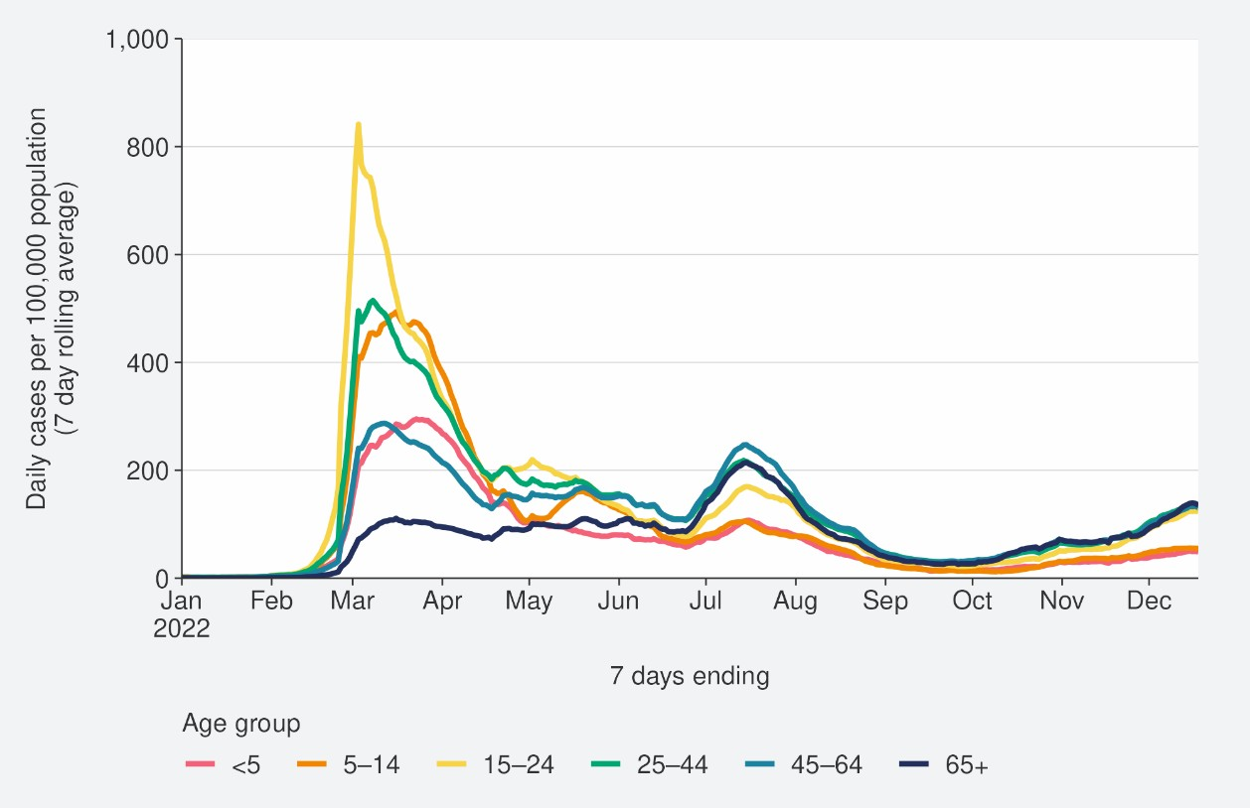
Source: NCTS/EpiSurv as at 2359hrs 18 December 2022

Hospitalisation and mortality trends

Hospitalisation
As seen in Figure 5, the national COVID-19 hospital admissions rate ‘for’ COVID-19 decreased substantially from mid-July but has increased since early October. In the week ending 11 December 6, the 7-day rolling average of hospital admissions was 2.1 per 100,000 population, an increase compared to the previous week (1.8 per 100,000). The rate was highest in the 65+ age group (7.5 per 100,000).
Modelling scenarios suggest current hospital admissions are tracking below the best fit of the model prediction and indicate admissions are expected to increase (see

Figure 6).

Figure 5: National7 hospital admissions rate for COVID-19, 01 January to 11 December 2022
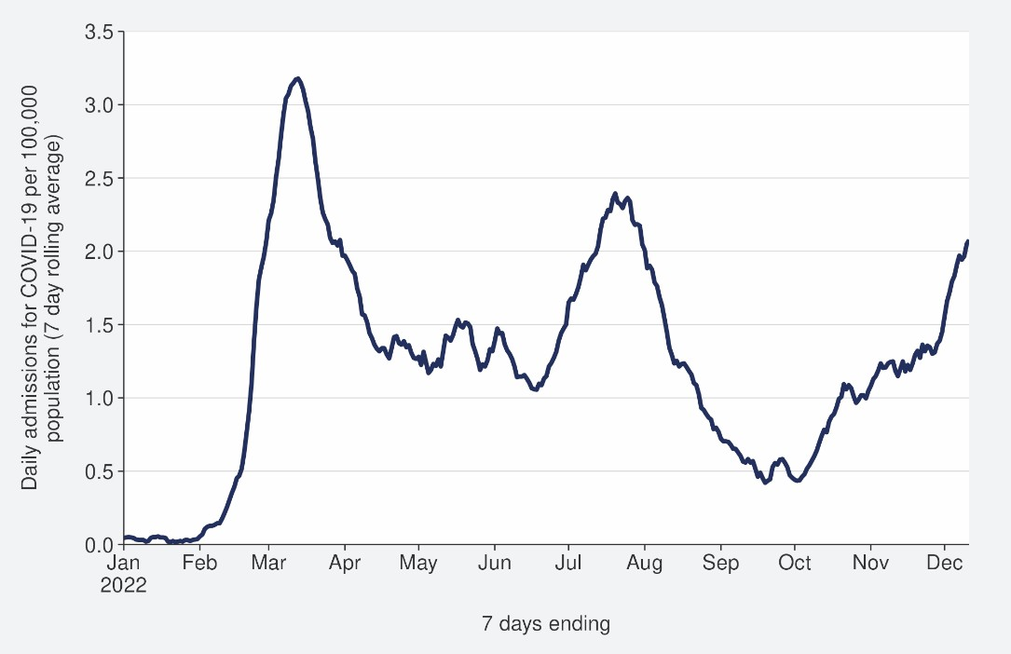
Source: NMDS/Inpatient’s admissions feed as of 19 December 2022 data up to 11 December 2022

6New hospital admissions who had COVID-19 at the time of admission or while in hospital; excluding hospitalisations that were admitted and discharged within 24hrs. The ‘for’ measure excludes those who are identified as incidental with COVID-19, such as injuries. Recent trends are subject to revision. Please see glossary for further caveats.
7 Data are from Districts with tertiary hospitals; these Districts are Auckland, Canterbury, Southern, Counties Manukau, Waikato, Capital & Coast, Waitemata, and Northland.

Figure 6: COVID-19 Modelling Aotearoa hospital admissions for COVID-19 scenario8 compared with national admissions
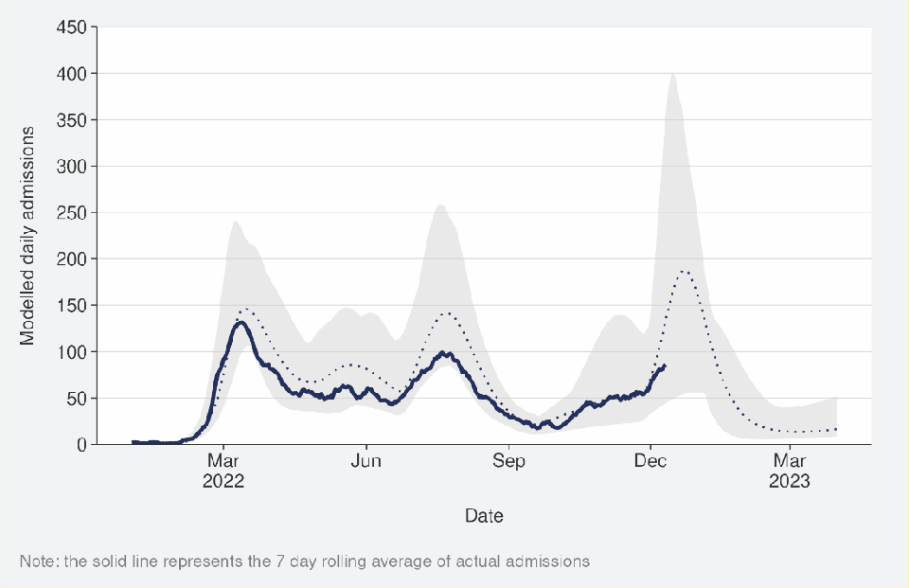
Sources: COVID-19 Modelling Aotearoa, ordinary differential equation model, October 2022, and Ministry of Health reported hospital admission data 11 December 2022

Mortality
From the first week of January to 18 December 2022, there were 3,463 deaths among people who died within 28 days of being reported as a case and/or with the cause being attributable to COVID-19 (that is, an underlying or contributory cause). Deaths peaked in the last week of July, and in the past month the trend has been relatively stable (see Figure 7)9.
Of the deaths that have been formally coded by cause of death, 1,403 (48%) were determined to have COVID-19 as the main underlying cause. COVID-19 contributed to a further 834 (28%) deaths and another 700 (24%) people died of an unrelated cause (Figure 7).
Deaths are currently tracking below the best fit of the modelled scenario but are predicted to increase in the next two months (see Figure 8).

8 The 'October’ scenario assumes previous infection provides greater protection against reinfection, severe disease, consistent with emerging international evidence, and transmissibility of an emerging variant is increased by 10%. It also incorporates updated data and future projections of uptake of second boosters, and an earlier transition to BA.5, consistent with the timing of cases and hospitalisations in New Zealand.
9 There were 56 deaths before the first week of 2022.

Figure 7: National weekly death counts by cause of death10, 01 January to 18 December 2022
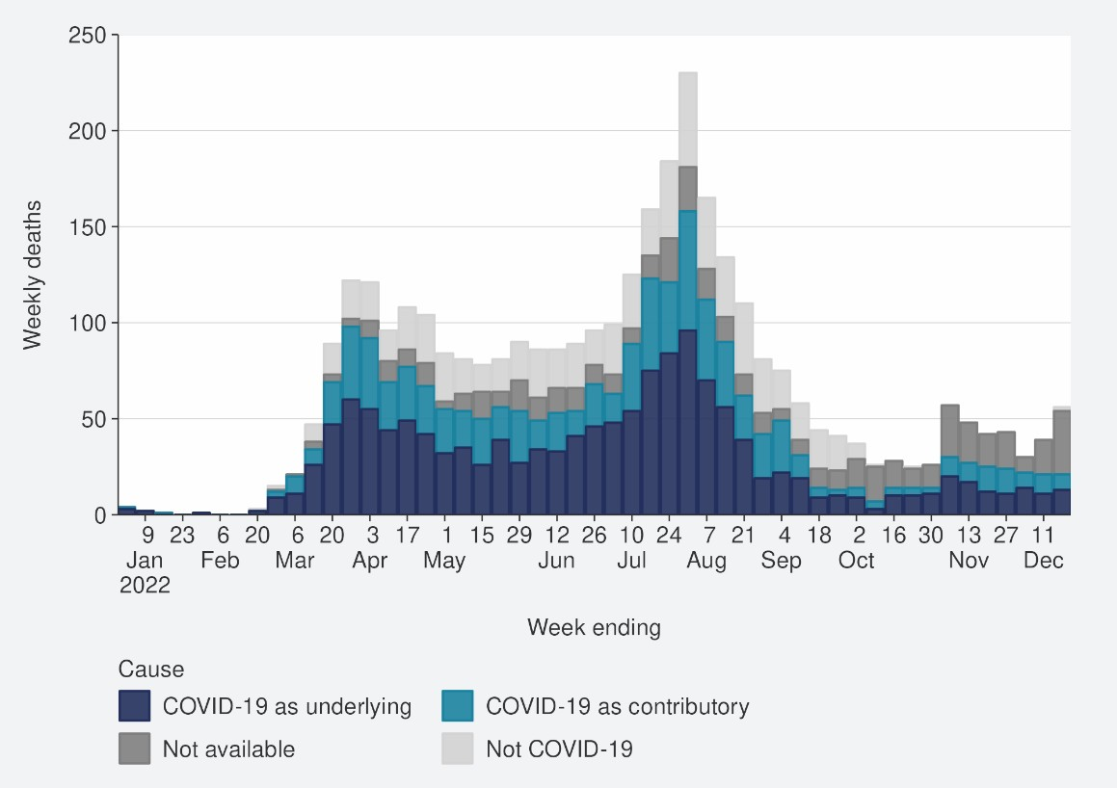
Source: Ministry of Health, 18 December 2022

Figure 8: COVID-19 Modelling Aotearoa death count compared with national observed deaths attributed to COVID-19
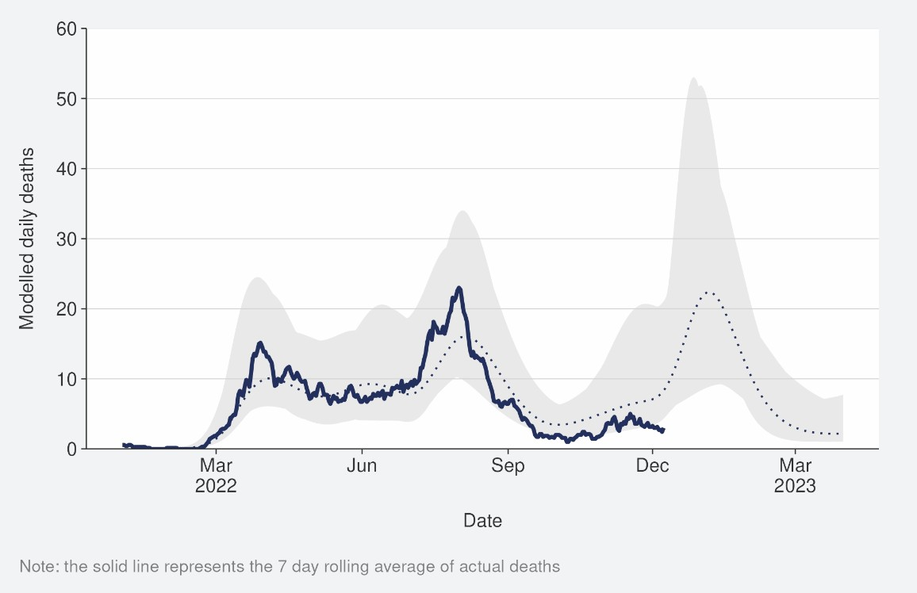
Sources: COVID-19 Modelling Aotearoa, ordinary differential equation model, October 2022, and Ministry of Health reported attributed deaths data 11 December 2022

10 Mortality data are affected by a delay due to time taken for reporting and death coding, the most recent weeks should be interpreted with caution.

Whole Genomic Sequencing

Wastewater and Community cases
Whole genomic sequencing data are updated on a fortnightly basis; the data have not been updated in this week’s report.
Wastewater variant analysis for the fortnight ending 11 December reports the following proportions: BA.2.75 58%, BA.4/5 19%, BQ.1.1 18%, XBC 3% and XBB 2%.
Figure 9 shows the proportions of variants in community cases, with BA.5 accounting for 33% of sequenced cases in the week to 09 December. Proportions of the BA.5 subvariant in the community have continued to decrease over the last few weeks, as the proportion of other variants increase: BA.2.75 (39%), BQ.1.1 (14%), and XBC (5%). 4% of PCR-positive hospital cases were identified with recombinant lineage XBC; a recombinant lineage of Delta and Omicron variants that has been present in Australia and South-East Asia for some time, with no indication of increased disease severity.
This lineage is not overrepresented among hospitalised cases in New Zealand at present.

Figure 9: Proportion of Variants of Concern in community cases11
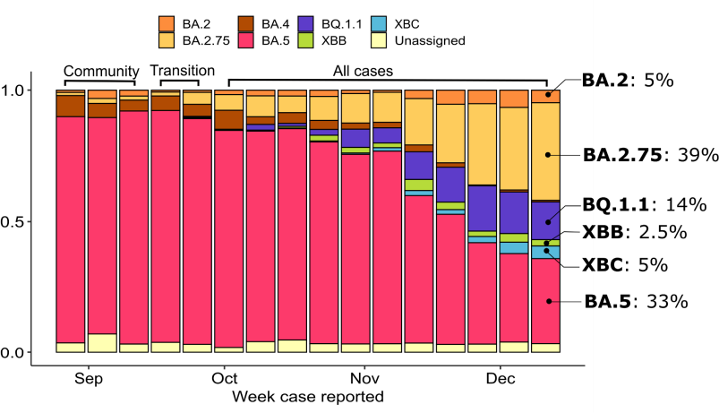
Source: ESR COVID-19 Genomics Insights Report #28, EpiSurv/Microreact 0900hrs 09 December 2022

11 Before the end of the COVID-19 Protection Framework, only data from community cases are presented. In the period marked as “transition”, cases known to be associated with the border were removed, but not all such cases can be reliably identified. Since the transition, data from all cases is used. Results before and after this transition are not directly comparable.

Hospitalised cases
Of samples collected from PCR positive hospital admissions for the fortnight ending 09 December 208/540 samples were successfully sequenced. As of 09 December; 38% were BA.5, 34% BA.2.75, 17% BQ.1.1, 3% BA.2, 4% XBC, 2%, XBB and 1% were BA.4.

Overall Variant Risk Status
In the second half of 2022, many new Omicron sub-variants have been reported. These variants demonstrate convergent evolution, a process whereby variants from different lineages accumulate similar mutations. Mutations in the spike protein appear to be responsible for the enhanced characteristics of these variants, compared to previous Omicron variants.

Although many of these new sub-variants demonstrate a transmission advantage over earlier sub-variants (which can come from increases in innate transmissibility or from immune evasion), there is currently no evidence of an increase in severity of disease caused by these variants.

Subvariants detected in cases in New Zealand such as BQ.1.1, BA.2.75 sub-lineages (including CH.1.1), XBB and XBC have demonstrated substantial immune evasion in laboratory testing compared to prior Omicron variants. Cases of these subvariants are likely to increase (as a proportion of cases) in the coming weeks. The current increase in incidence of SARS-CoV-2 infections is not driven by a single variant but is consists of a number of Omicron subvariants with increased immune evasion characteristics.

There is no strong evidence of an increase in disease severity associated with these variants.

Refer to the appendix for further details on the risk assessments for BA.2.75, BQ.1.1 and XBB, respectively.

Further information on variants of concern is also available on the Ministry of Health COVID-19 Science News Webpage.

Reinfection
‘Reinfection’ is now defined as a case reported at least 29 days after the last time a person reported a positive test for COVID-19. The definition of reinfection changed on 30 June; prior to this, reinfection was based on reports at least 90 days apart (based on the international literature at the time). Up until 30 June 2022, the vast majority of positive results detected within 90 days of the prior infection were not recorded in the system. Some potential reinfections within 90 days were recorded but were not representative of the general population.
In general, reinfection refers to a second or subsequent infection after the prior infection has cleared. In this analysis, we are not able to distinguish between reinfection with the same variant or different variants. Reinfection with a different variant to the first infection is more likely than reinfection with the same variant.
It is important to highlight that these data provide information on ‘redetections’ rather than true reinfections. True reinfections cannot be definitively captured in the data for a range of reasons. For example, a person with persistent infection due to being immunocompromised, who undergoes repeated testing due to regular hospital or
clinical visits, would appear in the data as a ‘reinfection’ when they may in reality have a chronic or persistent infection.
Figure 10 characterises the average number of cases per week by first infection and reinfection. Reinfections made up 29.7% of reported cases in the week ending 18 December, an increase from 27.7% compared with the week ending 11 December. The proportion of reported cases that were reinfections has increased in the past four weeks, after being stable at around 18% in the prior weeks. Figure 11 shows how many first infections and reinfections have been reported cumulatively over time.
Cumulatively, reinfections have made up 4.7% of total cases reported in 2022. The proportion of cases that are reinfections is expected to increase over time.

Figure 12 shows an age breakdown of reinfections by age group. Reinfections were highest in the 20–29-year-olds and similar in 10–19-year-olds. The lowest reinfections are in 80–89-year-olds.
The true number of reinfections is likely higher than reported here. In general, reporting of cases is expected to decline over time. Due to under-ascertainment of the first infection and subsequent infections and, as both are required to detect a reinfection, there is likely to be under-reporting of reinfections.

Figure 10: Reinfections 7 day rolling average from 01 January to 18 December

2022
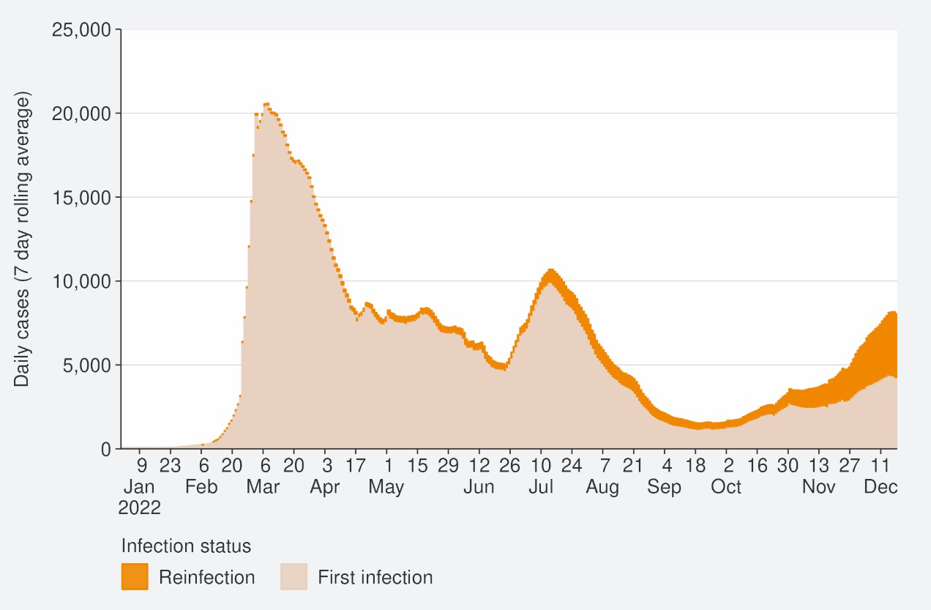
Source: NCTS/EpiSurv as at 2359hrs 18 December 2022

Figure 11: Reinfections cumulatively from 01 January to 18 December 2022
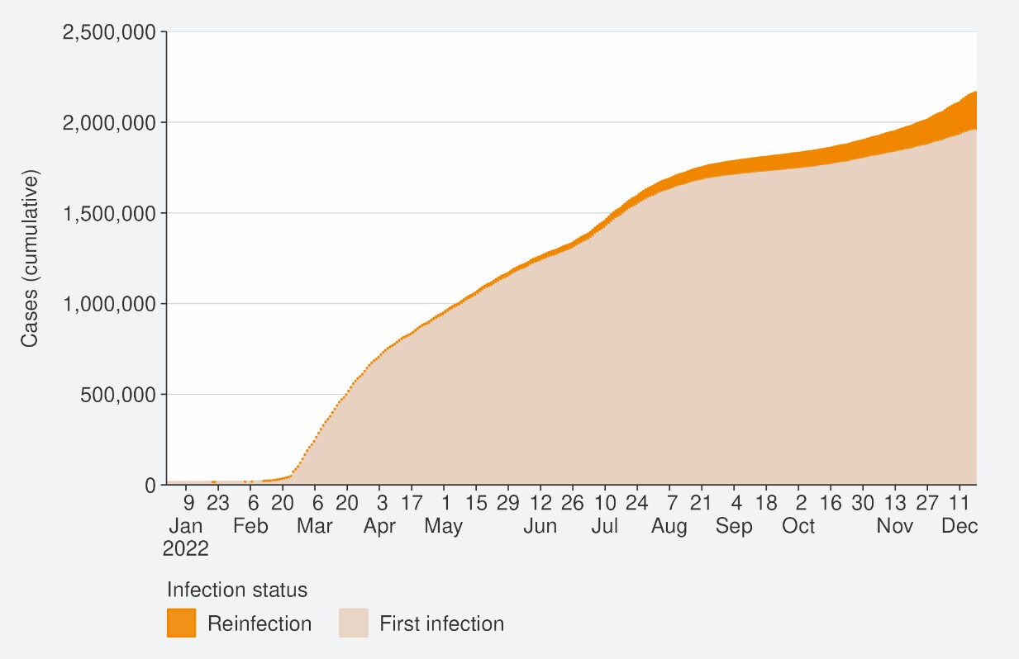
Source: NCTS/EpiSurv as at 2359hrs 18 December 2022

Figure 12: Reinfections by age group 01 January to 18 December 2022
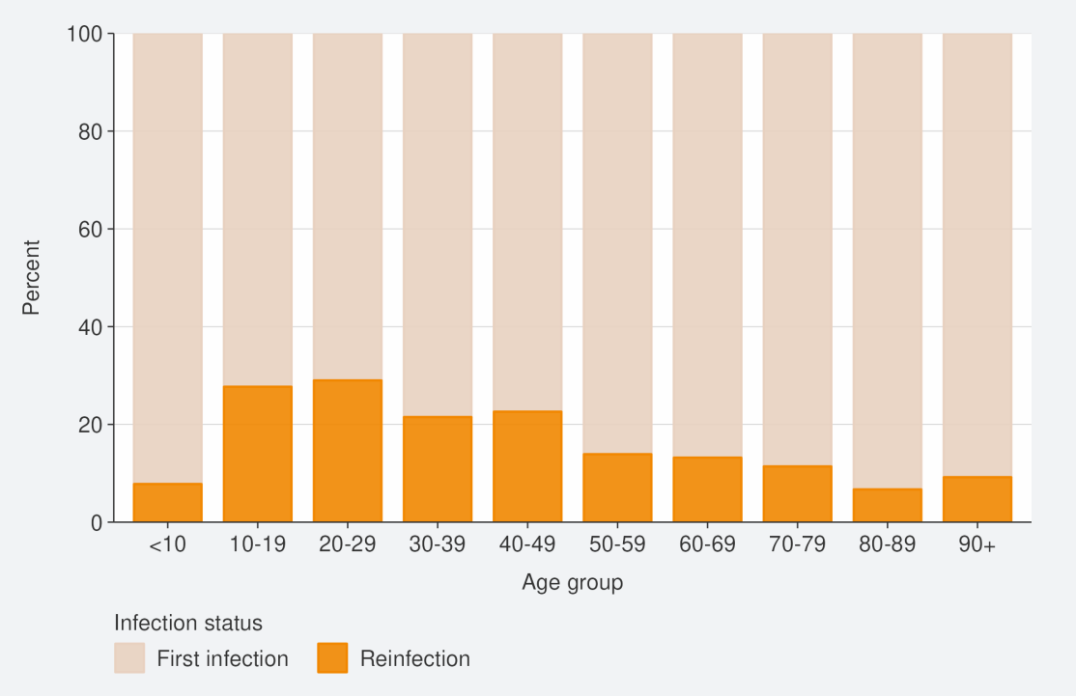
Source: NCTS/EpiSurv as at 2359hrs 18 December 2022

Comparison of epidemic trends by ethnicity
For the week ending 18 December, age-standardised reported case rates increased for Māori, European or Other and Asian (by 12.0%, 6.2% and 4.6%, respectively), whilst remained stable for Pacific peoples compared with the previous week (see Figure 13). The highest reported case rates were in Pacific peoples (115.5 per 100,000); followed by European or Other and Māori (113.9 and 106.9 per 100,000, respectively); Asian had the lowest rate (98.9 per 100,000). Refer to the appendix for non-age-standardised rates by ethnicity.
Overall, those in the 65+ age group (135.6 per 100,000) had the highest reported case for the week ending 18 December. This trend has been driven by reported cases in European or Other, with the highest cases rate being those in the 65+ age group (140,1 per 100,000). High rates in 65+ were also observed in Pacific peoples, Māori and Asian ethnicity; however, their highest rates were in the 25-44 age groups (154.6, 139.3 and 123.1 per 100,000, respectively).
Figure 14 shows that the age-standardised hospitalisation rates for COVID-19 increased for all ethnicities, apart from Asian in the week ending 11 December as compared with the week prior. Pacific peoples had the highest age-standardised hospitalisation rate (2.6 per 100,000) for the week ending 11 December; followed by Māori (2.2 per 100,000); Asian and European and Other had similar rates (1.3 and 1.4 per 100,000, respectively). For all ethnicities, those aged 80+ had the highest hospitalisation rates. Pacific peoples aged 80+ had the highest hospitalisation rate (23.4 per 100,000); followed by European or Other (16.6 per 100,000); Asian and Māori had the lowest hospitalisation rate for those aged 80+ (13.1 and 12.1 per 100,000, respectively).
The cumulative total for the year shows that overall, Pacific peoples and Māori have had the highest risks of hospitalisation for COVID-19, 2.3 and 1.8 times the risk of European or Other, respectively for 01 January to 18 December. Asian people have had a hospitalisation rate almost 10% lower than European or Other (see Figure 15).
The cumulative age-standardised mortality rate for 01 January to 18 December shows that Pacific peoples have had the highest risk, 2.2 times that of European or Other, followed by Māori at 1.7 times that of European or Other. Asian people have had the lowest risk of Mortality, 40% lower than European or Other (see Figure 16).12
The lower reported case rates, but higher hospitalisation and death rates for Māori and Pacific peoples, suggests they may have lower levels of case ascertainment and/or a higher risk of poor outcomes after infection compared with Asian and European or Other ethnicities.

12 These calculations are based on 2,237 deaths occurring between January 2022 and 18 December 2022

Figure 13: National age-standardised reported case rates by ethnicity from 01 January to 18 December 2022
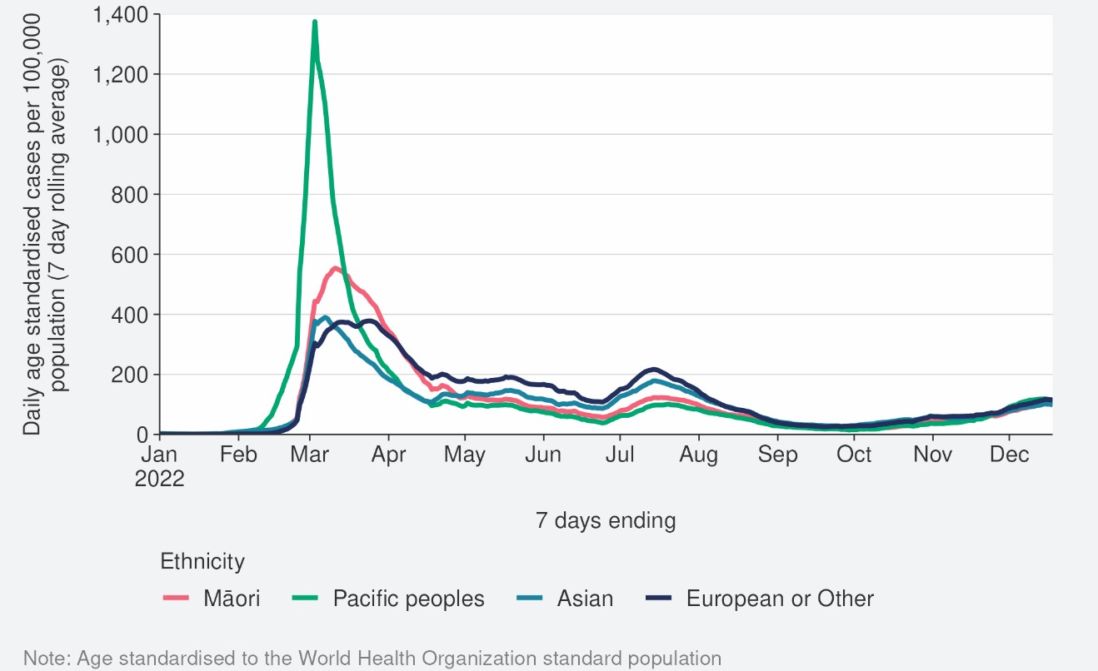
Source: NCTS/EpiSurv as at 2359hrs 18 December 2022

Figure 14: National age-standardised hospitalisation rates by ethnicity from 01 January to 11 December 2022
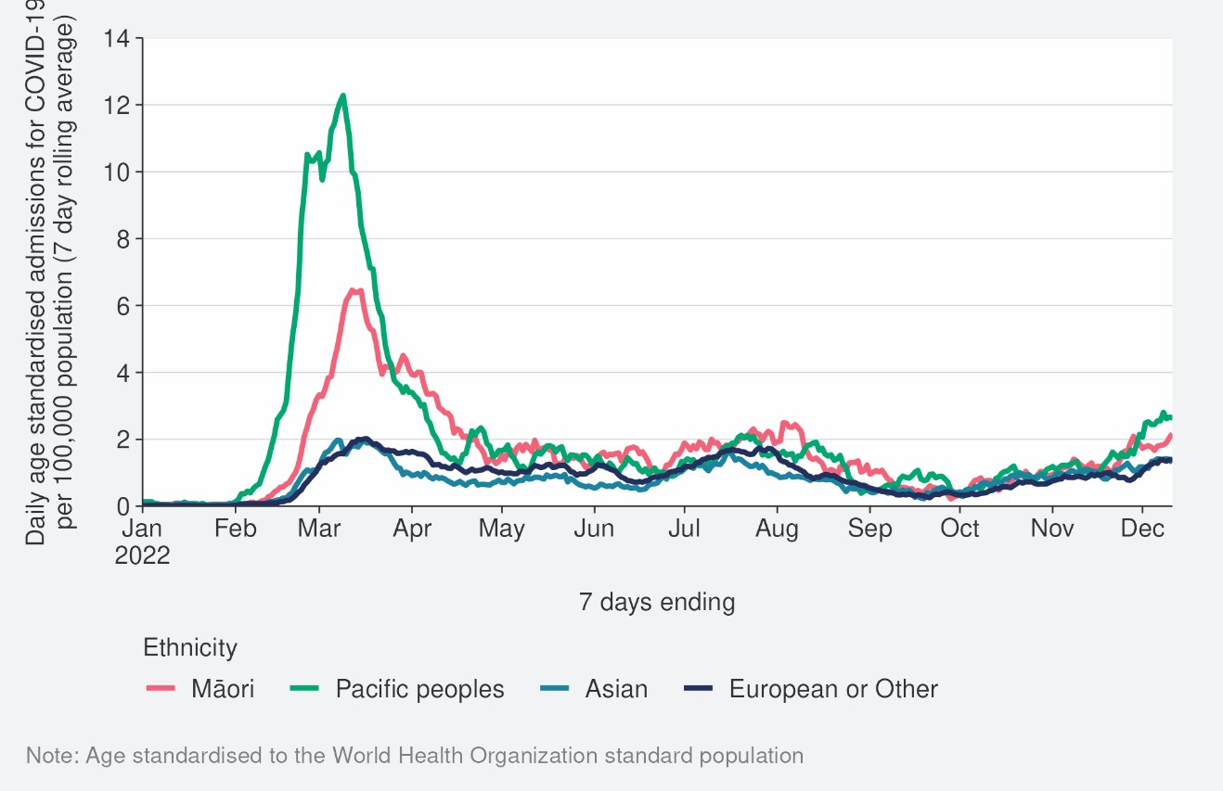
Source: NCTS/EpiSurv as at 2359hrs 11 December 2022

Figure 15: Age-standardised cumulative incidence (and 95% confidence intervals) of hospitalisation for COVID-19 by ethnicity, 01 January 2022 to 18 December 2022
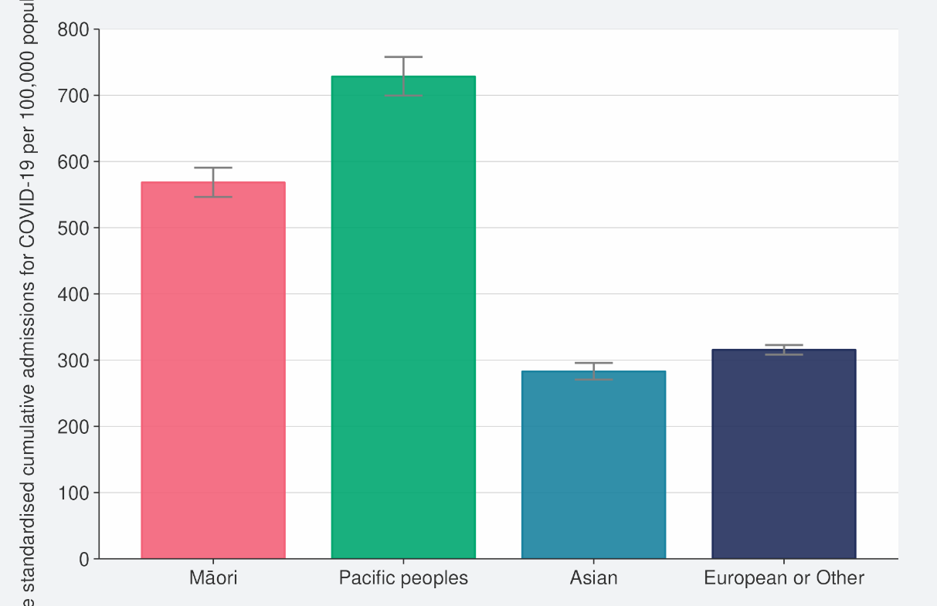
Source: NCTS/EpiSurv, NMDS, Inpatient Admissions dataset and CVIP population estimates, 01 January 2022 to 18 December 2022

Figure 16: Age-standardised cumulative incidence (and 95% confidence intervals) of mortality attributed to COVID-19 by ethnicity, 01 January 2022 to 18 December 2022
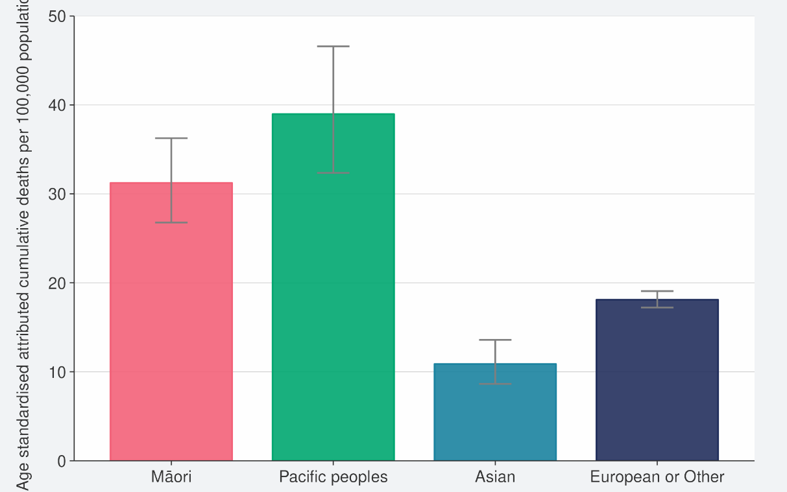
Source: NCTS/EpiSurv, NMDS, Inpatient Admissions dataset and CVIP population estimates, 01 January 2022 to 18 December 2022

Comparison of epidemic trends by deprivation
Figure 17 shows the 7-day rolling average for reported case rates by residential area deprivation level (based on NZDep2018)13. Age-standardised case rates increased for all deprivation levels in the week ending 18 December. Refer to the appendix for non- age-standardised rates by deprivation.
Figure 18 shows that those most deprived have had, and continue to have, the highest rates of hospitalisation, both recently and cumulatively during 2022.
Those most deprived have had around 1.9 times the risk of hospitalisation compared with those who are least deprived (see Figure 19)
Cumulative rates of mortality are also highest for those most deprived; 2.0 times higher than the risk of those least deprived (see Figure 20)14.
As lower case rates have been reported among those most deprived, continued higher hospitalisation and death rates suggest those who are most deprived may have lower levels of case ascertainment and/or a higher risk of poor outcomes after infection compared with those who are least deprived.

13 Atkinson J, Salmond C, Crampton P (2019). NZDep2018 Index of Deprivation, Final Research Report, December 2020. Wellington: University of Otago.
14 These calculations are based on 2,237 deaths occurring between January 2022 and 18 December 2022.

Figure 17: National age-standardised reported case rates by deprivation status for weeks 01 January to 18 December 2022
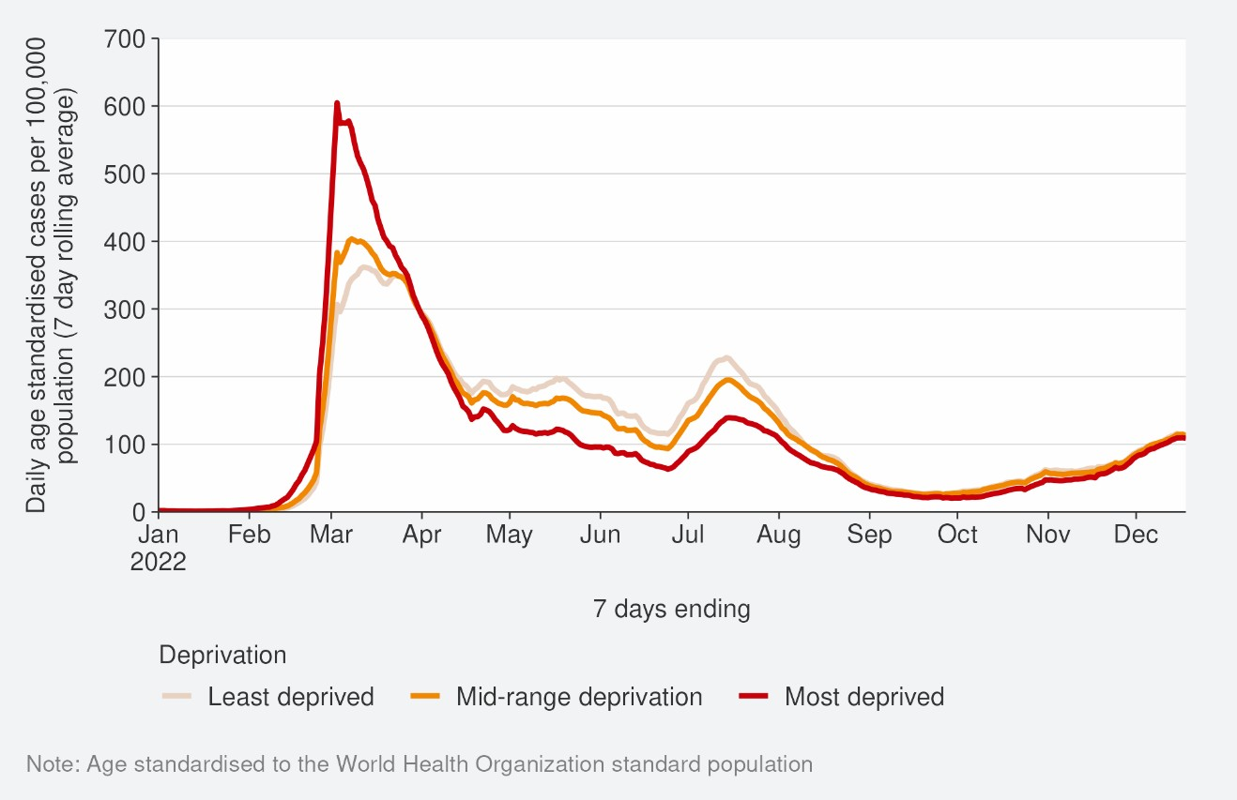
Source: NCTS/EpiSurv as at 2359hrs 18 December 2022

Figure 18: Age-standardised hospital admission rates for COVID-19 by deprivation from 01 January to 11 December 2022
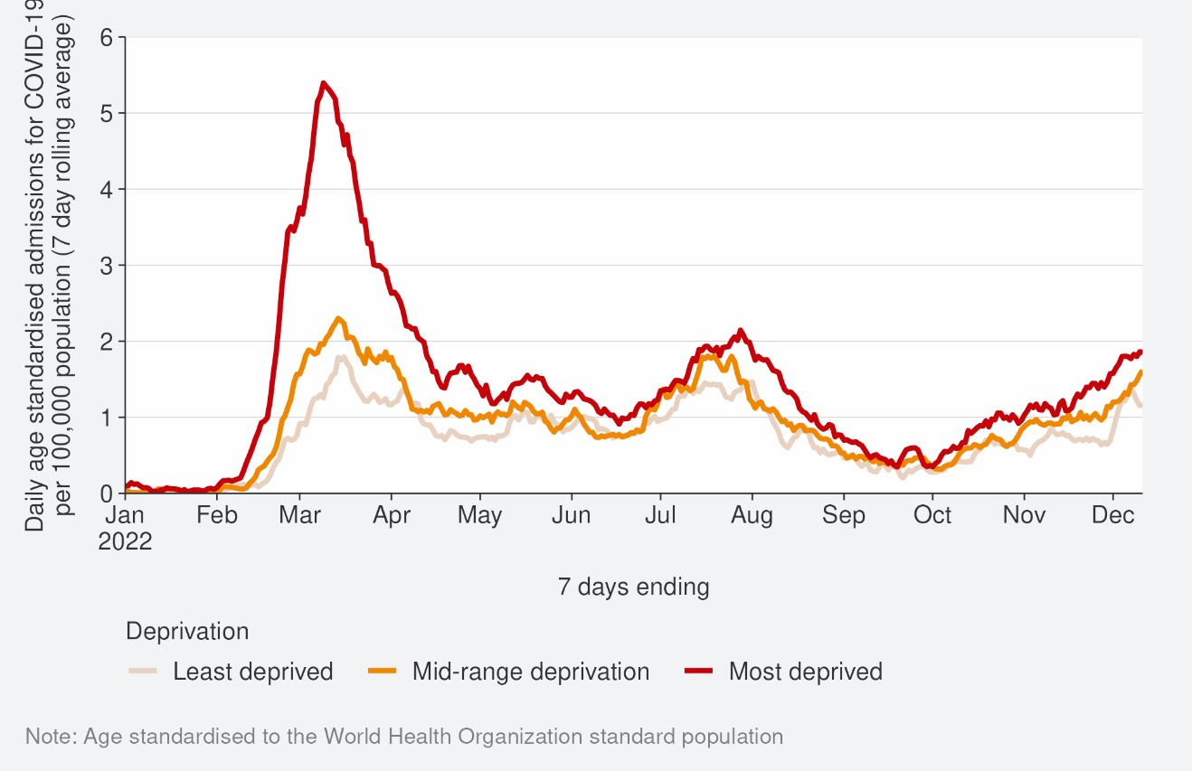
Source: NMDS/Inpatients admissions feed as of 19 December 2022 data up to 11 December 2022

Figure 19: Age-standardised cumulative incidence (and 95% confidence intervals) of hospitalisation for COVID-19 by deprivation, 01 January 2022 to 18 December 2022
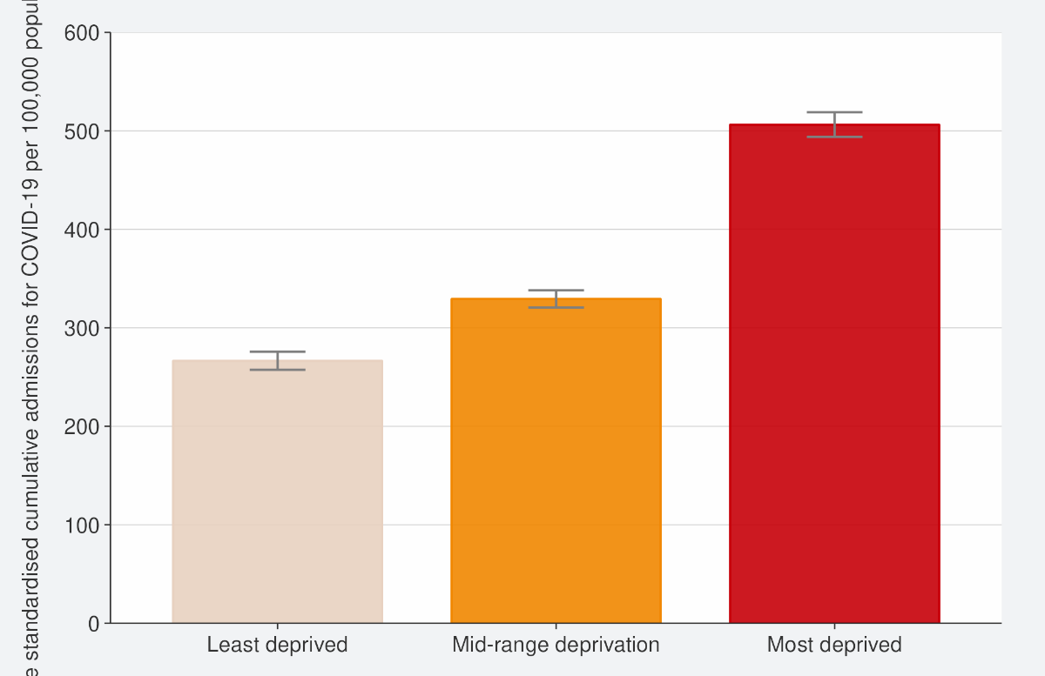
Source: NCTS/EpiSurv, NMDS, Inpatient Admissions dataset and CVIP population estimates 01 January 2022 to 18 December 2022

Figure 20: Age-standardised cumulative incidence (and 95% confidence intervals) of mortality attributed to COVID-19 by deprivation, 01 January 2022 to 18 December 2022
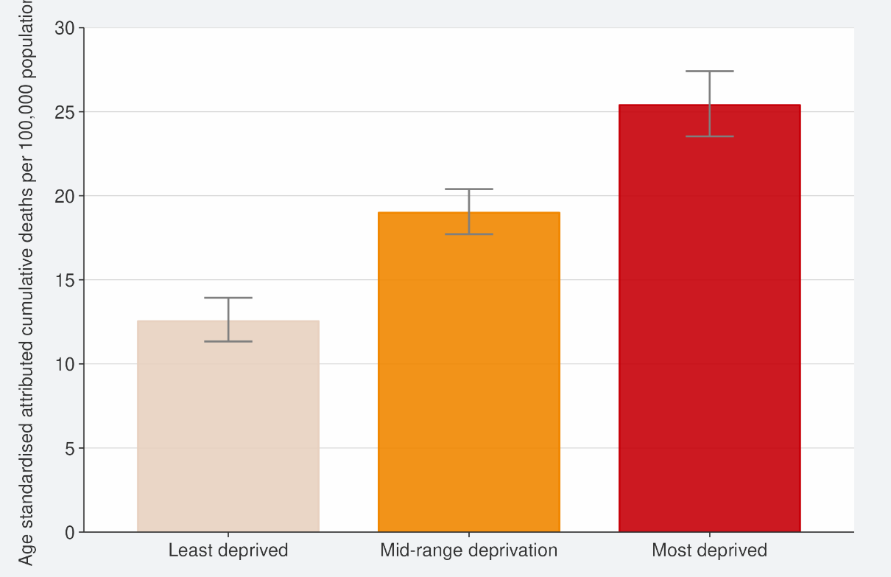
Source: EpiSurv, Death Documents, The Healthcare User database, Mortality Collections database and CVIP population estimates, 01 January 2020 to 18 December 2022

Global pandemic summary
Please note, global trends in cases, hospitalisations and deaths should be interpreted with caution as several countries have been progressively changing COVID-19 testing strategies, resulting in lower overall numbers of tests performed and consequently lower numbers of cases detected. Furthermore, approaches of counting hospitalisations and deaths can differ from country to country.
Over the next few months, we expect the global situation for the COVID-19 pandemic to be driven by the ongoing emergence of new variants, waning immunity, and particularly the Northern Hemisphere heading into winter.
- Globally, in the week ending 18 December, the number of new weekly cases was similar (+3%) to the previous week, with over 3.7 million new cases reported. However, the true number of incident cases is likely to be underestimated due to a decline in testing internationally.
- The number of new weekly deaths increased by 6% as compared with the previous week, with over 10,400 new fatalities reported.
- As of 18 December 2022, over 649 million confirmed cases and over 6.6 million deaths have been reported globally.
- From 19 November to 19 December 2022, the Omicron variant of concern accounted for 99.7% of sequences reported globally.
- BA.5 and its descendent lineages continued to be dominant globally, accounting for 68.4% of sequences submitted to GISAID15 in the week ending 04 December 2022; however, prevalence has been decreasing. Prevalence of BA.2 and its descendent lineages is rising, mainly due to BA.2.7516. Together BA.2 and BA.2.75 account for 12.6% of sequences submitted. BA.4 and its descendent lineages are declining with a prevalence of 1.2% during the same reporting period.
- At the country level, the highest numbers of new weekly cases were reported from Japan (1,046,650 new cases; +23%), the Republic of Korea (459,811 new cases;
+9%), the United States of America (445,424 new cases; -3%), France (341,136 new
cases; -20%), and Brazil (337,810 new cases; +74%).
- In Australia, in the 14 days to 16 December, there were 795 new cases per 100,000 population. This is similar (+4%) to the week prior (14 days to 09 December 2022) where there were 764 per 100,000 population. As of 16 December 2022, there were 3,323 current cases in hospital, an increase 10.8% from when last reported (on 09 December).
- In China, there were 5 confirmed deaths reported in the week to 19 December 2022; in the previous week there were no deaths. Multiple regions (Zhejiang province,

15 Global Initiative on Sharing Avian Influenza Data: The GISAID Initiative promotes the rapid sharing of data from all influenza viruses and the coronavirus causing COVID-19.
16 includes descendent lineages

Chongqing and Wuhu City) have allowed employees testing positive for COVID-19 to be at workplaces.
Sources: Weekly epidemiological update on COVID-19 - 21 December 2022 (who.int)/ Coronavirus (COVID-19) common operating picture – 16 December 2022 (health.gov.au)

Appendix: Table of summary statistics

Table 1: Reported 7-day rolling average of case rates and hospital admissions by region, age group, ethnicity, and deprivation

 | Reported Cases (7-day rolling average) |  |  |  |  | Hospital admissions (7-day rolling average)
 | Week ending 11/12/2022 |  | Week ending 18/12/2022 |  | %  Change | Week ending 04/12/2022 |  | Week ending 11/12/2022 |  | %  Change
 | Number | Rate (per 100,000  population) | Number | Rate (per 100,000  population) |  | Number | Rate (per 100,000  population) | Number | Rate (per 100,000  population)
National | 5,722.0 | 109.3 | 6,098.6 | 116.5 | 6.6% | 74.3 | 1.8 | 86.0 | 2.1 | 15.8%
Region
Northern | 2,265.7 | 113.5 | 2,416.4 | 121.0 | 6.7% | 43.7 | 2.2 | 48.3 | 2.4 | 10.5%
Te Manawa Taki | 918.1 | 89.8 | 1,053.3 | 103.0 | 14.7% | 8.0 | 1.8 | 8.9 | 2.0 | 10.7%
Central | 1,149.9 | 117.6 | 1,261.7 | 129.0 | 9.7% | 4.0 | 0.8 | 6.6 | 1.4 | 64.3%
Te Waipounamu | 1,382.7 | 114.5 | 1,360.1 | 112.6 | -1.6% | 18.6 | 1.5 | 22.3 | 1.8 | 20.0%
Age group
<5 | 143.4 | 46.1 | 151.9 | 48.9 | 5.9% | 6.3 | 2.6 | 7.7 | 3.2 | 22.7%
5-14 | 372.7 | 54.9 | 373.3 | 55.0 | 0.2% | 1.9 | 0.3 | 1.3 | 0.2 | -30.8%
15-24 | 737.7 | 112.8 | 806.3 | 123.3 | 9.3% | 4.1 | 0.8 | 4.1 | 0.8 | 0.0%
25-44 | 1,859.7 | 126.5 | 1,951.7 | 132.7 | 4.9% | 11.0 | 0.9 | 10.1 | 0.8 | -7.8%

45-64 | 1,583.6 | 122.8 | 1,689.0 | 131.0 | 6.7% | 14.0 | 1.4 | 15.3 | 1.5 | 9.2%
65+ | 1,024.9 | 123.4 | 1,126.4 | 135.6 | 9.9% | 37.0 | 5.9 | 47.4 | 7.5 | 28.2%
Ethnicity
Māori | 737.9 | 92.0 | 826.9 | 103.1 | 12.1% | 8.4 | 1.6 | 10.4 | 2.0 | 23.7%
Pacific peoples | 454.6 | 116.3 | 454.0 | 116.1 | -0.1% | 8.1 | 2.3 | 8.9 | 2.5 | 8.8%
Asian | 828.7 | 99.4 | 869.1 | 104.2 | 4.9% | 10.0 | 1.3 | 9.6 | 1.3 | -4.3%
European or Other17 | 3,668.9 | 115.8 | 3,913.3 | 123.5 | 6.7% | 47.3 | 1.9 | 56.6 | 2.3 | 19.6%
Deprivation
Least deprived | 1,734.3 | 114.6 | 1,811.0 | 119.6 | 4.4% | 20.0 | 1.6 | 20.3 | 1.6 | 1.4%
Mid-range deprivation | 2,249.9 | 112.2 | 2,411.0 | 120.2 | 7.2% | 27.4 | 1.7 | 37.0 | 2.3 | 34.9%
Most deprived | 1,641.1 | 104.6 | 1,775.3 | 113.2 | 8.2% | 25.0 | 2.2 | 26.4 | 2.3 | 5.7%

17 ‘Other’ referring to all ethnicities other than Māori, Pacific peoples, Asian and European, specifically MELAA; Middle Eastern, Latin American and African. See Table 2 for breakdowns of MELAA ethnicities.

Table 2: Cumulative reported cases and hospitalisations admissions from 01 January 2022 to 11 December by level 2 ethnicity.

Ethnicity | Level 2 Ethnicity | Cumulative reported cases of COVID-19 | Cases per 1,000  population | Cumulative hospitalisation for COVID-19 | Hospitalisations per 1,000 population | Population
Asian | Asian NFD | 9,930 | 445 | 34 | 2 | 22,320
Asian | Chinese | 70,485 | 300 | 597 | 3 | 235,331
Asian | Indian | 106,616 | 435 | 911 | 4 | 245,079
Asian | Other Asian | 52,231 | 429 | 368 | 3 | 121,732
Asian | Southeast Asian | 60,025 | 551 | 309 | 3 | 108,939
Māori | Māori | 299,075 | 392 | 3,645 | 5 | 762,780
MELAA | African | 10,830 | 411 | 130 | 5 | 26,364
MELAA | Latin American / Hispanic | 14,931 | 515 | 87 | 3 | 28,998
MELAA | Middle Eastern | 10,740 | 332 | 189 | 6 | 32,395
Pacific Peoples | Cook Island  Māori | 21,131 | 396 | 321 | 6 | 53,299
Pacific Peoples | Fijian | 19,453 | 475 | 227 | 6 | 40,956
Pacific Peoples | Niuean | 8,653 | 444 | 138 | 7 | 19,477
Pacific Peoples | Other Pacific Island | 7,481 | 517 | 84 | 6 | 14,466
Pacific Peoples | Pacific Island NFD | 1,765 | 482 | 7 | 2 | 3,663
Pacific Peoples | Samoan | 74,220 | 479 | 1,208 | 8 | 154,997
Pacific Peoples | Tokelauan | 3,112 | 453 | 48 | 7 | 6,863
Pacific Peoples | Tongan | 32,236 | 443 | 579 | 8 | 72,703

Public Health Risk assessment for BA.2.75 (Centaurus), BQ.1.1 (Cerberus) and XBB (Gryphon)
The ‘Overall risk assessment’ is presented in comparison to the prior or current predominant variant, in this case BA.5. ‘Increased risk’ indicates the assessed variant as worse than the previous predominant variant with regards to that characteristic; ‘no change’ means that the assessed variant poses equivalent risk; and ‘decreased risk’ means that the assessed variant is better than the previous predominant variant.

‘Confidence level’ indicates the overall quality of data that are available to make the risk assessment: ‘High’ (high quality, robust data); ‘Moderate’ (good data with limitations); ‘Low’ (very little data available). ‘Insufficient data’ indicates that there are no data of reasonable quality on which to base an assessment at this time.

Table 3: Public Health Risk assessment for BA.2.75 (Centaurus), 15 December 2022
BA.2.75 has 8 key mutations from BA.2: 147E, 152R, 157L, 210V, 257S, 339H, 446S, 460K.
 | Overall risk assessment* | Confidence level ** | Assessment and rationale
Overall growth advantage | Increased Risk | Moderate | Evidence of a growth advantage compared to BA.5. Prevalence in New Zealand is increasing gradually. There is evidence that BA.2.75 has a growth advantage against BA.4/5 in some countries (India, Austria, Singapore). BA.2.75 and sub-lineages (excluding BN.1) have an estimated growth advantage of 22.5% per week (95% Credible Interval: 19.1 to 26.0%) compared to BA.5.2 in the UK (at 9 November 2022).  In the week ending 09 December 2022, BA.2.75 (and associated sublineages) made up 39% of all sequenced  cases and is now the predominant variant. In the fortnight ending 09 December 2022 it made up 34% of sequenced isolates from hospital cases.
Transmissibility | Insufficient  data | Insufficient  data | There are no direct data on intrinsic transmissibility and there is no current ability to measure this directly from  surveillance data.

Immune evasion | No change in risk | Low | No evidence of increased immune evasion.  Mutations suggest that BA.2.75 may have immune evasion potential. However, there is very limited data to evaluate immune evasion against vaccination, prior infection with BA.5, or a combination of the two (hybrid immunity). There are no estimates of vaccine effectiveness against BA.2.75.  Laboratory data: Neutralisation studies found that BA.2.75 was similar or slightly less able to neutralise antibodies produced after vaccination and BA.2 infection, compared to BA.4 or BA.5. Potentially higher receptor binding compared to other Omicron lineages. There are no data on the ability of antibodies produced after BA.5  infection to neutralise BA.2.75.
Severity | Insufficient data | Insufficient data | No evidence of a change in severity compared to BA.5  Few formal evaluations of BA.2.75 severity are available. An early assessment of the severity of BA.2 sub-lineages in India indicates that BA.2.74, BA.2.75, and BA.2.76 are causing ‘mild’ disease with no evidence of an increased risk of hospital admission or severe disease. Lab and animal studies suggest mixed results for binding compared to BA.5, but overall pathogenicity similar to BA.5. Some in vitro evidence to suggest an increases in cell-cell  fusion and ability to infect lower airways compared to BA.2 which could alter pathogenicity.
Therapeutics | Insufficient  data | Insufficient  data
Testing | Insufficient  data | Insufficient  data
Overall  Assessment | There is an increase in overall risk from the previous predominant variant, BA.5. (Moderate confidence)  BA.2.75 and associated sublineages are increasing in frequency in New Zealand and appear to be more transmissible and immune evasive.

Source: SARS-CoV-2 Variants of Concern Update – Manatū Hauora, Ministry of Health

Table 4: Public Health Risk assessment for BQ.1.1 (Cerberus), 15 December 2022
BQ.1.1 is related to BA.5.3 but with Spike protein mutations 444T, 460K, 346T

 | Overall risk assessment* | Confidence level ** | Assessment and rationale
Overall growth advantage | Increased risk | Moderate | Evidence of a growth advantage compared to BA.5.  BQ.1.1 variant has an estimated growth advantage of 48.5% per week (95% Credible Interval: 43.3 to 54.1%) compared to BA.5.2 in the UK (at 9 November 2022).  Currently present in New Zealand.  In the week ending 09 December 2022, BQ.1.1 made up 14% of all sequenced cases. In the fortnight ending 09 December 2022 it made up 17% of sequenced isolates from hospital cases.
Transmissibility | Insufficient data | Insufficient data | No direct data on intrinsic transmissibility and there is no current ability to measure from surveillance data. There is some laboratory evidence that ACE2 binding is increased for BQ.1.1 compared to prior Omicron variants  which may affect transmissibility/infectivity.
Immune evasion | Increased risk | Moderate | Evidence of increased immune evasion.  More resistant to neutralisation from sera of vaccinated and infected individuals. (35, 73) At least 2 small studies  show that mRNA bivalent BA.4/5 vaccine produces robust neutralising activity against BQ.1.1 compared to monovalent wild type vaccine.
Severity | Insufficient data | Insufficient data | No evidence of a change in severity compared to BA.5  Evidence from a surge of cases of this variant in France suggests it is not causing increased rates of hospitalisations and deaths.
Therapeutics | Increased  risk | Low | In vitro studies showed loss of efficacy of all currently approved clinical monoclonal antibody therapies including Evusheld and Bebtelovimab.

Testing | Insufficient  data | Insufficient  data | Evidence that suggests a clinically relevant decrease in the performance of RATs for detection of the Omicron  variant (varies by device), but it is uncertain how this will affect sensitivity specifically for BQ.1.1
Overall  Assessment | There is an increase in overall risk from the previous predominant variant, BA.5 (Moderate confidence)  BQ.1.1 is increasing in frequency overseas and appears to be more transmissible and immune evasive.

Source: SARS-CoV-2 Variants of Concern Update – Manatū Hauora, Ministry of Health

Table 5: Public Health Risk assessment for XBB (Gryphon), 15 December 2022

XBB is a recombinant virus (related to BA.2 and BJ.1) with additional spike protein mutations 364T, 445P, 446S and 490V

 | Overall risk assessment* | Confidence level ** | Assessment and rationale
Overall growth advantage | Increased risk | Low | Evidence of a growth advantage compared to BA.5  XBB has an estimated growth advantage of 56.9% per week (95% Credible Interval: 46.9 to 67.2%) compared to BA.5.2 in the UK (at 9 November 2022).  XBB is currently present in New Zealand and is continuing to fluctuate between 1-4% of sequenced cases. In  the week ending 09 December 2022, it made up 2.5% of all sequenced cases and 2% of isolates from hospital cases.
Transmissibility | Insufficient data | Insufficient data | No direct data on intrinsic transmissibility and there is no current ability to measure from surveillance data.  There is some laboratory evidence that ACE2 binding is increased for XBB compared to prior Omicron variants which may affect transmissibility/infectivity.
Immune  evasion | Increased  risk | Moderate | Evidence of increased immune evasion.  More resistant to neutralisation from sera of vaccinated and breakthrough infected individuals.

Severity | Insufficient  data | Insufficient  data | In late October 2022 the World Health Organization Technical Advisory Group on SARS-CoV-2 Virus Evolution  noted that current (limited) information does not indicate an increase in severity for XBB.
Therapeutics | Increased  risk | Low | In vitro studies showed loss of efficacy of all currently approved clinical monoclonal antibody therapies including Evusheld and Bebtelovimab.
Testing | Insufficient  data | Insufficient  data | Evidence that suggests a clinically relevant decrease in the performance of RATs for detection of the Omicron  variant (varies by device), but it is uncertain how this will affect sensitivity specifically for XBB.
Overall  Assessment | No change in risk

Source: SARS-CoV-2 Variants of Concern Update – Manatū Hauora, Ministry of Health

