COVID-19 TRENDS AND INSIGHTS REPORT
14 October 2022

Released 2022 health.govt.nz

Citation: Public Health Agency. 2022. COVID-19 Trends and Insights Report.
Wellington: Ministry of Health
Published in October 2022 by Ministry of Health PO Box 5013, Wellington 6140, New Zealand
HP 8608

This document is available at health.govt.nz

This work is licensed under the Creative Commons Attribution 4.0 International licence. In essence, you are free to: share ie, copy and redistribute the material in any medium or format; adapt ie, remix, transform and build upon the material. You must give appropriate credit, provide a link to the licence and indicate if changes were made.

Contents
Purpose of report 1
Executive summary 2
Key insights 3
National Trends 3
International Insights 3
National summary of epidemic trends 4
Hospitalisation and mortality trends 9
Whole Genome Sequencing 13
Global pandemic summary 17
Appendix: Table of summary statistics 18

COVID-19 TRENDS AND INSIGHTS REPORT iii

List of Figures
Figure 1: National wastewater trends (SARS-CoV-2 genome copies) compared with reported cases 5
Figure 2: COVID-19 Modelling Aotearoa scenarios compared with national reported case numbers 5
Figure 3: Regional reported case rates from January to 09 October 2022 6
Figure 4: National reported case rates by age from January to 09 October 2022 6
Figure 5: National age-standardised reported case rates by ethnicity from January to 09 October 2022 7
Figure 6: National age-standardised reported case rates by deprivation status for weeks 01 January – 09 October 2022 7
Figure 7: COVID-19 Modelling Aotearoa hospital occupancy scenario compared with national observed occupancy 8
Figure 8: National weekly death counts by cause of death, January to 09 October 20229
Figure 9: COVID-19 Modelling Aotearoa death count compared with national observed deaths attributed to COVID-19 10
Figure 10: Age-standardised cumulative incidence (and 95% confidence intervals) of mortality attributed to COVID-19 by ethnicity, 01 January 2022 to 02 October 2022 10
Figure 11: Age-standardised cumulative incidence (and 95% confidence intervals) of mortality attributed to COVID-19 by deprivation, 01 January 2022 to 02 October 2022
11
Figure 12: Proportion of Variants of Concern in community cases 13
Figure 13: Reinfections 7-day rolling average from 01 January to 09 October 2022 15
Figure 14: Reinfections cumulatively from 01 January to 09 October 2022 15

iv COVID-19 TRENDS AND INSIGHTS REPORT

Purpose of report
This report comments on trends in the New Zealand COVID-19 outbreak, including cases, hospitalisations and mortality. It also comments on international COVID-19 trends and the latest scientific insights related to outbreak management. The report relies on data that may be subject to change or are incomplete. An unknown proportion of infections are not reported as cases; this proportion may differ by characteristics such as ethnicity or deprivation group. Therefore, any differences in reported case rates must be interpreted with caution.

1

Executive summary
Overall, in the most recent 2 weeks, wastewater RNA levels and reported case rates have stabilised, mortality counts have continued to decrease.

BA.5 is the dominant subvariant accounting for an estimated 75% of cases; this is consistent with wastewater findings. Watchlist variants BA.2.75 and BA.4.6 each make up approximately 10% of cases.

The Omicron BQ.1.1 lineage has been detected in New Zealand in the fortnight to 09 October. BQ.1.1 is rising rapidly in Europe at present. However, domestically, the impact of BQ1.1 is difficult to predict at this stage, as we may have a situation where multiple new variants will be co-circulating, each with different immune evasion and severity profiles.

Key insights

National Trends

Cases | The 7-day rolling average of reported case rates was 32.2 per 100,000 population for the week ending 09 October. This was a 12% increase from the previous week, which was 28.6 per 100,000.
Wastewater | Wastewater quantification remained stable in the past week.
Mortality | As of 09 October, there were 2,004 deaths attributed to COVID-19 in 2022. The weekly number of deaths attributed to COVID-19 has continued to decrease.
Variants of Concern | BA.5 made up 75% of sequenced community cases seen in the last two weeks (17 September to 30 September), followed by BA.4.6 (15% of cases) and BA.2.75 (10% of cases).

International Insights

Globally, in the week ending 09 October, the number of new weekly cases decreased as compared to the previous week, with over 2.8 million new cases reported. The number of new weekly deaths remained stable compared to the previous week, with over 9,000 fatalities reported.
Globally, between 10 September to 10 October 2022, 101,441 SARS-CoV-2 sequences were submitted to GISAID, with Omicron accounting for 99.9% of sequences.

National summary of epidemic trends

Case trends
All evidence continues to support stabilisation in incidence in the community: Reported1 case rates and levels of viral ribonucleic acid (RNA) in wastewater had declined after 10 July but both measures have been relatively constant in the recent month to 09 October (see Figure 1).

Modelling scenarios that accounted for changes in masking and contact quarantine on 12 September and assumed no new variants, indicated case rates were expected to remain stable or slightly increase in the coming months (see Figure 2)2.

The general population’s reported case rate for the week ending 09 October was 32.2 per 100,000, a 12.4% increase from the previous weeks 28.6 per 100,000. Similar trends were observed in case rates by age (see Figure 4) and by region (see Figure 3).

Table 1 in the appendix provides information on specific rates.

1 Since 24 February 2022, most testing has been through self-administered rapid antigen tests (RATs) which require self-reporting of results. Therefore, it is likely that many infections are not detected or reported, and the proportion of infections reported (‘reported cases’) may differ by age, ethnicity and deprivation.
2 See the online glossary for modelling assumptions.

Figure 1: National wastewater trends (SARS-CoV-2 genome copies)3 compared with reported cases
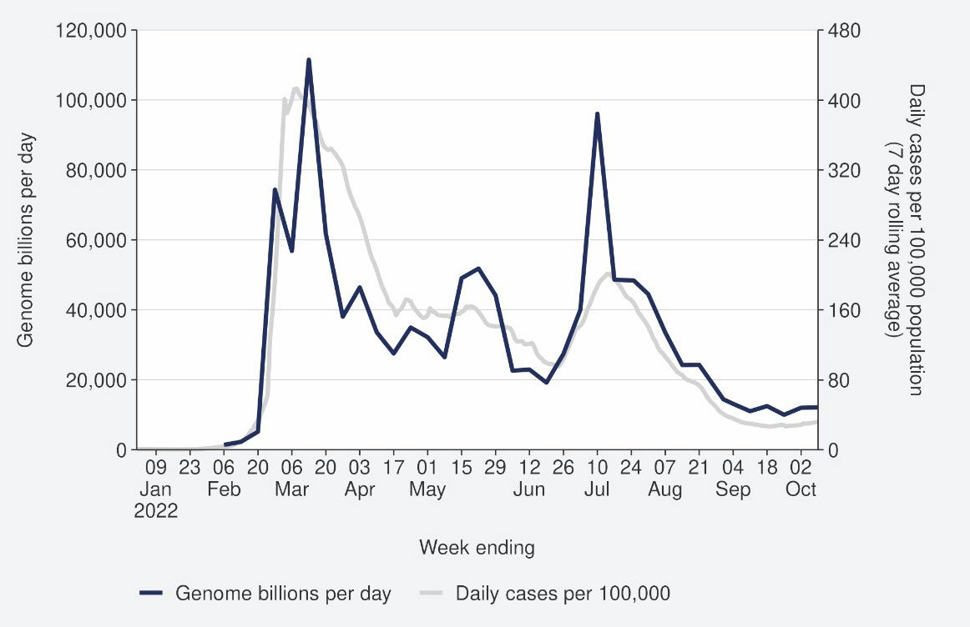
Sources: ESR SARS-CoV-2 in wastewater update for week ending 09 October 2022 and NCTS/EpiSurv as at 2359hrs 09 October 2022

3 Wastewater levels cannot be used to predict numbers of cases but do indicate trends in infection rates.

Figure 2: COVID-19 Modelling Aotearoa scenarios4 compared with national reported case numbers
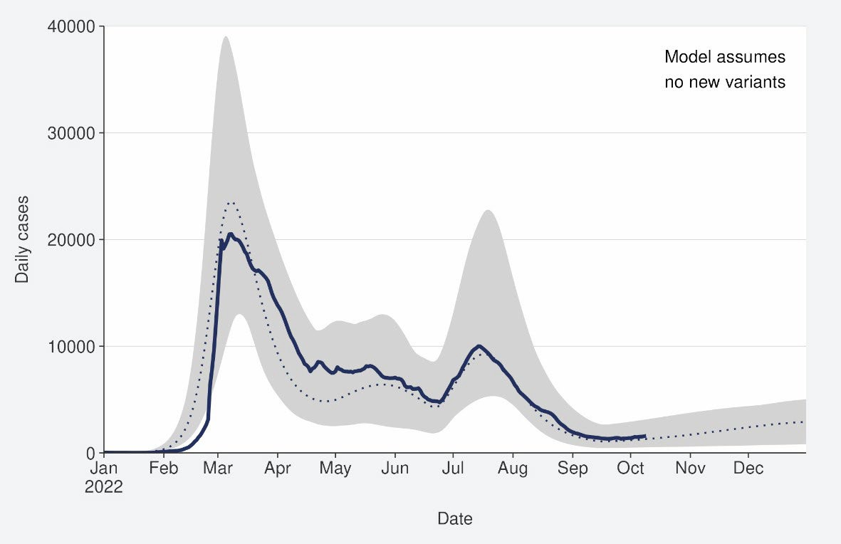
Sources: COVID-19 Modelling Aotearoa, ordinary differential equation model, September 2022, and NCTS/EpiSurv as at 2359hrs 09 October 2022

Figure 3: Regional reported case rates from January to 09 October 2022
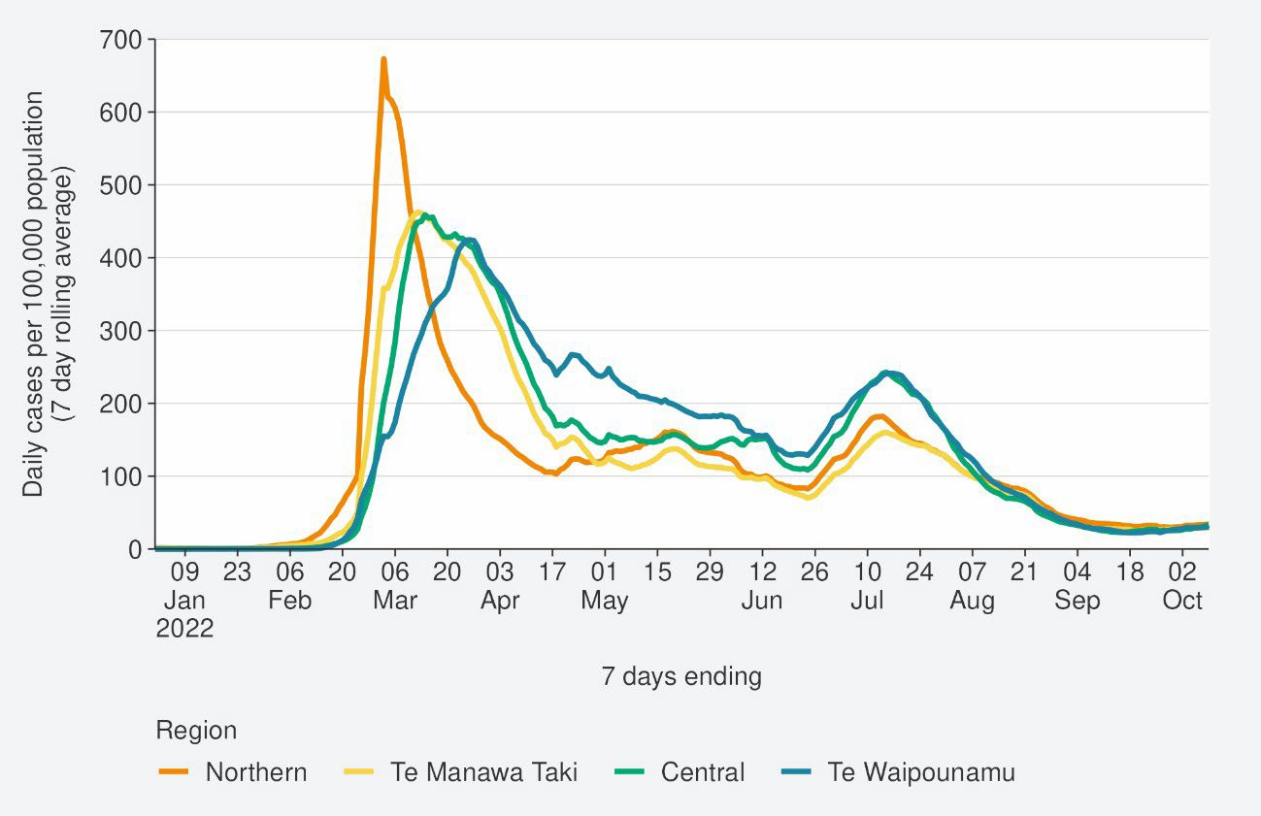
Source: NCTS/EpiSurv as at 2359hrs 09 October 2022

4 The ‘July’ BA.5 scenario assumes previous infection provides greater protection against reinfection and severe disease, consistent with emerging international evidence. It also incorporates updated data, future projections of uptake of second boosters and an earlier transition to BA.5, consistent with the timing of cases and hospitalisations in New Zealand.

Figure 4: National reported case rates by age from January to 09 October 2022
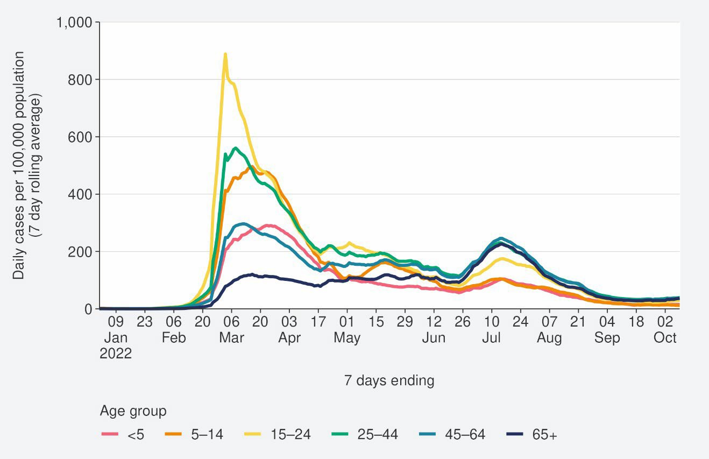
Source: NCTS/EpiSurv as at 2359hrs 09 October 2022

Figure 5: National age-standardised reported case rates by ethnicity from January to 09 October 2022
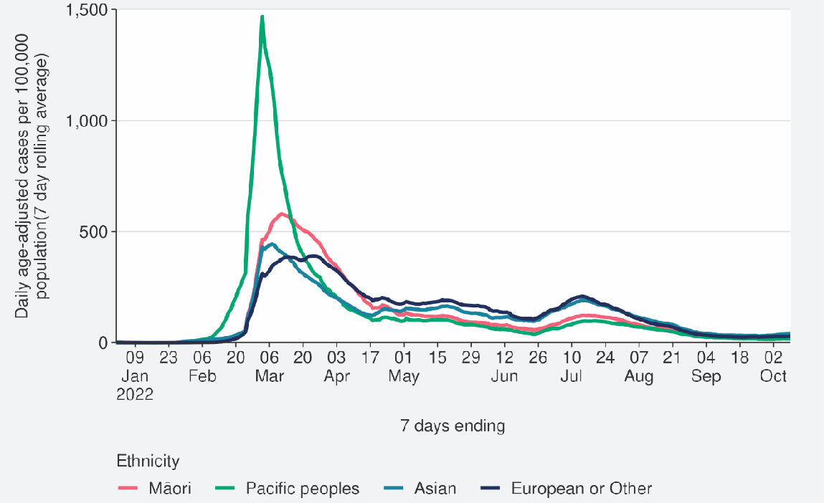
Source: NCTS/EpiSurv as at 2359hrs 09 October 2022

Figure 6: National age-standardised reported case rates by deprivation status for weeks 01 January – 09 October 2022
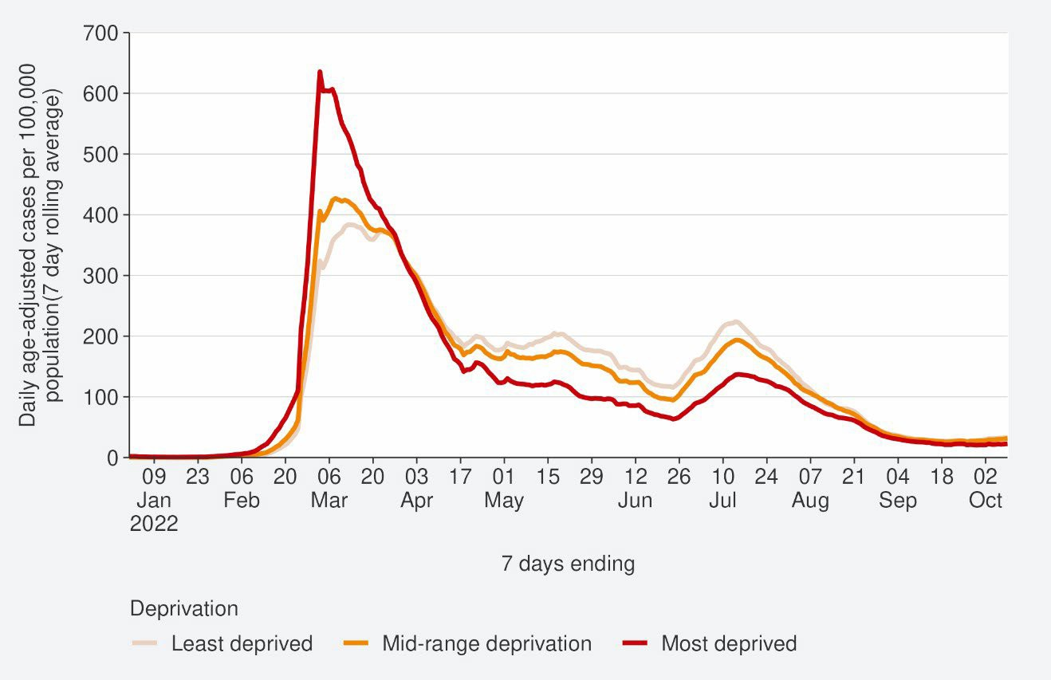
Source: NCTS/EpiSurv as at 2359hrs 09 October 2022

Hospitalisation and mortality trends

Hospitalisation
We have concluded our review of hospitalisation code and updated hospitalisation numbers are due for release on the week of Monday 17 October.

Modelling scenarios suggested that hospital occupancy was tracking near the median prediction and is expected to remain stable or slightly increase in the coming months (see Figure 7).

Figure 7: COVID-19 Modelling Aotearoa hospital occupancy5 scenario6 compared with national observed occupancy
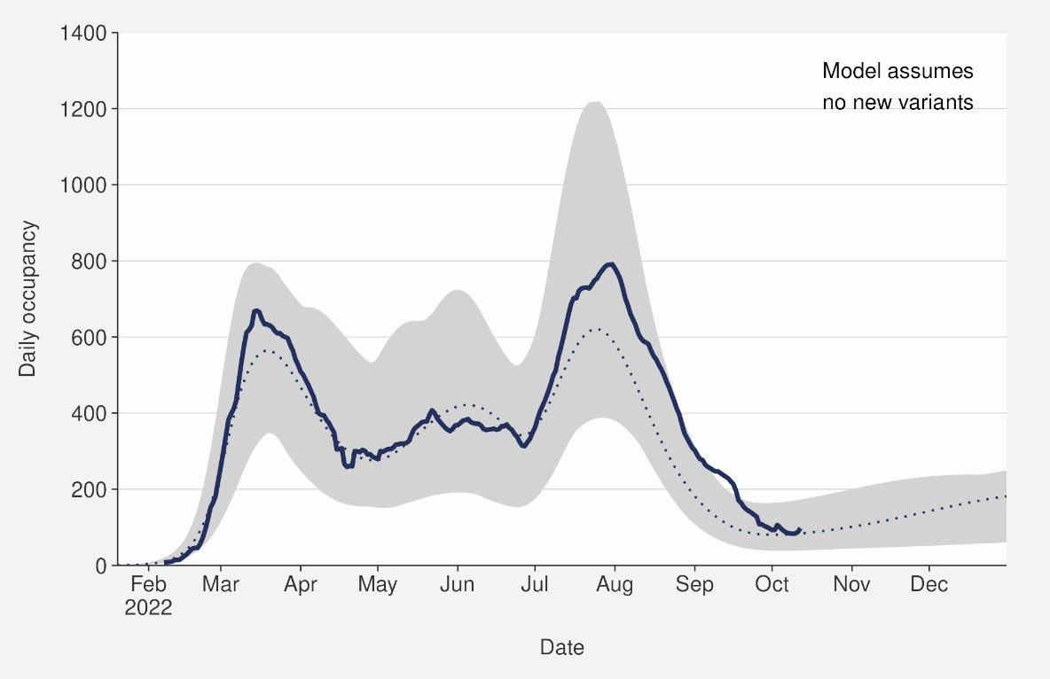
Sources: COVID-19 Modelling Aotearoa, ordinary differential equation model, September 2022, and Ministry of Health reported hospital occupancy data 09 October 2022

5 These data are for all hospitalisations with COVID-19, including those that were incidental, such as injuries.
6 The 'July’ scenario assumes previous infection provides greater protection against reinfection and severe disease, consistent with emerging international evidence. It also incorporates updated data, future projections of uptake of second boosters and an earlier transition to BA.5, consistent with the timing of cases and hospitalisations in New Zealand.

Mortality
From the first week of January to 09 October 2022, there were 3,031 deaths among people who died within 28 days of being reported as a case and/or with the cause being attributable to COVID-19 (that is an underlying or contributory cause) (see Figure 8)7.

Of these deaths in 2022 that have been formally coded by cause of death, 1,257 (47%) were determined to have COVID-19 as the main underlying cause. COVID-19 contributed to a further 747 (28%) deaths and another 687 (26%) people died of an unrelated cause (Figure 8). Deaths have been declining after peaking in the last week of July, when just over 150 people died with COVID-19 as their underlying or contributing cause.

Deaths are currently tracking below the lower range of the modelled scenario and are predicted to slightly increase in the coming months (see Figure 9).

Figure 8: National weekly death counts by cause of death8, January to 09 October 2022
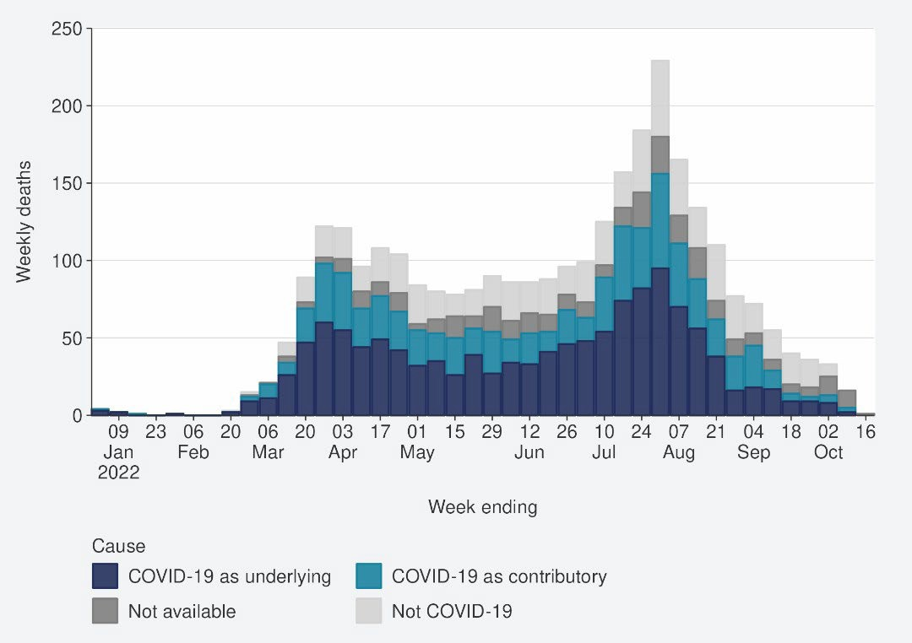
Source: Ministry of Health

7 There were 55 deaths before the first week of 2022.
8 Mortality data are affected by a delay due to time taken for reporting and death coding; the most recent weeks should be interpreted with caution.

Figure 9: COVID-19 Modelling Aotearoa death count compared with national observed deaths attributed to COVID-19
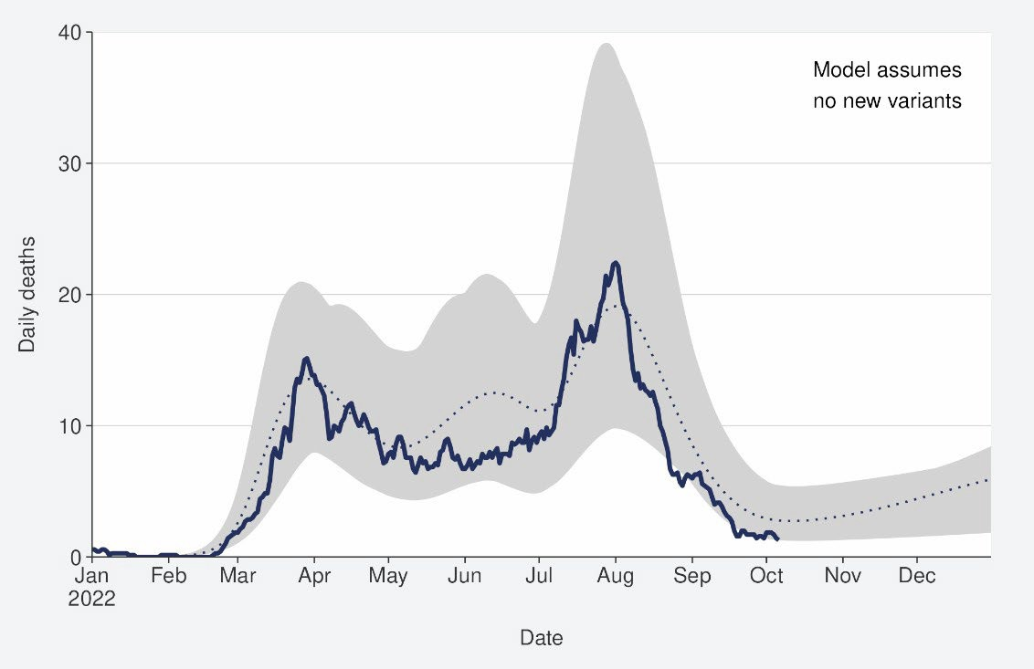
Sources: COVID-19 Modelling Aotearoa, ordinary differential equation model, September 2022, and Ministry of Health reported attributed deaths data 09 October 2022

Figure 10: Age-standardised cumulative incidence (and 95% confidence intervals) of mortality attributed to COVID-19 by ethnicity, 01 January 2022 to 02 October 2022
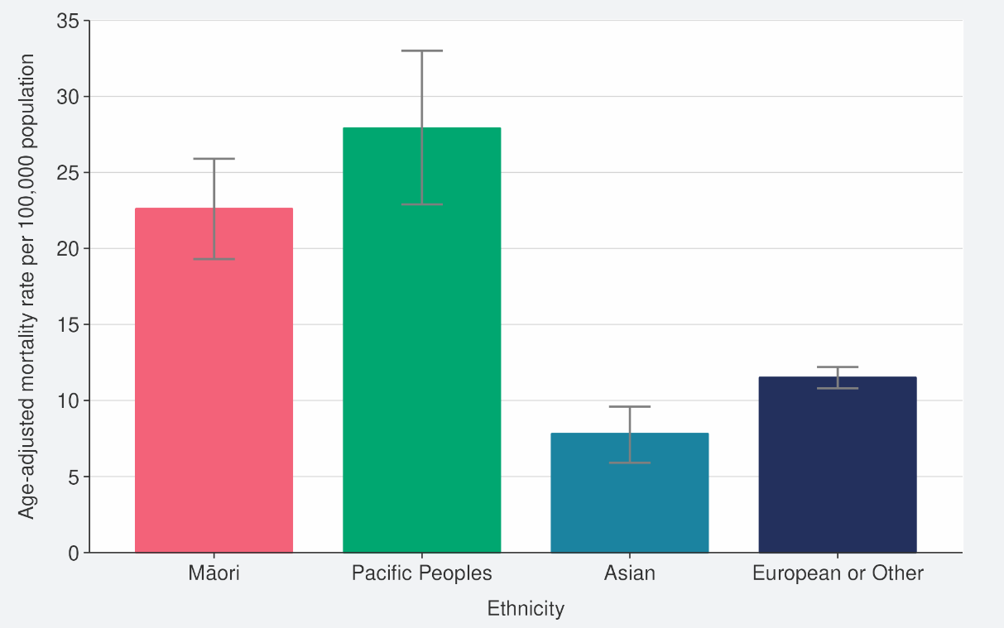
Source: NCTS/EpiSurv, NMDS, Inpatient Admissions dataset and CVIP population estimates, 01 January 2022 to 02 October 2022

Figure 11: Age-standardised cumulative incidence (and 95% confidence intervals) of mortality attributed to COVID-19 by deprivation, 01 January 2022 to 02 October 2022
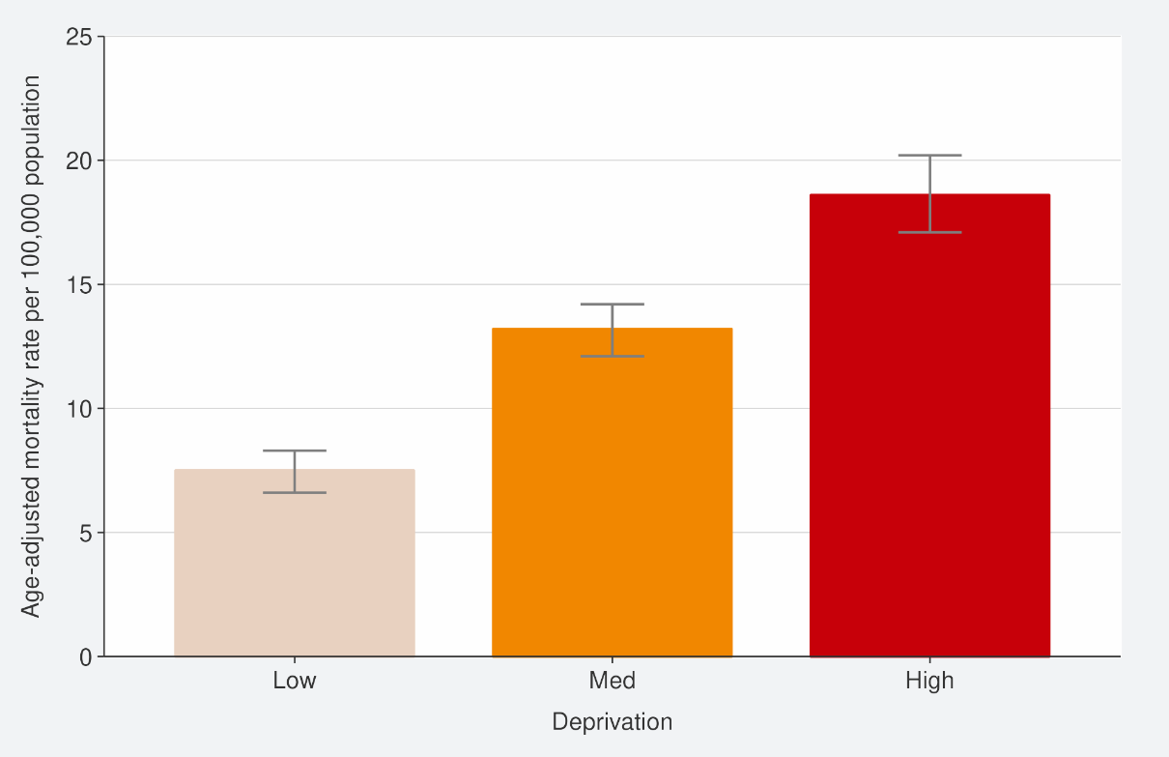
Source: EpiSurv, Death Documents, The Healthcare User database, Mortality Collections database and CVIP population estimates, 01 January 2020 to 02 October 2022

Whole genome sequencing

Community cases and wastewater
Whole genome sequencing data are updated on a fortnightly basis and have not been updated this week.

Figure 12 shows the proportions of variants in community cases, with BA.5 made up 75% of sequenced cases in the week to 30 September. BA.4.6 and BA.2.75 have increased over the past week; the changes in community sequencing were likely driven by the loss of distinction between border and community cases due to COVID-19 protection framework changes. Patterns in wastewater remained similar to previous weeks with BA.4/5 accounting for 90% of variants detected, although BA.2.75 detection has increased.

In the two weeks to 30 September, BA.4.6 made up 15% of samples; Omicron sub- variant BA.2.75 (including BA.2.75.2) was also detected in community samples accounting for 10% of sequenced samples.

Figure 12: Proportion of Variants of Concern in community cases
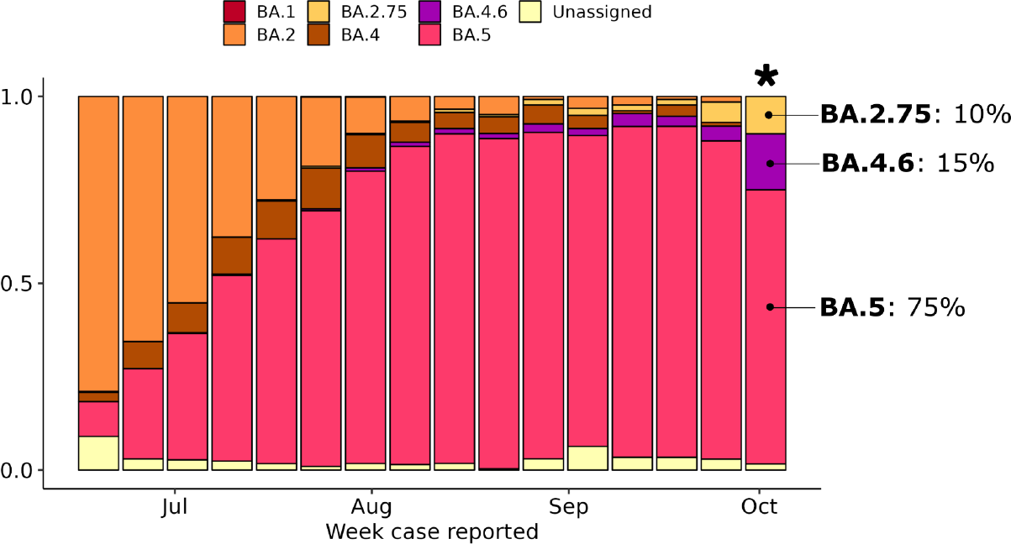
Source: ESR COVID-19 Genomics Insights Report #23, EpiSurv/Microreact 0900hrs 30 September 2022

Hospitalised cases
Of 87 successful sequences of COVID-19 positive hospital cases in the two weeks to 30 September 2022, 90% were BA.5, 5% were BA.4 (including BA.4.6) and 5% were BA.2.75.

Reinfection
‘Reinfection’ is now defined as a case reported at least 29 days after the last time a person reported a positive test for COVID-19. The definition of reinfection changed on 30 June; prior to this, reinfection was based on reports at least 90 days apart (based on the international literature at the time). Up until 30 June 2022, the vast majority of positive results that were detected within 90 days of the prior infection were not recorded in the system; some potential reinfections within 90 days were recorded but were not representative of the general population.
‘Reinfection’ in general refers to a second or subsequent infection, after the prior infection has cleared. In this analysis, we are not able to distinguish between reinfection with the same variant or different variants. Reinfection with a different variant to the first infection is more likely than reinfection with the same variant. Technically these data report on ‘redetections’ rather than true reinfections. True ‘reinfections’ cannot be definitively captured in the data for a range of reasons. For example, a person with persistent infection due to being immunocompromised who undergoes repeated testing due to regular hospital or clinical visits, would appear in the data as a ‘reinfection’ when in reality, they may be a chronic or persistent infection.
Figure 13 characterises the average number of cases per week by first infection and reinfection. Reinfection made up 10.8% of reported cases in the week ending 09 October. Figure 14 shows how many first infections and reinfections have been reported cumulatively over time. Cumulatively, reinfections have made up 2.1% of total cases reported in 2022. The proportion of cases that are reinfections is expected to increase over time. The true number of reinfections is likely higher than reported here. In general, reporting of cases is expected to decline over time. Due to under- ascertainment of the first infection and subsequent infections and as both are required to detect a reinfection, there is likely to be under-reporting of reinfections.

Figure 13: Reinfections 7-day rolling average from 01 January to 09 October 2022
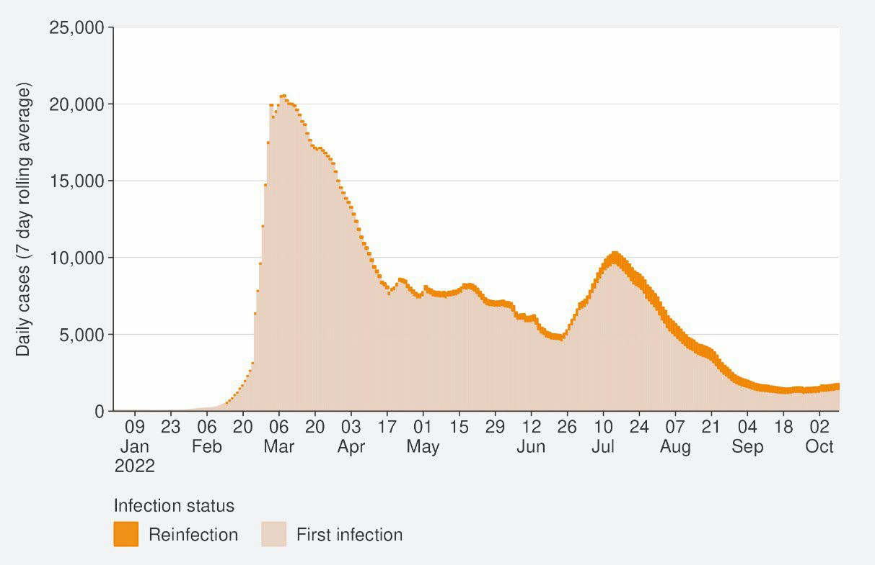
Source: NCTS/EpiSurv as at 2359hrs 09 October 2022

Figure 14: Reinfections cumulatively from 01 January to 09 October 2022
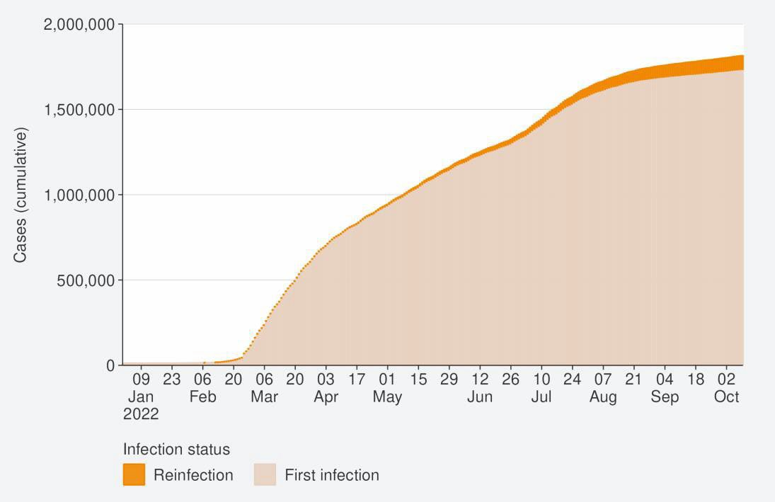
Source: NCTS/EpiSurv as at 2359hrs 09 October 2022

Global pandemic summary
We expected the global situation for the COVID-19 pandemic in the next few months to be driven by the ongoing emergence of new variants, waning immunity, behavioural change, changing outbreak control measures and the Northern Hemisphere heading towards the winter season.

- Globally, in the week ending 09 October, the number of new weekly cases decreased by 10% as compared to the previous week, with over 2.8 million new cases reported.
- The number of new weekly deaths remained stable compared to the previous week with over 9,000 fatalities reported.
- Globally, as of 09 October 2022, over 618 million confirmed cases and over 6.5 million deaths have been reported globally.
- There continues to be increased diversity within Omicron and within its descendent lineages. A number of these descendant lineages are being monitored.
- BA.5 Omicron descendent lineages continue to be dominant globally, with a decrease in weekly prevalence from 80.8% to 76.2% as of 18 September.
- BA.4 descendent lineages (including BA.4.6) accounted for 7.0% of all cases, a slight decrease from last week as of 18 September.
- BA.2 descendent lineages (including BA.2.75) still show a relatively low (3.9% as of 18 September) prevalence globally.
- Decreases in countries’ frequency of submitting COVID-19 genomes to GISAID make detecting accurate international representations of variant prevalence difficult.
Sources: World Health Organisation: Weekly epidemiological update on COVID-03 – 09 October 2022

Please note, global trends in cases and deaths should be interpreted with caution as several countries have been progressively changing COVID-19 testing strategies resulting in lower overall numbers of tests performed and consequently lower numbers of cases detected.

Appendix: Table of summary statistics

Table 1: Reported 7-day rolling average of case rates by region, age group, ethnicity and deprivation

Reported Cases (7-day rolling average)
 | Week ending  02/10/2022 |  | Week ending 09/10/2022 |  | %  Change
 | Number | Rate (per 100,000  population) | Number | Rate (per 100,000  population)
National | 1421.9 | 28.6 | 1597.9 | 32.2 | 12.4%
Region
Northern | 589.6 | 31.1 | 646.6 | 34.1 | 9.70%
Te Manawa Taki | 262.1 | 27.0 | 284.7 | 29.3 | 8.60%
Central | 248.9 | 26.5 | 312.4 | 33.3 | 25.50%
Te Waipounamu | 319.7 | 27.9 | 352.6 | 30.8 | 10.30%
Age group
<5 | 44.7 | 14.2 | 48.3 | 15.3 | 8.3%
5-14 | 92.7 | 13.7 | 81.0 | 12.0 | -12.6%
15-24 | 154.1 | 24.9 | 183.7 | 29.7 | 19.3%
25-44 | 485.3 | 36.0 | 525.3 | 38.9 | 8.2%
45-64 | 421.0 | 33.7 | 481.3 | 38.6 | 14.3%
65+ | 224.0 | 29.4 | 278.3 | 36.5 | 24.4%
Ethnicity
Māori | 133.4 | 17.5 | 159.0 | 20.8 | 19.2%
Pacific peoples | 61.7 | 16.8 | 70.1 | 19.1 | 13.7%
Asian | 264.4 | 36.0 | 314.6 | 42.9 | 19%
European or Other | 950.6 | 30.8 | 1043.6 | 33.8 | 9.8%
Deprivation
Least deprived | 475.1 | 33.0 | 538.9 | 37.4 | 13.4%
Mid-range deprivation | 586.9 | 31.0 | 663.9 | 35.0 | 13.2%
Most deprived | 334.9 | 22.5 | 368.4 | 24.7 | 10%

Table 2: Cumulative reported cases of COVID-19 from March 2020 to 09 October by level 2 ethnicity.

Ethnicity | Level 2 Ethnicity | Cumulative reported cases of COVID-19 | Cases per 1000  population | Population
Asian | Asian NFD | 8677 | 389 | 22320
Asian | Chinese | 57330 | 244 | 235331
Asian | Indian | 94567 | 386 | 245079
Asian | Other Asian | 45437 | 373 | 121732
Asian | Southeast Asian | 52609 | 483 | 108939
Māori | Māori | 271793 | 356 | 762780
MELAA | African | 9749 | 370 | 26364
MELAA | Latin American  / Hispanic | 13333 | 460 | 28998
MELAA | Middle Eastern | 9656 | 298 | 32395
Pacific Peoples | Cook Island  Māori | 19435 | 365 | 53299
Pacific Peoples | Fijian | 16978 | 415 | 40956
Pacific Peoples | Niuean | 7835 | 402 | 19477
Pacific Peoples | Other Pacific Island | 6936 | 479 | 14466
Pacific  Peoples | Pacific Island  NFD | 1636 | 447 | 3663
Pacific Peoples | Samoan | 67857 | 438 | 154997
Pacific  Peoples | Tokelauan | 2792 | 407 | 6863
Pacific Peoples | Tongan | 30253 | 416 | 72703

