COVID-19 TRENDS AND INSIGHTS REPORT
07 October 2022

Released 2022 health.govt.nz

Citation: Public Health Agency. 2022. COVID-19 Trends and Insights Report.
Wellington: Ministry of Health
Published in October 2022 by Ministry of Health PO Box 5013, Wellington 6140, New Zealand
HP 8608

This document is available at health.govt.nz

This work is licensed under the Creative Commons Attribution 4.0 International licence. In essence, you are free to: share ie, copy and redistribute the material in any medium or format; adapt ie, remix, transform and build upon the material. You must give appropriate credit, provide a link to the licence and indicate if changes were made.

Contents
Purpose of report 1
Executive summary 2
Key insights 3
National Trends 3
International Insights 3
National summary of epidemic trends 4
Hospitalisation and mortality trends 8
Whole Genomic Sequencing 12
Comparison of epidemic trends by deprivation 15
Global pandemic summary 16
Appendix: Table of summary statistics 17

COVID-19 TRENDS AND INSIGHTS REPORT iii

List of Figures
Figure 1: National wastewater trends (SARS-CoV-2 genome copies) compared with reported cases 5
Figure 2: COVID-19 Modelling Aotearoa scenarios compared with national reported case numbers 5
Figure 3: Regional reported case rates from January to 02 October 2022 6
Figure 4: National reported case rates by age from January to 02 October 2022 6
Figure 5: National age-standardised reported case rates by ethnicity from January to 02 October 2022 7
Figure 6: COVID-19 Modelling Aotearoa hospital occupancy scenario compared with national observed occupancy 8
Figure 7: National weekly death counts by cause of death, January to 02 October 20229
Figure 8: COVID-19 Modelling Aotearoa death count compared with national observed deaths attributed to COVID-19 10
Figure 9: Age-standardised cumulative incidence (and 95% confidence intervals) of mortality attributed to COVID-19 by ethnicity, 01 January 2022 to 02 October 2022 10
Figure 10: Age-standardised cumulative incidence (and 95% confidence intervals) of mortality attributed to COVID-19 by deprivation, 01 January 2022 to 02 October 2022
11
Figure 11: Proportion of Variants of Concern in community cases 12
Figure 12: Reinfections 7 day rolling average from 01 January to 02 October 2022 14
Figure 13: Reinfections cumulatively from 01 January to 02 October 2022 14
Figure 14: National age-standardised reported case rates by deprivation status for weeks 01 January – 02 October 2022 15

Purpose of report
This report comments on trends in the New Zealand COVID-19 outbreak, including cases, hospitalisations and mortality. It also comments on international COVID-19 trends and the latest scientific insights related to outbreak management. The report relies on data that may be subject to change or are incomplete. An unknown proportion of infections are not reported as cases, this proportion may differ by characteristics such as ethnicity or deprivation group. Therefore, any differences in reported case rates must be interpreted with caution.

Executive summary
Overall, in the most recent 2 weeks, wastewater RNA levels and reported case rates have stabilised, mortality counts have continued to decrease.

BA.5 is the dominant subvariant accounting for an estimated 75% of cases; this is consistent with wastewater findings. Watchlist variants BA.2.75 and BA.4.6 each make up approximately 10% of cases.

The Omicron BQ.1.1 lineage has not yet been detected in New Zealand in the fortnight to 30 September. However, as BQ.1.1 is rising rapidly in Europe at present, we might have a situation where we expected multiple new variants to be circulating, all with different immune evasion and severity profiles.

Key insights

National Trends

Cases | The 7-day rolling average of reported case rates was 28.6 per 100,000 population for the week ending 02 October. This was a 1.8% increase from the previous week, which was 28.1 per 100,000.
Wastewater | Wastewater quantification remained stable in the past week.
Mortality | As of 02 October, there were 1,991 deaths attributed to COVID-19 in 2022. The weekly number of deaths attributed to COVID-19 has continued to decrease.
Variants of Concern | BA.5 made up 75% of sequenced community cases seen in the last two weeks (17 September to 30 September), followed by BA.4.6 (15% of cases) and BA.2.75 (10% of cases).

International Insights

Globally, in the week ending 02 October, the number of new weekly cases decreased as compared to the previous week, with over 2.9 million new cases reported. The number of new weekly deaths decreased by 12% compared to the previous week, with over 8,400 fatalities reported.
Globally, between 03 September to 03 October 2022, 104,128 SARS-CoV-2 sequences were submitted to GISAID, with Omicron accounting for 99.9% of sequences.

National summary of epidemic trends

Case trends
All evidence continues to support stabilisation in incidence in the community: reported1 case rates and levels of viral ribonucleic acid (RNA) in wastewater have been declining since 10 July but both measures have been relatively constant in the recent weeks to 02 October (Figure 1).

Modelling scenarios that accounted for changes in masking and contact quarantine on 12 September and assumed no new variants, indicated case rates were expected to remain stable or slightly increase in the coming months (see Figure 2)2.

The general population’s reported case rate for the week ending 02 October was 28.6 per 100,000, a 1.8% increase from the previous weeks 28.1 per 100,000. Similar trends were observed in case rates by age (see Figure 4). All regions remained stable except Te Waipounamu, where case rates increased by 16.2% (see Figure 3).

Table 1 in the appendix provides information on specific rates.

1 Since 24 February 2022, most testing has been through self-administered rapid antigen tests (RATs) which require self-reporting of results. Therefore, it is likely that many infections are not detected or reported, and the proportion of infections reported (‘reported cases’) may differ by age, ethnicity and deprivation.
2 See the online glossary for modelling assumptions.

Figure 1: National wastewater trends (SARS-CoV-2 genome copies)3 compared with reported cases
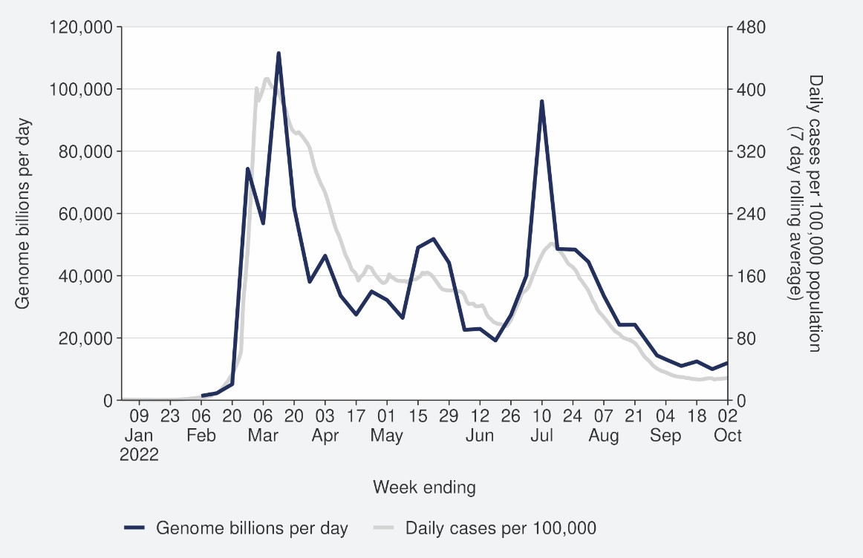
Sources: ESR SARS-CoV-2 in wastewater update for week ending 25 September 2022 and NCTS/EpiSurv as at 2359hrs 02 October 2022

Figure 2: COVID-19 Modelling Aotearoa scenarios4 compared with national reported case numbers
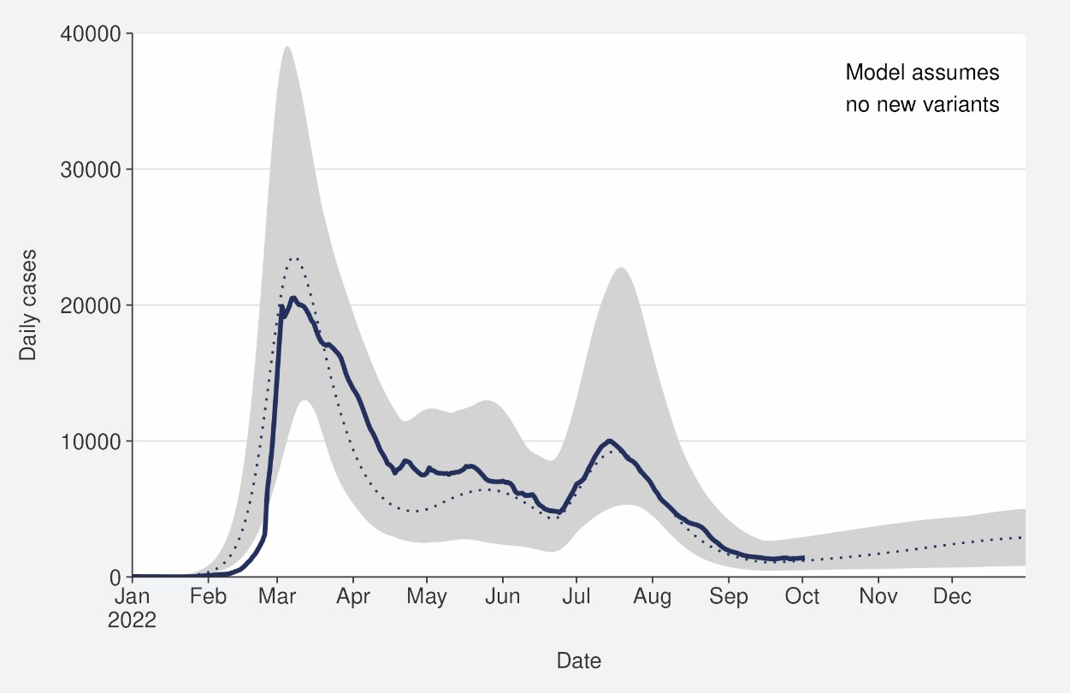
Sources: COVID-19 Modelling Aotearoa, ordinary differential equation model, September 2022, and NCTS/EpiSurv as at 2359hrs 02 October 2022

3 Wastewater levels cannot be used to predict numbers of cases but do indicate trends in infection rates.
4 The ‘July’ BA.5 scenario assumes previous infection provides greater protection against reinfection and severe disease, consistent with emerging international evidence. It also incorporates updated data, future projections of uptake of second boosters and an earlier transition to BA.5, consistent with the timing of cases and hospitalisations in New Zealand.

Figure 3: Regional reported case rates from January to 02 October 2022
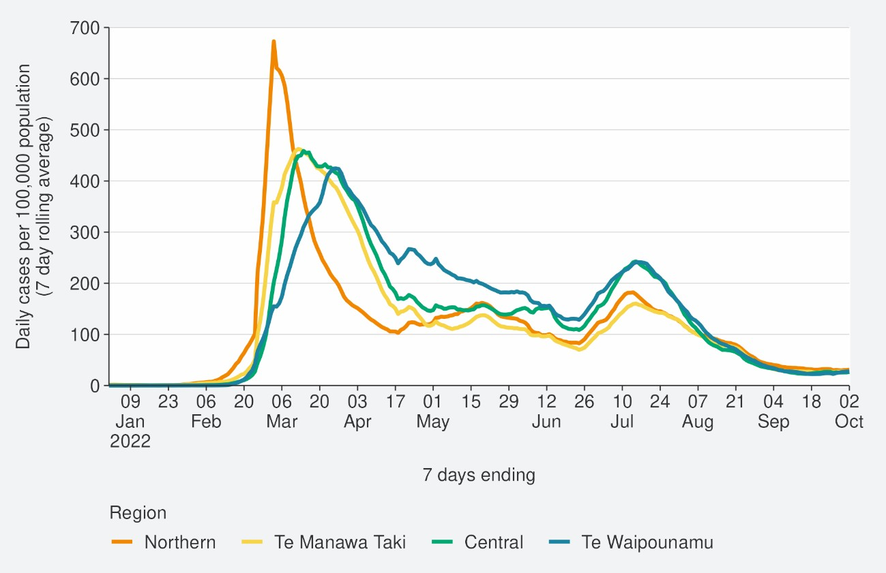
Source: NCTS/EpiSurv as at 2359hrs 02 October 2022

Figure 4: National reported case rates by age from January to 02 October 2022
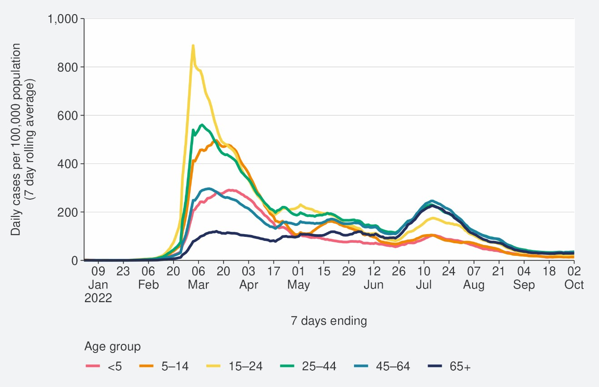
Source: NCTS/EpiSurv as at 2359hrs 02 October 2022

Figure 5: National age-standardised reported case rates by ethnicity from January to 02 October 2022
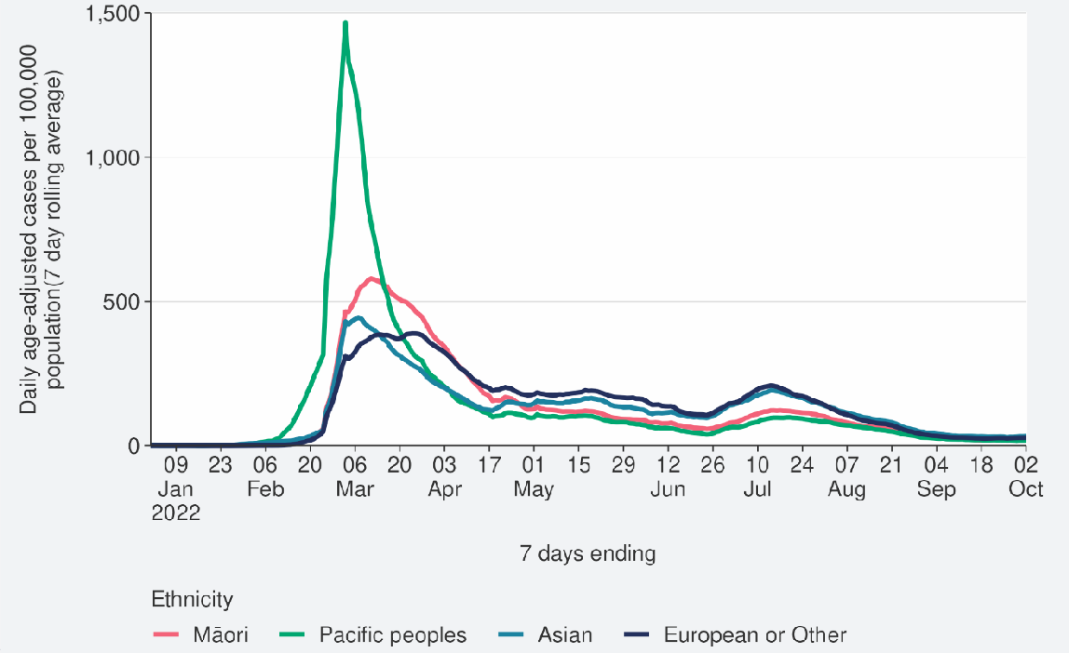
Source: NCTS/EpiSurv as at 2359hrs 02 October 2022

Hospitalisation and mortality trends

Hospitalisation
We are currently reviewing our hospitalisations data and as a result, the hospitalisations analysis has not been included in this week's Trends & Insights report. Hospitalisation insights will be included in next week's report.

Modelling scenarios suggested that current hospital occupancy was tracking near the median prediction and was expected to remain stable or slightly increase in the coming months (see Figure 6).

Figure 6: COVID-19 Modelling Aotearoa hospital occupancy5 scenario6 compared with national observed occupancy
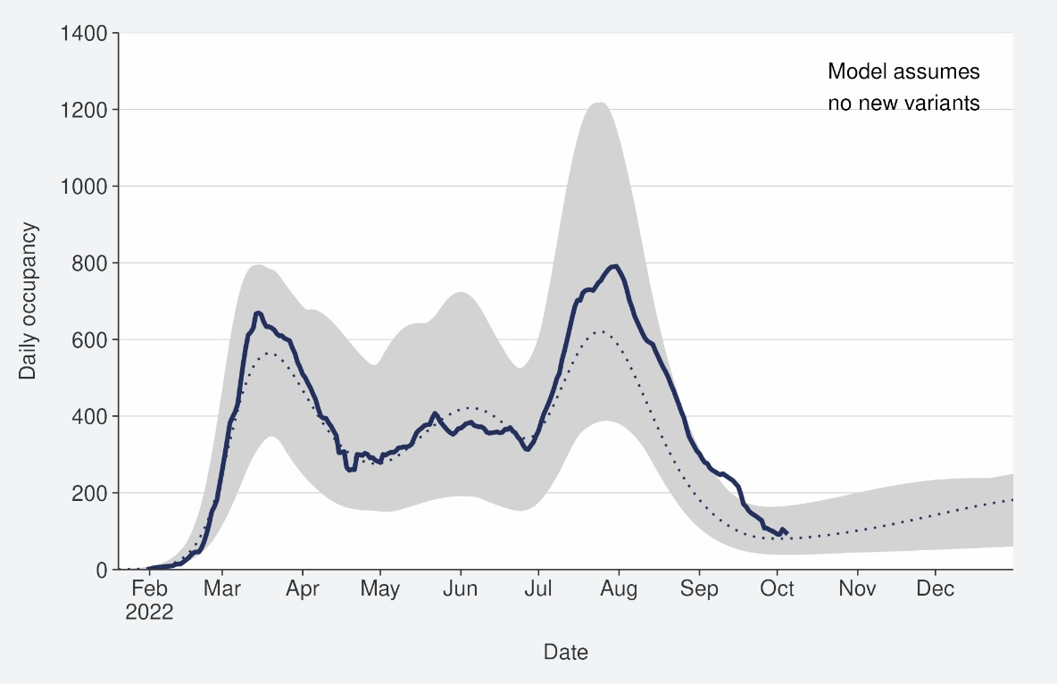
Sources: COVID-19 Modelling Aotearoa, ordinary differential equation model, September 2022, and Ministry of Health reported hospital occupancy data 25 September 2022

5 These data are for all hospitalisations with COVID-19, including those that were incidental, such as injuries.
6 The 'July’ scenario assumes previous infection provides greater protection against reinfection and severe disease, consistent with emerging international evidence. It also incorporates updated data, future projections of uptake of second boosters and an earlier transition to BA.5, consistent with the timing of cases and hospitalisations in New Zealand.

Mortality
From the first week of January to 02 October 2022, there were 3,006 deaths among people who died within 28 days of being reported as a case and/or with the cause being attributable to COVID-19 (that is an underlying or contributory cause) (see Figure 7)7.

Of these deaths in 2022 that have been formally coded by cause of death, 1,252 (47%) were determined to have COVID-19 as the main underlying cause. COVID-19 contributed to a further 735 (27%) deaths and another 687 (26%) people died of an unrelated cause (Figure 7). Deaths have been declining after peaking in the last week of July, when just over 150 people died with COVID-19 as their underlying or a contributing cause.

Deaths were currently tracking below the lower range of the modelled scenario and were predicted to slightly increase in the coming months (see Figure 8).

Figure 7: National weekly death counts by cause of death8, January to 02 October 2022

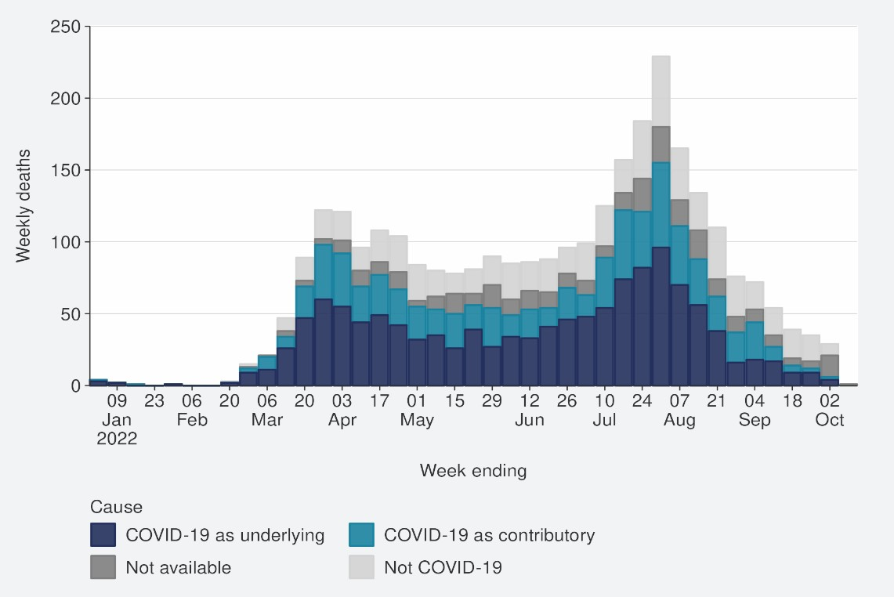
Source: Ministry of Health

7 There were 55 deaths before the first week of 2022.
8 Mortality data are affected by a delay due to time taken for reporting and death coding; the most recent weeks should be interpreted with caution.

Figure 8: COVID-19 Modelling Aotearoa death count compared with national observed deaths attributed to COVID-19
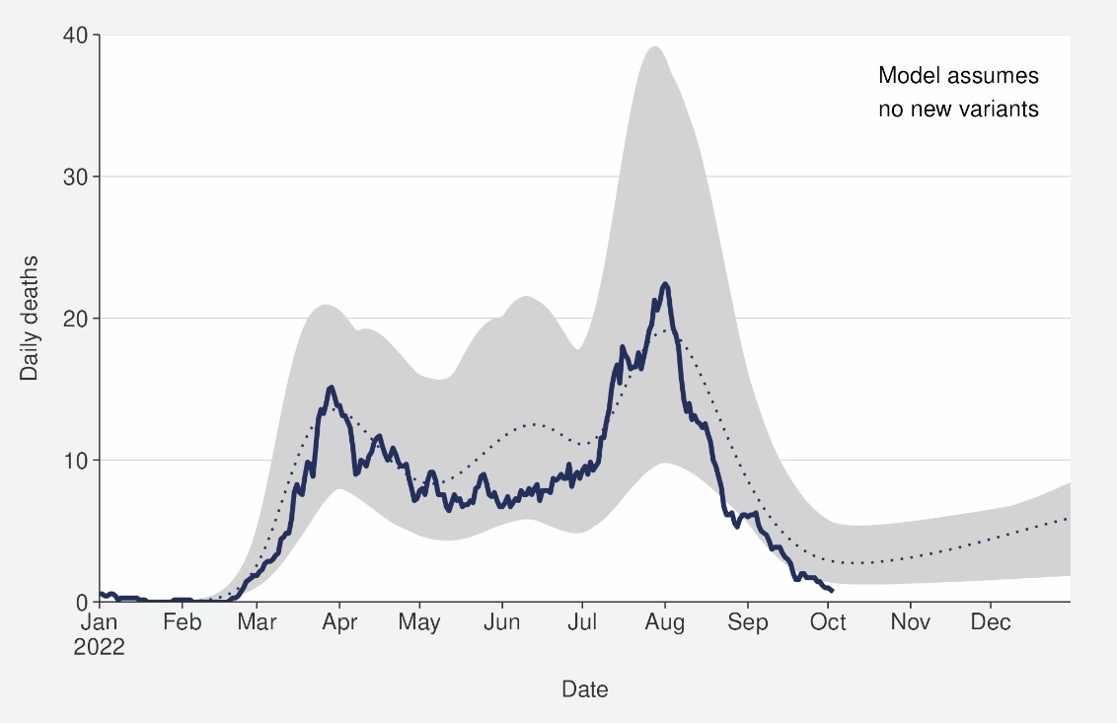
Sources: COVID-19 Modelling Aotearoa, ordinary differential equation model, September 2022, and Ministry of Health reported attributed deaths data 02 October 2022

Figure 9: Age-standardised cumulative incidence (and 95% confidence intervals) of mortality attributed to COVID-19 by ethnicity, 01 January 2022 to 02 October 2022
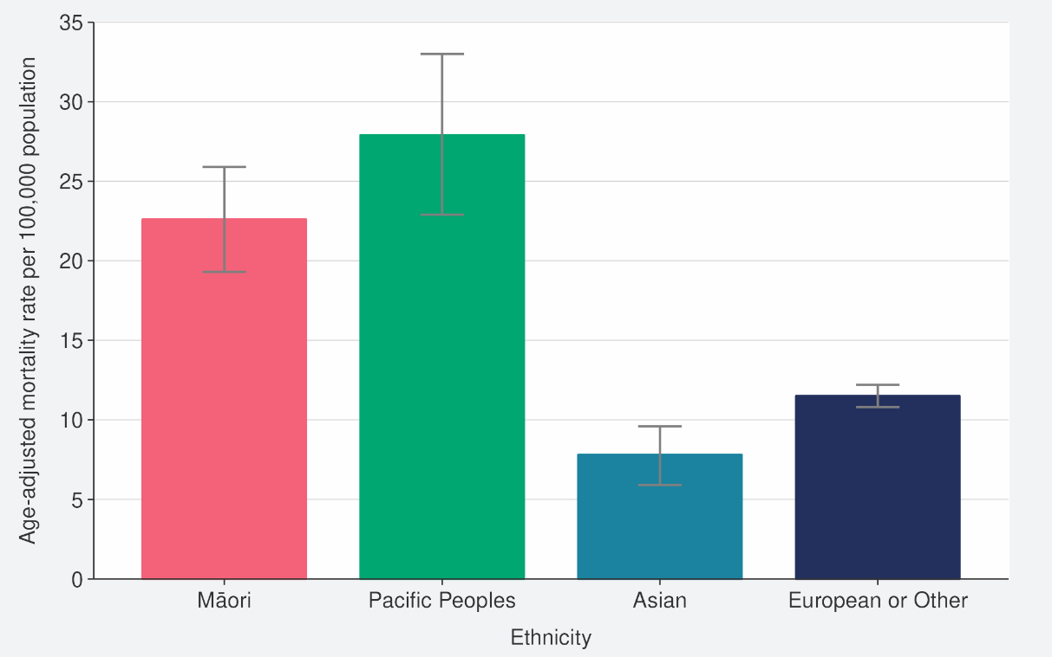
Source: NCTS/EpiSurv, NMDS, Inpatient Admissions dataset and CVIP population estimates, 01 January 2022 to 02 October 2022

Figure 10: Age-standardised cumulative incidence (and 95% confidence intervals) of mortality attributed to COVID-19 by deprivation, 01 January 2022 to 02 October 2022
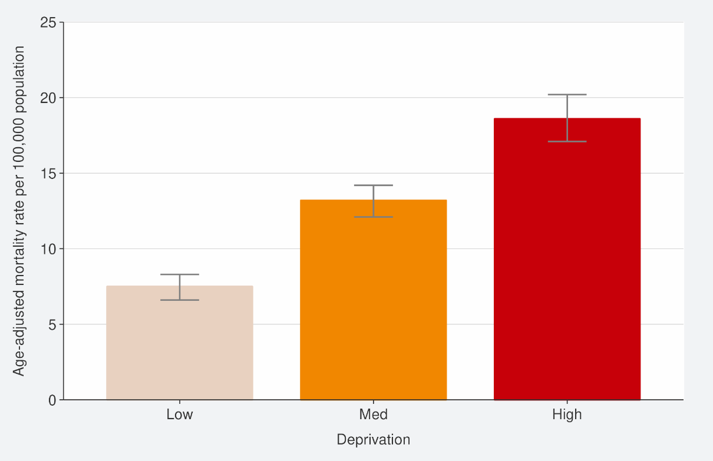
Source: EpiSurv, Death Documents, The Healthcare User database, Mortality Collections database and CVIP population estimates, 01 January 2020 to 02 October 2022

Whole Genomic Sequencing

Community cases and wastewater
Whole Genomic Sequencing data are updated on a fortnightly basis and have been updated this week.
Figure 11 shows the proportions of variants in community cases, with BA.5 made up 75% of sequenced cases in the week to 30 September. BA.4.6 and BA.2.75 have increased over the past week; the changes in community sequencing were likely driven by the loss of distinction between border and community cases due to COVID-19 protection framework changes. Patterns in wastewater remained similar to previous weeks with BA.4/5 accounting for 90% of variants detected, although BA.2.75 detection has increased.
In the two weeks to 30 September, BA.4.6 made up 15% of samples; Omicron sub- variant BA.2.75 (including BA.2.75.2) was also detected in community samples accounting for 10% of sequenced samples.

Figure 11: Proportion of Variants of Concern in community cases
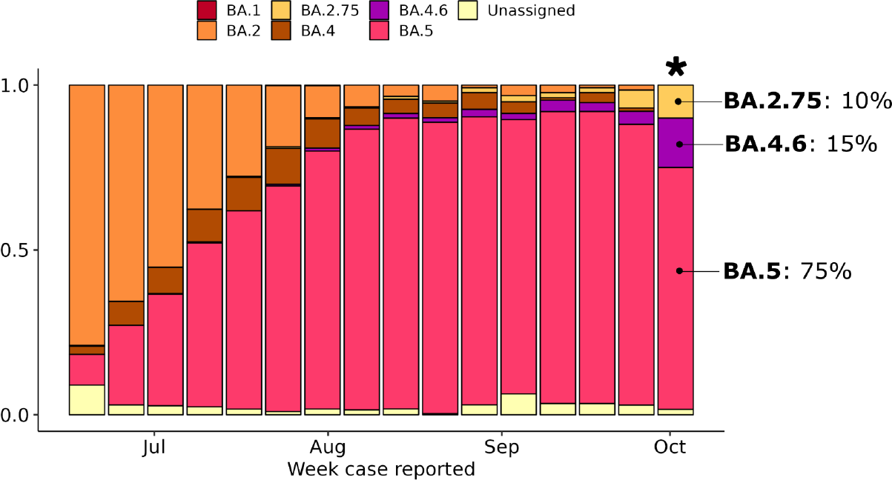
Source: ESR COVID-19 Genomics Insights Report #23, EpiSurv/Microreact 0900hrs 30 September 2022

Hospitalised cases
Of 87 successful sequences of COVID-19 positive hospital cases in the two weeks to 30 September 2022, 90% were BA.5, 5% were BA.4 (including BA.4.6) and 5% were BA.2.75.

Reinfection
‘Reinfection’ is now defined as a case reported at least 29 days after the last time a person reported a positive test for COVID-19. The definition of reinfection changed on 30 June; prior to this, reinfection was based on reports at least 90 days apart (based on the international literature at the time). Up until 30 June 2022, the vast majority of positive results that were detected within 90 days of the prior infection were not recorded in the system; some potential reinfections within 90 days were recorded but were not representative of the general population.
‘Reinfection’ in general refers to a second or subsequent infection, after the prior infection has cleared. In this analysis, we are not able to distinguish between reinfection with the same variant or different variants. Reinfection with a different variant to the first infection is more likely than reinfection with the same variant. Technically these data report on ‘redetections’ rather than true reinfections. True ‘reinfections’ cannot be definitively captured in the data for a range of reasons. For example, a person with persistent infection due to being immunocompromised who undergoes repeated testing due to regular hospital or clinical visits, would appear in the data as a ‘reinfection’ when in reality, they may be a chronic or persistent infection.
Figure 12 characterises the average number of cases per week by first infection and reinfection. Reinfection made up 10.7% of reported cases in the week ending 02 October. Figure 13 shows how many first infections and reinfections have been reported cumulatively over time. Cumulatively, reinfections have made up 2.1% of total cases reported in 2022. The proportion of cases that are reinfections is expected to increase over time. The true number of reinfections is likely higher than reported here. In general, reporting of cases is expected to decline over time. Due to under- ascertainment of the first infection and subsequent infections and as both are required to detect a reinfection, there is likely to be under-reporting of reinfections.

Figure 12: Reinfections 7-day rolling average from 01 January to 02 October 2022
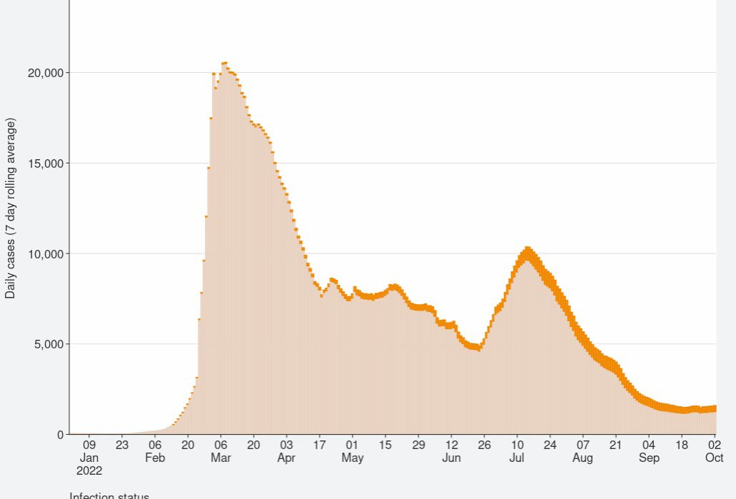
Source: NCTS/EpiSurv as at 2359hrs 02 October 2022

Figure 13: Reinfections cumulatively from 01 January to 02 October 2022
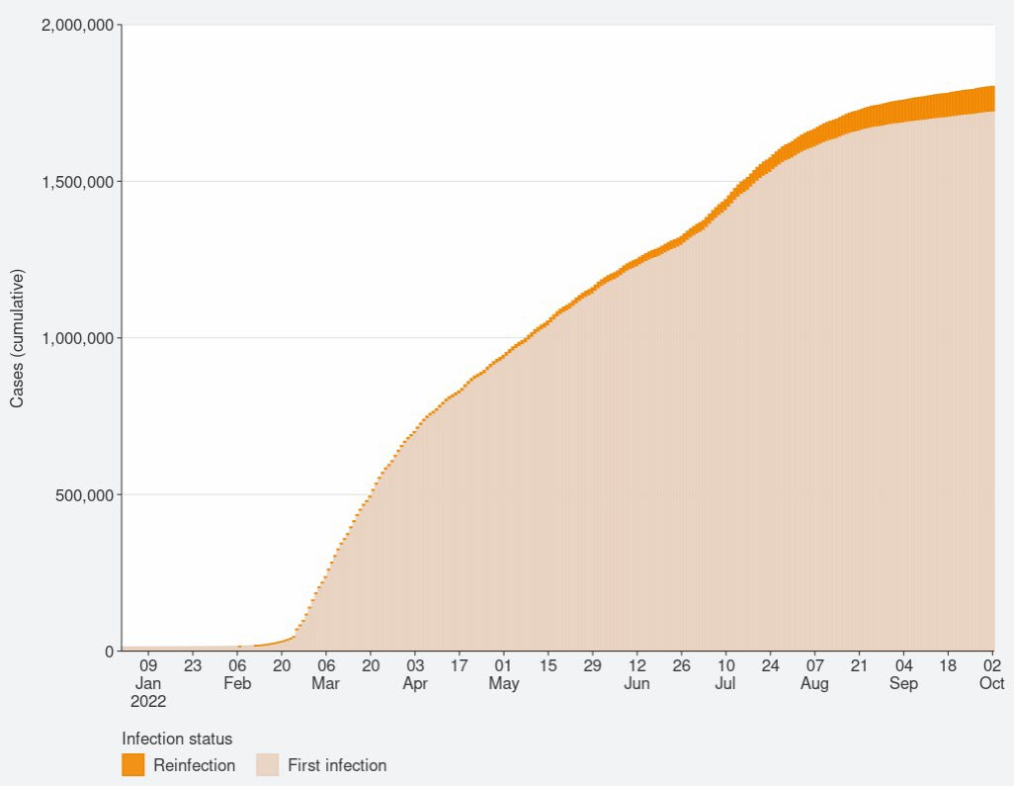
Source: NCTS/EpiSurv as at 2359hrs 02 October 2022

Comparison of epidemic trends by deprivation

Figure 14 shows the 7-day rolling average for reported case rates by residential area deprivation level (based on NZDep2018).9 Rates in the least deprived areas slightly increased; mid-range deprived rates remained stable; and rates decreased slightly for the most deprived in the week ending 02 October. Case rates in the past week were slightly higher in areas of least and mid-range deprivation, the differences were more substantial during July where those most-deprived had the lowest rate. Prior to May, case rates in those most deprived were higher than the mid-range and least deprived groups.

Cumulative rates of mortality are highest for those most deprived (Figure 10).

As lower-case rates have been reported among those most deprived, their continued higher hospitalisation and death rates suggest those who are most deprived may have lower levels of case ascertainment and/or a higher risk of poor outcomes after infection compared with those who are least deprived.

Figure 14: National age-standardised reported case rates by deprivation status for weeks 01 January – 02 October 2022
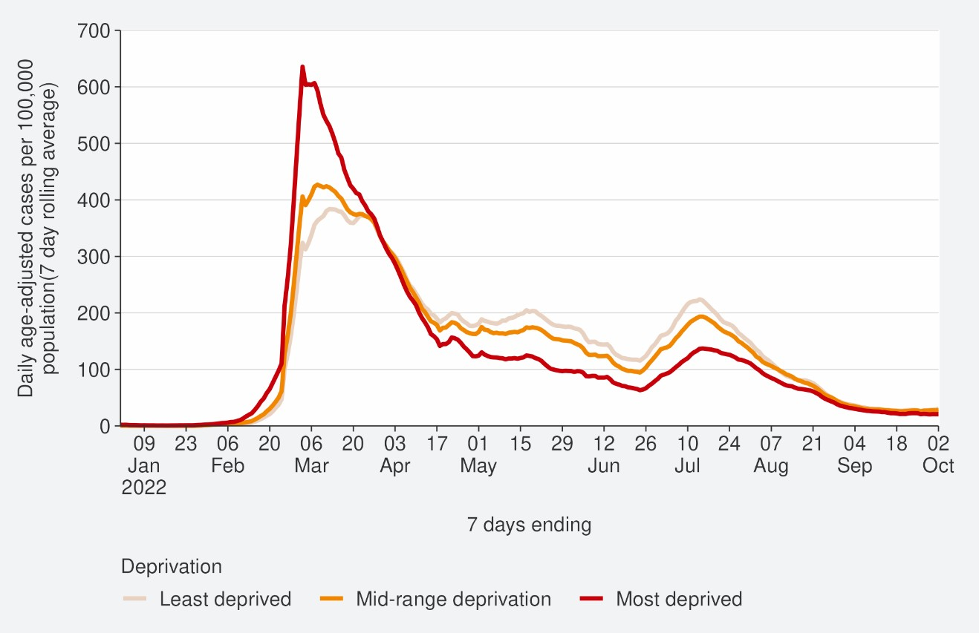
Source: NCTS/EpiSurv as at 2359hrs 02 October 2022

9 Atkinson J, Salmond C, Crampton P (2019). NZDep2018 Index of Deprivation, Final Research Report, December 2020. Wellington: University of Otago

Global pandemic summary
We expected the global situation for the COVID-19 pandemic in the next few months to be driven by the ongoing emergence of new variants, waning immunity and the Northern Hemisphere heading towards the winter season.

- Globally, in the week ending 02 October, the number of new weekly cases decreased by 6% as compared to the previous week, with over 2.9 million new cases reported.
- The number of new weekly deaths decreased by 12% compared to the previous week, with over 8,300 fatalities reported.
- Globally, as of 02 October 2022, over 615 million confirmed cases and over 6.5 million deaths have been reported.
- There continues to be increased diversity within Omicron and within its descendent lineages. A number of these descendant lineages are being monitored.
- BA.5 Omicron descendent lineages continue to be dominant globally, with a decrease in weekly prevalence from 81.2% to 80.8%.
- BA.4 descendent lineages (including BA.4.6) which accounted for 7.8%, a slight decrease from last week.
- BA.2 descendent lineages (including BA.2.75) still shows a relatively low (3.1% as of 02 October) prevalence globally.
- Decreases in countries’ frequency of submitting COVID-19 genomes to GISAID, make detecting accurate international representations of variant prevalence difficult.
Sources: World Health Organisation: Weekly epidemiological update on COVID-19 – 05 October 2022

Please note, global trends in cases and deaths should be interpreted with caution as several countries have been progressively changing COVID-19 testing strategies resulting in lower overall numbers of tests performed and consequently lower numbers of cases detected.

Appendix: Table of summary statistics

Table 1: Reported 7-day rolling average of case rates by region, age group, ethnicity and deprivation

 | Reported Cases (7-day rolling average)
 | Week ending  25/09/2022 |  | Week ending 02/10/2022 |  | %  Change
 | Number | Rate (per  100,000  population) | Number | Rate (per  100,000  population)
National | 1397.6 | 28.1 | 1421.9 | 28.6 | 1.8%
Region
Northern | 605 | 31.9 | 589.6 | 31.1 | -2.6%
Te Manawa Taki | 265 | 27.3 | 262.1 | 27.0 | -1.1%
Central | 250.6 | 26.7 | 248.9 | 26.5 | -0.7%
Te Waipounamu | 275.3 | 24.1 | 319.7 | 27.9 | 16.1%
Age group
<5 | 48.9 | 15.5 | 44.7 | 14.2 | -8.5%
5-14 | 96.3 | 14.3 | 92.7 | 13.7 | -3.7%
15-24 | 152.1 | 24.6 | 154.1 | 24.9 | 1.3%
25-44 | 460.3 | 34.1 | 485.3 | 36.0 | 5.4%
45-64 | seg | 32.5 | 421.0 | 33.7 | 3.8%
65+ | 234.0 | 30.7 | 224.0 | 29.4 | -4.3%
Ethnicity
Māori | 159.6 | 20.9 | 133.4 | 17.5 | -16.4%
Pacific peoples | 71.3 | 19.4 | 61.7 | 16.8 | -13.4%
Asian | 247.0 | 33.7 | 264.4 | 36.0 | 7.1%
European or Other | 910.0 | 29.5 | 950.6 | 30.8 | 4.5%
Deprivation
Least deprived | 448.9 | 31.2 | 475.1 | 33.0 | 5.9%
Mid-range deprivation | 561.1 | 29.6 | 586.9 | 31.0 | 4.6%
Most deprived | 361.7 | 24.3 | 334.9 | 22.5 | -7.4%

COVID-19 TRENDS AND INSIGHTS REPORT

Table 2: Cumulative reported cases of COVID-19 from March 2020 to 07 October by level 2 ethnicity.

Ethnicity | Level 2 Ethnicity | Cumulative reported cases of COVID-19 | Population
Asian | Asian NFD | 8660 | 22320
Asian | Chinese | 57103 | 235331
Asian | Indian | 94246 | 245079
Asian | Other Asian | 45330 | 121732
Asian | Southeast Asian | 52497 | 108939
Māori | Māori | 271428 | 762780
MELAA | African | 9737 | 26364
MELAA | Latin American  / Hispanic | 13304 | 28998
MELAA | Middle Eastern | 9640 | 32395
Pacific peoples | Cook Island  Māori | 19419 | 53299
Pacific peoples | Fijian | 16949 | 40956
Pacific peoples | Niuean | 7827 | 19477
Pacific peoples | Other Pacific Island | 6931 | 14466
Pacific peoples | Pacific Island NFD | 1633 | 3663
Pacific peoples | Samoan | 67793 | 154997
Pacific peoples | Tokelauan | 2791 | 6863
Pacific peoples | Tongan | 30232 | 72703

18 COVID-19 TRENDS AND INSIGHTS REPORT

