Covid-19 Trends and Insights Report
25 November 2022

Citation: Public Health Agency. 2022. COVID-19 Trends and Insights Report. Wellington: Ministry of Health
Published in November 2022 by Ministry of Health
PO Box 5013, Wellington 6140, New Zealand
HP 8608
This document is available at health.govt.nz
This work is licensed under the Creative Commons Attribution 4.0 International licence. In essence, you are free to: share i.e., copy and redistribute the material in any medium or format; adapt i.e., remix, transform and build upon the material. You must give appropriate credit, provide a link to the licence and indicate if changes were made.

Contents
Purpose of report 1
Executive summary 2
Key insights 3
National Trends 3
Māori 4
Pacific peoples 4
International Insights 4
National summary of epidemic trends 5
Hospitalisation and mortality trends 9
Whole Genomic Sequencing 14
Comparison of epidemic trends by ethnicity 18
Comparison of epidemic trends by deprivation 21
Global pandemic summary 24
Appendix: Table of summary statistics 26

List of Figures

Figure 1: National wastewater trends (SARS-CoV-2 genome copies) and reported cases to 20 November 2022 6
Figure 2: COVID-19 Modelling Aotearoa scenarios compared with national reported case numbers with 10% higher transmission 6
Figure 3: COVID-19 Modelling Aotearoa scenarios compared with national reported case numbers 7
Figure 4: Regional reported case rates from 01 January to 20 November 2022 7
Figure 5: National reported case rates by age from 01 January to 20 November 2022 8
Figure 6: National hospital admissions rate for COVID-19, 01 January to 13 November 2022 10
Figure 7: COVID-19 Modelling Aotearoa hospital admissions scenario compared with national admissions with 10% higher transmission 10
Figure 8: COVID-19 Modelling Aotearoa hospital admissions scenario compared with national admissions 11
Figure 9: National weekly death counts by cause of death, 01 January to 20 November 2022 12
Figure 10: COVID-19 Modelling Aotearoa death count compared with national observed deaths attributed to COVID-19 12
Figure 11: COVID-19 Modelling Aotearoa death count compared with national observed deaths attributed to COVID-19 13
Figure 12: Proportion of Variants of Concern in community cases 14
Figure 13: Reinfections 7 day rolling average from 01 January to 20 November 2022 17
Figure 14: Reinfections cumulatively from 01 January to 20 November 2022 17
Figure 15: National age-standardised reported case rates by ethnicity from 01 January to 20 November 2022 19
Figure 16: National age-standardised hospitalisation rates by ethnicity from 01 January to 13 November 2022 19
Figure 17: Age-standardised cumulative incidence (and 95% confidence intervals) of hospitalisation for COVID-19 by ethnicity, 01 January 2022 to 20 November 2022 20
Figure 18: Age-standardised cumulative incidence (and 95% confidence intervals) of mortality attributed to COVID-19 by ethnicity, 01 January 2022 to 20 November 2022 20
Figure 19: National age-standardised reported case rates by deprivation status for weeks 01 January – 20 November 2022 22
Figure 20: Age-standardised hospital admission rates for COVID-19 by deprivation from 01 January to 13 November 2022 22
Figure 21: Age-standardised cumulative incidence (and 95% confidence intervals) of hospitalisation for COVID-19 by deprivation, 01 January 2022 to 20 November 2022 23
Figure 22: Age-standardised cumulative incidence (and 95% confidence intervals) of mortality attributed to COVID-19 by deprivation, 01 January 2022 to 20 November 2022 23

Purpose of report
This report comments on trends in the New Zealand COVID-19 outbreak, including cases, hospitalisations and mortality. It also comments on international COVID-19 trends and the latest scientific insights related to outbreak management. The report relies on data that may be subject to change or are incomplete. An unknown proportion of infections are not reported as cases, this proportion may differ by characteristics such as ethnicity or deprivation group. Therefore, any differences in reported case rates must be interpreted with caution.

Executive summary
Overall, the key measures of infection (i.e. the levels of viral RNA in wastewater and reported case rates) used to monitor the COVID-19 epidemic show mixed trends in the past week. Case rates have increased; whilst wastewater quantification, hospital admissions, and mortality have started to stabilise.

BA.5 was the dominant subvariant accounting for an estimated 66% of cases, with the proportion of BA.5 declining slowly over the previous weeks. Detections of BA.2.75, XBB and BQ.1.1 are trending upward, both in WGS and wastewater. Both XBB and BA.2.75 variants are over-represented in reinfections.

It is possible that over the next few weeks, cases, hospitalisations and mortality could increase. However, the size, timing, and duration of the peak and new baseline trends of cases, hospitalisations and mortality is currently uncertain.

Key insights

National Trends
Cases | The 7-day rolling average of reported case rates was 65.6 per 100,000 population for the week ending 20 November. This was an increase from the previous week, which was 58.9 per 100,000. This week rates were highest in the 65+ age group, followed by 25–44 (75.9 and 74.9 per 100,000). The proportion of cases that were reinfections has increased this week, making up 20.0% of cases.
Wastewater | Wastewater quantification indicated a decrease in infections in the past week. However, it could be that recent trends have been affected by heavy rain across the motu. An exploratory estimate of case ascertainment rate (the proportion of infections reported as cases) is 33% [90% CI 26-41%] for the fortnight to 13 November.
Hospitalisations | The COVID-19 hospital admissions rate decreased substantially from mid-July but increased since early October. In the week ending 13 November, the 7-day rolling average of hospital admissions was 1.2 per 100,000 population; similar to the previous week. The rate was highest in the 65+ age group (3.8 per 100,000).
Mortality | As of 20 November, there were 2,128 deaths attributed to COVID-19 in 2022. The weekly number of deaths attributed to COVID-19 has declined since peaking early August, however mortality slightly increased in the past few weeks and no longer appears to be declining. The 80+ age group had the highest mortality rate across all age groups (0.7 per 100,000) for the week ending 10 November.
Variants of Concern | Prevalence of non-BA.5 variants continues to increase slowly. BA.5 accounts for 66% of sequenced community cases seen in the week 29 October to 11 November, followed by BA.2.75 (13%), BQ.1.1 (10%), BA.2 (4%), XBB (3%) and BA.4.6 (2%). In the same period, 8 cases of XBC were sequenced.  Wastewater variant analysis for the fortnight ending 13 November reports the following proportions: BA.4/5 56%, BA.2.75 24% and BQ.1.1 17%, BA.2 0%, XBB 7%

Māori
Cases | The 7-day rolling average of age-standardised reported case rates was 51.8 per 100,000 population on 20 November, lower than for European or Other, however there may be case ascertainment biases. Rates were highest in those aged 45-64 and 25-44 (68.5 and 67.5 per 100,000, respectively).
Hospitalisations | The age-standardised cumulative hospital admission risk for 2022 was 1.8 times higher in Māori than European or Other. The 7-day rolling average to 13 November was 1.3 per 100,000 and is highest in those aged 80+ (6.2 per 100,000), followed by those aged 70-79 (4.8 per 100,000).
Mortality | The age-standardised cumulative mortality rate for Māori was 1.9 times higher than European or Other in 2022.

Pacific peoples
Cases | The 7-day rolling average of age-standardised reported case rates was 49.3 per 100,000 population on 20 November, lower than for European or Other, however there may be case ascertainment biases. Rates were highest in those aged 25-44 and 45-64 (70.6 and 66.3 per 100,000, respectively).
Hospitalisations | Pacific peoples have the highest age-standardised cumulative risk of hospital admission in 2022, 2.2 times higher than European or Other. The 7-day rolling average to 13 November was 0.9 per 100,000 and is highest in those aged 80+ (13.6 per 100,000), followed by those aged 70-79 (3.6 per 100,000).
Mortality | Pacific peoples have the highest age-standardised cumulative mortality risk of any ethnicity in 2022, 2.4 times that of European or Other.

International Insights
Globally, in the week ending 20 November, the number of new weekly cases decreased by 5% as compared to the previous week, with over 2.4 million new cases reported. The number of new weekly deaths decreased by 13% as compared to the previous week, with over 7,800 new fatalities reported.
BA.5 Omicron descendent lineages continue to be dominant globally, with a stable weekly prevalence of approximately 72.1% as of 06 November. Proportions of BQ.1.1 and XBB and other subvariants of Omicron are increasing globally.
At the country level, the highest numbers of new weekly cases were reported from Japan, the Republic of Korea, the United States of America, France and China.
In Australia, in the 14 days to 18 November 2022, there were 482 new cases per 100,000 population. This is a large increase from the week prior (14 days to 11 November 2022) where there were 338 per 100,000 population.

National summary of epidemic trends

Case trends
Evidence suggests the incidence in the community has not varied substantially in the past few weeks: Reported case rates have increased in the week to 20 November whereas levels of viral ribonucleic acid (RNA) in wastewater have decreased (see Figure 1). Case ascertainment has declined from peak ascertainment in March. Work is underway to provide estimates of the peak ascertainment and current ascertainment levels. Wastewater quantification indicated a decrease in infections in the past week. However, it could be that recent trends have been affected by heavy rain across the motu. Based on combining wastewater data and reported cases, a preliminary estimate of case ascertainment rate (the proportion of infections reported as cases) is 33% [90% CI 26-41%] for the fortnight to 13 November.
Reported cases have been tracking above the modelled median since early October but remaining relatively stable over the last three weeks, in the week ending 20 November tracked below the modelled median rate. The updated model scenarios assuming a 10% increase in transmissibility caused by new variants, waning immunity, changes in masking and contact quarantine on 12 September, indicate that case rates are expected to increase (see Figure 2). The variant model is hypothetical but based on the properties of lineages recently reported overseas. Figure 3 shows the national reported cases and the modelled scenario which assumes no new variant.
The reported case rate for the week ending 20 November was 65.6 per 100,000, increased compared to the previous week (58.9 per 100,000). Regional case rates varied highest in Central region (73.0 per 100,000), having increased by 7.9%, and lowest in Te Manawa Taki (53.2 per 100,000), having increased by 14.1% compared with the week prior. The case rates were similar in Northern (68.6 per 100,000) and Te Waipounamu (66.3 per 100,000), increased 12.8% and 10.7%, respectively, from the week prior. (See Figure 4).
Increases were seen in all age groups (15-24, 25-44, 45-64, 65+) except for <5, 5-14, which remained stable compared to the week prior. The highest rates across all age groups were in those aged 45-64, 25–44 and 65+ (74.3, 74.9 and 75.9 per 100,000). The lowest rates were among under 5 years and 5–14-year-olds (31.1 and 37.6 per 100,000 respectively) (see Figure 5).
Table 1 of the appendix provides information on specific rates.
Figure 1: National wastewater trends (SARS-CoV-2 genome copies) and reported cases to 20 November 2022
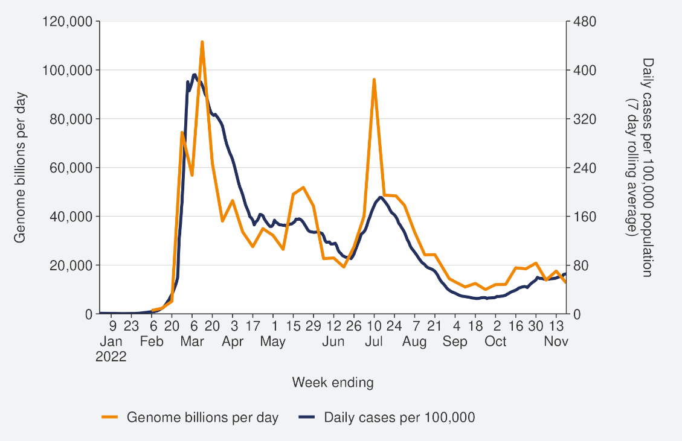
Sources: ESR SARS-CoV-2 in wastewater update for week ending 20 November 2022 and NCTS/EpiSurv as at 2359hrs 20 November 2022

Figure 2: COVID-19 Modelling Aotearoa scenarios compared with national reported case numbers with 10% higher transmission
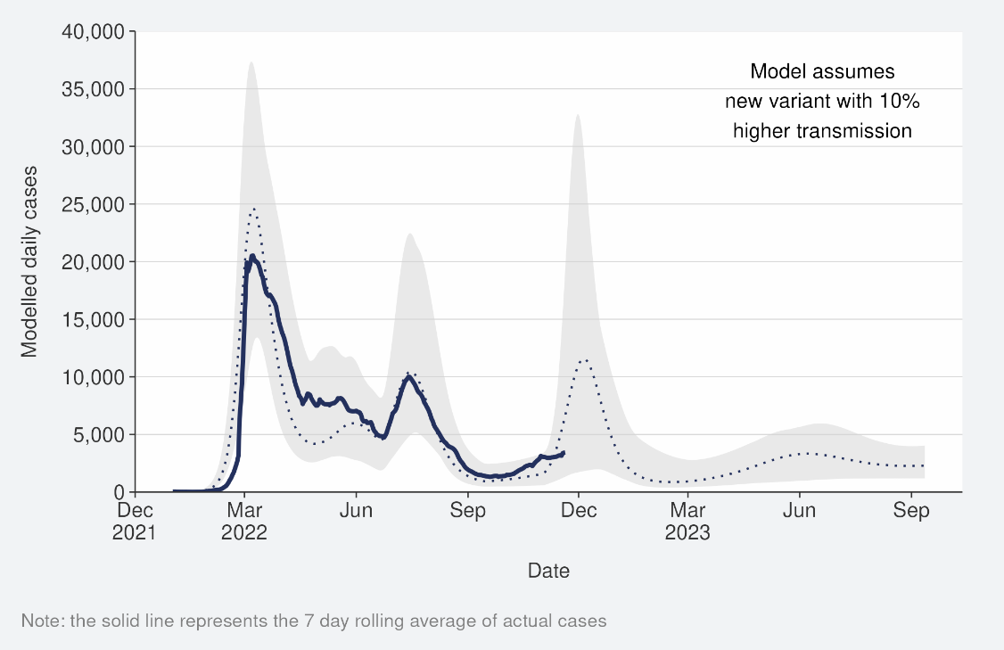
Sources: COVID-19 Modelling Aotearoa, ordinary differential equation model, October 2022, and NCTS/EpiSurv as at 2359hrs 20 November 2022
Figure 3: COVID-19 Modelling Aotearoa scenarios compared with national reported case numbers
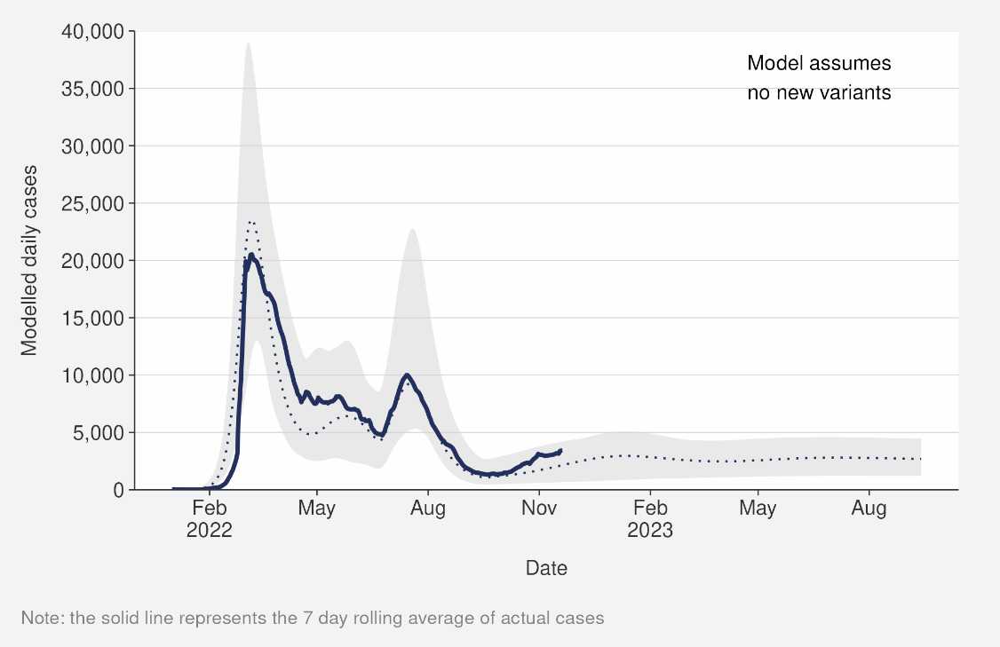
Sources: COVID-19 Modelling Aotearoa, ordinary differential equation model, October 2022, and NCTS/EpiSurv as at 2359hrs 20 November 2022

Figure 4: Regional reported case rates from 01 January to 20 November 2022
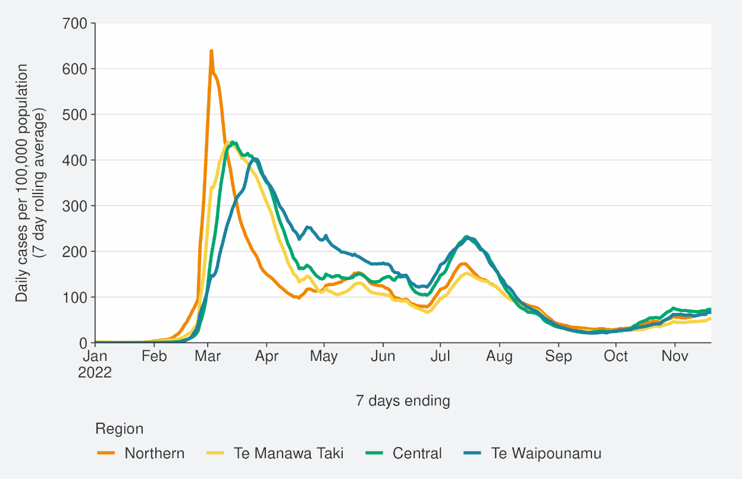
Source: NCTS/EpiSurv as at 2359hrs 20 November 2022

Figure 5: National reported case rates by age from 01 January to 20 November 2022
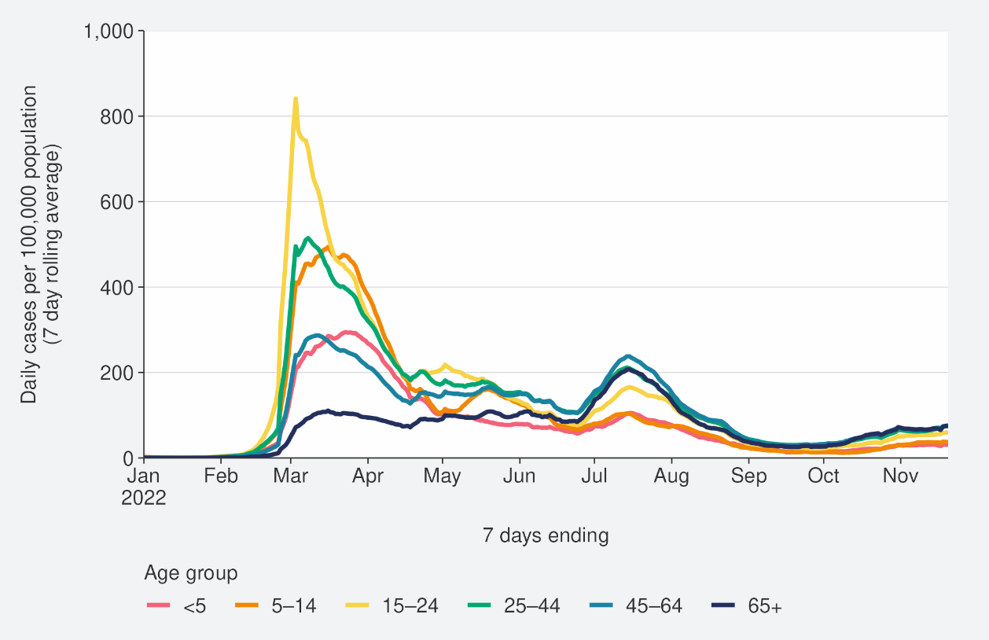
Source: NCTS/EpiSurv as at 2359hrs 20 November 2022

Hospitalisation and mortality trends

Hospitalisation
As seen in Figure 6, the national COVID-19 hospital admissions rate ‘for’ COVID-19, decreased substantially from mid-July but increased since early October. In the week ending 13 November, the 7-day rolling average of hospital admissions was 1.2 per 100,000 population, similar to the previous week. The rate was highest in the 65+ age group (3.8 per 100,000).
Despite reported case rates in the most recent July peak being half that of the March peak (201.2 and 413.2 per 100,000, respectively), the hospitalisation rate in the July peak was not substantially lower than the hospitalisation rate in March. This can be explained by the strong association between age and poor outcomes after infection. The reported case rates in those aged >65 years peaked at 75% higher in July than in March (refer back to Figure 5).
Modelling scenarios suggest current hospital admissions are tracking at the higher range of the prediction and indicate admissions are expected to increase. The variant model is hypothetical but based on the properties of lineages recently reported overseas (Figure 7). Figure 8 shows the national hospital admissions and the modelled scenario which assumed no new variant.

Figure 6: National hospital admissions rate for COVID-19, 01 January to 13 November 2022
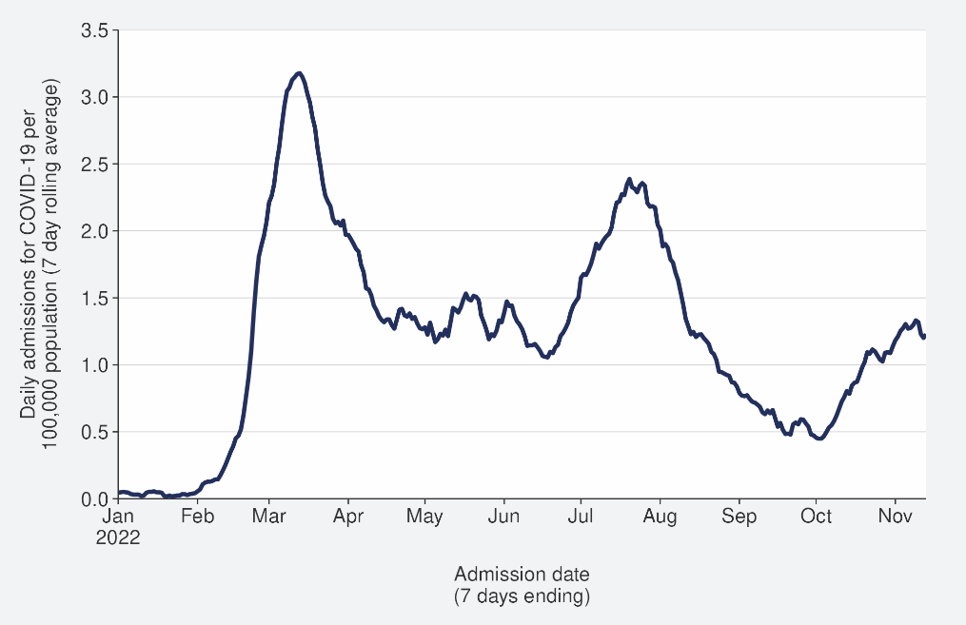
Source: NMDS/Inpatient’s admissions feed as of 14 November 2022 data up to 13 November 2022

Figure 7: COVID-19 Modelling Aotearoa hospital admissions scenario compared with national admissions with 10% higher transmission
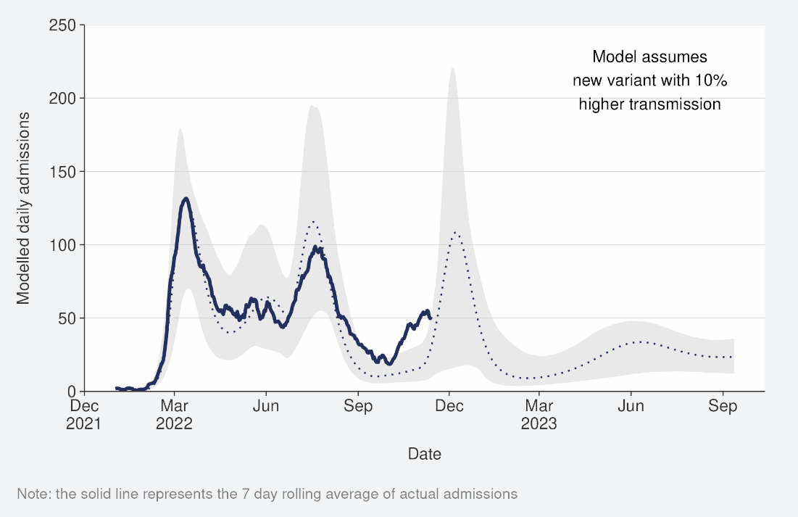
Sources: COVID-19 Modelling Aotearoa, ordinary differential equation model, October 2022, and Ministry of Health reported hospital admission data 13 November 2022
Figure 8: COVID-19 Modelling Aotearoa hospital admissions scenario compared with national admissions
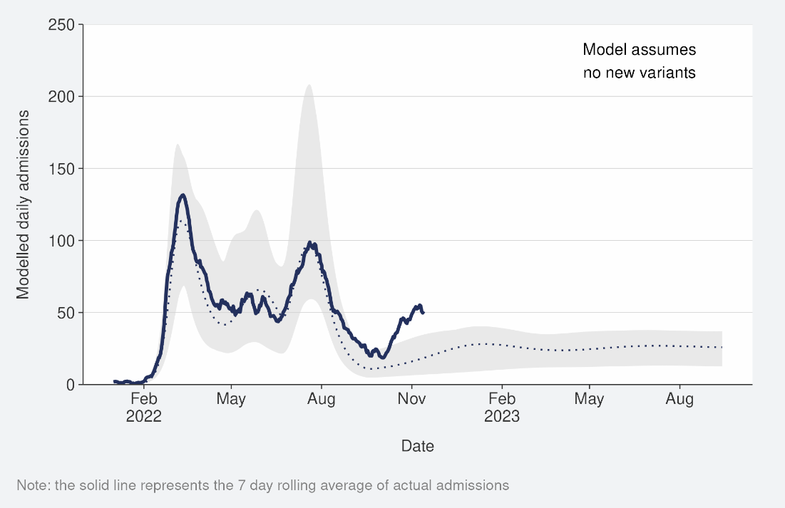
Sources: COVID-19 Modelling Aotearoa, ordinary differential equation model, October 2022, and Ministry of Health reported hospital admission data 13 November 2022

Mortality
From the first week of January to 20 November 2022, there were 3,261 deaths among people who died within 28 days of being reported as a case and/or with the cause being attributable to COVID-19 (that is an underlying or contributory cause) (see Figure 9).
Of these deaths that have been formally coded by cause of death, 1,344 (48%) were determined to have COVID-19 as the main underlying cause. COVID-19 contributed to a further 784 (28%) deaths and another 694 (25%) people died of an unrelated cause (Figure 9); As of 20 November, there were 2,128 deaths attributed to COVID-19 in 2022. The 80+ age group had the highest mortality rate across all age groups (0.7 per 100,000) for the week to 10 November. Deaths have been declining since peaking in the last week of July, though in the past few weeks this trend has stabilised and slightly increased. As seen with hospitalisations, due to the strong association of increasing age and increasing mortality risk, the patterns in mortality over time strongly reflect the case rates in those aged >65 years.
Deaths are currently tracking close to the median of the modelled scenario and may increase in the coming months if variant assumptions are borne out in the New Zealand context (see Figure 10).
Figure 11 shows the national death count and the modelled scenario which assumed no new variant.

Figure 9: National weekly death counts by cause of death, 01 January to 20 November 2022
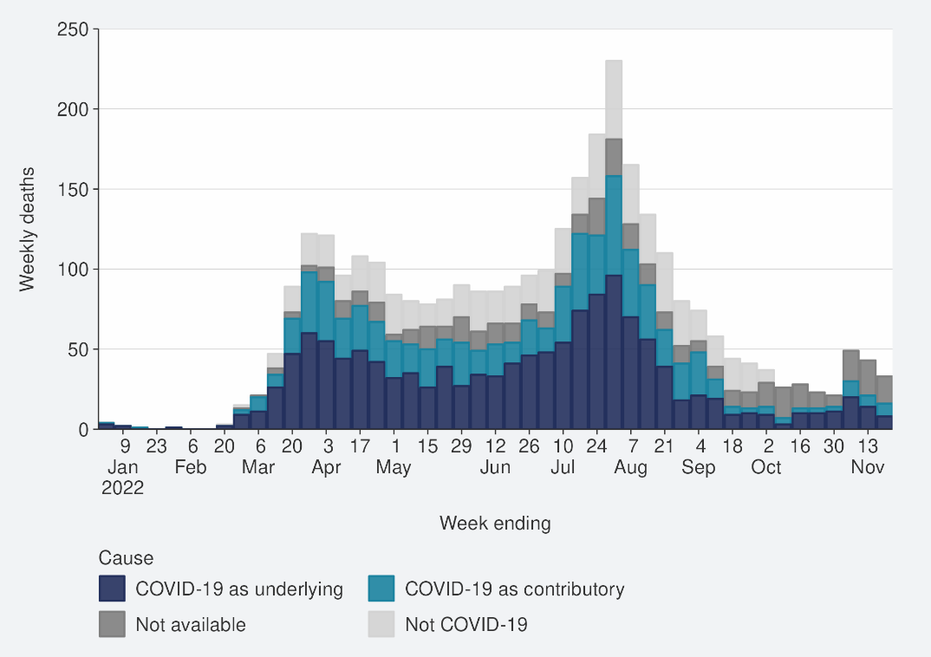
Source: Ministry of Health, 20 November 2022

Figure 10: COVID-19 Modelling Aotearoa death count compared with national observed deaths attributed to COVID-19
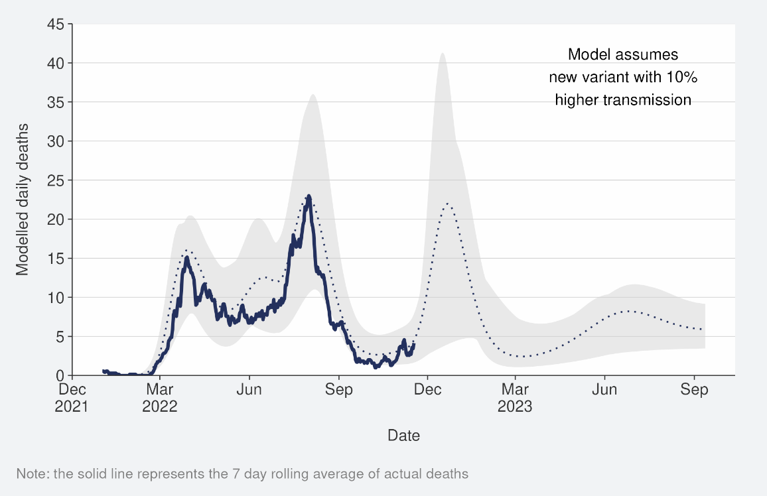
Sources: COVID-19 Modelling Aotearoa, ordinary differential equation model, October 2022, and Ministry of Health reported attributed deaths data 13 November 2022

Figure 11: COVID-19 Modelling Aotearoa death count compared with national observed deaths attributed to COVID-19

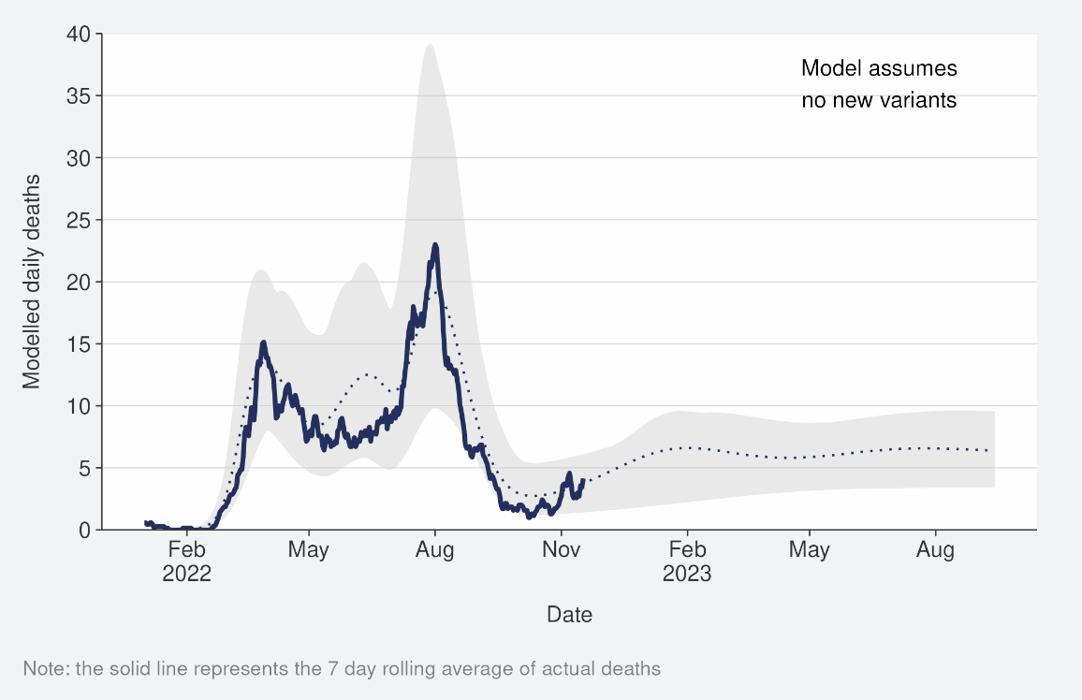
Sources: COVID-19 Modelling Aotearoa, ordinary differential equation model, October 2022, and Ministry of Health reported attributed deaths data 13 November 2022

Whole Genomic Sequencing

Wastewater and Community cases
Whole genomic sequencing data were updated on a fortnightly basis; the data have been updated in last week’s report.
Wastewater variant analysis for the fortnight ending 13 November reports the following proportions: BA.4/5 56%, BA.2.75 24% and BQ.1.1 17%, BA.2 0%, XBB 7%. Figure 12 shows the proportions of variants in community cases, with BA.5 accounting for 66% of sequenced cases in the week to 11 November. Proportions of the BA.5 subvariant in the community have continued to decrease over the last few weeks, as the proportion of other variants increase: BA.2.75 (13%), BQ.1.1 (10%), and XBB (3%). Additionally, 8 cases were identified with recombinant lineage XBC, none were recorded as hospitalised. XBC is a recombinant lineage of Delta and Omicron variants and has been present in Australia and South-East Asia for some time, with no indication of increased disease severity.
Figure 12: Proportion of Variants of Concern in community cases
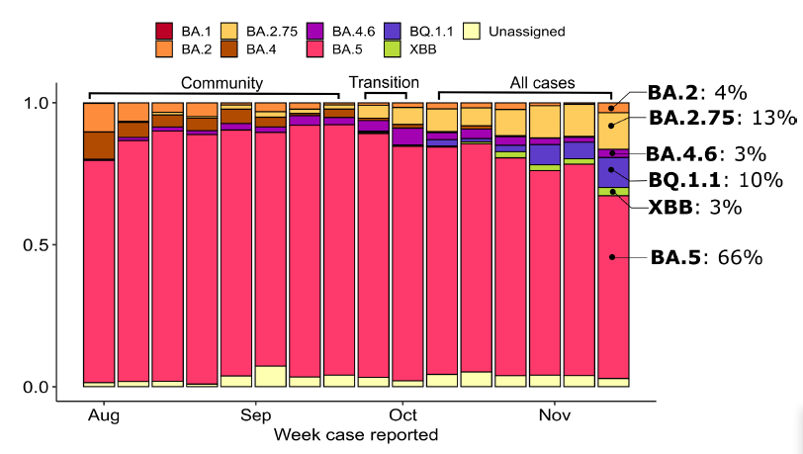
Source: ESR COVID-19 Genomics Insights Report #27, EpiSurv/Microreact 0900hrs 11 November 2022

Hospitalised cases
Of samples collected from PCR positive hospital admissions for the fortnight ending 11 November 203/378 samples were successfully sequenced. As of 16 November; 75% were BA.5, 11% BA.2.75, 5% BQ.1.1, 3% BA.4.6, 2% XBB and <2% were BA.2.

Overall Variant Risk Status
In the second half of 2022, many new Omicron sub-variants have been reported. These variants demonstrate convergent evolution which is a process whereby variants from different lineages accumulate similar mutations. Mutations in the spike protein appear to be responsible for the enhanced characteristics of these variants, compared to previous Omicron variants.

Although many of these new sub-variants demonstrate a transmission advantage over earlier sub-variants (which can come from increases in innate transmissibility or from immune evasion), there is currently no evidence of an increase in severity of disease caused by these variants.

Subvariants detected in cases in New Zealand such as BQ.1.1, BA.2.75 sub-lineages (including CH.1.1), XBB and XBC. BQ.1.1 and XBB have demonstrated substantial immune evasion in laboratory testing compared to prior Omicron variants. Cases of these subvariants are likely to increase relative to BA.5 in the coming weeks. CH.1.1 may have driven growth in BA.2.75 and its sub-variants in New Zealand in November and is likely to further increase (relative to BA.5). However, it is unknown if one or more variants will cause a wave or produce overall higher baseline incidence.

There is no strong evidence of an increase in disease severity associated with these variants.

Refer to the appendix for further details on the risk assessments for BQ.1.1 and XBB, respectively.

Further information on variants of concern is also available on the Ministry of Health COVID-19 Science News Webpage.

Reinfection

‘Reinfection’ is now defined as a case reported at least 29 days after the last time a person reported a positive test for COVID-19. The definition of reinfection changed on 30 June; prior to this, reinfection was based on reports at least 90 days apart (based on the international literature at the time). Up until 30 June 2022, the vast majority of positive results detected within 90 days of the prior infection were not recorded in the system. Some potential reinfections within 90 days were recorded but were not representative of the general population.
In general, reinfection refers to a second or subsequent infection after the prior infection has cleared. In this analysis, we are not able to distinguish between reinfection with the same variant or different variants. Reinfection with a different variant to the first infection is more likely than reinfection with the same variant. Technically, these data report on ‘redetections’ rather than true reinfections. True reinfections cannot be definitively captured in the data for a range of reasons. For example, a person with persistent infection due to being immunocompromised, who undergoes repeated testing due to regular hospital or clinical visits, would appear in the data as a ‘reinfection’ when they may have a chronic or persistent infection.
Figure 13 characterises the average number of cases per week by first infection and reinfection. Reinfections made up 20.0% of reported cases in the week ending 20 November. The proportion of reported cases that were reinfections has increased in the last two weeks, after being stable in the prior seven weeks. Figure 14 shows how many first infections and reinfections have been reported cumulatively over time. Cumulatively, reinfections have made up 3.0% of total cases reported in 2022. The proportion of cases that are reinfections is expected to increase over time. The true number of reinfections is likely higher than reported here. In general, reporting of cases is expected to decline over time. Due to under-ascertainment of the first infection and subsequent infections and, as both are required to detect a reinfection, there is likely to be under-reporting of reinfections.

Figure 13: Reinfections 7 day rolling average from 01 January to 20 November 2022
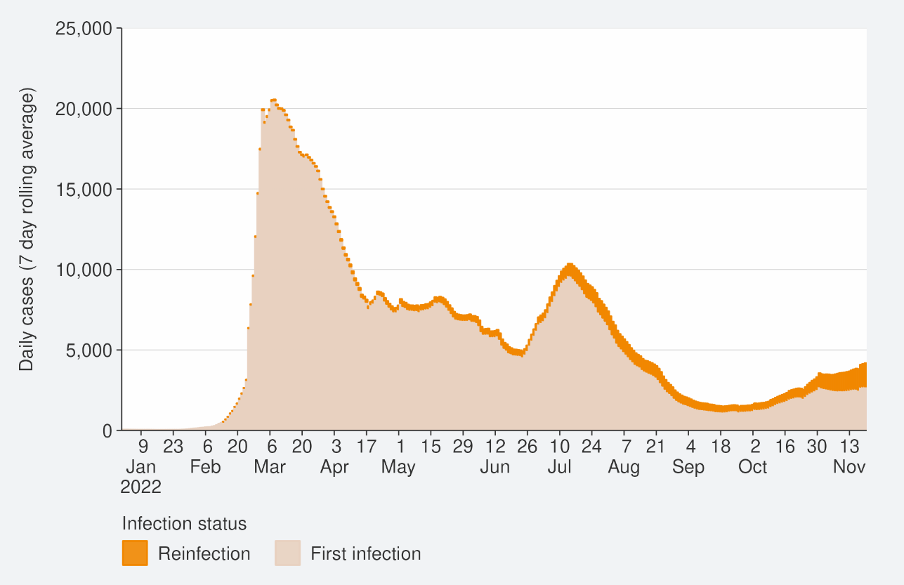
Source: NCTS/EpiSurv as at 2359hrs 20 November 2022

Figure 14: Reinfections cumulatively from 01 January to 20 November 2022
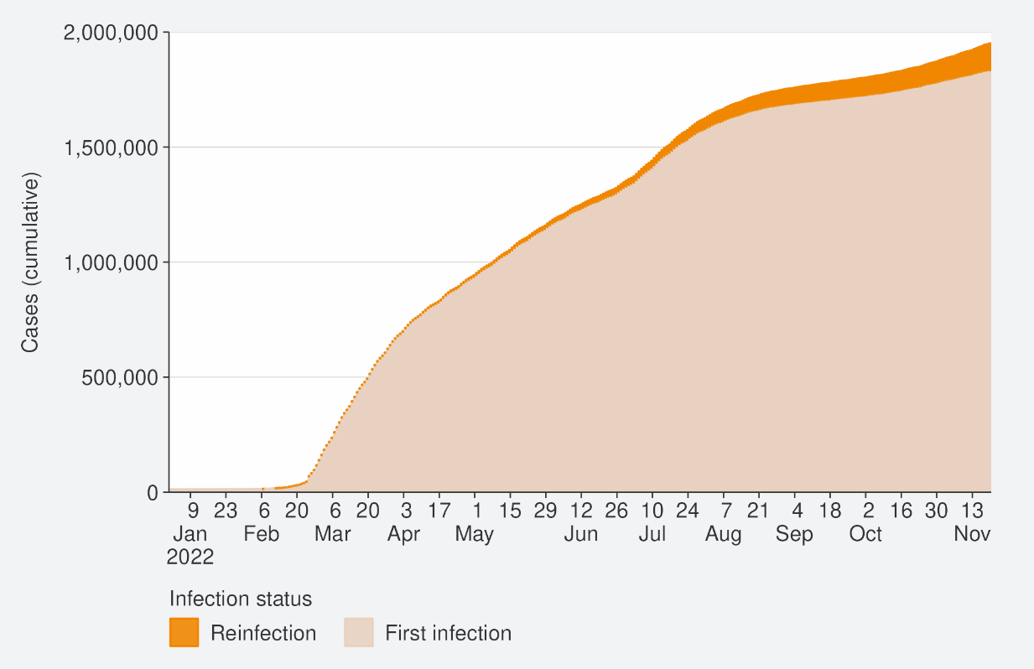
Source: NCTS/EpiSurv as at 2359hrs 20 November 2022

Comparison of epidemic trends by ethnicity
The age-standardised reported case rates have increased for all ethnicities (see Figure 15), in the week to 20 November. The highest rates were in European or Other and Asian (64.1 and 62.4 per 100,000 respectively) and the lowest were in Māori and Pacific peoples (51.8 and 49.3 per 100,000, respectively). Among Māori, rates were highest in those aged 45-64 and 25-44 (68.5 and 67.5 per 100,000, respectively). Among European or Other, case rates were highest in those aged 65+ and 45-64 (82.4 and 77.0 per 100,000, respectively). Among Pacific peoples, rates were highest in those aged 25-44 and 45-64 (70.6 and 66.3 per 100,000, respectively). Refer to in the appendix for non-age-standardised rates by ethnicity.
Figure 16 shows that the age standardised rates for hospitalisation for COVID-19 increased for Māori and European or Other ethnicity; case rate decreased for Pacific peoples and Asian ethnicities in the week ending 13 November. Māori had the highest hospitalisation rates in the week ending 13 November, followed by Asian ethnicities, European or Other and Pacific peoples. Within the Māori ethnicity, the 7-day rolling average of hospitalisation to 13 November was 1.3 per 100,00 and was highest in those aged 80+ (6.2 per 100,000), followed by those aged 70-79 (4.8 per 100,000). For Pacific peoples, the 7-day rolling average of hospitalisation to 13 November was 0.9 per 100,000 and was highest in those aged 80+ (13.6 per 100,000), followed by those aged 70-79 (3.6 per 100,000).
The cumulative total for the year shows that overall, Pacific peoples and Māori have had the highest risks of hospitalisation for COVID-19, 2.2 and 1.8 times the risk of European or Other, respectively for 01 January to 20 November. Asian people have had a hospitalisation rate almost 11% lower than European or Other (Figure 17).
The cumulative age-standardised mortality rate for 01 January to 20 November shows that Pacific peoples have had the highest risk, 2.4 times that of European or Other, followed by Māori at 1.9 times that of European or Other. Asian people have had the lowest risk of Mortality, 39% lower than European or Other (see Figure 18).
The lower reported case rates and higher hospitalisation and death rates for Māori and Pacific peoples suggests they may have lower levels of case ascertainment and/or a higher risk of poor outcomes after infection compared with Asian and European or Other ethnicities.

Figure 15: National age-standardised reported case rates by ethnicity from 01 January to 20 November 2022
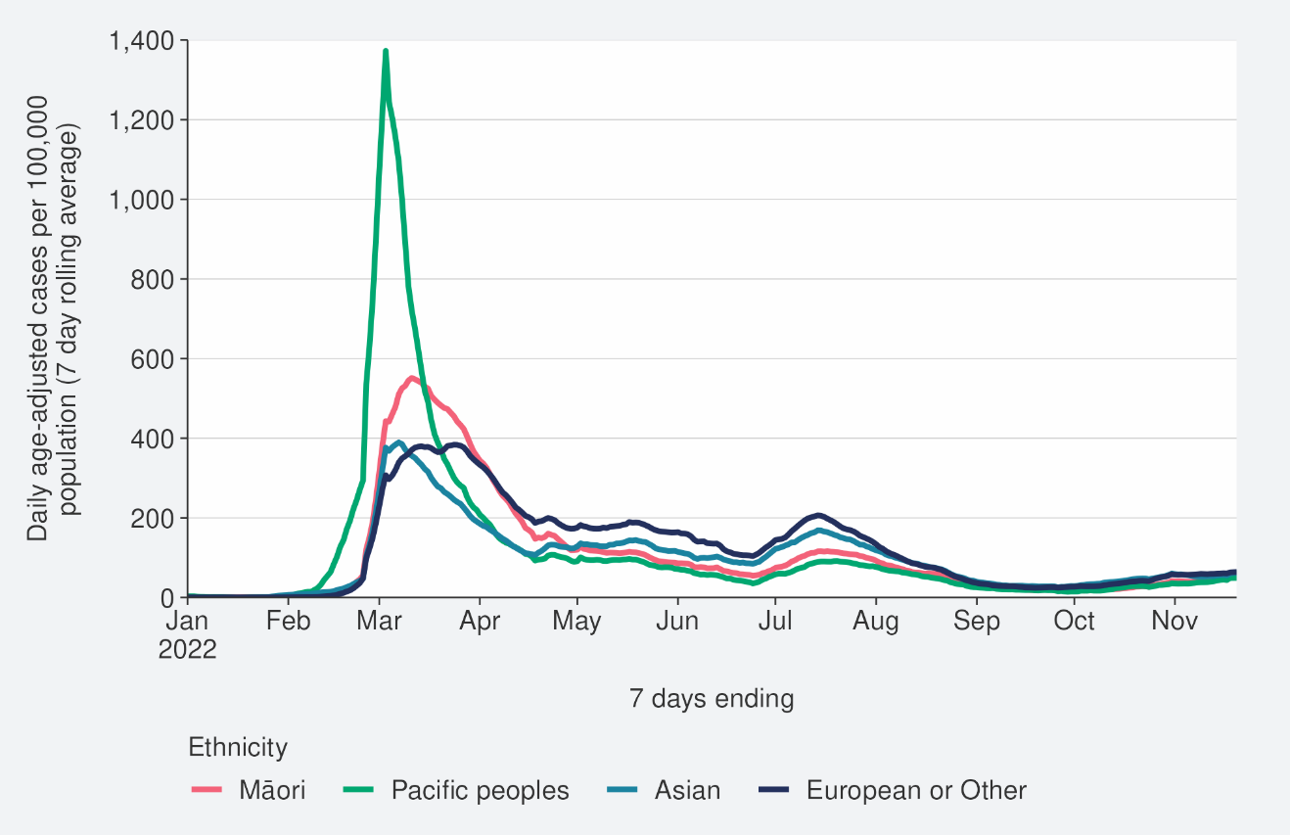
Source: NCTS/EpiSurv as at 2359hrs 20 November 2022

Figure 16: National age-standardised hospitalisation rates by ethnicity from 01 January to 13 November 2022
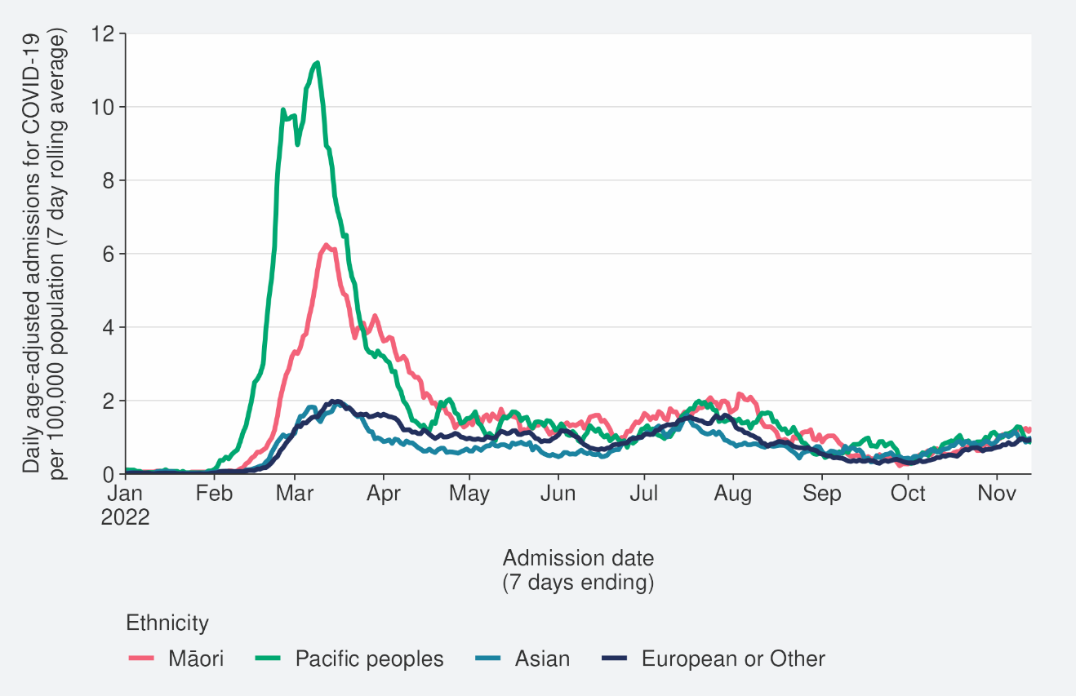
Source: NCTS/EpiSurv as at 2359hrs 13 November 2022

Figure 17: Age-standardised cumulative incidence (and 95% confidence intervals) of hospitalisation for COVID-19 by ethnicity, 01 January 2022 to 20 November 2022
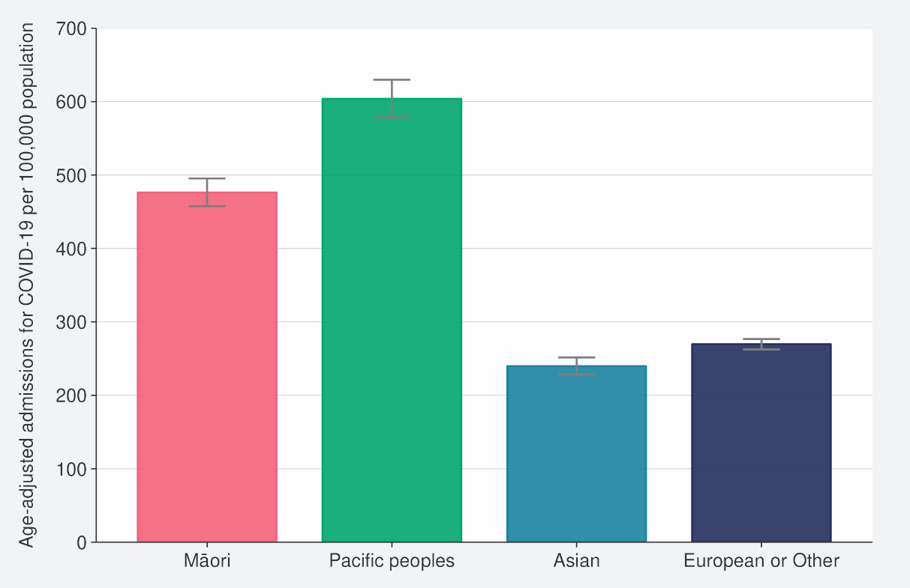
Source: NCTS/EpiSurv, NMDS, Inpatient Admissions dataset and CVIP population estimates, 01 January 2022 to 20 November 2022

Figure 18: Age-standardised cumulative incidence (and 95% confidence intervals) of mortality attributed to COVID-19 by ethnicity, 01 January 2022 to 20 November 2022
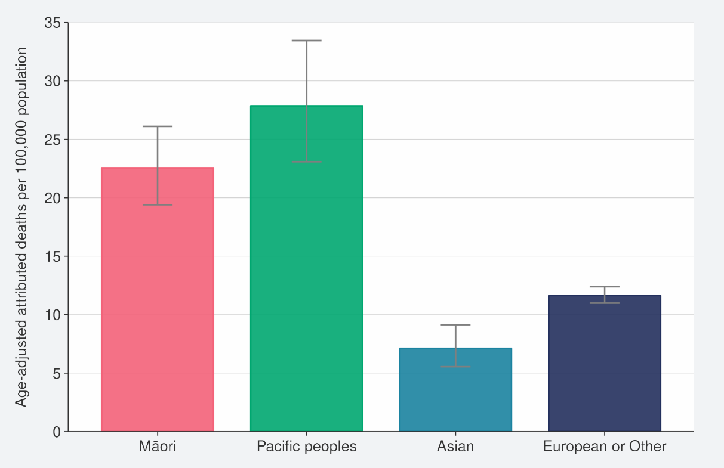
Source: NCTS/EpiSurv, NMDS, Inpatient Admissions dataset and CVIP population estimates, 01 January 2022 to 20 November 2022

Comparison of epidemic trends by deprivation
Figure 19 shows the 7-day rolling average for reported case rates by residential area deprivation level (based on NZDep2018). Age-standardised case rates increased in all deprivation levels in the week ending 20 November. Refer to the appendix for non-age-standardised rates by deprivation.
Figure 20 and Figure 21 show that those most deprived have had, and continue to have, the highest rates of hospitalisation, both recently and cumulatively during 2022. Those most deprived have had around 2 times the risk of hospitalisation compared with those who are least deprived.
Cumulative rates of mortality are also highest for those most deprived; 2.4 times higher than the risk of those least deprived (Figure 22).
As lower case rates have been reported among those most deprived, continued higher hospitalisation and death rates suggest those who are most deprived may have lower levels of case ascertainment and/or a higher risk of poor outcomes after infection compared with those who are least deprived.

Figure 19: National age-standardised reported case rates by deprivation status for weeks 01 January to 20 November 2022
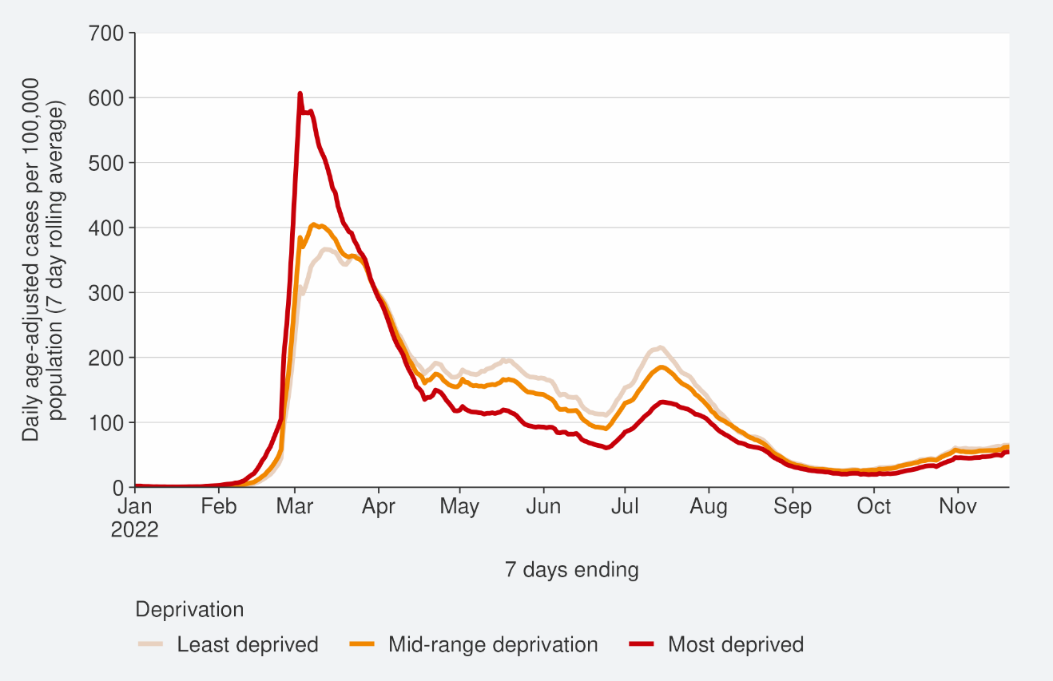
Source: NCTS/EpiSurv as at 2359hrs 20 November 2022

Figure 20: Age-standardised hospital admission rates for COVID-19 by deprivation from 01 January to 13 November 2022
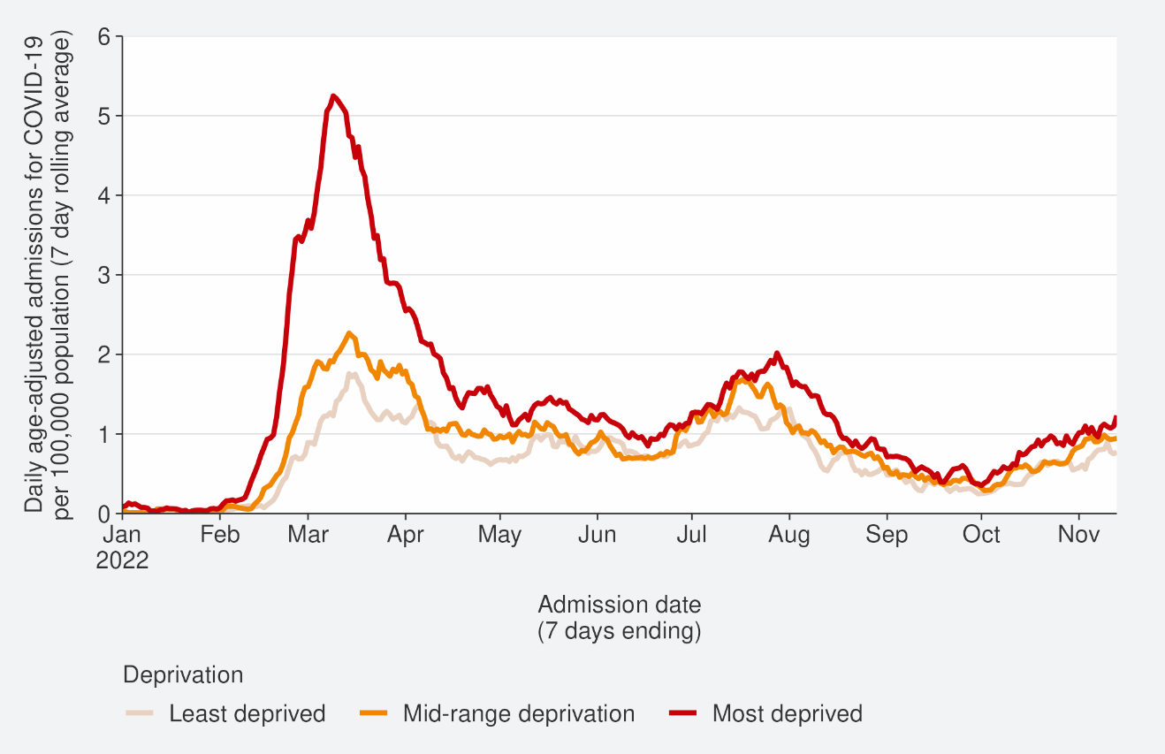
Source: NMDS/Inpatients admissions feed as of 20 November 2022 data up to 13 November 2022
Figure 21: Age-standardised cumulative incidence (and 95% confidence intervals) of hospitalisation for COVID-19 by deprivation, 01 January 2022 to 20 November 2022
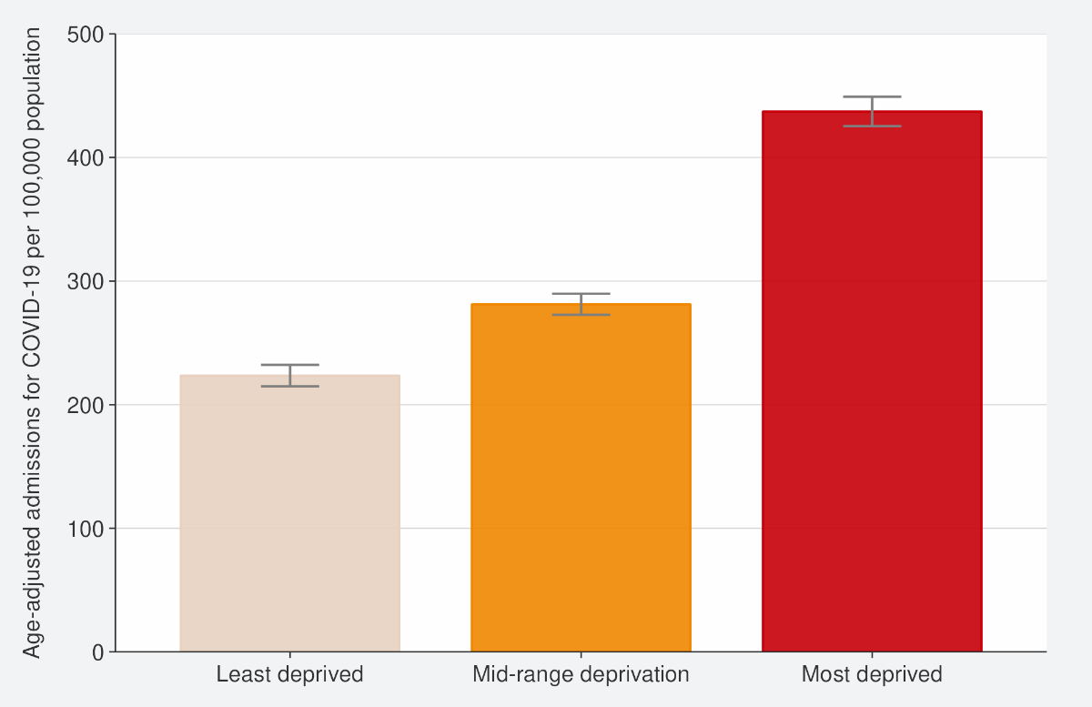
Source: NCTS/EpiSurv, NMDS, Inpatient Admissions dataset and CVIP population estimates 01 January 2022 to 20 November 2022

Figure 22: Age-standardised cumulative incidence (and 95% confidence intervals) of mortality attributed to COVID-19 by deprivation, 01 January 2022 to 20 November 2022
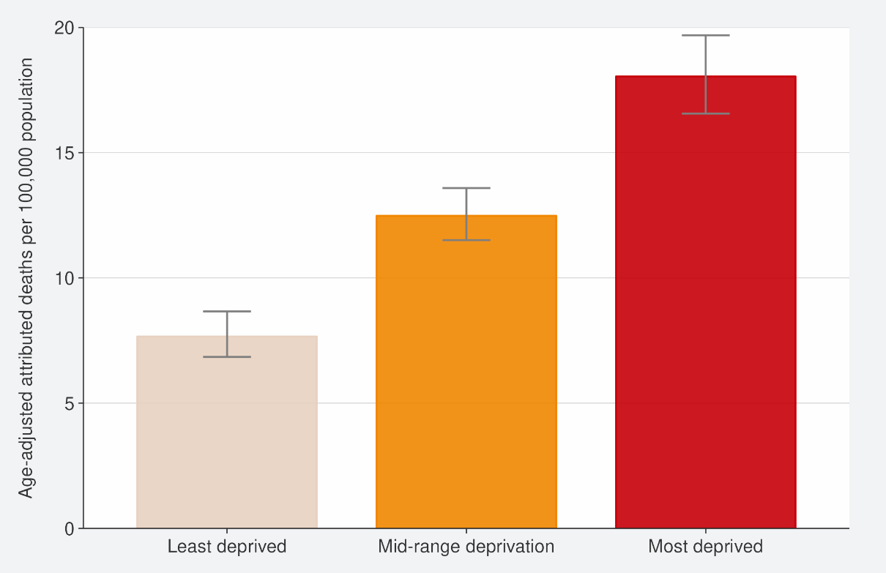
Source: EpiSurv, Death Documents, The Healthcare User database, Mortality Collections database and CVIP population estimates, 01 January 2020 to 20 November 2022

Global pandemic summary
Over the next few months, we expect the global situation for the COVID-19 pandemic to be driven by the ongoing emergence of new variants, waning immunity, and particularly with the Northern Hemisphere heading into winter.
- Globally, in the week ending 20 November, the number of new weekly cases decreased by 5% as compared to the previous week, with over 2.4 million new cases reported. However, the true number of incident cases is likely to be underestimated due to a decline in testing internationally.
- The number of new weekly deaths decreased by 13% as compared to the previous week, with over 7,800 new fatalities reported.
- As of 20 November 2022, over 634 million confirmed cases and 6.6 million deaths have been reported globally
- The global variant circulation indicates slow replacement of previously dominating BA.5 descendent lineages by the most recently emerging variants BQ.1 and XBB (a recombinant of BA.2.10.1 and BA.2.75)
- BA.5 and its descendent lineages continued to be dominant globally, accounting for 72.1% of sequences submitted to GISAID as of 06 November.
- BA.4 descendent lineages accounted for 3.6% of all cases, similar from last week as of 06 November.
- BA.2 descendent showed an increase of sequence prevalence from 6.4% to 9.2% for the week ending 06 November from the previous week.
- BQ.1 sequences increased from 19.1% to 23.1% in the week ending 06 November. Similarly, the prevalence of XBB sequences also increased, rising from 2.0% to 3.3% during the same reporting period.
- Unassigned sequences (presumed to be Omicron) account for 12.2% of sequences submitted to GISAID as of 06 November.
- In Australia, as of 18 November, cases and hospitalisations increased. In the 7 days to 18 November 2022, there were 482 new cases per 100,000 population. This was a large increase from the week prior (14 days to 11 November 2022) where there were 338 per 100,000 population.
- The Carnival Cruise Lines reintroduced COVID-19 mandates on Australian ships after a surge in cases. Masks are required on vessels in public indoor spaces and some outdoor settings (including events, during embarking and disembarking and on transfers). Additionally, 100% of crew and 95% of passengers over 12 years old must be fully vaccinated. Carnival Cruise Line operates 25 ships around the world including Majestic Princess which infected 800 people before the passengers disembarked in Sydney on 11 November 2022.
Sources: Weekly epidemiological update on COVID-19 - 23 November 2022 (who.int) / Australian Government: Coronavirus (COVID-19) common operating picture / The Guardian

Please note, global trends in cases, hospitalisations and deaths should be interpreted with caution as several countries have been progressively changing COVID-19 testing strategies, resulting in lower overall numbers of tests performed and consequently lower numbers of cases detected. Furthermore, approaches of counting hospitalisations and deaths can differ from country to country.

Appendix: Table of summary statistics
Table 1: Reported 7-day rolling average of case rates and hospital admissions by region, age group, ethnicity, and deprivation
 | Reported Cases (7-day rolling average) |  |  |  |  | Hospital admissions (7-day rolling average)
 | Week ending 13/11/2022 |  | Week ending 20/11/2022 |  | % Change | Week ending 06/11/2022 |  | Week ending 13/11/2022 |  | % Change
 | Number | Rate (per 100,000 population) | Number | Rate (per 100,000 population) |  | Number | Rate (per 100,000 population) | Number | Rate (per 100,000 population)
National | 3080.4 | 58.9 | 3433.6 | 65.6 | 11.5% | 52.6 | 1.3 | 50.9 | 1.2 | -3.3%
Region
Northern | 1,213.9 | 60.8 | 1,369.0 | 68.6 | 12.8% | 24.9 | 1.2 | 27.4 | 1.4 | 10.3%
Te Manawa Taki | 477.1 | 46.6 | 544.6 | 53.2 | 14.1% | 6.9 | 1.5 | 5.7 | 1.3 | -16.7%
Central | 661.6 | 67.6 | 713.9 | 73.0 | 7.9% | 4.3 | 0.9 | 4.3 | 0.9 | 0.0%
Te Waipounamu | 722.9 | 59.9 | 800.1 | 66.3 | 10.7% | 16.6 | 1.4 | 13.4 | 1.1 | -19.0%
Age group
<5 | 95.7 | 30.8 | 96.6 | 31.1 | 0.9% | 3.9 | 1.6 | 5.6 | 2.3 | 44.4%
5-14 | 250.4 | 36.9 | 254.9 | 37.6 | 1.8% | 2.0 | 0.4 | 2.0 | 0.4 | 0.0%
15-24 | 354.6 | 54.2 | 393.0 | 60.1 | 10.8% | 2.4 | 0.5 | 3.0 | 0.6 | 23.5%
25-44 | 950.3 | 64.6 | 1,100.6 | 74.9 | 15.8% | 5.7 | 0.5 | 8.4 | 0.7 | 47.5%
45-64 | 871.6 | 67.6 | 958.3 | 74.3 | 9.9% | 11.3 | 1.1 | 7.7 | 0.8 | -31.6%
65+ | 557.9 | 67.2 | 630.3 | 75.9 | 13.0% | 27.3 | 4.3 | 24.1 | 3.8 | -11.5%
Ethnicity
Māori | 363.7 | 45.3 | 415.6 | 51.8 | 14.3% | 5.9 | 1.1 | 6.6 | 1.2 | 12.2%
Pacific peoples | 166.9 | 42.7 | 201.9 | 51.6 | 21.0% | 4.3 | 1.2 | 3.3 | 0.9 | -23.3%
Asian | 471.0 | 56.5 | 553.3 | 66.3 | 17.5% | 7.6 | 1.0 | 7.4 | 1.0 | -1.9%
European or Other | 2,058.4 | 65.0 | 2,239.6 | 70.7 | 8.8% | 34.9 | 1.4 | 33.4 | 1.4 | -4.1%
Deprivation
Least deprived | 1,003.1 | 66.3 | 1,090.1 | 72.0 | 8.7% | 14.1 | 1.1 | 12.9 | 1.0 | -9.1%
Mid-range deprivation | 1,222.4 | 61.0 | 1,357.4 | 67.7 | 11.0% | 20.9 | 1.3 | 19.0 | 1.2 | -8.9%
Most deprived | 802.1 | 51.1 | 923.1 | 58.8 | 15.1% | 15.7 | 1.4 | 18.1 | 1.6 | 15.5%

Table 2: Cumulative reported cases and hospitalisations admissions from 01 January 2022 to 20 November by level 2 ethnicity.

Ethnicity | Level 2 Ethnicity | Cumulative reported cases of COVID-19 | Cases per 1,000 population | Cumulative  hospitalisation  for COVID-19 | Hospitalisations per 1,000 population | Population
Asian | Asian NFD | 9,234 | 414 | 30 | 1 | 22,320
Asian | Chinese | 63,659 | 271 | 519 | 2 | 235,331
Asian | Indian | 99,777 | 407 | 840 | 3 | 245,079
Asian | Other Asian | 48,480 | 398 | 329 | 3 | 121,732
Asian | Southeast Asian | 55,865 | 513 | 269 | 2 | 108,939
Māori | Māori | 279,249 | 366 | 3,322 | 4 | 762,780
MELAA | African | 10,148 | 385 | 125 | 5 | 26,364
MELAA | Latin American / Hispanic | 13,994 | 483 | 79 | 3 | 28,998
MELAA | Middle Eastern | 10,031 | 310 | 171 | 5 | 32,395
Pacific Peoples | Cook Island Māori | 19,644 | 369 | 298 | 6 | 53,299
Pacific Peoples | Fijian | 17,846 | 436 | 201 | 5 | 40,956
Pacific Peoples | Niuean | 8,046 | 413 | 121 | 6 | 19,477
Pacific Peoples | Other Pacific Island | 7,034 | 486 | 76 | 5 | 14,466
Pacific Peoples | Pacific Island NFD | 1,665 | 455 | 6 | 2 | 3,663
Pacific Peoples | Samoan | 69,070 | 446 | 1,081 | 7 | 154,997
Pacific Peoples | Tokelauan | 2,916 | 425 | 47 | 7 | 6,863
Pacific Peoples | Tongan | 30,211 | 416 | 524 | 7 | 72,703

Public Health Risk assessment for BQ.1.1 (Cerberus) and XBB (Gryphon)
The ‘Overall risk assessment’ is presented in comparison to the prior or current predominant variant, in this case BA.5. ‘Increased risk’ indicates the assessed variant as worse than the previous predominant variant with regards to that characteristic; ‘no change’ means that the assessed variant poses equivalent risk; and ‘decreased risk’ means that the assessed variant is better than the previous predominant variant.

‘Confidence level’ indicates the overall quality of data that are available to make the risk assessment: ‘High’ (high quality, robust data); ‘Moderate’ (good data with limitations); ‘Low’ (very little data available). ‘Insufficient data’ indicates that there are no data of reasonable quality on which to base an assessment at this time.

Table 3: Public Health Risk assessment for BQ.1.1 (Cerberus), 16 November 2022
BQ.1.1 is related to BA.5.3 but with Spike protein mutations 444T, 460K, 346T

 | Overall risk assessment | Confidence level | Assessment and rationale
Overall growth advantage | Increased risk | Moderate | Evidence of a growth advantage compared to BA.5.  BQ.1.1 variant has an estimated growth advantage of 63% per week (95% Credible Interval: 59 – 68) compared to BA.5 in the UK (on 20 October 2022).  Currently present in New Zealand and is growing relative to BA.5. In the fortnight ending 11 November 2022 it made up 10% of sequenced cases and 5% of isolates from hospital cases.
Transmissibility | Insufficient data | Insufficient data | No direct data on intrinsic transmissibility and there is no current ability to measure from surveillance data. There is some laboratory evidence that ACE2 binding is increased for BQ.1.1 compared to prior Omicron variants which may affect transmissibility/infectivity.
Immune evasion | Increased risk | Moderate | Evidence of increased immune evasion.  More resistant to neutralisation from sera of vaccinated and breakthrough infected individuals. At least 2 small studies show that mRNA bivalent BA.4/5 vaccine produces robust neutralising activity against BQ.1.1 compared to monovalent wild type vaccine.
Severity | Insufficient data | Insufficient data | No evidence of a change in severity compared to BA.5  Evidence from a surge of cases of this variant in France suggests it is not causing increased rates of hospitalisations and deaths.
Therapeutics | Increased risk | Low | One in vitro study showed loss of efficacy of all currently approved clinical monoclonal antibody therapies including Evusheld and Bebtelovimab.
Testing | Insufficient data | Insufficient data | Evidence that suggests a clinically relevant decrease in the performance of RATs for detection of the Omicron variant (varies by device), but it is uncertain how this will affect sensitivity specifically for BQ.1.1.
Overall Assessment | There is an increase in overall risk from the previous predominant variant, BA.5. (Moderate confidence)  BQ.1.1 is increasing in frequency overseas and appears to be more transmissible and immune evasive.

Source: SARS-CoV-2 Variants of Concern Update – Manatū Hauora, Ministry of Health

Table 4: Public Health Risk assessment for XBB (Gryphon), 16 November 2022

XBB is a recombinant virus (related to BA.2 and BJ.1) with additional spike protein mutations 364T, 445P, 446S and 490V

 | Overall risk assessment | Confidence level | Assessment and rationale
Overall growth advantage | Increased risk | Low | Evidence of a growth advantage compared to BA.5  Cases are increasing in Singapore against a background of BA.5.  Currently present in New Zealand and is growing. In the fortnight ending 11 November 2022 it made up 3% of all sequenced cases and 2% of isolates from hospital cases.
Transmissibility | Insufficient data | Insufficient data | No direct data on intrinsic transmissibility and there is no current ability to measure from surveillance data. There is some laboratory evidence that ACE2 binding is increased for XBB compared to prior Omicron variants which may affect transmissibility/infectivity.
Immune evasion | Increased risk | Moderate | Evidence of increased immune evasion.  More resistant to neutralisation from sera of vaccinated and breakthrough infected individuals.
Severity | Insufficient data | Insufficient data | In late October 2022 the World Health Organization Technical Advisory Group on SARS-CoV-2 Virus Evolution noted that current (limited) information does not indicate an increase in severity for XBB.
Therapeutics | Increased risk | Low | One in vitro study showed loss of efficacy of all currently approved clinical monoclonal antibody therapies including Evusheld and Bebtelovimab.
Testing | Insufficient data | Insufficient data | Evidence that suggests a clinically relevant decrease in the performance of RATs for detection of the Omicron variant (varies by device), but it is uncertain how this will affect sensitivity specifically for XBB.
Overall Assessment | No change in risk

Source: SARS-CoV-2 Variants of Concern Update – Manatū Hauora, Ministry of Health

Since 24 February 2022, most testing has been through self-administered rapid antigen tests (RATs) which require self-reporting of results. Therefore, it is likely that many infections are not detected or reported, and the proportion of infections reported (‘reported cases’) may differ by age, ethnicity, and deprivation.
See the online glossary for modelling assumptions.
Wastewater levels cannot be used to predict numbers of cases but do indicate trends in the infection rates.
The ‘July’ BA.5 scenario assumes that previous infection provides greater protection against reinfection and severe disease, this is consistent with emerging international evidence. It also incorporates updated data and future projections of uptake of second boosters, and an earlier transition to BA.5, consistent with the timing of cases and hospitalisations in New Zealand.
New hospital admissions who had COVID-19 at the time of admission or while in hospital; excluding hospitalisations that were admitted and discharged within 24hrs. The ‘for’ measure excludes those who are identified as incidental with COVID-19, such as injuries. Recent trends are subject to revision. Please see glossary for further caveats.
Data are from Districts with tertiary hospitals; these Districts are Auckland, Canterbury, Southern, Counties Manukau, Waikato, Capital & Coast, Waitemata, and Northland.
The 'October’ scenario assumes previous infection provides greater protection against reinfection, severe disease, consistent with emerging international evidence, and transmissibility of an emerging variant is increased by 10%. It also incorporates updated data and future projections of uptake of second boosters, and an earlier transition to BA.5, consistent with the timing of cases and hospitalisations in New Zealand.
There were 55 deaths before the first week of 2022.
Mortality data are affected by a delay due to time taken for reporting and death coding, the most recent weeks should be interpreted with caution.
Before the end of the COVID-19 Protection Framework, only data from community cases are presented. In the period marked as “transition”, cases known to be associated with the border were removed, but not all such cases can be reliably identified. Since the transition, data from all cases is used. Results before and after this transition are not directly comparable.
These calculations are based on 2,128 deaths occurring between January 2022 and 20 November 2022 (excludes deaths in the last 2 weeks and deaths where ethnicity was unknown).
Atkinson J, Salmond C, Crampton P (2019). NZDep2018 Index of Deprivation, Final Research Report, December 2020. Wellington: University of Otago.
These calculations are based on 2,128 deaths occurring between January 2022 and 20 November 2022 (excludes deaths in the last 2 weeks and deaths where the level of deprivation was unknown).
‘Other’ referring to all ethnicities other than Māori, Pacific peoples, Asian and European, specifically MELAA; Middle Eastern, Latin American and African. See Table 2 for breakdowns of MELAA ethnicities.

