Appendix 1

PRESCRIBING WITHOUT A SIGNATURE

Prescription Using NZePS

Key Requirements
Details of prescription:
- the prescription is a NZePS barcoded prescription
- the prescription is issued from a system authorised by the Manatū Hauora for electronic prescribing
- the barcode on the prescription is used at the point of dispensing at the community pharmacy.

How can I spot a legal Signature Exempt Prescription?
Signature Exempt NZePS Prescriptions will always have an NZePS barcode. Some may have the text “Signature Exempt” on the signature line, and others may not yet have this. But the presence of the NZePS barcode is the definitive sign that a prescription meets the requirements of the legislation once the barcode is used at the time of dispensing legal, even if it doesn’t have a signature.

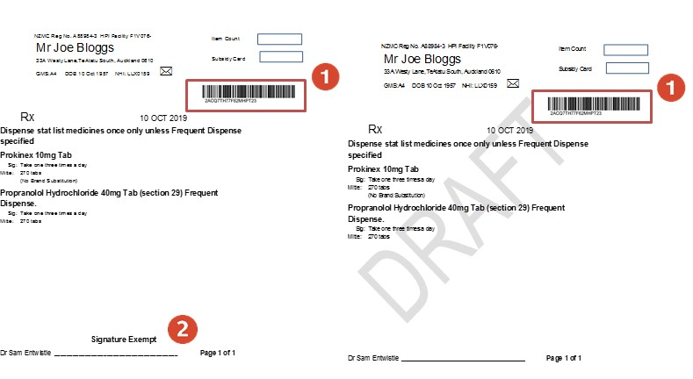
The electronic prescription has an NZePS barcode which is used at the point of dispensing at the Pharmacy. This barcode may be on the top of the prescription or the bottom.
On some electronic prescriptions, a label for “Signature Exempt” may appear on the signature line. If this label is not present, the prescription is still legal.

Electronic Prescription Direct to Pharmacy for Non-NZePS systems (until 31 October 2024)

Key Requirements
Details of prescription:
- the prescription must not include Controlled Drugs (Class A, B or C) (with the exception of Class C exempt or partially exempt controlled drugs)
- the prescription contains the prescriber’s registration authority number
- the prescription contains contact details of the prescriber
- the prescription must contain the statement “This Prescription meets the requirement of the Director-General of Health’s authorisation of October 2022 for prescriptions not signed personally by a prescriber with their usual signature”.

How to issue?
- The prescription must be generated by an electronic system that requires the prescriber to log on with a unique ID and password
- The prescription must be in a format that cannot be easily altered e.g. PDF, photograph.
- The prescription must be sent directly to the community pharmacy using a secure, electronic system that identifies the prescriber’s name and facility e.g. secure email or prescription must be faxed from a number that is recognised by the pharmacy as a valid prescriber. 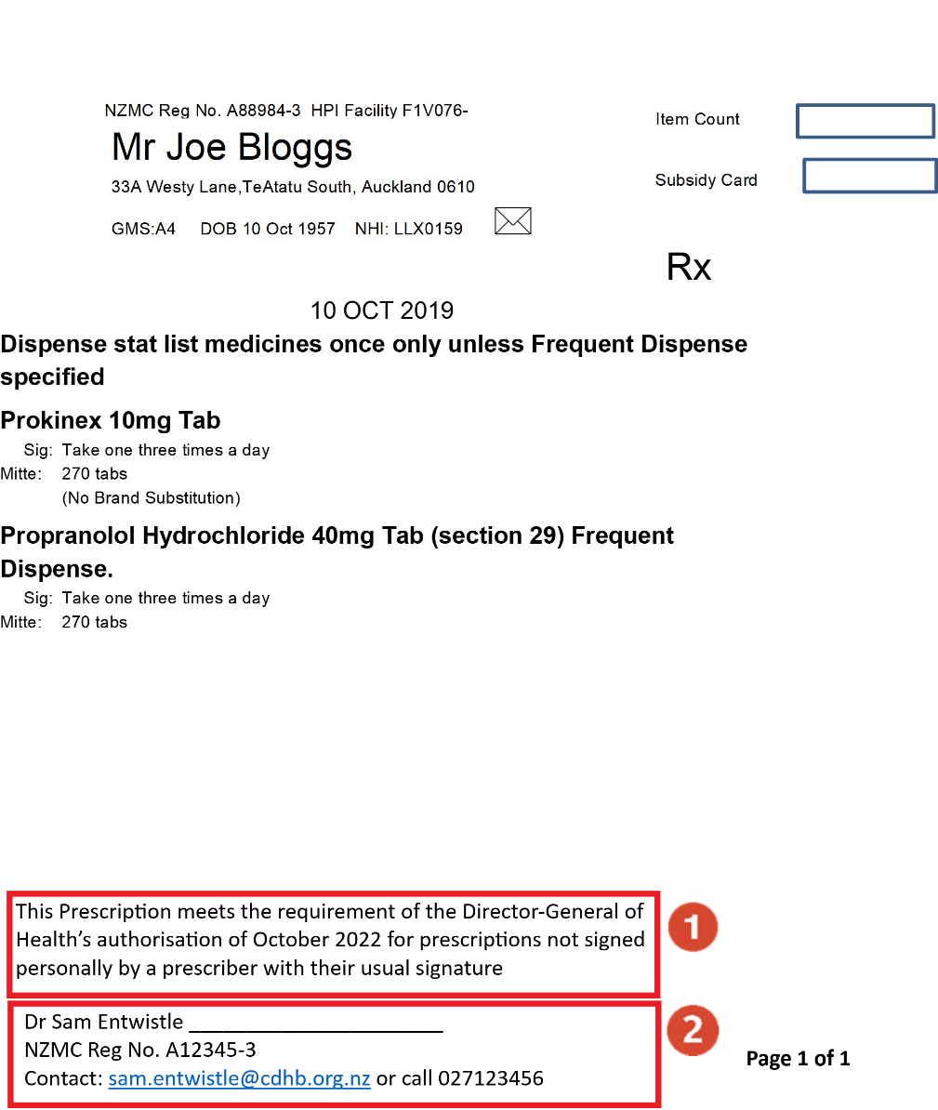

On electronic prescriptions without a barcode, there must be a statement that “This Prescription meets the requirement of the Director-General of Health’s authorisation of October 2022 for prescriptions not signed personally by a prescriber with their usual signature “
The prescription must also have:
- The registration authority number of the Prescriber (e.g. NZMC)
- The contact details of the prescriber.

- be faxed from a number that is recognised by the pharmacy as a valid prescriber.

On electronic prescriptions without a barcode, there must be a statement that “This Prescription meets the requirement of the Director-General of Health’s authorisation of October 2022 for prescriptions not signed personally by a prescriber with their usual signature “
The prescription must also have:
- The registration authority number of the Prescriber (e.g. NZMC)
- The contact details of the prescriber.

