In-Between Travel   
Update

Information for providers/employers and funders

August 2023

Citation: Ministry of Health. 2020. *In-Between Travel Update: Information for providers/employers and funders*. Wellington: Ministry of Health.

Published in August 2023 by the Te Whatu Ora – Health New Zealand  
PO Box 5013, Wellington 6140, New Zealand

ISBN 978-1-98-856870-6 (online)  
HP 7064



This document is available at tewhatuora.govt.nz

|  |  |
| --- | --- |
| **CCBY** | This work is licensed under the Creative Commons Attribution 4.0 International licence. In essence, you are free to: share i.e., copy and redistribute the material in any medium or format; adapt i.e., remix, transform and build upon the material. You must give appropriate credit, provide a link to the licence and indicate if changes were made. |

Contents

Executive summary 1

Background on In‑Between Travel 2

Contents of this document 3

Main changes 3

1 What is the agreed funding model? 4

2 How the payments are administered 5

3 One band funding model 6

a. What employers’ invoice and what employees receive 6

b. Treatment of travel time payments 7

c. Final agreed travel distance cost 7

4 Exceptional travel 8

5 Claiming 10

a. Additional columns are required as shown below 10

b. Will I need to build in any authorisation processes into my system? 10

c. IBT scenarios and calculations 11

d. Audit 22

6 Treatment of “no worse off” 23

Appendix 1: File specification for IBT claims 24

Main changes 24

Historical changes 24

Appendix 2: Claim file specification for visits 25

Appendix 3: Example updated claim file for visits 27

Appendix 4: Updated provider report for visits 28

Appendix 5: Flow chart for determining pay bands 29

Appendix 6: Historical IBT Rates 30

List of Tables

Table 1: One band 6

Table 2: Exceptional travel payment 9

Executive summary

This update provides important information about funding arrangements for travel payments for home and community support workers.

The purpose of this document is to lay out to providers / employers and funders technical guidance, and several simple scenarios on how to apply In-Between Travel (IBT).

Please take the time to consider the information below. We value your views and if you have general questions or feedback about the information here, please email us at IBT@health.govt.nz.

Background on In‑Between Travel

In 2014, the Ministry of Health (the Ministry) entered negotiations to find a solution that would lead to home support workers getting paid for the time they spend travelling between clients. This is referred to as In-Between Travel (IBT).

In March 2014, negotiations with unions, employers and funding agencies opened, and were successfully concluded in September of that year. The agreement was ratified in June 2015. Parties then agreed a variation to the agreement in August 2015, and the full settlement was implemented on 1 March 2016.

Following the in-between travel negotiations in 2014 and the subsequent settlement, legislation was introduced, the Home and Community Support (Payment for Travel Between Clients) Settlement Act 2016 (the Act).

The Act describes the Home and Community Support (HCS) services as those funded by the Ministry or a DHB that are performed in a client’s home for the purpose of assisting the client to continue to live in their own home. Also, the services funded by the Accident Compensation Corporation (ACC) that are performed in a client’s home for the purposes of supporting a client’s rehabilitation from an injury covered by the ACC Act. This is to achieve and sustain the client’s maximum level of participation in everyday life.

The Act also describes the payment for travel between clients, the amendments to other legislation that has been necessitated by the introduction of the Act. It provides Schedules that list former HCS employers, current HCS employers and the final Schedule that describes the mileage rate, qualifying distance, qualifying travel time and maximum travel distance.

The legislation is intended as a “one stop shop” where employers can check their obligations and employees can check their entitlements. It also extinguishes retrospective and future claims, amends the Minimum Wage Act and limits the liability of employers to specific travel payments.

**From 1 March 2016** the full IBT settlement took effect and this document is to provide important information to providers and interested parties around the implementation of the system.

In Budget 21[1] the Labour Government announced from 1 July 2021 to increase the Home and Community Support Service workers travel time payments, from the minimum wage to workers’ ordinary wage rates.

Contents of this document

Contained below are:

* + - 1. A summary of the Ministry’s agreed funding model.
      2. A summary of how the payments are administered.
      3. The one band model:
         1. what employers will receive and what employees will receive
         2. treatment of Travel Time Payments
         3. final agreed travel distance cost.
      4. Exceptional travel.
      5. Claiming:
         1. three additional columns are required
         2. will I need to build an authorisation process into my system?
         3. IBT scenarios and calculations
         4. audit.
      6. Treatment of ‘No worse off’.

Examples (in appendices) of updated claim form and provider report.

## Main changes

The main changes in the August 2023 version are:

* Changed travel time hourly rates to reflect the 3% increase to support worker’s wage rates effective from 1 July 2023 as agreed by funders.
* Te Whatu Ora will consider options to recover the funding (3%) that has been made available from 1 July 2023 to increase support worker wages from employers where the 3% has not been passed on to workers.

# What is the agreed funding model?

Negotiating parties have agreed upon a one band model for all travel up to 15 km, other than first visit (defined as travel by the employee to the first client visit of the day) and exceptional travel. Negotiating parties have also agreed an exceptional travel policy. For the one band, a standard payment will be made for all travel up to 15 km (other than first visit). A one band model has been agreed as analysis found most visits were less than 5 km and, although attempts have been made to develop a model that reflects local issues, this presented too many operational and data challenges.

Travel time and cost for the first visit will not be paid except where a visit requires travel of over 15 km (one way).

# How the payments are administered

IBT payments are administered by Sector Operations on behalf of Health sector funders.

# One band funding model

## What employers’ invoice and what employees receive[2]

From 1 July 2021, travel time payment will be based on the worker's pay band rather than the minimum wage rate.

The IBT rates shown in the table below will be effective from 1 July 2023. See Appendix 5 for clarification on pay bands and Appendix 6 for historical IBT rates.

Table 1: One band

|  |  |  |  |
| --- | --- | --- | --- |
|  | **One band: all travel under 15 km (first visit not paid)** | **Employer funding** | **Employee funding** |
| Travel time | 8.5 minutes | L0: $4.51[3]  L2: $4.78[4]  L3: $5.20[5]  L4a: $5.41[6]  L4b: $5.62[7] | L0: $3.31  L2: $3.51  L3: $3.82  L4a: $3.97  L4b: $4.12 |
| Travel distance | 3.7 km | $2.49[8] | $2.35 |
| **Total** |  | L0: $7.00  L2: $7.27  L3: $7.69  L4a: $7.90  L4b: $8.11 | L0: $5.66  L2: $5.86  L3: $6.17  L4a: $6.32  L4b: $6.47 |

**Notes:**

Travel time and distance will not be paid for the first visit, unless that first visit is over 15 km, in which case time and distance will be paid for (and invoiced). See IBT Scenarios and Calculations, scenario 2b.

Standard payments for travel time and travel distance are paid based on the employee’s pay band rate and the mileage rate for all travel under 15 km except for the first visit (which is not paid). Some visits under 15 km will take more than 8.5 minutes and 3.7 km, some less, but for travel under 15 km, other than the first visit, all employees will receive the two standard payments.

The employer funding for travel time represents the hourly agreed rate proportioned by 8.5 minutes. The employee funding for travel time represents the employee’s pay band rate proportioned by 8.5 minutes. Travel time is a taxable payment.

The Travel distance payments represent, for employees 3.7 km x 63.50c per km, and for employers 3.7km x 67.31c per km. This is a reimbursement and therefore non-taxable.

## Treatment of travel time payments

Travel time payments will be treated as any other income to employees, i.e., all relevant tax and employment obligations should be applied, eg, annual leave. The travel time rates will be reviewed if there are changes to The Act.

## Final agreed travel distance cost

The settlement parties agreed on an initial rate of 50c per kilometre for Qualifying Travel Cost reimbursement. This was increased on 24 August 2020 to 58.5 cents per kilometre. From 15 March 2022, the mileage rate was increased to 63.5 cents per kilometre. Providers will receive a 6% margin on travel mileage. Table 1 shows how this will be calculated.

The funders and negotiating parties will monitor the costs of in-between travel and explore increasing the mileage rate if it is affordable.

# Exceptional travel

Exceptional travel will be paid by the relevant funder after the banded range has been exceeded.

Exceptional travel will be paid using the following policy.

Exceptional travel is paid on an actuals basis and is only payable when travel exceeds 15 km and includes the first and last visits of the day, or for subsequent visits, the location of the last client. Note that the DHB and the Ministry do not normally fund the first and last visits as these visits are normal travel related to attending work.

Travel will need to exceed 15 km one way to a client (from either the employee’s normal place of residence for the first visit, or for subsequent visits, the location of the last client) for exceptional travel to be payable.

Exceptional travel will be paid where no other home and community support employee is available who can meet the specific needs of the client. This will be determined by the employer. Employers must actively manage exceptional travel and take reasonable steps to recruit workers that meet the client’s needs in the most efficient and effective way.

The client’s specific support needs can arise from:

their disabilities

their medical conditions or injuries

their behaviour

their age

other major factors, eg, family circumstance, accommodation, employment, social involvement

cultural, language, gender or other relevant social factors.

Table 2: Exceptional travel payment

The IBT rates shown in the table below will be effective from 1 July 2023. See Appendix 5 for clarification on pay bands and Appendix 6 for historical IBT rates.

|  |  |  |
| --- | --- | --- |
|  | **Employer funding** | **Employee funding** |
| Travel time | The below rates are per hour and therefore need to be proportioned:  L0: $31.86[9]  L2: $33.77[10]  L3: $36.71[11]  L4a: $38.19[12]  L4b: $39.66[13] | The below rates are per hour and therefore need to be proportioned:  L0: $23.38  L2: $24.78  L3: $26.94  L4a: $28.02  L4b: $29.10 |

Notes:

Where travel exceeds 15 km and the travel meets the exceptional travel policy criteria the total billable is the number of kilometres travelled to the client and the number of minutes to the client.

Calculations for travel time should be rounded to the nearest minute (13 minutes and 15 seconds should be rounded to 13 minutes, 13 minutes and 33 seconds to 14 minutes).

Calculations for travel distance should be rounded to the nearest kilometre (22.2 km should be rounded to 22 km and 22.5 km should be rounded to 23 km).

The band is currently set for travel, based on a one-way trip, of between (0–15 km).

Travel must occur for it to be payable.

# Claiming

## Additional columns are required as shown below

|  |  |  |
| --- | --- | --- |
| **Field** | **Description** | **Note** |
| Agreement number | Agreement number for main home and community support services | This should be the six-digit agreement number in valid number format, eg, 350000.  This will be used to identify the correct funder as the funding will no longer be managed centrally.  There will be a grace period from 28/2/2016 to 2/5/2016 where agreement numbers will not be mandatory. Payment can be made if the Funder and Bulk/FFS fields are submitted correctly. |
| Exceptional travel time | Number of minutes travel time for visits eligible for exceptional travel | This should be a valid number format, rounded to the nearest full minutes (eg, 13 minutes 15 seconds should be rounded to 13 minutes, 13 minutes 33 seconds should be rounded to 14 minutes).  The total number of minutes travelled for the in-between travel visit.  Please note for visits not eligible for exceptional travel this must be left blank. |
| Exceptional travel distance | Number of kilometres for visits eligible for exceptional travel | This should be a valid number format, rounded to the nearest full kilometres (22.2 km should be rounded to 22 km and 22.5 km should be rounded to 23 km).  The total number of kilometres travelled for the in-between travel visit.  Please note for visits not eligible for exceptional travel this must be left blank. |
| PayBand | The PE Pay Bands are “0”, “2”, “3”, “4a”, and “4b”. | This is a new requirement for claim starting 1 July 2021. Please refer to appendix 5 for clarification on Pay bands |

## Will I need to build in any authorisation processes into my system?

There will be no pre-authorisation process. You will however be expected to have an audit trail available for how the travel meets the exceptional travel policy and how the kilometres and time for the visit have been calculated. We are aware there are a variety of different processes and systems being used by providers, eg, geo tagging technology and are therefore allowing flexibility in how the audit trail is provided.

If you would like to discuss the suitability of the system you have designed, please contact the Ministry or your funder.

## IBT scenarios and calculations

The Ministry has prepared some scenarios of visits so that you understand how to treat claims. You can send any scenarios on which you wish clarification by emailing us at payequity_implementation@health.govt.nz.

### Scenario 1 – Standard travel (no exceptional travel)



For each visit the following payments are calculated:

|  |  |  |
| --- | --- | --- |
| **Visit** | **Distance** | **Payment** |
| 1 | 4 km | $0.00 |
| 2 | 10 km | $7.00 |
| 3 | 5 km | $7.00 |
| Home | 3 km | $0.00 |

Relevant part of the claim:

|  |  |  |  |  |  |  |  |  |  |  |  |  |  |
| --- | --- | --- | --- | --- | --- | --- | --- | --- | --- | --- | --- | --- | --- |
| **IBT PSO** | **Employee ID** | **Visit date** | **Visit time** | **Post code** | **First visit** | **Person NHI** | **Funder** | **FFS/ Bulk** | **Record ID** | **Agreement number** | **Excep travel time** | **Excep travel distance** | **PayBand** |
|  | 1001 | 01/07/2023 | 7:00 | 1001 | Y | AAA0001 |  |  | 1 | 350000 |  |  | 0 |
|  | 1001 | 01/07/2023 | 9:00 | 1001 | N | BBB0002 |  |  | 2 | 350000 |  |  | 0 |
|  | 1001 | 01/07/2023 | 11:00 | 1001 | N | CCC0003 |  |  | 3 | 350000 |  |  | 0 |

The Provider will receive the following payment information in their claim response file:

|  |  |  |  |  |  |  |  |  |  |  |  |  |  |  |  |  |  |  |
| --- | --- | --- | --- | --- | --- | --- | --- | --- | --- | --- | --- | --- | --- | --- | --- | --- | --- | --- |
| **IBTPSO** | **Employee ID** | **Visit date time** | **Post code** | **First visit** | **Person NHI** | **Funder** | **FFS/bulk** | **Record ID** | **Agreement number** | **Excep travel time** | **Excep travel distance** | **Cancelled Appt GST ex** | **Band time GST excl** | **Band distance GST excl** | **Excep time GST excl** | **Excep distance GST excl** | **Pay amount** | **Comments** |
|  | 1001 | 01/07/2023 8:00 | 1001 | Y | AAA0001 |  |  | 1 | 350000 |  |  |  |  |  |  |  |  |  |
|  | 1001 | 01/07/2023 9:00 | 1001 | N | BBB0002 |  |  | 2 | 350000 |  |  |  | $4.51 | $2.49 |  |  | $7.00 |  |
|  | 1001 | 01/07/2023 10:00 | 1001 | N | CCC0003 |  |  | 3 | 350000 |  |  |  | $4.51 | $2.49 |  |  | $7.00 |  |

### Scenario 2 – Round trip exceptional travel



For this round trip of exceptional travel, the following payment is calculated based on the employee’s pay band:

|  |  |
| --- | --- |
| **Calculation** | **Payment** |
| Time: 62 * ($36.71/60) | $37.93 |
| Distance: 68 * $0.6731 | $45.77 |
| Total | $83.70 |

Relevant part of the claim:

|  |  |  |  |  |  |  |  |  |  |  |  |  |  |
| --- | --- | --- | --- | --- | --- | --- | --- | --- | --- | --- | --- | --- | --- |
| **IBT PSO** | **Employee ID** | **Visit date** | **Visit time** | **Post code** | **First visit** | **Person NHI** | **Funder** | **FFS/ bulk** | **Record ID** | **Agreement number** | **Excep travel time** | **Excep travel distance** | **PayBand** |
|  | 2002 | 02/07/2023 | 7:00 | 2002 | Y | DDD0004 |  |  | 1 | 350001 | 62 | 68 | 3 |

The Provider will receive the following payment information in their claim response file:

|  |  |  |  |  |  |  |  |  |  |  |  |  |  |  |  |  |  |  |
| --- | --- | --- | --- | --- | --- | --- | --- | --- | --- | --- | --- | --- | --- | --- | --- | --- | --- | --- |
| **IBTPSO** | **Employee ID** | **Visit date time** | **Post code** | **First visit** | **Person NHI** | **Funder** | **FFS/bulk** | **Record ID** | **Agreement number** | **Excep travel time** | **Excep travel distance** | **Cancelled Appt GST ex** | **Band time GST excl** | **Band distance GST excl** | **Excep time GST excl** | **Excep distance GST excl** | **Pay amount** | **Comments** |
|  | 2002 | 02/077/2023 9:00 | 2002 | Y | DDD0004 |  |  | 1 | 350001 | 62 | 68 |  |  |  | $37.93 | $45.77 | $83.70 |  |

### Scenario 3 – Standard travel and exceptional travel



For this round trip of exceptional travel the following payment is calculated based on the employee’s pay band:

|  |  |  |  |  |  |
| --- | --- | --- | --- | --- | --- |
| **Visit** | **Distance** | **Travel Time** | **PayBand** | **Calculation** | **Payment** |
| 1 | 4 km |  | 4b | 1st visit, no payment | $0.00 |
| 2 | 16 km | 20 minutes | 4b | Time:20*(39.66/60) + Distance:16*0.6731 | $23.99 |
| 3 | 5 km |  | 4b | One band payment | $8.11 |
| Home | 21 km | 25 minutes | 4b | Time:25*(39.66/60) + Distance:21*0.6731 | $30.67 |

Relevant part of the claim:

|  |  |  |  |  |  |  |  |  |  |  |  |  |  |
| --- | --- | --- | --- | --- | --- | --- | --- | --- | --- | --- | --- | --- | --- |
| **IBT PSO** | **Employee ID** | **Visit date** | **Visit time** | **Post code** | **First visit** | **Person NHI** | **Funder** | **FFS/ bulk** | **Record ID** | **Agreement number** | **Excep travel time** | **Excep travel distance** | **PayBand** |
|  | 3003 | 03/07/2023 | 7:00 | 3003 | Y | EEE0005 |  |  | 1 | 350000 |  |  | 4b |
|  | 3003 | 03/07/2023 | 9:00 | 3003 | N | FFF0006 |  |  | 2 | 350000 | 20 | 16 | 4b |
|  | 3003 | 03/07/2023 | 11:00 | 3003 | N | GGG0008 |  |  | 3 | 350000 |  |  | 4b |
|  | 3003 | 03/07/2023 | 13:30 | 3003 | N | GGG0008 |  |  | 4 | 350000 | 25 | 21 | 4b |

Note that the long (Exceptional) trip home can also be claimed. Since there is no client to visit, the NHI and Agreement number in the claim should be the last client visited so that the funding can be provided by the appropriate funder. The visit time should be time of the arrival home and not again the start of the visit at the last client since that would be considered a duplicate claim.

The Provider will receive the following payment information in their claim response file:

|  |  |  |  |  |  |  |  |  |  |  |  |  |  |  |  |  |  |  |
| --- | --- | --- | --- | --- | --- | --- | --- | --- | --- | --- | --- | --- | --- | --- | --- | --- | --- | --- |
| **IBTPSO** | **Employee ID** | **Visit date time** | **Post code** | **First visit** | **Person NHI** | **Funder** | **FFS/bulk** | **Record ID** | **Agreement number** | **Excep travel time** | **Excep travel distance** | **Cancelled Appt GST ex** | **Band time GST excl** | **Band distance GST excl** | **Excep time GST excl** | **Excep distance GST excl** | **Pay amount** | **Comments** |
|  | 3003 | 03/07/2023  7:00 | 3003 | Y | EEE0005 |  |  | 1 | 350000 |  |  |  |  |  |  |  |  |  |
|  | 3003 | 03/07/2023  9:00 | 3003 | N | FFF0006 |  |  | 2 | 350000 | 20 | 16 |  |  |  | $13.22 | $10.77 | $23.99 |  |
|  | 3003 | 03/07/2023 11:00 | 3003 | N | GGG0008 |  |  | 3 | 350000 |  |  |  | $5.62 | $2.49 |  |  | $8.11 |  |
|  | 3003 | 03/07/2023 13:30 | 3003 | N | GGG0008 |  |  | 4 | 350000 | 25 | 21 |  |  |  | $16.53 | $14.14 | $30.67 |  |

### Scenario 4 – Standard travel and exceptional travel, mixed funding (Ministry of Health / DHB claiming only)



For this round trip of exceptional travel the following payment is calculated based on the employee’s pay band:

|  |  |  |  |  |  |
| --- | --- | --- | --- | --- | --- |
| **Visit** | **Distance** | **Travel Time** | **PayBand** | **Calculation** | **Payment** |
| 1 | 4 km |  | 4b | 1st visit, less than 15km no payment no payment | $0.00 |
| 2 (ACC) | 20 km | 25 minutes | 4b | no payment, need to be claimed with ACC. | ACC |
| 3 | 17 km | 20 minutes | 4b | Time:20*(39.66/60) + Distance:17*0.6731 | $24.66 |
| Home | 10 km |  | 4b | less than 15km no payment | $0.00 |

Relevant part of the claim:

|  |  |  |  |  |  |  |  |  |  |  |  |  |  |
| --- | --- | --- | --- | --- | --- | --- | --- | --- | --- | --- | --- | --- | --- |
| **IBT PSO** | **Employee ID** | **Visit date** | **Visit time** | **Post code** | **First visit** | **Person NHI** | **Funder** | **FFS/ bulk** | **Record ID** | **Agreement number** | **Excep travel time** | **Excep travel distance** | **PayBand** |
|  | 3003 | 04/07/2023 | 7:00 | 4004 | Y | HHH0009 |  |  | 1 | 350000 |  |  | 4b |
|  | 3003 | 04/07/2023 | 11:00 | 4004 | N | KKK0011 |  |  | 3 | 350000 | 20 | 17 | 4b |

Only the visits to clients H (HHH0009) and K (KKK0011) can be claimed with the Ministry, the visit to client J is to be claimed with ACC.

The Provider will receive the following payment information in their claim response file:

|  |  |  |  |  |  |  |  |  |  |  |  |  |  |  |  |  |  |  |
| --- | --- | --- | --- | --- | --- | --- | --- | --- | --- | --- | --- | --- | --- | --- | --- | --- | --- | --- |
| **IBTPSO** | **Employee ID** | **Visit date time** | **Post code** | **First visit** | **Person NHI** | **Funder** | **FFS/bulk** | **Record ID** | **Agreement number** | **Excep travel time** | **Excep travel distance** | **Cancelled Appt GST ex** | **Band time GST excl** | **Band distance GST excl** | **Excep time GST excl** | **Excep distance GST excl** | **Pay amount** | **Comments** |
|  | 3003 | 04/07/2023 7:00 | 4004 | Y | HHH0009 |  |  | 1 | 350000 |  |  |  |  |  |  |  |  |  |
|  | 3003 | 04/07/2023 11:00 | 4004 | N | KKK0011 |  |  | 3 | 350000 | 20 | 17 |  |  |  | $13.22 | $11.44 | $24.66 |  |

### Scenario 5 – Split Shifts between different clients

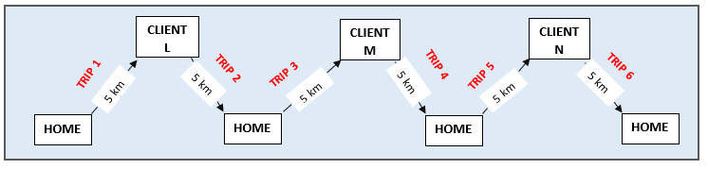

For each visit the following payments are calculated based on the employee’s pay band:

|  |  |  |
| --- | --- | --- |
| **Trip** | **Distance** | **Payment** |
| 1 (first visit) | 5 km | $0.00 |
| 2 | 5 km | $7.27 |
| 3 | 5 km | $7.27 |
| 4 | 5 km | $7.27 |
| 5 | 5 km | $7.27 |
| 6 (home) | 5 km | $0.00 |

 Relevant part of the claim:

|  |  |  |  |  |  |  |  |  |  |  |  |  |  |
| --- | --- | --- | --- | --- | --- | --- | --- | --- | --- | --- | --- | --- | --- |
| **IBT PSO** | **Employee ID** | **Visit date** | **Visit time** | **Post code** | **First visit** | **Person NHI** | **Funder** | **FFS/ bulk** | **Record ID** | **Agreement number** | **Excep travel time** | **Excep travel distance** | **PayBand** |
|  | 5005 | 05/07/2023 | 7:00 | 5000 | Y | LLL0010 |  |  | 1 | 350000 |  |  | 2 |
|  | 5005 | 05/07/2023 | 8:30 | 5000 | N | LLL0010 |  |  | 2 | 350000 |  |  | 2 |
|  | 5005 | 05/07/2023 | 11:00 | 5000 | N | MMM0010 |  |  | 3 | 350000 |  |  | 2 |
|  | 5005 | 05/07/2023 | 12:30 | 5000 | N | MMM0010 |  |  | 4 | 350000 |  |  | 2 |
|  | 5005 | 05/07/2023 | 17:00 | 5000 | N | NNN0010 |  |  | 5 | 350000 |  |  | 2 |

The Provider will receive the following payment information in their claim response file:

|  |  |  |  |  |  |  |  |  |  |  |  |  |  |  |  |  |  |  |
| --- | --- | --- | --- | --- | --- | --- | --- | --- | --- | --- | --- | --- | --- | --- | --- | --- | --- | --- |
| **IBTPSO** | **Employee ID** | **Visit date time** | **Post code** | **First visit** | **Person NHI** | **Funder** | **FFS/bulk** | **Record ID** | **Agreement number** | **Excep travel time** | **Excep travel distance** | **Cancelled Appt GST ex** | **Band time GST excl** | **Band distance GST excl** | **Excep time GST excl** | **Excep distance GST excl** | **Pay amount** | **Comments** |
|  | 5005 | 05/07/2023 7:00 | 5000 | Y | LLL0010 |  |  | 1 | 350000 |  |  |  |  |  |  |  |  |  |
|  | 5005 | 05/07/2023 08:30 | 5000 | N | LLL0010 |  |  | 2 | 350000 |  |  |  | $4.78 | $2.49 |  |  | $7.27 |  |
|  | 5005 | 05/07/2023 11:00 | 5000 | N | MMM0010 |  |  | 3 | 350000 |  |  |  | $4.78 | $2.49 |  |  | $7.27 |  |
|  | 5005 | 05/07/2023 12:30 | 5000 | N | MMM0010 |  |  | 4 | 350000 |  |  |  | $4.78 | $2.49 |  |  | $7.27 |  |
|  | 5005 | 05/07/2023 17:00 | 5000 | N | NNN0010 |  |  | 5 | 350000 |  |  |  | $4.78 | $2.49 |  |  | $7.27 |  |

### Scenario 6 – Split Shifts for same client

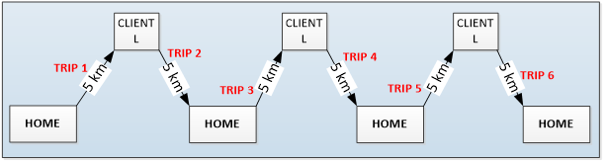

For each visit the following payments are calculated based on the employee’s pay band:

|  |  |  |
| --- | --- | --- |
| **Trip** | **Distance** | **Payment** |
| 1 (first visit) | 5 km | $0.00 |
| 2 | 5 km | $7.27 |
| 3 | 5 km | $7.27 |
| 4 | 5 km | $7.27 |
| 5 | 5 km | $7.27 |
| 6 (home) | 5 km | $0.00 |

 Relevant part of the claim:

|  |  |  |  |  |  |  |  |  |  |  |  |  |  |
| --- | --- | --- | --- | --- | --- | --- | --- | --- | --- | --- | --- | --- | --- |
| **IBT PSO** | **Employee ID** | **Visit date** | **Visit time** | **Post code** | **First visit** | **Person NHI** | **Funder** | **FFS/ bulk** | **Record ID** | **Agreement number** | **Excep travel time** | **Excep travel distance** | **PayBand** |
|  | 5005 | 05/07/2023 | 7:00 | 5000 | Y | LLL0010 |  |  | 1 | 350000 |  |  | 2 |
|  | 5005 | 05/07/2023 | 8:30 | 5000 | N | LLL0010 |  |  | 2 | 350000 |  |  | 2 |
|  | 5005 | 05/07/2023 | 11:00 | 5000 | N | LLL0010 |  |  | 3 | 350000 |  |  | 2 |
|  | 5005 | 05/07/2023 | 12:30 | 5000 | N | LLL0010 |  |  | 4 | 350000 |  |  | 2 |
|  | 5005 | 05/07/2023 | 17:00 | 5000 | N | LLL0010 |  |  | 5 | 350000 |  |  | 2 |

The Provider will receive the following payment information in their claim response file:

|  |  |  |  |  |  |  |  |  |  |  |  |  |  |  |  |  |  |  |
| --- | --- | --- | --- | --- | --- | --- | --- | --- | --- | --- | --- | --- | --- | --- | --- | --- | --- | --- |
| **IBTPSO** | **Employee ID** | **Visit date time** | **Post code** | **First visit** | **Person NHI** | **Funder** | **FFS/bulk** | **Record ID** | **Agreement number** | **Excep travel time** | **Excep travel distance** | **Cancelled Appt GST ex** | **Band time GST excl** | **Band distance GST excl** | **Excep time GST excl** | **Excep distance GST excl** | **Pay amount** | **Comments** |
|  | 5005 | 05/07/2023 7:00 | 5000 | Y | LLL0010 |  |  | 1 | 350000 |  |  |  |  |  |  |  |  |  |
|  | 5005 | 05/07/2023 08:30 | 5000 | N | LLL0010 |  |  | 2 | 350000 |  |  |  | $4.78 | $2.49 |  |  | $7.27 |  |
|  | 5005 | 05/07/2023 11:00 | 5000 | N | LLL0010 |  |  | 3 | 350000 |  |  |  | $4.78 | $2.49 |  |  | $7.27 |  |
|  | 5005 | 05/07/2023 12:30 | 5000 | N | LLL0010 |  |  | 4 | 350000 |  |  |  | $4.78 | $2.49 |  |  | $7.27 |  |
|  | 5005 | 05/07/2023 17:00 | 5000 | N | LLL0010 |  |  | 5 | 350000 |  |  |  | $4.78 | $2.49 |  |  | $7.27 |  |

* + 1. Scenario 7 – Split Shifts for exceptional travel

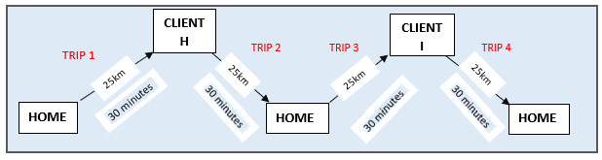

For each visit the following payments are calculated based on the employee’s pay band:

|  |  |  |  |  |  |
| --- | --- | --- | --- | --- | --- |
| **Trip** | **Distance** | **Travel Time** | **PayBand** | **Calculation** | **Payment** |
| 1 (first visit) | 25 km | 30 minutes | 2 | Time:30*(33.77/60) + Distance:25*0.6731 | $33.72 |
| 2 | 25 km | 30 minutes | 2 | Time:30*(33.77/60) + Distance:25*0.6731 | $33.72 |
| 3 | 25 km | 30 minutes | 2 | Time:30*(33.77/60) + Distance:25*0.6731 | $33.72 |
| 4 (home) | 25 km | 30 minutes | 2 | Time:30*(33.77/60) + Distance:25*0.6731 | $33.72 |

Relevant part of the claim:

|  |  |  |  |  |  |  |  |  |  |  |  |  |  |
| --- | --- | --- | --- | --- | --- | --- | --- | --- | --- | --- | --- | --- | --- |
| **IBT PSO** | **Employee ID** | **Visit date** | **Visit time** | **Post code** | **First visit** | **Person NHI** | **Funder** | **FFS/ bulk** | **Record ID** | **Agreement number** | **Excep travel time** | **Excep travel distance** | **PayBand** |
|  | 6006 | 06/07/2023 | 7:00 | 5000 | Y | HHH0010 |  |  | 1 | 350000 | 30 | 25 | 2 |
|  | 6006 | 06/07/2023 | 10:30 | 5000 | N | HHH0010 |  |  | 2 | 350000 | 30 | 25 | 2 |
|  | 6006 | 06/07/2023 | 15:00 | 5000 | N | III0010 |  |  | 3 | 350000 | 30 | 25 | 2 |
|  | 6006 | 06/07/2023 | 18:30 | 5000 | N | III0010 |  |  | 4 | 350000 | 30 | 25 | 2 |

The Provider will receive the following payment information in their claim response file:

|  |  |  |  |  |  |  |  |  |  |  |  |  |  |  |  |  |  |  |
| --- | --- | --- | --- | --- | --- | --- | --- | --- | --- | --- | --- | --- | --- | --- | --- | --- | --- | --- |
| **IBTPSO** | **Employee ID** | **Visit date time** | **Post code** | **First visit** | **Person NHI** | **Funder** | **FFS/bulk** | **Record ID** | **Agreement number** | **Excep travel time** | **Excep travel distance** | **Cancelled Appt GST ex** | **Band time GST excl** | **Band distance GST excl** | **Excep time GST excl** | **Excep distance GST excl** | **Pay amount** | **Comments** |
|  | 6006 | 06/07/2023 7:00 | 5000 | Y | HHH0010 |  |  | 1 | 350000 | 30 | 25 |  |  |  | $16.89 | $16.83 | $33.72 |  |
|  | 6006 | 06/07/2023 10:30 | 5000 | N | HHH0010 |  |  | 2 | 350000 | 30 | 25 |  |  |  | $16.89 | $16.83 | $33.72 |  |
|  | 6006 | 06/07/2023 15:00 | 5000 | N | III0010 |  |  | 3 | 350000 | 30 | 25 |  |  |  | $16.89 | $16.83 | $33.72 |  |
|  | 6006 | 06/07/2023 18:30 | 5000 | N | III0010 |  |  | 4 | 350000 | 30 | 25 |  |  |  | $16.89 | $16.83 | $33.72 |  |

## Audit

The Ministry of Health’s Audit & Compliance team will closely monitor and audit IBT claims to the Ministry and DHBs.

Funders expect that providers:

* can demonstrate that rostering of workers is appropriate and efficient, ie, home and community support workers are rostered to minimise IBT costs
* keep adequate and accurate records to support claims for exceptional travel for a client (including documentation of exceptional time and distances incurred).
* can demonstrate that the funding has been correctly passed on to workers.

Failure to provide adequate and accurate documentation of claims will be disputed and could lead to action to recover payment for those claims.

# Treatment of “no worse off”

* + - 1. Where a provider believes they are disadvantaged they should raise this with the funder. In all cases the parties must work together in good faith and with urgency to remedy any alleged financial disadvantage.
      2. More information is available in the variation to the settlement.

The parties to the In-Between Travel settlement agreement have agreed a variation to the agreement. The variation sets out the mechanism and process for dealing with any issues of disadvantage as a result of implementing the settlement agreement. The variation can be downloaded along with the settlement agreement and should now be read in conjunction with the settlement agreement.

Appendix 1:  
File specification for IBT claims

## Main changes

The new claim format is the same as the old format with one additional column, ‘PayBand’. The PayBand column can be filled with any of the following: 0, 2, 3, 4a, 4b. You may also leave the field blank to indicate level 0.

## Historical changes

Changes that were needed in previous IBT updates can be summarised as follows:

* Distance component added to the travel band.
* Exceptional travel (time and distance) added.
* Change in the funding source: DHBs and the Ministry instead of only the Ministry.
* Therefore, changes in the claim template and changes in the reports:
* separate payment in base band time and distance, add Exceptional Travel (ET) time and distance
* add summary per funder and per contract, also separated in base band time and distance, add ET time and distance. GST is added at contract level.
* A single travel band was confirmed.
* Cancellations for “Guaranteed Hours” can be claimed in the IBTPSO column (see <https://www.health.govt.nz/new-zealand-health-system/claims-provider-payments-and-entitlements/between-travel-settlement/between-travel-guaranteed-hours> for details).

Template changes:

* Add agreement number (6 digits, not starting with a 0, ie, 350001).[14]
* Add actual exceptional travel time (maximum 3 digits, full minutes, no decimals (will be rounded if added)).
* Add actual exceptional travel distance (maximum 3 digits, full kilometres, initially not less than 15 km for a single trip, no decimals (will be rounded if added)).

Notes:

* For exceptional travel: always claim the full door-to-door time and distance.
* For a first visit, also claim the full door-to-door time and distance.

Appendix 2:  
Claim file specification for visits

As before, the file upload mechanism stays the same; using “comma separated files” (.csv).



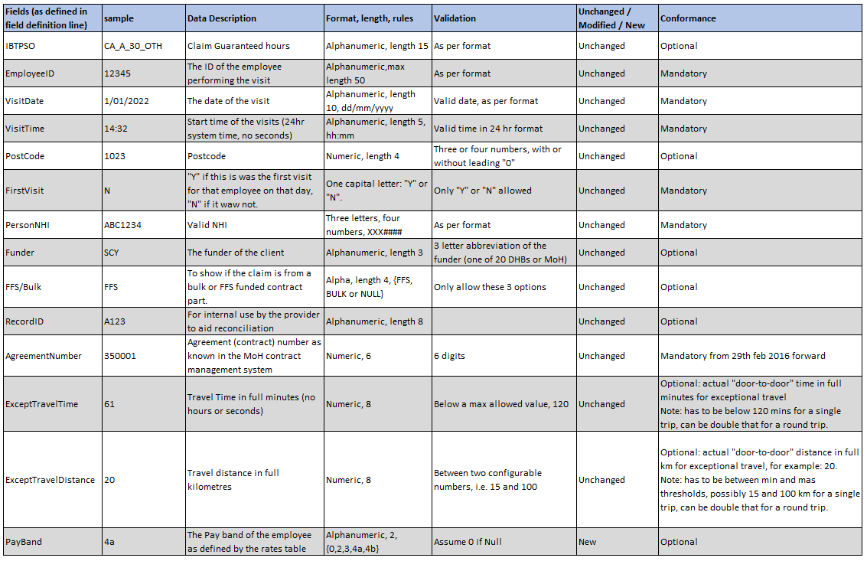

Appendix 3**:**Example updated claim file for visits

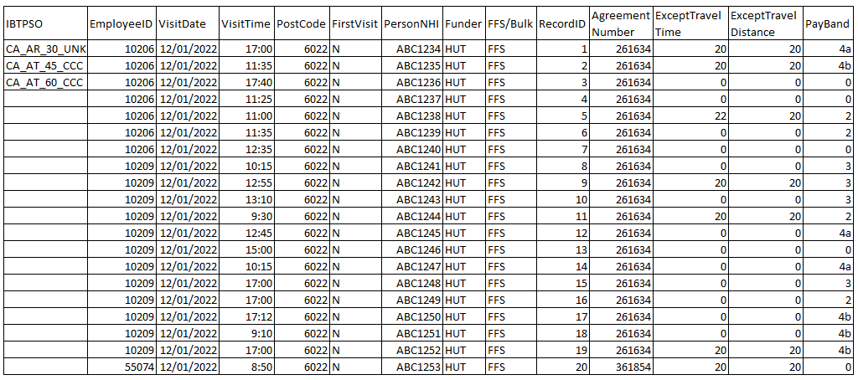

Appendix 4:  
Updated provider report for visits

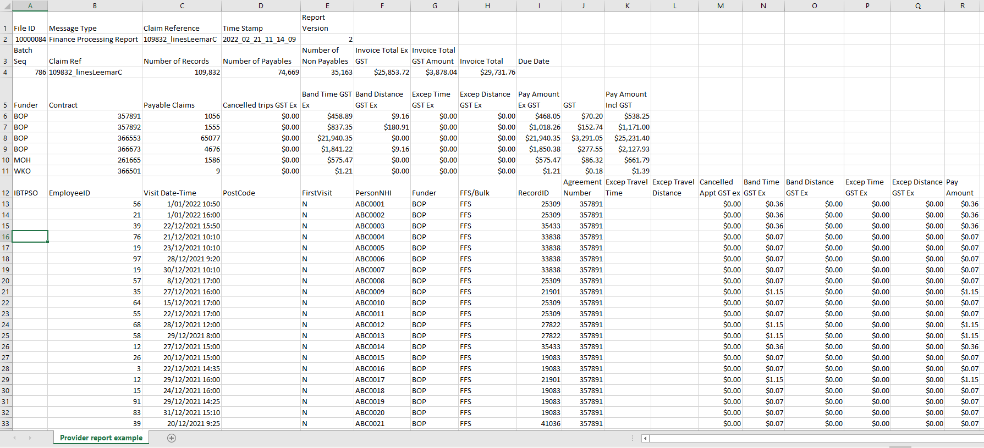

Appendix 5: Flow chart for determining pay bands

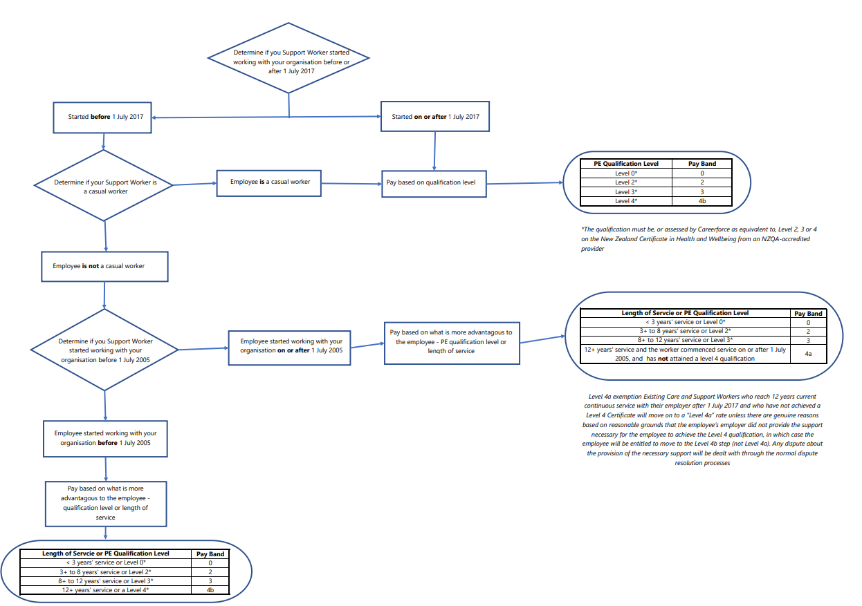

Appendix 6: Historical IBT Rates

Table 1: One band – Historical rates

Before 1 July 2021, travelling time was paid based on the Minimum Wage Rate and from 1 July 2021 it is paid based on the Pay Band. See Appendix 5 for clarification on pay bands.

|  |  |  |  |
| --- | --- | --- | --- |
|  | **One band: all travel under 15 km (first visit not paid)** | **Employer funding** | **Employee funding** |
| Travel time | 8.5 minutes | From 1 July 2023 L0: $4.51[15]  From 1 July 2023 L2: $4.78[16]  From 1 July 2023 L3: $5.20[17]  From 1 July 2023 L4a: $5.41[18]  From 1 July 2023 L4b: $5.62[19]  From 1 Apr 2023 L0: $4.38[20]  Other bands were unchanged as of 1 July 2022.  From 1 Jul 22 L0: $4.34[21]  From 1 Jul 22 L2: $4.65[22]  From 1 Jul 22 L3: $5.05[23]  From 1 Jul 22 L4a: $5.25[24]  From 1 Jul 22 L4b: $5.45[25]  From 1 Jul 21 L0: $4.22  From 1 Jul 21 L2: $4.51  From 1 Jul 21 L3: $4.90  From 1 Jul 21 L4a: $5.10  From 1 Jul 21 L4b: $5.30  From 1 Apr 21: $3.86 [26]  From 1 Apr 20: $3.65 [27]  From 1 Apr 19: $3.41 [28]  From 1 Apr 18: $3.18 [29]  From 1 Apr 17: $3.04 [30]  From 1 Apr 16: $2.95 [31]  From 29 Feb 16: $2.85 | From 1 July 2023 L0: $3.31  From 1 July 2023 L2: $3.51  From 1 July 2023 L3: $3.82  From 1 July 2023 L4a: $3.97  From 1 July 2023 L4b: $4.12  From 1 Apr 2023 L0: $3.22  Other bands were unchanged as of 1 July 2022.  From 1 Jul 22 L0: $3.19  From 1 Jul 22 L2: $3.41  From 1 Jul 22 L3: $3.71  From 1 Jul 22 L4a: $3.85  From 1 Jul 22 L4b: $4.00  From 1 Jul 21 L0: $3.09  From 1 Jul 21 L2: $3.31  From 1 Jul 21 L3: $3.60  From 1 Jul 21 L4a: $3.74  From 1 Jul 21 L4b: $3.89  From 1 Apr 21: $2.83  From 1 Apr 20: $2.68  From 1 Apr 19: $2.51  From 1 Apr 18: $2.34  From 1 Apr 17: $2.23  From 1 Apr 16: $2.16  From 29 Feb 16: $2.09 |
| Travel distance | 3.7 km | From 15 Mar 22: $2.49[32]  From 24 Aug 20: $2.29[33]  From 24 Aug 20 $2.29 [34]  From 29 Feb 16 $1.96 | From 15 Mar 22: $2.35  From 24 Aug 20: $2.16  From 24 Aug 20 $2.16  From 29 Feb 16 $1.85 |
| **Total** |  | From 1 July 2023 L0: $7.00  From 1 July 2023 L2: $7.27  From 1 July 2023 L3: $7.69  From 1 July 2023 L4a: $7.90  From 1 July 2023 L4b: $8.11  From 1 Apr 2023 L0: $6.87  From 1 Jul 22 L0: $6.83  From 1 Jul 22 L2: $7.14  From 1 Jul 22 L3: $7.54  From 1 Jul 22 L4a: $7.74  From 1 Jul 22 L4b: $7.94  From 15 Mar 22 L0: $6.71  From 15 Mar 22 L2: $7.00  From 15 Mar 22 L3: $7.39  From 15 Mar 22 L4a: $7.59  From 15 Mar 22 L4b: $7.79  From 1 Jul 21 L0: $6.51  From 1 Jul 21 L2: $6.80  From 1 Jul 21 L3: $7.19  From 1 Jul 21 L4a: $7.39  From 1 Jul 21 L4b: $7.59  **From 1 Apr 21: $6.15**  **From 24 Aug 20 $5.94**  **From 1 Apr 20: $5.61**  **From 1 Apr 19: $5.37**  **From 1 Apr 18: $5.14**  **From 1 Apr 17: $5.00**  **From 1 Apr 16: $4.91**  **From 29 Feb 16: $4.81** | From 1 July 2023 L0: $5.66  From 1 July 2023 L2: $5.86  From 1 July 2023 L3: $6.17  From 1 July 2023 L4a: $6.32  From 1 July 2023 L4b: $6.47  From 1 Apr 2023 L0: $5.57  From 1 July 22 L0: $5.54  From 1 July 22 L2: $5.76  From 1 July 22 L3: $6.06  From 1 July 22 L4a: $6.20  From 1 July 22 L4b: $6.35  From 15 Mar 22 L0: $5.44  From 15 Mar 22 L2: $5.66  From 15 Mar 22 L3: $5.95  From 15 Mar 22 L4a: $6.09  From 15 Mar 22 L4b: $6.24  From 1 Jul 21 L0: $5.25  From 1 Jul 21 L2: $5.47  From 1 Jul 21 L3: $5.76  From 1 Jul 21 L4a: $5.90  From 1 Jul 21 L4b: $6.05  **From 1 Apr 21: $4.99**  **From 24 Aug 20: $4.84**  **From 1 Apr 20: $4.53**  **From 1 Apr 19: $4.36**  **From 1 Apr 18: $4.19**  **From 1 Apr 17: $4.08**  **From 1 Apr 16: $4.01**  **From 29 Feb 16 $3.94** |

Table 2: Exceptional travel payment

|  |  |  |
| --- | --- | --- |
|  | **Employer funding** | **Employee funding** |
| Travel time | The below rates are per hour and therefore need to be proportioned:  From 1 July 2023  L0: $31.86[35]  L2: $33.77[36]  L3: $36.71[37]  L4a: $38.19[38]  L4b: $39.66[39]  From 1 April 2023  L0: $30.94[40]  Other bands were unchanged as of 1 July 2022.  From 1 July 2022  L0: $30.65[41]  L2: $32.79[42]  L3: $35.64[43]  L4a: $37.07[44]  L4b: $38.50[45]  From 1 July 2021 travel time is based on the employee’s Pay band:  L0: $29.76  L2: $31.83  L3: $34.60  L4a: $35.99  L4b: $37.38  Rates prior to 1 July 2021:  From 1 Apr 21 $27.26[46]  From 1 Apr 20 $25.76[47]  From 1 Apr 19 $24.06[48]  From 1 Apr 18: $22.46[49]  From 1 Apr 17: $21.46[50]  From 1 Apr 16: $20.79[51]  From 29 Feb 16: $20.10 | The below rates are per hour and therefore need to be proportioned:  From 1 July 2023  L0: $23.38  L2: $24.78  L3: $26.94  L4a: $28.02  L4b: $29.10  From 1 April 2023  L0: $22.70  Other bands were unchanged as of 1 July 2022.  From 1 July 2022  L0: $22.49  L2: $24.06  L3: $26.16  L4a: $27.20  L4b: $28.25  From 1 July 2021 travel time is based on the employee’s Pay:  L0: $21.84  L2: $23.36  L3: $25.39  L4a: $26.41  L4b: $27.43  Rates prior to 1 July 2021:  From 1 Apr 21: $20.00  From 1 Apr 20: $18.90  From 1 Apr 19: $17.70  From 1 Apr 18: $16.50  From 1 Apr 17: $15.75  From 1 Apr 16: $15.25  From 29 Feb 16: $14.75 |

1. https://www.health.govt.nz/about-ministry/what-we-do/budget-2021-vote-health
2. The first and last trips, if they are banded travel, will not be funded.
3. The travel time rate received by the employer for L0 pay band increased from $4.38 to $4.51 from 1 July 2023 as a result of the increase in the wage rate.
4. The travel time rate received by the employer for L2 pay band increased from $4.65 to $4.78 from 1 July 2023 as a result of the increase in the wage rate.
5. The travel time rate received by the employer for L3 pay band increased from $5.05 to $5.20 from 1 July 2023 as a result of the increase in the wage rate.
6. The travel time rate received by the employer for L4a pay band increased from $5.25 to $5.41 from 1 July 2023 as a result of the increase in the wage rate.
7. The travel time rate received by the employer for L4b pay band increased from $5.45 to $5.62 from 1 July 2023 as a result of the increase in the wage rate.
8. The mileage rate received by the employer increased from $2.29 to $2.49 from 15 March 2022
9. The travel time hourly rate received by the employer for L0 will increase from $30.94 to $31.86 from 1 July 2023 as a result of the increase in the wage rate.
10. The hourly rate received by the employer for L2 increased from $32.79 to $33.77 from 1 July 2023 as a result of the increase in the wage rate.
11. The hourly rate received by the employer for L3 increased from $35.64 to $36.71 from 1 July 2023 as a result of the increase in the wage rate.
12. The hourly rate received by the employer for L4a increased from $37.07 to $38.19 from 1 July 2023 as a result of the increase in the wage rate.
13. The hourly rate received by the employer for L4b increased from $38.50 to $39.66 from 1 July 2023 as a result of the increase in the wage rate.
14. Refer to Section 6, Claiming.
15. The travel time rate received by the employer for L0 pay band increased from $4.38 to $4.51 from 1 July 2023 as a result of the increase in the wage rate.
16. The travel time rate received by the employer for L2 pay band increased from $4.65 to $4.78 from 1 July 2023 as a result of the increase in the wage rate.
17. The travel time rate received by the employer for L3 pay band increased from $5.05 to $5.20 from 1 July 2023 as a result of the increase in the wage rate.
18. The travel time rate received by the employer for L4a pay band increased from $5.25 to $5.41 from 1 July 2023 as a result of the increase in the wage rate.
19. The travel time rate received by the employer for L4b pay band increased from $5.45 to $5.62 from 1 July 2023 as a result of the increase in the wage rate.
20. The travel time rate received by the employer for L0 pay band increased from $4.34 to $4.38 from 1 April 2023 as a result of the increase in the minimum wage. Other bands were unchanged as of 1 July 2022..
21. The travel time rate received by the employer for L0 pay band increased from $4.22 to $4.34 from 1 July 2022 as a result of the increase in the wage rate.
22. The travel time rate received by the employer for L2 pay band increased from $4.51 to $4.65 from 1 July 2022 as a result of the increase in the wage rate.
23. The travel time rate received by the employer for L3 pay band increased from $4.90 to $5.05 from 1 July 2022 as a result of the increase in the wage rate.
24. The travel time rate received by the employer for L4a pay band increased from $5.10 to $5.25 from 1 July 2022 as a result of the increase in the wage rate.
25. The travel time rate received by the employer for L4b pay band increased from $5.30 to $5.45 from 1 July 2022 as a result of the increase in the wage rate.
26. The travel time rate received by the employer increased from $3.65 to $3.86 from 1 April 2021 as a result of the increase in the minimum wage.
27. The travel time rate received by the employer increased from $3.41 to $3.65 from 1 April 2020 as a result of the increase in the minimum wage.
28. The travel time rate received by the employer increased from $3.18 to $3.41 from 1 April 2019 as a result of the increase in the minimum wage.
29. The travel time rate received by the employer increased from $3.04 to $3.18 from 1 April 2018 as a result of the increase in the minimum wage.
30. The travel time rate received by the employer increased from $2.95 to $3.04 from 1 April 2017 as a result of the increase in the minimum wage.
31. The travel time rate received by the employer increased from $2.85 to $2.95 from 1 April 2016 as a result of the increase in the minimum wage.
32. The mileage rate received by the employer increased from $2.29 to $2.49 from 15 March 2022
33. The mileage rate received by the employer increased from $1.96 to $2.29 from 24 August 2020.
34. The mileage rate received by the employer increased from $1.96 to $2.29 from 24 August 2020.
35. The travel time hourly rate received by the employer for L0 will increase from $30.94 to $31.86 from 1 July 2023 as a result of the increase in the wage rate.
36. The hourly rate received by the employer for L2 increased from $32.79 to $33.77 from 1 July 2023 as a result of the increase in the wage rate.
37. The hourly rate received by the employer for L3 increased from $35.64 to $36.71 from 1 July 2023 as a result of the increase in the wage rate.
38. The hourly rate received by the employer for L4a increased from $37.07 to $38.19 from 1 July 2023 as a result of the increase in the wage rate.
39. The hourly rate received by the employer for L4b increased from $38.50 to $39.66 from 1 July 2023 as a result of the increase in the wage rate.
40. The travel time hourly rate received by the employer for L0 increased from $30.65 to $30.94 from 1 April 2023 as a result of the minimum wage increase. Other bands unchanged.
41. The hourly rate received by the employer for L0 increased from $29.76 to $30.65 from 1 July 2022 as a result of the increase in the wage rate.
42. The hourly rate received by the employer for L2 increased from $31.83 to $32.79 from 1 July 2022 as a result of the increase in the wage rate.
43. The hourly rate received by the employer for L3 increased from $34.60 to $35.64 from 1 July 2022 as a result of the increase in the wage rate.
44. The hourly rate received by the employer for L4a increased from $35.99 to $37.07 from 1 July 2022 as a result of the increase in the wage rate.
45. The hourly rate received by the employer for L4b increased from $37.78 to $38.50 from 1 July 2022 as a result of the increase in the wage rate.
46. The hourly rate received by the employer increased from $25.76 to $27.26 from 1 April 2021 as a result of the increase in the minimum wage.
47. The hourly rate received by the employer increased from $24.06 to $25.76 from 1 April 2020 as a result of the increase in the minimum wage.
48. The hourly rate received by the employer increased from $22.46 to $24.06 from 1 April 2019 as a result of the increase in the minimum wage.
49. The hourly rate received by the employer increased from $21.46 to $22.46 from 1 April 2018 as a result of the increase in the minimum wage.
50. The hourly rate received by the employer increased from $20.79 to $21.46 from 1 April 2017 as a result of the increase in the minimum wage.
51. The hourly rate received by the employer increased from $20.10 to $20.79 from 1 April 2016 as a result of the increase in the minimum wage.