 

Hand Hygiene Australia Training Site: Logging in to access the online learning modules

# Site address: https://hhaustralia.southrock.com

**Registering as a user**

Before completing a learning module, you will need to create a Login ID and password. You will need to log in each time you access the learning modules.

On your first visit to the site, you will be prompted to register. Click on the button labelled ‘register now’ to start the registration process.

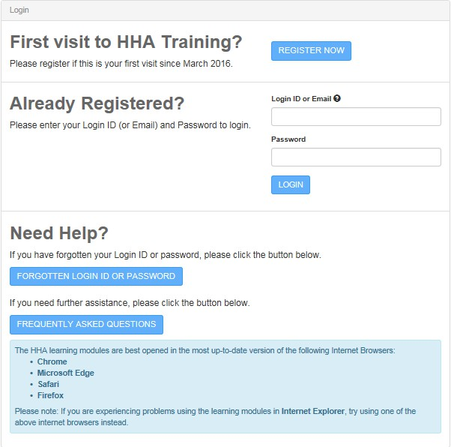

You will be asked to select your country and organisation. Your organisation is your hospital and will be available from a pick list.

You will then need to enter some basic information, select the module you want to complete and create a password. Once registered you can register for any of the online HH modules that are available.

# Once you have logged in

To access a learning module select ‘learner’. Those with administrator access will have more than one role and can switch between learner and admin view.

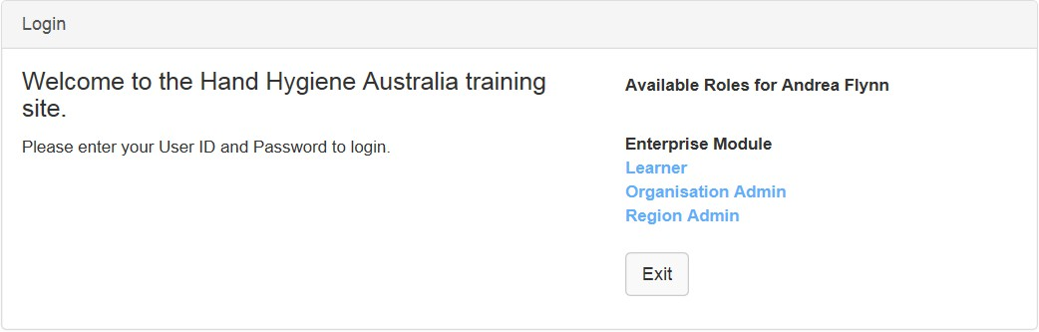

You can view the available modules by selecting ‘find a new module’ or the Catalogue button.

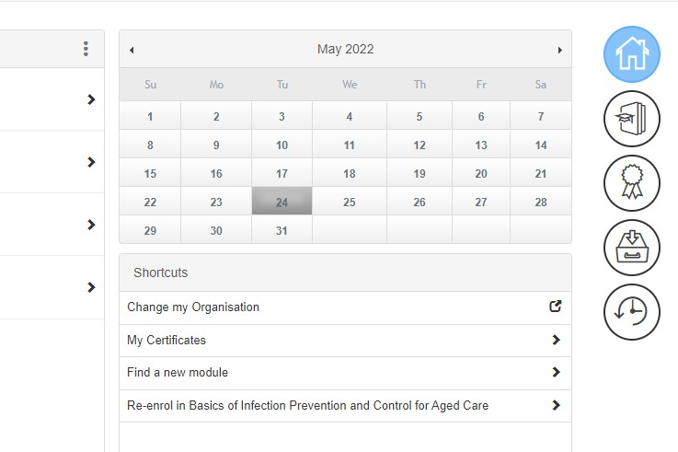

Next, select the modules you want to view, for example, HH Auditor Modules

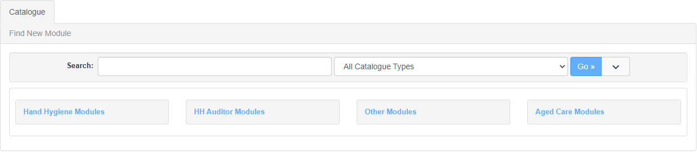

Find and select the module that you want to complete. Then select **Enrol**.

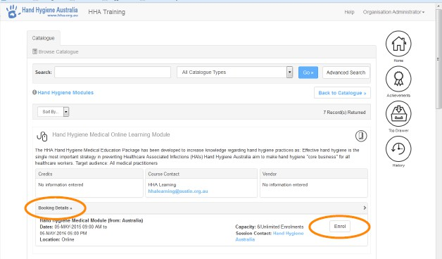

You can either select **Launch** to start the module immediately, or return to **Home** at any time and launch the module from there.

**Available Learning modules**

# Hand Hygiene Modules:

1. Hand Hygiene NZ Allied Health Online Learning Module (ALLIED_HEALTH_HHNZ)
2. Hand Hygiene NZ Medical Online Learning Module (MEDICAL_STAFF_NZ)
3. Hand Hygiene NZ Non-Clinical Online Learning Module (NON-CLINICAL_NZ)
4. Hand Hygiene NZ Nursing/Midwifery Online Learning Module (NURSING_MIDWIFERY_NZ)
5. Hand Hygiene NZ Renal/Dialysis Online Learning Module (RENAL_DIALYSIS_NZ)
6. Hand Hygiene Royal Australasian College of Surgeons Online Learning Module (RACS_HHA)
7. Hand Hygiene NZ Standard Theory Online Learning Module (STANDARD_NZ)
8. Hand Hygiene NZ Student Health Practitioners Online Learning Module (STUDENTS_NZ)

# Infection Control Modules:

1. The Basics of Infection Prevention and Control (BASICS_INFECTION_CONTROL_NZ)
2. Basics of Infection Prevention and Control in Aged Care (AGED_CARE_BASICS_INFECTION_CONTROL_NZ)

# HH Auditor Modules:

1. Hand Hygiene NZ Auditor Annual Validation Online Learning Module (ANNUAL_AUDITOR_NZ)
2. Hand Hygiene NZ Auditor Pre-Workshop Online Learning Module (PREWORKSHOP_NZ)