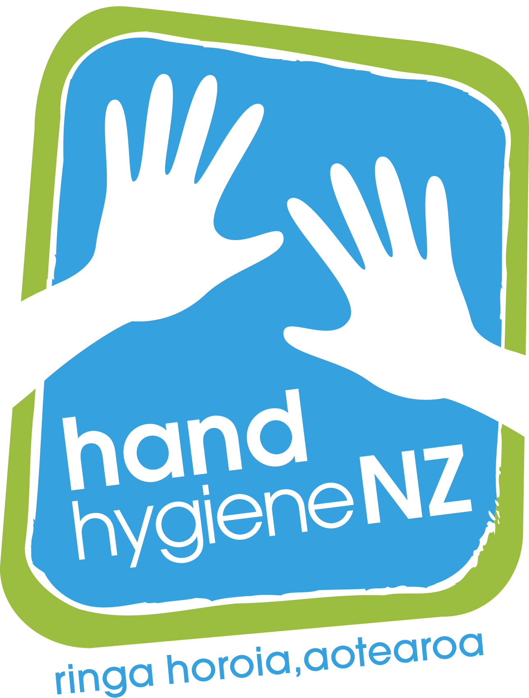

EVALUATING THE TOLERABILITY AND ACCEPTABILITY OF ALCOHOL-BASED HAND RUB
AMONG HEALTHCARE WORKERS

Questionnaire - Part TWO
To be completed after the three to five first consecutive days of product use and after one month of product use.

Participant No: …….........…….........
Product: …….........…….........

Date questionnaire returned …./…./….

Participant name: ………………………………

Number of distributed bottles: …….........…….........

Amount of product used (ml): …….........……..........

Evaluation of frequency of hand hygiene practice

During how many consecutive working days have you used the test product?
3 days 4 days 5 days 6 days 7 days > 7 days

How often do you have direct contact with patients during your working day (during the test period)?
< 1 contact Between 1 & 5 Between 6 & 10
Between 11 & 15 > 15 contacts

In what percentage of times where hand hygiene is recommended, do you really clean your hands?
0% 10% 20% 30% 40% 50%
60% 70% 80% 90% 100%

Has the present study changed your hand hygiene practice?
Yes No

During your last 5 opportunities for hand hygiene, how many times did you use hand rubbing to clean your hands?
0 1 2 3 4 5

How often do you practise hand hygiene during an average working hour
(during the test period)?
< 1 1-5 6-10 11-15 > 15

Evaluation of the test product

What is your opinion of the test product for hand hygiene?

Colour………………………...Unpleasant |  |  |  |  |  |  |  | Pleasant
Smell……………………………Unpleasant |  |  |  |  |  |  |  | Pleasant
Texture..….......................Very sticky |  |  |  |  |  |  |  | Not sticky at all
Irritation (stinging)…… Very irritating |  |  |  |  |  |  |  | Not irritating
Drying effect ………………….very much |  |  |  |  |  |  |  | Not at all
Ease of use………………….Very difficult |  |  |  |  |  |  |  | Very easy
Speed of drying…………….…Very slow |  |  |  |  |  |  |  | Very fast
Application…………..Very unpleasant |  |  |  |  |  |  |  | Very pleasant
Overall evaluation Dissatisfied |  |  |  |  |  |  |  | Very satisfied

Are there differences between the test product and the product used in your hospital?
Major No

Which product do you prefer?
Usual product Test Product No preference

Do you think that the test product could improve your hand hygiene compliance?
Yes, absolutely Not at all

Evaluation of Skin Condition

Self assessment of the skin on your hands (after use of the test product):

Appearance…………………….. Abnormal  (supple, red, blotchy, rash) |  |  |  |  |  |  |  | Normal
Intactness………………………...Abnormal  (abrasions, fissures) |  |  |  |  |  |  |  | Normal
Moisture content……...........Abnormal (dryness) |  |  |  |  |  |  |  | Normal
Sensation…………………………..Abnormal  (itching, burning, soreness) |  |  |  |  |  |  |  | Normal
How would you assess the overall integrity of the skin on your hands?

Very altered Perfect

