Workforce Requests Portal Guide

Vaccinating Health Worker
Contents
Sign up to the Workforce Requests Portal 1
Log in to the Workforce Requests Portal 9
Update your personal profile 12
Submit a new authorisation request 13
More information required 19
Download your current authorisation letter 22
Get help 24

Welcome to the Workforce Requests Portal  The Workforce Requests Portal will allow you to sign in securely to apply for vaccinator authorisation, upload and access your vaccinator authorisation documentation, and access your vaccinator authorisation letters.  Access the Workforce Requests Portal via the hyperlink, URL or QR code:  Workforce requests  https://workforcerequest.powerappsportals.com/SignIn?ReturnUrl=%2F | 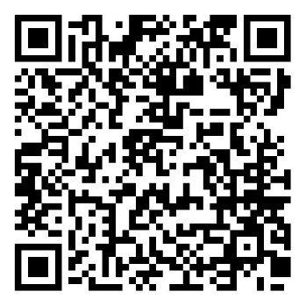

Sign up to the Workforce Requests Portal
If this is the first vaccinator authorisation request you are submitting, you’ll need to sign up and create a My Health Account Workforce to access the Workforce Requests Portal. Find out more About My Health Account Workforce – Health New Zealand | Te Whatu Ora.
If you have previously accessed the Workforce Requests Portal, you can go straight to Log in to the Workforce Requests Portal (page 9).
Step | Action | Screen shot guidance
1 | Access the Workforce Requests Portal via the link or QR code on the cover page  Tip: You can use any browser such as Edge, Chrome or Safari
2 | Click My Health Account Workforce button | 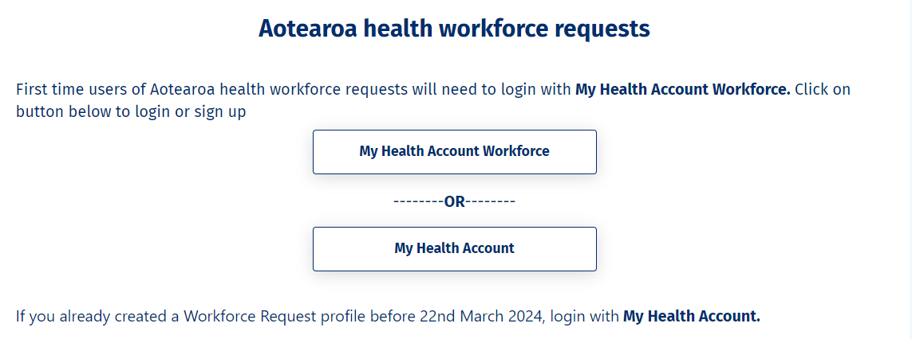
3 | Click Sign up  If you already have a My Health Account Workforce you can go straight to Log in. You don’t need to sign up to My Health Account Workforce again. | 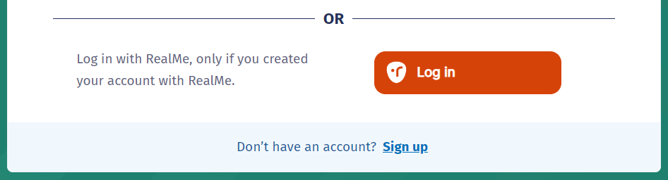
4 | Click Sign up with email to create an account linked to your email  Or  Click Log in to create an account using an existing RealMe account | 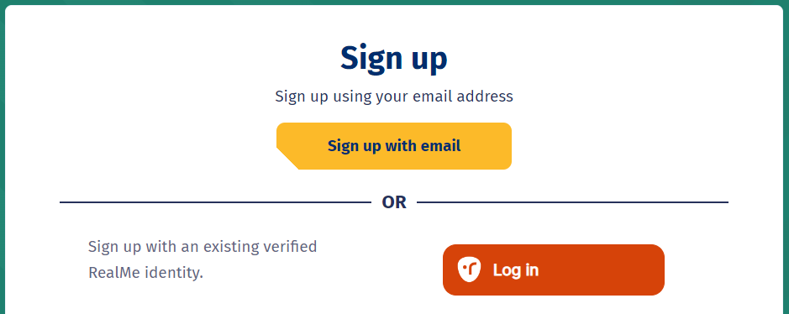
If you used RealMe or RealMe Verified to sign up for your personal My Health Account, you will need to sign up for My Health Account Workforce using an email address and password.

You’ll need your own email address. It must be unique to you and not one you share with someone else. It also must be a different email address from the one you used when you created a My Health Account as a health consumer. Use an email that you check often so that you’ll see notifications.

Not sure if you have a My Health Account? If you have accessed My Covid Record to create a vaccine pass or enter RAT test results, you will have set up a My Health Account

5  6  7 | Click hyperlinks to open and read the Privacy statement and Terms of use  Tick the box to confirm:  - you have read and agree to the Privacy statement and Terms of use  - you are making this application on your own behalf  Click Start | 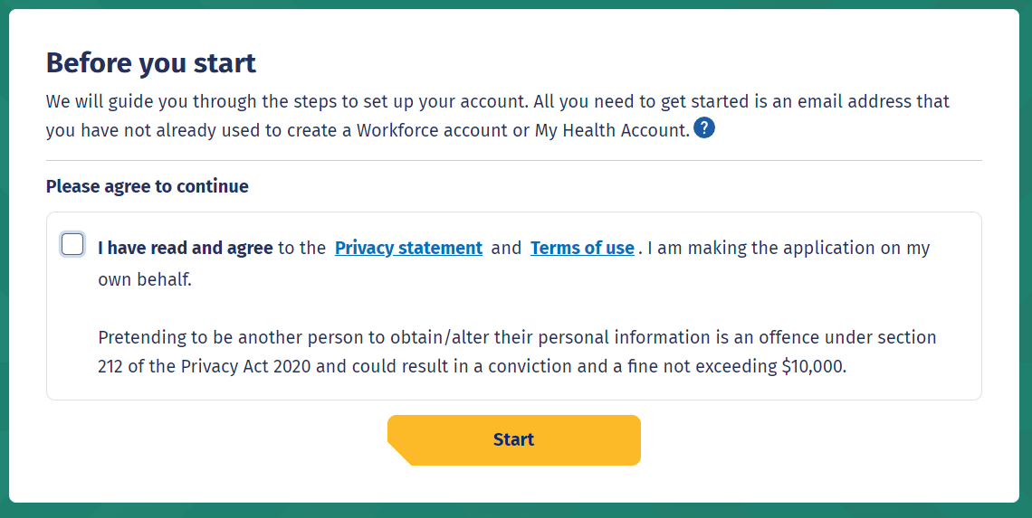
8  9 | Enter your email address  Click Send verification | 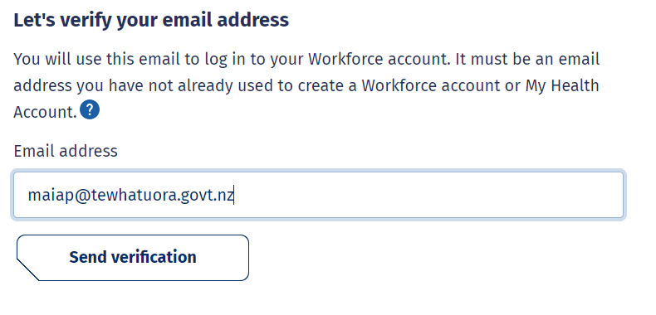
10 | Open your email application (e.g. outlook, gmail etc) in a new tab  Open the email  From: My Health Account  Subject: Here’s your My Health Account Workforce verification code  Note your verification code | 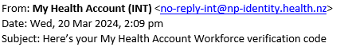  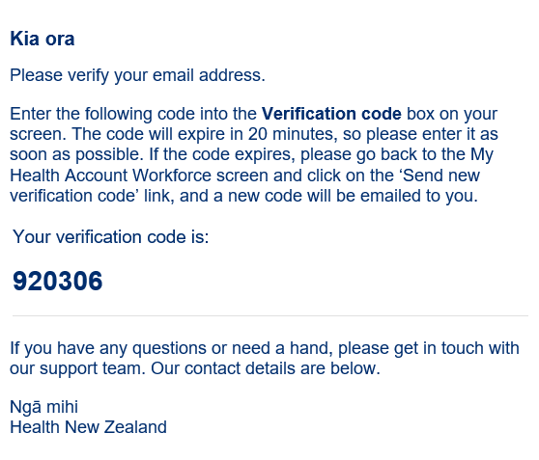
11  12 | Return to My Health Account Workforce portal tab  Enter your Verification code  Click Continue
13  14 | Enter a password  Tip: Note the criteria provided to guide you creating a strong password  Click Continue | 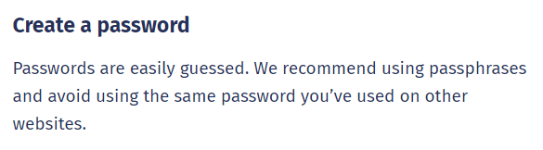
15 | Click Allow | 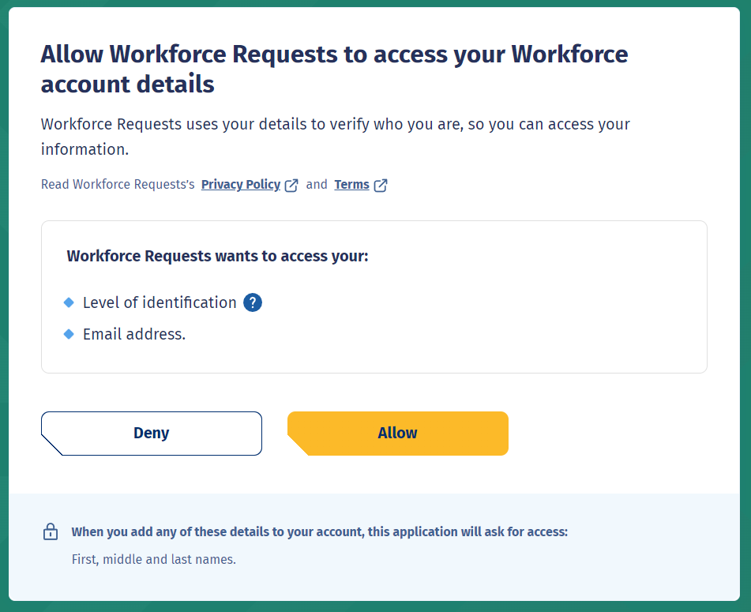
16  17 | Complete Your Details form fields (see Tips below, page 6)  Once you have completed all mandatory fields (marked with a *), click Submit | 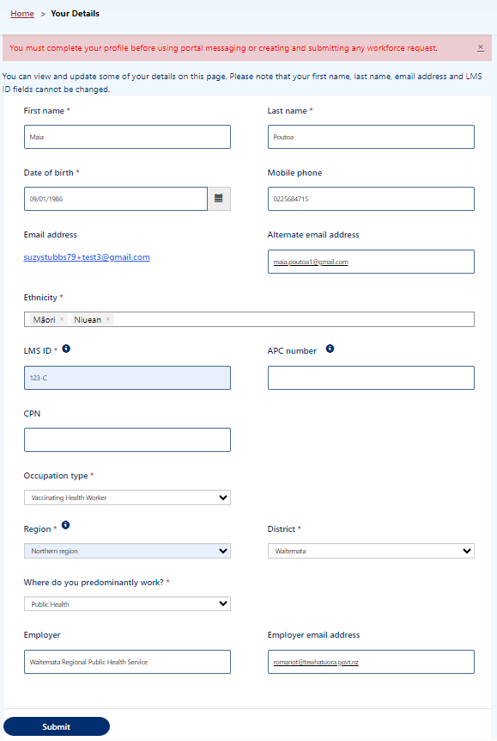  maiap@tewhatuora.govt.nz
Date of birth - use DD/MM/YYY format.

Alternate email address - you may like to add your personal / alternative email address here. Notifications and reminders from Workforce Requests will be sent to your sign-up email address and the alternate email address you provide (from June 2024).

Ethnicity - use the drop-down list on the right to select your ethnicity, you can select more than one ethnicity.

LMS ID - this is your Immunisation Advisory Centre (IMAC) Learning Management System (LMS) identity number, you’ll find the alpha-numeric identification on your IMAC certificate.

APC – As a Vaccinating Health Worker you don’t need to complete this field. (APC = Annual Practicing Certificate number).

CPN / HPI – As a Vaccinating Health Worker you don’t need to complete this field. CPN / HPI = Health Provider Index Common Person Number).

Occupation Type– Choose the occupation type that best matches your role. If you choose other, you’ll be asked to enter in your role title.

Region and District – This is the Health NZ Region and District you work in. The Districts in the drop down will change according to the Region you choose.

Employer and Employer email address – we encourage you to include your employer details here. In the future we may include your employer in reminders we send you when your vaccination authorisation is due for renewal.

18 | You are now signed up and taken to your Workforce Requests Portal home page  This is the page you’ll use to view your messages, submit vaccinator authorisation requests and ultimately download your vaccinator authorisation letter | 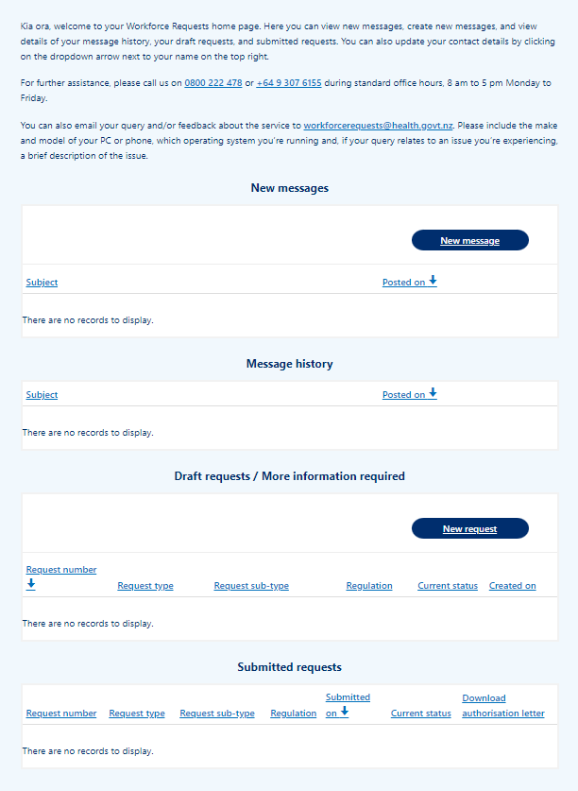
If you need to:

- Submit a new authorisation request – go to page 13.

Log in to the Workforce Requests Portal
When you are returning to the Workforce Requests Portal after initially signing up, you’ll need to log in to get to your home page.
Step | Action | Screen shot guidance
1 | Access the Workforce Requests Portal via the link or QR code on the cover page  Tip: You can use any browser such as Edge, Chrome or Safari
2 | Depending on how you initially signed up to the Workforce Requests Portal (see tip below), either  Click My Health Account Workforce button  Or  Click the My Health Account button
If you signed up to the Workforce Requests Portal before 22 March 2024 it’s likely that you signed up with a My Health Account.

If you signed up to the Workforce Requests Portal after 22 March 2024 it’s likely that you signed up with a My Health Workforce Account.

3  4 | Enter your Email address and Password  Click Log in  Tip: Click Forgot password? if you’ve forgotten your password. You’ll get an email to the email address you registered with | 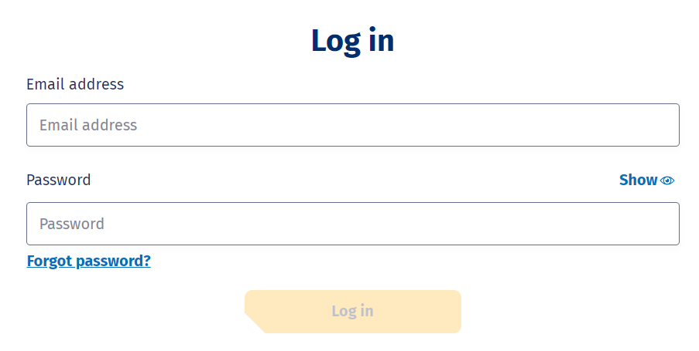
5 | You’ll be taken to your Workforce Requests Portal home page  This is the page you’ll use to view your messages, submit vaccinator authorisation requests and ultimately download your vaccinator authorisation letter | 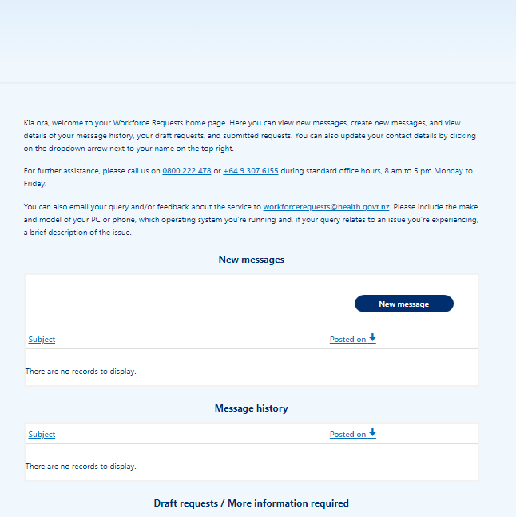
 | Click Home (top right of your screen) at any point to return to this home screen  Click your name and Sign out from the drop down to sign out of Workforce Requests Portal | 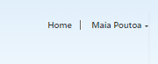
If you need to:

- Update your profile – go to page 12.
- Submit a new authorisation request – go to page 13.
- Download your Authorisation letter – go to page 22.

Update your personal profile
If you need to make changes to your personal details after your initial sign up. You can do this by updating your details in your:
- My Health Account Workforce – go to My Health Account Workforce | Health New Zealand | Te Whatu Ora. or Getting the most from your account – Health New Zealand | Te Whatu Ora for more information and trouble shooting.
- My Health Account – go to Getting the most from your account – Health New Zealand | Te Whatu Ora
If you want to update personal details only in your Workforce Requests Portal, follow the steps below.
Step | Action | Screen shot guidance
1 | Log in to your Workforce Requests Portal via the link or QR code on the cover page (page 9)  Tip: You can use any browser such as Edge, Chrome or Safari
2  3 | Click the down arrow by your name (top right of the page)  Click Your details
4 | Amend your personal details  Tip: You can’t change your:  - First or last name  - Primary email address  - LMS ID | 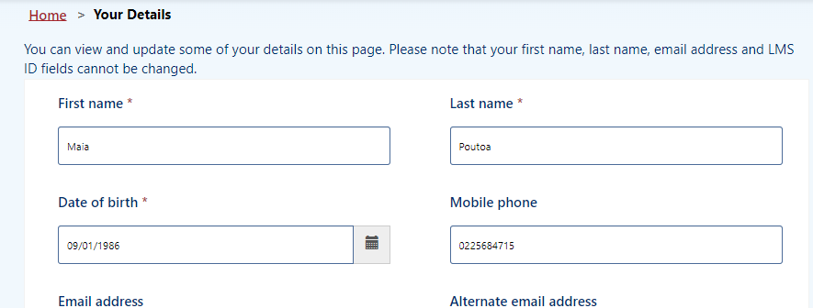
5 | Once you’ve updated your details, click Submit (bottom left of the screen)

Submit a new authorisation request
When you have completed the requirements to apply for your Vaccinating Health Worker authorisation you need to submit a new authorisation request. Your request will be reviewed and assessed by Health NZ – Te Whatu Ora and Medical Officer of Health (MOoH).
It’s important that you don’t vaccinate (apart from for your clinical assessment as part of you training) until you have received your vaccinator authorisation letter.
Step | Action | Screen shot guidance
1 | Log in to your Workforce Requests Portal via the link or QR code on the cover page (page 7)  Tip: You can use any browser such as Edge, Chrome or Safari
2  3 | From your home page, scroll down to Draft requests / More information required  Click New request | 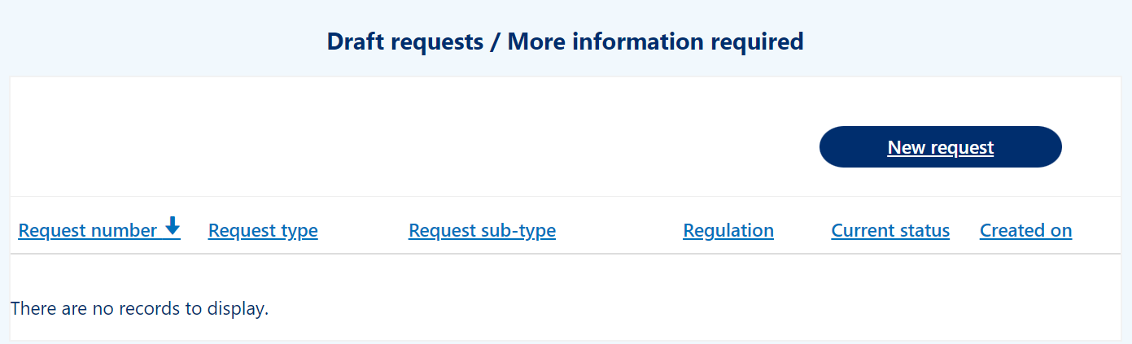
4  5 | Complete the drop-down fields  - Request type – select from the drop down list  - Request sub-type – select from the drop down list  - Request priority – select Standard or Urgent  See tips below (page 13) to help with your selections  Click Next | 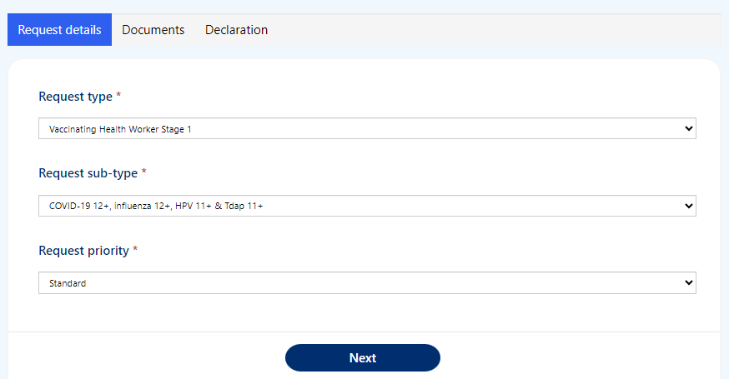
Request type and Request sub-type - For help with choosing the Request type and Request sub-type see the VHW resources section at Vaccinating workforce – Health New Zealand | Te Whatu Ora.

Request priority – Once we have all the information required to process your authorisation request, we aim to process Standard requests within 7 working days. If you require authorisation sooner than 7 days (i.e. you have a vaccination event coming up in less than 7 days), please select Urgent and provide the reason.

Note that these timeframes indicate processing once we have all the required documents. If you submit incomplete documentation this will delay your application being processed for approval. We’ll let you know if we need more information.

6  7 | You’ll need to upload the documents specified under Document type  The documents required will be specific to the Request type and Request sub-type you’ve selected  Click Upload file to upload your documents | 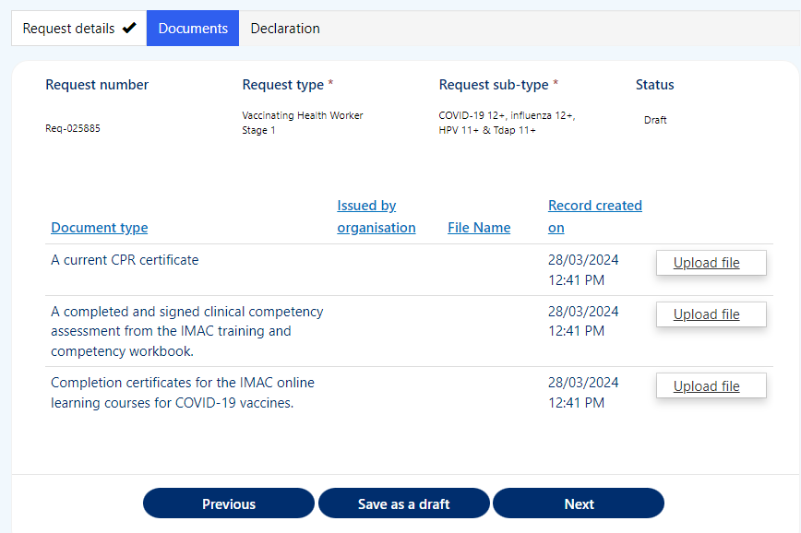
8  9  10 | Enter the name of the organisation who issued the document in the Issued by organisation field  Click Choose file and select file from your device  When your document is attached the document name will be displayed next to the Choose Files button  Tip: you can upload pdf or image files  Click Upload | 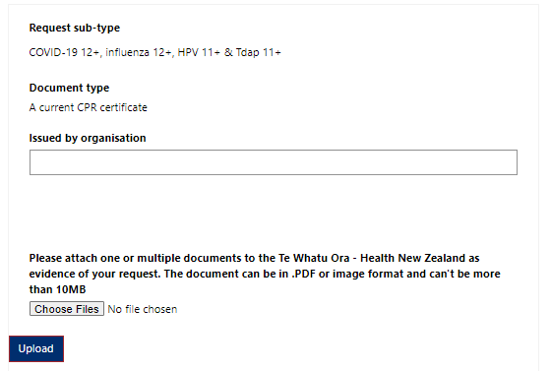
11 | Repeat steps 5 – 9 for each document / document type listed  You can upload more than one document against each Document type (e.g. multiple IMAC online learning certificates)  Just repeat steps 5 – 9 for each document  Note that when you do this only one document will show on the Documents view (see step 10), but you’ll see the documents you’ve uploaded against a Document type in the Upload view | 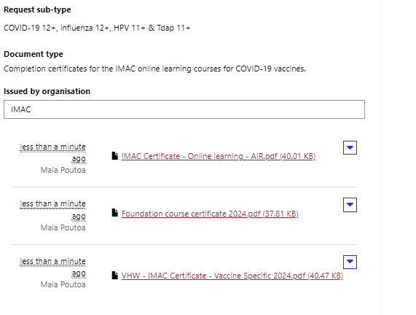
 | You can delete a file if you make a mistake.  - Click Upload file  - Click drop down arrow by the file you want to delete  - Click Delete  - Confirm you want to Delete  - Click Upload to save the change | 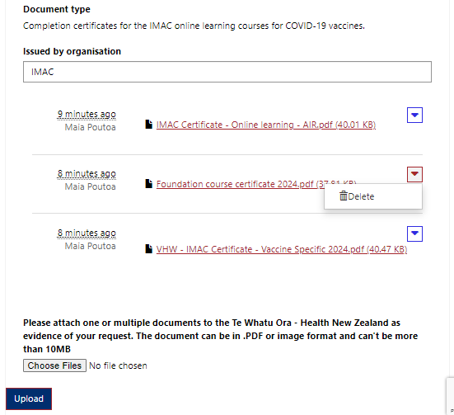
12 | Once you have uploaded all your documents click Next to continue | 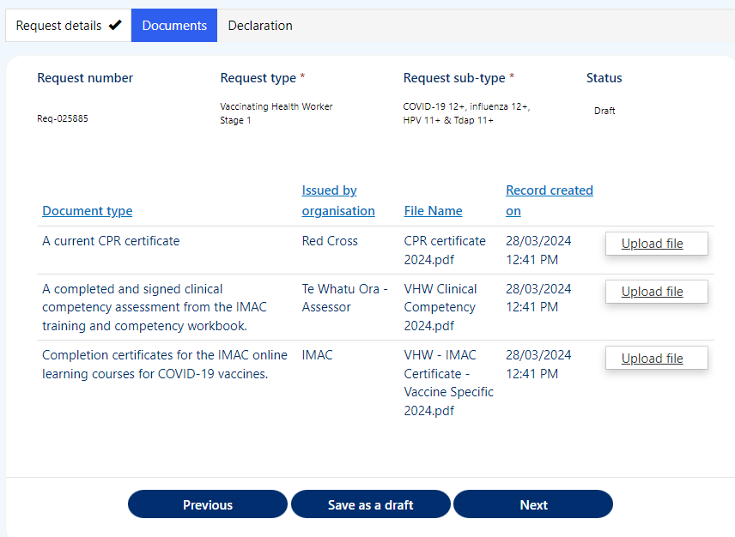
You can Save as a draft if you need to return to upload further documents at a later time.

It’s important that you upload all the documents needed to the same request. This means that if you come back to load more documents to the request, don’t start a New request, instead click the Req-number hyperlink in the Draft requests / More information required section.

Note: To review your request for authorisation we need all the documents listed to be uploaded successfully. Refer to VHW Authorisation Requirements under the VHW resources section at Vaccinating workforce – Health New Zealand | Te Whatu Ora.

If you submit your request without all the required documents, we’ll send you a request for more information (page 18) and this will delay your application been processed.

13  14 | To complete and submit your request, check the box to confirm your declaration  Click Submit | 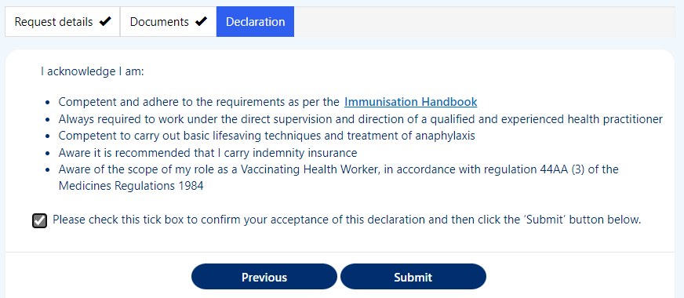
15 | You’ll return to your Workforce Requests Portal home page  Your request will now be sitting under your Submitted requests | 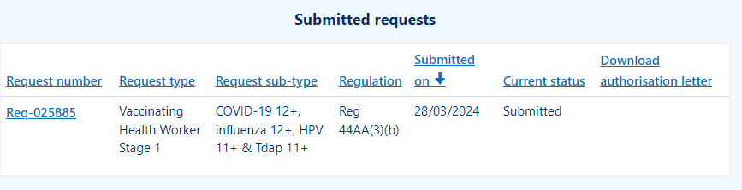
Your request will now be reviewed by Health NZ – Te Whatu Ora. Once your request has been reviewed you will receive a notification via email of:

- More information required – go to page 19.
- Authorisation letter – go to page 22.

More information required
Once we’ve received and reviewed your authorisation request we may request more information. This can occur when the information provided is not complete (e.g. a document is missing or in-complete). You’ll receive an email from Workforce Requests letting you know you have a notification in your Workforce Requests Portal, in that notification we’ll let you know what we need you to provide.
It’s important that you don’t vaccinate until you have received your vaccinator authorisation letter.
Step | Action | Screen shot guidance
1 | Log in to your Workforce Requests Portal via the link or QR code on the cover page  Tip: You can use any browser such as Edge, Chrome or Safari
2  3 | You’ll see a message in the New messages section  Click the Subject hyperlink to open and read the message, we’ll let you know what information is needed | 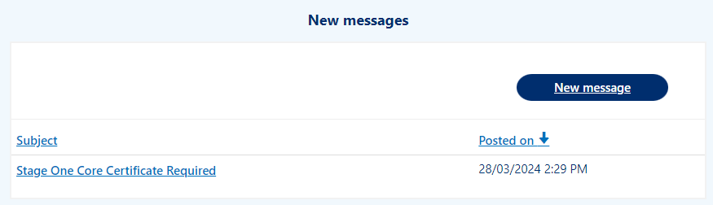
4 | Read the message, you can use the scroll bar on the right to view all the content  Click Return to return to your home screen | 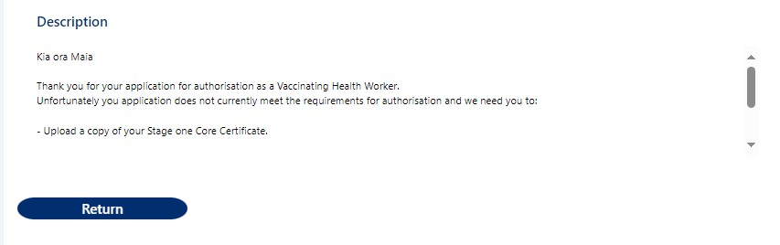
5 | Your request will now be under the Draft requests / More information required section  Click the Req-number hyperlink to open the request and upload the required information  Don’t click New request. You need to go into your existing request to add the additional information | 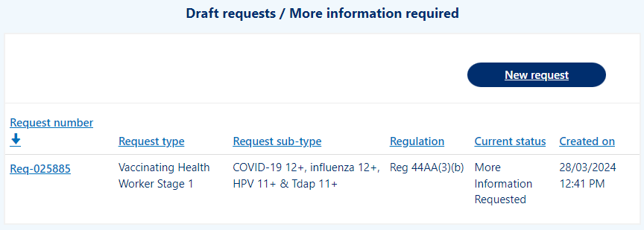
6 | Click Next to confirm the Request type, sub-type and priority | 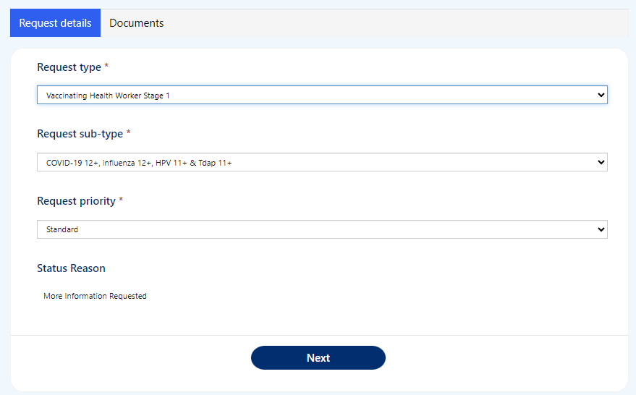
7 | Click Upload file against the required information to select file to upload  Once all required files have been uploaded, click Submit | 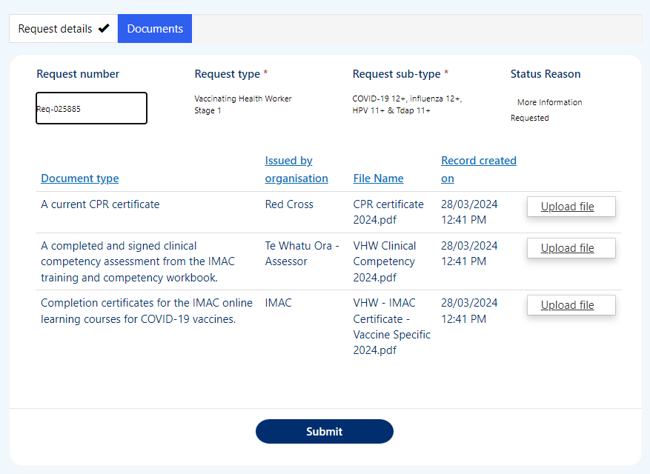
8 | Your request will now be displayed under the Submitted requests section again | 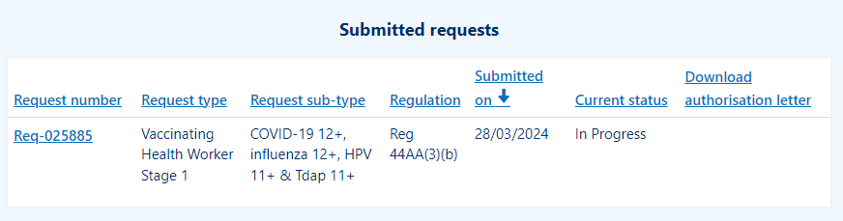

Download your current authorisation letter
You’ll receive an email from Workforce Requests to let you know you have a new notification when an authorisation letter is ready for you.
Once you’ve received your vaccinator authorisation letter you are authorised as a Vaccinating Health Worker. You can now vaccinate people within the age groups specified, and administer the vaccines specified in your authorisation letter. Remember as a Vaccinating Health Worker you should always work under the clinical supervision of a Registered Health Professional.
Step | Action | Screen shot guidance
1 | Log in to your Workforce Requests Portal via the link or QR code on the cover page  Tip: You can use any browser such as Edge, Chrome or Safari
2 | Under the New messages section click the Subject line / message title hyperlink  (e.g. Your new authorisation letter is now available on the workforce portal) | 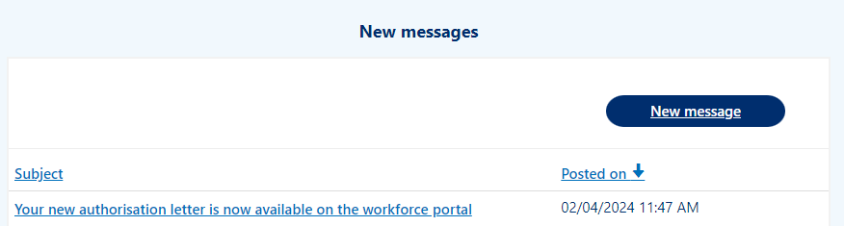
3 | Use the scroll bar to read the message  Once you have read the message click Return  Tip: It’s important to read this message so you understand the vaccinations and age groups you are authorised to vaccinate | 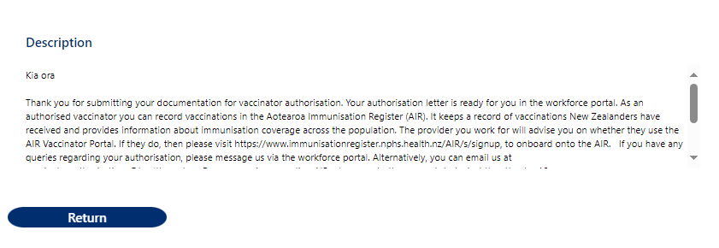
4 | Scroll down to the Submitted requests section  Click Download to download your approval letter  Tip: You’ll only be able to download the most current approval letter. Once a letter is superseded, you’ll no longer have access to the Download button | 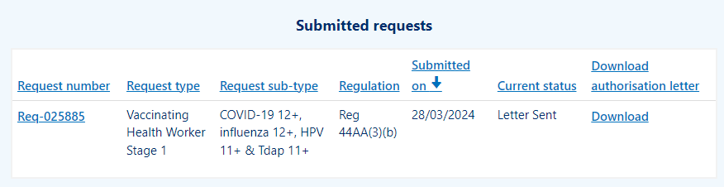
5 | It’s important that you read your authorisation letter to understand the vaccinations and age groups that you are authorised to vaccinate.  Provide a copy of your authorisation letter to your employer. | 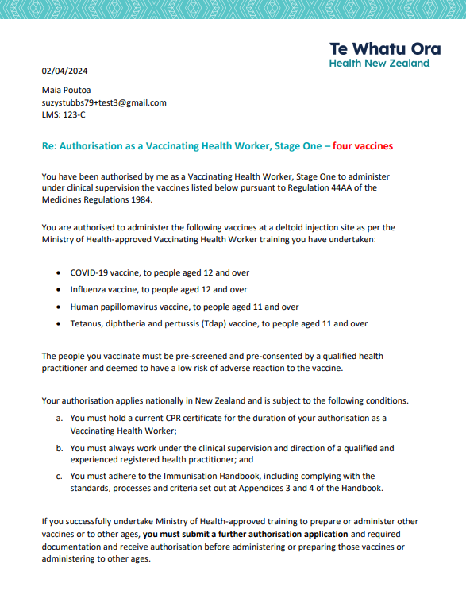

Get help

If you need help with:

- Setting up or accessing a My Health Account Workforce

    - Check out My Health Account Workforce information, help and FAQs at My Health Account Workforce – Health New Zealand | Te Whatu Ora

    - Contact the My Health Account Workforce team, contact details located at About My Health Account Workforce – Health New Zealand | Te Whatu Ora

- Setting up or accessing a My Health Account

    - Check out My Health Account information, help and FAQs at My Health Account – Health New Zealand | Te Whatu Ora

    - Contact the My Health Account team, contact details located at About My Health Account – Health New Zealand | Te Whatu Ora

- Applying for vaccinator authorisation in the Workforce Requests Portal

    - Contact the Vaccinator Authorisation team at vaccinatorauthorisations@health.govt.nz

    - Send us a message via your Workforce Requests Portal home page (see steps below)

Step | Action | Screen shot guidance
1 | Log in to your Workforce Requests Portal via the link or QR code on the cover page  Tip: You can use any browser such as Edge, Chrome or Safari
2 | Under the New messages section click New message | 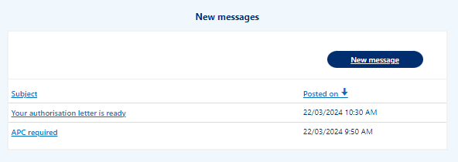
3  4 | Complete the fields:  - Subject - if your message is in relation to a submitted request please include the Req-number in the subject line  - Priority – select from the drop down  - Description – type your message, please provide as much detail as you can  Click Submit | 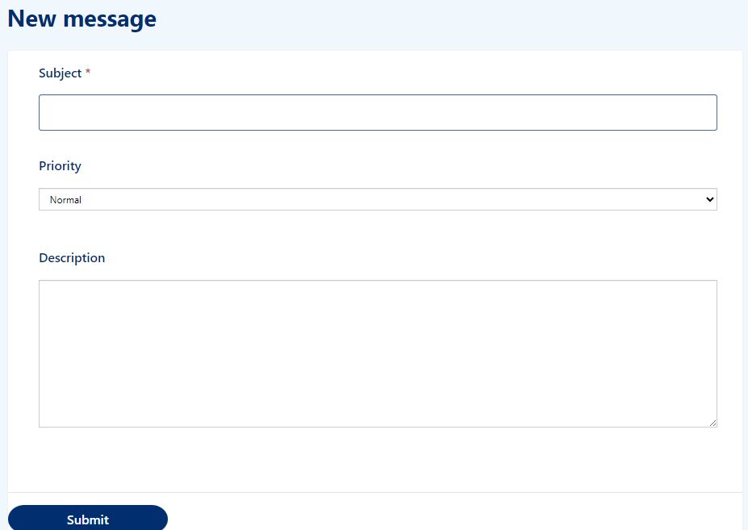
5 | Your message will:  - appear in your Workforce Requests Portal, Message history section.  - be sent to an administrator at Health NZ – Te Whatu Ora for action and response.  You’ll receive an email notification from Workforce Requests when you have a response to your message. Log in to your Workforce Requests Portal to view the response under the New messages section.

