Workforce Requests Portal Guide

Pharmacist Vaccinators
Contents
Sign up to the Workforce Requests Portal 1
Log in to the Workforce Requests Portal 7
Update your personal profile 9
Submit a new authorisation request – Transition to whole-of-life vaccinator 10
More information required 15
Uploading post authorisation requirement documents 17
Download your current authorisation letter 20
Get help 22

Welcome to the Workforce Requests Portal

The Workforce Requests Portal will allow you to sign in securely to apply for vaccinator authorisation, upload and access your vaccinator authorisation documentation, and access your vaccinator authorisation letters.

Access the Workforce Requests Portal via the hyperlink, URL or QR code:

Workforce requests

https://workforcerequest.powerappsportals.com/SignIn?ReturnUrl=%2F

Sign up to the Workforce Requests Portal
You’ll need to sign up and create a My Health Account Workforce to access the Workforce Requests Portal. Find out more at About My Health Account Workforce – Health New Zealand | Te Whatu Ora.
Step | Action | Screen shot guidance
1 | Access the Workforce Requests Portal via the link or QR code on the cover page  Tip: You can use any browser such as Edge, Chrome or Safari
2 | Click My Health Account Workforce button  This will take you to sign up for a My Health Account Workforce account | 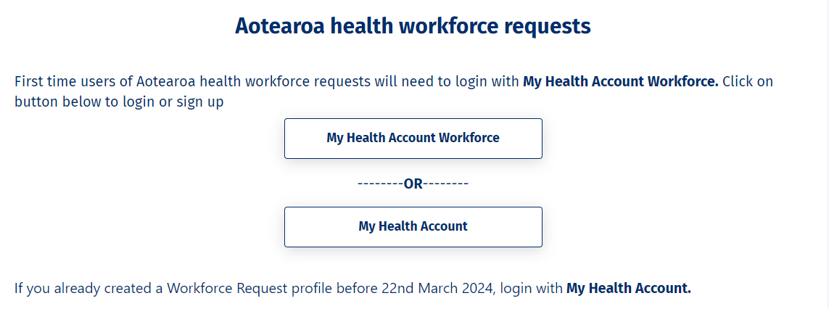
3 | Click Sign up  Tip: If you have a My Health Account Workforce already you can go to page 7 to log in then you’ll be directed to create Workforce Requests Portal profile steps 16 – 18 below | 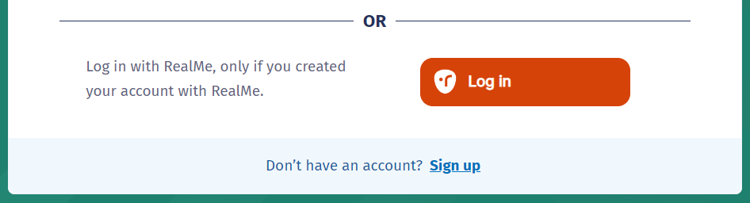
4 | Click Sign up with email to create an account linked to your email  Or  Click Log in to create an account using an existing RealMe account | 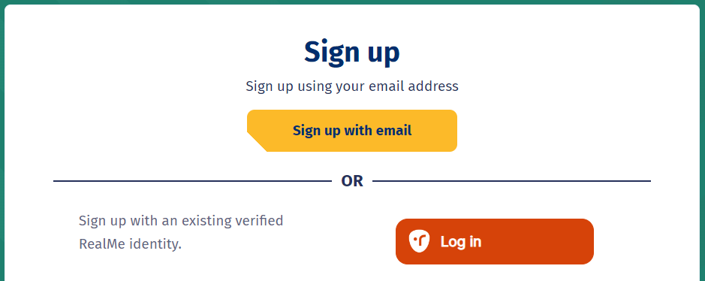
If you used RealMe or RealMe Verified to sign up for your personal My Health Account, you will need to sign up for My Health Account Workforce using an email address and password.

You’ll need your own email address. It must be unique to you and not one you share with someone else. It also must be a different email address from the one you used when you created a My Health Account as a health consumer.

Not sure if you have a My Health Account? If you have accessed My Covid Record to create a vaccine pass or enter RAT test results, you will have set up a My Health Account

5  6  7 | Click hyperlinks to open and read the Privacy statement and Terms of use  Tick the box to confirm:  - you have read and agree to the Privacy statement and Terms of use  - you are making this application on your own behalf  Click Start | 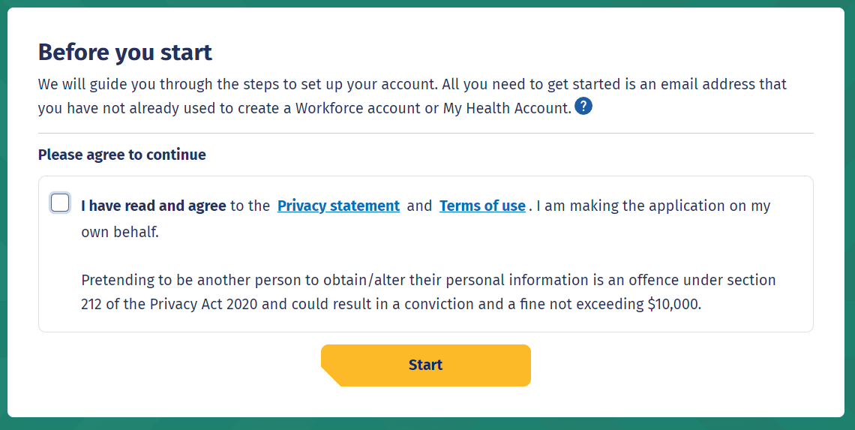
8  9 | Enter your email address  Click Send verification | 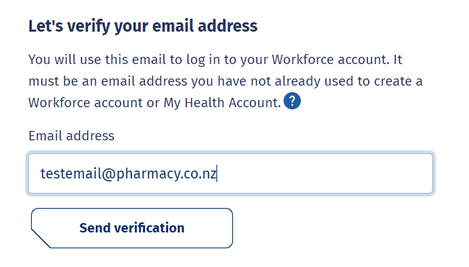
10 | Open your email application (e.g. outlook, gmail etc) in a new tab  Open the email  From: My Health Account  Subject: Here’s your My Health Account Workforce verification code  Note your verification code | 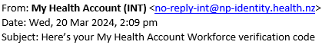  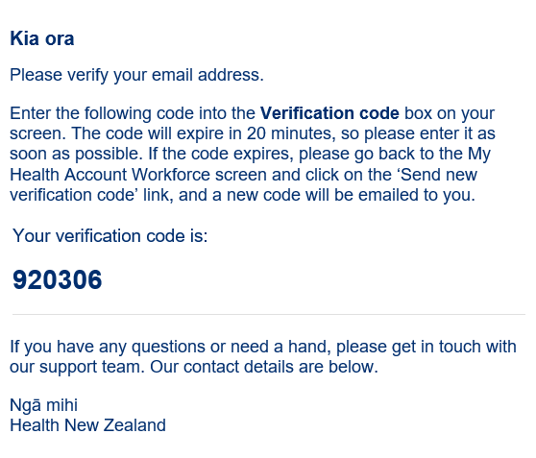
11  12 | Return to My Health Account Workforce portal tab  Enter your Verification code  Click Continue
13  14 | Enter a password  Tip: Note the criteria provided to guide you creating a strong password  Click Continue | 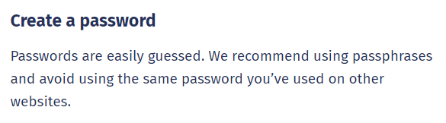
15 | Click Allow | 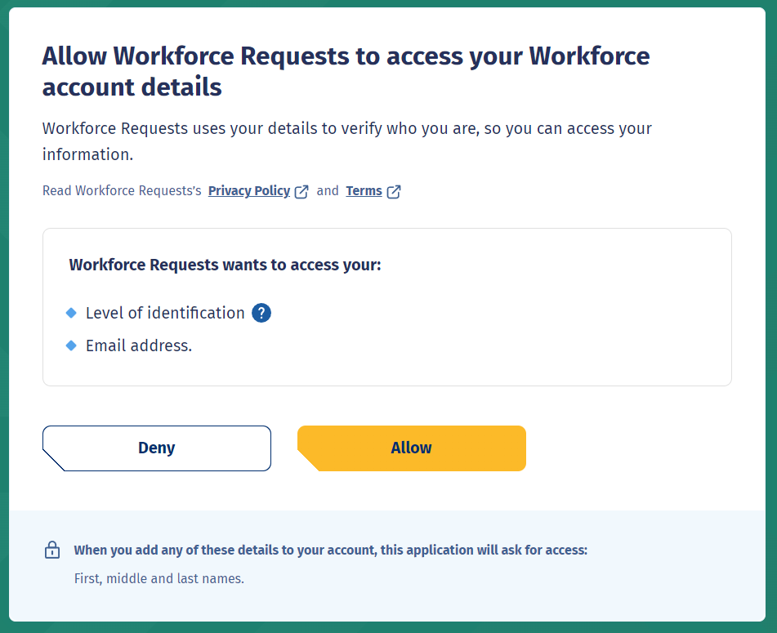
16  17 | You’ll now be taken to the Workforce Requests Portal to set up your profile  Complete Your Details form fields (see Tips below)  Once you have completed the form fields, click Submit | 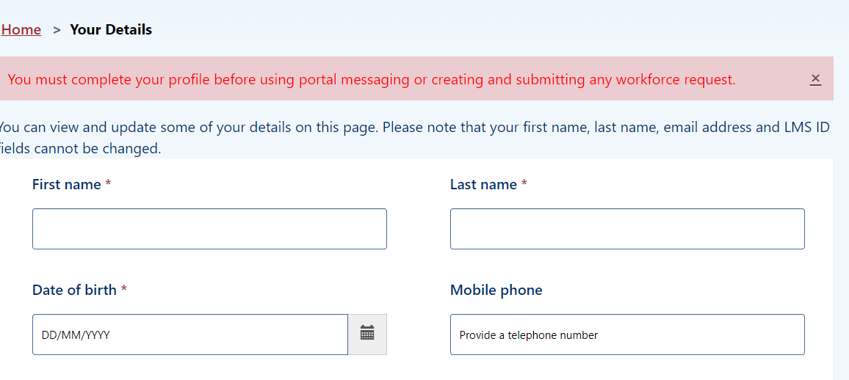  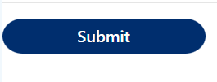
Date of birth - use DD/MM/YYY format.

Alternate email address - you may like to add your personal / alternative email address here. Notifications and reminders from Workforce Requests will be sent to your sign-up email address and the alternate email address you provide (from June 2024).

Ethnicity - use the drop-down list on the right to select your ethnicity, you can select more than one ethnicity.

LMS ID - this is your Immunisation Advisory Centre (IMAC) Learning Management System (LMS) identity number, you’ll find the alpha-numeric identification on your IMAC certificate.

APC – this is your Annual Practicing Certificate number.

CPN / HPI – this is your Health Provider Index Common Person Number, known as CPN or HPI number.

Employer and Employer email address - if you provide details the portal may include your employer in notifications of when your vaccination authorisation is due for renewal.

For more information go to Getting the most from your account – Health New Zealand | Te Whatu Ora)

18 | You are now signed up and taken to your Workforce Requests Portal home page  This is the page you’ll use to view your messages, submit vaccinator authorisation requests and ultimately download your vaccinator authorisation letter | 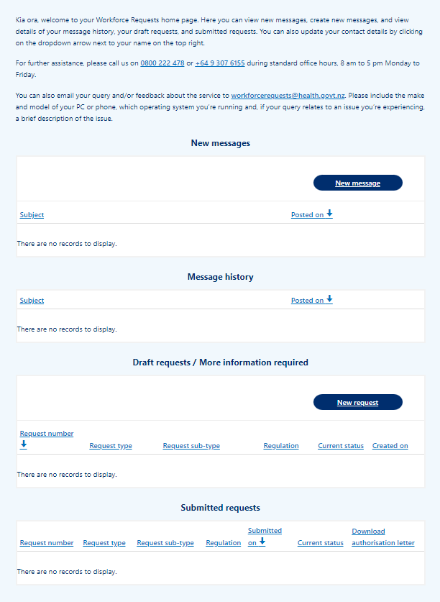
If you need to:

- Submit a new authorisation request – Transition to whole-of-life vaccinator – go to page 10

Log in to the Workforce Requests Portal
When you are returning to the Workforce Requests Portal after initially signing up, you’ll need to log in to get to your home page.
Step | Action | Screen shot guidance
1 | Access the Workforce Requests Portal via the link or QR code on the cover page  Tip: You can use any browser such as Edge, Chrome or Safari
2 | Click My Health Account Workforce button
3  4 | Enter your Email address and Password  Click Log in | 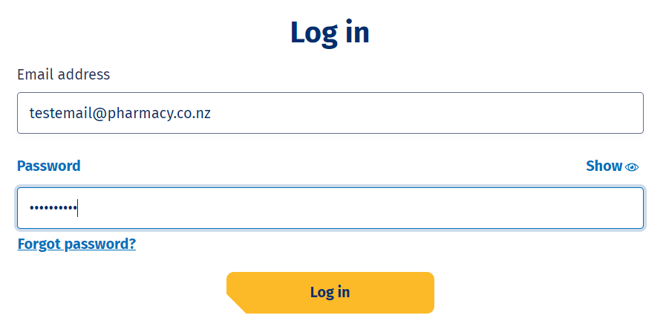
5 | You’ll be taken to your Workforce Requests Portal home page  This is the page you’ll use to view your messages, submit vaccinator authorisation requests and ultimately download your vaccinator authorisation letter
If you need to:

- Update your profile – go to page 9
- Submit a new authorisation request – Transition to whole-of-life vaccinator – go to page 10
- Upload your post authorisation requirements documents – go to page 17
- Download your Authorisation letter – go to page 20

Update your personal profile
If you need to make changes to your personal details after your initial sign up. You can do this by updating your details in your My Health Account Workforce account by going to My Health Account Workforce | Health New Zealand | Te Whatu Ora. See Getting the most from your account – Health New Zealand | Te Whatu Ora for more information and trouble shooting.
If you want to update personal details only in your Workforce Requests Portal, follow the steps below.
Step | Action | Screen shot guidance
1 | Log in to your Workforce Requests Portal via the link or QR code on the cover page (page 7)  Tip: You can use any browser such as Edge, Chrome or Safari
2  3 | Click the down arrow by your name (top right of the page)  Click Your details | 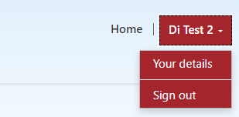
4 | Amend your personal details  Tip: You can’t change your:  - First or last name  - Primary email address  - LMS ID | 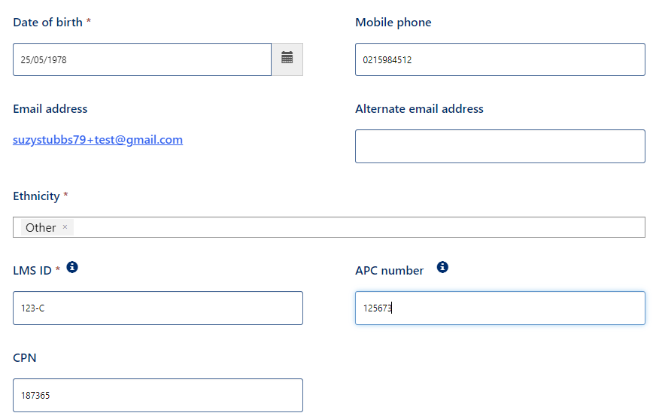
5 | Once you’ve updated your details, click Submit (bottom left of the screen)

Submit a new authorisation request – Transition to whole-of-life vaccinator
When you have completed the Transition to whole-of-life vaccinator training you can submit a new authorisation request. This will go to a Medical Officer of Health (MOoH) for review.
Step | Action | Screen shot guidance
1 | Log in to your Workforce Requests Portal via the link or QR code on the cover page (page 7)  Tip: You can use any browser such as Edge, Chrome or Safari
2  3 | From your home page, scroll down to Draft requests / More information required  Click New request | 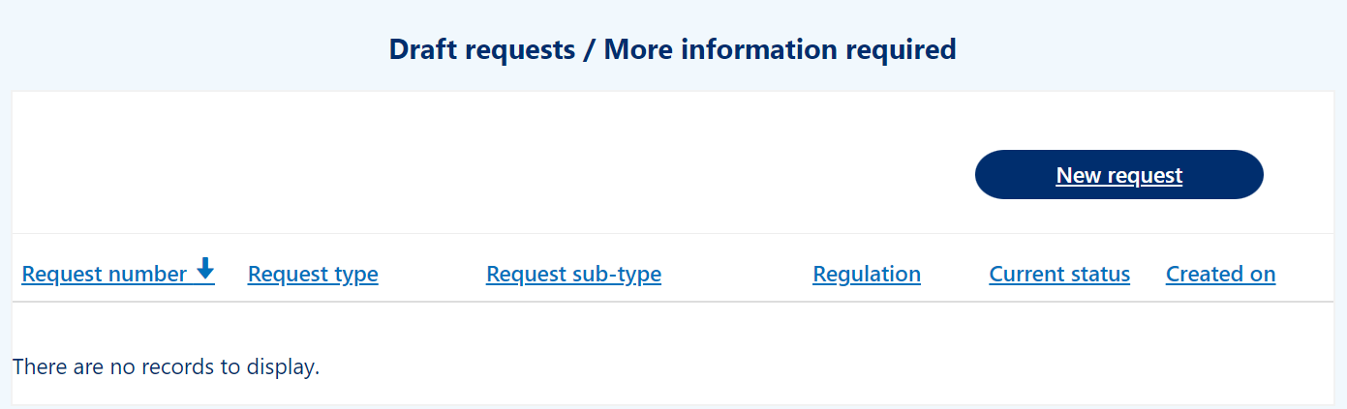
4 | Complete the drop-down fields  - Request type – select Authorised Vaccinator  - Request sub-type – select Transition to whole-of-life vaccinator  - Request priority – select Standard (approx. 7 working days) or Urgent (if you need authorisation sooner than 7 days. You’ll be prompted to add a reason for the urgent request)  Click Next | 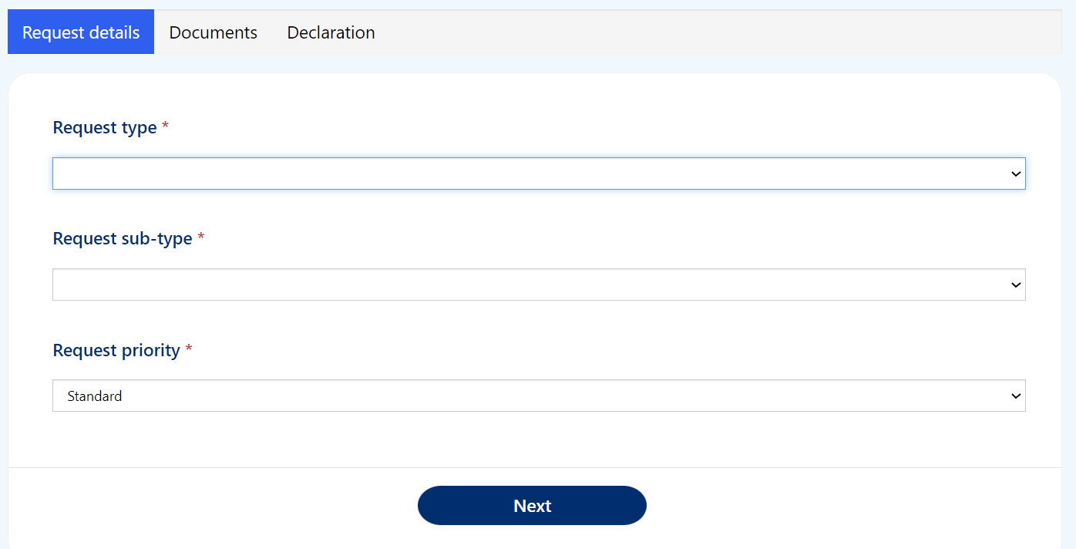
5 | Upload the following documents:  - Current CPR certificate  - Foundation Course or Update Training Certificate  - Copy of original clinical assessment  - Extending vaccinator skills (whole-of-life) Course Certificate  - Current APC  Click Upload file alongside the document you wish to upload | 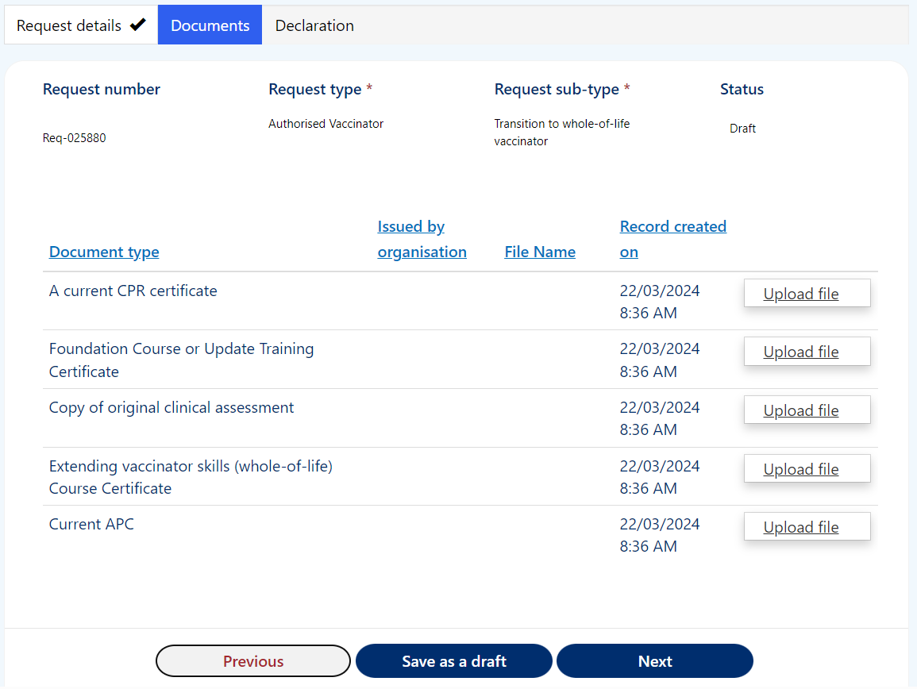
6  7  8  9 | Enter the name of the organisation who issued the document in the Issued by organisation field  Click Choose file to select file from your device  Tip: you can upload pdf or image files  Click Upload  Repeat steps 5 – 9 for each document type required | 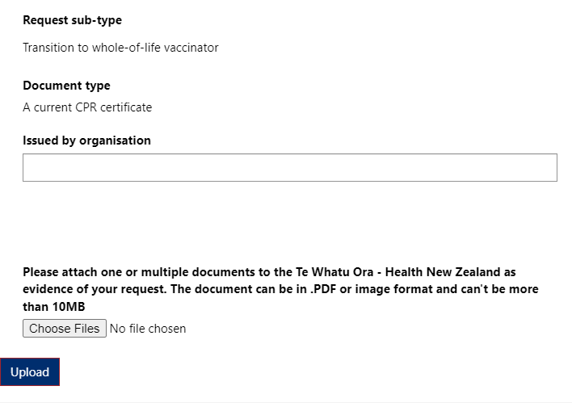
 | Tip: you can upload more than one file against each document type.  You can delete a file if you make a mistake.  - Click Upload file  - Click drop down arrow by the file you want to delete  - Click Delete  - Confirm you want to Delete  - Click Upload to save the change | 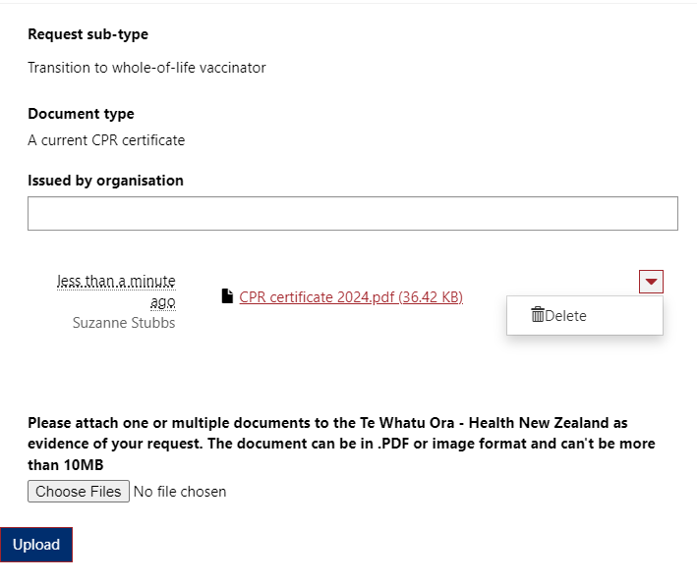
10 | Once you have uploaded all your documents click Next to continue  Tip: You can Save as a draft if you need to return to upload further documents at a later time | 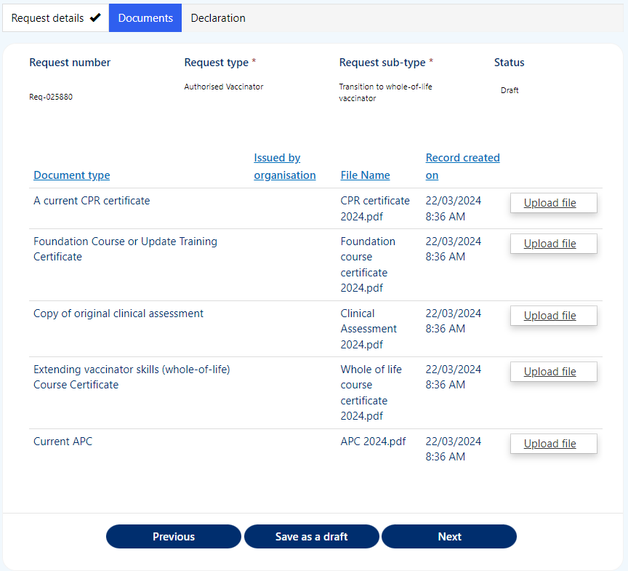
11  12 | To complete and submit your request, check the box to confirm your declaration  Click Submit | 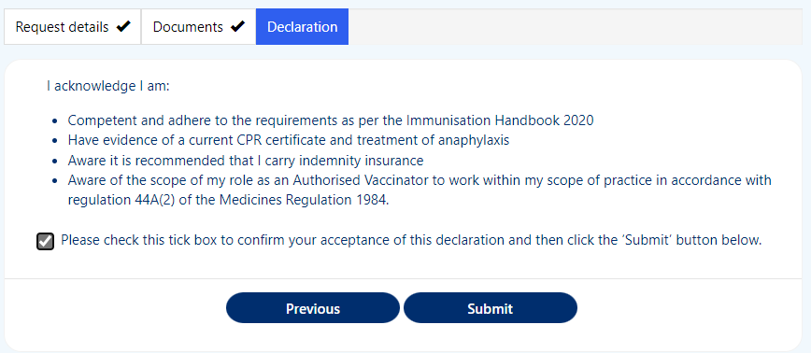
13 | You’ll return to your Workforce Requests Portal home page  Your request will now be sitting under your Submitted requests | 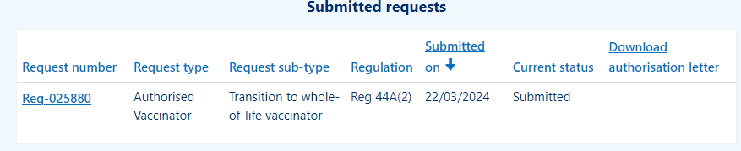
Your request will now be reviewed by Health NZ – Te Whatu Ora. Once your request has been reviewed you will receive a notification via email of:

- More information required – go to page 15
- Authorisation letter – go to page 20

More information required
Following an authorisation submission, Te Whatu Ora – Health NZ may request more information. This can occur when the information provided is not complete (e.g. a document is missing or in-complete). You’ll receive an email from Workforce Requests letting you know you have a notification in your Workforce Requests Portal.
Step | Action | Screen shot guidance
1 | Log in to your Workforce Requests Portal via the link or QR code on the cover page (page 7)  Tip: You can use any browser such as Edge, Chrome or Safari
2  3 | You’ll see a message in the New messages section  Click the Subject hyperlink to open and read the message, we’ll let you know what information is needed
4 | Your request will now be under the Draft requests / More information required section  Click the Req-number hyperlink to open the request and upload the required information | 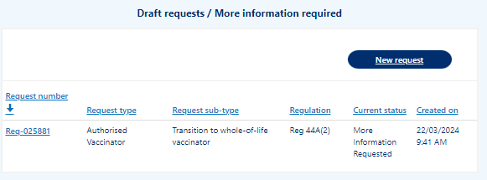
5 | Click Next to confirm the Request type, sub-type and priority | 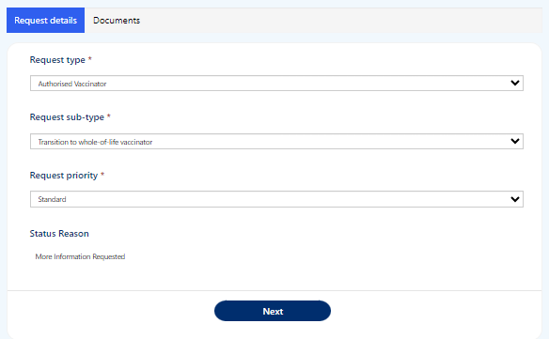
6 | Click Upload file against the required information to select file to upload  Once all required files have been uploaded, click Submit | 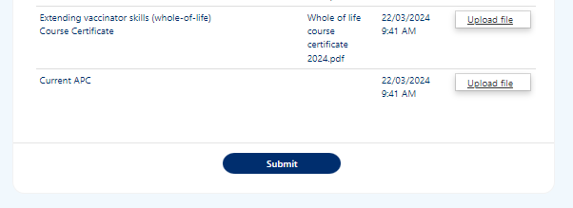
7 | Your request will now be displayed under the Submitted requests section again | 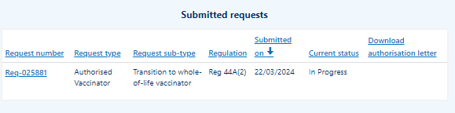

Uploading post authorisation requirement documents
After you have submitted a new authorisation request you will need to complete post authorisation requirements, and when you have successfully met these requirements you’ll need to upload post authorisation requirement documents as evidence of this. Post authorisation requirements documents are your:
- workbook sign off sheet
- completed and signed clinical assessment on a person under two years old
Step |  | Action |  | Screen shot guidance
1 |  | Log in to your Workforce Requests Portal via the link or QR code on the cover page (page 7)  Tip: You can use any browser such as Edge, Chrome or Safari
2  3 |  | From your home page, scroll down to the Post authorisation section. If you have Post authorisation requirements to complete and upload this will show here  Click the Req-number hyperlink |  | 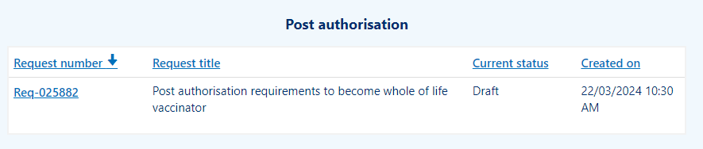
4 |  | Click Next to confirm Request details |  | 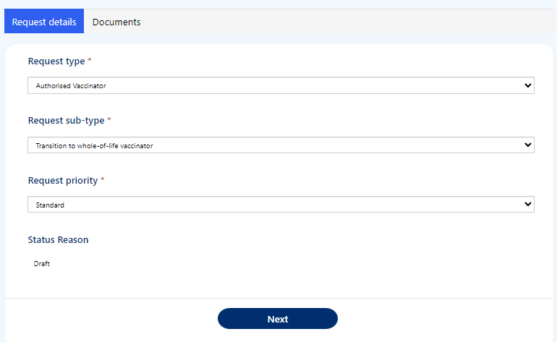
5 |  | Upload the listed documents:  - completed and signed clinical assessment  - Sign off sheet from workbook  Click Upload alongside the document you wish to upload |  | 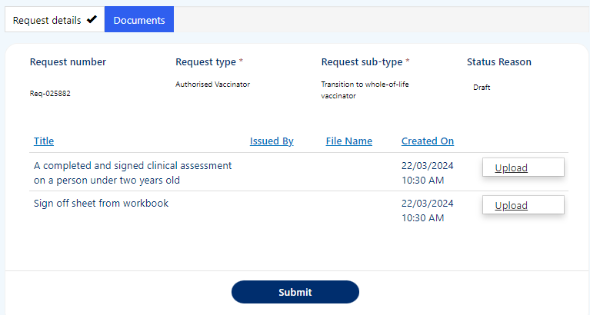
You can upload one or both documents before Submitting.

If you Submit with just one document uploaded, then you’ll receive an updated authorisation letter with remaining conditions included.

Once you have successfully complete and uploaded both post authorisation requirements documents you’ll receive an authorisation letter with no conditions.

6 |  | Once you have uploaded the post authorisation requirements document(s)  Click Submit  Repeat steps 1 – 6 to upload additional post authorisation requirements documents to a request.  Tip: If you upload a document in error, see page 12 for steps to delete the upload. |  | 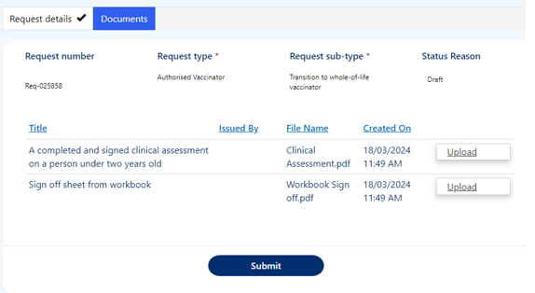
 | 7 | Once you have Submitted you’ll see this request in the Submitted requests section of your Workforce Requests Portal homepage | 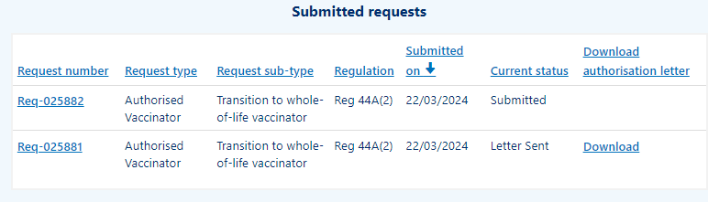
Once your request has been reviewed you will receive notification via email of:

- More information required – go to page 15
- Authorisation letter – go to page 20

Download your current authorisation letter
You’ll receive an email from Workforce Requests to let you know you have a new notification when an authorisation letter is ready for you.
Step | Action | Screen shot guidance
1 | Log in to your Workforce Requests Portal via the link or QR code on the cover page (page 7)  Tip: You can use any browser such as Edge, Chrome or Safari
2 | Under the New messages section click the Subject line / message title hyperlink | 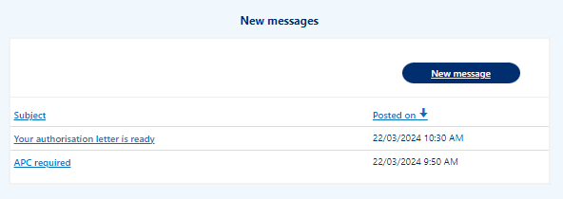
3 | Use the scroll bar to read the message  Once you have read the message click Return  Tip: Your initial authorisation will have conditions on your practice. It’s important that you read your authorisation letter to understand these conditions | 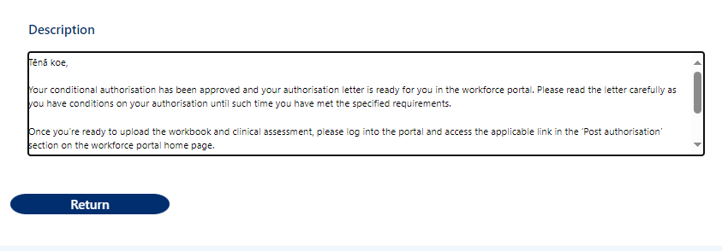
4 | Scroll down to the Submitted requests section  Click Download to download your approval letter  Tip: You’ll only be able to download the most current approval letter. Once a letter is superseded, you’ll no longer have access to the Download button | 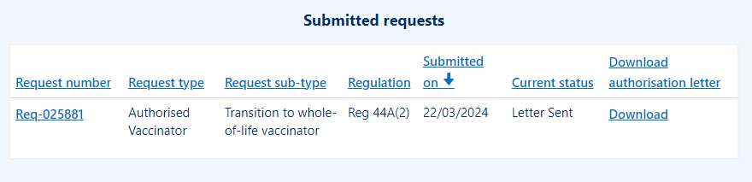
5 | You may have conditions on your authorisation  It’s important that you read your authorisation letter to understand these conditions  Go to Uploading post authorisation requirements (page 17) once you have successfully completed your post authorisation requirements and are ready to upload these documents as evidence | 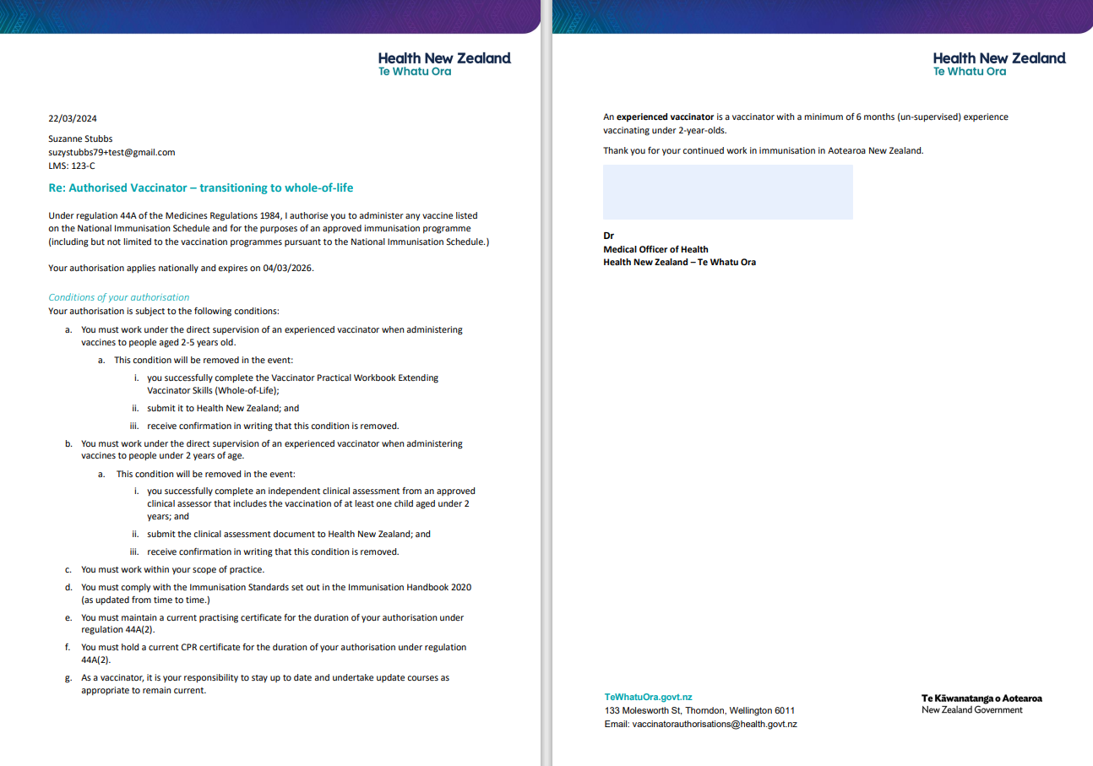

Get help
If you need help with:
- Setting up or accessing a My Health Account Workforce

  - Check out My Health Account Workforce information, help and FAQs at My Health Account Workforce – Health New Zealand | Te Whatu Ora

  - Contact the My Health Account Workforce team, contact details located at About My Health Account Workforce – Health New Zealand | Te Whatu Ora

- Applying for vaccinator authorisation in the Workforce Requests Portal

  - Contact the Vaccinator Authorisation team at vaccinatorauthorisations@health.govt.nz

  - Send us a message via your Workforce Requests Portal home page (see steps below)

Step | Action | Screen shot guidance
1 | Log in to your Workforce Requests Portal via the link or QR code on the cover page (page 7)  Tip: You can use any browser such as Edge, Chrome or Safari
2 | Under the New messages section click New message
3  4 | Complete the fields:  - Subject - if your message is in relation to a submitted request please include the Req-number in the subject line  - Priority – select from the drop down  - Description – type your message, please provide as much detail as you can  Click Submit | 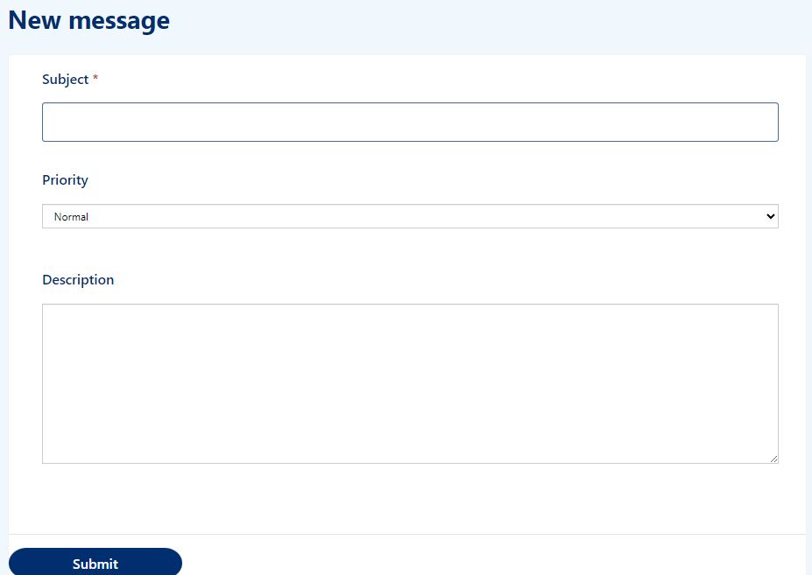
Your message will:
- appear in your Workforce Requests Portal, Message history section.
- be sent to an administrator at Health NZ – Te Whatu Ora for action and response.

You’ll receive an email notification from Workforce Requests when you have a response to your message. Log in to your Workforce Requests Portal to view the response under the New messages section.

