July 2023

Fees Review Committee (FRC)
Evidence and matters for consideration regarding increases in general practice co-payment fees

The Fees Review Committee takes account of relevant business and financial information when considering whether a proposed fees increase is reasonable to both practice and patient. The following questions have been adapted from clause 4.3 of the PHO Services Agreement Fees Review Process Reference Document (2006) which is attached as an appendix to this document. The relevant clauses are referenced as a footnote.

Please complete questions 1 – 5 in this document to support the data you have provided in the Financial Information Template and fill a minimum of TWO questions from questions 6 to 8.

NOTE: If your response needs more space, please attach responses as a separate word document or incorporate them in a business plan document.
NOTE: Your financial and business information will be treated confidentially and only viewed by the FRC and the district or regional managers who can deem the increases reasonable without referral to the FRC
- [Mandatory] Please provide the name of the practice and the name includes the names of the owner(s) of the practice so conflict of interest check can be completed with the fees review committee members

- [Mandatory] Please provide the specific provision(s) you are applying for a fees increase under (refer to appendix)

- Mandatory] Comment on significant income and cost changes (as stated in the financial information template for fees review submission, or as demonstrated by audited accounts and projections), any other relevant factors, and a general statement to support a proposed fee increase.

- [MANDATORY] Provide evidence of the practice fees in comparable practices in your locality and whether they are accepting new patients. This can be sourced by your PHO from the DHBs.

- [MANDATORY] Please note any anticipated changes in your enrolment status for new patient enrolments in the coming year.

Please answer at least TWO of the following questions
- Please explain how changes in clinical utilisation rates have led to a reduction in practice profits.
Provide an explanation to the reasons why utilisation rates have changed for specific age groups, such as more awareness of the importance of primary health care, follow-ups with patients discharged from hospital, referral processes, increase in long term condition management, and changes to the average appointment time slot.

- Please explain how any unusual increased costs are impacting on the financial viability of your practice. This may include changes to models of care, increase in costs such as rent, Information Technology, or other factors.

NOTE: wage rate increases are excluded from this analysis as the Labour Cost Index- Health is included with an 80% weighting in the Annual Statement of Acceptable GP Fee Increase.

- Please provide evidence of plans to invest in the business in a way that will advance the ends of the Primary Health Care Strategy, and the financial impact of these plans

Appendix: Provisions considered by the Fees Review Committee
The following is an extract from the Fees Review Process Guidance Document and indicates the specific provisions the Fees Review Committee uses in its decisions. One or more provisions may apply, and it is helpful to understand what provisions you think are the most applicable to your practice. Please use this to answer question 2.
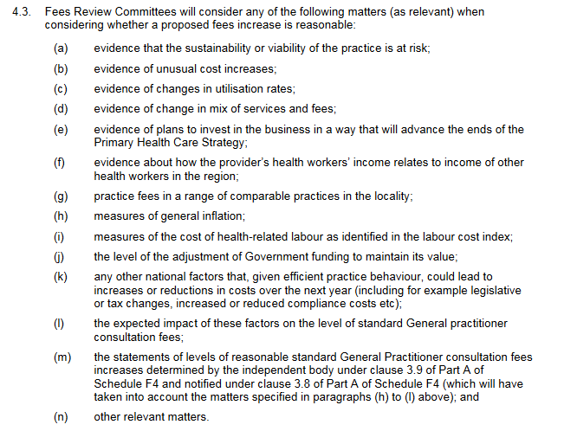

Clause 4.3(a), (b), (d), ( e), (h), (j), (m), (n)
Clause 4.3(g)
Clause 4.3(c)

