Annual Cold Chain Management Record

Facility name:

Date:

Designated cold chain staff:

Local immunisation/cold chain coordinator:

Contact number:

CCA expiry date:

Refrigerator manufacturer:

Contact number:

Citation: Ministry of Health. 2017. *Annual Cold Chain Management Record.* Wellington: Ministry of Health.

Updated in February 2020 by the  
Ministry of Health  
PO Box 5013, Wellington 6145, New Zealand

ISBN 978-1-98-850263-2 (online)  
HP 6634

This document is available on the Ministry of Health’s website:  
health.govt.nz

Ministry of health logo

### CCBY This work is licensed under the Creative Commons Attribution 4.0 International licence. In essence, you are free to: share ie, copy and redistribute the material in any medium or format; adapt ie, remix, transform and build upon the material. You must give appropriate credit, provide a link to the licence and indicate if changes were made.

Contents

Introduction 2

Daily checks 3

Weekly checks 3

Monthly checks 3

Six-monthly check 10

Annual check 17

Cold chain history 18

Key contacts 20

# Introduction

All vaccines must be stored between +2˚C to +8˚C at all times. The Annual Cold Chain Management Record (the Record) is designed to allow you to keep your daily minimum and maximum temperature recordings and a record your cold chain actions, equipment checks and services in one place.

All immunisation providers are required to comply with the Ministry of Health’s (the Ministry) *National Standards for Vaccine Storage and Transportation for Immunisation Providers 2017 (2nd edition)* (the Standards), to use a pharmaceutical refrigerator to store vaccines and undertake the appropriate temperature monitoring processes.

You must discuss any temperatures outside the required +2˚C to +8˚C range with your immunisation/cold chain coordinator, with the exception of temperatures between +8˚C and +12˚C for less than 30 minutes for known reasons, eg, stocktake, however your actions and responses should be documented. This does not apply to buffered probes.

A copy of the Standards can be found on the Ministry’s website [www.health.govt.nz/coldchain](http://www.health.govt.nz/coldchain)

# Daily checks

Record the refrigerator’s maximum and minimum temperatures at the same time every day (that the service is open). The person recording the temperature should initial in the space provided on the recording chart, see example below.

Any temperatures outside the +2˚C to +8˚C range must be followed up and the outcome documented, with the exception of temperatures between +8˚C and +12˚C for less than 30 minutes for known reasons, eg, stocktake, which do not need to be notified to the coordinator. This does not apply to buffered probes. However your actions and responses should be documented, see example below.

# Weekly checks

On an agreed day every week, the electronic data logger or continuous monitoring data should be downloaded, reviewed in conjunction with the daily minimum/maximum temperature recordings and action taken if temperatures are noted to be outside the required +2˚C to +8˚C range. This needs to be documented.

# Monthly checks

At the end of every month, complete a summary of the refrigerators performance, record this in the comments and checklist section. When further documentation is required add this to the cold chain history section in the record.

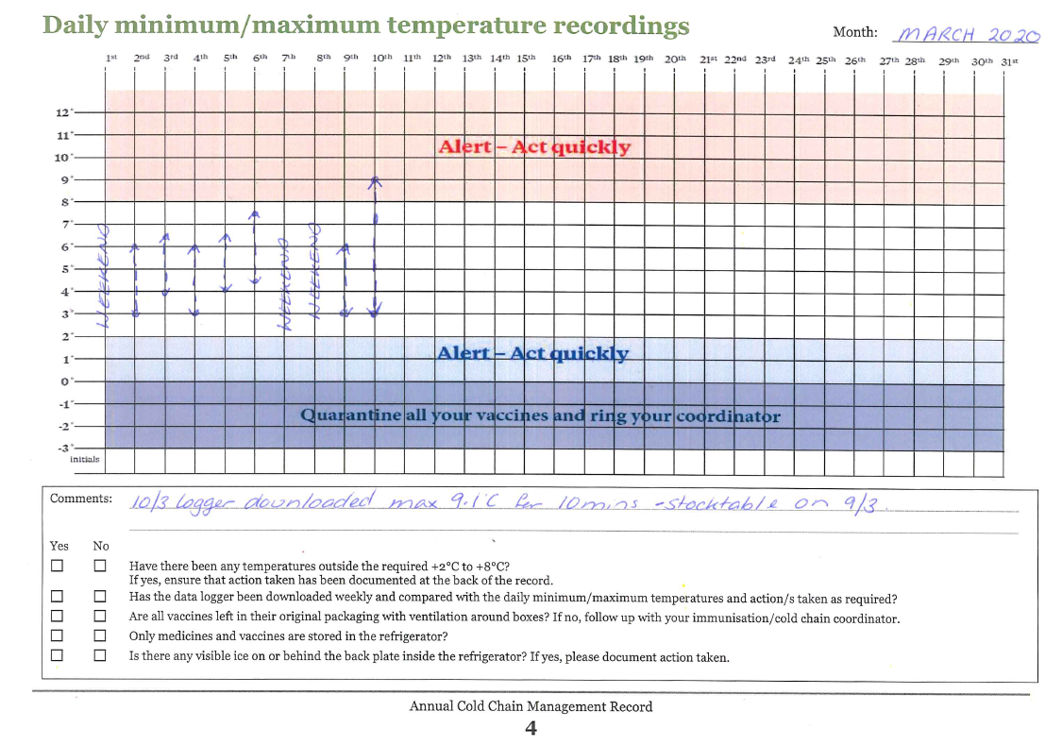

|  |  |  |
| --- | --- | --- |
| Daily minimum/maximum temperature recordings | Month: |  |

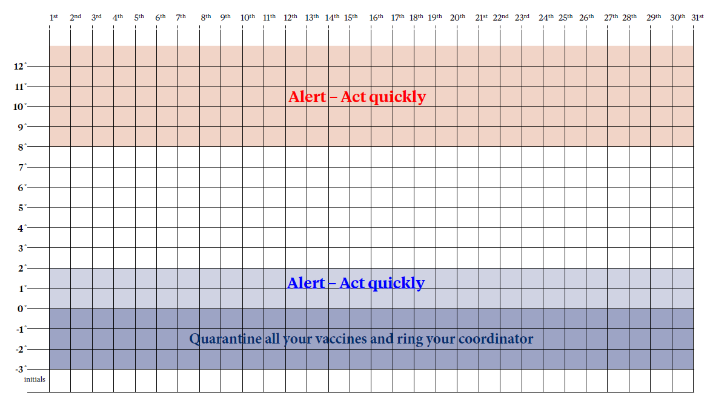

|  |  |  |  |  |  |
| --- | --- | --- | --- | --- | --- |
| Comments: | |  | | |  |
|  | | |  |
| Yes | No |  | | |  |
|  |  | Have there been any temperatures outside the required +2°C to +8°C? If yes, ensure that action taken has been documented at the back of the record. | | |  |
|  |  | Has the data logger been downloaded weekly and compared with the daily minimum/maximum temperatures and action/s taken as required? | | |  |
|  |  | Are all vaccines left in their original packaging with ventilation around boxes? If no, follow up with your immunisation/cold chain coordinator. | | |  |
|  |  | Only medicines and vaccines are stored in the refrigerator? | | |  |
|  |  | Is there any visible ice on or behind the back plate inside the refrigerator? If yes, please document action taken. | | |  |
| Daily minimum/maximum temperature recordings | | | | Month: |  | |



|  |  |  |  |  |  |
| --- | --- | --- | --- | --- | --- |
| Comments: | |  | | |  |
|  | | |  |
| Yes | No |  | | |  |
|  |  | Have there been any temperatures outside the required +2°C to +8°C? If yes, ensure that action taken has been documented at the back of the record. | | |  |
|  |  | Has the data logger been downloaded weekly and compared with the daily minimum/maximum temperatures and action/s taken as required? | | |  |
|  |  | Are all vaccines left in their original packaging with ventilation around boxes? If no, follow up with your immunisation/cold chain coordinator. | | |  |
|  |  | Only medicines and vaccines are stored in the refrigerator? | | |  |
|  |  | Is there any visible ice on or behind the back plate inside the refrigerator? If yes, please document action taken. | | |  |
| Daily minimum/maximum temperature recordings | | | | Month: |  | |



|  |  |  |  |  |  |
| --- | --- | --- | --- | --- | --- |
| Comments: | |  | | |  |
|  | | |  |
| Yes | No |  | | |  |
|  |  | Have there been any temperatures outside the required +2°C to +8°C? If yes, ensure that action taken has been documented at the back of the record. | | |  |
|  |  | Has the data logger been downloaded weekly and compared with the daily minimum/maximum temperatures and action/s taken as required? | | |  |
|  |  | Are all vaccines left in their original packaging with ventilation around boxes? If no, follow up with your immunisation/cold chain coordinator. | | |  |
|  |  | Only medicines and vaccines are stored in the refrigerator? | | |  |
|  |  | Is there any visible ice on or behind the back plate inside the refrigerator? If yes, please document action taken. | | |  |
| Daily minimum/maximum temperature recordings | | | | Month: |  | |



|  |  |  |  |  |  |
| --- | --- | --- | --- | --- | --- |
| Comments: | |  | | |  |
|  | | |  |
| Yes | No |  | | |  |
|  |  | Have there been any temperatures outside the required +2°C to +8°C? If yes, ensure that action taken has been documented at the back of the record. | | |  |
|  |  | Has the data logger been downloaded weekly and compared with the daily minimum/maximum temperatures and action/s taken as required? | | |  |
|  |  | Are all vaccines left in their original packaging with ventilation around boxes? If no, follow up with your immunisation/cold chain coordinator. | | |  |
|  |  | Only medicines and vaccines are stored in the refrigerator? | | |  |
|  |  | Is there any visible ice on or behind the back plate inside the refrigerator? If yes, please document action taken. | | |  |
| Daily minimum/maximum temperature recordings | | | | Month: |  | |



|  |  |  |  |  |  |
| --- | --- | --- | --- | --- | --- |
| Comments: | |  | | |  |
|  | | |  |
| Yes | No |  | | |  |
|  |  | Have there been any temperatures outside the required +2°C to +8°C? If yes, ensure that action taken has been documented at the back of the record. | | |  |
|  |  | Has the data logger been downloaded weekly and compared with the daily minimum/maximum temperatures and action/s taken as required? | | |  |
|  |  | Are all vaccines left in their original packaging with ventilation around boxes? If no, follow up with your immunisation/cold chain coordinator. | | |  |
|  |  | Only medicines and vaccines are stored in the refrigerator? | | |  |
|  |  | Is there any visible ice on or behind the back plate inside the refrigerator? If yes, please document action taken. | | |  |
| Daily minimum/maximum temperature recordings | | | | Month: |  | |



|  |  |  |  |
| --- | --- | --- | --- |
| Comments: | |  |  |
|  |  |
| Yes | No |  |  |
|  |  | Have there been any temperatures outside the required +2°C to +8°C? If yes, ensure that action taken has been documented at the back of the record. |  |
|  |  | Has the data logger been downloaded weekly and compared with the daily minimum/maximum temperatures and action/s taken as required? |  |
|  |  | Are all vaccines left in their original packaging with ventilation around boxes? If no, follow up with your immunisation/cold chain coordinator. |  |
|  |  | Only medicines and vaccines are stored in the refrigerator? |  |
|  |  | Is there any visible ice on or behind the back plate inside the refrigerator? If yes, please document action taken. |  |

# Six-monthly check

|  |  |  |  |
| --- | --- | --- | --- |
| Yes | No |  | |
|  |  | The door seal is checked and in good condition. | |
|  |  | If no, what action has been taken? |  |
|  |  | Refrigerator interior cleaned. | |
|  |  | Has any new cold chain equipment been purchased? | |
|  |  | If yes, have you discussed this with your immunisation/cold chain coordinator and updated your policy document? | |
|  |  | Do you have any new clinical staff? | |
|  |  | If yes, have they completed their cold chain orientation? | |
|  |  | Have they signed and dated the clinic cold chain policy? | |

|  |  |  |  |  |
| --- | --- | --- | --- | --- |
|  |  |  |  |  |
| Name |  | Signature |  | Date |

Review the results in your staff meetings to continuously improve vaccine cold chain management.

|  |  |  |
| --- | --- | --- |
| Daily minimum/maximum temperature recordings | Month: |  |



|  |  |  |  |  |  |
| --- | --- | --- | --- | --- | --- |
| Comments: | |  | | |  |
|  | | |  |
| Yes | No |  | | |  |
|  |  | Have there been any temperatures outside the required +2°C to +8°C? If yes, ensure that action taken has been documented at the back of the record. | | |  |
|  |  | Has the data logger been downloaded weekly and compared with the daily minimum/maximum temperatures and action/s taken as required? | | |  |
|  |  | Are all vaccines left in their original packaging with ventilation around boxes? If no, follow up with your immunisation/cold chain coordinator. | | |  |
|  |  | Only medicines and vaccines are stored in the refrigerator? | | |  |
|  |  | Is there any visible ice on or behind the back plate inside the refrigerator? If yes, please document action taken. | | |  |
| Daily minimum/maximum temperature recordings | | | | Month: |  | |



|  |  |  |  |  |  |
| --- | --- | --- | --- | --- | --- |
| Comments: | |  | | |  |
|  | | |  |
| Yes | No |  | | |  |
|  |  | Have there been any temperatures outside the required +2°C to +8°C? If yes, ensure that action taken has been documented at the back of the record. | | |  |
|  |  | Has the data logger been downloaded weekly and compared with the daily minimum/maximum temperatures and action/s taken as required? | | |  |
|  |  | Are all vaccines left in their original packaging with ventilation around boxes? If no, follow up with your immunisation/cold chain coordinator. | | |  |
|  |  | Only medicines and vaccines are stored in the refrigerator? | | |  |
|  |  | Is there any visible ice on or behind the back plate inside the refrigerator? If yes, please document action taken. | | |  |
| Daily minimum/maximum temperature recordings | | | | Month: |  | |



|  |  |  |  |  |  |
| --- | --- | --- | --- | --- | --- |
| Comments: | |  | | |  |
|  | | |  |
| Yes | No |  | | |  |
|  |  | Have there been any temperatures outside the required +2°C to +8°C? If yes, ensure that action taken has been documented at the back of the record. | | |  |
|  |  | Has the data logger been downloaded weekly and compared with the daily minimum/maximum temperatures and action/s taken as required? | | |  |
|  |  | Are all vaccines left in their original packaging with ventilation around boxes? If no, follow up with your immunisation/cold chain coordinator. | | |  |
|  |  | Only medicines and vaccines are stored in the refrigerator? | | |  |
|  |  | Is there any visible ice on or behind the back plate inside the refrigerator? If yes, please document action taken. | | |  |
| Daily minimum/maximum temperature recordings | | | | Month: |  | |



|  |  |  |  |  |  |
| --- | --- | --- | --- | --- | --- |
| Comments: | |  | | |  |
|  | | |  |
| Yes | No |  | | |  |
|  |  | Have there been any temperatures outside the required +2°C to +8°C? If yes, ensure that action taken has been documented at the back of the record. | | |  |
|  |  | Has the data logger been downloaded weekly and compared with the daily minimum/maximum temperatures and action/s taken as required? | | |  |
|  |  | Are all vaccines left in their original packaging with ventilation around boxes? If no, follow up with your immunisation/cold chain coordinator. | | |  |
|  |  | Only medicines and vaccines are stored in the refrigerator? | | |  |
|  |  | Is there any visible ice on or behind the back plate inside the refrigerator? If yes, please document action taken. | | |  |
| Daily minimum/maximum temperature recordings | | | | Month: |  | |



|  |  |  |  |  |  |
| --- | --- | --- | --- | --- | --- |
| Comments: | |  | | |  |
|  | | |  |
| Yes | No |  | | |  |
|  |  | Have there been any temperatures outside the required +2°C to +8°C? If yes, ensure that action taken has been documented at the back of the record. | | |  |
|  |  | Has the data logger been downloaded weekly and compared with the daily minimum/maximum temperatures and action/s taken as required? | | |  |
|  |  | Are all vaccines left in their original packaging with ventilation around boxes? If no, follow up with your immunisation/cold chain coordinator. | | |  |
|  |  | Only medicines and vaccines are stored in the refrigerator? | | |  |
|  |  | Is there any visible ice on or behind the back plate inside the refrigerator? If yes, please document action taken. | | |  |
| Daily minimum/maximum temperature recordings | | | | Month: |  | |



|  |  |  |  |
| --- | --- | --- | --- |
| Comments: | |  |  |
|  |  |
| Yes | No |  |  |
|  |  | Have there been any temperatures outside the required +2°C to +8°C? If yes, ensure that action taken has been documented at the back of the record. |  |
|  |  | Has the data logger been downloaded weekly and compared with the daily minimum/maximum temperatures and action/s taken as required? |  |
|  |  | Are all vaccines left in their original packaging with ventilation around boxes? If no, follow up with your immunisation/cold chain coordinator. |  |
|  |  | Only medicines and vaccines are stored in the refrigerator? |  |
|  |  | Is there any visible ice on or behind the back plate inside the refrigerator? If yes, please document action taken. |  |

# Annual check

|  |  |  |
| --- | --- | --- |
| Yes | No |  |
|  |  | The refrigerator has been serviced annually according to manufacturer’s recommendations. |
|  |  | The refrigerator is less than 10 years old. |
|  |  | The refrigerator has been externally monitored by either your immunisation/cold chain coordinator or refrigerator service provider and the result reviewed. |
|  |  | The temperature monitoring equipment eg, data logger, digital thermometer has been validated/calibrated as per manufacturer’s recommendation. |
|  |  | The service has an appropriately sized chilly bin/s, adequate ice packs and monitoring equipment for the alternative storage of vaccines, eg, during a power outage or equipment failure. |
|  |  | The battery for the digital minimum/maximum thermometer is replaced as per the manufacturer’s recommendations. |
|  |  | Your provider cold chain policy is reviewed and updated. |

|  |  |  |  |  |
| --- | --- | --- | --- | --- |
|  |  |  |  |  |
| Name |  | Signature |  | Date |

Review the results in your practice meetings to continuously improve management of vaccine storage and processes.

# Cold chain history

|  |  |
| --- | --- |
| Record cold chain events for the year, for example:   * change in the individual responsible for your cold chain management * Cold Chain Accreditation review date * staff training * annual refrigerator logging * purchase of a new vaccine refrigerator | * cold chain breach(es) and actions taken * review of the cold chain policy * annual calibration of the digital temperature monitoring device (eg, data logger) if required * annual refrigerator maintenance. |

| **Date** | **Comments – action taken** | **Name** | **Sign** |
| --- | --- | --- | --- |
|  |  |  |  |
|  |  |  |  |
|  |  |  |  |
|  |  |  |  |
|  |  |  |  |
|  |  |  |  |
|  |  |  |  |
|  |  |  |  |
|  |  |  |  |
|  |  |  |  |
|  |  |  |  |
|  |  |  |  |
|  |  |  |  |
|  |  |  |  |
|  |  |  |  |
|  |  |  |  |
|  |  |  |  |
|  |  |  |  |
|  |  |  |  |
|  |  |  |  |
|  |  |  |  |
|  |  |  |  |
|  |  |  |  |
|  |  |  |  |
|  |  |  |  |
|  |  |  |  |
|  |  |  |  |
|  |  |  |  |
|  |  |  |  |
|  |  |  |  |
|  |  |  |  |
|  |  |  |  |
|  |  |  |  |
|  |  |  |  |
|  |  |  |  |
|  |  |  |  |

# Key contacts

### Immunisation Advisory Centre (IMAC)

#### Regional immunisation advisors (IMAC)

Northern: Phone: 027 497 6971 Email: rianorthern@auckland.ac.nz

Midlands: Phone: 027 232 4567 Email: riamidland@auckland.ac.nz

Central: Phone: 027 292 4174 Email: riacentral@auckland.ac.nz

South Island: Phone: 027 242 2451 Email: riasouth@auckland.ac.nz

For immunisation/cold chain coordinator contact details, visit [www.immune.org.nz](http://www.immune.org.nz) or phone: 0800 IMMUNE (466863)

### ProPharma regional stores

ProPharma provides a vaccine distribution service only, not a technical inquiry/assistance service. All technical enquiries should be directed to the local immunisation/cold chain coordinator or regional immunisation advisor in the first instance.

ProPharma Whangarei (09) 438 9681

ProPharma Auckland (09) 570 1081

ProPharma Hamilton (07) 957 3850

ProPharma Wellington (04) 576 1811

ProPharma Christchurch (03) 389 5459

ProPharma Dunedin (03) 474 5061

### Healthcare Logistics

Healthcare Logistics stores and distributes influenza vaccines, private and travel vaccines.

Healthcare Logistics customer service number is (09) 969 0736.