Non-DHB Health and Disability Care Provider Influenza Vaccination Reimbursement

Provider Set-Up Guide

Context:

Te Whatu Ora- Health New Zealand is accepting claims for employee influenza vaccination reimbursement from 1 May 2022 to 30 September 2022.

Health and Disability sector employers, self-employed contractors, and carers employed under individualised funding arrangements who: 1) are not eligible for a funded vaccination under the eligibility criteria stated in the Pharmaceutical Schedule and 2) have patient/client contact.

In previous years the process was handled via email. This year the process will be managed through an online portal. The employer/provider will register an account on the portal and then create a request for the reimbursement they require. Included below are step-by-step instructions to registering an account and lodging a claim.

If you have any questions, email immunisation@health.govt.nz

Notes before starting

- Te Whatu Ora- Health New Zealand was formerly the Ministry of Health, therefore portal and other associated documents may refer to the Ministry of Health
- Each business entity will need a separate user account
- Requests can only be made by an employer on behalf of their employees. Requests cannot be lodged from individual employees on behalf of themselves.
- Please only submit one request per employer – for all your eligible staff, even if you have multiple sites.
- You will need a mobile phone for multi-factor authentication.
- You will not be able to edit your details after they have been entered into the system. Take your time, and ensure your information is entered correctly. Please email any requests for amendments to immunisation@health.gov.nz

Registration
To begin your registration, you will first be required to set up a User Account by entering your User Details. Once this account is established and verified, the user will be able to register and link their Health Provider/Employer profile, through which claims can be submitted.

Registering a User Account

Step 1- Enter https://healthproviderrequests.powerappsportals.com/SignIn?ReturnUrl=%2F into your browser. You should come up with the following page.
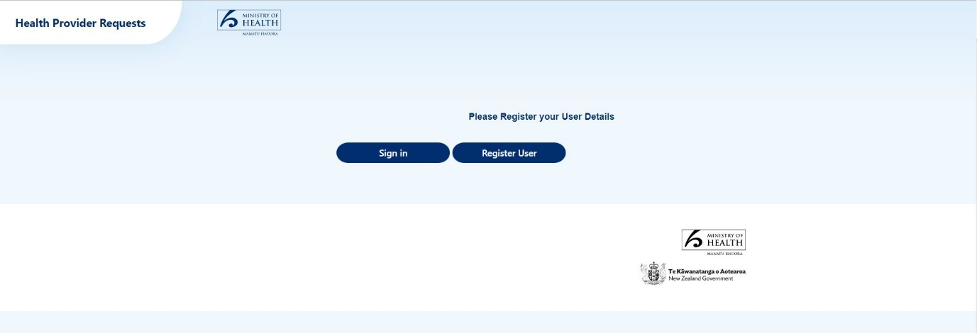

Step 2- Click on the ‘Register User’ button to begin.
Step 3- Enter your email address and click ‘send verification code’

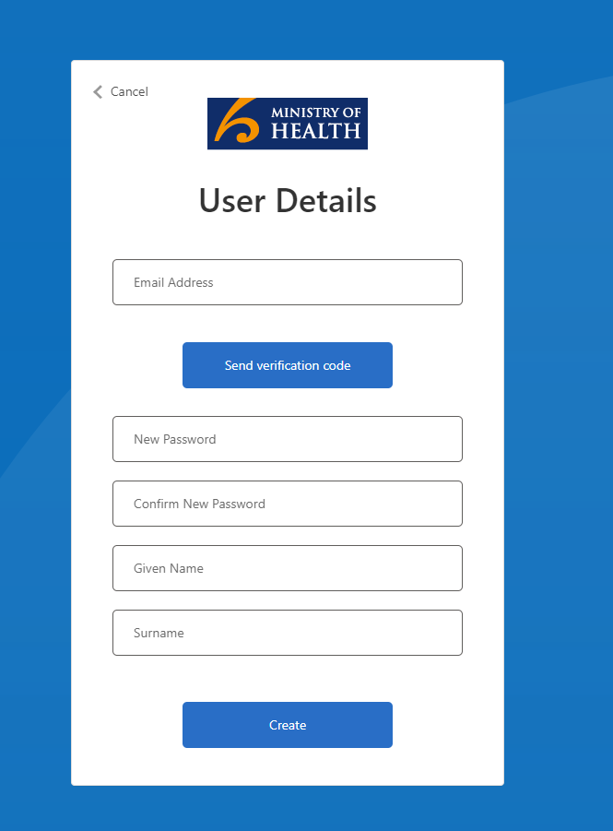
You will receive an email with your code shortly.
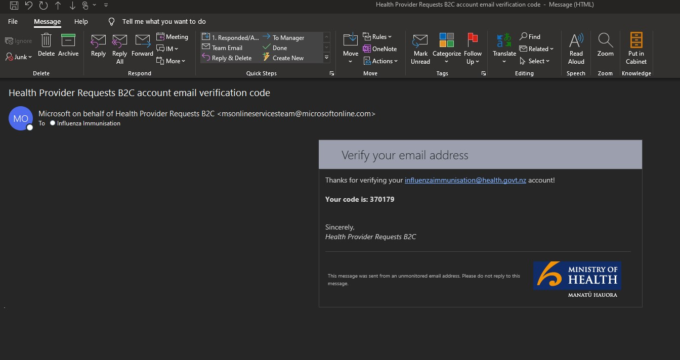

Step 4: Copy and paste the code and click ‘Verify Code’

Note: If you try to fill in your details without verifying your account you will encounter an error as follows

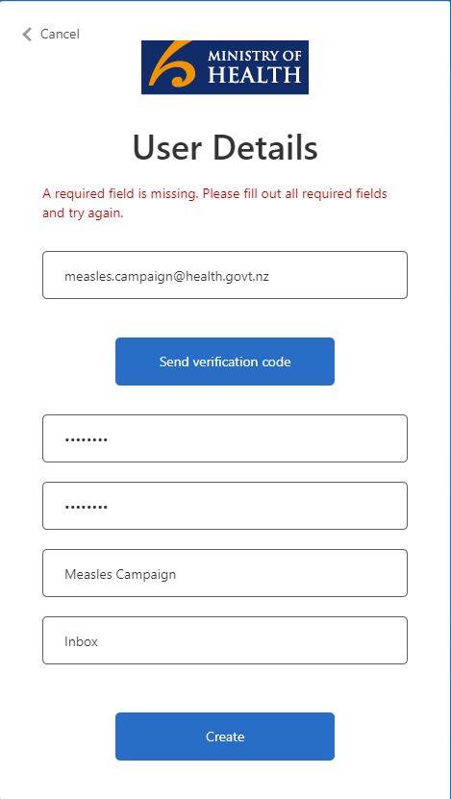

Step 5- Once verified, proceed to enter your password and given names.
Note: The password must be between 8 and 64 characters.
Your password must have at least 3 of the following:
- a lowercase letter
- an uppercase letter
- a number
- a symbol
Step 6- Multi-Factor authentication (MFA) is required to progress. Please make this a phone number that you will have continued access to as MFA will be required on all further sign ins.
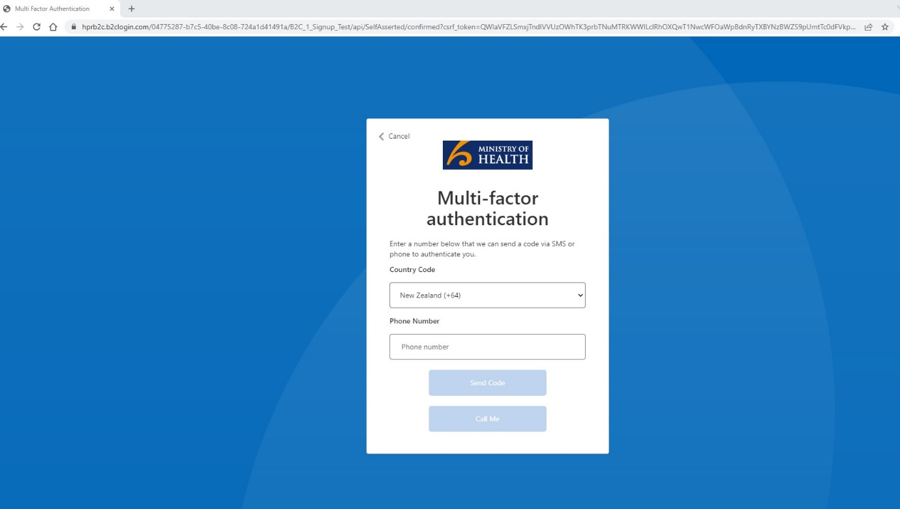

Step 7- You will arrive at your home screen. This means you have successfully set up your user account. You can log out and return to this point later to register your provider using your sign in details and MFA.
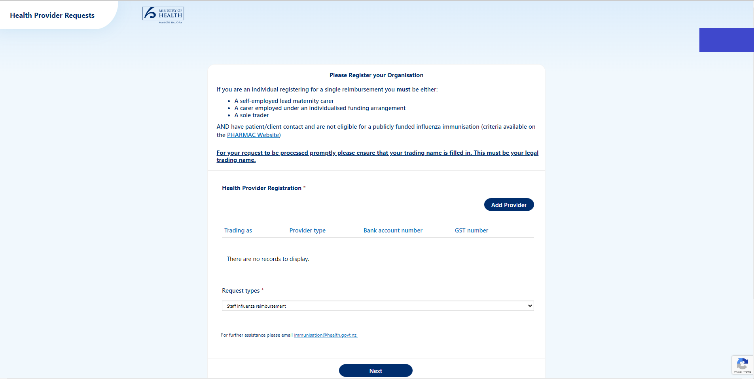

Registering a Health Provider Account
Now that you have created a user account, you can register the Health Provider/Employer who will make the request on behalf of their employees.

Step 1: Click on the ‘Add Provider’ button to prompt a pop-up to enter your business details.
Note: Take care in entering your details as you will NOT be able to edit them later. If you need to amend any details, please email immunisation@health.govt.nz with the details of your amendment along with your business name and contact details.
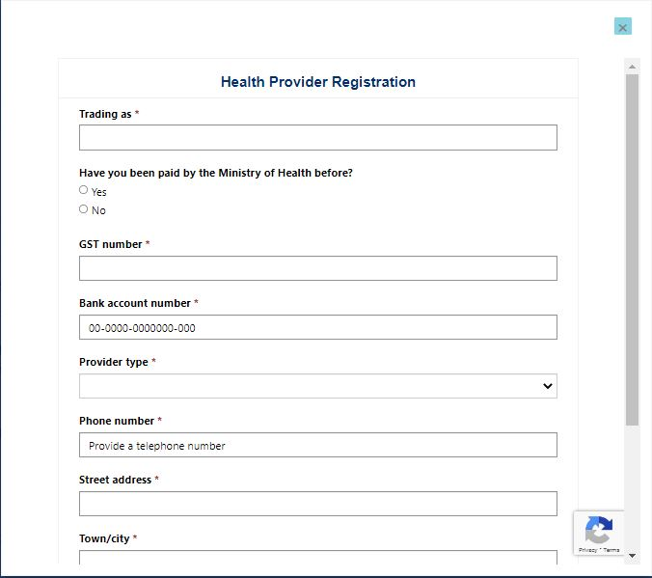The boxes with red stars denote a compulsory field. Enter your business details and address.
Please Note: If you respond “No” to Have you been paid by the Ministry before? You will be directed to email verification of your bank account details to immunisation@health.govt.nz. Suitable forms of bank account verification are as follows:
- Deposit slip
- Statement header scan
- Screenshot from online banking showing account name and number along with bank name and logo

Step 2: Confirm your organisations details. You will be prompted to confirm your details. Please click Ok to verify and submit the form. Click cancel to return to the form and edit your details.
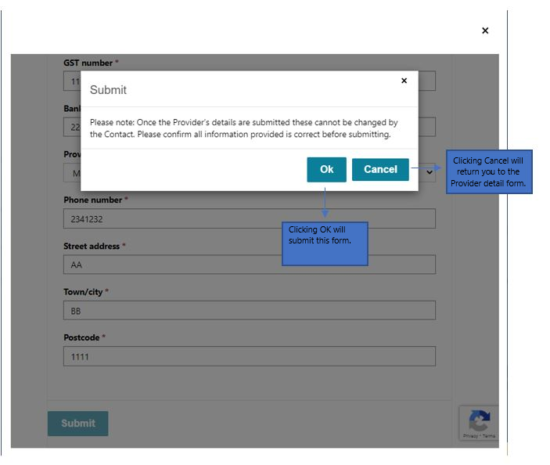
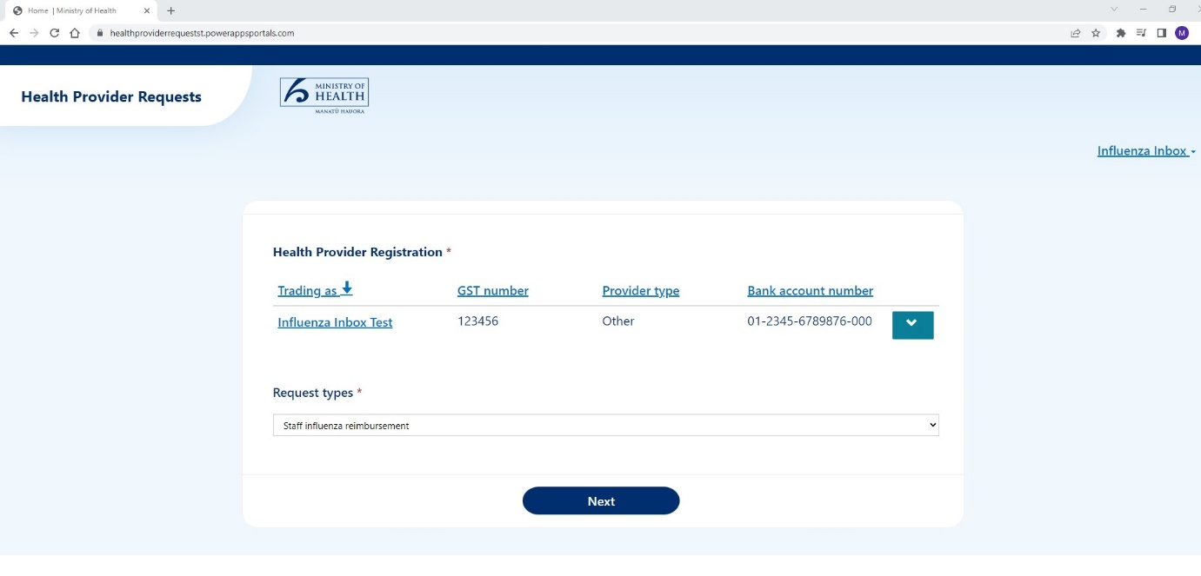
Step 3: Click Ok. Your business details wil be submitted and will appear as below:

Step 4- Click on the ‘Next’ button to proceed to enter a staff Influenza reimbursement claim.
You will arrive at the following dashboard. This page has two functions:
- Serves as the site to submit your staff Influenza claims
- Provides an overview of the claims that you have submitted.
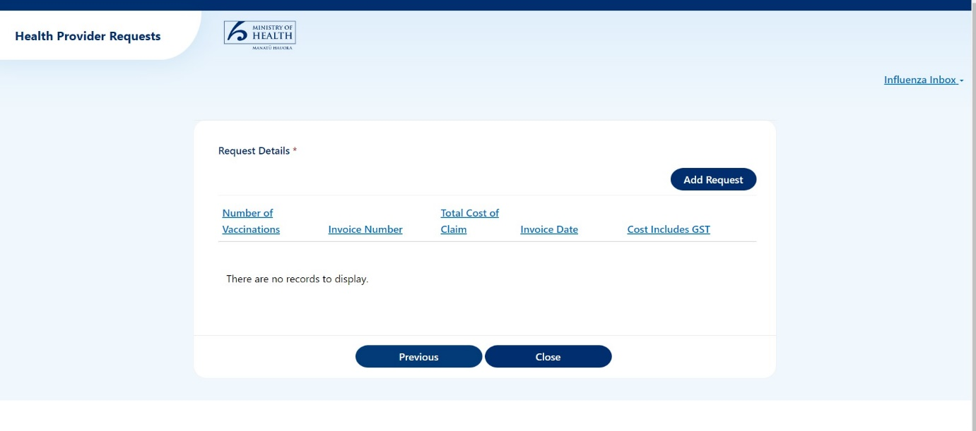

Submitting a Claim

Step 1: Click on the ‘Add Request’ button to prompt a pop-up to enter your Influenza claim details
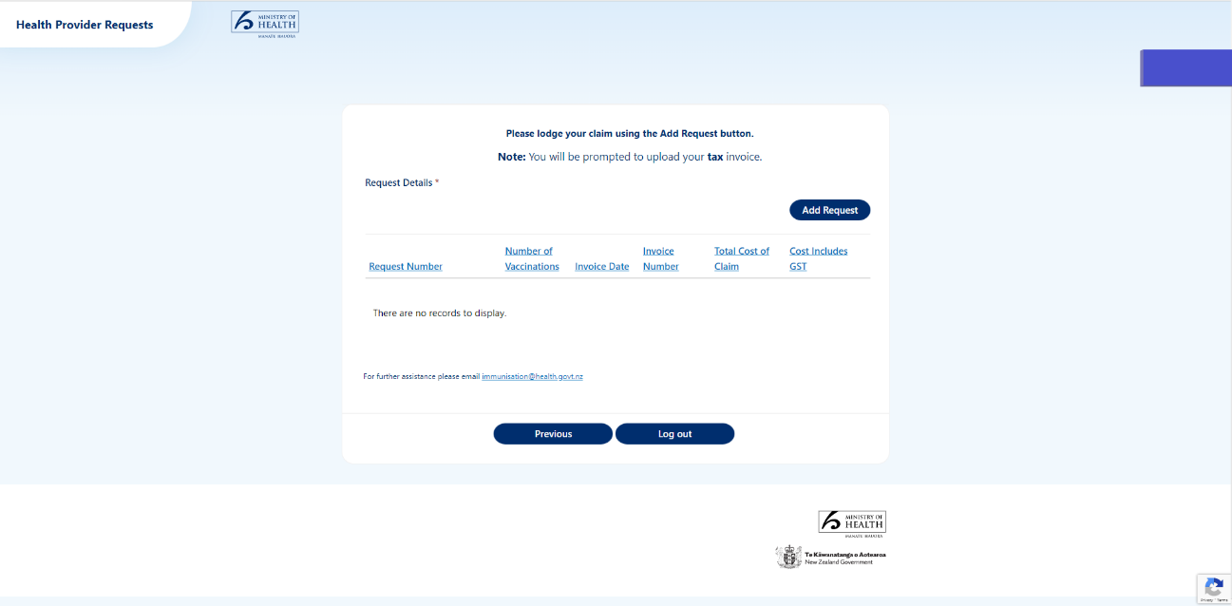
Pop-Up Screen should appear as below
The boxes with red stars denote a compulsory field. Enter your claim details and attach the tax invoice associated with this claim as supporting evidence. A template is provided at the end of this document, for reference or use, should you need. Please note that invoices must fulfil the IRD criteria for a tax invoice found here How tax invoices for GST work (ird.govt.nz)
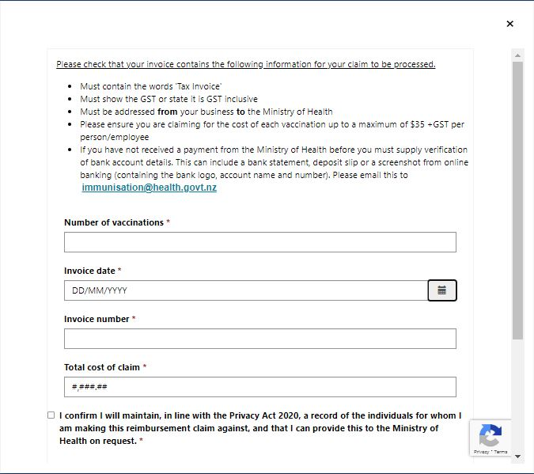
Please Note: An error message as below will be displayed if an invalid character is entered into the total cost of the claim field. This can happen if the user includes a $ in the total cost.

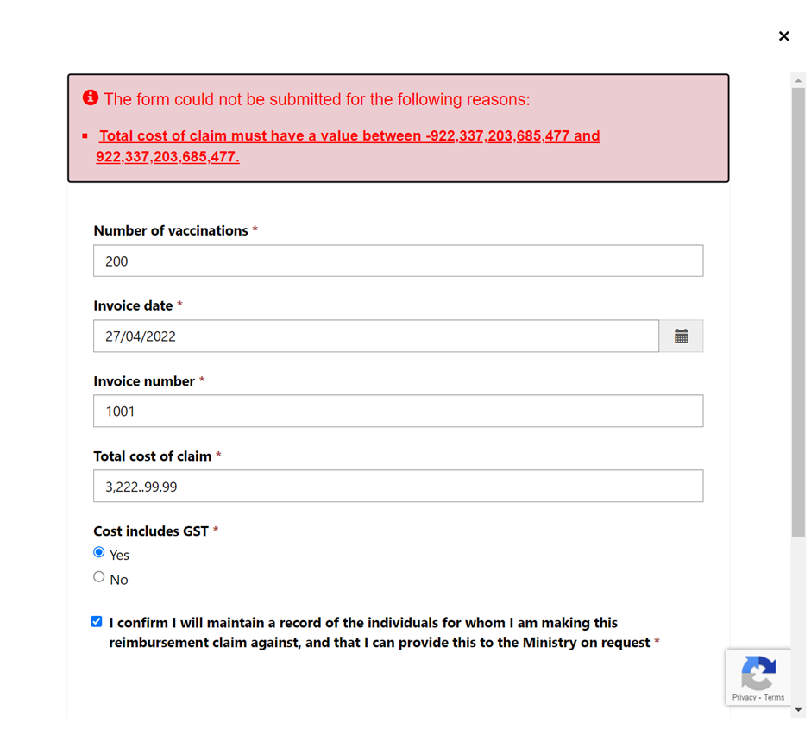

Step 2: Click ‘Submit’ to complete the request and to return to the overview dashboard view.
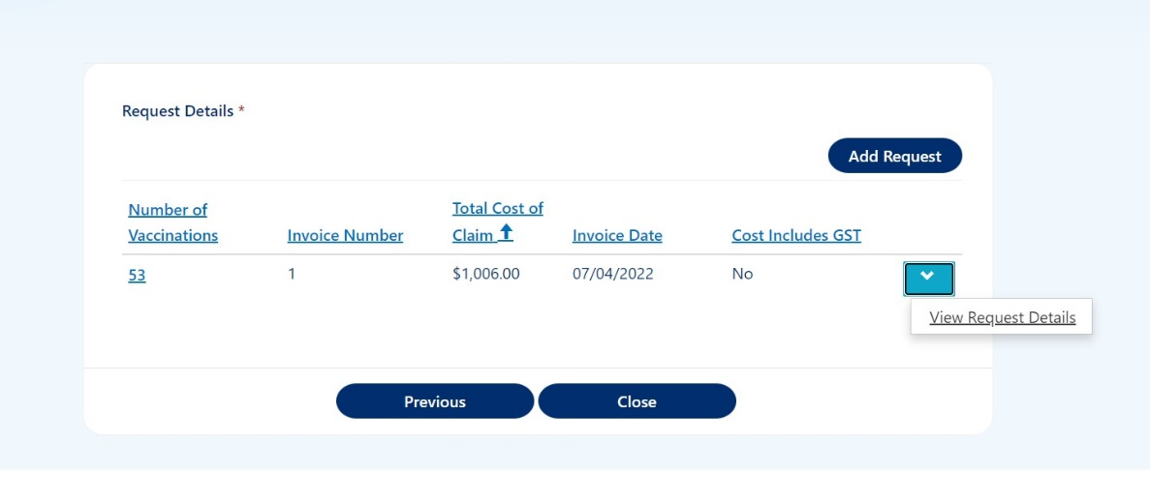

Congratulations, you have submitted your staff influenza vaccination reimbursement claim.

TAX INVOICE TEMPLATE
To: Te Whatu Ora Health New Zealand  PO Box 5013, WLG 6140  Re: Staff Influenza Vaccination Reimbursement |  | Invoice Date: Date  INVOICE NUMBER: #####  GST NUMBER: ##
Name
Company Name
Street Address
City
Post Code
Phone
Email

DESCRIPTION | QUANTITY | Unit Price | AMOUNT
 |  | SUBTOTAL
 |  | TOTAL GST (15%)
 |  | TOTAL NZD

Please pay direct credit to bank account: [bank account number]

_________________________________________________________________________________________
PAYMENT ADVICE

Customer: Te Whatu Ora Health New Zealand
Invoice Number: [#####]
Amount Due: [$$]
To:
Company Name
Street Address
City,
Post Code
Phone
Email

