Patient Management Guideline for Primary Care Ebola virus disease (EVD) 04 February 2015
This guidance has been developed specifically for primary care facilities and clinicians. It is based on the Ministry of Health’s Updated information for health professionals: Ebola virus disease (EVD) guidance document which has more detailed information and is kept updated on the Ministry’s website: www.health.govt.nz/ebolaguidance

In the first instance, general practitioners should phone their local public health unit for advice regarding any person with history or symptoms of concern, even if they do not formally meet the suspected case definition.

EVD should be suspected with:

A person who is unwell and has returned from an EVD affected country within 21 days of illness onset, with a fever or history of fever *
*Further details on case definitions and the most recent case definitions are located at: www.health.govt.nz/ebolacasedefinition
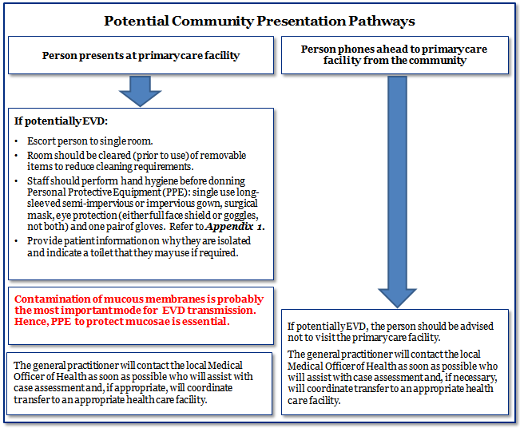

Additional key notes for primary care:
- Primary care facilities should clearly display signage requesting people immediately tell the nurse or receptionist on arrival if they are unwell and have travelled overseas recently.
- Any people that identify themselves to reception staff as being unwell and have visited an EVD affected country in the previous 21 days should be isolated in a single room as soon as possible. They should not sit in the general waiting room once EVD is considered a possibility and urgent advice should be sought from the local public health unit.
- Limit the number of staff who have contact with the person.
- If a patient has not identified themselves on arrival, but during a consultation EVD is identified as a possibility, then the clinician should take immediate steps to isolate the patient in order to limit further contact and seek advice from the local public health unit.
- Hand hygiene is an important infection prevention and control measure; EVD is not a robust virus, and is readily inactivated by soap and water or by alcohol based hand rub.
- It is important to remember that transmission of EVD from person to person occurs only through direct contact with the blood or body fluids of a symptomatic person. There is no evidence of EVD transmission through intact skin or through small droplet spread, such as coughing or sneezing.
- Appendix 1 contains a quick reference guide for standards of PPE. For correct donning & removal of PPE, go to www.albertahealthservices.ca/hp/if-hp-ipc-donning-ppe-poster.pdf and www.albertahealthservices.ca/hp/if-hp-ipc-doffing-ppe-poster.pdf
- Please note: that this standard of PPE is appropriate for any anticipated contact with a suspected EVD patient within a primary care facility. The recommended PPE is in line with that required for Standard Precautions.
- Refer to the Infection Prevention and Control section of the Ministry’s Updated information for health professionals: Ebola virus disease (EVD) for further guidance.
- Reception staff should be made aware of these instructions.

Guidelines for cleaning and decontamination of primary care facilities following suspected case of EVD:

Cleaning and decontamination of any rooms in which a suspected EVD case has been isolated, or any facilities used by the patient, should be discussed with the local public health unit. Once the patient with suspected EVD has been transferred, other patients and staff should not use the room in which the patient has been isolated or any other potentially contaminated areas (this includes toilets and other high contact surfaces) until advised by the local public health unit regarding cleaning and decontamination.

If you require urgent advice and cannot reach your local public health unit, please contact the Ministry of Health.
People infected with the EVD are infectious only once they develop symptoms. Once symptomatic, all body fluids and secretions such as blood, faeces, saliva, vomitus, and urine should be considered infectious. The level of infectiousness increases as the illness progresses.

You will be advised by your local public health unit appropriate measures for cleaning and disinfection and they will consult with the Ministry of Health. The following are general guidelines:

- If the patient has limited symptoms, such as fever, with no vomiting or diarrhoea, then the room in which the patient was assessed, toilet facilities (where appropriate) and all high contact surfaces such as door handles or touch screens can be cleaned, with reference to ‘guidance if undertaking environmental cleaning’ below. The primary care facility does not need to be closed.
- The general practitioner may continue to consult if a different room is available, but should ensure they have washed their hands thoroughly with soap and water or alcohol based hand rub.
- If the patient has symptoms such as vomiting, diarrhoea and / or bleeding, the local public health unit will conduct a risk assessment and advise on appropriate decontamination and consideration of closure of the facility.

Guidance if undertaking environmental cleaning:
Perform hand hygiene before donning the appropriate Personal Protective Equipment (PPE), including gloves, gown, apron, surgical mask, and eye protection. Gather equipment:
- bucket of warm water and detergent
- disposal cloths
- yellow Bio-hazard bags (double bagging required)
- fresh bleach solution from a household bleach product =5.25%, diluted to 1:50 (20 mls bleach made up to a litre with water). This gives a 0.1% solution or 1000ppm. EVD is susceptible to chlorine; therefore bleach is a suitable disinfectant for cleaning purposes. Typical household bleach (5.25%) needs to be diluted before use.

Areas not visibly soiled:
Surfaces and objects which are not visibly soiled should be wiped over with detergent and water, allowed to dry then disinfected with bleach solution and allowed to dry. Place all cloths into yellow bio-hazard bag.

Public areas passed through:
Public areas where the suspected EVD case has passed through and spent minimal time in (such as corridors) but are not visibly contaminated with body fluids do not need to be specifically cleaned and disinfected.

Final steps:
- remove PPE and place into yellow bio-hazard bags - perform hand hygiene.
- put on fresh set of PPE and tie off yellow bags – place one bag into another and tie this off also.
- place sealed bag into locked area away from public spaces. (See Appendix 2 for further guidance).
- empty out used cleaning solution – rinse with clean water, wipe inside and outside of buckets with bleach solution, invert and allow to dry.
- remove the second set of PPE and dispose of using normal waste management processes, then perform hand hygiene.

Appendix 1: Summary table of Personal Protective Equipment (PPE) for primary care

- Standard precautions apply to all.
- All items should be single use. Reusable eye protection may be used e.g. goggles, however it must be cleaned and disinfected with a dilute bleach solution (0.1% solution or 1000ppm) after each use.
- Always perform hand hygiene with soap & water or alcohol based hand rub before putting on gloves and after removing items of PPE.
- If unfamiliar with PPE, a ‘buddy’ system may be used in which a colleague who is familiar with PPE can assist you to ensure your PPE is put on and removed in a correct and safe manner
- PPE should be readily available in a designated area.
- PPE and other disposable items used with this patient must be disposed of safely (refer to Waste procedure in Appendix 2).

PPE item | Additional comments
Gloves | Disposable nitrile or latex gloves (not vinyl)
Long sleeved gown+/- plastic apron | Semi-impervious or impervious long-sleeved single use isolation gown
Surgical face mask | Must comply with AS/NZS 1716:2012 Standards. (Either ear loops or ties)
Eye protection | Goggles or Full face shield (not both)

Appendix 2: Waste procedure for packaging of class UN2814 Category A waste in primary care (in accordance with NZS5433:2012)
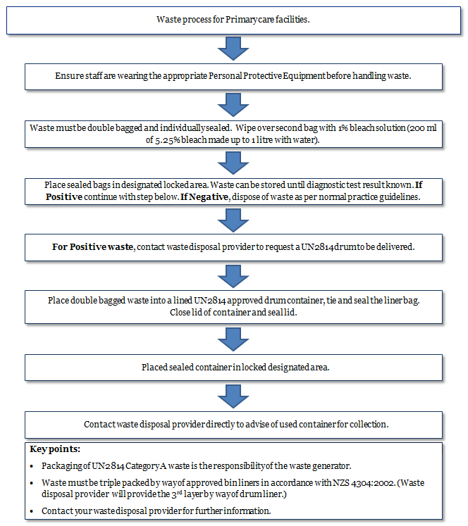
If you have any non-urgent queries please contact your local public health unit
HP6020
04 February 2015

