Memorandum – Anticoagulants and CPAMS
To: | NAAR 2022 participants
From: | Alex Rodgers, Principal Analyst, TAS, Te Whatu Ora
Subject: | Anticoagulants and CPAMS
Date: | 12 July 2022

Background
Anticoagulants are a commonly used medicine. There are three funded oral anticoagulants: dabigatran, rivaroxaban, and warfarin. Warfarin is the oldest, introduced over 50 years ago. The other two are newer; dabigatran has been funded since 2011 and rivaroxaban since 2018. All are funded without restriction.
Warfarin has a narrow therapeutic range. Like all medicines, too little makes it ineffective while too much risks adverse effects, and the right dose varies by person and over time. For most medicines getting into the therapeutic range and staying there is more straightforward, but for warfarin it is difficult and the adverse events can be severe. To assist with this, the community pharmacy contract (known as the ICPSA) establishes the Community Pharmacy Anticoagulant Management Service (CPAMS). A patient may be registered to CPAMS with a single pharmacy if they meet the entry criteria. The pharmacy provides testing of warfarin levels as well as advice on management, including dose adjustment.
This paper looks at the market for anticoagulants, access to CPAMS by ethnicity, and notes an upcoming study of CPAMS costs and benefits.

The market for anticoagulants
In a 2022 paper, Harper et al examined the use of these three medicines from 2011 to 2021. They found that the number of people on oral anticoagulants doubled during these ten years. Warfarin use has been steadily declining as new patients are more likely to be started on a newer agent; use has fallen by 45% since dabigatran was introduced and they note “there is no sign of a plateau”. Use of both dabigatran and rivaroxaban continue to rise; dabigatran use is now rising slowly, while rivaroxaban use rises steadily.
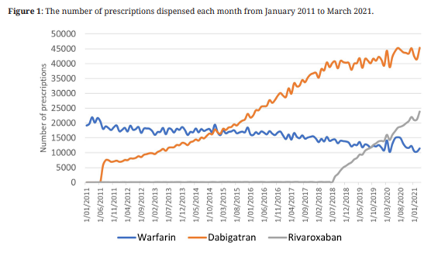

Ethnic breakdown
We looked at all dispensings of these oral anticoagulants in calendar year 2021, looking at the number of patients receiving each medicine and the ethnicity of these patients. (Note that a person may have multiple ethnicities, so a person who is “Māori” may also be other ethnicities such as Pacific, while “non-Māori, non-Pacific” means a person who is neither Māori nor Pacific.)

Māori
Māori are less likely to be on an anticoagulant than the general population. While 17% of New Zealanders are Māori, 12-13% of people on an anticoagulant are Māori. This is likely due to Māori in general being younger. Harper et al found that the average age of people on anticoagulants was between 70 and 76 years (varying by drug and with time); Stats NZ reports that the median age of Māori is 25.4 years compared with 41.4 years for Europeans.
There may be a slight trend for Māori to be on warfarin, compared with the general population. Māori make up 13.2% of warfarin users, 12.2% of dabigatran users, and 12.0% of rivaroxaban users.

Pacific peoples
Pacific people are less likely to be on an anticoagulant than the general population. While 9% of New Zealanders are Pacific, 4-7% of people on an anticoagulant are Pacific. This is likely due to Pacific people in general being younger. Harper et al found that the average age of people on anticoagulants was between 70 and 76 (varying by drug and with time); Stats NZ reports that the median age of Pacific people is 23.4 years compared with 41.4 years for Europeans.
There is a trend that Pacific people are more likely to be on warfarin compared with the general population. Pacific people make up 6.7% of warfarin users, 4.2% of dabigatran users, and 3.9% of rivaroxaban users.

Non-Māori, non-Pacific people
Non-Māori, non-Pacific people are more likely to be on one of the newer anticoagulants. This group makes up 80.4% of the population on warfarin, 83.8% of the population on dabigatran, and 84.2% of the population on rivaroxaban.

Enrolment in CPAMS
The criteria for being in the CPAMS program are set out in the ICPSA. In addition to being on warfarin and being referred to the program, a patient must “require warfarin loading and initial stabilisation, or have overlapping warfarin medication with low molecular weight heparin”. There are also exclusion criteria; patients must not “reside in an Aged Residential Care Facility (unless otherwise agreed by the DHB that CPAM Services may be provided in this setting)”, “have anti-phospholipid syndrome, anti-cardiolipid syndrome, lupus anti-coagulant syndrome”, or be “receiving active anti-neoplastic treatment”. Patients only need exit the service if they die or do not use the service.
The number of patients in the CPAMS program has been falling since around 2018. However, the percentage of warfarin patients who are in CPAMS continues to rise and is now over 30%.

The absolute decrease in CPAMS patients is driven by the decrease in patients on warfarin. The reason for the relative increase in CPAMS patients out of warfarin patients is less clear. It could be due to a steadily building cohort; patients may be unlikely to be moved out of the program barring death, whereas new warfarin patients are still being added.

Provider distribution
Not all pharmacies are CPAMS providers. Pharmacies are not required to provide the service, and it has been up to District Health Boards to accept pharmacies who wish to be in the program. As of May 2022 there are 179 pharmacies active in the CPAMS program, out of 1,076 pharmacies total (around one in six).
The map below shows the geographical distribution of CPAMS providers. There are some gaps in coverage, such as the far North, East Cape, the central North Island, Kaikoura/Hurunui, and the southern West Coast.
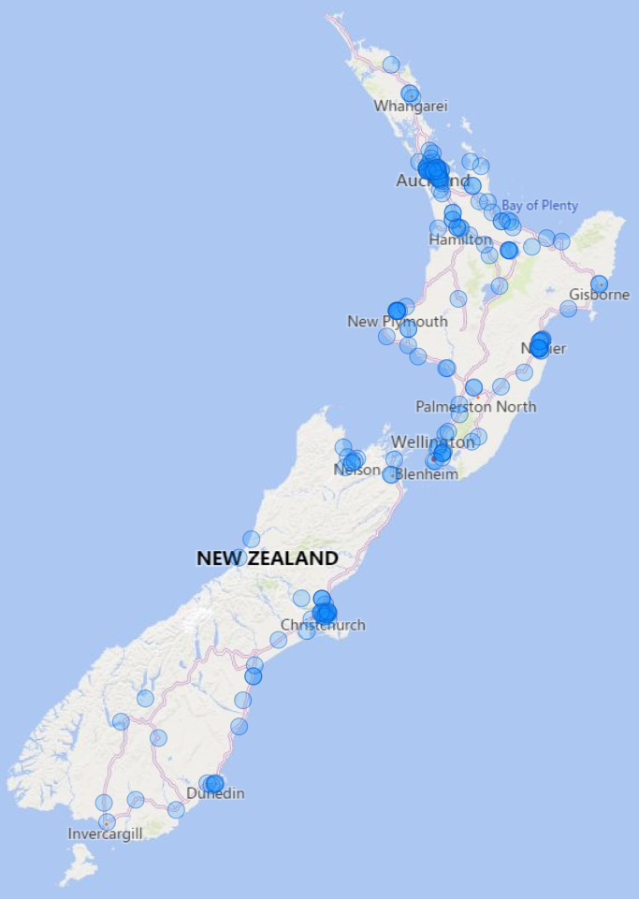
The economics of participating in CPAMS will vary for each pharmacy. The largest cost is pharmacist time, and that will depend on salaries in that region. We estimate that a typical pharmacy requires at least 21 registered patients to break even at CPAMS, given the fixed hardware costs, connection to INR Online and quality requirements.

Effect of Covid on CPAM services
We found that, apart from a decrease in April 2020, CPAMS services appear largely unaffected by the Covid pandemic and its associated lockdowns and restrictions. The graph below shows the average number of tests done on CPAMS patients in each month.

Ethnicity of CPAMS participants
As before we looked at all patients who were dispensed warfarin during calendar year 2021. However, we only have data on CPAMS patients by priority ethnicity so this data is presented using that.
Priority Ethnicity | Warfarin patents | CPAMS patients
Māori | 13.2% | 12.6%
Pacific | 6.4% | 5.8%
Other | 80.4% | 81.6%

Both Māori and Pacific people on warfarin are slightly less likely to be in the CPAMS program. For example, Māori make up 13.2% of all warfarin patients, but 12.6% of all CPAMS patients.

CPAMS payments
Pharmacies must file invoices to claim CPAM Service Fees. This differs from the similar program, the Long-Term Conditions program. This is presumably so because the fee is not just paid for each enrolled patient each month, but for each enrolled patient for which a CPAM Service was demonstrably provided. In LTC, the fee is just paid for every enrolled patient.
Around February 2021, payments for CPAMS dropped suddenly. The graph below shows actual payments recorded each month, against what payments would have been if pharmacies had received the fee of $45 for each registered patient.

The cause of this is unclear. It appears not attributable to a reduction in services provided; as shown above the average number of tests remains around 1.6 tests per registered patient per month. At this stage we consider it is most likely caused by delays in invoicing. Pharmacies are busy and may not have filed all invoices.

Value of the CPAMS program
Carlo Marra, a professor at the University of Otago, is currently preparing a paper that evaluates the potential cost avoidance and health gains of the CPAMS program. This paper is not yet published, but we have received some notes on the analysis done and its conclusions. The work is a meta-analysis of papers that examined the CPAMS program as well as overseas analyses of similar warfarin management programs.
Marra’s conclusion is that CPAMS improves health outcomes, as demonstrated by improvements in the “time in therapeutic range” (that is, how often a patient’s warfarin level is the right amount, neither too high nor too low). Reductions in thromboembolic events, haemorrhagic events, and mortality were also identified. They also concluded that CPAMS “results in substantial cost avoidance”, reporting that CPAMS reduced health costs by $462 per enrolled patient per year, even after accounting for CPAMS fees paid. Marra concludes that “the CPAMS service is dominant, that is, every enrolment of an eligible patient both reduces net costs and provides health gains.
As we have only seen some brief notes from this unpublished paper, it is difficult to know exactly what analysis was done and how applicable the conclusions will be. We await publication of the full work in order to better understand what work has been done and how its conclusions can be applied.

Discussion
There is some evidence that European patients are more likely to be on newer anticoagulants, while Māori and Pacific patients may be on warfarin more. It’s unclear why this would be the case.
It is unclear whether the CPAMS program as devised currently is an effective means of addressing health inequities. Māori and Pacific people are less likely to be on warfarin (or any oral anticoagulant) due to being much younger populations than the European population. Even looking only at patients who are on warfarin, Māori and Pacific appear less likely to be enrolled in CPAMS. We don’t know why this is. One possible explanation is that the areas that lack CPAMS providers are also frequently those with higher Māori populations, such as the Far North, central North Island, and Tairāwhiti.

Rivaroxaban was funded before 2018, but only for specific uses around surgery.
Harper, Chang, Stephens. The changing use of anticoagulants in New Zealand. New Zealand Medical Journal Vol 135 No 1554: 6 May 2022.
A person only has one ‘priority ethnicity’. If any ethnicity for a person is Māori, then their priority ethnicity is Māori; if they do not have any Māori ethnicity recorded but have any Pacific ethnicity, then their priority ethnicity is “Pacific”. All other people have the priority ethnicity of “Other”.
Correspondence provided by Carlo Marra to the Ministry of Health, describing currently unpublished research.

