Integrated Community Pharmacy Services

Integrated Community Pharmacy Services Agreement
National Annual Agreement Review 2024
Meeting 1 Minutes

Date | Monday 19 February 2024
Time | 9 am to 11:30 am
Location | MS Teams
Independent Chair | Shenagh Gleisner
Te Whatu Ora | - Martin Hefford, Director Living Well, National Commissioning  - Astuti Balram, Group Manager Primary Care, Living Well, National Commissioning  - Nicola Ehau, Regional Wayfinder, Commissioning, Te Manawataki  - Danny Wu, Regional Wayfinder, Commissioning, Northern Region
Te Aka Whai Ora | - Cherie Seamark, General Manager, Primary & Community Care
Provider representatives | Alchemy Group  Ravnit Lal | Bargain Chemist Group  Peter Shenoda
 | Canterbury CP Group  Arti Patel, Alex de Roo | Chemist Warehouse Group  Ravniel Singh, Saif Al-Sheibani
 | Countdown Pharmacy Group  Jeremy Armes, Jason Wong | Girn Group  Jatinder (Jay) Girn
 | Green Cross Health  Gemma Buchanan, Joel Sathuluri | Independent Pharmacy Group  Phil Berry
 | Kiwi Pharmacy  Ming Goh, Mitchell Trezise | Midland CP Group  Cath Knapton
 | NDL Group  Nikil Lal | Oakley Brown Pharmacy Group  Carolyn Oakley Brown,  Linda Hermiston
 | Pharmacy Care Group  Amrit Ram | Pharmacy Guild of NZ  Andrew Gaudin, Nicole Rickman, Glenn Mills, Sally McKechnie
 | Pharmacy Partners  David Mitchell | PillDrop  Jack Lee, Suzanne Burge
 | Totem Group  Kerry Oxenham | ZOOM Pharmacy  David Taylor, Din Redzepagic
Independent representatives | Ibrahim Al-Mudallal | Jessica Moh
 | David Bullen | Scott Moir
 | John Handforth | Nancy Nasef
 | Sam and Eliza Hood | Natalia Nu'u
 | Brett Hunter | Samit Patel
 | Ian McMichael | Craig Thompson
Observers | - Manatū Hauora: Andi Shirtcliffe  - Māori Pharmacists Association: Mariana Hudson  - Pacific Pharmacists Association: Diana Phone  - Pharmaceutical Society of NZ: Helen Morgan-Banda, CEO  - Pharmacy Council of New Zealand: Michael Pead, CEO
Te Whatu Ora  In attendance | - Billy Allan, Principal Service Development Manager, Pharmacist Services  - Andrew Bary, System Design Manager, Pharmacist Services  - Ruksana Shaikh, Programme Manager, Primary Care - Living Well  - Alex Rodgers, Principal Investment Analyst, Funding & Investment team, National Commissioning

Agenda
Time | Item | Page
9:00 am | 1.0 Welcome, introduction and apologies
 | 1.1 Welcome, karakia, introductions, new members
 | 1.2 Purpose of the meeting
9:30 am | 2.0 Orientation to the 2024 NAAR approach
 | 2.1 The wider context (Martin Hefford)
9:50 am | 3.0 Expert Advisory Group (EAG)
 | 3.1 Ratification of Terms of reference | Page 3
10:05 am | 3.2 EAG (governance) membership
10:20 am | 3.3 EAG work programme  Te Whatu Ora suggested topics  - Childhood immunisations: referring unenrolled pēpi for general practice enrolment  - Clozapine  - CPAMS  - Long Term Conditions (LTC)  - Funding for medicine supply changes that do not meet the Brand Switch Free (BSF) criteria
10:35 am | 4.0 APAS and unregistered (s26/s29) medicines payment error  (Andrew Bary) | Page 7
11:05 am | 5.0 Timeline for subsequent NAAR meetings
11:15 am | 6.0 Summary and next steps  6.1 Discussion summary  6.2 Agreed actions  6.3 Joint communique: key messages agreed  6.4 Next meeting  6.5 Karakia
11:30 am | Meeting close

- Welcome, karakia, apologies, agenda confirmation
Welcome: The Chair opened the meeting
Karakia timatanga: Martin Hefford
Apologies:  - Ibrahim Al-Mudallal  - Cath Knapton  - Mariana Hudson  - Brett Hunter  - Michael Pead  - Glenn Mills  - Danny Wu (Daniel Tsai attended in his absence)  - Sally McKechnie  - Helen Morgan-Banda  - Cherie Seamark | Unichem Peninsula Pharmacy  Midland Community Pharmacy Group  Māori Pharmacists Association (MPA)  Bethlehem Pharmacy & Bethlehem Dispensary  Pharmacy Council of New Zealand  Pharmacy Guild of New Zealand  Health New Zealand - Te Whatu Ora  Simpson Grierson (Pharmacy Guild of New Zealand)  Pharmaceutical Society New Zealand  Te Aka Whai Ora
Not present:  - Ming Goh  - Mitchell Trezise  - Amrit Ram  - Phil Berry  - Jessica Moh  - Nancy Nasef |  | - Natalia Nu’u  - Samit Patel  - Sam Hood  - Eliza Hood  - John Handforth
Introductory comments by the Chair
The Chair acknowledged the stresses being experienced by the Sector, and the challenges the NAAR process may have in meeting aspirations and needs. She commented on the respectful, thorough and concise engagement in NAAR 2023, expressed confidence that this will continue and reminded the Group that this is a confidential meeting.

The purpose of the meeting is primarily to talk about the NAAR approach for 2024 and to begin the establishment of the Expert Advisory Group (EAG).

- Orientation to the 2024 NAAR approach
Please note the presentation by Martin Hefford is attached to these minutes (Appendix 1).

Te Whatu Ora. The short-term focus will be upon the uplift offer and how to apply it. The actual uplift offer will not be available until May 2024 as it links to the government budget process. There is a desire to have everything completed so that the uplift can take place on 1 July 2024 so washup payments are not required.

Medium term work is to establish and operate the EAG to review existing ICPSA service specifications. The longer-term programme of service redesign (including looking at funding and workforce issues) will commence in a few months and should be complete by June 2026. It is hoped the new Pharmacy agreement will be clearer and simpler. Pharmacies will have opportunities to engage with this work.

Pharmacy Guild would like to understand timeframes for short, medium and long-term work and for the new agreement over the next two years, and to hear about more concrete plans for getting work under way to address sector sustainability and workforce cost pressures.

Te Whatu Ora introduced the idea of a two-year agreement as an option to explore. They also explained that there is a general desire to move to longer term agreements for other sectors, for example, general practice, and mental health sector. One scenario would be to include a first-year amount and for the second year, a clause for a cost adjustment mechanism formula. Te Whatu Ora invited comments from the Group.

Provider representatives were open to a longer-term agreement, but not without more certainty about the two-year budget as they did not want to carry the risk in relation to cost pressures; therefore, would wish to know the mechanisms proposed for the second year.

In relation to do some modelling work in advance:
Countdown Pharmacy Group. As we will not know the uplift figure until late May, can we have meetings in the interim so that we can look at service lines to determine how we redistribute APAS?

Pharmacy Guild would welcome continuing cost pressure recognition through services fees and continued removal of APAS funding back in to service fees. Also, supportive of comments to do the prework for the new variation.

Te Whatu Ora agreed to do work with NAAR to review the service fee lines across which to distribute the APAS payment and price uplift across, in advance of knowing the price uplift and undertaking modelling.

In relation to a national commissioning policy:
Pharmacy Guild. Te Whatu Ora has talked about a national contracting and commissioning provider policy. We would like an update on the new pharmacy provider policy as there are variances in approach across the Te Whatu Ora districts.

Green Cross commented that the work on a national policy was to be progressed as a priority as agreed under NAAR 2023. It has an impact on workforce issues as well as business sustainability. It is difficult to provide feedback before knowing what the uplift is.

Totem Group. It would be good to know what the linkages are between the pharmacy sector, the development of comprehensive primary and community care teams (CPCT) and the link with NAAR and the EAG.

Te Whatu Ora. The aim is still to align across the districts keeping in mind the local and regional factors. There is an interim policy being finalised shortly. The longer-term policy will depend on what the redesigned services will look like.

In relation to giving input on the uplift before the quantum is known:
Canterbury Community Pharmacy Group would like to provide feedback from NAAR to the Te Whatu Ora Board regarding what the Sector believes is an appropriate uplift and what they would like the Board to consider.

Te Whatu Ora. The Sector can put its view across in different ways. The reality is that Te Whatu Ora needs to work within the fiscal constraints. Te Whatu Ora acknowledged this is frustrating. The focus of NAAR, once the uplift is received, will be around how the uplift is applied across service lines.

In relation to the EAG:
Pharmacy Guild do not see the EAG as the place where the funding and payment models are addressed. The EAG is about new service models or redesigns.

PillDrop. Each year NAAR raises matters that are ‘outside of NAAR’. Will these points now be considered by the EAG for contract development?

Te Whatu Ora. The service redesign will be an opportunity to look at the funding model for the new agreement which needs to be looked at in totality rather than piecemeal. However, the EAG reports to and only makes recommendations to NAAR, including on financial matters. Funding and costing will always come back to NAAR.

And in conclusion from Te Whatu Ora
Te Whatu Ora sees community pharmacy as a channel for people to access medicines, clinical advice, and services. The EAG would lead discussions to see how we broaden the opportunities for added value with clinical interventions through community pharmacy, this could include recommendations to NAAR about simplifying payments. In parallel we want to broaden general practice teams, which may include prescribing pharmacist and others. Evidence is that there are substantial amounts of general practice work that can be undertaken by other clinicians. This would be as well as community pharmacy providing another front door which can see and treat people.

ACTION: 20240219:1 | To hold a NAAR meeting before the Te Whatu Ora Board price uplift offer is known to review the service fee lines across which to distribute the APAS payment and price uplift, in advance of knowing the price uplift and undertaking modelling.

- Expert Advisory Group (EAG)

3.1 Ratification of the Terms of Reference (ToR)

There was discussion about the two provider representatives having to be present for the meeting to progress, but it was clear that anyone putting their name forward for the EAG must ensure they attended.

The Terms of Reference was ratified by NAAR.

3.2 EAG Governance Group Membership

Te Whatu Ora put forward a possible process for the appointment of members to this group. They also noted that Shenagh Gleisner will be the independent chair of the EAG and that the Health Quality and Safety Commission (HQSC) will source the consumer representatives - however, HQSC’s robust approach means the process will take 8 weeks, so that is the timeframe from now.

Pharmacy Guild are of the opinion that the NAAR provider representative should make decisions about the two provider and the four practising community pharmacist representatives, just as Te Whatu Ora would make decisions about its representatives.

The Guild, building on Te Whatu Ora’s suggestions, laid out the proposed process: set criteria for what information would be required regarding the nominees, reach out for nominees through provider and practising community pharmacy representatives (noting representatives may also be nominees). The NAAR group would meet to try and reach a consensus on representatives, ideally ensuring there is a diversity of experience. If this is not possible then voting would take place. There would be a weighted vote depending on how many people are represented by the nominees. The Group indicated they were supportive of what the Pharmacy Guild has proposed.

Countdown Pharmacy Group stressed the importance of a breadth of experience amongst the provider representatives ensuring the second position represented different views from the Pharmacy Guild and Green Cross Health. It is important to reach out to all when seeking practising community pharmacist nominations.

It was agreed this would be picked up as part of the proposal that the Pharmacy Guild will circulate.

Te Whatu Ora. There are institutions being established in our communities that access whānau voice. Whānau voice would be helpful and is different from Te Aka Wahi Ora or HQSC. Te Whatu Ora will pursue this offline.

ACTION: 20240219:2 | Provider representatives to arrange practising community pharmacist (4 members) and provider (2 members) representatives to the EAG.
ACTION: 20240219:3 | Te Whatu Ora to arrange Māori (2 members), consumer / whānau voice (2 members), Ministry of Health and Te Whatu Ora representatives to the EAG.

3.2 EAG Work Programme

Te Whatu Ora laid out some suggested topics for the EAG work programme (these are listed on the agenda) and explained the rationale. It was noted that the first topic, the childhood immunisations work may need to advance ahead of the EAG membership being confirmed.

Ian McMichael. His areas of interest are ‘clozapine’ and ‘CPAMS’ but stressed the importance of not predetermine the scope in advance.

Pharmacy Guild have not yet formed a view on the work programme and may want to add other things in, for example minor ailments services and the CPCT. It would be good to find a process to identify the work programme so that once EAG is established we can get it signed off and get the work underway.

Countdown Pharmacy Group would like the EAG to review minor ailments services when the evaluation results are available.

Green Cross Health. The focus needs to be biggest bang for the buck from the patient and nationwide perspectives. Where is the greatest need and consider the financial sustainability to run the services?

Ministry of Health. The School of Pharmacy University of Otago has looked at the cost effectiveness and cost avoidance analyses of pharmacy led services. This may be useful for the EAG.

Te Whatu Ora suggested that alongside the EAG nominations process, topics can be invited for the EAG. Te Whatu Ora could establish a meeting of NAAR in about 5 weeks, to gather the work programme topics and priorities and this could be finalised by the Group. A strong plea was made to keep in mind we can only have four or five work programmes, so prioritising is important.

The Chair shared a communication from Michael Pead from the Pharmacy Council of New Zealand who was unable to attend the meeting. He asked that the pharmacy sector’s capacity and capability is front of mind for the EAG as it considers further pharmacy services. In terms of EAG membership he proposed competencies and experiences are paramount rather than position or office held.

He also listed criteria such as a diverse mix of practices, experts familiar with community pharmacy service design modelling, a focus on equity of access and quality improvement and the value for health consumers and the whole health sector. He also recommended a rigorous disclosure of interests to the Chair in advance.

ACTION: 20240219:4 | Te Whatu Ora to send Pharmacy Guild a copy of Michael Pead’s note.

- APAS and unregistered (s26/s29) medicines payment error

Te Whatu Ora gave a sincere apology for the error. The root cause is the same issue as the one in the early part of last year. The error stemmed from an issue in 2023 at which point preventative measures were put in place for the future, but the flow on from the original error was not entirely resolved until early February 2024.

Te Whatu Ora checked that everyone had read the paper on this subject and sought comments.

Pharmacy Guild stressed the importance of people understanding the preventative measures and changes undertaken to rectify the mistakes. As provider representatives, they must be able to provide confidence, assurance and trust about the payments system.

Point 14 in the paper states that corrective payments will be made on a single date. The ICPSA is clear that recovery of overpayments:
- depending on the size of the overpayment (clause D.42 (4)(a)), the maximum amount that Te Whatu Ora can set-off is the greater of $500 or an amount equal to 5% of the average of the total net monthly amounts paid to the Provider in each calendar month in the Quarter immediately preceding the month(s) in which the overpayment will be recovered.
- under D.45.(2), those that have been underpaid will be eligible for default interest.

Additionally, there will be pharmacies that will have been sold or closed. The Pharmacy Guild would like to understand the above. They would also like to ensure the repayments process to those underpaid is not slowed down.

Te Whatu Ora. In terms of the remediation, we will go back and look further, discuss with our Sector Operations team and provide further information. All details required will be sent out as soon as possible ensuring that remediation process aligns with the ICPSA.

Pharmacies that have closed or sold have been factored into the calculations. Four of the most significant overpayments have been to pharmacies that have closed or have been sold.

Countdown Pharmacy Group. This error is another illustration of why we need to move to a simpler and easier to understand agreement.

Green Cross Health. Will this mean that the manual calculations for the washups due in April under the ICPSA variation 5 will need to be recalculated?

Te Whatu Ora confirmed that the April calculations will be based on the correct data. Additionally, in terms of the steps being put in place to minimise this in the future, the Health Sector Agreements and Payments (HSAAP) work to replace Proclaim (which is an aging system) will give us greater ability to manage data and put in checks.

Pharmacy Guild. Along with having a more simplified agreement, moving more payments away from the APAS pool, will help mitigate should these errors happen again. Also, we want to apply redistributed APAS funding across as many lines as possible as all services feel cost pressures, there were some we could not like LTC. So, the modelling, impact analysis and timeline is important with the uplift being so late in May.

Green Cross Health. Has Te Whatu Ora rerun the analytics that NAAR was presented with in 2023 when decisions were made about how much was pulled out of the APAS pool and what that looks like now with the correct data set.

Te Whatu Ora. The paper notes that the modelling for NAAR 2023 used the incorrect data. Rerunning with the correct data set using the same calculations, the net uplift becomes 5.15% instead of 5% across the service lines used in the modelling. This is acknowledging the greater proportional uplift to the case mix and the handling fees. Had we modelled using the correct data set, for example on case mix, initial and repeat fees service lines the percentage increase would have been less.

ACTION: 20240219:5 | Te Whatu Ora to provide the information clarifying the APAS and unregistered (s26/s29) medicines payment error to NAAR by the end of the week.

- Timeline for Subsequent NAAR meetings

Te Whatu Ora. Based on discussions today, propose indicative meeting times are as follows:
- early April (in four/five weeks) to discuss the EAG work programme and explore service fee lines the Te Whatu Ora price uplift offer and APAS can be distributed across.
- late April/early May (in eight weeks) to discuss the EAG membership
- late May anticipating Te Whatu Ora’s price uplift offer
- mid-June to look at modelling with the uplift included, looking at redistributing 30%, 50% and 100% of the remaining APAS allocation
- late June (two weeks later) to continue the cycle until we reach an agreement.

NAAR confirmed agreement with the timeline.

ACTION: 20240219:6 | Te Whatu Ora to arrange NAAR meeting dates.

- Other business

Te Whatu Ora
Te Whatu Ora anticipates that the government will reinstate the standard $5 prescription co-payment from 1 July 2024. The ICPSA allows for a compulsory variation (clause C.25(1)(a)) like when the prescription co-payment was removed 1 July 2023. Te Whatu Ora will issue a compulsory variation, probably in May or June which will be independent of the NAAR 2024 process. After NAAR 2024 there will be a voluntary variation.

- Meeting close
The Chair confirmed the timing of receiving the communique and minutes and confirmed all meeting notes are confidential until the minutes are ratified.

Karakia whakamutunga: Martin Hefford

Summary of the actions:

Number | Action | Date due
20240219:1 | To hold a NAAR meeting before the Te Whatu Ora Board price uplift offer is known, to review the service fee lines across which to distribute the APAS payment and price uplift, in advance of knowing the price uplift and undertaking modelling. | See Action 6  Meeting to be arranged by 23 February 2024
20240219:2 | Provider representatives to arrange practising community pharmacist (4 members) and provider (2 members) representatives to the EAG. | 8 weeks  (For meeting 30 April)
20240219:3 | Te Whatu Ora to arrange Māori (2 members), consumer / whānau voice (2 members), Ministry of Health and Te Whatu Ora representatives to the EAG. | 8 weeks  (For meeting 30 April)
20240219:4 | Te Whatu Ora to send Pharmacy Guild a copy of Michael Pead’s note. | 23 February 2024
20240219:5 | Te Whatu Ora to provide the information clarifying the APAS and unregistered (s26/s29) medicines payment error to NAAR by the end of the week | 23 February 2024
20240219:6 | Te Whatu Ora to arrange NAAR meeting dates. | 23 February 2024

Appendix 1 NAAR 2024 and beyond: service redesign, Martin Hefford

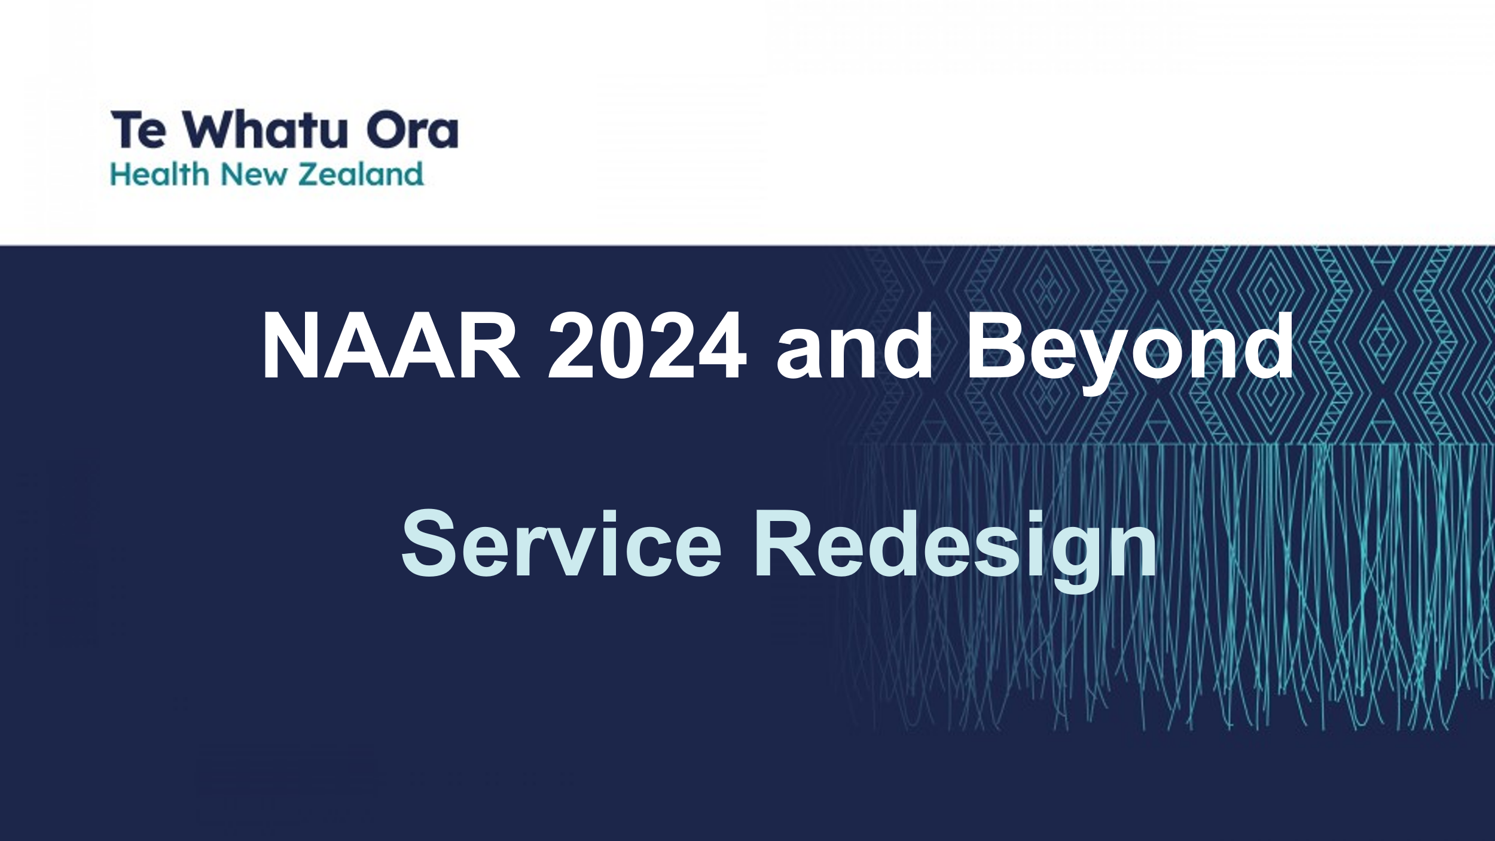

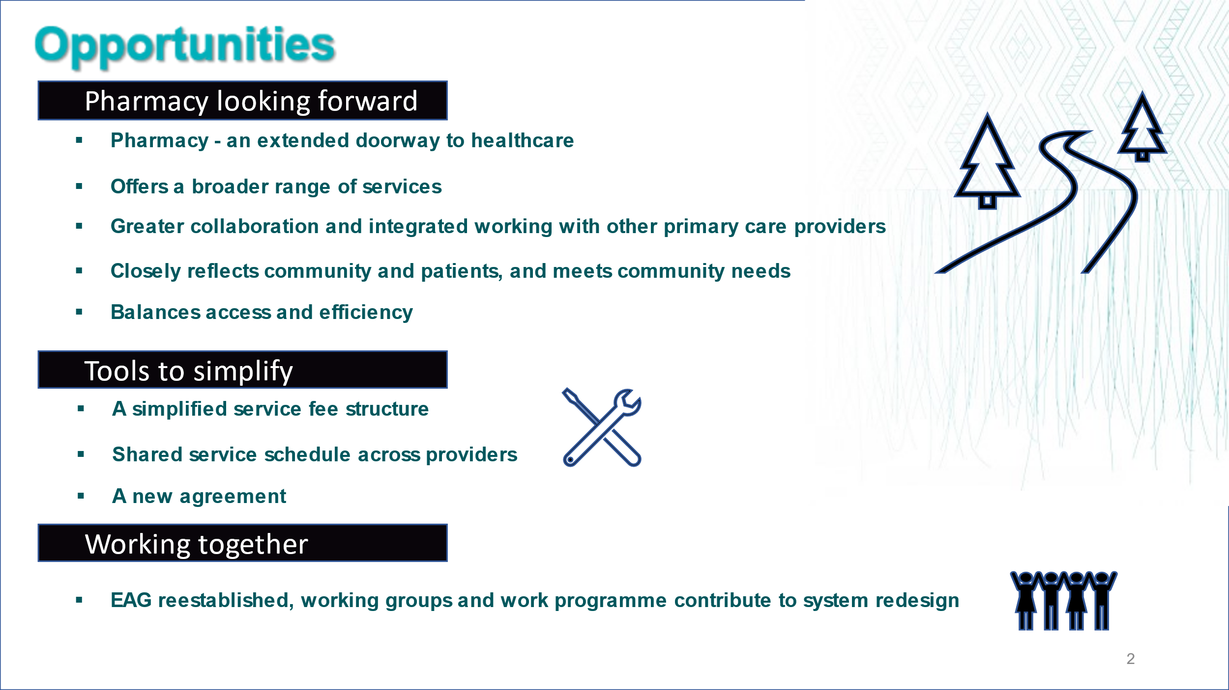

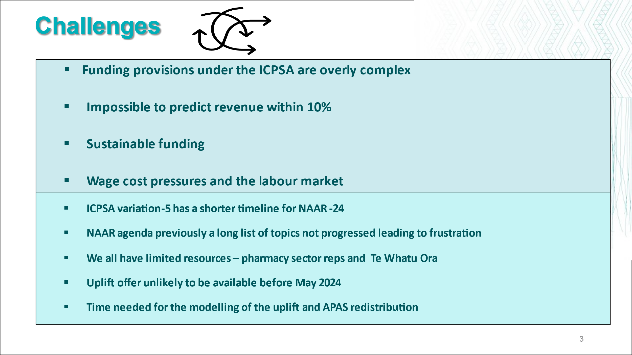

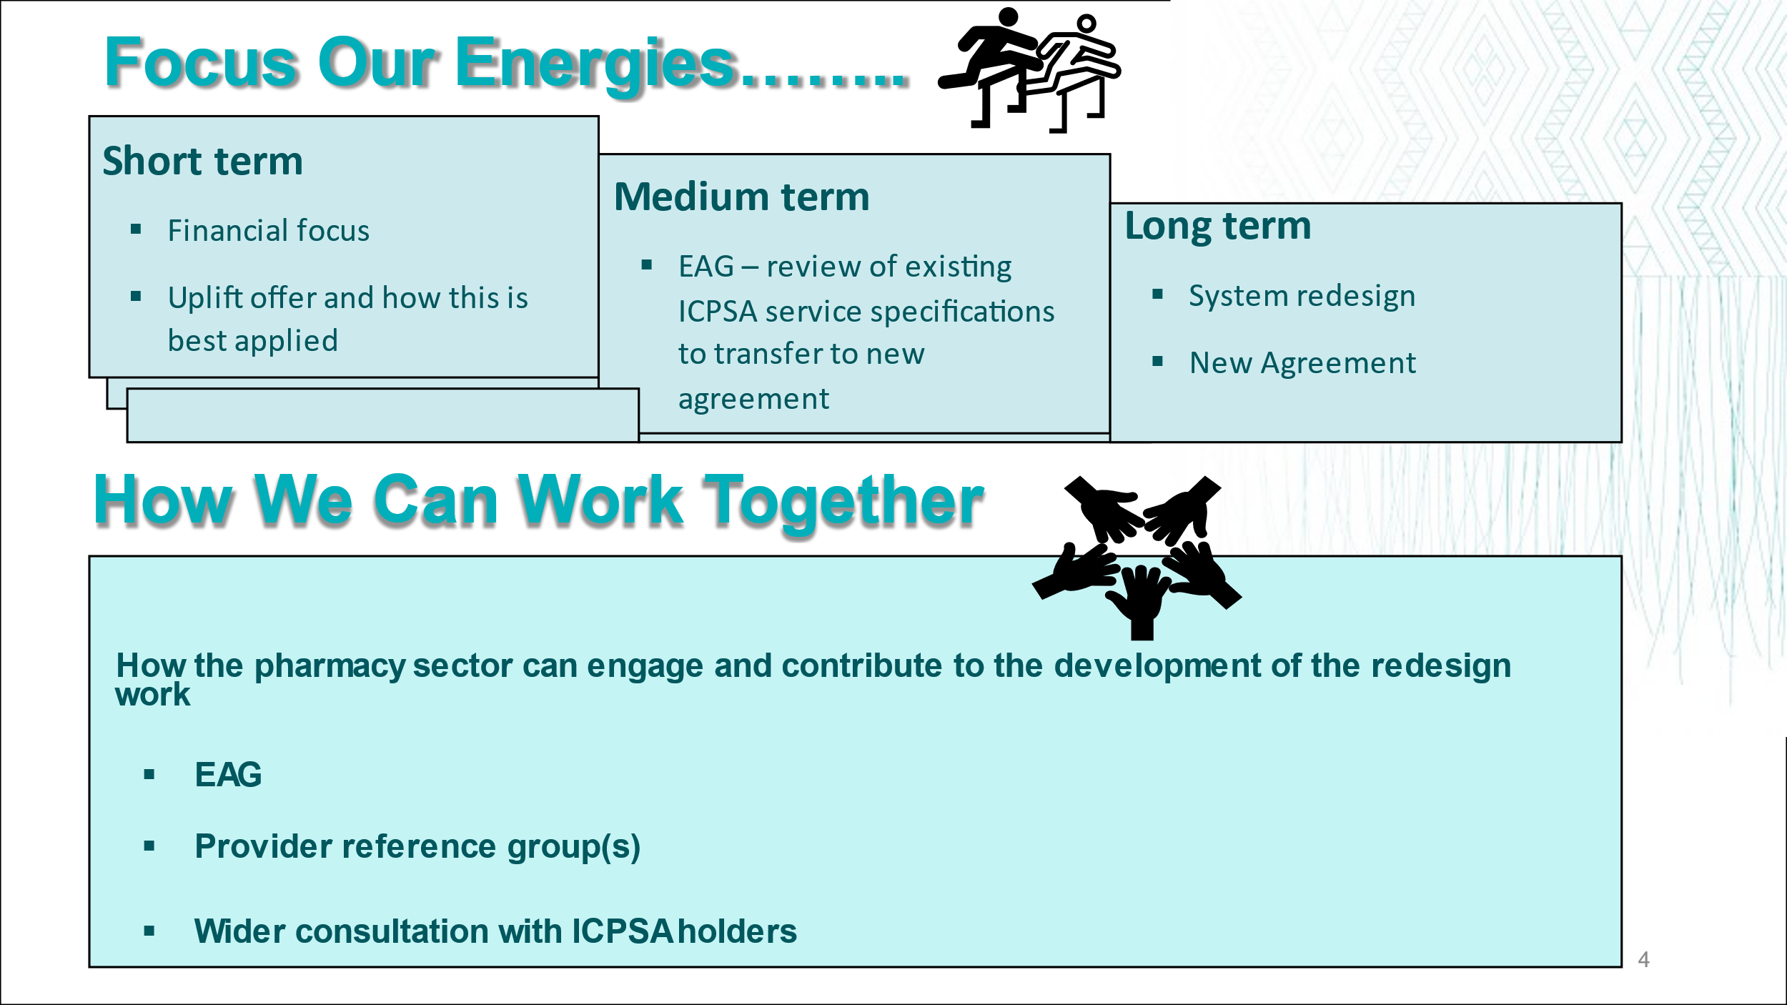

Price E, Shirtcliffe A, Fisher T, Chadwick M, Marra CA. A systematic review of economic evaluations of pharmacist services. Int J Pharm Pract. 2023 Sep 30;31(5):459-471. doi: 10.1093/ijpp/riad052. PMID: 37543960. https://pubmed.ncbi.nlm.nih.gov/37543960/

