|  |
| --- |
| **Ministry of Health** |
| **National Integration Applications – formerly known as the**  **COVID-19 Technology Integration Product (CTIP)**  **APIs for:**   * **COVID Consumer Channel COVID Vaccination Certificate Releases** * **Rapid Antigen Test result reporting** |
|  |
| Privacy Impact Assessment |
| **Date 23 August 2022** |

Document Approval

|  |  |  |
| --- | --- | --- |
| Title |  | Sign-off date |
| Approved by Senior Responsible Officer |  | 10/08/2022 |
| Approved by Chief Privacy Officer, Ministry of Health |  | 11/08/2022 |

The author of this document is Data & Digital Directorate, Ministry of Health.

Disclaimer

This Assessment has been prepared to assist the Ministry of Health (“the Ministry”) to review the National Integration Applications (NIA) (formerly COVID-19 Technology Integration Product (CTIP)) in relation to the COVID Consumer Channel (C3) APIs including the Rapid Antigen Test (RAT) reporting functions.

Related PIA activity includes the earlier CTIP PIAs. An earlier PIA covered CTIP and the APIs that provided access to testing and vaccination information about each Consumer (as linked to their NHI).

Every effort has been made to ensure that the information contained in this report is reliable and up to date. This Privacy Impact Assessment represents the current expectations of the way the COVID Consumer Channel (C3) ad RAT reporting services will operate.

This Assessment is intended to be a ‘work in progress’ and may be amended from time to time as circumstances change or new information is proposed to be collected and used.

**Assumptions applied**

The assumptions that have been applied in the development of this assessment include:

* As this project develops, there will be evidence and information generated through the development and deployment of the application (e.g. Statistics of use and feedback from users) that will impact on how the Ministry of Health determines what is important for the future purpose of this application. These may result in changes to the terms of use, the information collected, and the risks and mitigations required.
* Discussions will continue between key parties (i.e. the Ministry of Health, the Office of the Privacy Commissioner and the Government Chief Privacy Officer) and future versions of this assessment will record changes to information that is collected and the consequent risks, further analysis and mitigations.
* A subsequent version of the Privacy Impact Assessment will be made publicly available for the public to understand the collection, storage, use and sharing of personal and third-party information for purposes of transparency.

Contents

Glossary 4

Section One – Executive Summary 7

Scope of Assessment 9

Assessment content 9

Recommendation Summary 9

Section Two – New NIA APIs 10

Background 10

API Description 11

Relevant Project Stage 11

How Consumers will interact with the Project 12

Information fields involved in the identification: 13

Information Flows 17

Supervised & Bulk Reporting RAT Result Capture – Solution Detail 21

Where and how the information will be stored 22

Retention of information 22

Security features applying to Project 23

Manual processes involved? 24

Analytics 24

Governance 24

Section Three – Privacy Analysis 25

Appendix One – Detail about certificate generation for My Vaccine Pass 27

Appendix Two –Certificate generation for the International DCC 30

Appendix Three –Certificate generation for a vaccination record 33

Fstat

## Glossary

The following are definitions used in this Assessment:

| **Terms** | **Description, relationship and business rules** |
| --- | --- |
| **API** | Application Programming Interface – a software intermediary that allows two applications to ‘talk’ to each other. |
| **Bulk Reporting process** | The process for authorised users to upload supervised RAT results in bulk |
| **C3** | The “COVID Consumer Channel” - meaning the digital channels by which the Consumer can engage with the health system for COVID-19 specific information about themselves. This includes My Covid Record. |
| **Certificate Generation Service** | The technology service, provided by the certificate generation partner (MATTR) contracted to provide this service by the Ministry. The service provides digital certificates to NIA, containing a Consumer’s information based on the API request. The certificates generated will be either:   * My Vaccine Pass; or * The International DCC |
| **CICS** | COVID Immunisation Consumer Support |
| **CIR** | COVID-19 Immunisation Register |
| **CVC** | Covid Vaccination Certificate (e.g. My Vaccine Pass, International Travel Certificate or Vaccination record) |
| **Cogito** | New Zealand Certificate Issuing Authority (NZ CSCA) for International Digital Covid Certificate – the Ministry has a MOU with DIA to use this service that is also used to issue e-Passports |
| **Consumer** | An identifiable individual who chooses to access information about themselves made available via the C3 options. |
| **CTIP** | COVID-19 Technology Integration Product (middleware), now referred to as NIA |
| **DI** | Digital Identity, the Ministry project that has developed a secure digital identity for Consumers to enable them engage with health services and information at an appropriate level of identification – this operates as My Health Account. |
| **Domestic CVC** | Also known as My Vaccine Pass |
| **Eclair** | The national COVID-19 lab collection management and results repository operated by ESR |
| **ESR** | Institute of Environmental Science and Research, a Crown Research Institute |
| **EUDCC** | European Union Digital COVID Certificate |
| **Exemption** | The process specified in the relevant Order which will enable a Consumer to obtain an exemption from the requirement to be vaccinated in certain settings (for example to enter certain premises or events). Once finalised it is planned that this will be incorporated into a future release of My Covid Record. If that occurs the My Vaccine Pass will not distinguish between compliance of a Consumer with an Exemption and a Consumer who is Vaccinated. |
| **Face Mask Exemption Pass** | A Face Mask Exemption Pass can be provided for those who suffer from a physical illness, mental illness, conditions or disability that make it unsuitable for them to wear a face mask, so that they can access businesses and services that require a face mask is worn. |
| **International DCC** | The International Travel Vaccination Certificate created within My Covid Record, that can be used by New Zealand Vaccinated Consumers to verify their vaccination status for international travel. Further details about the International DCC can be found in Appendix Five of the My Covid Record [PIA](https://www.health.govt.nz/our-work/diseases-and-conditions/covid-19-novel-coronavirus/covid-19-vaccines/my-covid-record-proof-vaccination-status#your-privacy). The brand name will be the ‘International Travel Vaccination Certificate’. |
| **Landing Page** | Digital marketing asset/page to provide a conduit for consumers to bridge from emails and social media posts into the national booking system or other relevant services. The Landing Page is a static display of information with links to click through to other services like Book My Vaccine. |
| **MATTR** | Company providing QR code certification for My Vaccine Pass, and interfacing with Cogito and the EU DCC Gateway to produce the International DCC. |
| **My Vaccine Pass** | The domestic COVID-19 Vaccination Certificate that can be used by Consumers to demonstrate that they comply with the current Vaccination requirements in accordance with the relevant Order. This may include the Consumer being Vaccinated or having a valid Exemption. Further details about the My Vaccine Pass can be found in Appendix Four. |
| **My Vaccine Pass Verifier App** | The third-party App to be developed by MATTR at the request of the Ministry to enable verification of the My Vaccine Pass QR Code. This is further described in Annex One to Appendix Four. This will be named NZ Pass Verifier. |
| **Ministry** | The Ministry of Health |
| **NIA** | National Integration Applications (middleware) |
| **NIA DynamoDB** | The NIA database to store Face Mask Exemption Pass request logs of Face Mask Exemption Pass requests that have been made via My Covid Record, CICS or CIR. |
| **NZ CSCA** | New Zealand Country Signing Certificate Authority which will be incorporated into the International DCC. The International DCC digital signature NZ CSCA (via Cogito) will be able to be verified by NZ Customs and other international border agencies to confirm that the International DCC is authentic. |
| **Order** | The Order or Orders that are made under section 11 of the COVID-19 Public Health Response Act 2020, to either establish the process for issuing a domestic vaccine pass, or how it may be used and / or verified. At the time of writing this PIA the COVID- 19 Vaccination Certificate, known as My Vaccine Pass, is created pursuant to the COVID-19 Public Health Response (COVID-19 Vaccination Certificate) Order 2021. |
| **PCR test** | The most accurate test for detecting COVID-19 is a PCR test. This test detects genetic material from the virus in the sample. All viruses change over time and laboratories can sequence the genetic material from a PCR test to identify and understand which variant of COVID-19 a person has. |
| **Project** | The C3 project |
| **Rapid Antigen Test (RAT)** | Rapid Antigen Test – a test generally taken with a front of nose swab to detect the presence of specific proteins on the outer portion of the virus, such as the spike protein. The advantage of RATs is that they give a result quickly (often in less than 15 minutes), which assists with rapid risk assessment and reduces the amount of time a positive individual is active in the community. |
| **RAT Catcher** | The web application that will enable supervised RAT results to be processed and uploaded by clinicians to Eclair via NIA (multiple results can be uploaded at one time if required) |
| **RAT Reporter** | The RAT result reporting option that enables direct single entry of RAT results into Eclair by direct entry to Eclair. This will mainly be replaced by RAT Catcher. |
| **Web App** | Web App is a single page application that is web based and is accessed by using a secure login. It distinct from a native app (IOS/Android) that is download and install on the user’s device. This is the web-based app that Consumers will log into using their DI account. |
| **Vaccinated** | As defined in the relevant Order, or COVID-19 Public Health Response Act 2020, but essentially requiring that a Consumer has received a COVID-19 vaccine, or combination or COVID-19 vaccines, that are as specified by the Director-General by notice in the Gazette, and the vaccines were administered in accordance with the requirements specified for that vaccine, or combination of vaccines, in the notice. |
| **Web Channel** | A combination of various webservices to be managed by the Ministry of Health through the C3 project to provide an end-to-end pathway for experiences such as vaccination. |

# Section One – Executive Summary

1. The COVID-19 pandemic is forcing governments around the world to evaluate how standard public health approaches to managing and controlling infectious disease can be bolstered and augmented by technology.
2. The Ministry has already identified opportunities to support national COVID Vaccination Programme processes, including:
   1. the COVID Immunisation Register (CIR) to record vaccination events against the consumers NHI;
   2. the NIA, formerly called the Covid-19 Technology Integration Product (CTIP), which was initially implemented to support Contact Tracing. It provides a secure product to the Ministry and industry partners, so they can securely exchange information when necessary. This has been expanded to:
      1. enable secure exchanges for COVID-19 Test results, including Rapid Antigen Tests (RATs) to enable them to be reported to the COVID-19 test repository (Eclair); and
      2. enable certificate generation for vaccination records and Face Mask Exemption Passes; and
      3. store Face Mask Exemption Pass request logs.
   3. the Digital Identity (DI) project, establishing a digital identity for Consumers at pre-determined confidence levels to provide confidence to enable them to access health services about themselves.
3. This Privacy Impact Assessment (PIA) builds on the work described in other PIAs.
   1. One is the first update to the PIA for the CTIP ([here](https://www.health.govt.nz/our-work/diseases-and-conditions/covid-19-novel-coronavirus/covid-19-resources-and-tools/nz-covid-tracer-app/about-nz-covid-tracer-app/integrating-other-contact-tracing-apps-nz-covid-tracer-apis)).
   2. The second is the PIA for the DI ([here](https://www.health.govt.nz/our-work/digital-health/other-digital-health-initiatives/my-health-account/my-health-account-privacy-notice)).
   3. The third is the PIA for the Covid Consumer Channel My Covid Record and the Vaccination Certificates ([here](https://www.health.govt.nz/covid-19-novel-coronavirus/covid-19-resources-and-tools/covid-19-your-privacy)). This addresses the public facing components of the My Covid Record project, and also includes the ability for Consumers to self-report Rapid Antigen Test results (and also report on behalf of others).[1]
4. This PIA is about the API technology component to enable the exchanges of information for the following purposes:
   1. for the COVID Consumer Channel Vaccination Certificate Releases, and
   2. the components enabling reporting of RAT results to Eclair, the ESR Test result repository.
      1. This includes ‘unsupervised’ RAT reporting, being a person self-reporting (or reporting on behalf of another) their RAT result via My Covid Record; and
      2. Supervised RATs where a clinician administers / supervises the tests and reports the results, including:
         1. the Bulk Reporting process via an agreed process with specific sector agencies. This process will enable those agencies, who have entered a data agreement for that purpose, to upload RAT reporting information to enable NHI matching and reporting RAT results to Eclair.
         2. a new process for clinical ‘supervised’ RATs, RAT Catcher (currently RAT Catcher is in pilot at a number of selected Aged Residential Care facilities).
   3. Each uses NIA as a key component of the information upload component of the processes[2].
5. NIA components include both:
   1. the NIA Platform, being the secure software product, which manages integration and processing of information to support the Ministry; and
   2. Application Programming Interfaces (API(s)).
6. The API(s) will provide the mechanism to enable Consumers to:
   1. Connect via the COVID Consumer Channel C3 web app[3] (My Covid Record) to vaccination records held in the CIR, and COVID-19 test results in the national laboratory test reporting system Eclair (including the ability to self-report RATs or report RAT results on behalf of another); and
   2. create digital certificates from the above information, as well as Consumer entered information, via the Certificate Generation Service.
7. The APIs for the digital certificate creation and for reporting RAT results are those covered under this PIA.
8. Digital consumer channel options and secure self-service capabilities are essential to ensure a positive Consumer experience as New Zealand increases and expands the scale of vaccinations and the requirements for RAT reporting due to the current Omicron and Delta outbreak in the community. The foundation of the Covid Consumer Channel will be a seamless digital journey that is consistent and builds trust.
9. The underlying infrastructure that supports the new API(s) is already in production through NIA. The Ministry has previously successfully completed production verification testing of NIA.
10. The Office of the Privacy Commissioner and the Government Chief Privacy Officer have been advised of this Privacy Impact Assessment.

## Scope of Assessment

1. This Privacy Impact Assessment covers the APIs supporting the:
   1. C3 self-service web app (My Covid Record) to enable COVID-19 certificates to be generated and distributed to Consumers and RAT results to be reported;
   2. Assisted Channels (CICS and CIR) to enable COVID-19 certificates to be generated and distributed to Consumers; and
   3. The RAT reporting channels for supervised RAT reporting (RAT Catcher) and the Bulk Upload service. Both of these processes are currently being reviewed under their own PIAs.

## Assessment content

1. Section Two contains the description of the API components of:
   1. the C3 Project and User/Information Flows; and
   2. the supervised RAT Catcher reporting and the Bulk Upload RAT result capture.
2. Section Three contains the Privacy Analysis.

## Recommendation Summary

1. The Ministry will identify and mitigate privacy risks associated with this Project, prior to collecting, storing, using and sharing this personal and contact information.
2. The following are areas that the Ministry will concentrate on as it develops the Project:

|  |  |  |
| --- | --- | --- |
|  | Action – COVID Consumer Channel Initial Privacy Assessment (IPA) | Planned Date for completion |
| IPA- 01 | Clear and defined Privacy Materials must be available at Consumer connection points – which will be either the Web App and / or the DI tool.  This API component of the Project will not have any independent Privacy Statement but the Project will ensure that any component it connects with will have Privacy Statements in place before go-live. | Prior to Go Live and throughout Project |
| IPA-02 | The Ministry will follow its standard security review processes including Certification and Accreditation, and independent security testing. If any risks are identified they will be resolved or mitigated to ensure appropriate security will be applied to all aspects of the Project.  No production data is to be used before appropriate testing has been completed. | Prior to Go Live and throughout Programme |

# Section Two – New NIA APIs

## Background

1. The Ministry has elected to consolidate the emerging Consumer digital components across the COVID-19 response and the Immunisation programme as the C3 Web Channel, underpinned by interoperable APIs and services.
2. In addition, with the current Omicron and Delta outbreak, the significance of RATs as both a diagnostic and surveillance tool has greatly increased. As these RATS are completed outside the standard laboratory processes, new methods are required to ensure the relevant information securely and accurately reaches Eclair. Once in Eclair, there is a standardised process to enable the correct information to be returned to any Consumer who tests positive (this is not further addressed in this PIA).
3. This PIA incorporates the additional APIs related to NIA that will enable these processes.
4. The Ministry has developed an AWS – COVID Integration Hub and secure Application Processing Interfaces (APIs) – collectively called National Integration Applications (NIA).

*My Covid Record*

1. The C3 web app (My Covid Record) uses APIs which are exposed via NIA into the dependent systems supporting vaccination and testing, and eventually borders and contact tracing.
2. Consumers have faced increased number of situations in which they were required to demonstrate their vaccination and testing status, including international travel and domestic situations such as in some mandated employment roles[4] or other settings where there is a mandate to demonstrate vaccination to attend/ enter a service[5]. The expanded My Covid Record certificate services will enable consumers to access the relevant information and create a certificate of vaccination or face mask exemption to display as they choose.
3. In addition, COVID-19 Immunisation Consumer Support (CICS) (the call centre customer relationship management system) and the COVID-19 Immunisation Register (CIR) will use APIs which will be exposed via National Integration Applications (NIA) into the dependent systems. This will support vaccination certificate and Face Mask Exemption Pass generation for assisted channels where Consumers cannot or do not use My Covid Record to generate the certificates for themselves. The operational processes associated with those alternative assistance channels are not addressed further in this PIA.

*RAT Reporting*

1. The RAT reporting options[6] to upload RAT results to Eclair use NIA to pass test result data to Eclair with use of a Mirth API. Information uploaded via My Covid Record, from the RAT Catcher (supervised RAT processes) and the Bulk Reporting process tool will all transit the NIA Mirth API to reach Eclair.

## API Description

1. The APIs provide a read-only middleware layer between consuming applications and the source systems.
2. NIA APIs will be based on FHIR[7] standards. FHIR is an internationally recognised standard that defines how healthcare information can be exchanged between different computer systems.
3. The FHIR-based responses may contain more data than is required by client applications. Therefore client applications (such as My Covid Record, CICS or CIR) will instantly discard any superfluous data returned from NIA that is not required to fulfil the client application purpose.
4. NIA APIs are responsible for providing the Certificate Generation Service (further described in Appendices One and Two) with an individual’s information to enable the Certificate Generation Service to generate and return a digital certificate.
5. The Mirth / Eclair API is responsible for receiving reported RAT results from multiple sources (My Covid Record, RAT Catcher for supervised RATs, and the Bulk Reporting process) and transferring it into the Eclair test repository for COVID-19 related test results.

## Relevant Project Stage

*My Covid Record Certificates*

1. My Covid Record has been updated to incorporate the ability to request the generation of digital vaccination certificates.
2. To support My Covid Record, NIA has the following APIs (reviewed in the previous PIA) to:
   1. connect to CIR to retrieve the COVID vaccination records for a Consumer’s NHI number;
   2. connect to National Eclair to retrieve the COVID test records for a Consumer’s NHI number.
3. APIs connect to a Certificate Generation Service to enable appropriate COVID vaccination certificates to be generated in to a COVID-19 certificate matched to a Consumers NHI number and name.
   1. The Certificate Generations Service has been expanded to enable face mask exemptions, matched to a Consumers NHI number, to be generated.
4. The My Covid Record project timeline included a closed pilot during August 2021, followed by a public release in October 2021, and has been operating consistently since that time.

*RAT Reporting*

1. The Mirth / Eclair connection is now in operation for My Covid Record, RAT Catcher (supervised RATs), and the Bulk Reporting process tool and self-reported and on-behalf reports of RAT results are currently in operation for Consumers using My Covid Record. The information will transit NIA to Eclair.

## How Consumers will interact with the Project

*My Covid Record*

1. The new certificate related APIs on NIA that are covered in this PIA will not be directly accessed by the public.
2. Consumers will interact with the My Covid Record application that is integrated to the NIA APIs:
   1. My Covid Record will use these APIs to deliver that web apps intended functionality.
   2. CICS/CIR will use these APIs to request vaccination certificates (My Vaccine Pass, International DCC and a vaccination record PDF) and Face Mask Exemption Passes which are to be generated and emailed, or sent, to a specified email address or physical/ postal address.
3. In the future (subject to a future PIA) additional APIs may be created to enable one or more of these applications to:
   1. enable international vaccination certificates presented at the border or submitted domestically from international origins to the Travel Health Declaration rules engine to enable confirmation that a vaccination certificate can be issued in the form of My Vaccine Pass; and
   2. request testing certificates to be generated and emailed, or sent, to a specified email address or physical/ postal address (this postal option may be implemented on My Covid Record).
4. The Ministry applications (e.g. My Covid Record, CICS/ CIR) will be responsible for ensuring that the information requested through the API and/or displayed is limited to that which is appropriate for its user(s).
5. The initial APIs focussed on the ability to access the COVID Vaccination and Test records against the provided NHI on request.
6. The additional APIs support the generation of a vaccination certificate or Face Mask Exemption Pass for the verified NHI, by accessing the appropriate COVID vaccination records and NHI record (if applicable).
   1. The certificate generation process for My Vaccine Pass is described in more detail in Appendix One.
   2. The certificate generation process for the International DCC is described in more detail in Appendix Two.
   3. The certificate generation process for the vaccination record is described in more detail in Appendix Three.
   4. The certificate generation process for the Face Mask Exemption Pass is described in more detail in Appendix Four.

*RAT Reporting*

1. The Mirth / Eclair API is already established and in operation for My Covid Record for Consumers self-reporting their own results, and are also now able to report unsupervised RAT results on behalf of another, such as children, friends of those who do not have their own My Covid Record.
2. The supervised RAT processed in RAT Catcher, and the Bulk Reporting processes will not be accessed directly by Consumers.

## Information fields involved in the identification:

1. The following table summarises the data dictionary of the details that will be retrieved and returned by all of the NIA APIs that are related to the NHI provided by the requesting application(s).
2. The details retrieved and returned by My Vaccine Pass and the International DCC are detailed in the sections towards the bottom of this table.

|  |  |  |
| --- | --- | --- |
|  |  |  |
| **Data** | **Mandatory / voluntary field for collection** | **Purpose / necessity** |
| **DI Platform** | | |
| First Name | n/a | Retrieve from DI/NHI and returned to consuming app |
| Last Name | n/a | Retrieve from DI/NHI and returned to consuming app |
| NHI Number | n/a | Retrieve from DI/ NHI and returned to consuming app |
| Date of Birth | n/a | Retrieve from DI/ NHI and returned to consuming app |
| **CIR API** | | |
| First Name | n/a | Retrieve from CIR and returned to consuming app |
| Middle Name | n/a | Retrieve from CIR and returned to consuming app |
| Last Name | n/a | Retrieve from CIR and returned to consuming app |
| Date of Birth | n/a | Retrieve from CIR and returned to consuming app |
| Vaccine Status | n/a | Retrieve from CIR and returned to consuming app |
| Vaccine name | n/a | Retrieve from CIR and returned to consuming app |
| Vaccine completed datetime | n/a | Retrieve from CIR and returned to consuming app |
| Vaccine location | n/a | Retrieve from CIR and returned to consuming app |
| Place vaccine was administered | n/a | Retrieve from CIR and returned to consuming app |
| Vaccine manufacturer | n/a | Retrieve from CIR and returned to consuming app |
| Vaccine batch number | n/a | Retrieve from CIR and returned to consuming app |
| Vaccine antigen number | n/a | Retrieve from CIR and returned to consuming app |
| Vaccine site | n/a | Retrieve from CIR and returned to consuming app |
| Vaccine route | n/a | Retrieve from CIR and returned to consuming app |
| Vaccinator name | n/a | Retrieve from CIR and returned to consuming app |
| Vaccine dose number | n/a | Retrieve from CIR and returned to consuming app |
| Vaccine type | n/a | Retrieve from CIR and returned to consuming app |
| **Eclair API – to return PCR and RAT Results to My Covid Record** | | |
| Test completed datetime | n/a | Retrieve from ESR Eclair and returned to consuming app |
| Test result datetime | n/a | Retrieve from ESR Eclair and returned to consuming app |
| Test specimen site | n/a | Retrieve from ESR Eclair and returned to consuming app |
| Test result | n/a | Retrieve from ESR Eclair and returned to consuming app |
| Test laboratory | n/a | Retrieve from ESR Eclair and returned to consuming app |
| NHI API – to return NHI details to NIA to validate on behalf of or name details provided from My Covid Record | | |
| First Name | n/a | Retrieved from NHI, but not passed on to consuming app |
| Middle Name | n/a | Retrieved from NHI, but not passed on to consuming app |
| Last Name | n/a | Retrieved from NHI, but not passed on to consuming app |
| NHI Number | n/a | Retrieved from NHI, but not passed on to consuming app |
| Date of Birth | n/a | Retrieved from NHI, but not passed on to consuming app |
| **Domestic COVID-19 Vaccination Certificate (CVC) API** | | |
| First Name | M | Retrieved from CIR **OR** retrieved and validated from NHI, and passed to Certificate Generation Service |
| Middle Name | O | Retrieved from CIR **OR** retrieved and validated from NHI,and passed to Certificate Generation Service |
| Last Name | M | Retrieved from CIR **OR** retrieved and validated from NHI, and passed to Certificate Generation Service |
| Date of Birth | M | Retrieved from CIR and passed to Certificate Generation Service |
| Vaccine Status | M | Retrieved from CIR and passed to Certificate Generation Service |
| Valid from | M | occurrenceDateTime retrieved from CIR for the last vaccine administered and passed to the Certificate Generation Service |
| Expiration | M | Calculated as 180 days from certificate request and passed to the Certificate Generation Service |
| **International DCC API** | | |
| First Name | M | Retrieved from CIR **OR** retrieved and validated from NHI, and passed to Certificate Generation Service |
| Middle Name | O | Retrieved from CIR **OR** retrieved and validated from NHI, and passed to Certificate Generation Service |
| Last Name | M | Retrieved from CIR **OR** retrieved and validated from NHI,and passed to Certificate Generation Service |
| Date of birth | M | Retrieved from CIR and passed to Certificate Generation Service |
| Vaccine status | M | Retrieved from CIR and passed to Certificate Generation Service |
| Vaccine name | M | Retrieved from CIR and passed to Certificate Generation Service |
| Vaccine completed datetime | M | Retrieved from CIR and passed to Certificate Generation Service |
| Country vaccine was administered | M | Retrieved from CIR and passed to Certificate Generation Service |
| Vaccine manufacturer | M | Retrieved from CIR and passed to Certificate Generation Service |
| Vaccine dose number | M | Retrieved from CIR and passed to Certificate Generation Service |
| Number of doses in series | M | Retrieved from CIR and passed to Certificate Generation Service |
| **Copy of vaccinations (API)** | | |
| First Name | M | Retrieved from CIR **OR** retrieved and validated from NHI, and passed to Certificate Generation Service |
| Middle Name | O | Retrieved from CIR **OR** retrieved and validated from NHI, and passed to Certificate Generation Service |
| Last Name | M | Retrieved from CIR **OR** retrieved and validated from NHI,and passed to Certificate Generation Service |
| Date of birth | M | Retrieved from CIR and passed to Certificate Generation Service |
| Vaccine status | M | Retrieved from CIR and passed to Certificate Generation Service |
| Vaccine name | M | Retrieved from CIR and passed to Certificate Generation Service |
| Vaccine completed datetime | M | Retrieved from CIR and passed to Certificate Generation Service |
| Country vaccine was administered | M | Retrieved from CIR and passed to Certificate Generation Service |
| Vaccine manufacturer | M | Retrieved from CIR and passed to Certificate Generation Service |
| Vaccine dose number | M | Retrieved from CIR and passed to Certificate Generation Service |
| Number of doses in series | M | Retrieved from CIR and passed to Certificate Generation Service |
| **Face Mask Exemption Pass** | | |
| First Name | M | Retrieved from CIR **OR** retrieved and validated from NHI, and passed to Certificate Generation Service |
| Middle Name | O | Retrieved from CIR **OR** retrieved and validated from NHI, and passed to Certificate Generation Service |
| Last Name | M | Retrieved from CIR **OR** retrieved and validated from NHI,and passed to Certificate Generation Service |
| **Mirth/ Eclair API (from My Covid Record, RAT Catcher, and the Bulk Reporting process form)** | | |
| HPI CPN (Health Provider Index Common Person Number – clinician identifier) | M | Retrieved from RAT Catcher / Bulk Reporting Process and passed to consuming app (Eclair via NIA) |
| Supervising clinician first and last name | M | Bulk Reporting Process only (as per data agreement with organisation for clinician supervising Bulk Reporting process) |
| Facility ID | M | Retrieved from RAT Catcher and passed to consuming app (Eclair via NIA) |
| First Name | M | Retrieved from RAT Catcher / Bulk Reporting process and passed to consuming app (Eclair via NIA) |
| Last Name | M | Retrieved from RAT Catcher / Bulk Reporting process and passed to consuming app (Eclair via NIA) |
| Date of Birth | M | Retrieved from RAT Catcher / Bulk Reporting process and passed to consuming app (Eclair via NIA) |
| NHI | M | Retrieved from RAT Catcher via Patient Search API and passed to consuming app (Eclair via NIA)  Identified at Facility prior to Bulk Reporting process and passed to consuming app (Eclair via NIA) |
| Mobile Number | O | Retrieved from RAT Catcher / Bulk Reporting process and passed to consuming app (Eclair via NIA) |
| Test Kit Details | M | Retrieved from RAT Catcher and passed to consuming app (Eclair via NIA) |
| Lot Number | M | Retrieved from RAT Catcher and passed to consuming app (Eclair via NIA) |
| RAT Authoriser | M | Retrieved from RAT Catcher and passed to consuming app (Eclair via NIA) |
| Test completed datetime | M | Retrieved from RAT Catcher / Bulk Reporting process and passed to consuming app (Eclair via NIA) |
| Test result datetime | M | Retrieved from RAT Catcher / Bulk Reporting process and passed to consuming app (Eclair via NIA) |
| Test specimen site | O | Retrieved from RAT Catcher / Bulk Reporting process and passed to consuming app (Eclair via NIA) |
| Test result | M | Retrieved from RAT Catcher / Bulk Reporting process and passed to consuming app (Eclair via NIA) |
| Patient asymptomatic Y/N | M | Retrieved from Bulk Reporting process and passed to consuming app (Eclair via NIA) |
| Symptoms onset and date and time | M | Retrieved from Bulk Reporting process and passed to consuming app (Eclair via NIA) |

## Information Flows

*My Covid Record*

1. The My Covid Record processes ensure that the display only includes the information allowed given the confidence level associated with the consumers Digital Identity (DI).
2. The Certificate Generation Service processes ensure that the information contained in the certificates is provided by a trusted service consumer (e.g. My Covid Record, CICS or CIR).
3. The end-to-end information flows for the API processes (for the information retrieval and generation of certificates via the NIA APIs) are demonstrated in the following diagram.
4. The Certificate Generation Service component of the diagram (in the DCC and My Vaccine Pass boxes on the right of the diagram) is split into two parts in Appendix One and Appendix Two and described further in terms of My Vaccine Pass and also the International DCC.

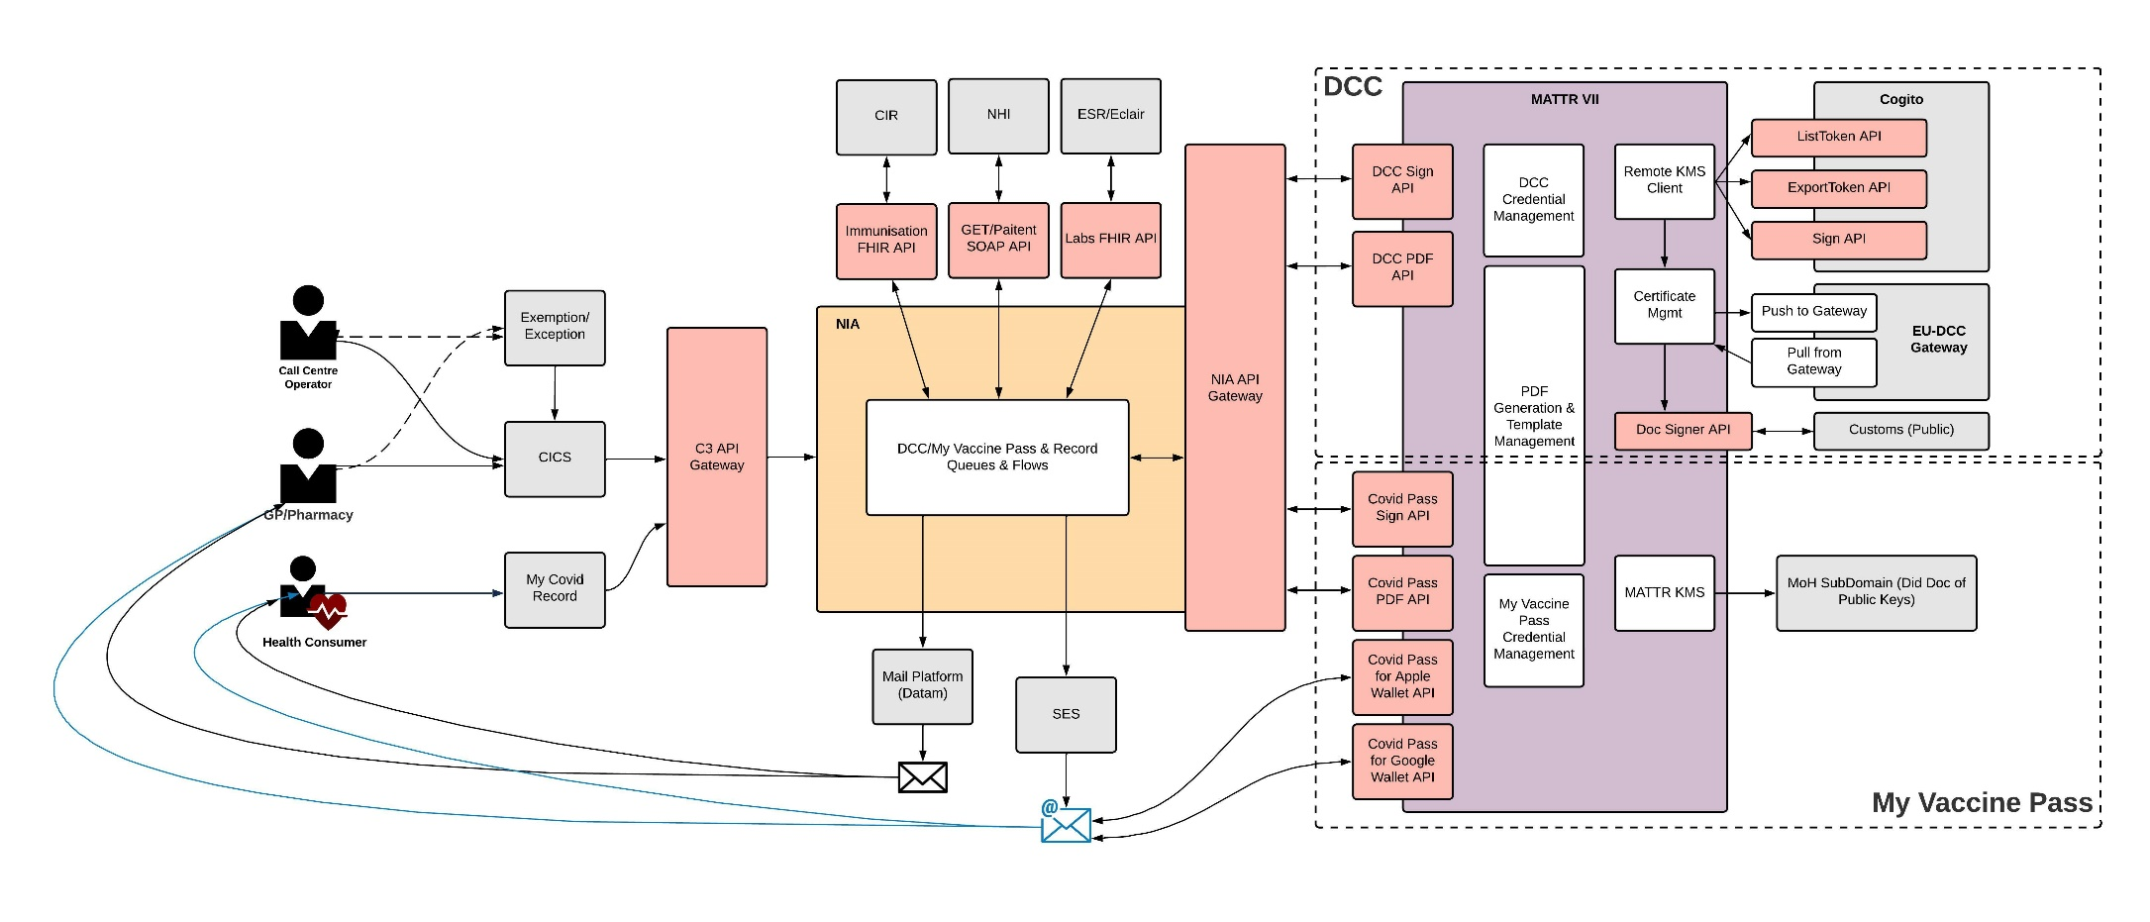

1. The initial components of the certificate generation process that is common to My Vaccine Pass,the International DCC, the vaccination record copy or Face Mask Exemption Pass are as follows:

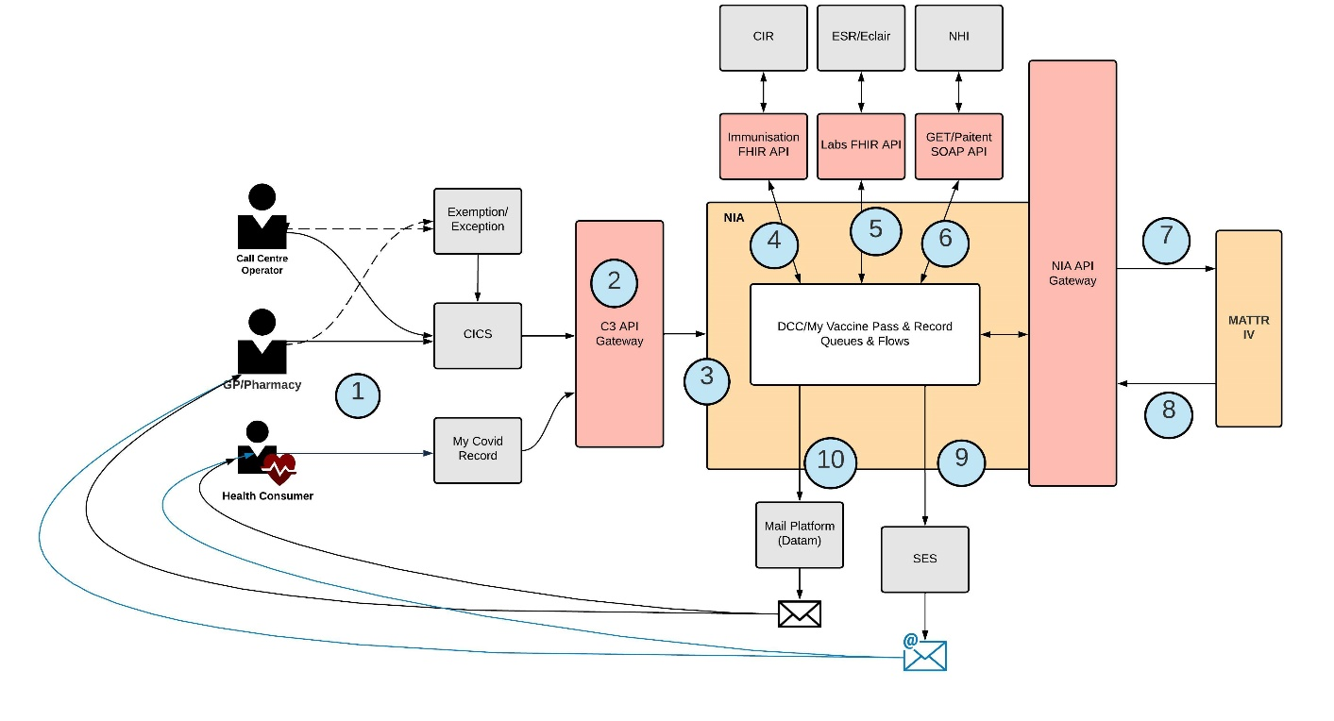

* 1. The consuming Service (e.g. My Covid Record, CICS or CIR manual processes) will request the original instruction to produce the Covid Vaccination Certificate (CVC).
  2. The instruction will travel via the API gateway to NIA.
  3. NIA will manage the process to generate a Domestic CVC, International DCC certificate or vaccination record. The source system will make the request containing:
     1. the Consumer’s NHI number;
     2. The Consumer’s name if it differs from their CIR record, and
     3. email address or postal address to send the Domestic CVC, International DCC certificate, vaccination record or Face Mask Exemptoin Pass to.
  4. NIA will retrieve the immunisation record for the NHI number from CIR (as applicable); or
  5. In the future NIA will retrieve the testing record for the NHI number from Eclair (if required).
  6. If the instruction contained a name, NIA will also retrieve the patient information from NHI and validate it is the same that has been provided from the source system;
  7. If the instruction was to generate a Domestic CVC or International DCC certificate, NIA will make an API request to the Certificate Generation Service, incorporating the identity and vaccination or test details, to generate a CVC.
     1. Or if the instruction was to generate a Vaccination record or Face Mask Exemption Pass, NIA will generate a Vaccination record PDF or Face Mask Exemption Pass.
  8. The Certificate Generation Service will receive the request and generate a Domestic CVC PDF or International DCC PDF (as applicable and the PDF will be returned to NIA).
  9. If the API request from the consuming Service (e.g. My Covid Record, CICS or CIR) to NIA contained an email address then the PDF will be emailed to the email address.
  10. If the API request from the consuming Service (e.g. My Covid Record, CICS or CIR) to NIA contained a postal or physical address then the PDF will be printed and posted to the postal or physical address.

*RAT Reporting*

1. The following diagram outlines the information flows for RAT reporting (excluding My Covid Record):

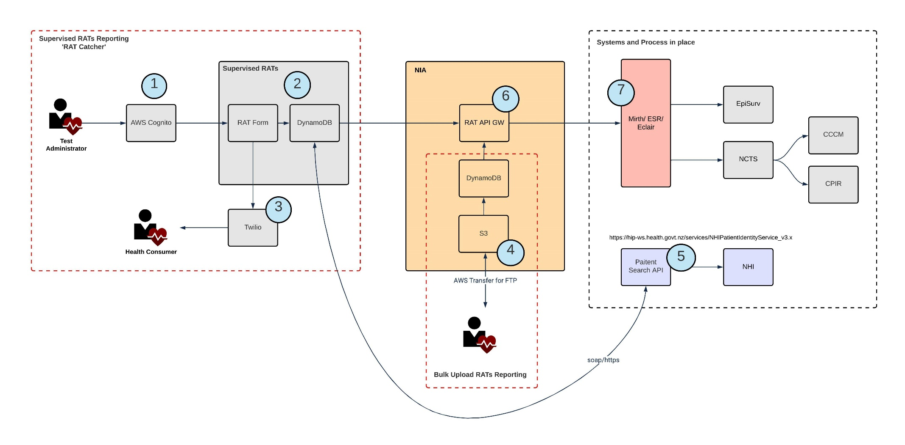

## **Supervised & Bulk Reporting RAT Result Capture – Solution Detail**

|  |  |
| --- | --- |
| **Ref** | **Description** |
| 1 | **Cognito**  This is a Facility Logon for those administering supervised RATs (clinical supervised RATs) – Username and Password required with Multi Factor Authentication via SMS for authorised system users |
| 2 | **Supervised RATs Front-end -** Built on same infrastructure as My Covid Record |
| 3 | **Twilio Service**  For validating patients phone number, as a requirement for Test Result submission to ESR (patient will receive SMS message with a code to pass to the administrator to confirm they have access to that phone number) |
| 4 | **SFTP Service – for the Bulk Reporting process only**  Provides sFTP (FTP via SSH) services to authorised organisations to Bulk Reporting RAT results. These will be treated as supervised RATs (as the organisations permitted to use these services will be under clinical supervision). Upon being provided with a user ID and private SSH key (or the organisation creates and provides NIA with their public key), organisations may configure an FTP client application (e.g. Filezilla) for easy upload of bulk RAT files to their own private 'input' remote folder.  **S3 Bucket** - On upload, AWS Transfer Services will automatically place the file into the bulk user –labelled folder within an S3 bucket. This is private to the organisation.  This will in-turn result in an 'Object Created' EventBridge event being fired in AWS, containing the bucket name and file key. This in-turn triggers a Steps function, as described next.  **Create User Lambda** - A support function which, when provided with a new Bulk user ID and public SSH key, creates an sFTP user and a corresponding secure private folder in RAT Org-Bulk User File bucket, and an sFTP, which it is able to upload files to. |
| 5 | **Patient Search API**  This is used by the Supervised process. It is used to provide the NHI for a patient or employee via a SOAP interface via secure internet service |
| 6 | **RAT API GW**  Standard pattern for passing test result data to ESR and other downstream systems via Mirth |
| 7 | **API to Eclair via Mirth (and Downstream Systems)**  These API and subsequent systems such as Eclair are all currently systems in use and have previously been security checked. My Covid Record will also use this API |

## Where and how the information will be stored

1. The NIA is hosted using Amazon Web Services (AWS) in Sydney, Australia, in the ap-southeast-2 region. The Ministry’s use of AWS has been established through the All-of-Government service agreements. The AWS tenancy used by NIA is owned by the Ministry, and subject to standard Ministry requirements for architecture, security, and audit controls. This application has an approved Authority to Operate, which includes a completed Security Risk Assessment.

## Retention of information

*Certificate generation*

1. For requests for certificates that are fulfilled 100% digitally (i.e. via My Covid Record, the only persistence of personally identifiable information in NIA, is in the queuing mechanisms (‘DCC queue’ and ‘Dead-Letter queue’). For requests that are posted, some personal information is persisted but not permanently. ‘Not persisted’ means once in-memory processing is completed, the information is automatically destroyed, so that the memory can be utilized for processing other records.
   1. Processing time usually completes within milliseconds or seconds - never hours or more, so the exposure window is very small.
   2. The retention and purge periods for the ‘DCC queue’ and ‘Dead-Letter Queue’ are configurable and are currently set to be retained for the life of the message in the queue, which is expected to be between 0 and 30 minutes. The information is permanently destroyed once the message is processed successfully, or purged automatically by the queue (dead letter queue only).
2. Certificates generated will be sent in PDF format to each Consumer requesting one. MATTR will create the digitally signed Certificates (My Vaccine Pass and the International DCC) and the PDF, and NIA will create Certificates and the PDF that do not require a digital signature (vaccination records and Face Mask Exemption Passes). Neither MATTR or NIA retain a copy of the PDF.
   1. The Consumer will hold and be responsible for the certificate(s) they receive.
   2. No information is stored in SES, as it is an SMTP server.
3. For postal processing, a secured database will hold personally identifiable data for those requiring fulfilment through the postal channel.
   1. This is expected to be retained on a daily basis, as this is the cadence for batching records for processing, but may be retained longer (e.g., 1 day) if there are SFTP processing errors (which require the process for a given day to be tried again until successful).
   2. Individual records are permanently and automatically purged from the database once they have been successfully processed.
4. Audit logging of information will occur, so that auditing and investigation of processes and activities can be conducted if required. Each request for generation of a certificate will log a message in a Cloudwatch middleware product (and will include the NHI number). The information will be retained to keep a log accessible to the Ministry for those individuals with access rights (in the event that there is a question as to what certificates were issued, and when). This will be set to be deleted on the repeal of the COVID-19 Public Health Response Act 2020 for the My Vaccine Pass certificate details, and retention will be aligned to international requirements for the International DCC.
5. For each pass or certificate requested, the following information will be retained in the audit log, and also for statistical reporting:
   1. The NHI number of the person it was issued to.
   2. The type of pass or certificate it is (e.g. My Vaccine Pass, EUDCC, vaccination record or Face Mask Exemption Pass)
   3. Whether a pass was issued for an Exemption/exception or not
   4. The channel the pass or certificate was issued via (My Covid Record, or the assisted channel type)
   5. The delivery method of the pass or certificate (email, post or other method)
   6. The jti (Json Web Token ID) of the My Vaccine Pass or the UVCI (unique vaccine certificate identifier) of the EUDCC (so it can be queried in the event of a fraud investigations). Every certificate generates a unique identifier for that certificate (so a Consumer who generated three EU DCC certificates would have a different identifier on each one).
6. As the authority of issuance, this information (for My Vaccine Pass and EUDCC) will be retained by MATTR in its secure, single tenancy AWS platform that has been Ministry of Health security ratified, and is undergoing a SOC2 compliance review. This information will also be replicated into the Ministry data warehouse tool, Snowflake, once it has completed the Snowflake Dataset Approval process, overseen by the Ministry Data Governance Group.
7. Logs may be collected and sent to the Ministry Security Operations Centre (SOC) via the Security Information and Event Management (SIEM) solution. These logs do not contain personal information, and are used for security monitoring and audit purposes.

*RAT Result reporting*

1. Results passed via RAT Catcher will pass through NIA with no persistent storage. For the Bulk Reporting process tool, there are Staging and Input/Output folders in NIA where data is held for 14 and 30 days respectively, as part of the system to ensure the correct data is passed through to downstream services and can be error checked.

## Security features applying to Project

1. The NIA solution follows standard Ministry security practices to protect information. The NIA Platform, via which the APIs will operate, implements standard Ministry security controls, including robust security and authorisation controls to prevent unauthorised client applications accessing health information.
2. The Ministry has contracted an independent All-of-Government approved provider to provide a continuous assurance process over the solution, including conducting a security risk assessment and providing advice for appropriate security and privacy controls.
3. Access to NIA API’s over internet are secured using the pattern below:
   1. Each client application accessing NIA API will use a standard OAuth 2.0 Client Credentials flow. Applications will be issued with a unique client identifier (Client ID), client secret, and appropriate scopes.
   2. Data transiting the network is encrypted using TLS 1.2 or better
   3. Downstream traffic to CIR is secured using mutual TLS, data from CIR will only be accessible after successful certificate exchange between NIA and CIR (or other source systems).
4. These security measures will help NIA to stop access of API unless it is a trusted party.

## Manual processes involved?

1. There are no manual processes involved directly in the new NIA APIs.

## Analytics

1. Statistical information collected about the use of the platform is further detailed in the My Covid Record PIA.

## Governance

1. Governance Group oversight is further described in the My Covid Record PIA.

# Section Three – Privacy Analysis

1. The purpose of this Assessment is to review the API processes that form part of the My Covid Record project. This analysis will address only the API aspects of the project as other issues have already been addressed in the My Covid Record PIA.
2. The Platform on which the APIs will be operating is the National Integration Applications (NIA). This has already been subject to PIA activity in respect of the platform
3. Collection, use and disclosure associated with the APIs is not further addressed in this PIA as there have been covered in the Web App PIA.
4. The key considerations for this C3 API analysis will be security and accuracy.

|  |  |  |  |
| --- | --- | --- | --- |
| **Health Information Privacy Code Rules** | | **Background and Key Controls** | **Residual risk** |
| Rule 5 | Storage and security of information   * Take care of it once you’ve got it | As the APIs are effectively the gateway to the relevant datasets it is important that the security review and operational controls are strong and effective.  The initial C3 operations were limited to a closed pilot and tested in an extended ‘real-world’ test scenario. This enabled further testing and user experience to be reviewed in a more secure setting with informed participants.  The security of the C3 project as a whole was reviewed by the Ministry security team. Each of the APIs was reviewed and subject to Pen testing and security review, which was completed to ATO level prior to public release of the certificate generation components of the service.  Security review, PEN Testing and ATO will be completed for both RAT Catcher and the Bulk Reporting process prior to launch. | **Medium** |
| Rule 8 | Accuracy etc. of information to be checked before use   * Make sure health information is correct before you use it | Accuracy features from contributing systems (such as the My Health DI, or source systems for vaccination or testing information CIR and Eclair) have already been noted in the Web App PIA.  The content of the display for My Covid Record is driven by the Web App (as the API will include more detail than what is displayed to the Consumer). Data is however only retrieved based on an exact NHI match, and only for records related to COVID-19. All specified records will be able to be returned for a given NHI, however there will be pagination for situations where large responses are returned.  Accuracy for RAT Catcher is expected to be high, as the fields are pre-formatted and are for supervised RATs. The Bulk Reporting process will be subject to data agreements entered with any permitted users specifying accuracy requirements. Both of these RAT test upload options will be specifically reviewed for accuracy in the relevant PIAs. | **Medium** |
| Rule 9 | Retention of information  Get rid of it when you’re done with it | No information is stored in SES, it is an SMTP[8] server.  For My Covid Record an audit record of all certificates requested (linked by NHI number) is stored by MATTR in its secure AWS platform. At present this has no deletion date (all records will be retained indefinitely). The Ministry will shortly set a time limit to align to the repeal of the Covid-19 Public Health Response Act 2000 for the My Vaccine Pass information, and review the international requirements for the EU DCC Framework for the International DCC.  If certificate related information is to be transferred to Snowflake a retention time frame must be set in relation to identifiable information (it is recommended this be aligned to the retention time frame for the MATTR audit records).  In terms of RAT result information, results passed via RAT Catcher will pass through NIA with no persistent storage. For the Bulk Reporting process tool, there are Staging and Input/Output folders in NIA where data is held for up to 30 days, as part of the system to ensure the correct data is passed through to downstream services and can be error checked. | **Medium** |

## Appendix One – Detail about certificate generation for My Vaccine Pass

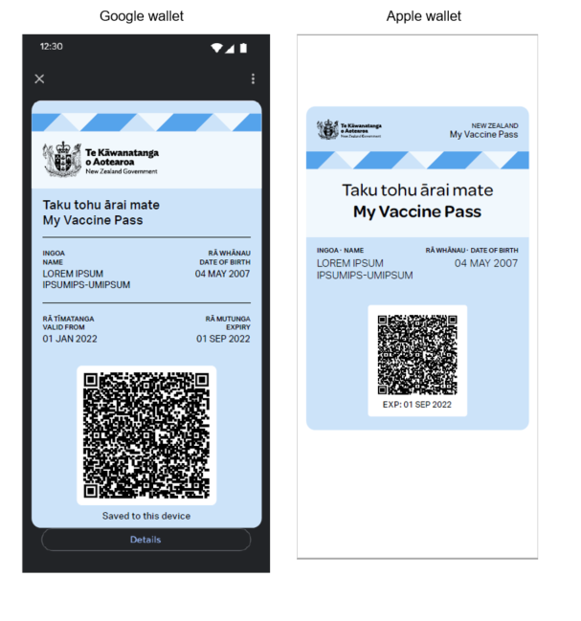

The initial steps for the generation of My Vaccine Pass, and return of the PDF are as outlined in Section Two paragraph 33. The following section of the diagram is specific to the generation of My Vaccine Pass (section extract – full version of diagram below):

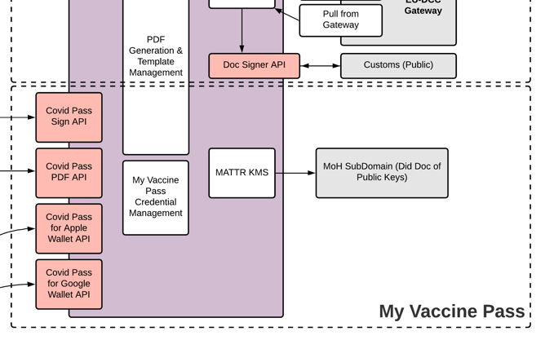

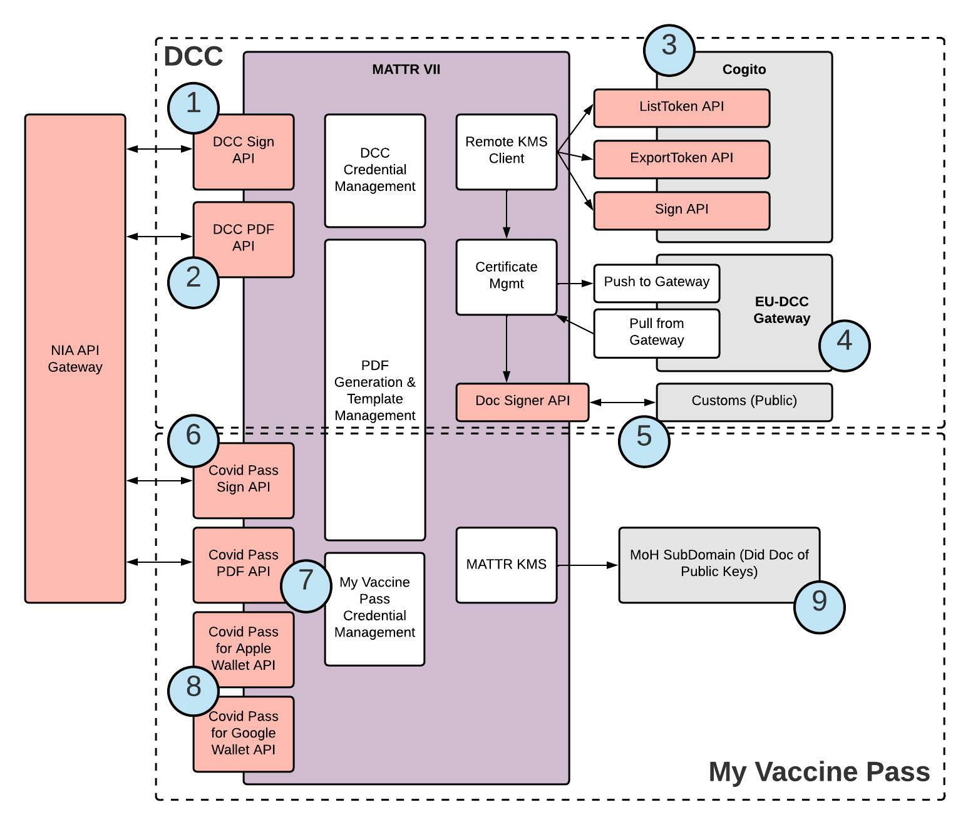

* 1. **At point 6**: MATTR will expose a credential generation (Sign COVID PASS in the above diagram. ‘COVID Pass’ is the My Vaccine Pass) API. NIA will call this API which will return a payload which can then be used to generate a PDF.
  2. **At point 7**: MATTR will expose a PDF Generation API. NIA will call this API which will generate a PDF using a defined MOH Template and the payload returned from the Sign DCC API. This will enable the creation of the PDF certificate returned to the Consumer.
  3. **At point 8:** These endpoints take a signed Covid Pass payload and converts to a form consumable by an Apple Wallet and Google Pay Wallet.
  4. **At point 9:** This is used for public key distribution as part of the My Vaccine Pass Verifier App and QR Code processes to enable third parties to verify a Covid Pass. It enables a check to be made that the certificate comes from a trusted source (This is a JSON Did Document containing the valid public key list). Initially a procedure will ensure this is updated when a new key is added (rotated) and this can be automated in the future if needed.

Listing of the FHIR Immunisation Event Attributes sourced from CIR, NHI and additional attributes, i.e. these are the values being provided to the Certificate Generation Service

|  |  |  |
| --- | --- | --- |
| **Certificate Field** | **FHIR Attribute** | **Comments** |
| Name | patient.name[*].given[0] + patient.name[*].given[1] + patient.name[*].family |  |
| Date of birth | birthDate |  |
| Valid from | occurrenceDateTime | *occurrenceDateTime retrieved from CIR for the last vaccine administered and passed to the Certificate Generation Service* |
| Expiration |  | *o if the Consumer is up to date with vaccination doses, their pass expiry date will be 180 days from date of request; or*  *o if the Consumer under 18 years and 30 days old, and has had their primary vaccination dose, their pass expiry date will be when they reach 18 years and 30 days OR 180 days from date of request – whichever is sooner; or*  *o if the Consumer has been recently infected with COVID-19, their pass expiry date will be 130 days from date of infection; or*  *o if the Consumer has a temporary medical exemption that expires less than or equal to 30 days in the past, their pass expiry date will be the temporary medical exemption expiry date plus 30 days OR 180 days from date of request – whichever is sooner.* |
| QR Code |  | *Business rules as per immunisation status* |

## Appendix Two –Certificate generation for the International DCC

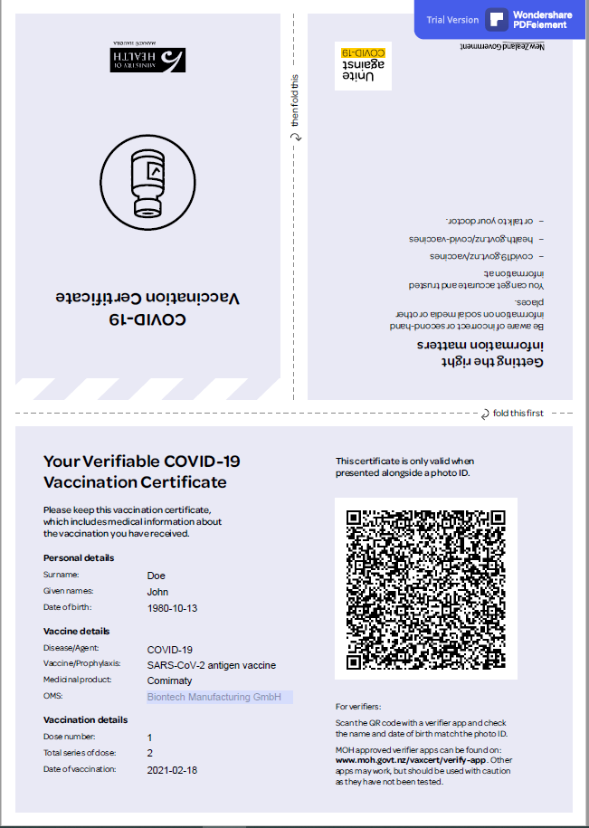

The initial steps for the generation of the International DCC are as outlined in Section Two paragraph 33. The following diagram section relates to the International DCC processes, and points 1 to 5 are described further below (section extract – full version of diagram below):

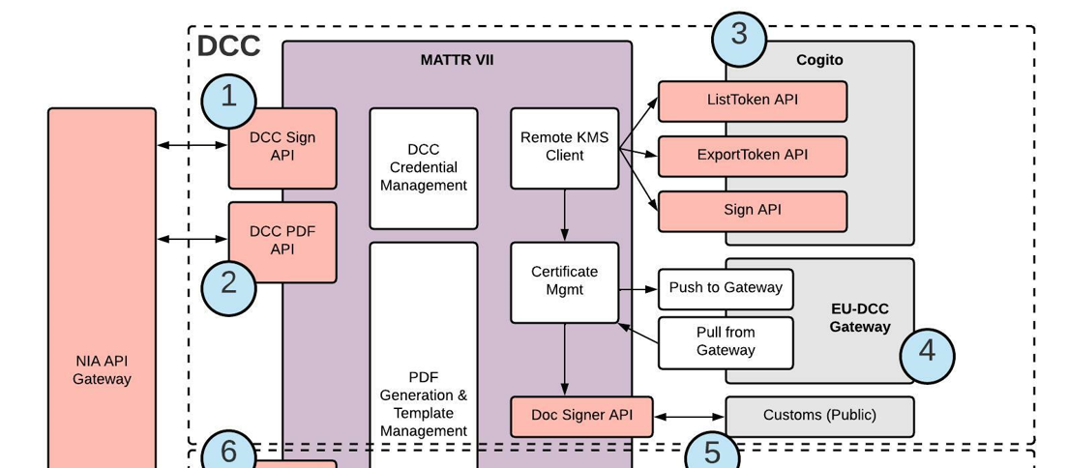



* 1. MATTR will expose a credential generation (Sign DCC) API as a standard MATTR VII product API. NIA will call this API which will return a payload which can then be used to generate a PDF.
  2. MATTR will expose a PDF Generation API as a standard MATTR VII product API. NIA will call this API which will generate a PDF using a defined MOH Template and the payload returned from the Sign DCC API.
  3. Three APIs are used by MATTR as shown in the integration flow between MATTR and Cogito:
  + ListToken (This returns a list of active document signer ID and MATTR selects the most recently created active.)
  + ExportToken (Using the document signer ID, MATTR retrieves the actual document certificate for computation of the thumbprint that is included in the DCC payload)
  + Sign (MATTR computes a Hash of the DCC payload and passes to Cogito for signing with the document signer Id)
  1. **Pushing NZ Document Signers to EU-DCC**

When new Document signers are created (e.g. every 3 months) the new document signer must be pushed to the EU-DCC Gateway where they are made available for download by other participating countries. (e.g. in order that Ireland can verify the authenticity of a NZ issued DCC).

* 1. **Pulling NZ Document Signers from EU-DCC**

MATTR VII will also retrieve the up to date set of document signers hourly from the EU-DCC Gateway and expose these via the Doc Signer Endpoint above (e.g. in order that NZ based organisations such as Customs, can verify the authenticity of a certificate issued in Ireland)

* 1. Exposing a list of Document Signers that were used by MoH to generate DCC so that these can be verified as authentic by Third Parties (this also includes Document Signers that were retrieved from the EU-DCC gateway).

Listing of the FHIR Immunisation Event Attributes sourced from CIR, NHI and additional attributes, i.e. these are the values being provided to the Certificate Generation Service to generate an International DCC:

|  |  |  |
| --- | --- | --- |
| **Certificate Field** | **FHIR Attribute** | **Comments** |
| Surname | patient.name[*].family |  |
| Given names | patient.name[*].given[0] + patient.name[*].given[1] |  |
| Date of birth | birthDate |  |
| Disease/ Agent |  | This is not returned in the FHIR response and will be hard coded |
| Vaccine/ Prophylaxis | vaccineCode.text | Vaccine/ Prophylaxis is mapped from the vaccineCode.text |
| Medicinal product | vaccineCode.text | Medicinal product is mapped from the vaccineCode.text |
| OMS | manufacturer.display | Manufacturer |
| Dose number | protocolApplied[*].doseNumberString | The most recent dose number will be displayed |
| Total series of dose | protocolApplied[*].seriesDosesString | How many doses required to be fully vaccinated |
| Date of vaccination | occurrenceDateTime |  |

## Appendix Three –Certificate generation for a vaccination record

NIA will generate a PDF using a defined MOH Template.



Listing of the FHIR Immunisation Event Attributes sourced from CIR, NHI and additional attributes, i.e. these are the values being provided to the Certificate Generation Service

|  |  |  |
| --- | --- | --- |
| **Certificate Field** | **FHIR Attribute** | **Comments** |
| Given names | patient.name[*].given[0] + patient.name[*].given[1] |  |
| Surname | patient.name[*].family |  |
| Date of birth | birthDate |  |
| NHI number | patient.identifier.value |  |
| Dose number | protocolApplied[*].doseNumberString |  |
| Vaccination type | vaccineCode.coding[*].display | The type of vaccination dose (e.g. vaccination, booster or additional) |
| Vaccine name | vaccineCode.text | Vaccine name is mapped from the vaccineCode.text |
| Manufacturer | manufacturer.display |  |
| Date of vaccination | occurrenceDateTime |  |
| Place administered | country |  |
| Batch number | lotNumber | Will only be displayed if it is recorded in CIR |

## Appendix Four – Certificate generation for a Face Mask Exemption Pass

NIA will generate a PDF using a defined MOH Template.

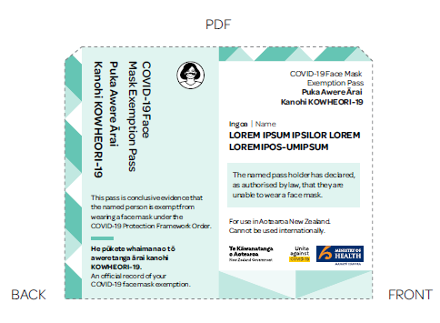

Listing of the FHIR Immunisation Event Attributes sourced from CIR and NHI, i.e. these are the values being provided to the Certificate Generation Service

|  |  |  |
| --- | --- | --- |
| **Certificate Field** | **FHIR Attribute** | **Comments** |
| Given names | patient.name[*].given[0] + patient.name[*].given[1] |  |
| Surname | patient.name[*].family |  |
| Date of birth | birthDate |  |
| NHI number | patient.identifier.value |  |

1. PIAs are currently in progress for RAT reporting of supervised RATs (RAT Catcher) and bulk-uploads of RAT results.
2. Refer to the NIA PIA (referred to as CTIP at the time of creation) for the underlying [NIA Platform](https://www.health.govt.nz/covid-19-novel-coronavirus/covid-19-resources-and-tools/nz-covid-tracer-app/about-nz-covid-tracer-app/integrating-other-contact-tracing-apps-nz-covid-tracer-apis) and the initial APIs to CIR and Eclair
3. C3 and the DI tool connect directly. The NIA platform links to the source systems, CIR and Eclair
4. If the person in the role may be either Vaccinated or have an Exemption
5. Some of these requirements have been recently removed in relation to My Vaccine Pass.
6. With the exception of the RAT Reporter, the original tool for pharmacists to report supervised RAT results directly to Eclair (subsequently expanded to enable GPs to use this capacity). This tool will in most cases be replaced with RAT Catcher.
7. Fast Healthcare Interoperability Resource Standards
8. Simple Mail Transfer Protocol