Te Whatu Ora Health New Zealand
COVID-19 Contact Tracing Form

Privacy Impact Assessment
Version 5
Date 11 October 2022

COVID-19 Contact Tracing Form

Document creation and management
Document Approval
 | Name/Title | Sign-off date
Approved by Senior Responsible Officer
Approved by Te Whatu Ora Privacy Officer | Viv Kerr | 10/102022
Version table
Date | Version number | Changes made | Version author
Disclaimer
This Assessment has been prepared to assist Te Whatu Ora to review the purposes for which information is collected via the Project and how that information can be used, and the privacy safeguards that are required to manage those purposes.
Every effort has been made to ensure that the information contained in this report is reliable and up to date. This Privacy Impact Assessment represents the current expectations of the way the Project will operate.
This Assessment is intended to be a ‘work in progress’ and may be amended from time to time as circumstances change or new information is proposed to be collected and used.
The author of this document is Data & Digital Directorate, Te Whatu Ora.
Assumptions applied
The assumptions that have been applied in the development of this assessment include:
- As this project develops, there will be evidence and information generated through the development and deployment of the application (e.g. Statistics of use and feedback from users) that will impact on how Te Whatu Ora determines what is important for the future purpose of this application. These may result in changes to the terms of use, the information collected, and the risks and mitigations required.
- Discussions will continue between key parties (i.e. Te Whatu Ora, the Office of the Privacy Commissioner and the Government Chief Privacy Officer) and future versions of this assessment will record changes to information that is collected and the consequent risks, further analysis and mitigations.
- A subsequent version of the Privacy Impact Assessment will be made publicly available for the public to understand the collection, storage, use and sharing of personal and third-party information for purposes of transparency.

Contents
Glossary 4
Section One –Summary of Project 6
Recommendation Summary 7
Process to be followed to invite a Case to use the form 7
Information Flows 10
Where and how the information will be stored 11
Security features applying to Project 12
Manual processes involved 12
Analytics 13
Governance 13
Section Two – Privacy Analysis 14
Appendix One – Process screens for the web application 17
Appendix Two: Draft Privacy Statement 25

Glossary
The following are definitions used in this Assessment:
Terms | Description, Relationship and Business Rules
Amazon Web Services | Amazon Web Services, the platform on which the Case Investigation webservice will operate
Case | A person who has had a positive laboratory test for COVID-19 or is suspected of having COVID-19. The case definition of COVID-19 infection can be found here
Care in the Community (CiTC) | The CiTC model is based on enabling people to be cared for in their home, when it is safe to do so, when they or a member of their household are considered to have COVID-19. The model is flexible, nationally supported, regionally coordinated and locally led, in order to meet the needs of local populations and effectively allocate system resources especially in a time of uncertainty when parts of the local health system may be subject to significant resourcing challenges.
Contact | The types of contact can be a Household Contact, Close Contact, a Casual Plus Contact (in some specific circumstances e.g., schools) and Casual Contacts. Full details can be found here.
Contact Tracer | An individual who is authorised to fulfil the role of contact tracer in accordance with section 92ZZA of the Health Act, and includes those assisting in Finders Services from the National Investigation and Tracing Centre operated by Te Whatu Ora. All Contact Tracers are subject to an obligation of confidentiality. If working in a PHU Contact Tracers are commonly referred to as case investigators.
Contact Tracing | The process used to find people who may have been exposed to an infectious disease, which is aligned with the provisions of the Health Act 1956 Part 3A, subpart 5. If a person is identified as a Contact of someone with COVID-19, depending on the Phase of the COVID-19 response, they may be notified of their Contact status and advised to self-isolate (or advised of other applicable public health requirements applicable at that time).
Consumer | The COVID-19 Contact Tracing Form is designed for the individuals who test positive for COVID-19, who are called a Case.
COVID-19 | The novel coronavirus, see: https://www.health.govt.nz/our-work/diseases-and-conditions/covid-19-novel-coronavirus
COVID Clinical Care Module (CCCM) | This is the clinical record system being operated nationally to support CiTC
Household Contact | Those individuals who live in a household setting with a Case or has spent at least one night or day in that residence when the Case was infectious.
TWO | Te Whatu Ora
NCTS | The National Contact Tracing Solution, being the IT solution used by Health to securely record and support Contact Tracing activities.
Phases | This refers to the Phases for response to Omicron in the community
Privacy Notice Materials | Material to be prepared to inform consumers in compliance with rule 3 of the Health Information Privacy Code 2020.
Project | COVID-19 Contact Tracing Form

Section One –Summary of Project
- The COVID-19 pandemic is forcing governments around the world to evaluate how to manage and control this infectious disease. New Zealand is currently pursuing a Minimisation and Protection strategy for Aotearoa New Zealand. This continues to involve Contact Tracing as a key public health measure to minimise the spread of COVID-19 and to support individuals that become a Case.
- It is anticipated that there may be a significant increase in the number of COVID-19 cases with the Framework enabling greater movement within New Zealand and the border settings changes in 2022. To sustain an effective public health response, it is important that Contact Tracing capability remain able to manage the number of cases with finite resources.
- Te Whatu Ora has developed an electronic form that a positive Case can choose to complete via web application. This was initially to enable the Case to provide some relevant details to Contact Tracers via the web application soon after they are advised of their positive test. It has now been expanded to enable the capture of relevant information about Cases that may signal a need for more closely supervised clinical care, and can be passed to the national clinical management system for CiTC or Care in the Community. The clinical system is called the COVID Clinical Care Module (CCCM).
  - The benefits of the web application to the Case are that they can choose the time they spend on getting the details together, and can come back to the webform over time if they need a break.
  - The benefits to the Contact Tracers will be to speed up access to Case details, and reduce the initial phone time in collection of details, with more time interacting directly with the Case once details have been reviewed and identified as requiring further clarification (which may also reduce interview time). Contact Tracers have been involved in the design of the form and the relevant information to be collected.
  - The benefits for the CiTC programme are that CCCM will receive relevant details identifying when a Case may need follow up, and to be placed under active management by the local CCCM regional hub. Currently it is assumed that most individuals will be able to self-manage their COVID-19 symptoms within their own residential setting. It is important that those who are more likely to suffer adverse health outcomes are under direct clinical management, so the web application will enable Cases to report if they have any relevant conditions and this can be sent to CCCM for follow up.
- This web application is called the COVID-19 Contact Tracing Form. This is the fifth update to the PIA.
- The Office of the Privacy Commissioner and the Government Chief Privacy Officer have been consulted and provided comments on a draft Privacy Impact Assessment. The comments have been considered by Te Whatu Ora and incorporated as appropriate.
- This Privacy Impact Assessment is expected to be a ‘living’ document that will be reviewed as the Project progresses. Te Whatu Ora plans a phased release of functionality in the Project, so features available in subsequent releases may require privacy review.

Recommendation Summary
- The following are areas that Te Whatu Ora will concentrate on as it develops the Project:
 | Action – COVID-19 Contact Tracing Form | Planned Date for completion
PIA- 01 | Clear and defined Privacy Materials are to be available directly from within the web application, and must be confirmed prior to the person proceeding to supply information to the web application.  These have been updated for the services expanded in this fifth update to the PIA. | Completed
PIA-02 | Te Whatu Ora will follow its standard security review processes including Certification and Authorisation, security risk assessment, and independent security testing. If any risks are identified they will be resolved or mitigated to ensure appropriate security will be applied to all aspects of the Project. This project will receive an Approval to Operate before go live.  No production data is to be used before appropriate testing has been completed. | Completed
PIA-03 | It is recommended that the Te Whatu Ora Privacy Officer review the Regional Hub purposes for use of the information being collected by the Form about underlying health conditions and disability status information. This is to ensure that this information collected is to be used in the Regional Hub processes, including determining the requirement for active management within CCCM (or existing community based medical services). | Completed

Process to be followed to invite a Case to use the form
- When there was a relatively low incidence of COVID-19, Cases were generally notified that they had tested positive by being called by a Contact Tracer.
- Now the levels of positive COVID-19 Cases are significantly increased, Cases will be notified by SMS message if they have a verified mobile phone number (or another mobile phone number is held within other Te Whatu Ora data holdings). There will also be some Cases directly contacted by Contact Tracers depending on the process settings at that point in the Omicron response.
- A mobile phone number may be verified as accurate during the testing process, or when a Contact Tracer first contacts a Case to tell them they have tested positive for COVID-19, the Contact Tracer can confirm the mobile phone number they have for the Case by talking with them.
- During the current Phase Three of the response automatic SMS notification of Cases will be enabled in NCTS, and the Case will be sent a text link directly to their mobile number, to complete the form.
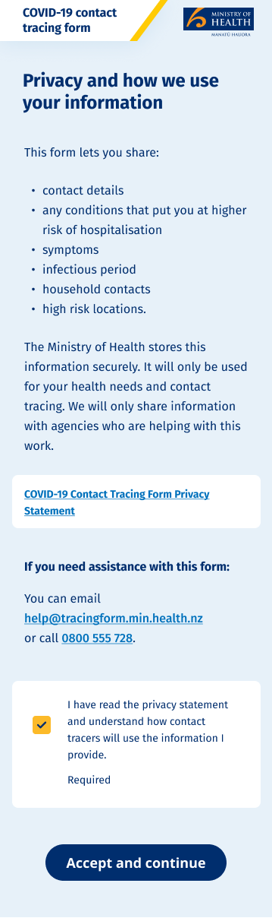
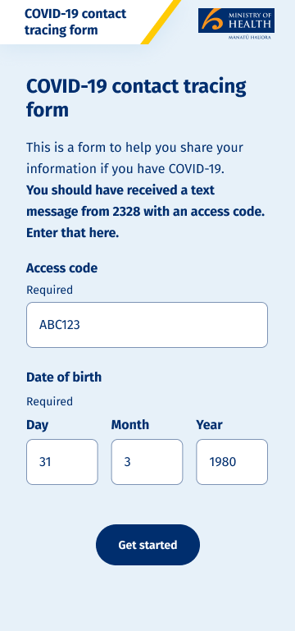
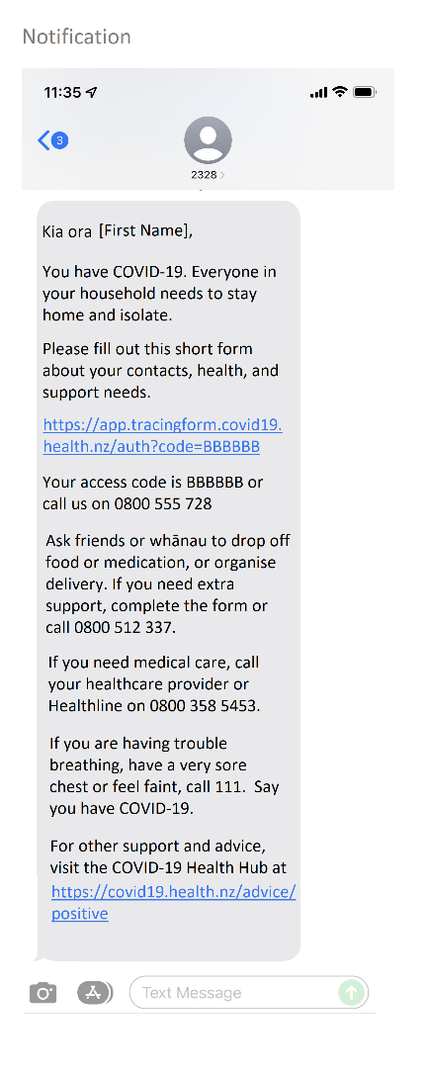
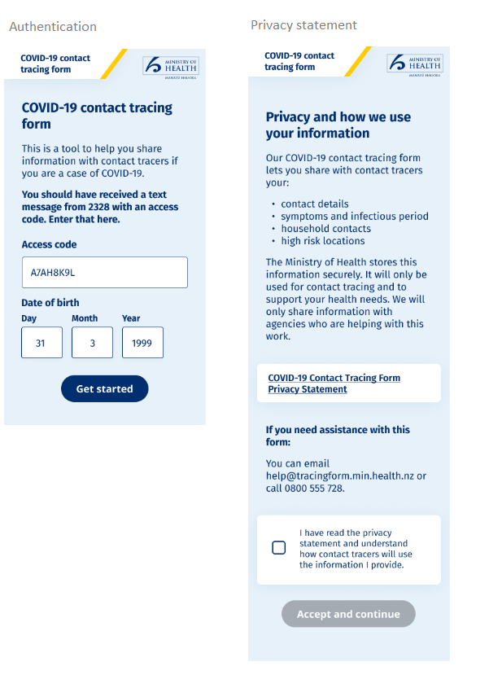

- The link to the web application is included in the initial message to the Case. This text message will contain a unique access code that will ultimately link to the Case record in the NCTS. The text will contain only the first name of the person (as recorded against the NHI for that test result).
- On following the link, the Case is prompted to call emergency services if they are experiencing ‘red flag’ symptoms (which will be described) or continue to complete the form if they are not. The response to the ‘red flag’ warning is not recorded.
- The person must enter the correct date of birth for the Case into the web application in order to proceed. If the Case chooses to proceed, the code will automatically populate into the Form, and the Case must enter their correct date of birth. The Privacy Statement available on the screen above appears as Appendix Two.
- If the Case proceeds past these initial screens, there are a series of questions that may take approximately 5 to 10 minutes for the Case to complete. The information will cover the following main areas, each of which have detailed explanations about how the information will be used within the form itself. The collection areas include:
  - Contact details for the Case;
  - Underlying conditions that may mark the Case as higher risk of negative health outcomes. This will be shared within the NCTS and CCCM systems to help inform the clinical care status (to identify those most likely to need additional health assistance). The assumption that a Case will be able to self-manage can be reversed if an underlying health condition signalling an adverse outcome from COVID-19 infection could result, and that person identified as under ‘active management’ in CCCM so contact will be made with the person to assist them in their health journey;
  - Self-identified disability information. This will be shared with the NCTS and CCCM systems to help inform the identification of those most likely needing additional health assistance so they can be given an initial contact call and then monitored as required;
  - The symptoms the Case may be experiencing and the onset date. More serious symptoms will be shared with NCTS and CCCM systems so cases can be prioritised, and contact can be made with the person to assist them in their health journey;
  - Household and other close contacts who have lived with the Case during the infectious period (to enable appropriate contact or text communications to be made with those individuals to provide the necessary information to them about how to manage their situation for household contacts, and to confirm household ‘bubble’ links so that it is clear how many may be in the household when managing the Case);
  - Suitability of accommodation to safely isolate. This will be shared within the NCTS systems to identify, prioritise, and allocate cases to alternative isolation options if required;
  - High risk occupation or living situations that may indicate the Case is in contact with vulnerable populations – some residential housing, aged residential care homes, place of worship, Marae, Tangihanga, and prison (to enable Contact Tracers to swiftly identify which Cases may require priority follow up due to the risk posed to others);
  - Bluetooth tracing – which can be uploaded in accordance with the directions given within the webform processes.
  - Some of the information originally collected has been removed, or minimised – particularly in relation to the timeline and contacts section which previously captured every location visited and Close Contacts. These are no longer required.
- Refer to Appendix One for full screen shots of each of the key collections.
- There is an option for a Case to begin the form, and then come back later to complete it. The information will be retained in an encrypted database within the AWS environment for up to 72 hours, until the Case decides to select the Submit button (after being given the opportunity to review the information they have added).
- After completing the form, the Case is given the option of indicating that they have welfare needs, and they are presented with instructions for accessing welfare assistance if needed.

Information Flows
- The proposed information flows for the NCTS Project elements are set out below
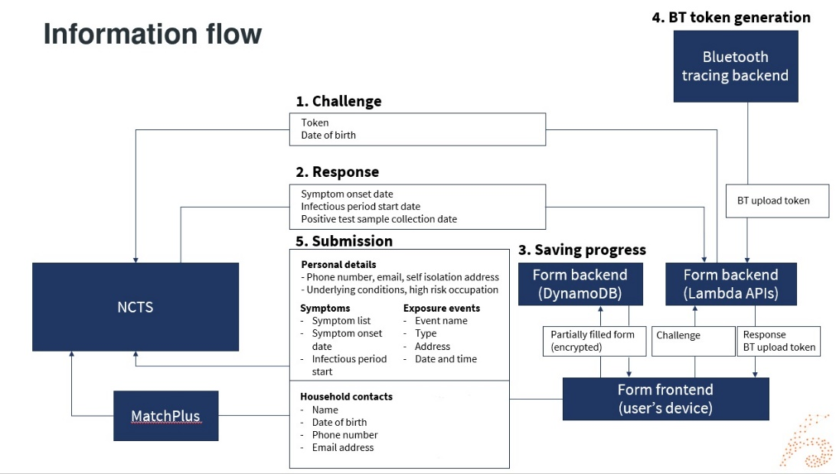
- The interactions with the CCCM processes are summarised below.
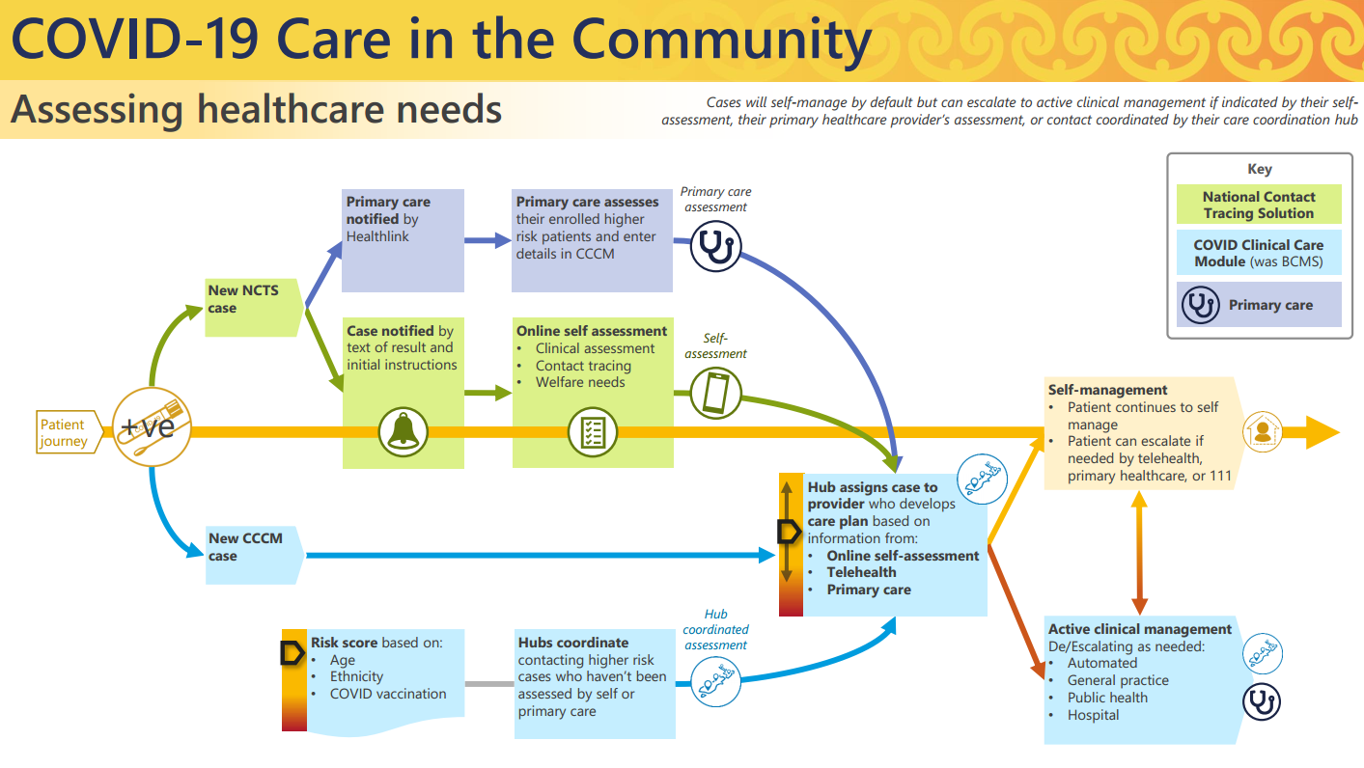
- Once the initial Form is opened by the Case, the response the Case enters to the code and date of birth ‘challenge’ are sent to the NCTS. The Case is then provided with the Privacy Screen and can click to continue with the Form if they wish.
- The Case will then complete the fields in each of the categories noted above in the ‘Submission’ box: Personal Details, Symptoms, Household Contacts, Exposure Events. If the Case chooses to do so they can upload their Bluetooth keys. These uploads follow the standard NCTS processes and the code to generate the upload is included in the Form contents. The relevant screens are contained in Appendix One.

Where and how the information will be stored
- During the time it takes the Case to complete the Form, the information is stored in a Dynamo Database. This Database is held in a secure Te Whatu Ora Amazon Web Service (AWS) environment hosted in Sydney, Australia.
- The information is only uploaded to the NCTS Case Record when the Case chooses to submit the information at the end of the Form. The NCTS environment is operated on a Salesforce Service Cloud instance based on AWS cloud infrastructure based in Sydney, Australia. The information will also be replicated into the CCCM database (which is part hosted in New Zealand and is further described in the CCCM PIA).
- Information provided about Household Contacts is sent to the Match+7 service to attempt to find a verified NHI Number.

Security features applying to Project
- Upon user verification of the Case’s one-time password (OTP) and date of birth, the user will have a base64 encoded cookie set composed of an opaque session ID, encryption key and their OTP.
- This cookie is set as secure, HTTPS only, and expires at the same time the Case’s OTP expires.
- The initial entry of information into the Form is recorded directly on a DynamoDB (database). The information is retained on the DynamoDB in an encrypted format – with the encryption key linked to the device of the user. Until the Case decides to ‘submit’ the information when they have completed the Form the information will not leave the DynamoDB. The information will persist temporarily so that the Case can refresh or reload the page and still return to the information completed to that point. Information is deleted from the DynamoDB on a rolling 72 hours schedule (so the details will persist for 72 hours from the date the invitation is sent by the Contact Tracer).
- Access to information in NCTS will be managed by existing security controls such as encryption of data in transit and at rest. There is multifactor authentication for all users of NCTS and role-based access controls and audit logging of all access.
- The web application is currently undergoing security testing, including penetration testing on the APIs and Threat Modelling. An Authority to Operate will be completed prior to approval to go live with this web application.

Manual processes involved
- In Phase One of the response the Contact Tracer could make the decision to send the invitation to complete the Self-service form after a discussion with the Case.
- In Phase Three the invitation to complete the Self-service form is sent automatically as part of the text message confirming the positive COVID-19 result.
- If Cases do not complete the Self-service form within 24 hours of being sent the invitation some Cases will be followed up by phone call from a Contact Tracer if they are within identified categories where self-management may be considered a greater risk. These categories may change from time to time and will be determined by clinical and contact tracing advisors.
- Information added by the Case through the Self-service form is added to NCTS, and a copy sent to CCCM of relevant contact and clinical details.
  - Information returned is then identified if there are high risk locations (where vulnerable people may have been exposed), or priority population groups (currently based on ethnicity). This can be followed by Contact Tracers if appropriate.
  - Clinical and disability information will be reviewed in CCCM by regional hubs to make contact as appropriate.

Analytics
- Statistical information collected about the use of the platform will be accessible to relevant Te Whatu Ora staff and its suppliers, in order to make decisions about the features and functionality of the COVID-19 Contact Tracing Form. Statistical information is not linked to personal information, and Te Whatu Ora is not able to use statistical information to identify individuals.
- The Form uses Google Analytics to record anonymous statistics about visitors. This collection is limited to public-facing pages and is used to inform decisions about page structures, call-to-action conversations, and usage platforms. Statistics are collected when a user navigated to an included page, and the information collected may include:
- Information about the browser and device used to access the page, including device type and manufacturer, operating system name and version, browser vendor and version, and other device settings such as system language, screen resolution, and display size.
- Information about the page visited, including the page URL and referrer
- The IP address will be used to determine the Consumer’s approximate location. This can indicate the country or region you are located in, depending on where your ISP originated.
- HTTP cookies are used to “remember” what a user has done on previous pages / interactions with the website. Google Analytics supports three JavaScript libraries (tags) for measuring website usage: gtag.js, analytics.js, and ga.js.
- Data collected for the COVID-19 Contact Tracing Form by Google Analytics are captured as “events”, which are triggered when specific actions happen on the website. These events are used to provide reporting into the effectiveness and performance of Form. These events do not contain personal information.
More information about how the tracking code works is available on the Google Analytics documentation website.

Governance
The Project governance is aligned to existing NCTS governance arrangements.

Section Two – Privacy Analysis
- The purpose of this Assessment is to review the process of collection, storage, use and sharing of personal and contact information for the purposes of the Project verification against the 13 Rules in the Health Information Privacy Code (HIPC) 2020.
- During the Omicron outbreak there is potential for Cases to rapidly increase, and digital options and technology support have been identified as key in managing the expected demand on Contact Tracing and clinical response resources.
- The COVID-19 Contact Tracing Form was a useful support for Contact Tracers, in Phase One of the Omicron response and Contact Tracer input was involved in the design. The general information collected is aligned to what a Contact Tracer would seek during their phone conversation with the Case, and provides a digital option for those who wish to use it provides further choice for Consumers. It is now also useful to the CiTC management of cases and relevant contact and clinical information is provided to CCCM for Regional Hub management of those cases who require active management.
- Te Whatu Ora has conducted its analysis under the Health Information Privacy Code as the information is about Consumers and their health services. Under clause 4(1)(e) it is considered that this is information about an ‘individual which is collected before or in the course of, and incidental to, the provision of any health service or disability service to that individual’.
Health Information Privacy Code Rules |  | Background and Key Controls | Residual risk
Rule 1 | Purpose of collection of health information  - Only collect health information if you really need it | Purpose  Collection of information for Contact Tracing and CCCM clinical purposes is part of the lawful activities associated with assisting the public health response to the COVID-19 pandemic.  Necessary  The information fields have been identified as necessary to inform the contact tracing processes, and the clinical escalation processes in CCCM. No information is to be collected that is inconsistent with existing and established Contact Tracing processes.  CiTC will be able to use the information about underlying health conditions, and it is recommended that a national process be developed to guide Regional Hubs how to manage this information, to ensure that each understand the purpose of this collection and how it may be used to support decisions on who can safely self-manage their COVID-19 related health issues and who may need to be moved to active management.  New information is to be collected about an individual’s disability status (to support that person’s Covid care needs), so clear processes will need to be established to show the purpose for which this is collected and how it will be used to provide support to those individuals.  It is recommended that the Te Whatu Ora Privacy Officer review the Regional Hub advice, and purposes, regarding underlying health conditions and disability status signalled within the Form. | Low
Rule 2 | Source of information  - Get it straight from the people concerned | In Phase One the Contact Tracer spoke directly to the Case, obtained their confirmation that they wished to be sent the link to the COVID-19 Contact Tracing Form, and the Case would then directly enter the information if they chose to. In Phase Three of the response, positive Case notification mainly occurs by text, and invitation to complete the Form is automatically sent if a mobile phone number is held. Each person chooses to complete the Form themselves and the request is sent to them to do so. It is not compulsory, although they will be sent reminder texts if it is not completed within 12, 24, and 48 hours.  There may be submission of details about household contacts (which will be the disclosure of identifiable information about another person). This is consistent with existing Contact Tracer processes. There are authorising powers under the Health Act to request this information from a Case, but there is also a serious threat in relation to those who may have been exposed to COVID-19 (rule 2(2)(c)(iii)) | Low
Rule 3 | Collection of information from individual  - Tell them what you’re going to do with it | The current Privacy Statement reflects the Rule 3 requirements. The full Privacy Statement (as set out in an updated draft in Appendix Two) is linked from one of the initial screens (see Appendix One). The Privacy Advice is provided prior to the Case submitting any personal information into the Form. | Low
Rule 4 | Manner of collection of information  - Be considerate when you’re getting it | Case can opt to use the web application in Phase Three of the Omicron response. Other links to support (such as welfare and urgent medical assistance) are provided in the initial text message if the person wishes to seek that support directly and in an immediate fashion. The number of Healthline is also included in the text.  If they person does not complete the Form they may be followed up by a Contact Tracer or Regional Hub representative to ensure that they are receiving the services they need if they are identified as group that needs additional assistance. This will depend on whether the individual is identified as a higher priority for contact via the then current focus of Contact Tracers. | Low
Rule 5 | Storage and security of information  - Take care of it once you’ve got it | The standard security Te Whatu Ora security review processes were completed to Authority to Operate level prior to go live. The NCTS components of the process are already established and security tested. If any risks are identified they will be mitigated or eliminated prior to go live. | Medium
Rule 6 | Access to personal information  - People can see their health information if they want to | The Privacy Statement will advise individuals how to make a request for access to their own information. | Low
Rule 7 | Correction of information  - They can correct it if it’s wrong | The Privacy Statement will advise individuals how to make a request to correct their own information. | Low
Rule 8 | Accuracy etc. of information to be checked before use  - Make sure health information is correct before you use it | There is a date of birth test to be completed after entry of the access code to make sure the text has been received by the correct Case (as they are identified only by first name in the initiating text). This should ensure only the correct person will complete application details.  The person has an opportunity to review all the information they have recorded before submission in a review screen at the end of the document. They are also given the opportunity to return and submit more information in a further form using the same link if they wish.  As each submission will create a new record there is a possibility of duplication (but no records will be overwritten so all information will be captured). Contact Tracers will be given training on how to de-duplicate, transfer and link records prior to go live. If there is duplication of Household Contacts contact tracers can rectify this by closing duplicate records. | Low
Rule 9 | Retention of information  - Get rid of it when you’re done with it | Standard retention policies will apply to information collected into NCTS, and into CCCM (noting that clinical information will be held in accordance with the Health (Retention of Health Information) Regulations).  The information captured by the application and held in the ‘Form’ (the encrypted DynamoDB) while the Case is completing the details and before they choose to select ‘submit’ will be retained for 72 hours days before automatic deletion.  Once submitted no information is retained in the interim encrypted database and will no longer show on the device screen for the Case. | Low
Rule 10 | Limits on use of information  - Use it for the purpose you got it | The Privacy Statement describes potential users of the information, and the purposes for use. All of those who will have access to the data for Contact Tracing related purposes will have role-based access into NCTS. Likewise, any access into CCCM will require role-based access into CCCM. This access will all be subject to audit monitoring of logged access activity. | Low
Rule 11 | Limits on disclosure of information  - Only disclose it if you have good reason | Existing NCTS rules will apply to the use of Contact Tracing information that is submitted to the NCTS.  Information that is supplied to CCCM will be subject to controls as set out in the CCCM PIA, and relates to those involved in clinical management of COVID-19 Cases.  The contact information submitted about Household contacts, if a mobile number is provided, will also be part of the new process for NCTS to send an automatic text message notification to those individuals identified as Household contacts (addressed in a sperate PIA). This is to meet the serious threat posed to them by potential exposure to Omicron. | Low
Rule 12 | Disclosure of personal information outside New Zealand | There is no expectation of any disclosure of information from the form outside New Zealand. | Low
Rule 13 | Unique identifiers  - Only assign unique identifiers where permitted | A unique code will be generated and a link to the NCTS file on the case will be incorporated into the data submitted to the NCTS so it can be linked to the originating Case file.  A Border Health Record will also be assigned to the Cases where a record is created in CCCM. NHI will also be used within CCCM consistent with its intended purposes for clinical management of identified Cases, and in some cases their household contacts (as probable Cases).  This is consistent with Rule 13. | Low

Appendix One – Process screens for the web application
Current as at the date of PIA publication – this may change over time
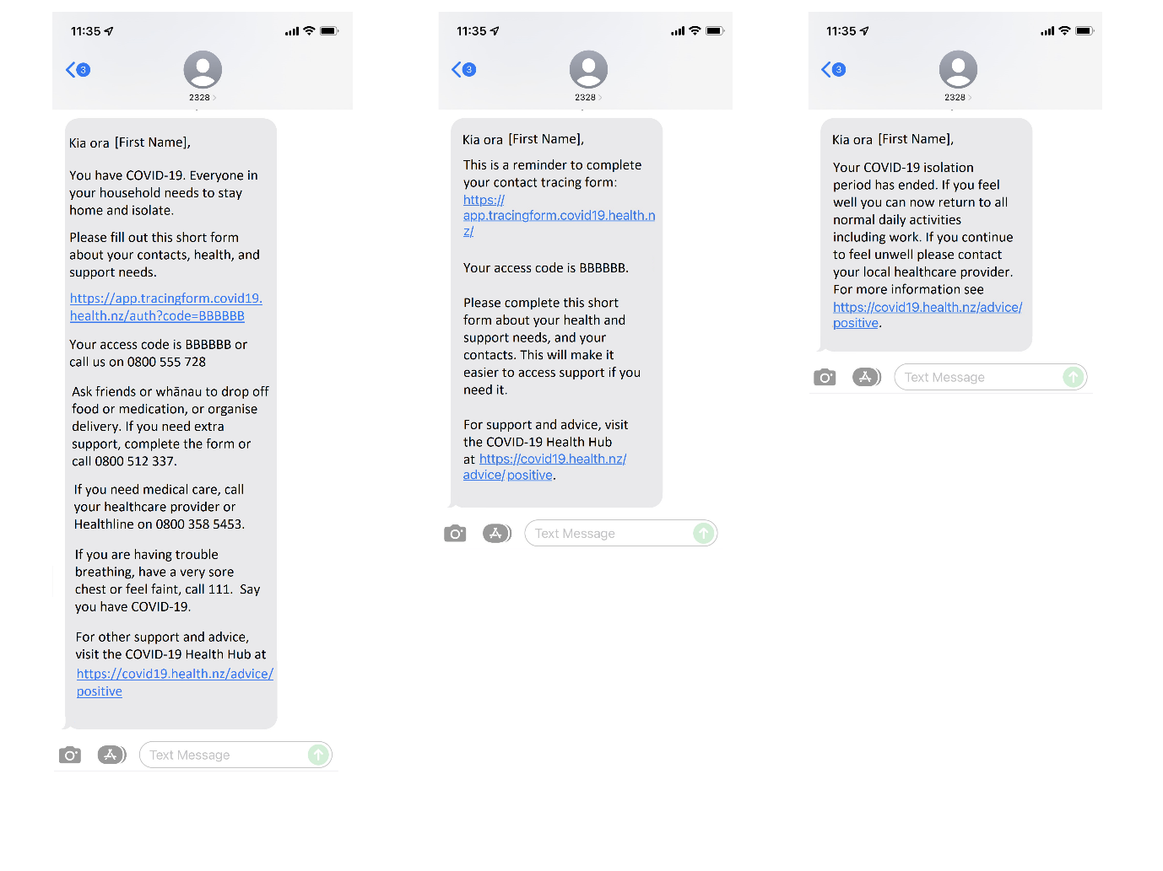
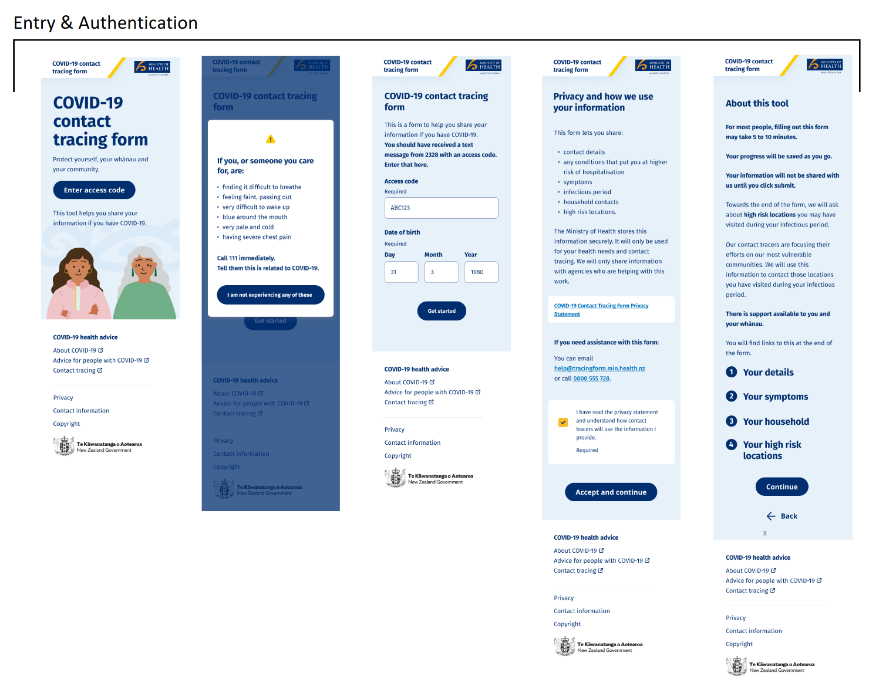
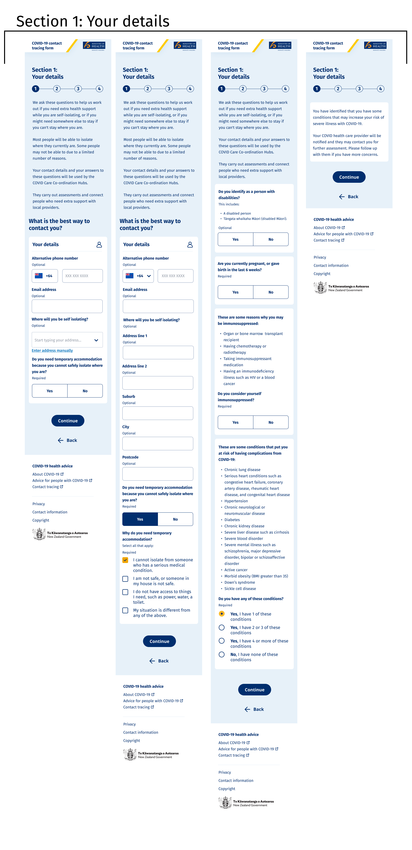
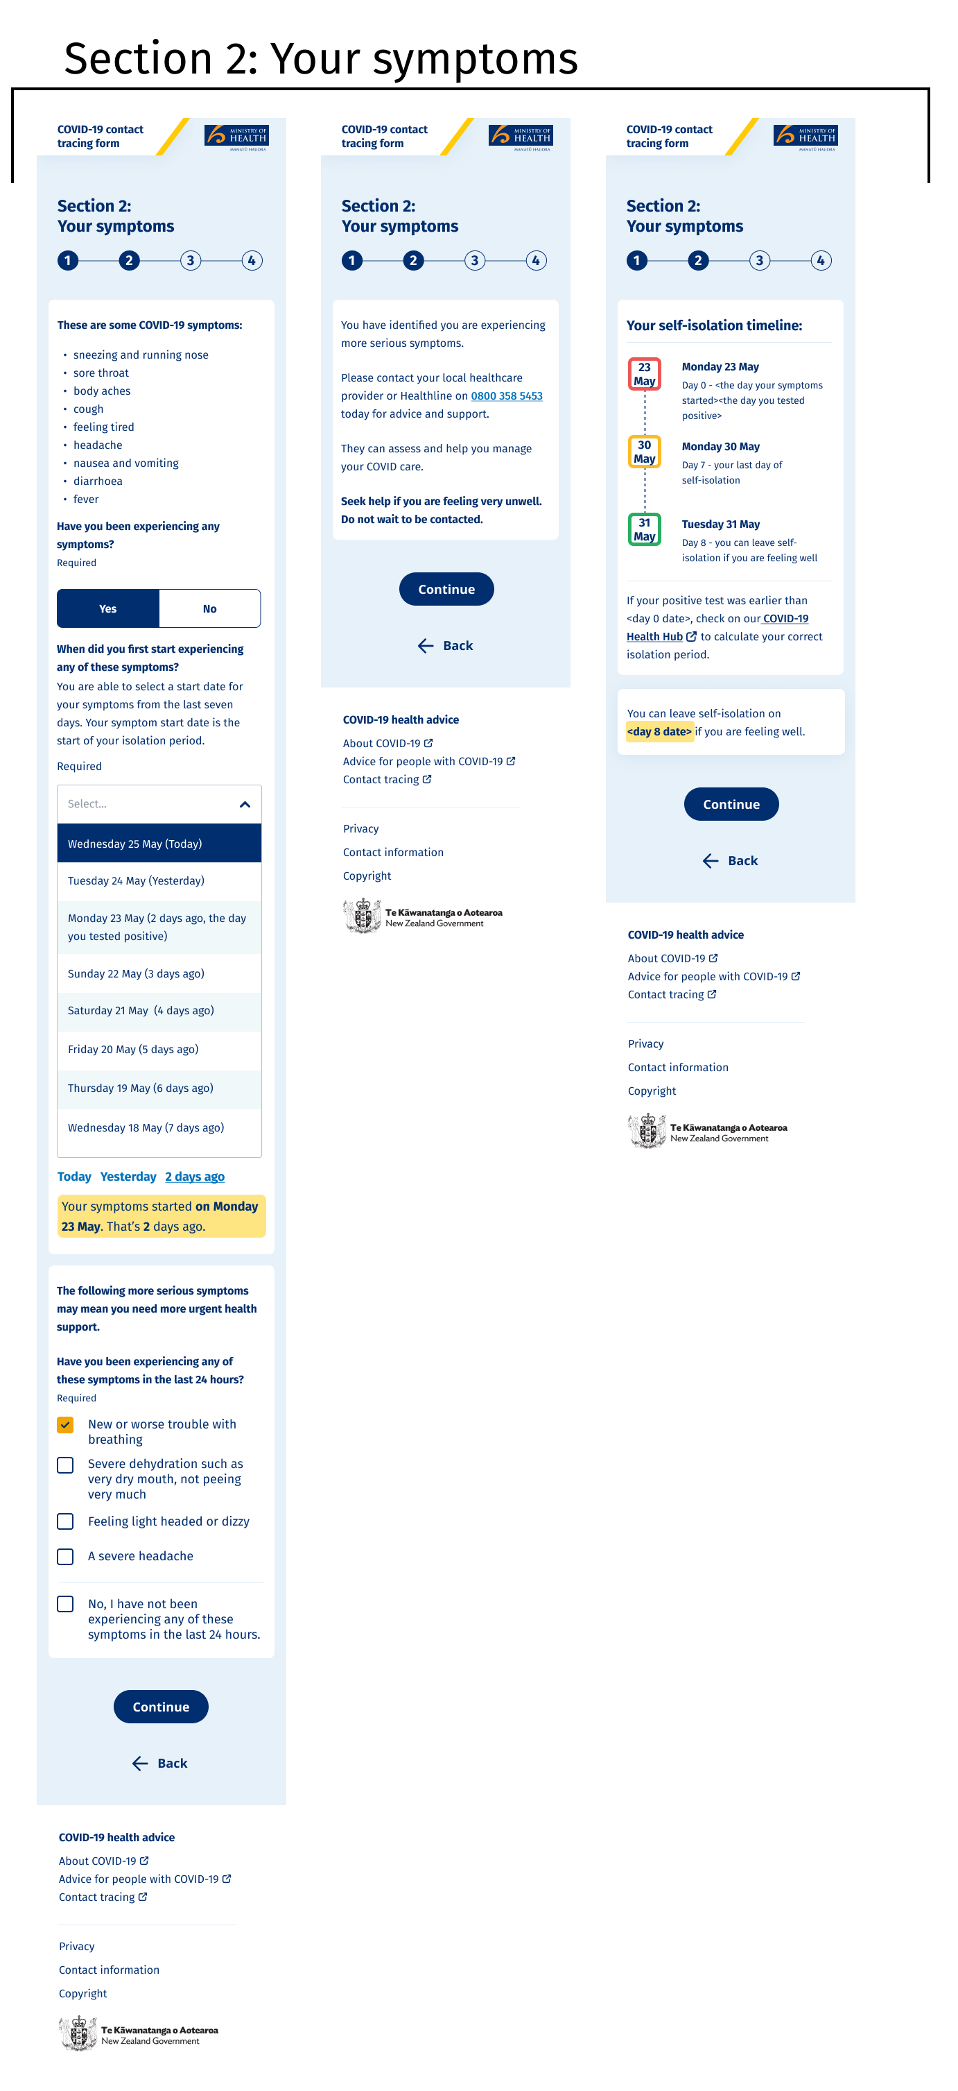
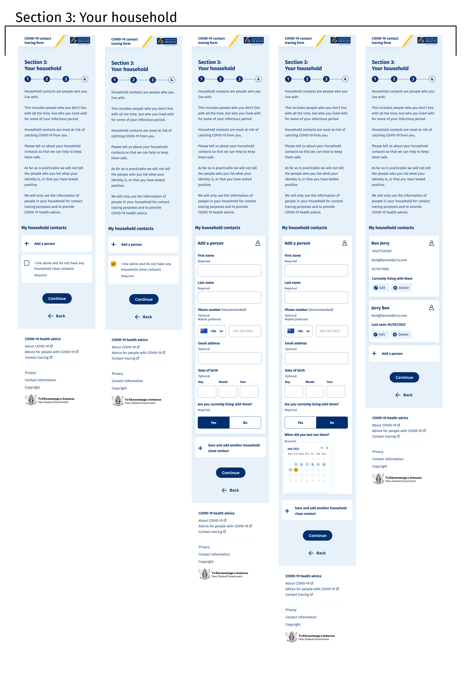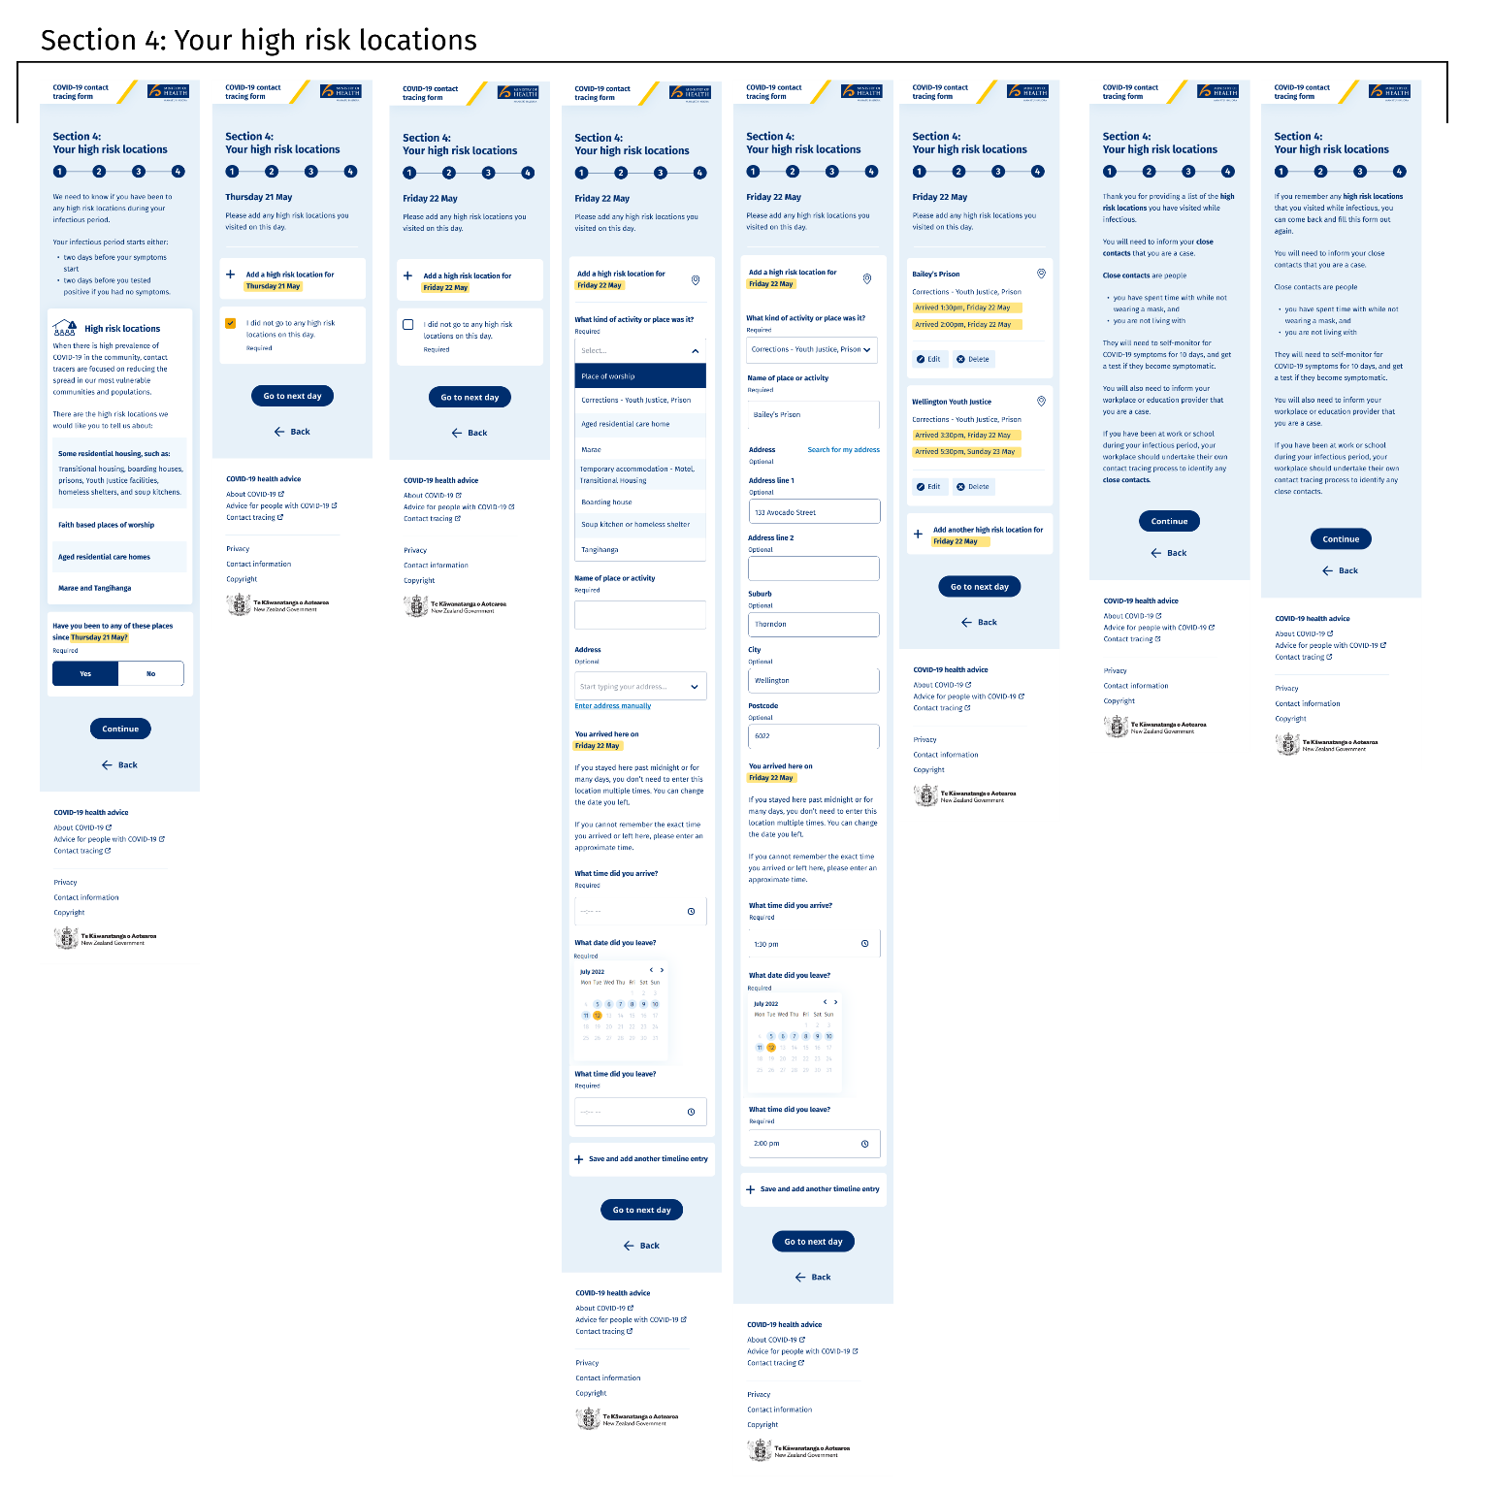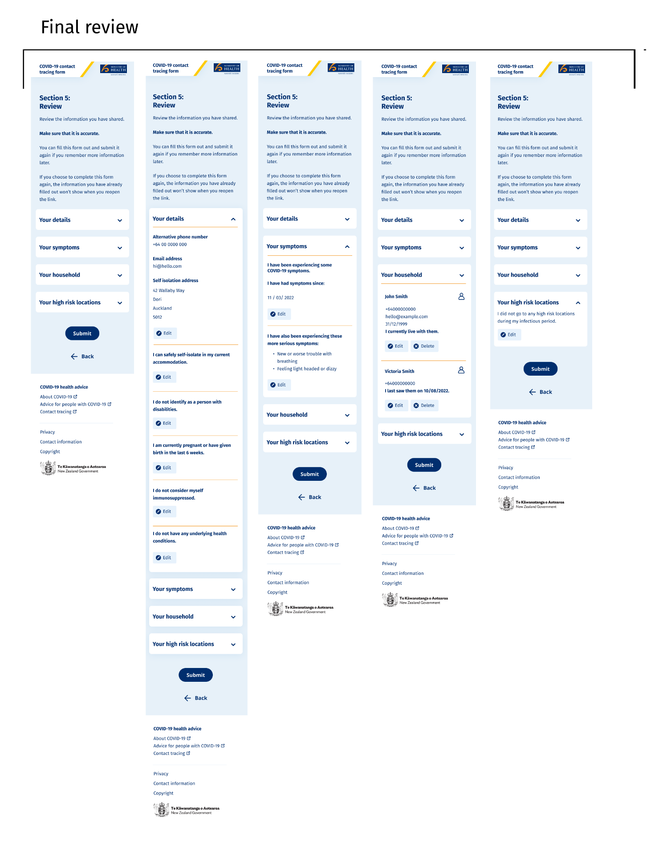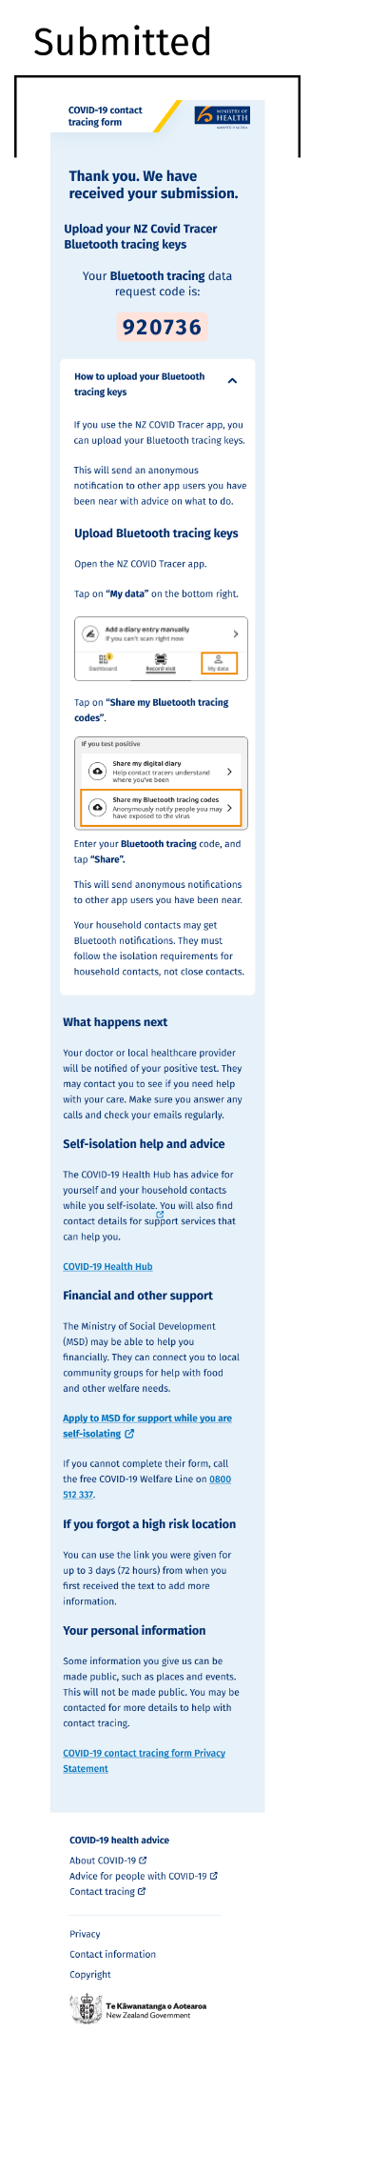

Appendix Two: Draft Privacy Statement
Privacy Statement to be published on Ministry website and linked from the webform
Te Whatu Ora has developed the COVID-19 Contact Tracing Form to support anyone who has tested positive for COVID-19 to self-report information online to contact tracers and to agencies working with the Care in the Community services.
You can only upload information if you have been sent an access code with your text notifying you that you are a positive Case. This access code will be provided by SMS (text) to the mobile number you provided when your test was reported, or from other mobile phone numbers that Te Whatu Ora holds about you (for example if you supplied a mobile phone number when you used Book My Vaccine or recorded a mobile phone number when you enrolled with your general practitioner).
The information collected via the COVID-19 Contact Tracing Form will be used for contact tracing and Care in the Community related purposes for the COVID-19 pandemic response. This includes helping you with your health, welfare and self-isolation needs. It may also help us to identify other people who may have been exposed to COVID-19 to make them aware they may be infected and to limit further spread of COVID-19. We will share information we collect only with agencies who are helping with these COVID-19 related tasks.
Use of the COVID-19 Contact Tracing Form is voluntary, although we recommend you do complete it as some of the information you supply will help us to identify if you have specific health, welfare or self-isolation needs. Each positive case who does not use the COVID-19 Contact Tracing Form may still need to inform a contact tracer about the same information in accordance with Health Act requirements if they are called.
What information we’ll ask for
We will require information to help us identify the following:
- How best to contact you, and where you will be self-isolating, so that we can make sure you can access the right help
- What your symptoms are, and when you began experiencing them, so we can work out your infectious period, and also so we can assist if you require healthcare or other support
- If you want to advise you are a disabled person, tāngata whaikaha, or a person living with a disability, so we can help you with your specific needs
- Any underlying health conditions, or serious symptoms, so that we can prioritise support for people more likely to get sick and the Care in the Community team can identify who may need to be contacted swiftly to provide clinical support
- When you might have been in contact with other people at high risk locations and who those people were. You can choose to upload your Covid Tracer Digital Diary Bluetooth records to assist with this. We will contact them to let them know they may have been exposed to COVID-19
- Who is in your household, to identify who else may require assistance with managing the risk of infection or related care needs.
- We will also send you a ‘release’ reminder text to confirm you have reached the end of your 7-day period of isolation as a Case, based on the information we hold about you.
Each screen will clearly outline the details we require you to complete. Your access code will last for three days, so you can re-enter information multiple times during that three-day period if you wish.
If you are completing the form on behalf of someone else, you’ll need them to confirm with you that you have their consent to do so (or otherwise be properly authorised to obtain or disclose that other person’s information, for example caregiver for a child).
Contact Tracers and those agencies working as part of the Care in the Community response will assess the information you provide to the COVID-19 Contact Tracing Form and will respond to you by call or email if they consider it necessary. They may check with you the details you have provided, and provide additional direction or advice to you.
We will use the information you submit for purposes directly related to COVID-19 and its management (including analysis, reporting and planning nationally and regionally). The information collected may also be used for statistical analysis and help to identify ways in which we can improve our services. Any information used in this way will not identify you personally.

Keeping your information safe
Your personal information will be held and managed by Te Whatu Ora in accordance with the Privacy Act 2020 and Health Information Privacy Code 2020. Section 92ZZG of the Health Act 1956 provides that information provided or obtained by a contact tracer under the Health Act may not be used or disclosed by anyone except for the effective management of infectious diseases. Care in the Community is part of that effective management response. The purposes for the COVID-19 Contact Tracing Form include identifying your potential contacts to help keep them and the community safe, and your health and welfare needs and the needs of your household. All of these purposes are consistent with the effective management of infectious disease, to help support you and minimise the spread of COVID-19.
We recommend you password protect your device. Once you have started the COVID-19 Contact Tracing Form, your answers will be encrypted and stored within our secure systems. The encryption means that unless someone else has access to your unlocked device, nobody can read your answers until you finish the form and choose to submit it. If you do not submit the form the information will be automatically deleted when your access code expires.
When you submit the form, we will collect the information via a secure Amazon Web Service (AWS). Any information you submit will be stored in the National Contact Tracing Solution (NCTS). The NCTS is a secure Salesforce platform based on Amazon Web Services (AWS) located in Sydney, Australia. The parts of the information relevant to your healthcare will also be recorded in the COVID Clinical Care Module (CCCM), the clinical system supporting management of Care in the Community.
Information you choose to share with us will be held securely in compliance with Te Whatu Ora standards. Security measures are in place to protect your information from unauthorised access. All access to your information by authorised users is tracked and monitored.
How long will your information be kept for?
Information will be held on the NCTS and on CCCM. Information about the health records of positive cases will be retained as required by the Health (Retention of Health Information) Regulations, and other information will be stored for the duration of the COVID-19 pandemic response, and then deleted (or de-identified).
How can you view or change any information about you?
To view any personal information held by us about you, or if you have any concerns or questions about the personal information that we hold and wish to request a correction, please write to:
The Privacy Officer
Te Whatu Ora
PO Box 5013
Wellington
Email: hnzprivacy@health.govt.nz
We may require proof of your identity before being able to provide you with any personal information.
Contact us
If you have concerns about your privacy, email hnzprivacy@health.govt.nz If you are not satisfied with our response to any privacy concerns, you can contact the Office of the Privacy Commissioner. http://privacy.org.nz/about-us/contact/

The current process for the positive texts involves sending the text to the verified number supplied with the test, and if that is not deliverable or an unverified number is provided and not deliverable Te Whatu Ora may reference other mobile phone numbers it holds (such as for Book My Vaccine and potentially NES details). This is to ensure the person has the opportunity to receive the text, as it is the gateway to additional services – such as medicine and welfare services.
This is to assist with accuracy – as people feeling unwell may struggle to remember the Code from one screen to the next. The auto-population of the code will only happen if the link sent to the person is used, and they must then enter their correct date of birth matching that of the NHI for the test performed.
The contact tracer will also have identified the likely onset date, and the questions contained in the web application fields will be set to include that detail.
The more serious symptoms are currently listed as new or worse trouble with breathing, severe dehydration such as a very dry mouth, not peeing very much, feeling light headed or dizzy, or a severe headache.
Previously the scanned locations from the NZ Covid Tracer Diary or Rippl App were able to be uploaded, but it is no longer a requirement to scan to enter locations so this feature has been removed.
If there are any welfare needs these will be able to be progressed directly by the Case if they choose to link to the MSD welfare website services. They can also be discussed directly with the Contact Tracer during any call they make to the Case, and managed in accordance with standard Contact Tracer processes.
https://developers.google.com/analytics/resources/concepts/gaConceptsTrackingOverview
The NCTS PIA can be found here.

