Ministry of Health
COVID Consumer Channel, incorporating:
- My Covid Record; and
- the Vaccination Certificate Generation Service

Privacy Impact Assessment
05 September 2022

Document Approval
Title |  | Sign- off date
Approved by Senior Responsible Officer |  | 31/08/2022
Approved by Principal Privacy Advisor, Te Whatu Ora – Health New Zealand |  | 02/09/2022

The author of this document is Data & Digital Directorate, Ministry of Health.
Disclaimer
This Assessment has been prepared to assist the Ministry of Health (“the Ministry”) to review the purposes for which the information collected for and via the COVID Consumer Channel (C3) can be used, and the privacy safeguards that are required to manage those purposes.
Every effort has been made to ensure that the information contained in this report is reliable and up to date. This Privacy Impact Assessment represents the current expectations of the way the COVID Consumer Channel (C3) services will operate.
This Assessment is intended to be a ‘work in progress’ and may be amended from time to time as circumstances change or new information is proposed to be collected and used.
Assumptions applied
The assumptions that have been applied in the development of this assessment include:
- As this project develops, there will be evidence and information generated through the development and deployment of the application (e.g. Statistics of use and feedback from users) that will impact on how the Ministry of Health determines what is important for the future purpose of this application. These may result in changes to the terms of use, the information collected, and the risks and mitigations required.
- Discussions will continue between key parties (i.e. the Ministry of Health, the Office of the Privacy Commissioner and the Government Chief Privacy Officer) and future versions of this assessment will record changes to information that is collected and the consequent risks, further analysis and mitigations.
- The Privacy Impact Assessment will be publicly available for the public to understand the collection, storage, use and sharing of personal and third-party information for purposes of transparency.
Contents
Glossary 4
Section One – Executive Summary 8
Scope of Assessment 9
Assessment content 10
Recommendation Summary 10
Section Two – COVID Consumer Channel (C3) 12
Background 12
How Consumers will interact with the Project 24
Information fields displayed to users: 27
Information Flows 29
Where and how the information will be stored 33
Retention of information 33
Security features applying to Project 35
Manual processes involved 36
Analytics 36
Equitable access 42
Governance 43
Section Three – Privacy Analysis 45
Appendix One –My Covid Record screens 59
Appendix Two – Draft Privacy statement 94
Appendix Three –Terms of use 98
Appendix Four – My Vaccine Pass 101
Appendix Four – Annex One: NZ Pass Verifier App description 105
Appendix Four – Annex Two: Terms of Use for NZ Pass Verifier App 106
Appendix Four - Annex Three: NZ Pass Verifier App – Process 108
Appendix Five – International Travel Vaccination Certificate (International DCC) 113
Appendix Six – Face Mask Exemption Pass 116

Glossary
The following are definitions used in this Assessment:
Terms | Description, relationship and business rules
API | Application Programming Interface – a software intermediary that allows two applications to ‘talk’ to each other.
C3 | The “COVID Consumer Channel” - meaning the digital channels by which the Consumer can engage with the health system for COVID-19 specific information about themselves. This includes My Covid Record.
Certificate Generation Service | The technology service, provided by the certificate generation partner (MATTR) contracted to provide this service by the Ministry. The service provides digital certificates to NIA, containing a Consumer’s information based on the API request. The certificates generated will be either:  - My Vaccine Pass; or  - The International DCC
CICS | COVID Immunisation Consumer Support
CIR | COVID Immunisation Register
Cogito | New Zealand Certificate Issuing Authority (NZ CSCA) for International Digital Covid Certificate.
Consumer | An identifiable individual who chooses to access information about themselves made available via the C3 options.
CSCA | Country Signing Certificate Authority
CTIP | COVID-19 Technology Integration Product (middleware), now referred to as NIA
CVC Order | The COVID-19 Public Health Response (COVID-19 Vaccination Certificate) Order 2021.
DI | Digital Identity, the Ministry project that has developed a secure digital identity for Consumers to enable them to engage with health services and information at an appropriate level of identification – this operates as My Health Account.
DSC | Document Signing Certificates
Eclair | The national COVID-19 lab collection management and results repository operated by ESR
Episurv | The national notifiable disease surveillance database, operated by ESR, on behalf of the Ministry of Health.
ESR | Institute of Environmental Science and Research, a Crown Research Institute
EUDCC | European Union Digital COVID Certificate
Exemption | The process specified in the relevant Order which will enable a Consumer to obtain an exemption from the requirement to be vaccinated in certain settings (for example to enter certain premises or events). Once finalised it is planned that this will be incorporated into a future release of My Covid Record. If that occurs the My Vaccine Pass will not distinguish between compliance of a Consumer with an Exemption and a Consumer who is Vaccinated.
Face Mask Exemption Pass | A Face Mask Exemption Pass can be provided for those who suffer from a physical illness, mental illness, conditions or disability that make it unsuitable for them to wear a face mask, so that they can access businesses and services that require a face mask is worn.
International DCC | The International Travel Vaccination Certificate created within My Covid Record, that can be used by New Zealand vaccinated Consumers to verify their vaccination status for international travel. Further details about the International DCC can be found in Appendix Five. The brand name will be the ‘International Travel Vaccination Certificate’.
Landing Page | Digital marketing asset/page to provide a conduit for Consumers to bridge from emails and social media posts into NIBS or other relevant services. The Landing Page is a static display of information with links to click through to other services like Book My Vaccine.
MATTR | Company providing QR code certification for My Vaccine Pass, and interfacing with Cogito and the EU DCC Gateway to produce the International DCC.
MATTR KMS | MATTR Key Management Service
MCR | See My Covid Record
MCR DynamoDB | The My Covid Record database to store self-reported RAT records. This is a temporary store, and records will get purged from this database on a regular basis.
Ministry | The Ministry of Health
MIQF | Managed Isolation or Quarantine Facility
My Covid Record | The web form that provides Consumers with access to relevant COVID-19 records about themselves, and generate vaccine certificates such as test and vaccination records, after establishing a My Health Account digital identity.
My Health Account | The name of the Ministry DI project. More details can be found here, and the sign up page here.
My Vaccine Pass | The domestic COVID-19 Vaccination Certificate that can be used by Consumers to demonstrate that they comply with the current Vaccination requirements in accordance with the relevant Order. This may include the Consumer being Vaccinated or having a valid Exemption. Further details about the My Vaccine Pass can be found in Appendix Four.
My Vaccine Pass Verifier App | The third-party App to be developed by MATTR at the request of the Ministry to enable verification of the My Vaccine Pass QR Code. This is further described in Annex One to Appendix Four. It will be known as the NZ Pass Verifier.
NCTS | National Contact Tracing Solution – the NCTS enables accurate and timely information on all COVID-19 cases and contacts to be recorded and allows all regions of New Zealand to work together when required.
NHI | National Health Index – this is the unique identifier that is assigned to every person who uses health and disability support services in New Zealand.
NIA | National Integration Applications (middleware)
NIA DynamoDB | The NIA database to store Face Mask Exemption Pass request logs of Face Mask Exemption Pass requests that have been made via My Covid Record, CICS or CIR.
NIBS | National Immunisation Booking System, also known as Book My Vaccine.
NZ CSCA | New Zealand Country Signing Certificate Authority which will be incorporated into the International DCC. The International DCC digital signature NZ CSCA (issued by Cogito) will be able to be verified by NZ Customs Service and other international border agencies to confirm that the International DCC is authentic.
PCR | This test is a swab of the back of your nose — this is often called a nasopharyngeal test, or polymerase chain reaction (PCR) test.
Project | The C3 project provides the digital channels by which the Consumer can engage with the health system for COVID-19 specific information about themselves.
Protection Framework Order | The COVID-19 Public health Response (Protection Framework) Order 2021. This Protection Framework Order provides for measures to prevent, and limit the risk of, the outbreak or spread of COVID-19 and to otherwise support the purposes of the Act.
RAT | Rapid Antigen Test – a test generally taken with a front of nose swab to detect the presence of specific proteins on the outer portion of the virus, such as the spike protein. The advantage of RATs is that they give a result quickly (often in less than 15 minutes), which assists with rapid risk assessment and reduces the amount of time a positive individual is active in the community.
Vaccinated | As defined in the relevant Order, or COVID-19 Public Health Response Act 2020, but essentially requiring that a Consumer has received a COVID-19 vaccine, or combination or COVID-19 vaccines, that are as specified by the Director-General by notice in the Gazette, and the vaccines were administered in accordance with the requirements specified for that vaccine, or combination of vaccines, in the notice.
Web app | Web app is a single page application that is web-based and is access by using a secure login. It is distinct from a native app (IOS/Android) that is downloaded and installed on the user’s device. This is the web-based app that Consumers will log into using their DI account.
Web Channel | A combination of various webservices to be managed by the Ministry of Health through the C3 project to provide an end-to-end pathway for personal health information such as vaccination.

Section One – Executive Summary
- The COVID-19 pandemic is forcing governments around the world to evaluate how standard public health approaches to managing and controlling infectious disease can be bolstered and augmented by technology.
- The Ministry has already identified opportunities to support national COVID Vaccination Programme processes, including:
  - the COVID Immunisation Register (CIR) to record vaccination events against the Consumer’s NHI;
  - Ministry investment in the national Eclair product through ESR as a repository for laboratory test results. It is the system of records for all COVID-19 test results; and
  - the COVID Consumer Channel (C3) to enable Consumers to directly access or generate certain services related to COVID-19.
- This Privacy Impact Assessment (PIA) reviews the C3 secure self-service web app. The features reviewed in this PIA include:
  - ‘My Covid Record’ – which enables Consumers to access relevant COVID-19 records about themselves, such as test and vaccination records, after establishing a My Health Account digital identity; and
  - The Domestic COVID-19 Vaccination Certificate (My Vaccine Pass) - the domestic vaccination pass that Consumers are able to use to confirm their status to confirm that they are either Vaccinated or have a valid Exemption.
    - My Vaccine Pass will leverage the information able to be accessed via the My Covid Record processes to create a digital confirmation of the Consumer’s status (with a QR Code incorporated). My Vaccine Pass will confirm the status of those who are Vaccinated, or have a valid Exemption, as a ‘Pass’.
    - My Vaccine Pass will be able to be scanned by a Verifier App, or a third party app using the MATTR technology, used by those controlling access to venues and locations to confirm the status of an individual who chooses to present the My Vaccine Pass.
  - The International Digital COVID Certificate (International DCC) - an international COVID-19 vaccination certificate that Consumers can use to confirm their vaccination status with New Zealand and overseas border officials.
    - The International DCC will leverage the information able to be accessed via the My Covid Record processes to create a digital confirmation of the Consumer’s vaccination record to EU Digital COVID Certificate (EUDCC) standards. This will include additional specific information about the individual’s vaccination details for the purposes of meeting the established international requirements.
  - The ability for a Consumer to upload their own Rapid Antigen Test (RAT) results or upload the results on behalf of another person.
  - The ability for a Consumer to request a Face Mask Exemption Pass for themselves or on behalf of another person.
- This Privacy Impact Assessment is in relation to Consumer interactions with My Covid Record:
  - A separate Privacy Impact Assessment related to the enabling APIs, including integration to the Ministry Digital Identity (DI) Platform, My Health Account, and underlying systems such as CIR, NIBS, Eclair, etc has been prepared. A further API PIA has been prepared for the API components of the Certificate Generation Service.
  - My Covid Record will connect to these APIs to enable Consumers to login using DI then view the appropriate information and functionality given their access level.
- With the initial spread of the Delta variant into the Community, and the subsequent spread of Omicron, Consumer self-service digital tools have become increasingly useful to enable Consumers to have fast access to information and be able to meet the vaccination certificate requirements of the Protection Framework Order.
- Digital consumer channel options and secure self-service capabilities are essential to ensure a positive consumer experience as New Zealand increases and expands the scale of vaccinations, and amends the public health settings to manage COVID-19 in the community. The foundation of C3 will be a seamless digital journey that is consistent and builds trust.
- The Office of the Privacy Commissioner and the Government Chief Privacy Officer have been consulted and provided comments on this version, and previous iterations, of this Privacy Impact Assessment. The comments have been considered by the Ministry and incorporated as appropriate.

Scope of Assessment
- This Privacy Impact Assessment is the fifth in relation to the Project. It covers:
  - C3, incorporating the Booking Landing Page, the Appointment Availability map and My Covid Record. The information available in My Covid Record includes vaccination and testing records for Consumers about themselves.
  - My Vaccine Pass (as further described in Appendix Four).
  - The International DCC (as further described in Appendix Five).
  - Vaccination record PDFs.
  - Reporting Rapid Antigen Test (RAT) results.
  - Face Mask Exemption Pass (as described in Appendix Six).
- This PIA does not address:
  - existing systems of record that have independently completed Privacy Impact Assessment, i.e. CIR, ESR Eclair, NCTS and the Ministry Digital Identity tool My Health Account.
  - the underlying NIA platform and its existing APIs.
  - the decision-making process, approvals, nor the conclusions reached about the decision to progress this Project.

Assessment content
- Section Two contains the Description of the Project and User/Information Flows for My Covid Record.
- Section Three contains the Privacy Analysis.
- Appendix Four contains a summary of the relevant details about My Vaccine Pass.
- Appendix Five contains a summary of the relevant details about the International DCC.
- Appendix Five contains a summary of the relevant details about the Face Mask Exemption Pass.

Recommendation Summary
- The Ministry will identify and mitigate privacy risks associated with this Project, prior to collecting, storing, using and sharing this personal and contact information.
- The following are areas that the Ministry will concentrate on as it develops the Project:
 | Action – COVID Consumer Channel Initial Privacy Assessment (IPA) | Planned Date for completion
IPA- 01 | Clear and defined Privacy statement materials will continue to be updated to align with current development. The current version is attached in Appendix Two. | Complete for current Release. To be maintained throughout the C3 Project
IPA - 02 | Implement Terms of use for Consumers (to reinforce the importance of Consumers taking care of their digital information and the responsibilities of both the Ministry and the Consumer). Current version attached in Appendix Three.  This reflects the change to include persons requesting a Face Mask Exemption Pass on their own behalf or on behalf of someone else. | Complete for current Release, and to be maintained throughout the C3 Project
IPA-03 | Complete any Ministry security assessment requirements including Certification and Authorisation, and independent security testing. If any risks are identified they will be resolved or mitigated to ensure appropriate security will be applied to all aspects of the Project.  The project completed penetration testing for its expansion to include the vaccination certificates, and proceeded to an ATO prior to public release.  No production data is to be used with any new release until appropriate testing has been completed, and appropriate mitigations applied (where necessary). | Complete for current Release, and to be maintained throughout the C3 Project
IPA-04 | Strong governance will need to be in place, and maintained, to manage any potential risk of ‘function creep’. This governance should also maintain oversight of related services such as the digital identity My Health account, which is an integral component of the C3 services. | In place
IPA-05 | The PIA has been updated to incorporate the changes to Orders, as they relate to COVID-19 face mask exemptions. | Completed

Section Two – COVID Consumer Channel (C3)

Background
- The Ministry is responsible for delivery of the COVID Consumer Channel (C3). It has elected to consolidate the emerging Consumer digital components across the COVID-19 response and the Immunisation programme as the C3 Web Channel, underpinned by interoperable APIs and services. C3 is designed to ensure common digital elements across the COVID-19 response are not duplicated.
- The COVID Consumer Channel was initiated to provide consistent messaging, look and feel across the digital consumer experience for COVID vaccinations to build trust and confidence in a channel that spans multiple products / services.
- The C3 website will use APIs (either existing or new) which will be exposed via the NIA platform into the dependent systems supporting vaccination, testing, borders, and contact tracing. C3 enables approved access to core systems such as the COVID Immunisation Register (CIR) and Eclair for test records. These processes are addressed in more detail in the NIA PIA.
- My Covid Record originally operated as a closed pilot from mid-August to early October 2021. Since that time it has been available on general public release. As at 23 May 2022:
  - 4.125 million people had been fully vaccinated;
  - 3.365 million L2N+ My Health Accounts were created;
  - 3.918 million My Vaccine Passes had been generated;
  - 720,547 International Travel Vaccination Certificates had been generated;
  - 2.362 million unsupervised RAT results have been entered in to My Covid Record jop(with 1.074 million (45.5%) being recorded as positive); and
  - 90,115 vaccination record copies have been created.
My Covid Record
- The initial offering, known as ‘My Covid Record’ enables individuals to obtain a digital identity, via My Health Account, and access COVID-19 related vaccination and testing information about themselves.
- My Covid Record offers:
Account creation
  - The ability to be directed to create a Ministry My Health Account login (the Ministry digital identity tool);
  - The ability to log into My Covid Record with that My Health Account digital identity;
View Access to COVID-19 vaccination and test records
  - The ’view your vaccination records’ feature, drawing information from the CIR. This information includes the name and date of birth of the individual, the vaccination and manufacturer, dose number and dates and the country the vaccination was administered in.
  - The ‘view your COVID test results’ feature, draws information from Eclair and MCR DynamoDB. This enables a Consumer to view their most recent COVID-19 test results (including, but not limited to the date and type of test).
    - The self-reported RAT results will be able to be viewed immediately (and the information held in the MCR DynamoDB associated with My Covid Record, and then sent to Eclair). These results can be detected (positive), not detected (negative) or failed (the test was inconclusive). The process for a Consumer to self-report these records is described further below.
    - The PCR results, performed within the existing laboratory system processes, and RAT results entered outside of My Covid Record, are reported to Eclair and can then be displayed within My Covid Record.
      - Negative results will display immediately they are available in Eclair.
      - There will be a two hour delay on positive results (not self-reported via My Covid Record) displaying in My Covid Record (so that either a contact tracer can make contact, or the Consumer receives the positive notification text which contains information to support them to self-isolate and get appropriate support). The Omicron response, and the vastly increased number of cases that are likely to be identified (in line with international experience) has led to a change in process to reduce the previous delay in displaying positive PCR tests.
Self-reporting Rapid Antigen Test Results
  - The ability to ‘self-report’ your Rapid Antigen Test (RAT) result was made available within My Covid Record in March 2022. This facility was initially planned for critical workers who are close contacts, but it is now available to all My Covid Record Consumers to upload a RAT result on their own behalf, or on behalf of another.
Self-reporting a RAT
    - After completing a RAT, the Consumer may choose to enter the result into My Covid Record (or must enter it in My Covid Record if they are a critical worker who is a close contact, asymptomatic, and wishes to return to work).
    - The information to be captured will include that it was self-reported, and will initially include the My Health Account identifier of the individual reporting the result (from My Covid Record), as well as the NHI number of who the RAT result is being reported about, a mobile number, date the RAT result was reported and test result (which can be added by the Consumer). The Consumer will be asked to confirm that by entering their mobile number that they consent to receiving COVID-19 information on that number. Future development will include the ability to capture if the RAT was performed up to seven days prior to today’s date.
    - The information entered by the Consumer is sent to a specific database for self-reported RAT records (MCR DynamoDB – this is linked directly to My Covid Record). The information will then be able to be transferred via a NIA API with ESR to Eclair (the test record database).
    - The information will be able to be removed for up to a specified amount of time (currently 20 minutes) to enable any changes to be made if the Consumer entered an incorrect result in error. This will assist to improve accuracy. After 20 minutes the information will be sent to Eclair and is then unable to be changed from My Covid Record.
    - Once in the Eclair database the information will be managed in accordance with the current clinical directives for testing results. The RAT results will be distributed in accordance with existing health sector patterns. This will include:
      - Copies of relevant test details to NCTS for access by contact tracers, and to the Public Health Units via Episurv.
      - if the person is enrolled with a GP then Healthlink will forward a copy of the results to that GP, and also to the DHB for that region where the Consumer is enrolled.
      - The Border Clinical Management System will also get a copy of the results from NCTS (so the system knows when to open a file to support the individual with Care in the Community clinical support).
      - If the person is a Border Worker, the result may ultimately be able to be viewed from within the Border Workers Testing Register (if it is modified to review those RAT results).
      - If necessary, it will be included in the NCTS / CPIR processes for sending test messages to Consumers of positive and negative test results.
    - A positive self-reported RAT result will initiate the contact tracing process (or a PCR test request) and enable care in the community support to be activated.
  - To mitigate the risk of fraudulent RAT results being entered, the report a RAT result process will also contain a warning to the My Covid Record holder:
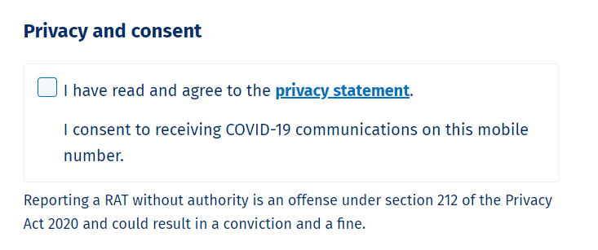
Reporting a RAT result on behalf of another
  - There is also the ability to enter a RAT result on behalf of someone else, where a Consumer can log into their own My Covid Record account and upload the RAT results on behalf of another person who has had a RAT test. The Consumer will need the details of that other person’s full name, NHI, Date of Birth and the authority or permission of that other person to report their RAT result. This functionality allows caregivers such as parents caring for young children, and adults caring for elderly family members who do not have their own My Covid Record accounts, to record RAT results on their behalf.
    - The information submitted will be NHI matched and recorded on the Eclair system as a ‘self-reported’ RAT (to signal it is a Consumer upload of the result rather than a supervised clinical process).
    - It will be possible to follow an audit trail to find who reported the self-reported RAT result if there was a subsequent question about the validity of the result (by contacting the Ministry to undertake that inquiry).
    - To further mitigate the risk of inappropriate results, the ‘on behalf’ process will also contain a warning to the My Covid Record Consumer prior to them reporting a RAT result on behalf of another person.
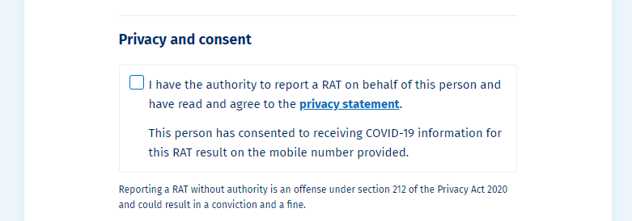
  - Eclair has recently moved to treating the RAT results as if they are diagnostic rather than surveillance tests. Due to the significant volumes of tests to be performed with the Omicron outbreak there will be insufficient volume of PCR testing resource capacity available to meet demand in a timely fashion.
Certificate Generation
- My Vaccine Pass. This enables a digital domestic credential to be generated at the request of the relevant Consumer. This allows the Consumer to demonstrate they are either Vaccinated or Exempt in accordance with the terms of the Orders. The My Vaccine Pass is described further in Appendix Four.
- The International DCC. This enables a digital international certificate to be generated, at the request of the relevant Consumer, to confirm their vaccination status, and details, to enable them to travel overseas. This is further described in Appendix Five.
On Behalf of orders for Vaccine Pass or International DCC
  - Ordering a Vaccine Pass or International DCC certificate on behalf of another person - if they have authority or permission to do so, and have the details of that other person’s full name, NHI and Date of Birth.
    - This ‘on behalf’ service will enable a parent to create a certificate for a child who does not have a My Health Account, or one person with a My Covid Record to assist another individual (without a My Covid Record) to obtain a certificate with that other person’s permission.
    - The certificate may only be returned to the email of the My Covid Record holder (as established by their My Health Account). This will be incorporated into the audit record held for the certificate generation.
    - There is the possibility that a certificate could be requested for a person who has not authorised that to occur, and does not know about it.
      - The certificate generated will however be specific to the person, as they will be named within it (in the form of a My Vaccine Pass or International DCC). It will have limited use to any other person, particularly if it needs to be compared to an identity document (for example in a border setting where the matching passport would be required).
      - To limit the opportunity for a certificate to be requested without permission, details including the NHI number of the other person will be required, as this is unlikely to be widely known.
    - The information submitted will be NHI matched and then compared against the Covid Immunisation Register to create the details to generate the certificate for the other person if there is a match.
    - It will be possible to follow an audit trail to find who requested the certificate if there was a subsequent question about the validity of the certificate (by making contact with the Ministry to undertake that inquiry and producing the certificate in question).
    - To further mitigate the risk of inappropriate requests, the ‘on behalf’ process will also contain a warning to the My Covid Record holder prior to them submitting a request for a certificate on behalf of another person:
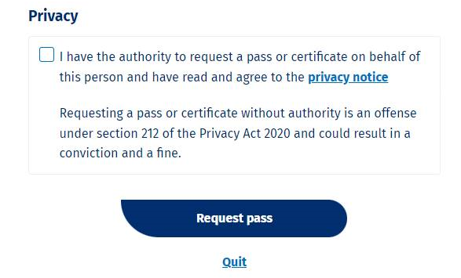

Requesting a Face Mask Exemption Pass
- A Face Mask Exemption Pass provides a Consumer with conclusive evidence that they are exempt from the requirement to wear a mask under the COVID-19 Protection Framework Order. The Face Mask Exemption Pass is described further in Appendix Six.
  - The ability to request a Face Mask Exemption Pass became available on 31st May 2022. This facility is available via the assisted channels, and a My Covid Record Consumer will also be able to request a Face Mask Exemption Pass for themself containing any name that can be matched with a name stored against their NHI number. The ability to request an exemption pass on behalf of another containing the name stored in CIR was also made available in June 2022.
    - This enables a Face Mask Exemption Pass to be generated at the request of the relevant Consumer. The information to be captured will include the reason(s) that the Face Mask Exemption Pass is being requested, and will initially include the My Health Account identifier of the individual requesting the pass (from My Covid Record), as well as the NHI number of who the exemption pass is being requested for and the date it was requested. The Consumer will be asked to confirm that they have read and agree to the privacy statement and declaration and understand that it is an offence to request an exemption pass under false pretence.

  - To mitigate the risk of inappropriate requests, the Face Mask Exemption Pass process will also contain a warning to the My Covid Record holder:
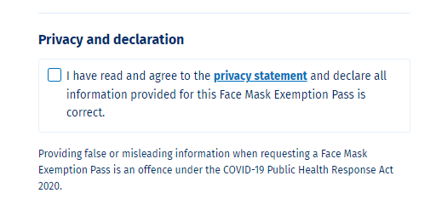

On Behalf requests for Face Mask Exemption Passes
  - Requesting a Face Mask Exemption Pass on behalf of another person - if they have authority or permission to do so, and have the details of that other person’s full name, NHI and Date of Birth.

    - This ‘on behalf’ service will enable a parent to request a Face Mask Exemption Pass for someone who does not have a My Health Account, or a person with My Covid Record to assist another individual (without My Covid Record) to obtain a Face Mask Exemption Pass with that other person’s permission.
    - The exemption pass may only be returned to the email of the My Covid Record holder (as established by their My Health Account). This will be incorporated into the audit record held for the exemption pass generation.
    - There is the possibility that a Face Mask Exemption Pass could be requested for a person who has not authorised that to occur, and does not know about it.
      - The exemption pass generated will however be specific to the person, as they will be named within it. It will have limited use to any other person, particularly if it needs to be compared to an identity document.
      - To limit the opportunity for an exemption pass to be requested without permission, details including the NHI number and date of birth of the other person will be required, as this is unlikely to be widely known.
    - The information submitted will be NHI matched and then compared against the Covid Immunisation Register to create the details to generate the exemption pass for the other person if there is a match.
    - It will be possible to follow an audit trail to find who requested the exemption pass if there was a subsequent question about the validity of the pass (by making contact with the Ministry to undertake that inquiry).
    - To further mitigate the risk of inappropriate requests, the ‘on behalf’ process will also contain a warning to the My Covid Record holder prior to them submitting a request for an exemption pass on behalf of another person e.g.:
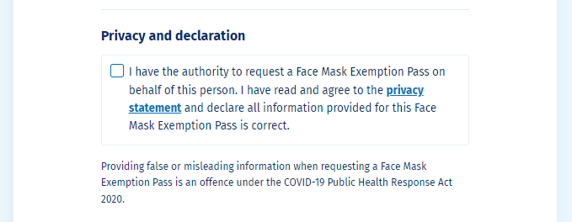

Digital Authorisation of services via My Covid Record
- Once a person has logged in to My Covid Record (with their established My Health Account identity) they will also be able to authorise certain digital activities, including:
Vaccination Bookings
  - Linking to the Book My Vaccine service when they are eligible for their booster shot of COVID-19 vaccine.
    - If chosen by the Consumer, this link will automatically populate the Book My Vaccine fields to enable the person to progress their booking promptly without re-entering their identification details.
    - The Consumer would be able to change their contact details on Book My Vaccine if they wished, and change to their preferred name. They will not be able to change the date of birth or NHI details (unless they follow existing NHI update processes).
    - In the future, the same functionality will be introduced to enable people booking an initial, second or subsequent vaccination for themselves.

- The general information flows are shown below. The Consumer will log into the C3 Secure Web App. This interacts with the Digital Identity application to confirm the Consumer’s account. Information will flow through various secure APIs (centred on the NIA Platform) to enable information to be confirmed by the CIR (vaccination information), NHI (different name) and Eclair (test results). Recent self-reported RAT result information will also flow from MCR DynamoDB via API to Eclair (not shown in the diagram below but it is linked directly to the C3 Secure Web App and will then send information via NIA to Eclair once the 20 minute withholding period has passed). Certificates for the My Vaccine Pass and the International DCC,as well as a copy of your vaccination record and the Face Mask Exemption Pass can be generated via the NIA API. Face Mask Exemption Pass logs will be stored in the NIA DynamoDB (also not shown in the diagram below but it is linked directly to NIA).
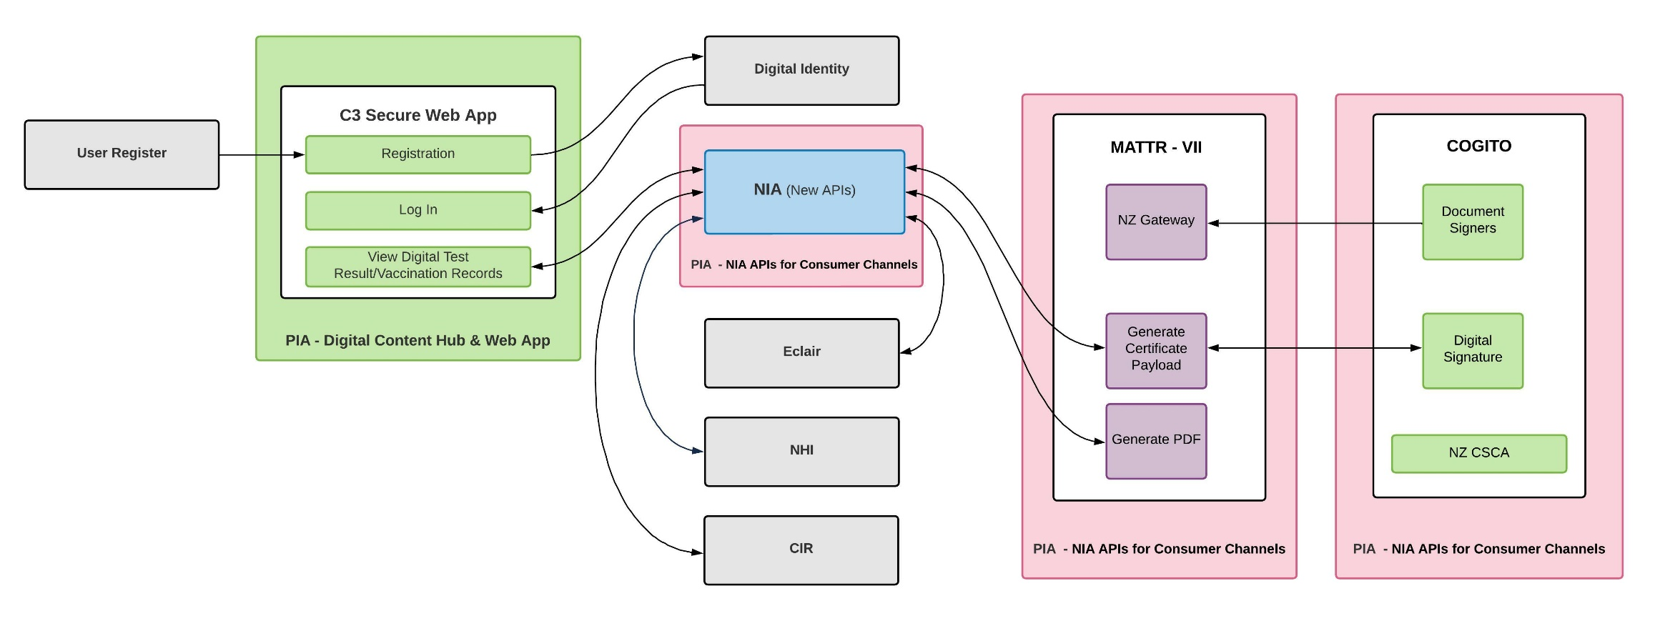

Alternatives to My Covid Record available
- Non-digital and assisted channel options, such as the national call centre, will continue to be offered to support those who cannot or choose not to use these digital options.
  - Some GP, pharmacy or primary health providers will be able to request a My Vaccine Pass, International DCC, vaccination record or Face Mask Exemption for their patients via CIR (and either print it there or email or post it to the Consumer);
  - A vaccination event record can be produced via CIR for those in the process of being vaccinated (and printed off or emailed to the Consumer); and
  - Call centre staff will have access to CIR and CICS to assist with certificate and pass generation (which can be emailed or posted to the Consumer);
  - Call centre staff will also have access to Eclair ESR (via an admin front end) to submit self-reported RAT results.
  - My Vaccine Pass is also available to Consumers who have been vaccinated overseas via this form https://www.overseas-vaccination.covid19.health.nz/.
Dependencies
- My Covid Record is heavily reliant on the operational processes within vaccination and testing activities to ensure that testing and vaccination activities are recorded correctly and against the right person. This is achieved through the agreed Service Designs for the vaccination and testing sites, and testing laboratories that all operational staff are trained and assessed on.
- My Covid Record is also dependent on the Digital Identity Platform to authenticate consumers logging into the secure self-service web app. The DI platform includes capability to create accounts as needed and to signal the level of confidence that has been achieved on that identity to inform the access that can be provided.
- The DI platform will confirm on login that the user is authorised, the level of the permissions / confidence (1, 2, 2N, 3 or 3N), and the duration of the access (token). Level 2N is required for the access to My Covid Record and the ability to generate My Vaccine Pass or the International DCC. Level 3N is a higher level of confidence, and this can also enable access to the My Covid Record services.
Interfaces
- The Ministry NIA Interfaces (APIs) that will form part of My Covid Record outcome (these have been reviewed in separate PIAs) are:
  - COVID vaccination records for an NHI: retrieve the vaccination records against the NHI bound to the logged in Digital Identity.
  - COVID testing records for an NHI: retrieve the testing records against the NHI bound to the logged in Digital Identity.
  - Generation of My Vaccine Pass for an individual: supply the domestic vaccination record details for the NHI either:
    - belonging to the logged-in My Health Account Digital Identity via My Covid Record or an ‘on behalf’ request is made for the vaccination records of another individual initiated by that My Covid Record logged in digital identity; or
    - linked to the patient record in CIR of the individual My Vaccine Pass is being generated for (if an assisted channel is being used).
  - Generation of the International DCC for an individual: supply the international vaccination record details for the NHI either:
    - belonging to the logged in My Health Account Digital Identity via My Covid Record or an ‘on behalf’ request is made for the vaccination records of another individual initiated by that My Covid Record logged in digital identity; or
    - linked to the patient record in CIR of the individual the international DCC is being generated for (if an assisted channel is being used).
  - Generation of a copy of an individual’s vaccination record: supply the domestic vaccination record details for the NHI either:
    - belonging to the logged-in My Health Account Digital Identity via My Covid Record; or
    - linked to the patient record in CIR of the individual the vaccination record is being generated for (if an assisted channel is being used).
  - Generation of the Face Mask Exemption Pass for an individual: validate the CIR details for the NHI either:
    - belonging to the logged in My Health Account Digital Identity via My Covid Record or an ‘on behalf’ request is made for the Face Mask Exemption of another individual initiated by that My Covid Record logged in digital identity; or
    - linked to the patient record in CIR of the individual the Face Mask Exemption Pass is being generated for (if an assisted channel is being used).
  - Submission of a self-reported RAT result, which will be linked to the relevant NHI either:
    - belonging to the logged in My Health Account Digital Identity via My Covid Record for the Consumer to submit their own result; or
    - ‘on behalf’ of another individual initiated by that My Covid Record logged-in digital identity;

How Consumers will interact with the Project
- My Covid Record will be publicly available on the internet and accessed through logging in with a Ministry My Health Account (also referred to as a Digital Identity). Consumers can access My Covid Record via Internet browsers on a desktop computer, laptop or mobile devices connected to the Internet.
- Screen shots for My Covid Record processes are included at Appendix One.
- Functionality for My Covid Record includes the following:
  - Register to obtain a login, and updating Confidence Levels for a My Health Account (via Digital Identity);
  - View my vaccination record (from CIR, via NIA);
  - View latest COVID test result (from Eclair and MCR DynamoDB, via NIA or directly);
  - Generate a My Vaccine Pass (either for the My Covid Record account holder – or on behalf of another person with their permission);
  - Generate an international DCC COVID-19 vaccination certificate (either for the My Covid Record account holder – or on behalf of another person with their permission);
  - Generate a copy of a Consumer’s COVID-19 vaccination record (for the My Covid Record account holder);
  - Generate a Face Mask Exemption Pass (either for the My Covid Record account holder – or on behalf of another person with their permission);
  - Self-report RAT Test results (either for the My Covid Record account holder – or on behalf of another person with their permission); and
  - Remove self-reported RAT results that have not been sent from MCR DynamoDB to Eclair.
- Access to view detailed COVID-19 vaccination and testing records, and generate a My Vaccine Pass or International DCC, requires that the user is authenticated (and their account is bound to their NHI number).
- If a user does not have the required confidence level or is not NHI bound, My Covid Record will direct the user to upgrade / elevate their identity via the Digital Identity service.
- A Consumer can elevate the confidence level of their Digital Identity from:
  - Level 1, username and password based only on a verified email address;
  - to Level 2 through confirming a matching ID document, such as a driver license, and Level 2N when matching to the NHI for that documented identity (this is sufficient for My Covid Record to access the individual’s vaccinations and tests and enable them to generate certificates);
  - a Consumer can automatically be elevated to Level 3 if they create a Digital Identity using their verified RealMe login details (this is not sufficient to access their COVID-19 records, or request generation of certificates via My Covid Record without the NHI match). The Consumer will then be elevated to Level 3N by matching to their NHI using the details supplied by the RealMe identity (this level 3N will also allow My Covid Record to access the individuals COVID-19 records and request generation of certificates). In future a Consumer can also be elevated to Level 3N by a trusted witness who confirms that the person that created the identity is who they say they are. Level 3N is not required for My Covid Record to access COVID-19 records or enable the generation of certificates.
- An additional option (to create greater equity of access for those without an ‘ID Document’) has been added to My Health Account to enable more Consumers to achieve Level 2N. The Consumer can submit their name and date of birth details and identify the practice they are enrolled with. If the Ministry is able to match the records to the practice records held on the National Enrolment Service (NES) it will offer to send a one-time password to the Consumers NES registered mobile phone number. If the Consumer can enter the code into My Health Account they can be registered at level 2N.
- At Level 2N or 3N the Consumer’s NHI number is linked to their Digital Identity. At Level 2N or 3N the Consumer will be able to have access to their COVID related personal health records and personally identifiable information. Other access to personally identifiable health information will be at 3N and will generally be managed through other My Health Account related processes (yet to be developed).
- The Ministry conducted a risk analysis, and an initial pilot for My Covid Record. In the unique COVID-19 setting the Ministry determined that it would use the 2N setting on the Digital Identity tool (the documented identity matched to NHI) to release vaccination and test records to Consumers in the My Covid Record web app.
  - It made this decision due to requirement for ease of access to this service for Consumers and the universal experience of Consumers facing COVID-19 challenges (everyone is impacted), as well as the current demands on the manual privacy requests (the Ministry is receiving significant volumes of requests for vaccination details) and it needs to ensure it can provide this information in a timely fashion.
  - It also notes the mitigation available in respect of the illegality of falsely representing the identity of another. The initial Digital Identity sign up process will be accompanied by a warning of the legal consequences of misrepresenting identity or accessing the information of another:
I have read and agree to the My Health Privacy Policy and Terms of use. I am making this application on my own behalf.’ – [ ] tick box
Pretending to be another person to obtain/alter their personal information is an offence under section 212 of the Privacy Act 2020 and could result in a conviction and a fine not exceeding $10,000.
- The level of the Consumer’s Digital Identity will determine what information and features they will have access to in the C3 web app for My Covid Record. This is outlined in the table below (see the My Health Account PIA for the latest details),
Confidence  Level | Account summary | Example of Assurance | Authorisation:  Account Allowed Access To
0 | No account | (No assurance required) | (Anonymous services; public websites and landing pages)
1 | Pseudonymous  (No confidence in account owner) | Account created and email address verified. The screen will show only the email supplied in the display. | Anonymous services requiring only an email.  At this level users are prompted to upgrade their account to view any further information
2N | ID Document verified  Or NES phone number one time code challenge met  & NHI matched | ID Document verified (official ID document details provided and verified at source) and NHI matched  - e.g. Driver’s license details provided and checked against NZTA. License details then used to search and match to a unique NHI  OR  NES phone records of Consumers enrolled general practice have been confirmed by use of one-time password sent to NES registered Consumer phone number | At this level users are able to view relevant information about their COVID-19 vaccination and, test results.  This includes information about the specific vaccine, date and time of administration, and batch number (although not available in initial releases).  It does not include information about the vaccinator, or other details that are not specific to the individual being vaccinated.  Test results will include test type, date sample taken, date result returned and test result.
3N | Verified RealMe or liveness verified  & NHI matched | Verified RealMe verified or liveness verified, and NHI matched. | All personally identifiable health information (noting that Covid vaccination and test results are available at level 2N as well).
- The user will need to log into the My Covid Record web app each time they want to access their own records from the underlying systems of record. Demand for the information has been identified for several cohorts:
  - Border Workers, due to the Government requirements that they are fully vaccinated and regularly tested. The general management of the border workforce is through the existing Border Workforce Testing Register. My Covid Record may however provide employees with a quick method to demonstrate vaccination status when they enter a restricted site, or enable the employee to keep up to date with the status of their testing records (a fast confirmation that the test has been received).
  - Those workers in the community who are required to be vaccinated (e.g. those who work in the health and disability sector etc). If use of the Border Workforce Testing Register is not currently mandated for the relevant PCBU, individuals may choose to use their My Covid Record (or their My Vaccine Pass) to establish their status to their employer.
  - Various use cases identified during the Delta outbreak, where an Alert Level setting required a test or vaccination status such as a border crossing out of Alert Level 4.
  - Various use cases identified during the Delta outbreak, where an Alert Level setting requires easy access to a Consumer’s NHI number (such as for testing).
  - My Vaccine Pass to enable Consumer’s access to New Zealand venues and events under Protection Framework Order settings.
  - Outbound international travellers where destination countries have started to adjust border settings for those fully vaccinated and/or recently tested, e.g. reduced or eliminating requirement to isolate – in the form of the International DCC.
- The C3 solution and infrastructure will also be providing unauthenticated landing page capability. This will include simple static HTML pages with links through to relevant systems (e.g. Vaccine Booking landing page). These will expand to include limited anonymous dynamic features such as a language selector so this preference can be passed through with the user into the booking workflow.

Information fields displayed to users:
- The following table summarises the data dictionary available to be displayed to users when logged in to My Covid Record at a sufficient confidence level. Note, not all information may be displayed at the same time, and will be dependent on the use case.
*Those items in grey shading below are not displayed to the Consumer
Data | Source system
User Identity
User ID | My Health Account (from DI)
First Name
Last Name
Preferred name
NHI Number
Date of birth
Email address
Phone number – This will now be displayed in My Covid Record with a request for Consumers to confirm if they are willing to be contacted on this number with the My Covid Record service offerings
COVID-19 vaccination Records
First Name | CIR (as recorded at vaccination event)
Middle Name
Last Name
Date of birth
Vaccine status
Vaccine name
Vaccine completed datetime
Vaccine location
Country vaccine was administered
Vaccine manufacturer
Vaccine batch number
Vaccine diluent number
Vaccine site
Vaccine route
Vaccinator name
Vaccine type (vaccination, additional or booster)
Vaccine dose number
Number of doses in series
COVID-19 Lab Test Results
Test completed datetime | Eclair or MCR DynamoDB (as recorded at test event)
Test result datetime
Test specimen site (type of test)
Test result
Test laboratory

Information Flows
- The Digital Identity platform authenticates a user and provides a secure access token that C3 can use to verify entitlement to access health records.
- The C3 APIs are responsible for ensuring that a user is authenticated (via Digital Identity) and authorised to access their COVID vaccination records and COVID test results, when available.
- C3 APIs will execute authorisation rules before requesting data from NIA. Requests to NIA will include the verified NHI number for the user, which will be used by CIR and Eclair to retrieve the relevant records.
- NIA APIs will provide FHIR-based responses for their relevant requests
  - COVID vaccination records (Immunisation resource)
  - COVID test result (Diagnostic Report resource)
  - Generate My Vaccine Pass
  - Generate an International DCC
  - Submit COVID self-reported RAT test results
  - Generate a copy of COVID-19 vaccination details
  - Generate a Face Mask Exemption Pass
- These resources will come from either CIR or Eclair as the sources of truth for the COVID-19 health data of an individual.
- The FHIR-based responses may contain more data than is required by My Covid Record, My Vaccine Pass, International DCC, vaccination record copy or Face Mask Exemption Pass. The C3 API will transform the data returned from NIA into lighter-weight subset required to be displayed to the user or to generate the vaccination certificates. Data not required by the frontend or to generate a vaccination certificate or exemption pass will be instantly discarded by the C3 API.
- The following diagram outlines the information flow between the (authenticated) C3 solution and relevant underlying systems including My Health Account (Digital Identity), CIR and Eclair. This shows the link to the Digital Identity service and then shows the NIA Platform (accessed from My Covid Record via an Application Programming interface) providing access to the information for the relevant individuals directly via the COVID Immunisation Register, and also the ESR Eclair testing data base.

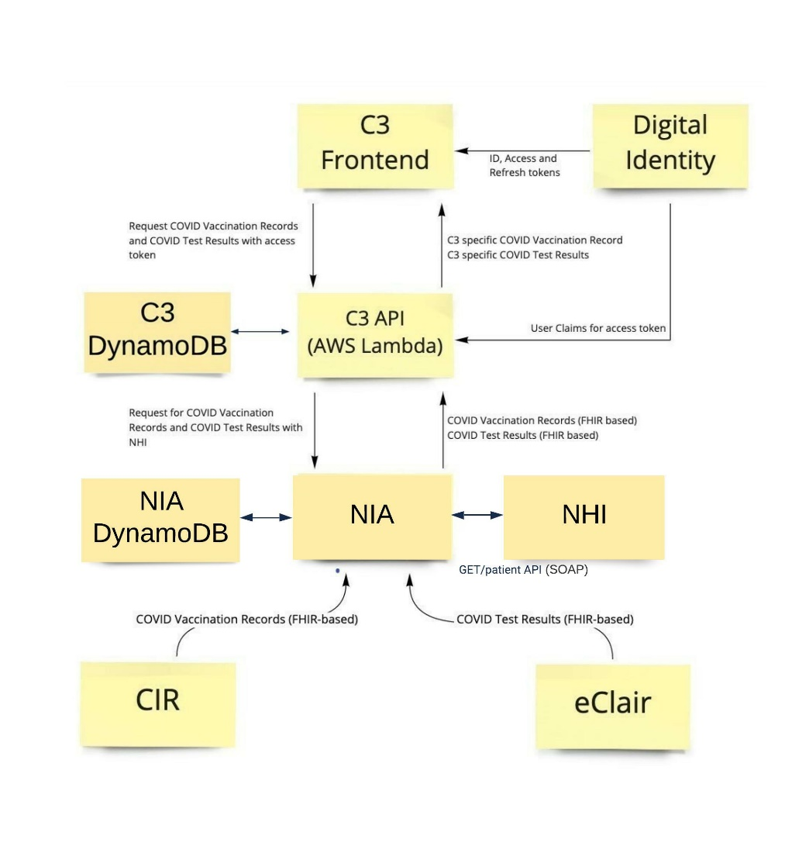
- The information flows that will enable the generation of the certificates are set out in the following diagram:
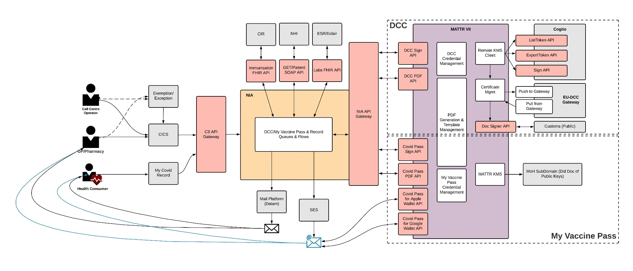

- For both International DCC and My Vaccine Pass, entry points to the My Covid Record service are via Self Service (Consumer) or Assisted Channels (GP/ Pharmacy/ MoH Call Operator). My Covid Record is the preferred mechanism for self-service (including “on behalf” requests) and CIR/CICS will be used for Assisted Channels (using a process incorporated into the Covid Immunisation Register).
- Regardless of entry point, all flows should follow the My Covid Record process for certificate generation, signing and delivery, which is via the C3 API Gateway and NIA.
  - Request vaccination certificate (International DCC, My Vaccine Pass, vaccination record copy and Face mask Exemption Pass) – the source system will make a request containing the NHI number and the Consumer’s email address or postal address for the PDF to be sent to. Vaccination details are retrieved from CIR using the individuals NHI number via the standard Immunisation FHIR API.
- The data is passed to the Certificate Generation Service (MATTR above) to be converted into the format required for the International DCC or My Vaccine Pass.
- MATTR formats the data received so it meets the required standards (as specified by the international and domestic standards). As part of the process a digital signature is computed for the data.
  - For the International DCC, MATTR passes data to the Cogito service, which computes a digital signature using Document Signing Certificates (DSC) signed by the Ministry of Health Country Signing Certificate Authority (CSCA).
  - For My Vaccine Pass, MATTR computes the digital signature using a private key managed in the MATTR Key Management Service (KMS).
- Once the full certificate details are generated, including the digital signature, it is compressed into a final text representation, inserted into a QR code, and formatted into the relevant PDF template.
- The formatted PDF is then sent to the Consumer supplied email address.
  - If the My Vaccine Pass is sent to a Consumer’s email address, the email message will also include Apple Wallet and Google Pay links (public endpoints exposed by MATTR), to enable the details to be retained by the Consumer in those formats.
  - If the certificate is generated via My Covid Record on someone else’s behalf, the PDF is sent to the email address held in Digital Identity for the logged in Consumer.
    - The email can then be forwarded on to the on-behalf individual’s email address (from where Digital wallets can be accessed) or printed as required.
- If no email address is provided when using the assisted channel options, the postal services can also be used and the PDF printed and mailed to recipients.

Where and how the information will be stored
- The C3 application is hosted using Amazon Web Services (AWS) in Sydney, Australia, in the ap-southeast-2 region. The Ministry’s use of AWS has been established through the All-of-Government service agreements. The AWS tenancy used by C3 is owned by the Ministry, and subject to standard Ministry requirements for architecture, security, and audit controls.
- The C3 frontend (My Covid Record) will use MCR DynamoDB as a transient storage solution to allow for incorrect test result submissions to be “undone” after 20 minutes. Any records in this DB will be removed within a maximum of 90 days, as the details will have been transferred to the Eclair test record database.
- The C3 frontend (My Covid Record) is a React web application. It utilises the Microsoft Authentication Library to support integration with Digital Identity. Access tokens provided by DI are stored using the web browser’s SessionStorage - which is cleared when the browser tab is closed.
- The C3 frontend (My Covid Record) will gather Face Mask Exemption Pass data and pass it on to NIA via a C3 API, but will not store the data.

Retention of information
- Personal data fetched from the CIR or Eclair will transit the NIA and C3 APIs, however, other than audit logs, personal data is not retained in the C3 infrastructure (except for as provided in paragraph 46 above for temporary MCR DynamoDB records) and will only be available while serving the request from the web browser. The My Covid Record display of details does not require personal health data be stored.
  - Personal data passed to NIA will be retained in the NIA DynamoDB for two years from the date of requesting the exemption pass or when the Covid Public Health Response Act is repealed, whichever event occurs first.
Certificates
- Certificates will be emailed to Consumers (via NIA) and Consumers will then be able to use (and reuse) that emailed certificate.
- If there is an error in delivery, as the generation of certificates is in real time, the Consumer will get a message of a failure of delivery and to try again later.
- For certificates, for each pass requested the following information will be retained in an audit log and for statistical reporting:
  - The claim ID of the person it was issued to
  - If the certificate was generated for someone else, the correlation ID
  - The type of pass it is (My Vaccine Pass, EUDCC, vaccination record copy or Face Mask Exemption Pass)
  - Whether a pass was issued for an exemption/exception or not
  - The channel the pass was issued via (in this case, the My Covid Record channel)
  - The delivery method of the pass (email or postal)
  - The jti (Json Web Token ID) of the My Vaccine Pass or the UVCI (unique vaccine certificate identifier) of the EUDCC (so it can be queried in the event of a fraud investigations). Every certificate generates a unique identifier for that certificate (so a Consumer who generated three EU DCC certificates would have a different identifier on each one)
  - For Face Mask Exemption Passes, the reason(s) for requesting the exemption pass
  - For on behalf requests, the person’s name, Date of Birth and NHI are entered into My Covid Record by the requestor/agent. These details are validated via NIA, and if valid proceed to Mule/CIR as normal for the retrieval of vaccination information and the creation of the relevant certificate. No personal identifying information is retained in NIA or Mule. The on behalf patient records are not returned to the My Covid Record ‘front end’ and are neither stored or displayed (although that My Covid Record holder does receive the certificate to their relevant 2N email address via NIA).
- As the authority of issuance, this information will be retained by MATTR in its secure, single tenancy AWS platform that has been Ministry of Health security ratified - a SOC2 compliance review was completed by EY in Dec 2021, with the final report now pending. Currently, data will be retained until the Ministry instructs its deletion and this retention period is configurable. This information will also be replicated into the Ministry data warehouse tool, Snowflake, once it has completed the Snowflake Dataset Approval process, overseen by the Ministry Data Governance Group.
- Logs may be collected and sent to the Ministry Security Operations Centre (SOC) via the Security Information and Event Management (SIEM) solution. These logs do not contain personal information, and are used for security monitoring and audit purposes.
Self-reported RAT results
- For self-reported RAT results, for each result reported the following information will be retained in an audit log and for statistical reporting:
  - The My Health Account identifier of the self-reported RAT result is being submitted from
  - The NHI the self-reported RAT result relates to
  - The result of the test (detected (positive), not detected (negative) or failed)
  - The date and time the test was entered in to My Covid Record
  - For on behalf requests, the person’s name (the one who took the test), date of birth and NHI are entered into My Covid Record by the requestor. These details are validated via NIA (from CIR), and if valid proceed to check if that NHI has already reached the limits of self-reported RATs for the specified time period (currently 12 hours), before allowing the requestor to enter the RAT result. No personal identifying information is retained in the NIA process. The on-behalf patient records are not returned to the My Covid Record ‘front end’ and are neither stored or displayed.

Security features applying to Project
- The My Covid Record solution follows standard Ministry security practices to protect information. The project operated in beta first (under an Interim Approval To Operate (IATO)) and then after an initial closed pilot obtained an Approval To Operate (ATO) prior to public release.
- Prior to any public web-access for any new changes of significance an ATO will be obtained to ensure that security is appropriate for a public facing website that will enable access to identifiable health information.
- The Ministry has contracted an independent All-of-Government approved provider to provide a continuous assurance process over the solution, including conducting security risk assessments and providing advice for appropriate security and privacy controls.
- The solution implements standard security controls for protecting information at rest and in transit, including:
  - All communication between the web browser and C3 infrastructure (and in storage) is encrypted using TLS1.2 or higher.
  - Authentication is performed by Digital Identity. Integration is via a standard OAuth 2.0 authorisation code flow with PKCE between C3 frontend and Digital Identity (Azure AD B2C). This flow provides an OAuth 2.0 access token with a lifetime of 15 minutes, and a refresh token with a lifetime of 1 hour
  - The C3 API performs the validation and authorisation of the access token provided by Digital Identity, and uses the access token to retrieve claims from Azure AD B2C which includes NHI and confidence level. C3 API is authenticated to NIA via OAuth 2.0 client credentials specific to C3. All communication between C3 and NIA is encrypted using TLS1.2 or better.
  - The C3 infrastructure is deployed into a managed AWS tenancy controlled by the Ministry. Standard security controls and policies apply to resources deployed in the tenancy, and the environment is linked to the Ministry SOC/SIEM solution for security event monitoring.
  - The API connecting My Covid Record with Eclair has also now completed its security testing satisfactorily.

Manual processes involved
- There are limited manual processes involved directly in the landing page or the secure web app.
- Assisted channels are enabled so that Consumers who cannot or choose not to use digital channels are not excluded.
  - My Vaccine Pass, International DCC, vaccination record copies and Face Mask Exemption Passes are available to be generated via the assisted channels, to enable these Consumers access to their vaccination certificates and exemption passes without having to be digitally registered for My Covid Record.
  - My Vaccine Pass is also available to be emailed to overseas visitors by completing a digital form and providing evidence of their COVID-19 vaccinations.
  - Consumers can also get supervised RATs at a pharmacy and these results are entered in to ESR (by pharmacy staff). Assisted channels also have access to enter self-reported RATs directly in to ESR, to enable those that are unable to get these entered digitally via My Covid Record to have their RATs reported.

Analytics
- Statistical information collected about the use of the platform will be accessible to relevant Ministry staff and its suppliers, in order to make decisions about the features and functionality of the landing page and secure web app. Statistical information is not linked to personal information, and the Ministry is not able to use statistical information to identify individuals.
- The Digital Content Hub Pages and My Covid Record use Google Analytics to record anonymous statistics about visitors. This collection is limited to public-facing pages and is used to inform decisions about page structures, call-to-action conversions, and usage patterns. Statistics are collected when a user navigates to an included page, and the information collected may include:
- Information about the browser and device used to access the page, including device type and manufacturer, operating system name and version, browser vendor and version, and other device settings such as system language, screen resolution, and display size.
- Information about the page visited, including the page URL and referrer
- the IP address will be used to determine the Consumer’s approximate location. This can indicate the country or region you are located in, depending on where your ISP originated
- HTTP cookies are used to "remember" what a user has done on previous pages / interactions with the website. Google Analytics supports three JavaScript libraries (tags) for measuring website usage: gtag.js, analytics.js, and ga.js:
Cookie Name | Default expiration time | Description
_ga | 2 years | Used to distinguish users.
_gid | 24 hours | Used to distinguish users.
_gat | 1 minute | Used to throttle request rate. If Google Analytics is deployed via Google Tag Manager, this cookie will be named _dc_gtm_<property- id>.
AMP_TOKEN | 30 seconds to 1 year | Contains a token that can be used to retrieve a Client ID from AMP Client ID service. Other possible values indicate opt-out, inflight request or an error retrieving a Client ID from AMP Client ID service.
_gac_<property-id>  _gac_gb_<container-id> | 90 days | Contains campaign related information for the user. If you have linked your Google Analytics and Google Ads accounts, Google Ads website conversion tags will read this cookie unless you opt-out. Learn more.
_ga_<container-id> | 2 years | Used to persist session state.

- Data collected for My Covid Record by Google Analytics are captured as “events”, which are triggered when specific actions happen on the website. These events are used to provide reporting into the effectiveness and performance of My Covid Record. Specific events are listed in the table below. These events do not contain personal information:

Event Name | Attributes | Trigger | Notes
_session.start |  | When a user first visits C3
_session.stop |  | When a user navigates away from C3
page_view | url | Every time a user navigates to a new URL
login | url | When a user clicks the login button | url attribute is the originating page
logout |  | When a user clicks the logout button
signup | url | When a user clicks the ‘Next’ button inside the “Create a My Health Account” dialog.
vaccinationRecordsDisplayed | numOfRecords | The “Vaccination records” widget is displayed
vaccinationRecordsFailedToLoad | reason | When the vaccination records fail to load “Reason” will be either handled or unhandled.
vaccinationRecordExpanded | numOfRecords | When a user expands the details of a single record by clicking on it.
bookVaccinationLink | url | Everytime a user clicks the “Book Now” button to book a vaccination
upgradeAccount |  | Every time a user clicks on “Go to My Health Account”
viewNHINumber | open: Boolean | When a user clicks on “View NHI number” CTA | open is true if the Dialog has been opened, and false if it has been closed.
incorrectDetailsForm |  | When a user clicks the Update incorrect or missing vaccine or test details link
requestVaccinationCertificateSubmit | hasChangedEmail: boolean  hasChangedName: boolean  certificateFor = ‘myself’ | ‘someoneElse’  certificateType = ‘DomesticCovidVaccinationCertificate’ | ‘InternationalCovidVaccinationCertificate’ | When the user clicks the Submit request button on the Confirm your details step of the Request Vaccination Certificate Wizard.
requestVaccinationRecord |  | When the user clicks the “Get a copy of your vaccinations” CTA
requestVaccinationRecordSubmit | hasChangedName: boolean | When the user clicks the “Submit” button on the Confirm your details step of the Get a copy of your vaccinations Wizard.
labRecordsExpanded |  | When a user expands the details of a single record by clicking on it
bookSecondVaccinationDose |  | When a user clicks the get your second vaccination “Book a vaccination” CTA
reportRATResult |  | When the user clicks the “ Report a test result” CTA
submitRATResult | ratResultFor = ‘myself’ | 'someoneElse | When the user clicks the “Submit result” CTA
removeRATResult | ratResultFor = ‘myself’ | 'someoneElse | When a user clicks “Yes, remove result” CTA
submitFaceMaskExemptionRequest | reasonPhysicalIllness = true  reaonMentalIllness = true  reasonCondition = true  reasonDisability = true  maskExemptionFor = ‘myself' | 'someoneElse'  hasChangedEmail = boolean  hasChangedName: boolean | When a user clicks on “Complete request” CTA at the ed of the Request Face Mask Exemption Pass flow

- More information about how the tracking code works is available on the Google Analytics documentation website.
- My Covid Record currently also uses Amazon Pinpoint to collect information about specific events and actions taken on the website. This information is stored in the Ministry AWS tenancy separately from other health information. It is not possible for this data to be linked to personal information shown by C3. Data collected by Amazon Pinpoint is detailed on the Amazon Website. This data is captured as “events”, which are triggered when specific actions happen on the website. A summary of this information is presented below:
Data | Description
Event Type | The action that triggered the event to be recorded, e.g. login
Timestamps | The time the event was triggered, and the time the event was recorded in Amazon Pinpoint
Application, Client, and Device | Information about the application, the browser, and the device it is running on. This includes:  - a unique identifier, make, model, and operating system version of the device, and  - application name and version  This information is only used in aggregate and not to identify any individual, or attribute analytics to personal information
Session | Information about the current session the event was captured in
Attributes | Custom attributes that can accompany events, if configured in the application.

- These analytics events are captured at key stages of the website experience. These events are used to provide reporting into the effectiveness and performance of the C3 service. Specific events are listed in the table below. These events do not contain personal information:
Event Name | Attributes | Trigger | Notes
_session.start |  | When a user first visits C3
_session.stop |  | When a user navigates away from C3
pageView | url | Every time a user navigates to a new URL
login | url | When a user clicks the login button | url attribute is the originating page
logout |  | When a user clicks the logout button
signup | url | When a user clicks the ‘Next’ button inside the “Create a My Health Account” dialog.
vaccinationRecordsDisplayed | numOfRecords | The “Vaccination records” widget is displayed
vaccinationRecordsFailedToLoad | reason | When the vaccination records fail to load “Reason” will be either handled or unhandled.
vaccinationRecordExpanded | numOfRecords | When a user expands the details of a single record by clicking on it.
bookVaccinationLink | url | Everytime a user clicks the “Book Now” button to book a vaccination
bookPfzerSecondDose | url | Every time a user clicks on “Book Pfizer vaccination”
upgradeAccount |  | Every time a user clicks on “Go to My Health Account”
viewNHINumber | open: Boolean | When a user clicks on “View NHI number” CTA | open is true if the Dialog has been opened, and false if it has been closed.
incorrectDetailsForm |  | When a user clicks the Update incorrect or missing vaccine or test details link
labRecordExpanded | numOfRecords | When a user expands the details of a single record by clicking on it
requestVaccinationCertificateSubmit | hasChangedEmail: boolean  hasChangedName: booleancertificateFor: ‘myself’ | ‘somebodyElse’  certificateType: ‘DomesticCovidVaccinationCertificate’ | ‘InternationalCovidVaccinationCertificate’ | When the user clicks the Submit request button on the Confirm your details step of the Request Vaccination Certificate Wizard.
requestVacciantionRecord |  | When the user clicks the “Get a copy of your vaccinations” CTA
requestVacciantionRecordSubmit | hasChangedName: boolean | When the user clicks the “Submit” button on the Confirm your details step of the Request Copy of Vaccinations Wizard.
reportRATResult |  | When the user clicks the “ Report a test result” CTA
submitRATResult | ratResultFor = ‘myself’ | 'someoneElse | When the user clicks the “Submit result” CTA
removeRATResult | ratResultFor = ‘myself’ | 'someoneElse | When a user clicks “Yes, remove result” CTA
submitFaceMaskExemptionRequest | reasonPhysicalIllness = true  reaonMentalIllness = true  reasonCondition = true  reasonDisability = true  maskExemptionFor = ‘myself' | 'someoneElse'  hasChangedEmail = boolean  hasChangedName: boolean | When a user clicks on “Complete request” CTA at the ed of the Request Face Mask Exemption Pass flow

Equitable access
- Equitable solutions have been developed for vaccination certificates in addition to the digital solution My Vaccine Pass. Those who may have challenges can use alternative methods to access their COVID-related records or have a certificate created. There will be a paper-based option available by mail or produced by in person attendance at a vaccination centre or certain GP or pharmacy locations.
- The status of those who have a legitimate Exemption will also be given the opportunity to be issued with a My Vaccine Pass which will not highlight their status as ‘exempt’. The pass will show a person with an Exemption in the same way it will confirm a person with a completed vaccination requirement. Both will have a green tick for ‘pass’. The Ministry will manage the Exemption processes and it is understood that it may be able to record an exempt status on the Covid Immunisation Register – which will make the detail available to the My Covid Record for the time frame specified on that exemption record.

Governance
- Governance Group oversight, and Steering Group processes applicable to the Digital Content Hub Pages, C3 Self-service Web App and related NIA APIs is through the established COVID Vaccination and Immunisation Programme (CVIP). This is the primary funding source of this project. The governance model hierarchy being:
  - Invitation, CPIR, Booking, CIR and C3 Technical Steering Group – which meets weekly to review and endorse recommendations for the CVIP Programme Leadership Group;
  - CVIP Programme Leadership Group (PLG) – Daily decision-making meetings across all elements of vaccination programme including technology and operations;
  - CVIP Steering Group – Weekly oversight session across all elements of vaccination programme including technology and operations.
- A key governance role will be to maintain oversight to prevent the risks of function creep, and ensure security is applied at all stages of development and each iterative release. This is being included in the Invitation, CPIR, Booking, CIR and C3 Technical Steering Group Terms of Reference.
- There is potential for new uses for the information and My Covid Record to be identified over time:
  - If information is used in a manner inconsistent with the authorisation given by Consumers on sign up there is the potential for a privacy breach.
  - It is essential that experienced governance oversight and control is retained to make sure the Information is not used inconsistently with the authority given when the Information was collected, or other legitimate ground consistent with the Privacy Act and the Health Information Privacy Code is identified for use or disclosure.
  - The CVIP release management process and relevant checklist includes confirmation that required updates to the Privacy statement have been completed for each future release.

Section Three – Privacy Analysis
- The purpose of this Assessment is to review the process of collection, storage, use and sharing of personal and contact information for the purposes of the C3 Project, and specifically ‘My Covid Record’, My Vaccine Pass and the International DCC against the 13 Rules in the Health Information Privacy Code (HIPC).
- COVID-19 continues to mutate, creating new public challenges as it does so. Strategies for management are also fast evolving – and the need for flexibility to meet changing requirements continues. This could range from changing requirements about vaccine effectiveness (such as a potential future requirement for booster shots in order to be perceived as ‘fully vaccinated’) to public health measures introduced for employment and large events to proceed safely.
  - The C3 design is intended to be flexible to meet the changes, but does recognise the importance of keeping people informed of progress, while also retaining flexibility within the system developments to meet the changing requirements.
  - This Privacy Impact Assessment is a further iteration to reflect the current changes. Updating Assessments and Privacy Statements is an ongoing commitment C3 has to keep up to date information available to Consumers. Transparency in the Privacy statements and Terms of Use is also a commitment for the C3 project.
- Providing options for Consumers has been a focus of the C3 project – with the initial choice for Consumers as to whether or not to opt-in to the services offered in association with the My Covid Record project.
  - Where possible, options are made available within the My Covid Record settings to enable Consumers to utilise options to minimise the amount of information to be displayed (if they choose to show their My Covid Record details to another party).
  - The DCC has been considered from the perspective of minimising the information displayed, balanced against the need to ensure the correct person is presenting the certification that they have been vaccinated as required in the public health settings at the time of presentation whether mandatory under an Order or not).
  - The My Vaccine Pass was originally designed to comply with the Protection Framework but its use is no longer mandatory. The amount of information displayed on the pass has been minimised to include name, date of birth and expiry date.

My Covid Record
- A key risk area is where the balance lies between making access relatively easily available to Consumers (to ensure equitable access and easy uptake) and controlling access to identifiable information about individuals in the Covid setting to ensure Consumers only see information about themselves.
  - The Ministry conducted a risk analysis, and also reviewed findings from the closed pilot it conducted for My Covid Record. It acknowledged that 3N, requiring an in-person confirmation of identity by a trusted person, was not able to be achieved at scale in the current COVID-19 settings.
  - The Ministry determined that a digital identity confidence level of 2N is required, specifically for the My Covid Record. This is the verified document identity, linked to a Consumer’s unique NHI. A Consumer can claim a documented identity at My Health confidence level 2, but this does not establish that the person asserting the documented identity is in fact that person (that would require Level 3N confidence).
  - This level 2N determination applies only to the following records about a Consumer in My Covid Record:
    - View of the COVID-19 vaccination records
    - View of COVID-19 test results
    - View of NHI number
    - View of date of birth
    - Generate a COVID-19 vaccination certificate (this will be either My Vaccine Pass or the International DCC) for themselves, or on behalf for another person
    - Self-report a RAT for themselves, or on behalf of another person
    - Generate a copy of COVID-19 vaccinations for themselves
    - Generate a Face Mask Exemption Pass for themselves, and in the near future on behalf of another person
  - This decision to apply the level 2N confidence level is not applicable beyond My Covid Record. Other identifiable health information will still require a 3N level of confidence.
  - The benefits to Consumers of being able to readily access information about themselves is considered of high importance – and there have been significant volumes of requests from Consumers to the Ministry about their vaccination status, confirming their desire to access this information.
    - Manual responses to such requests risk failing to meet prescribed time limits (including those urgent requests).
    - At scale, the risk of manual processes accidentally returning incorrect information to an individual or to the wrong individual greatly increases the risk of inaccuracy.
- Under s 57 of the Privacy Act 2020 the Ministry has to decide that it is reasonably satisfied of the identity of a Consumer when they seek information about themselves. It must ensure appropriate procedures are applied so that only the Consumer (or an authorised person) will receive the information. Section 57 provides:
S57 If an agency receives a request to access personal information, the agency—
(a) may give access to the information only if the agency is satisfied of the identity of the requestor; and
(b) must not give access to the information if the agency has reasonable grounds to believe that the request is made under the threat of physical or mental harm; and
(c) must ensure, by the adoption of appropriate procedures, that any information intended for a requestor is received—
(i) only by that requestor; or
(ii) if the request is made by a requestor as the representative of an individual, only by the requestor or the individual; and
(d) must ensure that, if the request is made by a requestor as agent for an individual, the requestor has the written authority of the individual to obtain the information, or is otherwise properly authorised by the individual to obtain the information.
- Individuals however also have responsibilities. It is an offence, with a fine not exceeding $10,000 on conviction, under s212(2)(c) of the Privacy Act 2020 to:
- mislead an agency by impersonating an individual, or falsely pretending to be an individual or to be acting under the authority of an individual for the purpose of:
(i) Obtaining access to that individual’s personal information;
(ii) Having that individual’s personal information used, altered or destroyed.
- In providing this C3 service to Consumers the Ministry has balanced convenience and ease of access for Consumers against inadvertent disclosure to the wrong person (or a deliberate attempt to access information about another).
- The Ministry has acknowledged there is some risk that information could be accessed maliciously by someone with knowledge of another Consumer’s documents (such as their drivers licence details). Mitigating this risk, a strong warning is incorporated into the Digital Identity tool of the consequences of a breach of s212, and security processes will apply to My Covid Record.
- An equivalent warning is incorporated into the ‘on behalf’ certificate generation, Face Mask Exemption Pass request and RAT rest result upload screens. The individual requesting the certificate or creating the record would need to have access to the NHI number of the person they were creating the record on behalf of, and an audit record will be retained of who generated each certificate or submitted a RAT result on behalf of another (although it would need an administrator search to find those details).
- The Ministry has also worked to enable the My Covid Record to be viewed with limited information available (such as confirmation of vaccination, but no NHI visible on the screen). This may enable the Consumer to use the record in multiple settings of their own choosing with the minimum amount of information displayed to achieve their purpose.

My Vaccine Pass
- My Vaccine Pass, the domestic certificate of COVID-19 vaccination is a method by which a Consumer can show that they meet any mandated requirements to enable entry to a premise or access to a location. This was originally to meet Order requirements, but may now be used when there is no specific Order requirement but the Consumer chooses to demonstrate their vaccination status.
- Legislation provides some assurances and protections for My Vaccine Pass.

  - The requirement to show a pass is no longer mandatory under the Protection Framework rules, so this is an option for businesses to resolve with their customers (subject to those locations where vaccination evidence may not be requested). The Protection Framework Order has established the circumstances when a person will not be required to show that they are vaccinated, and includes an age limit below which no vaccine pass is required (12 years and 3 months or younger). Protections have been provided to ensure certain essential services will remain available (for example, supermarkets and pharmacies) regardless of whether or not a person is vaccinated and holds a My Vaccine Pass.

  - Section 34B of the COVID-19 Public Health Response Act 2020 provides:

    - that information about an identifiable individual collected or obtained by any person for the purpose of determining whether the individual is vaccinated may not be held, stored, used or disclosed by the person except for certain limited purposes.

    - It is provided in 34B(4) that it is an offence to intentionally fail, without reasonable excuse, to comply with the section. If convicted, an individual could be imprisoned for up to 6 months, and fined up to $12,000. Any other ‘person’ could be fined up to $15,000. This is a significant deterrent from misuse of the vaccination status related information.

- More details about My Vaccine Pass are contained in Appendix Four.
NZ Pass Verifier App
- This App is able to be used to scan the QR Code, displayed on the My Vaccine Pass, to check the name on the pass matches the details recorded on the QR Code. This will confirm that the person of the name incorporated into the QR Code is either vaccinated in accordance with current vaccination requirements, or has an exemption. My Vaccine Pass will confirm that the person is compliant with requirements and will not distinguish between the two categories (vaccinated or exempt).
- The NZ Pass Verifier App will be freely available for download to enable technical verification of the pass in a privacy enhancing manner. The App itself will not collect details, it will instead briefly display the QR Code details for a short period of time. The App will also be covered by the provisions of s34B of the COVID-19 Public Health Response Act 2020.
- More details about the Verifier App can be found in Annex One to Appendix Four.
International DCC
- The International DCC will be a method by which a Consumer can show that they meet part of the mandated requirements to enable entry to an overseas country capable of recognising a matching vaccination certificate.
- Inclusion of International DCC certificates to enable Consumers to easily access proof of their COVID-19 vaccination status will allow officials at international borders to verify the Consumer’s COVID-19 vaccination status.
- The Ministry has conducted its analysis under the Health Information Privacy Code as the information is about Consumers and their health services. Under clause 4(1)(e) it is considered that this is information about an ‘individual which is collected before or in the course of, and incidental to, the provision of any health service or disability service to that individual’.
Health Information Privacy Code Rules |  | Background and Key Controls | Residual risk
Rule 1 | Purpose of collection of health information  - Only collect health information if you really need it | Purpose  The creation of My Covid Record, generation of the International DCC vaccination certificate, My Vaccine Pass (and potentially COVID-19 test certificate), copies of vaccination records, generation of a COVID-19 Face Mask Exemption Pass, as well as ability to digitally self-report Rapid Antigen Tests (RATs) are for the lawful purposes of creating tools that Consumers can choose to engage with to obtain and provide COVID-19 related health information about themselves and on behalf of others. Consumers can use that information in a format that will enable them to assert a vaccination status (and test status) to third parties as required.  Necessary  The confidence levels for My Covid Record are allocated by the Ministry’s Digital Identity tool. Information to be displayed will be aligned to the necessary confidence level to enable confidence that other information (about vaccination or testing) can be displayed to the requestor (either the Consumer themselves or a third party when the Consumer chooses to display the information).  The Ministry has determined access to My Covid Record information will be available to Consumers at Level 2N. After risk analysis the Ministry has determined that it is an acceptable balance between availability of the information to a Consumer against the risk that it may be potentially be accessed by a person other than the Consumer. The factors considered in reaching this decision include:  - The Ministry has conducted a risk analysis, and in the unique COVID-19 setting has determined that it will use the 2N setting to release this COVID-19 specific information. It has made this decision due to the universal experience of Consumers facing COVID-19 challenges (everyone is impacted), the current demands on the manual privacy requests (the Ministry is receiving significant volumes of requests for vaccination details), and the illegality of falsely representing the identity of another.  - Pursuant to section 212 of the Privacy Act is it an offence to mislead an agency by impersonating an individual or falsely pretending to be an individual for the purpose of obtaining access to that individual’s personal information. The Ministry will incorporate warnings in the Digital Identity process about the legal prohibition against false identity claims (in obtaining or altering the information of another).  - The 2N setting underlying My Covid Record is considered adequate for asserting a vaccination (or testing) status, and may be aligned with a need to provide a form of identification that matches the name displayed on the certificate. In a public health setting the Order will establish the circumstances in which My Vaccine Pass may be provided.  Once Consumers are adequately identified then only the service they request will be activated, to link to the information they seek for COVID-19 vaccination proof.  The information to be displayed in each of the Certificates is designed to be the minimum amount of information to meet the public health objectives, or international requirements in the case of the EU DCC (or only that information necessary). The details on the My Vaccine Pass are limited to name, date of birth and date of certificate expiry. It is considered these details are necessary to enable the certificate holder to reliably establish their identity as the person to whom the certificate has been issued.  - There is some variability in name (as what is recorded against the NHI may be different to some of the identity documents a person holds). The date of birth however remains consistent and is a reliable indicator of the person when linked to a slight name variant.  - Since the My Vaccine Pass has been available to the public the Ministry has had a small number of queries suggesting a photograph should have been used as part of the process to establish the identity of the person. This is not a technically feasible option. A key security feature of the My Vaccine Pass is the QR code. This contains a digital signature that proves the content of the QR code has not been tampered with or altered. Consideration was originally given to the feasibility of including a photo or other biometric data. At a technical level this would have increased the QR code size beyond the maximum limit of the QR code specification, and would be impractical to store and scan. Additionally, there are significant operational challenges to obtain a suitable and accurate photo of the person, as the Ministry of Health does not maintain an existing record of current photos of individuals. Not all verification processes to obtain a Vaccine Pass are associated with a photo – and as some individuals do not have photo ID it would be inequitable to require only photo ID. It is therefore discounted as an option for the My Vaccine Pass.  Section 34B of the COVID-19 Public Health Act now controls the use of information related to an individual’s vaccination status.  The Ministry design for the NZ Pass Verifier App is that it is used only to ‘verify’ the status of a person (and enable the ID checking process to make sure the certificate is displayed by a person with a matching ID) and not collect that information.  - As the App will be made available as a ‘package’ for third parties to incorporate into their own products there is potential for the App to be adapted to collect more than was originally intended.  - Terms of Use will be part of the requirements for use of the Verifier App (reference Annex Two in Appendix Four).  - The Verifier App will need to check in for updates every seven days or it will cease operate. This will enable the Ministry to maintain the currency of the Verifier App settings.  - The association with the original Ministry product will lend a perception of authenticity to the third party products – and the measures of control rely largely on operator compliance so this aspect of the processes was initially considered a ‘Medium’ risk. The implementation of section 34B has however returned that risk perception to low. | Low
Rule 2 | Source of information  - Get it straight from the people concerned | The Level of Confidence and application for services will be made by Consumers on an opt in basis (if they wish to use the C3 services). The source of the information will be provided by those Consumers to initiate the process. Any information ‘collection’ (or referral to other sources such as CIR and Eclair) will then be solely at the authorisation of the Consumer e.g. display the vaccination status or test result. Interactions with the DI service are covered in the DI PIA.  In the ‘on behalf’ certificate request, and self-reporting of RAT results, it is made clear to the My Covid Record account holder that they must have the authorisation of the person they are to seek the certificate, or report the RAT result, for.  In the certificate verification settings (NZ Pass Verifier App or international travel) the Consumer will be making the certificate available for verification so any information ‘collected’ will be as presented by the Consumer themselves.  One potential challenge will be with the use of NZ Pass Verifier App in the community – if the third party modifies the App so that it collects and retains information, which is not the expectation of the Ministry and the Consumer. The third party may be collecting information from the Consumer, but without the Consumer understanding that the certificate display is being captured differently to the standard Ministry NZ Pass Verifier App. There are also options where the Consumer may already be known to the third party (such as ticketing situations) where the collection of the status will not be unreasonable – and will be driven by the Consumer choice to provide those details (for example: https://www.youtube.com/watch?v=IrSbZC2LETs). Section 34B should again mitigate this risk with the significant penalty that will apply for inappropriate use of information. The Orders have combined to put some controls on what information may be required to verify vaccination status and the settings in which this is required and prohibited..  Technical controls, to disable the screenshot function during scanning, are in place for Android.  In the COVID-19 face mask exemption setting, the Consumer will be making the exemption pass available as evidence so any information ‘collected’ will be as presented by the Consumer themselves. | Low
Rule 3 | Collection of information from individual  - Tell them what you’re going to do with it | Privacy Materials need to be available to the Consumer prior to them engaging with the C3 processes.  A draft of the updated My Covid Record Privacy Statement is contained in Appendix Two.  Consideration has been given to transparency about the prospect of updates to the Privacy statement and how that will be managed. The Privacy statement itself confirms that it will be updated on the website when applicable (and the Ministry’s practice is to ensure this is either before or at the same time as any release incorporating a relevant change). | Low
Rule 4 | Manner of collection of information  - Be considerate when you’re getting it | Participation will be opt-in by Consumers. Originally the My Health Account service was available only to those over 16, but this has been lowered to include those 12 years and over to match the necessity of this age group requiring a My Vaccine Pass and required to wear a face mask. It is not considered there are any specific issues that need to be considered for this age group (other than the potential challenges for them locating relevant ID documents to obtain the My Health Account, and then establish they are the certificate holder if that is required for the 12 to 16 age group). There will be assisted channels available for those that face challenges.  There is no current provision in My Covid Record to access detailed information on behalf of another (for example by a parent or guardian) unless this information has been provided on behalf of that person, to the Ministry via My Covid Record. A Consumer with authority may request a vaccination certificate or Face Mask Exemption Pass be sent to their verified email address on behalf of somebody else. The certificate or exemption pass will not contain any additional personal information that wasn’t already entered by them in My Covid Record when making the request (other than confirming the individual is vaccinated by producing a certificate confirming that status).  Access to additional detailed Covid information will be managed in future by the DI processes, and under the My Health Account PIA. | Low
Rule 5 | Storage and security of information  - Take care of it once you’ve got it | My Covid Record does not currently store personal information regarding digital identity, vaccinations, or PCR test results. All this personal information and health data is fetched in real-time from source systems (via either My Health Account or via NIA – for CIR and Eclair details).  In the case of a self-reported RAT the information will be stored temporarily in the MCR DynamoDB, to allow individuals to correct an entry for up to 20 minutes. For this stage of the project, these records will be able to be accessed by My Covid Record in its test display feature. These records are then uploaded from MCR DynamoDB to Eclair via NIA API to enable these RAT results to be retrieved. The records will be purged from the MCR DynamoDB (within 90 days of creation). This information will only be able to be accessed by an administrator.  In the case of Face Mask Exemption Pass requests, the information will be stored in the NIA DynamoDB, to allow the requests to be investigated if there is a reported breach of somebody fraudulently presenting a Face Mask Exemption Pass who is not eligible for one. This information will be purged from the NIA DynamoDB two years from the date of requesting the exemption pass or when the Covid Public Health Response Act is repealed, whichever event occurs first. For this stage of the project, this information will only be able to be accessed by a NIA administrator e.g. in the case of a Police request for individual declaration information.  The introduction of processes for generation and distribution of digitally signed certificates (digitally and manually) requires personal information to be passed on to a third party certificate generation service. The certificates will be created and returned to NIA and then emailed to Consumers. Each of these pathways has been fully reviewed from a security perspective.  The APIs with other services (including DI, CIR and Eclair) have already been reviewed in earlier phases, including the certificate generation APIs (which were fully security reviewed prior to public release, and are reviewed in a separate NIA PIA). The new NIA API to upload self-reported RATs to Eclair has been subject to security review.  The platform will remain relatively static – and the NIA platform has already been subject to PIA review. My Covid Record web app and API components will continue to change, so each change will be subject to ongoing security review.  NZ Pass Verifier App used to scan My Vaccine Pass QR code was subject to standard Ministry security review.  Section 11 of the Privacy Act 2020 will apply to the hosting of the My Covid Record related accounts, as the information will be held on behalf of the Ministry for safe custody and processing. My Covid Record account information will hosted in Australia but will be held only as agent for the Ministry and the information may not be used by the contracted provider for its own purposes | Medium
Rule 6 | Access to personal information  - People can see their health information if they want to | The Consumer will be able to access authorised information about themselves directly within their device at the level of authentication / authorisation they have attained.  As there are multiple source systems involved, and My Covid Record is not a repository of that information (it provides access when requested to information from other sources), the My Covid Record Privacy Statement references a central email at the Ministry for management of any requests for personal information – so that the Consumer will not need to try and identify a specific source to approach. | Low
Rule 7 | Correction of information  - They can correct it if it’s wrong | A Consumer does not have the ability to correct personal information held directly in the current My Covid Record processes (other than the RAT test they self-report), as My Covid Record displays only information held in the originating source and does not itself hold that information. If a Consumer is concerned about the accuracy of their vaccination or testing results they will need to contact the clinical team involved (and this is included in the Privacy Statement associated with My Covid Record – see Appendix Two, and there is also a note on the My Covid Record screens about the email and phone contact if people consider their records are incorrect.)  One area where a Consumer may need to update the underlying name of their account is when it does not match the name they are known as or their passport (the international DCC requires the passport and certificate names to match). Users can update the My Health Account information by contacting the relevant helpdesk and can update information on the NHI service by contacting their GP or hospital as per current processes.  The Consumer will be able to choose to amend the email and mobile number used to send communications to them within My Health Account, or in the certificate generation screens when requesting a certificate for themselves (if requesting a certificate ‘on behalf’ there is no option to select a different email), If they are reporting a positive RAT result on behalf of another person they will be able to enter a mobile number for the person the positive text message will to be sent to.  The Consumer will be able to request that a different name held in NHI is included in their My Vaccine Pass, International Travel Vaccination Certificate, copy of their vaccination record or Face Mask Exemption Pass.  Personal information held regarding Face Mask Exemption Pass requests is a point in time audit record that cannot be changed. | Low
Rule 8 | Accuracy etc. of information to be checked before use  - Make sure health information is correct before you use it | In terms of the information displayed via My Covid Record, it will be linked to the information held on the source systems (the CIR – immunisation database, the Eclair laboratory test result system, and MCR DynamoDB holding the self-reported RAT result) by the unique NHI or unique My Health Account identifier assigned to each Consumer.  The CIR, and the Eclair laboratory test result system are clinical systems that are maintained to ensure a high level of accuracy and currency. It is acknowledged that some Consumers will have duplicate NHI records, but the Ministry has a well-established process that is designed to connect these to a single master NHI. If a Consumer seeks correction (perhaps because no record showed when they consider one should have displayed) then the potential for NHI duplicate will be investigated as part of the standard processes. Self-reported RAT results are based on a high trust model, and additional checks in the self-reporting RAT flow have been introduced to try and reduce the number of erroneous results entered. This includes the ability to enter results up to seven days in the past, a 20-minute delay for the reporter to change the result if it is not accurate, and warnings on the screens themselves for the on-behalf submissions.  My Health Account controls the accuracy of binding the account the NHI, and verifying that the identity matches the NHI properly. It is possible that My Health Account could link the wrong NHI number, or a duplicate, which then does not match against source systems. This is further addressed in the My Health DI PIA.  Once My Covid Record can access the NHI (via the DI information), it is used to look up the relevant data in CIR / Eclair. Potentially, if COVID-19 vaccination or test results have not been recorded against the NHI submitted by My Covid Record, then incorrect vaccination record or results may be returned (or no vaccination record or results returned when there should be some vaccination record or results there). This is to be rectified via manual processes, and users will be directed to contact the Ministry if the information does not look accurate – or something is missing that they expect to be there (the contact phone and email to seek assistance appear on the relevant screens within My Covid Record).  With the introduction of automated text messages to inform the Consumer of their test results, the delay in the display of positive PCR test results has been reduced to two hours – so a person is likely to get a text or see their records in My Covid Record before any contact tracer / public health official makes contact with them. This is a decision made in response to expectation of vastly increased numbers of positive cases, and the need to let individuals know as quickly as possible of the need to self-isolate, and take other appropriate action.  Self-reported RATs that have been entered via My Covid Record will display the information as entered by the Consumer.  - My Covid Record will fetch the self-reported RATs that are saved against the NHI number, and display these alongside all other COVID-19 test results retrieved from Eclair. In time, other entities will be able to enter RAT results (for example if one is completed at a workplace authorised to do so). These results will also display on My Covid Record for the person with an NHI matching the reported RAT result.  - The reliance to be placed on the reliability and consequences to follow a self-reported RAT will follow clinical direction set within the Eclair operational processes. Refer to clause 6.5.5. of Section Two for more details.  - It is noted that there is a possibility of fraudulent representation of either a negative or positive result (potentially in the employment context or for access to a venue) and this will be addressed as either part of the development of this functionality in My Covid Record or potentially in communications made to the sector that may rely on such information (such as employers).  Requesting a Face Mask Exemption Pass is based on a high trust model and it is acknowledged that there is a possibility of fraudulently requesting an exemption pass for either yourself or on someone else’s behalf. A warning will be provided on the relevant MCR screens that will align with the offences described in the relevant Order. | Medium
Rule 9 | Retention of information  - Get rid of it when you’re done with it | The C3 web app sources the information directly from source data (CIR, Eclair or MCR DynamoDB) in response to each request. Only the MCR DynamoDB retains information for the My Covid Record display feature. This information will be retained in the MCR DynamoDB for a limited amount of time only (up to 90 days, during which time it will have been transferred to Eclair for retention as a health record).  The NIA API processes describe the transit process for the information.  There will be audit logging and retention of information related to certificate or pass generation that will be retained until the COVID Public Health Response Act is repealed (or longer if that is required for the International DCC – yet to be finalised). The details to be maintained have been minimised (claim and correlation details), type of pass, whether for exemption / exception, channel used to request the pass and delivery method and the Json Web Token ID). In the event of a fraudulent request for a certificate or use of a certificate, the integrity of the system requires that a record be securely maintained against with fraudulent activity can be verified. Full details are provided in the Privacy Statement. This data set is to be retained for auditing or fraud related queries, and is managed as the record for the authority of issuance of the certificate or pass.  There will also be audit logging and retention of information related to self-reported RAT results. The details retained are the My Health Account identifier, NHI, test result, date of reporting the test. This data set is to be retained for auditing or fraud related queries.  The Ministry will also retain a copy of these audit log details within its Snowflake data warehouse tool (once it has completed the standard SDA processes and obtained Data Governance Approval). This dataset will be used for business level reporting, and no reports produced from the information will identify any individual. This dataset will also be retained until the COVID Public Health Response Act is repealed.  Emails will be sent from NIA to the Consumer with copies of the certificate so the Consumer will hold these details. A copy of the PDF is not retained as part of this service.  - An expiry date will also be incorporated into My Vaccine Pass dependent on the Consumer’s vaccination status at the time of requesting the My Vaccine Pass It is important to have an expiry date as once My Vaccine Pass is generated and sent to the Consumer it will stay ‘valid’ unless an expiry date is provided. The Certificate only needs to be generated once during that period for the Consumer to be able to ‘display’ it continuously – it does not get updated on an ongoing basis.  - if the Consumer is up to date with vaccination doses, their pass expiry date will be 180 days from date of request; or  - if the Consumer under 18 years and 30 days old, and has had their primary vaccination dose, their pass expiry date will be when they reach 18 years and 30 days OR 180 days from date of request – whichever is sooner; or  - if the Consumer has been recently infected, their pass expiry date will be 130 days from date of infection; or  - if the Consumer has a temporary medical exemption that expires <= 30 days in the past, their pass expiry date will be the temporary medical exemption expiry date + 30 days OR 180 days from date of request – whichever is sooner.  - In addition, the use of My Vaccine Pass may only be appropriate for the public health risk settings for a period of time. The use of an expiry date will ensure that on each extension the ongoing need for My Vaccine Pass will be reconsidered, and any privacy settings can be reviewed for adequacy  NZ Pass Verifier App used to scan the My Vaccine Pass QR code will briefly show the individual’s name and date of birth after scanning the QR code on the device screen (along with pass or fail) in order to match this information with the name that is printed on the certificate, and on another form of ID (if that is required) - this information from the QR Code scan is not retained in the App – the App will discard the details when the verifier dismisses the details, scans again, or closes the App. (A timeout mechanism built into the Verifier App means the information is only displayed on the screen for a specified short amount of time before disappearing.)  Logs retained by the Ministry Security Operations Centre and Security Information and Event Management solution do not contain identifiable information. These logs will be retained for 90 days.  In the case of Face Mask Exemption Pass request logs, they will be retained by the Ministry Security Operations Centre and Security Information and Event Management solution for two years from the date of requesting the exemption pass or when the Covid Public Health Response Act is repealed, whichever event occurs first. | Low
Rule 10 | Limits on use of information  - Use it for the purpose you got it | My Covid Record will use the identifiable information obtained for the purpose of:  - confirming the appropriate level of identity confidence and then enabling:  - the Consumer to access the information requested about themselves (within the current My Covid Record settings); and  - The Consumer to request My Vaccine Pass or International DCC; and  - the Consumer to request a PDF copy of their vaccination record; and  - the Consumer to self-report a RAT result (or report an ‘on-behalf’ result);and  - the Consumer to request a Face Mask Exemption Pass;  - the Consumer to request a different name held in NHI is included in their My Vaccine Pass, International DCC, vaccination record or Face Mask Exemption Pass;  - audit, monitoring and reporting on the records retained  The Consumer receiving the information via the C3 service will need to determine how that information is managed by them. The access to My Covid Record is largely a display only service.  The Digital Certificates, once made available to the Consumer (for storing or sending by the Consumer) will remain under the Consumer’s control.  The content of the certificates will be able to be used by any relevant verifier, business or venue that the Consumer presents that information to.  - The International DCC is expected to be controlled by international controls as they apply to each countries border settings.  - My Vaccine Pass and its interactions with NZ Pass verifier processes will be subject to section 34B of the COVID-19 Public Health Response Act, limiting use of the information with offence penalties. Consumers are not forced to participate in verification if it is not legally required, are not required to produce a pass in certain locations (such as supermarkets and pharmacies), and due to the limited amount of information contained on the My Vaccine Pass can display their vaccination status without disclosing more information than is necessary. The Terms of Use for the verifier App will also limit the use of information (to seek to encourage appropriate behaviour from the App User).  - The Face Mask Exemption Pass is expected to be accepted by businesses and services where wearing a face mask is required.  Currently ‘write’ access is limited to self-reporting RAT results to support contact tracing and help manage care in the community for those who have reported a positive RAT result. Personal information held in My Health Account and Eclair (after being supplied via API from the MCR DynamoDB) may be passed on to the NCTS to enable digital and voice communications with a Consumer who has uploaded a result that indicates they are positive.  Non-identifiable analytics will also be outlined to the Consumer in the Privacy Statement. | Low
Rule 11 | Limits on disclosure of information  - Only disclose it if you have good reason | My Covid Record information will only involve enabling the display of requested information back to the Consumer who supplied the relevant ID to receive that information. There is no current print or download function, (although a ‘share’ feature may be added in future) but a Consumer can choose to activate their device’s print function if they wish. It will be in the Consumer’s control what information they show others when logged in.  In the case of the vaccination certificates a copy will be sent directly to the Consumer at their request. The Consumer then chooses the locations to display or submit the certificate details.  The risk that a third party may take known details of a Consumer (such as drivers licence details) to achieve a 2N level of confidence, and thereby access the information available, is acknowledged by the Ministry. The Ministry has determined that the warning on the DI sign-up web screens highlighting it is illegal to falsely pretend to be another will serve to mitigate the risk and deter those who were considering being intrusive about information relating to another.  The issue has been raised that some settings may be sensitive in terms of any display of a person’s name (such as for sex workers and their clients). Due to the nature of proof created by the certificate (as without the identifying details anyone could present the digital certificate as if it is was their own) it will not be possible to resolve this problem within My Covid Record. A Consumer can however contact the assisted channel and get a certificate issued under another name held in NHI (e.g. an assumed or alternate preferred name). | Low to medium
Rule 12 | Disclosure of personal information outside New Zealand | There will be no disclosure of information made outside New Zealand under the rules identified in Rule 12.  A Consumer may choose to use their International DCC in overseas settings – but no further disclosure will occur from the My Covid Record processes if this is the case – the document will stand on its own with an embedded ‘signature’ in the QR Code incorporated into the certificate. | Low
Rule 13 | Unique identifiers  - Only assign unique identifiers where permitted | The NHI is the unique identifier for patients who receive healthcare in New Zealand and ‘is the cornerstone of clinical and administrative patient-related information’.  The My Covid Record use of the NHI in the health sector is for the purpose linking the unique identification of the individual as presented to My Covid Record to enable the Consumer to receive access to information about themselves in specific COVID related scenarios of vaccination and test results.  My Covid Record has addressed the expectation that all parties interacting with the My Health Account (other than Consumers) will be consistent with Schedule 2 of the HIPC. This will require removal of NHI from display screens unless used for display to a Schedule 2 party. The Consumer will be able to view this additional information about themselves in an independent ‘pop up’ screen. The NHI detail will not be included in the My Vaccine Pass or the International DCC.  Every certificate generates a unique identifier for that certificate (so a Consumer who generated three EU DCC certificates for themselves would have a different identifier on each one). Each certificate will be issued with a unique identifier captured within it, and this will be retained in the audit log. The jti (Json Web Token ID) of the My Vaccine Pass or the UVCI (unique vaccine certificate identifier) of the EUDCC will be held in the log so it can be queried in the event of a fraud investigation or other relevant query. | Low

Appendix One –My Covid Record screens
Landing Page:
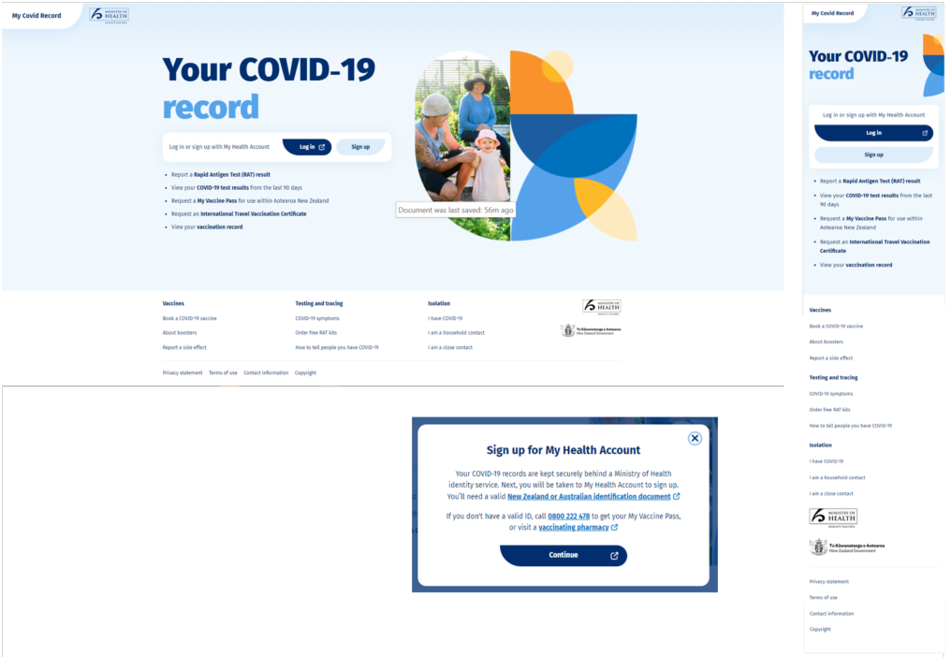

Logged In – Level 1 dashboard
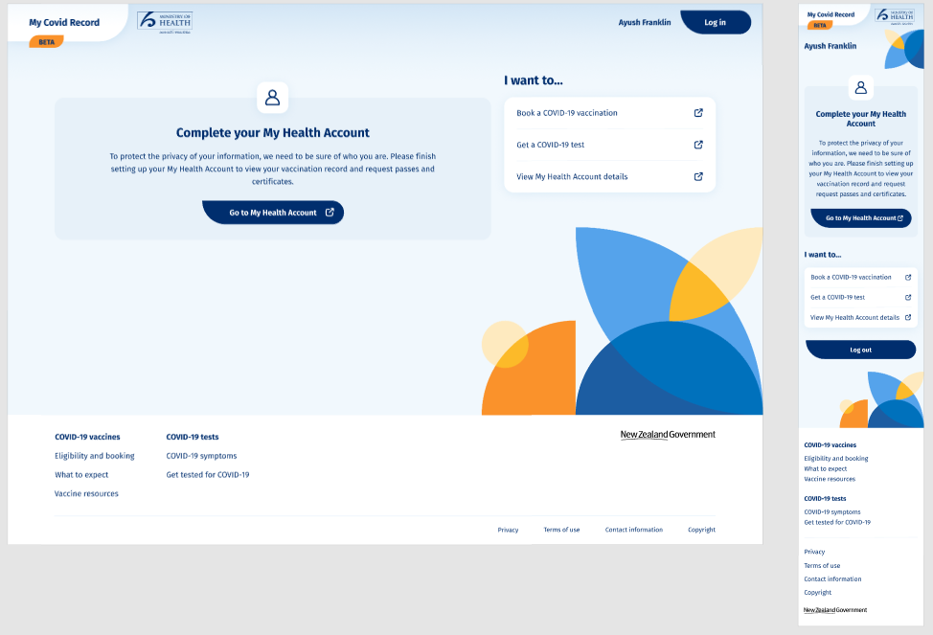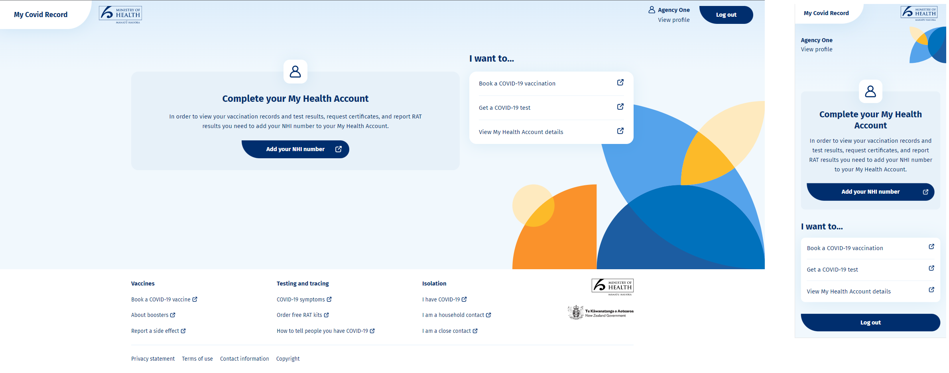The My Health Account processes are covered under a specific PIA and are not further addressed in this PIA

Logged In – Level 2 dashboard
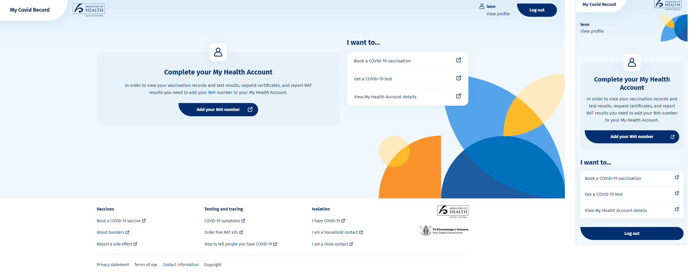

Logged In – Level 2N dashboard
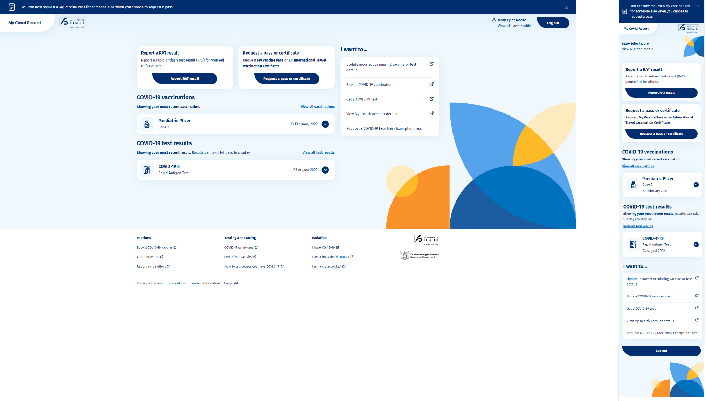

Vaccination module - no vaccination record
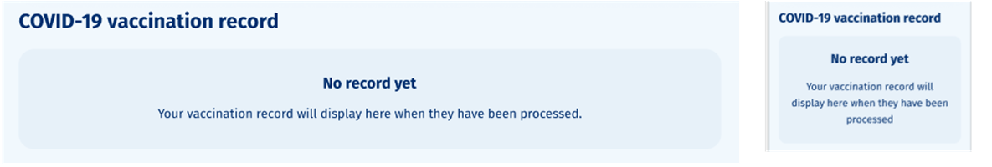
Test result module - No results
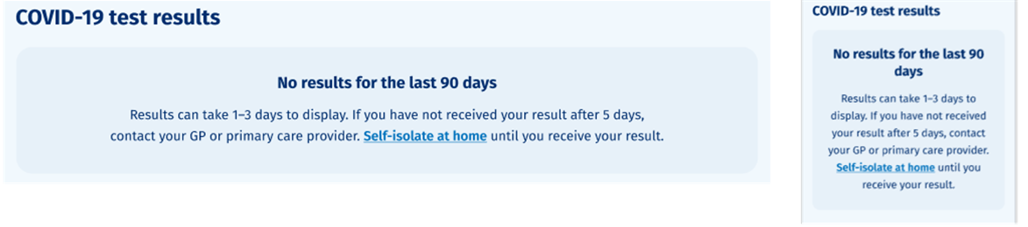

Logged In – Level 2N Vaccination screen
If the Consumer selects “View all vaccinations” the Vaccination screen is displayed, displaying all COVID-19 immunisations for the Consumer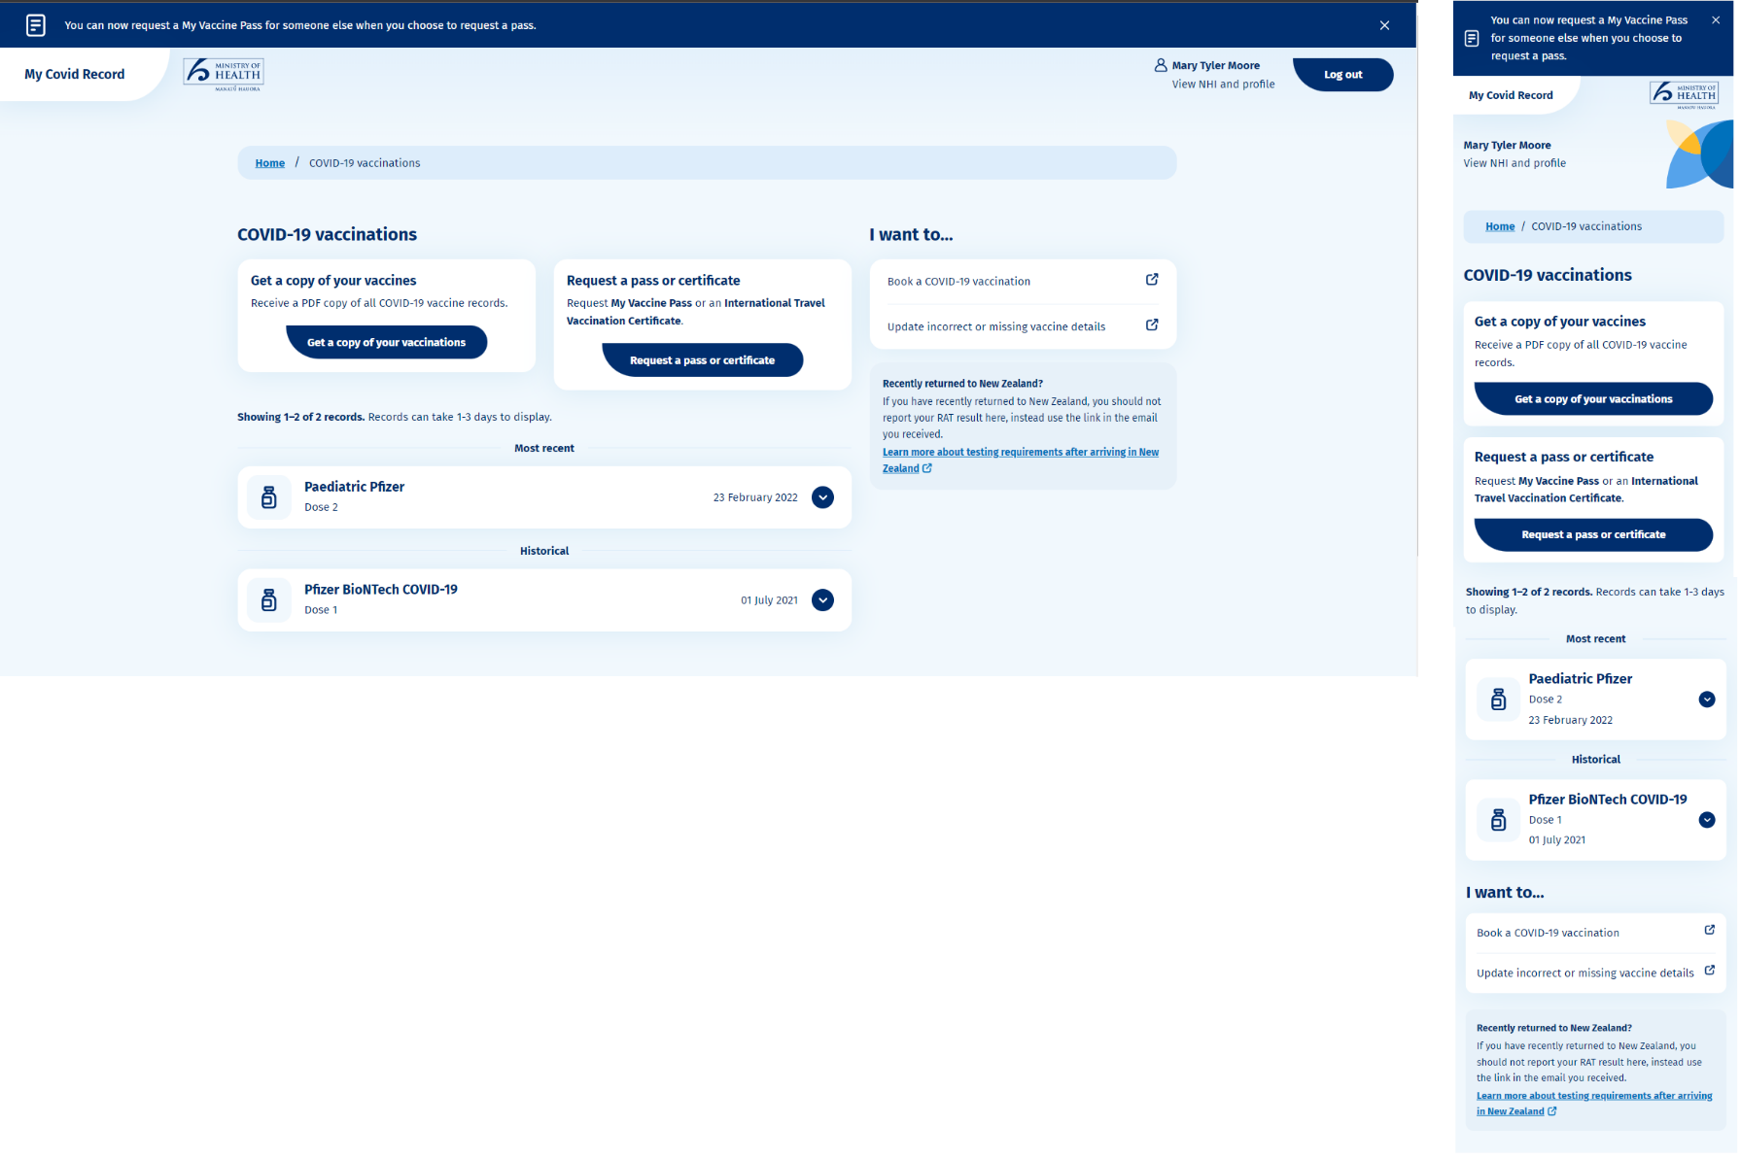

Vaccination record (expanded)

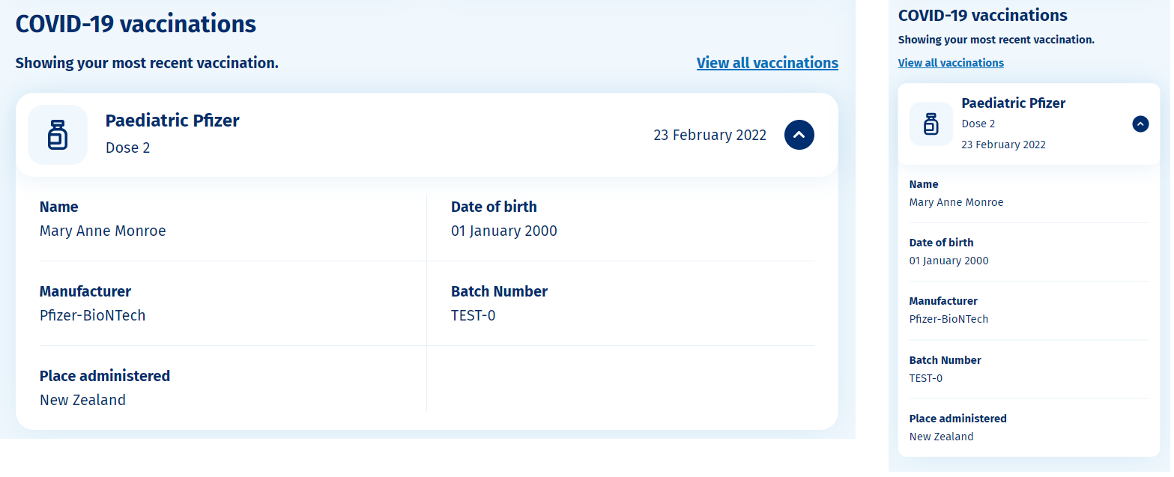

Logged In – Level 2N Test results screen
If the Consumer selects “View all test results” the Test results screen is displayed, displaying COVID-19 test results from the past 90 days
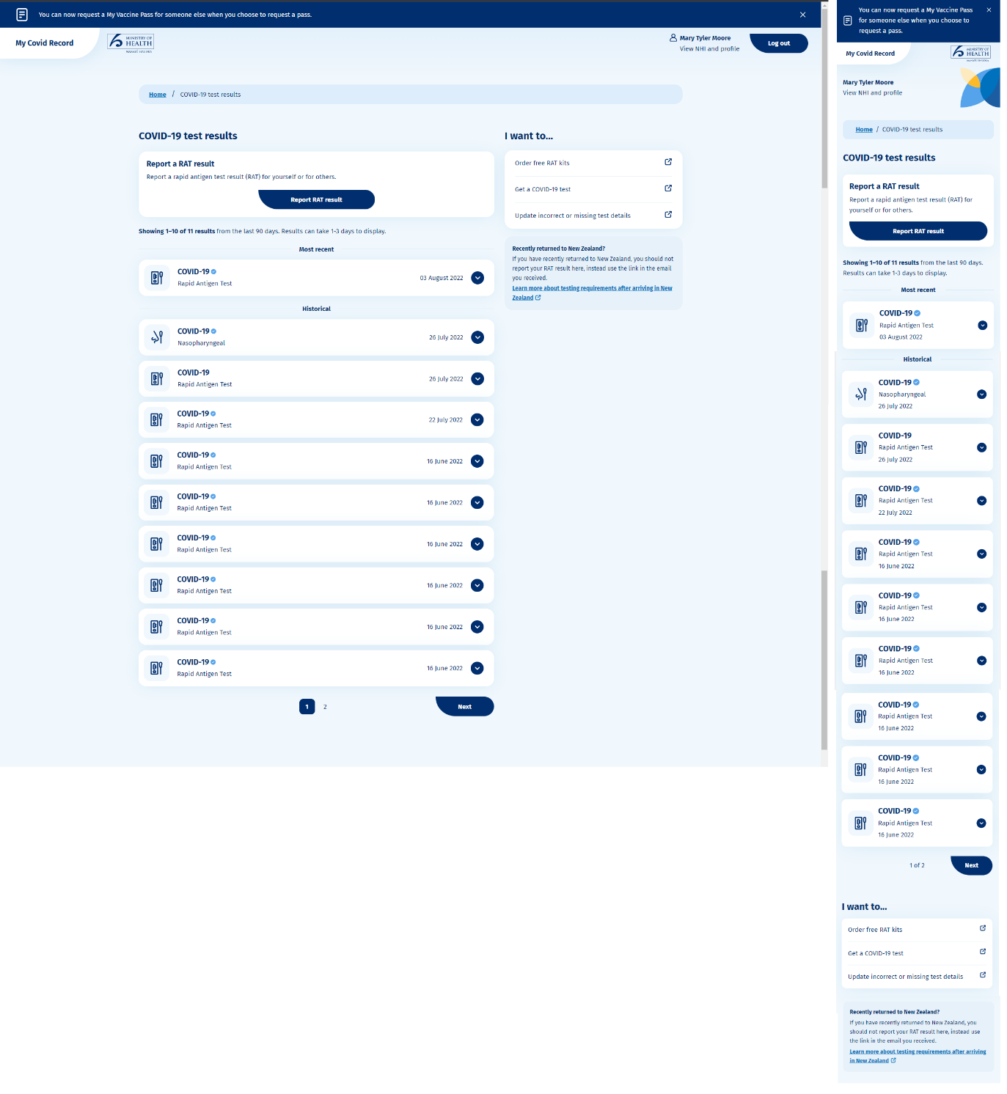

Test result (expanded)
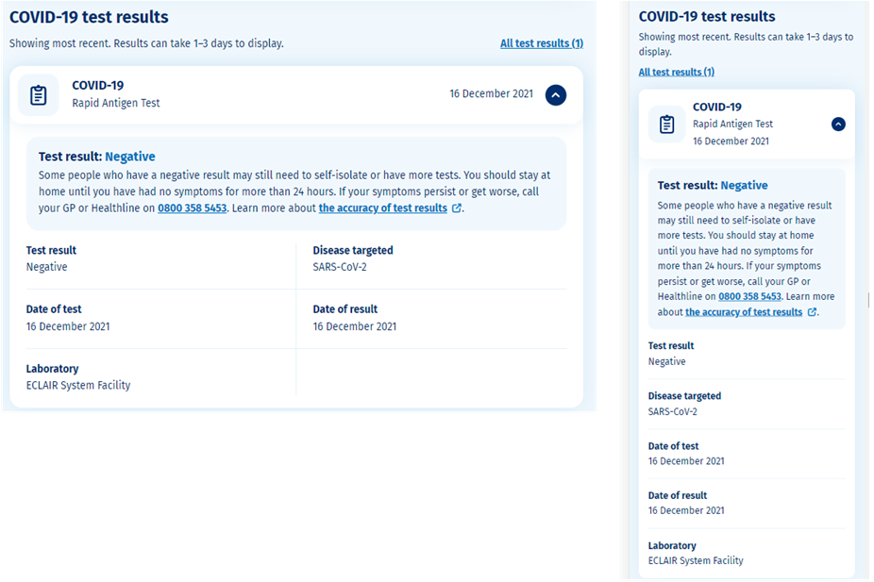

Logged In – Level 2N (Self-report Rapid Antigen Test (RAT) flow)

Self-report RAT landing page (Authenticated)
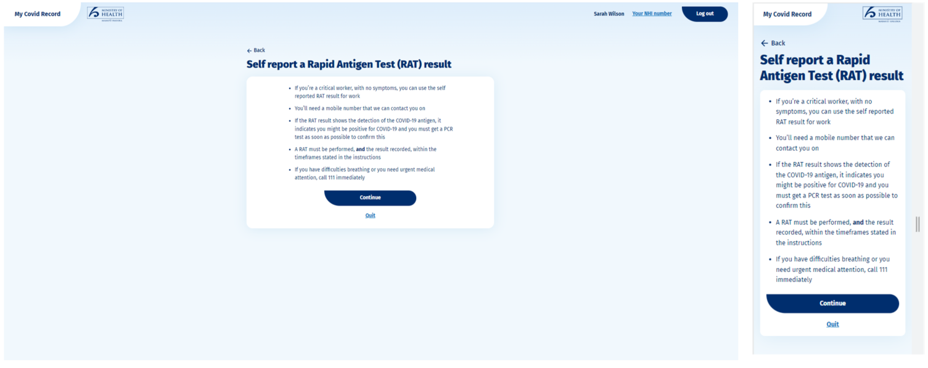

Self- report RAT enter details page (context = myself)
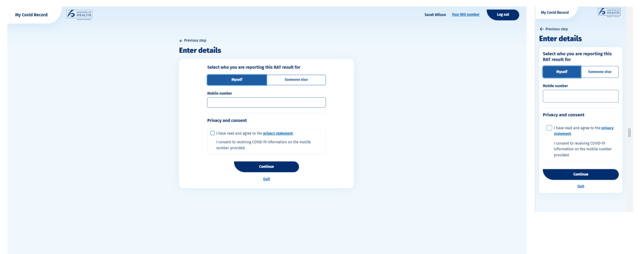

Self- report RAT enter details page (context = someone else)
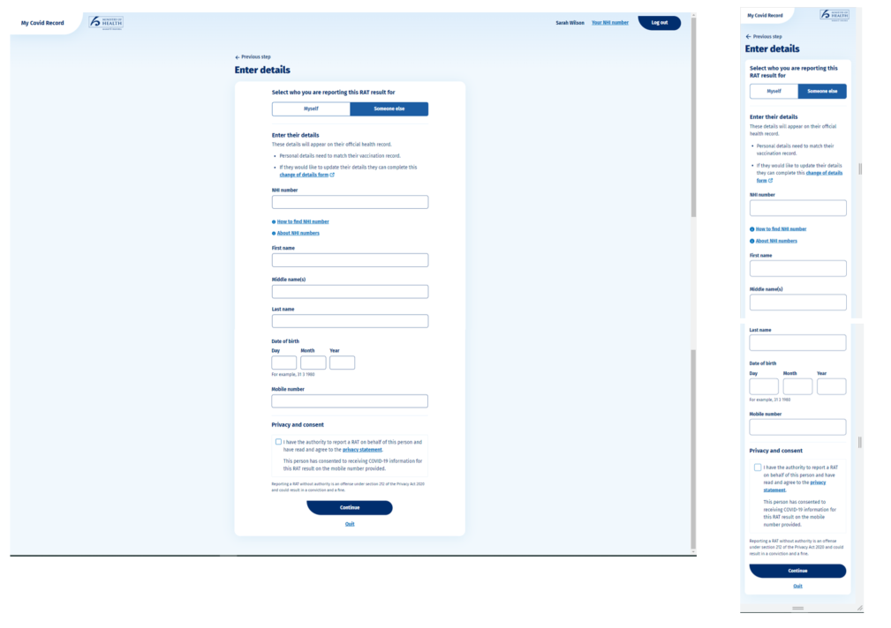

Self-report RAT report result page 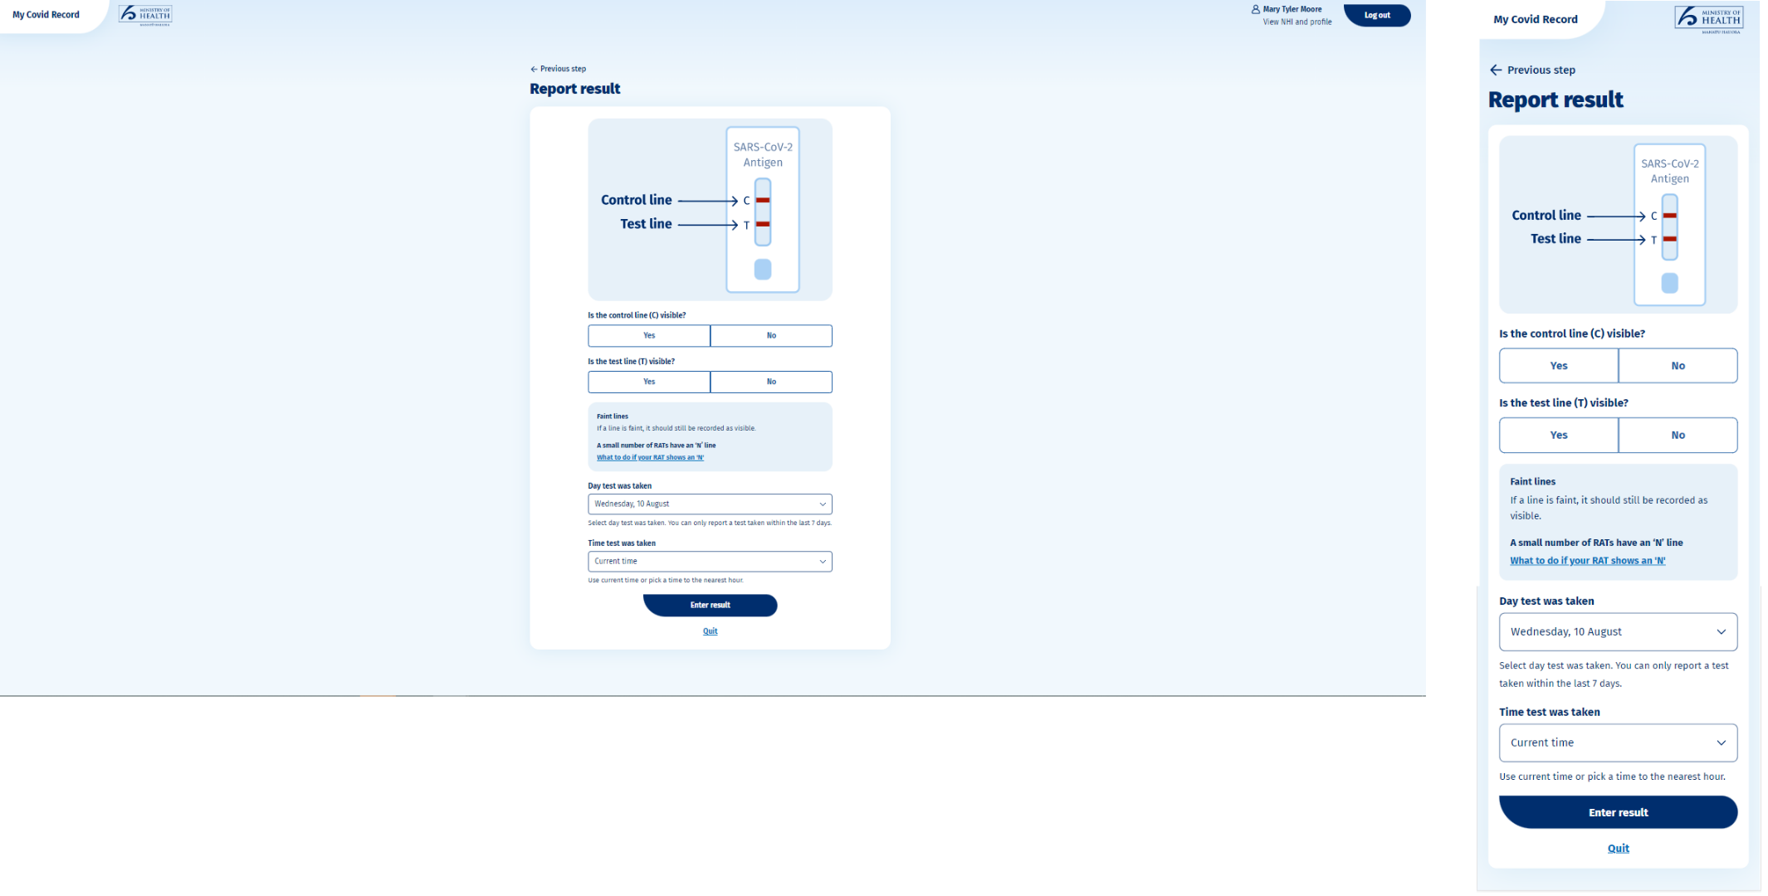
Enter result pop-up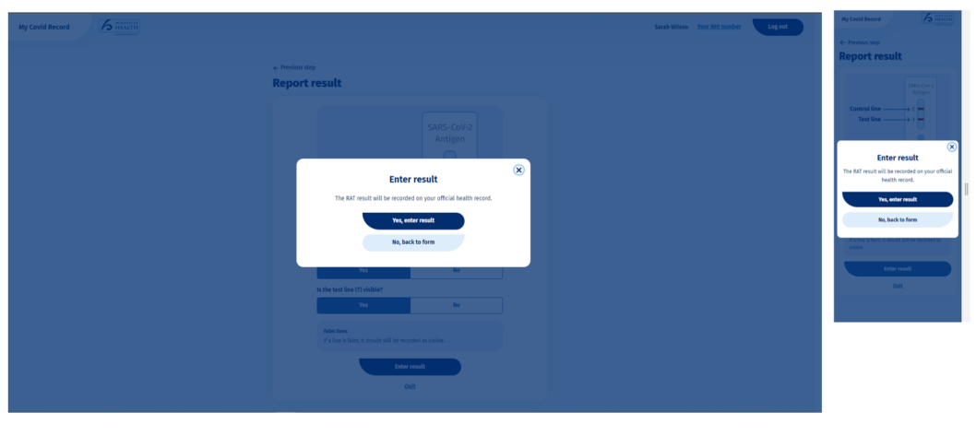

RAT result page (detected, not detected and failed) 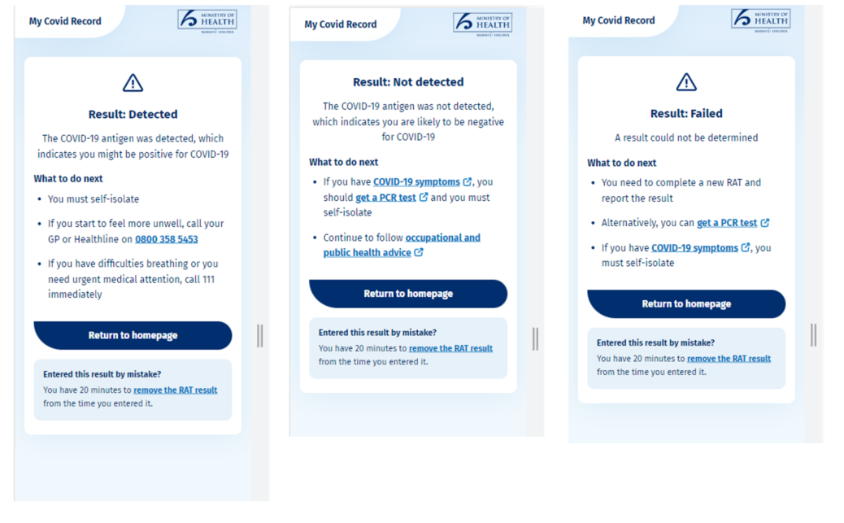

Remove RAT pop-up
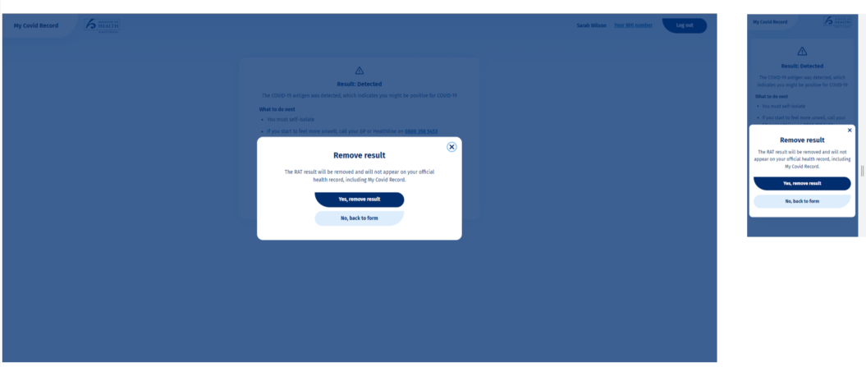
RAT result removed page 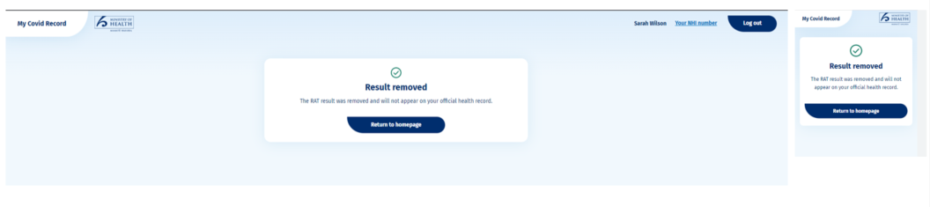
RAT result page

Logged In – Level 2N dashboard (Vaccine passes and certificates flow)

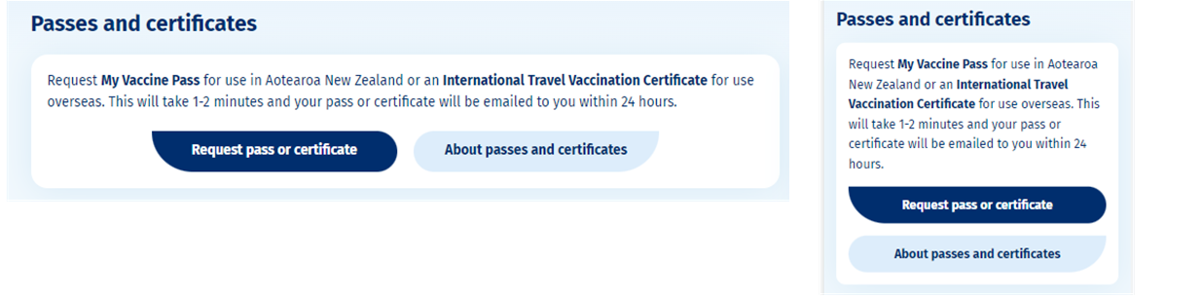

About passes and certificates
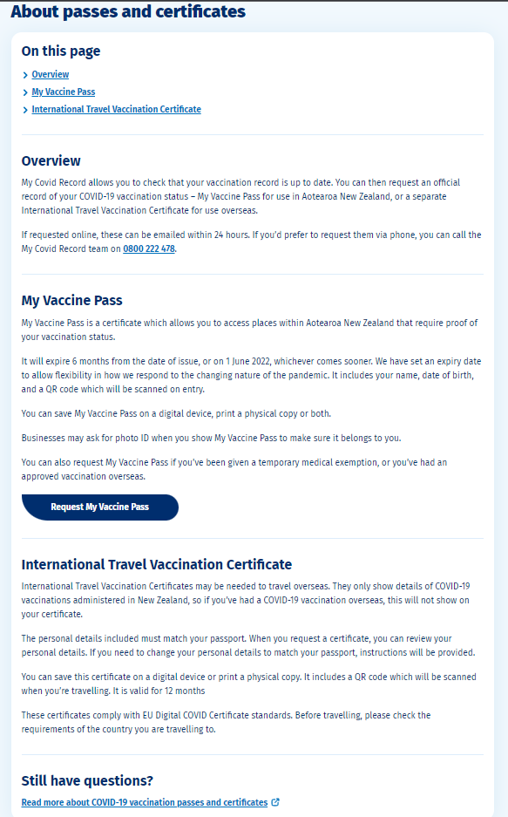

Request a pass or certificate
Enter details (on entry)
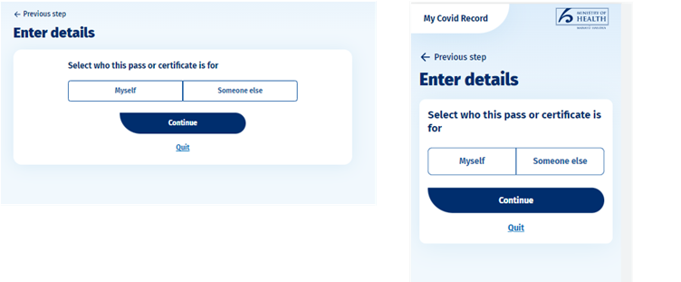

Enter details (My Vaccine Pass for myself)
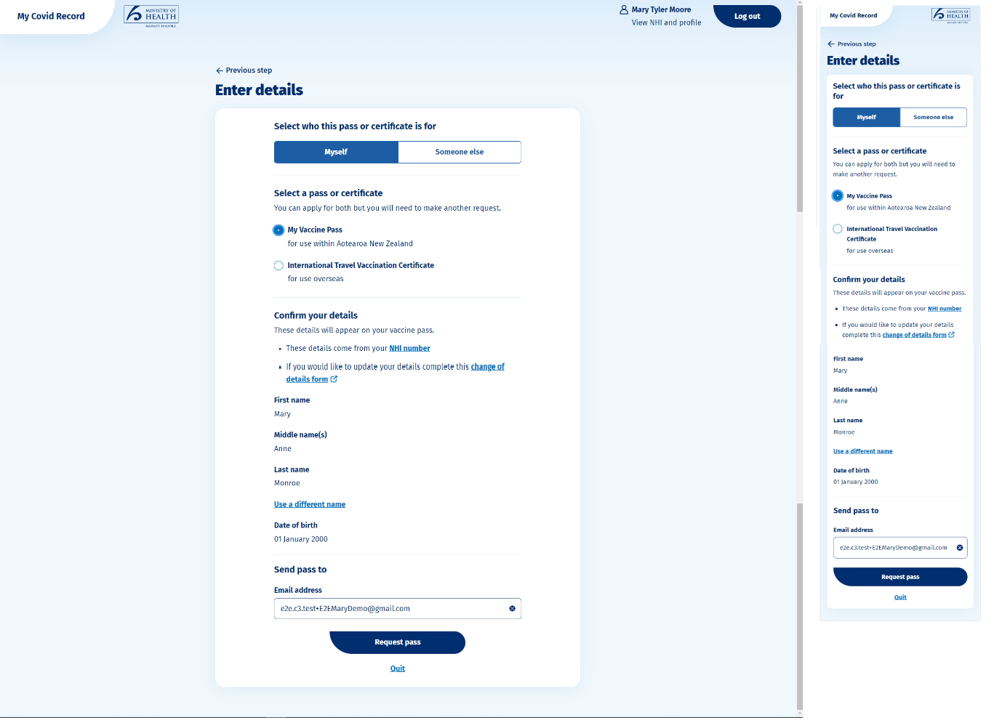
If the Consumer selects to use a different name when requesting a My Vaccine Pass, International Travel Vacciantion Certificate, copy of their vacciantion record
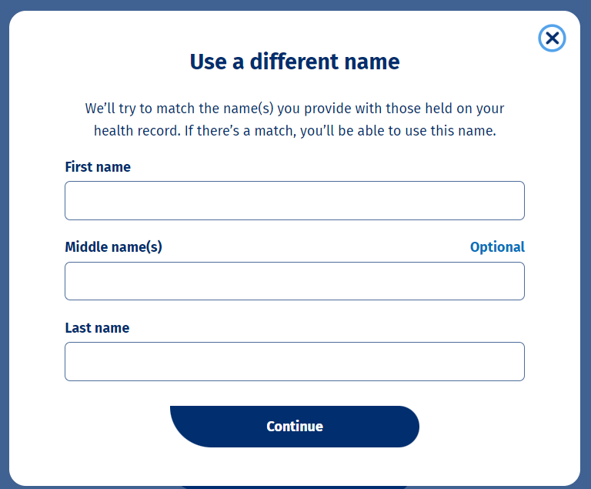

Enter details (International Travel Vaccination Certificate on behalf of someone else)
Your request was successfully submitted (My Vaccine Pass for myself)
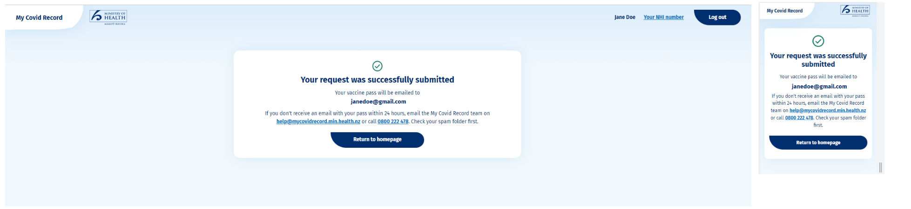
Your request was successfully submitted (International Travel Vaccination Certificate for myself)
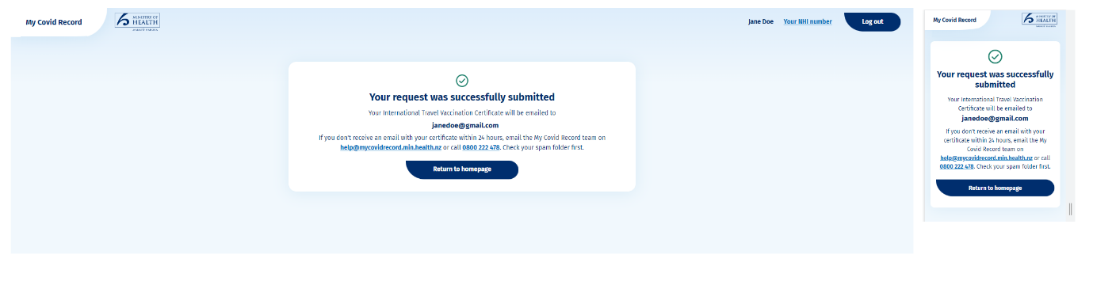

Your request was successfully submitted (for someone else)
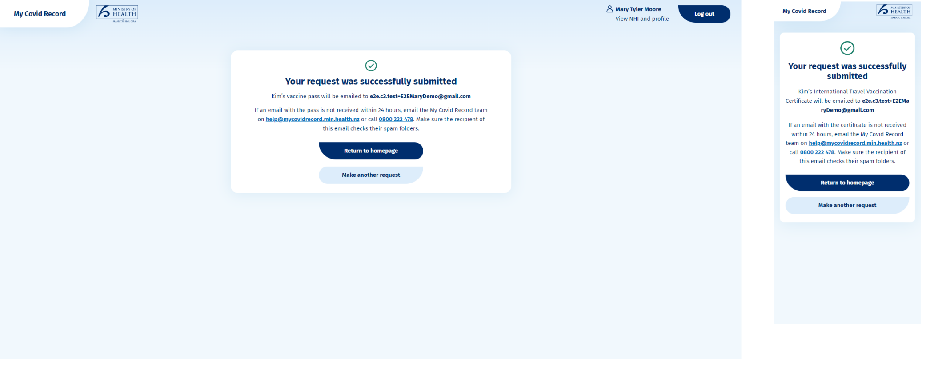

Logged In – Level 2N (Get a copy of your vaccinations flow):

Get a copy of your vaccinations
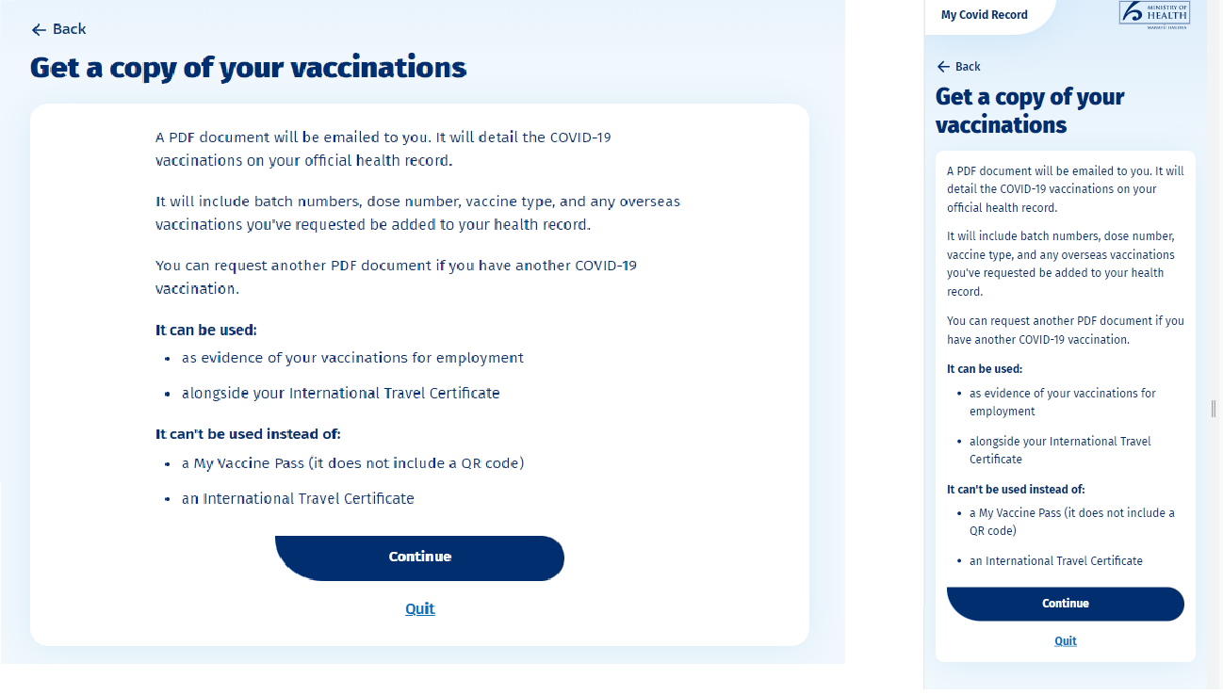
Enter details
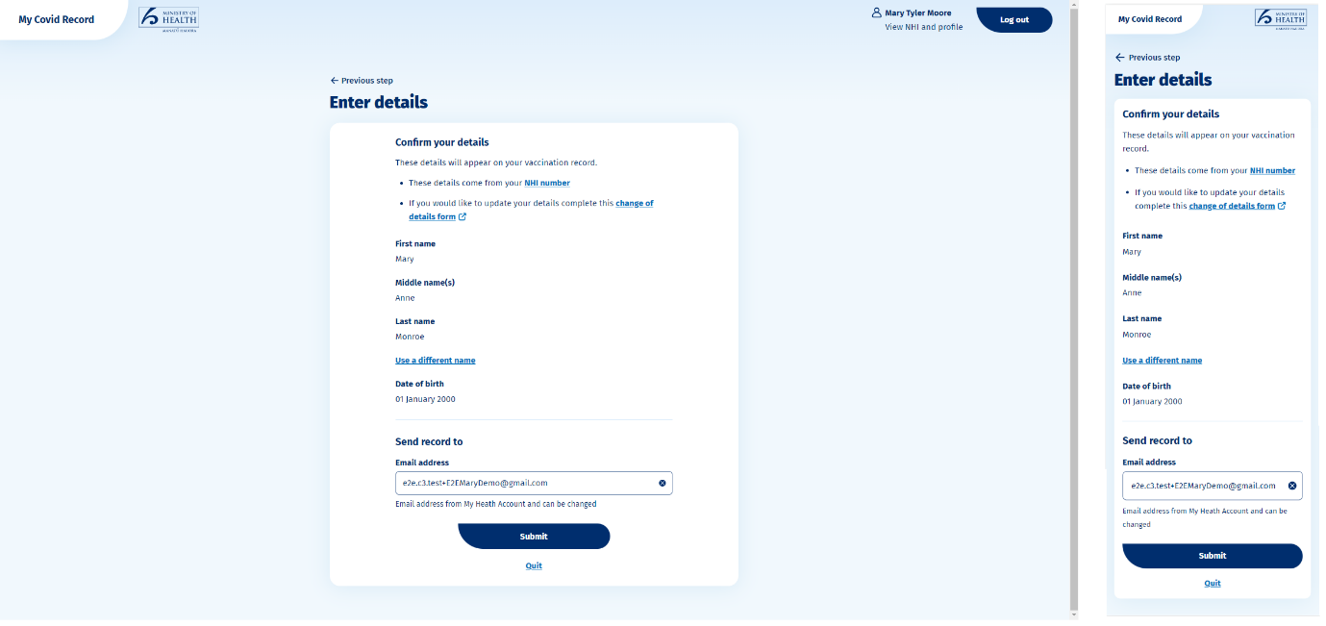

If the Consumer selects to use a different name when requesting a copy of their vaccination record
Request successfully submitted
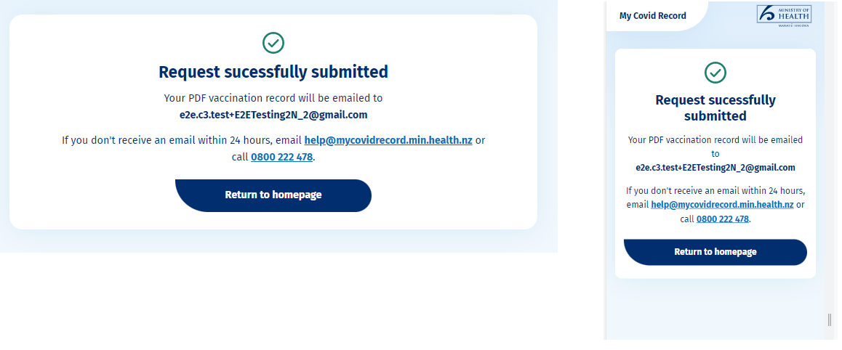

Logged In – Level 2N (Request Face Mask Exemption Pass flow)

Face Mask Exemption Pass landing page (Authenticated)
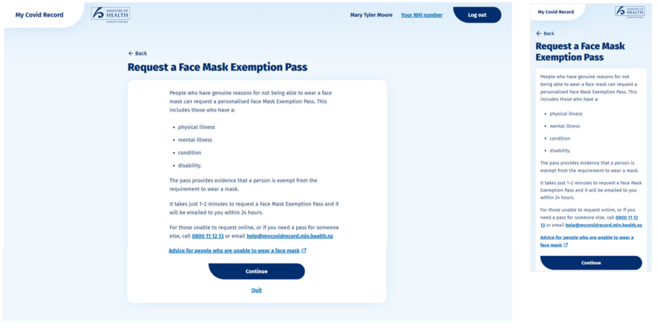

Face Mask Exemption Pass reason(s) page
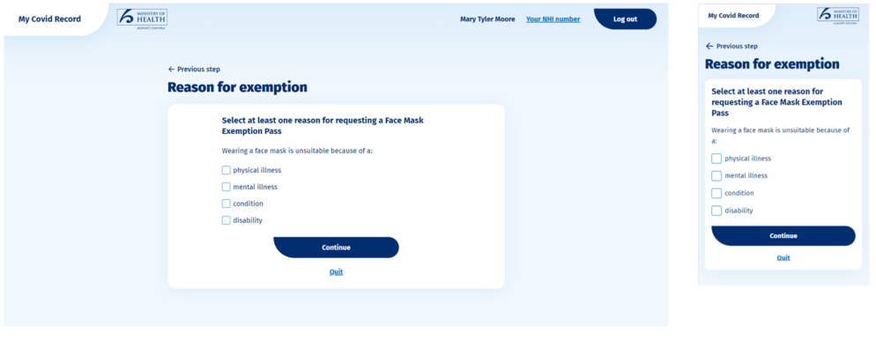

Face Mask Exemption Pass enter details page
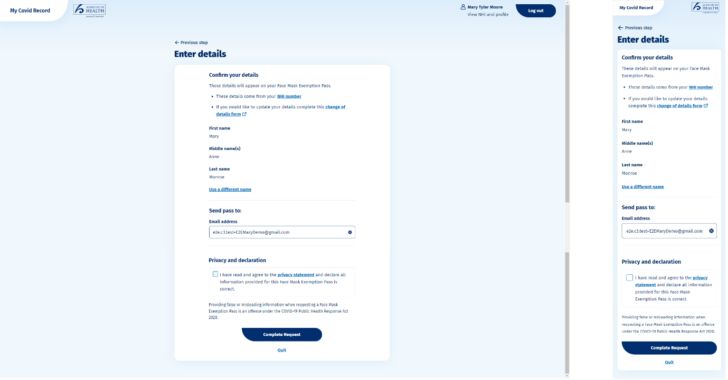

If the Consumer selects to use a different name when requesting a My Vaccine Pass, International Travel Vacciantion Certificate, copy of their vacciantion record or Face Mask Exemption Pass for “Myself”

Face Mask Exemption Pass success page
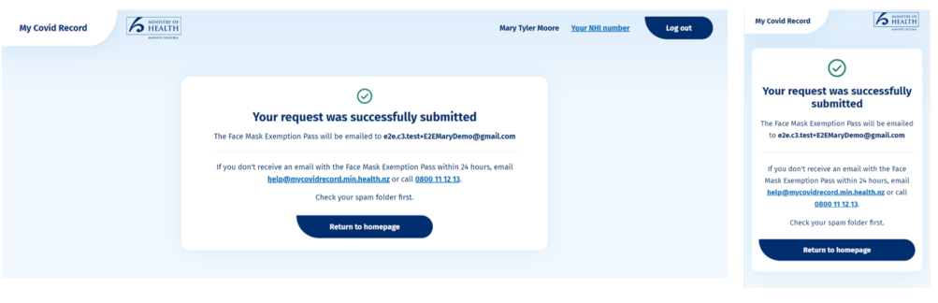

Logged in – Level 1, 2 and 3 profile screen
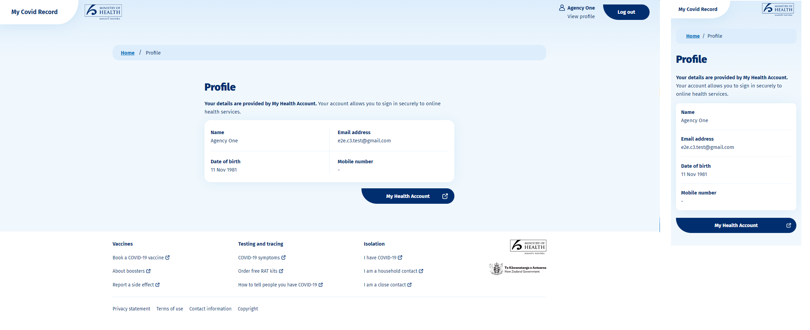

Logged in – Level 2N screen
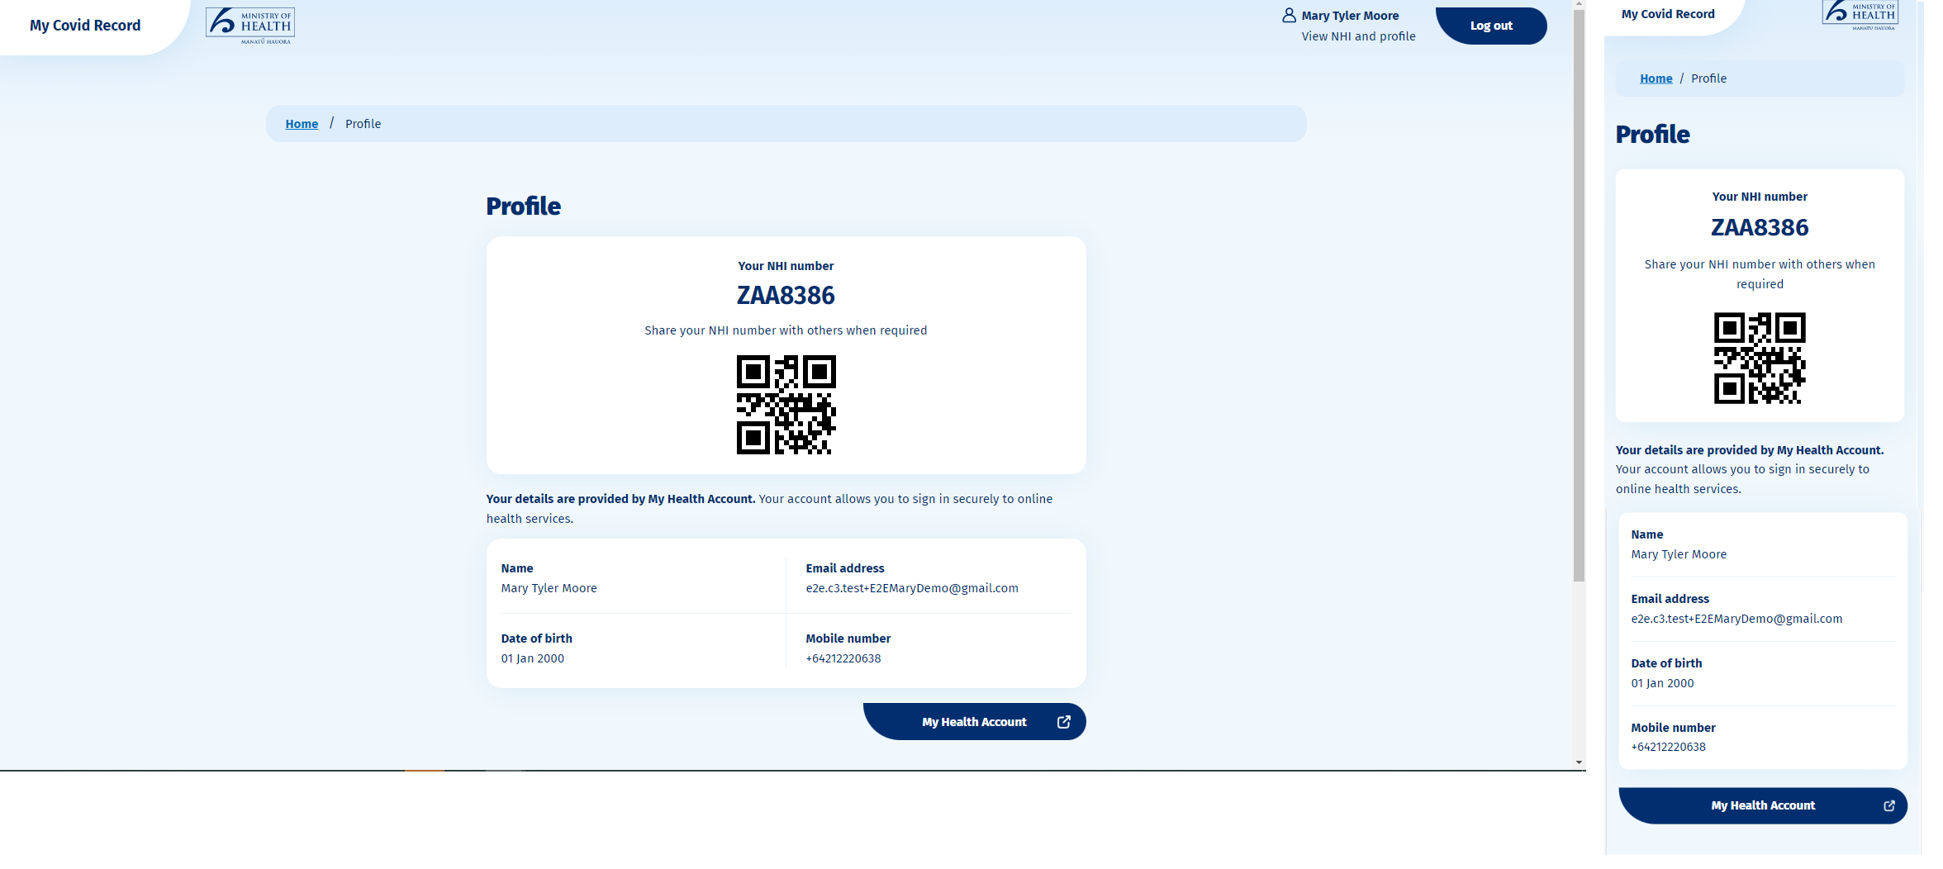

Appendix Two – Draft Privacy statement
Privacy statement – My Covid Record
My Covid Record is a website owned by the Ministry of Health. Find out what personal information is collected if you use My Covid Record, where it’s kept, and who can access it.
About My Covid Record
Through the My Covid Record website you can view your COVID-19 test results, self-report your Rapid Antigen Tests (RATs), view and get a copy of your COVID-19 vaccination record, and request a My Vaccine Pass, International Travel Vaccination Certificate or Face Mask Exemption Pass.
In order to use My Covid Record, you first need to create a My Health Account – part of this process is having your identity verified.
Registration for My Covid Record is voluntary.
How we use your information
My Covid Record uses your My Health Account login and password to confirm it’s you, so it can display your COVID-19 health information.
Rapid Antigen Tests (RAT)
If you report a Rapid Antigen Test (RAT) result, we will keep these details in our testing systems. You may also report RAT results for another person if you have their permission to do so. Details we keep include the date the RAT was self-reported, the test result, the NHI and the My Health Account that the RAT was self-reported from, as well as the contact details you provide to My Covid Record.
Positive RAT results
If a positive result is reported, the personal details of that person the result was reported for, may be shared with the Contact Tracing Team, the GP the person is enrolled with, and the Care in the Community team (this is the team that is working to support COVID-19 cases and their household members).
My Vaccine Pass and International Travel Certificates
You can request a My Vaccine Pass or International Travel Vaccination Certificate for yourself, or for another person if you have their permission to do so and you are each eligible for a pass or certificate (certificate).
Your vaccination record
As well as viewing your vaccination record, you can also get a copy of it. The PDF document details the COVID-19 vaccinations included on your official health record.
Face Mask Exemption Passes
You can request a Face Mask Exemption Pass for yourself if you have genuine reasons for not being able to wear a face mask. The personalised exemption pass is conclusive evidence that the pass holder is exempt, and will help access businesses and services where a mask is required.
Advice for people who are unable to wear a face mask.
Privacy
If you request a pass, certificate, a copy of your vaccination record or a Face Mask Exemption Pass, we will keep an audit log record to enable investigation of any query about the legitimacy. This will include a unique identifier of the person it was requested by, if you have requested a different NHI name, and the person it’s for if it is a different person. If the request is for a Face Mask Exemption Pass, the reason(s) as to why a wearing a face mask is unsuitable will also be logged.
Other audit log details will include when it was requested, the type of document, whether it is for an exemption/exception, the method by which the certificate was requested, how it was delivered to the requester, and the certificate identifier if applicable.
We will also use the information you submit for internal Ministry of Health statistical reporting (you will not be identified in any such reports produced).
Booking a vaccination – connecting you to Book My Vaccine
When you’re viewing your vaccination record in My Covid Record, there may be a button encouraging you to book a vaccine or a booster. Clicking this button may share some of your details with the ‘Book My Vaccine’ booking system – another website owned by the Ministry of Health. This makes the booking process much quicker.
Steps taken to protect your privacy
We take your privacy seriously. The Privacy Commissioner and the Government Chief Privacy Officer have both advised on the development of My Covid Record.
A Privacy Impact Assessment (PIA) that describes this Service and the technology it uses has been completed. The PIA is updated when new features and functionality as they become available.
Privacy Impact Assessment
Keeping your information secure
Your personal information will be held and managed in accordance with the Privacy Act 2020 and Health Information Privacy Code 2020.
Any information you provide to the Ministry of Health will be shared as set out in this Privacy Statement but will otherwise not be shared with other Government agencies without your consent. It will not be used for enforcement purposes unless there is evidence of fraudulent use of the services within My Health Account or My Covid Record, or breach of any COVID-19 related legal requirements.
Information you choose to share with us will be held securely in compliance with Ministry standards and the New Zealand Privacy Act 2020 including the Health Information Privacy Code. Security measures are in place to protect your information from unauthorised access.
In order to deliver My Covid Record we use Amazon Web Services in Australia. Use of other third-party services is detailed in the current Privacy Impact Assessment.
How long information is kept
My Covid Record displays your COVID-19 vaccination and test result information from other Ministry source systems.
Information retained for audit and reporting purposes, will be retained until the repeal of the COVID-19 Public Health Response Act 2020, or in accordance with international requirements for the International DCC.
You can remove access to the Service by calling the My Covid Record Team on 0800 222 478 and requesting that your My Health Account is deleted.
Keeping your account safe
Do not share your My Health Account with other people and keep your My Health Account password safe.
Use of screen lock on a device you use to access your My Health Account is recommended.
If you believe your password may have been compromised, please change it. If you believe your My Health Account has been compromised, please call 0800 222 478 as soon as you can.
Viewing and changing your information
If you’d like to view or change the personal information held by the Ministry of Health about you, or if you have any questions your personal information email information@identity.health.nz , or write to:
The Privacy Officer
Ministry of Health
PO Box 5013
Wellington
We may require proof of your identity before being able to provide you with any personal information.
When you contact us, any information you provide regarding your identity and the Service you’re contacting us about, will be collected.
Incorrect vaccine or test result details
If you think the details of your vaccinations or test results are incorrect, email help@mycovidrecord.min.health.nz or call the Contact Centre on 0800 222 478.
Statistical information
We may collect statistical information to help us improve the Service and understand how it is being used. This information is aggregated and doesn't identify you personally. Full details about the statistical information collected is addressed in the PIA.
Information collected for statistical purposes will not be linked to the personal information you provide or the profile you create.
Contact
Feedback
Feedback is important and is used to evaluate and improve My Covid Record.
- Phone 0800 222 478 8am to 5pm Monday to Friday
- Email help@mycovidrecord.min.health.nz
If you provide feedback by email, the email will be sent to the appropriate Ministry of Health staff. This could include your email address and other identifying information that you have provided.
Privacy concerns
Email help@mycovidrecords.min.health.nz
If you are not satisfied with the response to any privacy concern you can contact the Office of the Privacy Commissioner.
Contact the Office of the Privacy Commissioner
Updates to this Privacy Statement
This Privacy Statement will be updated to let you know about changes in how we collect and process your information or changes in related laws.
The date when the document was last updated is shown on this Privacy Statement.
Last updated 23 August 2022

Appendix Three –Terms of use
My Covid Record terms of use
If you choose to use My Covid Record you will need to accept some terms of use – these form an agreement between you and the Ministry of Health.
What you are agreeing to
By accepting these terms, you understand and agree:
- your age must be 12 years and above to use My Covid Record
- provided you have successfully logged in we will act on your instructions without further enquiry
- to use My Covid Record, you must also register for a My Health Account, and the terms of use for My Health Account will also apply to you – you can access those when you register for a My Health Account.
- you consent to us using your validated My Health Account so we can access the information we hold and display agreed information to you
- if you enter a Rapid Antigen Test (RAT) result, the information you enter is true and correct
- if you enter a detected (positive) Rapid Antigen Test (RAT) result, the contact tracing process may be activated, and you may be contacted
- if you enter a Rapid Antigen Test (RAT) result on behalf of someone else, you must have the legal authority to do so, or have obtained permission of the person concerned. – If you enter a detected RAT result, the contact tracing process may be activated, and that person may be contacted
- if you request a My Vaccine Pass or International Travel Certificate on behalf of someone else, you have the legal authority, or have obtained permission of the person concerned, to do so
- if you request a Face Mask Exemption Pass on behalf of someone else, you have the legal authority, or have gained permission of the person concerned to make the declaration that they have a physical illness or mental illness or condition or disability that makes wearing a face mask unsuitable
- you cannot use a Face Mask Exemption Pass relating to another person, or knowingly let someone else use a Face Mask Exemption Pass belonging to someone else
Your My Health Account login is valuable and confidential. It authenticates your online identity so you can use My Covid Record. You must take good care of the login details you create (email address and password) and keep them secure.
By using My Covid Record you agree to:
- notify the My Covid Record Team on 0800 222 478 immediately if you know, or have reason to believe, that there has been or is about to be fraudulent or other unlawful use of your login.
- immediately change your password and notify the My Covid Record Team on 0800 222 478 if you believe the security of your password has been compromised or if you are aware of any unauthorised use of your My Health Account login.
Anyone who knowingly accesses or uses, or attempts to access or use, My Covid Record for an unlawful purpose may be liable to prosecution under New Zealand Law. This includes:
- fraud or attempted fraud or hacking or attempted hacking or seeking a My Vaccine Pass, International Travel Certificate or Face Mask Exemption Pass on behalf of another person without legal authority or their permission,
- reporting a RAT on behalf of another person without legal authority or their permission.
If you would like support using My Covid Record email help@mycovidrecord.min.health.nz.
Disclaimer
Except where we have an explicit legal obligation under New Zealand legislation we disclaim and exclude all liability for any claim, loss, demand, or damages of any kind whatsoever (including for our negligence) arising out of or in connection with the use of either My Covid Record, or the information, content or materials included on My Covid Record, any pass or certificate generated by use of My Covid Record or any linked website.
It’s your responsibility to provide accurate information, and we are entitled to rely, without making further inquiry, on information provided by you or any third party you choose to interact with via this Service.
International Travel Vaccination Certificates
The format of the International Travel Vaccination Certificate generated by My Covid Record will comply with the EU Digital COVID Certificate (EUDCC) Framework and will provide digital proof that you have been vaccinated against COVID-19.
However, it will be the authorities managing the border in each country you travel to that will be the responsible decision maker as to whether you can enter that country, or any conditions that will apply to your entry.
Not all countries will accept the International Travel Vaccination Certificate generated through My Covid Record. It is your responsibility to ensure you have all necessary travel documents, and that you have confirmed the International Travel Vaccination Certificate will meet your travel requirements.
You are solely responsible for ensuring the name and identification details contained in your certificate are accurate and reflect any other travel documentation you hold.
The Ministry of Health has no liability for any cost, time delay, or refusal of entry to any other country when you use an International Travel Vaccination Certificate produced from My Covid Record.
Continuity of service
We will make reasonable efforts to keep My Covid Record operational at all times, but we make no warranty or representation, express or implied, as to continuity of the service.
We reserve the right to suspend, terminate, or otherwise alter access to some or all of the services at any time and without notice if we consider that:
- this is necessary to maintain the integrity or security of My Covid Record or related services; or
- your login is being misused or has otherwise been compromised; or
- you breach these terms; or
- we decide to remove or reduce the services available.
Changes to the terms of use
We may revise these terms of use at any time. Revisions take effect when published to our website.
Security
You must not modify, distribute, alter, tamper with, repair, or otherwise create derivative works of My Covid Record unless expressly permitted.
You must not reverse engineer, disassemble, or decompile My Covid Record or apply any other process or procedure to derive the source code of any software included in the Services (except to the extent applicable law doesn’t allow this restriction).
My Covid Record has been, and will continue to be, subjected to independent security audits. If you discover a potential security vulnerability or suspect a security incident related to this service, email to itsecurity@identity.health.nz, or by following the disclosure process on cert.govt.nz.
Last updated 31 May 2022

Appendix Four – My Vaccine Pass
The My Vaccine Pass is issued by the automated electronic system accessed via My Covid Record. A person is eligible to apply for a My Vaccine Pass if they have been vaccinated, recently infected or are an exempt person.
The Protection Framework Order sets out the situations in which the My Vaccine Pass must not be required. Most businesses have the option of limiting access to their premises to people with a My Vaccine Pass (as a condition of entry) but this is no longer a requirements under the rules.

If an application is made by an eligible person (vaccinated, exempt or recently infected) and they have provided complete and correct information a My Vaccine Pass will be generated via My Covid Record. My Vaccine Pass will include evidence of the Consumer’s full name and date of birth (but no other personal information). If the Consumer is requesting a My Vaccine Pass for themself, they can request the pass contains any name that can be matched with a name stored against their NHI number. The Pass will also contain the expiry date dependent on the Consumer’s eligibility:
  - if the Consumer is up to date with vaccination doses, their pass expiry date will be 180 days from date of request; or
  - if the Consumer under 18 years and 30 days old, and has had their primary vaccination dose, their pass expiry date will be when they reach 18 years and 30 days OR 180 days from date of request – whichever is sooner; or
  - if the Consumer has been recently infected with COVID-19, their pass expiry date will be 130 days from date of infection; or
  - if the Consumer has a temporary medical exemption that expires less than or equal to 30 days in the past, their pass expiry date will be the temporary medical exemption expiry date plus 30 days OR 180 days from date of request – whichever is sooner.

The QR Code incorporated into the My Vaccine Pass will confirm the name, date of birth and expiry date if scanned.
Process for obtaining My Vaccine Pass
Using My Covid Record a Consumer will be able to request that My Vaccine Pass is generated and emailed to them (to the email address associated to their My Health Account). The PDF of My Vaccine Pass will not be returned to or stored by My Covid Record.
- Relevant information will be temporarily retained by NIA (NHI and email address for operational logging and debugging).
- Audit and security logs however will be maintained on the MATTR platform in case of need for enforcement purposes or to verify the legitimacy of a pass issued. This will include NHI, certificate type – My Vaccine Pass or International DCC – if person is Vaccinated or has an Exemption, the method by which the certificate was delivered and the unique certificate identifier.
- A copy of this information will also be retained within the Ministry data warehouse and analytics tool, Snowflake to be used for reporting and analytical purposes.
The certificate generation processes are addressed in more detail in the NIA API Privacy Impact Assessment.
Once My Vaccine Pass has been emailed to the Consumer, this information will belong to the Consumer to do with as they choose, within the Terms and Conditions and under relevant legislation. Consumers will be able to download and save My Vaccine Pass to their personal devices and print them as they see fit. They will also be able to download the electronic My Vaccine Pass to a Consumer’s digital wallet via email (Google or Apple).
The My Vaccine Pass will appear as below:
Google or Apple Wallet My Vaccine Pass (the Consumer has the choice to use the wallet for display):
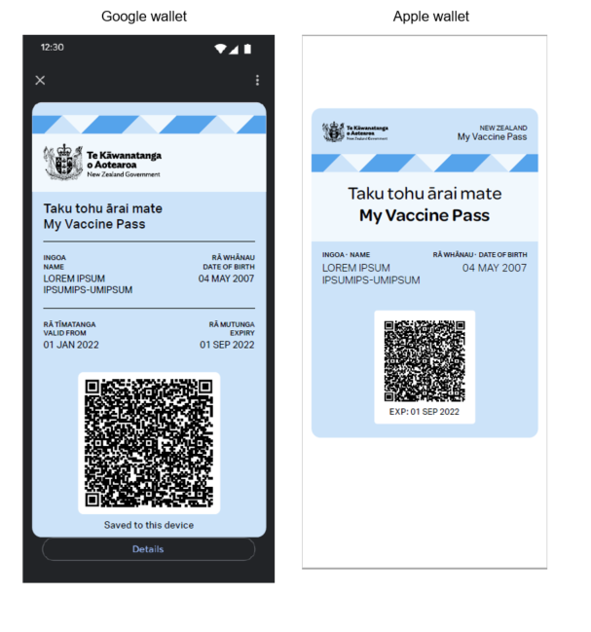
Print at home A4 My Vaccine Pass
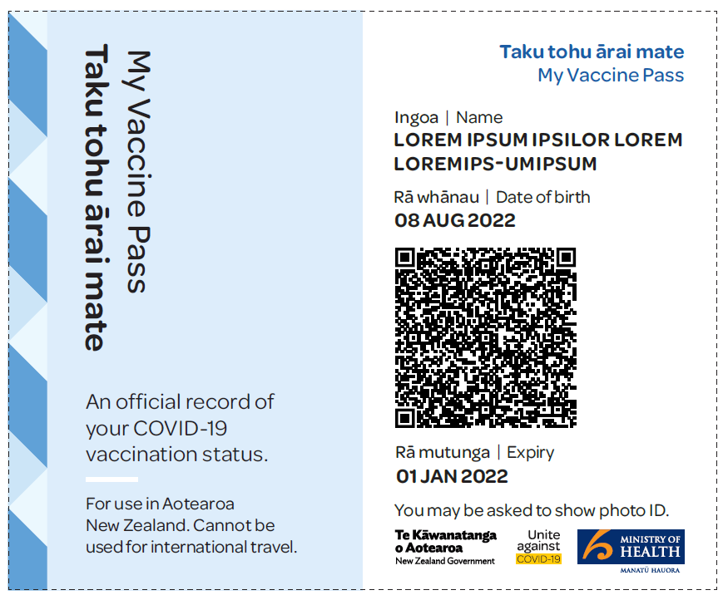
Equity of access and other channels for provision of My Vaccine Pass
To ensure equity of access a Consumer will also be able to request that My Vaccine Pass is generated and distributed to them via assisted channels. These are NIA processes rather than My Covid Record processes. These channels will include a telephone contact centre, and the ability to request a vaccination certificate be issued at a vaccination site (or other site with access to CIR, such as a GP or pharmacy). They will be able to generate a certificate using the CIR (and this can be printed on site, emailed or posted to the Consumer.)
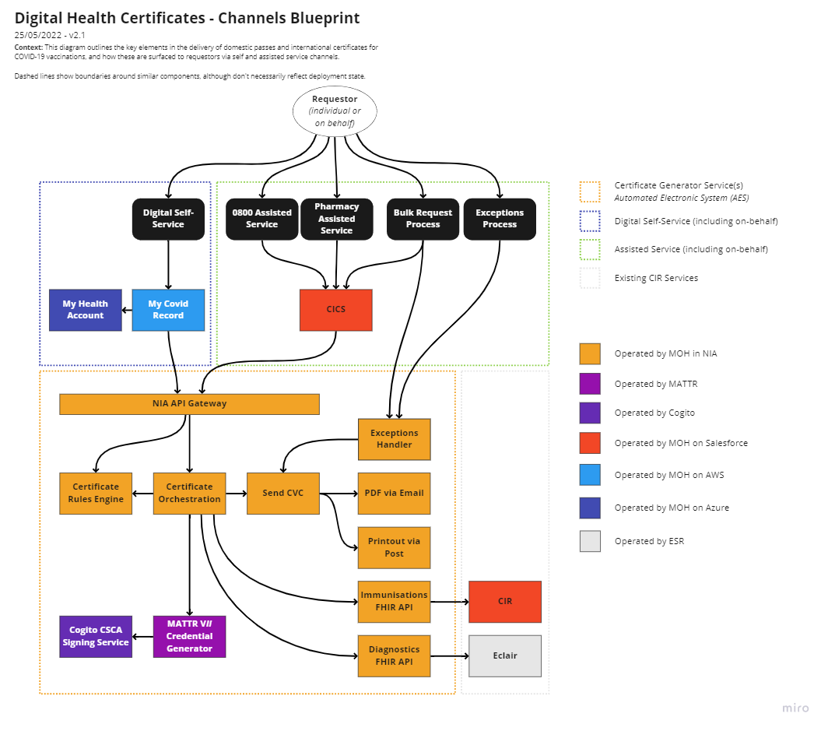

Appendix Four – Annex One: NZ Pass Verifier App description
NZ Pass Verifier, the Verifier App (the App) is available to businesses, venues and event organisers to download, so that they can read the QR code presented in My Vaccine Pass. This will enable them to verify that the My Vaccine Pass displayed is an authentic record of vaccination (it matches the vaccination record of a person who has claimed that identity).
It will also be available for use by any user via the Apple App Store, Google Play, and the Ministry GitHub, to maximise the number of devices that will be able to use it. Terms of Use will apply to any users of the Apple or Google version of the App (as per Annex Two).
The App must check for updates to the security keys at least once every fourteen days or it will be unable to scan. A successful connection to the internet will update the keys and the app will continue to function. The Ministry may also opt to force an update check for the app if necessary, directing users to update the app using the normal process (either Apple or Google store). This will enable frequent updates to terms of use or the QR Code credentials if required.
NZ Pass Verifier App will be able to scan My Vaccine Pass and display a green ‘tick’ to the App user if the QR code confirms the status of the My Vaccine Pass. This will show the Pass is for a Consumer who is either Vaccinated or has an Exemption (the Pass will not distinguish between the two). It will also show the name and date of birth of the Consumer the Pass was issued to.
- The App will only temporarily display the name and date of birth of the individual vaccinated so that the person scanning can identify if the name appearing on the face of the ‘Pass’ is the same as the name embedded in the QR Code.
  - A successful (“Valid”) scan will timeout after a set interval (5 seconds at time of writing). The user may press their finger to the screen to hold the scan in place if they wish to further check details, but on lifting their finger the timeout will continue.
  - An unsuccessful scan remains visible until the display is dismissed by the user.
  - If required by an Order an event organiser would be able to request and view another form of matching ID, so the person presenting the My Vaccine Pass could demonstrate they are the person the pass was issued to.
- No personal details are saved or retained by the NZ Pass Verifier App.
Controls on what situations will be prohibited from requiring proof of vaccination are managed in the Protection Framework Order.
The Android app version has screenshot disabled. The Apple iOS version is being investigated, as the native software does not support disablement of screenshot.
No contact tracing requirements need to be met with the NZ Pass Verifier App.

Appendix Four – Annex Two: Terms of Use for NZ Pass Verifier App
Terms of Use – Draft 15 November 2021
Welcome to the NZ Pass Verifier mobile application (the ‘app’). This is a digital verification app made available by the New Zealand Ministry of Health (‘we’, ‘our’) to anyone who downloads or uses it.
Any use by you of the app is subject to:
- these Terms of Use;
- the Privacy Act 2020; and
- any Orders or other legal requirements that may be in place governing the ability to require presentation of a COVID-19 Vaccination Certificate (a CVC), or verification of the CVC (Orders).
These terms apply to the entire contents of the app, to any web feeds produced by the app, any interactions you may have with the app, any use by you of the app and to any feedback or submissions provided back to the Ministry of Health.
By downloading, viewing and/or using the app, you will be deemed to agree to these Terms of Use.
Agreement to Terms
Your use of the app is governed by New Zealand Law.
If you choose to use this app, these terms will form an agreement between you and us.
By accepting these terms, you understand and agree the app is for the purpose of scanning a My Vaccine Pass, as issued by the NZ Ministry of Health, to assist with complying with then current Orders only, and not for the collection and / or use of information about the presenter of the pass for any unrelated purpose.
To notify the service Contact Centre on 0800 222 478 or help@mycovidrecord.min.health.nz immediately if you know or have reason to believe that there has been or is about to be fraudulent or other unlawful use of the app.
Anyone who knowingly accesses or uses, or attempt to access or use, the service for an unlawful purpose (including but not limited to fraud or attempted fraud or hacking or attempted hacking), may be liable to prosecution under New Zealand Law.
Privacy
No information about the user of the device is collected. Information contained within a pass is not collected or retained by the app.
You must use any personal information about any other person that is accessed by use of the app in accordance with the Privacy Code 2020, and in accordance with any Order requirements.
Disclaimer
Except where we have an explicit legal obligation under New Zealand legislation we disclaim and exclude all liability for any claim, loss, demand or damages of any kind whatsoever (including for our negligence) arising out of or in connection with the use of either this app or the information, content or materials associated with this app or included on this app or on any website we link to.
Continuity of function
We make no warranty or representation, express or implied, as to continuity of function of the app. We reserve the right to suspend, terminate or otherwise alter access to some or all of the app at any time and without notice if we consider that:
- This is necessary to maintain the integrity or security of related capabilities; or
- We decide it is necessary for us to amend or alter the settings for the app; or
- We decide to remove or reduce the functions available in the app.
Revisions of Terms
We may revise these Terms at any time. Revisions take effect when published to our website.
Security
You must not modify, distribute, alter, tamper with, repair, or otherwise create derivative works of the app unless expressly permitted.
You must not reverse engineer, disassemble, or decompile the app or apply any other process or procedure to derive the source code of any software included in the services (except to the extent applicable law doesn’t allow this restriction).
The service has been and will continue to be subjected to independent security audits. If you discover a potential security vulnerability or suspect a security incident related to this service, you can report it to us following the Responsible Disclosure process outlined on our website.
Technical Information
Public technical material about Verification can be found at https://github.com/minhealthnz/nzcovidpass-spec
Information collected:
The app uses Amazon Pinpoint - https://aws.amazon.com/pinpoint/ - for basic broad event collection, supporting simple reporting at country level. The events collected (by date) are:
i. # valid scans
ii. # invalid scans (breakdown by reason not required)
iii. # installs or first opens

Appendix Four - Annex Three: NZ Pass Verifier App – Process
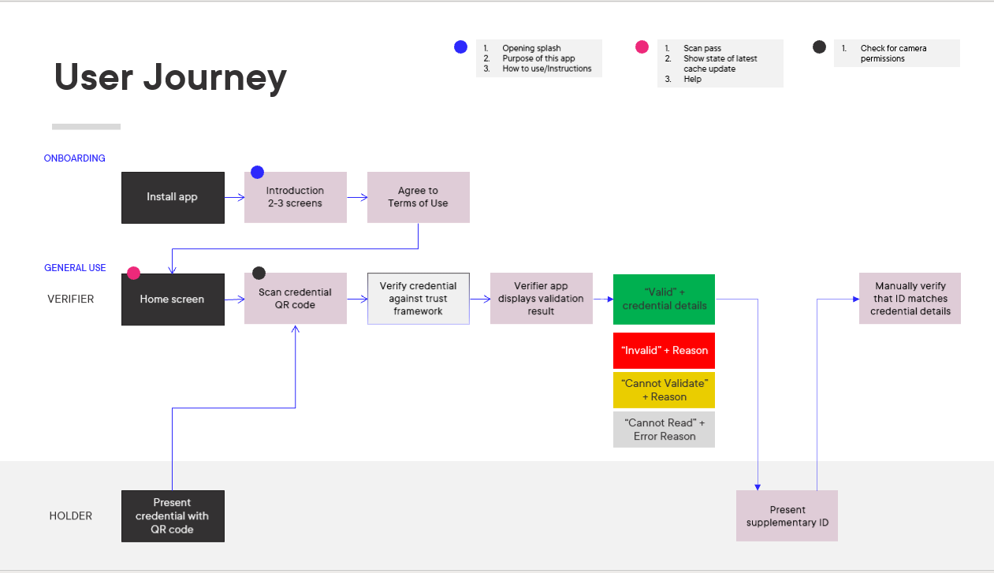
*The introduction screens will not be available in the early stages of the verifier App, it will default directly to the Terms of Use requirements

Verifier App – Business Onboarding
NB Privacy Statement will be included in the Terms of Use.
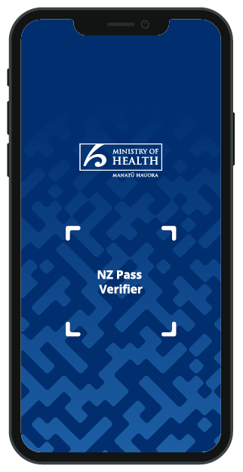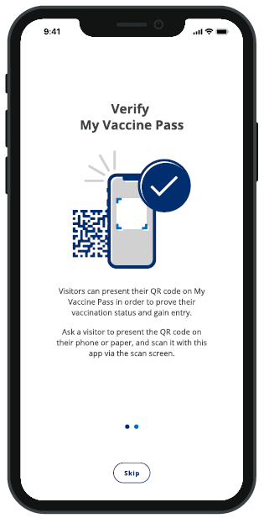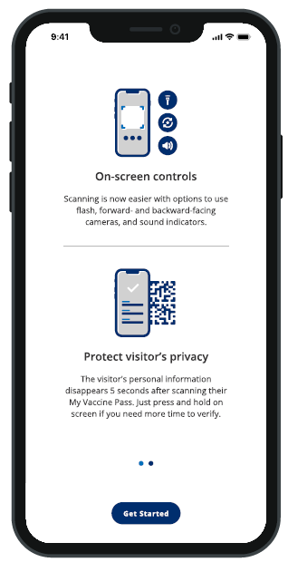
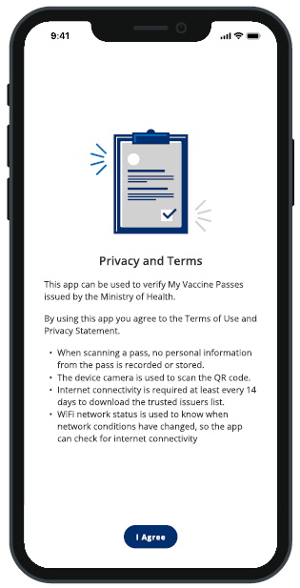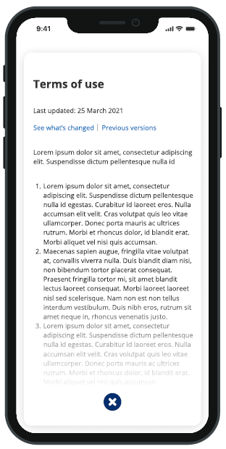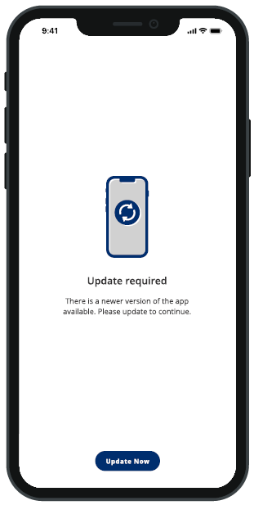

Verifier App – Scanning and Verification Process
NB the name and date of birth displays temporarily under a “timer” function to enable ID verification (shown by the green bar above the surname). To prevent this disappearing too soon (requiring a rescan) the verifier can hold their thumb on the screen to pause this (eg a person is trying to find their ID). After validation this personal information is not retained and can only be seen by scanning the persons’ My Vaccine Pass QR code again.. This feature was not live in the first version of the Verifier App - scanned results were not retained and were overwritten by the next scan.
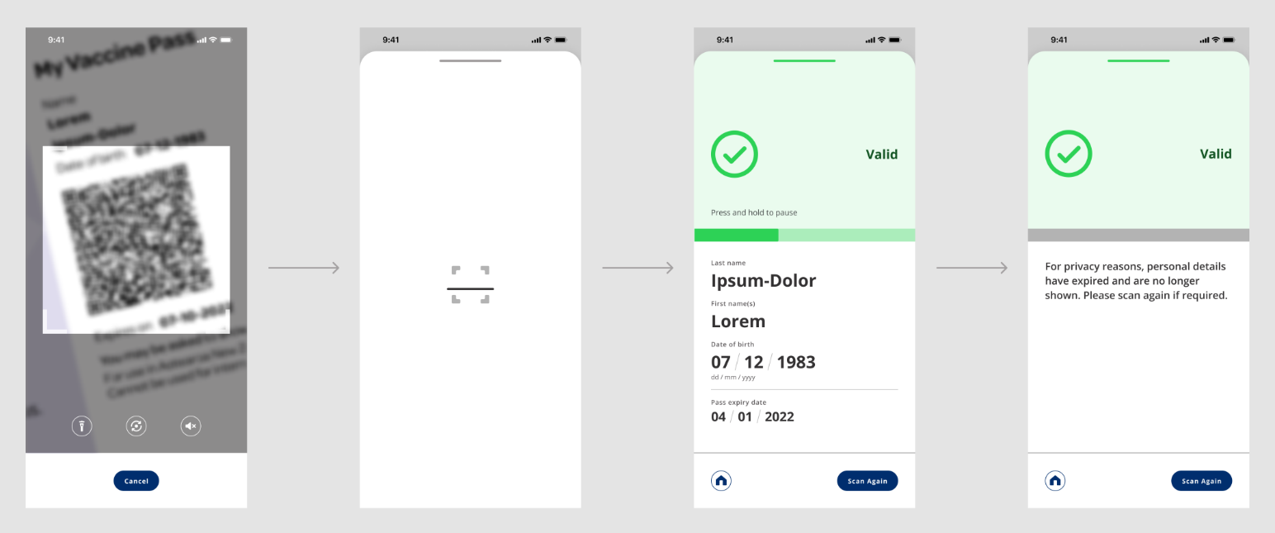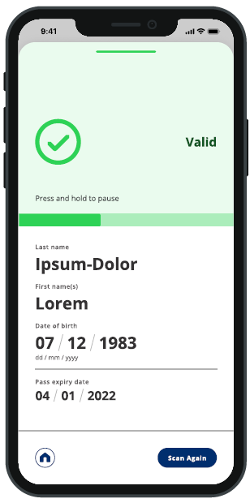
Verifier App = Other Results
If the QR code is not valid (e.g. expired) or there are technical issues, one of these screens will show instead (N.B. all text can be changed, and none of the text on any screen is yet final)

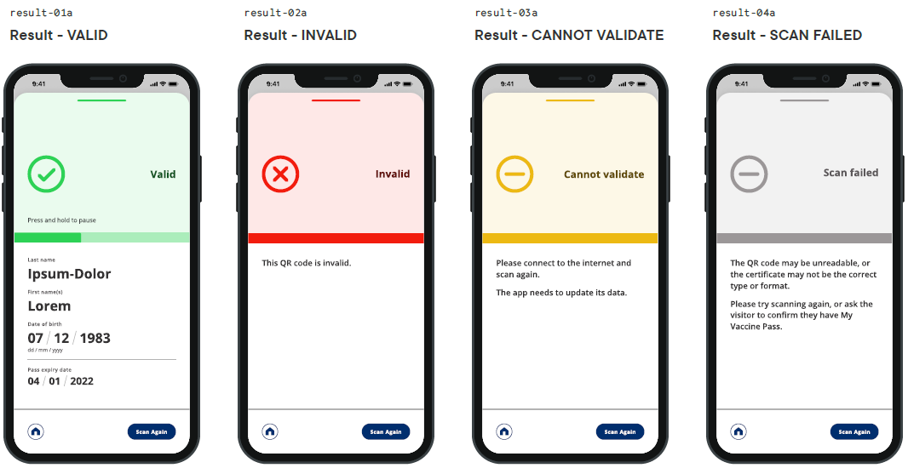
These “failure” screens are purely to do with validity of the QR code or technical issues with scanning it – no personal information is shown on these screens, nor can any assumptions be made about the individual being scanned.

Appendix Five – International Travel Vaccination Certificate (International DCC)
The International DCC will enable Consumers to confirm their vaccination status to overseas countries that allow entry across their borders to EU Digital COVID Certificate (EUDCC) standards.
Draft International DCC
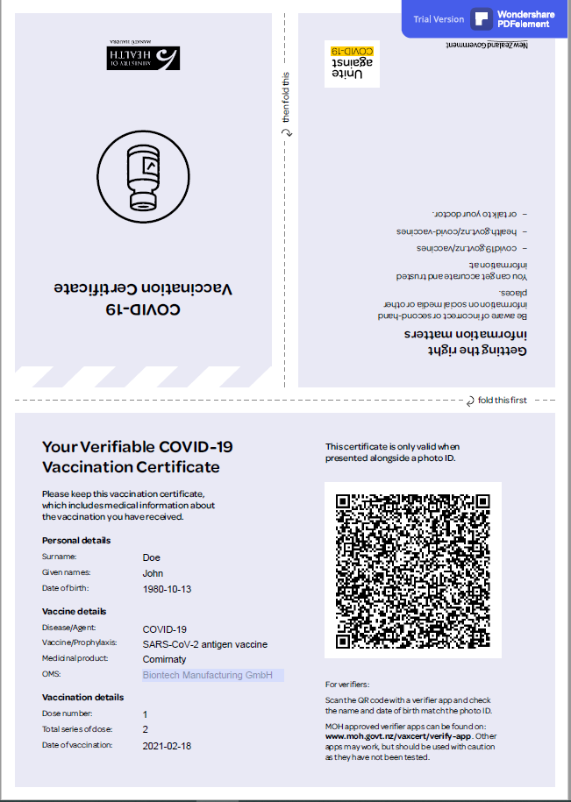
The International DCC will include the Consumer’s:
- Personal details, including name and date of birth;
  - If the Consumer is requesting an International Travel Vaccination Certificate for themself, they can request the certificate contains any name that can be matched with a name stored against their NHI number.
- vaccine details, including disease the vaccine was for, the vaccine, medicinal product and manufacturer;
- vaccination details, including how many doses you have received, series in the dose required, date of the most recent dose that has been received, and country the vaccination has been administered in;
- COVID-19 test results and date test taken (once this is a requirement); and
- a verification QR code containing the New Zealand Country Signing Certificate Authority (NZ CSCA).
Using My Covid Record a Consumer will be able to request that an International DCC is generated and emailed to them (to the email address associated to their My Health Account). The International DCC will not be returned to or stored by My Covid Record. Relevant logs will be retained by NIA, these processes will be addressed in more detail in the NIA PIA.
To ensure equity of access a Consumer will also be able to request that an International DCC is generated and distributed to them via assisted channels. These channels will include a telephone contact centre, and the ability to request a certificate be issued at a vaccination site or other site with access to CIR, such as a GP or pharmacy (and this certificate can be printed on site, emailed or posted to the Consumer).
Summary of certificate generation for the International DCC
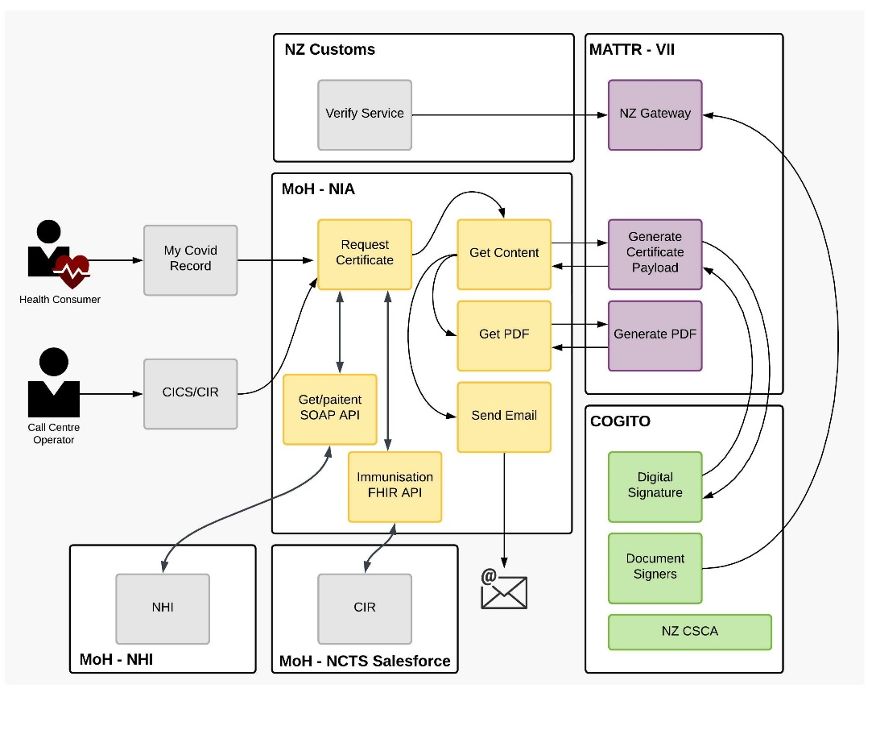
- The consuming Service (e.g. My Covid Record, CICS or CIR), will make an API request to NIA to generate an International DCC containing:
  - the Consumer’s NHI number;
if the Consumer has requested a different name, the Consumer’s name; and
  - email address or postal address to send the International DCC to;
- NIA will retrieve the immunisation record for the NHI number from CIR;
  - If the Consumer has requested a different name, NIA will retrieve the Consumers names form NHI and match the name;
- NIA will make an API request to the Certificate Generation Service to generate an International DCC;
- The Certificate Generation Service (MATTR in the above diagram) will request a digital signature from the NZ CSCA (Cogito in the above diagram);
- The NZ CSCA will return a digital signature to the Certificate Generation Service;
- The Certificate Generation Service will generate an International DCC PDF;
- The International DCC PDF will be returned to NIA;
- IF the API request from the consuming Service (e.g. My Covid Record, CICS or CIR) to NIA contained an email address THEN the international DCC PDF will be emailed to the email address.
- ELSE IF the API request from the consuming Service (e.g. My Covid Record, CICS or CIR) to NIA contained a postal or physical address THEN the International DCC PDF will be printed and posted to the postal or physical address.
Additional technical details can be found in the PIA for the Covid-19 Technology Integration Product (NIA) APIs for COVID Consumer Channel COVID Vaccination Certificate Releases.
International DCC Verification Service
A verification service will be available to NZ Customs and other border agencies, so that they can scan the QR code presented in the International DCC to verify that it is authentic. This will be managed by Customs.
The Exemption Process will not be available in the International DCC process, as a New Zealand based exemption is not expected to meet the international requirements for vaccination.

Appendix Six – Face Mask Exemption Pass

The Face Mask Exemption Pass will enable Consumers to confirm their face mask exemption status to access business and services where wearing a face mask is required.
The Face Mask Exemption Pass will look like the below:
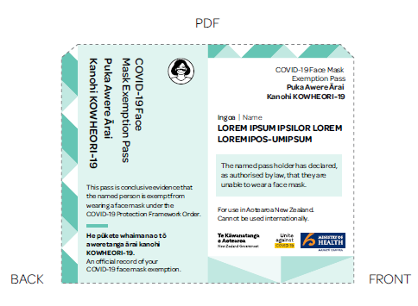
The Face Mask Exemption Pass will include the Consumer’s name only.
Using My Covid Record, a Consumer will be able to request that a Face Mask Exemption Pass is generated and emailed to them (to the email address associated to their My Health Account). The Face Mask Exemption Pass will not be returned to or stored by My Covid Record. Relevant logs will be retained by NIA in the NIA DynamoDB, these processes will be addressed in more detail in the NIA PIA.
To ensure equity of access a Consumer will also be able to request that a Face Mask Exemption Pass is generated and distributed to them via assisted channels. These channels will include a telephone contact centre, and in the near future, the ability to request a certificate be issued at other sites with access to CIR, such as a GP or pharmacy (and this exemption can be printed on site, emailed or posted to the Consumer).

Summary of certificate generation for the Face Mask Exemption Pass
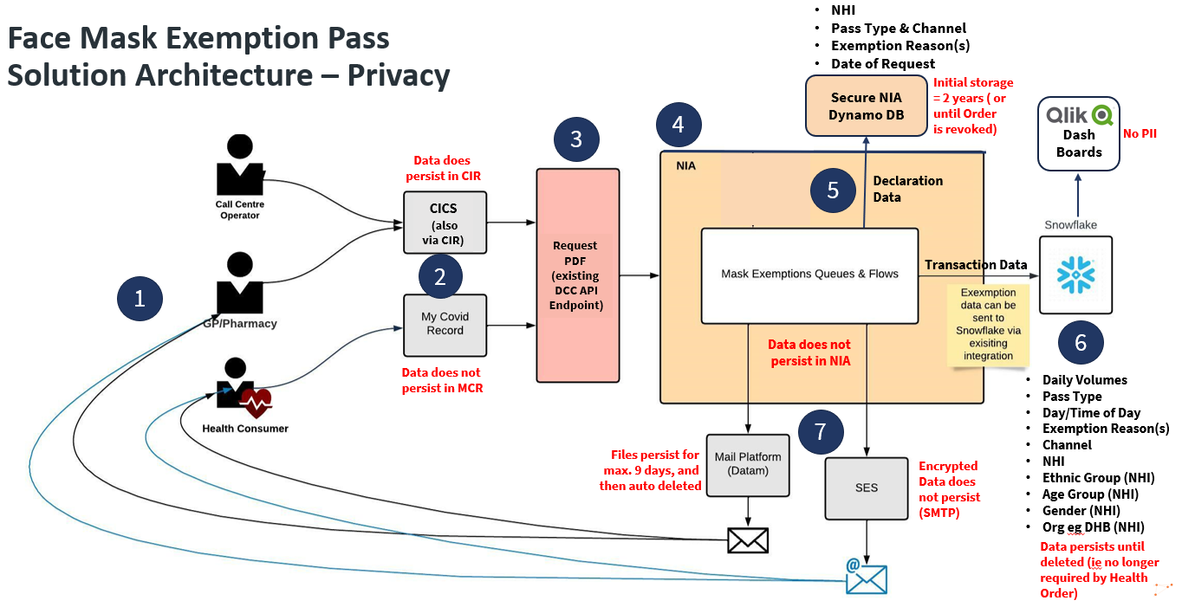
- The Call Centre Operator, GP or Pharmacist or Health Consumer will request a Face Mask Exemption Pass via My Covid Record or an assisted channel (CICS or CIR),
- The consuming Service (e.g. My Covid Record, CICS or CIR), will make an API request to NIA to generate a Face Mask Exemption containing the Consumer’s:
  - NHI number;
  - name(s)
  - reason(s) for requesting the exemption;
  - delivery method (email or postal);
  - email address or postal address to send the face mask exemption pass to; and
  - MHA ID.
- The NIA gateway will validate the NHI number, name and DOB in NHI, and request the Face Mask Exemption Pass;
- NIA will generate a Face Mask Exemption Pass;
- NIA will store the Face Mask Exemption Pass request logs the NIA DynamoDB (including the NHI, pass type and channel, exemption reason(s) and the date of request,
- The Face Mask Exemption Pass request data will also be sent to Snowflake.
- IF the API request from the consuming Service (e.g. My Covid Record, CICS or CIR) to NIA contained an email address THEN the Face Mask Exemption Pass PDF will be emailed to the email address;
  - ELSE IF the API request from the consuming Service (e.g. My Covid Record, CICS or CIR) to NIA contained a postal or physical address THEN the Face Mask Exemption Pass PDF will be printed and posted to the postal or physical address.
Additional technical details can be found in the PIA for the Covid-19 Technology Integration Product (NIA) APIs for COVID Consumer Channel COVID Vaccination Certificate Releases.

As further described in Appendix Four.
This NZ Pass Verifier App is further described in Annex One to Appendix Four.
As further described in Appendix Five.
The PIA for APIs for COVID Consumer Channel COVID Vaccination Certificate Releases November 2021 can be found here
The expansion of use of or access to the Information beyond that originally contemplated
This involved a closed ‘group’ of identified individuals associated with the Ministry of Health or Managed Isolation and Quarantine Facilities as part of the pilot.
RATs became diagnostic at 7am on 23 February 2022
See the diagram on page 20 for information flows
The My Health Digital Identity project is subject to its own PIA: https://www.health.govt.nz/our-work/digital-health/other-digital-health-initiatives/my-health-account/my-health-account-privacy-notice
Reference s212(2) of the Privacy Act 2020.
Confidence levels not involving NHI are excluded from the table as the information will be NHI linked to details to be displayed
The Consumer will need to use the web app to pull the records from the ‘back-end’ systems each time. Some certificates that can be delivered via the web app can be downloaded to a digital device wallet or printed out by the user.
Now a Protection Framework requirement
Fast Healthcare Interoperability Resources API standard for exchanging electronic health records
Reference the table in paragraph 32
The NIA PIA – APIs for Covid Consumer Channel COVID Vaccination Certificate Releases can also be referred to for NIA related processes.
More information about the assisted channels can be found on the COVID-19 health hub, https://covid19.health.nz/advice/household-get-test the general COVID-19 website reference here https://covid19.govt.nz/testing-and-tracing/covid-19-testing/rapid-antigen-tests-rats/#understanding-and-reporting-your-test-results and the assisted channel phone number is 0800 22 478 (option 3)
https://developers.google.com/analytics/resources/concepts/gaConceptsTrackingOverview
In-person access can be extremely limited in lockdown scenarios. The original plan was for trusted individuals within medical practice settings to complete the ‘in-person’ verification. These medical settings are currently busy with challenges meeting health care needs, and this infrastructure has not yet been established
A person can be liable on conviction of a fine up to $10,000
As specified in section 5(1) of the Covid Public Health Response Act 2020
A person is deemed recently infected if they have had a positive COVID-19 test result within the past 130 days
A person may be granted a vaccination exemption by the Director-General if they meet the criteria set out in clause 6 of the CVC order.
If the Consumer wants to send the certificate to an alternative email, they have already logged in to the account so there will be an audit trail of any changes they have requested.
As an SDK – software development kit.
If the Consumer wants to send the certificate to an alternative email, they have already logged in to the account so there will be an audit trail of any changes they have requested.
The reference to the Privacy Letter Form is a more manual process that will be phased out with the introduction of the My Covid Record Certificate generation processes
If the Consumer wants to send the exemption pass to an alternative email, they have already logged in to the account so there will be an audit trail of any changes they have requested.

