Ministry of Health

Care in the Community (CitC) – COVID Clinical Care Module (CCCM)

Privacy Impact Assessment
Date 28 April 2022

Document Approval
 | Name/Title | Sign-off date
Approved by Senior Responsible Officer | Daniel Hirst (Group Manager – Covid Care in the Community)
Approved by Manager, Risk & Privacy, Ministry of Health | Caitlin Hawkins

The author of this document is Data & Digital Directorate, Ministry of Health.
Disclaimer
This Assessment has been prepared to assist the Ministry of Health (“the Ministry”) to review the purposes for which the information collected for and via the CCCM (derived from the Border Clinical Management System (BCMS) and related Ministry systems for the clinical component of the Care in the Community (CitC) programme can be used.
BCMS was originally developed to support individual Guests health needs and the District Health Board (DHB) teams operational management at a facility, regional and national level of the Managed Isolation and Quarantine (MIQ) Facilities. The platform is now being expanded for use to support a national shared COVID CitC record to allow cross discipline, regional and care setting medical care for those individuals and their whānau isolating in their own home or another community location, including ‘hospital in the home’.
This PIA will also review the privacy safeguards that are required to manage those purposes.
Every effort has been made to ensure that the information contained in this report is reliable and up to date. This Privacy Impact Assessment represents the current expectations of the way the IT system components are supporting the clinical aspects of the CitC services.
This Assessment is intended to be a ‘work in progress’ and may be amended from time to time as circumstances change or new information is proposed to be collected and used.
Assumptions applied
The assumptions that have been applied in the development of this assessment include:
- As this project develops, there will be evidence and information generated through the development and deployment of the application (e.g. Statistics of use and feedback from users), and change in response to the surge of Omicron COVID cases, and as the number of cases declines, the move to living with COVID as an endemic disease. This will impact on how the Ministry of Health determines what is important for the future purpose of this application. These may result in changes to the terms of use, the information collected, and the risks and mitigations required.
- Discussions will continue between key parties (i.e. the Ministry of Health, the Office of the Privacy Commissioner and the Government Chief Privacy Officer) and future versions of this assessment will record changes to information that is collected and the consequent risks, further analysis and mitigations.
- A subsequent version of the Privacy Impact Assessment will be made publicly available for the public to understand the collection, storage, use and sharing of personal and third-party information for purposes of transparency.

Contents
Glossary 4
Section One – Executive Summary 7
Privacy Impact Assessment 8
Scope of Assessment 9
Assessment content 10
Recommendation Summary 10
Section Two – COVID Clinical Care Module to support Care in the Community 13
Background 13
COVID Clinical Care Module– CiTC Description 13
CCCM DASHBOARDS 18
CCCM – enhancements added to BCMS 19
Test related processes 20
How Consumers will interact with the Project 21
Information fields involved in the CCCM: 22
Information Flows 23
Where and how the information will be stored 24
How long will information be retained for? 25
Security features applying to Project 25
Statistical metrics 26
Governance 27
Potential Features to be addressed in future Privacy Impact Assessment activity 29
Section Three – Privacy Analysis 31
Appendix One – System interaction overview (as at 4 March 2022) 45
Appendix Two – Security questions assured by Royal New Zealand College of General Practitioners Foundation Standard 58
Appendix Three – Process for PMS to interact with CCCM 59
Appendix Four – CCCM Dashboard Views 65
Appendix Five – Matrix for access 75
Appendix Six – Summary of Risk Stratification approach 78
Appendix Seven – Set up of BHR from NCTS 81
Appendix Eight – Privacy and explanation script 83
Appendix Nine – Probable Case Creation 87
Appendix Ten – Draft Privacy Statement for CCCM 90

Glossary
The following are definitions used in this Assessment:
Terms | Description, relationship and business rules
Active Management | When a Case is being managed with clinical assistance, managed within CCCM
Border Clinical Management System (BCMS) | The Border Clinical Management System was originally created to manage the clinical component of Managed Isolation and Quarantine processes. It is now being expanded to provide a shared coordinating clinical record solution to nationally support the CiTC requirements of individuals who are required to self-isolate as Cases, and their household contacts. The COVID Clinical Care Module is the BCMS component addressed in this PIA.
Border Health Record | The record created within the National Border Solution to manage a specific COVID encounter per Case. It represents the time limited episode of COVID care, be it the stay in the MIQF or the public health active episode of a Case or household contact. In the CCCM solution this creates a link between NCTS and the BCMS so that the Case will be shown in the relevant BCMS queue for clinical management while the Case is under active public health management. The BHR creates the time-based bookends of “COVID care”.
Care in the Community | The CitC model is based on enabling people to be cared for in their home, when it is safe to do so, when they or a member of their household are considered to have COVID-19. The model is flexible, nationally supported, regionally coordinated and locally led, in order to meet the needs of local populations and effectively allocate system resources especially in a time of uncertainty when parts of the local health system may well become non-functional for short term as well.
Case | A person who is considered to have COVID-19. The definition of a Case has been expanded as at 11 March 2022, to both Confirmed and Probable cases. These classifications are defined by the Ministry of Health as:  - Confirmed: laboratory evidence via PCR testing or a significant rise in IgG antibodies.  - Probable: a close contact who meets the clinical criteria, with a high exposure history, or returned a positive RAT
Close Contact | Means any person who may have been exposed to a Case of COVID-19 (as further described on the Ministry website) and includes household contacts.
Bubble | People who are living in close proximity with the Case and thus at much higher propensity for transmission of COVID are household contacts The collection of the Case and household contacts is called a Bubble in the CCCM and linked with a unique bubble number
CitC | Care in the Community
Contact Tracer | An individual who is authorised to fulfil the role of contact tracer in accordance with section 92ZZA of the Health Act, and who is responsible for identifying and contacting Cases and Close Contacts.
Contact Tracing | This is the process used to find people who may have been exposed to an infectious disease, which is aligned with the provisions of the Health Act 1956 Part 3A, subpart 5. If a person is identified as a Close Contact of someone with COVID-19 they can expected to be contacted by a Contact Tracer, generally by telephone.
COVID Clinical Care Module (CCCM) | The BCMS adaptations to support the shared clinical component of Care in the Community.
Facilities | The regional controls within CCCM to limit access of users to those Cases within the allocated Facility. These are also called Care Coordination Centres
Framework | The Framework issued by the Ministry of Health called ‘COVID-19 Care in the Community: Framework for Public Health, DHBs, PHOs, Iwi, Providers, Social and Well-being Organisations’ (issued as Version 2.0 dated 20 December 2021 at the time of creation of this PIA).
Ministry | The Ministry of Health
National Border Solution | The system operated by the Ministry, initially set up to manage those travellers arriving at the New Zealand borders during their stay in Managed Isolation and Quarantine (and expanded to include those community Cases required to reside in an MIQ during their infectious period).
Phases | This refers to the Phases for response to Omicron in the community. The current response plans for the Phases can be found here: https://www.health.govt.nz/our-work/diseases-and-conditions/covid-19-novel-coronavirus/covid-19-response-planning/omicron-community-what-means-you
Privacy Notice Materials | Material to be prepared to inform consumers in compliance with rule 3 of the Health Information Privacy Code 2020.
Project | The COVID Clinical Care Module
NCTS | National Contact Tracing Solution – the NCTS enables accurate and timely information on all COVID-19 Cases and contacts to be recorded and allows all regions of New Zealand to work together when required.
NHI | National Health Index – this is the unique identifier that is assigned to every person who uses health and disability support services in New Zealand.
(Local) Care Coordination Hubs (CCHs) | Local Care Coordination Hubs set up in every location in Aotearoa to manage and oversee all COVID Cases in the community for that area. This is facilitated by DHBs and includes health providers organised by the region. Activities include Case investigation, clinical management, welfare referral/management and overall coordination to ensure all people under care have been appropriately cared for during the period of care. These can be public health hubs and clinical hubs, and in some regions they are combined, and in others they operate separately (for example ‘Case investigation’ could be managed separately from the clinical and welfare component). Primary Health Organisations can also be part of the Hub functions.
Self-managed | When a Case is able to support their own COVID-19 recovery in their own home or community setting without medical intervention of any significance.

Section One – Executive Summary
- Community spread of COVID-19 is a serious threat to the safety of New Zealanders and will adversely affect certain groups more than others. New Zealand has now moved to Phase Three of the Omicron response. The peak of daily Omicron cases has passed but there are still thousands of new cases per day. The number of cases is likely to continue to decline but it is anticipated that there may be further waves of COVID-19 in the future.
- During the recent Covid -19 Omicron variation outbreak in the community, Cases grew exponentially and spread nationwide. A main aim of the response to COVID-19 in the current Phase is to maintain our national hospital capacity to provide care. This has this created a need for a cross discipline shared care record that is visible in numerous different clinical care settings.
- As Aotearoa New Zealand’s vaccination rate has increased, disease transmission and serious illness requiring hospitalisation has reduced. The majority of people with COVID-19 are able to isolate at home, and this is supported by a range of clinical and welfare providers. To facilitate this their clinical record needs to be immediately available for all care settings to facilitate rapid communication and cross monitoring of their clinical care.
  - In order to be able to manage the scale of daily infections clinical care is focused on those with the greatest risk of poorer outcomes from COVID-19 infection.
  - Care Coordination Hubs (CCHs) operate to coordinate care. They also provide an opportunity to pool resources to respond to surges in cases.
  - Some people will not be able to safely isolate and recover at home. A small number need hospital level. Care therefore needs to be able to pass seamlessly and safely between providers.
  - A portion of the population are not enrolled with a primary care provider. The CCH acts as a safety net for the community in their locality and are responsible for ensuring the provision of clinical and welfare care.
- To combat the COVID-19 threat the Ministry is supporting District Health Boards and national coalitions of clinical care providers by providing access to a bounded shared care record clinical system for the duration of the CiTC programme. This will be centrally coordinated (at a regional level) but peripherally managed (able to be managed at point of care). This is called the COVID Clinical Care Module (CCCM). The CCCM is able to include inputs from primary and secondary health, as well as social and welfare information if that is part of the holistic care provided in that region. That information is then visible across other areas of the health system that could interact with the person, provided they have been granted appropriate levels of access to CCCM. The CCCM record is only visible in CCCM during, and for a strictly limited time after, the acute stage of COVID infection.
- Providing well-coordinated care to persons and whānau will be dependent on striking the right balance between sharing critical health and clinical information needed for their care where necessary, while protecting person and whānau privacy.

Privacy Impact Assessment
- This Privacy Impact Assessment (PIA) addresses the COVID Clinical Care Module (CCCM) – the IT solution that assists in provision of this clinical care for Care in the Community. This is a ‘Fit for Now’ solution that leverages and extends the existing IT and digital assets available to the Ministry at the end of 2021.
- The core Ministry system identified for this purpose was the Border Clinical Management System (BCMS).
- The base platform of BCMS has been extended to facilitate the increased community coordination of COVID care. The base architecture and systems of the BCMS will remain and continue to be used to support the Monitored Isolation and Quarantine Facilities, for as long as is required. For Care in the Community, greater interaction with other Ministry COVID-19 and primary sector IT systems has been enabled, and a direct point of care access for Cases in the community has been established.
  - CCCM holds the clinical record of those Cases who are managed within the CitC setting, for the duration of their acute COVID-19 clinical management.
  - CitC will be coordinated locally by CCHs with a combination of Iwi, DHB staff, community clinical service providers general practice providers, and telehealth providers all collaborating. CCHs can use the CCCM, and the National Contact Tracing Solution (NCTS) to access appropriate information about the Cases they are providing care for and will record the clinical and manaaki welfare support provided into the CCCM.
  - This shared care record is designed to enable general practice clinicians who are contributing to the care of a person to do so from within their normal information systems.
  - Information collected through the online self service form or by contact tracers is displayed in NCTS and imported into the CCCM record. This will indicate whether the patient is more likely to have an adverse outcome from COVID-19 and will be used to prioritise patients for outreach. There will also be an intention to follow up where the Case does not respond to the initial text message advising that they are a Case, or do not complete the initial assessment webform.
  - A standardised risk score is displayed in CCCM. This score is calculated using a person’s age, ethnicity and vaccination status and gives a risk of hospitalisation when that individual contracts COVID-19. The score is used at some CCHs to prioritise contact with people who have tested positive but have not completed the self-service form.
- The CCCM includes and sends relevant information to and from the existing National Contact Tracing System (NCTS) and National Border Solution (NBS) including interactions with:
  - ESR Eclair, the national repository for all COVID-19 test results (positive test results are sent to NCTS for transfer to CCCM, but test ordering is managed outside of CCCM via the standard primary and secondary care systems);
  - The NBS where the Border Health Record number is generated as a common data point across systems, and is acting as a conduit for data flow between NCTS and CCCM/BCMS
  - The NCTS, to transfer relevant Case and household information to CCCM and to enable contact tracing and call centre staff to refer individuals to the CiTC CCCM module.
  - Point of care clinical care systems already in use by clinicians delivering care – i.e. Practice Management Systems for approved GP practices and Clinical workstations/portal interfaces for DHB hospital level care (although this is currently only live in the Northern Region).

Scope of Assessment
- This Privacy Impact Assessment is in addition to the original Privacy Impact Assessment for the Border Clinical Management System dated 16 March 2021 (the original PIA). This PIA addresses the additional CCCM features within the BCMS.
  - CCCM will utilise existing Ministry IT systems and involve multiple agencies who will be involved in delivery of care in the Community.
  - This PIA covers the COVID Clinical Care Module. This is the IT system being used to support the clinical component of the Care in the Community.
- The current Assessment covers:
  - The personal and demographic information to be collected from the Consumer;
  - Where and how the information is to be collected, used, disclosed and stored.
- This Assessment is limited to the Ministry IT systems used to support this care delivery and does not review:
  - the decision-making process, approvals, nor the conclusions reached about the decision to progress this Project;
  - Any Fit for the Future solution to replace the Fit for Now CCCM solution that is the subject of this PIA;
  - the delivery of the care component involved in Care in the Community, or any decision making by CCHs about how care will be managed in that region;
  - any Whakarongorau involvement as part of the care provision, or the ‘dialler’ feature that enables automatic dialling of phone numbers held within CCCM to automatically call and initiate contact with Cases that are allocated for a call.
- This Privacy Impact Assessment is expected to be a ‘living’ document that will be reviewed as the Project progresses. The Ministry of Health plans a phased release of functionality in the Project, so features available in subsequent releases may require privacy review.
- The Office of the Privacy Commissioner and the Government Chief Privacy Officer have been consulted and provided comments on a draft Privacy Impact Assessment. The comments have been considered by the Ministry and incorporated as the Ministry determines is appropriate.

Assessment content
- Section Two contains the Description of the Project and User/Information Flows.
- Section Three contains the Privacy Analysis.

Recommendation Summary
- The following are areas that the Ministry will concentrate on as it develops the Project:
 | Action – CCCM Project (PIA) | Planned Date for completion
PIA- 01 | Clear and defined Privacy Materials, including the purpose statement, will be developed to ensure all Consumers have a full understanding of how this Information will be used.  - As the majority of the Cases will not be seen in person it will not be possible to hand a brochure to them at the time that they are first told they are a positive Case (prior to the information being collected from them).  - An overarching Privacy Statement about the CCCM processes will be loaded to the Ministry of Health website to support localised processes and initial scripted advice to individuals about their privacy.  - Each region will have the specific privacy scripts that their callers will reference, and a reminder will be present on first opening the person’s record to remind the caller to cover the privacy aspects of a shared care record (example in appendix 8)  The Privacy Notice Materials provided must be clear, and appropriately worded for the intended audience (level of complexity and language(s) it is written in). There is a plan in place to extend language options for Privacy Materials, and it is recommended that this be scheduled to ensure this progresses promptly.  Recommendation  - Provide new Privacy Statement on Ministry website describing the CCCM processes (refer Appendix Ten)  - Consider minor update to the ESR Privacy Statement for COVID-19 Testing and Reporting to expressly reference CCCM https://www.esr.cri.nz/our-expertise/covid-19-response/privacy-covid/ | In progress
PIA-02 | Many of the CCCM components have already been subject to security review. The Ministry will follow its standard security review processes including Certification and Accreditation, Cloud risk assessment, and independent security testing for any new components or interfaces.  If any risks are identified they will be resolved or mitigated to ensure appropriate security will be applied to all aspects of the Project.  Recommendation  No production data is to be used in any new component or interface before appropriate testing has been completed. | Prior to Go Live and throughout Programme prior to any new features of significance progressing to go live.
PIA-03 | Strong governance will need to be in place to manage any potential risk of ‘function creep’. There are multiple parties involved (from call centre staff, to contact tracers, to DHB clinical staff, to PHOs to individual GP practitioners. Clear oversight of what the information is permitted to be used for, and general privacy oversight of the multiple parties will be an important feature as will centralised privacy oversight.  Governance of this project is driven by the Ministry of Health. Governance provision includes:  - The Ministry Data Governance Group will have oversight of the CCCM and will continue to have a role in Snowflake availability of datasets.  - A CiTC specific Privacy Officer has been appointed to oversee all national operations (and is based in the Ministry of Health so will have direct links with the CCCM development team). The Privacy Officer will assist to raise issues of importance with the Ministry Data Governance Group.  - The Covid-19 Data and Digital Advisory Group (CDAG) has also been established to include a clinical oversight for advising the wider programme on the implementation and design of digital enablers and making recommendations  - Each CCH will be required to implement Standard Operating Procedures to ensure privacy considerations are covered and appropriate training is undertaken. Existing training materials on how to use the CCCM will be reviewed and enhanced with privacy materials – including in particular the breach process and notification pathway (to the CiTC Privacy Officer).  Recommendation:  It is recommended that where there is doubt, the Care in the Community Privacy Officer be responsible for determining which body (CDGA or DGG) it is appropriate to take information sharing, use, or change requests to for a decision. | Progressing
PIA-04 | Due to the significantly increased numbers of authorised users with access to BCMS related clinical and sensitive records, and the need for the record to be available nationally (to treat users wherever they are located at the time they fall ill) risk mitigation features identified will include:  - Role based access, limiting users to only the information necessary for the role they are to perform (and this is to be aligned to existing patterns in the health sector);  - Terms of Use to be confirmed by all CCCM authorised users (renewed every three months at the time of the forced password change);  Recommendations  - The CCCM direct platform access be removed as soon as possible for GPs who are intended to access via their own Practice Management Systems (PMS) link into CCCM, only for their own patients. Work on a “practice level” dashboard is progressing at pace to enable removal of this access so GPs can manage their own patients via a dashboard linked to their PMS and limited to their enrolled patients they are actively managing.  - An audit and monitoring programme is to be implemented to ensure access to CCCM records is appropriate and by authorised users with a need to access those records for purposes directly related to COVID-19 Care in the Community.  - The responsibilities of each party (for example CCHs) should be identified, including reporting responsibility to the CiTC Privacy Officer to confirm the plan in place and its operational performance at regular intervals.  - A confirmation audit is underway to check that all users have the correct access rights, and only those rights necessary for the role they play in the CiTC response (for example GPs who have direct CCCM access require that level of access as they will be consistently working outside their own practice, for example, out of hours cover, covering for other practices and / or performing CCH tasks). | Ongoing
PIA-05 | Confirmation to be obtained that Whakarongorau processes and engagement with CCCM are fully reviewed by PIA activity to support appropriate limitation on access to CCCM records. | End of April 2022
PIA-06 | To prevent a patient’s risk calculation from being included in their records, with the risk that it may be shared with a third party such as an insurer, the risk score generated by the Risk Stratification Tool is not to be included in records saved from CCCM to GPs’ PMS files. | Completed

Section Two – COVID Clinical Care Module to support Care in the Community

Background
- After the Covid-19 Delta community outbreak, plans for development of a national response to enable caring for Covid-19 Cases were advanced. With the Omicron community outbreak community Cases grew exponentially but, with vaccination rates high the majority of Cases were able to self-manage in their own homes, or to receive care in their own homes or other locations in the community rather than in a formal clinical setting (such as a hospital or isolation facility). New Zealand has now moved to Phase Three of the Omicron response as the peak of daily cases has passed, but there are still thousands of new cases per day. While the number of cases is likely to continue to declinec, it is anticipated that there may be further waves of COVID-19 in the future. The CCCM has been developed to provide a secure shared clinical record available across care settings. It has been made available to be used nationally to prevent duplication and reinvention of multiple disparate systems that would then all need to interact with the national systems to support the care of Covid-19 Cases in the community and ongoing surveillance of COVID.
- The Border Clinical Management System was originally created so that a national record could be maintained of the clinical care of travellers arriving at the border and being housed in Managed Isolation and Quarantine Facilities. The BCMS has now been adapted to include the CCCM for CiTC to enable a nationally available community response.
- The ability to have a nationally available CCCM record means that if the resources in one region or Facility are overwhelmed other regions or Facilities are able to provide support (both inter and intra regionally, much as has happened with Contact Tracing). A high number of health care workers in a region may also get sick at the same time, requiring support to be provided by less affected regions. In addition, individuals travel out of their usual region and may test positive when away from home. A local response to those Cases is also be able to be managed via CCCM.
- The availability of a preconfigured system that can be iteratively optimised to create a care system for COVID means limited resources can be focussed on one known solution, and there is less duplication of effort and fewer systems interacting with the national system, and a detailed review can take place.

COVID Clinical Care Module– CiTC Description
- The Ministry of Health and District Health Boards have worked to develop the national CCCM to manage those Cases who will receive CiTC (in their own home or their isolation address).
- This is based around a regional model with local Care Coordination Hubs (CCHs). Each region is split into specific sub areas to allow a division of Cases into smaller sets, and each of these divisions is set up as a ‘facility’ in CCCM. This has materialised as the eight main clinical regions having between four and ten facilities with varying access to one or more of those facilities per region.
  - The enrolled practice name is inserted into the allocation field when the person is enrolled with a GP.
    - If the Case is enrolled with the GP who is caring for the Case directly (as they will have received information of the result of the positive test via standard Healthlink notification processes) that GP may provide the care directly within their own Practice Management System (PMS), and not engage with CCCM.
    - If the GP is participating in CCCM they can choose to link from their PMS directly into CCCM for that patient and enter the COVID-19 Case related details directly from their PMS.
    - If the person is not enrolled, or is isolating away from their region of enrolment the CCCM will be able to manage care for those individuals.
  - Providers are allocated to their respective “facility” or “facilities” as needed to cover the work. Providers have access to all person records in the “facility/facilities” they are assigned to. The access within the person record is then role-based.
  - There may be instances where a provider has access to another facility that isn’t their own but is in their region’s Public Health Unit, as they may be called upon to care for the Case if the Case doesn’t have an assigned provider (e.g. when a Case is discovered outside of the Case’s home region, or is not enrolled). All users must complete the standard BCMS Terms Of Use when they are granted access to CCCM.
- The Ministry has responsibility for the operation of the CCCM IT system, and DHBs are responsible for the delivery of care and the local Hub models (this clinical care management is not further addressed in this PIA).
- The plan for CCCM is that authorised users who are part of the COVID-19 clinical local Hub management (or have clinical responsibility for the Case and are participating in CCCM processes) will be able to use CCCM to access the most up to date COVID-19 related information about that Case and their COVID-19 status and history.
- Transfer and acceptance of COVID-19 Cases via CCCM can be managed in two ways:
  - The CCCM as a stand-alone dashboard and person record (based on the BCMS national shared care record) is offered to DHBs and Public Health Units who need to manage persons in the community as part of local CCH activity (as well as those placed in MIQ).
  - General Practice teams can also use their own practice management systems to launch the CCCM person record directly from the Healthlink webform. Access to the Healthlink webform is controlled to those practices that have complied with the MOH third party security and privacy requirements (see further details in Appendices Two and Three).
    - There is a short-term situation, arising from some regional practices with large numbers of people under their care, where they have requested dashboard overview and workflow access and the CCHs have permitted access to a Facility level dashboard. The GPs in question can then filter down, using the allocation field, to their own Cases but they have been granted temporary access to a wider range of people record than was initially intended. It is expected that this wider access will be removed by April 2022 when a GP specific dashboard is created.
    - This programme will be overseen by the Ministry and will include regularly scheduled reviews of authorised users and spot checks of files and users.
  - It is planned in future that Hospital staff will use their own clinical workstation to launch the CCCM person record directly using existing integration capability supported by the clinical workstations. Access to the link is controlled by the hospital information services set up, and will only go live when the region has shown they complied with the MOH third party security and privacy requirements (see further details in Appendices Two and Three).
  - If other care providers are to be provided with access this will need to be addressed as discrete entry points, and access will need to be authorised by the Care in Community Data and Digital Advisory Group (CDAG).
- A detailed explanation of the information and system exchanges that will occur for CCCM (as at 9 March 2022) are set out in Appendix One.
- For CCCM, the existing positive COVID-19 test result process where Eclair sends the positive test result to NCTS will continue. NCTS will now forward information to the National Border Solution for a Border Health Record number to be created, and this will create a Case record in CCCM.
  - This CCCM record will be defaulted to ‘self-management’, and it is intended that this setting will be reviewed by CCHs for allocation to a facility or provider where considered clinically necessary. The CCH decision making will be assisted by information available, either via the GP the person is enrolled with if they are using CCCM, information supplied by the Case in response to Contact Tracer or call centre questions, or via the self-management tool, or as signalled in the risk stratification processes. Vaccination status from the Covid Immunisation Register will soon also populate the CCCM record. Each CCH manages the process in the manner most appropriate for that regions operational requirements.
  - Those persons deemed clinically well with no to minimal risk factors for severe Covid will be left on the self-management pathway and not interacted with again unless they phone in for help.
  - For those Cases who are identified by the clinical review process as having a greater level of clinical risk, either the local CCH or the enrolled general practice can record within CCCM that they have the care of the person under their control. This record will be set to ‘Active Management’ and ongoing contact with the person will be recorded in the CCCM record.
- Cases can be moved from Self-management to Active Management (and back again) with clinical input if a Case’s condition improves or deteriorates. This can be managed by any CCCM user including telehealth services.
- A summary of the CCCM processes applied to CiTC is outlined in the diagram below.
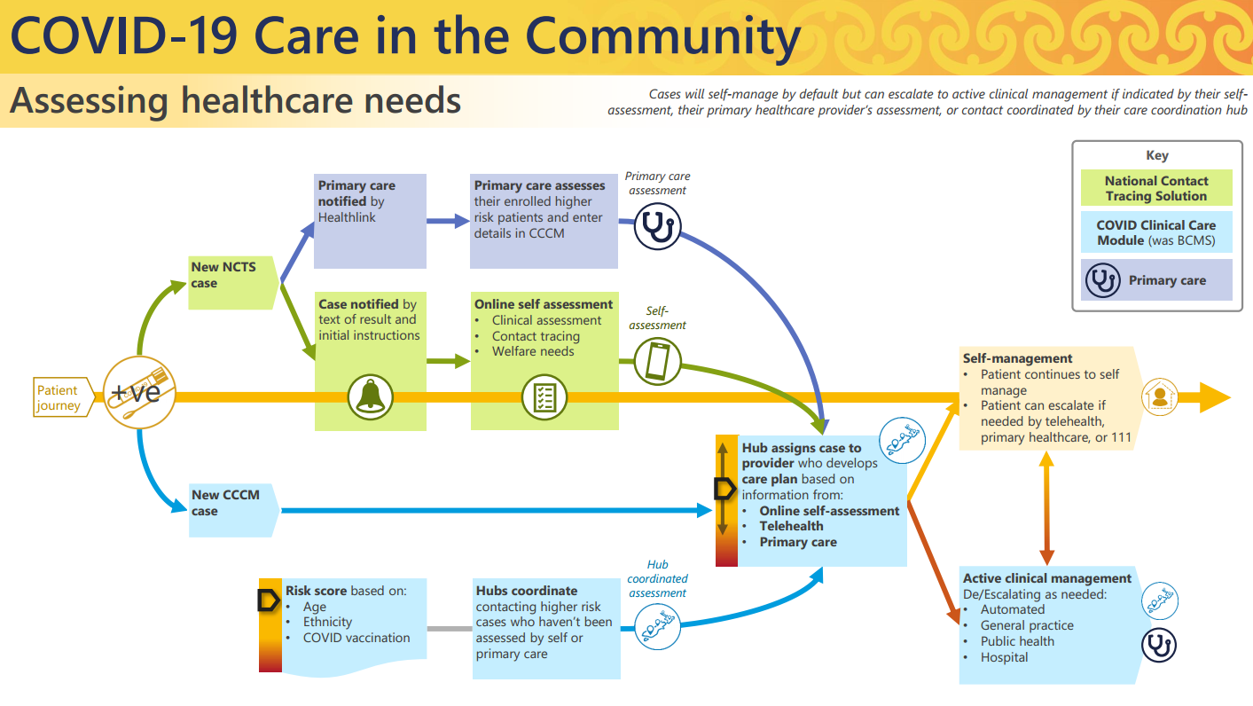
- Community-based care assumes that clinical support for persons requiring clinical and local manaaki welfare care will be provided through a combination of general practice teams, established telehealth clinical services, pharmacy services, and ambulance services. Clinical care is anticipated to be available and accessible 24/7 to meet the needs of households.
- Self-managed Cases will have a Case record created in CCCM (and Border Health Record number (BHR) assigned in NBS to help Case linking) but are expected to follow general pathways outside the Active Management CCCM processes. For example, a Self-managed Case process is as follows:
  - Day One: Receive text notification of positive Case and link to COVID-19 Contact Tracer Form (to upload details about health, contacts etc to NCTS) and the COVID-19 Clinical Hub information website (a static website with general information).
  - Cases will self-manage unless review identifies requirement to move to Active Management (review will assess long term conditions and symptoms, if provided, to decide if the person can stay in self-management)
  - Once the person has completed their self-isolation period they will receive a release from isolation text message
- More complex CiTC (where admission to hospital is not required) will require a multidisciplinary team clinical approach that will not only draw upon primary care clinical resources, but will also require specialist services, and DHB outreach clinical supports, delivered through the regional and local CCCM coordination functions.
- For Active Management the Case will be identified by any engagement with a Self-managed Case where it is clinically indicated that the Case should shift to Active Management. This could be the initial clinical engagement or after escalation to telehealth services, or a clinician in contact with the Case.
- General CCH responsibilities include the following:
Person journey and responsible organisation
Task | Responsibility
Allocation of Case manager (Case management workforce is drawn from PHU, MIQ, primary care, Kaupapa Māori and Pacific providers, and regional/local coordinators) | Regional Coordination Centre (RCC)
Contact person (visit or call) to conduct initial assessment | Case manager as allocated by RCC
Update CCCM with needs assessment data and risk assessment | Case manager
Regular (every second day at a minimum) health and wellbeing checks. Checks will be more frequent where the Case manager or primary care provider considers this is necessary. | Case manager, supported by primary care where necessary
Wellbeing support | Community provider as allocated by RCC
Handover of care when isolation period is complete to ensure that people with ongoing needs are appropriately connected to health or social services | Case manager and primary care
- CCHs will identify their own local practices for management of their community Cases, and those processes are not addressed in this PIA. Each region will be responsible for management of privacy for the practices they implement.
  - These regional processes will include determining who makes the initial contact with whānau, and what is included in that initial contact. The first contact should include a health assessment for immediate risk, a discussion around what is important to the person and their household, and referral to additional support if immediate assistance is required.
  - Public Health Units (PHUs), District Health Boards (DHBs) and other health providers in each region will work with local maanaki, Māori and Pacific Island community partners and community leaders to develop local methods and plans for contacting and notifying people who have tested positive for COVID-19 within 24 hours of diagnosis.
  - This has been supplemented with a “positive text” that is now sent from NCTS to all new cases (and includes the MSD number to call if the person wants welfare assistance based around finance and housing). MSD will only be utilised for areas under their control, specifically money and housing. MSD are only sent details of the person with the direct consent of the person or if the person chooses to phone the MSD number available from the self-service tool and searchable on the internet. MSD only have access to the demographic details needed to initiate first contact with the person. The MSD response is not further addressed in this PIA, as it is subject to its own PIA.
- It is expected that the person’s and whānau’s usual primary care team(s), where available, would provide ongoing COVID-related care during isolation, at no cost to the person and whānau. This is consistent with the approach to testing and vaccines and would reduce the risk of cost being a barrier to accessing COVID-related care.
  - For people who are not enrolled with a primary health organisation (PHO), they will be referred to a local provider who can assist with their care needs. People will be supported to enrol with a PHO where possible (such as where there is capacity with a local GP) and where they wish to do so. Not being enrolled with a PHO will not be a barrier to care being provided.
  - Non-COVID health problems will be identified for some people who are isolating, and during the isolation period these needs should also be addressed by the relevant health practitioner.

CCCM DASHBOARDS
- All Cases and household contacts will appear on the CCCM Dashboard, this can then be sorted by clinical acuity and self versus active management. The Cases for each CCH will show the current status of that Case, and will be highlighted if some activity is overdue, and a ‘white board note’ can highlight key activity. Symbols shown on the dashboard will show at a glance their acuity if they are under self or active management and underlying conditions of relevance that need to be taken account of to assess their risk of clinical deterioration (without a need to review detailed notes of each Case).
- A more detailed explanation of the Dashboard view, for the Hubs and assigned service practitioners, can be found in Appendix Four.

CCCM – enhancements added to BCMS
- Enhancements from the original MIQF focussed BCMS include:
  - Automation of manual steps as much as possible. The Delta wave showed clinical services would not be able to cope with any higher case load than was experienced during Delta, and reduction of manual tasks is clinically important (both to deliver clinical care in a timely fashion but also to maintain overall management of Cases to ensure pathway targets are met and individuals are not overlooked and left without appropriate services).
  - Increased data exchange between NCTS, BCMS (via the National Border System), ESR Eclair, and GP and hospital clinical systems. This includes:
    - Automatic Case creation (creating a Border Health Record in NBS) – this can originate with a contact tracer within NCTS or directly from the participating GP or hospital clinical systems
    - Making clinical data entered into the NCTS available for the front-end clinicians to use and expand on (this will include current symptoms and underlying conditions of significance)
    - Ensuring sufficient data is returned to NCTS (confirming actions undertaken) to ensure safety pathway monitoring can be put in place
    - Increased information messages between the various systems
  - Increased access to view and input data in various care settings, specifically:
    - Increased access to the CCCM as a national web-based portal of care for community or GP PHO hubs of care (via the CCH access).
    - Access to the CCCM from within approved GP practice management systems (PMS) for direct access to clinical records. Prior to a GP practice being permitted to be able to access via their PMS to CCCM the practice must have met the RCGPNZ foundation standards (or their equivalent via the Ministry of Health security assessment process facilitated by the relevant Primary Care Organisation). Included in these standards is proof that they meet and exceed the security and privacy requirements equivalent to those set out in Appendix Two. The process by which a GP connection via PMS can be launched is set out in Appendix Three.
    - In order to establish secure access from hospital clinical management systems to CCCM, the solution leverages the Orion Concerto (iSPRX or similar) or local DHB Clinical Workstation technology (once approved by the Ministry of Health security processes). This provides a way for clinicians to interact with the patient who has been referred to them and view the history of the patient as they have been managed in self-isolation.
      - A secure method via use of a short-lived URL (60 seconds to limit re-use) and key exchange between systems enables the creation of a unique session in CCCM for that user. Communications between the systems are encrypted.
      - The link only passes the logged in user details (full name, username, council number, region accessing from) and the NHI and name of the patient – to make a match within the BCMS before the Case will launch. The Case only launches if the BHR shows it is under active management.
      - CCCM retains an audit record of the changes against the user session established
- All improvements to the CCCM for Community COVID care are shared with the isolation facilities, as it is the same base product (BCMS). There are some needs that are not shared, and the way the BCMS determines which to apply to the patient record is based on the attribution of the ‘facility’ as of type ‘Community’. Community attribution for the ‘facility’ will show the enhancements aimed at and useful in community care.

Test related processes
- From 11 March 2022 the definition of Case includes both Confirmed and Probable (including RAT results) cases.
- Identification of a Case occurs in a number of ways. Eclair will record the following results:
  - Laboratory reported PCR test;
  - A supervised RAT uploaded via Healthlink used by the relevant clinician, a medical facility or pharmacy that supervises it;
  - A self-administered RAT uploaded through My Covid Record by the person (or someone on their behalf).
- There will be an additional facility added to CCCM to create a ‘provisional’ Case record and synchronise with NCTS.
  - In addition to a diagnostic test, Cases may be identified by GP diagnosis (by using clinical judgment based on the Case’s symptoms, and potentially proximity to other Cases). RATs may not be available for a household group self-isolating, or performing a COVID-19 test can cause a time delay before a Case gets entered into CCCM to create an active record, but the GP may wish to immediately commence recording a record.
  - The new feature will enable a new provisional Case account to be created in CCCM (initially only by GPs with PMS access to CCCM, but then in a subsequent release for CCCM dashboard for Hub clinical users). If created by a CCCM user this provisional record will be able to be accessed by other CCCM users within the users allocated to the relevant facility.
  - The Case record will include the Border Health Record when it creates the NCTS record for a Case Event and the relevant persons NHI. These two fields will then be returned in the Border Health Record payload when returned to CCCM so the correct records are merged.
  - When the case is created in NCTS is also sent to ESR to maintain an authoritative record of all cases in Episurv.

How Consumers will interact with the Project
- Current advice is also available on the Ministry website for people with COVID-19: https://www.health.govt.nz/our-work/diseases-and-conditions/covid-19-novel-coronavirus/covid-19-health-advice-public/advice-people-covid-19 This has been supplemented with the COVID-19 Health Hub – a purpose built information site that Cases will be advised of when a text is first sent to them after they are designated a COVID Case.
- As soon as possible when a person has tested positive for COVID-19 (confirmed) or been deemed a clinical COVID Case (probable), their point of contact in the health system will seek informed consent to share relevant information with providers of other services that the person may need (for example, a GP sharing information about a person’s welfare needs with a social services provider).
  - This could be via the contact tracers (where their script provides: Please be assured that all information gathered during this call is strictly confidential and will only be used to support you while you are isolating. It will only be shared with other Health Care professionals when and if required. If you have a welfare need, information about that need and your contact details will be shared with the Ministry of Social Development which is coordinating welfare services and will connect you with a service that can help you.
  - There is also a ‘pop up’ on the CCCM screens for the first health professional first documenting in the person’s record which provides: Please assure the person that all information gathered during this call is strictly confidential and will only be used to support them while they are isolating. It will only be shared and visible to other health professionals when and if required. This is supplemented with a “script” provided within each hub to the frontline staff (appendix eight is an example from the northern Māori Regional Coordination Hub)
- Guidance to providers is that where informed consent has been provided, the following information should be recorded in the CCCM:
  - Whether the person and household are already engaged with a trusted clinical provider or not. If not, this needs to be assigned as soon as possible. DHBs are responsible for ensuring that a clinical provider is available to support the health needs of people and whānau who are not enrolled with a general practice.
  - Current care or support needs relating to whānau support, disability, mental health, aged care, home and community support services, child development, and maternity.
  - Household members (ages, medical conditions, ability to work or continue education from home, access to sick leave, special needs, ethnicity, and preferred language).
  - Information on the housing situation and whether self-solation at home is a safe or realistic option for the whānau (housing tenure, number of bedrooms and bathrooms, bed sharing, any potential challenges for isolation and/or quarantine).
  - Ability to access basic needs to ensure that the whānau has what they need to maintain an isolation/quarantine ‘bubble’. which could include income support (including leave support to take time away from work while they're isolating at home for a specified period of time), help getting food, help accessing hardship support, and other supports to stay at home
  - COVID-19 status and testing of household members (dates, results, symptoms, retesting).

Information fields involved in the CCCM:
- The Person Level Report in Appendix Four sets out the information fields that may be incorporated into the CCCM (which is the clinical record for the COVID-19 management of the individual).

Information Flows
- The proposed information flows are described in detail in Appendix One. A summary of the components and processes over which information will follow is set out below. The full description of the process flows appears in Appendix One.

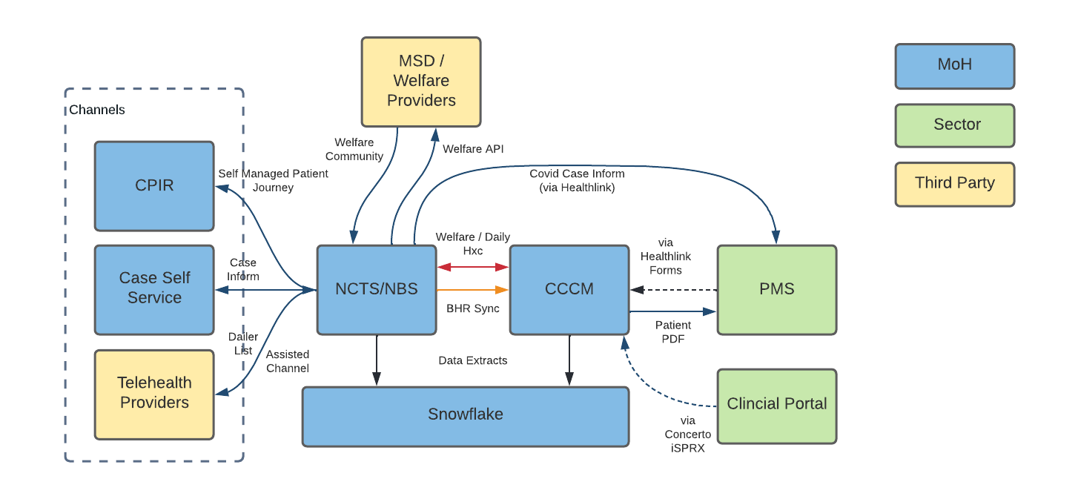

Where and how the information will be stored
- As described in Appendix One, information will be stored in the Ministry COVID-19 environment, including NCTS, BCMS (and the CCCM module) and NBS.
- A copy of clinical and administrative data is being curated on the MOH Snowflake database (which has been subject to review by the Ministry Data Governance Group based on the established SDA Process).
  - This will contribute to the normal MOH reporting (with the reports containing no identifiable information).
  - Snowflake may also allow a single point of sharing of clinical data back to the relevant DHBs and PHOs for their ongoing quality improvement and audit responsibilities. Any such access will be subject to approval by the Ministry Data Governance Group. Current approval is for DHB users, with access to the data subject to conditions including:
    - The regional Case data is being shared under serious threat justification – due to the Omicron wave the use of the data is deemed urgent and critical to allow DHBs to manage their services;
    - Use and sharing of this data will be reviewed regularly and may not continue to be shared if the situation changes. The data sharing will be reviewed by the Data Governance Group on 1 May 2022;
    - Access to the data is to be restricted to a small group of DHB users or analysts, is to be used with caution, and is not to be shared outside of the agency;
    - The data is to be used for strategic and management purposes, not operational or clinical (in accordance with Rule 11(2)(c)(ii) of the HIPC as it will not be published in a form that could be reasonably expected to identify the individuals concerned).
- Investigations are currently underway by the MOH reporting and procurement teams to see if there is sufficient data to help fulfil the payment requirements without further administrative burden on the clinical workforce during this intensive work period. A full analysis and privacy impact will be prepared and reviewed prior to any formal work or release of data for this purpose.
- If a practice management system is involved in the care of a person then it will also contain relevant information about the Case (including some information made available via CCCM) processes

How long will information be retained for?
- The clinical record on CCCM will continue to be maintained as required by the Health Information (Retention of Health Information) Regulations (as previously applied to BCMS). This does not require it be available to all CCCM users indefinitely, however.
  - After the persons isolation period has ended, their records will transfer to the ‘Discharge Dashboard’ – and access will then be limited to senior managers in each CCH.
  - An example of the type of information visible on that restricted Discharge Dashboard would include the following:
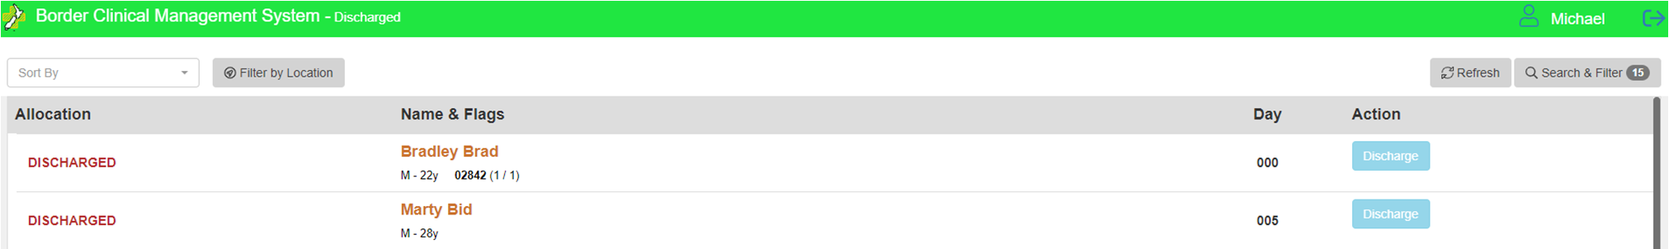
- During the care of the person, clinical notes can be shared via standard Healthlink HL7 messaging processes to either the enrolled GP or another GP involved in the care of the patient. This can only occur if the clinician sending the note/record indicates they have the person’s express permission to share this information outside of the CCCM/BCMS confines with the designated person. When the enrolled GP has contributed data associated with the person record, a distinction will be made to only apply this express permission to share with check box when the unique electronic practice identifier (eDI) is not that of the enrolled GP.
- Any GP will also be able to request transfer of records at a subsequent time in accordance with standard clinical practice.

Security features applying to Project
- An initial iteration of CCCM was approved under an Interim Approval To Operate in December 2021. An Approval To Operate is currently being finalised for the integrations for CCCM and the overall IT systems underlying Care in the Community (including CCCM). Full security details have been reviewed by the Ministry security team and independent security consultants.
- One of the key controls on access to information is role based access. This is a well-established clinical model of care that will be used in the care of the person. This involves the lead clinician delegating the initial screening and ongoing low level clinical care to members of their team.
  - This involves delegating care to qualified nursing graduates and the health care workforce that is a combination of apprentice training and NZ Certification in health and wellbeing.
  - This also involves the wellbeing and administrative staff having access to the person record in a way that excludes specific clinical details but allows them to facilitate extra help and support for the patient.
  - The role based matrix is available in Appendix Five. It is important to note all people involved in the care of the person and interacting with their record are part of an organisation. All organisations that have been granted access to CCCM/BCMS have shown they comply with or exceed the privacy and security standards as set out in the appendix.
  - All access to records will be tracked and can be audited.
- An additional control will be the audit program to be implemented to ensure access is appropriate. CCHs will be required to report to the CiTC Privacy Officer what auditing is occurring and any findings of significance.

Statistical metrics
- Metrics are applied to all parts of the person journey, from testing through to follow-up and discharge; specifics are set out in the Table below. Note that while these are the nationally-determined metrics, additional locally-determined metrics may be developed, but are not required to be reported to the Ministry of Health.
Table C: Metrics for CiTC model (prior to Omicron surge)
Step |  | Metric | Provisional target
Test |  | Captured and reported on in the COVID directorate
hNotify | 2.1 | Percent of successful notifications by Primary Point of Contact within 24 hrs from positive test result entered in EpiSurv/total notification attempts | 80% - Note how the Northern Region indicates how this is currently difficult to report on, and we are looking into the feasibility of reporting on this measure with BCMS.
 | 2.2 | Percent of referrals to the appropriate clinical, public health and welfare support within 24 hrs of the initial contact / total number of referrals | 80% - Note how this provisional target can create adverse effects, as there is a risk of creating adverse incentives.
Assess needs and pathway | 3.1 | Percent of Cases isolating at home / total active Cases | No provisional target because this is determined by the number of active Cases in the community.
 | 3.2 | Percent of Cases in managed isolation / total active Cases
 | 3.3 | Percent of Cases from home isolation to managed isolation or alternative accommodation within 48 hours of identified need following needs assessment / total isolating households | 80% - Note how this can currently not yet be reported on, and we are looking into the feasibility of reporting on this measure with BCMS.
 | 3.4 | Percent of hospital Cases / total active Cases | No provisional target because this is determined by the number of active Cases in the community.
 | 3.5 | Percent of ICU Cases / hospital Cases
Care and Support | 4.1 | Percent of scheduled contacts from care representatives (welfare, clinical, public health) on agreed days during isolation being on time / total scheduled contacts | 90% - days have yet to be confirmed. Note how this can currently not yet be reported on, but it will be in the future with BCMS.
 | 4.2 | Percent of delivery of equipment/information within 24 hours / total active Cases | 90%
Follow-up and discharge | 5.1 | Percent of Cases recovered and released / total active Cases | No provisional target because this is determined by the number of active Cases in the community.
 | 5.2 | Percent of deaths in hospital that originated in home isolation / total active Cases | No provisional target because this is determined by the number of active Cases in the community.
 | 5.3 | Percent of deaths in home isolation / total active Cases | No provisional target because this is a clinical outcome.

- Having a success framework, metrics and a baseline enables ongoing monitoring of the health system’s performance, provision of CiTC and identification of gaps that require addressing in relation to the changing threat of COVID-19. Where targets have been attached to metrics, these focus on actions taken by the health sector to meet persons’ and households’ needs.
- The metrics will be disaggregated by persons’ age, ethnicity and locality, to enable tracking of how well the model of care is responding to the needs of specific population groups, and the model can be updated to better reflect these needs.
- The management of the data collection is consistent with the Data Protection and Use Policy. Collection and sharing of information should be done in ethical and responsible ways. This should include considering issues related to data access and the use, relevance, and quality of data about Māori and Māori Data Sovereignty.

Governance
- Risks have been identified in the COVID-19 CiTC Framework for Public Health, DHBs, PHOs, Iwi, Providers, Social and Well-being Organisations (dated 20 December 2021) include:
Across Aotearoa New Zealand, systems are being developed for COVID-19 Care in the Community. There are considerable risks where change is constant, roles, responsibilities and processes are not fully established, and information (IT) systems are not well integrated. There are also challenges related to Māori health and equity, with Māori twice as likely to have severe illness and be hospitalised than non-Māori. Clear, effective, and consistent governance for quality and safety is critical in this context.
- Overall governance will be provided by the Ministry Data Governance Group.
- The Ministry has also appointed a Privacy Officer to have specific oversight of this CiTC project, and that Privacy Officer will be involved in the ongoing governance activity for the whole CiTC project.
  - Due to the national nature of this project, with a multitude of hubs operating nationally with some flexibility in their individual operations, and a potentially very large number of participating general practices it is important that there be a consistent point of contact with the ability to identify systemic issues, and manage mitigation. This will ensure matters such as privacy breach responses, and issues where additional training can be provided, are managed consistently and promptly.
  - This oversight role will involve both the clinical CCCM arm of the project, as well as the welfare module for the interactions with the MSD IT components (covered in a separate PIA). MSD will remain responsible for its own privacy oversight once the information is under its direct management.
  - The CiTC Privacy Officer will refer any matters requiring decision to that group as considered appropriate.
- Clinical governance involvement in the CCCM has also been identified as of key importance, due to the clinical nature of the tool, and the medical need that is being responded to.
- The Ministry of Health has established a COVID-19 Health System Readiness Programme (Health System Preparedness Programme, HSPP).
- A key part of the HSPP is delivering Care in the Community. This workstream enables the ongoing management and care of COVID-19 to occur outside of isolation facilities, but rather within a patient’s own home (or provided care facility if required). CiTC is designed to meet a patient’s clinical, wellbeing and welfare needs, during COVID-19 isolation.
- Overall clinical governance will be provided through the CiTC Clinical Oversight Group (CICCOG), currently being established with the Health Quality & Safety Commission. The purpose of this group is to ensure underpinning clinical and health principles for the COVID CiTC workstream are sound, practical, feasible, and will deliver safe and effective outcomes. CICCOG will also provide clinical-related strategic oversight of the work programme including models of care, community care framework and clinical pathways.
- The CICCOG will be supported by three advisory groups that each have a specific focus on key components of the programme. These advisory groups are
  - CiTC Advisory Group, supporting and advising on clinical pathways and implementation.
  - COVID-19 New Therapeutics Implementation Group, providing clinical advice and support for the implementation planning and operationalisation for the distribution of new COVID-19 therapeutics.
  - CiTC Clinical Digital Advisory Group (CDAG), advising the wider programme on the implementation and design of digital enablers.
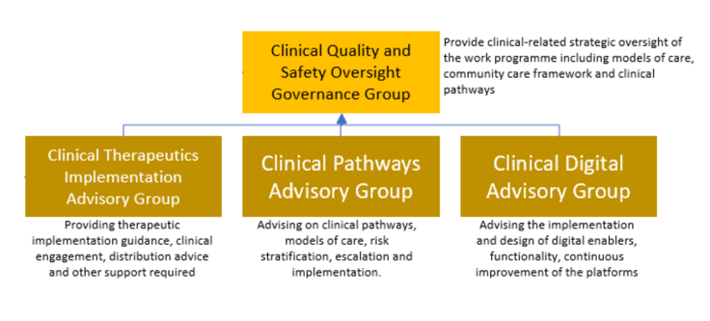
- The CDAG is to ensure the underpinning clinical and health principles for CiTC workstream and its work are sound, practical, and feasible, and will deliver safe and equitable health outcomes for all New Zealanders. The Terms of Reference (dated 21 February 2022) provide:
The CDAG will:
- Provide independent advice to COVID 19 CiTC on clinical and operational matters relating to the development and delivery of digital systems, processes, and technology to facilitate integrated care.
- Provide independent advice and recommendations to the Minister of Health and/or the Minister of COVID Response (or other Ministers as requested) on matters of COVID-19 preparedness, as required.
- Provide technology related clinical advice to the Data and Digital workstream within CiTC and the delivery of its work programme.
- Consider and provide advice on future opportunities for the health sector within the technology space.
Membership
The nominated chair of the CDAG is the Clinical Lead COVID 19 care in Community.
The membership of the CDAG is to be agreed by the Director General of Health, upon recommendation of the Chair. Members are to be considered experts in their clinical fields. At any one time, the membership of the CDAG must not exceed eight (8) core members (excluding guests or supporting experts).
When determining membership, due consideration must be given to include Māori and Pacific representation and tino rangatiratanga (Māori self-determination) when appointing members.

Potential Features to be addressed in future Privacy Impact Assessment activity
- High level overview of identified needs that have not yet been developed, but would have a privacy implication include the following:
  - Any potential GP payment system driven by information or interactions occurring across CCCM will be fully reviewed from a privacy perspective prior to implementation.
  - Any payment Practice dashboard for GP Practices– to allow a practice to do a predetermined search from their practice management system. This would be based on the eDI they pass and the eDI associated as the ‘facility edi” in the CCCM. This would then limit the practices view to the patients associated with them in a way that is a hard electronic association. This will cut down the need to access the CCCM/BCMS dashboard with its wider access, and would allow the practices to benefit from the dashboard workflow functionality they are missing when only accessing the patient from within patient context.
  - Other third-party interactions with the CCCM/BCMS – the largest clinical risk is that the 111 services have no visibility of the data in the CCCM and cannot contribute to it – they are performing the majority of the in-home face to face visits and this is seen as an opportunity to greatly enhance the national shared care nature of the care being provided.
  - Any access by practice health care assistants direct access from the patient management system into CCCM. Currently the PMSCCCM interaction is hard coded to only allow access to usernames that have an HPI associated with them. As health care assistants are not yet a registered workforce within New Zealand they do not have an HPI and thus are not able to currently have access from the PMS. This is creating an extra burden on the health workforce, as their normal working practices allow this role.
  - Patient portal development to allow a person to self-report their symptoms and vitals on a regular basis direct into the CCCM/BCMS and then allow the health workforce to review these “en masse” rather than having to contact each person directly. The review “en masse” would require the development of a clinical dashboard – the RBAC would limit this to a registered health professional – which would surface the relevant red flag questions and answers in such a way that the clinician can rapidly review numerous patients and escalate up care where there is a worrying trend developing.

Section Three – Privacy Analysis
- The purpose of this Assessment is to review the process of collection, storage, use and sharing of personal and contact information for the purposes of the CCCM Project verification against the 13 Rules in the Health Information Privacy Code (HIPC).
- Due to the recent Covid -19 Omicron variation outbreak in the community, Cases are growing exponentially and spreading nationwide.
  - The anticipated national scale of the health response that will be required is unprecedented in modern times. This is a nationally spreading virus which may touch every part of New Zealand.
  - The scale of the numbers of Cases will rule out individual medical attendances in every case. Many Cases will need no medical assistance and can self-manage. Others however may need medical intervention. The level of intervention required will vary.
  - In many cases a person may initially be medically supported in their own home, with telephone and video calls, and prescription deliveries and potentially some home visits if provided by the responsible clinician or an outreach team.
  - Some Cases however will require transfer to hospital level care. This is a serious illness, and for some individuals, a fatal illness.
  - It is crucial that steps are taken to ensure that those who need medical support are identified and able to access that support.
- Consideration of the overwhelmed health systems in other countries, and the likelihood that at some stage New Zealand would also face a large-scale outbreak led to urgent planning of a national shared care model.
- The existing primary care system and clinicians will be of great significance in the response, with enrolled patients potentially receiving care from their regular general practitioner as a first response, while numbers of Cases are relatively low. This direct management from a person’s regular GP and practice will have the benefit that the GP will have direct access to the patient’s historical records, and in many cases a strong relationship with the patient and their family. As COVID is a clinical disease and the severity of it is directly related to the underlying clinical state of the person, the persons pre-existing long term conditions are directly related to the care of COVID.
- This traditional model may not be sustainable in the face of the following potential issues:
  - With the rapid spread of the Omicron variant, and Delta Cases also in the mix, some regions and specific locations may quickly become overwhelmed. Individual practices may find significant numbers of their patients may test positive, as the virus spreads rapidly in that location. Staff at that practice may also become unwell, as may their families. Capacity may no longer be available to support the need of that local community at that point in time. Other practices in that region may also be overwhelmed by the impact of the local outbreak, and unable to provide support.
  - Most practices will not offer 24 hour care, and illness with a COVID-19 infection may develop rapidly.
  - Patients may not be in their own locations when they suffer illness, or may attempt to isolate in different locations due to vulnerable family members.
  - Also a percentage of individuals are not enrolled with any practice, either by choice, or because they do not meet the eligibility criteria to enrol (for example visitors to New Zealand, or those who do not meet the Eligibility Criteria to enrol). There will be no direct connection with a local enrolled practice in these cases.
  - This leaves a number of individuals who may require immediate access to care outside the traditional primary care support network.
- The Ministry is contributing IT and clinical knowledge and experience, combined with clinical guidance from DHBs who have been involved in previous outbreaks, to develop a tool that can support the large number of members of the New Zealand community who are likely to require care in the Omicron outbreak.
  - This shared care model is designed to be a ‘fit for now’ solution to manage this serious health crisis, and is specific to COVID-19 Cases.
  - It is based on the existing national borders PMS system, the Border Clinical Management System (BCMS). The BCMS was ‘stood up’ for management of health care of those individuals under the care of Managed Isolation and Quarantine Facilities when they arrived at the New Zealand borders and has now operated successfully for a year. BCMS has also been used when community Cases during previous outbreaks were required to be located within MIQF.
  - The new module is under ongoing development, and called the Covid Care Clinical Module (CCCM). It will enable national oversight to some degree of the number of Cases receiving clinical care, and will seek to implement some pathway management to attempt to ensure individuals requiring access to medical care are not overlooked.
  - This design is proceeding under urgency to provide a clinical information sharing platform, with some pathway management features, to support primary and secondary care of COVID-19 Cases in New Zealand during the Omicron outbreak.
- The balance must be found between the clinical drivers for the need to provide a national solution involving a large number of users, and the privacy protections to be incorporated in the system to manage people with the dignity and respect for confidentiality that they deserve.
- Governance has been developing during this project to include a specific Clinical Digital Advisory Group as part of the Clinical Quality and Safety Oversight Governance Group.
  - It is strongly recommended that the governance component ensure that the ‘Fit for Now’ solution does not expand its scope beyond the original intentions to deploy a simple share care approach. CCCM is not a step to a national PMS system, but a pandemic response platform to support care.
  - There is currently no established use case for this CCCM system beyond the current urgent COVID-19 response and the purposes for development should therefore be managed with that in mind. It is recommended that a clear and defined scope for this project be prescribed and defined, to remove any uncertainty about the boundaries for future CCCM developments.
- There will also be a specific Privacy Officer tasked with national oversight of this project who will be able to investigate and resolve operational matters, and assess where improvement would be advantageous.
- The shared care record via CCCM will be short-lived in terms of a generally available clinical record. It is designed to commence when a Case, or a probable Case, is identified via the testing systems (either RATs for PCR, both of which are diagnostic tests in Phase Three), and end a short period after the COVID-19 episode ends.
  - After a period of weeks that Case will be either resolved in terms of treatment, or have moved into secondary care management, and will be fully managed by a secondary care level provider (usually a DHB hospital facility).
  - The CCCM record will then be ‘archived’ (no longer visible to any other than a small number of high-level users), and a discharge summary sent to the GP or Practice the person is enrolled with for their records. If a different GP subsequently requests a copy of the record, it can be made available. The records will be held in accordance with the Health (Retention of Health Information) Regulations 1996.
- There are currently two main access methods to access information. This includes:
  - the access on an individual NHI linked record basis by a general practitioner providing direct care to the individual (via link from their PMS and HealthLink) – they must be logged in with their credentials into the PMS, and their practice must be one that has met security standards equivalent to those outlined in Appendix Two of this PIA); or
  - direct access by Role Based Access (RBAC) into the central CCCM records on the BCMS platform. This currently permits access to users with this access to records within the CCCM module as outlined in the RBAC Matrix (see Appendix Five of this PIA).
- Limitation (regional and other options) has been considered to limit the total numbers of individuals who may access the records:
  - With contact tracing it was identified that regional limits on access to information created challenges when local outbreaks (for example in Auckland) overwhelmed the local resource response. Cases were then able to be transferred to other locations within New Zealand to provide support via phone to provide management assistance. Each of those resources was then able to use their unique credentials to log in to the nationally managed National Contact Tracing System to triage and manage Cases as required. These considerations have been taken into account when considering the most optimal care options for CCCM.
  - The one exception to regional limitation is the Whakarongorau contract – this team was contracted by the Ministry of Health to manage overflow and all inbound clinical calls from across New Zealand. The Whakarongorau 0800 OUR MIQ number has been on nearly every text and advice to people with COVID-19 “contact your health care provider, or call Healthline on…” Accordingly they have needed far wider access than any region in order to manage both the outgoing and inbound calls and to document clinical care so that continuity is not being lost.
  - Limitation options should continue to be reviewed to make sure information is limited to those who need to see it (such as providing limited access for some users to allow access only to a queue of activities they are assigned to manage, and potentially increasing the use of facility options to limit the pool of available Cases on display).
- Consideration should also be given to the methods of audit of access that are available – and the frequency with which that audit activity should occur, and who is responsible for managing and reporting on it. The contributing DHBs may have some experience and options to share on how they manage pro-active auditing and monitoring of the extensive clinical information holdings, with large numbers of users.
- The Governance oversight groups are to continue to be developed, to ensure the CCCM remains focussed on the core task of support of the CiTC project, and that there is no function creep in the scope of the CCCM. It is a ‘fit for now’ project to respond to COVID-19, not a new national PMS operational system.
- The Ministry has conducted its analysis under the Health Information Privacy Code as the information is about Consumers and their health services. Under clause 4(1)(e) it is considered that this is information about an ‘individual which is collected before or in the course of, and incidental to, the provision of any health service or disability service to that individual’.

Health Information Privacy Code Rules |  | Solution practices and rules analysis | Commentary | Residual risk
Rule 1 | Purpose of collection of health information  - Only collect health information if you really need it | The purpose of the CCCM collection of information is to enable a ‘Fit for Now’ IT tool to manage the current Omicron outbreak. It is intended to provide:  - accurate, secure, and timely management of health information for those who require CiTCsupport. This will include an accurate and secure record of their COVID-19 management as well as any other health related issues during the time they are receiving Care in the Community. This will also include interactions with other Ministry systems as appropriate to support COVID-19 related records, and the ability to make referrals to other clinical services as appropriate; and  - support for national, regional, and local providers, both primary and secondary care level to monitor and deliver care to COVID-19 Cases. This will include RBAC controlled access for clinicians directly involved in care, clinical operations managers to oversee ‘facility’ activity inCCHs, and management staff looking to manage overall resourcing need projections (via non-identifiable and aggregated data. | Purpose  Collection of information for the CCCM purposes is part of the lawful activities associated with CiTC Case management, to support the public health response to the COVID-19 pandemic.  The nature of this project is to develop an IT tool that will support the immediate needs of the Omicron response (and any subsequent pandemic related situation where the need for a central clinical record is still required).  Controls to help avoid function creep will be the appointed Privacy Officer with oversight of the CiTC project, the CDAG to assist with the ‘digital enabler’ component by making recommendations and the Ministry Data Governance group for oversight of CiTC, and CCCM, including any related matters such as supply of information to Snowflake.  Necessary  The information collected, and made available via the CCCM is considered necessary for delivery of clinical care to COVID Cases in the community due to the significant number of simultaneous Cases occurring with the Omicron outbreak, and to manage oversight of the Case numbers to limit the opportunities for individuals to be missed who are more likely to suffer ill-effects from COVID-19.  Information fields collected: The CCCM is based on a practice management system designed for clinical patient care. It has been adapted from the BCMS, which has been used for over a year in the border settings for care of COVID-19 Cases and their pre-existing conditions.  - Information fields collected from and about Cases are designed to support the management of COVID-19 Cases including related clinical risk factors, and any social and manaaki welfare issues that impact on those risk factors.  - General information fields can be identified from the Dashboards in Appendix Four, and the Role Based Access Matrix in Appendix Five signals the limitations that are placed on access depending on the role of the individuals with access credentials. These have been determined as clinically necessary or appropriate, with the assistance of clinicians, to meet the CCCM purposes.  - Not all available fields will need to be completed – this will be managed at the discretion of the authorised user, and in conjunction with the needs of the Case requiring medical assistance.  In recognition of the Fit for Now nature of the CCCM project, and the unique COVID-19 related Case load, the time frame within which records will remain generally accessible for view is limited to up to six weeks after the last clinical engagement (or ‘discharge’ from CCCM if that occurs later). Some files may be closed within 28 days of being reported as a Case – but flexibility is required as there is potential for long COVIC, or potentially re-infection. This timeframe of up to six weeks will meet the purposes for collection (being the management and care of COVID-19 CiTC processes). This time frame is to cover the expected range of recovery time frame for the acute and post-management stage of COVID-19, noting that Cases requiring longer term care may be managed outside the CCCM. Information will be retained securely in accordance with legal requirements for retention of health records, but there will be limited users authorised to retrieve this information after the six week period (but full ability retained to provide a copy of records to another medical practitioner on request, or at the request of the Case or their authorised representative.)  Recommendation:  The Governance roles be clarified to confirm which entities or role will have oversight of which aspects of CCCM operations. The role of the Data Governance Group, CDAG and the CCCM Privacy Officer need to be aligned so the focus for each can be identified and the authority for decision making clarified. | Low
Rule 2 | Source of information  - Get it straight from the people concerned | The initial collection of information (identity and contact details to accompany the test sample) related to a test result is collected at the point of testing, and the results then recorded in Eclair. This information is collected directly from individuals.  The initial creation of the Case record in the CCCM is created from information held within Ministry systems (NCTS) including details such as positive Case status, the relevant NHI, and name associated with a positive COVID-19 test result.  - Compliance in CCCM obtaining the information directly from the individual is not reasonably practicable (Rule 2(2)(d)) due to the large numbers of Cases and the need to have a complete list of Cases to assist with identification of those Cases needing clinical oversight and support.  Key information, such as underlying health conditions that have an impact on COVID-19 infection outcomes, is collected directly from individuals, either via Contact Tracers during their communications with Cases, or more frequently from the Covid-19 Contact Tracing form (completed directly by individuals and uploaded to NCTS). The Privacy Statement directly accessible within the COVID-19 Contact Tracing form advises individuals about the information required including:  - ‘What your symptoms are, and when you began experiencing them, so we can work out your infectious period, and also so we can assist if you require healthcare or other support  - Any underlying health conditions, so that we can prioritise support for people more likely to get sick  Daily health checks or other clinical engagement with individuals will involve collection by clinicians in direct communication with Cases (either in person or more likely by phone or video).  Any information obtained during these direct clinical or health check interactions is compliant with HIPC Rule 2. | Due to the likelihood of widespread Cases in New Zealand, and the challenges to providing timely medical support to those who need it, the initial record creation in CCCM will not be collected directly from individuals. The need to collect information from sources other than directly from the individuals is considered to meet the ‘not reasonably practicable’ exception to Rule 2.  Apart from the initial test result and NCTS supply of information to open an NHI linked record in CCCM, it is the intention that the CCCM will record information arising directly from clinical, and daily health check communications with Cases.  - The collection of information during clinical attendances will be consistent with Rule 2 as the information will come directly from the clinical interactions with the Case (or in response to queries made on their behalf).  - Section 22F of the Health Act will also cover communication of information from sources other than the Case for diagnostic and other purposes.  - There may be some capture of information related to household contacts (due to the high likelihood that they will become infected with Omicron) and it is considered that either Rule (2)(a) will apply if the household contact is made aware of the collection or Rule 2(c)(iii) will apply so as to avoid prejudice the health and safety of that household contact. | Low
Rule 3 | Collection of information from individual  - Tell them what you’re going to do with it | There are a number of Privacy Statements available at various collection points, including test collection and contact tracing processes or COVID-19 Contact Tracing form submission. Each indicate that information will be used to support the care provided to the individual if required.  At every “test” collection site, be it a community testing centre or a GP, they will have privacy statements available for view. The mobile phone number verification process at testing expressly states confirms the contact point for the person consenting to get ongoing information and questions about their covid care.  The ESR Privacy Statement for Eclair provides for how test results will be used and who may have access to them.  - The general nature of the use of information outlined in the Éclair Privacy Statement is consistent with CCCM, but as it is a new project it is suggested that the Éclair Privacy Statement be updated to reflect the CiTC project.  Key information, such as underlying health conditions that have an impact on COVID-19 infection outcomes, is collected directly from individuals, either via Contact Tracers during their communications with Cases, or more frequently from the Covid-19 Contact Tracing form (completed directly by individuals and uploaded to NCTS). The Privacy Statement directly accessible within the COVID-19 Contact Tracing form advises individuals about the information required including:  - ‘What your symptoms are, and when you began experiencing them, so we can work out your infectious period, and also so we can assist if you require healthcare or other support  - Any underlying health conditions, so that we can prioritise support for people more likely to get sick  As part of the CCCM activities, the clinician is to take all reasonable steps to ensure any Consumer who will be managed via CCCM is aware that:  - information is being collected,  - the purpose of the collection  as part of the initial communication with the Consumer. The CCCM system will prompt the first clinician that enters a note on the record for the Case ‘Please assure the person that all information gathered during this call is strictly confidential and will only be used to support them while they are isolating. It will only be shared and visible to other health professionals when and if required’. | The BCMS Privacy Statement does not fully reflect the CCCM processes.  A CiTC Privacy Statement – particularly covering the CCCM activity - should be created and available from an appropriate site on the Ministry website. This should include full details in accordance with Rule 3 so that those who are interested in more information about CCCM, and its privacy implications, have a point of reference to find out more. A draft is attached as Appendix Ten.  It is also suggested that the initial collecting point (the Eclair Privacy Statement) could benefit from some enhancement of its Privacy Statement to directly refer to the CCCM for the sake of transparency  Recommendations:  - Provide new Privacy Statement on Ministry website describing the CCCM processes (refer Appendix 9)  - Consider minor update to the ESR Privacy Statement for COVID-19 Testing and Reporting to expressly reference CCCM https://www.esr.cri.nz/our-expertise/covid-19-response/privacy-covid/ | Low
Rule 4 | Manner of collection of information  - Be considerate when you’re getting it | The CCCM will not collect personal information by unlawful, unfair or unreasonably intrusive means.  There will be individuals who are under 16 years old, or those with challenges with language or disabilities who may require CCCM support. It is expected that the clinical staff operating the CCCM will use existing experience and Standard Operating Procedures to ensure each of these individuals are managed in accordance with their needs and any information privacy specific issues are managed appropriately. | The CCCM is a clinical module, and will be operated by clinicians in terms of the identifiable health information contained on it (and as provided in the Role Based Access assigned as indicated in the matrix in Appendix Five).  Clinical information should therefore be collected by standardised and well-established clinical processes, and Standards Operating Procedures are expected to be in place in each CCH to make sure that this CCCM information is managed in a minimally intrusive manner as far as is possible. | Low
Rule 5 | Storage and security of information  - Take care of it once you’ve got it | Personal information is to be held and managed in accordance with the Privacy Act and Health Information Privacy Code.  Technical controls will be managed by Ministry security reviews to ensure controls are adequate. Security of the CCCM, and its interfaces, is a key area for protection of sensitive health information. Security flaws could lead to significant and damaging consequences for any Case whose information may be involved in a security breach due to inadequate security, and the trust in the overall CiTC operations could also be significantly harmed – leading to challenges in ongoing willingness to engage with CCCM processes.  The initial security incorporated into the BCMS has been described in the BCMS security section of Part Two of the BCMS Privacy Impact Assessment. The Ministry security team and independent contractors are following standard processes to review all CCCM modifications from the original BCMS product. An Authority to Operate is currently being finalised for both the overall Care in the Community project as well as for the CCCM integrations. It is expected these will be completed in the week commencing 7 March 2022.  Operational controls already existing in the base BCMS platform will include for example:  - training of CCCM users. There are standardised training materials provided on how to use the CCCM system and the PMS link to the system. There are regular weekly training sessions and also contact points provided for support to use the CCCM.  - Terms of Use that must be accepted when first using credentials for access to CCCM.  - management of access allocation (and removal) of role-based access controls from a central CCCM point, after submission of chosen users by CCHs, who will confirm the identity and roles of users to be granted access rights. | The security of CCCM will be managed on an ongoing basis by review from the Ministry security team and external testing for any new features or changes.  - Operation of the CCCM will be limited to any ATO approval, which has been approved after independent security testing. This will minimise security risks by only permitting activity that has met necessary security requirements.  - The Ministry has used an All of Government supplier for the penetration testing of the CCCM and its exposed APIs.  - Approval via review and testing will continue for the lifetime of the BCMS and CCCM. These reviews will continue to set the operational parameters for the BCMS and CCCM to ensure security is maintained  - Any material design changes in future releases, e.g. new integrations, will require additional security review and an amendment to the ATO would be completed prior to that go live.  - All third party interfaces have been designed around “go into BCMS/CCCM view and do”. For the PMS access, the record of care is written back in the outbox as a history of what the clinician saw and what they did – and this is saved as a webform.  How to identify and manage a privacy breach (and who to notify in relation to the BCMS system) is being incorporated into the training and Hub breach notification processes.  Recommendation: The audit and monitoring policy be finalised and implemented setting out the responsibilities of CCHs for management of record access at that location. This is a feature that each CCH be required to report to the CCCM Privacy Officer. | Medium
Rule 6 | Access to personal information  - People can see their health information if they want to | Each Case will have the ability to request access to information held about them in the CCCM. In addition, their General Practitioner will be able to request a copy of the CCCM information about the Case (with their approval) or the Case can request that a copy be sent to their General Practitioner (and the supply will generally be automatic on discharge from CCCM if the person has an enrolled practitioner).  The Case can also contact the Ministry to initiate this access request process (and the Ministry contact details will be provided in the CCCM Privacy Statement). | It is recommended that due to the involvement of multiple parties in the operation of CCCM (the Ministry, DHBs and primary practice providers – potentially including the PHOs who have responsibility for enrolled populations), and the national spread around the country of current and former Cases, that a Standard Operating Procedure be developed for management of Case (and former Case) requests for access to, and correction of CCCM information.  This should have one obvious contact point for Cases which could then be responsible for management of all requests to make sure they are passed on to an appropriate party when required (it is suggested that this be the national CCCM Privacy Officer role to oversee which party needs to respond). Each agency would still need to manage any requests that were made directly to them, but the SOP would enable a pathway to ensure that each requestor was able to obtain full access to all information, with clarity on which parties may be requested to contribute to the request to make sure nothing is overlooked.  This will ensure that a process compliant with Part 4 of the Privacy Act 2020 will be able to be established, and available, so that all responsible parties can consistently and promptly manage such inquiries. | Low
Rule 7 | Correction of information  - They can correct it if it’s wrong | Not every request for correction of a clinical record will result in a requested change being made. It is important however that processes are established that comply with Part 4 of the Privacy Act 2020. | It is recommended that this be included as part of the Standard Operating Procedure for requests for access to information. | Low
Rule 8 | Accuracy etc. of information to be checked before use  - Make sure health information is correct before you use it | Initial CCCM files, with NHI details included, are expected to be confirmed by clinicians when first contacting the Case, as would apply to standard clinical practice. This will enable up to date and accurate details to be checked directly with the Case and updated as required to make sure they are accurate. Not all clinicians currently participate in CCCM so there is not final pathway oversight of the care of all COVID Cases – and it is acknowledged that there will not be a full picture of COVID care management nationally with the isolated management of some files directly by GPs without direct submission of that data to CCCM. By identifying unenrolled patients however it is likely that CCCM will be able to identify a large number of those without a direct relationship for care provision.  All changes are traceable to the logged in person and can be audited easily.  It can be reasonably assumed that Cases will provide details that are true and correct to the clinical team. In the event that it is not correct, (someone does not remember to advise or hides an underlying condition for example) the medical consultation must be the method used that will identify the accuracy / inaccuracy of information provided.  All Cases are set to self-management (by the person) unless a clinician decides they should be moved to clinical care within CCCM. | Standard Operating Procedures should already apply to clinicians and CCHs as they have existing medical association with individuals and should apply standard professional practices to manage the accuracy of patient records.  There may be challenges with multiple parties working on single patient files which are being managed within a CCH (potentially also including regular checks from a call centre contributing information). Part of this challenge is designed to be managed by the CCH Dashboard (see Appendix Four). This provides for a summary screen showing highlighted annotations of the features most relevant to each Case in terms of COVID-19 management, and also has an option for Whiteboard notes to enable care handover. This information highlights pathway risk areas where more up-to-date information may be required (such as test overdue) which is designed to assist in retaining clinically accurate information and identify when key time frames are to be met or are overdue.  Each PMS link via Healthlink to the CCCM will record updates directly into CCCM and then have a complete updated record returned to the clinician’s PMS so that all information is available in the single returned form. This is to make sure that all current information remains to hand on each occasion that the clinician needs to review that file for COVID-19 management of that Case. This should prevent earlier reporting being overlooked which might lead to inaccurate treatment decisions (for example missing underlying conditions reported, as they are buried in earlier iterations of the record).  Additional interfaces with other clinical systems are incorporated into the CCCM (as described in Appendix One). These are either standard clinical interfaces that are in existing operation, or appropriate testing has been conducted before Go Live to ensure they will work as intended and accurately link the correct information to the correct file.  The creation of a ‘provisional’ case by a GP or within CCCM will be linked by the bbmsID added to the record at the time it is passed to NCTS for record creation, so it will be returned with that ID when it links back to CCCM, to avoid duplication of the record. On Case creation in NCTS, the case is sent to ESR to maintain an authoritative record of cases in Episurv / Eclair. The clinical teams are currently determining how the Case will be reported as it is possible that no follow up test will be completed (it is possible it may be recorded as a ‘suspect case’ in Eclair). | Low
Rule 9 | Retention of information  - Get rid of it when you’re done with it | As the records relate to the clinical care for Cases during a COVID-19 episode they will be available for view within CCCM for a short time (for 28 days after symptom onset). The health records created are not likely to be reactivated within the CCCM context (unless the Case tests positive for COVID-19 again at a later date or the clinician needs to re-open a care record). The records are however health records and must be maintained in accordance with legal requirements.  Any ‘health record’ details will be stored in accordance with the Health (Retention of Information Retention) Regulations 1996.  Discharged Cases show in a separate dashboard with access limited to CCH nurse managers and doctors to review details after discharge when requested by the past Case. Access restrictions to the dashboard is as per the Matrix in Appendix Five. | A Retention of Information Policy will be finalised for the CCCM. This is to reflect the need to retain health records for a minimum of 10 years, and the two-year requirement for all audit logs of access to the CCCM.  The Ministry has ensured that its contract with the vendor will enable the Case records to either be held by this vendor or capable of being securely transferred to another secure record repository so that the 10 year retention time frame can be met (the Ministry will manage this as part of its post-pandemic governance).  The accessing of records of a Case no longer under management in the CCCM system is one of the key scenarios that will be covered by the proactive monitoring of log files for inappropriate activity given to limited occasions when that would be required. | Low
Rule 10 | Limits on use of information  - Use it for the purpose you got it | The intended purposes for use of the BCMS are related to the use for which the information is obtained: to manage the health requirements within CCCM of Cases and others in their bubble during the relevant COVID-19 episode.  Any other uses must be identified, reviewed from a privacy and security perspective and incorporated into the Privacy Statement prior to implementation.  The CCCM has the potential to be a rich and informative database that may have significant value both for management of resources to meet current and anticipated needs, but also to identify and review findings for management of the current and future pandemics. There are options, including de-identification of information, and the statistical and research exceptions under Rule 10(1)(e) that should be signalled in the Privacy Statement if it is intended that they be pursued in the interests of transparency. | Role based access controls: These have been designed to limit the user roles who can access information – this will contribute to control on use of the information. For example, non-clinical staff should not be able to access clinical information where their role does not require it. Those without access credentials will not be able to access the information at all.  Data Governance: The governance roles with oversight of the CCCM will need to provide oversight of the use of the data, and the future use of CCCM itself, to ensure guidance against function creep remains in place.  This will include not only future uses of information, but also role-based access controls – which could potentially increase access and thereby use to previously unintended groups. For example, the planned limitation to GPs to access only their own patients via PMS access to CCCM being overridden in some CCH settings and full access to that Regional Dashboard provided to help the practitioners have easy viewing ability of all of their Cases (and incidentally all other Cases in that facility). Unintended uses of CCCM features may work outside the planned controls and this should be managed and returned to planned controls as soon as possible.  Recommendation: The Privacy Statement clearly identify all potential uses of the information to ensure full transparency.  The potential to use interactions with CCCM as a basis for calculating payment to be made to practitioners participating in the CiTC programme is to be considered – and will be reviewed from a privacy perspective prior to any implementation (and incorporated into the Privacy Statement if to procced). | Low
Rule 11 | Limits on disclosure of information  - Only disclose it if you have good reason | Information within the CCCM is to be held securely and the ‘disclosures’ from it controlled to match intended uses.  BCMS information relating to MIQ entries is not available within CCCM as it is designated to ‘facilities’ that do not permit CCCM facility users to access the information.  The general practitioner a person is enrolled with will be able to launch access into that Case record within CCCM if they have a practice that is participating in CCCM processes.  CCHs control who is to be given access to specific roles in that region – with the role allocated from a central CCCM point once the Hub has confirmed the identity and role of the user.  Any request for information from a GP subsequently requiring records about a former Case from CCCM will enable an authorised transfer of a copy of the records at any time, and the Privacy Statement provides that records will be provided to the practitioner the Case is enrolled with on discharge. | Only those required to have access to the data for CCCM related purposes (as outlined in the Privacy Statement as a purpose for collection) will have role-based access. The access available for each role is as set out in Appendix Five. This should be enforced by Standard Operating Procedures at each CCH and subject to audit monitoring of logged access activity. Standard processes already apply in each regional DHB setting for management of and access to information for different roles (including those under supervision). All practitioners under the Health Practitioners Competence Assurance Act 2003 must meet certain standards in their management of information and oversight.  Audit and monitoring of access will be used to identify if authorised users are accessing information appropriate only to the role they are performing and the Cases they are managing. An audit and monitoring strategy and CCH plans are to be developed to ensure that this can happen. This should also be monitored by the CCCM Privacy Officer with regular reporting of the Hubs to that role.  All authorised users will be subject to Terms of Use they must electronically confirm at signup to their access rights – this is part of the standard BCMS processes. This will require them to take care of information and avoid inappropriate disclosure of information.  Participating GPs using their PMS to enter CCCM are restricted to accessing information related to their own patients (and their access is also recorded in CCCM via CPN used to access the file).  To prevent a patient’s risk calculation from being included in their records, with the risk that it may be shared with a third party such as an insurer, the risk score generated by the Risk Stratification Tool is not to be included in records saved from CCCM to GPs’ PMS files.  Recommendations:  The CCCM Privacy Officer to provide recommendations to each CCH to:  - Contact the CCCM Privacy Officer role for all privacy related matters associated with Care in the Community, and to provide notice of any system issues as well as specific privacy breaches in that region related to CCCM.  - Ensure Cases are assigned to appropriately sized ‘facilities’ within that region, where appropriate, to limit the range of Case information available to any user groups in that region to those Cases they are involved with.  - Remember to send notice of revocation when users no longer require access  The temporary solution within those CCHs that have enabled CCCM access to Hub records, for GPs who were only intended to have PMS access will be removed as soon as possible (and potentially replaced with a Dashboard unique to the Cases and bubble members managed by that practice).  Any other access to information, such as via Snowflake or use for research purposes should be signalled in the Privacy Statement and subject to standard Ministry processes for approval prior to any information release. | Low
Rule 12 | Disclosure of health information outside New Zealand | CCCM is part of BCMS which is hosted in New Zealand. Some IT support services for the BCMS will however be provided from Pakistan (a contracted agent of the BCMS SaaS provider) under controlled conditions as described in the BCMS PIA.  For each of these purposes the information will be held only as agent for the BCMS, and it may not be used by the contracted provider for its own purposes. | It is considered that section 11 of the Privacy Act 2020 will apply to the hosting of the CCCM on BCMS (which is within New Zealand), and provision of support services, as the information will be held on behalf of the joint Ministry / DHB clinical management system for CCCM for safe custody and processing by the vendor Valentia (and its subcontracted agents).  The vendor is not permitted to use the information for its own purposes. The limitations and processes to apply to the provision of support services have been detailed in Appendix Eight of the BCMS PIA and reviewed by the Ministry security team.  The access to the BCMS by the subcontracted provider based in Pakistan is restricted to only those rare Cases where it is necessary to have access to the production database. Access will be specifically provided via a jump host in each Case and all access monitored and recorded. | Low
Rule 13 | Unique identifiers  - Only assign unique identifiers where permitted | NHI assignment within the CCCM setting is consistent with Rule 13(3) as the Ministry of Health, District Health Boards and practitioners are all authorised to assign the NHI number. | This is a unique identifier for use within the health system. It has been connected to the individual at the point of testing and can reasonably be expected to be reliable when that testing has followed standard processes.  It is noted that now self-reported RATs are included in Eclair holdings, individuals can either upload their own result via their My Covid Record (which has an NHI bound to that account as part of the My Health Account digital identity processes) or may use assisted channels (where NHI will be looked up in accordance with standard processes). Each of these processes are expected to be reasonably reliable in the allocation of NHI. | Low

Appendix One – System interaction overview (as at 4 March 2022)
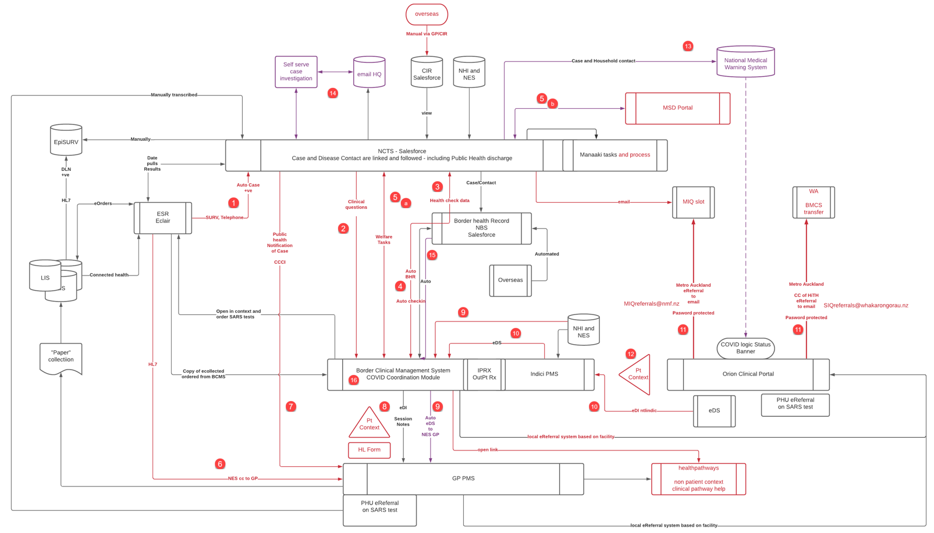
- Changes in Red in production
- Changes in Purple in various stages of creation
- Changes numbered and details below

Summary of System Interaction Diagram above:
The numbers on the diagram above match the explanation in the same numbered paragraph below
Test Results
- The Eclair COVID-19 test repository will send positive COVID-19 test results via an existing API to NCTS.
  - This is done via secure SFTP transfer of Detected diagnostic results. The tests are currently Nucleic Acid Amplification Test (NAAT)- Polymerase Chain Reaction (PCR). Rapid Antigen Tests (RATs) will form part of the results in Phase Three (as they have now moved from a surveillance to a diagnostic role in Phase Three).
  - The data provided is linked to a Case (linked by BHR) that is created for the relevant individual within NCTS (linked by NHI).
  - Data transferred with test results includes
    - For eCollection systems:
      - Consented telephone numbers (which are verified on site in the case of mobile phone numbers). During the eOrdering process verbal consent is obtained from the individual to use the phone number for COVID communications including:
        - Answers to pre-test probability questions which allows the laboratory to prioritise samples
        - SURV code associated with the test which allows public health to know “why” the swab was taken
        - Symptoms reported at the time of ordering
      - NHI barcode on a verified phone number
      - Collection text message
      - Result delayed text message – sent at 48 and 168 hours after the specimen has been received in the laboratory and not resulted
      - Result text message – negative, spoiled, delay in result and positive
    - For ‘paper’ collection systems: Phone numbers present in the laboratory for the person either obtained at the point of SARS CoV2 ordering or previous eOrder or paper collection.

NCTS information
- Additional information is then collected by contact tracers or public health unit interviews, or via the Ministry COVID-19 self-service Contact Tracing Form tool, and recorded on the NCTS. This includes collection of certain clinical data, specifically the co-morbidities of the person.
  - The relevant information is transferred to CCCM once the CCCM record is created. The process for creation of the CCCM follows the process set out in paragraph 4 below (setting up the BHR).
  - Information sent from NCTS to CCCM will include information relevant to the care of the individual:
    - Name, contact details, isolation address and test result;
    - Information about underlying health conditions, as per the collection from the Covid-19 Contact Tracing Form (aligned to the questions asked by contact tracers):
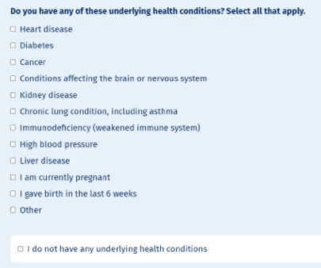
    - Predicted isolation start and end dates for Cases / Contacts
    - If the person is enrolled on the National Enrolment Service the GP practice name and identifier. This will enable CCCM to identify which GP or practice the Case is enrolled with. In a future release an entry will be able to be created for a ‘service’ GP, if a different GP is managing the COVID care for the person in the community.
    - Any welfare tasks that have been sent to MSD via the MSD portal
  - The transfer of the clinical data previously collected on the Case journey through the various collection systems will prevent double entering (potentially reducing errors). To support triaging of patients who self-report information that indicates they may need more assistance, this data may also be used in future iterations of the Risk Stratification Tool to recalculate the risk and send an updated score reported to CCM.
  - The CCCM clinician can view and choose to ingest (transfer a copy of) the data from the NCTS underlying conditions into the CCCM past medical history page by clicking “copy to assessment” document. This means the clinician is verifying the veracity, and relevance of the data before including it in the clinical record
Health checks
- Health checks done in either CCCM or NCTS will automatically update the other system, thus allowing the clinical reviewer to know if a check has already occurred (this will avoid duplicated calls when the task has already been achieved). This will confirm on the NCTS that the check has been done – thereby forming part of the ‘safety net’ as a reporting search can be run to highlight where a regular check has not occurred. If no check had been done this will be identified and followed up.
Border Health Record
- Auto creation of a Border Health Record (BHR) number will occur within the National Border System – when the contact tracer confirms that the individual will be allocated to Care in the Community. This NCTS process is set out in Appendix Six. This was previously a manual step, but automation will reduce errors and ensure a record is created. It is important to create the BHR as it denotes the episode of COVID care - one person may end up with different COVID care episodes over the course of this pandemic, and so may have multiple BHR over time.
Welfare tasks
- Transfer of welfare tasks can occur between CCCM and NCTS (from wherever the welfare need is first raised by the Case). The NCTS has an API with a Ministry of Social (MSD) API that can collect limited identification and contact information to enable a Case to receive assistance with any identified welfare needs:
  - As maanaki and some welfare needs will be managed locally, the initial assessment welfare question and the welfare flag is not transferred into NCTS and the label has been updated to indicate as much. The welfare flag on the regular health check does send to the MSD portal and has been updated to make this explicit to the end user, and this includes making sure the person has consented to this level of data sharing.
  - Point 5.a shows the two way interaction where a welfare task can be set in the CCCM or in the NCTS. Point 5.b establishes that the information can ultimately be transferred to the MSD portal (via the NCTS / MSD API) or a welfare task set in NCTS and managed via MSD will be visible to CCCM to see the completion status.
  - Update of the task outcome from the MSD portal to the welfare task in CCCM - so the clinician can be aware of the outcome of the welfare task while interacting with the person’s record (mainly whether it is still active or resolved).
  - The first time a Case answers “yes” to the question of needing welfare on the CCCM regular health check – the clinician or health assistant working on the file will be presented with a pop up that says:
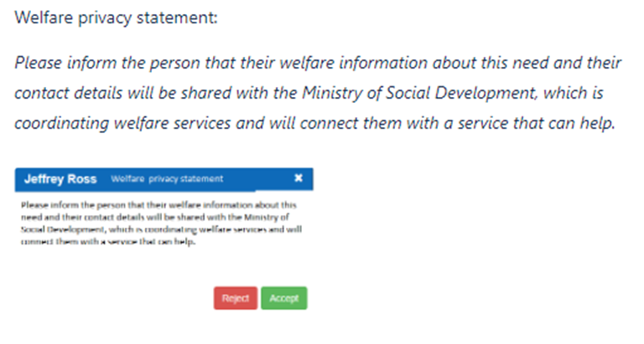
Click to Reject / Accept. If the CCCM user clicks ‘reject’ they are unable to set the welfare flag that will transfer the information.
Healthlink – Test results to enrolled GP
- ESR Eclair provides an automatic copy of SARS CoV2 results to the GP the person is enrolled with (if the results did not already provide for a “to” or a “cc” clinician). This transfer occurs via Healthlink.
  - eCollection systems operate outside of GP practice management systems and are generally used by Community Based Assessment Clinic (CBAC) or Community Testing Centres (CTC), thus all results are returned to the enrolled GP so they are aware of the test being done. The results will also be presented in the person portal for the consumer to view (if that practice operates a person portal).
  - “Paper” collection systems are assumed to have chosen to NOT return all results to the enrolled GP, so only positive SARS CoV2 results are copied to the enrolled GP, so they are aware of the positive result and can initiate care of the person according to the local CCH’s operating model.
Covid clinical care inform message
- The NCTS ‘covid care inform system’ set up for the distribution of covid immunisation records has been used to inform the GP when an NCTS Case or household contact record has been allocated to follow up. This will make the GP the person is enrolled with aware of the Case and the co-located disease contacts (aka household aka bubble members) and that the relevant CCCM record has been created.
PMS
- A Healthlink smart form link has been created to launch the CCCM in person context from any GP practice management system (PMS) that has authority to connect to CCCM (see the approval criteria in Appendix Two).
Security features of CCCM
  - As a new feature this has been subject to extensive and ongoing security review. This CCCM integration is currently being finalised under an Approval To Operate from a security perspective in the week commencing 7 March 2022.
Process requirements before authorisation to connect to CCCM via PMS
  - In addition, the MOH has a series of questions to evaluate the security (information technology and physical) and privacy policies and procedures that need to be met in order to grant a third party access to a MOH system. A copy is attached at Appendix Two). These questions have been mapped by the Royal College of General Practitioners of New Zealand (RCGPNZ) to their foundation standards assessment process. Review of the RCGPNZ has shown the foundation standards meets and exceeds the MOH security and privacy requirements.
    - RCGPNZ has supplied a list of all foundation standard assessed GP practices. These practices have been given access to the Healthlink link to the CCCM
    - Non Foundation accredited GP practices have been advised to speak with their Primary Health Organisations (PHO) to fill in the 15 questions and return them for review to the MOH provisioning team. The MOH are also actively asking the PHOs these questions as these GP practices are frequently in high deprivation areas and the clinical team want to make sure these practices are not disadvantaged as this could impact on the population they serve.
    - Regular reports of the foundation standard GP practices that have lapsed will be provided to the MOH provisioning team to ensure CCCM access is removed as needed. During COVID however, a temporary amnesty is being granted to this (for those who have lapsed since July 2021 – to align with the Delta outbreak timeframes) as the foundation standard assessment is an intensive workload and involves onsite visits, both of which are impractical during the high COVID workload and social restrictions needed to minimise spread.
  - This PMS feature is enabled via Healthlink by supplying Healthlink with the eDI of the practices, once they confirm that they meet the security requirements (either RCGPNZ foundation requirements or the security questions in Appendix Two).
Information transiting Healthlink
  - This Healthlink connection sends through only enough details to ensure the right person in the right location can be viewed and enables a record to be retained to support an audit of clinician doing the viewing and doing. This includes:
    - Clinician details including name, NZ Professional Council Number, and CPN (the health professional unique identifier)- this is a mandatory field. PMS users who do not have a CPN will be refused access with an error message that is nonspecific. This is a security requirement to prevent the person knowing why they have been refused entry
    - Facility details including practice name and HPI.
    - Person details including name, NHI, date of birth.
  - The access available to any Healthlink enabled PMS is limited to clinically active CCCM Cases.
    - A public health active Case in CCCM is determined by Case or disease contact creation and resolution in NCTS.
    - The period when a Case is clinically active will include the period for six weeks after release from public health care. The access for six weeks after release from NCTS has proved important from a clinical point of view, as a person’s clinical situation can deteriorate despite being released from public health, and knowledge of recent COVID is necessary to help the clinical reasoning on presentation of the person regardless of the care setting they present in. Currently it is also considered that some individuals will need a follow up at six weeks after discharge and this could be recorded in the CCCM. This time frame will be kept under review.
    - The first time the clinician logs into CCCM via the PMS route they are presented with the same Terms of Use used when first accessing the BCMS.
    - The first time any clinician enters notes on the person record – they are presented with a privacy statement
Please assure the person that all information gathered during this call is strictly confidential and will only be used to support them while they are isolating. It will only be shared and visible to other health professionals when and if required
    - All notes that can be sent outside of the CCCM/BCMS already have two check boxes that must be checked before the CCCM will send any messages externally (limited to GP inboxes with the EDI and HL7 messages). These check boxes require confirmation that:
      - The person consents to share notes with the wider NZ health system
      - Send note to GP inbox. This then sends to the eDI of the named GP entered on the person information screen of CCCM via established Healthlink processes.
Provider Case management
  - From this point the provider takes over and contacts the Case to undertake clinical or welfare assessment (local need – not the MSD service) in CCCM as needed. This may be separate organisations including in some Cases (including individual practices and Maori/Pasific Island community providers for example) or may done by one organisation. Either way welfare assessment / provision information is sent back to Salesforce (NCTS) to be available in that system as required.
  - Providers have access to certain “facilities” within the CCCM, and in that facility they have access to all the records. Once in the record what they have access to is role-based. There may be instances where a provider has access to another Facility that isn’t their own but is in their region’s PHU, as they may be called upon to care for the Case.
  - Audit logs on all CCCM users (User ID) are available to ensure a trail of which providers view/update (read/write) which contact details is in place and available. Exception based reporting available as needed to check Case access from a security perspective.
GP Management of COVID positive person info
  - All GP practices that have met the RNZCGPs foundation standards have access to the Healthlink form. If the GP is not the person's enrolled GP, the GP would need to have their admin staff enter the person as a “casual” i.e. non enrolled person in their local PMS before they have access to the link that will open the CCCM record for that person. This is to enable GPs to manage COVID positive persons that have been referred to the PHU for that region (for example people who may be travelling when diagnosed and not be able to visit their enrolled GP) or for after hours or sickness cover. The practices are expected to have a well-established review process of all casual patients, and audit why they are there and what activity has occurred on them, and to maintain privacy standards.
  - This ‘view’ also enables GPs to see other people in the COVID positive Cases’ bubble. This is again to enable management of COVID at a household level and identify likely Cases for self-isolation as early as possible (without having to wait for a positive test result and referral from ESR). With Omicron most household contacts are likely to contract COVID-19.
  - However the GP cannot see details of those in the bubble from the BCMS in context view - just the names of those in the bubble. Should the GP wish to look up these additional contacts’ details they would need to view them by opening that patient within their patient management system with the same safeguards as mentioned in 8.9.
  - From a security perspective, audit logs are available in the database of BCMS/CCCM to track which GPs launch and view which persons BHR. This data is being exported, curated and access controlled via the MOH Snowflake instance.
NHI and NES
- The NHI and National Enrolment Service database is available to provide relevant details for each record within BCMS.
Discharge information
- On closure of the public health Case the CCCM system maintains a copy of the record. This can be found in the “discharge persons” dashboard (see Appendix Four). This is role (RBAC) protected to doctors and audit managers and only visible via the CCCM/BCMS main dashboard entry point:
  - Hospitals can send a discharge summary of the hospital level care received by the person to CCCM. This is done by using the existing Healthlink method of sharing discharge summaries from hospitals to GP PMS systems.
  - For the discharge summary to be directed to CCCM, the specific eDI (electronic data interchange, a unique number that identifies which PMS needs to receive the electronic message) of the CCCM system has been made known to the hospital systems
Secure email referrals
- This relates to MIQF activities. The Metro Auckland hospitals have had to discharge persons to monitored isolation or community care. In order to avoid the emailing of word documents to generic emails (which has privacy risks associated with it) the metro Auckland region utilised their internal referral product to create a password protected email to the generic inboxes with enough details for the MIQ or Community Whanau HQ teams to manage the person’s safely and securely from there. This is localised to the metro Auckland region and has gone through a local Privacy Impact Assessment. This facility is likely to become defunct shortly as the service will move to within the hospital systems associated with the remaining MIQF, rather than being managed by a call centre.
Hospital access
- The hospitals will be able to access the CCCM system in two different ways (in test at the time of development of this PIA – but the Northern region is piloting it):
  - Stand-alone BCMS/CCCM dashboard (access provided to hospital staff, as named users of CCCM with two factor authentication – the team will essentially be working as a clinical hub with their own patients in CCCM, rather than within the hospital system so that the data is not isolated from other providers, given these patients are at home and their GP may still be involved in their care); or
  - a limited set of “hospital in the home” nursing and medical staff to allow more intensive (twice and three times daily) medical check in, on persons with a high risk of needing hospital level care if not monitored and actively managed (the patient may also have been discharged from hospital and require ongoing oversight for a period of time). This team will have a range of specialties including intensivist, general medicine and other hospital level specialists to provide a more intensive level of care for these individuals. Each hospital has a Covid Coordinator- and as such they know who has Covid but will not be staying in hospital. The Coordinator will alert Whakarongorau or their local administration services to transfer to the “HiTH” – hospital in the home. This is a specific ‘facility’ within CCCM – so the hospital can monitor these patients in the community.
  - In person visibility of the CCCM record – the hospital system will launch to the same view the GP PMS launches to with the same features. The access will be via use of the hospital clinical workstation using either an Orion Concerto or Healthviews portal.
    - Clinician details including name, NZ Professional Council Number, and CPN (the health professional unique identifier) are captured on CCCM as part of the audit trail - this is a mandatory field and comes from their clinical portal settings.
    - Facility details including the region they are accessing the CCCM from.
    - Person details including name, NHI, date of birth.
  - The access is limited to Active public health CCCM Cases and for six weeks after release from COVID care.
  - The MOH security team are already engaged regionally at assessing the security (information technology and physical) and privacy policy and procedures for each DHB region. This will be used as the baseline assessment to allow this third party integration with a MOH system (in this Case the CCCM).
National Medical Warning System (only under consideration – not yet approved – independent of this CCCM project)
- On creating a Case or disease contact in NCTS an National Medical Warning System (NMWS) alert may be placed on the persons record. This is not reviewed further in this PIA as it will be subject to its own PIA activity. The current plans for inclusion of an alert on NMWS are considering the following points:
  - People will move around, and may not understand the need to explain to healthcare professionals their COVID status ahead of the first physical interactions
  - The NMWS is well integrated with other clinical systems throughout the NZ health IT ecosystem
  - This allows the alert to be shown to clinical users within the context of their PMS or other native clinical system.
  - This will allow the clinicians and other authorised health information personal to prepare prior to the first face to face encounter, and thus make sure the person is streamed to the right place in the hospital.
  - It will also allow this diagnosis to factor into their decision making on admission / treatment decisions (to determine risks).
  - The decision on whether or not to include an NMWS alert for COVID-19 will be made separately to this CCCM PIA.
COVID-19 Contact Tracing Application
- A self-service Case investigation tool will now upload information directly from the Consumer to NCTS. This tool has questions similar to what the contact tracers would ask about existing health conditions relevant to COVID-19.
  - This upload of information is likely to be completed faster than traditional contact tracing processes – as texts are now to be sent to positive Cases with a link to this website. This will enable a degree of clinical risk triaging to begin earlier in the Case assessment and care pathway allocation process by identifying those with greater health or equity risk using this self-submitted information.
  - However, as demand for support is expected to dramatically challenge the health workforce’s ability to respond, some degree of risk-based resource allocation will be necessary. To support this, it is intended that self-reported information from the Contact Tracing form may be included in future iterations of the automated risk stratification tool to enable re-calculation of a patient’s risk score where the new information may change it. In its first release, the stratification tool will use only limited demographic and vaccination status information for use in prioritising patients who do not respond to initial, automated, contact for follow-up (refer to Appendix Six for more details).
Automatic record creation
- An automatic BHR and BCMS/CCCM allocation process will ensure all Case and disease contacts will have a CCCM record when this is accessed in any care setting
Expanded BCMS functions
- Expanded function within the BCMS enable more focused clinical care of the COVID Case. The original BCMS was more focused on predicting and testing for COVID in returnees and close contacts
  - Functions now available to COVID Clinical Care Module and Managed Isolation Facilities
Dashboards available
    - Main Worklist – This allows a “Facility” (which is a sub section of a local CCH region) to see all people under their care, and prioritise and perform the regular checks required to ensure they are being monitored appropriately, changes made for COVID care:
      - ‘Room’ for MIQF has changed to ‘allocation’ for CCCM
      - Population based clinical risk score field is visible – this is not populated and won’t be until that tool and the clinical implications are signed off by the Director-General.
      - Clinical acuity / risk stratification score is visible and able to be changed on the dashboard
      - Search can separate out ethnicity and vaccination status as these are predictors of needing more intensive monitoring
    - Clinical Dashboard. This is a new dashboard aimed at clinical safety netting as the regular health checks are already being devolved down to less medically qualified staff (health care assistants) and will be soon be done predominantly by the persons themselves via a self-service tool. This Clinical Dashboard is an overview of clinical information that allows a person to review at a glance a large number of people under the care in that clinical facility.
      - Certain important clinical criteria have been chosen by the Community Digital and Data Advisory Group (CDAG) as relevant to have on a dashboard that will give optimal clinical oversight
      - The Clinical Dashboard is only available to nursing and clinical staff, as the clinical details are visible on the dashboard.
      - Consideration is being given to implementing a GP Practice Dashboard so that is it a ‘cut down’ view of only those people who have the same ‘facility GP’. This is intended to decrease the wider access that is currently available and will allow the GP to also have the benefit of the workflow functionality. This would be reviewed from a privacy perspective before it proceeds.
  - No new roles or groups were created during this change, however the allocation of the roles has fallen under the MOH provisioning team who have set up a robust system where every user account needs to be vouched for by the CCCM/BCMS superuser in the region
      - The User set up screen allows a search and find users by roles and facility allocation, allowing for review of who has access to what facilities, and regular review by the regions to ensure only employed users have access
      - Each region has set up an audit manager, who has access to the Audit by person and Audit by staff dashboards that allow them to review access focused on a person and what staff opened their record or focused on what a particular records a staff member opened
Record Closure
- Case Record Closure. NCTS follows the public health policy on infection isolation period, this is currently 7 days from symptom onset or test positive date whichever is earlier. At the end of the isolation period the Case in NCTS is closed automatically and a release from public health message is sent to the individual.
- Clinical Record Closure: Because someone on active management may still need to be cared for if they are still symptomatic, the BHR and clinical record in CCCM will not be automatically closed. Instead the clinician may close the case at any time after the isolation period has ended, or 14 days has passed. The case will automatically be ‘archived’ 28 days after symptom onset – and the clinician will no longer have access to it (without the authority of an administrator).

Appendix Two – Security questions assured by Royal New Zealand College of General Practitioners Foundation Standard
The following questions must be confirmed prior to any PMS connection to CCCM – either by confirmation from the RNZCGP that the Foundation Standard has been met or individual confirmation of the following questions

15 question summary of the MOH COVID-19 Third Party Questionnaire

- Do you have a comprehensive (police, credit and professional) background check before hiring new staff?
- Do you have ongoing comprehensive background checks happening at a 3 (or less) yearly interval?
- Do you have a staff security awareness training and sign off package? -
- Do you have a staff privacy awareness training and sign off package?
- Do you have a regular audit process in place to ensure privacy and security practices?
- Do you have a system for staff to report privacy, security or physical risks?
- Do you have a mechanism to discipline detected privacy and security practice breeches?
- Do you have a robust method to ensure termination of access on staff leaving employment?
- Do you use role specific access to features within the practice management system?
- Do you have a computer enforced strong (> 8 characters with complexity) password control policy?
- Do you have a policy and process that ensures disposed equipment cannot cause a breach of security or privacy?
- Are you confident in your physical security and access to computer equipment on your location?
- Is there appropriate signage relating to the collection of personal information e.g. CCTV?
- Do you have a regular audit of physical security on your location?
- Do you have a comprehensive review of all physical checks that happens at a 3 (or less) yearly interval?

Appendix Three – Process for PMS to interact with CCCM

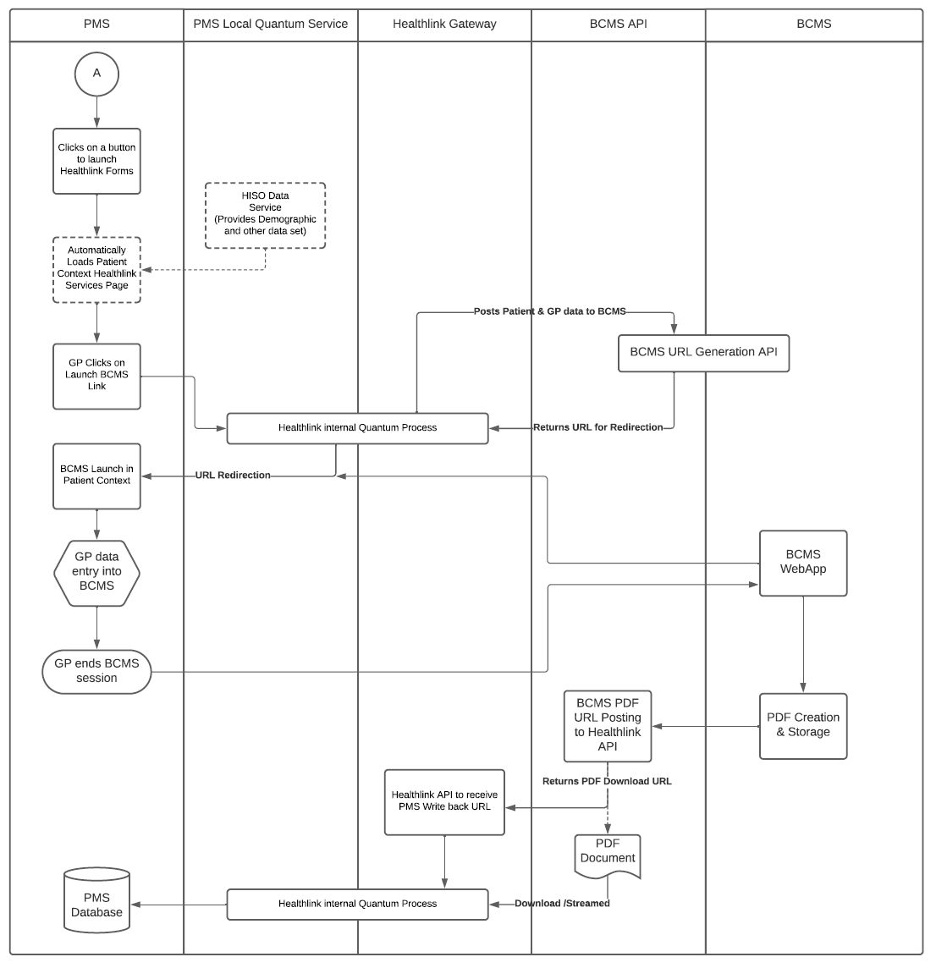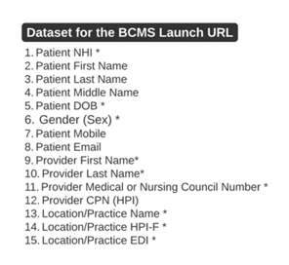
Extracts from Training Materials provided to Practices using PMS to interact with CCCM:
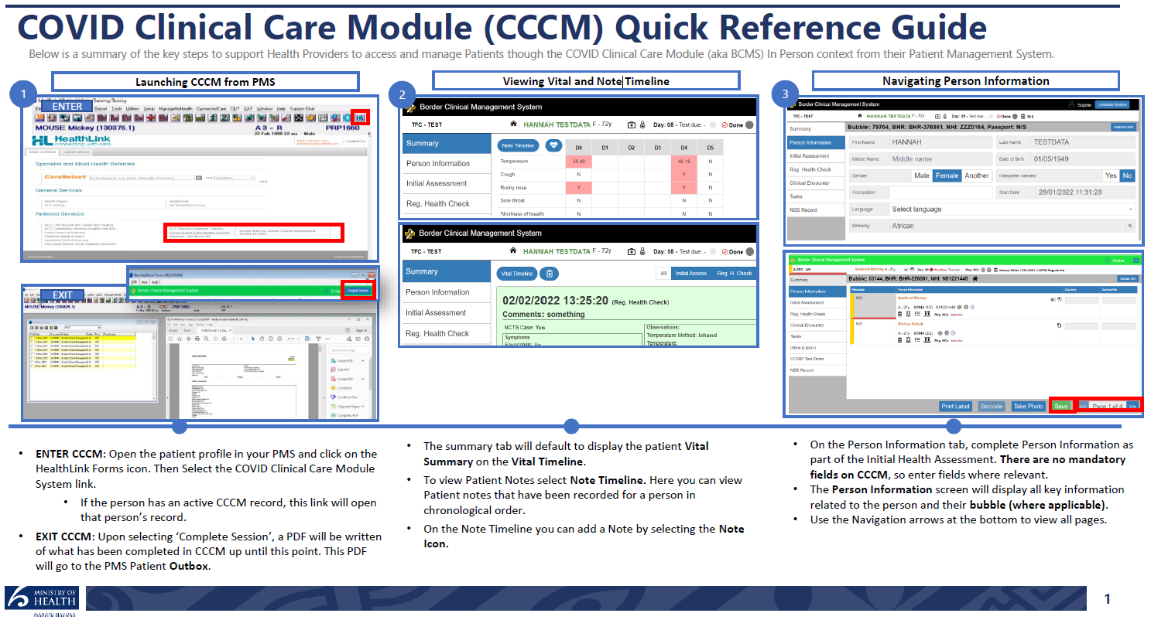
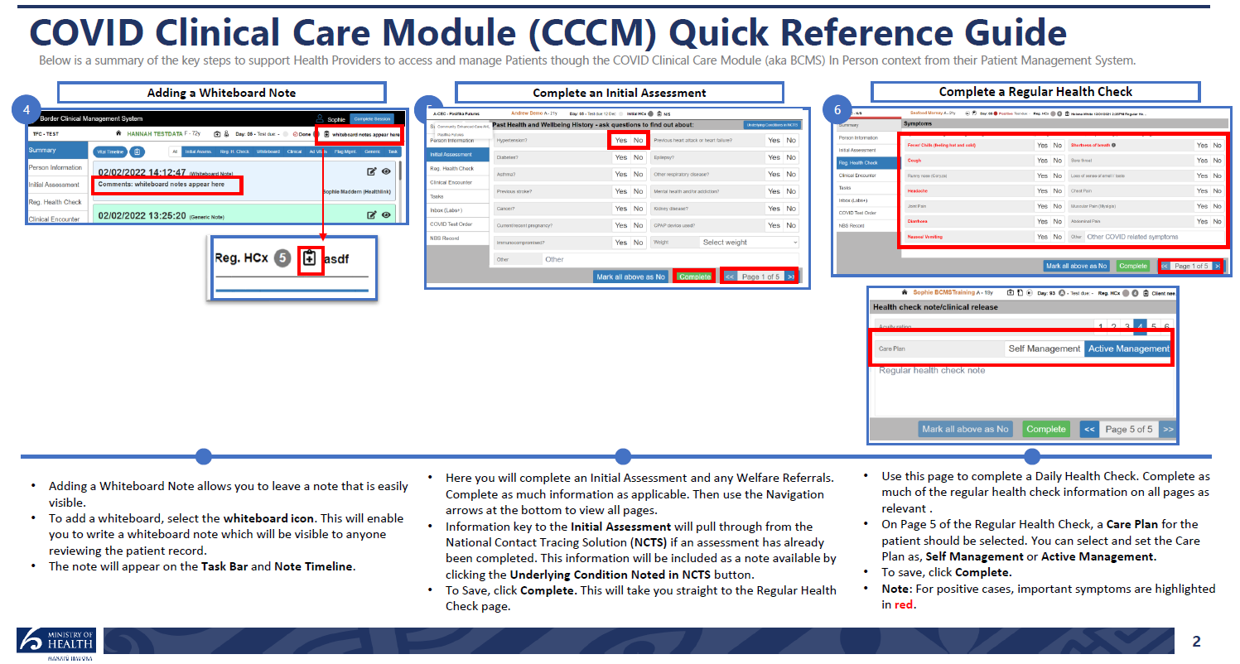
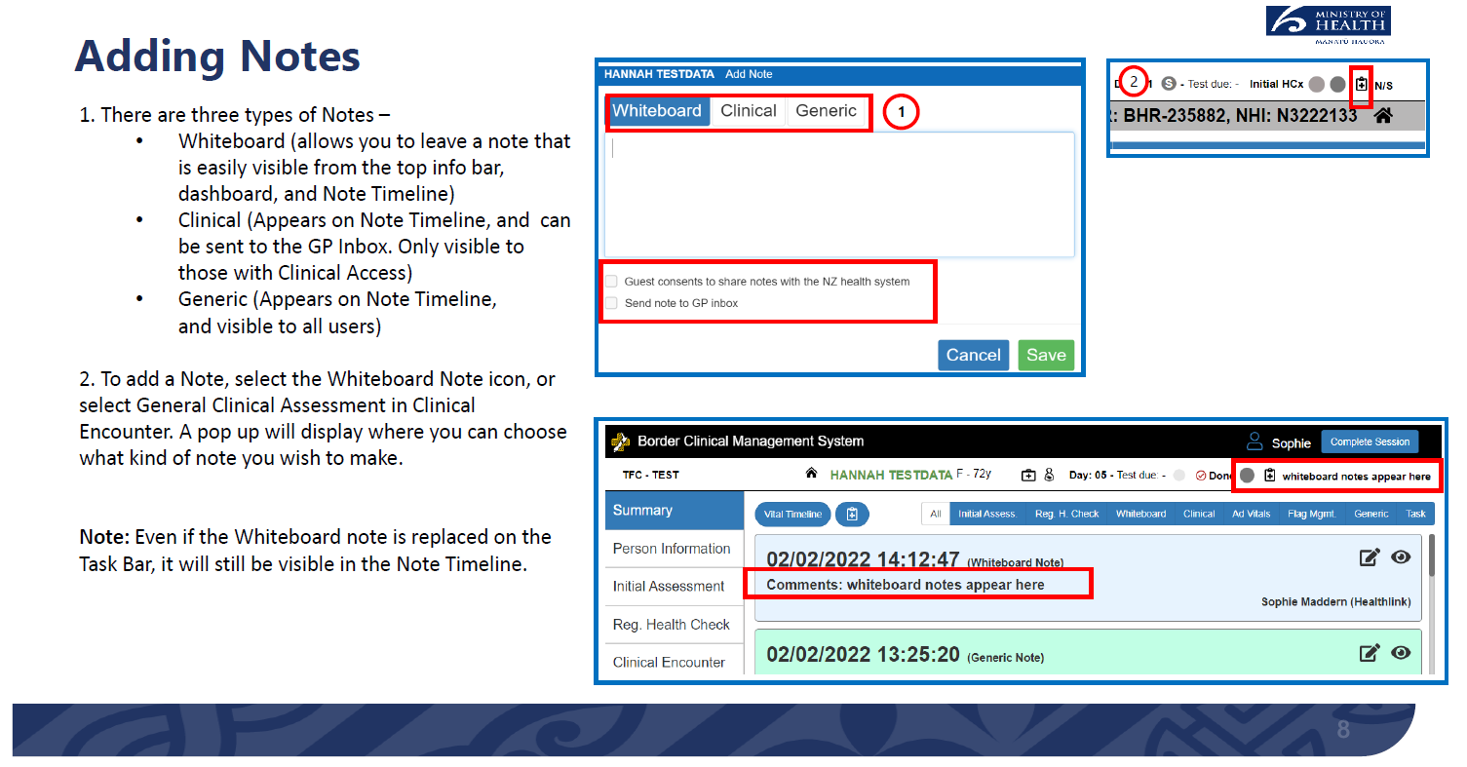
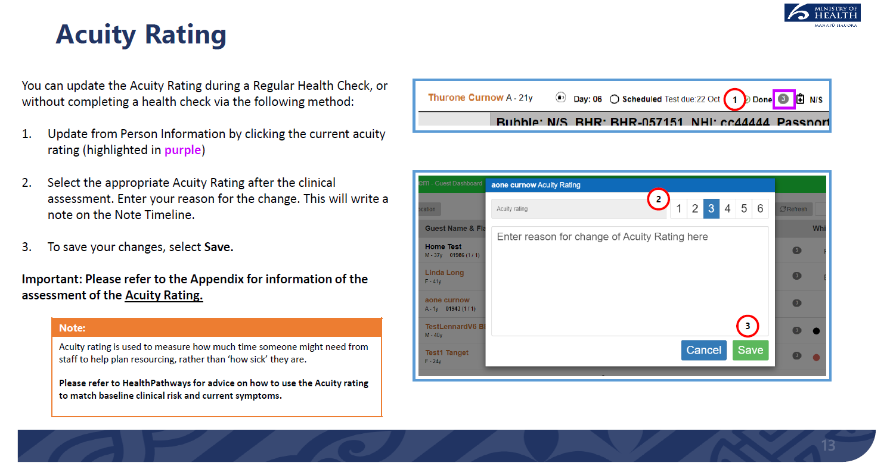
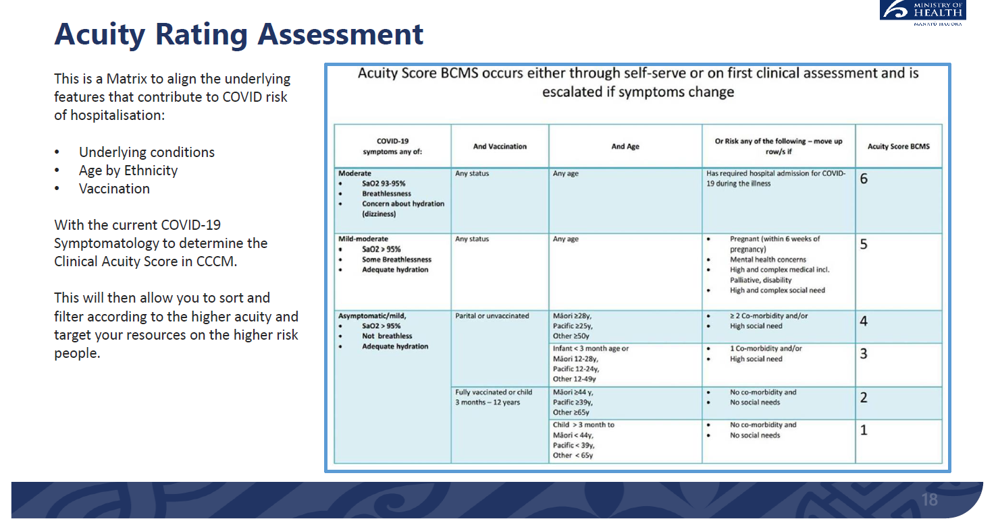

Appendix Four – CCCM Dashboard Views
Local Care Coordination Hub Dashboard (all Active management Cases in thearea covered by the CCH)
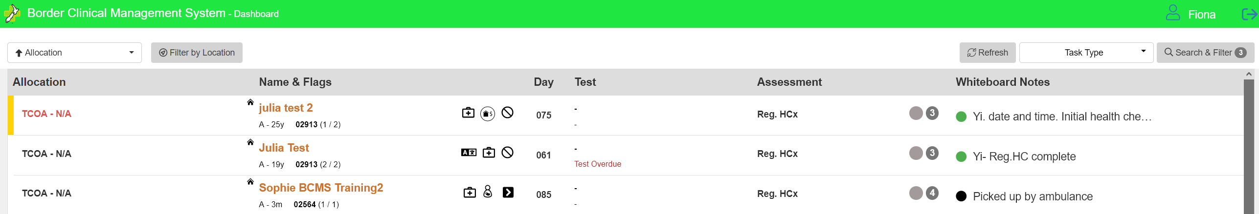
This dashboard displays the provider with responsibility (in this case TCOA – Training Community Outreach Auckland)
The person name, age and bubble number (as well as the number of tests required and completed) appear under the ‘Name and Flags’ heading.
The symbols signal a status of high importance in management of the specific COVID-19 Case. For example: The first symbol is that the person has an underlying long term clinical condition of relevance to their covid care and when the button is hovered over it will show what it is (e.g. cancer, diabetes, asthma etc), the second symbol indicates the welfare or support requirements (e.g. financial support, animal needs, food or cultural needs) and the last indicates allergies (e.g. tramadol or amoxicillin or peanuts). This figure indicates pregnancy . This figures indicates there is more information
The test column highlights when a test is due or what the most recent result was.
The whiteboard notes is meant as a quick handover note that is visible without having to open the record.
Dashboard options include: 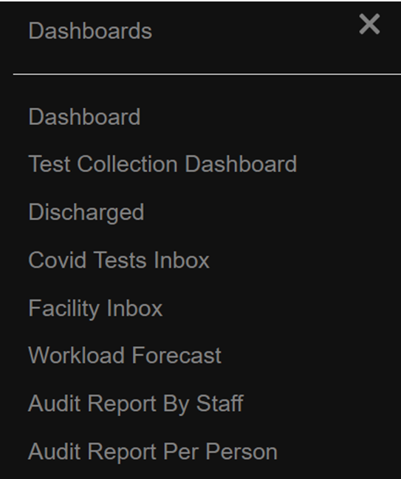
Discharge Dashboard
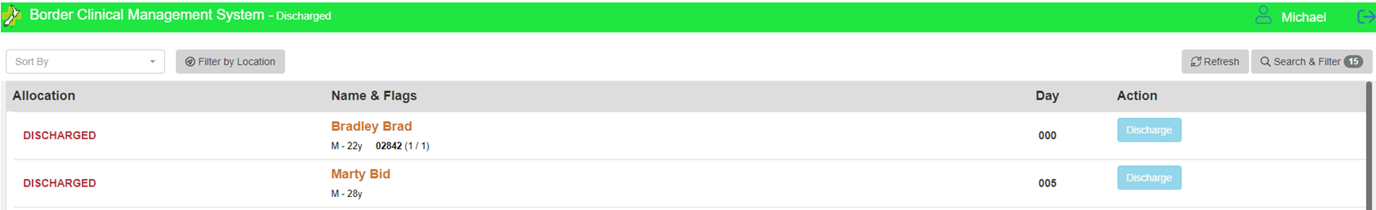

Dashboard for Assigned Practitioner or Team managing Case
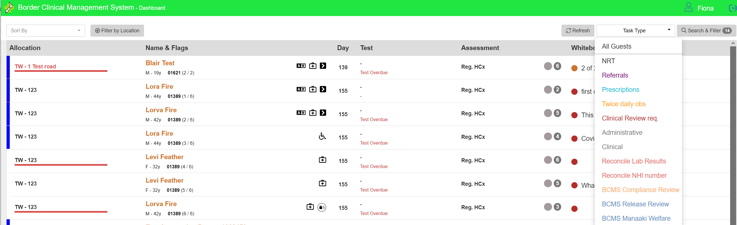

Person Level record:
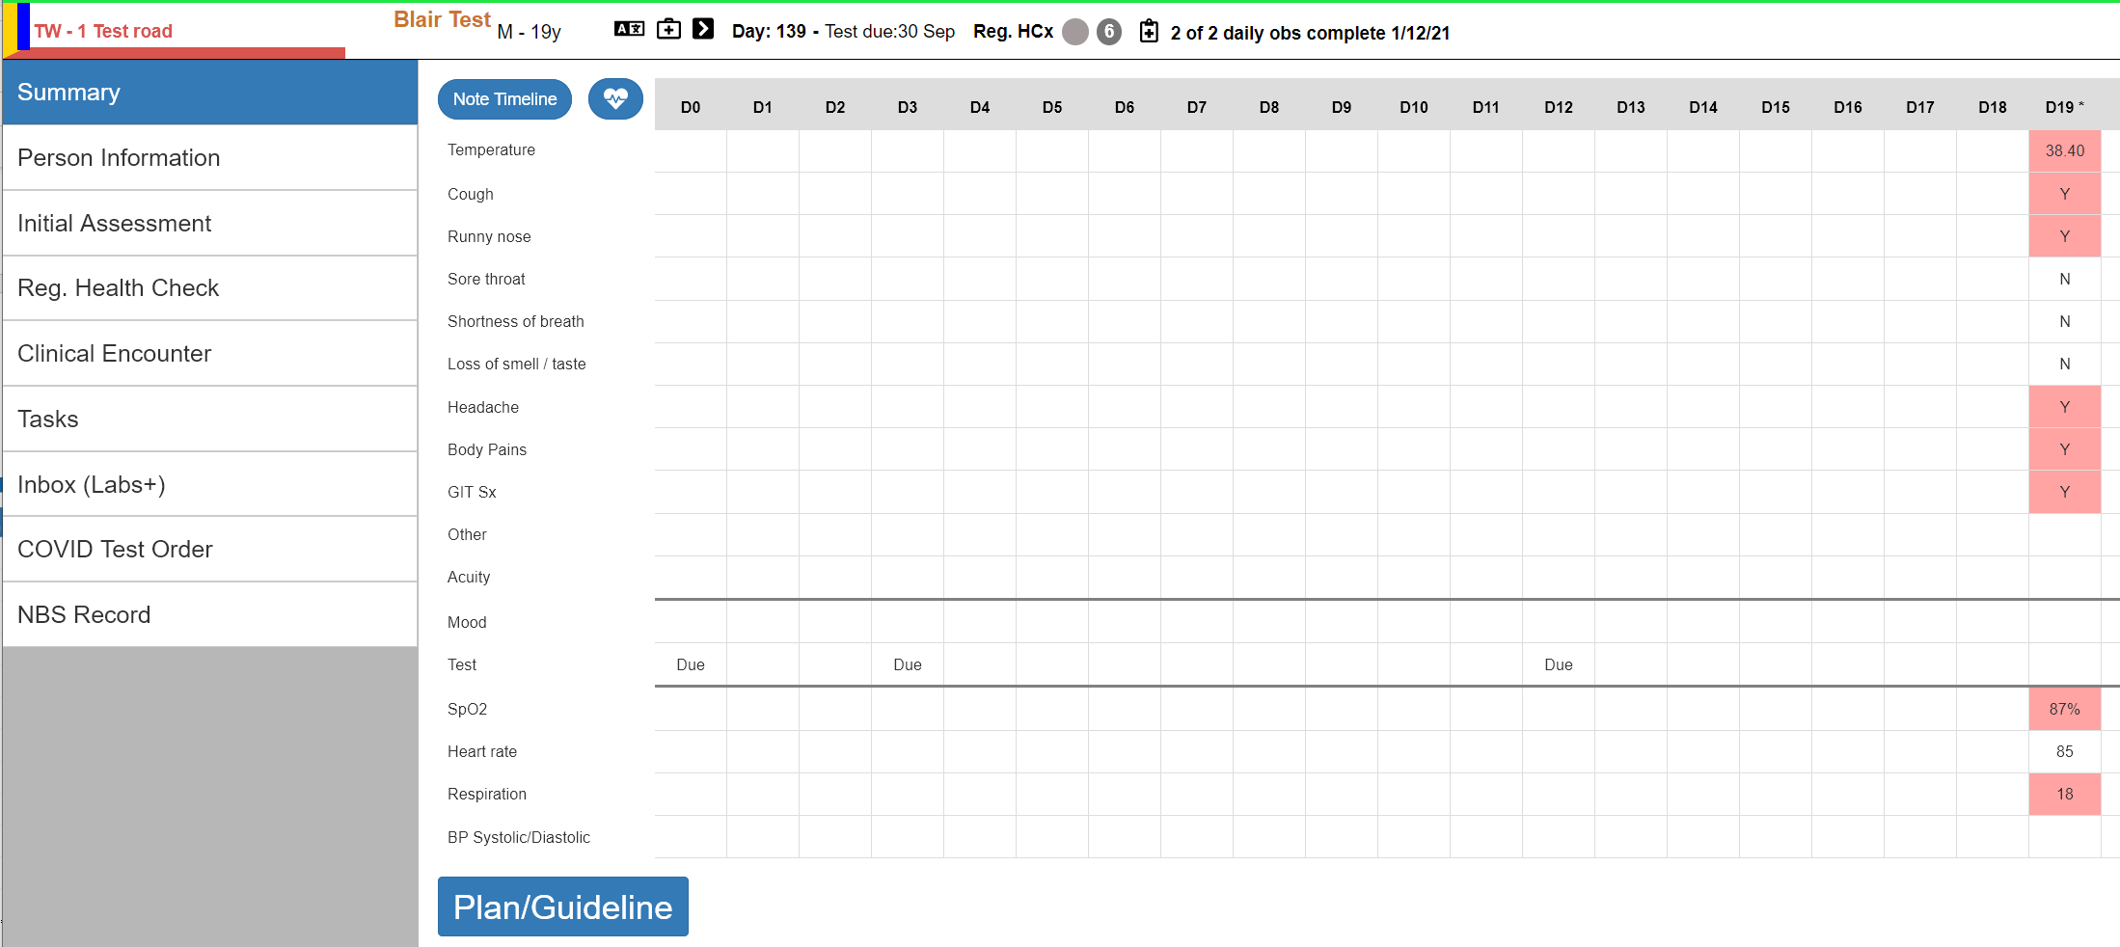
What will be visible / accessible on this screen will be dependent on the role accessing the record. For example, an administrative person will not see notes denoted as clinical. The GP and DHB user do not see the inbox (labs+) tab.
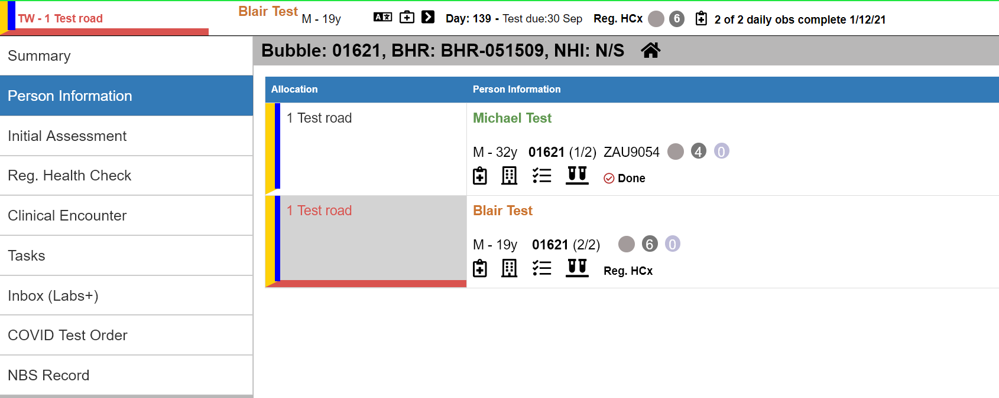
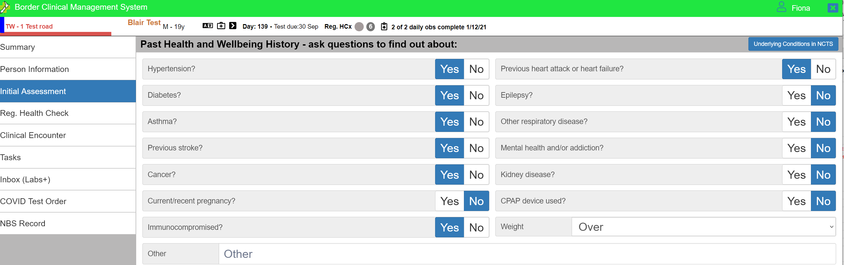
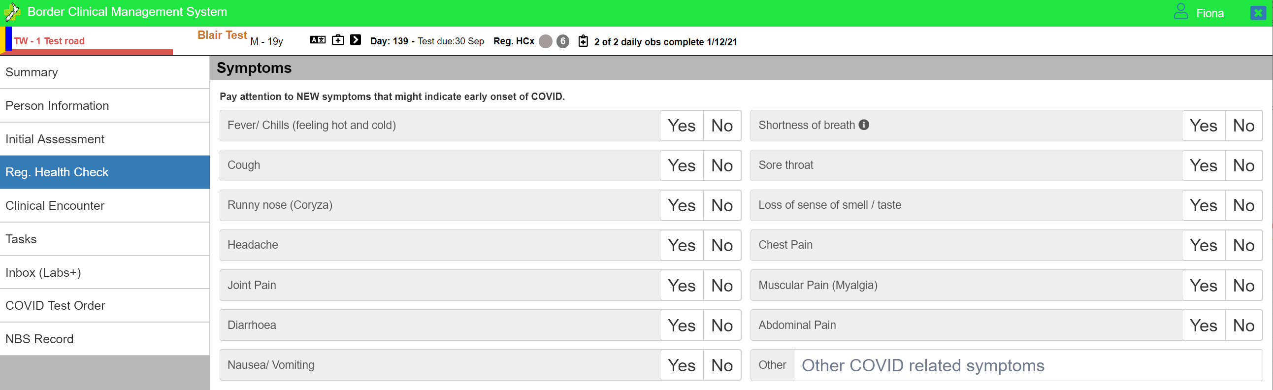
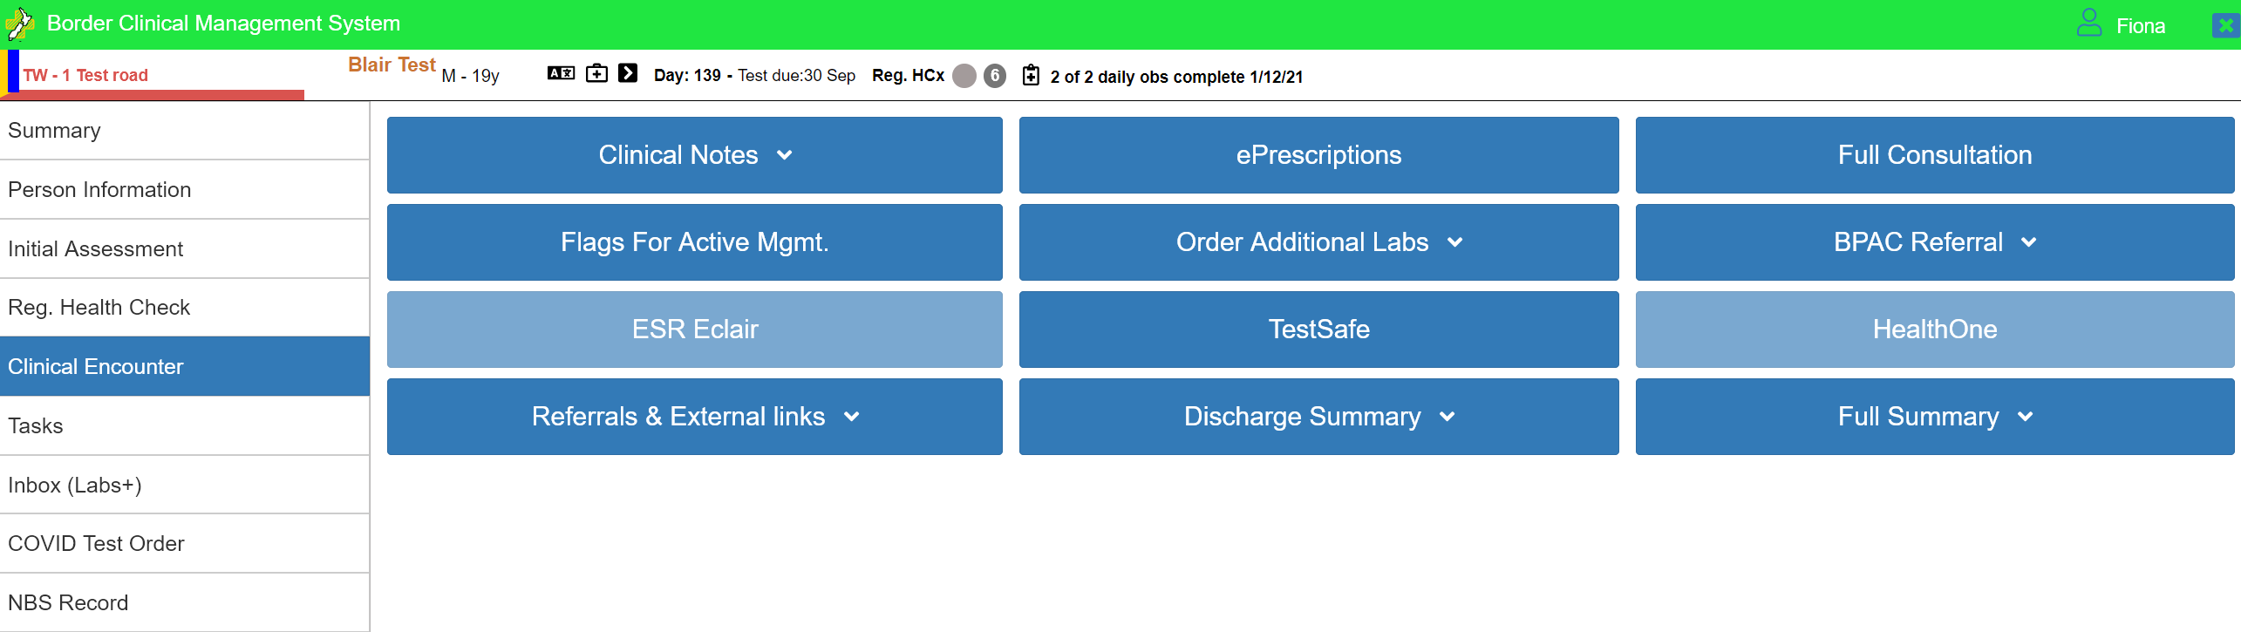
Tiles above in a paler blue are not accessible – only Canterbury users would be able to access the HealthOne tab. The ESR tab is not visible because the patient does not have a verified NHI in this image (and this information would not be visible to a non-clinical user role either)
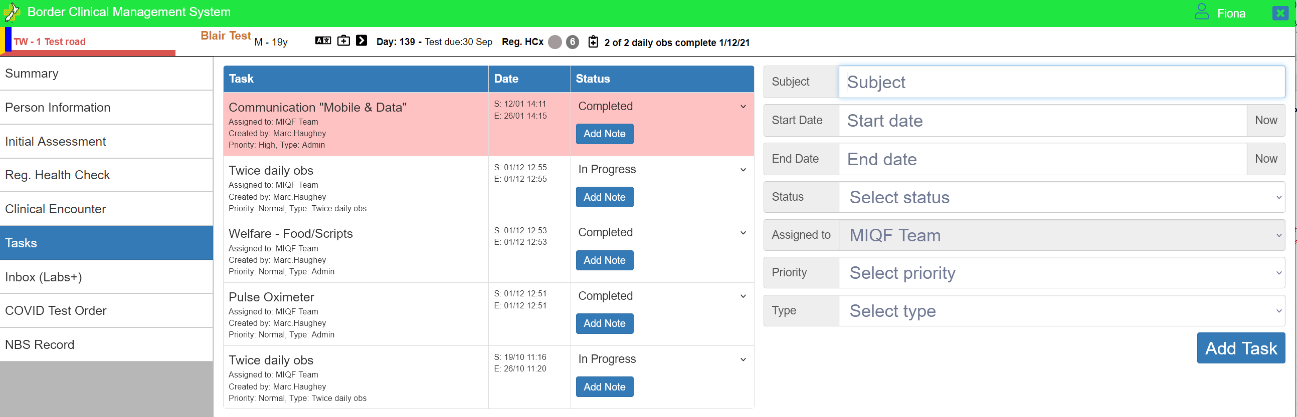
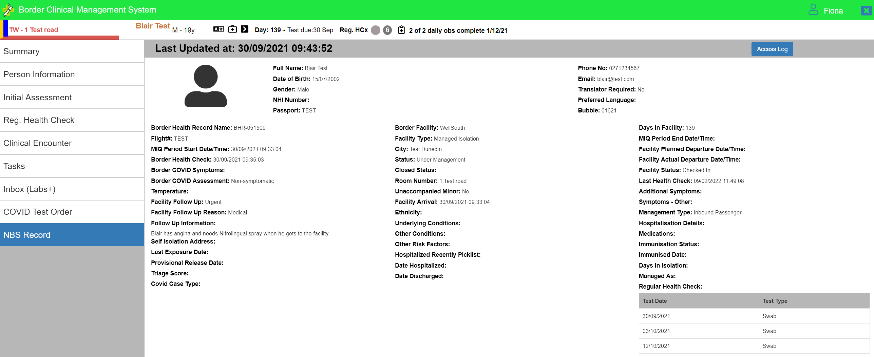
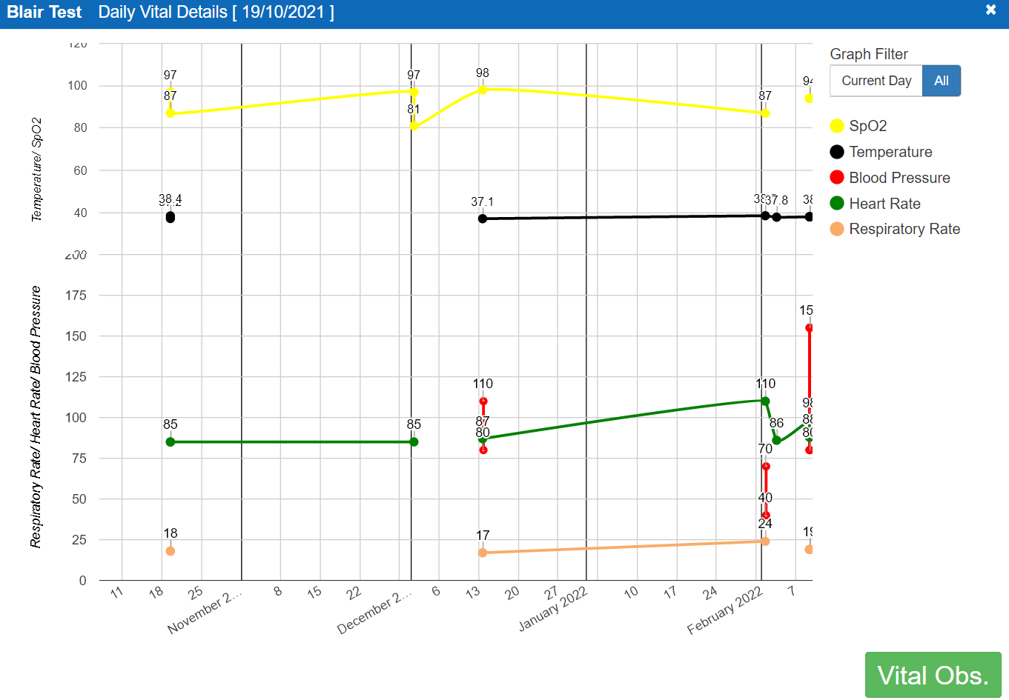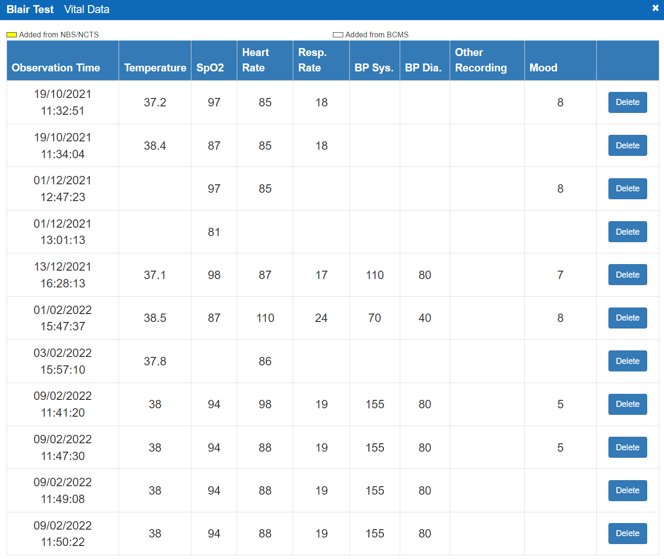
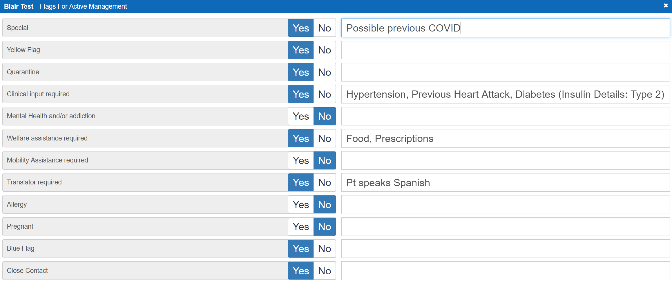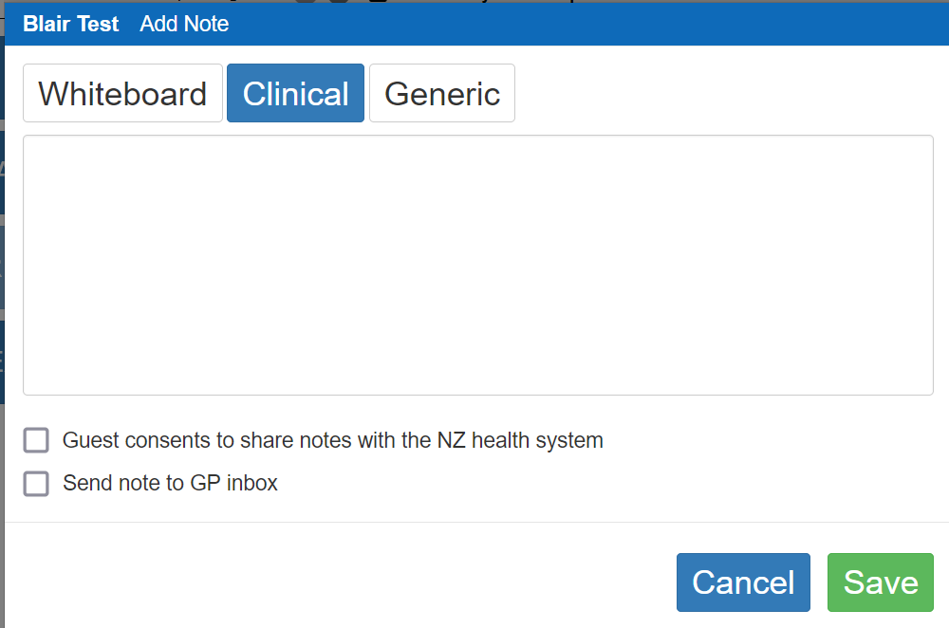

Appendix Five – Matrix for access
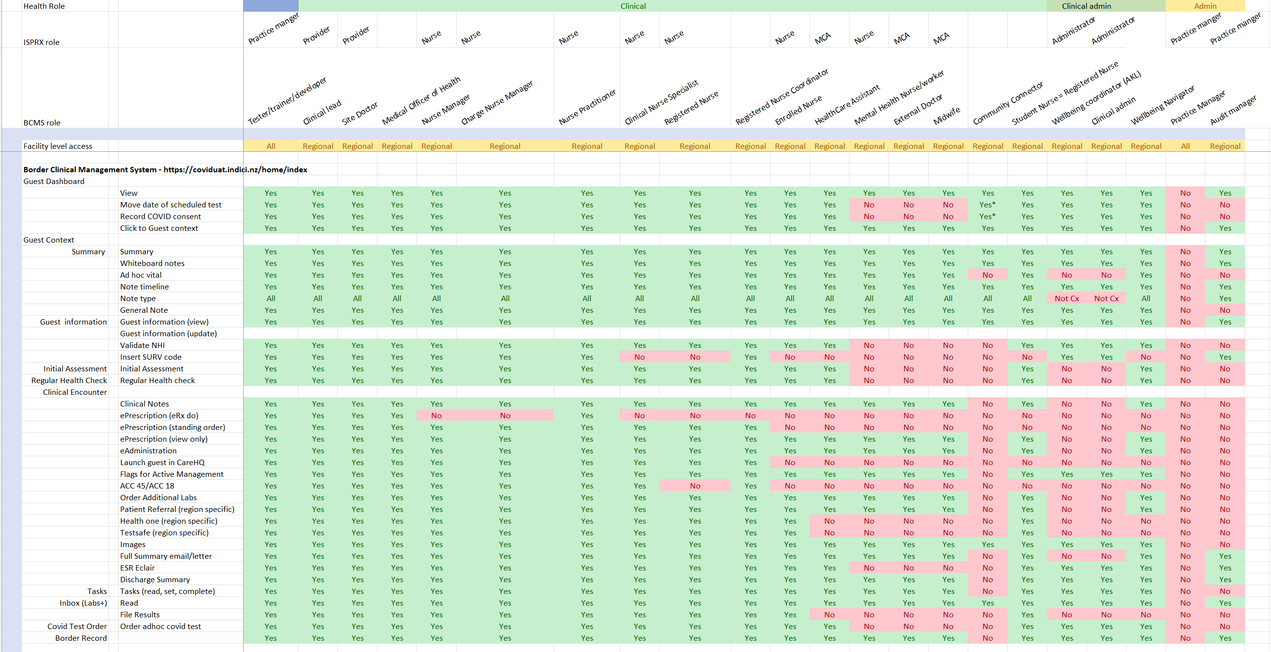
Swab taker role:
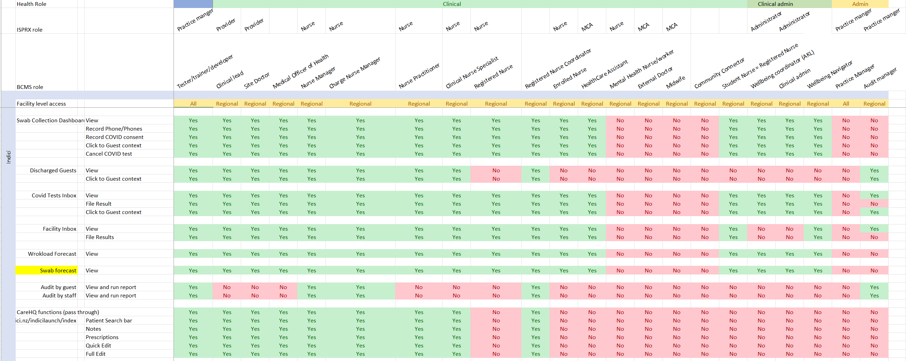

Administrative role:
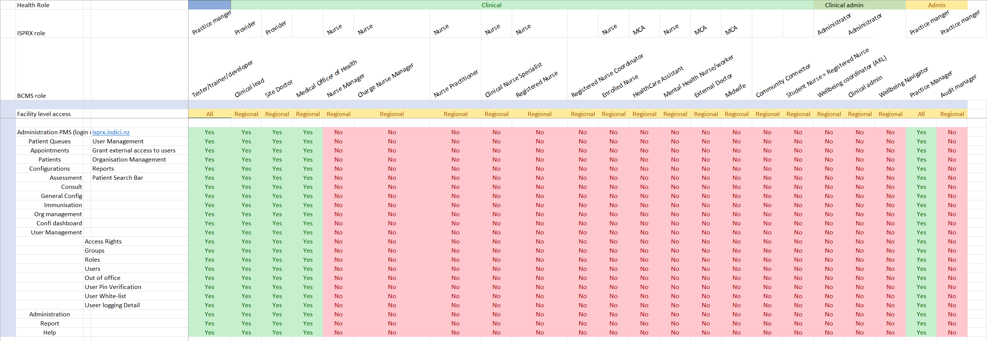

Appendix Six – Summary of Risk Stratification approach
Using clinical and demographic factors (age, ethnicity, and vaccination status) which are known to impact the risk of hospitalisation, the Ministry’s Data & Digital Directorate and COVID-19 Care in the Community teams have developed a population-based Risk Stratification tool derived from a model built by Waitematā District Health Board for assessing the risk of hospital admission for COVID patients in the Northern Region. The tool has been implemented as a part of a suite of digital and assisted pathways to manage the growing number of COVID-19 Cases, and sits in the COVID Population Identification & Registration database (CPIR). It is used to support contact decision making only, and is not used in support of, or in place of, clinical assessment.
Ethnicity (Māori, Pacific, and other) is included in this calculation because Māori and Pacific Island people have to date been impacted by COVID at a higher rate than other ethnicities and, due to historic and ongoing inequities, are also more likely to have underlying conditions or other inequity-related risk factors than other ethnicities. The Ministry also has responsibilities under Te Tiriti o Waitangi to achieve equity and improve outcomes for Māori.
Early identification of people at higher risk, including by reason of the statistically poor outcomes indicated by ethnicity, is intended to enable them to be quickly directed for contact and support through the Ministry-contracted provider Reach Aotearoa, their local Care Coordination Hub (CCH), or a local culturally appropriate provider. Where these providers are not able to reach them within 24 hours, they will be prioritised via their score in the daily report run by their CCH.
Reach Aotearoa has outreach targets of 12 hours for contacting contact Māori and Pacific Island people, and anyone in Decile 9/10 on the New Zealand Index of Deprivation.

Clinical Assessment
Key points
- Nationally the Covid-19 population risk stratification tool will be useful and clinically safe to apply for ‘patient contact triage’.
- The risk stratification tool reflects an equity approach and honours Te Tiriti o Waitangi in that it prioritises Māori ethnicity.
- The added value in the risk calculation in the current form is to support prioritisation of patient contact triage at Care Coordination Hub level to identify those people who should be prioritised for contact for a first clinical assessment.
- It does not replace clinical assessment to determine the actual risk for a person based on pre-existing factors (age, ethnicity, vaccination status and co-morbidities) in combination with clinical acuity.
- In its current form the tool must be restricted to point 1 above only and its implementation plan must include in parallel, strong mechanisms to safety net those stratified into a lower risk category for patient contact purposes.
- The governance of how this tool performs prospectively is critical.
- The risk stratification prior to diagnosis is worth continuing to pursue to strengthen its accuracy by the inclusion of further data available nationally (for example NZePS data, disability sector data is worthwhile to increase utility for future-proofing Covid-19 disease management (any variant) over the course of the year.
- Co-morbidity data is available at PHO level so this risk calculator would need the overlay of both patient specific data (from GP/telehealth or self-service form) and/or PHO data.
- Resourcing a small team of experts to continue this work is important.
Limitations and considerations
- It will not support decision making at a clinical care provider level, particularly a general practice where a person is enrolled and has access to their medical record as well as knowledge of their broader circumstances.
- Robust agreed safety netting to ensure all those that are deemed ‘lower risk” get a timely clinical assessment and processes for ensuring this happens.
- Other known higher risk patients and patient groups are excluded in this calculation for whom health equity of access and outcomes is a concern for example; refugee and refugee-background people, people with disabilities, moderate-severe mental health patients etc so the clinical safety of this tool RELIES on the ability of the localities to overlay their data.
- The PDH review notes that this tool was developed based on a cohort of patients which may not reflect reality with the Omicron variant and was for a localised Auckland area outbreak which may not also be reflected nationally.
- The tool doesn’t include booster doses which research confirms to be highly effective in preventing severe disease from Omicron. As such Booster dose status and time from booster dose must be included in future iterations as soon as possible to enhance accuracy and support patient contact triage.
Timeline of steps required to implement
- We need to understand how the Covid Care Coordination Hubs will use this tool and how it would stratify its local population, and what local data overlay is possible, so approval to activate the risk tool with close prospective governance.
- A rapid surge will mean we do not have capacity to implement any new systems so if there is any utility in this tool at all we should not lose the momentum that we have created.
- The team membership for the prospective analysis of this tool must be defined and resourced and ideally will include an epidemiologist to support the ability to understand where and why the model diverges from reality, if this occurs, in an OMICRON environment or indeed other variants.
Future
- The governance of how this tool performs prospectively will determine if efforts to further refine the tool to increase its utility is worthwhile.
- The current user case of this tool must be restricted to prioritisation of contact triage only (as above point 1) to remain clinically safe.
- It would be useful to continue to refine and strengthen the tool as part of winter planning as we approach any respiratory illness and potentially other severe respiratory illness as the border opens as the same populations will be more at risk of these other illness.
- There is NO linear relationship between the variables in the tool and the human patient and whilst we can be sure from international experience, we have yet to see how this plays out in our Aotearoa communities, with our ethnic diversity and post-codes.

Appendix Seven – Set up of BHR from NCTS
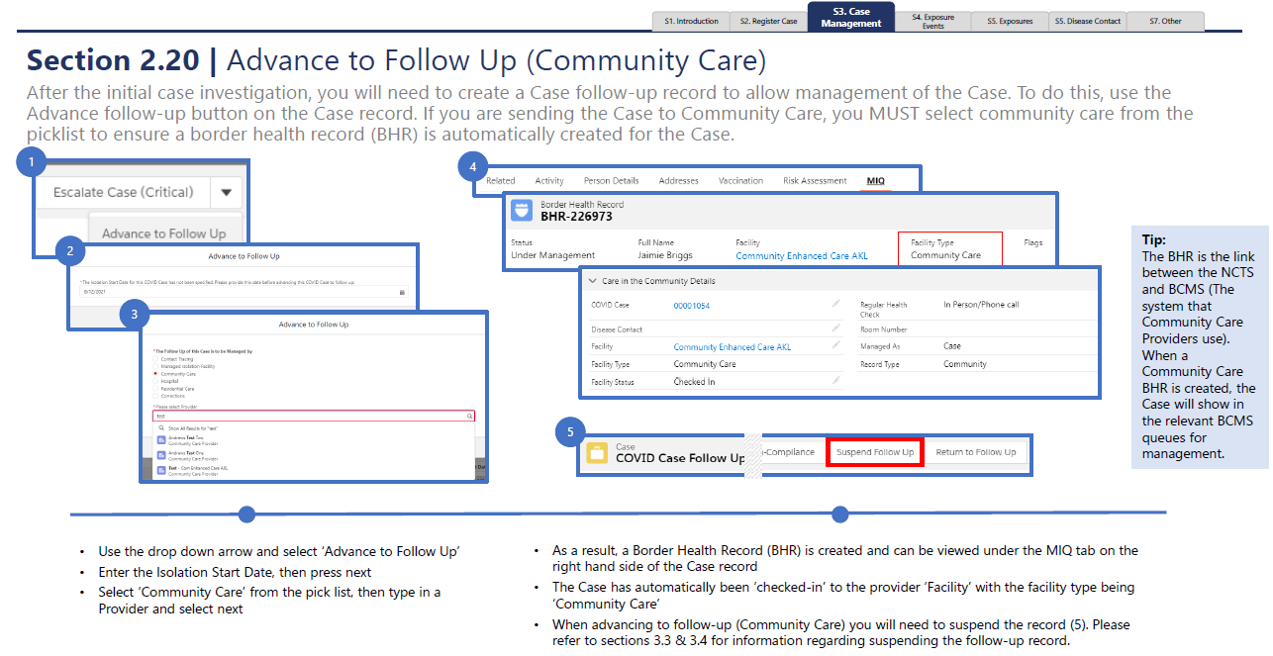

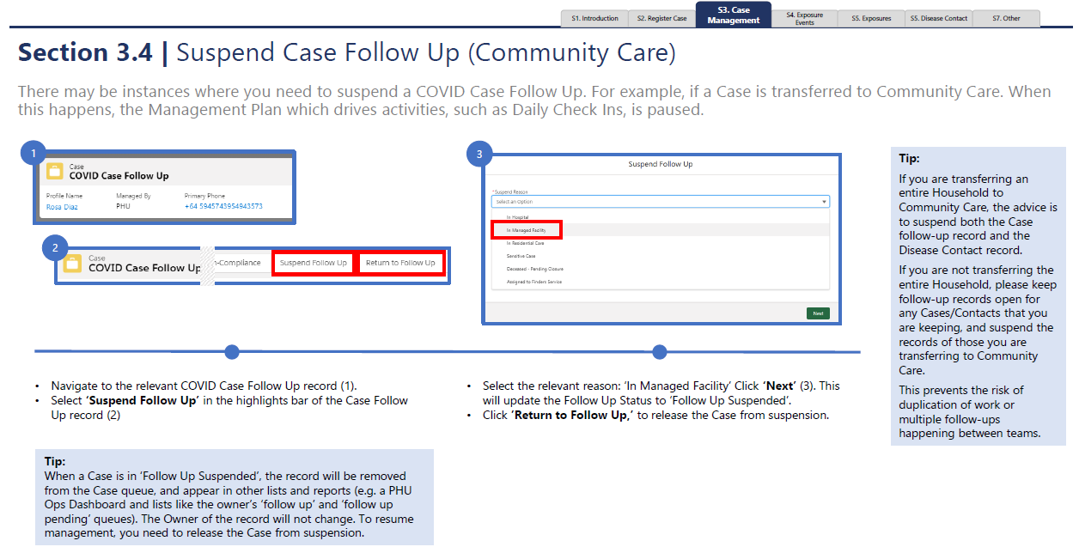

Appendix Eight – Privacy and explanation script
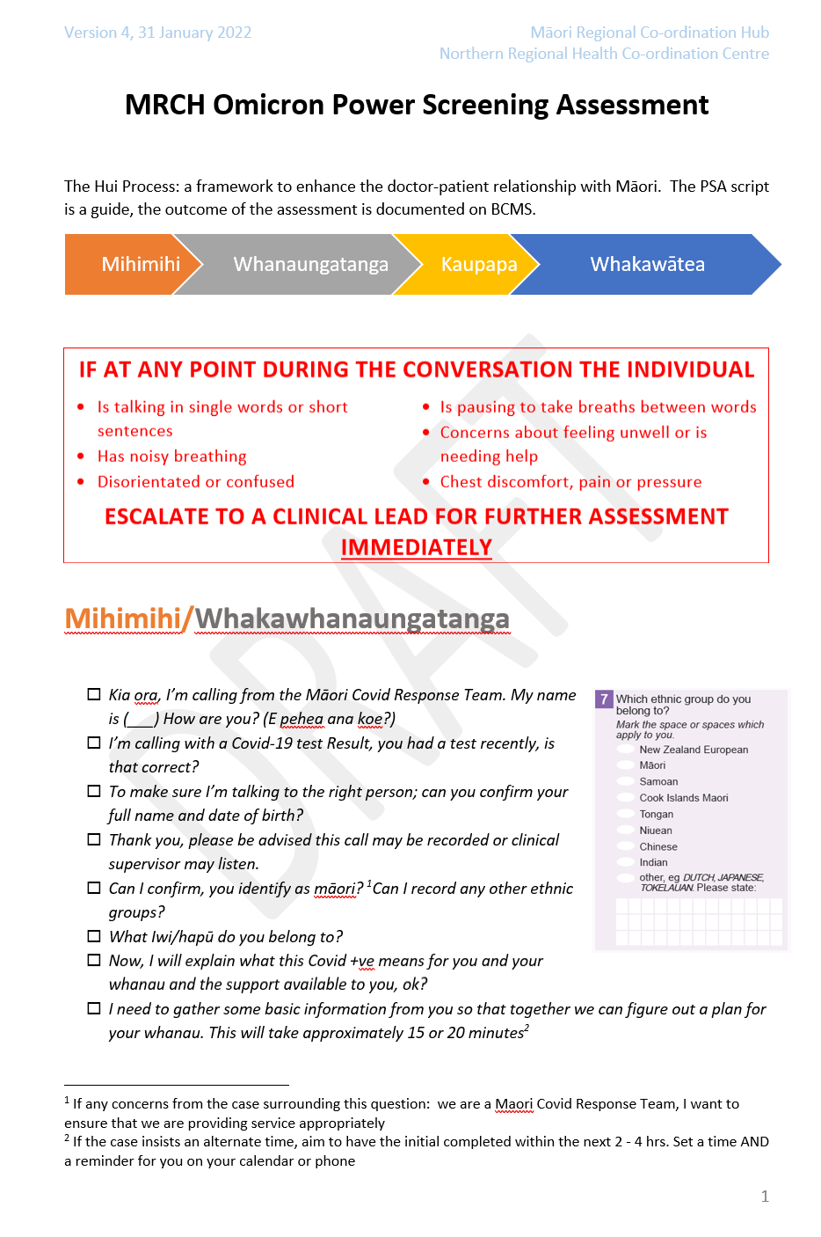
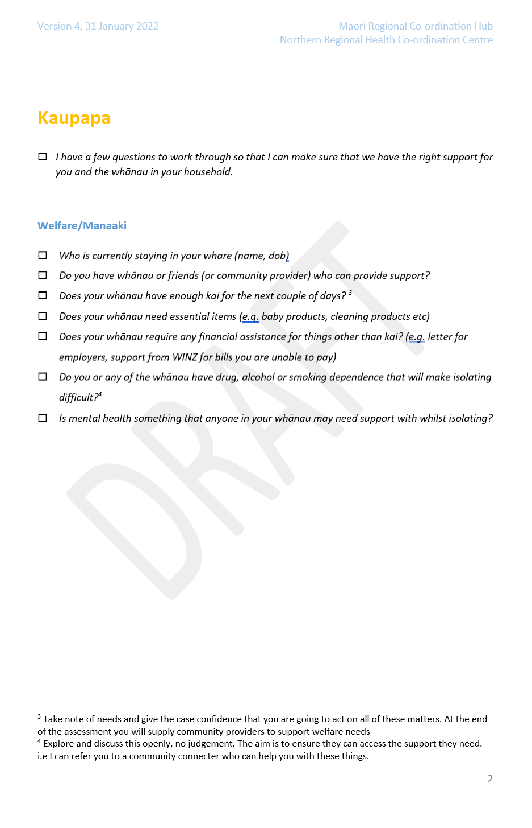
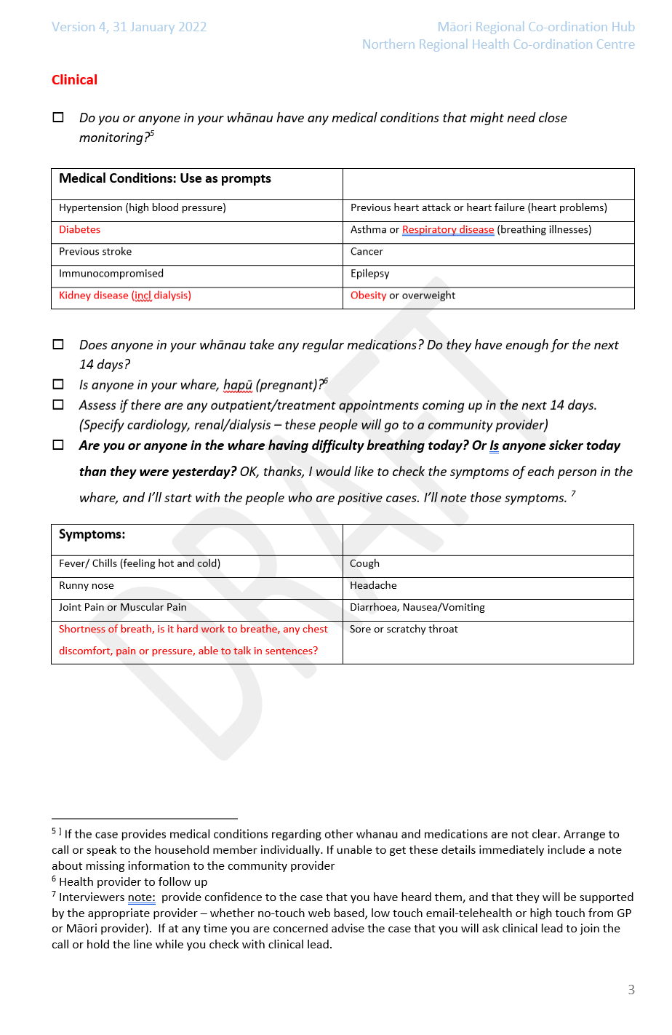
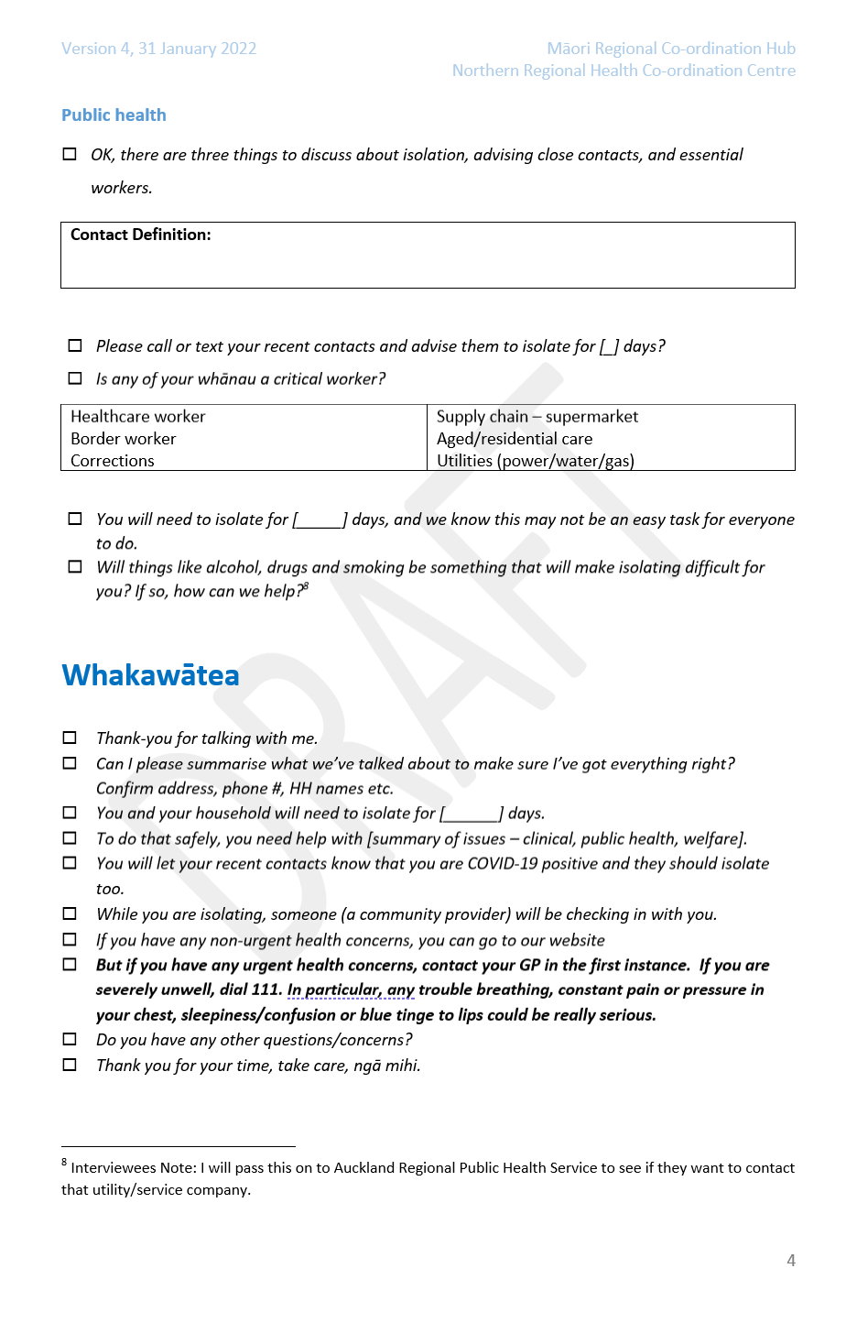

Appendix Nine – Probable Case Creation
High-level requirements
The entry form has to be as simple as possible using already known information where possible. After form submission, the user must be allowed to complete all usual actions like regular health checks etc. in BCMS. The Case Event will create a new probable case in NCTS or link to an existing active Case. When the NCTS Case is returned to CCCM this must be merged with the record created by the GP. Until that merge happens, other users should be able to access and update the Case where applicable. Initial MVP will be just for case creation from a GP PMS but the next sprint will enable the case creation from the CCCM dashboard for cloud users. The key difference here is they will need to allocate a facility, and NCTS will have to accept that facility and not allocate them elsewhere.
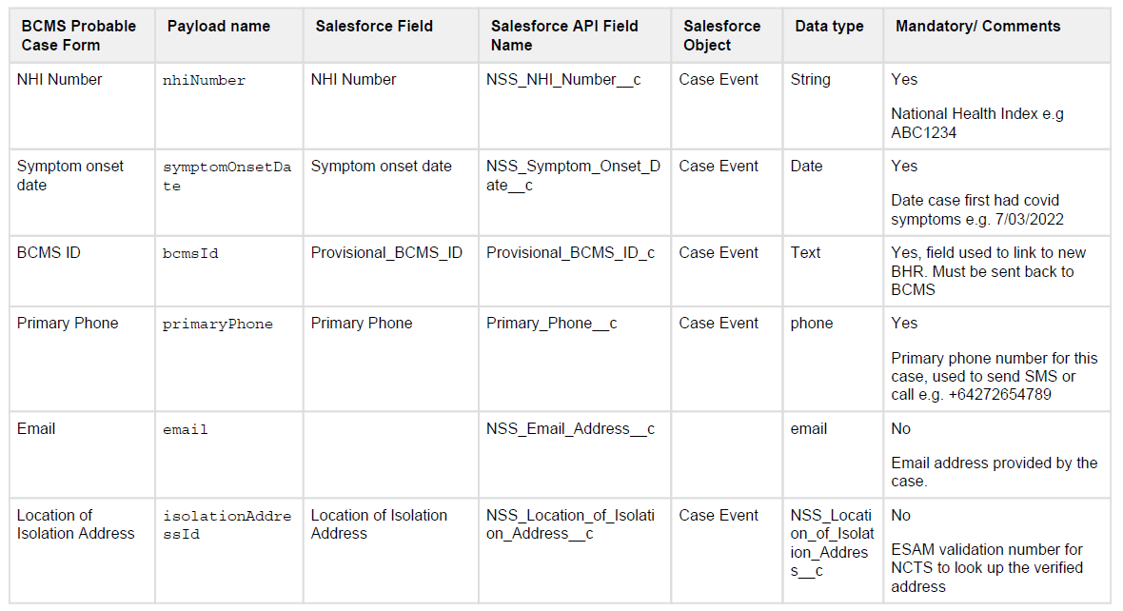
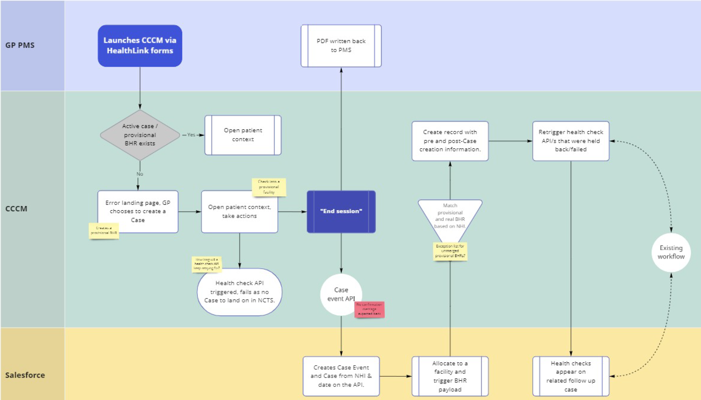
BHR payload update
Once the Case returns to CCCM to merge with the provisional record, CCCM needs to know who this person is to do the matching. CCCM will have passed the bcmsId to NCTS in the Case Event API, and the NHI number. These two fields can be passed back in the usual BHR payload to CCCM so it can identify which records are to be merged.
New field on the BHR payload to be called Provisional_BCMS_ID.
A Case created by the GP bypasses the normal diagnostic and public health process for cases recorded in ESR Episurv. For cases created by a clinician directly in CCCM, there is an additional process to inform ESR about these so they can be recorded in Episurv.

Appendix Ten – Draft Privacy Statement for CCCM
For Ministry of Health website
Care in the Community (CiTC) – Covid Clinical Care Module (CCCM) – Privacy Statement
The Ministry of Health is providing the CiTC Module (CCCM) as a shared care record to support the provision of clinical care for individuals who have a positive case of COVID-19 (a Case), and their household contacts. The majority of Cases are expected to be able to self-manage their care, but for those who require clinical support the CCCM will be available to help with their COVID-19 episode.
- Positive results of COVID-19 tests will be supplied to the CCCM. If a Case indicates they have an underlying health condition that has relevance to COVID-19 outcomes, or signal that they need additional medical assistance, (either by submitting those details into the digital form that accompanied their positive text notification or by calling the helpline or from their enrolled clinician) the CCCM Case record for them will be activated and care provided may be recorded in CCCM.
- Care can be managed regionally, and may be provided by the practice or practitioner each person is enrolled with, or from a local Care Coordination Hub (CCH) with oversight of available primary or secondary care level support.
How your information will be used
The CCCM is to be used to manage the clinical care, and manaaki welfare support of Cases and their household contacts, and to support the public health response to the COVID-19 pandemic. Only those service providers who have a need to access this information for one of the purposes above to provide care will be given access to the information, and all access will be tracked and audited. There will be disclosures to relevant services provided to you, including laboratory, prescription or other referral services (such as welfare services) as required.
Other than the information used to identify you, the positive test result and your vaccination status all other information is to be collected from you, or others involved in your care (such as family and whanau supporting you or those health professionals and organisations providing care to you). It is not mandatory that you receive this care, nor that you contribute additional information. The care provided to you for your COVID-19 episode may however be affected if you do not provide full information as requested.
A discharge summary will be sent to the practice or general practitioner you are enrolled with. This will summarise your care once your COVID-19 episode is completed within CCCM (for example you recover or you enter hospital for further care).
District Health Boards may wish to see information about all Cases and household contacts so they can plan resources to take account of Cases that currently need care, and anticipate those who may need care in the future.
The Ministry of Health may also use the information for planning and reporting purposes in relation to the COIVD-19 public health response, but will not include any identifiable information in any reports produced.
There may in future be research projects that may be interested in COVID-19 and Case related information. Such applications would be subject to standard Ministry review processes and be required to meet any Ethics Committee requirements before proceeding. No identifiable information would be included in any research reports produced. You may also be invited to participate in surveys, but it will not be mandatory that you do so.
Steps taken to protect your privacy
We take your privacy seriously. The Privacy Commissioner and the Government Chief Privacy Officer have both advised on the development of the Covid Clinical Care Module.
A Privacy Impact Assessment (PIA) that describes this Service and the technology it uses has been completed. The PIA is updated when new features and functionality as they become available.
Privacy Impact Assessment
How long information is kept
Health record information will be retained as required by the Health (Retention of Health Information) Regulations (a minimum of 10 years from the last service provided to you). It will not be visible within CCCM six weeks after your discharge from the COVID-19 episode (to limit the ability for anyone to view your records after you have been discharged). A copy of your record can however be made available on request by you or a general practitioner on your behalf.
Viewing and changing your information
If you would like to view or change the personal information held on CCCM about you, or if you have any questions about your personal information email information@health.govt.nz, or write to:
The Privacy Officer
Ministry of Health
PO Box 5013
Wellington
We may require proof of your identity before being able to provide you with any personal information.
When you contact us, any information you provide regarding your identity and the Service you are contacting us about, will be collected.
Privacy concerns
Email privacy@health.govt.nz
If you are not satisfied with the response to any privacy concern you can contact the Office of the Privacy Commissioner.
Contact the Office of the Privacy Commissioner
Updates to this Privacy Statement
This Privacy Statement will be updated to let you know about any changes in how your information is processed or collected.
The date when the document was last updated is shown on this Privacy Statement.
Last updated 10 May 2022

For those areas managing needs outside the MSD supported welfare provisions, as that is provided for separately and is addressed in its own PIA. The manaaki aspects of care may be performed and reported to CCCM, particularly when local Māori and Pacifica providers are involved in providing support.
The BCMS is already in use to support national clinical care in the New Zealand border setting for travelers arriving in at Managed Isolation and Quarantine Facilities (MIQF), and some community cases during the Delta outbreak who resided in MIQF. A full PIA was done for the BCMS (Managed Isolation and Quarantine Facility Guests) dated 16 March 2021.
Some Cases may be managed directly by their own GP and may not be incorporated into the CCCM IT environment for their clinical care. Others may be managed by their own GP, but within the CCCM if that GP is authorised to use the CCCM system.
This is addressed in a separate PIA: COVID-19 Contact Form: Privacy Impact Assessment.
As at 8 March 2022 this is live only in the Northern Region, and is production ready in the Southern and Midland regions too.
The expansion of use of or access to the Information beyond that originally contemplated
Some cases will be managed by Cases in the community with direct support from their own medical practice, or without contact with a medical practice – relying on telehealth support only.
This was approved by the CiTC Privacy Officer. It is considered critical clinical information in a COVID care setting, and that calling it from the ‘system of truth’ (the Covid Immunisation Register- the CIR) rather than requiring it to be collected again from Consumers is appropriate. The CIR Privacy Statement indicated it will be used for managing the health of the individual and may be shared with ‘health professionals who work with you, such as your family doctor, nurse or midwife. Access to the information will continue to be tracked within CCCM.
In the active clinical management box in the bottom left of the diagram the ‘automated’ escalation or de-escalation is via the online self-assessment tool
To help in Case linking
Hosted on the Ministry of Health Amazon Web Service cloud service
The minimum retention period is 10 years beginning on the day after the date shown in the health information as the most recent date on which a provider provided services to that individual – regulation 5.
Paragraph 4 page 17
There are existing training materials developed for both PMS users and those with direct CCCM access.
There are at least 161,000 known individuals who are not enrolled (this does not include those who are not entitled to be enrolled as they are not eligible)
This was focused on the short-term care of these arrivals and generally captured test results and management of COVID-19 cases, as well as the co-existing care of other medical requirements of individuals in those MIQF. It was subsequently expanded to include
http://www.legislation.govt.nz/regulation/public/1996/0343/latest/DLM225616.html
A PIA on this tool was completed on 8 February 2022.
The Privacy Impact Assessment for the COVID-19 Contact Tracing Application can be found here
The proposed Practice Dashboard would restrict the GPs to their own patients but would still show similar features for those patients to those showed in the Clinical Dashboard.
The New Zealand Index of Deprivation is a small-area-based index providing a measure of neighbourhood deprivation, by looking at the comparative socioeconomic positions of small areas and assigning them decile numbers from 1 (least deprived) to 10 (most deprived). The index is based on 9 socioeconomic variables from the Census. https://ehinz.ac.nz/indicators/population-vulnerability/socioeconomic-deprivation-profile/

