|  |
| --- |
| **Ministry of Health** |
| **The National Immunisation Booking System**  **“BookMyVaccine”** |
|  |
| Privacy Impact Assessment |
| **Date 4 April 2022** |

Document Approval

|  |  |  |
| --- | --- | --- |
|  | Name/Title | Sign-off date |
| Approved by Senior Responsible Officer |  |  |
| Approved by Chief Privacy Officer, Ministry of Health |  |  |

The author of this document is Data & Digital Directorate, Ministry of Health.

Disclaimer

This Assessment has been prepared to assist the Ministry of Health (“the Ministry”) to review the purposes for which the information collected for and via the Booking System can be used, and the privacy safeguards that are required to manage those purposes.

Every effort has been made to ensure that the information contained in this report is reliable and up to date. This Privacy Impact Assessment represents the current expectations of the way the Booking System services will operate.

This Assessment is intended to be a ‘work in progress’ and may be amended from time to time as circumstances change or new information is proposed to be collected and used.

**Assumptions applied**

The assumptions that have been applied in the development of this assessment include:

* As this project develops, there will be evidence and information generated through the development and deployment of the application (e.g. Statistics of use and feedback from users) that will impact on how the Ministry of Health determines what is important for the future purpose of this application. These may result in changes to the terms of use, the information collected, and the risks and mitigations required.
* Discussions will continue between key parties (i.e. the Ministry of Health, the Office of the Privacy Commissioner and the Government Chief Privacy Officer) and future versions of this assessment will record changes to information that is collected and the consequent risks, further analysis and mitigations.
* This version of the Privacy Impact Assessment will be made publicly available. This will enable those members of the public who are interested to further review and understand the collection, storage, use and sharing of their personal information.

Contents

Glossary 5

Section One – Executive Summary 7

Scope of Assessment 7

Assessment content 8

Recommendation Summary 8

Section Two – The Booking System 9

Background 9

Relevant Project Stage 9

The Booking System Components 10

NHI Match Process View: 16

Information fields involved in the Booking System: 18

Where and how the information will be stored 20

How long will information be retained for? 21

Security features applying to Project 21

Manual processes involved 22

Analytics 22

Governance 22

Section Three – Privacy Analysis 23

Appendix One – Summary of Third Phase 30

Appendix Two - Booking System connections 31

Appendix Three – Snowflake Application to Data Governance Group 32

Appendix Four – amended Privacy Statement 39

About Book My Vaccine 39

What information is collected 39

Reporting 40

NHI number matching 40

Booking cancellations 40

Fraudulent bookings 41

Booking on behalf of another 41

Bookings for young adults and children 41

Ages 5 to 11 41

Ages 12 to 15 41

Keeping your information safe 42

**Who can see and access your information** 42

Contact us 44

Appendix Five – summary of Booking System components reviewed in First Privacy Impact Assessment 45

Appendix Six – Summary of review of Group 4 invitation dataset 50

Appendix Seven – Invitation communication templates 58

## Glossary

The following are definitions used in this Assessment:

| **Terms** | **Description** |
| --- | --- |
| **AVMS** | Accenture Vaccine Management Solution, a product suite of software capabilities for use with national vaccination programmes, supplied and supported by Accenture PLC. |
| **Booking System** | The nationally available booking and scheduling functionality that can be used by Consumers and Providers to book vaccination appointments at available locations. This will enable management of appointment expectations and site vaccination availability. This is currently known as NIBS within the Ministry, but its public branding will be ‘Book My Vaccine’. |
| **Call Centre** | The service(s) that may be contracted by the Ministry to assist Consumers to create vaccination bookings through the Booking System |
| **CBAC** | Community Based Assessment Centre (a model that may be used to provide large scale roll out of vaccination) |
| **CIR** | COVID-19 Immunisation Register |
| **Concierge** | The role at vaccination locations to assist those who have made bookings to manage their attendance while at a vaccination site. |
| **Consumers** | Those individuals in New Zealand eligible to receive a vaccination |
| **Correlation ID** | The unique system identifier that will enable the systems (AVMS, CPIR and CIR) to connect records. |
| **COVID-19** | The novel coronavirus, see: <https://www.health.govt.nz/our-work/diseases-and-conditions/covid-19-novel-coronavirus> |
| **CPIR** | COVID19 Population Identification and Registration service |
| **Eligible** | Those Consumers who meet the current group requirements to be eligible to receive the vaccination over different time periods. |
| **First Phase** | Development of a minimum viable product to enable bookings to be recorded on behalf of Consumers to manage nation-wide roll out of vaccinations. This was subject to a previous PIA dated 7 May 2021. |
| **Go Live** | For the purposes of the Second Phase the point at which the Booking System will commence integration with Match+ and CIR services (by 27 May 2021). |
| **Group Four** | The population group for the general public that progressed in age related bands as further described in Appendix Six. |
| **Landing Page** | The webpage managed by the Ministry that will enable Consumers to link to various web offerings, including the Booking System. |
| **Information** | The personal and demographic information that is to be collected via the Booking System |
| **Match+** | The NHI match service that will operate within CPIR to identify the correct NHI for the information subset submitted for each Consumer |
| **Ministry** | The Ministry of Health |
| **NCTS** | National Contact Tracing Solution, being the IT environment within which the Booking System will operate |
| **NIBS** | National Immunisation Booking System – the formal name for the Booking System |
| **Privacy Notice Materials** | Material to be prepared to inform consumers in compliance with Rule 3 of the Health Information Privacy Code 2020. |
| **Project** | The process of arranging vaccination bookings for the New Zealand community with a focus on the Booking System |
| **Providers** | The administrators involved in the vaccination programme (including Concierge, and Site Managers at the Vaccination locations) who have access rights to the Booking System (via role based access) |
| **Salesforce Connect** | The system feature that enables links to be made to information held between AVMS, CPIR and the CIR by use of the Correlation ID (a unique record identifier that itself holds no personally identifiable information) |
| **Site Managers** | The managers with oversight and management responsibilities for one or more sites where vaccinations may be provided, which can include CBAC or other locations |
| **Snowflake** | The Ministry purpose-built cloud data warehouse solution focussed on COVID-19 datasets used to support management of COVID-19 related issues (including access by analysts for reporting, and forecasting). It is a secure platform used to make approved datasets available to authorised analysts. It currently contains border arrival information, cases, contact tracing information, laboratory testing, the NHI register, vaccinations information and will shortly contain booking and registration information. Any new datasets to be incorporated into Snowflake require Data Governance Approval through a set process (the application for the inclusion of the Booking System dataset is set out in Appendix 5). Access to information (including the personal and demographic information that is to be collected via the Booking System or via processes underpinning the other datasets) is also governed by the Data Governance processes. Users are subject to Terms of Use, and individual approval. Access to and use of information on Snowflake can be audited. |
| **Vaccination Programme** | The national COVID-19 vaccination programme. |

# Section One – Executive Summary

1. As part of the New Zealand Government’s response to Covid-19, the Ministry of Health worked with stakeholders to implement a vaccine management approach that is supported by an end-to-end digital eco-system. The Ministry has developed a collection of different technologies, solutions and capabilities, all assembled to work together to deliver efficient, secure and equitable outcomes.
2. This Privacy Impact Assessment (PIA) reviews the National Immunisation Booking System (NIBS - the Booking System), commonly referred to as “Book My Vaccine”. The Booking System includes the COVID19 Population Identification and Registration service (CPIR) and integration with the NHI and COVID-19 Immunisation Register (CIR).
3. This Privacy Impact Assessment is the fourth in relation to the Booking System Project.
4. The Office of the Privacy Commissioner and the Government Chief Privacy Officer have been consulted and provided comments on this Privacy Impact Assessment. The comments have been considered by the Ministry and incorporated as the Ministry has determined appropriate. The Booking System will continue to develop over time and further information will be provided for review and comment on those new developments.

## Scope of Assessment

1. The current Assessment covers:
   1. The IT components of the NIBS Booking System which are used to make vaccination bookings and to send invitations to book. These components include the initial webform, the site management and booking tool (AVMS), and the COVID19 Population Identification and Registration service (CPIR);
   2. AVMS integration with the Ministry Snowflake data repository and CPIR;
   3. NHI matching of booking information and sending of invitations via CPIR[1] processes;
   4. Integration of NHI matched information directly into the CIR, and return to NIBS; and
   5. Group booking ability.
2. This Assessment does not review:
   1. the decision-making process, approvals, nor the conclusions reached about the decision to progress this Project;
   2. the CIR processes at time of vaccination or the CIR operations other than as specifically described in this PIA.

*History*

1. The first Privacy Impact Assessment addressed the Skedulo webform collection point, and access to information in the AVMS. A summary of those components is included in Appendix Five. The second Privacy Impact Assessment addressed the inclusion of CPIR, and integrations. The third and this fourth version of the Privacy Impact Assessment built on those earlier features and incorporate relevant changes as they are developed. This PIA adds group bookings and minor process updates.

## Assessment content

1. Section Two contains the Description of the Project and User/Information Flows.
2. Section Three contains the Privacy Analysis.

## Recommendation Summary

1. The Ministry will identify and mitigate privacy risks associated with this Project, prior to collecting, storing, using and sharing this personal and contact information.
2. It is important that the Ministry retain privacy and security at the forefront of planning for the Booking System. Convenience and time saving are important operational matters for the vaccination programme. It is however essential that the Booking System does not risk any loss of trust in the vaccination programme by undertaking activities the Consumer does not expect or have a security failure of some type.
3. At present the Ministry considers it has found the right balance, with improved efficiencies in process via controlled integrations to analyse and share information that will directly support the vaccination programme. It must ensure it retains that focus, when considering future enhancements of the Booking System.

*Fourth Phase recommendations*

1. The following are areas that it is recommended that the Ministry concentrate on as it develops the Fourth Phase of this Project:

|  |  |  |
| --- | --- | --- |
|  | **Fourth Phase**  Action – Booking System Fourth Privacy Assessment (PA) | Planned Date for completion |
| PA-01 | Complete any Ministry security assessment requirements | Complete |
| PA- 02 | This Privacy Impact Assessment be published on the Ministry of Health website | Complete |
| PA-03 | Update Privacy ‘click’ screen to allow for booking on behalf of others:  Add: ‘*If I am booking on behalf of another person I confirm I have their authority and have read and agree to the Privacy Statement’.*  It is also recommended that the confirmation email sent to the Consumer includes a link to the Privacy Statement so they can easily refer back to this information, if they wish. | End of March 2022 |

# Section Two – The Booking System

## Background

1. Booking an appointment, and inviting people to receive appropriate vaccinations when they become eligible, has been part of the strategy to enable mass vaccination of the NZ population. This strategy now includes booster doses, and multiple COVID-19 vaccination options.
2. The Ministry has developed Book My Vaccine to deliver the booking management system for COVID-19 vaccination in Phases.

## Relevant Project Stage

1. The current PIA (the fourth for this project) adds consideration of the bulk booking process, where one person can book in for a group of others, and also the linking of a verified NHI back to the NIBS Booking System once the person presents for vaccination (via the Covid-19 Immunisation Register).
2. The technical components of the Booking System were addressed in the First Phase PIA. These include:
   1. Skedulo (the public facing web-based component of the system);
   2. AVMS (the back-end system which manages the booking system configuration, site information and locations, bookings made and active). It holds a key data set, of bookings for those currently eligible; and
   3. the external functionality required to make the booking system function and to enable communication with Consumers (Google Maps, the Amazon Simple Email Service (SES) and Twilio SMS Service).
3. Features the Second phase PIA included were:
   1. Integration between AVMS and CPIR to enable NHI matching via the Ministry Match+ service; and
   2. Integrations between CPIR and CIR, and CIR and AVMS. This enables those Booking System records with a CPIR matched NHI to be linked by Salesforce Connect so that when the Consumer arrives for their vaccination appointment, the CIR will be able to link back to the AVMS booking record to check for details and send a message that the Consumer has attended the booking; and
   3. Integration of AVMS and CPIR with the existing Ministry Snowflake Data Warehouse. This integration method is aligned with the measures used in the National Contact Tracing Solution transfers.
4. Appendix Six summarises the process that was followed to identify the individuals (and their contact details) for inclusion in the Group Four invitation dataset. Appendix Seven includes the invitation communications that were sent for the initial Group 4 invitations, sent via post, email and text.

## The Booking System Components

*Landing Page*

1. The Landing Page is a general purpose information only page that is freely visible, and does not require the Consumer to register to view or capture any personal information.
2. This domain is hosted on Amazon Web Services (AWS), using the Ministry’s account for National Contact Tracing System (NCTS). A view of the Landing Page (and URL) appears in Appendix Seven.

*Skedulo*

1. The Booking System requests a minimum amount of information from the Consumer, to enable a vaccination booking to be made. The ‘mandatory’ Information requested includes first and last name, date of birth, ethnicity and either/or a mobile phone number and email addresses to enable the booking to be made. Optional fields include NHI, middle name, preferred first and last name, gender and residential address.
2. This Skedulo component is otherwise as outlined in the First Phase PIA. A summary of that PIA is contained in Appendix Five of this PIA.

*AVMS*

1. This will operate essentially as set out in the First Phase PIA (see the summary in Appendix Five). Integrations enable information collected by the Booking System into AVMS to be accessible to other systems. This essentially includes integration with Snowflake, CPIR and the CIR, as set out below.
2. Essentially, there will be two ‘jobs’ that the AVMS Booking System will be managing. One is booking and scheduling for those who are currently eligible.
3. In addition, if a Consumer record is matched (using the CPIR process outlined below) to their NHI, the CIR will be able to send a record back to AVMS to confirm when that Consumer has attended their booking time (noting that this is not necessarily a confirmation that they have been vaccinated – as they may be turned away if they are not well for instance). CIR also sends back the NHI to AVMS after matching has occurred.
4. An identifier has previously been generated in AVMS (the Correlation ID) that followed the Consumer record through the integration processes. This was not linked to the NHI or any identifiable details of the Consumer but it did enable the systems to connect records with a unique system identifier.
   1. From approximately 22 March 2022 this will be updated, to remedy the identified challenge that the Correlation ID could only match records when all details were identical (for example if Elizabeth was used in one record, and Liz in another, then the records could not be matched and duplicate records were a possibility).
   2. The change will mean CPIR will be able to ‘stamp’ a verified / linked NHI number onto related bookings, as the profile of the person making a booking and historical bookings are linked via NHI. Both NIBS and CPIR will have an additional information field ‘verified NHI’ that can be populated, and used to link records.
   3. This will enable the call centre advisors to have a single view of the Consumer’s bookings so they can provide appropriate advice when called.
   4. This will also enable a ‘verified NHI’ record to be captured if a booking is made from My Covid Record, which will pre-populate the booking record with the Consumers details, as recorded in My Covid Record.
   5. No additional personally identifiable information will be visible to NIBS users or Consumers – only administrative users will be able to see this ‘verified’ NHI detail as part of the matching process.
5. A new capability is to be added to the Booking System, to enable Consumers to book for groups of people (whether or not the person making the group booking is to be one of Consumers receiving a vaccination at that time).
   1. Potential groups could include, for example, family members, a marae based group, elderly members of a church congregation. Up to 5 members of a group can be added at any time[2].

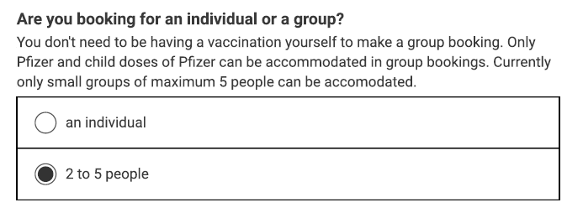

* 1. As it is possible not all individuals will have their own mobile phone number or email the person making the booking can be the person who is contacted about any changes to the booking system, and will receive the confirmation details for the booking.

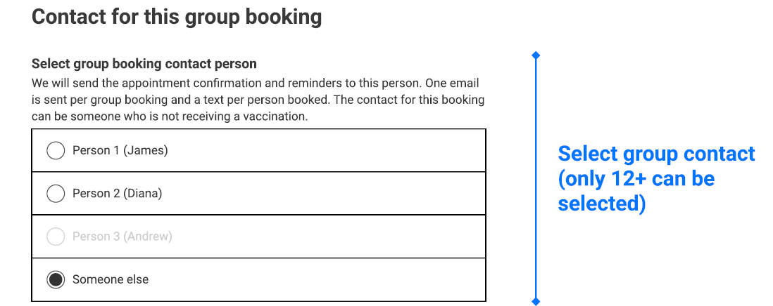

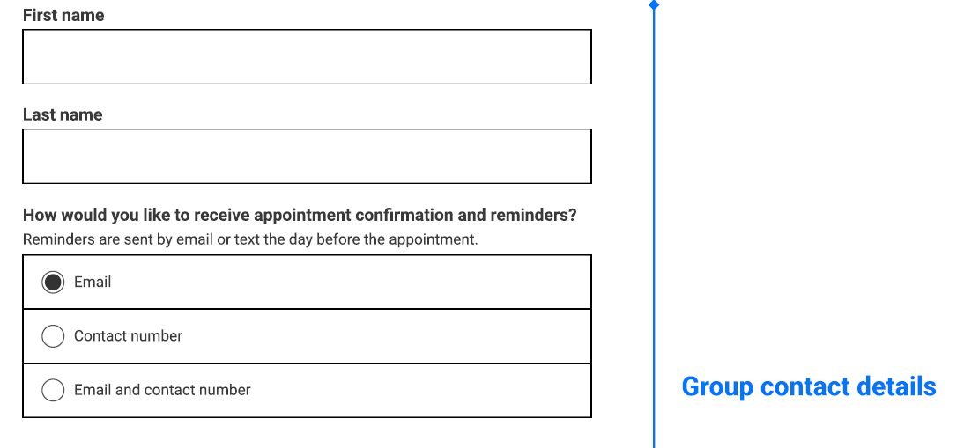

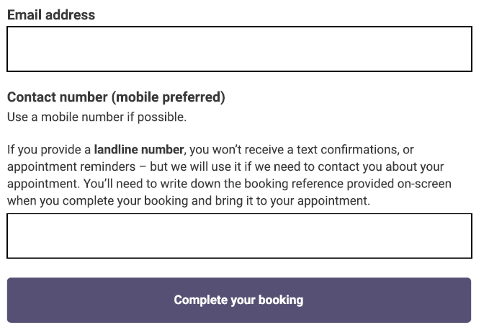

1. There are also now more choices for Consumer of vaccination type with the addition of AstraZeneca and Novavax.

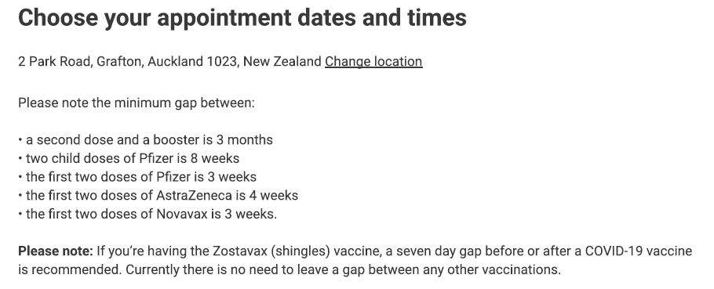

*CPIR integration*

1. The COVID19 Population Identification and Registration service (CPIR) has multiple purposes:
   1. It will hold the invitation datasets to invite target population groups. This can include personalised letters, and follow-up with a communication to an email or text address if one is held.
   2. These text and email capabilities are also being utilised with the contact tracing services and have been used to send text messages to positive cases, close contacts and household contacts[3].
   3. Details provided by the Consumer will be used in CPIR to associate the Consumer to their NHI number where possible. It uses existing NHI matching technology (Match+) that is currently operating within the NCTS (for contact tracing, border arrival records and also the Border Workforce Testing Register).

*CPIR Invitations for Group Four[4]*

1. In 2021, when the Ministry initiated invitations for the age based general population vaccination invitations, the Ministry identified a dataset from information held by it that was designed to include as many Group Four individuals as possible. A summary of the dataset and the matters considered by the Ministry in preparing this dataset are included in Appendix Six.

*CPIR NHI Matching*

1. CPIR is intended to reduce the administrative burden of receiving a Consumer at the vaccination site, finding their NHI details, updating the CIR case record and assisting to ensure the Consumer can legitimately receive a vaccination.
2. The CPIR process is generally as follows:
   1. The Consumer makes a booking in Skedulo/AVMS. This booking is confirmed for them at the time of booking, both to reduce anxiety and to encourage vaccination.
   2. CPIR will subsequently match information from the AVMS system within CPIR by use of an Amazon AppFlow integration. CPIR will match the AVMS data[5] against an NHI record (where possible) using an algorithm, or a manual process, and then load the NHI matched records to the COVID Immunisation Register (the CIR)
   3. The CPIR matching process takes some time (1 hour for the algorithm match, and then potentially 1-2 days for the manual matching of those not adequately matched by the Match+ algorithm).
   4. Other system NHI matches using Match+ typically match about 80% of records to an NHI. This Skedulo sourced collection however is directly from Consumers and is not verified[6]. This is in contrast to the other Match+ operations which use official data sources including verified identity documents such as passport linked details. The total record match percentage may therefore be lower.
   5. It is important that this NHI match is correct as a person’s medical record will be updated for vaccination with the use of this assigned NHI. The algorithm requires a match to meet a minimum threshold before it is returned as a match. This weighted score is based on a number of factors depending on the data that was supplied.
   6. The matching algorithm applies a weighting to the match, it must meet a minimum threshold score of 112[7] and it must also be 15 points clear of the next closest match. This means that if the algorithm returns a match for an NHI, but there is another match that is similar, the match will still be referred to the Ministry matching team to check it is correct.
3. The automated Match+ process is supplemented with a manual process where the Ministry contact centre will do a manual match if the algorithm match is insufficient in accordance with its rules.
   1. The Ministry contact centre will attempt to match each Consumer to an existing NHI, either by a manual match from the information provided, or they will make direct contact with the Consumer on the contact details provided. If contact is made with the Consumer, and no existing NHI match can be identified the contact centre may assign a new NHI to the Consumer, and the Booking System will treat this as a match and follow its CIR notification processes (described below in paragraph 22).
   2. The planned process is that if the Ministry Contact Centre is unable to contact the Consumer, the booking may be cancelled. The process for this will be rigorous. The intent of Booking System is to assist people with the vaccination processes so removing bookings will not be a first response. This process will be documented prior to the implementation of the Third Phase. The current plan is:
      1. If the booking is cancelled, notice of this and an opportunity to rebook will be sent to the contact details provided.
      2. If the booking is not cancelled, NHI matching or allocation will happen at the vaccination site if the Consumer presents for the appointment. No information on that Consumer booking record will be sent to the CIR from CPIR.
   3. A process will also be developed for the removal of bookings where fraud is suspected, or where the Ministry has reason to believe that the booking is not genuine or is mischievous in nature. This will include when information may be shared with other agencies where fraud is suspected.
4. If there is an NHI match then that detail will be uploaded to CIR as a case event (and the Correlation ID, and the ‘verified NHI’ record field will be populated and will be linked to that record). The CIR process will still need to accept that record before it will update or create the CIR case and participant record. These details are also checked with the Consumer in CIR when they arrive for vaccination.

*CIR integration*

1. CIR[8] holds a full record of the NHI database within its system to enable creation of participant records for all those who attend to get vaccinated.
2. A Participant Record is created in the CIR, along with the NHI number, which is turn creates a Case Reference. CIR requires a Case reference with a matched NHI, in order to allow a Vaccinator to legitimately provide a vaccination to the consumer. Missing information must be populated to obtain an NHI before a vaccination may occur. If the Booking System does not provide this the NHI will be manually looked up directly via the CIR using existing processes. If a verified NHI is assigned then this will be returned to that booking record in CPIR for complete the ‘verified NHI’ field.
3. Information about the booking in AVMS (where CPIR confirmed an NHI link) will be visible in CIR, using a Salesforce feature called Salesforce Connect. Users of the CIR will be able to access booking information within AVMS using either the link from the matching process (Correlation ID) or by searching information provided by the Consumer about their booking.
4. Once a booking has been located and the consumer is ‘checked in’ the booking is marked as attended within AVMS. This is used to generate reports for appointments that have been missed, so that a reminder notice can be sent to the contact details provided by the Consumer, together with information about how to re-book. If a Consumer misses their first appointment and does not rebook in response to outreach services (and after a time period to be finalised by the Ministry), the second appointment will be cancelled to release booking slots for other Consumers.
5. If the CPIR did not match an NHI then no Correlation ID would be sent to CIR, and that booking will only be able to be viewed in AVMS, and the vaccinator will need to look up the Consumers NHI directly, and separately create a new participant record in the CIR.

*Snowflake integration*

1. The Ministry Data Governance Group approved Snowflake access to the Booking System information. The extended application is recorded in Appendix Three.
2. The Booking System information transferred to Snowflake from AVMS will not immediately be NHI linked (as that linking process happens within CPIR, with an extract from the Booking System). The NHI is not transferred back to the AVMS, until the linking has occurred. Snowflake therefore also integrates with the CPIR to add the NHI detail to the AVMS extract.
3. The Booking System Privacy Statement (reference Appendix Four) provides that information will be used to report on numbers booked and attending vaccinations and facility capacity. This is aligned with the intended Snowflake uses for the information as Snowflake will be used to report on the performance of the system (e,g. numbers of consumers invited, booking, re-scheduling, how many bookings followed through and how long it takes to complete the booking process etc).
4. The users of this Snowflake dataset will be limited to the following roles:
   1. Ministry COVID-19 developers – developers in the Ministry Business Intelligence Data Warehouse team supporting the Snowflake platform and data pipelines for reporting. This small team has access to identifiable information in order to create non-identifiable datasets for other users and to otherwise manage information sets securely within Snowflake.
   2. Ministry COVID-19 data analysts – (from the Ministry COVID-19 Science and Insights Group including Public Health Intelligence and Surveillance and data analysts) directly involved with the COVID-19 Vaccine and Immunisation programme response within the Ministry.
   3. In addition, with approval from the dataset owner, the data will be read by Qlik Sense at the Ministry to provide governed views of appointment bookings and facility capacity with respect to the vaccination and immunisation programme. This information is displayed is at aggregate level and is non-identifiable.
   4. Research will be limited to those projects authorised by the Ministry with appropriate ethical approval.
   5. Any further sharing of the information in an identifiable format within the health sector must be assessed, and must not occur unless approved using the standard Ministry Snowflake processes (currently Data Governance Group approvals[9]). This may involve health sector agencies such as the operational arm of the DHBs who are involved directly in the provision of vaccination services.

## NHI Match Process View:

1. The below diagram describes how bookings are processed in the CPIR system i.e. how NHI matches are handled.

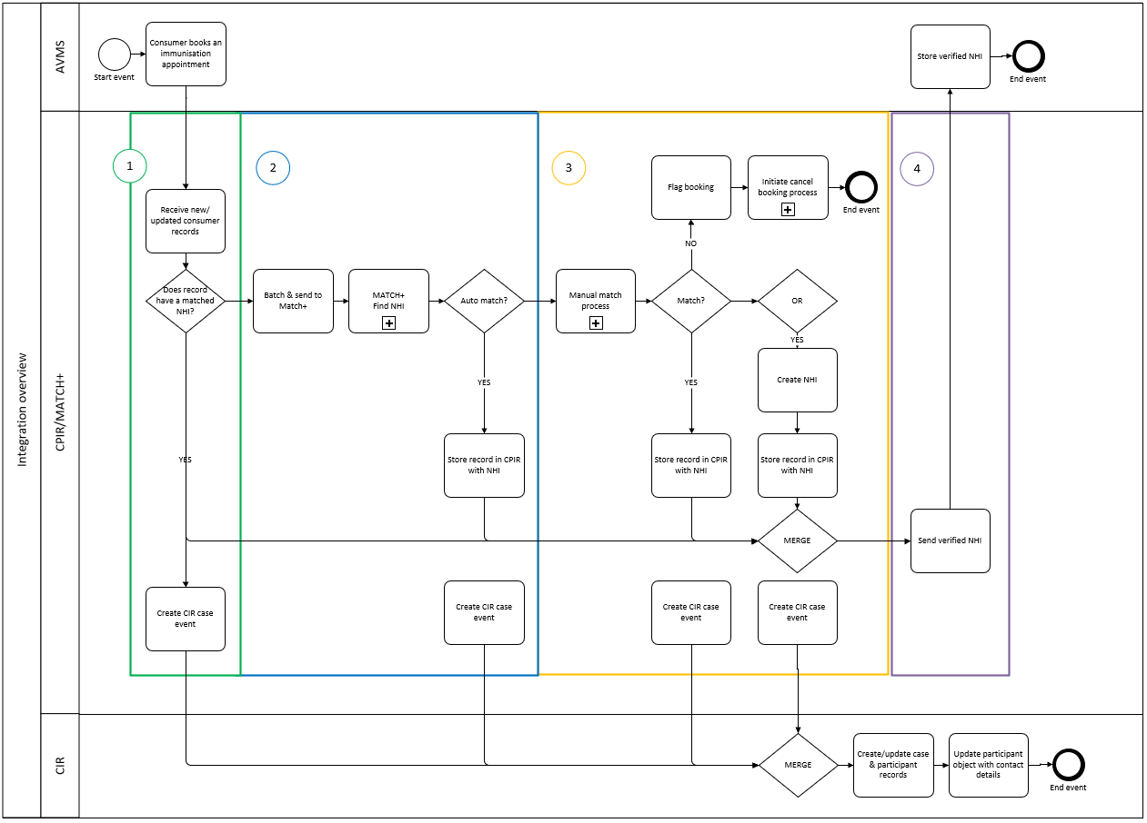

1. The green pathway (number 1 above) shows the process for integration of the Booking System information from AVMS with the CIR, via the CPIR integration tool.
2. Parts 2 and 3 are the components where NHI matching processes take place[10]. This is not accessible to Consumers, AVMS Users or CIR Users. It is managed within a secure digital matching process, and only if reliable matches are not identified will a record be available to the specialist Ministry NHI matching team. The matched NHI information detail will be available to the integrated CIR, via linked Correlation ID. Part 4 is the process where the verified NHI number is sent to AVMS

## Information fields involved in the Booking System:

1. The Information to be collected via the Booking System to enable a booking to be created is set out below. This includes all information that will be collected:
   1. via the webform process managed by the call centre (where eligibility will already have been identified prior to commencing the booking process); or
   2. when the Consumer is able to enter their own information directly via the webform, or it is collected by call centre services from the Consumers directly; or
   3. during the NHI matching process.

|  |  |  |
| --- | --- | --- |
| **Information** | **Mandatory or optional field** | **Reasons for collection**  **-To make the booking and for statistical reporting in each case, as well as purposes set out below** |
| Eligibility Category | Mandatory | To determine if eligible to book now or later |
| First name and last name (middle name optional) | Mandatory | To make booking, and identify relevant person at vaccination appointment and for NHI matching |
| Preferred first and last name | Optional | To assist with identification of the relevant person at the vaccination appointment and for NHI matching purposes (not all individuals use their full legal name in settings where they interact with health services) |
| Date of birth | Mandatory | To make booking, identify relevant person at vaccination appointment, for NHI matching and demographic reporting |
| Contact email and / or contact mobile phone | Mandatory at least one be provided | To send appointment confirmation and reminders and to contact relevant person in relation to vaccination appointment (including where an appointment has been missed, or needs to be verified or rescheduled)  It will also be used as a source of COVID-19 related contact information, for example if an individual cannot be located to send a positive test or household contact SMS message |
| Gender | Optional | To assist with demographic reporting and for matching to NHI number |
| Ethnicity | Mandatory | To assist with demographic reporting and for matching to NHI number |
| Address | Optional | To assist with identification, and for matching to NHI number |
| Booking location dates and times | Mandatory | To confirm the vaccination bookings |
| If special assistance required | Optional | For the consumer to indicate they may require help on the day of vaccination. This triggers a requirement at the DHB to get in touch with the consumer to confirm what assistance is required. |
| Acknowledgment of Privacy Terms | Mandatory | Confirming Consumer aware of how the Ministry manages their privacy |
| Confirmation consent obtained if completing the form for someone else | Mandatory | To confirm authority to book on behalf of another |
| NHI supplied by the consumer | Optional | To compare to NHI match |
| NHI as matched by Ministry processes | Mandatory if match can be made | To enable linking to records in COVID-19 Immunisation Register, to increase efficiencies at point of vaccination, and to identify and manage bookings that may not be genuine. |
| Confirmation Booking Attended | Mandatory if match can be made | To confirm within Booking System when a booking has been attended or not, and to assist with follow up of missed bookings NB: A record of attendance does not confirm that a vaccination has been provided. This record will be maintained in the CIR. |

1. Assistance required queries were included in Phase Three:

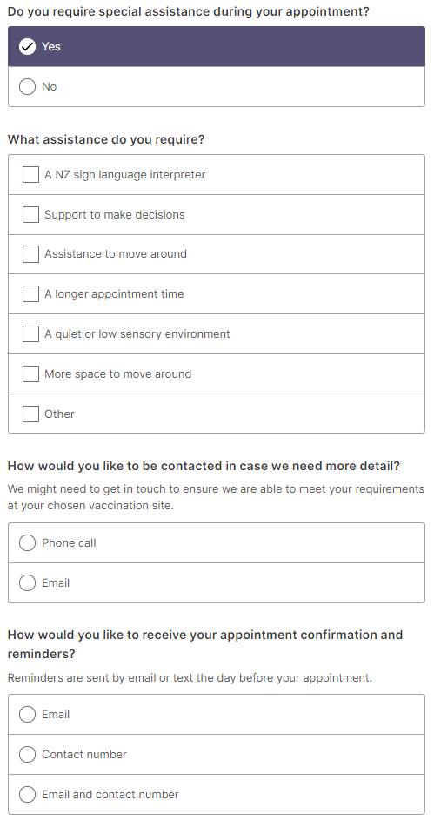

1. There is an option for a person who has not previously engaged with the Booking System but has had a first dose to record those details.

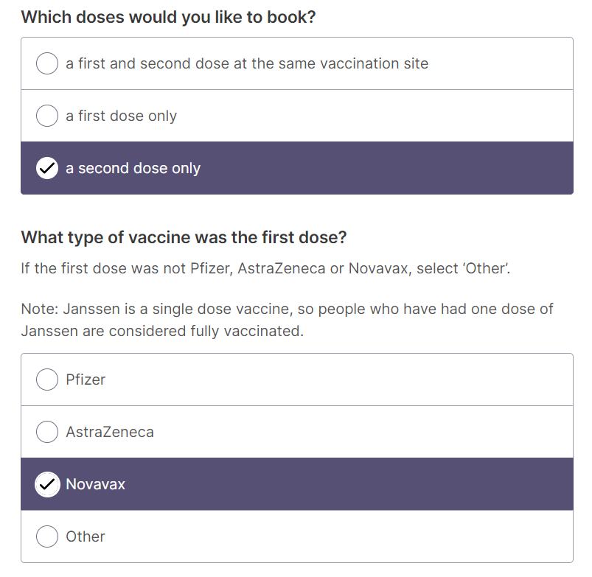 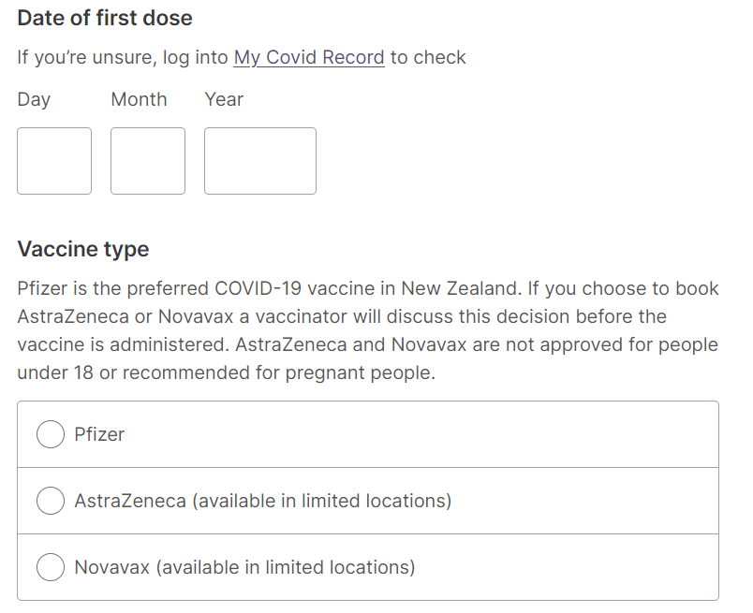

## Where and how the information will be stored

1. The Skedulo webform will be hosted on Amazon Web Services (based in Australia). The Information will be recorded within AVMS on a Salesforce product (with the Booking System Information hosted in Australia).
2. The personal information for the invitations and Booking details is transferred to CPIR within Amazon Web Services (based in Australia). All data storage is encrypted in transit and at rest.
3. Data from AVMS and CPIR is now integrated within the Ministry Data warehousing tool Snowflake.
4. Information on CIR is held within the Ministry NCTS environment (subject to the CIR PIA).

## How long will information be retained for?

1. In order to limit the opportunity for duplicate bookings to be made it will be necessary to retain the records within AVMS until the vaccination roll out has been completed. It is expected that this will be 20 working days after the date on which the COVID-19 Public Health Response Act 2020 is repealed.
2. Personally identifiable information transferred to the CPIR and Snowflake will remain until 20 working days after the date on which the COVID-19 Public Health Response Act 2020 is repealed.
   1. The information will be retained in CPIR so that any subsequent communications with unvaccinated, vaccinated or partly vaccinated individuals who are being managed as part of the Booking System processes can continue to be managed. There may be subsequent communications that are required with those who have been vaccinated, or not yet fully vaccinated, and the CPIR is the IT tool that will be responsible for management of those communications.
   2. Snowflake will retain the information so that it can provide full reporting for statistical purposes and the information will not be published in a form that could reasonably be expected to identify the individual concerned (as per rule 10(1)(e(ii) of the Health Information Privacy Code). Key reporting purposes for this information include the ability to monitor the use and performance of the Booking System throughout the pandemic, and also as part of the overall monitoring of the efficacy of the COVID-19 vaccination and immunisation programme. The Booking System information is assessed against registration (CPIR) and vaccination (CIR) data to understand the channels that people use in order to get their vaccination and whether there are ways in which the availably of the service is such that outcomes are equitable.
3. There is an option for an individual to request deletion of all of their information from the Booking System (initiated via the call centre risk and verification team who contact the Ministry Risk and Privacy team to action). This will also include information transferred to CPIR and Snowflake (but will not be retrospective if the information has already been transferred and been incorporated into reporting datasets). Information transferred to CIR will not be removed as that is a clinical record. If an individual is not satisfied with the retention time frames for the CPIR or Snowflake they will then be able to seek the removal of their identifiable information earlier than that time. This can currently be enacted by emailing the Ministry and requesting this.

## Security features applying to Project

1. The Ministry security team and an external third party during each release work through a Security Risk assessment process to ensure all new features and integrations are reviewed. This will include all information in transit and at rest. Each control is to be reviewed for effectiveness and efficacy and relevant risks identified, and mitigated prior to Go Live for each release.

## Manual processes involved

1. The Call Centre and Ministry or DHB approved operators can are ‘act on behalf of’ the Consumer to complete the booking and will complete manual data entry on the Consumer’s behalf if requested to do so.

## Analytics

1. Simple Google Analytics is in use with the Skedulo webform, as identified in the First Phase. No identifiable information is captured. This information is being used to understand user behaviours especially with the Eligibility questions, and to update in response should they appear to be causing high levels of non-completion.

## Governance

1. Governance Group oversight, and Steering Group processes applicable to the CIR Processes are applied to the Booking System.
2. A key governance role will be to maintain oversight to prevent the risks of function creep, and ensure security is applied at all stages of development. This should be included in the governance group Terms of Reference. Snowflake processes and datasets are already subject to the Ministry Data Governance Group.
3. There is potential for new uses for the Information to be identified over time, including access by other agencies.
   1. If Information is used in a manner inconsistent with the authorisation given by Consumers on sign up there is the potential for a privacy breach.
   2. It is essential that experienced governance oversight and control is retained to make sure the Information is not used inconsistently with the authority given when the Information was collected, or other legitimate ground consistent with the Privacy Act is identified for use or disclosure.
   3. Each new Phase for the Booking System is subject to Privacy Impact Assessment and any potential new information collection or use identified and appropriate limitations or controls applied.

# Section Three – Privacy Analysis

1. The purpose of this Assessment is to review the Booking System process of collection, storage, use and sharing of personal and contact information.
2. Summarised recommendations can be found in Section One of this PIA.
3. Appendix Six also contains a mini-PIA in relation to the information that was used to create the Group 4 dataset.
4. The Ministry has conducted its analysis under the Health Information Privacy Code as the information is about Consumers and their health services. Under clause 4(1)(e) it is considered that this is information about an ‘*individual which is collected before or in the course of, and incidental to, the provision of any health service or disability service to that individual’*.

|  |  |  |  |
| --- | --- | --- | --- |
| **Health Information Privacy Code Rules** | | **Background and Key Controls** | **Residual risk** |
| Rule 1 | Purpose of collection of health information   * Only collect health information if you really need it | *Purpose*  The Booking System Information collection is to support the COVID-19 public health response. The information collected is used for the purpose of identifying, contacting and managing individuals who wish to book vaccination appointments (and then to check the attendance at the relevant vaccination location) or to invite individuals to participate in vaccination bookings. The information will also be used to help manage resources to ensure that there are enough vaccinations at the right location at the right time, and to compile reports on the numbers booked, and performance of the vaccination programme. These are lawful purposes to assist with management of vaccination booking processes. The key contact details (text or email) may also be used to contact the individual if another COVID-19 risk arises, such as a positive test result, or household contact messaging, and the mobile phone number provided at that time is not accurate or is absent.  The integration with the CPIR will enable increased efficiencies and accuracy of the link (via NHI matching) between the person creating their booking and the clinical record subsequently maintained on the CIR of the vaccination delivered to each Consumer, and the booking matches within the Booking System.  The integration with the CIR will enable a record of those Consumers who had an NHI match and attended their booking appointment to be returned to the Booking System as a verified NHI match. This will help with analysis of patterns of bookings / attendance behaviour and will support identification of additional resourcing requirements. There will be no penalties applied for missed bookings. It will also help bookings for that individual can be confidently linked within the Booking System, and available to support the Call Centre for queries, thereby improving accuracy of matches and removal of duplicate records.  The collection will be managed by the Ministry of Health (and those agencies supporting the booking process including those with concierge and site manager roles in the process who may be DHB staff or other health related service providers).  *Necessary*  As the information is about being able to enable an identifiable person to make a vaccination appointment this does require collection of identifying information. The information fields are limited to those necessary to create and manage the vaccination cohorts, booking appointments, match to NHI records, and these are as identified in the Privacy Statement for Consumers.  The CIR integration will also enable identification of individuals who have already been vaccinated to be removed from the invitation process, which should reduce unnecessary communications with those individuals who have already chosen to participate. | **Low** |
| Rule 2 | Source of information   * Get it straight from the people concerned | The collection of the majority of the Booking System information is designed to be directly from the individual (or an authorised person on their behalf – including group bookings). People will be able to enter information directly on their own behalf into the Booking System, or alternatively call centre staff will be speaking directly to the Consumer (or their authorised representative) and obtaining the information from them.  If the Consumer requires assistance, the webform can be completed by someone acting on their behalf. Anyone completing the form for another will be asked to confirm the permission to act on behalf of the Consumer within the web screens of the Booking System. In the group booking screens the person making the booking can add their first and last name, and their contact details as representative of the group.  The NHI may be provided directly by the Consumer if they know it, but information will still be checked via Match+ within CPIR to make sure the NHI is one that complies with the matching algorithm (or is matched in person by the Ministry team). In addition, the CIR will return confirmation to the AVMS if a person with a matched NHI attends a booking session, so there is a ‘verified’ NHI field captured to record this in the Booking System. These features are included in the Privacy Statement, so Rule 2(2) will apply to these collections of NHI and booking attendance.  The source of any invitation dataset will generally be from information already held by the Ministry rather than directly from the individuals (for example, see the Group Four process in Appendix Six. It was not considered reasonably practicable during the urgent nation-wide roll out to collect information from individuals directly (rule 2(2)(d) when the Ministry is not aware of their identity without compiling the invitation dataset). | **Low** |
| Rule 3 | Collection of information from individual   * Tell them what you’re going to do with it | The collection process incorporates a Rule 3 compliant process in the webform itself. A short form privacy statement links to a longer form statement on the Ministry website. The text of the version updated for this fourth PIA version is in Appendix Four. The Customer will be required to confirm that they have seen the Privacy Material information prior to continuing. It is recommended that this also be updated to confirm that if the booking is on behalf of another / others that the following statement be linked to the ‘tick box’ for privacy confirmation: *If I am booking on behalf of another person I confirm I have their authority and have read and agree to the Privacy Statement.*  It is recommended that the confirmation email sent to the Consumer includes a link to the Privacy Statement so they can easily refer back to this information, if they wish.  Call centre staff include an appropriate privacy statement in the initial communication with the Consumer if they are the point of contact with the Booking System in accordance with a script for this purpose. | **Low** |
| Rule 4 | Manner of collection of information   * Be considerate when you’re getting it | Consumers can be any age and capacity permitted by the relevant cohorts.  The Privacy Statement has been updated to include information for the age groups between 5 and 16 years old.  The amount of information being collected is minimised to only that necessary to be able to identify the individual, enable outreach activities, address future eligibility, confirm NHI details, and enable reporting so it is not considered the volume of information is unfair.  An authorised third party is able to complete the information submission on behalf of the Consumer (and are requested to confirm they have authority from the Consumer as part of the process). This will provide an opportunity for assistance to be provided to those who lack capacity to complete the process themselves or do not have access to appropriate technology.  If a young person completes for a Consumer who is eligible, the information being collected will not be about the young person, and this should not impact the manner of collection (other than their name as the authorised representative). This information is an opt-in collection so it will be a choice whether it is provided. | **Low** |
| Rule 5 | Storage and security of information   * Take care of it once you’ve got it | The Ministry will ensure that it has completed all necessary security requirements from the standard Ministry of Health processes prior to implementing any changes to the Booking System  Audit tracking and monitoring applies on both the Booking System and CIR, to ensure that adequate and strong controls are in place to limit access to information to that necessary for the role in question.  A review on AVMS access was conducted. There are different user profiles that are used in AVMS and each of these are assigned to an individual based on the role that they are performing. User profiles limit what an individual can see and also what they are able to update. A history field has been implemented for fields where users are able to make updates, which tracks user changes and there is an ability to report on this. For the most part all external users have very limited update access, as this is retained this to a few individuals within the Ministry. If an external user has a need to update something that they do not have the permission to update, they are able to submit a formal request through the helpdesk for consideration. | **Medium** |
| Rule 6 | Access to personal information   * People can see their health information if they want to | Individuals are advised that they can ‘view any personal information held by us about you’ in the privacy statement and directed to a Covid specific email address [covid-19.privacy@health.govt.nz](mailto:covid-19.privacy@health.govt.nz)  Standard Ministry processes would then be applied to confirm identity and provide relevant information | **Low** |
| Rule 7 | Correction of information   * They can correct it if it’s wrong | The Booking System information is, essentially, to enable individuals to secure a date, time and location for vaccination. Corrections to dates and sites for attendance will be able to be made directly by the Consumer, or with assistance of the call centre if requested. This will be by use of the unique booking link supplied in the response email / text at the time of booking. The Consumer must then follow the link and enter their email or mobile number (as used to make the booking) to get access to the date and time of their booking to change it)  Any corrections to name, date of birth or contact details will need to be managed during the CIR processes, at the time of vaccination, as they cannot be made in Skedulo.  The challenge of an incorrect NHI match via CPIR is that it may be unknown to both the Consumer and the vaccinator. This is not unique to the Booking System – it is a general issue that will also apply to CIR processes when walk-ins arrive and are not matched correctly. This is a matter that should be dealt with in CIR training. To date it appears that these processes are operating successfully and duplicates removed as expected. | **Low** |
| Rule 8 | Accuracy etc. of information to be checked before use   * Make sure health information is correct before you use it | *Skedulo*  From the Third Phase Skedulo operates with a feature that rejects bookings if the full name, date of birth and one of the contact details is replicated in an attempted new booking. This will not indicate why the booking is rejected, it will instead refer the Consumer to the call centre, Whakarongorau for assistance to address the booking directly with the Consumer.  *AVMS*  The Booking System project must retain an awareness of the unverified nature of the original information collection – and ensure appropriate mitigations are applied to the information. Current mitigations against inaccurate information being submitted include:   * The incorporation of CPIR NHI matching. This is intended to be one method of increasing the accuracy of the information reaching the vaccination site – by identifying the NHI associated with that Consumer’s details. This should minimise false entries of ‘created’ names by those who seek to cause disruption. * The NHI assigned by CPIR processes will enable creation of a link for the CIR record to check back to the correct AVMS record for confirmed booking details. If there is no NHI match within CPIR, there will be no ability to use the CIR link on presentation to the CIR site. The vaccination site users will then need to complete the standard NHI matching processes for those unmatched records. * Care has been taken to ensure that the CPIR NHI matching is organised at a high level of ‘match’ i.e that the settings are detailed enough to make it unlikely that the wrong NHI will be assigned to the details submitted for a Consumer. If the wrong NHI was matched, and this was transmitted to the CIR record, the vaccination record would then be linked to a different person, and not the person receiving that treatment on the day. It will be a more accurate and clinically safe result if a record is not NHI matched via Match+ in the case of any doubt.   + One mitigation is that the automated Match+ process is supplemented with a manual process whereby the Ministry contact centre will do a manual match.   + The Match+ matching algorithm requires the match be a high percentage match and also that it be at least 15 % clear of the next closest match. This means that if the algorithm match is within 15 % of another match, the match will still be referred to the Ministry manual matching team to check to make sure the correct record is picked if there are similarities.   + The NHI number will also be provided to Group 4 participants in their sealed invitation letter to enable them to input their own NHI to enhance the accuracy of the NHI match process. * Training for CIR users who will access the AVMS link (when there is an NHI match) is to make sure that they check the NHI details with the individual just to make sure they are vaccinating the correct person for the clinical record they are about to create. * A process is available for CIR users for the unusual situation where a person turns up to be vaccinated and it is discovered that there is already a vaccination recorded against that NHI. This could have clinical consequences for both parties involved.   *CPIR integration*  The unverified data source from the Booking System Skedulo webform collection will create challenges in reuse of the CPIR for any other information collection activities, or reuse of the booking information:   * The person submitting the information may or may not be who they say they are. * This could have limited the prospects of any future use of the CPIR information for anything other than current booking related purposes. It is however balanced against the use of information entered by legitimate individuals who have chosen the up to date and accurate contact details they wish to be contacted by. The mobile phone number in particular has been identified as having potential importance with the 2022 Omicron outbreak – to enable COVID-19 related follow up in other areas such as advising of positive Case status or household contact status where other contact methods have failed. Only those mobile numbers provided within the previous 6 months will be used for this purpose (to make sure they are reasonably current). The Privacy Statement for Book My Vaccine is now updated to signal this potential purpose. * The CPIR Match+ service will match to the NHI database it holds using algorithms already developed and in use in applications on the National Contact Tracing Solution. The difference is that in those other applications the data comes from an independent and more authoritative source. In the case of the National Border Solution it is from a source with verified and passport linked details (therefore it is a high likelihood of it being correct as it is from a reputable source that verifies the information). The NHI supplied will however be verified during the vaccination process at CIR – and if verified will be recorded back to Book My Vaccine as a ‘verified’ NHI (a new data field created for this purpose).   *Snowflake*  The information held in Snowflake will be used for reporting and trend information. It will not be used in respect of any identifiable individual included in that information, and there will be no consequences for any individual of the use of that reporting information. It is however important that the information is sufficiently accurate that appropriate conclusions can be drawn from the aggregated information within Snowflake. It will therefore be regularly updated so that any updates to Consumer data within the Booking System are passed through and updated on Snowflake (including any deletions requested by a Consumer).  *CIR integration*  CIR processes will continue unchanged in terms of verification of the individual who presents for vaccination. These processes are not further addressed in this PIA.  The CIR link back to an NHI supported Booking System record will enhance correct linking of verified NHI to a person’s records, having already gone through a designed CPIR matching process, rather than being simply a single look-up at the CIR appointment when there may be other time pressures | **Medium** |
| Rule 9 | Retention of information   * Get rid of it when you’re done with it | The integrated systems, have added some complexity which is likely to require the retention of records beyond a confirmation of completion of booking attendances – noting also the addition of booster doses has extended the time frames over which records need to be retained to make sure individuals book for the correct vaccination. The retention time frame is set out in the Privacy Statement.   * *AVMS - Booking System* – ‘expired’ Booking System details (dates for second booking have passed, or the latest date on which the second vaccination was due) are to be routinely deleted from the Booking System every six months (following a manual request from System Administrators for deletion of information). If a verified NHI has been achieved, then this record will be retained in AVMS to make sure that subsequent bookings can be linked within the booking system processes, and only one record is created for individuals to avoid duplication. * *CPIR* – using the Match+ service, CPIR will retain the details of the Booking System records it has received, and those NHI matched, and those not matched. One key purpose of the CPIR is to enable a link between a booking and a CIR matched record based on NHI. CPIR may, however, also be used to generate the follow up on those who have registered their interest in a subsequent vaccination. There may also be a future requirement to be able to contact individuals if a subsequent booster shot or other circumstances requires it. CPIR will be the tool used for this purpose. It is recommended that the CPIR information be held until the repeal of the COVID-19 Public Health Response Act 2020 and then is to be securely deleted. * *CIR* – Information that is accepted into CIR (via the Salesforce Connect tool) is incorporated into the CIR health record about the individual and will be retained for the same time frames as the CIR information. * *Snowflake* – (for information obtained from AVMS and CPIR) This information is to be held until the end of the COVID-19 Public Health Response Act 2020 and then is to be deleted, or identifiers removed for a research dataset. * *Service providers (as Ministry agents) to send invitation communications* – Twilio (SMS), AWS SES (email) and New Zealand Post (postal mail). This information is to be held for the following time frames:   + NZ Post will destroy the data supplied to send the postal communications within 30 days.   + AWS SES does not store the information as it treats it as transactional   + Twilio will destroy the information on instruction – and the Ministry must action that instruction promptly. It is understood that this will be set to retention for no longer than 90 days before being deleted. Only limited system administration individuals can access this Twilio information.   + The destruction must occur in a secure and prompt manner   The option for a person to request deletion of information about them in the Booking System is in place (and is ultimately managed by the Ministry of Health privacy and risk team). The flow of data from AVMS to CPIR and Snowflake is also to be included in this process. | **Low** |
| Rule 10 | Limits on use of information   * Use it for the purpose you got it | Current use of the Booking System information is to be aligned to the purposes identified in Rule 1, and has been approved for use in Snowflake by the Data Governance Group. Snowflake integrations are to be limited to those uses approved by the Data Governance Group (as per the Appendix Three data set approval application)  This will be an area that will need to be subject to Data Governance controls if any use is contemplated outside the Booking System purposes and related CIR vaccination purposes.  The NCTS Data Governance processes set out in the Application for access to NCTS information should apply if any new requests for additional use of the Booking System information are made.  Data governance will also apply to any new uses for information or new users other than those already contemplated in the existing RBAC roles  As the information collected via the Booking System processes has integrations that will expand the locations in which the information is held (CPIR, Snowflake and CIR) each of those will need to be carefully managed to make sure that the purposes remain consistent with those identified in the Privacy Statement, or otherwise authorised in law. | **Low** |
| Rule 11 | Limits on disclosure of information   * Only disclose it if you have good reason | Communications will be sent directly to individuals for invitations (as per Rule 11(1)(a)) or the individuals who have confirmed they are authorised to assist the Consumer.  The Ministry has noted the risk that an unauthorised individual may access information about another (particularly the NHI detail) from communications sent. The only communication initiated by the Ministry without the Consumer first providing contact details was the Group Four invitation letter (which also contained the name, address and NHI of each Consumer). It was in a sealed envelope, addressed directly to the individual concerned. The Ministry notes it is an offence to open mail addressed to another. It determined on balance that the risk a person will inappropriately access the NHI of another person is low. This was carefully monitored as the Group 4 roll out progressed and no issues of significance identified.  In terms of disclosure from the Booking System, other than invitations as noted above, or booking confirmation details sent back to the person who made the booking, access to information is limited to those with authorised access rights to the various components of the Booking System (and its integrated parts). Each authorised user will be able to see information in accordance with the role settings applied to them.   * Access to the information is controlled by Role Based Access for AVMS users at vaccination sites, and limited to information necessary for the performance of that role. This was detailed in the First Phase PIA and is summarised in Appendix Five of this PIA. * CPIR is an applied algorithm based process that will either add an NHI to the record of each Consumer, or send relevant NHI matching details to the selected Ministry NHI team members who will be involved in the manual match. It is not directly accessible other than by system administrators. * The CIR integration will enable a link to an existing NHI linked record within the CIR via the Correlation ID. This will enable the addition of the booking details for each Consumer, when NHI is matched. The CIR access roles will be those applied within the standard CIR processes. The addition of the Booking System NHI linked information has not significantly expanded the information holdings already available within the CIR.   Any disclosure to NZ Post / AWS or Twilio is in the role of Ministry agency only.  As indicated, the security review has checked access provisions (and associated audit and tracing ability) during its reviews. Provided adequate controls are in place to limit access to information necessary to each role it is likely this rule 11 can be complied with.  Appropriate RBAC (role based access controls) must be applied to:   * AVMS * CPIR (very limited access) * Snowflake; and * CIR (not directly reviewed in this PIA) | **Low provided adequate controls are in place** |
| Rule 12 | Disclosure of personal information outside New Zealand | There is no expectation of any disclosure of personal information from the Booking System outside New Zealand (otherwise than for safe custody or processing in compliance with s11 of the Privacy Act 2020, due to the hosting sites being located in Australia).  AVMS, CPIR and CIR are all on an AWS platform in Sydney.  The AWS communications will transit Australia and the Twilio communications will transit Australia and the United States, but only for processing purposes as per s11. Only email / text address and first name will be used in the invitation communications. | **Low** |
| Rule 13 | Unique identifiers   * Only assign unique identifiers where permitted | Each booking confirmation will receive a unique booking reference so that it can be used uniquely in respect of a single Consumer for the purposes of the vaccination booking processes.  A Correlation ID will also be used for system to system linking. This will be used to link the unique booking to CPIR record and CIR record. This will not be visible to Consumers. It will enable the link between the integrated systems so identified information can be displayed. This reference will be used to link the AVMS record to the CIR record (and enable relevant information to be uploaded if the CIR user confirms that at the time the Consumer presents for their vaccination). It is visible in CIR but does not disclose any additional identifiable information to the viewer. Book My Vaccine will now also have a ‘verified’ NHI field when CIR confirms the NHI in relation to a booking attended.  The NHI will be used for the booking components of the Booking Service. The Ministry of Health is in charge of CPIR operations and therefore is effectively ‘assigning’ the NHI to the Consumers booking/ registration record. It is an agency approved under Schedule 2 of the HIPC to assign the NHI. This NHI assignment is consistent with the purposes for which the NHI is designed to be used – to uniquely identify Consumers in a health setting.  The NHI was included in invitations sent to individuals by post via the CPIR related processes for Group Four. This enabled individuals to enter their own NHI into the webform when they supplied their details to Book My Vaccine. This is expected to enhance the accuracy of the NHI matching in Match +. The NHI will only be included in the letters, not email or text – and is to be sent in a sealed envelope with the envelope marked: *For the intended recipient only* | **Low** |

## Appendix One – Summary of Third Phase

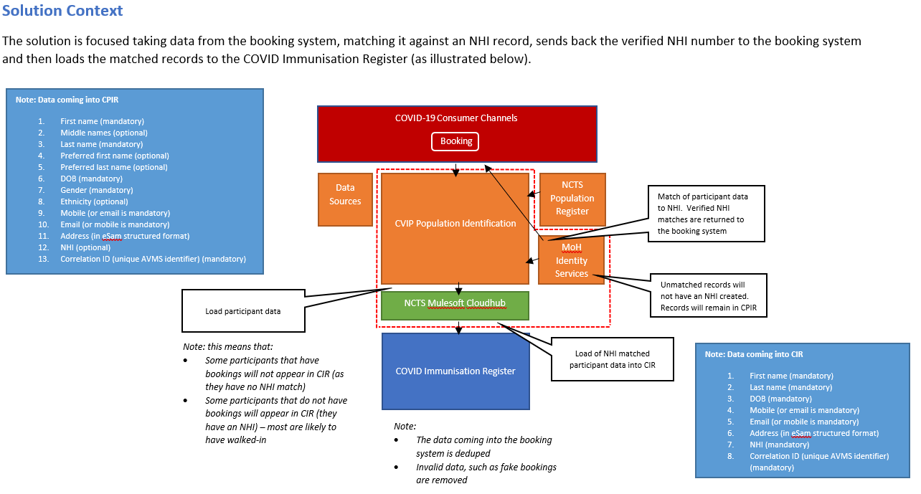

## Appendix Two - Booking System connections

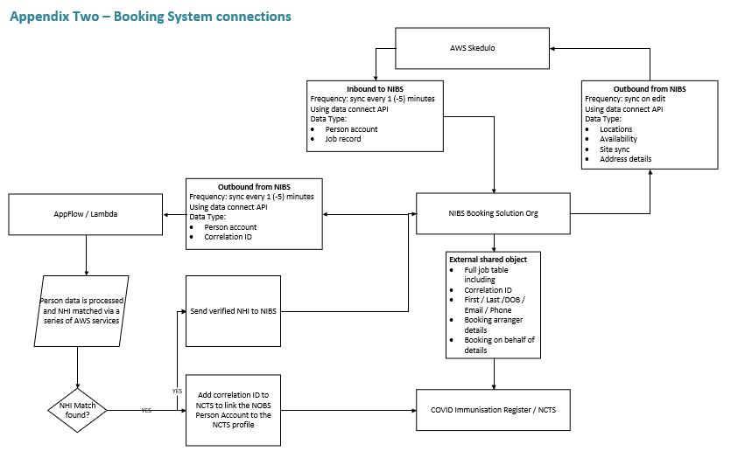

## Appendix Three – Snowflake Application to Data Governance Group

Memo – Snowflake dataset approval

Data Governance Group, Ministry of Health

|  |  |
| --- | --- |
| **Date:** | 28 May 2021 – Revised 10 July 2021 |
| **To:** | Data Governance Group |
| **From:** | Eva Sundin, BIDW, Manager National Collections & Reporting, Data & Digital |
| **Copy to:** | Caitlin Hawkins, Manager Risk and Privacy, COVID-19 Health System Response  Tracey Vandenberg, Group Manager National Collections & Reporting, Data & Digital  Michael Dreyer; Group Manager Data Services, Data & Digital |
| **Subject:** | **COVID-19 vaccination booking dataset storage and accessibility through Snowflake** |

Introduction to Snowflake

* Snowflake is a purpose-built cloud data warehousing service.
* The Ministry Snowflake implementation delivers a platform that provides the Ministry and wider health sector the capability to engage with datasets that are made available within a secure environment.
* The platform delivers key capabilities of dataset storage and accessibility.
* Datasets are ingested into Snowflake and can be stored there.

From a security perspective, the platform has been approved for this purpose.

* Stored datasets can be made accessible to authorised users via Snowflake.

From a security perspective, the platform has been approved for this purpose, however there is the privacy perspective that requires Data Governance oversight of access and usage.

* Datasets can be accessed and analysed using the analytical tools most effective for the authorised user without the constraints of their connected health status.
* Users are authorised if
  + They can demonstrate that access to the platform and dataset(s) are essential in their current role and the relevant approvers agree.
  + They have completed the relevant training and assessments on handling sensitive health data as required for the level of data they need to access.
  + They agree to the terms and conditions of access.
* In most cases, accessibility to identifiable data via Snowflake is designed to be limited to a relatively small group of analysts and developers who can and will perform analytics on large and complex datasets on behalf of the Ministry who will in turn share aggregated and de-identified outputs with a larger audience. This includes the use of the Ministry’s tool Qlik Sense to read data from Snowflake and present it in visual aggregated form to the wider Ministry and health sector where approved.
* A full external security review has been completed of the Ministry Snowflake technology implementation.
* The Snowflake (vendor) organisation and technology accreditations and certifications were factors in this review.
* The review confirmed the Ministry has a platform and set up that will keep the datasets within the platform safe and secure.
* A full approval to operate (ATO) is in place until April 2023.
* A full Privacy Impact Assessment has been completed.
* The assessment provided recommendations of oversight by the Ministry Data Governance Group of any appropriate controls on dataset access and use. With the intention of building patterns of dataset storage and access that fit within the Data Governance Group expectations.

Purpose

This memo is a request to the Data Governance Group for

**Adding a new dataset to Snowflake – data storage**

**Providing access to use datasets held in Snowflake – data accessibility**

Requested Information

Fill in the white fields below – and remove the italic instructions

|  |
| --- |
| **Background Details of Dataset:** |
| **Proposed dataset to include in Snowflake:**  **COVID-19 vaccination booking registration and invitation data** |
| **Skedulo** is a booking front end that is accessible on the public internet.  **AVMS (The Accenture Vaccination Management System)** is a digital recording system within Salesforce that records the facility capacity, booking and attendance information for vaccination appointments. AVMSis the back-end system that manages the configuration of the Skedulo booking system, provides booking administration capabilities and is the source of truth for vaccine facility capacity, bookings and attendance records. AVMS also includes registrations for vaccination should the person not be eligible for booking at time of access.  CPIR (COVID-19 Population Identification and Registration) is the database and source of invitation cohorts and the rules that define the invitation cohorts. This information will be used in Snowflake to report and measure the invitation, booking and vaccination progress against the total Group 4 population.  Collectively, the system is known as **National Immunisation Booking System (NIBS)**. |

**Adding a new dataset to Snowflake – data storage**

|  |
| --- |
| **Collector of information, and contributor of dataset to Ministry Data Warehouse:** |
| NIBS is a digital booking system that is managed by the Ministry of Health (the Ministry) and used to hold the booking information of vaccination appointments as part of the program to administer the COVID-19 vaccinations in New Zealand. NIBS has multiple components including AVMS and CPIR.  The owner of the COVID-19 booking, registration and invitation data is Caitlin Hawkins, Manager Risk and Privacy, COVID-19 Health System Response, as an interim owner while more people are onboarded. |
| **Original purpose for collection / legislative authority for use:** |
| The COVID-19 pandemic has forced governments around the world to evaluate how standard public health approaches to managing and controlling infectious disease can be bolstered and augmented by technology. It has highlighted a need for MoH to better manage the health sector data and information systems supporting pandemic responses and immunisation information.  The COVID-19 Vaccine Strategy sets out the Government's mission to ensure that New Zealand has access to safe and effective vaccines as early as possible.  Vaccines are available in New Zealand to help limit the spread of COVID-19. Vaccinations are recognised by the World Health Organisation as one of the most important public health services in reducing the burden of infectious disease.  The health system requires access to and visibility of timely, accurate and high-quality data to support effective decision making and resource allocation.  The NIBS dataset will provide an accurate view of facility capacity and booking/attendance information of vaccination appointments. This will support the monitoring of the New Zealand COVID-19 vaccine rollout program and provide a future view of appointments that have been booked and are available by vaccination facility.  The Privacy Statement accompanying NIBS indicates the use of data for managing resources and reporting on volumes. An amended privacy statement is underway to specifically note the use and storage of this data in the Ministry’s data warehouse. |
| **Conditions applicable to dataset:** |
| Any identity information recorded in the NIBS dataset will not be shared within the Ministry, or with other Government agencies unless the individuals concerned are directly involved in assisting with the public health response to COVID-19 and they have demonstrated that there is a legitimate need for that information and a lawful basis on which it can be provided to them.  The PIA for the NIBS system is still in progress; the following constraints have been identified:   * Reports generated as part of the reporting activities must not include identity information. * Identity information from this dataset will be removed in accordance with the Privacy Statement and Privacy Impact Assessment. * Management of the dataset is to be in accordance with the Health Information Privacy Code. |

**Providing access to use data sets held in Snowflake – data accessibility**

|  |
| --- |
| **Proposed Use of Dataset** |
| Terms of use to be completed *(what is the end user intending to use the dataset for)*  Effective delivery of immunisation coverage includes reporting and analytical activities to support the monitoring of   * Vaccine consumption and coverage * Rollout to population and cohorts through appropriate prioritisation and sequencing ensuring equity and the meeting of obligations of Te Tiriti * Vaccinator workforce * Network performance to ensure efficiencies can be leveraged and replicated * Facility capacity and appointment bookings * Effective channels by which the New Zealand public can register interest, book their appointment and receive their vaccination.   The NIBS booking, registration and invitation information is to be incorporated into Snowflake to enable the effective management of the vaccination programme by authorised users, limited to the following roles:   * Ministry COVID-19 developers – developers in NCR BIDW team supporting the Snowflake platform and data pipelines for reporting. * Ministry COVID-19 data analysts – analysts directly involved with COVID-19 Vaccination and Immunisation Programme within the Ministry will have this role.   In addition, with approval from the dataset owner, the data will be read by Qlik Sense at the Ministry to provide governed views of appointment bookings and facility capacity with respect to the vaccination and immunisation programme. This information is displayed in Qlik Sense at aggregate level and is non-identifiable.  Research will be limited to those projects authorised by the Ministry with appropriate ethical approval.  External access to this data in identifiable form is limited to those authorised by the Ministry (via the Data Governance Group). |
| What is the Patient, Health and Disability System outcomes that will be achieved with by using this data?  Effective delivery of the COVID-19 Vaccination Strategy requiring national and regional planning and reporting and analysis activities. |
| How will this data request support the achievement of equitable outcomes for priority population groups?  The NIBS data will allow access to the source of truth for cohorts from Groups picked for invitations, bookings, facility capacity and attendance. It will provide complete, up-to-date data on the quantity of available appointments by vaccine facility and booking and attendance numbers.  This will help us better understand variances in service uptake by geography, and ethnicity, including inequities for Maori in rural and urban areas. Greater understanding of forward uptake will allow us to tactically respond promptly through targeted campaigns, as well as strategically design services and programs which better meet the needs of Maori in all regions of New Zealand.  Where available, analysis by ethnic groups will be presented and made available. |
| What are the known benefits, issues and risks of using this data? *(Include consideration to ethics and consent to share.)*  The NIBS data is planned to be digitally collected and would be of reasonable quality as people provide their own. The understanding of facility capacity and vaccination appointment bookings is critical to New Zealand’s COVID-19 response. In the absence of the NIBS dataset, the Ministry of Health would be collating data using paper forms, spreadsheets, and other mechanisms to understand the facility capacity and vaccination appointment booking volumes.  Risk is improper access management, which is mitigated by the possibilities created by Snowflake’s access management functionality. |
| What are the impacts of not gaining access to this data (i.e. can the outcomes be enabled with non-identifiable information)?  The COVID-19 Vaccination and Immunisation Programme will have to retrieve the data manually through NIBS and run reports themselves. NIBS has limited reporting capability such that the programme and all the DHB operational partners will have limited information to work with and make decisions on. |
| **Identifiable / non-identifiable:** |
| *Can the information be used in a non-identifiable form?*  *If not, explain why not.*  The NIBS dataset has consumer and site data (but no vaccinator data).  For Ministry analysts in the COVID-19 response and vaccination rollout programme, identifiable information at a granular level is required to enable an appropriate and quick response. They need to be able to link this data set with other COVID-19 datasets they have access to (e.g. vaccination events, hospital admissions, clinically-coded diagnoses associated with hospital admissions) to provide reporting required on the end-to-end management of COVID-19 in New Zealand. This is then shared with other analysts and decision makers as aggregated / de-identified outputs.  Specific to NIBS, there is a requirement to join data from cohorts picked for invitations to registrations to bookings and to vaccination events and report on the overall performance of the pre-event component of the vaccine rollout, including the efficacy of the different invitation channels.  For other analysts and decision makers we will work with the dataset owner to display the same information in non-identifiable form via Qlik Sense at the Ministry. Qlik Sense will also be reading data from Snowflake. |
| **How conditions on dataset use will be met:** |
| **Access controls:** |
| * *Limited to XXX role at XXXX agency* * *Limited to provider / regional / national access* * *Any time frame restrictions? (e.g. point in time to remove dataset and replace with more up to date one – or restrict ability to build longitudinal datasets if not necessary)* * *Needs specific dataset owner approval*   Internal access (in addition to platform requirements)   * Each internal analyst requesting access will need to state their purpose and their application must be approved by the dataset owner (as specified above) before they are granted access to this dataset.   External access:   * Applications for access to granular data using Snowflake will be reviewed and approved by the Data Governance Group. Access is granted to an agency account, not individual people in the health sector.   All access:  All authorised users will leave an audit trail, which will be monitored for inappropriate patterns of use. If any information is extracted from within Snowflake and removed to a third-party system, an additional mitigation will be the Terms of Use entered by all users to require appropriate compliance with privacy requirements |
| **Operational controls** |
| Training required and assessments required: *Choose from option*  *Introduction to working with sensitive health data*  *Working with sensitive health data – Ciphered identifiers*  *Working with sensitive health data – Identifiers and Identifiable*  Terms of use to be completed by each authorised user before access to NIBS data sets. These will include the controls as follows:   * Only authorised users are permitted to have access to the information, and such use must be tracked and audited * All research is required to have appropriate Ministry approvals and ethical approvals where required   To manage any ‘operational’ privacy risks created by authorised users all Snowflake users will complete:   * Terms of Use incorporating requirements on appropriate management of information, and * Training. Prior to authorisation being granted to a user the Ministry will determine which online training series must be completed by that user. This also involves the user successfully passing the related assessment prior to being granted access. See list above * Monitoring of audit trails will be undertaken on a regular basis.   The Snowflake operational team will provide regular updates to the Data Governance Group on access and use of NIBS data. |

|  |
| --- |
| **Data Governance Group Consideration** |
| **Approval to add new dataset to Snowflake** |
| *Yes / No* |
| **Approval of access to new dataset(s) in Snowflake** |
| *Yes / No* |
| **Any additional conditions to be applied by Data Governance Group** |
| *Add applicable conditions in here* |

## Appendix Four – amended Privacy Statement

Privacy statement

**To book your COVID-19 vaccination we need to collect some information from you using our booking system ‘Book My Vaccine’. Find out what we record, where it's kept, and who can access it.**

About Book My Vaccine

Book My Vaccine is the COVID-19 booking system provided by the Ministry of Health. It allows you to:

* book COVID-19 vaccination appointments for yourself or others
* change or cancel your vaccination appointments.

What information is collected

You’ll need to provide some personal information and contact details to book or register.

These will either be your details, or those of the person or group you’re completing the booking for (you’ll need to confirm you have their consent).

These details will help us to make the bookings, match each booking to the relevant National Health Index number the appointment is for, to identify each individual at the vaccination appointment(s), contact each person (or the person making the booking) regarding the vaccination appointments or other COVID-19 related matters, including texting positive COVID-19 test results if we do not have a current mobile number for the person.

|  |  |
| --- | --- |
| **Type of information** | **Mandatory/ optional** |
| Eligibility category | Mandatory |
| First name and last name (middle name optional) | Mandatory |
| Preferred first and last name | Optional |
| Date of birth | Mandatory |
| Contact email and/or contact number | Mandatory (at least one be needs to be provided) |
| Gender | Optional – you can choose ‘prefer not to say’ |
| Ethnicity | Mandatory |
| Address | Optional |
| Assistance required | Optional |
| Booking location, dates, and times | Mandatory |
| Acknowledgment that you accept our privacy statement | Mandatory |
| Confirmation that you have consent if you’re completing the form for someone else (including a group of others) | Mandatory |
| NHI number supplied during booking | Optional |

**We will also record and store:**

|  |  |  |
| --- | --- | --- |
| Your NHI as matched by Ministry of Health | Mandatory if match can be made | This is to link your booking records to your NHI number so it can be used during your appointments, and so we can match your appointments within the system.  Linking you to your NHI number also helps us identify and manage bookings that may not be genuine. |
| Confirmation booking attended | Mandatory if match can be made | Used to confirm within the Booking System when a booking has been attended and to follow up missed appointments. |

Reporting

We use information supplied during booking for statistical reporting so we can track how our bookings are progressing nationally – you are not identified in any of these reports.

NHI number matching

We will link your details to your National Health Index (NHI) number where we have sufficient details for a match. This is your unique identifier in the health system.

Our team may contact you if we can’t match you to your NHI number and will allocate a new one to you if necessary.

Booking cancellations

If we cancel a booking for any reason, we will advise you using the contact details provided and include advice on how to re-book.

Bookings may be cancelled if we can’t match you to an NHI number and we can’t contact you with the contact details provided.

Fraudulent bookings

Information may be shared with other agencies where we have reason to believe that a fraudulent booking has been made, or where one person attempts to use the identity of another person.

Booking on behalf of another

You may authorise another person to complete a booking on your behalf, but they must confirm that they have your consent to do this.

If you are a person making a booking on behalf of one or more other people you need to get their consent to do so – and must explain the matters outlined in this Privacy Statement to them.

Bookings for young adults and children

### Ages 5 to 11

Children aged 5 to 11 are eligible for a child (paediatric) course of Pfizer. They are not eligible for AstraZeneca or booster vaccinations.

It’s recommended that a parent or caregiver books on behalf of a child. COVID-19 vaccination is different for ages 5 to 11 and it’s important you select the right age band when booking.

A parent, caregiver, legal power of attorney, or whanaungatanga will need to accompany a child to their appointment(s) as the responsible adult.

At the appointment a health professional will discuss the vaccination with the adult and child. They can ask any questions and the responsible adult will need to confirm consent for the child to be vaccinated.

### Ages 12 to 15

Young people aged 12 to 15 are eligible for a primary course of Pfizer. They are not eligible for AstraZeneca or booster vaccinations.

We recommend young people discuss vaccination with whānau or a trusted support person.

A health professional will also discuss the vaccine with them before they get vaccinated and answer any questions they have. If they have a good understanding, they can say yes or no to getting the vaccine. If they’d prefer, a parent or caregiver can provide consent instead.

[COVID-19 vaccine and children: Information for parents and caregivers](https://www.health.govt.nz/our-work/diseases-and-conditions/covid-19-novel-coronavirus/covid-19-vaccines/covid-19-vaccine-health-advice/covid-19-vaccine-and-children-information-parents-and-caregivers)

Keeping your information safe

Your personal information will be held and managed in accordance with the Privacy Act and Health Information Privacy Code. Secure measures are in place to protect your information from unauthorised access.

Access to your information is limited to authorised users. This access is recorded and can be audited.

In order to host Book My Vaccine we use Amazon Web Services located in Sydney, Australia.

### **Who can see and access your information**

We will share your information with the people and organisations who are involved in managing your vaccination appointments and providing the vaccination to you. We need to be able to:

* identify you when you book and when you arrive at your appointment
* communicate with you when we have relevant information for you or to help you attend your appointment
* link your details to your NHI number and to the COVID-19 Immunisation Register when you present for your vaccination
* manage resources to have enough vaccinations at the right location at the right time
* identify and make improvements to the vaccination programme by:
  + reporting on the number of people booking and attending vaccinations
  + understanding facility capacity
  + monitoring how effective the vaccination programme is.

In addition, your information will be stored on the Ministry of Health secure reporting database and used for supporting the COVID-19 response. This may include matching with other Ministry of Health datasets. You will not be identified in any reports generated as part of these reporting activities.

If you are under 16 years of age, your parent or guardian may request access to your information.

Book My Vaccine Privacy Impact Assessment [LINK TO [UPDATED VERSION ON WEBSITE](https://bookmyvaccine.covid19.health.nz/privacy)]

Information will also be collected from you when you present for your vaccinations. This is managed separately by vaccination staff.

[COVID-19 vaccine and your privacy](https://www.health.govt.nz/our-work/diseases-and-conditions/covid-19-novel-coronavirus/covid-19-vaccines/covid-19-getting-vaccine/covid-19-vaccine-and-your-privacy)

**How long your information is kept**

Your information will be held within the Book My Vaccine booking system and in the Ministry of Health’s secure reporting database until the COVID-19 Public Health Response 2020 Act is repealed, or as required by the Public Records Act 2005.

**Accessing or changing your information**

To view any personal information held by us about you, or if you have any concerns or questions about the personal information that we hold and wish to request a correction:

**Email**: [covid-19.privacy@health.govt.nz](mailto:covid-19.privacy@health.govt.nz)

**Write to**:  
The Privacy Officer  
Ministry of Health  
PO Box 5013  
Wellington

We may require proof of your identity before being able to provide you with any personal information.

**Google Analytics**

We use Google Analytics to collect and analyse details about the use of our website. No effort is made to identify individual users. You may opt out from having Google Analytics collect your information by disabling cookies in your browser or by installing the [Google Analytics Opt-out browser add-on](https://tools.google.com/dlpage/gaoptout).

The information collected includes your IP address, the pages you accessed on the website, the links you clicked on, the date and time you visited the website, the referring site (if any), the operating system on your device, the web-browser you used and other incidental information such as screen resolution and language setting. Google reCAPTCHA is also used.

[Google Analytics Privacy Policy](https://support.google.com/analytics/answer/6004245)

Contact us

If you have concerns about your privacy email [covid-19.privacy@health.govt.nz](mailto:covid-19.privacy@health.govt.nz).

If you are not satisfied with our response to any privacy concerns, you can contact the Office of the Privacy Commissioner.

[Contact us – Privacy Commissioner](https://privacy.org.nz/about-us/contact/)

## Appendix Five – summary of Booking System components reviewed in First Privacy Impact Assessment

**The Booking System**

1. The Booking System will enable collection of some identification and demographic details about Consumers who opt in to make a vaccination booking.
2. The Information required will include mandatory details, such as name(s), date of birth, location details (but not address) and either a mobile phone number or email address to enable the booking to be made (and appointment reminders to be sent). Additional information, such as gender, ethnicity and address may also be provided.
3. The technical components of the Booking System will include:
   1. Skedulo (the public facing web-based component of the system);
   2. AVMS (the back-end system which manages the booking system configuration, site information and locations, bookings made and active),
   3. the external functionality required to make the booking system function (Google Maps, the SES Email Service and Twilio SMS Service); and
   4. the integration with the existing Ministry Snowflake Data Warehouse.
4. This First Phase technical componentry and interactions are set out in the following diagram:

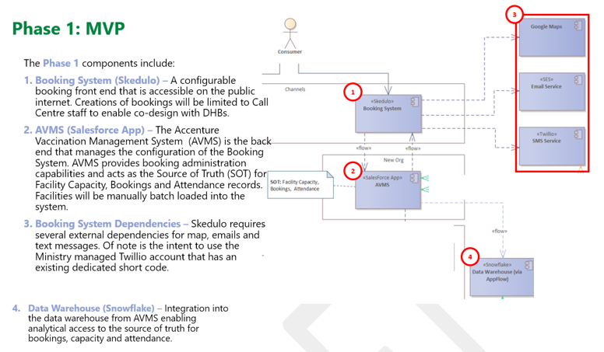

Consumer interaction with the Booking System

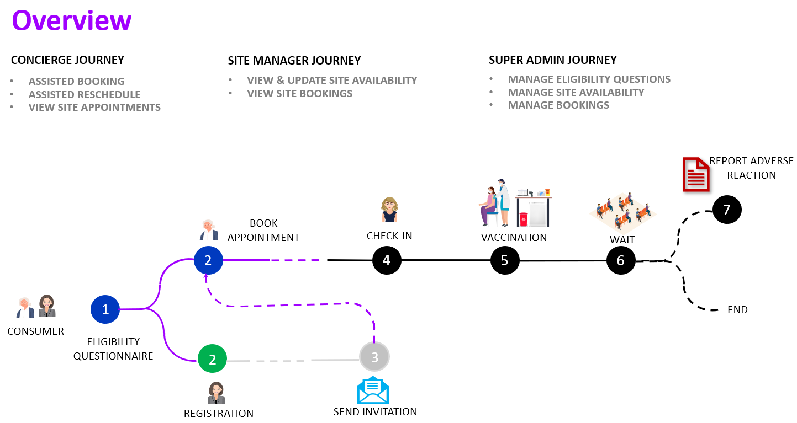

*Consumer information – collection processes*

1. During the First Phase a ‘call centre’ staff member will be able to receive calls from Consumers and use the webform to book them for two vaccination appointments (the current vaccination requires two injections).
   1. If the Consumer wishes to participate in the First Phase they will initiate the call, and the call centre staff will manage the booking process by asking the Consumer to provide relevant information and will fill in the Booking System details for the Consumer.
   2. The call centre staff will also be able to assist with rescheduling if a person has been unable to make changes themselves from the link in the confirmation email they receive.
2. All call centre staff are provided with Standard Operating Procedures and scripts to help them ensure each call covers the appropriate matters consistently (including the necessary privacy advice, as the collection will be over the phone without the Consumer being able to directly review the Privacy Statement during that process). This will continue to be updated as more sites roll out and wider experience is gathered.
   1. Eligibility questions are to be designed to minimise the personal information that must be disclosed to determine an eligibility category match.
   2. Consumers should be informed that participation in the Booking System (and vaccination process) is voluntary (and which information fields are optional if they do proceed).
3. Progressive cohorts of Consumers will soon be able to book themselves in via the Ministry [website](https://www.health.govt.nz/our-work/diseases-and-conditions/covid-19-novel-coronavirus/covid-19-vaccines/covid-19-getting-vaccine/covid-19-when-you-can-get-vaccine#where) for a vaccination appointment at a location convenient to them. Consumers will have access to the webform to submit their personal details (on an opt in basis) to enable either a booking to be made, or their contact details registered so they can be invited at a future date in the event that they are not currently eligible.
4. The Consumer will have access to a privacy screen page, within the webform, at the outset of the booking process. The wording is as follows:

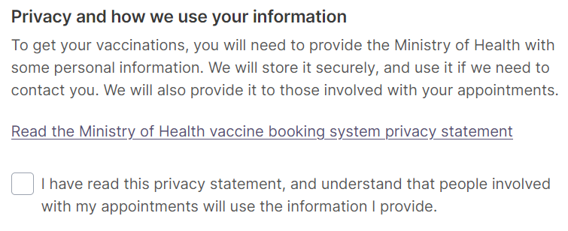

1. This screen contains a link to the full Privacy Statement – to be found [here](https://www.health.govt.nz/our-work/diseases-and-conditions/covid-19-novel-coronavirus/covid-19-vaccines/covid-19-getting-vaccine/covid-19-vaccine-and-your-privacy/covid-19-vaccine-booking-system-privacy-statement).
2. The webform is public facing, and anyone who discovered the URL would be able to enter a booking for themselves, and others, as soon as the Booking System goes ‘Live’. While the eligibility cohorts are Groups 1 to 3 a management plan has been put in place to make sure this can be managed, in the event that the webform becomes publicly known earlier than expected, through use of Access codes unique to each regional provider location.
   1. There is potential an ineligible person may book themselves an appointment without current entitlement to do so. The call centre staff, or Consumers, will have an additional access code that needs to be entered in the First Phase, and no booking will be able to be made from the webform without this access code.
      1. The management plan may also need to involve vaccinators if it is a concern if an ‘ineligible’ person receives an early vaccination. This will be managed by DHBs at each site. This will be under existing processes that are part of the vaccination processes rather than as part of the Booking System processes.
      2. It may be decided that someone ‘ineligible’ getting a vaccination early is not considered a particular risk – or the vaccination site may need to manage it directly and arrange to re-book the individual when they become Eligible.
   2. After the initial Phases (which are controlled by an access code), the public facing webform could be subject to false entries by people wishing to cause issues for the Vaccination Programme – although the number of screens that must be filled is likely to deter those who are not very determined, or have the relevant IT skills. There are capabilities in the software platform to create reports of suspicious activity for action by the Ministry.

*Concierge and Site Manager use for Booking System*

1. Providers will have administrative access to the Information entered onto the Booking System, which has set up appointment dates at the various vaccination event locations. This will enable them to prepare adequate resources to meet demand, and to manage the appointments as they fall due (also, in the rare case of an event having to be cancelled or postponed for unexpected occurrence, for example extreme weather etc this will enable communication with those booked).
2. Provider access to the Information stored within the Booking System by those working at the vaccination sites (or managing those sites) will be controlled by unique user login, and role based access with permissions for access set in accordance with the needs of that role.
3. The three Provider roles that can access the AVMS ‘back-end’ for the First Phase include:
   1. The Ministry super admin role – this is aligned to a standard administrative role and is not limited to one location. This role will be able to set up Site Managers. It will also enable features such as changing the eligibility questions etc. There will be a small number of these users.
   2. The site manager – the access fields will include all appointment details that correspond with the list of sites the Site Manager is responsible for. The Site Manager can set up new locations – and may set up ‘hidden’ locations that cannot be booked by Consumers directly through the Booking System but may be available to provide additional appointments if required.
   3. The concierge role (vaccination site user) – the access fields are limited by location to the venue the user is working at. The concierge will be able to see the appointments booked at that location for the specified dates, including the details submitted by the individual when making the booking.
4. All actions by each User will be tracked and can be audited.
5. A concierge is expected to operate at nominated vaccination sites to assist Consumers who are booked to attend a vaccination appointment (noting that some sites may not have sufficient staff or size to have a concierge role and the Site Manager may take on some of the service responsibilities).
6. The concierge role is to operate with Standard Operating Procedures to ensure that adequate advice about privacy concerns is available, and site management of privacy issues is consistently managed. It is noted that each site may need to amend the Procedures to meet some specific requirements, but the privacy aspects should generally remain consistent. In the Second Phase this role will may become redundant as most bookings will be able to matched directly to the CIR by Correlation ID. Site managers will be able to access AVMS to check up on any bookings that have not been NHI linked.

Information fields involved in the identification:

1. The Information to be collected via the Booking System in the First Phase to enable a booking to be created is set out below. This includes all information that will be collected, either:
   1. via the webform process managed by the call centre (where eligibility will already have been identified prior to commencing the booking process); or
   2. when the Consumer is (in a subsequent Phase) able to enter their own information directly via the webform.[11]

|  |  |  |
| --- | --- | --- |
| **Data** | **Mandatory / optional field for collection** | **Purpose / necessity** |
| Eligibility | Mandatory | Declaration that the Consumer falls into group currently eligible to receive vaccination (individual answers not being captured, just confirming the Consumer believes they are eligible) |
| Record date time and location of selected appointment | Mandatory | To enable booking to be made to match Consumer choice of date, time and location.  The site administrators will have created options for locations and appointment times into the Booking System and the Customer will match to times available that suit them. |
| Acknowledged Privacy Terms (in the First Phase this will be ‘ticked’ by the Call Centre operator after completing the privacy script delivery to the Consumer) | Mandatory | Privacy and authorisation |
| In the Second Phase there will be a requirement to confirm Consumer consent if authorised representative completes booking (and enters their name) | Mandatory if applicable | Privacy and authorisation |
| Name (First and Last) | Mandatory | To make booking, and identify relevant person at vaccination appointment |
| Date of Birth | Optional | To make booking, and identify relevant person at vaccination appointment |
| Gender | Optional | To assist with identification, by match to NHI number (once that capability is in place) |
| Either contact Email and / or contact mobile phone number | Mandatory | To enable confirmation of appointment to be sent electronically (and incorporate booking reference for future reference as well as link to Privacy Information) |
| Residential Address | Optional | To assist with identification, by match to NHI number (once that capability is in place) |

1. In the First Phase a site booking on the Skedulo webform can only be accessed via an access code (only available to call centre workers or authorised users working within a regional location). The Call Centre operators (or authorised users) name will not be recorded in the First Phase but in a subsequent phase, when the webform is open to the public there will be a field to collect the name (or call centre worker ID) along with that of any other third party completing the form for the Consumer.

## Appendix Six – Summary of review of Group 4 invitation dataset

1. The dataset used to invite Group Four (age banded general population invitations) included the National Enrolment Service (NES) dataset, and other health services users from the 2019 and 2020 year (as not all individuals choose to enrol on NES or are eligible to enrol, but all are able to be vaccinated if they choose).
   1. The Ministry removed individuals who had already been vaccinated (as registered on the CIR), had a booking on the Booking System, were deceased or had an overseas address.
   2. To enhance accuracy, rules were applied to the dataset to adopt the most recent contact details. The contact details will then prioritise NES contact details and finally NHI details from the recent HSU individuals who are not NES enrolled. This should provide the most recent contact details, reflect Consumer choice and reduce the risk of details being out of date.
2. The need to maximise vaccination numbers is further described below, leading to the Ministry decision to include personalised communications as a key part of its strategy to encourage vaccination.
3. CPIR created datasets for the invitations, and they were communicated in the following ways (by third parties acting as agents for the Ministry):
   1. The initial communication by letter telling individuals it is their turn to vaccinate. This was sent via NZ Post.
   2. At the time the letter is due to be received, a brief email and a text communication were also be sent (if those details were part of the dataset collected, or if the Consumer has previously registered their contact details on the Booking System).
      1. The email communication was sent via AWS SES – which enabled the email created by the Ministry to be communicated to the list of email addresses (no NHI included). No copy of this email was retained by the AWS system.
      2. The text was sent via Twilio. Twilio was required to securely delete the text list by the Ministry within 90 days after the communication had occurred.
4. The content of the communications sent is detailed in Appendix Seven. The email and SMS text communications contained identifiable details. The letter has the name and physical address of the person being invited – and as that was in a letter and sealed envelope format only the correct recipient is expected to open the letter invitation[12]. The envelope was to have a statement indicating ‘*For the intended recipient only’.*
5. The invitations assisted to manage resourcing as they progressed in age bands – to encourage those who are within the appropriate category to get vaccinated over different time frames.
6. The invitation dataset (for each age band cohort) was also matched against the CIR records (based on NHI) to identify if individuals were already vaccinated – and removed those Consumers from the invitation dataset (this was timed as close to the communications being sent as possible to minimise the potential for re-inviting those already part of the CIR vaccination processes).

**Summary of the processes for Group Four invitations:**

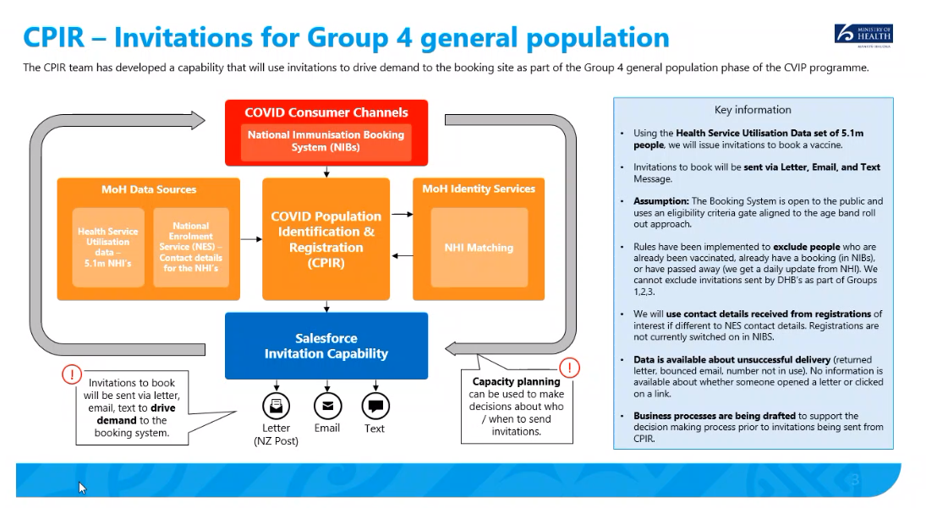

**Invitation dataset:**

The Ministry has prepared a dataset to provide invitations to Group 4 members. The Ministry will use the Health Service User (HSU) dataset. This contains information about those individuals who have had a contact point with the health systems reported to the Ministry in the previous two years.

**Need for wide national coverage**

The Ministry has notedthe research of Te Pūnaha Matatini (currently subject to formal peer review) released on [30 June 2021](https://cpb-ap-se2.wpmucdn.com/blogs.auckland.ac.nz/dist/d/75/files/2017/01/a-covid-19-vaccination-model-for-aotearoa-new-zealand.pdf)[13]

The report notes:

1. *We use a mathematical model to estimate the effect of New Zealand’s vaccine rollout on the potential spread and health impacts of COVID-19 and the implications for controlling border-related outbreaks.*

*2. The model can be used to estimate the theoretical population immunity threshold, which represents a point in the vaccination rollout at which we could relax border restrictions with few or no controls in place and see only small occasional outbreaks.*

*3. While there are significant uncertainties in 𝑅o for new variants, for a variant that would have 𝑅o = 4.5 with no public health measures (e.g. the Alpha variant), the population immunity threshold is estimated to require 83% of the population to be vaccinated under baseline vaccine effectiveness assumptions. For a variant with 𝑅o = 6.0 (e.g. the Delta variant), this would need to be 97%.*

*4. While coverage is below this threshold, relaxing controls completely would risk serious health impacts, including thousands of fatalities.*

*5. Whether or not New Zealand reaches a theoretical population immunity threshold, the higher vaccination coverage is, the more collective protection the population has against adverse health outcomes from COVID-19, and the easier it will become to control outbreaks’*

The desired vaccination threshold is therefore extremely high – and every vaccination opportunity will be important.

**Information collected:**

Only those details necessary for the invitation dataset will be collected into the dataset for use by the CPIR. The data will include demographics (age, date of birth, gender, ethnicity), geography (DHB of enrolment, and meshblock of last known address) and contact details from the National Enrolment Service (NES) Register where available (or NHI if not), including address, email address and phone number. Identifiers will include names and NHI. The source of the data is not included in the dataset to be hold in CPIR.

The information will be supplied on a single occasion. It will then be filtered to remove those who have been vaccinated, or have a current booking with the Ministry Booking System or who are deceased. Those with an overseas address are to be removed. Age band selected datasets will then be selected and sent to Consumers in relevant locations to invite Consumers for their vaccinations and their age bands fall due. The invitation process will ‘refresh’ with up-to-date NES contact details (where held) or details supplied by Consumers to the Booking System prior to the relevant invitations for the age band being sent.

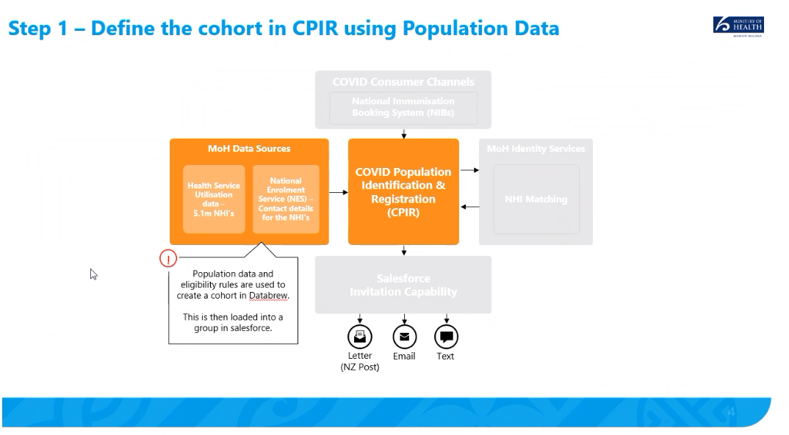

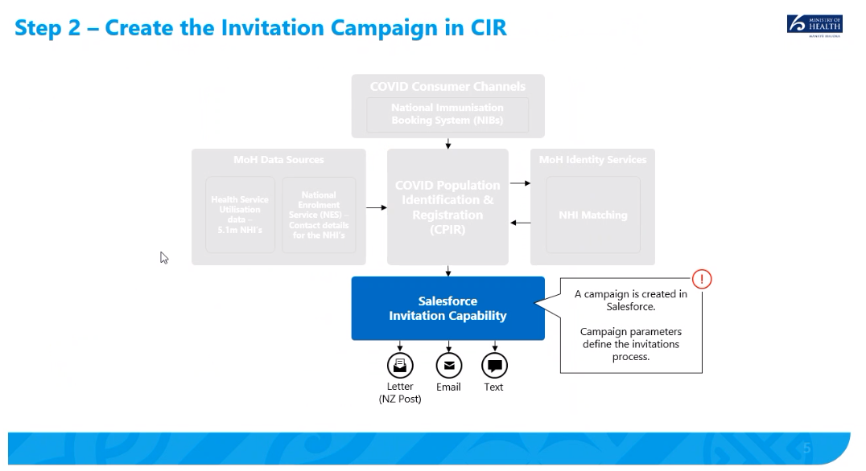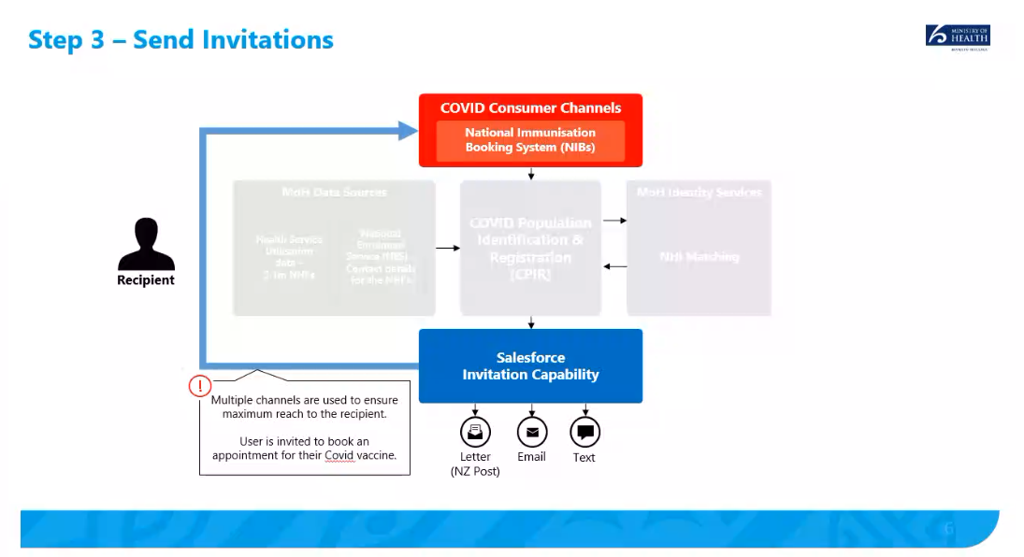

**How invitations will be sent:**

The contact details sourced from NES (or NHI for those who do not have a NES record) will be used to create outbound communications via up to three channels, to be sent directly to Consumers, via post and then text and email (if those details are held):

Post: The initial invitation sent to each Consumer in Group 4 will be by post. Post invitations will be triggered within the MoH environment and sent to an existing provider, NZ Post via an encrypted channel to create the letter and deliver mail on behalf of the Ministry. The data will contain identifiable information in the form of names, addresses and NHI numbers. NHI numbers are included to enable the person to provide this when they book their vaccine, easing the operational burden of NHI matching. The NZ Post processes include SmartMAIL. SmartMAIL is a file-based mail processing system, which works on a barcode system that is read by an intelligent inserting mail machine. The barcode is referenced back to a computer file giving much greater accuracy and integrity of insertion of letters into the envelopes. The envelope addressed to the individuals will advise: *For the intended recipient only.*

Email: Email invitations will be created internally within the MoH environment (via AWS Simple Email Service) and will be delivered to a Customer’s preferred email address sourced from NES or the Booking System. The content will not include NHI, to minimise any risks associated with incorrect email address for a recipient.

Text: SMS invitations will be triggered within the MoH environment and sent to an existing provider, Twilio via an encrypted channel to deliver on our behalf. The content will not include an individual’s NHI, to minimise any risks associated with incorrect SMS address for a recipient.

**Who will be able to access the information?**

The data will be stored in the existing secure NCTS environment. The only staff that will have access are in the COVID programme and have passed the MoH ‘Working with sensitive data’ training. Any access once this is loaded into CPIR will be restricted to the small number of individuals with RBAC access – and all access will be recorded. Any access to the information via Snowflake will be governed by the application approved by the Data Governance Group.

Those involved in the process of sending invitations will also be able to access the information for the purposes of performing related tasks.

**Summary of the Assessment for the Group Four dataset**

|  |  |  |
| --- | --- | --- |
| HIPC (in a nutshell) | | Privacy impact in relation to the use of HSU data to identify individuals to invite for COVID-19 Vaccination |
| Rule 1 | **Purpose of collection of health information**   * Only collect health information if you really need it | *The HSU information is lawfully held (performance of Ministry functions under the New Zealand Public Health and Disability Services Act)*  *The amount of the information to be collected for the purposes of the Booking System invitations is limited to that necessary (and as already established as appropriate fields in the Booking System PIA).*  *It is necessary to collect identifiable information to create and send the invitations.*  *The use of NES and NHI data is directly related to the purpose for collection (provision of and invitations for health care) and planning coordination and provision of health and disability.*  *The use of information from additional data sources in the HSU is to obtain the maximum number of people who could be invited to be vaccinated, including from those who are in hard to reach groups (and do not engage with NES, or are not eligible to do so).* |
| Rule 2 | **Source of health information**   * Get it straight from the people concerned | Rule 2 requires a health agency to collect health information directly from the individual concerned.  *It is not reasonably practicable in the circumstances of the urgent nation-wide roll out to collect information from individuals directly (rule 2(2)(d)) when the Ministry is not otherwise aware of their identity.* |
| Rule 3 | **Collection of health information from individual**   * Tell them what you’re going to do with it | *The Ministry is not collecting the information from the individuals concerned, and compliance is not reasonably practicable in the circumstances of this case (as per Rule 3(4)(b).*  *The information is already held by the Ministry.* |
| Rule 4 | **Manner of collection of health information**   * Be considerate when you’re getting it | Rule 4 addresses how information is collected.  *Comment:*  *No new information is being collected.* |
| Rule 5 | **Storage and security of health information**   * Take care of it once you’ve got it | Rule 5 requires health agencies to protect the information that they store appropriately.  *Comment:*  *The Ministry currently holds this information securely within its existing Ministry Data Warehouse systems and will securely transfer it to the Booking System in accordance with the security requirements applicable to that system.*  *Where the Ministry is using third parties to provide services it will implement necessary technical and operational security, for example: NZ Post is being used as the Ministry’s agent for the proposed mailout, information will be transferred securely to NZ Post. They will be expected to store it securely and delete it once agreed mailouts have been sent. Twilio will also be obliged to delete the information once the processes are completed (after 90 days). AWS will not retain any information.*  *The disclosure of the NHI to Consumers will be communicated only in the invitation letter (sealed with the envelope advising: For the intended recipient only). Email and text communications will not contain this detail in the initial communications as it has not been independently verified with the Consumer.* |
| Rule 6 | **Access to personal health information**   * People can see their health information if they want to | Rule 6 requires agencies that hold health information on an individual to disclose it to that individual at their request.  *Comment:*  *Existing processes for access to data held by the Ministry apply.* |
| Rule 7 | **Correction of health information**   * They can correct it if it’s wrong | Rule 7 requires agencies to allow individuals to request the correction of health information and to request that information be attached to indicate that it is wrong if a dispute is not resolved if the individual so wishes.  *Comment: Individuals are able to request that their contact details used in the invitation are updated by emailing or calling the Covid Vaccination helpline on 0800 28 29 26 or by emailing booking@vaccine.covid19.health.nz*  *If we have incorrect details, people will not receive their invitations. The way that these people will be engaged in the Vaccination programme is through other public media campaigns.* |
| Rule 8 | **Accuracy etc. of health information to be checked before use**   * Make sure health information is correct before you use it | *Rules will be applied to the dataset to adopt the most recent contact details, including contact details from the individual if they have input them into the Booking System, then NES contact details and finally NHI details from the recent HSU individuals who are not NES enrolled). This should provide the most recent contact details and reduce the risk of details being out of date.*  *The operational design should seek to minimise the use of contact details where accuracy cannot be verified. This is a primary mechanism for reducing the chances of privacy breaches through use of this data.*  *There are identified risks that information may inadvertently go to the wrong person (due to the large volume of communications, the potential for errors in the source systems and movement of people and changes to contact details). Mitigations include:*   * *not including any personal information with emails or texts other than first names, and* * *the initial communication will be by post (and that will contain the persons identifiable details to make the invitation personal to encourage participation in the vaccination processes). It is not legal to open a postal communication addressed to another person.*   *Any privacy breaches will be managed by the Ministry breach process in accordance with the requirements of the Privacy Act 2020 processes.* |
| Rule 9 | **Retention of health information**   * Get rid of it when you’re done with it | *The version of the HSU securely retained in CPIR until the Vaccination Program completes in December 2021*  *NZ Post will delete data supplied to them for this purpose within 30 days.*  *AWS does not store the information as it is transactional.*  *Twilio provides a number of services to the Ministry, all of which operate under the same set of rules. A destruction time frame will be agreed for the Twilio dataset – it is anticipated that this will be 90 days as some of the Twilio services will require a response from a Consumer (although not the invitations service) and if the original message is not retained this cannot be managed.* |
| Rule 10 | **Limits on use of health information**   * Use it for the purpose you got it | *Rule 10 limits the way in which an agency can use information collected for one purpose for an alternative purpose.*  *In terms of use of the information NES data is able to be used to support vaccination invitations as it is directly related to the purpose for collection. NHI data is able to be used as the purpose of the NHI is to help with the planning, coordination and provision of health and disability support services across New Zealand. Any information from CIR* ***(****to identify those already vaccinated)**is also within this category*.  *Other information from the HSU dataset held by the Ministry will be used within the serious threat exemption provisions of Rule 10(d)(i) collected due to the need to increase the vaccination rates of the New Zealand population (including the 16 to 25 year olds, and those of Maori ethnicity, who are less likely to engage with the NES)*. |
| Rule 11 | **Limits on disclosure of health information**  Only disclose it if you have good reason | This rule limits how an agency can disclose information about an individual.  *Comment:*  *The Ministry is re-using information it holds already and will disclose those details directly to the person themselves (as per Rule 11(1)(a)).*  *Pursuant to section 11 of the Privacy Act the Ministry agents (NZ Post, AWS and Twilio) will hold the information only for the purposes of processing the information and hold the information only on behalf of the Ministry and will not use the information for their own purposes*. |
| Rule 12 | **Disclosure of health information outside New Zealand**   * Only disclose to countries with privacy law similar to NZ | This rule limits disclosure to a foreign person or entity.  *Comment:*  *No information is being disclosed to any overseas entity as part of this work* |
| Rule 13 | **Unique identifiers**   * Only assign unique identifiers where permitted | Rule 13 limits the way in which an organisation can assign unique identifiers for use with other agencies.  *Comment:*  *There will be no change to the use of identifiers.* |

## Appendix Seven – Invitation communication templates

The invitation communications directed people to a Book My Vaccine landing page:

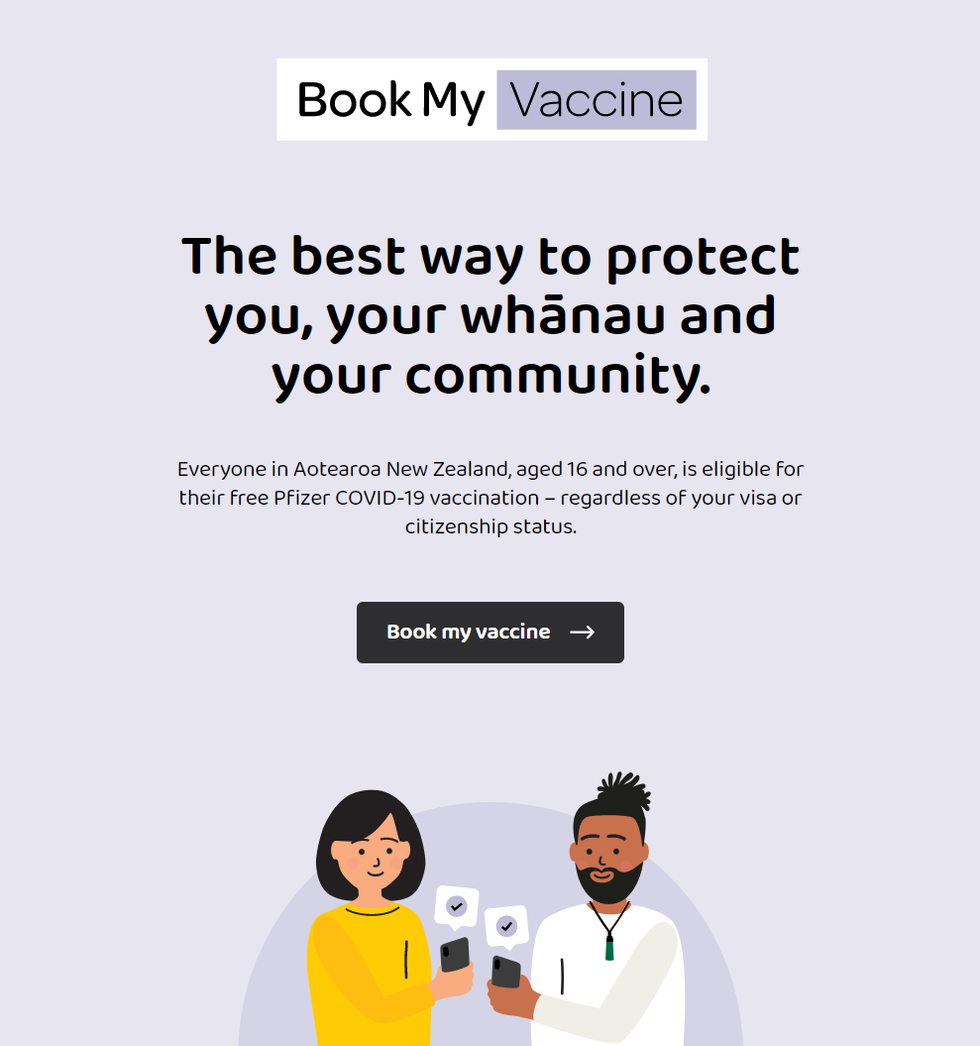

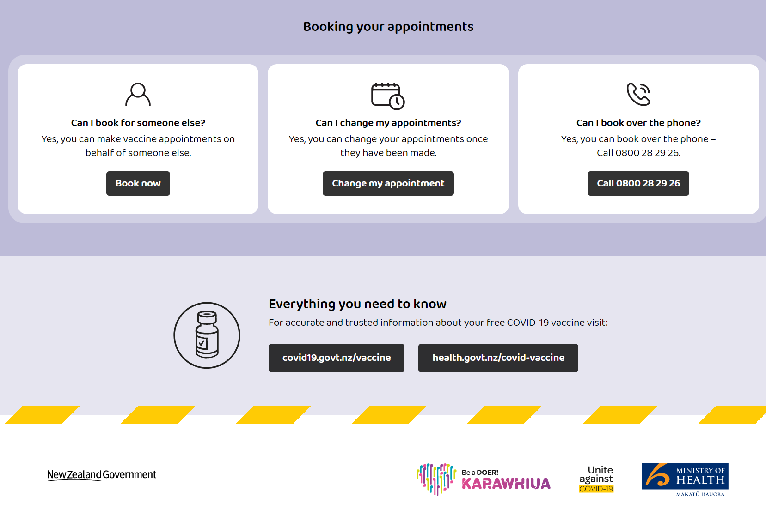

**Invitation Letter**

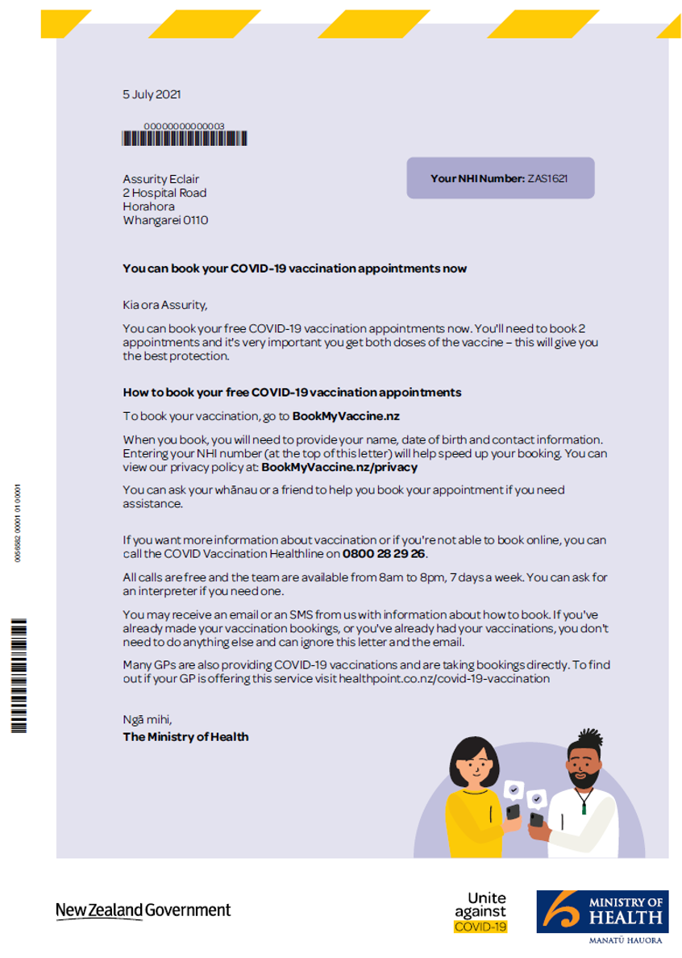

**Envelope**

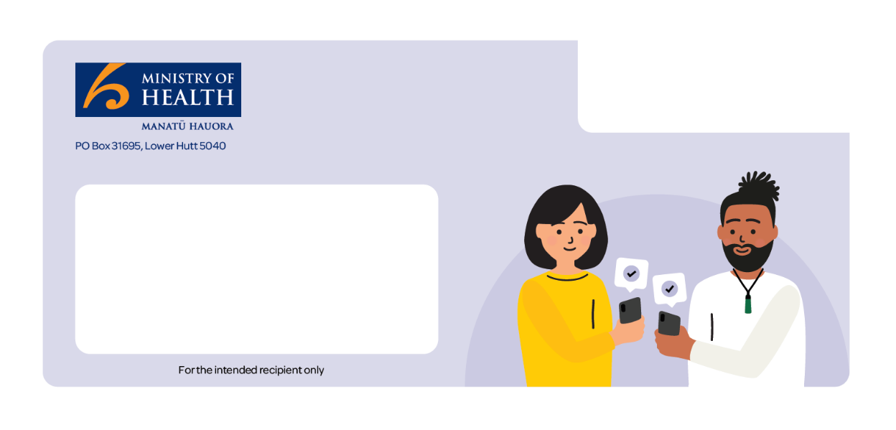

As all Consumers in New Zealand were invited to participate in the COVID-19 Vaccination Programme there was not the same need to hide the nature of the communication as the invitations were essentially going to everyone. For security, and to add confidence to Consumers when receiving one of these communications, it was determined that an accessible and friendly communication ‘package’ response will be sent (starting with the envelope) so that it is clear that it comes from a trusted Ministry source.

**SMS Invitation**

The SMS contained ‘Kia Ora’ and the person’s first name on the first line.

The content was: To book your free COVID-19 vaccine now, go to: **bookmyvaccine.nz** or phone **0800 28 29 26** free of charge

It had ‘Ministry of Health’ at the base of the text.

**Email Invitation**

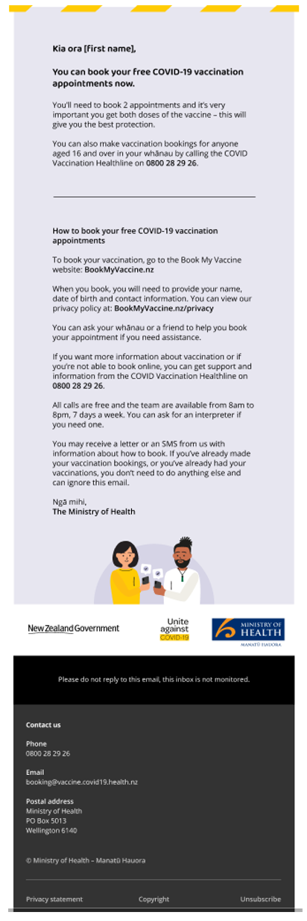

**Privacy Screen on Booking System**



1. CPIR as a text communication tool for NCTS is addressed in a separate Privacy Impact Assessment summarising its use as the mechanism to text Cases and Household Contacts (and formerly Close Contacts)
2. This number of maximum attendees may be increased in future.
3. These processes are addressed in a separate PIA for CPIR and NCTS texting processes.
4. Group Four was the largest group and invitations progressed in age bands – starting on 28 July 2021 <https://covid19.govt.nz/covid-19-vaccines/how-to-get-a-covid-19-vaccination/booking-your-vaccination-appointments/>
5. As many of the following fields as are provided by the Consumer: First name, Last name, Date of birth, Middle names, Preferred First Name, Preferred Last Name, Address, NHI number, Gender, Ethnicity, Email address, Mobile number, Booking flag
6. In contrast to the verified NHI supplied if the automatic link from My Covid Record is used.
7. The ‘score’ is based on how closely the fields submitted match the fields held on the NHI (different fields are weighted on perceived reliability).
8. CIR is recognised as a ‘high trust’ record where checking processes will be applied with the Consumer in person. The Booking System records, due to their unverified nature are not considered equally high trust.
9. As noted in the First Phase PIA ‘*It is important that the Data Governance requirements for this Information are recognised, and that this is not treated as an additional data set with multiple uses. It is also noted that this is ‘low trust’ data, as it has not been verified, and users of the information must remain aware of this relatively low level of reliability during the First Phase in particular.’*
10. This does not fully describe all manual matching activities, which have been further described at paragraph 22 above.
11. Note that the Table below applied to the First Phase of the Booking System and has been superseded by the Third Phase Privacy Impact Assessment Table
12. Under the Postal Services Act 1998 s23 it is an offence to willfully and without reasonable excuse open or cause to be opened any postal article that is not addressed to the person. An offence against this provision is liable on conviction to imprisonment for not more than 6 months or a fine of not more than $5,000.
13. <https://cpb-ap-se2.wpmucdn.com/blogs.auckland.ac.nz/dist/d/75/files/2017/01/a-covid-19-vaccination-model-for-aotearoa-new-zealand.pdf>