COVID-19 Instructions on specimen collection

REVIEWED 12 MAY 2021

This document provides information on how to take nasopharyngeal, and oropharyngeal + anterior nasal specimens for COVID-19.

A nasopharyngeal swab (use swabs with flexible shafts) placed into a viral transport media (VTM) will obtain the optimal specimen and is the preferred collection method for both symptomatic and asymptomatic testing due to its higher sensitivity in detecting the virus.

An oropharyngeal with an anterior nasal swab (use swabs with more rigid shafts) may be considered for the following:

For border and managed isolation and quarantine facility workers undergoing high frequency swabbing (fortnightly and in some cases weekly) who do not tolerate the nasopharyngeal swab.
- Health practitioners may also request the alternate swab if someone is experiencing problems receiving the nasopharyngeal swab.
The swab manufacturer may vary by region – please consult with your local pathology provider as to which swab type to use.
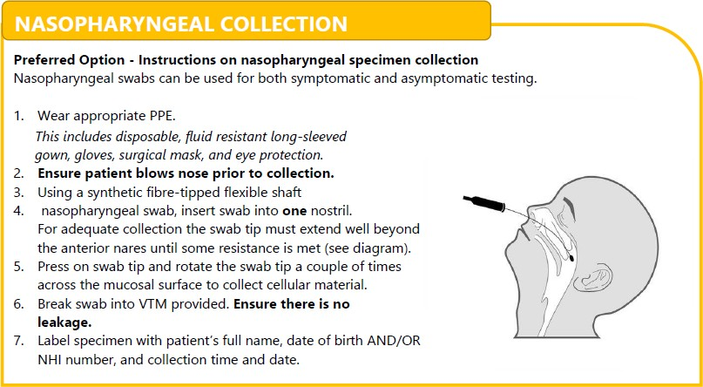

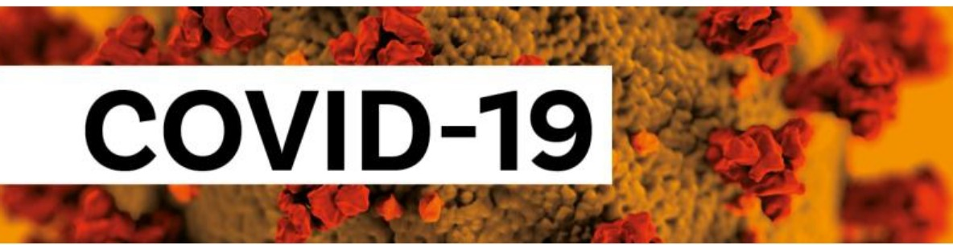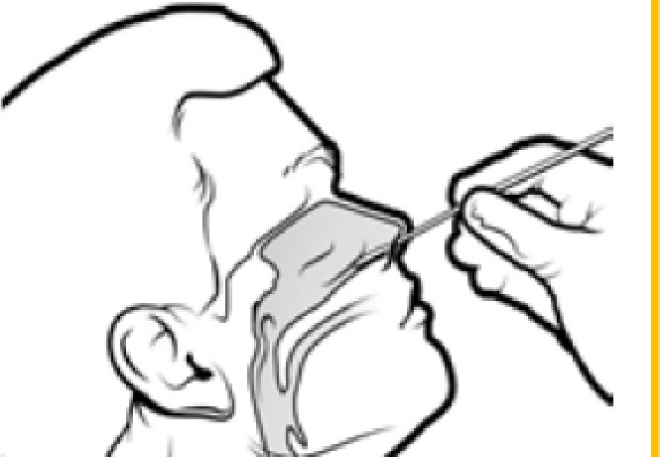OROPHARVNG'EAL {THROAT) and ANTERIOR NASAL

MI N I STRY OF
HEALTH
MANA.TU HAUORA
NewZealand Government
Alte rnative option - Inst r u ctions on oropharyngeal and nasal sp ecimen collecti on.
Oro pha ry ng ea ll a ndl d ee p nasal swabs can be used fo r bo th sympto matic and asym pto ma tic tes t ing.
Oro p ha ry ng ea ll specimens ₀₁₁ t he i r own sho ulld not be talke n if t he re are no sympto ms as they are u nlli ke ly to co llllec t a n adequate amo unt of vi rus.

  - Wear a ppro p ria t e PPE.
This includes disposable, fl.uid resistant long -sleeved gown, gloves , surgical mask, and eye protection.
  - En su re pat ient blows n ose pr,i or to collectio n.
  - Use a tongue depre sso r to ho ld the t o ng ue o ut of the way
  - Us ing a viral o ropha ryngea l swab (DO NOT use
sta nd a rd bacte ria l swabs), swab bo th tonsill ar beds
and the back of the t h roat.
  - Using , t h e :SAM E swab, inse rt i nto one no stri l unt il t he floc lked tip is no lo nge r vis ib le and ro tate a few times . Repea t for the ot her no st i l.
  - De pe nd ing o n reg io na l s upp ly, e it he r break swab
i nto VTM provid ed ( Ens ure there is no leakage) o r place swab ba ck i nto ba rrel co nta i n i ng the foa m VTM.
  - Labe l spe ci me n wit h patient's f u ll name , da te of bi rth AND / OR
  - N IH I nu mbe r, and oolllect io n t ime and da t e.
I \
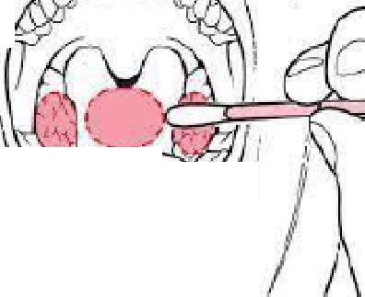
I

'
\\ 1/

