Temporary Exemption for Signatures on Prescriptions without NZePS (without an NZePS barcode)
For other community and hospital prescribers that do not use a system that can integrate with NZePS, the Director-General of Health authorised an alternative form of prescription that is not signed personally by a prescriber with their usual signature if they meet certain conditions, ensuring easy identification of the authorised prescriber and the healthcare facility. Many clinicians may be working away from their normal places of work and lack the equipment needed to print and scan or fax a signed prescription to a pharmacy. The “Director-General authorisation of an alternative form of prescription pursuant to regulation 43 of the Medicines Regulations 1984”, will expire on the 31 October 2024.

This temporary authorisation recognises prescriptions not signed personally by a prescriber with their usual signature as legal when all of the following conditions are met:
- the prescription is generated by an electronic system and requires the prescriber to log on with a unique ID and password;
- the prescription does not include Controlled Drugs (Class A, B or C) but can include a Class C exempted or partially exempted controlled drug as defined by the Misuse of Drugs Act 1975. Prescriptions with a Controlled Drug will continue to require an original wet ink prescriber signature. See Appendix 3 for the list of Class C Controlled Drugs. The classification for these Class C controlled drugs are also available on the NZ Formulary.
- the prescription includes all of the following:
  - the prescriber’s registration authority number (e.g. MCNZ) that uniquely identifies the prescriber;
  - the contact details of the prescriber to enable the pharmacy to contact the prescriber to verify identify or request amendments to the prescription; and
  - the following statement “This Prescription meets the requirement of the Director-General of Health’s authorisation of October 2022 for prescriptions not signed personally by a prescriber with their usual signature”.
- the prescription must be in a format that cannot be easily altered by anyone other than the prescriber (e.g. PDF, photograph);
- the prescription must be sent directly to the community pharmacy using a secure, electronic system to send that identifies the prescriber’s name and facility. The following would satisfy this requirement:
  - a secure email system that identifies the prescriber and the healthcare facility through its email address. A secure email is defined in the Secure Digital Communications within the NZ Health & Disability advisory from June 2019:
https://www.health.govt.nz/system/files/documents/publications/joint-acc-moh-advice-on-securing-email-and-fax-jun2019.pdf
  - a secure clinical communication system that links prescriber and pharmacies such as the Electronic Request Management System.
  - a fax from a number that is recognised by the pharmacy as a valid prescriber
- the electronic prescription is kept on and submitted as required by the Integrated Community Pharmacy Services Agreement (ICPSA) as a criterion for payment.
If amendments are required to the prescription, it is the prescribers’ responsibility to contact the pharmacy to check if the prescription has been dispensed, instruct the pharmacy to cancel the prescription and to send the pharmacy an amended prescription. Pharmacy must maintain a copy of the cancelled prescription and the amended prescription.
It is also a prescriber’s (not a pharmacy’s) responsibility to ensure that they only use this authorised alternative form of prescription (signature exempt) if their system is not technically capable of integrating with the NZePS.
This temporary authorisation does not affect NZePS Prescriptions (with barcode). The ability to generate signature exempt prescriptions when NZePS is used is an enduring capability subject to requirements detailed in Appendix 2 being met.

Except where a prescription contains one or more Class A, B or C controlled drugs (except Class C exempt or partially exempt controlled drugs), this Director-General authorisation of an alternative form of prescription pursuant to regulation 43 of the Medicines Regulations 1984) means that the following arrangements apply until the 31October 2024:

- Pharmacies do not need to obtain original copies of non-NZePS faxed/emailed prescriptions if the following conditions are met:
  - each faxed prescription must otherwise be fully compliant with regulation 41 of the Medicines Regulations 1984; and
  - the prescription must meet the requirements of the authorisation (see Appendix 1)
- Pharmacies do not need to match telephone or pharmacy generated prescriptions with a prescription signed by a general practitioner to claim for the dispensing if the following conditions are met:
  - an electronic medication chart is used by the ARC facility, GP and pharmacy for prescribing, dispensing and administration;
  - a telephone or pharmacy generated prescription is generated that matches the medication chart; and
  - the telephone or pharmacy generated prescription is attached to the medication chart and is kept and submitted as required by the Integrated Community Pharmacy Services Agreement (ICPSA).
Vendors and organisations that wish to integrate with the NZePS can contact onlinehelpdesk@health.govt.nz with “NZePS Integration” in the subject line.

Appendix 1
Example of a correctly written non-NZePS prescription:
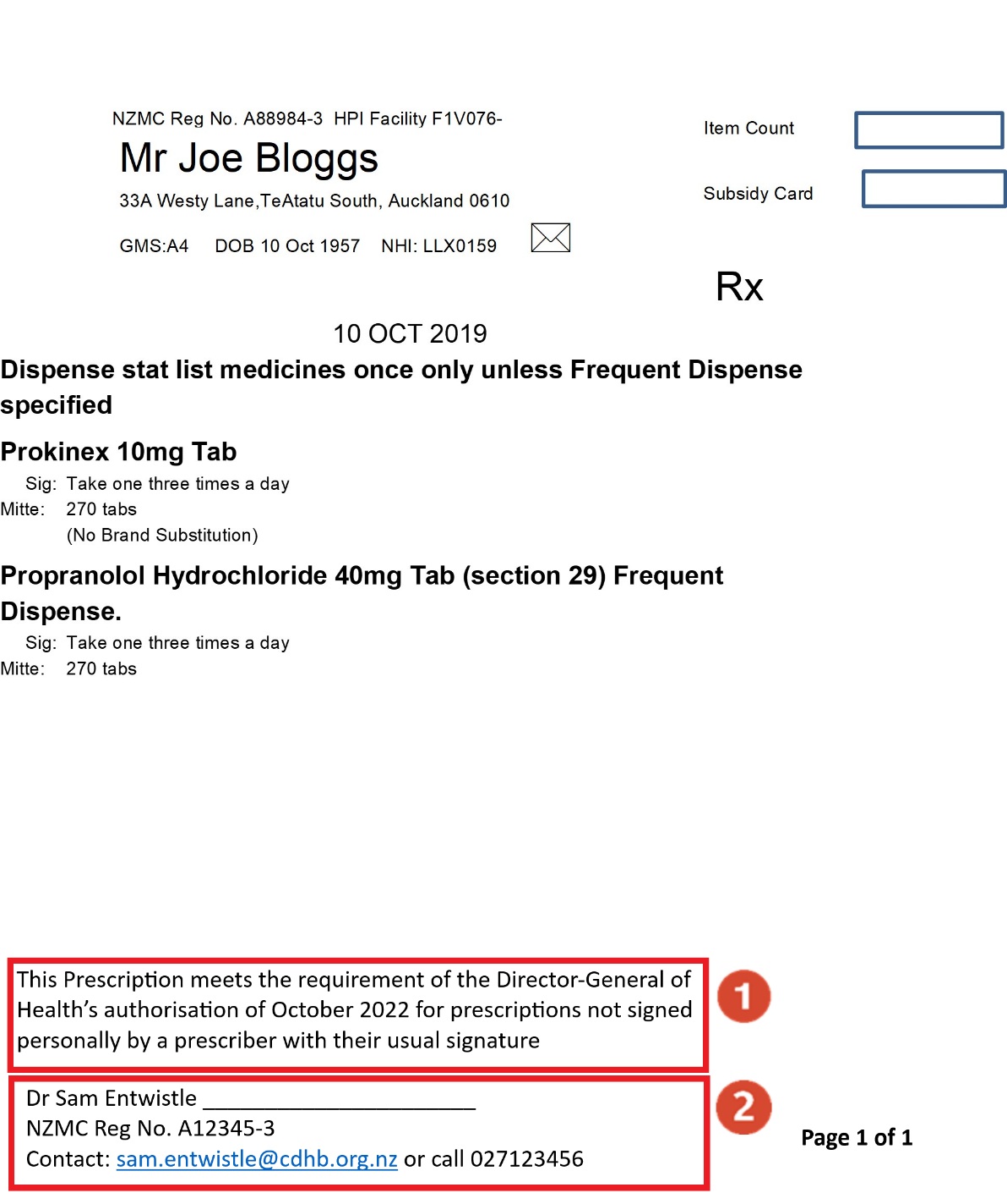

On electronic prescriptions without a barcode there must be a statement that reads “This Prescription meets the requirement of the Director-General of Health’s authorisation of October 2022 for prescriptions not signed personally by a prescriber with their usual signature”
The prescription must also have:
- The registration authority number of the Prescriber (e.g. NZMC)
- The contact details of the prescriber.

If you have any questions about electronic prescribing, please visit the Ministry’s website: https://www.health.govt.nz/our-work/digital-health/other-digital-health-initiatives/emedicines/new-zealand-eprescription-service/signature-exempt-prescriptions-and-remote-prescribing

Appendix 2

Signature Exempt Prescriptions using NZePS (with barcode)
A current Director-General of Health authorisation of an alternative form of prescription under the Medicines Regulations 1984 allows unsigned prescriptions if all of the following conditions are met:
- the prescription does not include Controlled Drugs (Class A, B or C) but can include Class C exempted or partially exempted controlled drugs as defined by the Misuse of Drugs Act 1975.
- the prescription is a NZePS barcoded prescription.
- the system that generates the prescription has been authorised by the Ministry of Health for electronic prescribing.
- At the community pharmacy the barcode is used (e.g. scanned or manually entered) at the point of dispensing.
Being able to prescribe using NZePS is a requirement for this authorisation to apply. This ensures:
- prescriptions can only be dispensed once and the electronic prescription when downloaded aligns with the medication details on the paper prescription.
- prescribers can be notified when medicines are not dispensed in a set number of days to monitor adherence.
- data quality of the community dispensed medication list, which is used by several hospitals for medicines reconciliation, is improved as prescriptions can be matched with the dispensing records.
- The ability to electronically prescribe medications without the need for signatures supports innovative care approaches, such as virtual consultations.
The Ministry has worked with the prescribing system vendors to develop a way for prescribers to generate electronic scripts that can be sent directly from the GP to a pharmacy. The following systems have now been approved to use this approach:
- Medtech 32 and Medtech Evolution
- MyPractice
- Indici
- Medimap
- Profile for Windows
- Pulse (MedOnline)
- Elixir Medical Software
- Waikato DHB Clinical Workstation
- Expect (Maternity Software)
- TrakCare
Signature Exempt NZePS Prescriptions will have an NZePs barcode. Some may have the text “Signature Exempt” on the signature line, and others may not. But the presence of the NZePS barcode that can be used at the point of dispensing is the definitive sign that a prescription meets the requirement for being signature exempt.

Examples of correctly written NZePS prescriptions:

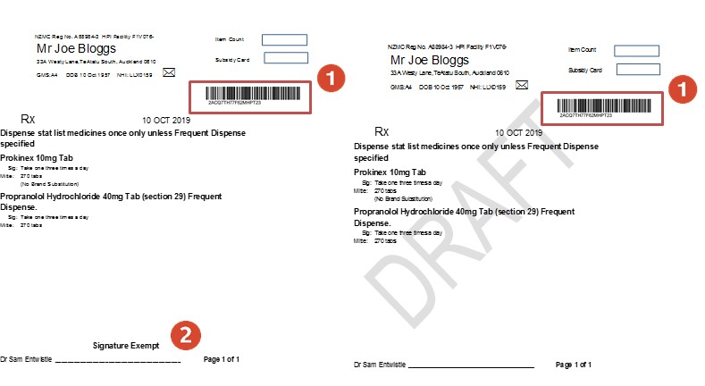

The electronic prescription has an NZePS barcode which is scanned or manually entered at the pharmacy. This barcode may be either on the top of the prescription or the bottom.
On some electronic prescriptions, a label for “Signature Exempt” may appear on the signature line. Even if this label is not present, this prescription may still be legal.

If you are not already on NZePS or have any questions about joining, please contact the Ministry’s Online Helpdesk (onlinehelpdesk@health.govt.nz) including NZePS in the subject line to ensure a timely response.

Appendix 3 Class C Controlled Drugs

Class C controlled drugs (NOT exempt or partially exempt)

Prescriptions for the following list of medicines require the prescriber wet ink signature and the original prescription sent to the pharmacy (Misuse of Drugs Regulations 1977).

Class C Controlled Drugs (except Class C5)
Generic name | Brand and form | Strength available
Buprenorphine | Buprenorphine Naloxone BNM sublingual tablet | 2 mg with naloxone 0.5 mg  8 mg with naloxone 2 mg
Codeine | Tablet | 15 mg, 30 mg, 60 mg
Dihydrocodeine | DHC Continus long-acting tablet | 60 mg
Phenobarbitone | Tablet  Max Health injection  Aspen injection | 15 mg, 30mg  200 mg/mL  200 mg/mL
Benzodiazepines (Class C5 Controlled Drug)
Generic name | Brand and form | Strength available
Alprazolam | Xanax tablet  Arrow-Alprazolam tablet | 250 microgram,  500 microgram, 1 mg  250 microgram,  500 microgram, 1 mg, 2 mg
Clobazam | Frisium tablet | 10 mg
Clonazepam | Paxam tablet  Rivotril oral drops  Rivotril injection | 500 microgram, 2 mg  2.5 mg/mL  1 mg/mL
Diazepam | Arrow-Diazepam tablet  Stesolid rectal tube  Hospira injection | 2 mg, 5 mg  5 mg, 10 mg  5 mg/mL
Lorazepam | Ativan tablet | 1 mg, 2.5 mg
Midazolam | Midazolam-Claris injection  Pfizer injection | 1 mg/mL, 5 mg/mL  1 mg/mL, 5 mg/mL
Nitrazepam | Nitrados tablet | 5 mg
Oxazepam | Ox-Pam tablet | 10 mg, 15 mg
Phentermine | Duromine capsule  Metermine capsule | 15 mg, 30 mg  15 mg, 30 mg
Temazepam | Normison tablet | 10 mg
Triazolam | Hypam tablet | 125 microgram,  250 microgram

Class C controlled drugs (that ARE exempt or partially exempt)

Prescriptions for the following list of medicines DO NOT require the prescriber wet ink signature and original prescription sent to the pharmacy (Misuse of Drugs Regulations 1977).

Class C (exempt and partially exempt) C controlled drugs
Gee’s Linctus
Paracetamol and codeine combination preparations
Pholcodine

