Assisted dying
care pathways for health practitioners
Supporting  information guide | September 2021

This guide is designed to support health practitioners’ understanding
of their role in responding to a person
who raises assisted dying or in providing
assisted dying services.

The Ministry of Health will be responsible for the End of Life Choice Act 2019
(the Act) and has a work programme underway to implement and oversee the assisted dying service. Assisted dying will be legal in New Zealand from 7 November 2021. More information on this work can be found on the Ministry’s website.

You can find the Act in full on the New Zealand Legislation website.

Section 1:
Care pathways for assisted dying
There are three care pathways for assisted dying services to reflect that while a person may raise assisted dying with any health practitioner, not all health practitioners will provide these services. These care pathways provide an overview of the process followed when a person raises the topic of assisted dying, or chooses to access the assisted dying service.

- For medical practitioners who do not provide assisted dying services for reasons of conscientious objection or as they do not have the appropriate skills or experience (reasons of competency).
- For health practitioners (not including medical practitioners) who cannot provide assisted dying services.
- For medical and nurse practitioners who will provide assisted dying services.

Objectives of the care pathways
All three care pathways aim to ensure that assisted dying services are provided in a person- and whānau-centred approach, which focusses on what matters from the perspectives of the person and their whānau at each step of the process.

A person- and whānau-centred approach means that a person and their whānau are heard, information is provided in a way that is understood by a person and their whānau, and the person is empowered to self-determine. Choosing assisted dying is the person’s choice.

Health practitioners should also consider any additional support a person may need throughout these care pathways based on their individual circumstances, such as for a person with complex, disability or social support needs.

The objectives of the care pathways include:
- robust accountability and safety measures
- timely access to appropriate information (verbal, written, accessible formats, translations)
- equitable access and service delivery
- continuity of care throughout the care pathway
- consistency with health and disability system legislation and strategies,
including standards of care, codes of conduct, evidenced best practice and
Te Tiriti o Waitangi.

Definitions of terms used
Term | Definition
Assisted dying | The administration by an attending medical practitioner or an attending nurse practitioner of medication to a person to relieve the person’s suffering by hastening death; or the self-administration by the person of medication to relieve their suffering by hastening death
Attending medical practitioner (AMP) | The medical practitioner who provides end-to-end care throughout the assisted dying service, including carrying out the first eligibility assessment and preparing and administering the medication for assisted dying
Attending nurse practitioner (ANP) | The nurse practitioner who administers the medication for assisted dying (under the instruction of the attending medical practitioner)
Health practitioner | A health professional who is registered and holds a practising certificate in line with the Health Practitioners Competence Assurance Act 2003
Independent medical practitioner (IMP) | The medical practitioner who provides the second eligibility assessment (the SCENZ Group provides the IMP – see below)
Medical practitioner | A doctor who is registered with the Medical Council of New Zealand and holds a practising certificate
Nurse practitioner | A practitioner who has advanced education, clinical training and the demonstrated competence and legal authority to practise beyond the level of a registered nurse
Person | The person who has requested assisted dying
Psychiatrist | A medical practitioner with a specialty in psychiatry, who may perform a competency assessment as part of the assisted dying process, if required (the SCENZ Group provides the psychiatrist – see below)
Request for assisted dying | The clear request that a person would like to start the assisted dying process, noting that they may have already had some conversations before making this request
Support and Consultation for End of Life in New Zealand Group (SCENZ Group) | The statutory body for the assisted dying service that is responsible for maintaining lists of practitioners who are willing to provide assisted dying services, as well as providing practical help in relation to assisted dying

Role of health and disability
service providers
All health and disability service providers may care for or support people who choose to access assisted dying services. Service providers should have appropriate policies and procedures in place to support staff in situations where a person in the service provider’s care asks for information about or access to assisted dying services. These policies or procedures may vary between service providers based on the the service provider’s level of involvement in assisted dying services.

Service providers should also encourage staff to complete training provided by the Ministry of Health, and provide additional guidance and support, where appropriate. This may include group discussions or debrief sessions, as well as access to pastoral or wellbeing support, such as Employee Assistance Programmes.

For more information that supports health service providers to prepare and create appropriate policies and procedures, see the ‘Preparing for assisted dying services’ and ‘Policy guidance for assisted dying services’ information sheets found on the Ministry’s website.

Workforce training and support
All health practitioners, regardless of their involvement in assisted dying services, should complete appropriate training to ensure they understand their legal obligations under the Act and to enable them to fulfil their duty of care to the person. This includes being prepared to respond to a person who may raise assisted dying with them in a respectful and helpful manner, including knowing where to direct a person who wishes to access this service.

The Ministry of Health has created a number of learning and guidance resources to support practitioners. All of these resources are available through LearnOnline.

Ministry of Health resources include:
- e-learning modules about assisted dying services (these can be completed by individuals, or as a group as part of an information and discussion session)
- webinars about the implementation of assisted dying services
- information sheets for health practitioners.

Medical and nurse practitioners who provide assisted dying services and wish to access funding under the fee-for-service model must complete certain additional training in order to claim funding. More information can be found on the Ministry’s website.

Responsiveness to Māori through the care pathways
Health practitioners should follow the steps in the care pathways in a way that adheres to Te Tiriti o Waitangi and that allows for self-determination and the consideration of options for Māori.

Applying the articles and principles, as articulated by the Ministry of Health’s Te Tiriti o Waitangi Framework, enables Māori to express their mana, ensure they receive high-quality, culturally appropriate and safe services, and supports health practitioners to work effectively and respectfully with Māori.

Māori should be given the opportunity to self-determine their involvement in the assisted dying service, with the practitioner able to support Māori in their aspirations, whatever they are (that is recognising mana motuhake). This includes understanding a Māori worldview of health and supporting Māori and whānau to identify their own pae ora outcomes.

In particular, health practitioners should consider what good quality end of life care looks like for Māori. Health practitioners may want to refer to Mauri Mate: A Māori Palliative Care Framework for Hospices and Te Ipu Aronui.

Health practitioners are encouraged to follow evidence-based consultation practices for Māori and whānau Māori, such as the Meihana model (developed by the University of Otago).

The Meihana model builds on the holistic Māori health model, Te Whare Tapa Wha. Following the Meihana model encourages a person- and whānau-centric approach that takes into account a person’s cultural and spiritual identity, as well as their clinical and wellbeing needs.

The model can be used from the first contact with a person and their whānau to provide a comprehensive understanding of the whānau circumstances and how a person fits within this.

Health practitioners who would benefit from support or guidance in achieving greater responsiveness to Māori should refer to the general guidance from their professional association.
- Medical Council of New Zealand:
He Ara Hauora Māori: A Pathway to Māori Health Equity.
- Nursing Council of New Zealand:
Guidelines for Cultural Safety, Te Tiriti o Waitangi, and Māori Health.
- Pharmacy Council of New Zealand:
Statement on Cultural Competency.

Section 2:
Overarching concepts
in the care pathways
Each care pathway has overarching concepts that are present throughout. These are described below.

Cultural and spiritual support
Health practitioners should engage with people in a culturally appropriate way as it is important that the person and their whānau feel culturally safe. This includes understanding and considering needs specific to the person’s culture and identity, such as needs related to religious beliefs and te ao Māori tikanga (eg, kawa, blessing of rooms, rākau rongoā, mirimiri, karakia).

Supporting and allowing space for a person’s cultural and spiritual needs is particularly important when caring for someone at the end of their life. Health practitioners should be responsive to these needs and encourage and support a person in what is important to them.

Health practitioners who would benefit from support or guidance in cultural safety should refer to the general guidance from their professional association.
- Medical Council of New Zealand:
Statement on Cultural Safety.
- Nursing Council of New Zealand:
Guidelines for Cultural Safety, Te Tiriti o Waitangi, and Māori Health.
- Pharmacy Council of New Zealand:
Statement on Cultural Competency.

Involvement of whānau
Health practitioners should encourage a person wishing to choose assisted dying to discuss this with whānau and ensure there is opportunity for the patient to do so.​ ​If a person chooses to involve their whānau, it is important that the whānau is included and able to play an active role throughout the process in supporting the person. ​

Whānau may mean different things for a person. Whānau may be a person’s close family and may also include a person's extended family and whānau, their partners, friends, or other representatives chosen by the person. The involved whānau could be one person or many people.

Note: Choosing assisted dying is the person's choice only. They do not have to discuss it with their whānau if they don't want to, and they should be made aware of this.

Optimisation of end of life care
Assisted dying does not replace the care a person is already getting. Instead, it provides another option in some circumstances. If a person chooses to access assisted dying services, this option will most likely be in addition to the care they are already getting, such as palliative care.

As part of the assessment process, the attending medical practitioner must ensure a person understands their other options for end of life care. In some situations, this may lead to a person seeking other end of life care if they choose this, eg, referrals to palliative or hospice care in addition to, or instead of, seeking assisted dying.

A person’s health care team should support continuity of care and optimisation of their wider care so that their other health needs are addressed during the assisted dying assessment process and/or up until their assisted death takes place. Continuing this care also means that if the person is found not to be eligible for assisted dying or the person chooses not to have an assisted death, their wider health needs continue to be met.

Accessible information
A person should have access to the information they need to support an informed decision at every step in the care pathway. This includes information being explained to them verbally, as well as clear and accessible written information and/or other appropriate formats (accessible formats and translations). The Ministry of Health will be producing printable information sheets that the public can access, or that a health practitioner could provide to a person when assisted dying is raised.

Health practitioners should consider the health literacy of the person and their whānau and allow time and space for answering questions and additional consultations or conversations as appropriate. A person and their whānau may need certain points repeated or explained in a way that is understandable to them, particularly as navigating through the health system at a time of grief may be challenging or add complexities.

Ministry of Health secretariat support
The Ministry of Health will have an assisted dying secretariat that supports the assisted dying care pathway and provides a consistent point of contact for the person, their whānau and involved health practitioners.

The Registrar (assisted dying) is part of this secretariat. The Registrar is a statutory role created under the Act. Their role includes checking that the processes required by the Act have been complied with to ensure people who wish to receive assisted dying are eligible and notifying the attending medical practitioner if they are satisfied that the processes have been complied with before the administration of assisted dying medication. They are also responsible for establishing and maintaining a register of approved forms.

The secretariat also includes clinical advisors who provide information and support to help the person and their whānau navigate the assisted dying service, and provide follow up pastoral support following the assisted death.

The secretariat will support the Support and Consultation for End of Life in New Zealand (SCENZ) Group by identifying appropriate practitioners to undertake the assessment process from the lists held by the SCENZ Group.

More information about the statutory roles can be found on the Ministry’s website.

Section 3:
Frameworks that underpin the care pathways
Each care pathway is underpinned by a number of frameworks, as described below.

End of Life Choice Act 2019
The care pathways are based on the process outlined in the End of Life Choice Act 2019.

Health practitioners have obligations under this Act, even if they are choosing not to be involved in providing assisted dying services.

Medical and nurse practitioners who are providing assisted dying services must follow the steps as outlined in the Act. Medical and nurse practitioners will be supported to do so through the forms that must be completed throughout the care pathway.

Te Tiriti o Waitangi
Health practitioners should provide health services in a way that aligns with the principles of Te Tiriti o Waitangi. Health practitioners should understand what Te Tiriti o Waitangi means to their practice.

Meeting these responsibilities may include:
- ensuring Māori have equitable access to services and equitable health outcomes
- supporting Māori in their aspirations – that is, supporting mana motuhake
- delivering services in a way that embraces, supports and encourages a Māori worldview of health
- delivering services in a whānau-centred way.

Professional standards
Professional standards continue to apply to assisted dying services in the same way that they do in the provision of any other health service. This includes if a health practitioner has a conscientious objection.

Health practitioners should understand the relevant guidelines of their profession and consider these when responding to a person who raises assisted dying or providing assisted dying services:
- Medical Council of New Zealand: Current Standards.
- Nursing Council of New Zealand: Tikanga Whanonga | Code of Conduct.
- Pharmacy Council of New Zealand: Standards and practice information.

Code of Health and Disability Services Consumers’ Rights
The Code of Health and Disability Services Consumers' Rights (the Code) applies when providing assisted dying services, as with any other health service.

Health practitioners should have their obligations under the Code in mind when responding to a person who raises assisted dying, or when providing assisted dying services. The Code is available in full on the HDC website.

Note: There are some instances the Act overrides the Code in relation to assisted dying services.

Under the Act, a health practitioner cannot raise assisted dying with a person. This overrides Right 6 (1)(b), which states that a person would expect to receive “an explanation of the options available”. However, once the person raises assisted dying, Right 6 applies in full.

Under the Act, a person’s competence must be assessed throughout the process of accessing assisted dying. This overrides Right 7(2), which states that a person must be presumed competent, unless there are reasonable grounds to believe that person is not competent. If they are not found to be competent, assisted dying services cannot be provided.

Under the Act, advanced directives are not allowed. This overrides Right 7(5), which states that advanced directives may be used in accordance with common law.

Standard of Care for administering medication
for assisted dying services
The Standard of Care (Standard of Care) for administering medication for assisted dying services has been developed to ensure best practice in the administration of medication for assisted dying services.

It covers the period from receipt of the medication from the pharmacy until the death of the person receiving the service and return of the medication kit. Safe storage and transport of the medication are covered by other legislation and professional or clinical guidelines and standards.

More information about the Standard of Care is available on the Ministry’s website.

Ngā Paerewa
More broadly, the care pathways should be followed in line with the Ngā Paerewa: Health and Disability Services Standard NZS 8134:2021 (the 2021 standard).

The 2021 standard sets out the minimum requirements for acceptable care and support within specified services. The 2021 standard focuses on putting people and whānau at the centre and supporting providers to meet their obligations under Te Tiriti o Waitangi.

While all of the 2021 Standard applies, there are some sections that health practitioners should particularly keep in mind within the context of assisted dying services. These include (but are not limited to) criteria in:
- Section 1.1: Pae ora | Healthy futures
- Section 1.2: Ola manuia o ngā iwi o Te Moana-nui-a-Kiwa kei Aotearoa | Ola manuia of Pacific peoples in Aotearoa
- Section 1.3: Aku motika i te wā e tukuna ana ngā ratonga | My rights during service delivery
- Section1.4: E whakautetia ana ahau | I am treated with respect
- Section 1.5: E whakahaumarutia ana ahau i ngā mahi tūkino | I am protected from abuse
- Section 1.6: Ka kitea ngā whakawhitiwhitinga whai hua | Effective communication occurs
- Section 1.7: Kua whai mōhio ahau, ā, ka taea a au te mahi whiringa | I am informed and able to make choices
- Section 1.8: Nōku te mana ki te tuku amuamu | I have the right to complain
- Section 2.3: Whakahaeranga ratonga | Service management
- Section 2.3: Mōhiohio | Information
- Section 3.4: Aku rongoā | My medication

Assisted Dying Clinical Guideline
The Assisted Dying Clinical Guideline (Clinical Guideline) covers the considerations and requirements to be followed by the attending medical practitioner or attending nurse practitioner in the administration of medication to assist a person to die under the Act. Medical or nurse practitioner involved in providing assisted dying services will be given access to the Clinical Guideline.

Data collection
Medical and nurse practitioners providing assisted dying services are required to complete forms according to the requirements of the Act. These forms will be collected and managed in an electronic system. The information collected will include demographic data, assessment and service delivery data, and data on assisted deaths.

Data will be collected throughout the assisted dying process to enable operational reporting, service monitoring and improvement, transparency, and accountability, including supporting analysis of equity and the needs and interests of Māori. Data will be available to enable research into assisted dying services.

Section 4:
Care pathway for medical and nurse practitioners providing assisted dying services
This pathway describes the steps taken by medical and nurse practitioners who provide assisted dying services as per the roles set out in the Act.
- Attending medical practitioner (AMP)
- supporting the application process and providing the first assessment, providing the opinion on eligibility, prescribing and administering the assisted dying medication (if an attending nurse practitioner is not involved). The AMP could be the person’s existing medical practitioner or be from the list held by the SCENZ Group.
- Independent medical practitioner (IMP)
- providing the second independent assessment. The IMP is from the list held by the SCENZ Group.
- Psychiatrist
- providing a third assessment, if required to determine a person’s competence to request assisted dying. The psychiatrist is from the list held by the SCENZ Group.
- Attending nurse practitioner (ANP)
- prescribing and administering the assisted dying medication (acting under the instruction of the AMP). The ANP could be the person’s existing nurse practitioner or be from the list held by the SCENZ Group.

A person is likely to have initial conversations prior to this care pathway. These conversations may be with their AMP (if the AMP is their existing medical practitioner) or they may be with another member of their health care team.

Medical and nurse practitioners providing assisted dying services outside of district health board hospital settings will be able to claim for funding under a fee-for-service model. The steps of this care pathway align with the modules in this fee-for-service model, which will be created through a notice made under section 88 of the New Zealand Health and Disability Act 2000. More information about the fee-for-service model is available on the Ministry’s website.

Each step may be comprised of more than one appointment or interaction. Virtual consultations may be used during some steps of the care pathway if this is appropriate.

Each step of the care pathway includes forms that must be completed to the requirements of the Act. These forms will be collected and managed in an electronic system.

Throughout the care pathway, the medical or nurse practitioner will be able to seek help and support from the Ministry of Health assisted dying secretariat. The secretariat will also provide support to the person and their whānau, including support to the whānau following the assisted death.

The care pathway depicts an overview of providing assisted dying services only. Further guidance and training is available for medical and nurse practitioners who provide assisted dying, including the Standard of Care for administering medication for assisted dying services and the Assisted Dying Clinical Guideline.

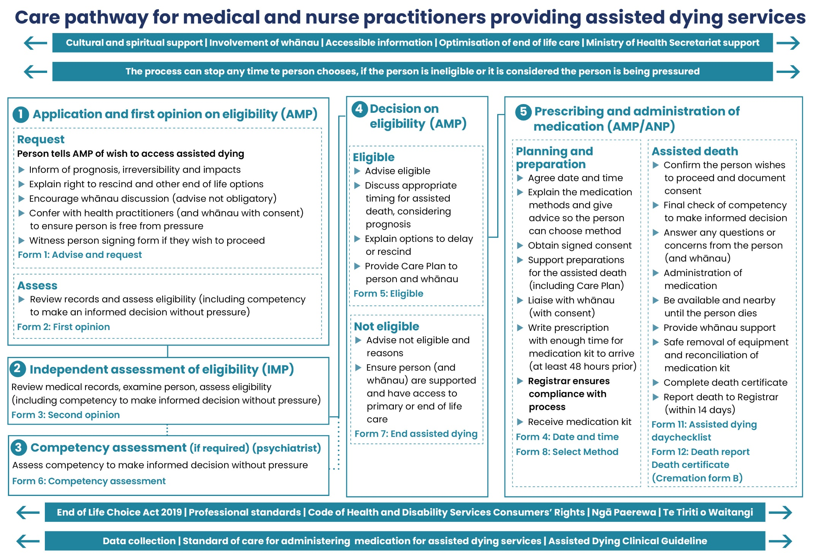

Section 5:
Care pathway for medical practitioners not providing assisted dying services
This care pathway describes the steps a medical practitioner not providing assisted dying services should take if a person raises assisted dying with them – these align with Responding when a person raises assisted dying: A conversation guide for registered health professionals. These interactions
are prior to the process outlined from section 11 onwards of the Act.

Medical practitioners have legal obligations under the Act to act as a person’s attending medical practitioner (AMP) and provide assisted dying services to a person in their care who requests access to this service. A medical practitioner can opt out of doing so if they have a conscientious objection or if they lack the appropriate skills or experience to provide assisted dying services (reasons of competency).

At a minimum, medical practitioners with a conscientious objection must:
- inform the person of their objection
- tell the person they have the right to ask the Support and Consultation for End of Life in New Zealand (SCENZ) Group for the name and contact details of a medical practitioner who is willing to participate in assisted dying.

Medical practitioners who lack the appropriate skills or experience to provide assisted dying services (reasons of competency) are advised to tell the person the reason they do not provide the service and inform them of the SCENZ Group as a minimum.

Medical practitioners following this care pathway are advised not to discuss a person’s eligibility for assisted dying. There is a formal process for this that is outlined in the Care pathway for medical and nurse practitioners providing assisted dying services.

Medical practitioners may consider it appropriate to discuss eligibility if the person raising assisted dying is clearly not eligible, ie, is under 18 years old, is not a New Zealand citizen, or does not have a terminal illness. Medical practitioners should only discuss eligibility if they are competent and confident to do so.

Medical practitioners should determine their personal and organisational level of involvement in providing assisted dying services (and information and support related to these services). Medical practitioners should consider their willingness and ability to provide the full service before they start the assessment processes required by the Act and agree to be a person’s AMP.

It may be helpful for medical practitioners to undertake self-reflection on their own feelings and biases towards assisted dying services. For more information see Responding when a person raises assisted dying: A handbook for registered health professionals.

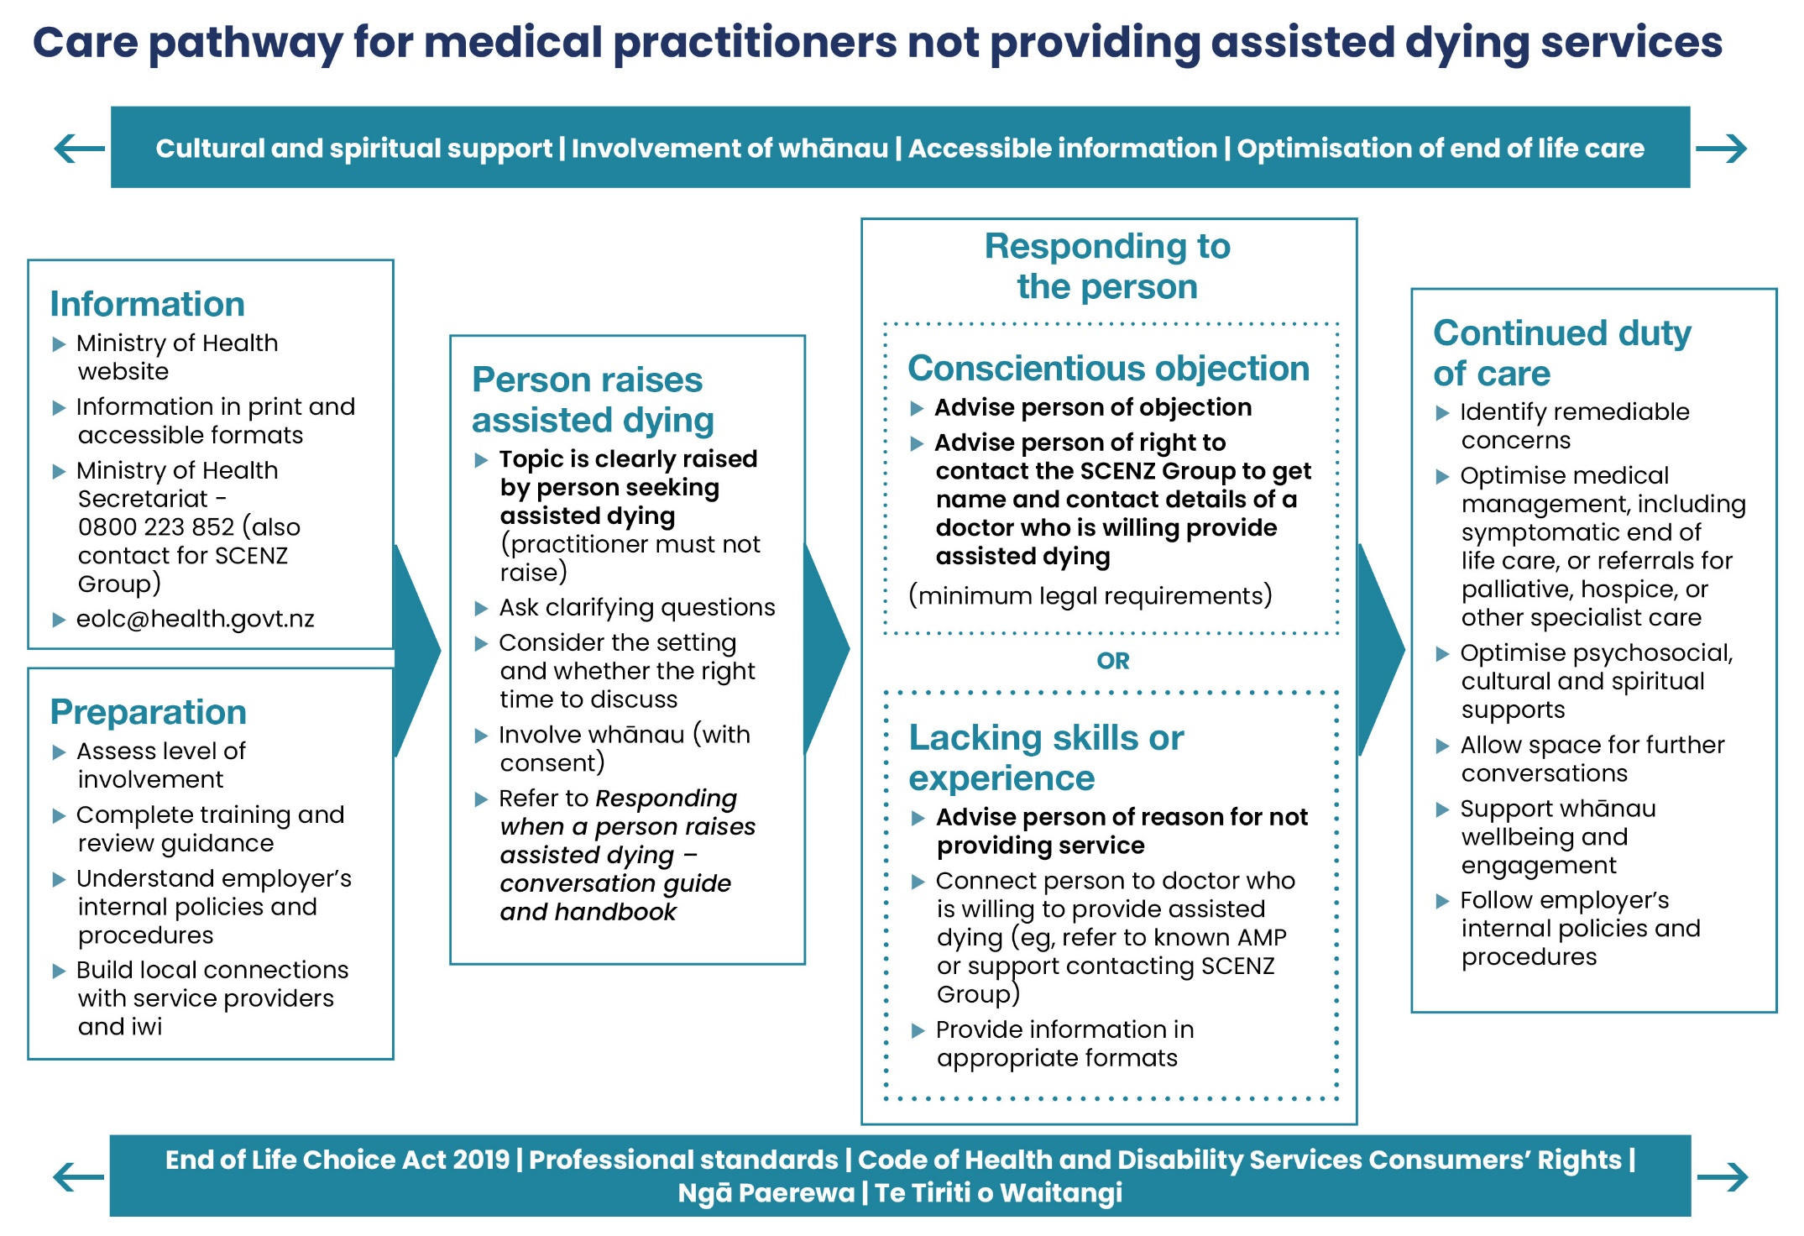

Section 6:
Care pathway for
health practitioners
(not including medical practitioners)

This care pathway describes the steps health practitioners (not including medical practitioners) should take if a person raises assisted dying with them – these align with Responding when a person raises assisted dying: A conversation guide for registered health professionals. These interactions
are prior to the process outlined from section 11 onwards of the Act.

Only medical practitioners can start the process outlined in the Act. Other health practitioners may play a role in supporting a person through the process, or in the case of nurse practitioners in prescribing and administering the medication.

Health practitioners should consider their willingness to support a person to access assisted dying. Health practitioners may conscientiously object to helping a person access assisted dying. While medical practitioners are legally obliged to disclose a conscientious objection, other health practitioners are not obliged to, but they may choose to.

Regardless of personal belief, health practitioners should ensure they understand their legal and professional obligations and meet these by ensuring continuity of care is maintained for the person and access to lawful medical treatment is not being inhibited. This includes being prepared to respond to a person in their care who may raise this with them in a respectful and helpful manner, including knowing where to direct a person who wishes to access this service.

Health practitioners following this care pathway are advised not to discuss a person’s eligibility for assisted dying. There is a formal process for this that is outlined in the Care pathway for medical and nurse practitioners providing assisted dying services.

Health practitioners may consider it appropriate to discuss eligibility if the person raising assisted dying is clearly not eligible, ie, is under 18 years old, is not a New Zealand citizen or does not have a terminal illness. Health practitioners should only discuss eligibility if they are competent and confident to do so.

It may be helpful for health practitioners to undertake self-reflection on their own feelings and biases towards assisted dying services. For more information see Responding when a person raises assisted dying: A handbook for registered health professionals.

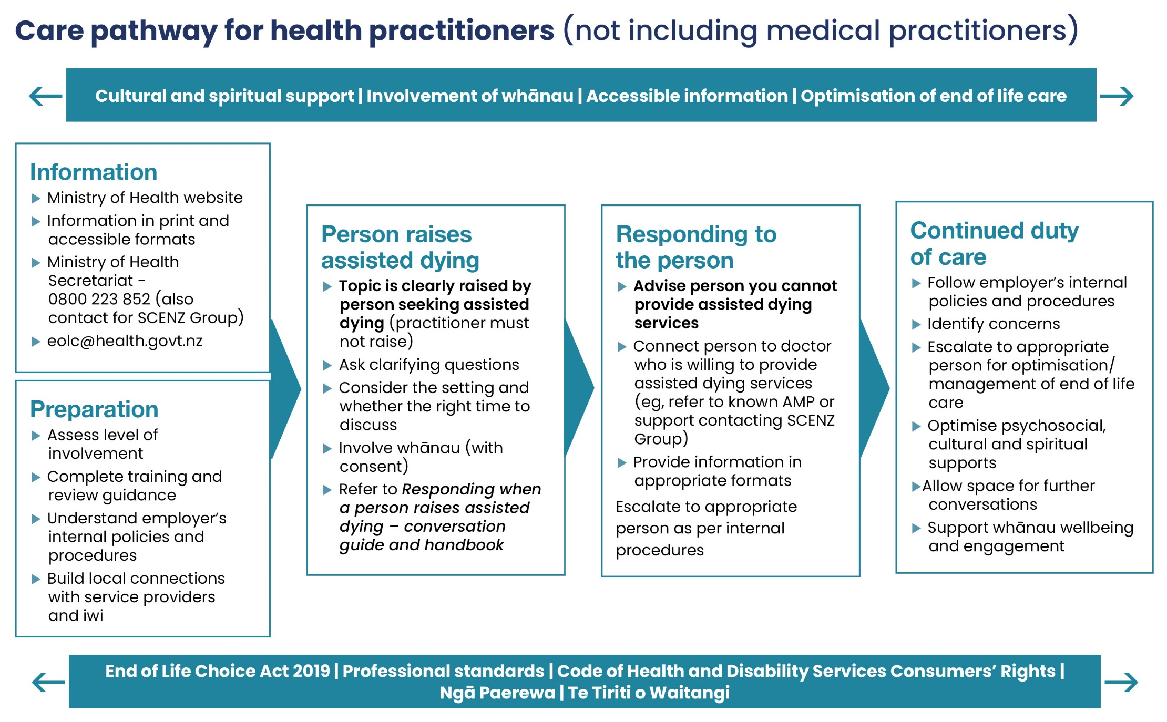

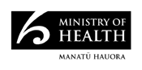
September 2021
HP 7857

