- Career planning is a continuous process of self-assessment and goal setting. This plan incorporates your career and professional development aspirations and aligns these with organisational goals as reflected in your role description.  - The Nursing Directorate manages postgraduate funding for nurses. A requirement for accessing this funding is to attain the appropriate level of the Nursing Professional Development and Recognition Programme (PDRP) (for Te Whatu Ora staff) and have an agreed Professional Development and Career Plan (PDCP).  - Before starting your career plan, it is important to work through the career planning process so that your plan is realistic and achievable for you, taking into account your self-assessment (Know Yourself) and your career research (Explore Possibilities). Consider what knowledge and skills you need to fulfil the role description (i.e. clinical competences and professional behaviours), meet objectives and develop in your career. |  |  |  |  |  |  |  |  | 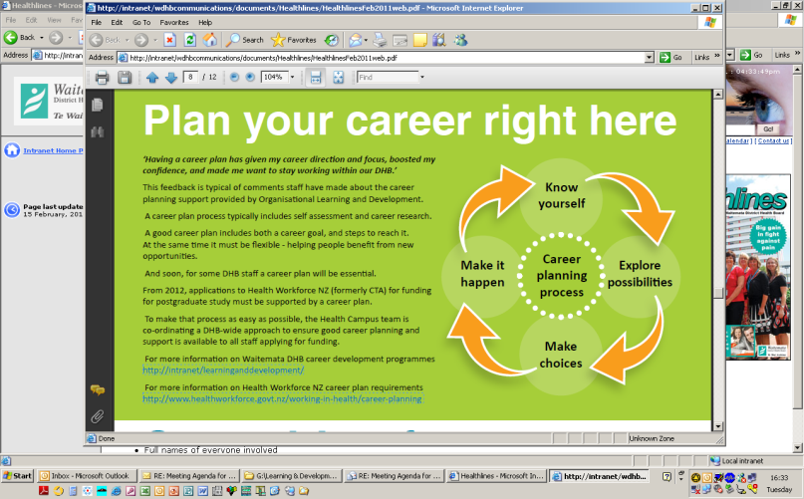
Name: |  |  | Role: |  |  |  | Workplace:
 | Career &/or Professional Development Goals |  | Action Plan to Achieve Goals |  |  |  |  |  |  | Timeframe for achievement

Short Term

(within 1 year)

Longer Term

(up to 5 years)
I have discussed my professional development and career aspirations with my line manager who is in agreement. |  |  |  |  | The plan meets the needs of the service and fits with the strategic direction of workforce development within the organisation. I have discussed this plan and agree to support the achievement of these goals.
Staff Member Sign: |  |  |  |  | Line Manager Sign:
Name: |  |  |  |  | Name:
Title: |  |  |  |  | Title:
Date: |  |  |  |  | Date:

