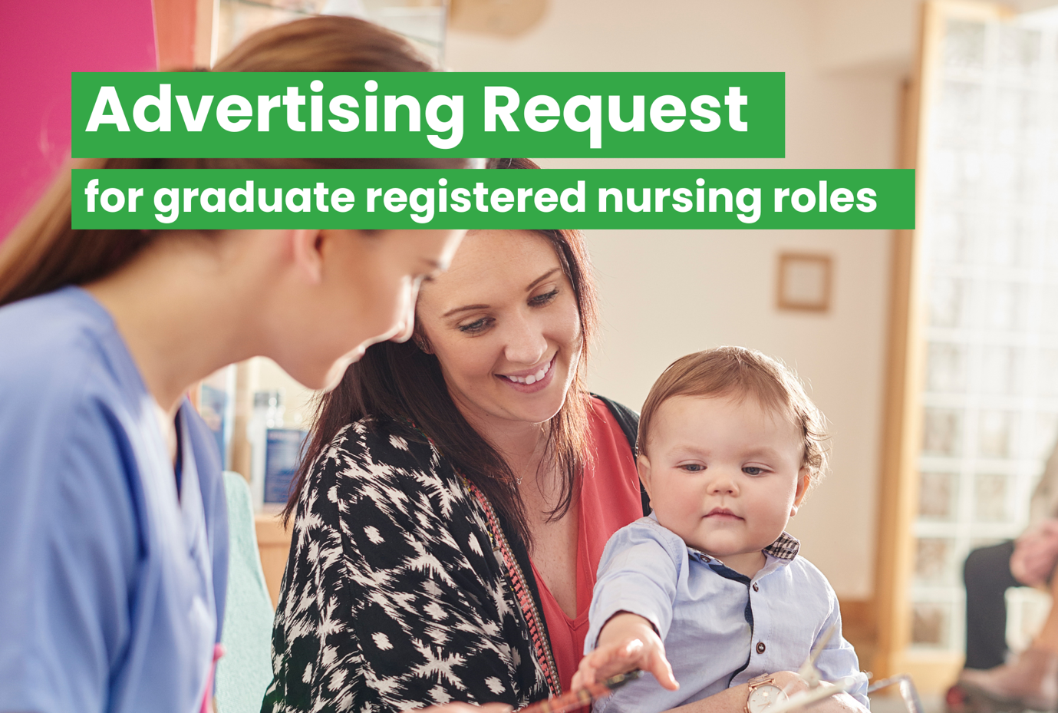

|  |  |
| --- | --- |
| **Your Details** | |
| **Full Name:** | Click or tap here to enter text. |
| **Your Email Address:**  *(for booking confirmation)* | Click or tap here to enter text. |
| **Your Phone Number:** | Click or tap here to enter text. |

|  |  |
| --- | --- |
| **Advertising Details** | |
| **Organisation Name:** | Click or tap here to enter text. |
| **Position Title:**  *(50 characters or less)* | Click or tap here to enter text. |
| **Job Location**  *(City / Region within NZ)* | Click or tap here to enter text. |
| **FTE or FT and PT** | Click or tap here to enter text. |
| **Number of Vacancies** | Click or tap here to enter text. |
| **Vacancy URL / Website:**  *(URL to receive applications)*  *If no URL, please supply an email address to receive applications.* | Click or tap here to enter text. |
| **Advertisement Start Date:** | Click or tap here to enter text. |
| **Closing Date:** | Click or tap here to enter text. |

|  |
| --- |
| To proceed with listing your free graduate registered nursing vacancy on Kiwi Health Jobs, please email the following information to [info@kiwihealthjobs.com](mailto:info@kiwihealthjobs.com)**:**   * This **Booking Form** completed with all fields filled * The **Job Description** attached as a Word document * The **New Graduate advertisement text**, if applicable, also attached as a Word document * The **Email address or URL** directing applicants to the job listing on your careers website * Your **Organisation Logo** attached as a PNG file (required only if this is your first time advertising with us)   Please note: Once all required information is received, your role will be listed within **two business days**. |