|  |
| --- |
| Student Nurses |

*Ward 6 North – Orthopaedics & Urology*

2023

Welcome!!

We are looking forward to working with you

Student Name:

The 6 North (6NW) Clinical area

Ward 6 North is located on the 6th floor of Wellington Regional Hospital. 6NW is a 36 bedded acute specialist surgical unit providing pre and post-operative care for patients who have undergone or are about to undergo elective (booked) and acute (emergency) Orthopaedic, spinal, trauma, or urological surgical procedures.

Some of the common procedures we provide care for:

* Total Hip Joint Replacement (THJR)
* Total Knee Joint Replacement (TKJR)
* Dynamic Hip Screws (DHS)
* Proximal Femoral Nail Anti-Rotation (PFNA)
* Laminectomy/Laminoplasty
* Open Reduction Internal Fixation (ORIF)
* External Fixation (ExFix)
* Trans Urethral Removal of Bladder Tumour (TURBT)
* Trans Urethral Removal of the Prostate (TURP)
* Ureteric Stenting (JJ Stent)
* Bladder Neck Incisions (BNI)

We have a multi-disciplinary approach to patient care bringing in expertise from multiple modalities. Our Multi-Disciplinary Team (MDT) is comprised of the following:

* Charge Nurse Manager (CNM)
* Surgical House Officers (Junior Doctors)
* Physiotherapists (NZRP)
* Occupational Therapists (NZROT)
* Social Worker (NZRSW)
* Clinical Pharmacist/Pharmacy Intern
* Patient Care Coordinator(s)

Emma Lange  
Charge Nurse Manager

Elaine Ramlose  
Associate Charge Nurse Manager

Roel Catalan  
Associate Charge Nurse Manager

Andreea Igorov  
Associate Charge Nurse Manager

Lise Larsen  
Registered Nurse – Clinical Coach

Jasmine Lee  
Clinical Nurse Educator

Jenny Amdengan

Associate Charge Nurse Manager

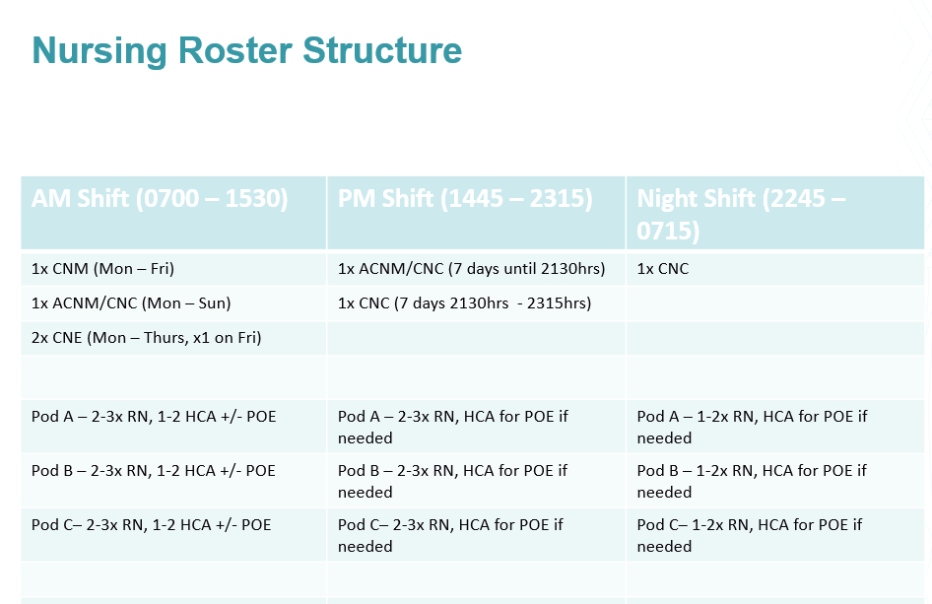

**Contacts**

|  |  |  |  |
| --- | --- | --- | --- |
| Ward 6 North Senior Nurses | Main contact | Email for main contact | Phone number |
| Charge Nurse Manager (CNM) | Emma Lange | Emma.lange@ccdhb.org.nz | 027 289 4514 |
| Clinical Nurse Educator (CNE) | Jasmine Lee | Jasmine.lee@ccdhb.org.nz | 027 295 0652 |
| Associate Charge Nurse Manager (ACNM) | Duty ACNM | - | 027 515 3701 |
| Clinical Liaison Nurse (CLN) | Lise Larsen | Lise.larsen@ccdhb.org.nz | 022 648 8553 |

Who to contact:

* Roster issues – Clinical Nurse Educator (CNE)
* Running late/sick – Duty ACNM
* Clinical/Patient Queries – Preceptor or CLN first then CNE
* Issues with preceptor – CLN &CNE

**Your Preceptor/ Clinical Liaison Nurse**

You won’t be allocated one main preceptor, but a variety of nurses on the ward. These preceptors will be responsible for helping you completing your objectives. We will endeavor to ensure that you mainly work with one or two preceptors across your placement, however, due to shift work this is not always possible. It is **your** responsibility to ensure the nurse you are working with is aware of your objectives for the day/week. You must provide evaluations and/or other paperwork to your preceptor in a timely fashion (i.e. not on the due date!!). You preceptor will not complete any evaluations if you give it to them on your last days in the unit.

**Dedicated Educational Unit**

6 North is a Dedicated Educational Unit. The Dedicated Education Unit (DEU) model of clinical teaching and learning in Wellington and is a partnership between organisations, the education provider Massey University (Massey), Victoria University and Whitireia New Zealand (Whitireia) and Te Whatu Ora Capital. Coast and Hutt Valley. Collaboration allows practice areas to provide a more supportive clinical learning and teaching environment for students. DEU’s are dedicated to supporting nursing students on clinical placement encouraging incidental and intentional learning modes, and peer teaching. The DEU is based on an Australian model and replaces the Preceptorship model to focus on student learning and curriculum integration.

**Preceptor:**

Your Preceptor will work alongside you to support your practice and learning during your placement. You will work with your preceptor in a shared care model for your orientation period. This means you will be allocated your own workload and be supported by your preceptor for this time.

**Clinical Liaison Nurse**

Lise Larsen is the Dedicated Education Unit Clinical liaison nurse (CLN) for 6 North and your main clinical contact. Lise will provide you with some structured clinical learning during your clinical placement. Lise has an excellent understanding of your programme and academic study and will work alongside your academic tutors and yourself to support your learning needs and complete formative and summative assessments during your placement.

In addition the CLN will compete all assessments and references relating to ACE for third year students.

If you have any concerns or questions do not hesitate to contact either Lise or one of the CNEs.

.

**Expectations of the Student Nurse while in 6NW**

The shift times for 6NW are:

|  |  |  |
| --- | --- | --- |
| Morning (AM) | : | 0700hrs to 1530hrs |
| Afternoon (PM) | : | 1445hrs to 2315hrs |
| Night (N) | : | 2245hrs to 0715hrs |

## We have a few expectations of student nurses working on 6NW:

* It is expected that you arrive on time for your shift and if you are going to be late or you are unwell and cannot come to call the unit on **027 515 3701**
* You must complete the full shift that you are allocated to work – if you are unable to do so please discuss this with your nurse, preceptor or nurse educator. A lot of learning occurs at quiet times in the unit!
* It is important for your preceptor or the nurse you are working with that he/she is aware of your objectives
* Due to infection control a clean uniform must be worn, long hair must be tied back and cardigans must not be worn when working in the floor
* If you are not achieving your objective please see Lise or your preceptor (before the last week in the unit)
* Please ensure all documentation you need to complete for the polytechnic/university is accomplished before the last days in the unit – your preceptor will **not** complete any paper that is given to him or her if it is given in the last days of your placement
* ASK LOTS OF QUESTIONS!!! We are here to optimize your learning, so please ask any questions you have, even if it’s the same one over and over until you understand!

**Safety Measures on 6 North**

**What to do in the event of a cardiac arrest:**

**D** – Look for danger

**R** – Check responsiveness

**S** – Send for Help

**A** – Open the airway

**B** – Check for signs of breathing

**C** – Commence chest compressions

**D** – Attach defibrillator (AED) as soon as available

**What to do in the event of a fire (RACE Protocol)**

**R**emove people from danger

**A**ctivate the alarm (Fire Alarm + 777)

**C**onfine the fire (if safe to do so)

**E**xtinguish the fire (if it is small and safe to do so)

**Security Access Cards**

You will be issued with a hospital swipe card which will give you access into the wards, the secure drug rooms and other areas in the building. If you have any issues, let your CLN or one of the senior nurses know so we can get this fixed for you.

**COVID-19 Requirements:**

* Minimum of a surgical mask must be worn at all times when in direct contact with patients, staff and visitors. Mask can be removed when eating or drinking.
* If caring for a patient with active COVID-19 infection – Enhanced Airborne PPE must be donned and doffed as per protocol.
* Follow guidance of RNs and Infection Control if unsure.

**Treasure Hunt**

This list is designed to help you become familiar with the environment, but is by no means exhaustive of all the things you will be required to locate.

|  |  |  |  |
| --- | --- | --- | --- |
| □ | Pyxis Medication Machine | □ | Discharge information |
| □ | Controlled Drug cupboard | □ | Clinical policies & procedures |
| □ | Linen supplies | □ | Roster |
| □ | Charge Nurse Manager Office | □ | Manual BP machine |
| □ | CNE/ACNM Office | □ | Suction Equipment |
|  |  |  | Scales |
| □ | Intravenous Fluids and equipment | □ | Bio-hazard bags |
| □ | Store room | □ | Tympanic thermometer & covers |
| □ | Staff tea room | □ | Stationery supplies |
| □ | Resuscitation trolley | □ | Photocopier |
| □ | Dirty utility room | □ | Patient charts |
| □ | Clean utility room | □ | Laboratory forms |
| □ | Dressing trolley and Materials | □ | Alginate linen bags |
| □ | Isolation Equipment | □ | Incident Reporting |
| □ | ECG machine | □ | Assessment Room |
| □ | Blood glucose trolley | □ | Sterile Gloves |
|  | District Nurse Referral |  | Lamson Tube System |
| □ | Where to store your bags | □ | Drug Fridge |
|  |  |  |  |
|  |  |  |  |
|  |  |  |  |
|  |  |  |  |
|  |  |  |  |
|  |  |  |  |

**Common Medications**

**Analgesia:**

* Paracetamol (PO/IV)
* Tramadol (PO/IV)
* Sevredol (PO)
* Morphine (IV)
* Fentanyl (IV)
* Ketamine (IV)
* Ropivacaine (via nerve catheter)
* Bupivacaine (via nerve catheter)
* Oxycodone (PO)
* Gabapentin (PO)
* Pregabalin (PO)

**Antibiotics:**

* Flucloxacillin (PO/IV)
* Amoxicillin + Clavulanic Acid (PO/IV)
* Cefazolin (IV)
* Meropenem (IV)
* Vancomycin (IV)
* Gentamicin (IV)

**NSAIDs:**

* Ibuprofen (PO)
* Celecoxib (PO)
* Orphenadrine Citrate (PO)
* Naproxen (PO)

**Gastrointestinal Drugs:**

* Docusate + Sennosides (PO)
* Maloxole (PO)
* Fleet Enema (PR)
* Glyceryl (PR)
* Bisacodyl (PO)
* Omeprazole (PO/IV)
* Ondansetron (PO/IV)
* Metoclopramide (PO/IV)

**Diabetic Drugs:**

* Metformin
* Gliclazide
* Glipizide
* Empagliflozin
* Insulin (SC)
* Glucose + Insulin + Potassium (IV)

**Antihypertensive Agents - β Blockers:**

* Metoprolol
* Bisoprolol
* Propanolol
* Atenolol

**Antihypertensive Agents – α-1 Blockers**

* Doxazosin
* Terazosin
* Tamsulosin

**Antihypertensive Agents – Ca2+ Channel Blockers**

* Amlodipine
* Felodipine
* Nifedipine
* Verapamil

**Antihypertensive Agents – Angiotensin Converting Enzyme Inhibitors (ACEi)**

* Quinapril
* Lisinopril
* Captopril
* Perindopril

**Antihypertensive Agents – Angiotensin Receptor Blockers (ARB)**

* Candesartan
* Losartan
* Valsartan

**Evaluation of Clinical Experience**

Nurse: Date of placement

Date of Evaluation: Preceptor:

This evaluation is intended to offer feedback to the preceptor and their clinical area.

|  |  |  |  |  |  |  |
| --- | --- | --- | --- | --- | --- | --- |
| **Clinical Learning** | **1**  **Strongly Agree** | **2**  **Agree** | **3**  **Neither agree or disagree** | **4**  **Disagree** | **5**  **Strongly disagree** | **Comments** |
| The staff were welcoming and learned to know the students by their personal name |  |  |  |  |  |  |
| The staff were easy to approach and generally interested in student supervision |  |  |  |  |  |  |
| A preceptor(s) was identified/introduced to me on arrival to area |  |  |  |  |  |  |
| One preceptor had an overview of my experience and completed my assessment |  |  |  |  |  |  |
| An orientation to the clinical area was provided |  |  |  |  |  |  |
| My learning objectives were achieved |  |  |  |  |  |  |
| I felt integrated into the nursing team |  |  |  |  |  |  |
| I formally met with the “named preceptor” at least fortnightly |  |  |  |  |  |  |
| There were sufficient meaningful learning situations in the clinical placement |  |  |  |  |  |  |
| **How was the Preceptor?** |  |  |  |  |  |  |
| The preceptor assessed and acknowledged my previous skills and knowledge |  |  |  |  |  |  |
| The preceptor discussed my prepared learning objectives |  |  |  |  |  |  |
| The preceptor assisted with planning learning activities |  |  |  |  |  |  |
| The preceptor supported me by observing and supervising my clinical practice |  |  |  |  |  |  |
| The preceptor was a good role model for safe and competent clinical practice |  |  |  |  |  |  |
| I felt comfortable asking my preceptor questions |  |  |  |  |  |  |
| The preceptor provided me with regular constructive feedback on my practice |  |  |  |  |  |  |

**Additional comments:**

P**lease return this form to Charge Nurse Manager or Clinical Nurse Educator**

