**Lead Maternity Carer**

**Access Holders**

**Handbook 2025**

**Hutt Valley Hospital**

Contents

Key Contacts 0

Welcome to Health New Zealand | Te Whatu Ora – Hutt Valley Women’s Health Service 9

Introduction 9

Maternity Quality and Safety Programme (MQSP) 10

Administrative and Legal Requirements 11

Access Agreements, Identification and Security 11

Security Cards 12

LMC Car Parking 12

Information and Communication Technology 14

Health New Zealand | Te Whatu Ora Intranet 15

Accessing policies, guidelines and patient information sheets 15

BadgerNet 17

Single Clinical Portal 17

Internal Referrals 19

Midwifery webpage and LMC Hub 20

Reportable Events / SQuARE 21

Antenatal Classes 21

Midwifery Continuing Education and Professional Meetings 22

Orientation 22

Study Days and Courses 22

Ongoing Education to maintain key clinical competencies 23

Midwifery and Multidisciplinary Forums 23

LMC Hui 23

Maternity Morbidity and Mortality Meeting (M&M) 24

Obstetric/Paediatric Meeting 24

Perinatal Education Meeting (PQAA protected) 25

CTG meetings 25

Kenepuru Maternity Staff and LMC shared lunch 25

Maternity bookings (Hutt Hospital) 26

Eligibility for healthcare 27

Copies of medical records for patients 27

Maternity Facilities & Services in Capital, Coast and Hutt Valley 28

Maternal Health Coordinators 28

Homebirth 28

How to order homebirth supplies and equipment 29

Escalation, Consultation, Transfers and Emergency transfers from homebirths and Primary Units 30

Consultation with the Birthing Suite CMM 30

Consultation with Hutt Hospital obstetric team during homebirth 30

Outpatient Clinics and Referral processes 32

Community Midwifery Team (CMT) 32

Maternity Assessment Unit (MAU) 33

Early Pregnancy Assessment Clinic (EPAC) 34

Immunisations 34

Antenatal Clinic/Secondary Care Clinic 34

Pregnancy Ultrasound Providers 36

Birthing Suite – Hutt Hospital 37

Booking an induction of labour 39

Day of Induction 40

Elective Caesarean Section 40

Primary Intrapartum Care (PIC) team 40

Neonatal review at birth 41

Documentation following birth 42

Labour & Birth Summary: electronic record (BadgerNet) 42

Post-birth Smart Form (BadgerNet) 42

Infant feeding plan (BadgerNet & Paper) 43

Newborn notification form (paper) 43

Newborn Observation Chart/Newborn Early Warning Score – NOC/NEWS (Paper) 44

Customised GROW Chart 44

Electronic discharge summary 45

Handover 45

Readmissions 47

Patient At Risk Team (PAR Nurse) 47

Postnatal Ward 47

Friends and whānau visiting 48

Transfer to primary units 49

Infant Feeding and Support 49

Lactation Consultants 50

Maori and Pacific Breastfeeding Support 50

Breastfeeding support in the community 50

Antenatal milk expression 50

Special Care Baby Unit (SCBU) 51

Visiting SCBU 51

Wellington Hospital Neonatal Intensive Care Unit (NICU) 52

Visiting NICU 52

Referrals 52

Urgent consultations and referrals 52

ISBAR communications handover tool 53

Escalation Process 53

Acute and Afterhours Referrals 54

Other Services at Hutt Valley 55

Anaesthetics 55

Cultural Support Services 57

Whānau Care Services 57

Pacific Health Support Services 58

Dietitian 60

Physiotherapy & Pelvic Health referrals - Inpatient 60

Iron Infusions 60

Maternal Wellbeing and Child Protection Group Referral 61

Newborn Hearing Screening 63

Obstetric Diabetes Clinic 64

Prophylactic Anti-D 64

Safe Sleep Device referrals 64

Sexual Health 65

Specialist Maternal Mental Health (SMMH), MHAIDS, Capital, Coast, Hutt Valley and Wairarapa 66

Social Work 68

Primary Units 69

Kenepuru Maternity Unit (KMU) Te Hohipera o Kenepuru / Kenepuru Hospital 69

Paraparaumu Maternity Unit 79

A guide for Lead Maternity Carer Access Holders to navigate services in Capital, Coast and Hutt Valley Districts Maternity Services.

This handbook should be used alongside current electronic information on the Health New Zealand | Te Whatu Ora : Capital, Coast & Hutt Valley website district (LMC Hub) and internal intranet.

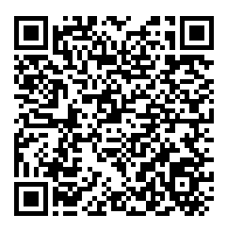Access the LMC hub which can be found on the Health New Zealand | Te Whatu Ora CCHV midwifery webpage

Scan the QR code or click [*here*](http://www.ccdhb.org.nz/working-with-us/midwifery/lmc-maternity-access-hub-at-te-whatu-ora-capital)

Access to a full list of up to date clinical policies, protocols and patient information sheets go to at District Docs:

To access District Docs -

At a Facility:

1. Log on to the system
2. Click on Hutt Valley intranet icon
3. Click on DISTRICT DOCS icon on the right hand side of the intranet page.

Offsite:

1. Log into CITRIX offsite (via the LMC Hub)
2. Click on the DISTRICT DOCS icon

This document was created as a project for the Maternity Quality & Safety Programme which aims to improve the maternity care we provide to whānau in our region and the health and wellbeing of our communities. Special thanks to all who were involved in the production of this document.

If you have any feedback, updates or ideas for this handbook please contact [Nicole.Anderson@huttvalleydhb.org.nz](mailto:MQSP@ccdhb.org.nz)

## Key Contacts

|  |  |  |
| --- | --- | --- |
| **Campuses** | | |
| Hutt Hospital | 04 566 6999 | [www.huttvalleydhb.org.nz](http://www.huttvalleydhb.org.nz) |
| Capital and Coast | 04 385 5999 | [www.ccdhb.org.nz](http://www.ccdhb.org.nz) |
| **Women’s Health Service – Hutt Valley** | | |
| Service Manager  Women’s & Children’s *(Interim)* | 027 267 3381 | Emma Joines  [Emma.Joines@huttvalleydhb.org.nz](mailto:Emma.Joines@huttvalleydhb.org.nz) |
| Director of Midwifery | 027 836 0294 | Carolyn Coles  [Carolyn.coles@ccdhb.org.nz](mailto:Carolyn.coles@ccdhb.org.nz) |
| Associate Directors of Midwifery | 027 205 8343  027 283 0491 | Wendy Castle  [Wendy.Castle@ccdhb.org.nz](mailto:Wendy.Castle@ccdhb.org.nz)  Karen Daniells  [Karen.Daniells@ccdhb.org.nz](mailto:Karen.Daniells@ccdhb.org.nz) |

|  |  |  |
| --- | --- | --- |
| Maternity Quality and Safety Programme  Coordinator |  | Niki Anderson  [Nicole.Anderson@huttvalleydhb.org.nz](mailto:Nicole.Anderson@huttvalleydhb.org.nz) |
| National Mortality  Review Committee  Midwife Coordinator |  | Anita O’Boyle  [pmmrcmidwife@huttvalleydhb.org.nz](mailto:pmmrcmidwife@huttvalleydhb.org.nz) |
| Women’s Health  Administrator | 04 587 2726 | Sonya Hitchcock  [access.agreements@huttvalleydhb.org.nz](mailto:access.agreements@huttvalleydhb.org.nz) |
| **Hutt Maternity** | | |
| Midwife Manager Inpatient | 027 293 4890  027 248 1322 | Christina Walton (Inpatient Services)  [Christina.Walton@huttvalleydhb.org.nz](mailto:Christina.Walton@huttvalleydhb.org.nz)  Krystal Williams (Community, district-wide)  [Krystal.Williams@huttvalleydhb.org.nz](mailto:Krystal.Williams@huttvalleydhb.org.nz) |

|  |  |  |  |  |
| --- | --- | --- | --- | --- |
| Clinical Midwife  Managers - Inpatient | Birthing Suite  027 809 3936  Postnatal  027 271 2830 | Emma Compton  Liz Hayes  Tracey Hoare  Kayla Hughes | Vicki Jewson  Abi McCarthy  Sarah Methorst  Verity O’Connor | Amanda Perry  Jaime Stratford  Kristina Turner |
|  |  | [CMMHuttMaternity@huttvalleydhb.org.nz](mailto:CMMHuttMaternity@huttvalleydhb.org.nz) | | |
| Obstetric Head  of Department |  | Gemma Nightingale  [Gemma.Nightingale@huttvalleydhb.org.nz](mailto:Gemma.Nightingale@huttvalleydhb.org.nz) | | |
| On-Call Obstetric  Registrar | 027 249 8629  #9025 (Internal) |  | | |
| Maternity Admin | 04 5999 999  Ext 8163 | [RES-MaternityAdmin@huttvalleydhb.org.nz](mailto:RES-MaternityAdmin@huttvalleydhb.org.nz) | | |
| **Education and clinical coaching** | | | | |
| Midwife Educator | 027 469 1829 | Alison Grant  [MaternityEducationHVDHB@huttvalleydhb.org.nz](mailto:MaternityEducationHVDHB@huttvalleydhb.org.nz) | | |
| Clinical Coach Midwife |  | Sunny Larkin-Jones  [Sunny.Larkin-jones@huttvalleydhb.org.nz](mailto:Sunny.Larkin-jones@huttvalleydhb.org.nz)  Michelle Walker  [Michelle.Walker2@ccdhb.org.nz](mailto:Michelle.Walker2@ccdhb.org.nz) | | |
| **Maternity Assessment Unit (MAU)** | | | | |
| MAU Admin | 04 587 2649 | [MaternityOutpatientsTeamHVDHB@huttvalleydhb.org.nz](mailto:MaternityOutpatientsTeamHVDHB@huttvalleydhb.org.nz) | | |
| MAU Referrals |  | [RES-MaternityAdmin@huttvalleydhb.org.nz](mailto:RES-MaternityAdmin@huttvalleydhb.org.nz) | | |
| Early Pregnancy  Assessment Clinic  (EPAC) | 04 587 2652 | [epac@huttvalleydhb.org.nz](mailto:epac@huttvalleydhb.org.nz) | | |
| Maternal Fetal  Medicine  (Wellington Hospital) | 021 199 8223  (MFM Midwife) | [RES-MFMReferrals@ccdhb.org.nz](mailto:RES-MFMReferrals@ccdhb.org.nz) | | |
| **Community Midwifery Team (CMT)** | | | | |
| Clinical Midwife  Manager - CMT | 027 344 0951 | Julie Mannering – Hutt Valley  [Julie.Mannering@huttvalleydhb.org.nz](mailto:Julie.Mannering@huttvalleydhb.org.nz) | | |
| Community Midwives | 0800 488 628 | [RES-communitymidwives@huttvalleydhb.org.nz](mailto:RES-communitymidwives@huttvalleydhb.org.nz) | | |
| **Lactation Consultants** | | | | |
| Lactation Consultants | 04 587 2556 | Rietha de Coning Laura Francis  [RES-LactationConsultants@huttvalleydhb.org.nz](mailto:RES-LactationConsultants@huttvalleydhb.org.nz) | | |
| Māori & Pacific Breastfeeding Support | 022 103 9832 | Stephanie Davis | | |
| **Special Care Baby Unit (SCBU)** | | | | |
| Paed Reg (SCBU) | 027 208 8411  Pager 509 | 24/7 Cover of birthing, postnatal and SCBU | | |
| Paed Reg (CW) |  | 24/7 Cover of Children’s Ward/ED | | |
| Associate Clinical  Nurse Manager | 027 809 3940 | Soniya Lawrence  [Soniya.Lawrence@huttvalleydhb.org.nz](mailto:Soniya.Lawrence@huttvalleydhb.org.nz) | | |
| SCBU Ward | 04 570 9054 |  | | |
| **Other Services** | | | | |
| Awanui Labs | 04 570 9992 | Or 04 566 6999 *8512 for Hutt Hospital Lab | | |
| BadgerNet Helpdesk | 0800 223 431 | [BadgerNetMaternity@huttvalleydhb.org.nz](mailto:BadgerNetMaternity@huttvalleydhb.org.nz) | | |
| Car Park Management | 04 579 2699 | [RES-Parking@huttvalleydhb.org.nz](mailto:RES-Parking@huttvalleydhb.org.nz) | | |
| ICT Helpdesk | X9178 | External phone: 04 918 6146 | | |
| Maternal Care and  Child Wellbeing  Multi-Agency Group | 027 248 1322  027 652 91639 | Krystal Williams  Lynne O’Toole  [Referrals](https://intranet.huttvalleydhb.org.nz/forms/clinical/maternity/vip-referral-form-to-mccw-mag.pdf)  RES-VIP@huttvalleydhb.org.nz | | |
| Maternal Health Coordinators | 027 225 0057 | [homebirth@ccdhb.org.nz](mailto:homebirth@ccdhb.org.nz)  Vee Samoa | | |
| Newborn Hearing  Screening | 04 587 2647  027 280 0441 | Julia Harmon (Acting Team Leader)  [NewbornHearingScreening@huttvalleydhb.org.nz](mailto:NewbornHearingScreening@huttvalleydhb.org.nz) | | |
| NZ Blood Service | 04 380 2243 |  | | |
| Safe Sleep  Moe ora mo nga pēpi | 04 939 4640 | Pepi-pod/wahakura  Kokiri Marae Health and Social Services  [Referrals](https://www.takirimai.org.nz/index.php?page=service&t=827) | | |
| Smokefree Coordinator  Regional Stop  Smoking Service | 0800 923 257 | Kokiri Marae Health and Social Services  [SmokeFreeCoordinatorHVDHB@huttvalleydhb.org.nz](mailto:SmokeFreeCoordinatorHVDHB@huttvalleydhb.org.nz) | | |
| Women’s and  Children’s  Social Worker | 04 570 9620  027 298 6706 | Suzanne Stewart  [Suzanne.Stewart@huttvalleydhb.org.nz](mailto:Suzanne.Stewart@huttvalleydhb.org.nz) | | |
| Women’s Health  Physio | 04 570 9212 | Refer via Internal Referral on Concerto | | |

|  |  |  |
| --- | --- | --- |
| **Wellington Regional Hospital - Maternity** | | |
| Birthing Suite Midwife Manager | 027 442 2829 | Jo McMullan  [Jo.McMullan@ccdhb.org.nz](mailto:Jo.McMullan@ccdhb.org.nz) |
| Birthing Suite Clerk  (NCC) | 04 806 0650 | [BirthingSuiteWardAdmin@ccdhb.org.nz](mailto:BirthingSuiteWardAdmin@ccdhb.org.nz) |
| Birthing Suite Clinical Midwife Manager (CMM) | 04 806 0845  021 199 8212 | [CMMBS@ccdhb.org.nz](mailto:CMMBS@ccdhb.org.nz) |
| Ward 4 North  AN/PN Wards  Midwife Manager | 027 406 7555 | Kerry Haslam  [Kerry.haslam@ccdhb.org.nz](mailto:Kerry.haslam@ccdhb.org.nz) |
| Ward 4 North AN/PN Wards CMM | 04 806 0889  027 265 2696 | [ACMM4NorthMaternity@ccdhb.org.nz](mailto:ACMM4NorthMaternity@ccdhb.org.nz) |
| Ward 4 North Clerk (NCC) | 04 385 5999  ext 80880 |  |
| CMT Clinical Midwife Manager | 027 319 4312 | Desree Morrison |
| CMT Referrals |  | [CommunityMidwiferyTeam@ccdhb.org.nz](mailto:CommunityMidwiferyTeam@ccdhb.org.nz) |
| Neonatal Intensive  Care Unit (NICU) | 04 385 5999  ext 80800 |  |

|  |  |  |
| --- | --- | --- |
| NICU Associate Charge Nurse Manager | 021 199 8307 | 24/7 |
| **Kenepuru Maternity Unit** | | |
| KMU Midwife Manager | 04 918 2012 or  027 703 2008 | Jenny Quinn  Jenny.Quinn@ccdhb.org.nz |
| KMU RM | 04 918 2010 |  |
| KMU Clerk (NCC) | 04 918 2001 |  |
| **Paraparaumu Birthing Unit** | | |
| PMU Midwife Manager | 021 452 763 | Gwen Ryan  Gwen.Ryan@ccdhb.org.nz |
| PMU RM | 04 903 0205 |  |

## Welcome to Health New Zealand | Te Whatu Ora – Hutt Valley Women’s Health Service

### Introduction

Whether you are just starting out, have recently moved here, or you have been an LMC in our region for many years – we are very glad to have you providing the midwifery care that is essential to the hauora (health and wellbeing) of our communities.

This handbook is intended to both support you in your provision of care, and support us all in the collaborative care we provide together when required. This is intended to be a living document that we all contribute to as things change in our environment and within our services. It contains information about Health New Zealand | Te Whatu Ora maternity services and facilities. You will be able to find the administrative documents you need to complete, how to access ICT systems, hospital parking available to LMCs, the multidisciplinary forums you can participate in and how to refer people to relevant services.

If you have any feedback, updates or ideas for this handbook please contact [Nicole.Anderson@huttvalleydhb.org.nz](mailto:MQSP@ccdhb.org.nz)

Hutt Maternity facilities provide primary and secondary care for approximately 1600 whānau who have their babies each year.

Whānau also have access to Capital and Coast maternity facilities located at:

* Wellington Regional Hospital – primary/secondary/tertiary maternity facility
* Kenepuru Maternity Unit at Kenepuru Community Hospital – primary birthing unit
* Kāpiti Health Centre (Paraparaumu) – primary birthing unit

## Maternity Quality and Safety Programme (MQSP)

The Maternity Quality and Safety Programme (MQSP) was established in 2012. It aims to:

* Improve local maternity quality and safety
* Improve national service improvement tools and support
* Monitor outcomes and establish national priorities for maternity quality and safety
* Broaden the scope and visibility of maternity quality activities

[The National Maternity Monitoring Group](https://www.tewhatuora.govt.nz/for-health-professionals/health-workforce-development/maternity/national-maternity-clinical-guidance/national-maternity-monitoring-group/) oversees the National Maternity Standards, their analysis and reporting, and advises on priorities for improving the quality and safety of the Maternity service.

The Capital, Coast and Hutt Valley (CCHV) MQSP governance group is responsible for agreeing the local MQSP work plan, progressing MQSP projects and allocating funding for initiatives that reflect local maternity service priorities.

The MQSP Governance group is chaired by the Director of Midwifery and has representatives that include – Māori, Pacific peoples, the disability community, midwife LMCs, Midwife Managers, Operations Managers, Clinical Obstetric Leads, and MQSP midwife coordinators.

There is one MQSP midwife coordinator for Hutt Valley. They are responsible for progressing the improvement projects they have been allocated to. If you have any ideas for initiatives that would improve the maternity care in our communities and want to apply for funding, contact [Nicole.Anderson@huttvalleydhb.org.nz](mailto:MQSP@ccdhb.org.nz)

## Administrative and Legal Requirements

### Access Agreements, Identification and Security

To apply for an access agreement, please complete all the forms listed below. These are available online [here](https://www.ccdhb.org.nz/working-with-us/midwifery/lmc-hub/).

* [National Access Agreement](https://www.ccdhb.org.nz/working-with-us/midwifery/lmc-hub/national-access-agreement.pdf)
* [Vulnerable Children’s Act (VCA) Children’s Worker Safety Check](https://www.ccdhb.org.nz/working-with-us/midwifery/lmc-hub/childrens-worker-saftety-check.pdf)
* [ICT and Security Access Agreement](https://www.ccdhb.org.nz/working-with-us/midwifery/lmc-hub/security-access-agreement.pdf)
* [Photo ID card request form / Swipe access](https://www.ccdhb.org.nz/working-with-us/midwifery/lmc-hub/photo-id-request-hv.docx)

You will also need to attach copies of supporting documentation:

* Annual Practising Certificate (updated annually) – [Midwifery Council Website](https://www.midwiferycouncil.health.nz/)
* Indemnity Insurance (updated annually)
* Two referees: Name and contact details
* Photo ID – Passport or driver’s license

**Women’s Health Service Administration**

Contact the administrator on [access.agreements@huttvalleydhb.org.nz](mailto:access.agreements@huttvalleydhb.org.nz) if you

* Require additional information regarding access
* Have changes to make to your contact details
* Have updated your APC, VCA documentation or indemnity

To ensure continued access to Hutt Hospital, please provide the administrator with updated APC as soon as it is available.

* For any issues please email [carolyn.coles@ccdhb.org.nz](mailto:carolyn.coles@ccdhb.org.nz) for details)

Please email all documents to the Hutt Valley Women’s Health Administrator at [access.agreements@huttvalleydhb.org.nz](mailto:access.agreements@huttvalleydhb.org.nz) . The WHS Administrator will process your agreement once all information has been provided.

### Security Cards

Security cards enable you to access maternity facilities after-hours and staff only areas.

**Photo ID** cards must be carried at all times. Cards contain barcodes which give access to glucometer, lactate and eventually Pyxis and ABL90 machines.

**If you lose your security card**, please report it immediately to the Telephonist (extension 0). The access rights to the card will be removed from the database to prevent illicit access violations from occurring.

### LMC Car Parking

#### Hutt Hospital

Two LMC car park spaces are available, situated opposite the entrance to the Emergency Department main entrance. LMCs can apply for a discounted parking permit through the parking office situated on the ground floor ([Contractor Carpark Application Form](https://intranet.huttvalleydhb.org.nz/policies-guidelines/general/carpark-management-policy/contractor-car-park-application-form.docx)). Contact 04 579 2699 or [parking@huttvalleydhb.org.nz](mailto:parking@huttvalleydhb.org.nz) for further information.

To park in these spaces an LMC Parking Pass must be displayed on the dashboard. There is no official time limit on these parks, but please try to keep them for emergencies only for our LMC colleagues on urgent business.

LMCs can park in the PM parking situated next to the Emergency Department Entrance.

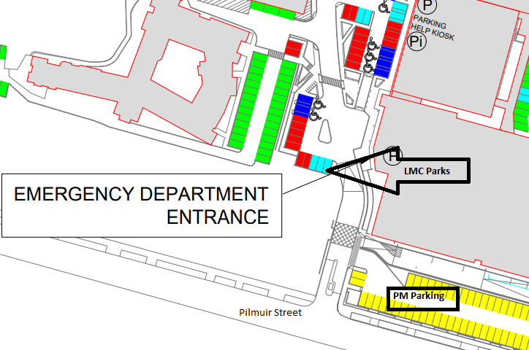

A full version of the Hutt Valley Campus parking map can be found [here](https://intranet.huttvalleydhb.org.nz/staff-info/a-z-staff-info/staff-parking-faqs/hutt-valley-hospital-car-parking-map-04-may-2023.pdf).

## Information and Communication Technology

All LMCs will be allocated a unique login and email address (this can be used across all sites).

If you have computer access problems contact the ICT service desk on 04 570 9178, or log a ticket on the ICT help desk portal on the intranet homepage.

**Hutt Hospital computer logon (Citrix Desktop)** provides access to clinical information systems such as Single Clinical Portal, BadgerNet and Ko Awatea. It also allows access to all in-hospital policies, processes and information sheets via the DistrictDocs link on the homepage.

To access your Citrix desktop from home – head to [www.huttvalleydhb.org.nz](http://www.huttvalleydhb.org.nz) – click on Health Professionals – Staff and Provider login – log in to Citrix Gateway.

The first time you log in you will need to set up two-step multifactor authentication to ensure login security is managed by you. This will also allow you to access all Microsoft 365 systems with your hospital email address and login.

**Your hospital email address** provides secure (health approved) facilities to send patient information and receive important communications. We recommend connecting your email to your phone to ensure you receive updates which may impact your clients, or working on Capital, Coast and Hutt Valley sites. You can scan documents from the Ricoh photocopiers to your Hutt Valley email address.

**Please note – communication involving confidential patient information from Health New Zealand | Te Whatu Ora will only be sent to a secure location.**

To set up access to your emails on your smart device, ensure your device is password protected for security, then use the following comprehensive guide [here](https://3dhb.sharepoint.com/sites/ccdhbintranet/Shared%20Documents/3DHB%20ICT/Exchange%20online%20migration/User%20guides/Outlook%20Email%20Setup%20Guide%20-%20iOS%20Device.pdf#search=emails%20on%20phone).

### Health New Zealand | Te Whatu Ora Intranet

[Hutt Valley Intranet](https://intranet.huttvalleydhb.org.nz/) provides access to information about services, changes to services and health related events across the Wellington region. **This page can be accessed onsite at any facility, or logged on via Citrix if you are offsite.**

The Capital, Coast Intranet can be accessed [here](https://3dhb.sharepoint.com/sites/ccdhbintranet/Pages/Home.aspx).

The National Intranet can be accessed [here](https://hauoraaotearoa.sharepoint.com/sites/Intranet).

### Accessing policies, guidelines and patient information sheets

These can be accessed via [DistrictDocs](https://3dhb.sharepoint.com/sites/ccdhbintranet/Pages/How%20Do%20I/DistrictDocs.aspx), the electronic documents and records management system. All policies, procedures, forms, guidelines and patient information pamphlets are stored on DistrictDocs and reviewed on a five year cycle (unless specified otherwise).

To search For Maternity Policies – Open District Docs – Scroll down to Maternity on the left hand side and click.

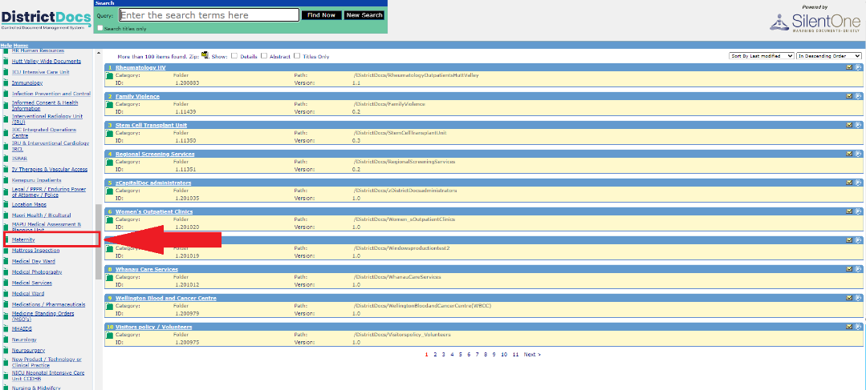

Please note – Some policies are site dependent, they are specific to “Hutt Valley” “Capital, Coast” or “District Wide”. Click on “Hutt Valley”. This will take you to the Hutt Valley documents.

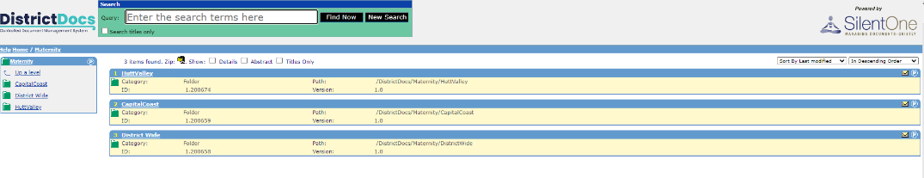

You can use the “search” function to search for keywords. Please ensure you open the correct policy for the facility.

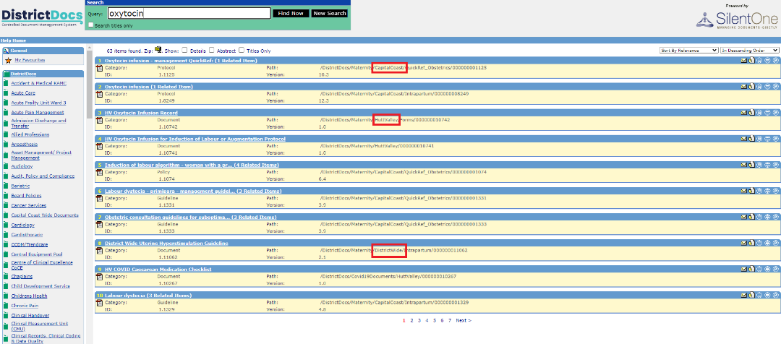

### BadgerNet

BadgerNet is the online documentation system used in the Maternity Assessment Unit, by the Community Midwifery Team and for inpatient care. BadgerNet can be accessed from home by logging in through Citrix and clicking on the BadgerNet icon. BadgerNet has a Ko Awatea introduction course called “BadgerNet - Lead Maternity Carer Midwives eLearning” which will give you an overview of the system.

**Discharge summaries, specialist reviews, medical discharge letters, operative or instrumental birth reports, labour and birth report, obstetric reviews from BadgerNet will only be sent to a Health New Zealand | Te Whatu Ora email address.**

|  |  |
| --- | --- |
| For BADGERNET assistance | |
| Non-urgent query | [BadgerNetMaternity@huttvalleydhb.org.nz](mailto:BadgerNetMaternity@huttvalleydhb.org.nz) |
| Normal business hours | 0800 223 431 |

### Single Clinical Portal

In 2025 the Single Clinical Portal will replace the three separate clinical portals MAP/Concerto/Medical App Portal across Captial Coast, Hutt Valley and Wairarapa districts. Single Clinical Portal will show a single view of all patient data (clinical documents, blood tests, investigations, etc) from all three sites, in the same place.

It also allows you to complete referrals and clinical documentation letters and summaries for all maternity clients. You can access Single Clinical Portal on desktop or start/clinical systems on all computers, or access offsite via your Citrix login.

**Use section on set up for Citrix login and Multifactor Authentication (MFA) on your home computer to access.**

**Records should only be accessed for people whom you are providing care. This system must not be used for personal use.**

#### ****How to use Single Clinical Portal****

Access the user guide for setting up single clinical portal through the ICT Knowledge Hub on any computer or [here](https://3dhb.sharepoint.com/sites/ITKnowledgeHub/SitePages/Single-Clinical-Portal-Training-Resources.aspx)

**Some functions will not be available until later in 2025. If you are unsure, check functions available in Concerto (till it closes mid 2025).**

#### Ordering tests in hospital

Any tests ordered through Awanui Labs are reported on Single Clinical Portal– outpatient Awanui Labs are reported under “Regional Lab” results.

All tests require electronic sign-off by the ordering clinician within 4 weeks. This is a safety mechanism to ensure abnormal test results are actioned. Follow-up will occur if you have not signed off your results within this timeframe. If you have ordered a test through the hospital but will be away or unavailable for follow-up and sign-off, please ensure your back up midwife is aware to follow up and sign off the result.

[Click here](https://www.ccdhb.org.nz/working-with-us/midwifery/lmc-hub/how-do-i-sign-off-my-unsigned-results-map-2019.pdf) for instructions to manage unsigned results.

### Internal Referrals

Some areas have not yet transitioned to the single clinical portal. Until then – these may still be accessible on Concerto. These include referrals which can be accessed through the person’s NHI.

Your client does not need to be an inpatient to create an Internal Referral.

To Create an Internal Referral – bring up the person’s clinical file. Select “Add New Document”

Then select “Create Internal Referral” from the menu

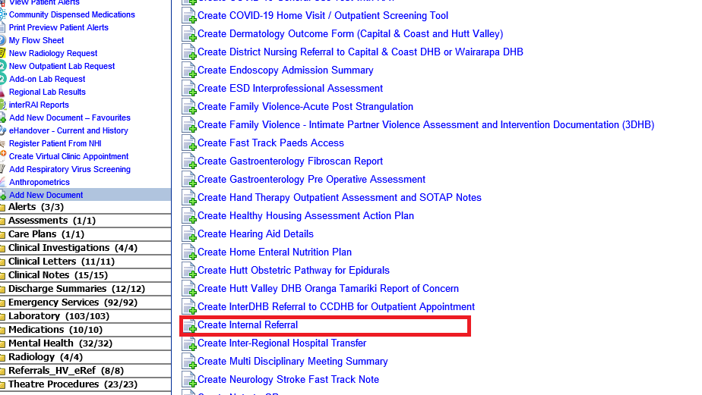An Internal Referral form will be created. Select which department you wish to refer to in the drop down box. Then fill in all relevant details and click “Finish”.

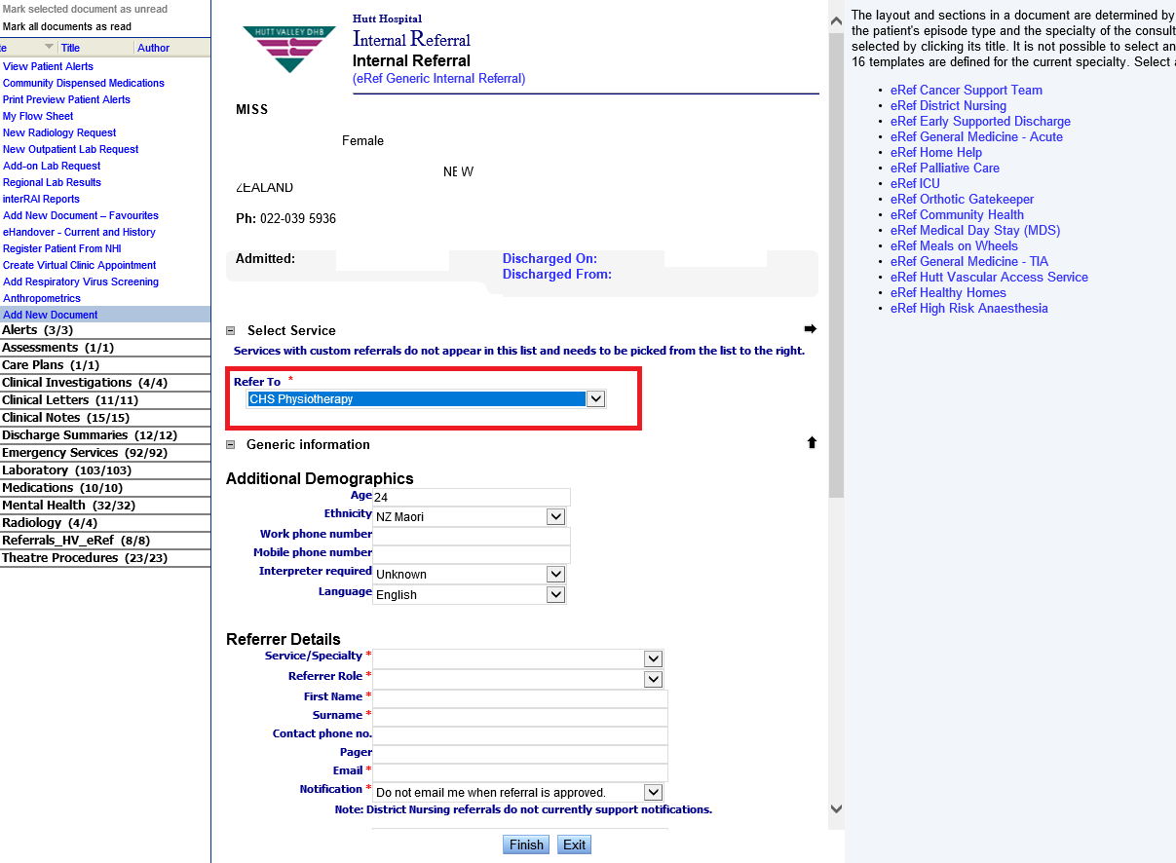

This process may change over the coming year with the BadgerNet rollout – if any updates are required, please email [Nicole.Anderson@huttvalleydhb.org.nz](mailto:MQSP@ccdhb.org.nz)

### Midwifery webpage and LMC Hub

This provides access to all midwifery related information, including the LMC Hub. The LMC Hub gives you access to a range of documents and links to access education and loan equipment. The Midwifery page can be accessed via Google search CCDHB Midwifery. The LMC Hub can also be accessed through the LMC Hub icon on the Midwifery page or click here for the [LMC Hub.](https://www.ccdhb.org.nz/working-with-us/midwifery/lmc-maternity-access-hub-at-te-whatu-ora-capital/)

### Reportable Events / SQuARE

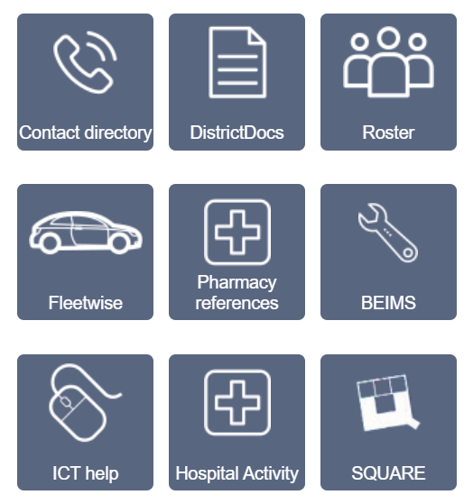Health professionals working in Capital, Coast and Hutt Valley facilities are required to report any event that causes harm or near miss of harm. This is part of the Health Quality and Safety systems based patient safety framework. The review and identification of patterns of harm informs how we can improve the safety of care we provide.

All access holders are required to familiarise themselves with SQUARE (electronic reportable events system). You can find this by clicking on the

**SQUARE** logo on the Intranet.

More information can be found [here.](https://intranet.huttvalleydhb.org.nz/policies-guidelines/quality-risk/event-reporting-square-manual/) Discuss the reporting of events with the CMM on-duty at the time of the event for guidance on how to complete SQUARE and if any other follow up is required.

## Antenatal Classes

See the [Pēpe-Ora](https://www.wellington.pepeora.nz/hutt-valley) website for an up to date list of local antenatal classes.

## Midwifery Continuing Education and Professional Meetings

### Orientation

Contact the Midwife Educator on MaternityEducationHVDHB@huttvalleydhb.org.nz to arrange an orientation to Hutt Hospital maternity facilities. Advise if additional orientation is required for other regional facilities.

### Study Days and Courses

A variety of education days are offered each year at Hutt Hospital and across the district, including regular CTG workshops, Emergency Skills Days, Prompt, Fetal Surveillance Education Programme and more. The midwife educator will also regularly email available education dates throughout the year and takes bookings directly by email or in person.

Non-maternity education opportunities (e.g. Violence Intervention Programme training days) can be booked via MyPay if you are a staff member, or you can email the Midwife Educator with preferred dates.

A variety of other courses can be accessed via the Ko Awatea online learning platform on the intranet [Learning & Development](https://aus01.safelinks.protection.outlook.com/?url=http%3A%2F%2Fintranet.huttvalleydhb.org.nz%2Flearning-development%2F&data=05%7C02%7C%7Ccc45aa7ac7574685cad208dc8fea7153%7C99d61bf7055a41ceb0b204bfec89f424%7C0%7C0%7C638543484290482359%7CUnknown%7CTWFpbGZsb3d8eyJWIjoiMC4wLjAwMDAiLCJQIjoiV2luMzIiLCJBTiI6Ik1haWwiLCJXVCI6Mn0%3D%7C0%7C%7C%7C&sdata=v%2BO%2BYwn8ztB5vXCwxf9ZSMKZW1jPp2e2mCvau2xlEJo%3D&reserved=0)

Please contact Midwife Educators to be added to the education mailing lists and to book orientation as required in facilities:

Alison Grant [Alison.Grant@huttvalleydhb.org.nz](mailto:Alison.Grant@huttvalleydhb.org.nz) **Hutt**

Katie & Sara-Jane [RES-MidwifeEducators@ccdhb.org.nz](mailto:RES-MidwifeEducators@ccdhb.org.nz) **Capital Coast**

### Ongoing Education to maintain key clinical competencies

Midwives are encouraged to regularly attend study days that are relevant to clinical care and maintain clinical competence. Examples of these are:

* Epidural study day (every 3 years)
* Newborn Life Support (3 years)
* Fetal Surveillance Education (FSEP) (alternating annually FSEP full/ FSEP refresher)
* PROMPT (Practical Obstetric Multi-Professional Training) at your local unit

Newborn Life Support and PROMPT will cover your annual APC requirements instead of attending the Emergency Skills Refresher day.

## Midwifery and Multidisciplinary Forums

Hutt Valley host a number of midwifery and multidisciplinary forums to keep clinicians up to date, publicize changes in guidance and policy, and promote good communication in the maternity care environment. LMCs are encouraged to attend to ensure diverse perspectives are represented.

### LMC Hui

#### Hutt Valley LMC Interface Hui

The Hutt LMC interface hui is organized by the Associate Director of Midwifery. LMCs from across the region are welcome to attend. The LMC interface hui is usually held on the third Monday of the month from 1.00pm to 2.30pm. The interface hui is currently held upstairs, Hutt Valley Health Hub, 135 Witako Street, Epuni.

The forums provide a space for LMCs, maternity services and other health service providers to share information and find solutions to issues as they arise. They also provide an opportunity for whakawhanaungatanga, enabling people to build relationships and collaborate in care initiatives.

There is often a speaker or an education session as part of the hui. (One CPD professional hour is awarded for each hui attended).

#### Capital, Coast LMC Interface Hui

The LMC Capital, Coast (CC) interface hui is organized by the Co-LMC Maternity Quality and Safety Programme (MQSP) representatives. Hutt Valley LMCs are also welcome. The CC LMC interface hui is usually held on the 2nd Wednesday/Thursday of the month from 1.30pm to 2.30pm, but dates can vary. The interface hui is currently held upstairs, 1841 Pub, Johnsonville. LMCs from across the district are welcome.

### Maternity Morbidity and Mortality Meeting (M&M)

A multidisciplinary meeting looking at the outcomes of recent events and reviews. The team provide teaching and review of guidance where recurrent themes are identified. Figures from the last quarter on birth outcomes will also be shared.

### Obstetric/Paediatric Meeting

Is an opportunity for our service to collectively review complex pregnant people where there are medical implications for their pregnancy or implications on the baby in utero/ ex utero.

The meeting is held on the second Wednesday of every month and is a joint meeting between obstetrics, medicine (Dr Eileen Bass) and paediatrics (Dr Sarah Mills).

Recommendations are made for care and can be found under “Patient Memo” (this may change with BadgerNet).

Referral is usually made after a pregnant person has been reviewed in the Antenatal Clinic by the registrar or consultant.

### Perinatal Education Meeting (PQAA protected)

This is a multidisciplinary forum for the discussion and review of recent cases of perinatal mortality and morbidity to facilitate organisational and clinician learning. LMCs are invited to attend regularly. They may also be invited to present cases alongside other members of the multidisciplinary team. These meetings are held at Hutt Hospital in the Auditorium of the Learning Centre three times a year. Education certificates are provided.

### CTG meetings

Case scenarios together with CTG traces are reviewed and discussed. These meetings are coordinated by the Midwife Educator and attended by LMCs, core midwives and medical staff. These occur each Monday from 12.30 to 1.30pm in the Maternity meeting room and are also offered via zoom.

### Kenepuru Maternity Staff and LMC shared lunch

Monthly meeting for KMU staff and LMCs to share notices, events and discuss any issues arising. Collaborative education sessions also run from time to time.

## Maternity bookings (Hutt Hospital)

We encourage LMCs to submit the booking of their clients to the birthing facility of their choice as soon as they have completed the booking and preferably before 20 weeks gestation.

The booking process enables clinical care to be informed by the knowledge of a person’s key medical and obstetric history, booking bloods and ultrasound scans undertaken. It also enables the facility to anticipate and manage resources through the peaks and troughs of birthing patterns across the district.

Following booking, clinical records are moved from off-site storage and held in the file room on the Maternity Unit (opposite education office).

Hutt Hospital maternity facility bookings require the following (**completed**) documentation:

***Maternity booking form***

***Patient Information form*** (admission form)

***Newborn Enrolment Form*** ([click here](https://silentone/content/DistrictDocs/Maternity/DistrictWide/Forms/000000102998/__file__/000000102998.pdf))

*Supplementary information should be given to clients with this form* Newborn Services & Well Child providers in your region* ***(***[*click**here*](https://silentone/content/DistrictDocs/Maternity/DistrictWide/Forms/000000102999/__file__/000000102999.pdf)***)***

*This form is a legal document that can only be signed by the parents/baby’s legal guardians.

Ensure all fields are completed by parents including their choice of the baby’s ethnicity (this may be different to the mother). This is crucial to being able to understand how our services are performing for different groups and ensuring all newborns are offered appropriate services.

**Homebirths** - regardless of place of birth, booking in hospital is encouraged to enable safer care if a maternal or neonatal transfer is required in an emergency.

### Eligibility for healthcare

The Ministry of Health determine who is eligible for free maternity healthcare in New Zealand. For more information on current eligibility criteria go to [www.moh.govt.nz/eligibility](http://www.moh.govt.nz/eligibility)

The eligibility status for all clients must be identified at the start of pregnancy. Clients are required to provide proof of eligibility to the LMC (for maternity care), and to Health New Zealand | Te Whatu Ora (at booking) by providing copies of citizenship and/or passport, and marriage certificate (if appropriate).

Non-eligible clients will be billed for their maternity care. It is important that people know this, and can make an informed choice about where and from whom they will receive care. If an LMC provides care to an ineligible client they **cannot** claim for this care under Section 94.

## Copies of medical records for patients

If a person wishes to view their medical records there is a formal process to follow. They must complete the appropriate request form and forward this to Medical Records. More information can be found at: <https://intranet.huttvalleydhb.org.nz/forms/clinical/clinical-docs-forms/request-to-view-or-obtain-copies-of-health-information.doc>

## Maternity Facilities & Services in Capital, Coast and Hutt Valley

### Maternal Health Coordinators

Our team supports midwives and the community, offering culturally appropriate, accessible, and effective services. The following services are managed by the team:

**Pēpe Ora:** Maintenance of the Pēpe Ora website and coordination of quarterly hui for updates and resources.  
Email : [Pepeora@ccdhb.org.nz](mailto:Pepeora@ccdhb.org.nz) | Phone: 027 225 0057   
Website: [www.pepeora.nz](https://aus01.safelinks.protection.outlook.com/?url=http%3A%2F%2Fwww.pepeora.nz%2F&data=05%7C02%7C%7C7538e5e7b27a4ea5e1c508dcfc5766ba%7C99d61bf7055a41ceb0b204bfec89f424%7C0%7C0%7C638662699522905184%7CUnknown%7CTWFpbGZsb3d8eyJFbXB0eU1hcGkiOnRydWUsIlYiOiIwLjAuMDAwMCIsIlAiOiJXaW4zMiIsIkFOIjoiTWFpbCIsIldUIjoyfQ%3D%3D%7C0%7C%7C%7C&sdata=%2FKijss66r%2FYF2h%2BUwqqps9W0pT3VyGguI8z2kgM3Niw%3D&reserved=0)

**In-Patient Survey:** We gather feedback from some Māori, Pacific and Young peoples, after birth to improve our maternity services.

**Homebirth Equipment: Management of birth packs and loan equipment – please contact Maternal Health Co-ordinator for queries regarding orders. *See information below***

### Homebirth

Capital, Coast and Hutt Valley is committed to increasing place of birth options for the community as part of its ‘Optimising Birth’ initiative to improve birthing outcomes. This includes homebirth.

Homebirth is a safe choice for pregnant people who are well, with a normal, healthy pregnancy. Evidence shows that pregnant people who choose and plan to birth at home or in a birthing centre are more likely to have a normal birth, and feel more positive about their birth experience than those who give birth in hospital *(Dixon, L., Prileszky, G., Guilliland, K., Miller, M., and Anderson, J. 2019).*

Reported rates of homebirths in the Hutt Valley region have increased slightly from 2.5% in 2021, to 3.6% in 2022 for Hutt Valley domiciled births.

## **How to order h**omebirth supplies and equipment

LMCs who have clients who are planning a homebirth can be supplied with birth packs, loan pools, pool liners/covers and pulse oximeters. The latest forms and information can be accessed at website: [www.ccdhb.org.nz/working-with-us/midwifery/lmc-hub/](http://www.ccdhb.org.nz/working-with-us/midwifery/lmc-hub/)

**To order**

1. Download and complete Te Whatu Ora Capital Coast and Hutt Valley Homebirth Equipment Order Form.
2. Email it to the Maternal Health Coordinators at [**homebirth@ccdhb.org.nz**](mailto:homebirth@ccdhb.org.nz)
3. The team will confirm your order and when it will be ready for collection.
4. Collection of orders can be made between 8.00am-4.30pm Monday to Friday.

Contact Maternal Health Coordinator. ***Email:*** [Homebirth@ccdhb.org.nz](mailto:Homebirth@ccdhb.org.nz) | Phone: 027 225 0057 if you have any queries.

**Important order information:**

Orders can be sent any time but will only be processed after 32 weeks gestation (to ensure equitable access).

Minimum three days between order and pickup

The order will be confirmed by email by the Maternal Health Coordinator please do not collect without confirmation

Equipment must be collected and returned by the LMC (or midwife / medical representative) – ***loan equipment agreements are with the LMC***

For midwives who support high numbers of waterbirths, you can order disposable liners and covers for your own birth pools if that is preferable.

The care of the equipment and its timely return after birth is the responsibility of the LMC. Delay in the return of equipment impacts other people who have planned a homebirth, so please return homebirth equipment as soon as possible.

Any problems, please contact the Maternal Health Coordinator or the Community Midwifery Manager.

## Escalation, Consultation, Transfers and Emergency transfers from homebirths and Primary Units

### Consultation with the Birthing Suite CMM

If you are providing midwifery care at a homebirth, in addition to other supports you have put in place including your back up LMC who may be present, you can also call the Clinical Midwife Manager (CMM) if you would like another midwifery opinion and/or collegial support.

Birthing Suite CMM: 027 809 3936

Birthing Suite CMMs at Hutt Valley are responsible for coordinating the clinical resources within the secondary unit for labour, birth, acute admissions and postnatal inpatients. They are also there to provide clinical and collegial support to their midwifery colleagues.

### Consultation with Hutt Hospital obstetric team during homebirth

If you are providing midwifery care at a homebirth and a non-urgent indication has arisen for obstetric/paediatric consultation (Referral Guidelines) and transport to the hospital is indicated, with the person’s consent,

* Call the**Obstetric or Paediatric Registrar/SMO on-call** to consult re: immediate plan of care and mode of transport
* Call the **CMM: 027 809 3936** so that they can prepare for your arrival
* Call111 -Wellington Free Ambulance to arrange transport *if required*

#### Emergency

In the event of an obstetric or neonatal emergency at home (e.g. PPH, baby requiring resuscitation) with consent, arrange for the most appropriate people to**:**

* Call 111 - Wellington Free Ambulance to arrange emergency transport to Hutt Hospital and/or provide paramedic clinical support.

State

* Your name
* That you are a midwife
* The address
* That this is a life threatening, time critical maternal/neonatal emergency requiring immediate transport to Hutt Hospital

This sequence of statements will enable the paramedic Call-Centre to arrange emergency Wellington Free Ambulance support and transport to hospital ASAP. The LMC can instruct the most appropriate facility to be transported to.

* Call your local LMC back up if they are not present
* Call the obstetric/paediatric on-call **SMO** for an immediate plan of care and confirm mode of transport.
* Ask for ongoing SMO input into clinical management on ‘hands free’ if required
* Call the Birthing Suite CMM: 027 809 3936 so that they can prepare equipment and clinical team for your arrival

**Accompany the person/baby in the ambulance – the LMC is usually the most appropriate person to have clinical responsibility during an obstetric or neonatal emergency at home until care is handed over to the specialist at the hospital.** However, clinical responsibility should move to the most appropriate health practitioner in the specific circumstances.

On route **update the CMM** if there is any clinical deterioration so that the appropriate teams and equipment are available on arrival.

## Outpatient Clinics and Referral processes

### Community Midwifery Team (CMT)

The Community Midwifery Team (CMT) are Health New Zealand | Te Whatu Ora employed midwives who provide antenatal care for pregnant people who have been unable to find an LMC midwife, or who have babies in Special Care Baby Unit from out of our region.

**Labour and birth** care for whānau under CMT is provided by hospital employed midwives working in Birthing Suite or LMC midwives providing intrapartum care as part of the Primary Intrapartum Care (PIC) team (see PIC team section).

Eligible CMT whānau are also offered an opportunity to have their labour and birth care provided at KMU with an LMC midwife if they participate in the Birthing at Kenepuru trial (see BAK Trial section under Kenepuru Maternity Unit).

**Postnatal Care** is provided by the CMT team. In some instances CMT may hand over postnatal care to LMCs. If you would like to provide postnatal care to CMT clients, please contact the Clinical Midwife Manager of the relevant hospital and register your interest.

Julie Mannering – Hutt Valley 027 344 0951

Desree Morrison – Capital, Coast 027 319 4312

When a CMT client is requiring LMC postnatal care, the CMT CMM will send out a group text to LMCs and allocate in a manner to ensure equal opportunities for all LMC providers.

Once postnatal care has been allocated to you, you accept clinical responsibility and your contact details will be shared with the person. You can access all clinical notes for Capital, Coast clients through BadgerNet. From May 2024, all notes for Hutt Valley clients will be on BadgerNet – there may be some antenatal notes on Single Clinical Portal during the transition period.

Transfer of careIf you are unable to continue to provide care for a person you have registered, please email the CMT team your referral and all relevant clinical documentation for the person being referred. A verbal handover will also be requested.

CMT Hutt Valley - [RES-communitymidwives@huttvalleydhb.org.nz](mailto:RES-communitymidwives@huttvalleydhb.org.nz)

CMT Capital, Coast – [CommunityMidwiferyTeam@ccdhb.org.nz](mailto:CommunityMidwiferyTeam@ccdhb.org.nz)

If pregnant people are unable to find a midwife, they can self-refer [here](https://www.huttvalleydhb.org.nz/your-health-services/maternity/contact-us/).

**Urgent out of hours** contact the Hospital Switchboard 04 5666 999 and ask to page the on-call Community Midwife via the operator.

### Maternity Assessment Unit (MAU)

The MAU is open Mon-Fri 8am-4.30pm for people requiring acute assessment for pregnancy complications, after completing the initial assessment, LMCs may refer their clients directly to the MAU for further assessments. The unit is staffed by midwives, an obstetric registrar/house officer, providing prioritised acute assessments and reviews (See Referrals section).

### Early Pregnancy Assessment Clinic (EPAC)

EPAC is open Mon-Fri 8.00am-4.30pm for people who require pregnancy tests (free), are experiencing pain and/or bleeding in early pregnancy (<20 weeks) who are clinically stable. For acute emergencies or outside of these hours, people should present to the Emergency Department.

EPAC is staffed by one of our experienced Registered Nurses and Midwives, and an obstetric registrar/house officer. People can be referred by their GP, LMC or via the Emergency Department (*See the referrals section)*.

### Immunisations

Whooping cough, influenza and Covid vaccines are free and recommended during pregnancy. People can go to [**https://www.immunise.health.nz/immunisation-during-pregnancy/**](https://www.immunise.health.nz/immunisation-during-pregnancy/) and book their vaccines online at a location convenient to them. Many community pharmacies are able to administer vaccines. Several staff in MAU are also vaccinators who are happy to vaccinate on an ad-hoc basis on weekdays 8am – 12pm.

### Antenatal Clinic/Secondary Care Clinic

*The Te Whatu Ora processes for referring clients for indications as per the* [***Guidelines for Consultation with Obstetric and Related Medical Services (Referral Guidelines)***](https://www.tewhatuora.govt.nz/publications/guidelines-for-consultation-with-obstetric-and-related-medical-services-referral-guidelines/)*are described in this section of the guide.*

Obstetric Clinics are held Monday – Friday in the Maternity Assessment Unit for pregnant people requiring obstetric consultations.

LMCs are welcome to attend clinic appointments. The three way conversation described in the referral guidelines is particularly valuable face to face for the shared development and communication of more complex plans of care.

Clinic outcomes will be electronically documented on Single Clinical Portal and BadgerNet.

Referrals are triaged weekdays, prioritised according to need and a suitable date and appointment time made. It is advisable to confirm this booking has been received. ***For urgent referrals, see Urgent Referrals & Consultations section.***

#### To refer to secondary care:

* Fill in all in the information on this [form](https://silentone/content/DistrictDocs/Maternity/HuttValley/Forms/000000011235/__file__/000000011235.docx). Please include all relevant scans and a completed GROW 2.0 chart.
* Email documentation to [RES-MaternityAdmin@huttvalleydhb.org.nz](mailto:RES-MaternityAdmin@huttvalleydhb.org.nz)

#### Tertiary Care Clinics

Maternal Fetal Medicine (MFM) provides tertiary obstetric care for women and their whānau who may require complex interventions, prenatal diagnostic or therapeutic procedures during pregnancy. Referral is recommended for people who have any of the following:

* Fetal anomalies identified on a scan
* High risk screening result (combined screen or NIPT)
* Any structural abnormality identified (cleft lip, heart defect, kidney problems or development problem)
* Previous baby with, or family history of genetic abnormalities

Referrals can be sent to MFM on [RES-MFMReferrals@ccdhb.org.nz](mailto:RES-MFMReferrals@ccdhb.org.nz) with the following information:

* 1. [Maternal fetal medicine referral form](https://silentone/content/DistrictDocs/Women_sOutpatientClinics/CapitalCoast/PerinatalUltrasound_MFM/000000101210/__file__/000000101210.pdf) (*preferred*)
  2. All relevant blood results
  3. All relevant scan results

Referrals are triaged weekdays 08.00-4.30pm by one of our fetal medicine consultants and prioritised according to need. Contact the MFM midwives should you wish to discuss the referral further.

For urgent advice/consultation – contact the MFM midwife on 021 199 8237 or the MFM fellow on 021 199 8237.

## Pregnancy Ultrasound Providers

All pregnancy scans referred by a midwife or doctor are funded or partially funded for New Zealand residents and visitors to New Zealand who have a Visa or consecutive Visa's totaling two or more years. **Eligible Non-Residents must also have a National Health Index (NHI) number**.

Within the Capital, Coast and Hutt Valley district the ultrasound providers are:

* Pacific Radiology
* Horizon Radiology
* Hutt Hospital Radiology Department
* North City Ultrasound
* Sharp Ultrasound (Kāpiti)
* Valley Ultrasound
* Wellington Obstetrics & Ultrasound

Costs can vary depending on the type of scan or if the person holds a Community Services Card. There is currently an arrangement with Capital, Coast and Hutt Valley whereby all anatomy scans should be free for ALL consumers. If this is not happening please bring this up at the LMC Interface Hui.

You can arrange access to view images and reports (PACS) for the respective companies by registering through their websites.

## Birthing Suite – Hutt Hospital

Birthing Suite is an 8-bedded facility, with one assessment room with 2 beds.

An obstetric registrar is on-call/on-site 24/7 *(see referral section).*

A Clinical Midwife Manager works in Birthing Suite and postnatal 24/7.

An anaesthetic consultant works on Birthing Suite Monday – Friday, 8am-12pm. An anaesthetic registrar is onsite and on-call (Duty Anaesthetist/DA) 24/7

Scrubs are available for midwives to wear when supporting people in theatre.

After birth, well people can go directly home (after 2 hours) or transfer to one of the two primary maternity facilities (Paraparaumu or Kenepuru).

People who require additional care will be transferred to the Postnatal Ward.

Virtual tours are available for whānau on the [Hutt Hospital](https://www.huttvalleydhb.org.nz/your-health-services/maternity/contact-us/) website. **Please note**, this video tour is in the process of being updated and some information is out of date.

The Birthing Suite CMM on duty clinically manages the unit 24/7. The CMM should be contacted:

* when people require admission
* when people require assessment (by LMC or facility)
* when people require transfer from a primary birthing unit/home
* for expert midwifery advice and support

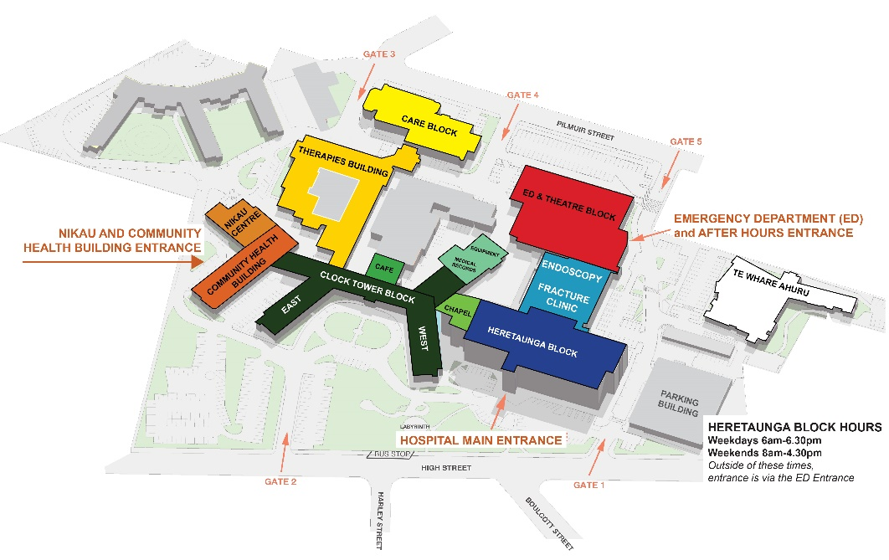

In times of hospital disruption e.g. pandemic or earthquake please refer to Hutt Hospital website for up-to-date instructions regarding access to the unit

Hutt Maternity is located on the second floor of the Heretaunga Block, at the hospital’s main entrance. When you come into the building, proceed to the lifts to take you to Maternity on Level 2.

You can use any gate to enter the hospital campus. We recommend using the High Street entrance (Gate 2) or Pilmuir Street entrance (Gate 5). There is a parking building next to the Heretaunga Block.

The Heretaunga Block is open on weekdays 6.30am-6.30pm and weekends 8.00am–4.30pm. Outside of these times, you must access via the Emergency Department (Gate 5) entrance. All other entrances will be closed.

## Booking an induction of labour

Birthing Suite accepts two inductions (max) per day excluding weekends. There is currently a working group in progress to re-evaluate the IOL booking process. Any changes will be communicated widely.

The method for booking and pathway for induction differs depending on parity, history of previous caesarean, anaesthetic risk, fetal wellbeing and gestation. Currently IOLs are booked in an obstetric clinic or the LMC may be contacted to book an appropriate time.

LMCs are recommended to refer to the ***Induction of Labour policy*** for instructions on referral and booking (click [here](https://silentone/content/DistrictDocs/Maternity/HuttValley/000000011320/__file__/000000011320.pdf)).

**Uncomplicated post-dates inductions of labour:**

1. Contact the CMM to confirm the booking time / date

**All other inductions of labour**

For booking all other IOLs, refer to instructions in the IOL policy, and use the following as a guide:

1. The IOL diary is managed by the Birthing Suite CMM. Contact the CMM to obtain details of availability
2. All requests for IOL will be **triaged by the Birthing Suite team on-call for the day of induction.**
3. Either the LMC or the clinic Doctor seeing the pregnant person will contact the CMM to confirm the booking time / date in the IOL diary. Please advise the CMM if there is any relevant information prior to admission.

### Day of Induction

All pregnant people being induced should arrive in Birthing Suite by 7.30am unless informed otherwise.

Core midwives usually commence the IOL process. The LMC will be called to attend when your client is in established labour requiring 1:1 care. If you are expecting to be off-call, please provide details of LMC back-up to be contacted for the labour.

At times of high acuity or limited staff availability, whānau should be made aware that the unit may delay IOLs for the safety of all involved.

## Elective Caesarean Section

Pregnant people attending secondary obstetric clinics are often booked for an elective Caesarean section at the time of consultation. Elective procedures are usually only performed 2-3 days per week between Monday - Friday, with a maximum of two electives performed per day.

Our skilled team of Theatre Midwives are there to provide midwifery care from Surgical Admissions, through theatre and PACU and up to the ward.

LMCs are encouraged to attend. If you are unable to attend on a particular day of the week, provide this information with the referral. This is accommodated where possible.

Please advise if there is any relevant information prior to admission.

## Primary Intrapartum Care (PIC) team

At times of high CMT demand there is a Primary Intrapartum Care (PIC) team option for LMCs to sign up for. This is for CMT clients who are in labour at Hutt Hospital and need a midwife to provide intrapartum care. A roster is made up for the month and you can choose what days you are available to be called for intrapartum care.

This is a completely optional roster but there is an expectation that once you are rostered on you are available.

You can choose to be part on a text list for LMCs happy to be messaged for intrapartum care. There is no obligation to respond to these texts. To be added to this list please email [access.agreements@huttvalleydhb.org.nz](mailto:access.agreements@huttvalleydhb.org.nz) or contact the Birthing Suite CMM.

## Neonatal review at birth

For babies that require neonatal attendance at birth, please contact the SCBU Registrar on-call (in advance where possible). Examples include:

|  |  |
| --- | --- |
| * Meconium stained liquor with fetal distress * Thick meconium * Preterm birth less than 37 weeks * Severe IUGR * Suspected fetal infection | * Emergency caesarean section * Elective caesarean (difficulty anticipated or under GA) * Vaginal breech * Instrumental birth * Fetal abnormality * Multiple births |

See policy (available on District Docs) [***Paediatric Attendance at Deliveries***](https://silentone/content/DistrictDocs/ChildrensHealth/HuttValley/PaediatricMedical/000000010749/__file__/000000010749.pdf)

## Documentation following birth

### Labour & Birth Summary: electronic record (BadgerNet)

* **A labour and birth summary** needs to be completed immediately following the birth. The responsibility for completion of this form sits with the LMC midwife or person facilitating the birth.
* Completing the ‘Labour and Birth’ form in BadgerNet produces the ‘Mother Labour and Birth’ summary.
* Printing a paper copy for the folder is not required. ‘Confirm and Save’ the summary to send a copy to Single Clinical Portal and to the LMC via email/EDI.
* Complete the **Newborn Notification Form** with whānau in pregnancy using the **Newborn Services Information Sheet** on available services.
* After birth, finalise (birth details) and ensure that the parents have completed the baby’s ethnicity details, then pop on clipboard in Birthing Suite office. This form **must** be signed by the parents.
* Create a WellChild book

### Post-birth Smart Form (BadgerNet)

* After birth, complete a paper Admission form and give to admin (**Out of hours** email to ED Administrators) to enable registration of the newborn and NHI labels to be created.
* Complete the ‘Post-birth Smart Form’ on BadgerNet. Complete all the tabs on the left.
* Information entered in to the ‘Post-birth Smart Form’ produces the ‘Baby Labour and Birth’ summary.
* Printing a paper copy for the folder is not required. ‘Confirm and Save’ the summary to send a copy to Single Clinical Portal and to the LMC via email/EDI.
* Information given is used to generate registration of the newborn with the Department of Internal Affairs. **Check patient labels and information on address, ethnicity and sex carefully – if incorrect, it can cause problems for parents registering their child.** Whānau will need to register their newborn online – see information in WellChild books.

### Infant feeding plan (BadgerNet & Paper)

* For all babies an infant feeding plan needs to be completed following birth. Please identify any factors which may influence normal establishment of breastfeeding. This needs to be documented in the ‘Overview’ section of the baby’s BadgerNet record, add or update the ‘Feeding Plan’.
* Please fill in the feeding chart (found on all bassinets) and orientate the parents to this

### Newborn notification form (paper)

* All whānau need to consent or decline enrolment in multiple regional services on the newborn enrolment form after birth.
* Complete the **Newborn Notification Form** with whānau in pregnancy using the **Newborn Services Information Sheet** on available services.
* After birth, finalise (birth details) and ensure that the parents have completed the baby’s ethnicity details, then pop on clipboard in Birthing Suite office.

### Newborn Observation Chart/Newborn Early Warning Score – NOC/NEWS (Paper)

All observations are recorded on the paper NOC/NEWS chart. The chart needs to be commenced for all babies by the LMC. Please remember to complete the risk assessment sections on both the paper chart and on BadgerNet. Ensure risk factors and management plans are clearly handed over to the next member of staff.

### Customised GROW Chart

GROW is a clinical system used to provide an individualised chart in pregnancy of projected fetal growth, and neonatal centile measurements after birth. Measurements are based on accurate maternal demographics.

Produced by the Perinatal Institute UK, the programme is funded for use in New Zealand pregnancies and babies by Health New Zealand | Te Whatu Ora. LMCs who use MMPO, BadgerNet or Expect will be able to access GROW and Centile calculations for neonates through their electronic notes.

To ensure a customized GROW chart can be generated, please provide details to generate this including height, weight and previous obstetric history with maternity facility booking. Centile calculation is required at handover to postnatal teams for all neonates.

Further information on GROW can be accessed here: <https://3dhb.sharepoint.com/sites/ccdhbintranet/SitePages/GROW-applications.aspx>

### Electronic discharge summary

**Electronic discharge summary** needs to be completed on BadgerNet when people are discharged from the maternity facility. This will be completed by staff, copies will be uploaded to Single Clinical Portal and sent to the LMC and GP via secure email/EDI.

## Handover

1. Inform the CMM/midwife on duty and administration team of the birth details, as soon as possible. See ISBAR section for handover recommendations:

* Details should include: mothers name, mode of birth, EBL, perineal status, obstetric and maternal history, date and time of birth, babies weight and sex. Discuss any discharge or transfer details with the CMM so a postnatal bed can be arranged.
* Where partners wish to stay overnight, this requires agreement with the ward CMM/midwife on duty, a single room and no violence or health risks. The support person should expect to abide by the rules as explained in ***MATY110 Partners or support people staying overnight within Hutt Maternity.***

1. Neonates requiring review prior to handover, the LMC midwife needs to contact the on-call paediatrician.
2. Please document the time you handover clinical responsibility of care, or discharge your clients from the maternity unit postpartum.
3. Handover of care verbally, should ideally be done, in front of the woman/person at the bedside. Please ensure all relevant information is present to ensure appropriate postnatal care can be facilitated.
4. The birthing room should be cleared away of any instruments and sharps, soiled linen and bins should be emptied. It is the responsibility of the midwife to remove blood from surfaces. Our birthing instruments are disposable and should be disposed of in the large sharps container in the sluice room. Forceps and ventouse equipment can be sent to CSSD for sterilization – if you are unsure please ask one of our midwives.

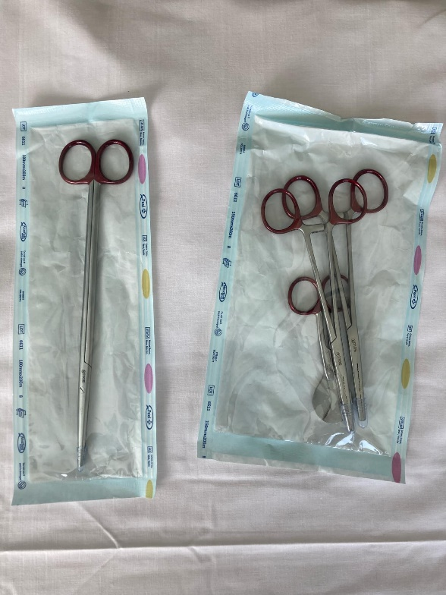

*These red handled instruments should be disposed of in the sharps container*.

## Readmissions

For unwell clients in the community, see acute referral section.

Readmissions in the first 42 days after birth are usually admitted to Postnatal or Gynaecology depending on their condition. As a BFHI accredited hospital, the baby is welcome to be admitted with the mother.

Transfer of clinical care from LMC to obstetric/medical team will occur, for the admitted mother **or** newborn until discharge back to primary care.

The **boarder mother or boarder newborn will remain under LMC care** while staying onsite. LMCs are be expected to complete all usual, checks/postnatal appointments while admitted if no transfer of clinical responsibility has occurred.

Please refer any relevant medical, whānau or social history to the CMM on duty for re-admissions, to enable appropriate care-planning.

## Patient At Risk Team (PAR Nurse)

The PAR service is a nurse-led team of specialised nurses, who work in partnership with the intensive care unit and ward teams. Using advanced clinical assessment, diagnostic reasoning and education to support the early recognition and management of acutely unwell and deteriorating ward patients. They can offer advanced skills, leadership and support during clinical emergencies. They are available 24/7 through the Operator – Dial “0”. If you require a consultation with the PAR nurse please inform your CMM.

## Postnatal Ward

The Postnatal ward is managed by a Clinical Midwife Manager as staffing allows, out of hours the Birthing Suite CMM manages the postnatal ward. The CMM should be contacted to discuss additional care requirements of inpatients.

The postnatal ward is resourced for 17 antenatal/postnatal beds, there are four unresourced beds available for people “Rooming In” with babies under SCBU care.

The rooms are a mix of single and double rooms with shared bathrooms. Single rooms are most often allocated to people who require additional medical or social support. The allocations are made by the CMM on duty.

The following specialist services are accessible for inpatients at Hutt:

* Lactation consultation (maternity and SCBU)
* Physiotherapy – women’s health
* Social work
* Mental health – Crisis Assessment & Treatment Team (CATT)
* Women’s ultrasound
* Phlebotomy
* Newborn hearing screening (see below)

Postnatal stays are funded for 24-48 hours with some people requiring longer and some shorter stays. The LMC may identify clinical reasons for a longer length of stay (discuss with CMM) which may include:

* Breastfeeding issues
* Post-operative recovery
* Mental health concerns
* Prematurity

To facilitate bed flow, there may be times when staff recommend to well patients an earlier discharge.

### Friends and whānau visiting

People receiving care in birthing suite are able to have visitors 24/7 due to the nature of labour and birth. The postnatal ward visiting hours are between 8.30am and 8.30pm. Visiting restrictions can change dependent on external circumstances such as pandemic. It may change with little warning so please check with the Birthing Suite CMM if you or your clients have any questions.

We welcome support people to stay overnight. Our facilities are able to accommodate one support person overnight with the following criteria:

* The support person must be over 18 years old
* Your client is in a single room.
* There is a documented Family Violence Screening

## Transfer to primary units

Transfer to the primary units can occur when the person is clinically ready for discharge, no sooner than four hours after birth of the placenta. Transfer to a primary unit is encouraged for all low risk people and should be discussed antenatally.

Following a caesarean, people can transfer to the primary unit following medical discharge (this should be at least 24 hours after birth).

Please see the sections “Kenepuru Maternity Unit” and “Paraparaumu Maternity Unit” at the end of this handbook.

## Infant Feeding and Support

Capital, Coast and Hutt Valley has Baby Friendly Hospital Initiative accreditation at all maternity facilities. This means that at the time of discharge from hospital all four facilities maintained an exclusive breastfeeding rate of 75% or more.

If a parent is unable to breastfeed or chooses not to do so they will be supported in their decision. Education provided by staff will include the sterilising of bottles and formula preparation.

### Lactation Consultants

Inpatient support is available Monday to Sunday for people with complex breastfeeding issues at Hutt Hospital. Inpatient referrals can be made through the electronic whiteboard or by phoning the lactation consultants.

### Maori and Pacific Breastfeeding Support

Stephanie Davis provides breastfeeding support for Māori and Pacific māma alongside Te Rūnanganui o Te Āti Awa in Waiwhetū.

Mondays, Tuesdays and Wednesdays, she will introduce her services to māma when they are inpatients on those days and follow up any discharges to offer community support.

She is supported by the breastfeeding advocates at Whāngai Pēpē.

Stephanie Davis – 021 1966 292

### Breastfeeding support in the community

Referrals can be made by emailing this [form](https://silentone/content/DistrictDocs/Maternity/HuttValley/Forms/000000010571/__file__/000000010571.pdf).

Information leaflets are available for breastfeeding people [here](https://silentone/content/DistrictDocs/Maternity/HuttValley/PatientInformation/000000010168/__file__/000000010168.pdf).

### Antenatal milk expression

Hutt Hospital supports the use of antenatal milk expression for most pregnant people (see policy for details), in case supplementation is required after birth.

Expressing packs are available from the Maternity Enquiries on level 2, or through MAU.

## Special Care Baby Unit (SCBU)

SCBU provides secondary level care for babies from 32 weeks gestation.

Premature babies likely to be born before this gestation or very low birthweight babies will need support from the NICU at Wellington Regional Hospital. Ideally people will birth at Wellington but at times these babies will be transferred to the NICU post birth. A neonatal retrieval team will facilitate the transfer of the baby and Hutt maternity staff will endeavour to arrange transfer of the mother to Wellington Hospital as soon as possible after transfer of the baby.

Paediatric staff provide specialist advice and support during the antenatal/postnatal period, and during births requiring paediatric attendance *(see referral section)*.

SCBU information for parents is available from the Unit. If you are aware your client’s baby will require SCBU admission, tours for parents can be arranged prior to the birth.

### Visiting SCBU

Parents/Mātua/legal guardians can visit their baby in SCBU 24 hours a day.

2.30-6.30pm is open visiting. Due to limited space, 2 people only are permitted at the bedside and a parent/mātua must be present. Siblings can only visit at this time.

Visitors (excluding siblings) must be over 12 years of age.

Anyone with coughs, colds or infectious diseases will not be permitted entry for the safety of the babies on the unit.

If the unit is over-capacity, or situations change (such as Covid/Flu/RSV circulating) visiting may be restricted to parents and siblings only. This will be communicated to whānau by the shift coordinator or SCBU manager.

## Wellington Hospital Neonatal Intensive Care Unit (NICU)

NICU provides secondary and tertiary level care for babies from 23 weeks gestation. Neonatal staff provide specialist advice and support during the antenatal/postnatal period, and during births requiring neonatal attendance *(see referrals)*. NICU has a comprehensive intranet page to help familiarize yourself with staff in the unit. You can find it [here](https://3dhb.sharepoint.com/sites/ccdhbintranet/Pages/Teams/Neonatal-intensive-care-(NICU).aspx).

NICU information for parents is located here ([click here](https://www.ccdhb.org.nz/our-services/a-to-z-of-our-services/neonatal-intensive-care-unit-nicu/))

Virtual tour of the unit are available at: <https://www.youtube.com/watch?v=8bB87ZEAAXs>

### Visiting NICU

Open visiting is allowed for parents of NICU babies. Other visitor restrictions can change with little warning so please check with the NICU Charge Nurse Manager if you and your clients are coming in to hospital under upgraded alert levels.

## Referrals

### Urgent consultations and referrals

See “How to create Internal Referral” in the “Electronic Systems” section.

### ISBAR communications handover tool

We recommend the use of the **ISBAR** communication tool at Hutt hospital for all urgent consultations, referrals and handovers:

|  |  |
| --- | --- |
| **I** | **IDENTIFY**  The person you are talking to, your name, role and location Client/patient’s/newborn’s name and NHI |
| **S** | **SITUATION**  Reason for communication, is it an emergency or urgent |
| **B** | **BACKGROUND**  Relevant obstetric history, relevant medical or family history |
| **A** | **ASSESSMENT**  Assessment of what is occurring, latest assessment and investigations, is this outside normal range? |
| **R** | **RECOMMENDATION**  Suggested clinical plan or action, request for assistance,  agree who will do what and when |

### Escalation Process

If you have received advice from a registrar or house surgeon and you feel unhappy with that advice or remain concerned about your client’s (or newborn’s) condition, it is essential you escalate your concerns again. Support can be obtained by talking with the CMM or a colleague. If you are still concerned, contact the on-call SMO directly.  It is important that for the safety of your client or newborn and health care providers, they remain at the focus of all conversations and that we keep everyone safe.

### Acute and Afterhours Referrals

The following should be used as a guide only.

**To prevent the spread of infection, please alert staff if there is a concern about COVID, measles, whooping cough, influenza, or other infection.**

|  |  |
| --- | --- |
| **Miscarriages**  ***Less than 20 weeks*** | Send person to the Emergency Department. Contact obstetric registrar to inform of admission. |
| **Ectopic pregnancies** | Send person to the Emergency Department as soon as possible. Refer to O&G registrar (weekdays/daytime), or Birthing Suite obstetric registrar (after hours) |

|  |  |
| --- | --- |
| **Antenatal concerns – woman or fetus** | Refer to both Birthing Suite CMM and consult with Birthing Suite obstetric registrar, following assessment. People are likely to be reviewed in Birthing Suite and a management plan made. |
| **Postnatal concerns – woman**  *Less than 7 days* | Refer to Birthing Suite obstetric registrar, following assessment. They will advise the best location to send the person to. Advise CMM of pending arrival. |
| **Postnatal concerns – woman**  *8 days or more* | Refer to Birthing Suite Obstetric Registrar, following assessment. They will advise the best location to send the person to. Advise CMM of pending arrival. |
| **Neonatal concerns**  *Less than 7 days* | Refer to Paediatric registrar (Children’s Ward) following assessment. They will advise the best location to send the newborn to for review. You are likely to be advised to send the newborn to Emergency Department, but if not urgent may be referred to GP. |
| **Neonatal concerns**  *8 days or more* | Refer to paediatric registrar (Children’s Ward), following assessment. They will advise the best location to send babies to, e.g. Emergency Department, or to the baby’s GP.  For non-urgent referrals, contact the baby’s GP, to confirm if referral to general practice is appropriate. |

## Other Services at Hutt Valley

### Anaesthetics

#### Inpatient

A nominated Obstetric Anaesthetist is present on Birthing Suite Monday – Friday 0800-12pm, they are available on extension #9126. This is a consultant position that rotates every day.

Outside of these hours, an anaesthetic registrar (Duty Anaesthetist or “DA”) is available 24/7 on #9091.

#### Outpatient

An antenatal anaesthetic consult clinic is run out of MAU every week. Ideally the request for consultation should be made between 20 and 28 weeks, although some pregnant people would benefit from earlier referral.

**For non-urgent referrals** you can create an internal referral through Single Clinical Portal.

Urgent referrals should be made through the Obstetric Anaesthetist (#9126) Mon-Fri 08.00-4.30pm or the on-call Duty Anaesthetist (#9091) after hours.

Outpatient anaesthetic appointments are available for any client who has:

* Significant cardiac disease
* Significant respiratory disease
* Significant systemic disease with the potential to impact on multiple organ systems
* Neurological conditions (even if symptoms are mild)
* Significant haematological conditions eg
  + Any coagulopathy including Von Willebrand’s disease
  + Significant thrombocytopaenia (platelets <100)
* Pathology of the lumbar spine
* Pregnant people likely to pose a technical challenge for the Anaesthetist
* Known or suspected difficult airway
* Morbid obesity (BMI >40)
* Pregnant people at risk of massive obstetric haemorrhage (e.g. major placenta praevia)
* Pregnant people in whom consent is likely to be difficult to obtain in labour
  + A person who would refuse blood products
  + A person with an intellectual disability
  + A person who requires an interpreter to consent
  + Any person with strong views for or against anaesthesia in labour should be offered the opportunity to discuss with an anaesthetist so they are fully informed.
* Any condition in which the obstetric/midwifery team or pregnant person has concerns and would like an anaesthetic opinion

The above list is not exhaustive, for further information please contact Maternity Assessment Unit.

### Cultural Support Services

### Whānau Care Services

The Māori Health Team was created to support whānau, the community, and the health workforce to improve outcomes across Māori health, including equitable access to services and supports that are appropriate to the needs of whānau. About 24,000 Māori whānau make up about 17 percent of the total population of the Hutt Valley, which is slightly higher than the national average.

Whānau Care’s primary functions are to:

* Support Māori whānau in their hospital and health care journey
* Connect whānau with appropriate community supports and services
* Build strong connections and foundations within Māori communities
* Influence health services to ensure they are equitable
* Support the hospital to meet the needs of Māori whānau

The Māori Health Team also work closely with Māori health and social service providers to ensure whānau have appropriate and co-ordinated services that best meet the needs of their whānau.

Whānau can contact the team at any time before, during or after their hospital stay.

|  |  |
| --- | --- |
| Tikanga | * Application of the guidelines in practice * Performing karakia * Body parts return – practical arrangements |
| Temporary accommodation | * Te Whare Whānau o Te Pehi Parata   (for out of town whānau in special circumstances)   * Other accommodation options |
| Communication | * Facilitation of whānau hui * Assistance with delivery of clinical information * Consultations with whānau |
| Tangihanga support | * Terminal illness and at the time of death * Bereavement processes of whānau spokespersons |

If you have whānau who request the support of the Whānau Care team, or who you believe would benefit from the services, contact 04 5666 999 and ask for Whānau Care Services (Monday to Friday between 8am and 5pm) to discuss with the team, prior to referring.

### Pacific Health Support Services

The Pacific Health Unit (PHU) is dedicated to ensuring a seamless healthcare journey for Pacific patients. They provide services across Wellington, Kenepuru, Hutt Valley and Wairarapa hospitals.

The team works closely with Pacific patients and their fanau/family to understand their health requirements and connect them with culturally appropriate social and clinical support services – both within the hospital and in the broader community.

We have close relationships with community-based Pacific support services and will refer patients to them to ensure ongoing care and support.

**At Hutt Hospital, the team's office is based on the ground floor of the Clock tower building not far from Cafē Stat. Phone 570 9770.**

The service provides:

* Cultural support and advocacy for vulnerable Pacific patients and their families to ensure a culturally sensitive health system is established that works for our people
* Cultural support to clinicians and advocacy for appropriate Pacific models of care for the holistic care of our Pacific patients
* Clinical support for Pacific patients through interpretation of health information where possible for better understanding of health conditions and medication adherence
* Links to appropriate hospital services and community Pacific health support services for ease of “continuum of care” for patients
* Social support for Pacific patients and family who present with complex cultural and social family dynamics
* Pacific advice and leadership on Pacific Health issues across all levels in the district

**Referral**

Make a referral through the Single Clinical Portal (or Concerto) / Clinical Documents / Pacific Health Referral- Hutt/ Wellington).

Pacific patients and their family can contact our Pacific Health Unit directly. We encourage patients to discuss their referral.

### Dietitian

Any pregnant person who has dietary restrictions which may impact on their pregnancy including: hyperemesis, sudden weight loss during pregnancy or diabetes can be offered referral to the dietitian.

Inpatient referrals for dietetic services can be made as above –by clicking the “diet” tab on the Maternity Whiteboard.

Outpatient referrals can be made through “Create internal referral” on Single Clinical Portal (or Concerto)

### Physiotherapy & Pelvic Health referrals - Inpatient

Physiotherapy referrals can be made on the ward via the electronic whiteboard. If urgent please follow-up with a phone call. Referrals may include:

* 3/4th degree tears – they will then be followed up in outpatients
* Problems with continence/pelvic floor education
* Reduced mobility due to pain

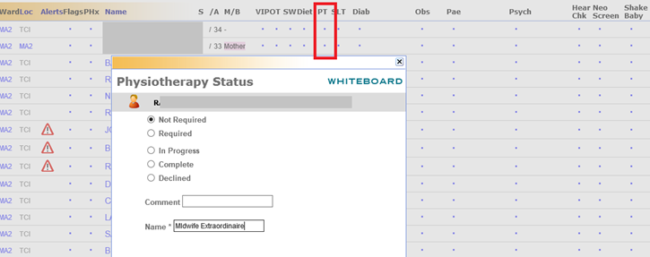

### Iron Infusions

Refer to the [Ferric Carboxymaltose Maternity Inpatient Administration](https://silentone/content/DistrictDocs/Maternity/HuttValley/000000010642/__file__/000000010642.pdf) policy for treatment pathway. This policy is currently under review and will be updated in the near future to include an appropriate referral pathway.

**To refer** a pregnant person for consideration of an iron infusion please create a referral to Antenatal Clinic, or you can email Julie Mannering (CMT CMM) directly.

### Maternal Wellbeing and Child Protection Group Referral

This is a multi-agency group set up to identify and support whānau who have complex social, addiction or mental health needs. Following referral, the group aims to collaborate with whānau and their LMCs to help plan care and increase the chances of families parenting successfully, while protecting vulnerable infants.

Membership of the group includes:

* Naku Enei Tamariki (NET) Manager
* Wellchild Providers (Plunket, Tamariki Ora and Thriving Cores)
* Integrated Community Response (Kokiri Marae)
* Kaiwhahairi Haapu Wananga (NET)
* Oranga Tamariki Practice Leader
* Violence Intervention Programme Coordinator
* Midwife Manager
* Community Midwife Clinical Midwife Manager
* Associate Clinical Nurse Manager, Special Care Baby Unit
* Women’s Health Social Worker
* Hapū Māmā social worker
* Capital, Coast and Hutt Valley District Mental Health Liaison
* Police Family Safety Team Member

Referral can be made for whānau with:

* Complex social needs
* Addiction
* Mental health needs
* Or is mandatory for whānau who have received a court order or directed by Oranga Tamariki (Ministry for Children).

LMCs are encouraged to discuss with whānau, and refer early in pregnancy to improve information sharing and enable time to link whānau with services and organisations and provide wrap around supports. Referrals are reviewed weekly. Urgent referrals are prioritised.

Fill in the referral form [here](https://intranet.huttvalleydhb.org.nz/forms/clinical/maternity/vip-referral-form-to-mccw-mag.pdf), and email it to Maternal Care and Child Wellbeing Multi-Agency Group: RES-VIP@huttvalleydhb.org.nz

### Newborn Hearing Screening

The aim of the New Zealand Universal Newborn Hearing Screening and Early intervention Programme is for the early identification of babies with hearing loss so that they can access timely and appropriate interventions. All babies should be offered screening for hearing loss before one month of age. If screening is not completed on the postnatal ward or the baby was born at home then screening can be carried out in an outpatient clinic.

For homebirths it is the responsibility of the LMC to use the referral form [here](https://silentone/content/DistrictDocs/Maternity/CapitalCoast/Forms/000000008328/__file__/000000008328.pdf) and provide the required information so that a community appointment can be made.

### Obstetric Diabetes Clinic

Under the Referral Guidelines, it is recommended that pregnant people with **pre-existing or diabetes of pregnancy (gestational diabetes)** are referred to the Antenatal Diabetes Clinic for planning of care during pregnancy and birth. Please refer to Antenatal Diabetic Clinic using the usual secondary care referral process.

*NB A nationwide Diabetes of Pregnancy Guideline is in development, please refer to the nationwide document when available for the most up to date guidance. (October, 2024).*

Refer to the Management of Antenatal Diabetes policy [here](https://intranet.huttvalleydhb.org.nz/forms/clinical/maternity/vip-referral-form-to-mccw-mag.pdf).

### Prophylactic Anti-D

Rhesus negative pregnant people who are antenatal inpatients at Hutt Hospital will be offered prophylactic Anti-D immunoglobulin during their stay.

LMCs can order Anti-D immunoglobulin from New Zealand Blood Service using the **Request for Blood Bank Tests and Blood Components or Products** (111F018) form from NZ Blood ([click here](https://www.nzblood.co.nz/clinical-information/transfusion-medicine/information-for-health-professionals/request-forms/)), and administer to their clients in the community (in a setting with access to resuscitation equipment).

### Safe Sleep Device referrals

Babies at high risk of SUDI receive free safe sleep pods, so they can safely bed-share with their parents/mātua. The Moe Ora Mo Ngā Pēpi programme at Kokiri Marae provides pēpi pods (plastic pods) or wahakura (kaupapa Māori woven flax pods). Both pēpi pods and wahakura come with a mattress, sheets and blanket and are for the family to keep. The pods hold babies up to five months of age, when babies are considered most at risk from sudden infant death.

Whānau that meet two of the three referral criteria: (1) Māori or Pacific, (2) clinical risk such as prematurity and low birthweight, or (3) environmental risk factors such as an unsafe sleeping environment – can be referred to the Safe Sleep programme for a free pod. The pod comes with a resource kit for breastfeeding support and smoking cessation. Referral forms can be found at [Wahakura/Pēpipod Referral Form](https://www.takirimai.org.nz/ReferralForm) or contact Marice Martine on 022 077 4430

### Sexual Health

The Wellington Sexual Health Service provides specialist sexual health care to the greater Wellington, Hutt, and some areas of the Wairarapa.

We have a specialist on-call line 0508 144 441 for clinical advice on complex cases, to discuss acute referrals and provide advice for interpreting syphilis serology.

Referrals are received either through, E- referrals EDI: shealthw or sent password protected to our generic email [sexualhealth@tuora.org.nz](mailto:sexualhealth@tuora.org.nz)

The triage nurse line is available on 0800 188 881 select option 3.

STI management guidelines are available on the New Zealand Sexual Health Society website  [Inclusive NZ Sexual Health Guidelines for Professionals | NZSHS](https://aus01.safelinks.protection.outlook.com/?url=https%3A%2F%2Fwww.nzshs.org%2Fguidelines%2F&data=05%7C02%7C%7C0177b2c3d719434e6bc208dcaa8e4b6c%7C99d61bf7055a41ceb0b204bfec89f424%7C0%7C0%7C638572775336305599%7CUnknown%7CTWFpbGZsb3d8eyJWIjoiMC4wLjAwMDAiLCJQIjoiV2luMzIiLCJBTiI6Ik1haWwiLCJXVCI6Mn0%3D%7C0%7C%7C%7C&sdata=%2FymV92Ry75Rsq4iePA1iyQpJx68sZTnFuuMpfxNzA88%3D&reserved=0)

Wāhi Mārie is the new daytime sexual assault/family violence unit that has opened at the Cuba Street / Kelvin Grove site.

We provide a safe and confidential space, Doctors and Nurses with specialist training in the care of people that have experienced trauma from sexual harm.  We see people aged 14 and over.  When referring someone 16 or under, please ring to discuss before making a referral.

Visits are free and open to anyone that has ever experienced harm from sexual violence.

For advice, or to make a referral for a therapeutic assessment, ring 04 805 0522, Monday-Friday 9:00-4:00pm or email [wahimarie@tuora.org.nz](mailto:wahimarie@tuora.org.nz)

E- Referrals can be made through BPAC or through our website, or HealthLink.  EDI: wahimari

Self-referrals can ring for information or to book an appointment on our freephone, 0800 723 377.

On-call forensic services are provided 24/7 for people that have been sexually assaulted in the last 7 days.  These can be arranged by Police or by contacting Wellington HELP.

### Specialist Maternal Mental Health (SMMH), MHAIDS, Capital, Coast, Hutt Valley and Wairarapa

The SMMH service is for people who are pregnant or have a baby under one year old (at the time of referral) who are experiencing moderate to severe mental health issues.

We offer a range of services, including: mental health assessments; treatment and planning; individualised support and therapy; medication reviews and advice; information about community support services; and a Wellbeing clinic.

SMMH covers Wellington, Porirua, Kāpiti and the Hutt Valley. We meet with people and their partners and whānau in a location that suits them this is often in their own homes, or at a community mental health office in the Wellington region.

In the Wairarapa, a member of our team works alongside GPs as well as the adult community mental health team to advise other health professionals who are caring for pregnant people or new parents who are experiencing mental health issues.

Appointments require consent from the pregnant person. For pregnant people with pre-existing **moderate to severe mood disorders** a referral can be made directly to SMMH. Refer to the Maternal Mental Health Referrer’s Guide [here](https://silentone/content/DistrictDocs/Maternity/CapitalCoast/Forms/000000102699/__file__/000000102699.pdf).

#### SMMH Referral:

Urgent and after hours referrals contact 0800 745 477.

For non-urgent referrals to SMMH phone 04 806 0002 or email [tewharetipu@mhaids.health.nz](mailto:tewharetipu@mhaids.health.nz) and provide the following information in the email:

Attention to SMMH

* Full name, DOB, current address and contact details of client
* Full name, current address and contact details of client, their parents/legal guardian (if under 18) and next of kin
* Referrer contact details
* Reason for referral – current and historical concerns
* Current and previously trialled interventions
* Current support networks
* What is being requested from MHAIDS service
* Confirmation of consent given by client and/or legal guardian

To discuss whether a referral seems appropriate or to follow up on a referral you can call 04 806 0002 and request a call-back from the SMMH duty person.

Working collaboratively with referrers where possible is encouraged. Please don’t hesitate to make contact either through the duty line above or directly with your client’s clinician if they are in our service already.

Further information about the service can be found [here](https://www.mhaids.health.nz/our-services/specialist-maternal-mental-health-service/).

#### Wellbeing Clinics

SMMH also provide a secondary care triage clinic as part of consult-liaison work. This service is offered fortnightly at Wellington Hospital (Women’s Clinic), Kenepuru Hospital (Outpatients), Hutt Hospital (Maternity Services) and Masterton Hospital (Maternity Services).

The Wellbeing Clinics are for pregnant women with mild to moderate distress where some brief contact or linking with other services may prevent the need for mental health services. It is not for people who are already under a mental health team or are experiencing mental health crises. An appointment for a brief assessment/discussion is offered.

**NB:** Pregnant people cannot be referred to both Specialist Maternal Mental Health (SMMH) and the Wellbeing Clinic. You can only refer to one service.

Referral to the Hutt Wellbeing Clinics are arranged by contacting Maternity Assessment Unit at Hutt Hospital. Capital and Coast Wellington/Kenepuru referrals are to be sent by email to [RES-primcareReg@ccdhb.org.nz](mailto:RES-primcareReg@ccdhb.org.nz) using the Wellbeing Clinic Referral form on Capital Docs.

For people (or their whānau) who are feeling anxious, stressed or not enjoying their pregnancy or newborn, 1737 is a national telephone/text service which provides free counselling 24/7. 1737 will provide text or phone contact depending on their preference.

**For urgent mental health support contact:**

**0800 745 477 (this is a 24/7 service)**

### Social Work

The Hutt Hospital Community Social Work Team provides a free, confidential short-term service, to anyone with a physical health issue. The service also accepts referrals for family/whānau members who are affected by the physical health needs of someone they care for.

Consent from the client/patient is always required.

Specifically we work with people experiencing:

* A new diagnoses or a difficulty related to a chronic health condition
* Difficulties arising from, during or after pregnancy
* Practical, financial, interpersonal, social difficulties related to their health condition
* Stress when caring for either a child or adult with health issues.

Our service is generally short-term and non-acute. Our work is centred on emotional and practical support. We engage with clients to identify areas with which they would like assistance.

The Hutt Hospital Inpatient Social Work Service provides interventions to people who have been admitted to the hospital. There are social workers on all of the inpatient wards. This team works to support patients with discharge planning and any psychosocial issues that are impacting on their health.

If you have a client that would benefit from a social work referral, please refer via the internal referral system on Single Clinical Portal (or Concerto). Please provide all relevant information on the referral including: gravida, parity, EDD, gestation (or days post birth if postnatal), relevant social history and a comprehensive summary of the reason for referral.

## Primary Units

### Kenepuru Maternity Unit (KMU) Te Hohipera o Kenepuru / Kenepuru Hospital

16 Hospital Drive, Kenepuru

#### Location

KMU is a primary maternity facility attached to Kenepuru hospital which is situated approximately 30 minutes’ drive from Hutt Hospital.

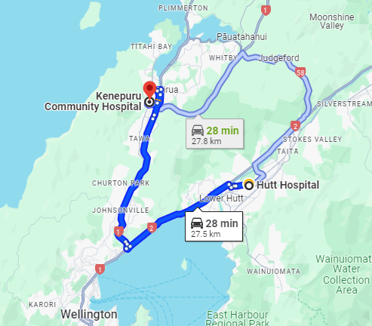

#### Facilities

KMU has two birthing rooms, one birthing pool and six single postnatal rooms with ensuite bathrooms. The unit has an assessment room that LMCs can use for antenatal, labour and postnatal assessments, CTG’s and/or combining with a tour of the unit. It is best to book this space. There is also a whānau room with couches, tables, a TV, and tea and coffee making facilities. KMU is very lucky to have a sizable garden area with picnic tables and sun umbrellas where whānau can spend time together.

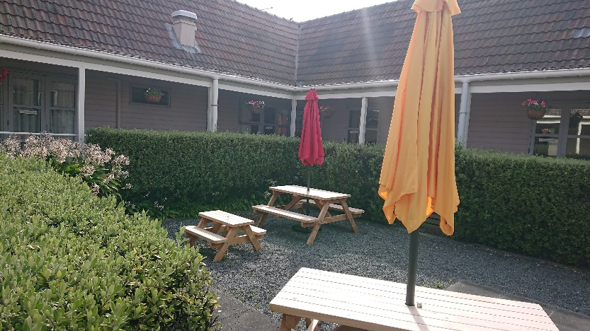

If partners wish to stay overnight, and meet the eligibility criteria, discuss this with the KMU midwife on duty.

#### Staff

KMU is managed by a Midwife Manager – Jenny Quinn and coordinated 24/7 by a midwife. There is always a midwife on duty to support LMCs and provide postnatal care. Most shifts have two core staff - either two midwives or a midwife and a nurse. KMU also has two part-time administrators, two HCA’s and cleaning staff.

#### Booking at KMU

The policy for the ‘*Booking criteria and administration process for Birthing at Kenepuru/Paraparaumu Primary Facilities’* policy canbe found inDistrictDocs *OR* [*click here*](https://silentone/content/__object__/000000000161.pdf)(See Maternity Bookings section).

#### Transfers to KMU for Postnatal Stay

People who have birthed at Hutt Hospital are welcome to transfer to KMU for their postnatal stay. Postnatal transfer to KMU is dependent on the acuity and available beds. People who booked to labour and birth at Kenepuru should be given priority for a KMU postnatal bed. Talk to the CMM to arrange.

#### Tours of KMU

KMU welcomes opportunities for people to come and see the unit for themselves. Please call KMU to see what options there are for enabling whānau to have a tour of the unit or direct pregnant people to the virtual tour. If you are able to attend with your client it is a great opportunity to combine a tour with an antenatal appointment.

#### Virtual tour of KMU

A virtual tour of KMU can be found on the Wellington Pēpē Ora website site under ‘Places to give birth’ or click [**here.**](https://www.youtube.com/watch?v=PFSI9nJ-mHs)

#### Open Days at KMU

KMU will be holding Open Days every four months where whānau (and LMC midwives) can come and see what the unit has to offer. As an LMC you will receive notification of the Open Day dates and there will be publicity with each upcoming event.

#### Monthly KMU staff and LMC hui and shared lunch

The KMU staff and LMCs have a regular monthly hui alternating Wednesday and Thursday 1pm on the 1st week of every month. Bring a plate and share some kai. Notices are shared, any issues arising are discussed and education sessions are available from time to time as well.

#### Birthing at Kenepuru Trial (BAK)

The **B**irthing **a**t **K**enepuru **(BAK) Trial** is a midwifery-led, collaborative between the Community Midwifery Teams (CMT), Kenepuru-based midwives and LMC midwives.

It aims to offer a choice of place of birth for those who are eligible for primary birth and are under the care of the Capital, Coast and Hutt Valley CMTs. LMCs in the Wellington region have offered to provide labour and birth care for CMT whānau that meet the criteria and wish to labour and birth at KMU. LMCs claim for labour and birth care as per section 94 of the primary maternity services notice.

This is a brief summary of BAK midwifery roles:

* **The Community midwifery Team**

The Community Midwifery Team midwives will provide antenatal care throughout the pregnancy. As part of that care they will explain labour and birth options, provide information and answer any questions. They will also give the Kenepuru Maternity Unit free 0800 contact number to call when the person thinks they are in labour after 37 weeks gestation.

* **Kenepuru Maternity Unit (KMU) midwives and nurses**

When the person thinks that they are in labour, they call the KMU midwife on the free KMU number **0800 536 400**. The midwife will provide early labour advice and invite the person in for an assessment if they think the labour is progressing. If the KMU midwife assessment confirms labour she contacts the **BAK LMC** to come and provide labour and birth care at KMU.

* **A Birthing At Kenepuru (BAK) LMC midwife** attends KMU to provide labour and birth care when the KMU midwife calls her to confirm that labour has established.

**A postnatal LMC midwife** will be allocated via CMT.

There are protocols and flowcharts available that define the communication pathways and detailed roles for all the Midwifery teams involved.

BAK LMCs can choose to be on a three month roster, a text list and an after-hours call list to provide labour care for BAK clients. If you are interested in becoming a BAK LMC please get in touch with **Karen Daniells (ADoM): 027 283 0491**

#### Outpatient services at Kenepuru

Kenepuru Hospital offers numerous outpatient services to support the maternity community. These include iron infusions (available in the Medical Day Unit and arranged by medical staff), Maternal Mental Health appointments, Newborn Hearing Screening, Obstetric Clinics, Women’s Physiotherapy clinics, prophylactic Anti-D clinic and newborn (paediatric) clinics. At this time there are no maternity ultrasound services available based at Kenepuru Hospital.

#### Support, Escalation, Transfers and Emergency transfers from the KMU

If the LMC needs assistance when providing midwifery care at KMU, there are a number of clinicians that can be called upon depending on the nature and the urgency of the assistance required.

In the first instance consult, discuss and work with the KMU midwife on shift. Care is provided by the most appropriate health practitioner(s) available.

Urgent assistance can be summoned by pressing the emergency bell in the birthing room.

#### Kahu Pōkai/Midwives & Tapuhi/Nurses

KMU midwives provide clinical and logistical support. They can also provide a collegial sounding board to work through different plans of care.

On some shifts there will be an experienced midwife and an experienced nurse. The nurses can provide clinical and logistical support appropriate to their scope of practice.

HCA and Administrator support are available for four hours per day.

#### Midwife Manager

There is usually an experienced Midwifery Manager on site 8.00am-4.30pm. She can be called upon during working hours for additional clinical, logistical and decision making support.

#### Duty Nurse Manager KMU- 0274583388 / #6373

The Duty Nurse Managers (DNM) rotate through Wellington and Kenepuru Hospital. They are responsible for ensuring that operations run smoothly after-hours across the hospital, including KMU. They are also the first point of contact for any issues like fire, mass casualty, natural disasters.

The DNMs provide leadership in a variety of medical and non-medical settings. They are advanced life support trained. They are able to access Blood Bank and dispense blood products including Anti-D. Most have completed PROMPT training and Newborn Life Support (NLS) programmes.

If unfolding events require escalation and support greater this can be provided by the KMU midwifery and nursing staff, and the DNM can be called for logistical and clinical support. The DNM will come with the Medical Registrar and an orderly, in response to a Medical Emergency Team (MET) call – 777.

At KMU, it will usually be the KMU midwife that calls the DNM while the LMC continues to manage the clinical situation.

#### Patient At Risk (PAR) nurses

The PAR service is a nurse-led team of specialised nurses, who work in partnership with the intensive care unit and ward teams.  Using advanced clinical assessment, diagnostic reasoning and education to support the early recognition and management of acutely unwell and deteriorating ward patients. They can offer advanced skills, leadership and support during clinical emergencies. They are available 07.00am-7.00pm Monday to Friday at Kenepuru Hospital on #6814.

#### Clinical Midwife Manager (CMM) support from Birth Suite Wellington Hospital

Clinical midwife managers in birthing suite at Wellington are responsible for coordinating the clinical resources in the secondary / tertiary unit. They are also there to provide clinical and collegial support to midwives.

Call the clinical midwife manager **CMM: 021 199 8212 *if***

* you need some additional collegial support
* you would like another midwifery opinion

#### Consultation with the obstetric/neonatal team from KMU

The Capital, Coast protocol for transfer from the primary units to Wellington Hospital can be found [here](https://silentone/content/__object__/000000101272.pdf). There is a summary of key actions below.

#### Non-urgent

If you are providing midwifery care at KMU and a non-urgent indication has arisen for obstetric/neonatal consultation (Referral Guidelines) and transport to the hospital,

* call the KMU midwife to assist you with midwifery care as required, then, with consent, and enabling a three way conversation where able, arrange for the most appropriate person to:
* Call the Obstetric or Neonatal team on-call: registrar/SMO to agree immediate plan of care and mode of transport to Wellington Hospital
* Call the birthing suite CMM: 021 199 8212 so that they can prepare for your arrival
* Call 111 - Wellington Free Ambulance to arrange transport if required

#### Emergency

If you are providing midwifery care at KMU and there is an obstetric or neonatal emergency,

* Use emergency bell to call the KMU midwife (and nurse) to assist. Then arrange for the most appropriate people to:
* Call **777** for hospital emergency support (Duty Nurse Manager, the duty Medical Registrar, an orderly and emergency resuscitation equipment will respond)
* Call **111 - Wellington Free Ambulance** to arrange emergency transport to Wellington Hospital and provide paramedic clinical support.

State

* Your name
* That you are a midwife
* The address: Kenepuru Maternity Unit, Kenepuru Community Hospital, 16 Hospital Drive, Porirua
* Situation: **That this is a life threatening, time critical maternal/neonatal emergency** requiring immediate transport to Birthing Suite Wellington Hospital

This sequence of statements will enable the paramedic Call-Centre to arrange emergency Wellington Free Ambulance support and transport from Kenepuru to Wellington Hospital ASAP.

#### For Maternal emergency

* Call the obstetric **on-call SMO** to agree an immediate plan of care enabling a three way conversation as able
* Confirm mode of transport and plan during transport
* Request ongoing SMO input into clinical management on ‘hands free’ if required.

#### For Neonatal emergency

* Call the neonatal **on-call SMO** to agree an immediate plan of care, enabling a three way conversation as able.
* **Confirm with the SMO** that they will organize the NICU retrieval of the baby if applicable. Newborn’s requiring assistance or at risk of requiring assistance **are always transferred from the primary unit to Wellington by the NICU retrieval team.**
* Request ongoing SMO input into neonatal clinical management on ‘hands free’ if required

The Transport Retrieval to Wellington NICU policy can be found in DistrictDocs or click [**here.**](https://silentone/content/__object__/000000000680.pdf)

### Paraparaumu Maternity Unit

35 Warrimoo St, Paraparaumu

#### Location

PMU maternity unit is a primary maternity facility situated approximately 40 minutes north of Hutt Hospital, as part of the Kāpiti Health Centre. Pregnant people without medical or maternity complications are encouraged to birth here.

#### Facilities

PMU has one birthing room with a large birthing pool and two postnatal rooms that can flex up to three rooms at the weekend. It also has a small whānau room. Partners are not able to stay overnight as PMU is a sole charge unit.

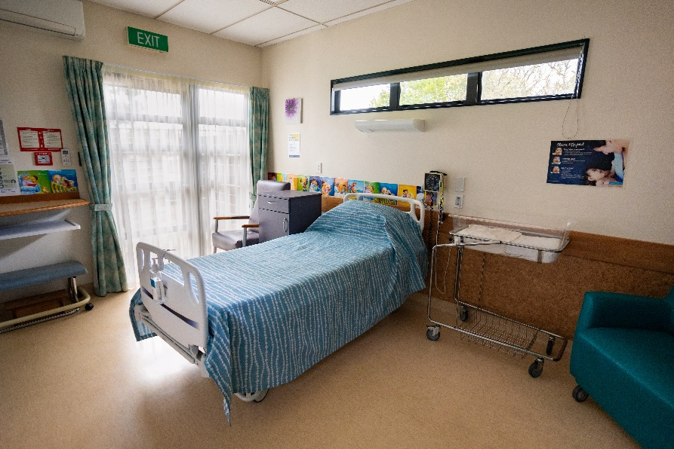

#### Staff

PMU has a part-time Midwife Manager – Gwen Ryan. There is one PMU midwife at the unit 24/7 to support LMCs and provide postnatal care. There is no administrative or HCA support.

#### Tours of PMU

PMU welcomes opportunities for people to come and see the unit for themselves. Please call PMU to see what options there are for enabling whānau to have a tour of the unit.

#### Virtual tour of PMU

A virtual tour of PMU can be found on the Wellington Pēpē Ora website site under ‘Places to give birth’ or click [**here.**](https://www.youtube.com/watch?v=Q-kjFWzXsCI)

#### Booking at PMU

The policy for the *‘Booking criteria and administration process for Birthing at Kenepuru/Paraparaumu Primary Facilities’* policy canbe found inDistrictDocs *OR* [*click here*](https://silentone/content/__object__/000000000161.pdf)

#### Transfers to PMU for Postnatal Stay

People who have birthed at Hutt Hospital may want to transfer to PMU for their postnatal stay. Postnatal transfer to PMU is dependent on the acuity and available beds. Transfers are triaged and coordinated by the CMMs in Hutt and the midwives at PMU. People who book to labour and birth at PMU will be given priority for beds wherever possible. Talk to the CMM to arrange.

#### LMC responsibilities

LMC midwives have a responsibility to leave the birthing rooms and equipment in good condition and alert the PMU midwives of consumables used and any facility/equipment issues so that they can be actioned.

Post birth LMCs are responsible for the cleaning up of any blood spills on the floor/bed/equipment in the room, following the blood product cleaning policy.

#### PMU staff and LMC hui and shared lunch

The PMU staff and LMCs have a regular hui on the first Friday of alternating months at 12.45pm. Bring a plate and share some kai. Notices are shared, any issues arising are discussed. Case presentations and education sessions also happen at this hui.

#### Outpatient services at Paraparaumu

An obstetric clinic is held every fortnight from the Kāpiti Health Centre.

There are currently no additional breastfeeding support services running out of PMU, lactation consultants can be arranged privately or service provisions in Porirua can be used.

#### Support, Escalation, Transfer and Emergency transfer from PMU

The Capital, Coast protocol for transfer from the primary units to Wellington Hospital can be found [here](https://silentone/content/__object__/000000101272.pdf). There is a summary of key actions below.

#### Consultation with the obstetric/neonatal team from PMU

#### Non-urgent

If you are providing midwifery care at PMU and a non-urgent indication has arisen for obstetric/neonatal consultation (Referral Guidelines) and transport to the hospital,

* Call the PMU midwife to assist you with midwifery care as required, then, with consent, and enabling a three way conversation as able, arrange for the most appropriate person to
* Call the Obstetric or Neonatal team on-call: registrar/SMO to agree immediate plan of care and mode of transport to Wellington Hospital
* Call the birthing suite CMM: 021 199 8212 so that they can prepare for your arrival
* Call **1-111**Wellington Free Ambulance to arrange ambulance transfer to Wellington – if required

#### Emergency

#### If you are providing midwifery care at PMU and there is an obstetric or neonatal emergency

* Call the PMU midwife to assist (call bell – there is no emergency bell)
* Call 111 - Wellington Free Ambulance to arrange emergency transport to Wellington and provide paramedic clinical support.

State

* Your name
* That you are a midwife
* The address: Paraparaumu Maternity Unit, 35 Warrimoo Street**,** Paraparaumu
* Situation:That this is a life threatening, time critical maternal/neonatal emergency requiring immediate transport to Wellington Hospital

This sequence of statements will enable the paramedic Call-Centre to arrange emergency Wellington Free Ambulance support and transport from Paraparaumu to Wellington ASAP.

* Call the LMC back up if they are not already present

#### For Maternal emergency

* ***Call the obstetric on-call SMO to agree an immediate plan of care enabling a three way conversation as able.***
* ***Confirm mode of transport***
* ***Request ongoing SMO input into clinical management on ‘hands free’ if required.***

#### Neonatal emergency

* Call the neonatal **on -call SMO** to agree an immediate plan of care, enabling a three way conversation as able.
* **Confirm with the SMO** that they will organize the NICU retrieval of the baby if applicable. Newborns requiring assistance or at risk of requiring assistance **are always transferred from the primary unit to Wellington by the NICU retrieval team.**
* Request ongoing SMO input into neonatal clinical management on ‘hands free’ if required

The Transport Retrieval to Wellington NICU policy can be found in DistrictDocs or click [**here.**](https://silentone/content/__object__/000000000680.pdf)