Improving Māori Health Outcomes Through Research

Health New Zealand | Te Whatu Ora Waikato has included in its priorities “Radical improvement in Māori health outcomes by eliminating health inequities for Māori” and “Incorporating te Tiriti o Waitangi in everything it does”. In this context, the Waikato Māori Research Review Committee aims to limit harms and maximise positive impacts for Māori health from research processes and outcomes.

For an in-depth review of factors to consider, we refer you to a University of Auckland Faculty of Medical and Health Sciences paper – ‘Māori Responsiveness Paper for HRC applicants’ – a link to which is on the Maori Consultation webpage.https://www.waikatodhb.health.nz/learning-and-research/research/research-approval-process/maori-consultation

There are several factors to consider, including:
- Consultation. The Committee encourages researchers to contact us to discuss your research. Also consider building respectful relationships with Māori who are colleagues, advisors, partners and governors in addition to Māori as participants.

- Māori research workforce development. Consider how your research process can contribute toward developing the Māori research workforce, for example by including an emerging Māori researcher on the team with the appropriate supports.

- Research Question. We need more research into issues that are important causes of avoidable death and disease for Māori. Consider how the problem is framed. What impact will your research have on Māori health and equity? Will it be equity neutral at a minimum?

- Research Design: Is it possible to oversample Māori in order to get equal or adequate explanatory power. This would mean enough Māori participants to infer statistically significant data for Māori and to examine inequities. The Committee would be pleased to help with Māori recruitment strategies.

- Importance of high quality ethnicity data – we encourage the collection and analysis of data by ethnicity. Please use the standard census question (below). Note that the NHI ethnicity undercounts Māori by about 20%. The Committee would be pleased to help with approaches for collecting and analysing data by ethnicity.

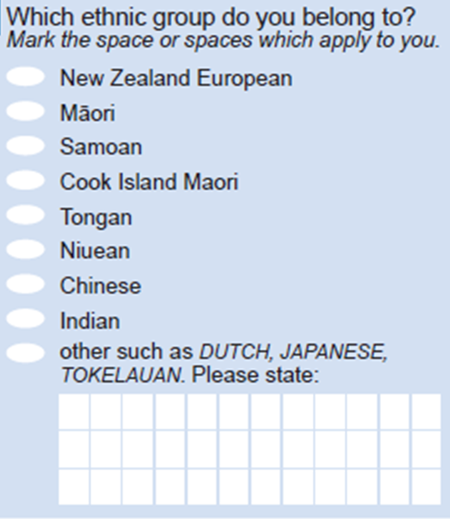
Source: Statistics New Zealand, 2013 Census

- Research analysis. Consider how data are interpreted, and what is discussed. Framing is especially important here. We encourage an approach that moves beyond victim blaming and looks at systems. The Committee would be pleased to provide guidance on analysis and equity focussed reporting.

Application for Research Project submissions for consideration by the Waikato Māori Research Review Committee.

Note: Please complete the form below and attach the Waikato Research Office allocated RD number, Approval of Research form, study protocol and ethics application, Patient Information Sheets and the Patient Consent form(s) (if applicable).

1. Applicant name, contact details and position
2. Submitter’s name, contact details and position (if different from above)
3. Full name of Research/Study Proposal and Waikato DHB research database number
4. Background of the Proposal
Research relationships should be reciprocal and equitable and acknowledge the rights, roles and responsibilities of all involved. Maori consultation should occur in the early stages of development of a research proposal.
5. Please describe the significance of the area under study for Māori plus its equity profile.
Please include statistics on the issue under study, for Māori plus inequities in the area. If data are not readily available, please illustrate the general area with data you can find.

6. Please describe;
1) The potential impact of this research for Māori.
2) The potential impact of the research on equity for Māori – could it be equity positive (decrease existing inequities), neutral or negative (increase inequities)?
3) how this research project can contribute to improving health literacy for Maori participants and whanau *
4) any contribution of koha (gift) to participants, or reimbursement of costs for study participation

*Useful reference: http://www.hqsc.govt.nz/publications-and-resources/publication/2046/
7. Please identify Māori with whom consultation has taken place/ or is planned to take place, apart from this Committee. (Where consultation has already taken place, attach a copy of the supporting documentation to the application form
8. What has been done to ensure that the research process contributes toward developing the Māori research workforce?
9. Will statistically significant data be produced for Māori and will inequities be examined?
10. Please describe strategies to ensure appropriate recruitment for Māori.
11. Will you be collecting ethnicity data? If so what question will you use?
12. MANAAKITANGA. Research should be conducted with respect for all persons involved and respect for their culture
Please confirm the following:
(a) ☐ contact details for Te Puna Oranga Māori Health Service are provided on your patient information and consent form (phone number)
☐ No, please explain: type or paste text here

(b) ☐ provision has been made to involve the participant’s whānau in the study if requested
☐ No, please explain: type or paste text here

(c) ☐ provision has been made for participants to undertake the study in Te Reo Māori if desired
☐ No, please explain: type or paste text here

(d) ☐ provision has been made for appropriate Tikanga Māori Best Practice protocols to be carried out when required
☐ No, please explain: type or paste text here

(e) Describe any other provisions you have made in your study to ensure the cultural preferences of Māori have been considered:
type or paste text here

13. Study Results

- Please detail how study results will be disseminated to study participants and whānau type or paste text here

- Please confirm that the dissemination plan for the study includes a full report of study results to be sent to the Research Office:

- Please confirm that the study results report will detail the numbers of Māori recruited and any specific issues or concerns recruiting or maintaining Māori in the study. This should be submitted following the completion of local involvement in the study.

14. Tissue Samples
If your study involves Tissue samples, please complete separate form ‘TPOMCRRC Questionnaire Human Tissue Collection and Storage’

Any queries please contact, Te Puna Oranga Maori Health Service), Waikato DHB
(07) 8343628 or Research (WKresearch@tewhatuora.govt.nz)

Office use only | Date | Comment
Date received:
MRRC review date:
Request for further information sent:
Response received:
Final endorsement letter sent:

