

Easy Read information about health workers being on strike

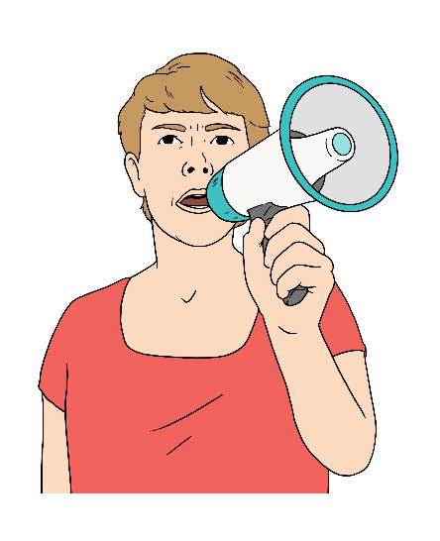
What is a strike?

A strike is when people decide not to go to work to try and get better
- pay

- support at work.

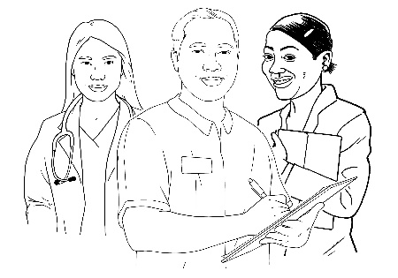
Health workers across New Zealand are going on strike from
- Thursday 23 October
to
- 7 o’clock in the morning on Friday 24 October.

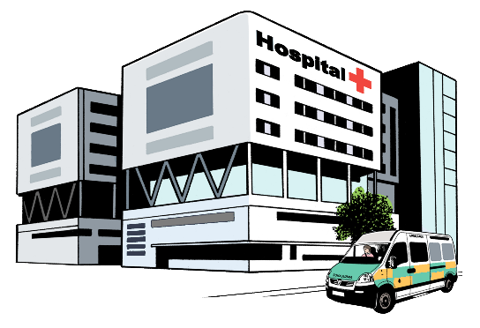
On these days there will be less people working at the hospital.

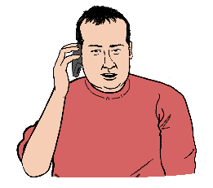
If you have an emergency
- call 111 or
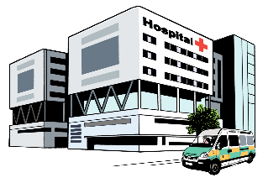
- go to the hospital emergency department.

If you need healthcare but it is not an emergency
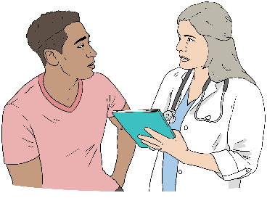
- go to your own local doctor

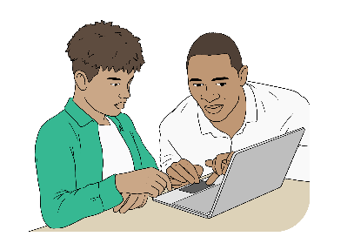
- go to an urgent care or afterhours clinic

- book an appointment with a doctor over a video call
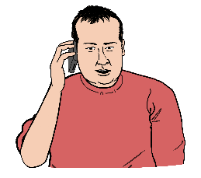
- call Healthline on 0800 611 116

You can also call 0800 252 672 for healthcare if
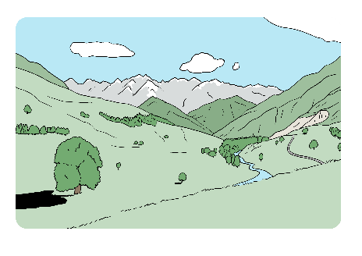
- you live out of town in a rural area like a farm and

- your doctor is closed.

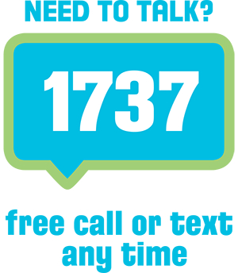
You can call or text 1737 for mental health support if you feel
- worried

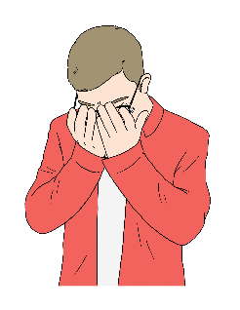
- sad

- you are not coping well with something

- you need someone to talk to.

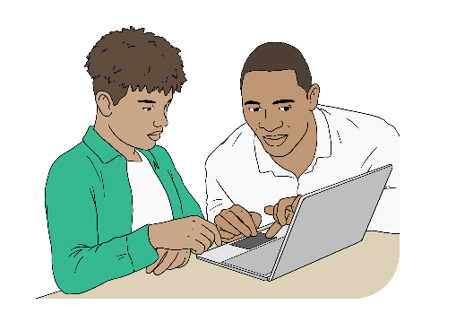
You can find more information on this website:
www.info.health.nz

