NZNO Nursing Workforce Factsheet

July 2025

# Key NZNO nursing workforce stats

* 35,341 individuals employed, with an FTE of 29,578.5.[1]
* Overall FTE increased by 178.4 FTE between March 2024 (29,400.1 FTE) and March 2025 (29,578.5).

|  |  |  |  |
| --- | --- | --- | --- |
| **Average wage and remuneration including allowances / overtime / penal rates** | | | |
| **Nurse** | **Base Salary** | **Median Penal Rate** | **Total\*** |
| Graduate RN1 | $75,773 | $921 | $76,694 |
| Middle Step RN4 | $91,179 | $9,831 | $103,357 |
| Top Step RN7 (6+ years) | $106,739 | $13,390 | $120,129 |

**\*Note:** Total excludes up to $4,500 PDRP allowance and overtime.

* The weighted average base FTE salary for a nurse is $101,189 p.a., with the Registered Nurse Step 5 pay point being the closest to this, at $100,849 p.a.
* $125,662 is the average salary for both Senior and Registered Nurses and includes overtime, PDRP allowance and penal rates.

# Wage increases over time

Since 2011, the Household Living Cost Price Index has grown by 39.9% and over the same time the Labour Cost Index has grown by 35.53%.

In comparison the top salary step of a registered nurse covered by the NZNO collective agreement has risen by 73.95% and for the middle step the rise has been 65.1%.

Over the same period the wage growth for a senior nurse at the top of the pay scale has been 54.05% while the increase for a nurse at the middle of the pay scale has been 60.66%.

These figures include growth from the Pay Equity adjustment.

When pay equity is excluded, the top salary step for a registered nurse has risen by 45.24%, with a 39.57% increase for the middle salary step. For senior nurses the top salary step has grown by 37.34% excluding pay equity, and the middle step of the pay scale rose 36.01%.

Nurses got sizeable pay increases through the last collective bargaining agreement. In the first year (from 1 April 2023) they received an extra $4000 (or $5000 for a senior nurse), plus a one-off lump sum of $750. From 1 April 2024, they received an additional $2,000 or 3% (whichever was higher), plus a lump sum of $500.

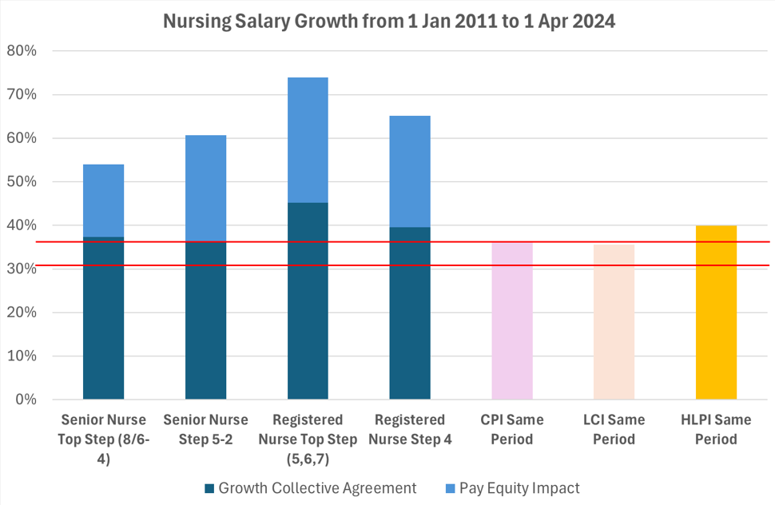

# Current NZNO collective agreement negotiations

The Health NZ nursing workforce falls under the coverage of three different collective agreements. The New Zealand Nurses Organisation Nursing & Midwifery Collective Agreement (NZNO CA) is the biggest, covering more than 10 times the number of nurses.

In September 2024, Health NZ began renegotiating its collective agreement with NZNO, which represents Health NZ nurses, healthcare assistants and some midwives.

After six days of bargaining, NZNO gave notice of a nationwide 8-hour strike on 3 December, followed by rolling 4-hour strikes, from 10-19 December 2024.

On 18 March, NZNO applied to the Employment Relations Authority (ERA) for facilitation, a move supported by Health NZ.

Perioperative and ward nurses also took strike action in a limited number of Auckland and Whangārei workplaces in May and June.

# The ERA recommendations and our offers

Health NZ told the Employment Relations Authority (ERA) its offer was influenced by the need to reduce its operational expenditure to become financially sustainable and by the Government Workforce Policy Statement (GWPS). The GWPS requires it to ensure pay reviews are within its baseline budget and are sustainable, and to factor in increases in pay progression through salary scales and avoid backdating any components of pay adjustments.

The Authority issued its recommendations on 29 April, finding there was no reason to question the economic rationale behind the Health NZ offer, and neither was there a rationale to support seeking further funding from the Government. It recommended NZNO take the Health NZ offer of one percent for each year of the two-year term to members for ratification. [Read the full recommendations [here](https://determinations.era.govt.nz/determination/view/20301)]

Health NZ accepted the ERA’s recommendations and made an offer to NZNO on 9 May based on proposals developed in bargaining and the recommendations.

NZNO members voted not to accept the offer during a ballot which closed on 23 May.

On 30 June, Health New Zealand made a new offer to the NZNO which will remain on the table for ratification until 31 July.

# How nurses will benefit from the 30 June offer

* The key difference between the May and June offers is that registered nurses have been offered an additional 1% pay increase in the first year. Under the May offer, nurses would have received a 1% increase in April 2025 and a further 1% increase in April 2026. Under the June offer, registered nurses would gain a 2% increase in June 2025 and a further 1% in June 2026. They would also gain a $325 lump sum payment in each of the two years.
* Under the June offer, a new graduate nurse on Step 1 ($75,773) would get 2% from 2 June 2025 - an extra $1515 per year. When they progress to Step 2 (usually the anniversary of their appointment to the role), their salary would increase to $83,317 – a total increase of $7544 or $145 per week. In June 2026 they would get an additional 1% increase, taking their salary to $84,150. That’s a total pay increase of $8,377, or 11 %, by the start of June 2026.
* Most nurses (72%) are on Step 7, the highest step. A Step 7 RN ($106,739) would get a 2% increase in June 2025 - an extra $2135 per year or an extra $41.05 a week. They would get an additional 1% increase in June 2026 – giving them a total base pay increase of $3224, or 3%.
* The offer includes a $2,000 increase to step 5 for the Enrolled Nurses salary scale effective from January 2026.

# Further Information on pay and conditions

## Breakdown of allowances / overtime / penal rates

There are a range of additional allowances including but not limited to:

* Overtime and penal payments for on-call, evening, night and weekend work, call back
* On-call allowance
* Meal allowance
* Higher duties allowance.

These allowances are paid in addition to base salary.

## Leave

* Across the 3 relevant CAs, employees are entitled to 4 weeks annual leave per year for the first 5 years of service.  After 5 years of continuous service, this increases to 5 weeks.
* 10 days sick leave with ability to apply for a further 10 days of discretionary sick leave
* Long service leave (1 week every 5 years)
* Up to 5 days shift leave for working outside of the hours 8am to 5pm

## Other additional payments/benefits

* Around 30% of nurses choose to participate in the Professional Development Recognition Programme (PDRP).  These nurses are eligible for an allowance of $3,000 - $4,500 p.a., depending on level of assessed competence.
* Nurse Practitioners are eligible for a Professional Development Allowance of up to $6,000 p.a.
* 14 weeks top-up of wages for paid parental leave.

1. March 2025