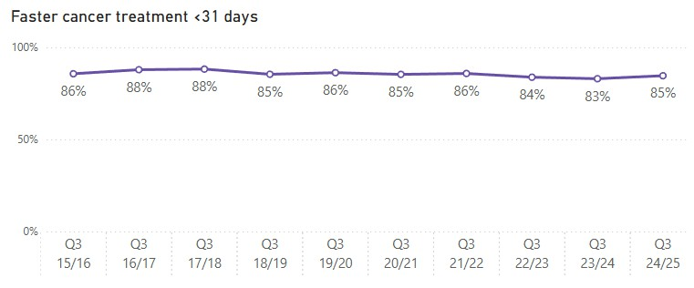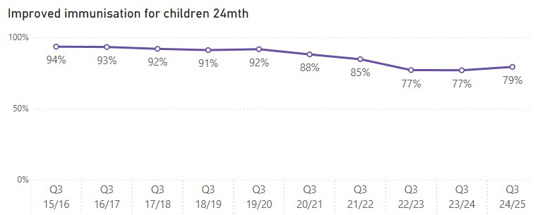

**Health Targets 2024/25 Quarter 3 Last 10 Years**

**Treated in < 31 days Q3 24/25**

**3,694**

**Treated in < 31 days Q3 23/24**

**3,785**

Reductions in wait time will mean you and your whānau will be guided through complex cancer care pathways to receive treatment sooner.

**Children**

**Immunised**

**Q3 24/25**

**11,359**

**Children**

**Immunised Q3 23/24**

**12,078**

Better immunisation coverage will reduce the risk of measles, mumps, rubella and other infectious diseases which can cause harm to children.

Reductions in wait time will mean you receive diagnosis, treatment, and progress through to a hospital bed (if needed) sooner.

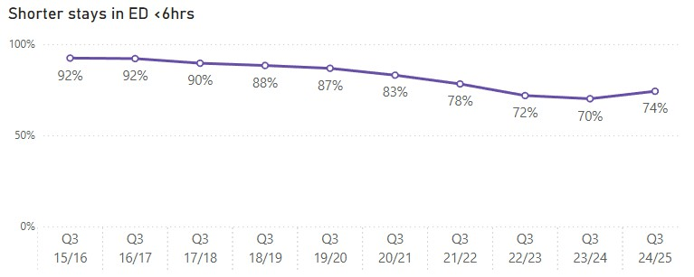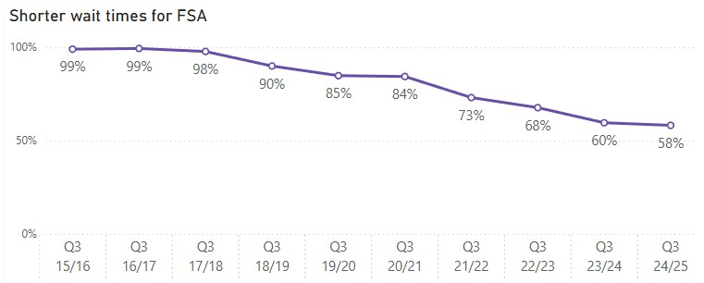

**Seen within**

**6 hrs Q3 24/25**

**247,643**

**Seen within 6 hrs**

**Q3 23/24**

**225,542**

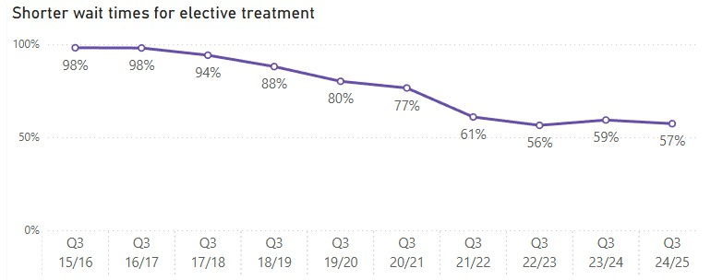**People waiting <4 months**



**People waiting < 4 months Q3 24/25**

**116,594**

**People waiting < 4 months Q3 23/24**

**114,855**

Reductions in waiting will mean you are seen by a hospital specialist sooner who will start plans for your condition.

Reductions in waiting times will mean you receive your treatment sooner.

**Q3 24/25**

# 47,114

**People waiting < 4 months Q3 23/24**

# 44,303

**Note:** All results are rounded to the nearest whole number. When comparing data to previously published results, theremay be slight variations as data is now morecomplete. [See caveats.](https://www.tewhatuora.govt.nz/corporate-information/planning-and-performance/health-targets/health-targets/performance)