Terms of Reference
Acute Care Sector Advisory Group

Background

Patients in New Zealand who present acutely receive high quality care as demonstrated by international comparison with other OECD countries.
Demand for acute care is increasing due to a growing, ageing and more comorbid population many of whom have poor access to health maintaining resources due to socioeconomic factors Publicly funded hospitals are constrained by staffing capacity (including staff safety and wellbeing), poorly maintained facilities and processes that do not support the safe, efficient and effective flow of patients through the system. There are also constraints associated with access to primary care in the community. This means that our people are at risk of not receiving equitable, timely, adequate or safe care.
The Ministry of Health’s (the Ministry) DHB Performance Support and Infrastructure Directorate (DHB PSI) intends to commence development of a programme of work around acute/unplanned care (urgent and emergency).

Purpose
The primary purpose of the Acute Care Sector Advisory Group (ACSAG) is to provide expert advice to the Ministry of Health on evidence-based improvements (informed by available evidence that is applicable to the national, regional and locality contexts) in acute care and process flows across the healthcare system that will meet current and projected patient needs while continuing to provide high quality and safe care.

Functions

The ACSAG has the following identified scope of responsibilities to:

- provide expert advice to the Ministry on the drivers and pressures affecting acute care and patient flow
- identify how improvements can be made in acute care in:
  - access and models of care
  - data collection processes including real time data
  - access measures – the role of specific measures eg, ED length of stay
  - lifting overall district health board performance
- provide advice on delivering equity of health outcomes for Māori and Pacific peoples
- advise the Ministry on the key stakeholder relationships to improve acute flow
- work collaboratively with other networks as agreed to help achieve their objectives.

Treaty of Waitangi

The Advisory Group will recognise the Ministry of Health’s Treaty of Waitangi obligations and consider how Pae Ora will be achieved for Maori. The Advisory Group will apply and adhere to the Ministry Te Tiriti Framework (appendix one).

Achieving equity

It is a priority for the Government to deliver equitable health outcomes for all New Zealanders so everyone can achieve the same outcomes and have the same access to services and support, regardless of who they are or where they live. The Ministry of Health is committed to addressing access to healthcare and how healthcare services are delivered to ensure equitable outcomes.

Term

This Terms of Reference (ToR) is effective from April 2021 until April 2022 when the ACSAG and this ToR will be reviewed.

Membership

COO | Lyn Horgan (MCDHB) | lyn.horgan@midcentraldhb.govt.nz
Primary Care | Vanessa Weenink | weeninkvanessa@gmail.com
Emergency Department CD | Peter Jones (ADHB and Ministry of Health) | Peter.G.Jones@health.govt.nz
Medical CD | Lucille Wilkinson (NDHB) | Lucille.Wilkinson@northlanddhb.org.nz
Surgical CD | Li Hsee (ADHB) | LiH@adhb.govt.nz
Public Health | Papaarangi Reid | p.reid@auckland.ac.nz
Public Health | Elana Curtis | e.curtis@auckland.ac.nz
College of Emergency Nursing | Sue Stebbeings | cennzchair@gmail.com
Associate DDG (Ministry of Health) | Jess Smaling | Jessica.Smaling@health.govt.nz
Manager System Flow (Ministry of Health) | Adam Simpson | Adam.Simpson@health.govt.nz
Clinical Director | André Cromhout | Andre.Cromhout@ccdhb.org.nz
Chief Medical Officer (Ministry of Health) | Andrew Connolly | Andrew.Connolly@health.govt.nz
NZ Orthopaedic Association | Peter Devane | peterdevane@yahoo.co.nz
St John Ambulance | Kris Gagliardi | kris.gagliardi@stjohn.org.nz
Wellington Free Ambulance | Vanessa Simpson | vanessa.simpson@wfa.org.nz
College of Urgent Care | Kelvin Ward | kelvin.ward@rnzcuc.org.nz
Manager - Data and Analytics (MoH) | Hayden Luscombe | Hayden.Luscombe@health.govt.nz
Programme Director – Acute Care (MoH) | Kate Clark | Kate.clark@health.govt.nz
Emergency Department CD | Scott Pearson (CDHB) | Scott.Pearson@cdhb.health.nz

Role and Responsibilities of ACSAG Members

The Group members are expected to:
- attend ASAG meetings and teleconference meetings. Substitutions will not be possible due to the need for consistency and ongoing knowledge of the work of the ACSAG. If unable to attend the meeting or teleconference, members must arrange to forward input on all agenda items prior to the meeting or teleconference
- provide information, research, evidence, methodologies and tools that contribute to the work of the Advisory Group
- contribute to, and at times lead the development of written advice on ACSAG key functions
- be diligent, prepared and actively participate in meetings
- provide frank opinion in the national interest, regardless of personal affiliations.

The Advisory Group as a whole will:
- ensure that the independent views of members are given due weight and consideration
- ensure fair and full participation of all members
- regularly review its own performance.

Role and Responsibilities of Chair of the ACSAG

The chair of the ACSAG will be Peter G Jones Auckland DHB and Ministry of Health ED clinical lead who will be responsible for:

- chairing the meetings and teleconference meetings
- obtaining views and opinions from ACSAG members
- managing the process of conflict resolution
- being the spokesperson for the ACSAG.

Confidentiality

All work circulated to and engaged with by the ACSAG, whether verbal or written, shall be treated as confidential for use by the ACSAG, unless deemed otherwise by the Ministry and expressly stated. No information, in any form, should be released without prior written approval by the Ministry. Information of a commercially sensitive nature is deemed confidential. By agreeing to these terms of reference, members are agreeing to these conditions of confidentiality.

Conflict of interest

The Ministry recognises that the ACSAG members have interests in the matters being considered. In general, these interests only become a ‘conflict of interest’ where there is the potential for personal (or organisation) gain. Personal or organisation gain could be actual or perceived. Members must declare that they have a financial, professional, organisation or personal interest (direct or indirect) that might create conflict.

When members believe they have a conflict of interest on a subject that will prevent them from reaching an impartial decision or undertaking an activity consistent with the ACSAG’s functions, they must declare that conflict of interest to the Chair who will ensure that conflicts of interest are managed appropriately.

Meeting Protocol

Meetings will be chaired by Peter G Jones.

Advisory Group meetings will occur on a monthly basis.

A meeting quorum for the ACSAG will be 9 members - half of the members plus one, not including the Chair who must be present.

Secretariat support will be provided by the System Flow team in the Ministry of Health.

This includes:
- scheduling meetings
- preparing agendas and supporting papers and distributing in advance of meetings
- preparing meeting minutes.

Proposed Meeting Dates

Meetings and teleconference dates will be confirmed at the first meeting. It is anticipated the membership will participate in some group meetings by video and teleconference and work completed outside of scheduled meetings is similarly progressed via email or teleconference as required.

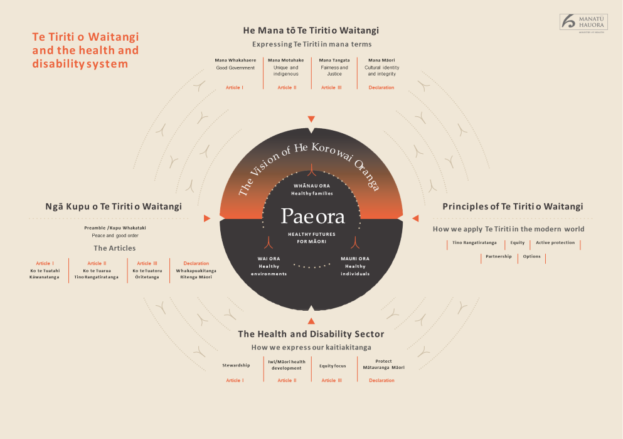

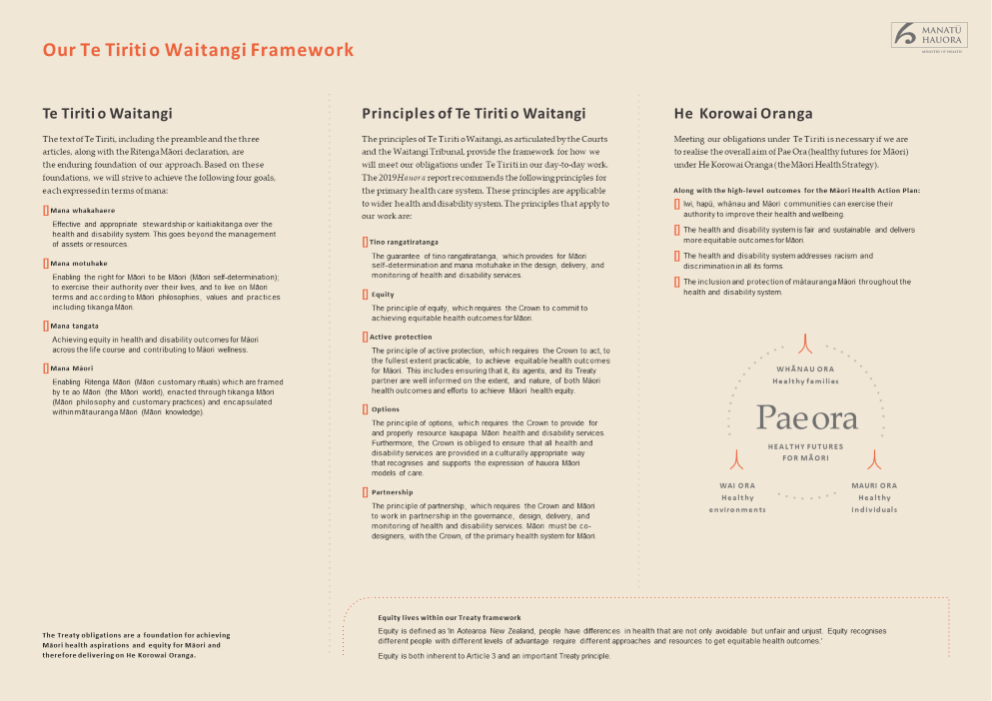

https://stats.oecd.org/Index.aspx?QueryId=51881

