What should you do when the ethnicity in your PMS is different from what is on the NHI for an existing patient or when the ethnicity on the enrolment form is not the same as what is on the NHI for a new patient?

- Enter the person’s ethnicity from the answer they gave on their enrolment form. For existing patients you should review the most recent enrolment form you have for them.
- If
- your patient did not answer the ethnicity question on their enrolment form
- you do not have an enrolment form for your patient
- the enrolment form the patient completed did not have the standard ethnicity question
put a reminder into your system to get your patient to complete an enrolment form next time they are in the clinic.
- Enter the ethnicity into the MyPractice PMS then
- go to the NHI compare and update page
- click the update NHI button on the ethnicity section
- add the 4th 5th and 6th ethnicity if the patient has listed more than 3 ethnicities on the form
- then click the update button

The Standard Ethnicity Question
A person enrolling with your practice will complete an enrolment form. On the form somewhere they will answer the ethnicity question. The ethnicity question should look something like this
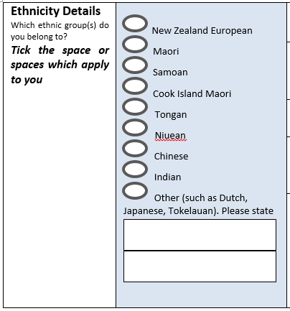
The question reads ‘Which ethnic group(s) do you belong to? Tick the space or spaces that apply to you’ There are the 8 ethnicities named as above and there is room to enter one or more ethnicities in a space labelled ‘other, such as Dutch, Japanese, Tokelauan. Please state’

Examples

Example 1 Multiple responses
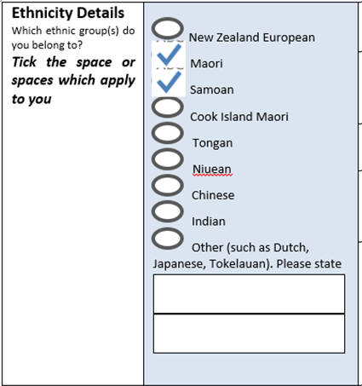
Enter ethnicities in the Patient Registration Details page
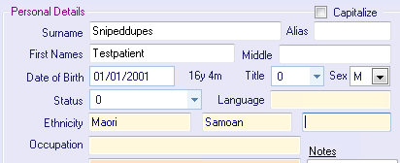
Click the NHI button 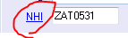 or when you close the patient record you will be taken to the NHI Compare and update page.
Click the Update NHI button
Click the update button 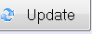
The NHI and the PMS are synchronised

Example 2 Fijian Indian
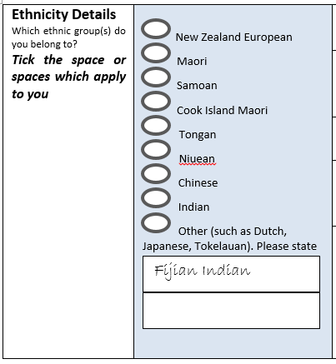
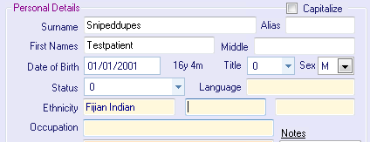
Note that a Fijian Indian response like the one above is different from
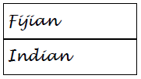
These would be entered as

Example 3 New Zealander
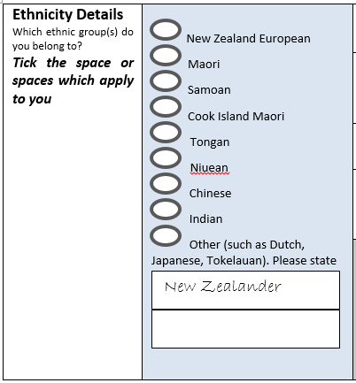
Enter in MyPractice PMS
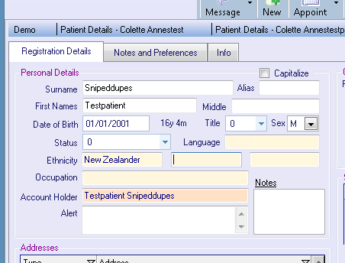
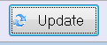
Note that a ‘New Zealander’ response is different from a ‘New Zealand European’ response. If someone ticks the New Zealand European box you should select the New Zealand European option from the list.
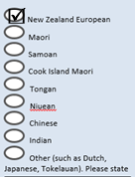

Example 4 More than 3 responses
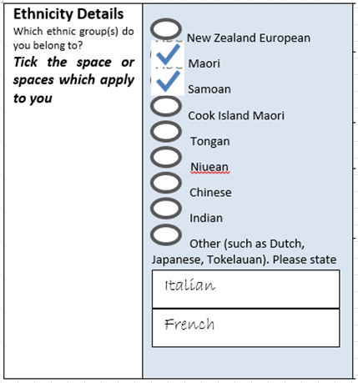
Enter the first 3 responses into the registration Details page
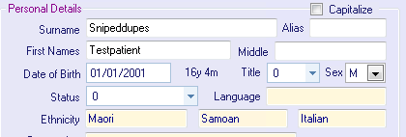
On the NHI Compare and Update page click the Update NHI button and enter any additional ethnicities into the yellow section
The NHI lists all the ethnicities, the Registration Details screen will show only 3 ethnicities. The PMS software considers all the ethnicities entered on the NHI and uses the Ethnicity Data Protocol Prioritisation table to select the 3 ethnicities to retain in the PMS.
(at publishing the MyPractice PMS is not automatically selecting the prioritised ethnicities to retain in the PMS. If a user entered Maori in one of the additional 4th, 5th or 6th places on the NHI it would not be visible on the patient registration page)

Example 4 Response that doesn’t appear in the PMS drop down list
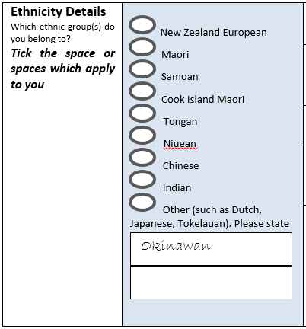
If you enter Okinawan into the Mypractice Registration Details page you will get this error
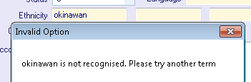
To find the correct way to classify this response you can use one of the following tools

Ministry of Health developed tool
Go to this link http://refraction.nz/eths and click 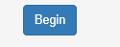
Enter ‘Okinawan’ in the place provided and the correct classification will appear in the grey area below
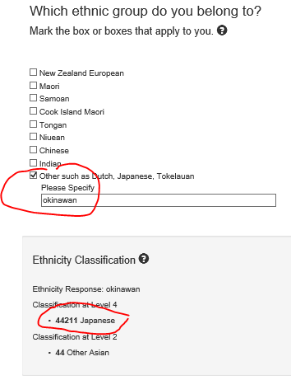

Statistics NZ codefinder
Go to this link http://www.stats.govt.nz/tools_and_services/classificationcodefinder.aspx, select ethnicity classification, enter ‘okinawan’ as a keyword, clock Go and the correct classification will show in the results
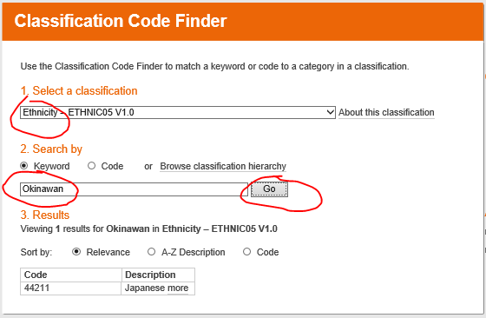

Enter ‘Japanese’ in the Registration details page and update the NHI as in the above examples
