Health Planning Unit
Functional Design Brief
Template Guidance

Contents
Document Control and Endorsement 3
Navigating this document 5
1 Service Overview 6
1.1 Description 6
1.2 Service Specific Policies, Standards and Guidelines 6
1.3 Scope of Service 6
1.4 Patient Journey 7
1.5 Workforce Profile 8
1.6 Future Trends and Innovation 9
2 Operational Context 10
2.1 Practices and Approaches 10
2.2 Seven Flows of Healthcare 12
3 Design Approach 14
3.1 Functional Relationships 14
3.2 Design Requirements 17
3.3 Description of Accommodation 19
3.4 Schedule of Accommodation 19
Appendix A: Change Management Opportunities 20

Document Control and Endorsement

Document Development
Project Name
Health Planning Unit
Related AusHFG HPU Revision and date
Document name
Document owner
Primary Author

Document Contributors
Section | Primary Contributor/s
Section 1  Service Overview | Health New Zealand – Hospital and Specialist Services  Te Aka Whai Ora
Section 2  Operational Approach | Health New Zealand – Hospital and Specialist Services  Te Aka Whai Ora
Section 3  Design Approach | Health New Zealand – [Regional and Local entity]  - Clinical Lead / Service Manager  - General Manager  - Facilities Manager

Document Revision
All revisions to the HPU FDB (including SoA) during development of the FDB, and at each design phase milestone through to completion of Preliminary Design, are recorded in this section.
All changes to the FDB and/or SOA must follow the Change Management Process (appendix A) and gain written approval.
All updated documents must be reissued.
Version | Issue Date | Description of amendments / updates since previous Issue | Section Reference

Document Approval
This document (state title and version) has been endorsed by the following key stakeholders.
Name | Title | Signature | Date

Endorsement Caveats
The final version of this document has been reviewed and endorsed with the following caveats:
Example text
- Proposed separate Paediatric ICU (subject to a separate Business Case which is in progress).
- Workforce planning is indicative only and a staff model will be prepared as part of the project.

Navigating this document
This Health Planning Unit Functional Design Brief Template is the fourth of a suite of four guidance artefacts. The purpose of each of the artefact documents are outlined below:
Artefact 1: Strategic and Functional Design Brief Guide provides general context, guidance, and background to the strategic and functional design briefing process and document development.
Artefact 2: Health Facility Strategic Brief Template Guide identifies the required components that should be in every Health Facility Strategic Brief prepared for Health New Zealand as a minimum. It provides an overview of the project, service planning context, cultural narrative, project design principles and the health facility functional capacity requirement for points of care.
Artefact 3: Health Facility Wide Practice and Approaches Template Guide
The Health Facility Practice and Approaches will identify operational approaches and associated design requirements that are consistent across the health facility. Inputs only include those that differ from approaches described in the New Zealand Health Facility Design Guidance or Australasian Health Facility Guidelines (AHFG).
Artefact 4: Health Planning Unit Functional Design Brief Template identifies the required components that should be in every Health Planning Unit (HPU) Functional Design Brief report prepared for Health New Zealand as a minimum. Individual HPU Functional Design Briefs are required for each HPU identified within the scope of the project.
Written content provided in black text is to be retained and provides lead in narrative relevant to the section.
Written content in blue text in a blue box provides guidance or text examples for the required output as a guide to the author. Content guidance and blue boxes should be deleted. Example content may be reviewed, edited, or deleted as relevant.

Service Overview

Description
Provide a high-level description of the service include the following:
- Official name and acronym
- Network Plan and Future Facility Profile
- Current level of service/capability (role delineation level) and expected change to realise the planned future level of service (such as point of care numbers, technology, workforce)

Service Specific Policies, Standards and Guidelines
The service will operate in accordance with the following service standards and guidelines, national policies, plans, and priorities impacting the HPU service including:
List relevant documents impacting the service including the following:
- National policies / frameworks
- Regional/local plans or priorities
- College or professional guidelines
- Industry standards
These should be service specific and take care not to repeat those key planning documents outlined in the strategic brief.
As a minimum the design must meet the relevant design requirements as identified in:
List relevant documents impacting the design including the following:
- Australasian Health Facility Guidelines (all parts)
- Australasian Health Facility Guidelines Part B – Provide HPU reference if applicable.
- New Zealand Health Facility Design Guidance Notes

Scope of Service
Provide a summary of how the service functions including:
- key features of the model of care
- any specific Māori and Pacific cultural considerations.
This information will assist the design team in understanding the types of activities occurring within the department and the types of people that it will accommodate.

Patient Journey
Provide a flow diagram or narrative demonstrating patient or services flow through the unit.

Workforce Profile
Provide an outline of new roles and workforce profiles that are anticipated to be introduced into the service to support future model of care and delivery needs.

The following table provides a summary of the indicative future workforce profile for the service.
Complete the following table indicating the future workforce profile.
Table 1: Workforce profile by FTE and Headcount
Role | FTE | % Admin time per day | Peak Headcount
 |  |  | AM | PM | Night
TOTAL

.

Future Trends and Innovation
Health facilities must have sufficient flexibility and adaptability of infrastructure and building services to expand or contract in response to climate change, outbreaks of disease, models of care and technology changes. The establishment of resilient and sustainable services will be influenced by innovation and future trends emerging in technology, equipment, systems and processes.

Information Technology and Communication
Summarise any specific data and digital technologies that are anticipated to be adopted by the service to support the specific service delivery needs.

Robotics and Automation
Summarise any service specific aspirations and intent to adopt various technologies which promote automation and the use of robotics.

Specialised Equipment

Workforce model changes
Identify any service specific emerging trends in healthcare provision will result in changes in workforce profile and skillset requirements. Consideration should be given to the nature of these roles and how they may impact design and spatial allocations.

Other Emerging Trends in Practice
Consider other changes in practice that may occur within this service and / or associated support services, such as Education and Training, Increased expectation of culturally safe care, or Logistics, Waste management etc.

Operational Context

Practices and Approaches
Operational Policies and Procedures are essential to safe practice and for the governance of the Facility. The NZ Health Facility Design Guidance Note (NZDGN), Strategic Brief, and Health Facility Wide Practices and Approaches identify overarching and facility wide practices and approaches.
Operational Practice and Approaches outlined in this section are unique to this HPU and are identified as likely to necessitate specific design considerations.
In the context of a redevelopment which includes a number of HPUs, a Health Facility Wide Practice and Approaches document will be established to describe the operational practice and approaches which affect all or most services within the project scope and avoids duplication of content across multiple FDB’s.
The author should ensure that duplication is avoided and remove operational practice and approaches suggested in this section if they are documented in the NZDGN or Health Facility Wide Practice and Approaches.
Operational Practice and Approaches are categorised in this section as follows:
  - Tikanga Considerations
  - Patient
  - Infection Prevention and Control
  - Operational Support
  - Staff Support
The list of subjects is suggestive only and should be refined to reflect specific HPU requirements only.
Each subject should include a summary of the operational principles and describe the specific design requirements needed to support the operational approach. Some examples are provided as an indication of required content – these should be reviewed and amended/deleted as required.

Tikanga Considerations
Identify considerations specific to Mana Whenua of the Project. Consideration to be to the nature of services within the HPU and the requirements of whānau.

Patient
Identify considerations specific to the HPU service patient cohort, such as Child and Adolescent Units which will require additional overlay to provide for recreational or school activities.

Infection Prevention and Control
Identify considerations specific to the HPU service and patient cohort of the unit such as Oncology or Renal Units which will require additional overlay to appropriately respond to the IPC requirements.

Operational Support
Identify considerations specific to the HPU service where the interface with support services such as sterilisation services is pertinent and will require additional overlay to provide for management of reusable medical instrumentation in an Outpatient Clinic for example.

Staff Support
Identify considerations specific to the HPU service where the requirement for staff is specific rather than for the whole of organisation or facility response. HPU’s which have dedicated facilities such as Operating Theatres will need the approach outlined here.

Seven Flows of Healthcare
This section outlines operational flows that are specific to the service, and which are anticipated to directly impact facility design.
Existing operational flows are indicative at a point in time and should be reviewed and updated as required during the Project and beyond. Operational flows which may not currently be in practice, however, are planned for the new facility will be based on recent trends in practice and innovative ways of working that have been informed by evidence. Change management should be initiated to support the modification of existing and adoption of new practices and flows.

Patients
For an acute, secure mental health ward, describe the admission flow of an involuntary patient arriving by ambulance. Consideration for Tūpāpaku and bereaved whānau is necessary.

Visiting Whānau

Staff

Information
For a Mail Service, describe how mail is received, sorted and distributed.
For a medical records service, describe how medical records are used, filed, stored etc.

Medication
For a chemotherapy service, describe procedures relating to clean up of spills.

Equipment
For a CSSD, describe the dirty to clean flow – explain the functional flow of instruments, including what happens at each stage, from soiled to sterile using the name of rooms or spaces as listed in the SOA.

Logistics
Logistic flows must consider whakatapu to whakanoa – identifying flows with restriction and what these are, to flows without restriction.
Note: When tapu (sacred or spiritual restriction) is removed, things become noa (unrestricted), the process being called whakanoa.

Food

Waste

Linen

Supplies

Design Approach

Functional Relationships

External Functional Relationships
External functional relationships are defined by both the required proximity and nature of the travel pathways between departments or service areas to support safe and efficient clinical, logistic, and public movement within the facility.
In the context of a redevelopment which includes a number of services / departments it is anticipated that an adjacency matrix will be prepared which highlights the external relationships of all departments and must be read in conjunction with this section.
Functional relationships are classified as types of access between departments using the following descriptors:
Table 2: External relationship descriptors
Classification | Definition
Immediate | Meaning side by side or directly across an internal corridor. Includes transfers via dedicated hot lifts / trauma lifts.
Direct | Linking components by a horizontally or vertically contiguous route
Ready | Linking accommodation components by a mix of horizontal and vertical unimpeded routes which do not cross over with public travel routes.
Easy | Means accessible via internal and external routes including public routes with a travel time exceeding 10 minutes. If an adjacency is not specifically described, it is assumed as Easy.

Immediate
List the key services and departments requiring immediate access.

Direct
List the key services and departments requiring direct access.

Ready
List the key services and departments requiring ready access.

Easy
List the key services and departments requiring easy access.

The identified external functional relationships must be provided as a graphic as below.
Figure 1: External Functional Relationships
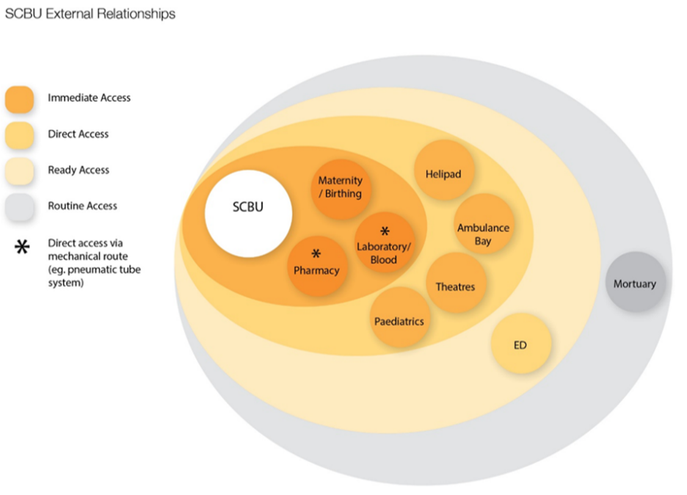

Internal Functional Relationships
Groupings or logical planning zones are clusters of rooms which support the same activity within an HPU. Effective planning approaches to grouping rooms can achieve lean, efficient workflows and reduce travel distances for staff.
  - The internal relationships for zones (groups of rooms) and individual rooms within a unit will be reflected in a diagram of shapes and shades which convey a consistent theme throughout the briefing documents.
  - It should be noted that any diagrams contained in the functional design brief is not intended to reflect an actual floor plan nor do the shapes represent scale and proportion.
  - The Schedule of Accommodation should be organised in such a way to reflect the synergies and adjacencies of the functional groups and the specific accommodation content.
  - Descriptors for internal relationships will use terms like contiguous, immediately adjacent, adjoining, and direct line of sight.
The HPU will consist of the following functional zones which consist of rooms that will be grouped together in the design to facilitate service delivery in an efficient way.
List the nominated zones appropriate for the service such as:
- Front of House
- Patient Accommodation
- Therapy
- Clinical Support
- Non-Clinical Support
- Staff Resources
A graphic and/or further descriptors must be provided to portray the required adjacencies of zones to inform design.

Design Requirements

Service Specific Design Requirements
Describe features of the Model of Care that may influence the design of the unit.
Example:
- The ICU will be designed in four pods of twelve beds each. These pods should be as similar in design as possible and offer direct access to shared support spaces such as clean utility, dirty utility, storage, pneumatic tube, staff bases, handover rooms, and two single-person offices for staff educators.
- Staff must be able to observe the bed areas from the staff bases and vice versa.

Workspace Requirements
The primary workspace allocation reflects the workspace where the staff member will spend most of their administration / computer related time within the HPU. The NZ Government Property Group provides a set of principles that should be used to guide any Health New Zealand facility workplace design. https://www.gpg.govt.nz/workplace-design/principles-for-good-workplace-design/
The primary workspace required for each role has been considered in collaboration with the hospital and HPU leadership team.
Primary workspace types include:
  - Office 1 or 2 person: A dedicated office for specific roles such as Unit Manager, Head of Department, Clinical Directors etc.
  - Shared Workspace: A shared workstation in an open office area for staff work part time where the space may be shared on alternate days/shifts with another staff member.
  - Hot desk: A smaller workspace in an open office type area for use by staff who have minimal daily computer use, or staff who are based in the facility short term e.g., volunteers, students, visiting staff.
  - Staff Station: An open workstation in a clinical area with computer workstations.
  - Clinical Workroom: A shared office either in or immediately adjacent to a HPU clinical area with multiple computer workstations.
  - Reception: An open workstation in a front of house area.
The following table summarises the primary workspace requirement for this HPU and has informed the HPU SoA room requirement.
Complete the following table noting the primary workspace type for staff that require these spaces within the HPU. Note that some staff may have access to a primary workspace within another HPU or dept – this should not be duplicated.
Table 3: HPU Primary Workspace Requirement
Role | FTE | Headcount | HPU Primary Workspace Type
TOTAL

Architecture, Interiors and Building Services
The following design requirements for the interior environment outline specific service requirements not already covered in the relevant AusHFG Health Planning Unit (HPU).
Provide descriptors as relevant considering items such as acoustics, natural light, external access, etc.

Description of Accommodation
The AusHFG provide detailed information on commonly used rooms and spaces across healthcare projects known as Standard Component Rooms. NZ health projects must use Standard Component Rooms (SC) as a basis of space planning for each service/department.
See: https://healthfacilityguidelines.com.au/standard-components
Project room types are categorised as follows:
  - Standard Component Rooms: Standard Component Rooms align with detail provided in AusHFG and do not require further description in this section of the FDB.
  - Standard Component Rooms – Derived: Where there are deviations required from standard component rooms to meet the service need, they are known as Standard Component Room – Derived (SD-D). Departures from AusHFG Standard Components are described in this section.
  - Non-Standard Rooms: Where a AusHFG standard component room does not exist for a required room type, this is known as a Non-Standard Room (NS). Full detail of NS rooms are described in this section.
  - Generic Rooms: Generic Rooms are those rooms that are repeated across the facility, regardless of room type. These are described in the Generic Rooms section of the Facility Wide Functional Brief.
The following sections describe the rooms outlined in the Schedule of Accommodation for this service according to room type (SD-D, or NS).

Schedule of Accommodation
This Schedule of Accommodation (SoA) reflects the rooms that are specific to the HPU and includes allowances for circulation (internal corridors and space between rooms), however does not include allowances for travel and engineering (corridors and space needed to join departments and provide for building services infrastructure).
This SoA was developed at the same time as the FDB and reflects a point in time. As the project moves through the design phases the SoA may change in response to arising information, such as site and design constraints, and these changes will be maintained and recorded in a separate Project SoA document, typically an excel workbook, and reported in the project deliverables provided by the design team at agreed milestones.
Include SoA table ensuring alignment with IIG Design Assurance current example and Technical Guidance Note. Please see the following link for guidance: https://www.tewhatuora.govt.nz/our-health-system/infrastructure-and-investment/facility-design-guidance-resources/

Appendix A: Change Management Opportunities

Change is Inevitable
For the current state to successfully reach the future intent the following change management opportunities have been identified during the planning of our new health facility.
List identified change management opportunities which may have been identified during engagement and the development of the HPU FDB.
Change management opportunities should be categorised according to which opportunities may be implemented immediately and which will only be enabled by the new health facility.
Table 4: Change Opportunities
Opportunities | Immediate / New Facility Dependent

