New Zealand Health Facility Functional Design Brief
Template
  - Version 2.0
Released August 2023
Citation: Te Whatu Ora – Health New Zealand. 2023. New Zealand Health Facility Functional Design Brief Template. Wellington: Te Whatu Ora – Health New Zealand.
Published in August 2023 by Te Whatu Ora – Health New Zealand
PO Box 793, Wellington 6140, New Zealand
This document is available at tewhatuora.govt.nz
This work is licensed under the Creative Commons Attribution 4.0 International licence. In essence, you are free to: share ie, copy and redistribute the material in any medium or format; adapt ie, remix, transform and build upon the material. You must give appropriate credit, provide a link to the licence and indicate if changes were made.

Introduction
This Functional Design Brief (FDB) template should be completed for each Health Planning Unit (HPU) in every health facility project in Aotearoa New Zealand.
Te Whatu Ora requires project teams to use the Australasian Health Facility Guidelines (AusHFG) and associated Schedules of Accommodation (SoA) as the basis for briefing and designing individual HPUs. The language, content, and codes used in the FDB and SoA should align with the AusHFG. New Zealand Design Guidance Notes (DGN) should also be referenced.
The template is designed to capture information relevant to the HPU only. If necessary, project teams may insert additional headings or sub-headings to ensure the HPU is comprehensively described.
This template should be read in conjunction with the New Zealand Health Facility Design Brief overview document.

How to use this template
Every heading in the template is followed by a guide box, which may include instructions, examples, diagrams, tables, or notes.
A heading within each guide box indicates where to click to add text. The box will disappear when you start typing, so it is suggested you make a reference copy of the template. If you delete all your text, the guide box will reappear.
If a heading in the FDB does not apply to your project, please write not applicable (N/A) in the guide box to make the reader aware the heading was considered.
Please note: If additional headings are added, remember to update Table of Contents to include new headings.
Section 13 Examples, has examples of tables and diagrams for use in the FDB. This section should be deleted upon completion of the FDB.

Cover page
Instruction
Provide an FDB cover page with the project name, HPU and any other essential project information that can be readily summarised (approximately five bullet points).

Contents
Introduction 3
How to use this template 3
Cover page 4
Endorsement sheet 7
1 Background 9
2 Service Description 9
3 HPU Model of Care Overview 9
4 Specific HPU Operational Policies and Procedures 10
4.1 General (within HPU) 11
4.2 Cultural considerations 11
4.3 Clinical support services 11
4.4 Non-clinical support services 12
4.5 IT and Communications 14
4.6 Support space and amenities 14
4.7 Education, training and research 15
5 Workforce – Staffing Profile 15
6 Change Management Actions 15
7 Functional Relationships 16
7.1 Relative location of HPU 16
7.2 External Relationships 16
7.3 Internal relationships 16
8 Design Requirements 17
8.1 Design Principles 17
8.2 HPU-specific design requirements 17
8.3 Cultural design considerations 17
8.4 Interior environment 17
9 Standard, Derived and Non-Standard Components 18
9.1 AusHFG standard component room (SC) 18
9.2 AusHFG Standard Component Room – Derived (SC-D) 18
9.3 Non-Standard / Unique Room (NS) 19
10 Schedule of Accommodation 19
11 Consulted Stakeholders 19
12 References and Resources 20
13 Examples 21
Example 1: Functional Relationship Diagram 21
Example 2: Staffing Profile 22
Example 3: Consulted Stakeholders 24

Endorsement sheet

The Functional Design Brief & Schedule of Accommodation Endorsement Sheet
Project Name | Click or tap here to enter text.
Health Planning Unit | Click or tap here to enter text.
Primary Author | Click or tap here to enter text.
Issue date | Click or tap to enter a date.
Version | Click or tap here to enter text.

Designated Signatories
Name | Title | Signature | Date
Click or tap here to enter text. | Click or tap here to enter text. |  | Click or tap to enter a date.
Click or tap here to enter text. | Click or tap here to enter text. |  | Click or tap to enter a date.
Click or tap here to enter text. | Click or tap here to enter text. |  | Click or tap to enter a date.
Click or tap here to enter text. | Click or tap here to enter text. |  | Click or tap to enter a date.
Click or tap here to enter text. | Click or tap here to enter text. |  | Click or tap to enter a date.

Endorsement Caveats
Click or tap here to enter text.
Example text
Proposed separate Paediatric ICU (subject to a separate Business Case which is in progress).
Workforce planning is indicative only and a staff model will be prepared as part of the project.

Document Revision History
Record all deviations from the FDB (including SoA) During the project in this section. All updated documents must be reissued.
Version | Issue Date | Changes
Click or tap here to enter text. | Click or tap to enter a date. | Click or tap here to enter text.
Click or tap here to enter text. | Click or tap to enter a date. | Click or tap here to enter text.
Click or tap here to enter text. | Click or tap to enter a date. | Click or tap here to enter text.

AusHFG and NZ DGN References
Click or tap here to enter text.
Example text:
B.0360, Intensive Care Unit (version/date)
NZ DGN: Intensive Care Unit (version/date)

- Background

Instruction
Provide a brief synopsis of the overall project, drawing from the Business Case. It should note:
• Project scope
• local demographics including iwi,
• Business Case objectives
• any government objectives, such as equity of access to services
• other.
- Service Description
Instruction
Provide a high-level description of the service, drawing from the CSP, including:
• regional context and other influences
• current clinical level of service and the expected change to realise the desired future service (eg, bed numbers, additional resources, improving technology),
• target demographic of the service (eg, adults, older patients, comorbid, ethnicity).
A table may be inserted here to illustrate current and future bed numbers.
Note: In the absence of a CSP, the service description should state what assumptions have been used, considering current capacity and future demand. The CSP or the detailed analysis and assumptions underpinning capacity must be included in the Appendix. The DHB executive/ clinicians must be involved in developing any assumptions used.
- HPU Model of Care Overview
Instruction
Provide a high-level description of how the unit functions, including key features of the MOC that will influence design
Example
The ICU is specially staffed and equipped to manage patients with life-threatening or potentially life-threatening, and reversible or potentially reversible organ failure. The unit provides a concentration of clinical expertise, technology and therapeutic resources for the support of patients and their families, and utilised the specialised skills of medical and nursing and other staff experienced in the management of critically ill patients. Where possible the patient will remain in the same bedroom for the duration of the admission. The average length of stay is 6 days.
The unit caters for most complex conditions found in adults and paediatrics, such as cardic, vascular, thoracis, neurology, trauma, organ failure, drug overdose, and other emergency conditions, however, referral to specialised ICU’s is required for patients who require super specialty services such as severe burns, acute spinal injuries, and cardiac transplantation
Note: If needed provide a simple patient pathway flow diagram demonstrating how patients should flow through the unit. This will be more relevant in some HPUs e.g., operating theatre, emergency department.
- Specific HPU Operational Policies and Procedures

Instruction
Provide specific operational policies and procedures for the planned HPU. If the HPU falls under an organisation-wide policy or procedure, such as a linen trolley exchange system, or nurse call system; it is only necessary to note, ‘as per hospital-wide policy’.
  - General (within HPU)
    - Admission procedures
Click or tap here to enter text.
    - Discharge procedures (including patient transfer)
Click or tap here to enter text.
    - Opening Hours
Click or tap here to enter text.
    - Visiting Hours
Click or tap here to enter text.
    - Other
Click or tap here to enter text.
  - Cultural considerations
    - Examples include; tūpāpaku (the deceased), rituals and ceremonies
Click or tap here to enter text.
    - Other
Click or tap here to enter text.
  - Clinical support services
    - Allied Health
Click or tap here to enter text.
    - Blood bank
Click or tap here to enter text.
    - Clinical information (medical records)
Click or tap here to enter text.
    - Infection prevention and control
Click or tap here to enter text.
    - Interpreter Service
Click or tap here to enter text.
    - Māori Health Unit
Click or tap here to enter text.
    - Medical imaging
Click or tap here to enter text.
    - Pathology
Click or tap here to enter text.
    - Pharmacy
Click or tap here to enter text.
    - Other
Click or tap here to enter text.
  - Non-clinical support services
    - Cleaning
Click or tap here to enter text.
    - Clinical engineering
Click or tap here to enter text.
    - Food services
Click or tap here to enter text.
    - Linen services

4.4.4.1 Clean Linen
Click or tap here to enter text.

4.4.4.2 Dirty Linen
Click or tap here to enter text.
    - Orderlies
Click or tap here to enter text.
    - Security

4.4.6.1 CCTV
Click or tap here to enter text.

4.4.6.2 Access to the Unit
Click or tap here to enter text.
    - Sterile services
Click or tap here to enter text.
    - Supply (consumables)
Click or tap here to enter text.
    - Waste management
Click or tap here to enter text.
    - Other
Click or tap here to enter text.
  - IT and Communications
    - Clinical IT systems
Click or tap here to enter text.
    - Nurse call system
Click or tap here to enter text.
    - Security – duress call
Click or tap here to enter text.
    - Video/teleconferencing
Click or tap here to enter text.
    - Other
Click or tap here to enter text.
  - Support space and amenities
    - Workspace
Click or tap here to enter text.
    - Staff amenities
Click or tap here to enter text.
    - Other
Click or tap here to enter text.
  - Education, training and research
    - Disaster planning
Click or tap here to enter text.
    - Pandemic planning
Click or tap here to enter text.
    - Other
Click or tap here to enter text.
- Workforce – Staffing Profile
Instruction
Provide an indicative staffing profile for the HPU. This will include staff type, FTE, and where possible, the headcount. It is also a helpful, or in some cases an alternative approach, to include a shift profile for services operating 24/7 (i.e., number of staff on each shift). Staffing profiles are typically described in a table showing current and future staffing. See Example 2.

- Change Management Actions
Instruction
List the elements of the MoC, operational policies or staffing profile, that may require significant changes to the current service. These points may impact on the HPU design
Note: This list will likely form the basis of the project’s change management plan.
- Functional Relationships
  - Relative location of HPU
Instruction
Describe the optimal location of the HPU within the hospital/facility.
  - External Relationships
Instruction
Explain the key relationships between the HPU and other services needed to support its operation (e.g., medical imaging, pathology, operating theatres). It is not necessary to list off-site services, such as a GP clinic.
External relationships are typically described as follows:
• Immediate access – immediately adjacent.
• Direct access - Direct adjacency between services; may include a dedicated connection via a horizontal or vertical route with minimal corner turns between the two areas or services.
• Ready access – Horizontal or vertical proximity between services that doesn’t require a dedicated connection.
• Easy access – Proximity between services is not important, but movement between services should be easy to navigate.
Typically, these are illustrated using a table, adjacency matrix, or bubble diagram. See Example 1.
  - Internal relationships
Instruction
Describe the key functional relationships within the HPU, indicating how spaces should be grouped to support the delivery of care. Narratives and diagrams can be used to illustrate these relationships.
- Design Requirements
  - Design Principles
Instruction
Provide a bullet point list of design principles for the HPU. These should be developed with the PUG, with reference to the AusHFG and NZ DGN.
Example
• The ICU environment should provide natural light, views of nature and low noise levels to promote an atmosphere of healing and wellbeing.
• The ICU environment should support family participation in care by providing appropriate spaces and amenities for diverse groups of people.
  - HPU-specific design requirements
Instruction
Describe features of the MoC that may influence the design of the unit.
Example
• The ICU will be designed in four pods of twelve beds each. These pods should be as similar in design as possible and offer direct access to shared support spaces such as clean utility, dirty utility, storage, Lamson tube, staff bases, handover rooms, and two single-person offices for staff educators.
• Staff must be able to observe the bed areas from the staff bases and vice versa.
  - Cultural design considerations
Instruction
Describe aspects of the HPU design which relate directly to cultural considerations noted in sections 4.2 or 8.
  - Interior environment
Instruction
Provide specific requirements of the interior environment that are not already covered in the AusHFG. (Consider; acoustics, natural light, access to the outside).
- Standard, Derived and Non-Standard Components
  - AusHFG standard component room (SC)
Instruction
Include SC rooms for the HPU in the Schedule of Accommodation. It is not necessary to duplicate them in this section.
  - AusHFG Standard Component Room – Derived (SC-D)
Instruction
A Standard Component room – Derived (SC-D) is one for which the activity within the room, or the size of the room, varies from the description in the AusHFG Standard Component room data sheet.
Provide a list of SC-D rooms, including the variation, and cross-reference each of these rooms in the SoA.
Example
AusHFG description — 1BR-IC 1 Bed Room — Intensive Care, 25m2
• An acuity adaptable, enclosed bed room for a patient requiring intensive medical treatment, nursing care and monitoring for potentially life threatening conditions. Visual access to a main Staff Station or Sub Staff Station is required. Natural light is required to patient beds. Dialysis facilities may be required, assumed to be provided via mobile reverse osmosis water dialysis units. As mobile Imaging may be required, shielding requirements must be confirmed with Radiation Consultant
Variation
• In addition to the above, a family zone is required in each bedroom, providing space for one adult to sleep in a full-length horizontal position. The positioning of the family space must not encroach on clinical space around the bed or obstruct access to the bedroom or ensuite (if included).
  - Non-Standard / Unique Room (NS)
Instruction
Describe activities within HPU-specific rooms that do not exist in the AusHFG Standard Components. These are classified as Non-Standard Room (NS). Cross-reference each of these rooms in the SoA.
Example
Whānau Room
This room needs to accommodate up to 15 people. It should be accessible from the waiting room and clinical areas. An external window is desirable. Main activities in this room include whānau/family/carer gatherings, singing and quiet contemplation. Food and drink may be consumed in this room. A beverage bay within the room is required. The room will not be used for sleeping. It needs close access to public WC facilities. It will not be used for tūpāpaku.
- Schedule of Accommodation
Instruction
Provide an SoA for the FDB.
Please attach the completed SoA to the FDB.
HNZ provide a standard SoA template and a SoA Technical Guidance Note detailing how to prepare a SoA. Contact facility.design@health.govt.nz for the latest versions.
- Consulted Stakeholders
Instruction
Provide a table with names, positions and department of people consulted during the FDB PUG process. Include dates of meetings.
See Example 3.
- References and Resources
Instruction
List references and resources used to develop this FDB
Example
• AusHFG, HPU from Part B
• Relevant college or professional body guidelines e.g., College of Intensive Care for Australia and New Zealand – IC-1 Minimum Standards of Intensive Care Units (2016)
• The NZ ACC Moving and Handling Guidelines https://www.acc.co.nz/assets/provider/1d98940288/acc6075-moving-and-handling-people-guidelines.pdf
• National policies and strategies legislation
• Other standards and guidelines.

- Examples
Delete all examples when FDB is completed.

Example 1: Functional Relationship Diagram
Project teams are free to choose which functional relationship diagrams best represent their project. Some examples are provided here.
Figure 1: External functional relationships – bubble diagram (Example only)
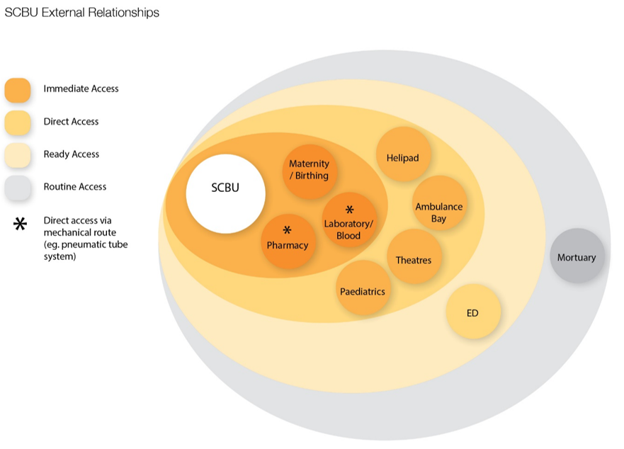
Figure 2: External functional relationships – matrix. (Example only)
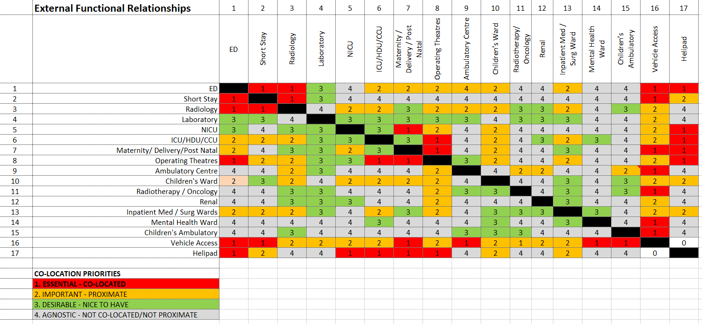
Figure 3: Internal functional relationships. (Example only)
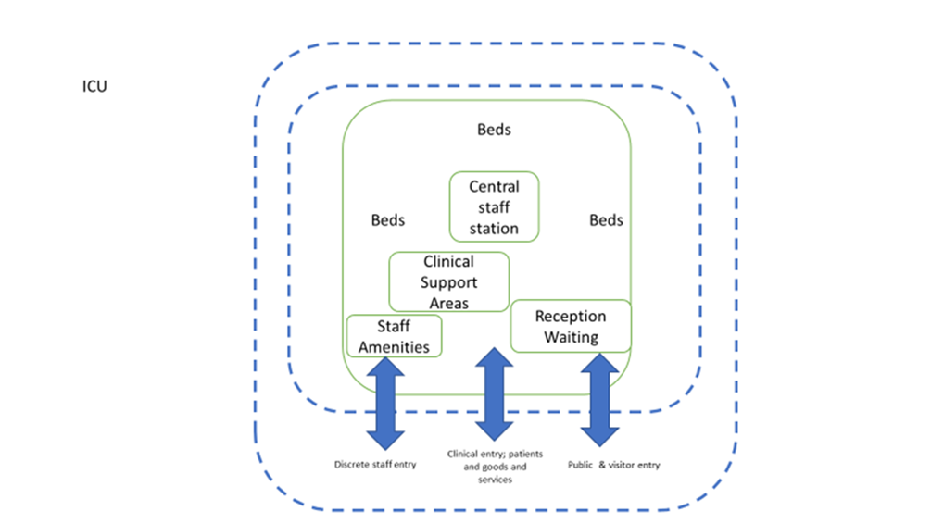

Example 2: Staffing Profile
The information in this table is used to determine staff amenities (staff room, lockers, WC/showers etc.), workspaces, meeting/tutorial rooms, parking etc. Add/subtract rows as required.
Future staffing profiles should be estimated against proposed changes outlined in CSP.

Staff Role | Current FTE  (@ time of FDB) | Current Head count | Future FTE  (link to CSP) | Future Head count  (link to CSP) | Future Estimated work balance  e.g.  50% clinical 50% admin | Comments
Medical
Clinical Director | 1.0 | 1 | 1.0 | 1 | 25% clinical 75% admin
SMO | 6 | 9 | 12 | 15 | 75% clinical 25% admin
RMO
Other
Nursing
CNM |  |  |  |  | 20% clinical 80% admin
Nurse Practitioner |  |  |  |  | 50% clinical  50% admin
Educator
Registered Nurses
Other
Allied Health
Physio
Other
Auxiliary Staff
Technician |  |  |  |  | 50% admin
Receptionist |  |  |  |  | 100% admin
Secretary |  |  | 2 | 4 | 100% admin
Other

Example 3: Consulted Stakeholders
 |  | User Group Meetings/Dates
Title/Name | Role and Department | 1 | 2 | 3 | 4
Ms x | Nurse Manager, ICU | 2/2/22 | 2/3/22

These documents should be attached to the completed FDB
The FDB is not; a business case, a clinical services plan, a justification for a service, a model of care document, an overarching project brief.
Part B - Health Facility Briefing and Planning; 0080 - General Requirements, Revision 5.0, 01 March 2016, Section 0.19, Page 20 https://AHFG-prod-com-au.s3.amazonaws.com/download/Part%20B.0080_5.pdf
Example contributed by, Ian Grant, HIU, Ministry of Health, and Steve Berendsen, Programme Manager, Taranaki DHB

