COVID-19 TRENDS AND INSIGHTS REPORT
28 October 2022

Released 2022 health.govt.nz

Citation: Public Health Agency. 2022. COVID-19 Trends and Insights Report.
Wellington: Ministry of Health
Published in October 2022 by Ministry of Health PO Box 5013, Wellington 6140, New Zealand
HP 8608

This document is available at health.govt.nz

This work is licensed under the Creative Commons Attribution 4.0 International licence. In essence, you are free to: share ie, copy and redistribute the material in any medium or format; adapt ie, remix, transform and build upon the material. You must give appropriate credit, provide a link to the licence and indicate if changes were made.

Contents
Purpose of report 1
Executive summary 2
Key insights 3
National Trends 3
Māori 3
Pacific peoples 4
International Insights 4
National summary of epidemic trends 5
Hospitalisation and mortality trends 8
Whole Genomic Sequencing 11
Comparison of epidemic trends by ethnicity 15
Comparison of epidemic trends by deprivation 18
Global pandemic summary 21
Appendix: Table of summary statistics 22

COVID-19 TRENDS AND INSIGHTS REPORT iii

List of Figures
Figure 1: National wastewater trends (SARS-CoV-2 genome copies) compared with reported cases 6
Figure 2: COVID-19 Modelling Aotearoa scenarios compared with national reported case numbers 6
Figure 3: Regional reported case rates from January to 23 October 2022 7
Figure 4: National reported case rates by age from January to 23 October 2022 7
Figure 5: National hospital admissions rate for COVID-19, January to 16 October 2022 8
Figure 6: COVID-19 Modelling Aotearoa hospital occupancy scenario compared with national observed occupancy 9
Figure 7: National weekly death counts by cause of death, February to 23 October 2022 10
Figure 8: COVID-19 Modelling Aotearoa death count compared with national observed deaths attributed to COVID-19 10
Figure 9: Proportion of Variants of Concern in community cases 11
Figure 10: Reinfections 7 day rolling average from 01 January to 23 October 2022
14
Figure 11: Reinfections cumulatively from 01 January to 23 October 2022 14
Figure 12: National age-standardised reported case rates by ethnicity from January to 23 October 2022 16
Figure 13: National age-standardised hospitalisation rates by ethnicity from January to 16 October 2022 16
Figure 14: Age-standardised cumulative incidence (and 95% confidence intervals) of hospitalisation for COVID-19 by ethnicity, 01 January 2022 to 23 October 2022
17
Figure 15: Age-standardised cumulative incidence (and 95% confidence intervals) of mortality attributed to COVID-19 by ethnicity, 01 January 2022 to 23 October 2022 17
Figure 16: National age-standardised reported case rates by deprivation status for weeks 01 January – 23 October 2022 19
Figure 17: Age-standardised hospital admission rates for COVID-19 by deprivation from January to 16 October 2022 19
Figure 18: Age-standardised cumulative incidence (and 95% confidence intervals) of hospitalisation for COVID-19 by deprivation, 01 January 2022 to 23 October 2022 20
Figure 19: Age-standardised cumulative incidence (and 95% confidence intervals) of mortality attributed to COVID-19 by deprivation, 01 January 2022 to 23 October 2022 20

Purpose of report
This report comments on trends in the New Zealand COVID-19 outbreak, including cases, hospitalisations and mortality. It also comments on international COVID-19 trends and the latest scientific insights related to outbreak management. The report relies on data that may be subject to change or are incomplete. An unknown proportion of infections are not reported as cases, this proportion may differ by characteristics such as ethnicity or deprivation group. Therefore, any differences in reported case rates must be interpreted with caution.

Executive summary
Overall, key measures of infection (levels of viral RNA in wastewater and reported case rates) used to monitor the COVID-19 epidemic have been increasing after two months of decline since the July peak. Following a similar trend to case rates, after previously decreasing substantially, hospital admission and occupancy rates have also started to increase. Meanwhile, mortality counts have continued to decrease; however, both measures (hospital admission and mortality rates) lag behind changes in infection rates.

BA.5 was the dominant subvariant accounting for an estimated 84% of cases, with the proportion of BA.5 declining slowly over the previous weeks, as proportions of several other subvariants increase, both in WGS and wastewater.

Over the next fortnight, it is probable that cases, hospitalisations and mortality will continue to increase. It is still uncertain, at this stage, what impact new variants of concern in the community will have on overall infections, hospitalisations and mortality.

Key insights

National Trends

Cases | The 7-day rolling average of reported case rates was 47.0 per 100,000 population for the week ending 23 October. This was a 14.5% increase from the previous week, which was 41.1 per 100,000. Rates were highest in the 65+ age group (62.8 per 100,000).
Wastewater | Wastewater quantification indicated an increase in transmission in the past week and suggests an approximate 35-45% case under-ascertainment.
Hospitalisations | The COVID-19 hospital admissions rate has been increasing since early October, with a 7-day rolling average of 0.9 per 100,000 for the week ending 16 October. The rate was highest in the 65+ age group (3.2 per 100,000), followed by the 0-4 age group (1.1 per 100,000).
Mortality | As of 16 October, there were 2,041 deaths attributed to COVID-19 in 2022. The weekly number of deaths attributed to COVID-19 has continued to decrease. The 80+ age group had the highest mortality rate across all age groups (0.8 per 100,000); followed by the 70-79 age group (0.1 per  100,000).
Variants of Concern | Based on individual WGS, BA.5 accounts for 84% of sequenced community cases seen in the week 08 to 14 October, followed by BA.4.6 (6% of cases), BA.2.75 (4% of cases) and BA.4 (2% of cases).  Wastewater variant analysis for the fortnight ending 16 October reports the following proportions: BA.4/5 87%, BA.1/BA.2.75 9% and BQ.1.1 4%. Variant XBB is being monitored by both WGS and wastewater but currently accounts for close to 0% of samples.

Māori

Cases | The 7-day rolling average of reported case rates was 29.2 per 100,000 population on 23 October, lower than for European or Other, however there may be case ascertainment biases. Rates were highest in those aged 25-44 and 45-64 (41.8 and 39.6 per 100,000, respectively).
Hospitalisations | The age-standardised cumulative hospital admission risk for 2022 was 1.9 times higher in Māori than European or other. The 7-day rolling average to 16 October was 0.5 per 100,000 and highest in those aged 70-79 (1.2 per  100,000), followed by those aged 60-69 (1.0 per 100,000).
Mortality | The age-standardised cumulative mortality rate for Māori was 1.9 times higher than European or Other in 2022.

Pacific peoples

Cases | The 7-day rolling average of reported case rates was 31.3 per 100,000 population on 23 October; lower than for European or Other, however there may be case ascertainment biases. Rates were highest in those aged 25-44 and 45-64 (40.8 and 40.6 per 100,000, respectively).
Hospitalisations | Pacific peoples have the highest age-standardised cumulative risk of hospital admission in 2022, 2.4 times higher than European or other. The 7-day rolling average to 16 October was 1.0 per 100,000 and highest in those aged 80+ (20.5 per 100,000) followed by those aged 70-79 (2.7 per  100,000).
Mortality | Pacific peoples have the highest age-standardised cumulative mortality risk of any ethnicity in 2022, 2.4 times that of European or other.

International Insights

Globally, in the week ending 23 October, the number of new weekly cases decreased by 15% compared with the previous week, with over 2.6 million new cases reported. The number of weekly deaths decreased by 13% compared with the previous week, with over 8,500 deaths reported.
BA.5 Omicron descendent lineages continue to be dominant globally, with a stable weekly prevalence of approximately 78% as of 09 October. Proportions of BQ.1.1 and XBB and other subvariants of Omicron remain low, but are increasing globally.
In Australia, as at 18 October, cases and hospitalisations continue to decline nationally. In NSW, cases of subvariants XBB and BQ.1.1 have low prevalence but are increasing.
In Singapore, the wave due to the XBB variant has peaked.

National summary of epidemic trends

Case trends
Evidence supports an increase in incidence in the community: Reported1 case rates and levels of viral ribonucleic acid (RNA) in wastewater have been increasing since 02 October after both measures were relatively constant in September (see Figure 1).
Recent Wastewater data through 16 October suggested that approximately 60-70% of infections were reported as cases.
After tracking closely to the modelled median rate, the reported cases have increased above the median in the week to 23 October. Modelling scenarios that account for changes in masking and contact quarantine on 12 September and assume no new variants, indicate case rates are expected to remain stable or slightly increase in the coming months (see Figure 2)2.
The general population reported case rate for the week ending 23 October was 47.0 per 100,000, a 14.5% increase from the previous week (41.1 per 100,000). The case rate was highest in Central region (57.6 per 100,000), having increased by 14.9%, and lowest in Te Manawa Taki (38.1 per 100,000), having increased by 20.0% compared with the week prior (see Figure 3).
Increases were seen across all age groups. The reported case rate increased 19.9% to
62.8 per 100,000 in those aged 65 years and older; this was the highest rate across all age groups. The lowest rate was among 5–14-year-olds (20.2 per 100,000) (see Figure 4).
Table 1 in the appendix provides information on specific rates.

1 Since 24 February 2022, most testing has been through self-administered rapid antigen tests (RATs) which require self-reporting of results. Therefore, it is likely that many infections are not detected or reported, and the proportion of infections reported (‘reported cases’) may differ by age, ethnicity, and deprivation.
2 See the online glossary for modelling assumptions.

Figure 1: National wastewater trends (SARS-CoV-2 genome copies)3 compared with reported cases
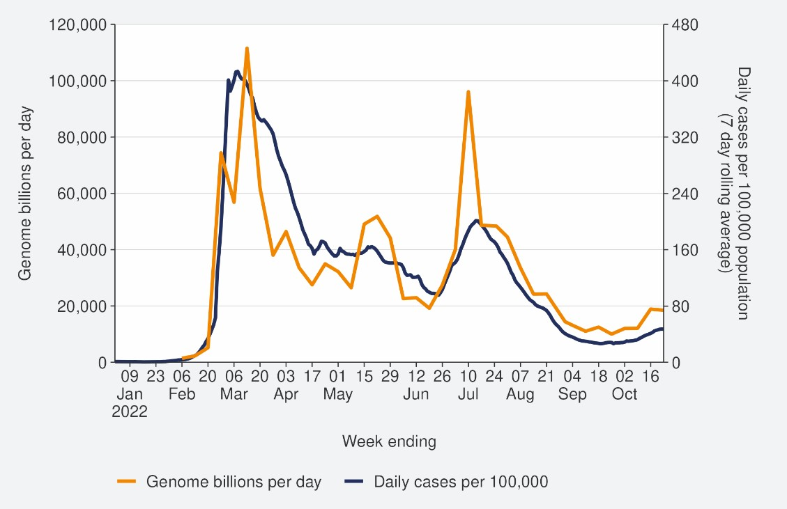
Sources: ESR SARS-CoV-2 in wastewater update for week ending 16 October 2022 and NCTS/EpiSurv as at 2359hrs 23 October 2022

Figure 2: COVID-19 Modelling Aotearoa scenarios4 compared with national reported case numbers
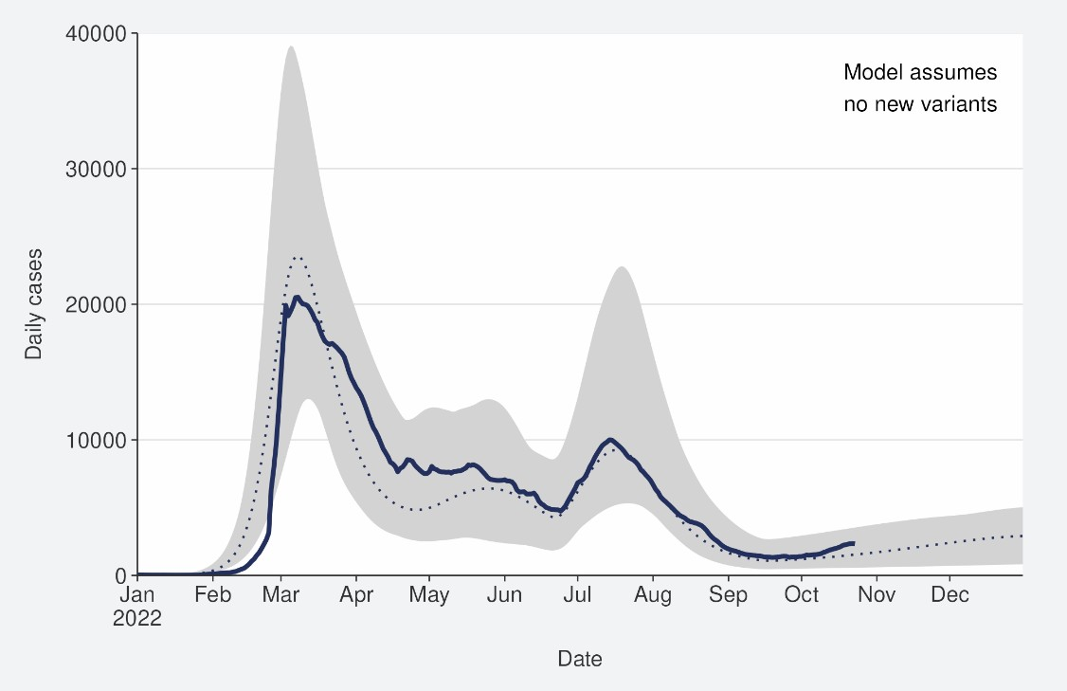
Sources: COVID-19 Modelling Aotearoa, ordinary differential equation model, September 2022, and NCTS/EpiSurv as at 2359hrs 23 October 2022

3 Wastewater levels cannot be used to predict numbers of cases but do indicate trends in the infection rates.
4 The ‘July’ BA.5 scenario assumes previous infection provides greater protection against reinfection and severe disease, consistent with emerging international evidence. It also incorporates updated data and future projections of uptake of second boosters, and an earlier transition to BA.5, consistent with the timing of cases and hospitalisations in New Zealand.

Figure 3: Regional reported case rates from January to 23 October 2022
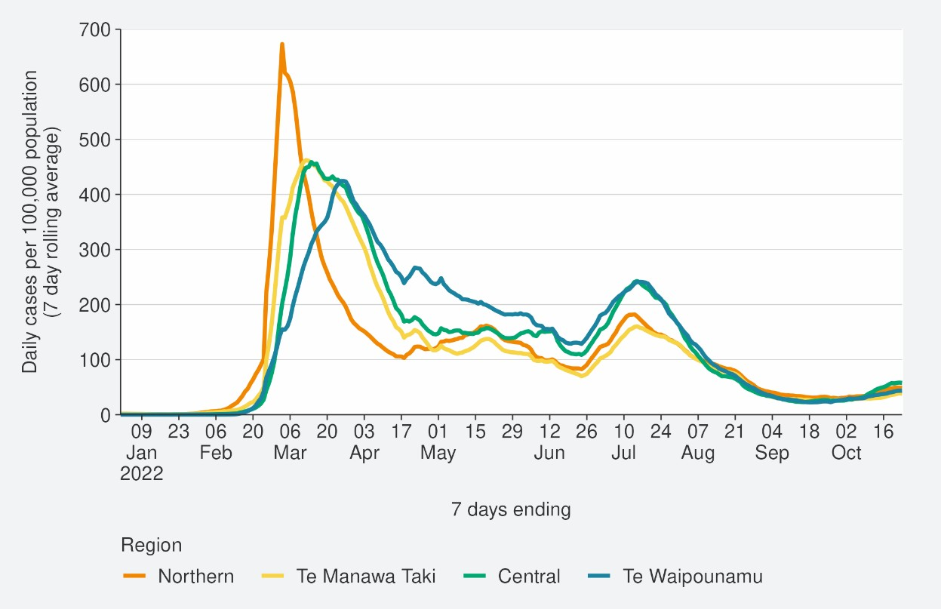
Source: NCTS/EpiSurv as at 2359hrs 23 October 2022

Figure 4: National reported case rates by age from January to 23 October 2022
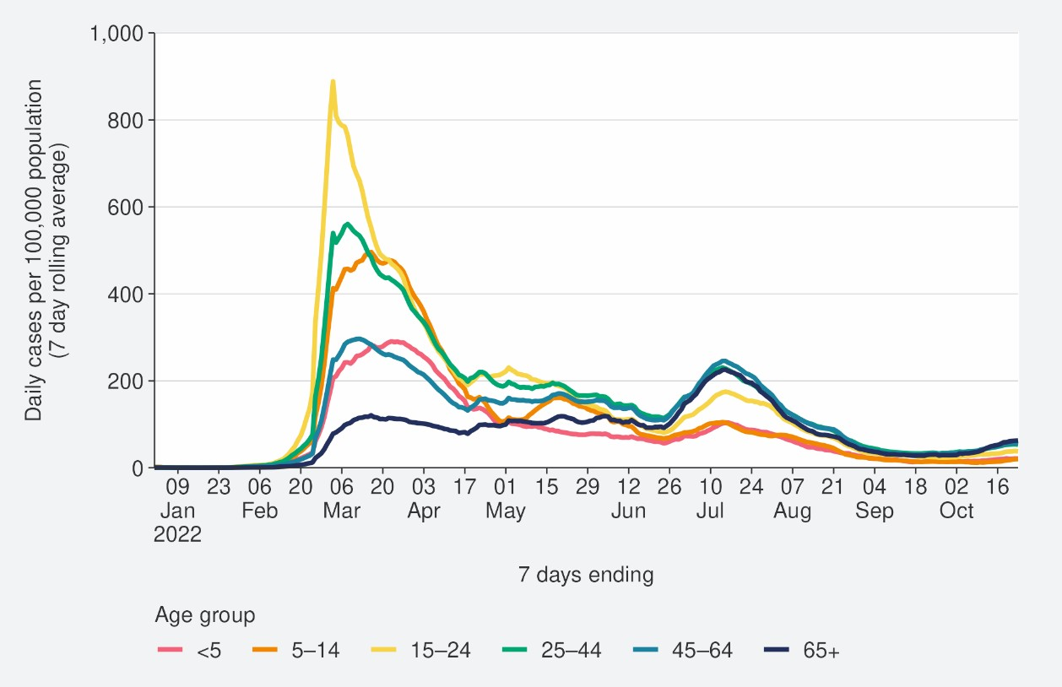
Source: NCTS/EpiSurv as at 2359hrs 23 October 2022

Hospitalisation and mortality trends

Hospitalisation
As seen in Figure 5, the national COVID-19 hospital admissions rate ‘for’ COVID-19 decreased substantially from mid-July to mid-September, but has since been increasing, with a 7-day rolling average of 0.9 per 100,000 population for the week ending 16 October.5
Despite reported case rates in the most recent July peak being half that of the March peak (201.2 and 413.2 per 100,000, respectively), the hospitalisation rate in the July peak was not substantially lower than the hospitalisation rate in March. This can be explained by the strong association between age and poor outcomes after infection. The reported case rates in those aged >65 years peaked at 75% higher in July than in March (refer back to Figure 4).
Modelling scenarios suggest current hospital occupancy is tracking towards the higher range of the prediction and is expected to slightly increase in the coming months (see Figure 6).

Figure 5: National6 hospital admissions rate for COVID-19, January to 16 October 2022
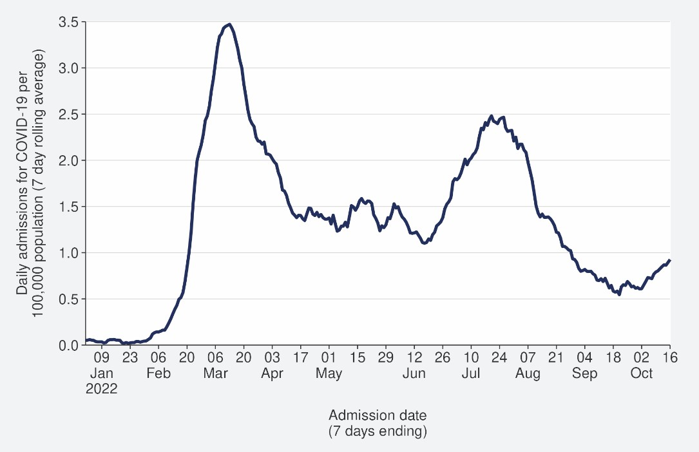
Source: NMDS/Inpatient’s admissions feed as of 18 October 2022 data up to 16 October 2022

5New hospital admissions who had COVID-19 at the time of admission or while in hospital; excluding hospitalisations that were admitted and discharged within 24hrs. The ‘for’ measure excludes those who are identified as incidental with COVID-19, such as injuries. Recent trends are subject to revision. Please see glossary for further caveats.
6 Data are from Districts with tertiary hospitals; these Districts are Auckland, Canterbury, Southern, Counties Manukau, Waikato, Capital & Coast, Waitemata, and Northland.

Figure 6: COVID-19 Modelling Aotearoa hospital occupancy7 scenario8 compared with national observed occupancy
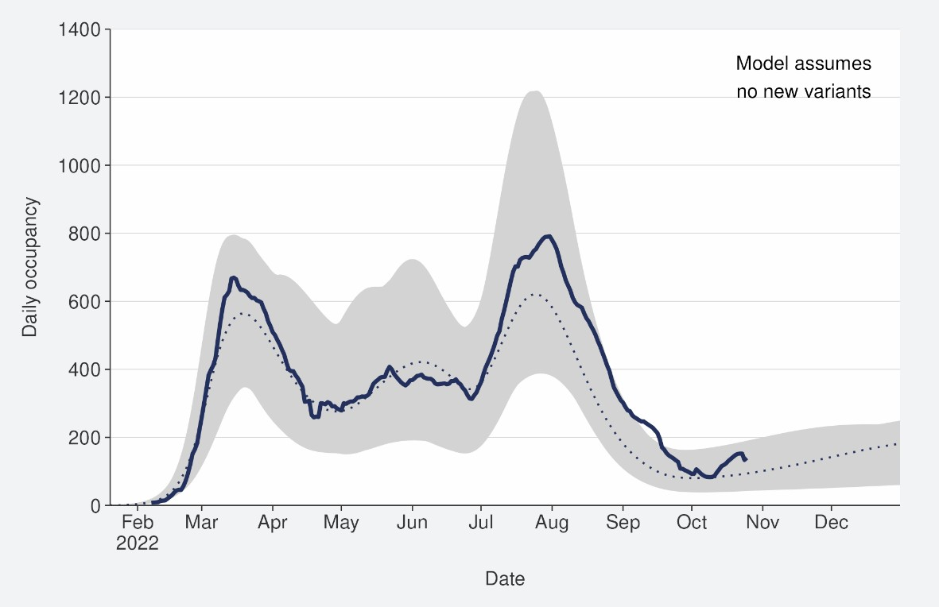
Sources: COVID-19 Modelling Aotearoa, ordinary differential equation model, September 2022, and Ministry of Health reported hospital occupancy data 23 October 2022

Mortality
From the first week of January to 23 October 2022, there were 3,105 deaths among people who died within 28 days of being reported as a case and/or with the cause being attributable to COVID-19 (that is an underlying or contributory cause) (see Figure 7)9.
Of these deaths in 2022 that have been formally coded by cause of death, 1,287 (47%) were determined to have COVID-19 as the main underlying cause. COVID-19 contributed to a further 754 (28%) deaths and another 693 (25%) people died of an unrelated cause (Figure 7). Deaths have been declining since peaking in the last week of July, though in the past few weeks the decline has slowed. As seen with hospitalisations, due to the strong association of increasing age and increasing mortality risk, the patterns in mortality over time strongly reflect the case rates in those aged >65 years.
Deaths are currently tracking close to lower range of the modelled scenario and are predicted to slightly increase in the coming months (see Figure 8).

7 These data are for all hospital occupancies with COVID-19, including those that were incidental, such as injuries.
8 The 'July’ scenario assumes previous infection provides greater protection against reinfection and severe disease, consistent with emerging international evidence. It also incorporates updated data and future projections of uptake of second boosters, and an earlier transition to BA.5, consistent with the timing of cases and hospitalisations in New Zealand.
9 There were 55 deaths before the first week of 2022.

Figure 7: National weekly death counts by cause of death10, February to 23 October 2022
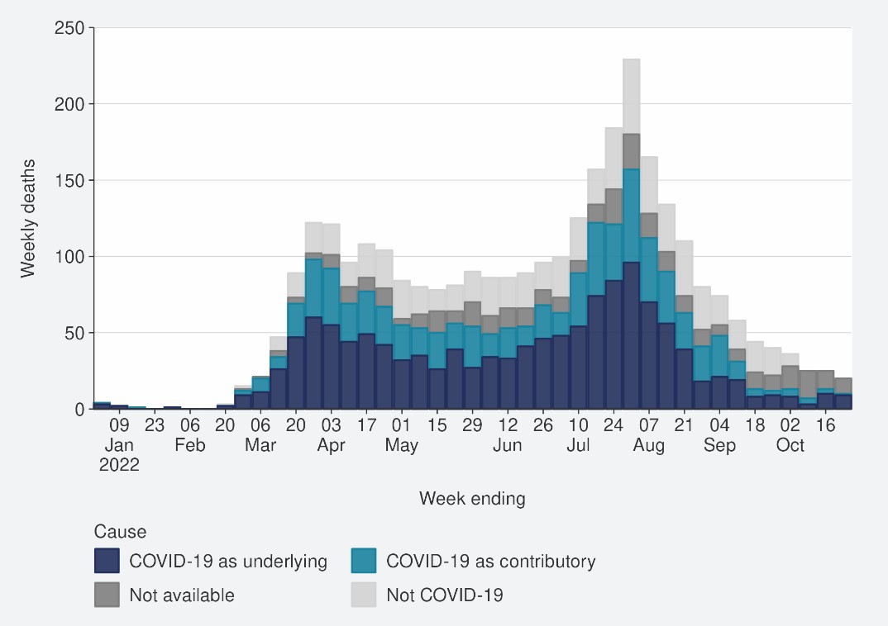
Source: Ministry of Health, 23 October 2022

Figure 8: COVID-19 Modelling Aotearoa death count compared with national observed deaths attributed to COVID-19
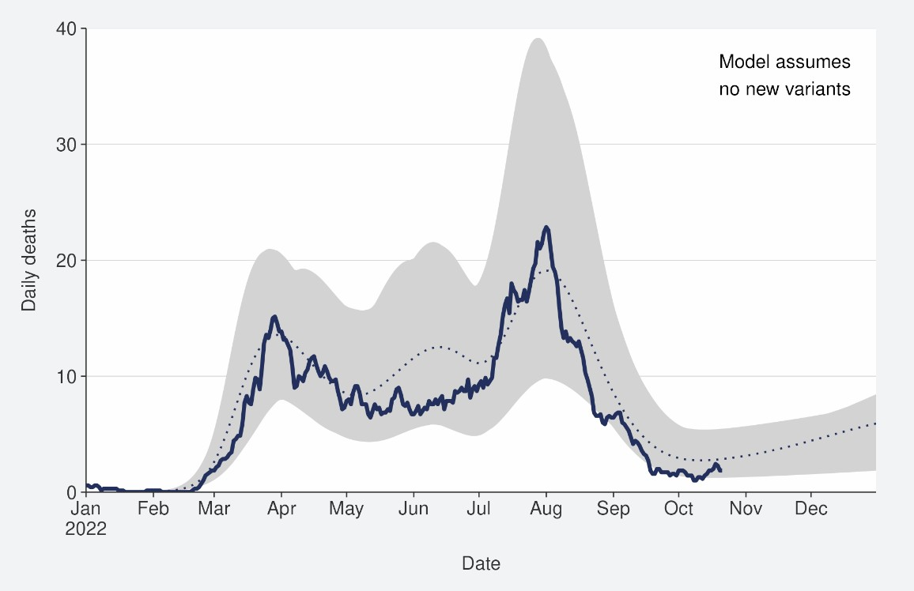
Sources: COVID-19 Modelling Aotearoa, ordinary differential equation model, September 2022, and Ministry of Health reported attributed deaths data 23 October 2022

10 Mortality data are affected by a delay due to time taken for reporting and death coding, the most recent weeks should be interpreted with caution.

Whole Genomic Sequencing

Community cases and wastewater
Whole Genomic Sequencing data is updated on a fortnightly basis; the data have not been updated for this week’s report.
Figure 9 shows the proportions of variants in community cases, with BA.5 accounting for 84% of sequenced cases in the week to 14 October. Proportions of the BA.5 subvariant in the community have remained constant over the last few weeks.
Watchlist variants BA.2.75 (4%) and BA.4.6 (6%) continue to be detected; the changes in community sequencing were likely driven by the loss of distinction between border and community cases following COVID-19 Protection Framework changes. Patterns in wastewater remained similar to previous weeks with BA.4/5 accounting for 91% of variants detected.
In the two weeks to 14 October, the Omicron variants BQ.1.1 and XBB were also detected in community samples with three BQ.1 cases, three BQ.1.1 cases and one case caused by the recombinant lineage XBB. BQ.1.1 was also detected in wastewater, but XBB has not been detected in wastewater yet.

Figure 9: Proportion of Variants of Concern in community cases11
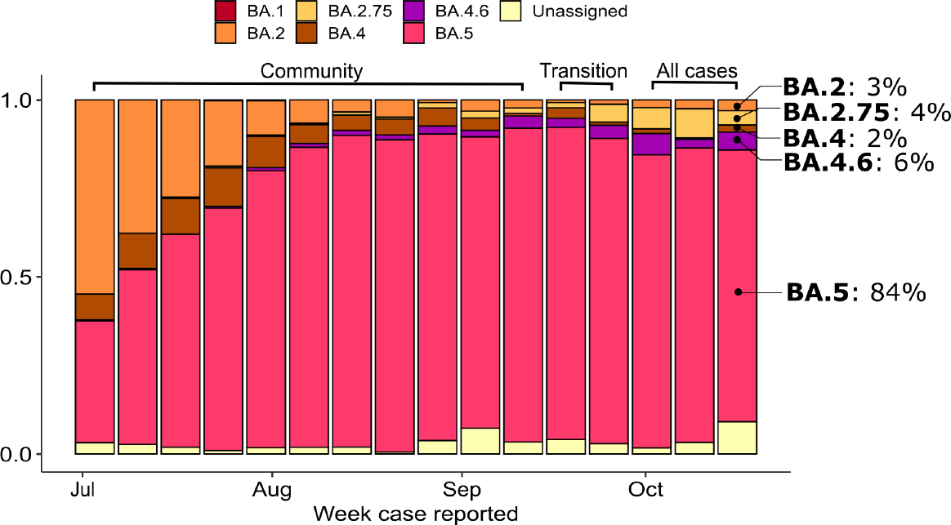
Source: ESR COVID-19 Genomics Insights Report #23, EpiSurv/Microreact 0900hrs 14 October 2022

11 For weeks before the end of the COVID-19 Protection Framework, only data from community cases were used. In the period marked as “transition”, cases known to be associated with the border are removed, but not all such cases can be reliably identified. In the most recent weeks, data from all cases is used. Cases classified as Omicron (Unassigned) are typically partial genomes where it is difficult to be definitive regarding variant/lineage.

Hospitalised cases
Not available for this reporting period.

Reinfection
‘Reinfection’ is now defined as a case reported at least 29 days after the last time a person reported a positive test for COVID-19. The definition of reinfection changed on 30 June; prior to this, reinfection was based on reports at least 90 days apart (based on the international literature at the time). Up until 30 June 2022, the vast majority of positive results detected within 90 days of the prior infection were not recorded in the system. Some potential reinfections within 90 days were recorded but were not representative of the general population.
Reinfection in general refers to a second or subsequent infection after the prior infection has cleared. In this analysis, we are not able to distinguish between reinfection with the same variant or different variants. Reinfection with a different variant to the first infection is more likely than reinfection with the same variant. Technically these data report on ‘redetections’ rather than true reinfections. True reinfections cannot be definitively captured in the data for a range of reasons. For example, a person with persistent infection due to being immunocompromised, who undergoes repeated testing due to regular hospital or clinical visits, would appear in the data as a ‘reinfection’ when they may have a chronic or persistent infection.
Figure 10 characterises the average number of cases per week by first infection and reinfection. Reinfections made up 10.2% of reported cases in the week ending 23 October. The proportion of reported cases that were reinfections has been stable in the past seven weeks. Figure 11 shows how many first infections and reinfections have been reported cumulatively over time. Cumulatively, reinfections have made up 2.3% of total cases reported in 2022. The proportion of cases that are reinfections is expected to increase over time. The true number of reinfections is likely higher than reported here. In general, reporting of cases is expected to decline over time. Due to under- ascertainment of the first infection and subsequent infections and, as both are required to detect a reinfection, there is likely to be under-reporting of reinfections.

Figure 10: Reinfections 7 day rolling average from 01 January to 23 October 2022
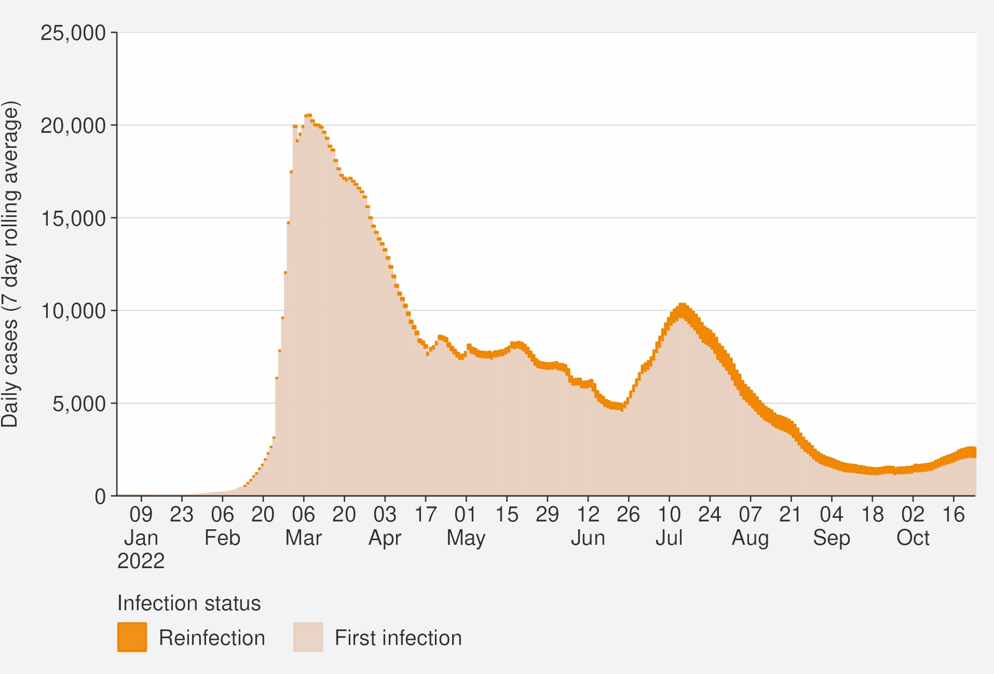
Source: NCTS/EpiSurv as at 2359hrs 23 October 2022

Figure 11: Reinfections cumulatively from 01 January to 23 October 2022
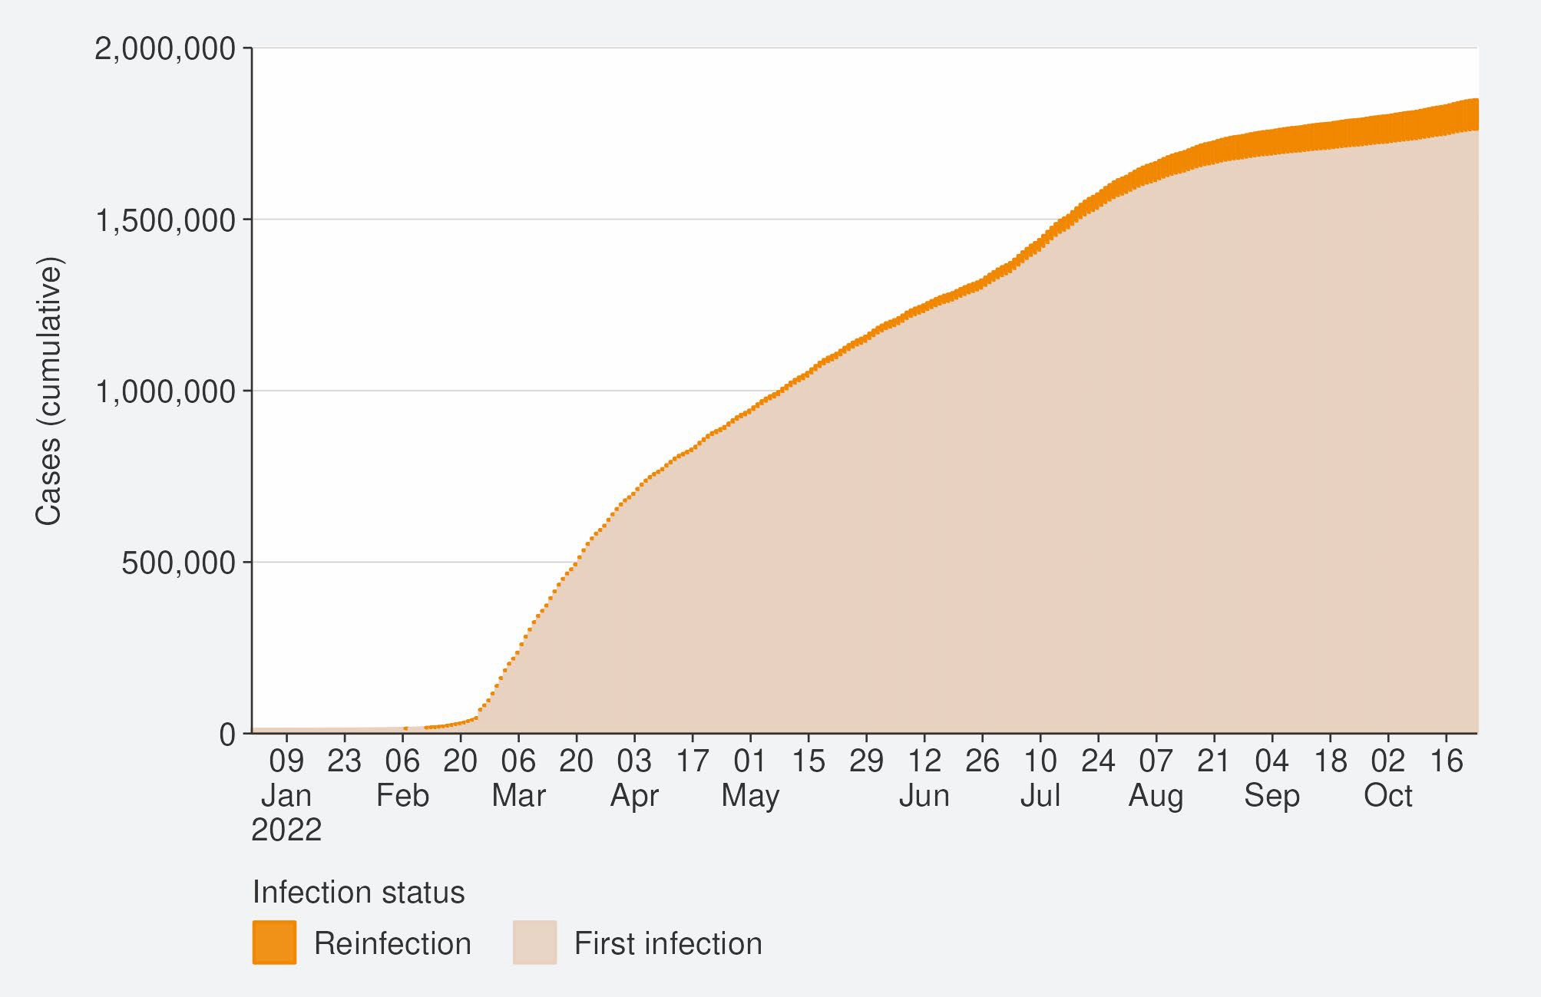
Source: NCTS/EpiSurv as at 2359hrs 23 October 2022

Comparison of epidemic trends by ethnicity
The age-standardised reported case rates have increased for all ethnicities (see Figure 12); in the week to 23 October. The highest rates were in Asian and European or other (53.8 and 42.0 per 100,000 respectively) and the lowest were in Māori and Pacific peoples (29.2 and 30.2 per 100,000, respectively). Among Māori, rates were highest in those aged 25-44 and 45-64 (41.8 and 39.6 per 100,000, respectively). Among Pacific peoples, rates were also highest in those aged 25-44 and 45-64 (40.8 and 40.6 per 100,000, respectively). This was unlike European or Other ethnicity where case rates were highest in those aged 65+ and 45-64 (65.4 and 59.4 per 100,000, respectively).
Refer to Table 1 and Table 2 in the appendix for non-age-standardised rates by ethnicity.
Figure 13 shows that the age standardised rates for hospitalisation for COVID-19 increased for all ethnicities except Māori in the week ending 16 October. Asian and Pacific peoples had the highest hospitalisation rate in the week ending 16 October, almost 2-fold higher than Māori and European or other.
The cumulative total for the year shows that overall, Pacific peoples and Māori have had the highest risks of hospitalisation for COVID-19 – 2.4 and 1.9 times the risk of European or other, respectively for 01 January to 23 October. Asian ethnicity has had a hospitalisation rate almost 15% lower than European or other (Figure 14).
The cumulative age-standardised mortality rate for 01 January to 23 October shows that Pacific peoples have had the highest risk, 2.4 times that of European or other, followed by Māori at 1.9 times that of European or other. Asian people have had the lowest risk of Mortality, 35% lower than European or other (see Figure 15).12
The lower reported case rates and higher hospitalisation and death rates for Māori and Pacific peoples suggests they may have lower levels of case ascertainment and/or a higher risk of poor outcomes after infection compared with Asian and European or other ethnicities.

12 These calculations are based on 1,896 deaths occurring between January 2022 and 02 October 2022 (excludes deaths in the last 2 weeks and deaths where ethnicity was unknown).

Figure 12: National age-standardised reported case rates by ethnicity from January to 23 October 2022
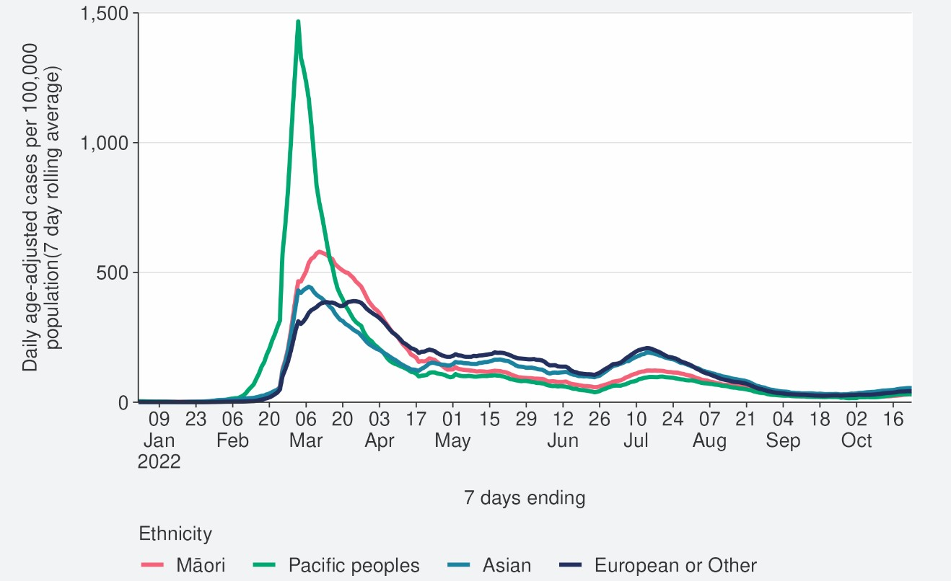
Source: NCTS/EpiSurv as at 2359hrs 23 October 2022

Figure 13: National age-standardised hospitalisation rates by ethnicity from January to 16 October 2022
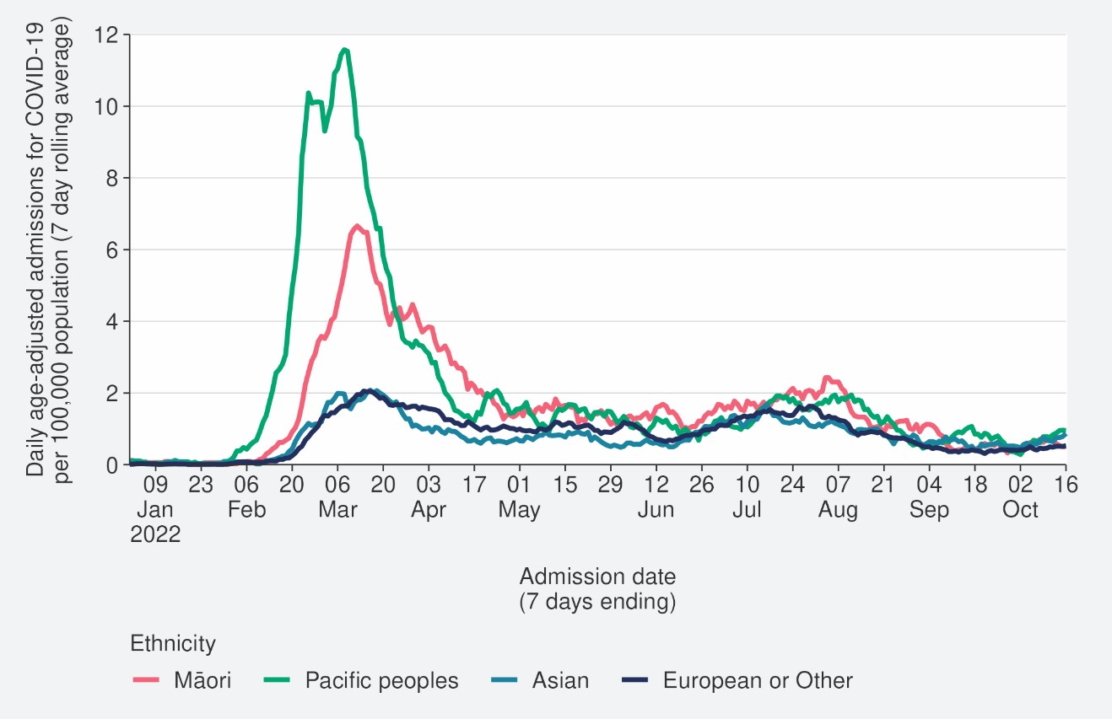
Source: NCTS/EpiSurv as at 2359hrs 16 October 2022

Figure 14: Age-standardised cumulative incidence (and 95% confidence intervals) of hospitalisation for COVID-19 by ethnicity, 01 January 2022 to 23 October 2022
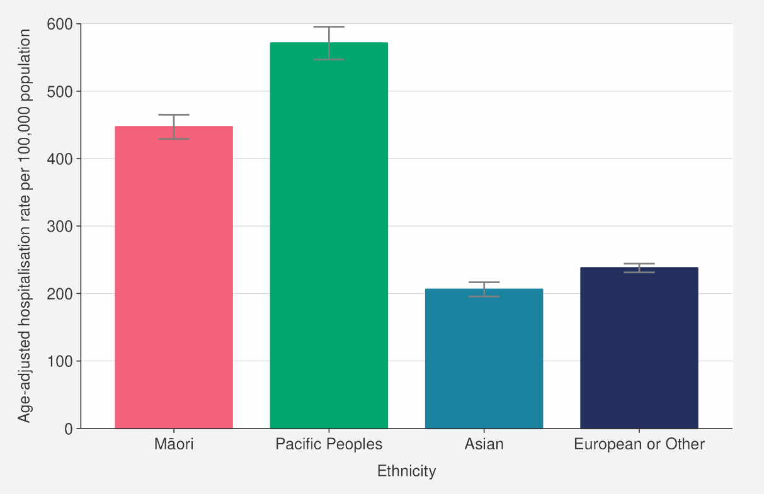
Source: NCTS/EpiSurv, NMDS, Inpatient Admissions dataset and CVIP population estimates, 01 January 2022 to 23 October 2022

Figure 15: Age-standardised cumulative incidence (and 95% confidence intervals) of mortality attributed to COVID-19 by ethnicity, 01 January 2022 to 23 October 2022
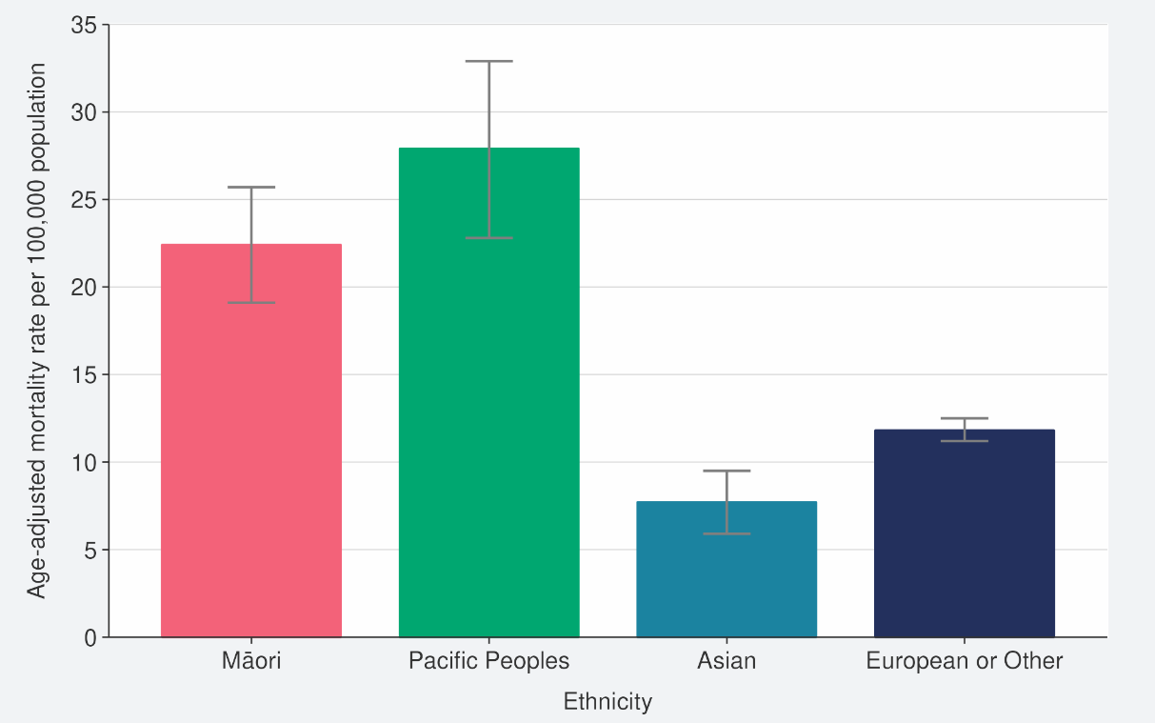
Source: NCTS/EpiSurv, NMDS, Inpatient Admissions dataset and CVIP population estimates, 01 January 2022 to 23 October 2022

Comparison of epidemic trends by deprivation
Figure 16 shows the 7-day rolling average for reported case rates by residential area deprivation level (based on NZDep2018)13. Age-standardised rates for all deprivation levels increased in the week ending 23 October. Rates in the week to 23 October were slightly higher in areas of least and mid-range deprivation. Refer to Table 1 in the appendix for non-age-standardised rates by deprivation.
Figure 17 and Figure 18 show that those most deprived have had, and continue to have, the highest rates of hospitalisation, both recently and cumulatively during 2022. Those most deprived have had 2.1 times the risk of hospitalisation compared with those who are least deprived.
Cumulative rates of mortality are also highest for those most deprived (Figure 19).14
As lower case rates have been reported among those most deprived, their continued higher hospitalisation and death rates suggest those who are most deprived may have lower levels of case ascertainment and/or a higher risk of poor outcomes after infection compared with those who are least deprived.

13 Atkinson J, Salmond C, Crampton P (2019). NZDep2018 Index of Deprivation, Final Research Report, December 2020. Wellington: University of Otago.
14 These calculations are based on 1,833 deaths occurring between January 2022 and 02 October 2022 (excludes deaths in the last 2 weeks and deaths where the level of deprivation was unknown).

Figure 16: National age-standardised reported case rates by deprivation status for weeks 01 January – 23 October 2022
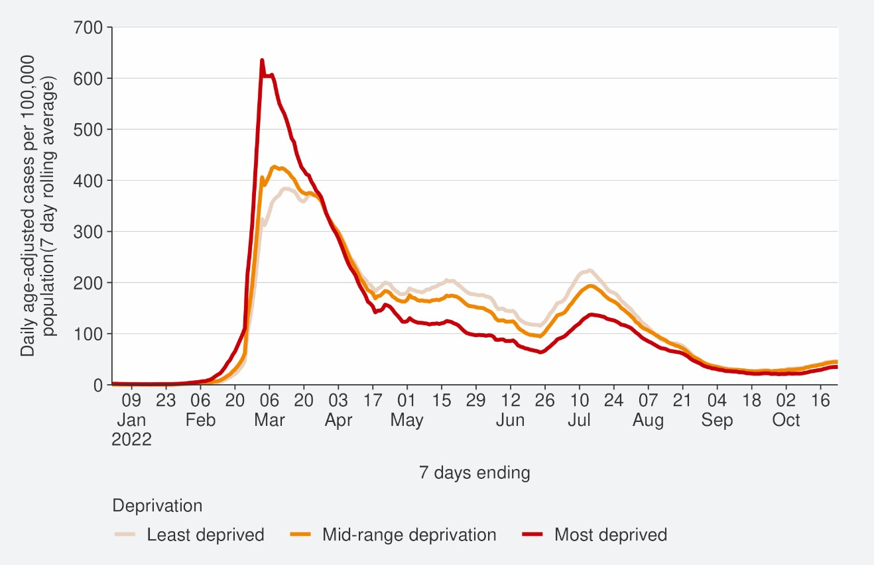
Source: NCTS/EpiSurv as at 2359hrs 23 October 2022

Figure 17: Age-standardised hospital admission rates for COVID-19 by deprivation from January to 16 October 2022
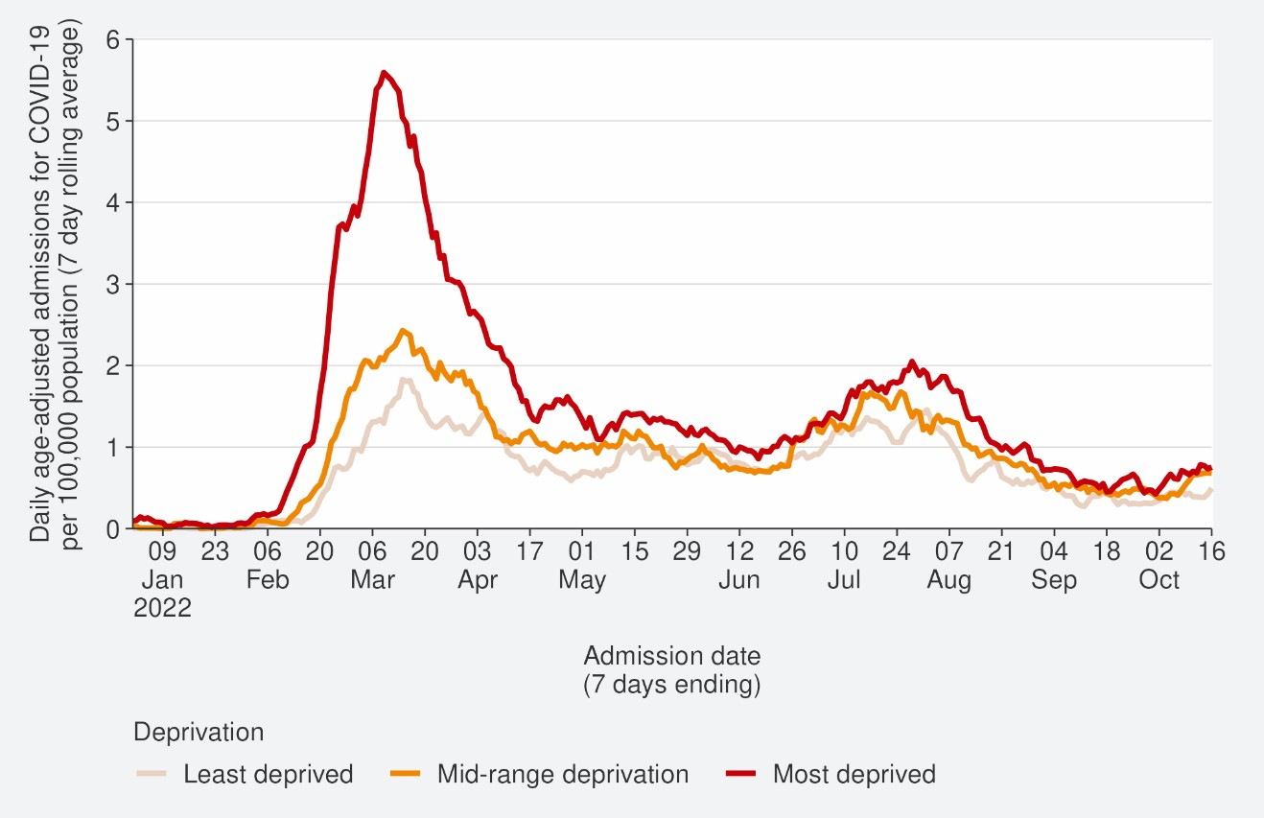
Source: NMDS/Inpatients admissions feed as of 18 October 2022 data up to 16 October 2022

Figure 18: Age-standardised cumulative incidence (and 95% confidence intervals) of hospitalisation for COVID-19 by deprivation, 01 January 2022 to 23 October 2022
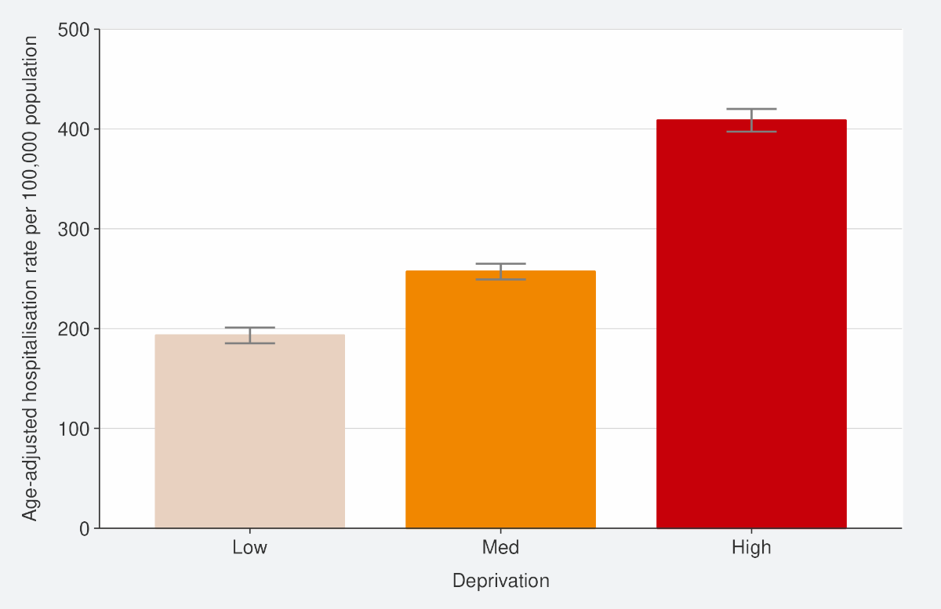
Source: NCTS/EpiSurv, NMDS, Inpatient Admissions dataset and CVIP population estimates 01 January 2022 to 23 October 2022

Figure 19: Age-standardised cumulative incidence (and 95% confidence intervals) of mortality attributed to COVID-19 by deprivation, 01 January 2022 to 23 October 2022
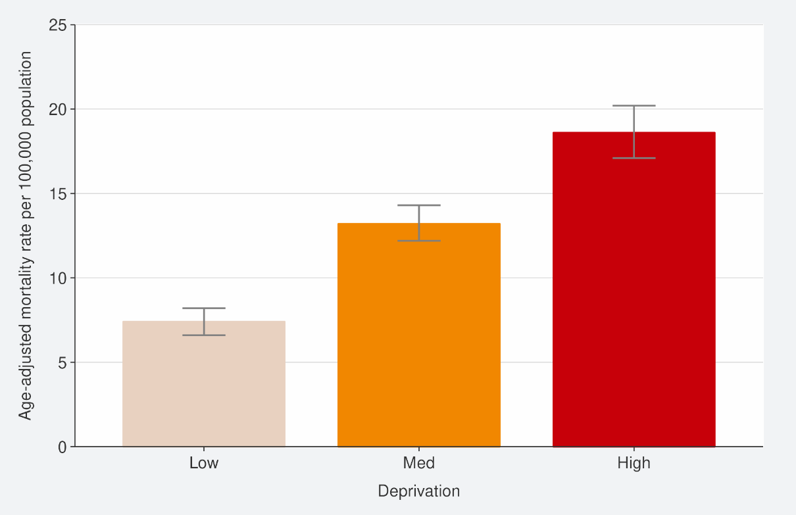
Source: EpiSurv, Death Documents, The Healthcare User database, Mortality Collections database and CVIP population estimates, 01 January 2020 to 23 October 2022

Global pandemic summary
We expect the global situation for the COVID-19 pandemic in the next few months to be driven by the ongoing emergence of new variants, waning immunity, and the Northern Hemisphere heading towards the winter season.

- Globally, in the week ending 23 October, the number of new weekly cases decreased by 15% as compared to the previous week with over 2.6 million new cases reported.
- The number of new weekly deaths decreased by 13% compared to the previous week with over 8,500 fatalities reported.
- Globally, as of 23 October 2022, over 624 million confirmed cases and over 6.5 million deaths have been reported.
- There continues to be increased diversity within Omicron and its descendent lineages. A number of these descendant lineages are under monitoring.
- BA.5 Omicron descendent lineages continue to be dominant globally, with a stable in weekly prevalence from 78.9% to 77.1% as of 09 October.
- BA.4 descendent lineages accounted for 5.4% of all cases, a slight decrease from last week as of 09 October.
- BA.2 descendent lineages still show a relatively low (4.3% as of 09 October) prevalence globally.
- Decreases in countries’ frequency of submitting COVID-19 genomes to GISAID make detecting accurate international representations of variant prevalence difficult.
- Omicron variant XBB is currently driving a wave in Singapore, though a decrease in cases has been observed there this week with 7-day rolling average of reported cases were 5,941 cases as of 25 October, a decrease from 8,506 the previous week.
- In Australia, as of 18 October, cases and hospitalisations continue to decline nationally. In NSW, cases of subvariants XBB and BQ.1.1 have low prevalence but are increasing.
Sources: World Health Organisation: Weekly epidemiological update on COVID-19 – 26 October 2022
/ Our world in data/ Straits Times / Australian Government: Coronavirus (COVID-19) common operating picture / Australian Bureau of Statistics, Australian Bureau of Statistics

Please note, global trends in cases, hospitalisations and deaths should be interpreted with caution as several countries have been progressively changing COVID-19 testing strategies, resulting in lower overall numbers of tests performed and consequently lower numbers of cases detected. Furthermore, approaches of counting hospitalisations and deaths can differ from country to country.

Appendix: Table of summary statistics

Table 1: Reported 7-day rolling average of case rates and hospital admissions by region, age group, ethnicity, and deprivation

 | Reported Cases (7-day rolling average) |  |  |  |  | Hospital admissions (7-day rolling average)
 | Week ending 16/10/2022 |  | Week ending 23/10/2022 |  | % Change | Week ending 09/10/2022 |  | Week ending 16/10/2022 |  | % Change
 | Number | Rate (per 100,000  population) | Number | Rate (per 100,000  population) |  | Number | Rate (per 100,000  population) | Number | Rate (per 100,000  population)
National | 2,041.0 | 41.1 | 2,336.4 | 47.0 | 14.5% | 34.4 | 0.9 | 31.9 | 0.9 | -7.5%
Region
Northern | 829.9 | 43.7 | 922.4 | 48.6 | 11.2% | 16.0 | 0.8 | 17.1 | 0.9 | 7.1%
Te Manawa Taki | 308.1 | 31.7 | 369.9 | 38.1 | 2% | 4.0 | 0.9 | 4.3 | 1.0 | 7.1%
Central | 469.7 | 50.1 | 539.9 | 57.6 | 14.9% | 1.4 | 0.3 | 2.7 | 0.6 | 90.0%
Te Waipounamu | 431.1 | 37.7 | 499.9 | 43.7 | 15.9% | 8.0 | 0.9 | 10.3 | 1.1 | 28.6%
Age group
<5 | 61.7 | 19.6 | 66.9 | 21.2 | 8.3% | 2.7 | 1.2 | 2.6 | 1.1 | -5.3%
5-14 | 98.1 | 14.6 | 136.1 | 20.2 | 38.7% | 0.6 | 0.1 | 1.0 | 0.2 | 75.0%
15-24 | 202.9 | 32.8 | 234.1 | 37.8 | 15.4% | 1.6 | 0.3 | 1.9 | 0.4 | 18.2%
25-44 | 655.1 | 48.5 | 719.7 | 53.3 | 9.9% | 3.4 | 0.3 | 5.3 | 0.5 | 54.2%

45-64 | 623.6 | 50 | 700.4 | 56.1 | 12.3% | 5.4 | 0.6 | 6.7 | 0.7 | 23.7%
65+ | 399.6 | 52.4 | 479.1 | 62.8 | 19.9% | 15.7 | 3.0 | 17 | 3.2 | 8.2%
Ethnicity
Māori | 181.7 | 23.8 | 222.6 | 29.2 | 22.5% | 3.0 | 0.6 | 2.4 | 0.5 | -19.0%
Pacific peoples | 103.6 | 28.3 | 114.7 | 31.3 | 10.8% | 2.7 | 0.8 | 3.4 | 1.0 | 26.3%
Asian | 382.3 | 52.1 | 423.9 | 57.8 | 10.9% | 5.6 | 0.8 | 6.0 | 0.9 | 7.7%
European or Other | 1359.0 | 44.1 | 1554.9 | 50.4 | 14.4% | 18.1 | 0.8 | 22.4 | 1.0 | 23.6%
Deprivation
Least deprived | 675.0 | 46.9 | 757.7 | 52.6 | 12.3% | 7.9 | 0.7 | 8.4 | 0.7 | 7.3%
Mid-range deprivation | 851.4 | 44.9 | 959.6 | 50.7 | 12.7% | 10.9 | 0.8 | 14.3 | 1 | 31.6%
Most deprived | 480.4 | 32.2 | 576.3 | 38.7 | 20.0% | 10 | 0.9 | 10.4 | 1 | 4.3%

Table 2: Cumulative reported cases and hospitalisations admissions from January 2022 to 23 October by level 2 ethnicity.

Ethnicity | Level 2 Ethnicity | Cumulative reported  cases of COVID-19 | Cases per 1000  population | Cumulative hospitalisation for COVID-19 | Hospitalisations per 1000 population | Population
Asian | Asian NFD | 8,783 | 394 | 26 | 1 | 22,320
Asian | Chinese | 59,105 | 251 | 466 | 2 | 235,331
Asian | Indian | 95,961 | 392 | 794 | 3 | 245,079
Asian | Other Asian | 46,226 | 380 | 312 | 3 | 121,732
Asian | Southeast Asian | 53,298 | 489 | 240 | 2 | 108,939
Māori | Māori | 269,676 | 354 | 3,153 | 4 | 762,780
MELAA15 | African | 9,753 | 370 | 115 | 4 | 26,364
MELAA | Latin American / Hispanic | 13,507 | 466 | 78 | 3 | 28,998
MELAA | Middle Eastern | 9,667 | 298 | 161 | 5 | 32,395
Pacific Peoples | Cook Island  Māori | 19,001 | 356 | 287 | 5 | 53,299
Pacific Peoples | Fijian | 17,215 | 420 | 188 | 5 | 40,956
Pacific Peoples | Niuean | 7,768 | 399 | 120 | 6 | 19,477
Pacific Peoples | Other Pacific Island | 6,881 | 476 | 71 | 5 | 14,466
Pacific Peoples | Pacific Island NFD | 1,624 | 443 | 6 | 2 | 3,663
Pacific Peoples | Samoan | 67,186 | 433 | 1,047 | 7 | 154,997
Pacific Peoples | Tokelauan | 2,790 | 407 | 43 | 6 | 6,863
Pacific Peoples | Tongan | 29,534 | 406 | 497 | 7 | 72,703

15 MELAA refers to Middle Eastern, Latin American and African.

