COVID-19 TRENDS AND INSIGHTS REPORT
23 September 2022

Released 2022 health.govt.nz

Citation: Public Health Agency. 2022. COVID-19 Trends and Insights Report.
Wellington: Ministry of Health
Published in September 2022 by Ministry of Health PO Box 5013, Wellington 6140, New Zealand
HP 8608

This document is available at health.govt.nz

This work is licensed under the Creative Commons Attribution 4.0 International licence. In essence, you are free to: share ie, copy and redistribute the material in any medium or format; adapt ie, remix, transform and build upon the material. You must give appropriate credit, provide a link to the licence and indicate if changes were made.

Purpose of report 1
Executive summary 2
Key insights 3
National Trends 3
Māori 3
Pacific peoples 3
International Insights 4
National summary of epidemic trends 5
Hospitalisation and mortality trends 8
Whole Genomic Sequencing 11
Comparison of epidemic trends by ethnicity 14
Comparison of epidemic trends by deprivation 17
Global pandemic summary 20
Appendix: Table of summary statistics 21

List of Figures
Figure 1: National wastewater trends (SARS-CoV-2 genome copies) compared with reported cases | 5
Figure 2: COVID-19 Modelling Aotearoa scenarios compared with national reported  case numbers | 6
Figure 3: Regional reported case rates from February to 18 September 2022 | 7
Figure 4: National reported case rates by age from February to 18 September 2022 Figure 5: National hospital admissions rate for COVID-19, February to 11 September  2022 | 7  8
Figure 6: COVID-19 Modelling Aotearoa hospital occupancy scenario compared with national observed occupancy | 9
COVID TRENDS AND INSIGHTS REPORT |  | iii

Figure 7: National weekly death counts by cause of death, February to 18 September 2022 10
Figure 8: COVID-19 Modelling Aotearoa death count compared with national observed deaths attributed to COVID-19 10
Figure 9: Frequency of Variants of Concern in community cases 11
Figure 10: Reinfections 7 day rolling average from 01 January to 18 September 13
Figure 11: Reinfections cumulatively from 01 January to 18 September 13
Figure 12: National age-standardised reported case rates by ethnicity from
January to 18 September 2022 15
Figure 13: National age-standardised hospitalisation rates by ethnicity from January to 11 September 2022 15
Figure 14: Age-standardised cumulative incidence (and 95% confidence intervals) of hospitalisation for COVID-19 by ethnicity, 01 January 2022 to 18 September 2022 16
Figure 15: Age-standardised cumulative incidence (and 95% confidence intervals) of mortality attributed to COVID-19 by ethnicity, 01 January 2022 to 18 September 202 16 Figure 16: National age-standardised reported case rates by deprivation status for weeks 01 January – 18 September 2022 18
Figure 17: Age-standardised hospital admission rates for COVID-19 by deprivation from January to 11 September 2022 18
Figure 18: Age-standardised cumulative incidence (and 95% confidence intervals) of hospitalisation for COVID-19 by deprivation, 01 January 2022 to 18 September 2022 19 Figure 19: Age-standardised cumulative incidence (and 95% confidence intervals) of mortality attributed to COVID-19 by deprivation, 01 January 2022 to 18 September 2022 19

Purpose of report
This report comments on trends in the New Zealand COVID-19 outbreak, including cases, hospitalisations and mortality. It also comments on international COVID-19 trends and the latest scientific insights related to outbreak management. The report relies on data that may be subject to change or are incomplete. An unknown proportion of infections are not reported as cases, this proportion may differ by characteristics such as ethnicity or deprivation group. Therefore, any differences in reported case rates must be interpreted with caution.

Executive summary
Overall, all key measures of the outbreak have been declining for the last two months. Trends are tracking to levels last seen in late February 2022. Reported case rates have continued to decrease nationally. Wastewater levels have also been declining since July but have increased slightly in the past week. The numbers of those who have been hospitalised and who have died have also continue to decrease.

BA.5 is the dominant subvariant accounting for an estimated 91% of cases; this is consistent with wastewater findings. In the two weeks to 16 September, variants BA.5, BA.4, BA.4.6 and BA.2 (including BA.2.75 and BA.2.75.2) were detected in community samples. While we may see one of these sub-variants slowly predominate over the next few months, they are not expected to cause a distinct wave.

Over the next couple of weeks, it is probable that cases, hospitalisations and mortality will continue to stabilise or slightly increase. However, as immunity decreases over time or if a substantially more transmissible variant emerges, there may be fluctuations in case rates in the future.

Key insights

National Trends

Cases | The 7-day rolling average of reported case rates was 26.9 per 100,000 population for the week ending 18 September. This was a 9.7% decrease from the previous week, which was 29.8 per 100,000.
Wastewater | Wastewater quantification indicates a slight increase in the past week
Hospitalisations | The COVID-19 hospital admissions rate has been decreasing since the mid-July 7-day rolling average peak of 2.5 per 100,000, to a 7-day rolling average of 0.8 per 100,000 for the week ending 11 September.
Mortality | As of 18 September, there were 1,921 deaths attributed to COVID-19 in 2022. The number of deaths attributed to COVID-19 appears to be continuing with a decreasing trend.
Variants of Concern | BA.5 makes up 91% of sequenced community cases seen in two weeks (03 September to 16 September), followed by BA.4.6 (3% of cases), BA.4 (3% of cases) and BA.2 (2% of cases).

Māori

Cases | The 7-day rolling average of reported case rates was 19.3 per 100,000 population on 18 September, lower than for European or Other, however there may be case ascertainment biases.
Hospitalisations | The age-standardised Māori hospitalisation rate for COVID-19 is 2.1 times higher than European or Other.
Mortality | The age-standardised cumulative mortality rate for Māori is 2.0 times higher than European or Other

Pacific peoples

Cases | The 7-day rolling average of reported case rates was 20.6 per 100,000 population on 18 September; there is likely ascertainment bias, but also to note that this rate is not age adjusted.
Hospitalisations | Pacific peoples have the highest cumulative rate of hospitalisation with COVID-19 which is approximately 2.8 times higher than European or Other.
Mortality | Pacific peoples have the highest age-standardised cumulative mortality risk of any ethnicity, 2.5 times that of European or Other.

International Insights

Globally, in the week ending 18 September, the number of new weekly cases remained stable as compared to the previous week, with over 3.2 million new cases reported. The number of new weekly deaths decreased by 17% compared to the previous week, with over 9,800 fatalities reported.
Globally, between 19 August to 19 September 2022, 120,617 SARS-CoV-2 sequences were submitted to GISAID, with Omicron accounting for 99.0% of sequences.

National summary of epidemic trends

Case trends
All evidence continues to support decline in incidence in the community: reported1 case rates and levels of viral ribonucleic acid (RNA) in wastewater have been declining since 10 July but have increased slightly in the week to 18 September (Figure 1).
Modelling scenarios that account for changes in masking and contact quarantine on 12 September and assume no new variants, indicate case rates are expected to remain stable or slightly increase in the coming months (see Figure 2)2.
The general population reported case rate for the week ending 18 September was 26.9 per 100,000, a 9.7% reduction from the previous week; the trend was similar for all regions (see Figure 3) and age groups (see Figure 4).
Table 1 in the appendix provides information on specific rates.

Figure 1: National wastewater trends (SARS-CoV-2 genome copies)3 compared with reported cases
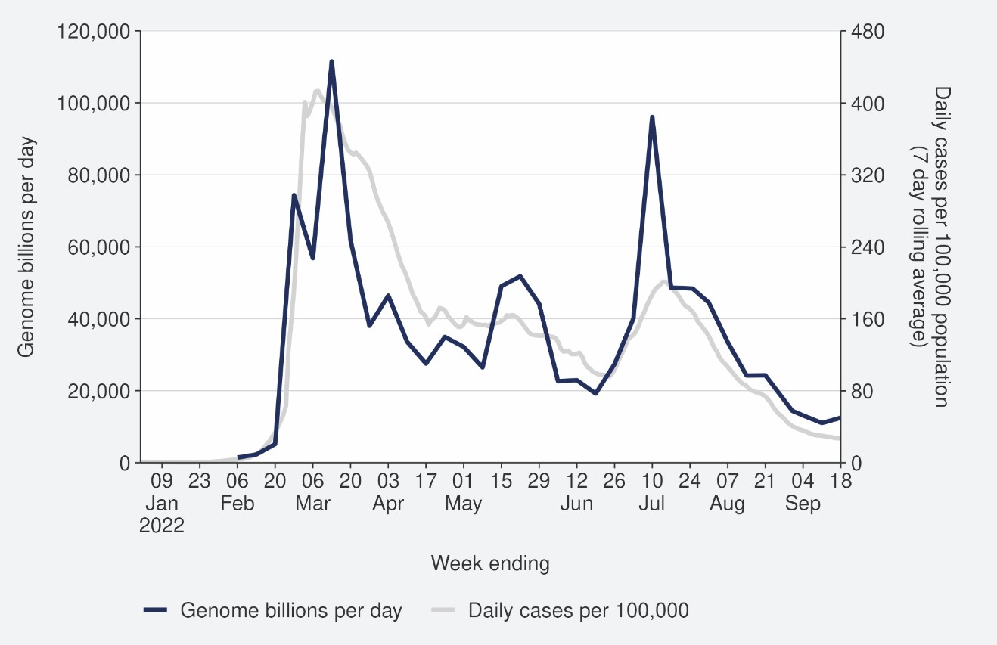
Sources: ESR SARS-CoV-2 in wastewater update for week ending 18 September 2022 and NCTS/EpiSurv as at 2359hrs 23 September 2022

1 Since 24 February 2022, most testing has been through self-administered rapid antigen tests (RATs) which require self-reporting of results. Therefore, it is likely that many infections are not detected or reported, and the proportion of infections reported (‘reported cases’) may differ by age, ethnicity and deprivation.
2 See the online glossary for modelling assumptions.
3 Wastewater levels cannot be used to predict numbers of cases but does indicate trends in the infection rates.

Figure 2: COVID-19 Modelling Aotearoa scenarios4 compared with national reported case numbers
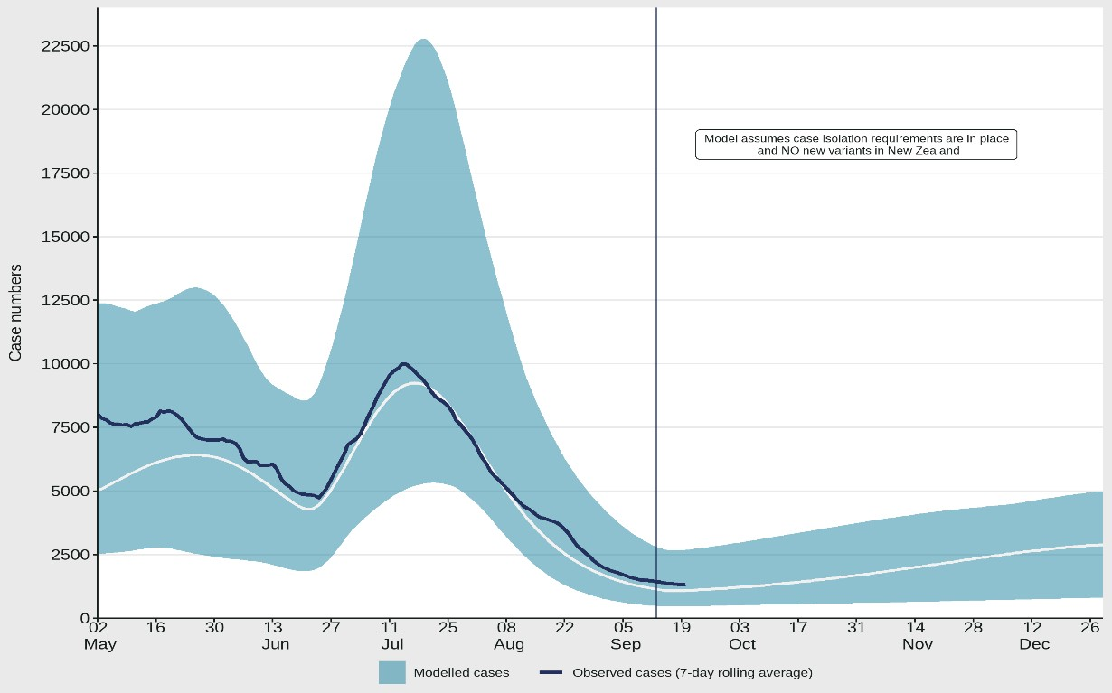
Sources: COVID-19 Modelling Aotearoa, ordinary differential equation model, September 2022, and NCTS/EpiSurv as at 2359hrs 18 September 2022

4 The ‘July’ BA.5 scenario assumes previous infection provides greater protection against reinfection and severe disease, consistent with emerging international evidence. It also incorporates updated data and future projections of uptake of second boosters, and an earlier transition to BA.5, consistent with the timing of cases and hospitalisations in New Zealand.

Figure 3: Regional reported case rates from February to 18 September 2022
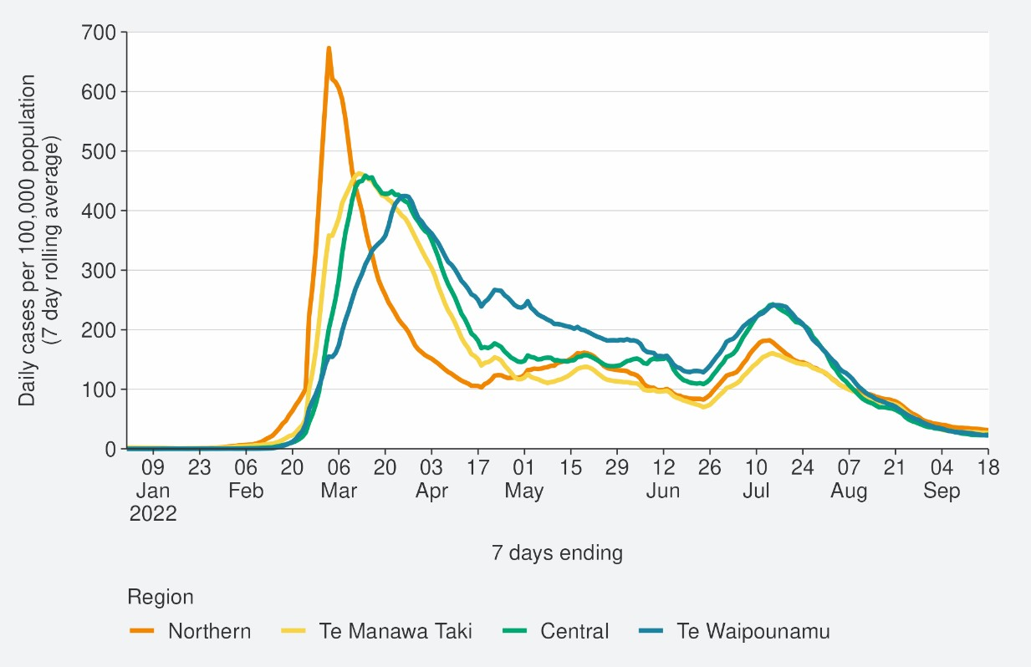
Source: NCTS/EpiSurv as at 2359hrs 18 September 2022

Figure 4: National reported case rates by age from February to 18 September 2022
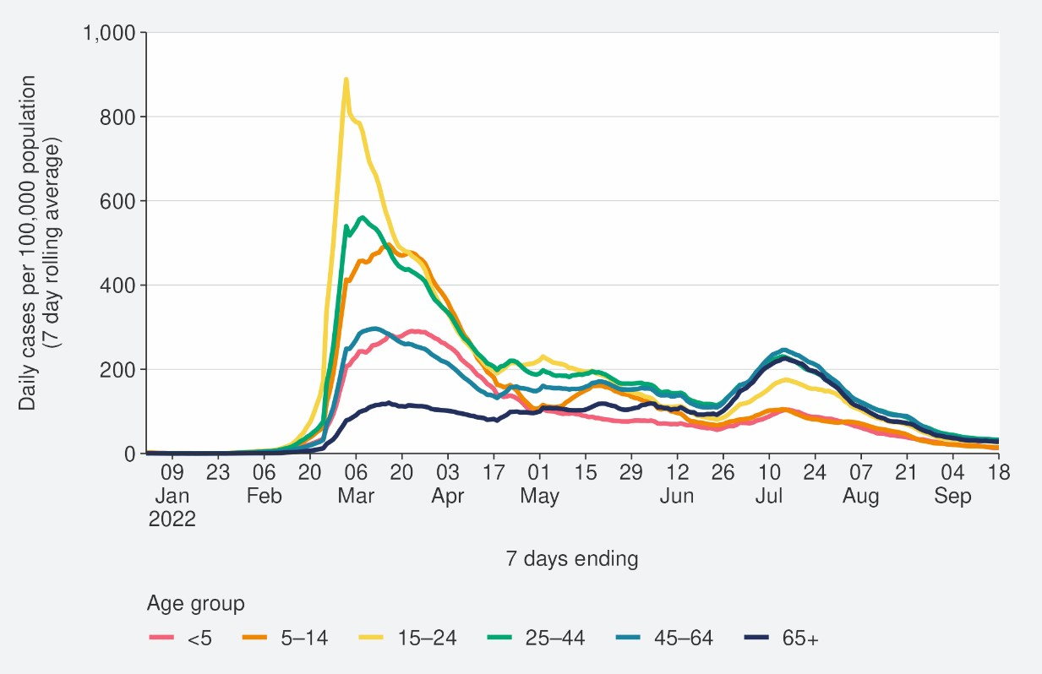
Source: NCTS/EpiSurv as at 2359hrs 18 September 2022

Hospitalisation and mortality trends

Hospitalisation
As seen in Figure 5, the national COVID-19 hospital admissions rate “for” COVID-19 has been decreasing since mid-July, to a 7-day rolling average of 0.8 per 100,000 of population for week ending 11 September.5 Despite case rates in the most recent July peak being half that of in the March peak (201.2 and 413.2 per 100,000), the hospitalisation rate in the July peak was only slightly lower than that in March. This can be explained by the strong association between age and poor outcomes after infection. The reported case rates in those aged >65 years peaked 75% higher in July than in March (refer back to
Figure 4). Modelling scenarios suggest that current hospital occupancy is tracking at the higher range of the prediction and is expected to remain stable or slightly increase in the coming months (see Figure 6).

Figure 5: National hospital admissions rate for COVID-19, February to 11 September 2022
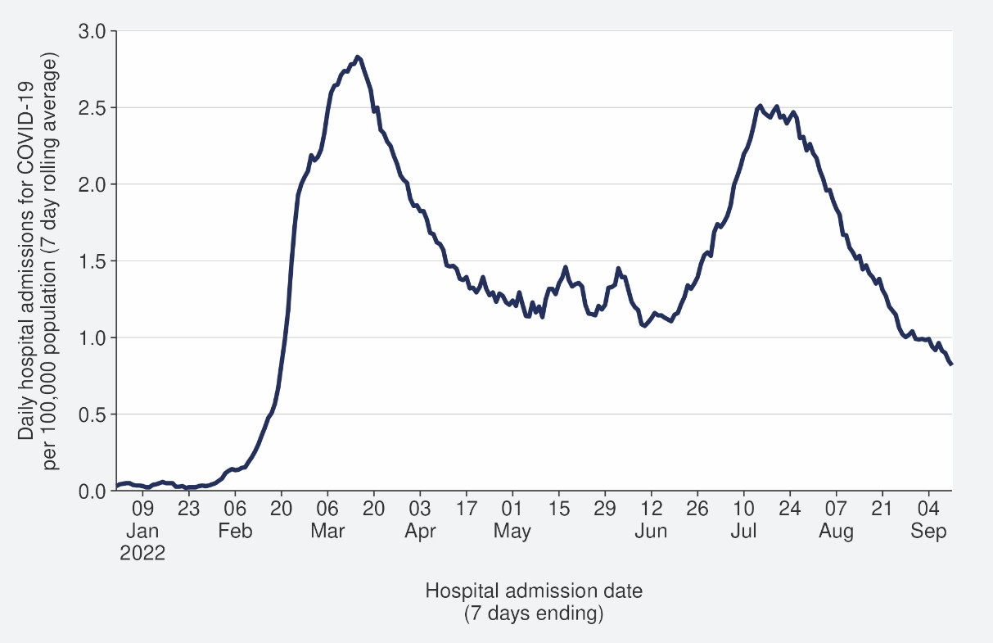
Source: NMDS/Inpatient’s admissions feed as of 20 September 2022 data up to 11 September 2022

5New hospital admissions who had COVID at the time of admission or while in hospital; excluding hospitalisations that were admitted and discharged within 24hrs. The ‘For’ measure excludes those who are identified as incidental with COVID-19, such as injuries. Recent trends are subject to revision. Please see glossary for further caveats.

Figure 6: COVID-19 Modelling Aotearoa hospital occupancy6 scenario7 compared with national observed occupancy
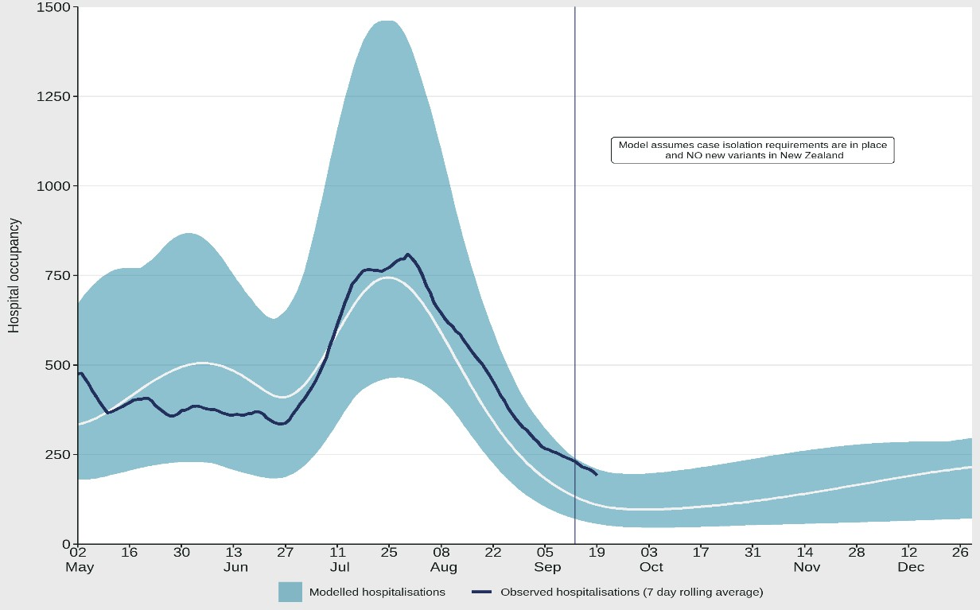
Sources: COVID-19 Modelling Aotearoa, ordinary differential equation model, September 2022, and Ministry of Health reported hospital occupancy data 18 September 2022

Mortality
From the first week of January to 18 September 2022, there were 2,920 deaths among people who died within 28 days of being reported as a case and/or with the cause being attributable to COVID-19 (that is an underlying or contributory cause) (see Figure 7)8.

Of the deaths in 2022 that have been formally coded by cause of death, 1,206 (47%) were determined to have COVID-19 as the main underlying cause. COVID-19 contributed to a further 715 (28%) deaths, another 652 (25%) people died of an unrelated cause (Figure 7). Deaths have been declining after peaking in the last week of July, when almost 150 people died with COVID-19 as their underlying or a contributing cause. As seen with hospitalisations, due to the strong association of increasing age and increasing mortality risk, the patterns in mortality over time strongly reflect the case rates in those aged >65 years.

Deaths are currently tracking below the lower range of the modelled scenario and are expected to remain stable or slightly increase in the coming months (see Figure 8).

6 These data are for all hospitalisations with COVID-19, including those that were incidental, such as injuries.
7 The 'July’ scenario assumes previous infection provides greater protection against reinfection and severe disease, consistent with emerging international evidence. It also incorporates updated data and future projections of uptake of second boosters, and an earlier transition to BA.5, consistent with the timing of cases and hospitalisations in New Zealand
8 There were 55 deaths before the first week of 2022.

Figure 7: National weekly death counts by cause of death9, February to 18 September 2022
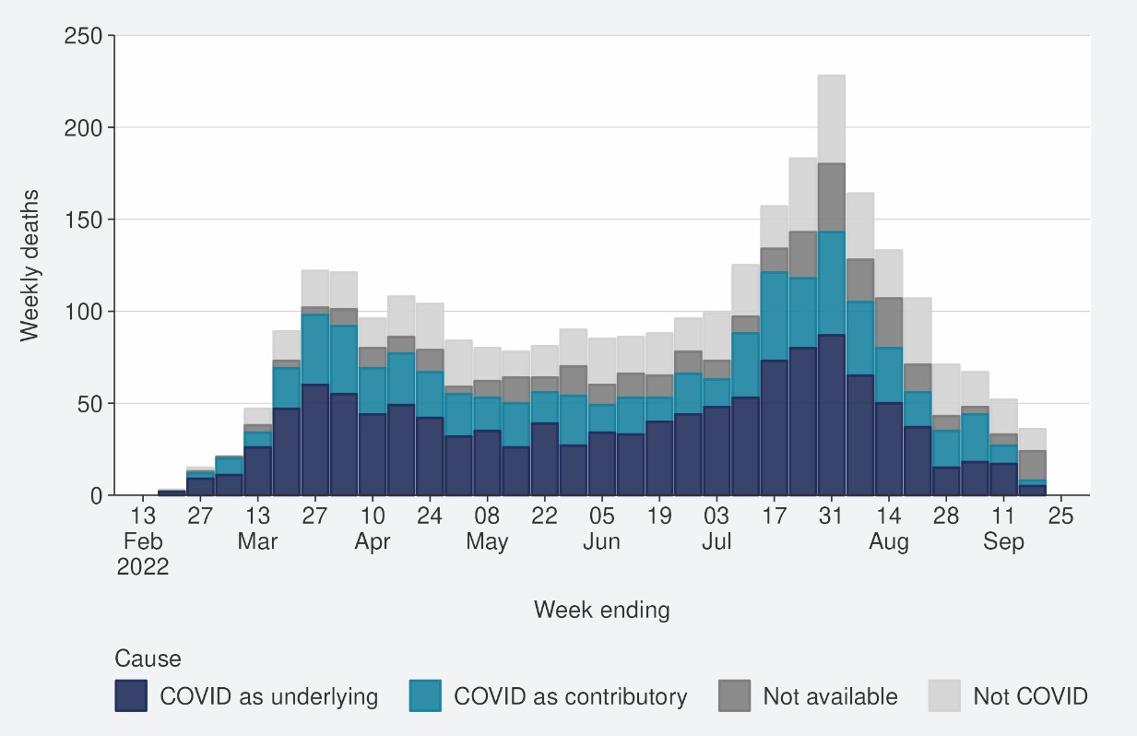
Source: Ministry of Health.

Figure 8: COVID-19 Modelling Aotearoa death count compared with national observed deaths attributed to COVID-19
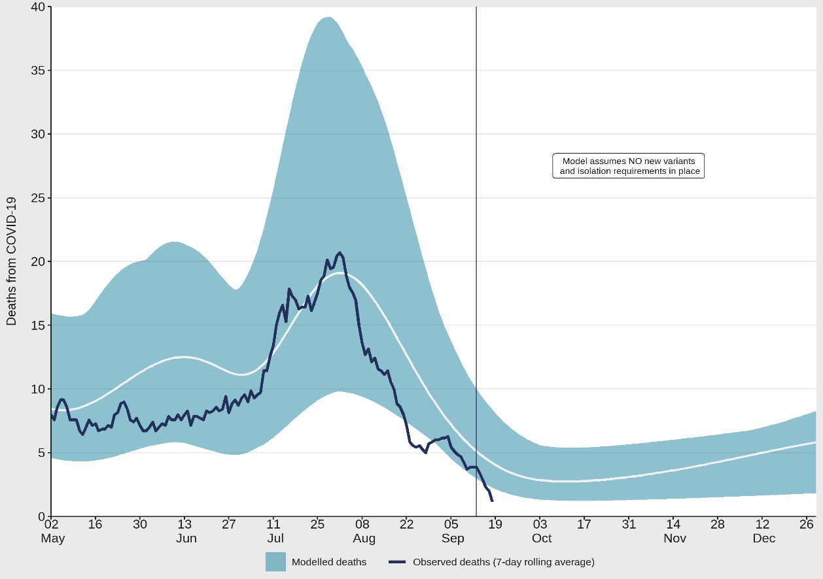
Sources: COVID-19 Modelling Aotearoa, ordinary differential equation model, September 2022, and Ministry of Health reported attributed deaths data 18 September 2022

9 Mortality data are affected by a delay due to time taken for reporting and death coding, the most recent weeks should be interpreted with caution.

Whole Genomic Sequencing

Community cases and wastewater

Figure 9 shows the proportions of variants in community cases have remained similar over the past few weeks, with BA.5 making up 91% of sequenced cases in the week to 16 September. Similar patterns have been seen in wastewater: BA.4/5 was also detected at all wastewater sites (14 of 20 sites were 100% BA.4/5) in the two weeks ending 18 September.
In the two weeks to 16 September, BA.4.6, BA.4 and BA.2 made up 3%, 3% and 2% of samples, respectively; Omicron sub-variant BA.2.75 (including BA.2.75.2) was also detected in community samples at a lower level and is likely spreading within the community. Additionally, BA.4.6 will likely increase as a proportion of cases, but its ability to compete against the dominant BA.5 variant is currently unknown.

Figure 9: Frequency of Variants of Concern in community cases
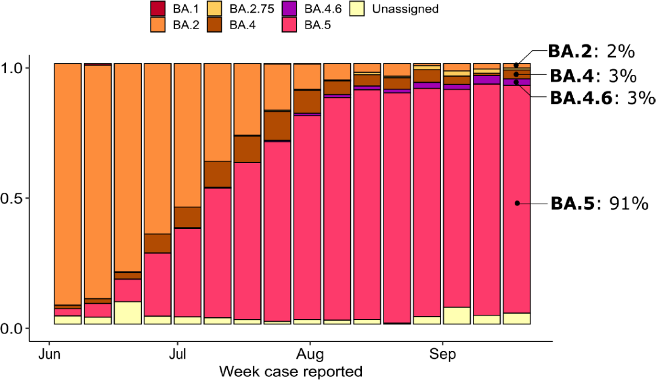
Source: ESR COVID-19 Genomics Insights Report #23, EpiSurv/Microreact 0900hrs 17 September 2022

Hospitalised cases
Of 81 successful sequences of COVID-19 positive hospital cases in the two weeks to 16 September 2022, 87% were BA.5, 7% were BA.4 (including BA.4.6), 2% were BA.2.75, and 2% were BA.2.

Reinfection
Figure 10 characterises the average number of cases per week by first infection and reinfection. Reinfection made up 12% of reported cases in the week ending 18 September. Figure 11 shows how many first infections and reinfections have been reported cumulatively over time. Cumulatively, reinfections have made up 2% of total cases reported in 2022. The proportion of cases that are reinfections is expected to increase over time. The true number of reinfections is likely higher than reported here. In general, reporting of cases is expected to decline over time. Due to under- ascertainment of the first infection and subsequent infections, and as both are required to detect a reinfection, there is likely to be under-reporting of reinfections.
‘Reinfection’ is now defined as a case reported at least 29 days after the last time a person reported a positive test for COVID-19. The definition of reinfection changed on 30 June; prior to this, reinfection was based on reports at least 90 days apart (based on the international literature at the time). Up until 30 June 2022, the vast majority of positive results that were detected within 90 days of the prior infection were not recorded in the system; some potential reinfections within 90 days were recorded but were not representative of the general population.
‘Reinfection’ in general refers to a second or subsequent infection, after the prior infection has cleared. In this analysis, we are not able to distinguish between reinfection with the same variant or different variants. Reinfection with a different variant to the first infection is more likely than reinfection with the same variant. Technically these data report on ‘redetections’ rather than true reinfections. True ‘reinfections’ cannot be definitively captured in the data for a range of reasons. For example, a person with persistent infection due to being immunocompromised who undergoes repeated testing due to regular hospital or clinical visits, would appear in the data as a ‘reinfection’ when in reality, they may be a chronic or persistent infection.

Figure 10: Reinfections 7 day rolling average from 01 January to 18 September

2022
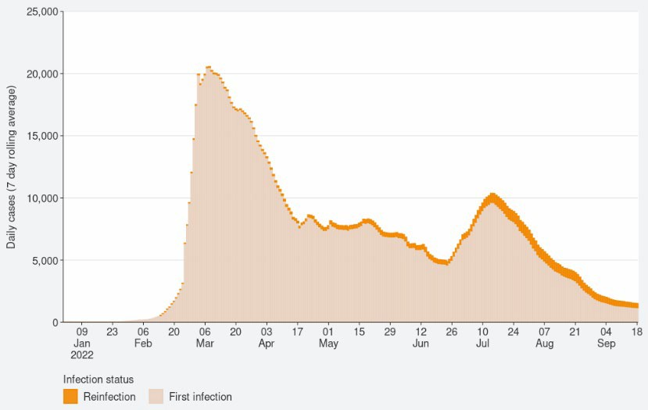
Source: NCTS/EpiSurv as at 2359hrs 18 September 2022

Figure 11: Reinfections cumulatively from 01 January to 18 September 2022
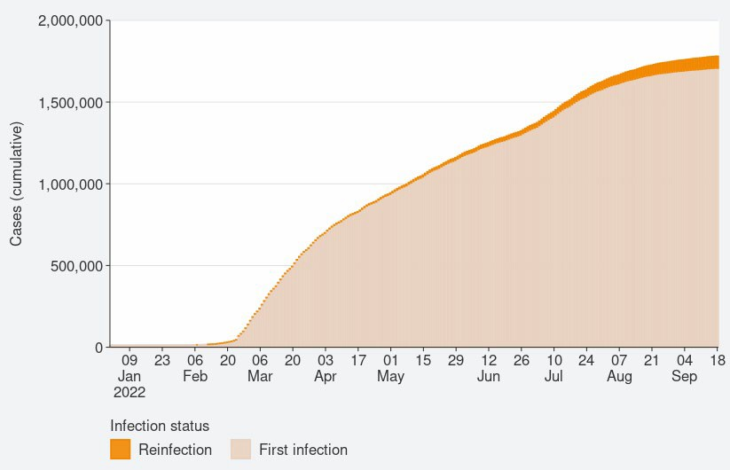
Source: NCTS/EpiSurv as at 2359hrs 18 September 2022

Comparison of epidemic trends by ethnicity
The age-standardised reported case rates have decreased for all ethnicities (see Figure 12); with there being around a 2-fold difference between the highest rates – in Asian and European and Other ethnicities and lowest rates – in Māori and Pacific peoples.
However, the cumulative total for the year shows that Māori and Pacific peoples have overall had a slightly higher risk of being reported as a case.

Figure 13 and Figure 14 shows that the age standardised rates for hospitalisation for COVID-19 are also declining for all ethnicities, but unlike the pattern in cases, Māori had the highest hospitalisation rate in the week ending 18 September, >2 fold higher than European and Other. This has been a consistent pattern across the year. The cumulative total for the year shows that Pacific peoples and Māori have had the highest risks of hospitalisation for COVID-19 – 2.8 and 2.1 times the risk of European and Other, respectively. Asian people have had a hospitalisation rate approximately 10% lower than European and Other.

The age standardised mortality rate for 1 January to 18 September shows that Pacific peoples have had the highest risk, 2.5 times that of European and Other, followed by Māori at 2 times that of European and Other. Asian people have had the lowest risk of Mortality, 35% lower than European and Other (see Figure 15).

The lower reported case rates and higher hospitalisation and death rates for Māori and Pacific peoples suggests they may have lower levels of case ascertainment and/or a higher risk of poor outcomes after infection compared with Asian and European and Other ethnicities.

Figure 12: National age-standardised reported case rates by ethnicity from January to 18 September 2022
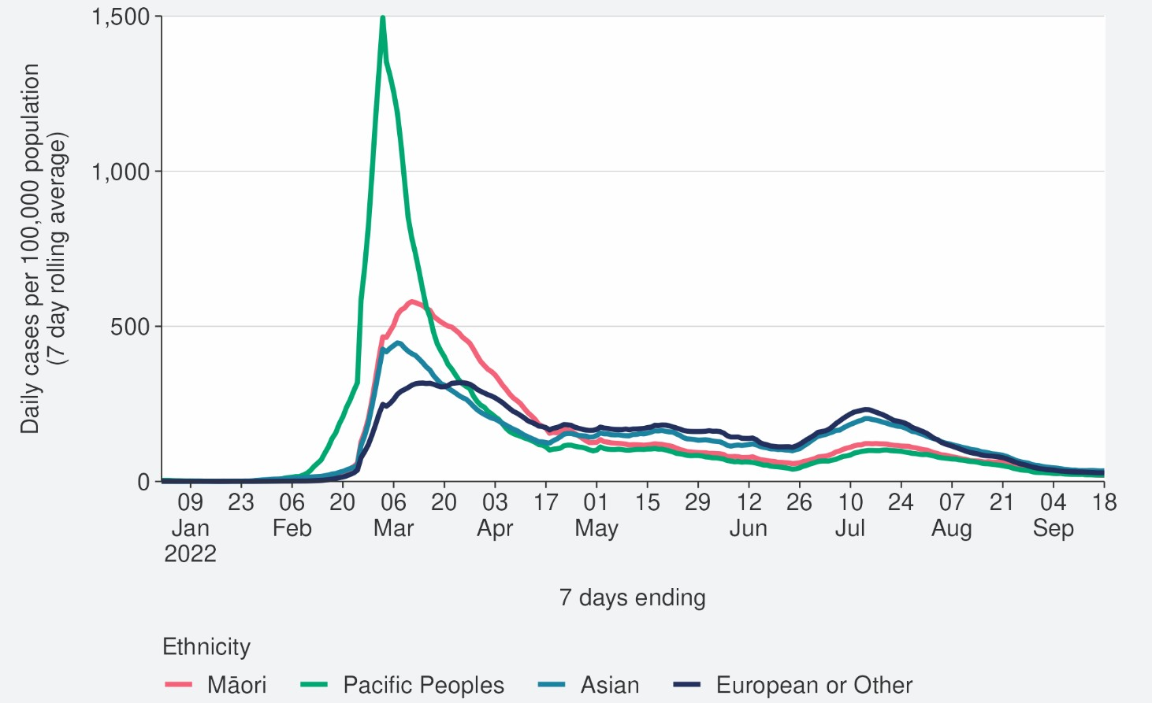
Source: NCTS/EpiSurv as at 2359hrs 18 September 2022

Figure 13: National age-standardised hospitalisation rates by ethnicity from January to 11 September 2022
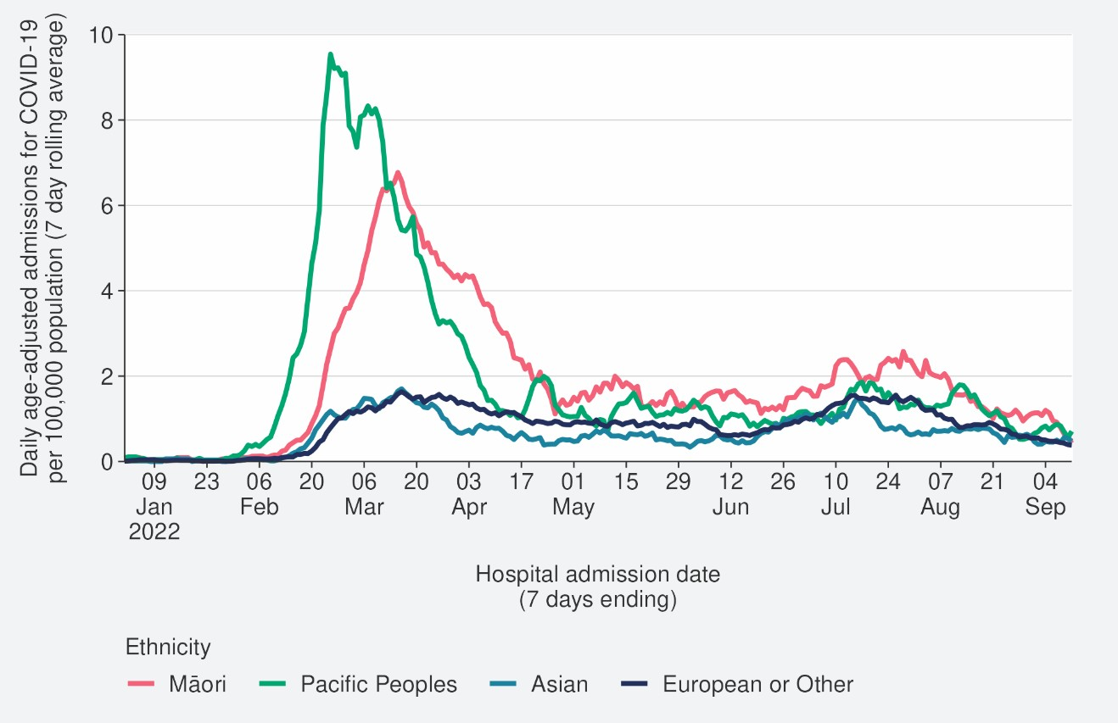
Source: NCTS/EpiSurv as at 2359hrs 11 September 2022

Figure 14: Age-standardised cumulative incidence (and 95% confidence intervals) of hospitalisation for COVID-19 by ethnicity, 01 January 2022 to 18 September 2022
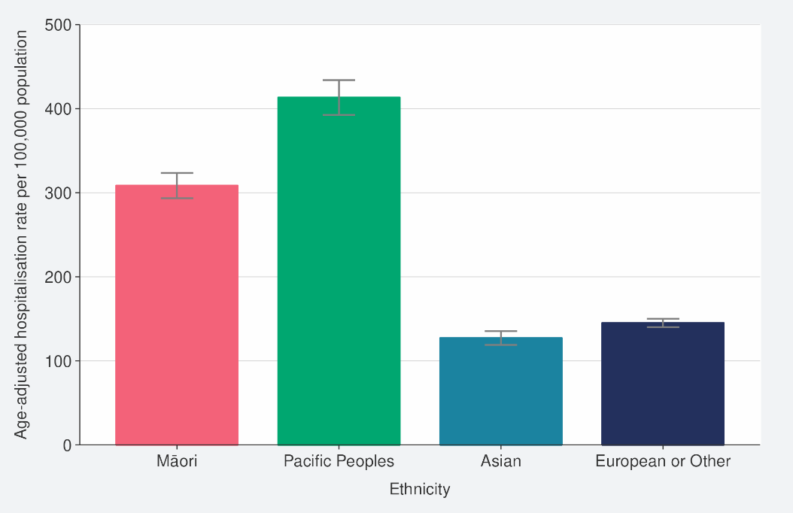
Source: NCTS/EpiSurv, NMDS, Inpatient Admissions dataset and CVIP population estimates, 01 January 2022 to 18 September 2022

Figure 15: Age-standardised cumulative incidence (and 95% confidence intervals) of mortality attributed to COVID-19 by ethnicity, 01 January 2022 to 18 September 2022
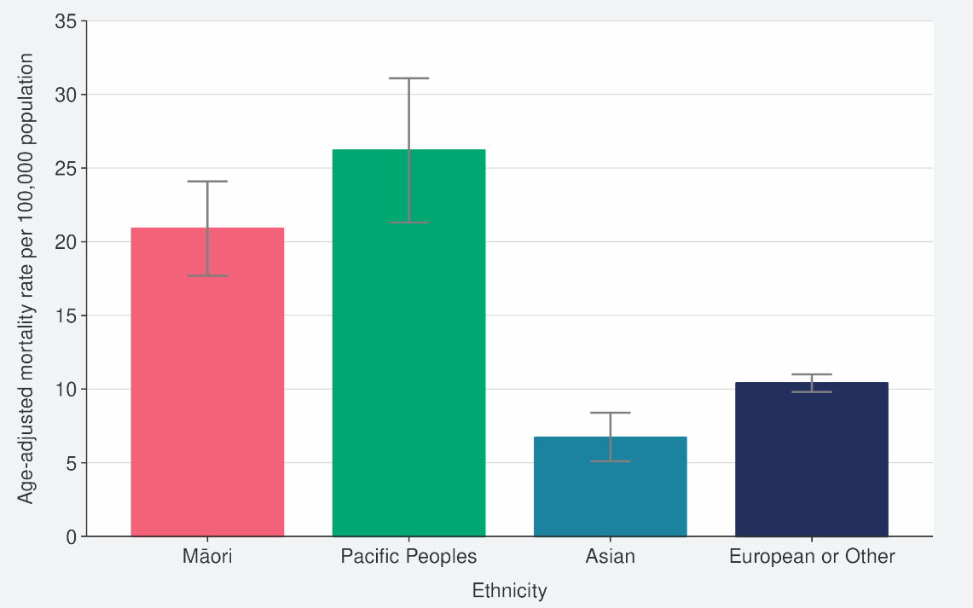
Source: NCTS/EpiSurv, NMDS, Inpatient Admissions dataset and CVIP population estimates, 01 January 2022 to 18 September 2022

Comparison of epidemic trends by deprivation
Figure 16 shows the 7-day rolling average for reported case rates by residential area deprivation level (based on NZDep2018).10 Rates for all deprivation levels have continued to decrease; rates in the past week were slightly higher in areas of least and mid-range deprivation, the differences were more substantial during July where those most-deprived had the lowest rate. Prior to May, case rates in those most deprived were higher than the mid-range and least deprived groups.

However, Figure 17 and Figure 18 show those most deprived have had and continue to have the highest rates of hospitalisation, both recently and cumulatively during 2022. Those most deprived have had 2.5 times the risk of hospitalisation compared with those who are least deprived.

Cumulative rates of mortality are also highest for those most deprived (Figure 19).

As lower case rates have been reported among those most deprived, their continued higher hospitalisation and death rates suggest those who are most deprived may have lower levels of case ascertainment and/or a higher risk of poor outcomes after infection compared with those who are least deprived.

10 Atkinson J, Salmond C, Crampton P (2019). NZDep2018 Index of Deprivation, Final Research Report, December 2020. Wellington: University of Otago

Figure 16: National age-standardised reported case rates by deprivation status for weeks 01 January – 18 September 2022
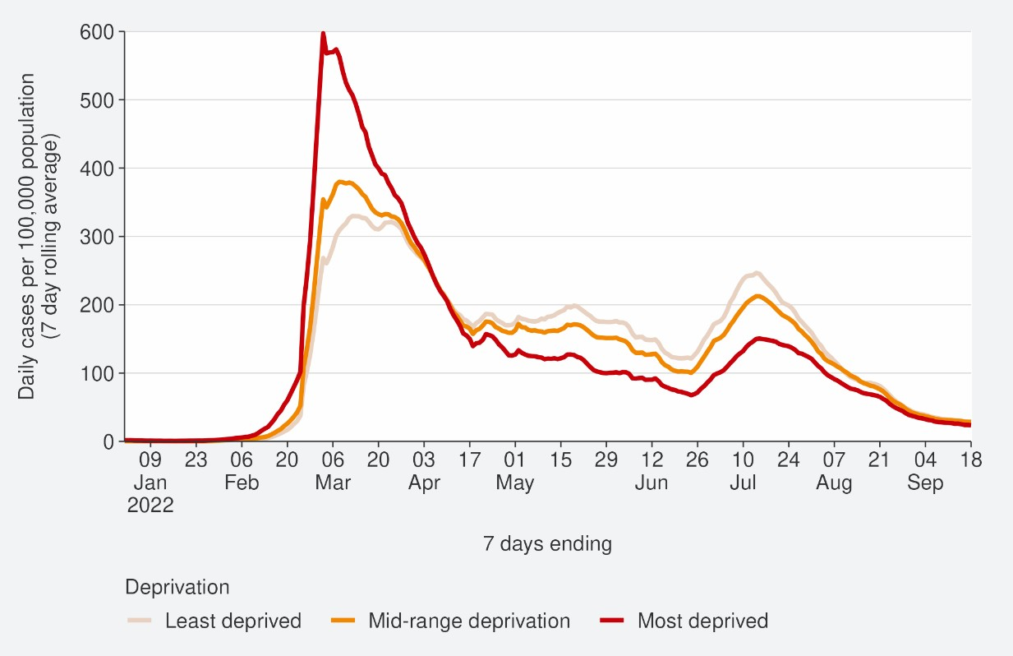
Source: NCTS/EpiSurv as at 2359hrs 18 September 2022

Figure 17: Age-standardised hospital admission rates for COVID-19 by deprivation from January to 11 September 2022
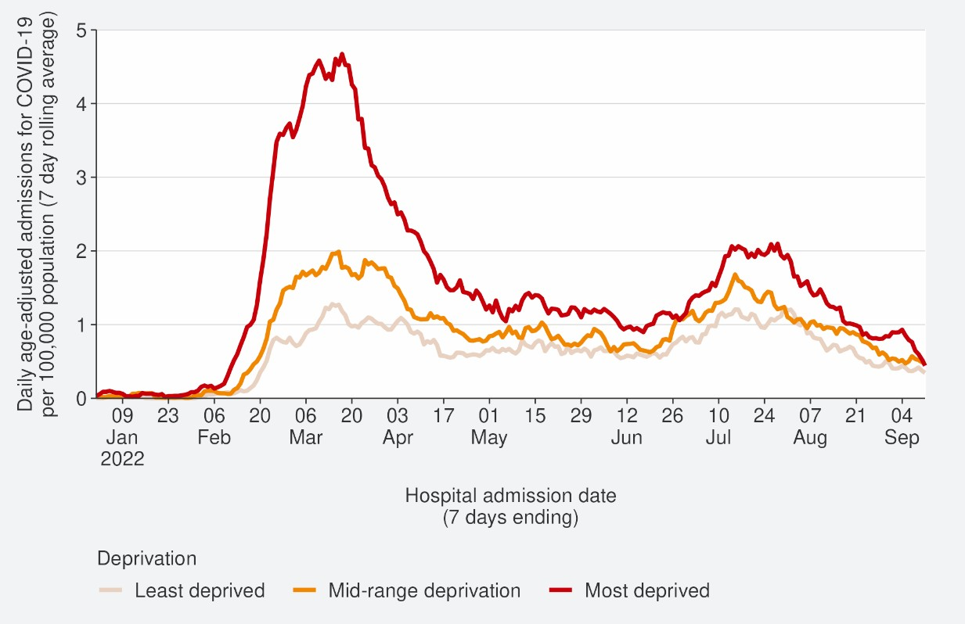
Source: NMDS/Inpatients admissions feed as of 20 September 2022 data up to 11 September 2022

Figure 18: Age-standardised cumulative incidence (and 95% confidence intervals) of hospitalisation for COVID-19 by deprivation, 01 January 2022 to 18 September 2022
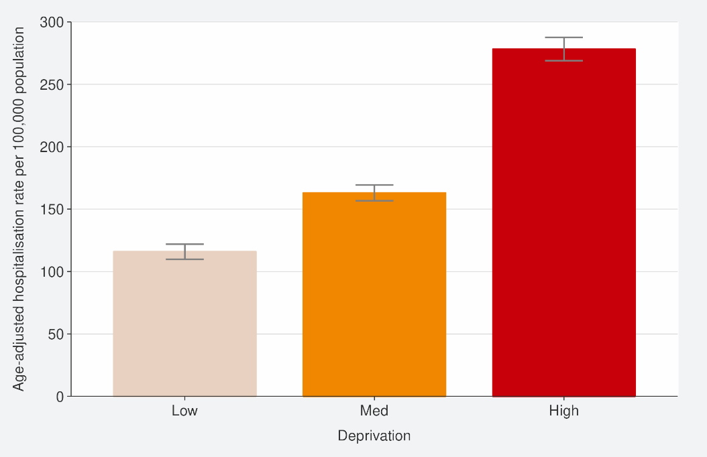
Source: NCTS/EpiSurv, NMDS, Inpatient Admissions dataset and CVIP population estimates 01 January 2022 to 18 September 2022

Figure 19: Age-standardised cumulative incidence (and 95% confidence intervals) of mortality attributed to COVID-19 by deprivation, 01 January 2022 to 18 September 2022
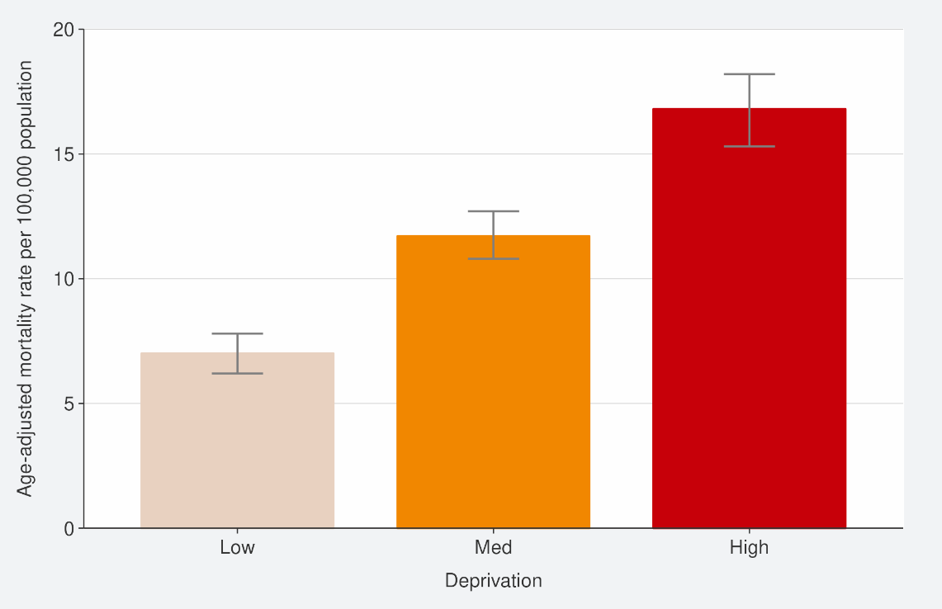
Source: EpiSurv, Death Documents, The Healthcare User database, Mortality Collections database and CVIP population estimates, 01 January 2020 to 18 September 2022

Global pandemic summary
We expect the global situation for the COVID-19 pandemic in the next few months to be driven by the ongoing emergence of new variants, waning immunity and the northern hemisphere heading towards the winter season.

- Globally, in the week ending 18 September, the number of new weekly cases remained stable as compared to the previous week, with over 3.2 million new cases reported.
- The number of new weekly deaths decreased by 17% compared to the previous week, with over 9,800 fatalities reported.
- Globally, as of 18 September 2022, over 609 million confirmed cases and over 6.5 million deaths have been reported.
- The prevalence of BA.2 descendent lineages (BA.2.X) remained stable.
- BA.2.75, an Omicron descendent lineage under monitoring, still shows a relatively low (1.2% and 1.26% as of 4 September) prevalence globally, but a number of countries have observed recent increasing trends.
- BA.5 Omicron descendent lineages continue to be dominant globally, with an increase in weekly prevalence from 90.0% to 76.6%.
- Decreases in countries frequency of submitting COVID-19 genomes to GISAID, make detecting accurate international representations of variant prevalence difficult.
Sources: World Health Organisation: Weekly epidemiological update on COVID-19 – 21 September 2022

Please note, global trends in cases and deaths should be interpreted with caution as several countries have been progressively changing COVID-19 testing strategies, resulting in lower overall numbers of tests performed and consequently lower numbers of cases detected.

Appendix: Table of summary statistics

Table 1: Reported 7-day rolling average of case rates and hospital admissions, by region, age group, ethnicity and deprivation

 | Reported Cases (7-day rolling average) |  |  |  |  | Hospital admissions (7-day rolling average)
 | Week ending 11/09/2022 |  | Week ending 18/09/2022 |  | % Change | Week ending 04/09/2022 |  | Week ending 11/09/2022 |  | % Change
 | Number | Rate (per 100,000  population) | Number | Rate (per 100,000  population) |  | Number | Rate (per 100,000  population) | Number | Rate (per 100,000  population)
National | 1480.0 | 29.8 | 1337.1 | 26.9 | -9.7% | 36.9 | 1.0 | 30.4 | 0.8 | -17.4%
Region
Northern | 659.1 | 34.7 | 600.4 | 31.6 | -8.9% | 14.7 | 0.8 | 11.6 | 0.6 | -21.4%
Te Manawa Taki | 270.1 | 27.8 | 258.3 | 26.6 | -4.4% | 5.6 | 1.3 | 5.7 | 1.3 | 2.6%
Central | 236.4 | 25.2 | 221.3 | 23.6 | -6.4% | 5.3 | 1.1 | 4.0 | 0.9 | -24.3%
Te Waipounamu | 311.6 | 27.2 | 256 | 22.4 | -17.8% | 11.0 | 1.2 | 9.1 | 1.0 | -16.9%
Age group
<5 | 60.7 | 19.3 | 43.0 | 13.6 | -29.5% | 2.3 | 1 | 0.9 | 0.4 | -62.5%
5-14 | 119.9 | 17.8 | 97.9 | 14.5 | -18.5% | 0.7 | 0.1 | 0.9 | 0.2 | 20.0%
15-24 | 183.1 | 29.6 | 166.7 | 26.9 | -9.1% | 0.4 | 0.1 | 0.1 | 0.0 | -66.7%
25-44 | 481.0 | 35.6 | 443.3 | 32.8 | -7.9% | 4.7 | 0.4 | 2 | 0.2 | -57.6%
45-64 | 398.1 | 31.9 | 371.9 | 29.8 | -6.6% | 6.6 | 0.7 | 4.7 | 0.5 | -28.3%

65+ | 237.1 | 31.1 | 214.4 | 28.1 | -9.6% | 22.1 | 4.2 | 21.9 | 4.1 | -1.3%
Ethnicity
Māori | 185.1 | 24.3 | 147.3 | 19.3 | -20.4% | 5.6 | 1.2 | 2.0 | 0.4 | -64.1%
Pacific peoples | 83.7 | 22.8 | 75.6 | 20.6 | -9.7% | 2.9 | 0.9 | 2.6 | 0.8 | -10%
Asian | 257.1 | 35.1 | 253.3 | 34.5 | -1.5% | 3.4 | 0.5 | 3.4 | 0.5 | 0.0%
European or Other | 935.1 | 30.3 | 847.9 | 27.5 | -9.3% | 24.7 | 1.1 | 22.3 | 1.0 | -9.8%
Deprivation
Least deprived | 456.1 | 31.7 | 418.4 | 29.1 | -8.3% | 7.7 | 0.7 | 7.4 | 0.6 | -3.7%
Mid-range deprivation | 589.0 | 31.1 | 538.9 | 28.4 | -8.5% | 14.3 | 1.0 | 13.4 | 0.9 | -6.0%
Most deprived | 404.3 | 27.1 | 353.0 | 23.7 | -12.7% | 13.7 | 1.3 | 8.9 | 0.8 | -35.4%

22 COVID TRENDS AND INSIGHTS REPORT

