COVID-19 TRENDS AND INSIGHTS REPORT
18 November 2022

Released 2022 health.govt.nz

Citation: Public Health Agency. 2022. COVID-19 Trends and Insights Report.
Wellington: Ministry of Health
Published in November 2022 by Ministry of Health PO Box 5013, Wellington 6140, New Zealand
HP 8608

This document is available at health.govt.nz

This work is licensed under the Creative Commons Attribution 4.0 International licence. In essence, you are free to: share i.e., copy and redistribute the material in any medium
or format; adapt i.e., remix, transform and build upon the material. You must give appropriate credit, provide a link to the licence and indicate if changes were made.

Contents
Purpose of report 1
Executive summary 2
Key insights 3
National Trends 3
Māori 4
Pacific peoples 4
International Insights 4
National summary of epidemic trends 5
Hospitalisation and mortality trends 9
Whole Genomic Sequencing 12
Comparison of epidemic trends by ethnicity 16
Comparison of epidemic trends by deprivation 19
Global pandemic summary 22
Appendix: Table of summary statistics 24

COVID-19 TRENDS AND INSIGHTS REPORT iii

List of Figures
Figure 1: National wastewater trends (SARS-CoV-2 genome copies) compared with reported cases 6
Figure 2: COVID-19 Modelling Aotearoa scenarios compared with national reported case numbers 7
Figure 3: Regional reported case rates from January to 13 November 2022 7
Figure 4: National reported case rates by age from January to 13 November 2022
. 8
Figure 5: National hospital admissions rate for COVID-19, January to 06 November 2022 9
Figure 6: COVID-19 Modelling Aotearoa hospital admissions scenario compared with national admissions 10
Figure 7: National weekly death counts by cause of death, February to 13 November 2022 11
Figure 8: COVID-19 Modelling Aotearoa death count compared with national observed deaths attributed to COVID-19 11
Figure 9: Proportion of Variants of Concern in community cases 12
Figure 10: Reinfections 7 day rolling average from 01 January to 13 November
2022 15
Figure 11: Reinfections cumulatively from 01 January to 13 November 2022 15
Figure 12: National age-standardised reported case rates by ethnicity from January to 13 November 2022 17
Figure 13: National age-standardised hospitalisation rates by ethnicity from January to 06 November 2022 17
Figure 14: Age-standardised cumulative incidence (and 95% confidence intervals) of hospitalisation for COVID-19 by ethnicity, 01 January 2022 to 13 November 2022 18
Figure 15: Age-standardised cumulative incidence (and 95% confidence intervals) of mortality attributed to COVID-19 by ethnicity, 01 January 2022 to 13 November 2022 18
Figure 16: National age-standardised reported case rates by deprivation status for weeks 01 January – 13 November 2022 20
Figure 17: Age-standardised hospital admission rates for COVID-19 by deprivation from January to 06 November 2022 20
Figure 18: Age-standardised cumulative incidence (and 95% confidence intervals) of hospitalisation for COVID-19 by deprivation, 01 January 2022 to 13 November 2022 21
Figure 19: Age-standardised cumulative incidence (and 95% confidence intervals) of mortality attributed to COVID-19 by deprivation, 01 January 2022 to 13 November 2022 21

Purpose of report
This report comments on trends in the New Zealand COVID-19 outbreak, including cases, hospitalisations and mortality. It also comments on international COVID-19 trends and the latest scientific insights related to outbreak management. The report relies on data that may be subject to change or are incomplete. An unknown proportion of infections are not reported as cases, this proportion may differ by characteristics such as ethnicity or deprivation group. Therefore, any differences in reported case rates must be interpreted with caution.

Executive summary
Overall, the key measures of infection (i.e. the levels of viral RNA in wastewater and reported case rates) used to monitor the COVID-19 epidemic show a small increase. Following a similar trend to case rates, hospital admissions have increased; whilst occupancy rates have started to stabilise. Meanwhile, mortality counts have increased slightly.

BA.5 was the dominant subvariant accounting for an estimated 66% of cases, with the proportion of BA.5 declining slowly over the previous weeks. Detections of BA.2.75, XBB and BQ.1.1 are trending upward, both in WGS and wastewater. Both XBB and BA.2.75 variants are over-represented in reinfections.

It is possible that over the next few weeks, cases, hospitalisations and mortality could increase to a new peak of the third wave. However, the size, timing, and duration of the peak and new baseline trends of cases, hospitalisations and mortality is currently uncertain.

Key insights

National Trends

Cases | The 7-day rolling average of reported case rates was 58.8 per 100,000 population for the week ending 13 November. This was an increase from the previous week, which was 56.7 per 100,000. This week rates were highest in the 45-64 age group, followed by 65+ (67.6 and 67.0 per 100,000). The proportion of cases that were reinfections has increased this week, making up 17.9% of cases.
Wastewater | Wastewater quantitation indicated an increase in transmission in the past week. Based on combining wastewater data and reported cases, an exploratory estimate of case ascertainment rate (the proportion of infections reported as cases) is 33% [90% CI 26-41%].1
Hospitalisations | The COVID-19 hospital admissions rate has been increasing since early October, with a 7-day rolling average of 1.2 per 100,000 for the week ending 06 November, an increase of 8.1% from the previous week. The rate was highest in the 65+ age group (4.1 per 100,000).
Mortality | As of 13 November, there were 2,104 deaths attributed to COVID-19 in 2022. The weekly number of deaths attributed to COVID-19 has declined since peaking early August, however this trend has stabilised and slightly increased in the past few weeks and no longer appears to be declining. The 80+ age group had the highest mortality rate across all age groups (1.3 per 100,000) for the week ending 06 November.
Variants of Concern | Prevalence of non-BA.5 variants continues to increase slowly. BA.5 accounts for 66% of sequenced community cases seen in the week 29 October to 11 November, followed by BA.2.75 (13%), BQ.1.1 (10%), BA.2 (4%), XBB (3%) and BA.4.6 (2%). In the same period, 8 cases of XBC were sequenced.  Wastewater variant analysis for the fortnight ending 11 November reports the following proportions: BA.4/5 88%, BA.1/BA.2.75 8% and BQ.1.1 4%.

1 The methodology used to make this assessment is in the process of being improved and updated. The recent assessment – developed in conjunction with ESR and other independent advice – is that the 75% assessment used in previous latest Trends and Insights report (11 November), should have been reported as a relative rather than absolute measure of case ascertainment rate (CAR). CAR is the proportion of infections that are reported as cases. Relative CAR is the proportion of the peak CAR that has been observed over the period that WW surveillance was active. Using an updated method for estimating absolute CAR, As of 02 November, 33% is now viewed as more realistic estimate, noting that wastewater- based epidemiology is cutting-edge science and subject to revisions as the field develops.

Māori

Cases | The 7-day rolling average of age-standardised reported case rates was  45.3 per 100,000 population on 13 November, lower than for European or Other, however there may be case ascertainment biases. Rates were highest in those aged 45-64 and 25-44 (58.4 and 54.9 per 100,000, respectively).
Hospitalisations | The age-standardised cumulative hospital admission risk for 2022 was 1.8 times higher in Māori than European or Other. The 7-day rolling average to 06 November was 1.0 per 100,000 and is highest in those aged 80+ (15.5 per 100,000), followed by those aged 70-79 (4.8 per 100,000).
Mortality | The age-standardised cumulative mortality rate for Māori was 1.9 times higher than European or Other in 2022.

Pacific peoples

Cases | The 7-day rolling average of age-standardised reported case rates was  40.8 per 100,000 population on 13 November, lower than for European or Other, however there may be case ascertainment biases. Rates were highest in those aged 25-44 and 45-64 (58.5 and 50.1 per 100,000, respectively).
Hospitalisations | Pacific peoples have the highest age-standardised cumulative risk of hospital admission in 2022, 2.3 times higher than European or Other. The 7-day rolling average to 06 November was 1.1 per 100,000 and is highest in those aged 80+ (13.6 per 100,000) followed by those aged 70-79 (6.0  per 100,000).
Mortality | Pacific peoples have the highest age-standardised cumulative mortality risk of any ethnicity in 2022, 2.4 times that of European or Other.

International Insights

Globally, in the week ending 13 November, the number of new weekly cases increased by 2% compared to the previous week, with over 2.3 million new cases reported. The number of new weekly deaths decreased by 30% compared to the previous week with over 7,400 fatalities reported.
BA.5 Omicron descendent lineages continue to be dominant globally, with a stable weekly prevalence of approximately 73.2% as of 14 November. Proportions of BQ.1.1 and XBB and other subvariants of Omicron are increasing globally.
At the country level, the highest numbers of new weekly cases were reported from Japan, the Republic of Korea, the United States of America, Germany and China.
In Australia, in the 14 days to 11 November 2022, there were 338 new cases per 100,000 population. This is a large increase from the week prior (14 days to 04 November 2022) where there were 248 per 100,000 population

National summary of epidemic trends

Case trends
Evidence supports a stabilisation/slight increase in incidence in the community: Reported2 case rates have been stable in the past week while levels of viral ribonucleic acid (RNA) in wastewater have increased (see Figure 1). The current case ascertainment appears to have decline from peak ascertainment in March. Work is underway to provide estimates of the peak ascertainment and current ascertainment levels. Based on combining wastewater data and reported cases, an preliminary estimate of case ascertainment rate (the proportion of infections reported as cases) is 33% [90% CI 26- 41%].
As of the week ending 13 November, reported cases have remained stable/slightly increased. Reported cases have been tracking above the modelled median since early October but since remaining relatively stable over the last two weeks, now track at the modelled median rate. The updated model scenarios accounting for a 10% increase in transmissibility caused by new variants, waning immunity, changes in masking and contact quarantine on 12 September, indicate that case rates are expected to increase (see Figure 2)3. The variant model is hypothetical but based on the properties of lineages recently reported overseas.
The general population reported case rate for the week ending 13 November was 58.8 per 100,000, similar to the previous week (56.7 per 100,000). The case rate was highest in Central region (67.5 per 100,000), having decreased by 4.5%, and lowest in Te Manawa Taki (46.7 per 100,000), having increased by 5.0% compared with the week prior. Northern region observed the largest increase to (60.8 per 100,000), having increased by 11.9% (see Figure 3) in the past week.
Slight increases were seen in all age groups (<5, 5-14, 15-24, 25-44, 45-64) except for 65+ which remained relatively stable. The highest rates across all age groups were in those aged 45-64 and 65+ (67.6 and 67.0 per 100,000). The lowest rates were among
under 5 years and 5–14-year-olds (30.8 and 36.9 per 100,000 respectively) (see Figure
4).
Table 1 of the appendix provides information on specific rates. Please note, global trends in cases, hospitalisations and deaths should be interpreted with caution as several countries have been progressively changing COVID-19 testing strategies, resulting in lower overall numbers of tests performed and consequently lower numbers

2 Since 24 February 2022, most testing has been through self-administered rapid antigen tests (RATs) which require self-reporting of results. Therefore, it is likely that many infections are not detected or reported, and the proportion of infections reported (‘reported cases’) may differ by age, ethnicity, and deprivation.
3 See the online glossary for modelling assumptions.

of cases detected. Furthermore, approaches of counting hospitalisations and deaths can differ from country to country.

Figure 1: National wastewater trends (SARS-CoV-2 genome copies)4 compared with reported cases
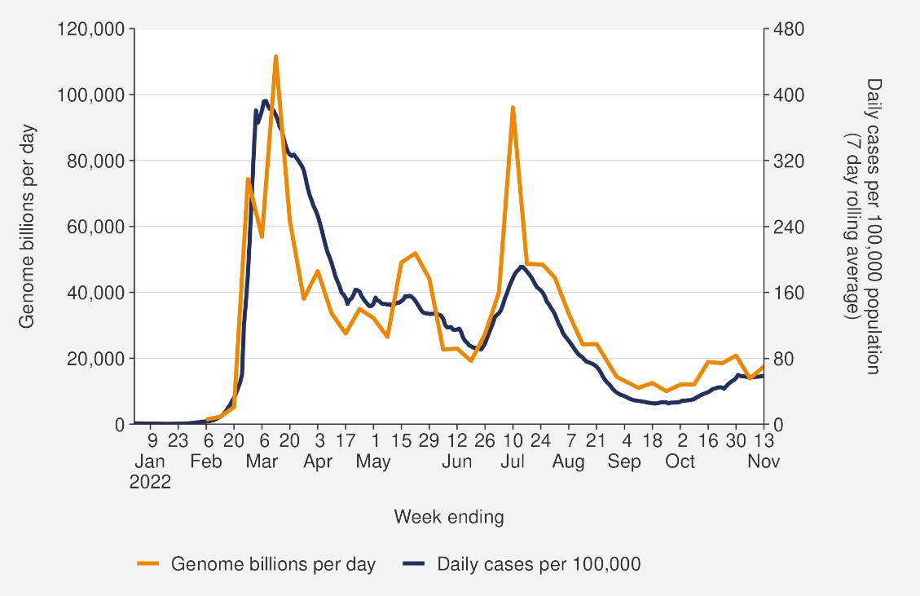
Sources: ESR SARS-CoV-2 in wastewater update for week ending 13 November 2022 and NCTS/EpiSurv as at 2359hrs 16 November 2022

4 Wastewater levels cannot be used to predict numbers of cases but do indicate trends in the infection rates.

Figure 2: COVID-19 Modelling Aotearoa scenarios5 compared with national reported case numbers
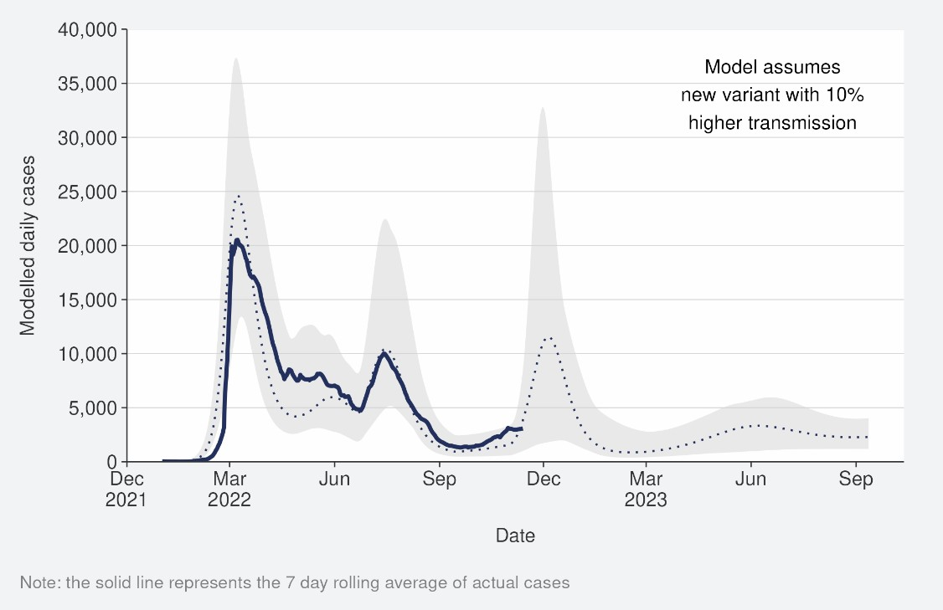
Sources: COVID-19 Modelling Aotearoa, ordinary differential equation model, October 2022, and NCTS/EpiSurv as at 2359hrs 13 November 2022

Figure 3: Regional reported case rates from January to 13 November 2022
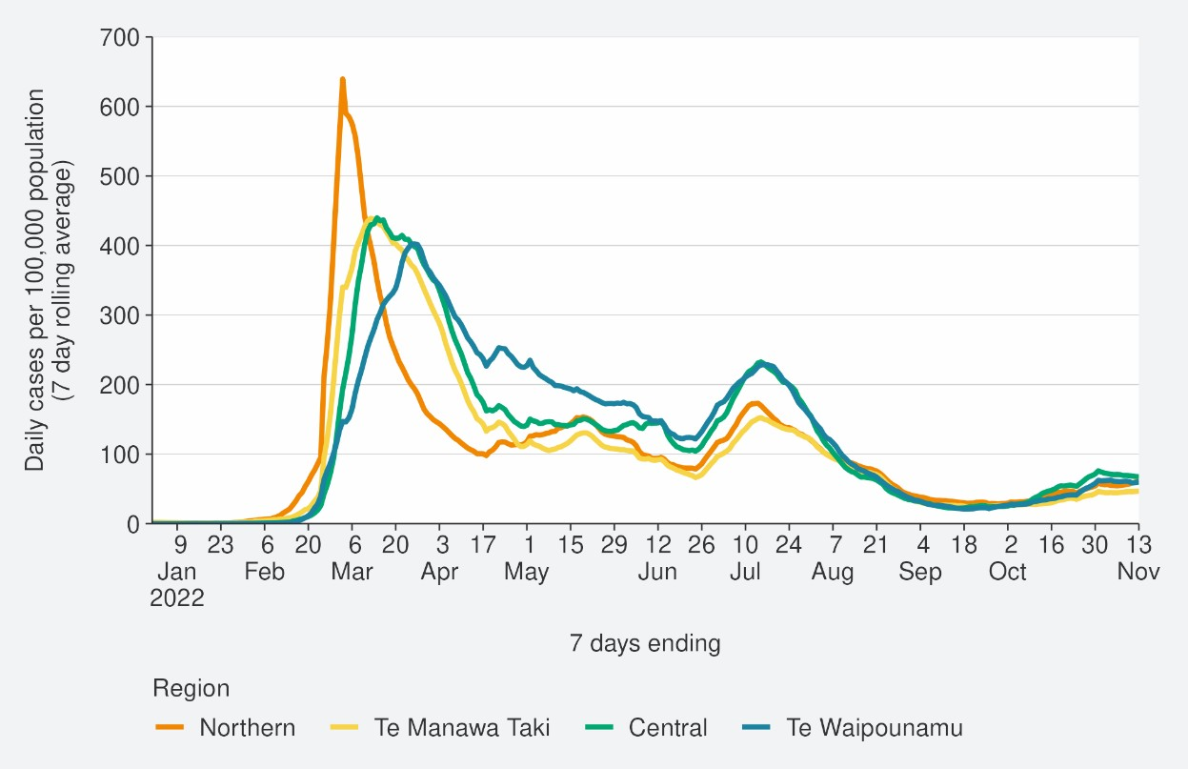
Source: NCTS/EpiSurv as at 2359hrs 13 November 2022

5 The ‘July’ BA.5 scenario assumes that previous infection provides greater protection against reinfection and severe disease, this is consistent with emerging international evidence. It also incorporates updated data and future projections of uptake of second boosters, and an earlier transition to BA.5, consistent with the timing of cases and hospitalisations in New Zealand.

Figure 4: National reported case rates by age from January to 13 November 2022
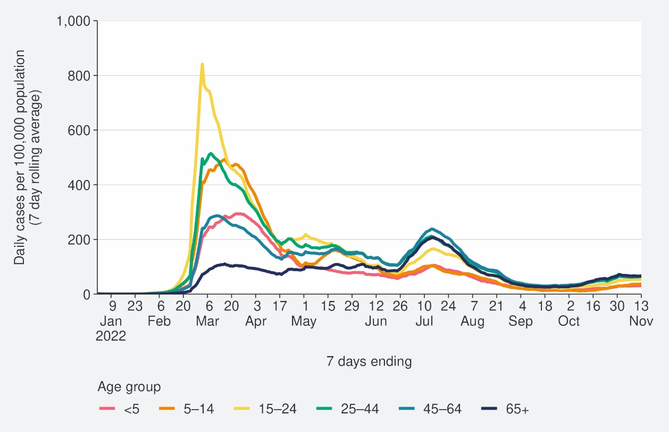
Source: NCTS/EpiSurv as at 2359hrs 13 November 2022

Hospitalisation and mortality trends

Hospitalisation
As seen in Figure 5, the national COVID-19 hospital admissions rate ‘for’ COVID-19, decreased substantially from mid-July but increased since mid-September. In the past week ending 06 November6, the 7-day rolling average of hospital admissions was 1.2 per 100,000 population; an increase of 8.1% from the previous week
Despite reported case rates in the most recent July peak being half that of the March peak (201.2 and 413.2 per 100,000, respectively), the hospitalisation rate in the July peak was not substantially lower than the hospitalisation rate in March. This can be explained by the strong association between age and poor outcomes after infection. The reported case rates in those aged >65 years peaked at 75% higher in July than in March (refer back to Figure 4).
Modelling scenarios suggest current hospital admissions are tracking above the higher range of the prediction and indicate admissions are expected to increase. The variant model is hypothetical but based on the properties of lineages recently reported overseas (Figure 6).

Figure 5: National7 hospital admissions rate for COVID-19, January to 06 November 2022
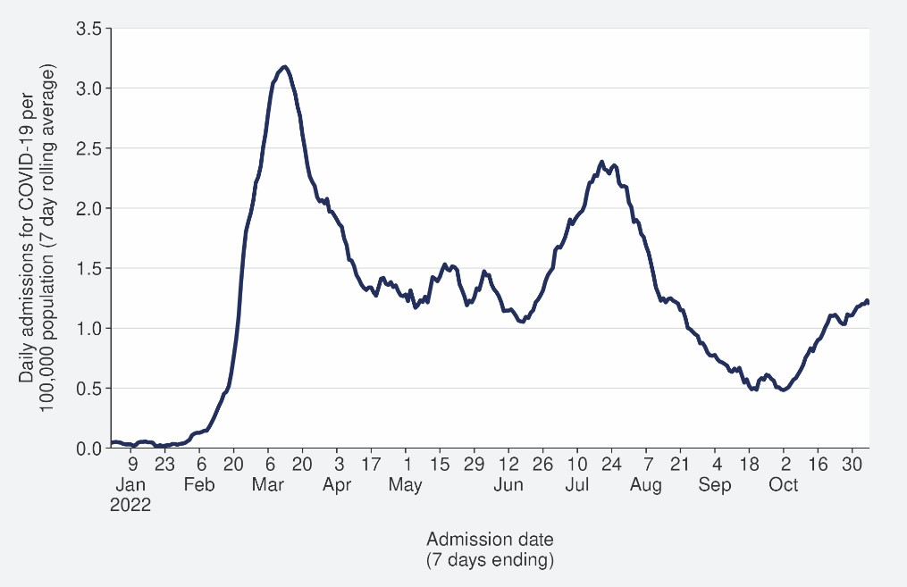

6New hospital admissions who had COVID-19 at the time of admission or while in hospital; excluding hospitalisations that were admitted and discharged within 24hrs. The ‘for’ measure excludes those who are identified as incidental with COVID-19, such as injuries. Recent trends are subject to revision. Please see glossary for further caveats.
7 Data are from Districts with tertiary hospitals; these Districts are Auckland, Canterbury, Southern, Counties Manukau, Waikato, Capital & Coast, Waitemata, and Northland.

Source: NMDS/Inpatient’s admissions feed as of 14 November 2022 data up to 06 November 2022

Figure 6: COVID-19 Modelling Aotearoa hospital admissions scenario8 compared with national admissions
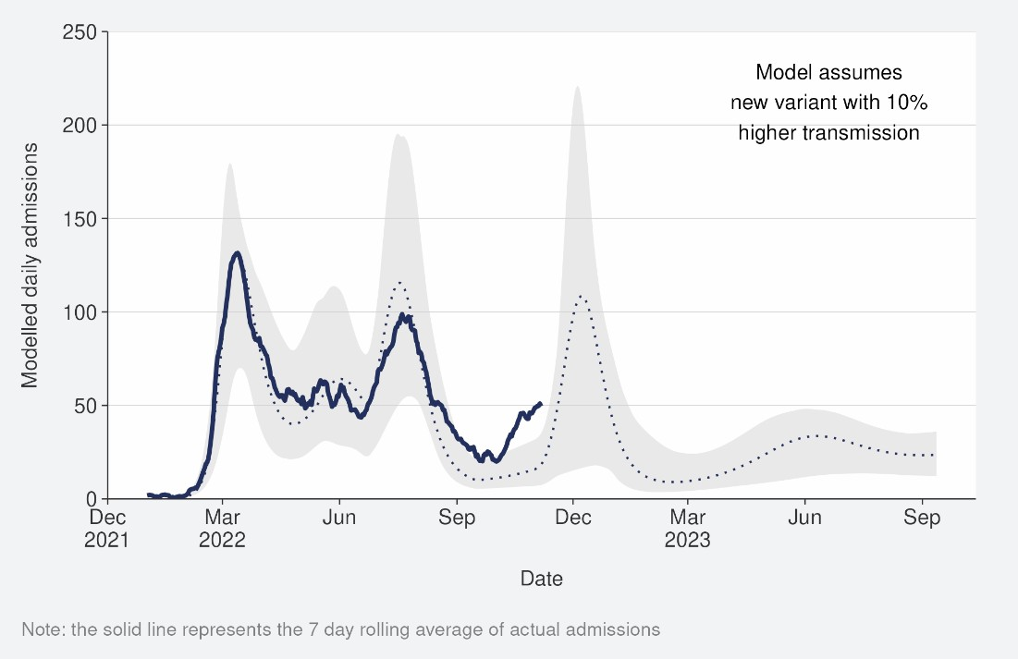
Sources: COVID-19 Modelling Aotearoa, ordinary differential equation model, October 2022, and Ministry of Health reported hospital admission data 06 November 2022

Mortality
From the first week of January to 13 November 2022, there were 3,222 deaths among people who died within 28 days of being reported as a case and/or with the cause being attributable to COVID-19 (that is an underlying or contributory cause) (see Figure 7)9.
Of the deaths in 2022 that have been formally coded as COVID-19 as the cause of death, 1,330 (47%) were determined to have COVID-19 as the main underlying cause. COVID-19 contributed to a further 774 (28%) deaths and another 693 (25%) people died of an unrelated cause (Figure 7). Deaths have been declining since peaking in the last week of July, though in the past few weeks this trend has stabilised and slightly increased in the past few weeks. As seen with hospitalisations, due to the strong association of increasing age and increasing mortality risk, the patterns in mortality over time strongly reflect the case rates in those aged >65 years.
Deaths are currently tracking close to the lower range of the modelled scenario and may increase in the coming months if variant assumptions are borne out in the New Zealand context (see Figure 8).

8 The 'October’ scenario assumes previous infection provides greater protection against reinfection, severe disease, consistent with emerging international evidence, and transmissibility of an emerging variant is increased by 10%. It also incorporates updated data and future projections of uptake of second boosters, and an earlier transition to BA.5, consistent with the timing of cases and hospitalisations in New Zealand.
9 There were 55 deaths before the first week of 2022.

Figure 7: National weekly death counts by cause of death10, February to 13 November 2022
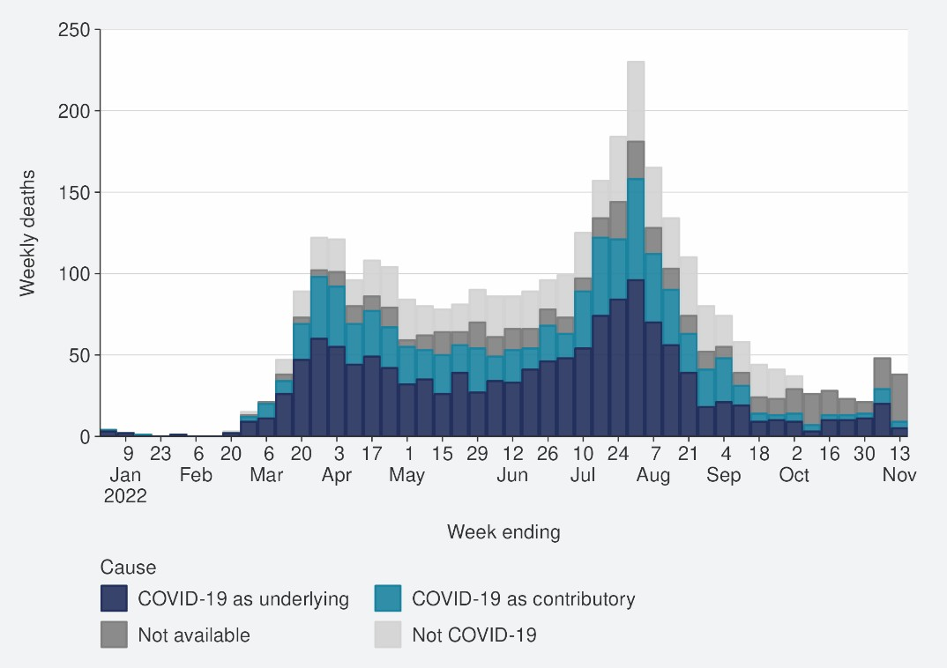
Source: Ministry of Health, 13 November 2022

Figure 8: COVID-19 Modelling Aotearoa death count compared with national observed deaths attributed to COVID-19
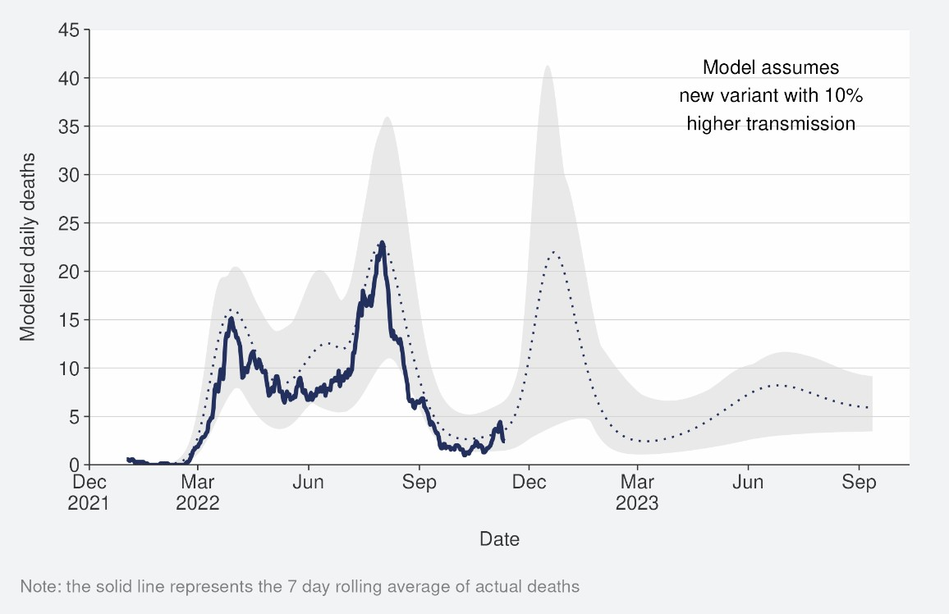
Sources: COVID-19 Modelling Aotearoa, ordinary differential equation model, October 2022, and Ministry of Health reported attributed deaths data 06 November 2022

10 Mortality data are affected by a delay due to time taken for reporting and death coding, the most recent weeks should be interpreted with caution.

Whole Genomic Sequencing

Community cases and wastewater
Whole genomic sequencing data is updated on a fortnightly basis; the data has been updated in this week’s report.
Figure 9 shows the proportions of variants in community cases, with BA.5 accounting for 66% of sequenced cases in the week to 11 November. Proportions of the BA.5 subvariant in the community have continued to decrease over the last few weeks, as proportion of variants increase BA.2.75 (13%), BQ.1.1 (10%), and XBB (3%). Additionally, 8 cases were identified with recombinant lineage XBC, none were recorded as hospitalised. XBC is a recombinant lineage of Delta and Omicron variants and has been present in Australia and Southeast Asia for some time, with no indication of increased disease severity.
Wastewater variant analysis for the fortnight ending 11 November reports the following proportions: BA.4/5 66%, BA.2.75 19%, BQ.1.1 10% and XBB 5%.

Figure 9: Proportion of Variants of Concern in community cases11
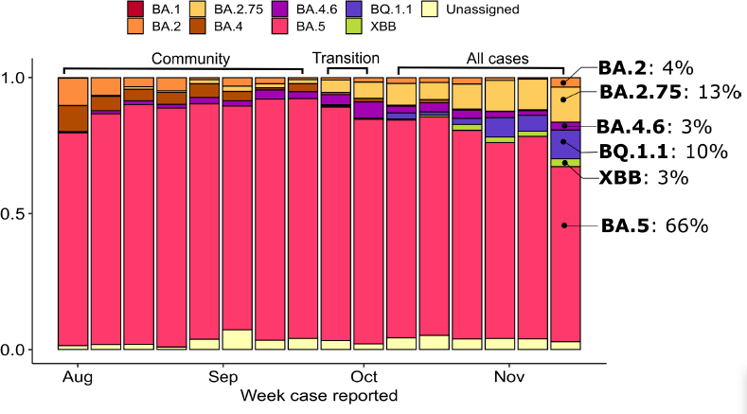
Source: ESR COVID-19 Genomics Insights Report #27, EpiSurv/Microreact 0900hrs 11 November 2022

Hospitalised cases
Of samples collected from PCR positive hospital admissions for the fortnight ending 11 November 203/378 samples successfully were successfully sequenced. As of 16

11 Before the end of the COVID-19 Protection Framework, only data from community cases are presented. In the period marked as “transition”, cases known to be associated with the border were removed, but not all such cases can be reliably identified. Since the transition, data from all cases is used. Results before and after this transition are not directly comparable.

November; 75% were BA.5, 11% BA.2.75, 5% BQ.1.1, 3% BA.4.6, 2% XBB and <2% were BA.2.

Variant risk assessments for BQ.1.1 and XBB
BQ.1.1 is increasing in prevalence in New Zealand relative to BA.5 (the previous predominant variant). BQ.1.1. is also increasing in frequency overseas and appears to have increased immune evasion compared to previous variants, causing an increase in cases internationally. There is not yet sufficient evidence to assess the performance of testing, therapeutic efficacy, or the severity of disease. Therefore, it is considered to pose a moderate risk though increasing cases rates (compared with BA.5) leading to further hospitalisations and deaths.
XBB has also been detected in recent weeks, and there is some evidence of increased immune evasion, and only weak evidence of a growth advantage and loss of therapeutic efficacy compared with BA.5. However, there is insufficient evidence regarding transmissibility, performance of testing or severity of disease. Overall, the current evidence is not sufficient to support that there is any increase in risk from XBB compared with BA.5.
As of 11 November 2022, BN.1.X accounts for 4.3% of USA national cases.12 The growth advantage and characteristics of disease it causes (e.g. severity) are not yet defined.
BN.1 is a descendant of BA.2.75.5 (and consequently BA.2.75), with S:R346T and S:490S mutations.13
Note that BR.2 a variant detected in Australia, will be reviewed in next week’s report.
Refer to the appendix for further details on the risk assessments for BQ.1.1 and XBB, respectively.
Further information on variants of concern is also available on the Ministry of Health COVID-19 Science News Webpage.

12 Centers for Disease Control and Prevention (CDC). COVID Data Tracker: Variant Proportions.
13 University of Edinburgh, et al. Lineage list.

Reinfection
‘Reinfection’ is now defined as a case reported at least 29 days after the last time a person reported a positive test for COVID-19. The definition of reinfection changed on 30 June; prior to this, reinfection was based on reports at least 90 days apart (based on the international literature at the time). Up until 30 June 2022, the vast majority of positive results detected within 90 days of the prior infection were not recorded in the system. Some potential reinfections within 90 days were recorded but were not representative of the general population.
In general, reinfection refers to a second or subsequent infection after the prior infection has cleared. In this analysis, we are not able to distinguish between reinfection with the same variant or different variants. Reinfection with a different variant to the first infection is more likely than reinfection with the same variant. Technically, these data report on ‘redetections’ rather than true reinfections. True reinfections cannot be definitively captured in the data for a range of reasons. For example, a person with persistent infection due to being immunocompromised, who undergoes repeated testing due to regular hospital or clinical visits, would appear in the data as a ‘reinfection’ when they may have a chronic or persistent infection.
Figure 10 characterises the average number of cases per week by first infection and reinfection. Reinfections made up 17.9% of reported cases in the week ending 13 November. The proportion of reported cases that were reinfections has increased this week, after being stable in the past seven weeks. Figure 11 shows how many first infections and reinfections have been reported cumulatively over time. Cumulatively, reinfections have made up 2.8% of total cases reported in 2022. The proportion of cases that are reinfections is expected to increase over time. The true number of reinfections is likely higher than reported here. In general, reporting of cases is expected to decline over time. Due to under-ascertainment of the first infection and subsequent infections and, as both are required to detect a reinfection, there is likely to be under-reporting of reinfections.

Figure 10: Reinfections 7 day rolling average from 01 January to 13 November

2022
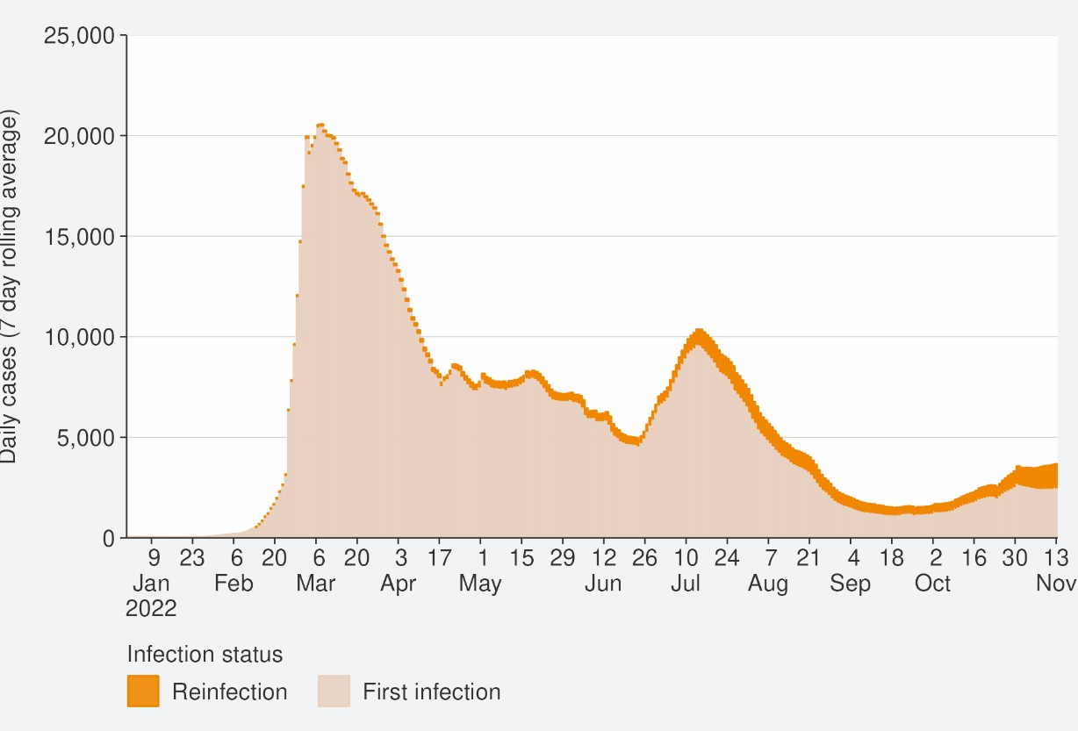
Source: NCTS/EpiSurv as at 2359hrs 13 November 2022

Figure 11: Reinfections cumulatively from 01 January to 13 November 2022
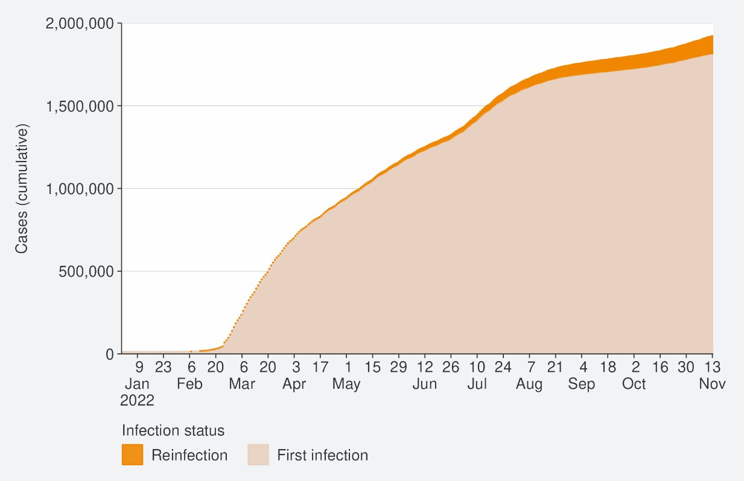
Source: NCTS/EpiSurv as at 2359hrs 13 November 2022

Comparison of epidemic trends by ethnicity
The age-standardised reported case rates have increased for all ethnicities, except Asian (see Figure 12), in the week to 13 November. The highest rates were in European or Other and Asian (59.4 and 54.0 per 100,000 respectively) and the lowest were in
Māori and Pacific peoples (45.3 and 40.8 per 100,000, respectively). Among Māori, rates were highest in those aged 45-64 and 25-44 (58.4 and 54.9 per 100,000, respectively). Among European or Other, case rates were highest in those aged 45-64 and 65+ (71.7 and 73.2 per 100,000, respectively). Among Pacific peoples, rates were highest in those aged 25-44 and 45-64 (58.5 and 50.1 per 100,000, respectively). Refer to in the appendix for non-age-standardised rates by ethnicity.
Figure 13 shows that the age standardised rates for hospitalisation for COVID-19 increased for all ethnicities other than Pacific peoples in the week ending 06 November. Pacific peoples and Māori ethnicities had the highest hospitalisation rates in the week ending 06 November, with Pacific peoples being almost 2-fold higher than European or Other. Within the Māori ethnicity, the 7-day rolling average of hospitalisation to 06 November was 1.0 per 100,00 and was highest in those aged 80+ (15.5 per 100,000), followed by those aged 70-79 (4.8 per 100,000). For Pacific peoples, the 7-day rolling average of hospitalisation to 06 November was 1.1 per 100,00 and was highest in those aged 80+ (13.6 per 100,000), followed by those aged 70-79 (6.0
per 100,000).
The cumulative total for the year shows that overall, Pacific peoples and Māori have had the highest risks of hospitalisation for COVID-19, 2.3 and 1.8 times the risk of European or Other, respectively for 01 January to 13 November. The Asian ethnicity has had a hospitalisation rate almost 11% lower than European or Other (Figure 14).
The cumulative age-standardised mortality rate for 01 January to 06 November shows that Pacific peoples have had the highest risk, 2.4 times that of European or Other, followed by Māori at 1.9 times that of European or Other. Asian people have had the lowest risk of Mortality, 36% lower than European or Other (see Figure 15).14
The lower reported case rates and higher hospitalisation and death rates for Māori and Pacific peoples suggests they may have lower levels of case ascertainment and/or a higher risk of poor outcomes after infection compared with Asian and European or Other ethnicities.

14 These calculations are based on 1,896 deaths occurring between January 2022 and 02 October 2022 (excludes deaths in the last 2 weeks and deaths where ethnicity was unknown).

Figure 12: National age-standardised reported case rates by ethnicity from January to 13 November 2022
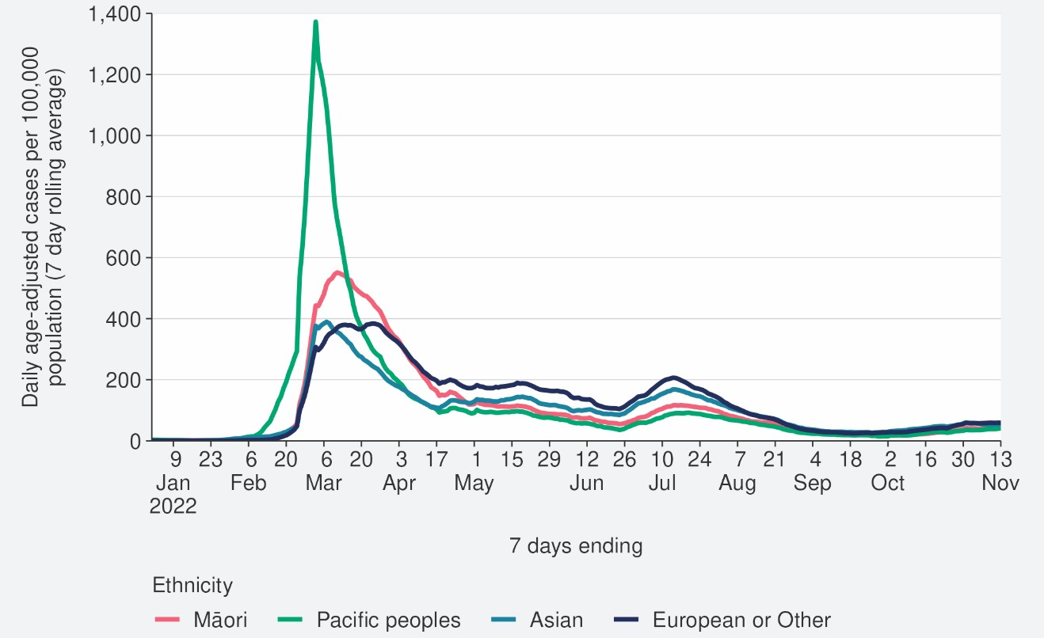
Source: NCTS/EpiSurv as at 2359hrs 13 November 2022

Figure 13: National age-standardised hospitalisation rates by ethnicity from January to 06 November 2022
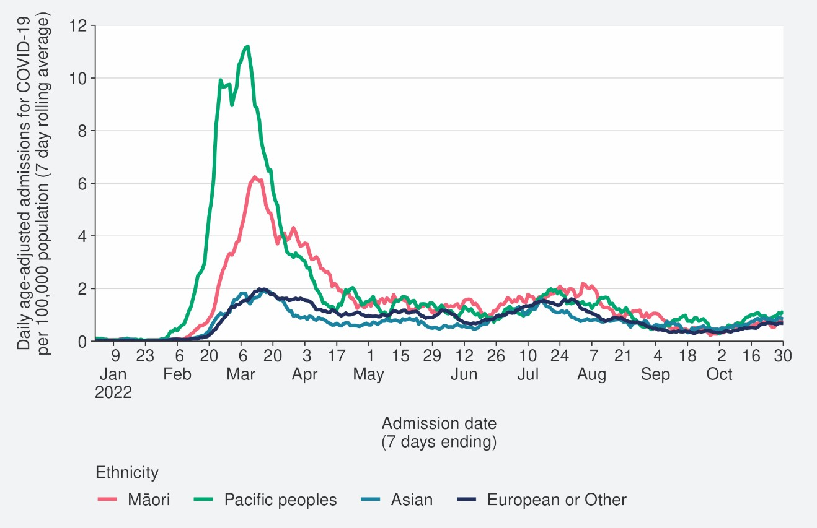
Source: NCTS/EpiSurv as at 2359hrs 06 November 2022

Figure 14: Age-standardised cumulative incidence (and 95% confidence intervals) of hospitalisation for COVID-19 by ethnicity, 01 January 2022 to 13 November 2022
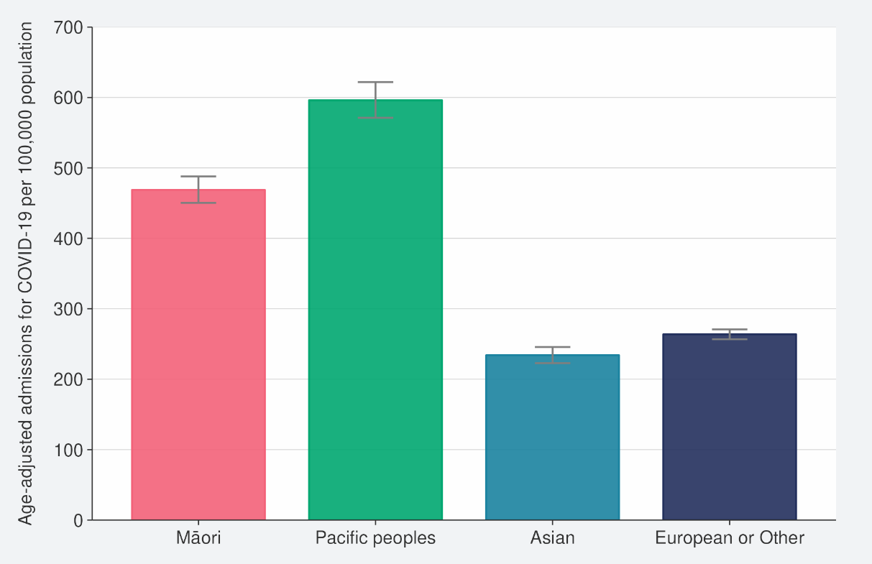
Source: NCTS/EpiSurv, NMDS, Inpatient Admissions dataset and CVIP population estimates, 01 January 2022 to 13 November 2022

Figure 15: Age-standardised cumulative incidence (and 95% confidence intervals) of mortality attributed to COVID-19 by ethnicity, 01 January 2022 to 13 November 2022
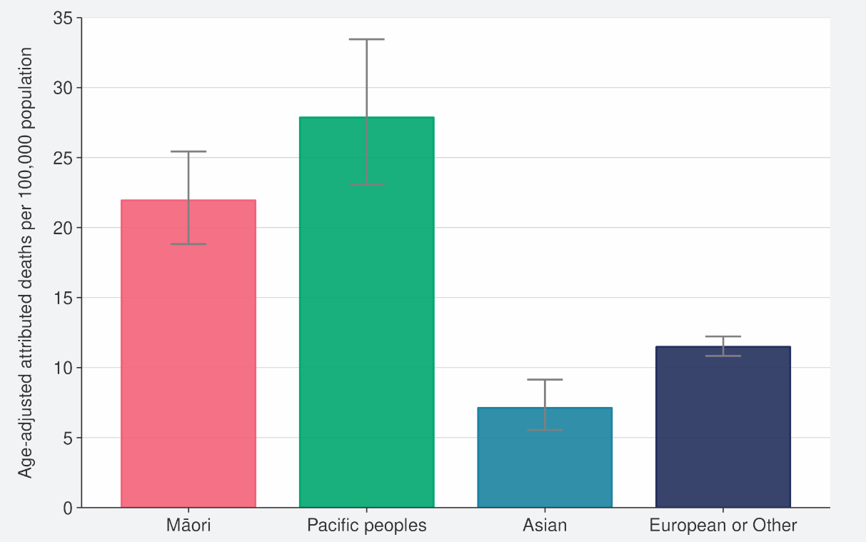
Source: NCTS/EpiSurv, NMDS, Inpatient Admissions dataset and CVIP population estimates, 01 January 2022 to 13 November 2022

Comparison of epidemic trends by deprivation
Figure 16 shows the 7-day rolling average for reported case rates by residential area deprivation level (based on NZDep2018)15. Age-standardised case rates increased in all deprivation levels in the week ending 13 November. Refer to the appendix for non- age-standardised rates by deprivation.
Figure 17 and Figure 18 show that those most deprived have had, and continue to have, the highest rates of hospitalisation, both recently and cumulatively during 2022. Those most deprived have had 2 times the risk of hospitalisation compared with those who are least deprived.
Cumulative rates of mortality are also highest for those most deprived; 2.4 times higher than the risk of those least deprived (Figure 19).16
As lower case rates have been reported among those most deprived, continued higher hospitalisation and death rates suggest those who are most deprived may have lower levels of case ascertainment and/or a higher risk of poor outcomes after infection compared with those who are least deprived.

15 Atkinson J, Salmond C, Crampton P (2019). NZDep2018 Index of Deprivation, Final Research Report, December 2020. Wellington: University of Otago.
16 These calculations are based on 1,833 deaths occurring between January 2022 and 02 October 2022 (excludes deaths in the last 2 weeks and deaths where the level of deprivation was unknown).

Figure 16: National age-standardised reported case rates by deprivation status for weeks 01 January – 13 November 2022
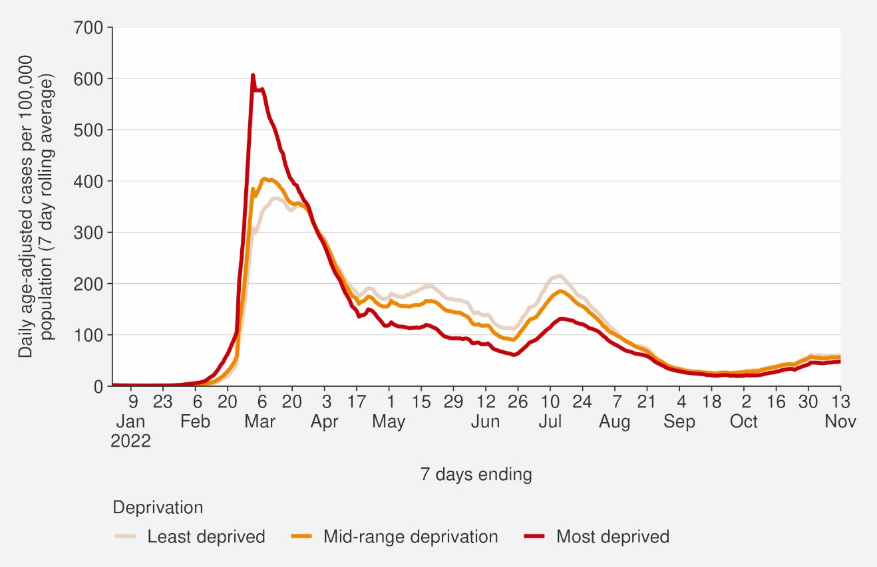
Source: NCTS/EpiSurv as at 2359hrs 13 November 2022

Figure 17: Age-standardised hospital admission rates for COVID-19 by deprivation from January to 06 November 2022
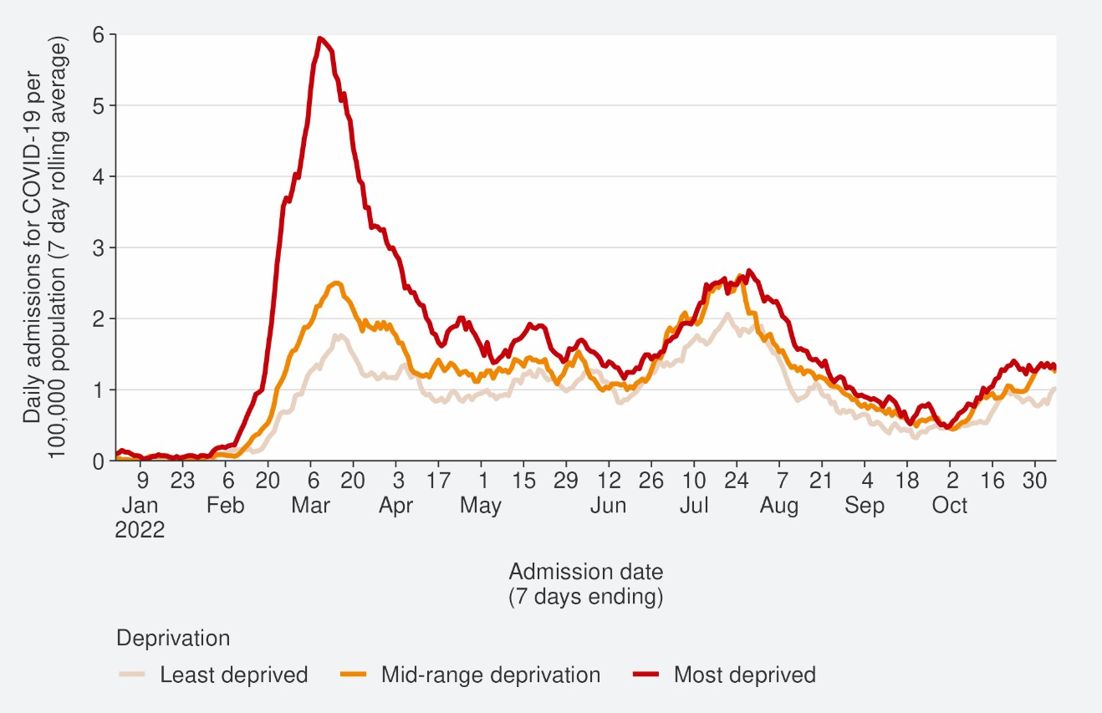
Source: NMDS/Inpatients admissions feed as of 30 October 2022 data up to 06 November 2022

Figure 18: Age-standardised cumulative incidence (and 95% confidence intervals) of hospitalisation for COVID-19 by deprivation, 01 January 2022 to 13 November 2022
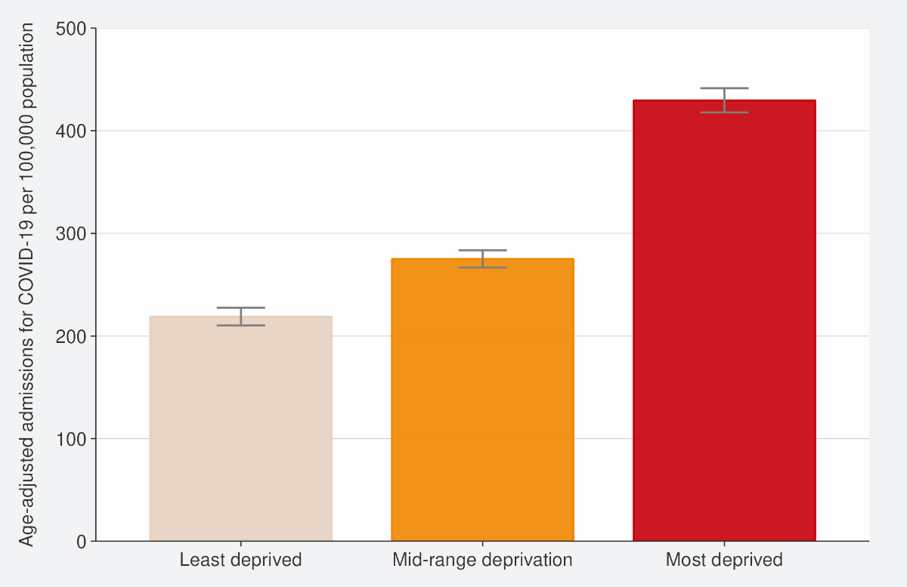
Source: NCTS/EpiSurv, NMDS, Inpatient Admissions dataset and CVIP population estimates 01 January 2022 to 13 November 2022

Figure 19: Age-standardised cumulative incidence (and 95% confidence intervals) of mortality attributed to COVID-19 by deprivation, 01 January 2022 to 13 November 2022
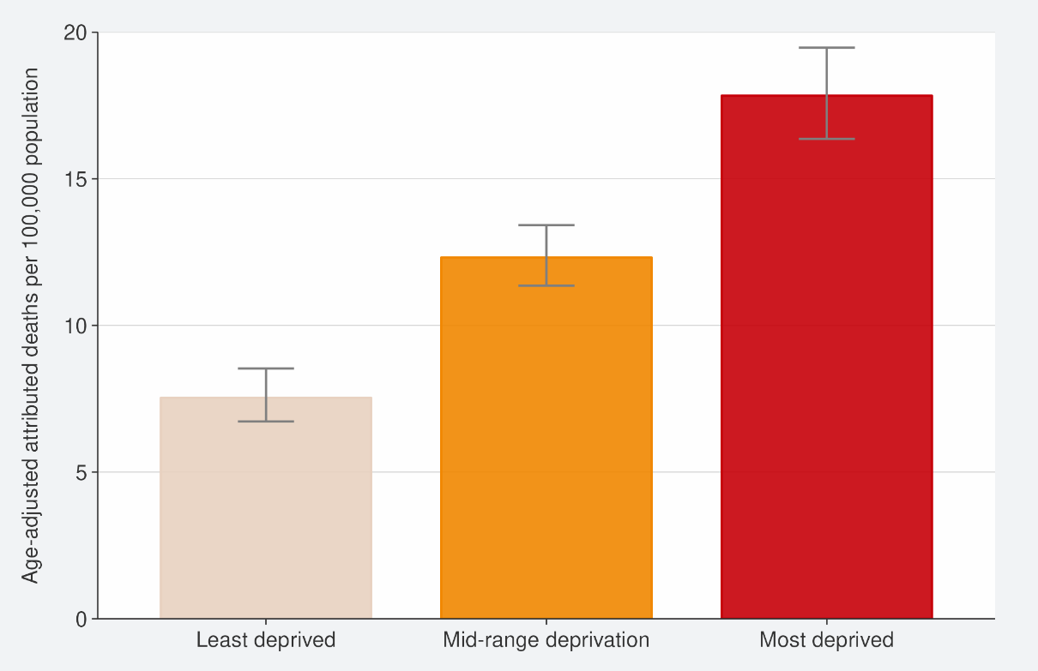
Source: EpiSurv, Death Documents, The Healthcare User database, Mortality Collections database and CVIP population estimates, 01 January 2020 to 13 November 2022

Global pandemic summary
Over the next few months, we expect the global situation for the COVID-19 pandemic to be driven by the ongoing emergence of new variants, waning immunity, and particularly with the Northern Hemisphere heading into winter.
- Globally, in the week ending 13 November, the number of new weekly cases increased by 2% as compared to the previous week with over 2.3 million new cases reported. However, the true number of incident cases is likely to be underestimated due to a decline in testing internationally.
- The number of new weekly deaths decreased by 30% compared to the previous week with over 7,400 fatalities reported.
- As of 13 November 2022, over 632 million confirmed cases and over 6.5 million deaths have been reported globally.
- The global variant circulation indicates slow replacement of previously dominating BA.5 descendent lineages by the most recently emerging variants BQ.1 and BA.5 + R346X.
- BA.5 and its descendent lineages continued to be dominant globally, accounting for 73.2% of sequences submitted to GISAID as of 30 October.
- BA.4 descendent lineages accounted for 3.5% of all cases, a slight decrease from last week as of 30 October.
- BA.2 descendent shows a stable rate of sequence prevalence from 6.3% to 6.8% for the week ending 30 October from the previous week.
- Unassigned sequences (presumed to be Omicron) account for 14.4% of sequences submitted to GISAID as of 30 October.
- In Australia, as of 11 November, cases and hospitalisations increased. In the 7 days to 11 November 2022, there were 56,986, new reported cases an increase of 46.1% from the week prior. There were 1,786 current cases in hospital with 66 in ICU, it is a 28% increase from when last reported (04 November 2022).
- New South Wales, Australia is working with staff of the Majestic Princess cruise ship to manage the health and wellbeing of on-board COVID-19 cases. The cruise ship has been designated a tier 3, or high transmission risk zone and urges those testing positive to isolate. Those considered visitors must isolate for 5-days on-board and all who wish to disembark must provide a RAT within 24hr prior.
Sources: Weekly epidemiological update on COVID-19 - 16 November 2022 (who.int) / Australian Government: Coronavirus (COVID-19) common operating picture / NSW statement on the Majestic Princess cruise ship

Please note, global trends in cases, hospitalisations and deaths should be interpreted with caution as several countries have been progressively changing COVID-19 testing strategies, resulting in lower overall numbers of tests performed and consequently

lower numbers of cases detected. Furthermore, approaches of counting hospitalisations and deaths can differ from country to country.

Appendix: Table of summary statistics

Table 1: Reported 7-day rolling average of case rates and hospital admissions by region, age group, ethnicity, and deprivation

 | Reported Cases (7-day rolling average) |  |  |  |  | Hospital admissions (7-day rolling average)
 | Week ending 06/11/2022 |  | Week ending 13/11/2022 |  | %  Change | Week ending 30/10/2022 |  | Week ending 06/11/2022 |  | %  Change
 | Number | Rate (per 100,000  population) | Number | Rate (per 100,000  population) |  | Number | Rate (per 100,000  population) | Number | Rate (per 100,000  population)
National | 2967.0 | 56.7 | 3079.4 | 58.8 | 3.6% | 45.9 | 1.1 | 49.6 | 1.2 | 8.1%
Region
Northern | 1086.0 | 54.4 | 1214.4 | 60.8 | 11.9% | 21.1 | 1.1 | 23.4 | 1.2 | 4.5%
Te Manawa Taki | 454.1 | 44.4 | 477.3 | 46.7 | 5% | 5.3 | 1.2 | 6.6 | 1.5 | 24.3%
Central | 689.6 | 70.5 | 659.7 | 67.5 | -4.5% | 3.3 | 0.7 | 3.9 | 0.8 | 8%
Te Waipounamu | 732.1 | 60.6 | 723.3 | 59.9 | -1.3% | 14.0 | 1.2 | 15.7 | 1.3 | 7.8%
Age group
<5 | 92.7 | 29.8 | 95.7 | 30.8 | 3.2% | 3.1 | 1.3 | 3.7 | 1.5 | 13%
5-14 | 228.1 | 33.6 | 250.6 | 36.9 | 9.9% | 0.9 | 0.2 | 1.9 | 0.3 | 160%
15-24 | 344 | 52.6 | 354.7 | 54.2 | 3.2% | 2.0 | 0.4 | 2.3 | 0.4 | 23.1%
25-44 | 915 | 62.2 | 950.6 | 64.7 | 3.9% | 5.3 | 0.4 | 5.3 | 0.4 | 5.7%

45-64 | 831.3 | 64.5 | 871.4 | 67.6 | 4.8% | 10.1 | 1.0 | 10.9 | 1.1 | 2.7%
65+ | 555.9 | 66.9 | 556.4 | 67.0 | -0.3% | 22.3 | 3.5 | 25.6 | 4.1 | 4.7%
Ethnicity
Māori | 318 | 39.6 | 363.6 | 45.3 | 14.2% | 3.9 | 0.7 | 5.4 | 1.0 | 35.7%
Pacific peoples | 144.9 | 37.1 | 166.7 | 42.6 | 15.1% | 3.7 | 1.0 | 4.1 | 1.2 | 0%
Asian | 480.4 | 57.6 | 471.1 | 56.5 | -2% | 6.3 | 0.8 | 7.1 | 0.9 | 11.1%
European or Other17 | 2001.3 | 63.2 | 2057.6 | 65.0 | 2.7% | 29.7 | 1.2 | 32.9 | 1.3 | 5.5%
Deprivation
Least deprived | 992.4 | 65.6 | 1003.7 | 66.3 | 1.2% | 9.7 | 0.8 | 13.0 | 1.0 | 30.0%
Mid-range deprivation | 1171.7 | 58.4 | 1220.7 | 60.9 | 4.0% | 18.1 | 1.1 | 20.0 | 1.2 | 0%
Most deprived | 756.0 | 48.2 | 802.7 | 51.2 | 6.2% | 14.4 | 1.2 | 14.9 | 1.3 | 2.0%

17 ‘Other’ referring to all ethnicities other than Māori, Pacific peoples, Asian and European, specifically MELAA; Middle Eastern, Latin American and African. See Table 2 for breakdowns of MELAA ethnicities.

Table 2: Cumulative reported cases and hospitalisations admissions from January 2022 to 13 November by level 2 ethnicity.

Ethnicity | Level 2 Ethnicity | Cumulative reported cases of  COVID-19 | Cases per 1,000  population | Cumulative hospitalisation for COVID-19 | Hospitalisations per 1,000 population | Population
Asian | Asian NFD | 9111.0 | 408.0 | 28.0 | 1.0 | 22320
Asian | Chinese | 62385.0 | 265.0 | 499.0 | 2.0 | 235331
Asian | Indian | 98700.0 | 403.0 | 827.0 | 3.0 | 245079
Asian | Other Asian | 47820.0 | 393.0 | 325.0 | 3.0 | 121732
Asian | Southeast Asian | 55129.0 | 506.0 | 265.0 | 2.0 | 108939
Māori | Māori | 276339.0 | 362.0 | 3275.0 | 4.0 | 762780
MELAA | African | 10029.0 | 380.0 | 121.0 | 5.0 | 26364
MELAA | Latin American / Hispanic | 13867.0 | 478.0 | 76.0 | 3.0 | 28998
MELAA | Middle Eastern | 9930.0 | 307.0 | 169.0 | 5.0 | 32395
Pacific Peoples | Cook Island  Māori | 19442.0 | 365.0 | 292.0 | 5.0 | 53299
Pacific Peoples | Fijian | 17669.0 | 431.0 | 198.0 | 5.0 | 40956
Pacific Peoples | Niuean | 7967.0 | 409.0 | 121.0 | 6.0 | 19477
Pacific Peoples | Other Pacific Island | 6987.0 | 483.0 | 75.0 | 5.0 | 14466
Pacific Peoples | Pacific Island NFD | 1651.0 | 451.0 | 6.0 | 2.0 | 3663
Pacific Peoples | Samoan | 68433.0 | 442.0 | 1074.0 | 7.0 | 154997
Pacific Peoples | Tokelauan | 2886.0 | 421.0 | 46.0 | 7.0 | 6863
Pacific Peoples | Tongan | 29982.0 | 412.0 | 513.0 | 7.0 | 72703

Public Health Risk assessment for BQ.1.1 (Cerberus) and XBB (Gryphon)
The ‘Overall risk assessment’ is presented in comparison to the prior or current predominant variant, in this case, BA.5. ‘Increased risk’ indicates the assessed variant as worse than the previous predominant variant with regards to that characteristic; ‘no change’ means that the assessed variant poses equivalent risk; and ‘decreased risk’ means that the assessed variant is better than the previous predominant variant.

‘Confidence level’ indicates the overall quality of data that are available to make the risk assessment: ‘High’ (high quality, robust data); ‘Moderate’ (good data with limitations); ‘Low’ (very little data available). ‘Insufficient data’ indicates that there are no data of reasonable quality on which to base an assessment at this time.

Table 3: Public Health Risk assessment for BQ.1.1 (Cerberus), 02 November 2022

 | Overall risk assessment | Confidence level | Assessment and rationale
Overall growth  advantage | Increased  risk | Moderate | Evidence of a growth advantage compared to BA.5.  Currently present in New Zealand and is growing relative to BA.5.
Transmissibility | Insufficient data | Insufficient data | No direct data on intrinsic transmissibility and there is no current ability to measure from  surveillance data. There is some laboratory evidence that ACE2 binding is increased for BQ.1.1 compared to prior Omicron variants which may affect transmissibility/infectivity.
Immune  evasion | Increased  risk | Moderate | Evidence of increased immune evasion.  More resistant to neutralisation from sera of vaccinated and breakthrough infected individuals.
Severity | Insufficient data | Insufficient data | No evidence of a change in severity compared to BA.5  Too few cases have been detected internationally or in New Zealand to evaluate severity.
Therapeutics | Increased  risk | Low | One in vitro study showed loss of efficacy of all currently approved clinical monoclonal antibody therapies including Evusheld and Bebtelovimab.

Testing | Insufficient data | Insufficient data | Currently there is some emerging evidence that suggests a clinically relevant decrease in the performance of RATs for detection of the Omicron variant. (7, 8)  However, it is uncertain how this will affect sensitivity specifically for BQ.1.1
Overall  Assessment | There is an increase in overall risk from the previous predominant variant, BA.5. (Moderate confidence)  BQ.1.1 is increasing in frequency overseas and appears to be more transmissible and immune evasive.

Source: SARS-CoV-2 Variants of Concern Update – Manatū Hauora, Ministry of Health

Table 4: Public Health Risk assessment for XBB (Gryphon), 02 November 2022

 | Overall risk assessment | Confidence level | Assessment and rationale
Overall growth advantage | Increased risk | Low | Evidence of a growth advantage compared to BA.5  Cases are increasing in Singapore against a background of BA.5. Cases of XBB have been detected in New Zealand.
Transmissibility | Insufficient data | Insufficient data | No direct data on intrinsic transmissibility and there is no current ability to measure from  surveillance data. There is some laboratory evidence that ACE2 binding is increased for XBB compared to prior Omicron variants which may affect transmissibility/infectivity.
Immune  evasion | Increased  risk | Moderate | Evidence of increased immune evasion.  More resistant to neutralisation from sera of vaccinated and breakthrough infected individuals.
Severity | Insufficient data | Insufficient data | In late October the WHO TAG-VE noted that current (limited) information does not indicate an increase in severity for XBB.  A divergence and weakening of the correlation between the number of cases and new  hospitalisations has been observed in Singapore.
Therapeutics | Increased  risk | Low | One in vitro study showed loss of efficacy of all currently approved clinical monoclonal antibody therapies including Evusheld and Bebtelovimab.

Testing | Insufficient data | Insufficient data | Currently there is some emerging evidence that suggests a clinically relevant decrease in the performance of RATs for detection of the Omicron variant.  However, it is uncertain how this will affect sensitivity specifically for XBB.
Overall  Assessment | No change in risk

Source: SARS-CoV-2 Variants of Concern Update – Manatū Hauora, Ministry of Health

