COVID-19: Guidance for return-to-work of healthcare workers
12 September 2023 (version 4.0)
Contents
COVID-19: Guidance for return-to-work of healthcare workers 1
Introduction 2
Who this guidance is for 2
COVID-19 symptoms 3
Stay home when sick – even if it’s not COVID-19 3
COVID-19 Reinfection 3
Managing HCWs who are cases or close contacts 4
COVID-19 transmission 4
Reporting COVID-19 exposure or infection 4
Potential actions 4
Rapid antigen tests, isolation times and infectivity 4
When staff are not at work 5
Return-to-work of healthcare workers who are cases 5
Summary of return-to-work pathways 6
Continue to do the basics well 8
Appendix 1 8

Introduction
This document provides guidance for clinical leaders and managers in the health sector to manage the return to work of healthcare workers (HCWs) who have been infected with, or exposed to, COVID-19, as well as those who have acute respiratory symptoms but have tested negative for COVID-19.
It provides structured return-to-work pathways to enable individual regions and/or services to make decisions appropriate for their circumstances.

Who this guidance is for
This guidance applies to healthcare workers in:
- hospitals;
- aged residential care;
- primary and community services;
- home support services provided for a variety of clients including mental health and disability support services; and
- is appropriate for use by NGOs and private providers in health services.
Health services are defined broadly and include all services that are an integral part of the health and wellbeing system.
In hospital settings, support to use this guidance may be provided by personnel in occupational health, infectious diseases, clinical microbiology, infection prevention and control (IPC) and/or service leadership.
In non-hospital settings, we recommend a registered health professional seeks further support and guidance from relevant clinical teams where available (such as occupational health, infectious diseases, clinical microbiology, IPC) and/or service leadership in applying this guidance to staff who are COVID-19 cases or contacts.
All service providers need to talk with their staff about the potential scenarios when this guidance will be applied and what that means in practice.

This is a living document and will be reviewed and updated accordingly. Please ensure you refer to the website for the most up-to-date version.

COVID-19 symptoms
The full list of COVID-19 symptoms is available on the Te Whatu Ora website: Symptoms of COVID-19. In some situations, as detailed below, HCWs will be able to return to work if they have no, or mild and improving symptoms.
The definition of mild symptoms for the purpose of this guidance is:
- no fevers (without fever-reducing medication such as paracetamol)
- minimal cough/sneeze
- minimal runny nose (i.e. does not require removal of mask or respirator to wipe)
- feeling well enough to return to work.

Stay home when sick – even if it’s not COVID-19
All healthcare workers must follow standard public health advice. Stay home when sick and only return to work once symptoms have resolved or are deemed to be mild and improving.
Be vigilant for symptoms. If new COVID-19-like symptoms develop, immediately test using a Rapid Antigen Test (RAT), or another approved test.
When symptomatic, the following guidance applies:
- If these are new symptoms and are greater than mild, even with a negative RAT stay at home while unwell.
- Can return to work if have three consecutive negative RATs, each 24 hours apart, or a negative PCR at 48 hours after symptoms started, and if symptoms have resolved or are mild and improving.
- For people that have a history of COVID-19-like symptoms due to other causes (e.g. hayfever, asthma), and have usual mild symptoms, test using a RAT and continue working if negative. Recommend repeat testing until three consecutive negative RATs, each 24 hours apart, to confirm the symptoms are not due to COVID-19.

COVID-19 Reinfection
Evidence on reinfections is evolving rapidly. The Ministry of Health and Te Whatu Ora are closely monitoring international evidence and information to ensure our guidance is in line with the latest public health advice. For up-to-date information visit the Unite Against COVID-19 website.
- If a person develops new symptoms consistent with COVID-19, and it’s 29 days or more since a previous infection, it’s possible they have a reinfection with COVID-19 and they should test using a RAT.
- If the RAT is positive, follow district or regional guidance for confirming a positive case before implementing case and contact management pathways.

Managing HCWs who are cases or close contacts

COVID-19 transmission
In healthcare settings, HCWs must wear the appropriate personal protective equipment (PPE) and adhere to IPC measures to reduce the risk of transmission. Additional guidance regarding vaccinations or increased testing requirements is in place with the intention of protecting vulnerable patients and workers.

Reporting COVID-19 exposure or infection
Workplaces must have documented processes and systems for HCWs to self-report COVID-19 exposure or infection. HCWs are recommended to self-report their positive result on My Covid Record in addition to any internal processes. Each workplace needs to ensure a process is in place and understood by HCWs. Local records must document staff management whilst maintaining confidentiality of staff health information.

Potential actions
The return-to-work pathways outlined in this guidance refer to actions that are recommended as best practice.
Management of HCWs who are COVID-19 cases or contacts involves making risk assessments and balanced decisions. This involves ensuring the wellbeing of the HCW whilst weighing the risks of COVID-19 transmission with wider health risks to patients, whānau and other staff. It is expected the pathways outlined in this guidance would be considered and implemented in a stepwise manner i.e., the Return Day 8 pathway should be deemed a non-viable option before looking to the Return with negative RATs pathway.

Rapid antigen tests, isolation times and infectivity
Rapid antigen tests (RATs) are used as part of implementing this guidance. We recommend all healthcare organisations provide their staff with access to a supply of RATs, including instructions for how to administer a RAT properly. Any RAT undertaken to return-to-work should be done at home before going to the workplace (not at work prior to starting a shift).
Cases
For HCWs who are COVID-19 cases, the return-to-work options use RATs to help indicate whether someone might be infectious or not. However, staff and managers should be aware that people may not be well enough to return despite ending their recommended isolation period or returning a negative RAT result.
Current evidence indicates that two correctly administered negative RATs at the end of the infectious period provides good reassurance a person is no longer infectious. A positive RAT indicates a person may still be infectious, although this is not always the case. Clinical judgement about whether or not someone has symptoms that could more easily facilitate transmission (e.g., sneezing and coughing) should also be part of the risk assessment when safe service delivery is at risk and an early return-to-work is being considered.
Current evidence suggests that very few cases will still be infectious after 10 days, if they have a normal immune response (i.e., are not immunocompromised).
Household Contacts and high-risk workplace exposure contacts
Current guidance recommends that all household contacts should take a RAT each day for 5 days from when the first case in the household tests positive. If symptomatic, the HCW should advise their manager and follow the general advice for staff with respiratory symptoms (see “stay home when sick” section above). Healthcare workers who have no symptoms can continue to work, but additional precautions such as wearing a mask up to day 10 are recommended for staff working with vulnerable patients/clients.

When staff are not at work
When not at work, HCWs should adhere to relevant community isolation and testing recommendations.

Return-to-work of healthcare workers who are cases
In each situation, HCWs wellbeing and the need to be at the workplace should be reviewed regularly. HCWs who are COVID-19 cases should discuss their return to work with their manager or clinical leader.
There are two pathways for COVID-19 cases to return to work:
- a negative RATs return to work from day 4 pathway; and
- a return to work on day 8 pathway for HCWs who continue to be RAT positive (or who have not tested).
For both pathways, HCWs must feel well enough to work and be asymptomatic or have only mild symptoms.
Information sheets, providing a more detailed description of each pathway, have been developed for managers and staff (see Appendix 1).

Summary of return-to-work pathways
Pathway | Eligibility |  | Description
Symptomatic HCWs | - Healthcare worker  - Works in or enters clinical area |  | If new respiratory symptoms develop:  - Stay home if feeling unwell.  - Do a RAT immediately.  - If positive, follow case pathways below.  - If negative, repeat RAT twice at least 24 hours apart.  - Return to work if all 3 RATs are negative and no or mild and improving symptoms.  If history of asthma or hayfever and have usual mild symptoms  - Do a RAT immediately.  - If negative, can continue working.  - Repeat RAT daily until 3 consecutive negative tests.
Household contacts or High risk workplace exposure | - Healthcare worker  - Works in or enters clinical area |  | - Do a RAT each day for 5 days, from the day that the first case in the household tests positive, if negative and have no symptoms can continue to work.  - If symptoms develop, RAT immediately and stay home and recover. Only return to work if symptoms have resolved or two negative RATs 48 hours apart and symptoms are mild and improving.  Adhere to the following precautions on workdays up to Day 10 and for the duration of time there are active cases in the household:  - Continue to do a pre-shift RAT.  - Wear a well-fitting medical mask, at all times and adhere to other IPC measures, and maintain distance from others in break and eating areas.  - If usually working in a higher risk patient area, consider redeployment or, if not feasible, consider wearing an P2/N95 particulate respirator.  Maintain extra vigilance if working in services with vulnerable patients/clients.
Cases – Return Day 8 | - Healthcare worker  - Works in or enters clinical area  - Complete 7 days away from work  - Asymptomatic or mildly symptomatic |  | Return from day 8 - no negative RATs required  - If not tested or do not have two negative RAT results, stay away from work for 7 days.  - If mild or no symptoms and feeling well enough, can return to work from day 8.  Adhere to the following precautions up to Day 10:  - Wear a well-fitting medical mask at all times and adhere to all other IPC measures.  - Maintain distance from others in shared break and eating areas.  - If usually working in a higher risk patient area, consider redeployment or wearing a P2/N95 particulate respirator at all times.
Cases – Test to return from  Day 4 |  | - Healthcare worker  - Works in or enters clinical area  - Complete at least 3 days away from work  - TWO negative RATs on consecutive days  - Asymptomatic or mildly symptomatic | Test to return – two negative RATS required  - If feeling well, can test to return with RATs (start testing from day 3 at the earliest).  - If mild or no symptoms and feeling well enough, return to work once two negative RATs at least 24 hours apart (return to work from day 4 at the earliest).  Adhere to the following precautions up to Day 10:  - Wear a well-fitting medical mask at all times or consider wearing a P2/N95 particulate respirator if working with vulnerable patients or working in a high-risk area.  - Adhere to all other IPC measures.  - Maintain distance from others in shared break and eating areas.
 |  | This pathway should not be taken to imply there is a compulsion to return to work until the healthcare worker is well enough to return to work; in some situations, limited duties may be appropriate.

Continue to do the basics well
To avoid transmission of COVID-19 and other respiratory infections, encourage all HCWs, and where possible patients/clients, to continue to do the basics well. This includes ensuring vaccinations are up to date, testing and staying home if unwell, wearing a mask correctly, and being vigilant about hand hygiene.
Staying home and testing if unwell
Ensure that any HCW who develops or has COVID-19-like symptoms stays home, tests, and communicates with their manager/clinical leader about next steps for work purposes. Staying home if unwell will help to limit transmission of other respiratory infections as well as COVID-19.
Mask wearing
Use of standard and transmission - based precautions and a risk assessment for COVID-19 and other respiratory infections should be adhered to by HCWs, to advise them on the most appropriate respiratory protection and any other PPE required when working clinically. For more information on infection prevention and control recommendations including donning and doffing of PPE, types of masks and particulate respirators and COVID-19 risk assessment please refer to the Te Whatu Ora IPC recommendations for health and disability care workers website.
Vaccinations
HCW are recommended to have received their primary COVID-19 vaccination course and initial booster. A second booster is recommended as a priority for HCW who meet clinical criteria for those at risk of severe illness from COVID-19 and is also available for other HCWs aged over 30 years.
More information about COVID-19 vaccines can be found on the COVID-19 website.
Safe spaces
COVID-19 and other respiratory infections can occur when people are closely interacting together without wearing masks, for example, at meal breaks where people are eating or drinking at the same table.
Consider ways of reducing transmission such as rostered/staggered meal breaks, having breaks outside, and asking HCWs to limit the time they spend with others when on breaks.
Staff wellbeing
It is critical that HCWs are able to take rest breaks during their normal working hours and especially during periods when workloads increase. Facilities for staff/department-only break areas should be made available to enable this and to limit potential transmission where possible.
Reporting processes
Ensure that HCWs are aware of processes to self-report exposure or illness in place, as not all workplaces have the same systems to report to.

Appendix 1
Information sheets of each pathway for managers and staff are on the following pages.

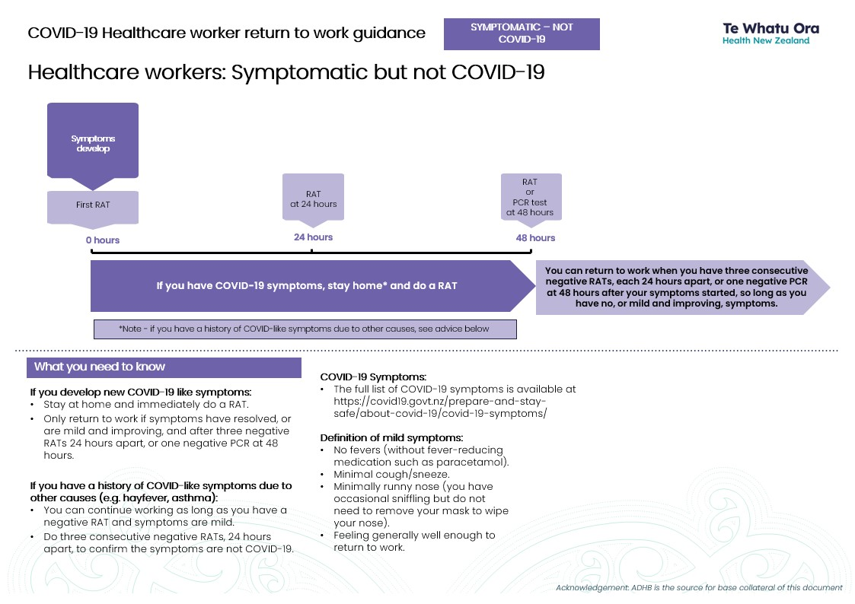
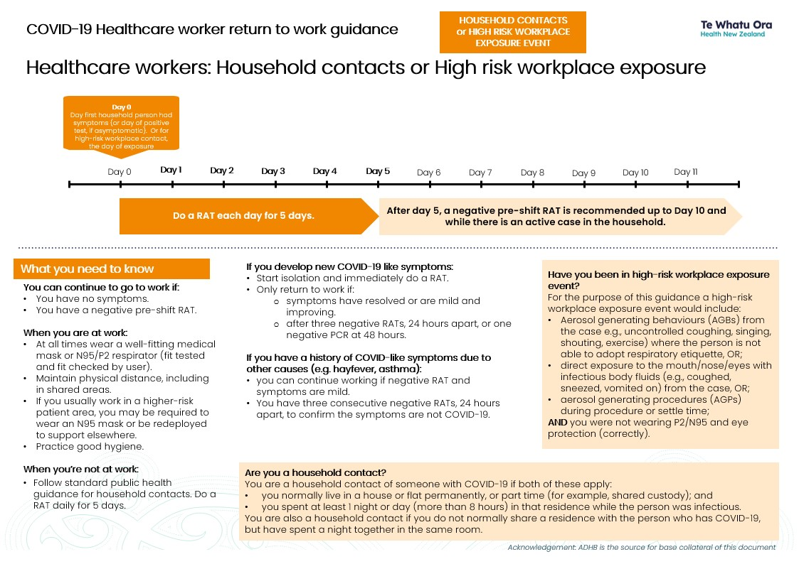
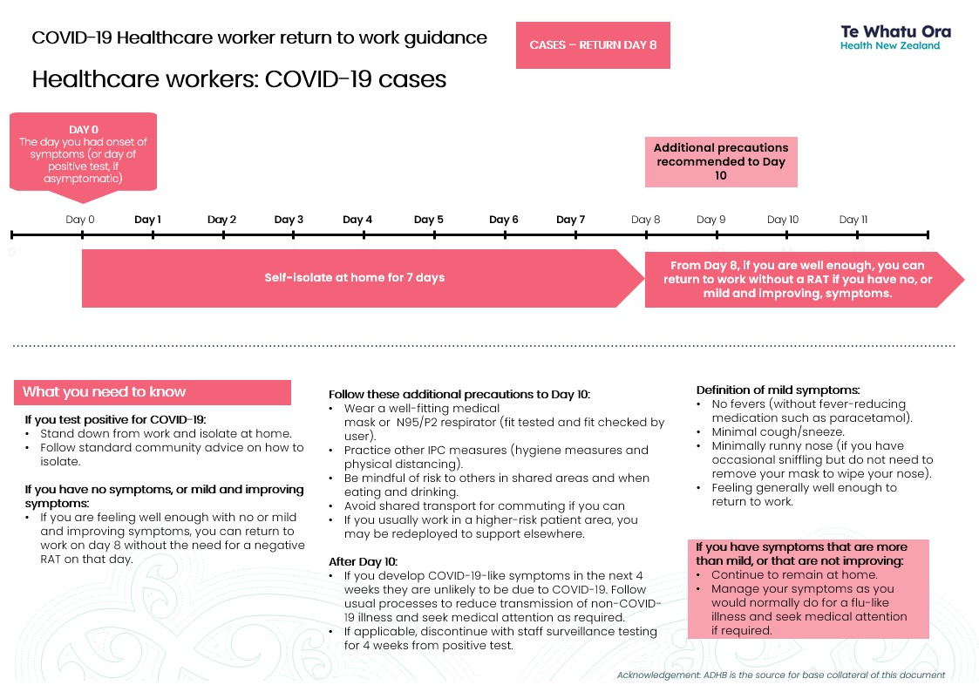
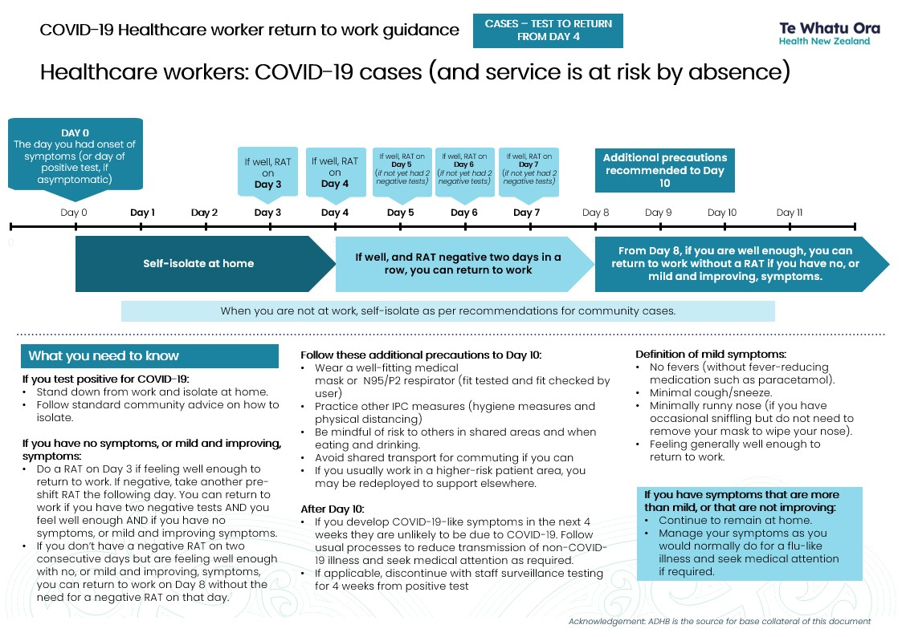

Correct use of a well-fitting fluid resistant medical mask (Type IIR or Level 2) or a P2/N95 particulate respirator that has been fit checked by user. A user seal check/fit check must always be performed when putting on a P2/N95 respirator. In situations where fit testing has not yet been carried out, successful seal check will provide reassurance of good mask fit.
Correct use of a well-fitting fluid resistant medical mask (Type IIR or Level 2) or a P2/N95 particulate respirator that has been fit checked by user. A user seal check/fit check must always be performed when putting on a P2/N95 respirator. In situations where fit testing has not yet been carried out, successful seal check will provide reassurance of good mask fit.
As above.

