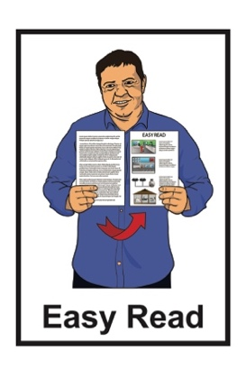

Information about measles
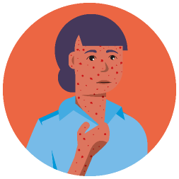
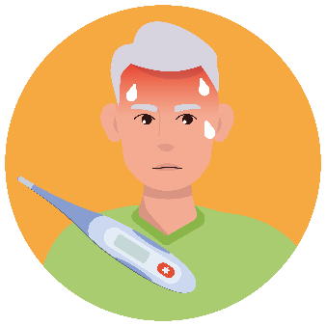
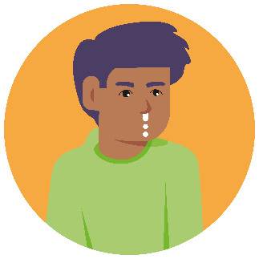
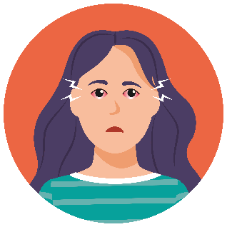

Published: May 2023

Contents page

Page number:
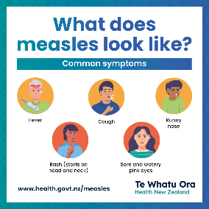

About measles 4

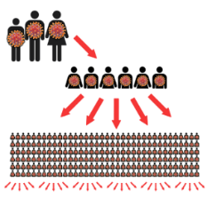
How measles spreads 6

What happens to your body when you get measles 7

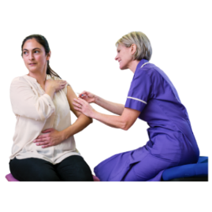
Keeping yourself safe
from measles 9

What to do if you think you have measles 11

Page number:

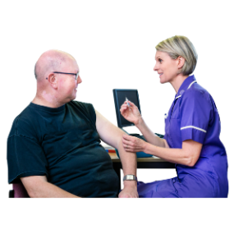
Check if you are protected against measles 14

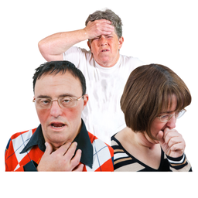
How measles symptoms are
different to COVID-19 17

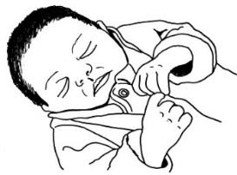
People at risk of serious illness 19

What to do if you catch measles 21

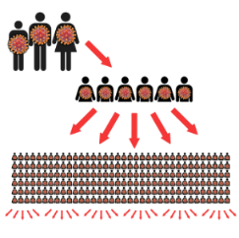
If you are a contact of someone
with measles 23

Page number:

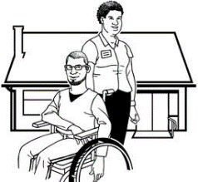
Isolation / quarantine support 26

Where to get more information 27

About measles

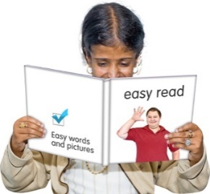
This booklet tells you the things you need to know about measles.

Measles is an illness that can make you very sick.

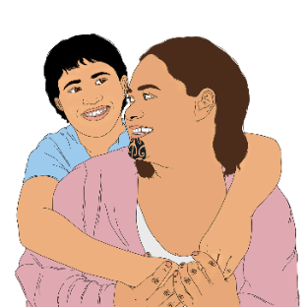
Measles can affect:
adults
children.

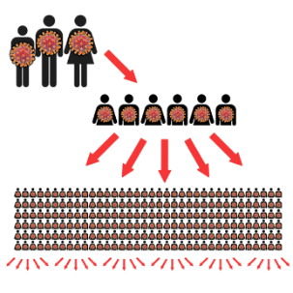
Measles can spread easily between people who are not immune to measles.

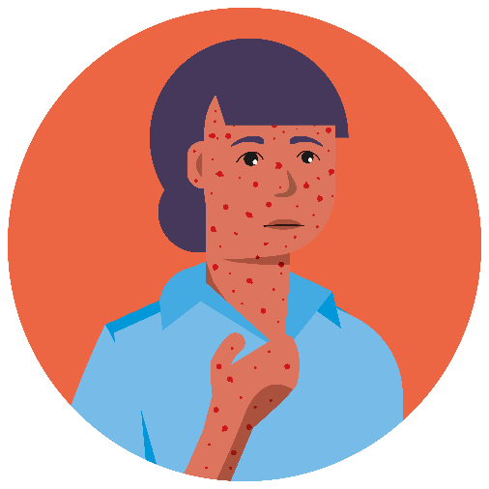
Being immune to measles means that you:
have had measles before
or
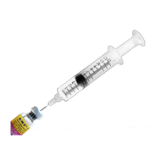
have had the Measles Mumps Rubella vaccine.

If you are immune you are less likely to get measles.

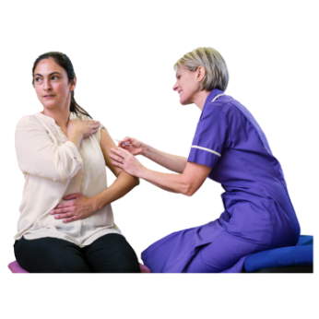
The Measles Mumps Rubella vaccine is an injection that can protect you from getting measles.

It is sometimes called the MMR vaccine.
You need to get it 2 times.

How measles spreads

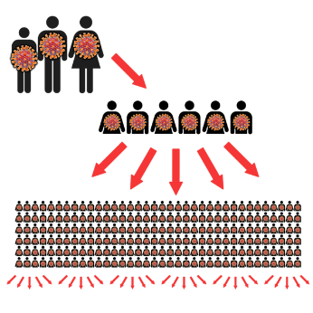
Measles spreads easily between people who are not immune to / protected against measles.

Measles is spread by:
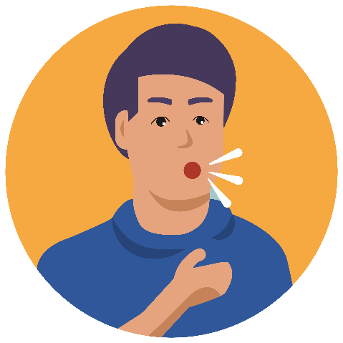
breathing
sneezing
coughing.

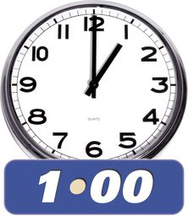
You can catch measles by going into a room if someone with measles has been in the room 1 hour before.

What happens to your body when you get measles

People with measles may have:

- a fever which means you would feel very hot
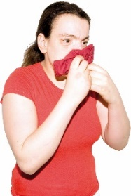
- a cough

- a runny nose

- eyes that are:
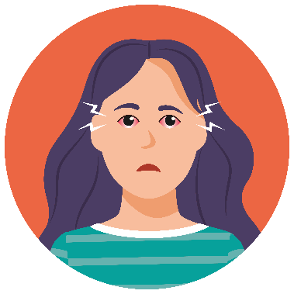
  - sore

  - watery

  - pink.

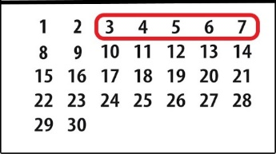
From day 3 to day 7 of having measles people may start to get a rash.

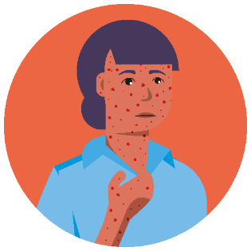
A rash is when parts of your skin become:

- swollen
- red
- itchy.
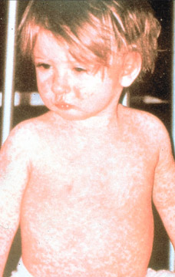

A measles rash usually:
starts on your face
then spreads to the rest of your body.

Keeping yourself safe from measles

Being vaccinated is a good way to stay safe from measles.

Being vaccinated means you get an injection in your arm.

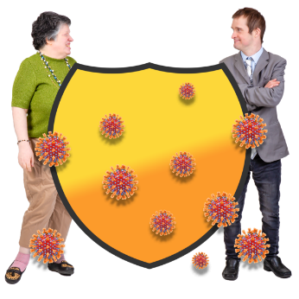
If you are vaccinated you are less likely to:

- get measles
- spread measles

- need to stay home if you are in contact with someone with measles.

Getting vaccinated to protect yourself from measles:

- is easy
- does not cost money.

The MMR vaccine is free for anyone in New Zealand born after 1 January 1969.

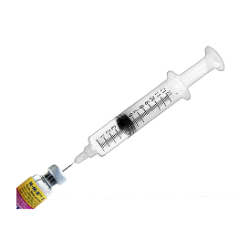
If you do not know if you had 2 MMR vaccine doses then it is best to get another injection.

It is still safe if you get too many doses of the MMR vaccine by mistake.
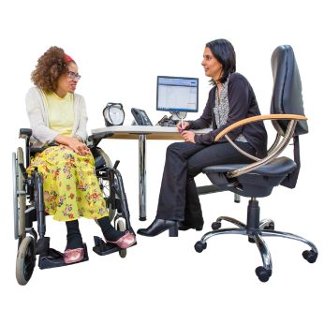

To get your vaccines ask your doctor.

What to do if you think you have measles

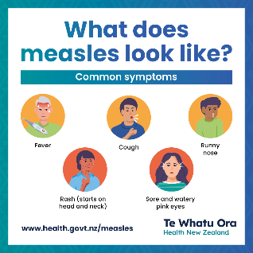
If you have measles symptoms you need to get medical advice right away.

Measles symptoms are:
- fever / feeling very hot
- cough
- runny nose
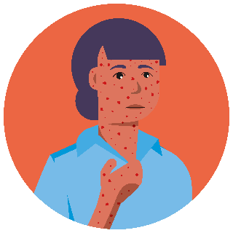
- sore eyes
- rash.

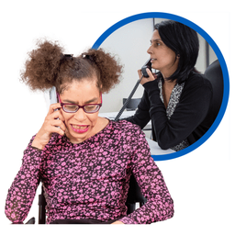
If you think you have measles you should call before you go to see a doctor.

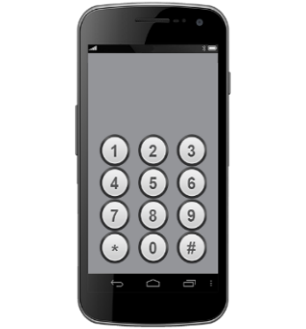
If it is an emergency you should call 111 right away.
111
111

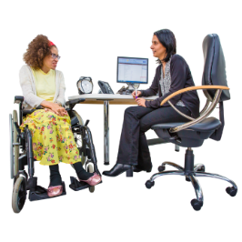
If it is not an emergency you can call:
- your usual doctor
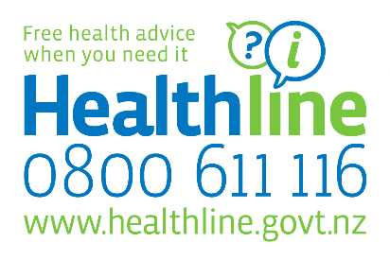
- Healthline: 0800 611 116
- the Disability Helpline:
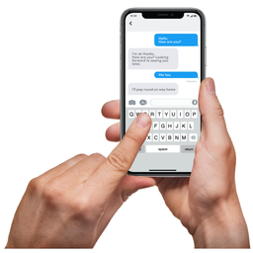
- call 0800 11 12 13
- text 8988.

You can use the NZ Relay service to call:

www.nzrelay.co.nz

The Disability Helpline is run by Whakarongorau Aotearoa / New Zealand Telehealth Services.

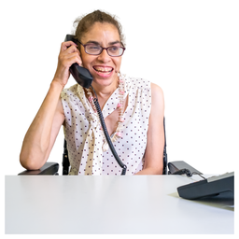
A person who knows about disability will answer your call from 8am to 8pm.

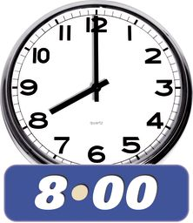
After 8pm, calls are answered by a trained member of the Healthline team.

Check if you are protected against measles

You are considered immune to measles if you:
- were born before 1 January 1969
- have had measles before
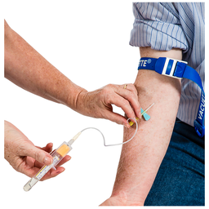
- have had two MMR vaccinations with the last dose more than 1 month ago.
- have had a blood test showing you are immune.

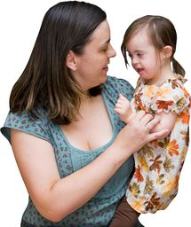
Babies less than 15 months old are said to be immune if:
they have had 1 MMR dose after they were 1 year old
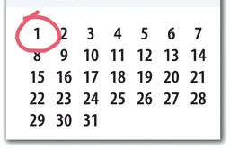
the MMR dose was given at least 1 month ago.

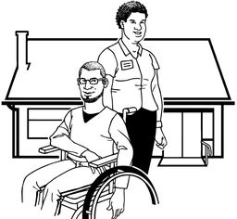
If you are immune you will not have to stay home in quarantine if you come into contact with someone who has measles.

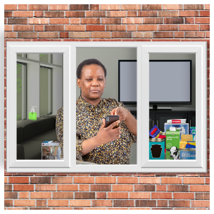
Quarantine means you have to stay at home away from other people.

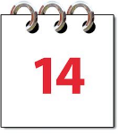
Quarantine usually lasts 14 days.

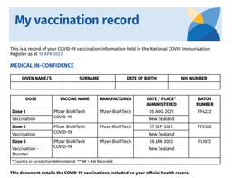
To check if you and your whānau are immune:
- look in your Wellchild Tamiriki Ora / Plunket book
- contact your doctor.

How measles symptoms are different to COVID-19

COVID-19 is an illness that can make you very sick.

Some symptoms of COVID-19 are the same as the symptoms of measles like:
- fever / feeling very hot
- cough
- runny nose.

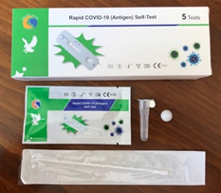
If you have symptoms like this you should:
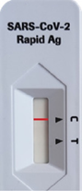
- take a test for COVID-19
- stay at home even if the test says you do not have COVID-19.

You should ask for medical advice if:
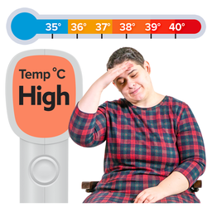
- your symptoms:
- get worse
- do not go away after 2 days
- a second test also says you do not have COVID-19
- you get measles symptoms like:
- a blotchy rash
- sore watery pink eyes.

People at risk of serious illness

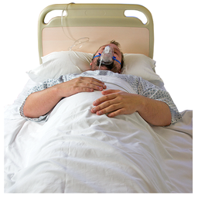
There are some people who can get very sick if they catch measles like:
people who have a long term illness
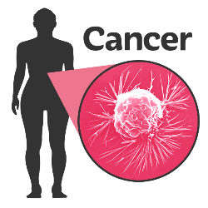
people who have a serious illness that affects their immune system
- children under 5 years old who have not had 1 dose of the MMR vaccine
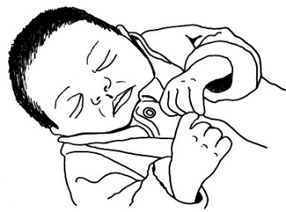
- babies younger than 1 year who are too young to get the MMR vaccine
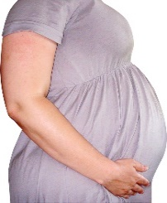
people who are pregnant.

It is very important for people / whānau who could get very sick to get vaccinated if they can.

Some people cannot get vaccinated like:
people who are pregnant
- babies younger than 1 year who are too young to get the MMR vaccine.

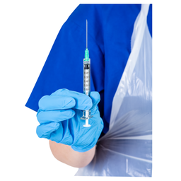
If there are a lot of cases of measles then babies under 1 might be able to get vaccinated.

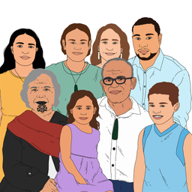
The best way to protect your whānau who cannot get vaccinated is to make sure that everyone else has the vaccine.

What to do if you catch measles

If a test shows you have measles you need to:
- stay home
- isolate / stay away from other people.

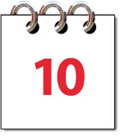
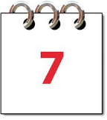
It takes around 7 to 10 days to get better from when you get symptoms.

You can leave your home 4 days after you develop a rash if you have had a final check with a health professional.

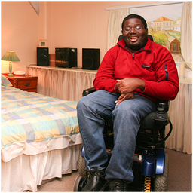
Most people can isolate safely at home.
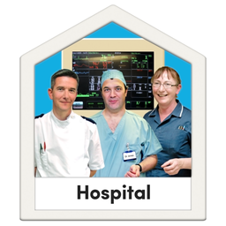
Around 1 in 10 people with measles need to go to hospital because of their symptoms.

If you need to isolate a health professional will be in touch regularly.

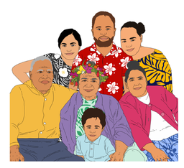
They will ask you if there is anyone else at risk of catching measles from you.

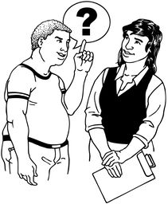
If there is someone at risk of catching measles in your home you can ask the health professional what to do.

If you are a contact of someone with measles

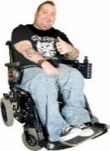
You need to quarantine if:
you are not immune
and
you have been in contact with someone with measles.

A health professional will:
explain what you need to do
check on you regularly.

If you have had one dose of MMR vaccine you:
do not have to quarantine
should stay away from:
- early learning services for 14 days
- healthcare facilities / hospitals for 14 days
- other places as advised by your health service.

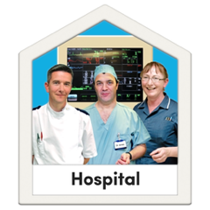
You can go to healthcare facilities if you need:
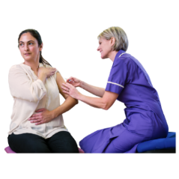
to get vaccinated
urgent medical attention.

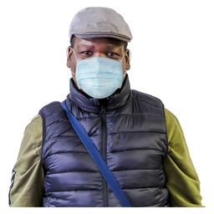
If you need to go to a healthcare facility you must:
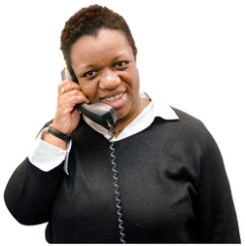
- wear a mask
- call first to say you have been near someone with measles.

Isolation / quarantine support

When the health professional calls you to talk about your quarantine you can let them know if you need support with:
money
other things.

You can also contact the Ministry of Social Development / MSD to ask if you can get financial support.

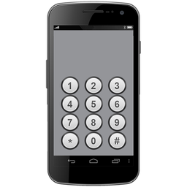
The number to call is:

0800 559 009

Where to get more information

You can find out more about measles on our website.

www.health.govt.nz/measles

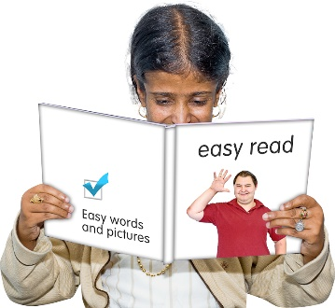
Some information on our website is not in Easy Read.

This information has been written by Te Whatu Ora Health New Zealand.

It has been translated into Easy Read by the Make it Easy Kia Māmā Mai service of People First New Zealand Ngā Tāngata Tuatahi.

The ideas in this document are not the ideas of People First New Zealand Ngā Tāngata Tuatahi.

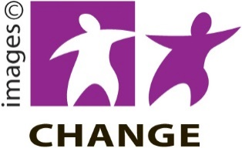
Make it Easy uses images from:

- Changepeople.org

- Photosymbols.com

- SGC Image Works

- Huriana Kopeke-Te Aho.
All images used in this Easy Read document are subject to copyright rules and cannot be used without permission.

